

[Document subtitle]

Project Name
DESIGN & IMPLEMENTATION OF SOLAR CHARGER WITH CASCADE DC TO DC CONVERTOR & HARMONICS FILTER

Project Advisor: Sir Fahad Usman Khan
Submitted By:
Muhammad Ali | 12017019-149
zohaib afzal | 12017019-069
abaid ullah anwar | 12017019-199
ghulam ghounsal fareed | 12017019-230
Department of Electrical Engineering
School of Engineering
University of Management and Technology Lahore

Department of Electrical Engineering
School of Engineering
University of Management and Technology Lahore

DESIGN & IMPLEMENTATION OF SOLAR CHARGER WITH CASCADE DC TO DC CONVERTOR & HARMONICS FILTER

Submitted to the faculty of the Electrical Engineering Department
of the University of Management and Technology Lahore
in partial fulfillment of the requirements for the Degree of

Bachelor of Science
in
Electrical Engineering

Signed:

Project Advisor Director Projects

Department of Electrical Engineering
School of Engineering
University of Management and Technology Lahore

DECLARATION OF ORIGINALITY

We declare that the work contained in this thesis is our own, except where explicitly stated otherwise. And more addition to this, that it has not been submitted to obtain another degree or any professional qualification.

Signed:

Muhammad Ali

Zohaib Afzal

Abaid-Ullah Anwar

Ghulam Ghounsal Fareed

Date:

Chapter | Topic | Page no
 | Declaration of originality | 03
 | Acknowledgement | 06
 | Abstract | 08
1.1 | Introduction | 10
1.2 | Problem statement | 11
2 | Thesis layout | 13
2.1 | Study analysis and proposed strategy | 13
2.2 | Importance and usage of convertors | 14
3 | Electronic conversions | 16
3.1 | Linear regulator | 16
3.2 | Switching mode regulators | 16
4 | Project implementation | 18
4.1 | Block diagram | 18
4.2 | Description of model | 19
5 | Components | 22
5.1 | LCD | 22
5.2 | Microcontroller configuration | 23
5.3 | LM 7805 | 24
5.4 | Types of voltage driver | 24
5.4.1 | TLP 250 | 24
5.4.2 | IR 2110 | 25
5.5 | IRF 740 | 26
6 | Implementation strategy for hardware/software | 28
7 | Software implementation | 35
8 | Calculations | 40
9 | References | 45
CONTENTS

1 | Block diagram | 18
2 | LCD Pin Diagram + configuration | 22,23
3 | Microcontroller Pin configuration | 23
4 | LM 7805 | 24
6 | TLP 250 | 25
7 | IR 2110 | 26
8 | IRF 740 | 26
9 | Buck convertor hardware + microcontroller | 29
10 | Boost circuit stages | 30,31
11 | Invertor | 32
12 | Harmonics filter | 32
13 | Complete circuit diagram | 33
14 | Buck convertor simulation | 36
15 | Cascaded boost convertor | 36,37
16 | Invertor | 38
17 | Calculations | 40,41,42,43
List of Figures

ACKNOWLEDGMENTS

We have taken too much efforts for the fulfilment of this project, there were many hurdles in the completion of this project. However, it was not possible without the kind and vigorously cheerful support of our project advisor, friends, teachers & parents. We are highly thankful to Allah who gave us such ability to think and implement and gave us such knowledge and helped us to use such knowledge in the positive manner in the form of this project.
We are owing too much thanks to Mr. Fahad Usman khan our project advisor MR. Awais Saeed for their great guidance, supervision and providing the best and complete information related to our project. And for giving us such attention & time.
We are highly obliged to our friends, Mazher Iqbal, Usama Ayuob, Muhammad Ali & Muhammad Ijaz for their support, co-operation & encouragement which very much helped us in the completion of our project.
We are highly indebted to our parents for their support, encouragement & prayers which lead us to successfully complete our project.
Many appreciations and thanks to all those who encouraged us and supported us for the fulfilment of our project.

Dedicated to our Parents

ABSTRACT

“Design and Implementation of Solar Charger with Cascaded DC to DC convertor & Harmonics filter”. As it can be understood from the title that we are using solar cells for the charging of our batteries and then utilize it for running our equipment’s.
The defect in the today’s system of the solar chargers is that they are low in efficiency and quality of the output we need to charge the batteries is not so high. It has ripples in it and the voltages are not stable, because the voltages are directly proportional to the sunlight intensity. when the sunlight is at its peak the voltages from the output of the solar panel will be very high and when the sun is going to be set in or on the rising time the sunlight intensity will be very low resulting the output of the solar panel very low, which is not acceptable. we need more stable voltages for better efficiency of our system. The other thing is the system harmonics which we need to minimize as low as possible.
So we have designed a charger to meet all these needs which has the functionality of voltage stability and which has almost negligible harmonics. We have used cascaded DC to DC convertors with programed MOSFET which will stabilize the voltage level and then on the final output a harmonics filter is installed to minimize the harmonics.
This will result in more efficient solar charger with more stabilized power output and reduced harmonics.

CHAPTER 1

INTRODUCTION

1.1 Overview:

As increase in the population and the shortage in the power production has forced the users to move on to the other energy sources from the traditional ones. In the past the only source for the power was hydro. By the passage of time and the inventions in the electrical power field the scientists invented many ways to meet the needs of electrical power, one of them was through solar cells.
Now by the passage of time, many improvements in this system were made and still needed more improvements. The previous system has not good efficiency and some issues regarding power output and the ripples in the output which results in the poor waveform.
The ripples and the dirty waveform cause the charging voltage fluctuate resulting the battery life decrease, which is not so good for a long backup of power in the power outage & also not economical. To meet our power shortage needs we have to stabilize the charging system which will increase the battery life and save our expenses for buying new batteries.
First of all, the solar cell, these are made up of silicon. Solar cells capture the solar light and going through a reaction it converts it from light energy to electrical energy. These solar cells have their own working efficiency which depends on the working place, weather and working hours. Like when working in the cloudy days its efficiency decreases same as while working in the shade or less light or as the sun is near to set in, at that time the efficiency will decrease. Because as you can see from the name that this is a solar cell and it works with the solar light. And when the sun light is enough then the efficiency will be at its peak. These both stages are not acceptable, because we have to operate on the constant voltages to charge our batteries for further uses.
The reason of charging the battery on constant voltage is that, the working efficiency of the battery depends on the way the battery is charged. Like if the battery is charged on low voltages it will not provide the appropriate backup time for which it was designed and assembled & it will take more time to fully charge the battery. For this purpose of constant voltages, we need to stabilize the output of the solar panel. We use DC to DC convertors to avail our desired output. DC to DC convertor is a convertor which changes one level of DC voltages into another level of voltages. We use buck and boost phenomena for the stabilizing of our voltages. The output voltages from the solar panel are high from our required level the buck portion will work and reduces the voltages to a specific level which we have selected for the charging of our battery (14V).
These 14 volts are now feed to our battery for the charging purpose. Then from the output of our battery which will be 12 volts we start our BOOST section 1st boost section increased our voltage level to 28 volts, after getting the desired output, the output of the 1st boost convertor is feed to the 2nd boost portion which enhanced it to 56 volts, following the sequence the output from the 2nd convertor is feed to the 3rd boost section which increased the output to 112 volts. This terminology of feeding ones output to the other and of that’s output to the next one is called cascade. And the resulting output will be more stabilized than from a single convertor. This stabilized output is then can be used for driving directly to a DC load or if you are willing to drive some AC loads then to do so you will need to invert it, and will use invertors. Inverters are such set of components which are used to invert the DC voltages to AC voltages. And then the output can be used for any type of AC loads assuring the invertor used and the backup battery installed and the solar panel used. The output of the invertor which is AC is not in its pure form it has some harmonics in it.
Harmonics are the additional frequency waves added to the actual frequency. Effect of the harmonics on the electrical system depends on the physical location, installation practices, electrical loading, and the ambient temperature. That means the same amount of harmonics level can effect differently on the two separate installations. The effect of the harmonics is large number of neutral currents, excessive rise in the temperature, vibrations, audible noise and protective devices malfunction.
To avoid all these in our system we are using a harmonics filters which will diminish the effect of harmonics on our system. This filter will filter the harmonics from the AC and the pure supply without any ripples will be available for us on the final output edge of the AC supply.

1.2. Problem statement:

“Voltage fluctuation and the harmonics disturb our electrical system a lot”. Our todays whole electrical system is moving towards the renewable sources of electrical energy to fulfil our needs. Because the electrical energy produced is less and the needs are far more than that. So everyone who can afford such sources to avail the facility of undisturbed electrical supply and to make their life happy & away from electrical load sheading, are moving towards installing small electrical generators, UPS and solar panels. The main effect of these sources is that the fluctuating voltages and some added frequencies (harmonics) in the system which effect the whole system very badly.
All the protection can also be effected by these, and this is not a good thing for the safety of the users. The other problem due to this is that due to the harmonics need to enlarge the size of the conductors for larger neutral currents, we have to change the ratings of the protective devices and due to the rise in temperature the system will be shut down for cooling purpose, and the efficiency will be effected. This should be controlled for the uninterrupted supply with better protection.
Fluctuation in the voltages cause the charging problem and the system malfunction. It can burn out the devices due to sudden rise and fall of the voltages. Moreover, this effects the charging time of the battery attached for the backup with the solar panels, the charging time will increase due to low voltages and the backup time will be less. And if the voltages will be high then it’s possible that the device will burnout. Or due to overheating it can also be tripped.
To resolve all these issues, we are going to improve the previous existing system by using cascaded DC to DC convertor to stabilize our voltages and after stabilizing the voltages we are going to use harmonics filter for the filtration of the harmonics.

CHAPTER 2

THESIS LAYOUT

2.1Study analysis and proposed strategy

In this convertor we will use Buck and boost terminology to obtain our desired fixed output. Our main concern will be on the final output and the power quality of the output voltage. For the power quality we are using harmonics filter. Users just have to install the panel and connect to our pre designed convertor which will stabilize and enhance the power quality.

We are using PIC18F452 for the controlling the switching of our MOSFET in this we have set a reference point of the voltage the incoming voltage from the panel will be compared to the reference voltages and then it will be decided that either the incoming voltages are higher than the voltages they are going to be compared or equal to the compared voltages.
If the voltages are higher than the compared voltages, then the duty cycle will be shrink resulting the output voltages minimized to the reference point voltages.
After getting our desired output of 14 volts we feed this to the battery and charge it, then took those 14 volts and boosted those to different levels to run different powered DC loads. And at the end we are inverting the voltages and enhancing the power quality of that by using harmonics filter. Harmonics filters reduce the number of harmonics in the AC voltages.

2.2Importance & usage of these type of convertors:

Convertors are main sources of converting one level of power into another level of power. And we do it so to make us achieve our desired output and to make that constant. DC to DC converters are employed in transportable electronic devices like cellular phones and portable computer like laptops & pagers that are being run on batteries. Such electronic devices typically contain many sub-circuits, every with its own voltage level demand totally different from that provided by the battery or AN external provide (sometimes higher or not up to the provision voltage). in addition, the battery voltage declines as its hold on energy is drained. Switched DC to DC converters supply a way to extend voltage from a partly down battery voltage thereby saving area rather than victimization multiple batteries to accomplish identical issue.
Most DC to DC convertor circuits conjointly regulate the output voltage. Some exceptions embrace high-efficiency semiconductor diode power sources, that are a form of DC to DC convertor that regulates this through the LEDs.
DC to DC converters developed to maximize the energy harvest for electrical phenomenon systems and for wind turbines are referred to as power optimizers.
Transformers used for voltage conversion at mains frequencies of 50–60 Hertz should be massive and significant for powers surpassing many watts. This makes them dear, and that they are subject to energy losses in their windings and because of eddy currents in their cores. DC-to-DC convertors in which we use transformers & inductors work on abundant higher frequencies, requiring solely abundant smaller, lighter, and cheaper wound elements. Consequently, these techniques are used even wherever a mains electrical device can be used; for instance, for domestic electronic appliances it's desirable to rectify mains voltage to DC, as we use switching mode methods to convert it to high-frequency AC at the required voltage, then, usually, rectify to DC. The whole circuit is cheaper and a lot more economical than an easy mains electrical device circuit of identical output.

CHAPTER 3

Some electronics conversions

1.1 Linear regulators:

These regulators use a technique of dividing or eliminating extra volts & amperes in the form of heat resulting the output a stable DC, which is free from or self-governed by the input voltage and output or load. There are some more convertors like, capacitors voltage doublers & Dickson multipliers. Thy both use diodes and capacitors to enhance the DC voltage by multiplying to an integer but these type of convertors has a flaw of very small output current.

1.2 Switching mode regulators:

Switching mode voltage regulators are such regulators which use switching techniques to change the voltage levels of the input to a different output levels.
The output can be both higher than the input or can be lower than the input voltage level. And to do so these convertors use a technique in which the they store input charge into the energy storage electric components.
They store the incoming voltages into themselves and then emit on a different voltage level. The emitted voltage can be higher than the input or can be lower than the input voltages. it has 75% to 98% efficiency as compared to linear mode convertors which emit extra voltages in the form of heat.
Higher response towards input to output makes less heat emitting & long battery life for the electrical machine which is using such battery. They use power FET in its design rather than bipolar transistors. Power FET’s has the ability to switch more effectively with the lower switching loss and higher frequency.

CHAPTER 4

PROJECT/SYSTEM IMPLEMENTATION MODEL

4.1 Block Diagram:

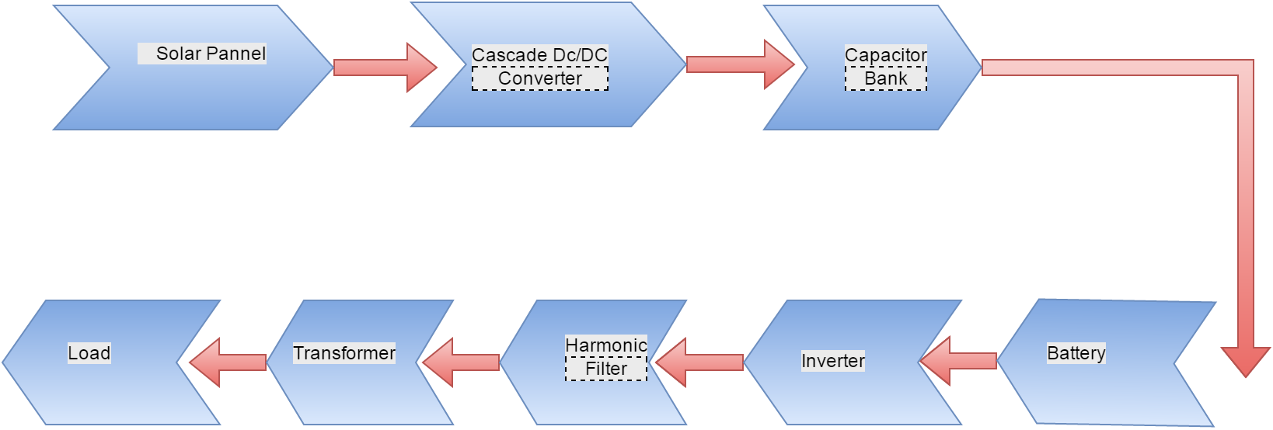

4.2 Description of Model:

Solar panel:

In solar panel, solar cells are made of usually cheap silicon. Cell made up of two wafers of doped (P & N type) in contact. One cell is only capable of 0.7V. According to load we connect these cells/panels/ arrays in series or in parallel. Our panel is of 50W and 2.5A. Our purpose is to charge 12V battery.

Cascaded DC/DC Converter:

Our main block of project is Dc/Dc converter, In Converter we are using topology of buck and boost converter with MOSFET. Purpose of this converter is to maintain fix output of 15V to charge Battery. Because solar output is variable, so for Charging of Dc battery and long life we have to charge on fix voltages. From solar input we choose value for which we only use Buck Converter. For topology of Cascaded DC-DC Converter we boost value of 12V from battery to 28V in our first stage and in next stage we boost up to 28V and then in final stage we boost up to 114V.

Battery:

Battery is used for storage of DC. Rating of Battery is described by (Ah) Amperes per hour and 12V. we have 7Ah and 12V battery for small load. We are just going to show the method. For heavy load, size of battery will increase which will increase the cost of project. the battery according to demand load. Usually Led Acid Battery will be used.

Inverter:

A power inverter changes DC voltages coming from battery to conventional Ac. Which we usually use for our appliances. Size of inverter depends upon your usage; more appliances will increase the rating of inverter. Watt is used for rating of inverter. For Required Watts of, output 220AC volts are multiplied to current draw by load. But we have to consider start up current taken by the device also, and then rating of inverter will increase.

Harmonic Filter:

Due to non-linear load harmonics will produce that could heat the device or damage the electronic device which is being used. To remove these odd harmonics, harmonic filter is necessary to use. A harmonic filter is made up of arrays of capacitors, inductors, and resistors, these components ground the harmonics.

Load:

Because all daily using equipment’s are on AC load, so according to that need our output is also AC.

CHAPTER 5

Components

5.1 LCD:

This component is use to display our results. In our circuit we are displaying Duty Cycle increase or decrease and Voltage of each section. It is 16X2. There are 8 data pins D0 to D7 and pin 1&2 is for VCC, we apply 5V on these pins. Pin 4 is for selection of register and pin no 5 is for command register, pin no 6 to select register.

Pin diagram:

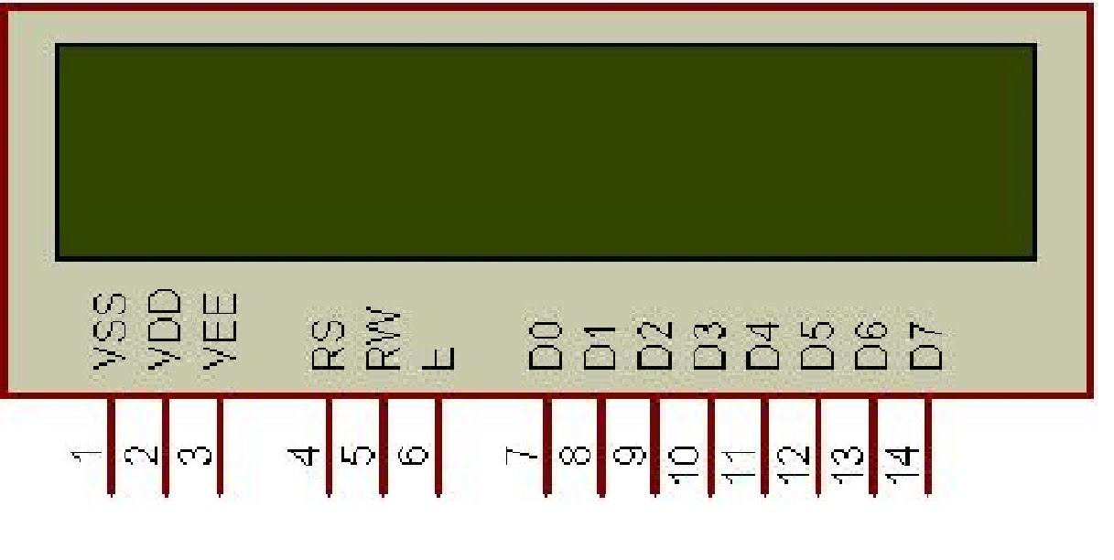
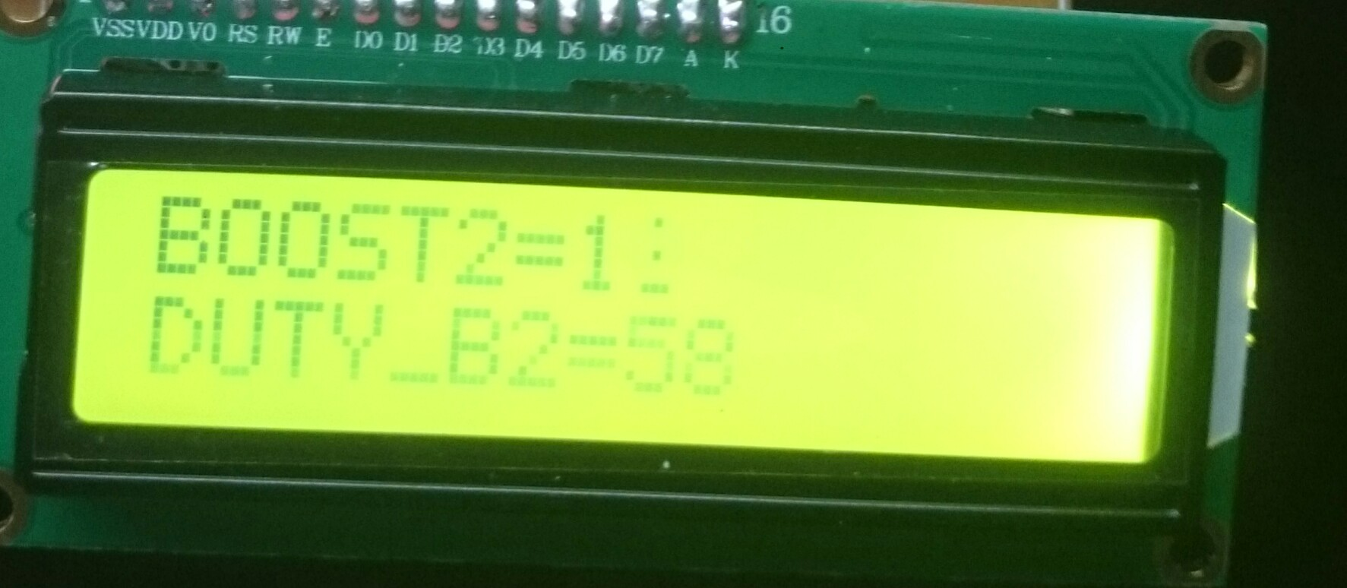

5.2 Microcontroller PIC18F452 Configuration:

This microcontroller has 40MHz clock speed. It is 40 pin IC. We are using frequency of 10 KHz. It has 4 ports, Port A, Port B, Port C, Port D. we can use any port as an input or output, it depends on user requirements whatever he want to use.
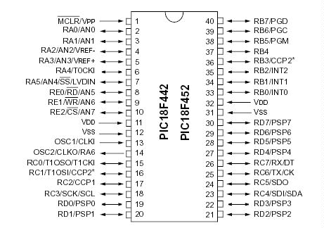

5.3 LM 7805 voltage regulator:

It is used to get 5V at output. This is positive regulator. So whatever at input, it gives 5V.
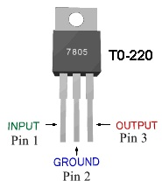

5.4 Types of Voltage Driver:

There are many types but in our circuit we are using two types of voltage driver.
- TLP-250
- IR-2110

5.4.1 TLP-250:

We are using this IC in our boost circuit. In our circuit working of is IC, just leveling the required voltages. MOSFET needs 12V to operate but microcontroller can only give 5V signal. So due to this switching of MOSFET is not possible without any other option. This is doing this job. We apply 12V external to TLP-250 for to ON state and in other pin it gwt signal from microcontroller and then it decides either MOSFET will on or off. As controller generates 5V signal, it operates the MOSFET on 12V. For off state of controller, it kept voltage in it, and MOSFET didn’t operate.

Pin configuration:

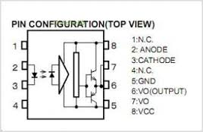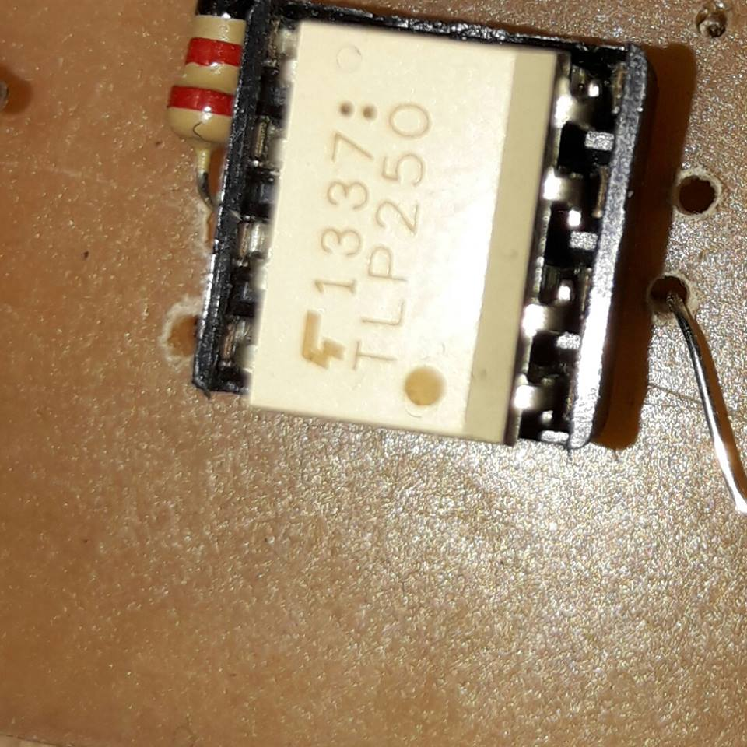

5.4.2 IR-2110:

We are using this IC in our boost circuit. In our circuit working of this IC is, it is acting like a bridge. MOSFET needs 12V to operate but microcontroller can only give 5V signal. So due to this switching of MOSFET is not possible without any other option. This is doing this job. We apply 12V external to IR-2110 for to ON state and in other pin it get signal from microcontroller and then it decide either MOSFET will on or off. As controller generates 5V signal, it operates the MOSFET on 12V. for off state of controller it kept voltage in it, and MOSFET didn’t operate.

Pin configuration:

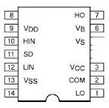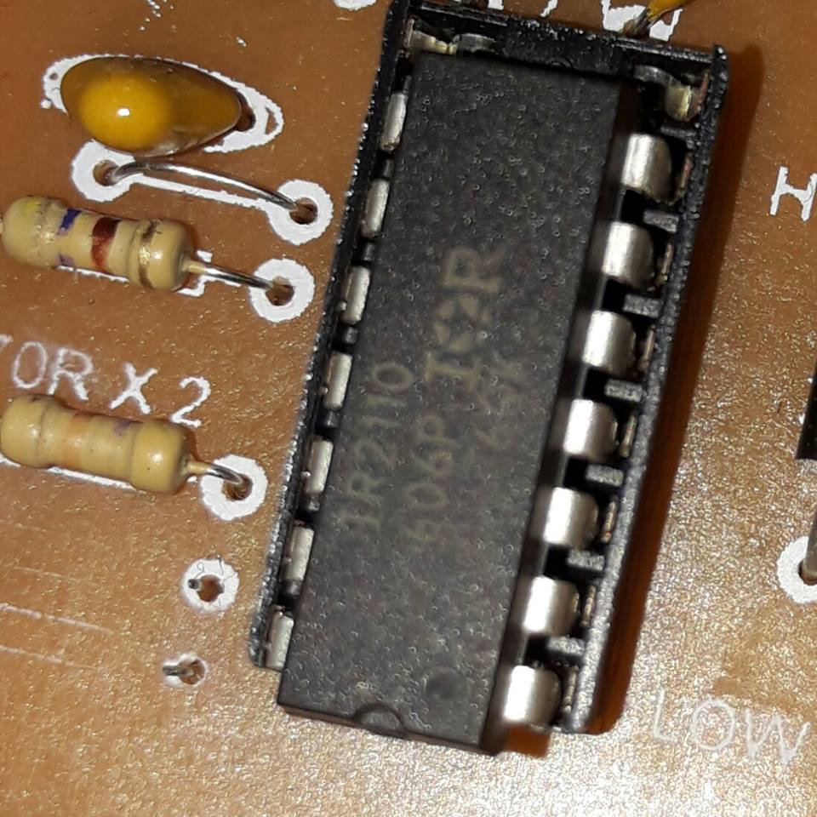
5.5 IRF-740:
We use this IC in our inverter circuit. We made the bridge of this NOSFET to make DC to AC. Due to opposite on off state of this IC we convert DC to AC. Polarity of this transistor is N. it can bear max 400v drain voltage. Open resistance is 550 ohm. And max gate voltage should not be more than 30V. Moreover, it is 125W Transistor.
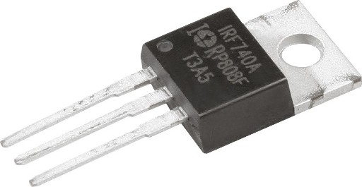

CHAPTER 6

IMPLEMENTATION STRATEGY FOR HARDWARE/SOFTWARE

Main source used for supply is solar panel in our circuit. Solar panel’s rating is 50W and 3A. This panel place in direct sunlight, where the sunlight is present for the maximum time. This will result in maximum time for the supply of voltages. The output from the panel is fluctuating, due to the rise and fall in the sunlight. To minimize this effect, we feed this to our Buck Converter. Which stabilize the output voltages, to our specified voltages. The voltages required for the battery charging purpose are 14V. Fix voltages increase the life of battery and charging time will decrease.
The pure DC supply from here will be fed directly to any DC load, and battery charging terminals can be added from here. So due to cascaded topology we have different stages of DC for different DC loads. First we boost at 28V from input of 14V of Battery. DC load of 28V could be use after first stage and then in second stage we boost at 56V, using same method of Boost. This stage is cascaded with previous stage, output of previous stage is input of next stage. Any DC load of 56V can be use just after this stage. This stage provides feasibility for big DC loads. For more than big rating of 56V, we construct and other stage of Boost. This stage is also cascaded with previous stages, output of previous stage is input of next stage. In this stage we Boost up to 114V approximately double of the previous value. DC load of this rating could be use here.
Mostly we have AC load in our home to use, so we invert this DC to AC for benefit of maximum users. This inverter inverts DC supply to AC, and we can use that to run our AC loads. Size of inverter, battery, and panel depends upon the size of load. For the selection of converter, we calculate the consumed current by the load and multiply it with the output AC voltage.
Watts= load Current*output of AC voltages.
But starting current of any load is greater than the consumed load, so we have to select the inverter with his starting rating.
Watts= starting current* output AC voltages
Inverter efficiency is usually more than 90%.
Output from the inverter section will be AC, and it surely has some amount of harmonics in it. These harmonics cause bad effect on the system and to minimize this effect, we will use harmonic filter. AC keeps harmonic in it so we use harmonic filter for purification of AC.

If the final output has low voltage level, then we can use transformer to boost to 220AC voltage.

Buck Circuit Hardware Diagram:

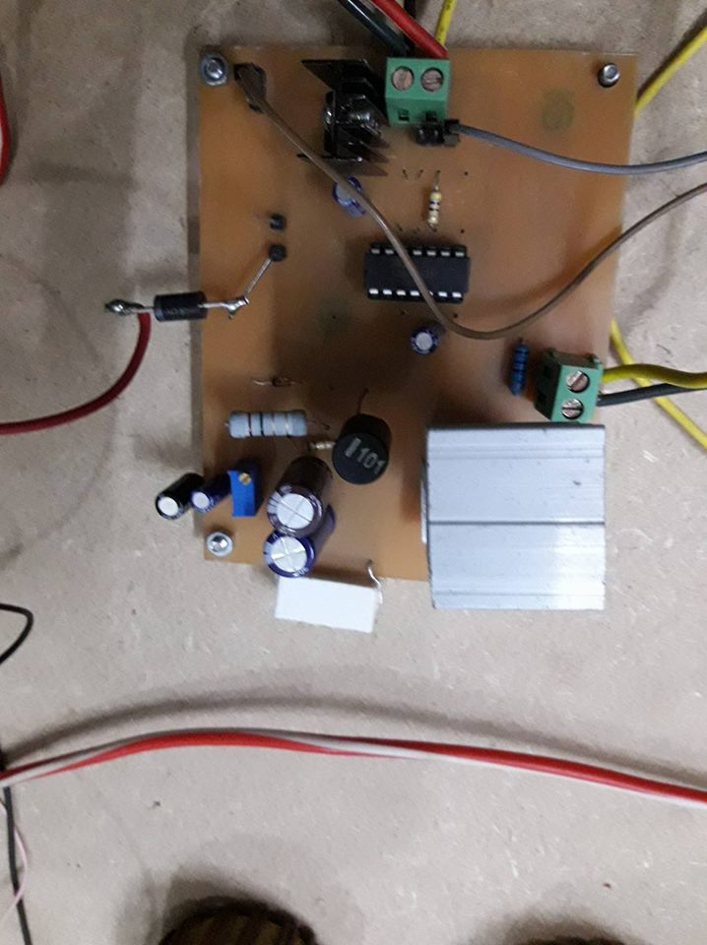

Buck Circuit with Microcontroller Hardware Diagram:

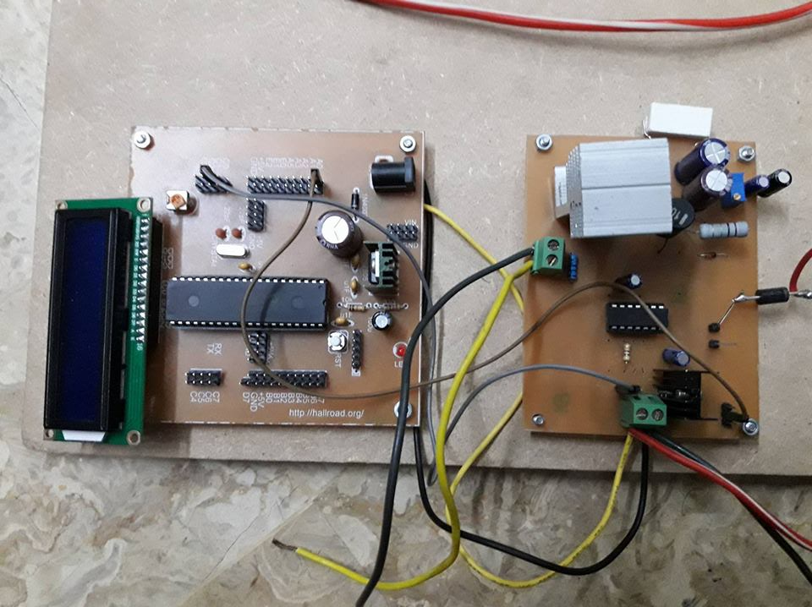

Boost Circuit input:

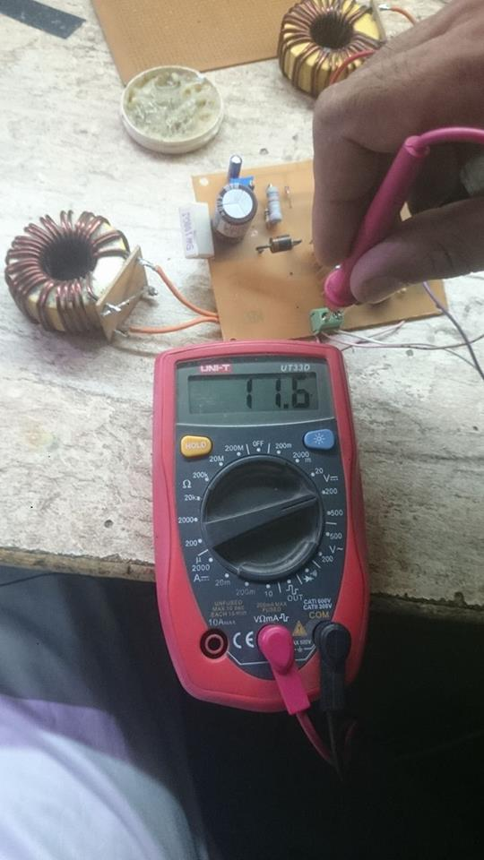

Boost Circuit First Stage 12V to 28V:

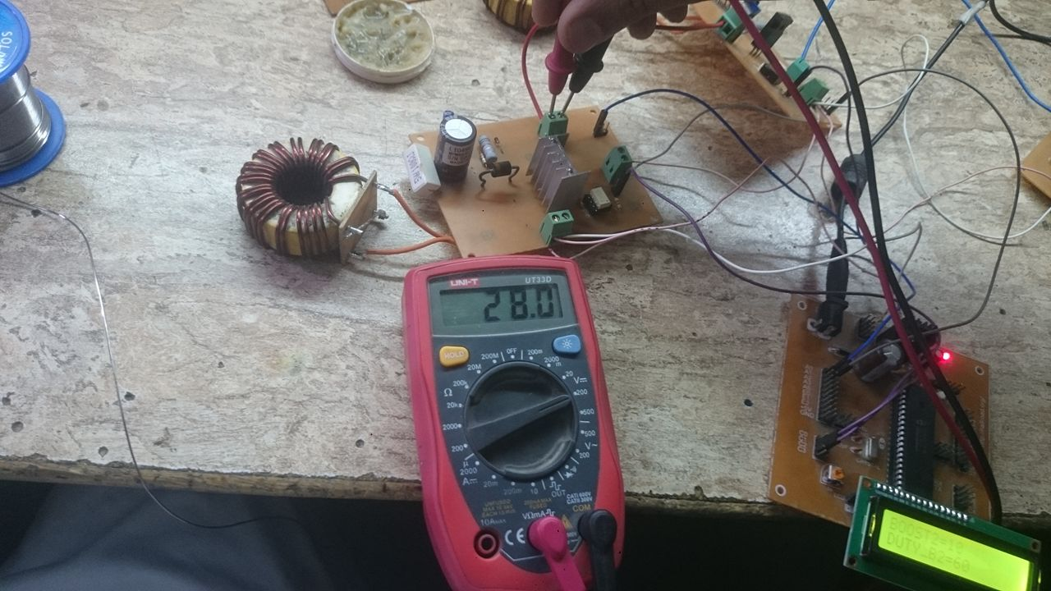

Boost Circuit Second Stage 28 to 56V:

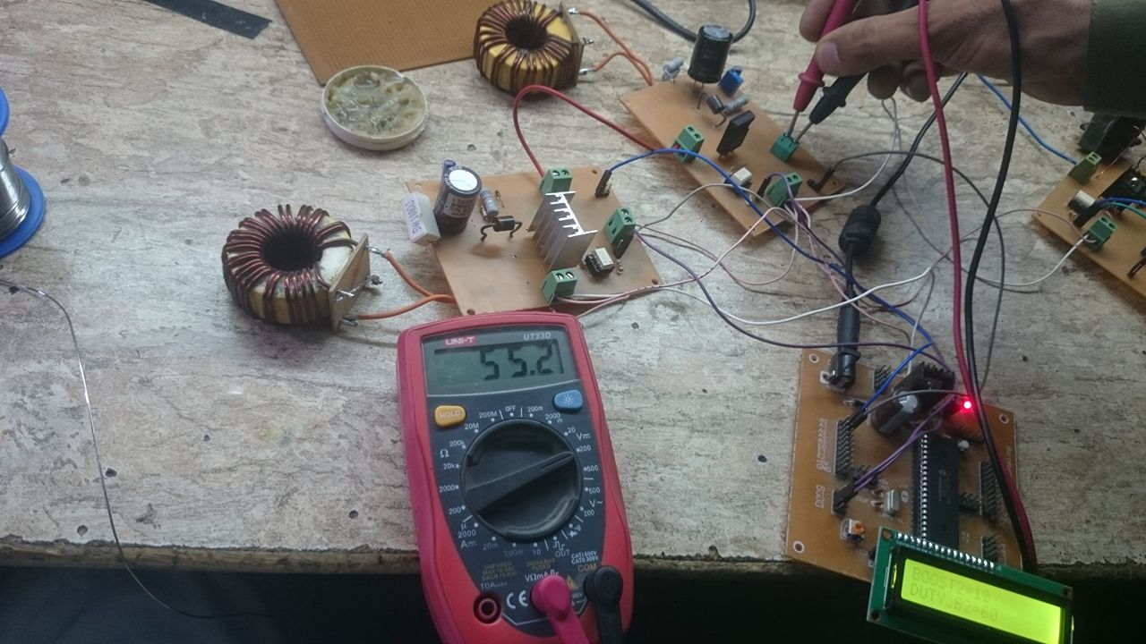

Boost Circuit Second Stage 56v to 112V:

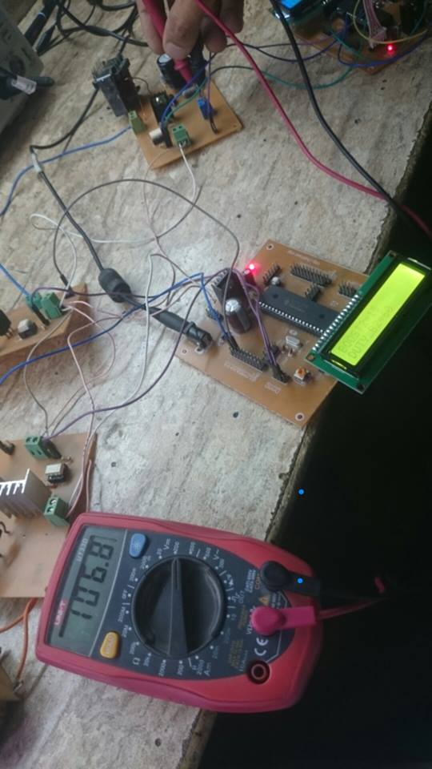
Inverter Circuit Diagram:

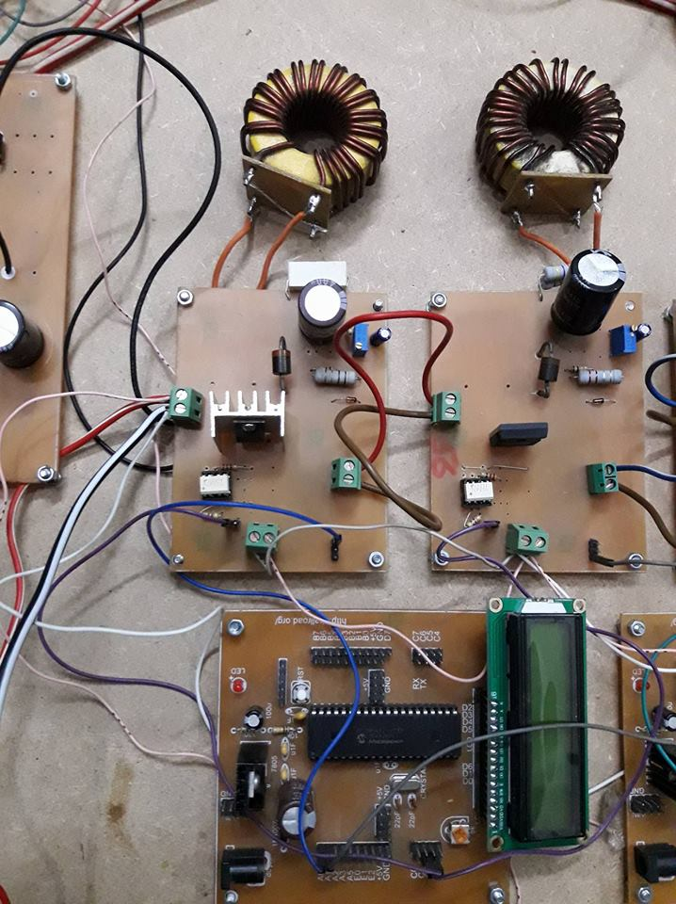

Harmonic Filter:

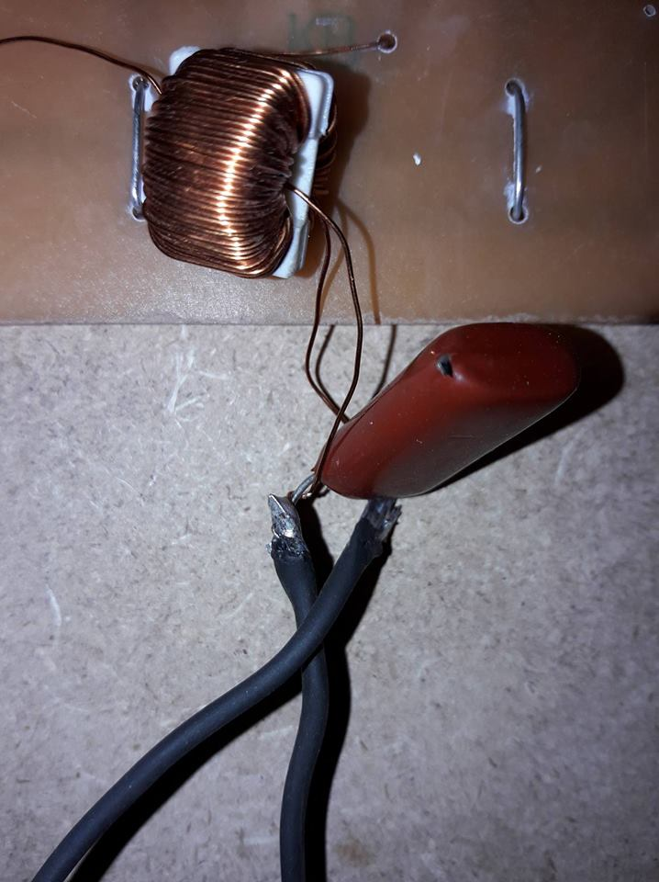

Hardware overall Circuit Diagram:

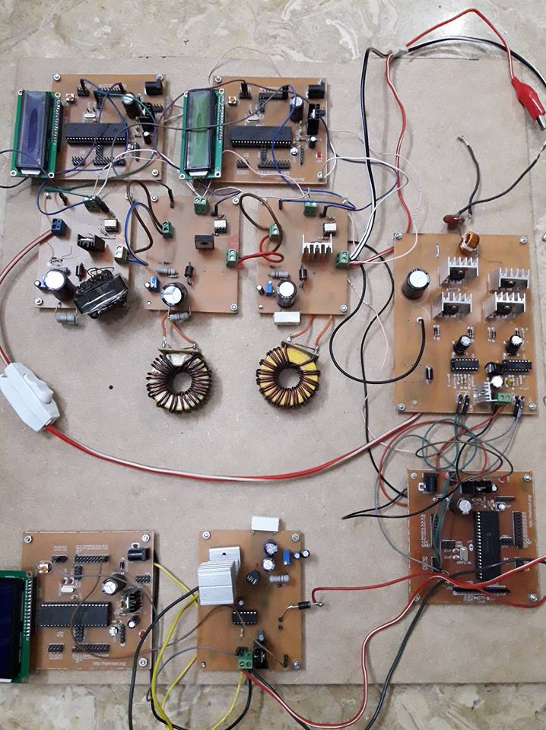

CHAPTER 7

SOFTWARE IMPLEMENTATION

We use Proteus software for the implementation of our circuit’s soft form. In which all the results verify according to our designed. We maintain fix voltages for the charging of battery, to do so we use method of Pulse Width Modulation (PWM). By changing width of pulse, we control the switching of MOSFET. In result we get approx. fix 14V. To generate PWM, we use microcontroller which interfaces by a software CCS. This software create many extension files for every compiling file like as .C, .h,.err,. esym, .hex, .sym, .lst, .cof, .Pjt, .tre, .sta. This Logic implementation is made in CCS software, and then we use a special burner of CCS. Each burner is not compatible for each Pic software. As in our university Micro,C software of Hex file and burner supported to this are used. We made all our logics in CCS software. As it is stated above for DC-DC Cascaded converter, we simulate separately of Buck converter and separate file for boost converter.
After making logic file of CCS language programming which is not too much different than C programming. The logic designing of C programming we learnt in the initial subjects. After making C file we convert in to Hex file. In proteus we design the circuit of Buck converter and Boost cascaded converter. In Proteus we use microcontroller for PWM and in our model we use PIC18F452. There are many IC which could be use but we use this due to low price and high switching speed. And most important it resist more heat in working condition than other IC’s. It read and sense Hex file.
Then by using burner we burn Hex file in it. Then further about design of buck and boost circuit. Starting from simulation circuit of Buck converter, in practical we have solar panel for our input. Here we didn’t have feature in Proteus software so we are using variable DC power supply. Because the power generated by panel is DC. In hard form due to different intensity of light, output of panel is varying all the time. After Dc battery we have MOSFET for switching, MOSFET is using for switching. In programming we set the reference value which we desired for charging of DC battery.
As input varies value is compare to the reference value and then value either incremented or decremented according to input. For higher value to buck, Duty Cycle of PWM decrease inversely to higher input value. Next for Boost simulation in Hardware we took 12V from charge DC battery from Solar Panel but here we use fix 12V power supply at the input of Boost circuit. In buck we have varying input but here we have constant fix supply as battery is charge regularly with requires load at output.
So change in Pulse on off time our required output To get requires output we use different calculations which are mentioned above in designing of Resistor, Capacitor, Inductor. Moreover, it is too difficult to simulate buck boost circuits at this software because Proteus Software is not good for analog simulation. Due to presence of capacitor and inductor it becomes difficult for proteus to extract 100% output results. So it terminates after some seconds of simulation. But still we put hard efforts to extract more than 95% exact required answers. Which we require for the hardware results. This PWM pulse will be the input of MOSFET. The stabilized output voltage from the MOSFET will be fed to the capacitor bank, after passing through capacitor bank it will reach to the battery.
Buck Converter:

Buck converter 25V to 14V
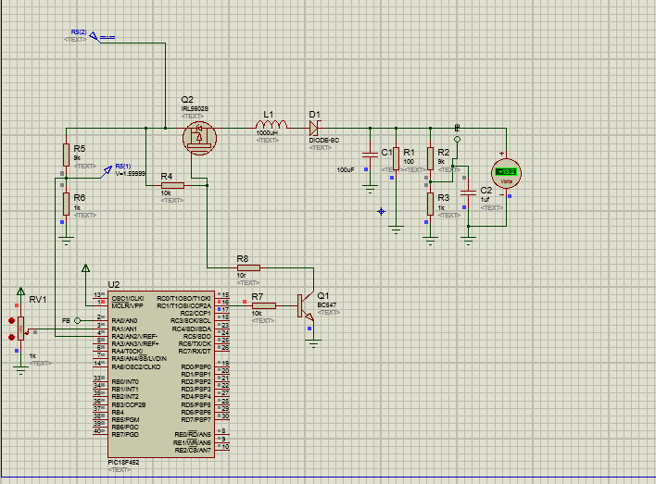

Cascaded Boost Converter:

First Stage 12V to 28V
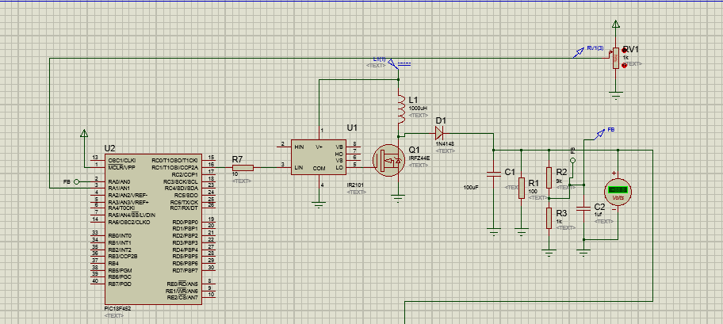

Second Stage 28V to 56V

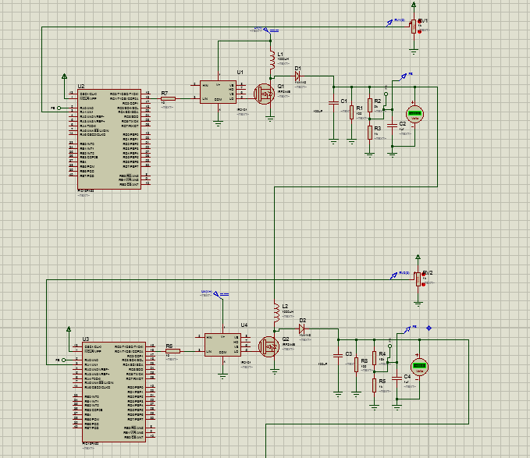

Last Stage Boost 56 to 112V
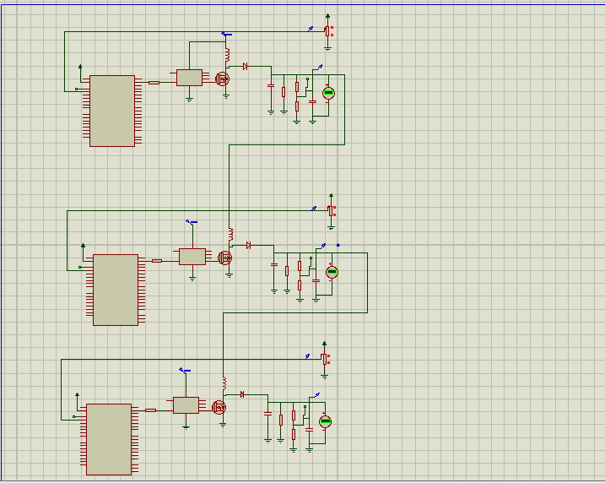

Inverter Circuit Diagram:

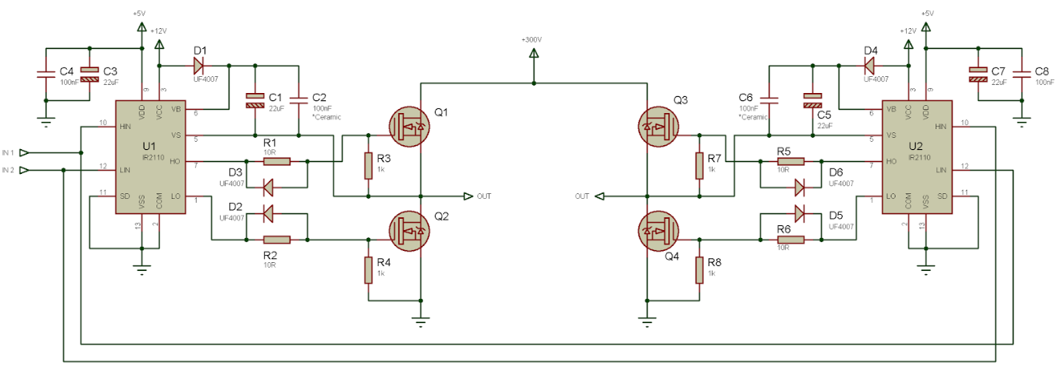

CHAPTER 8

Calculations:
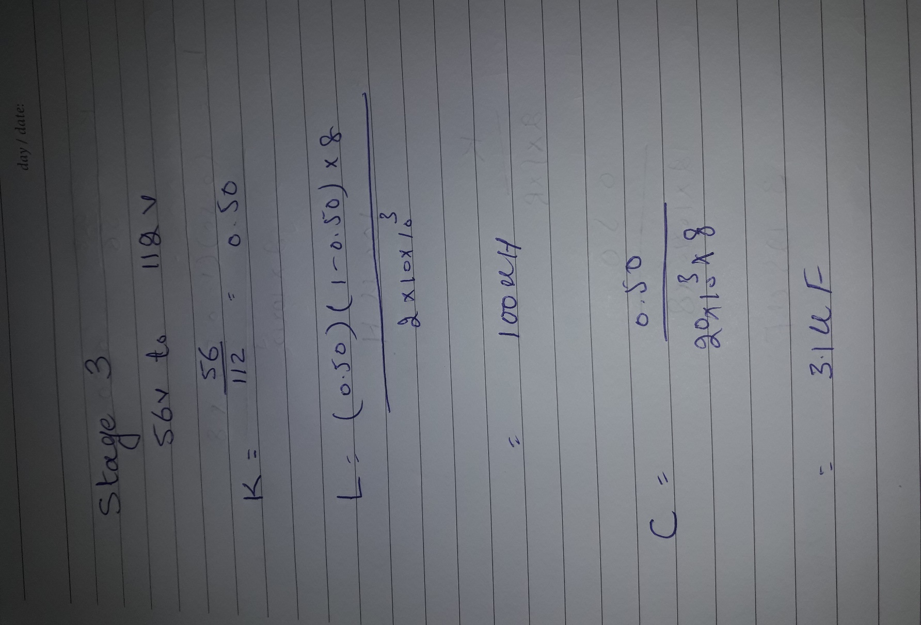
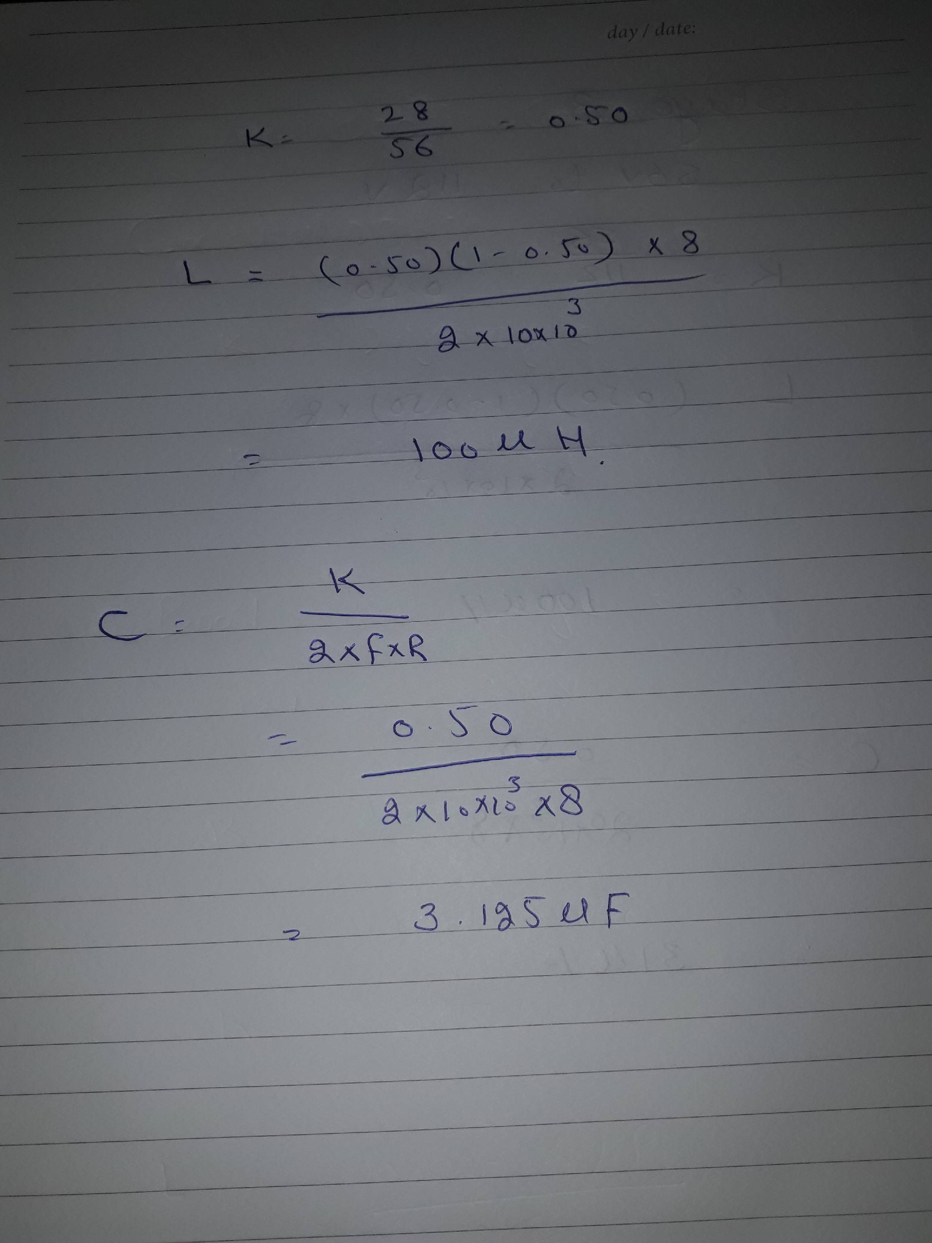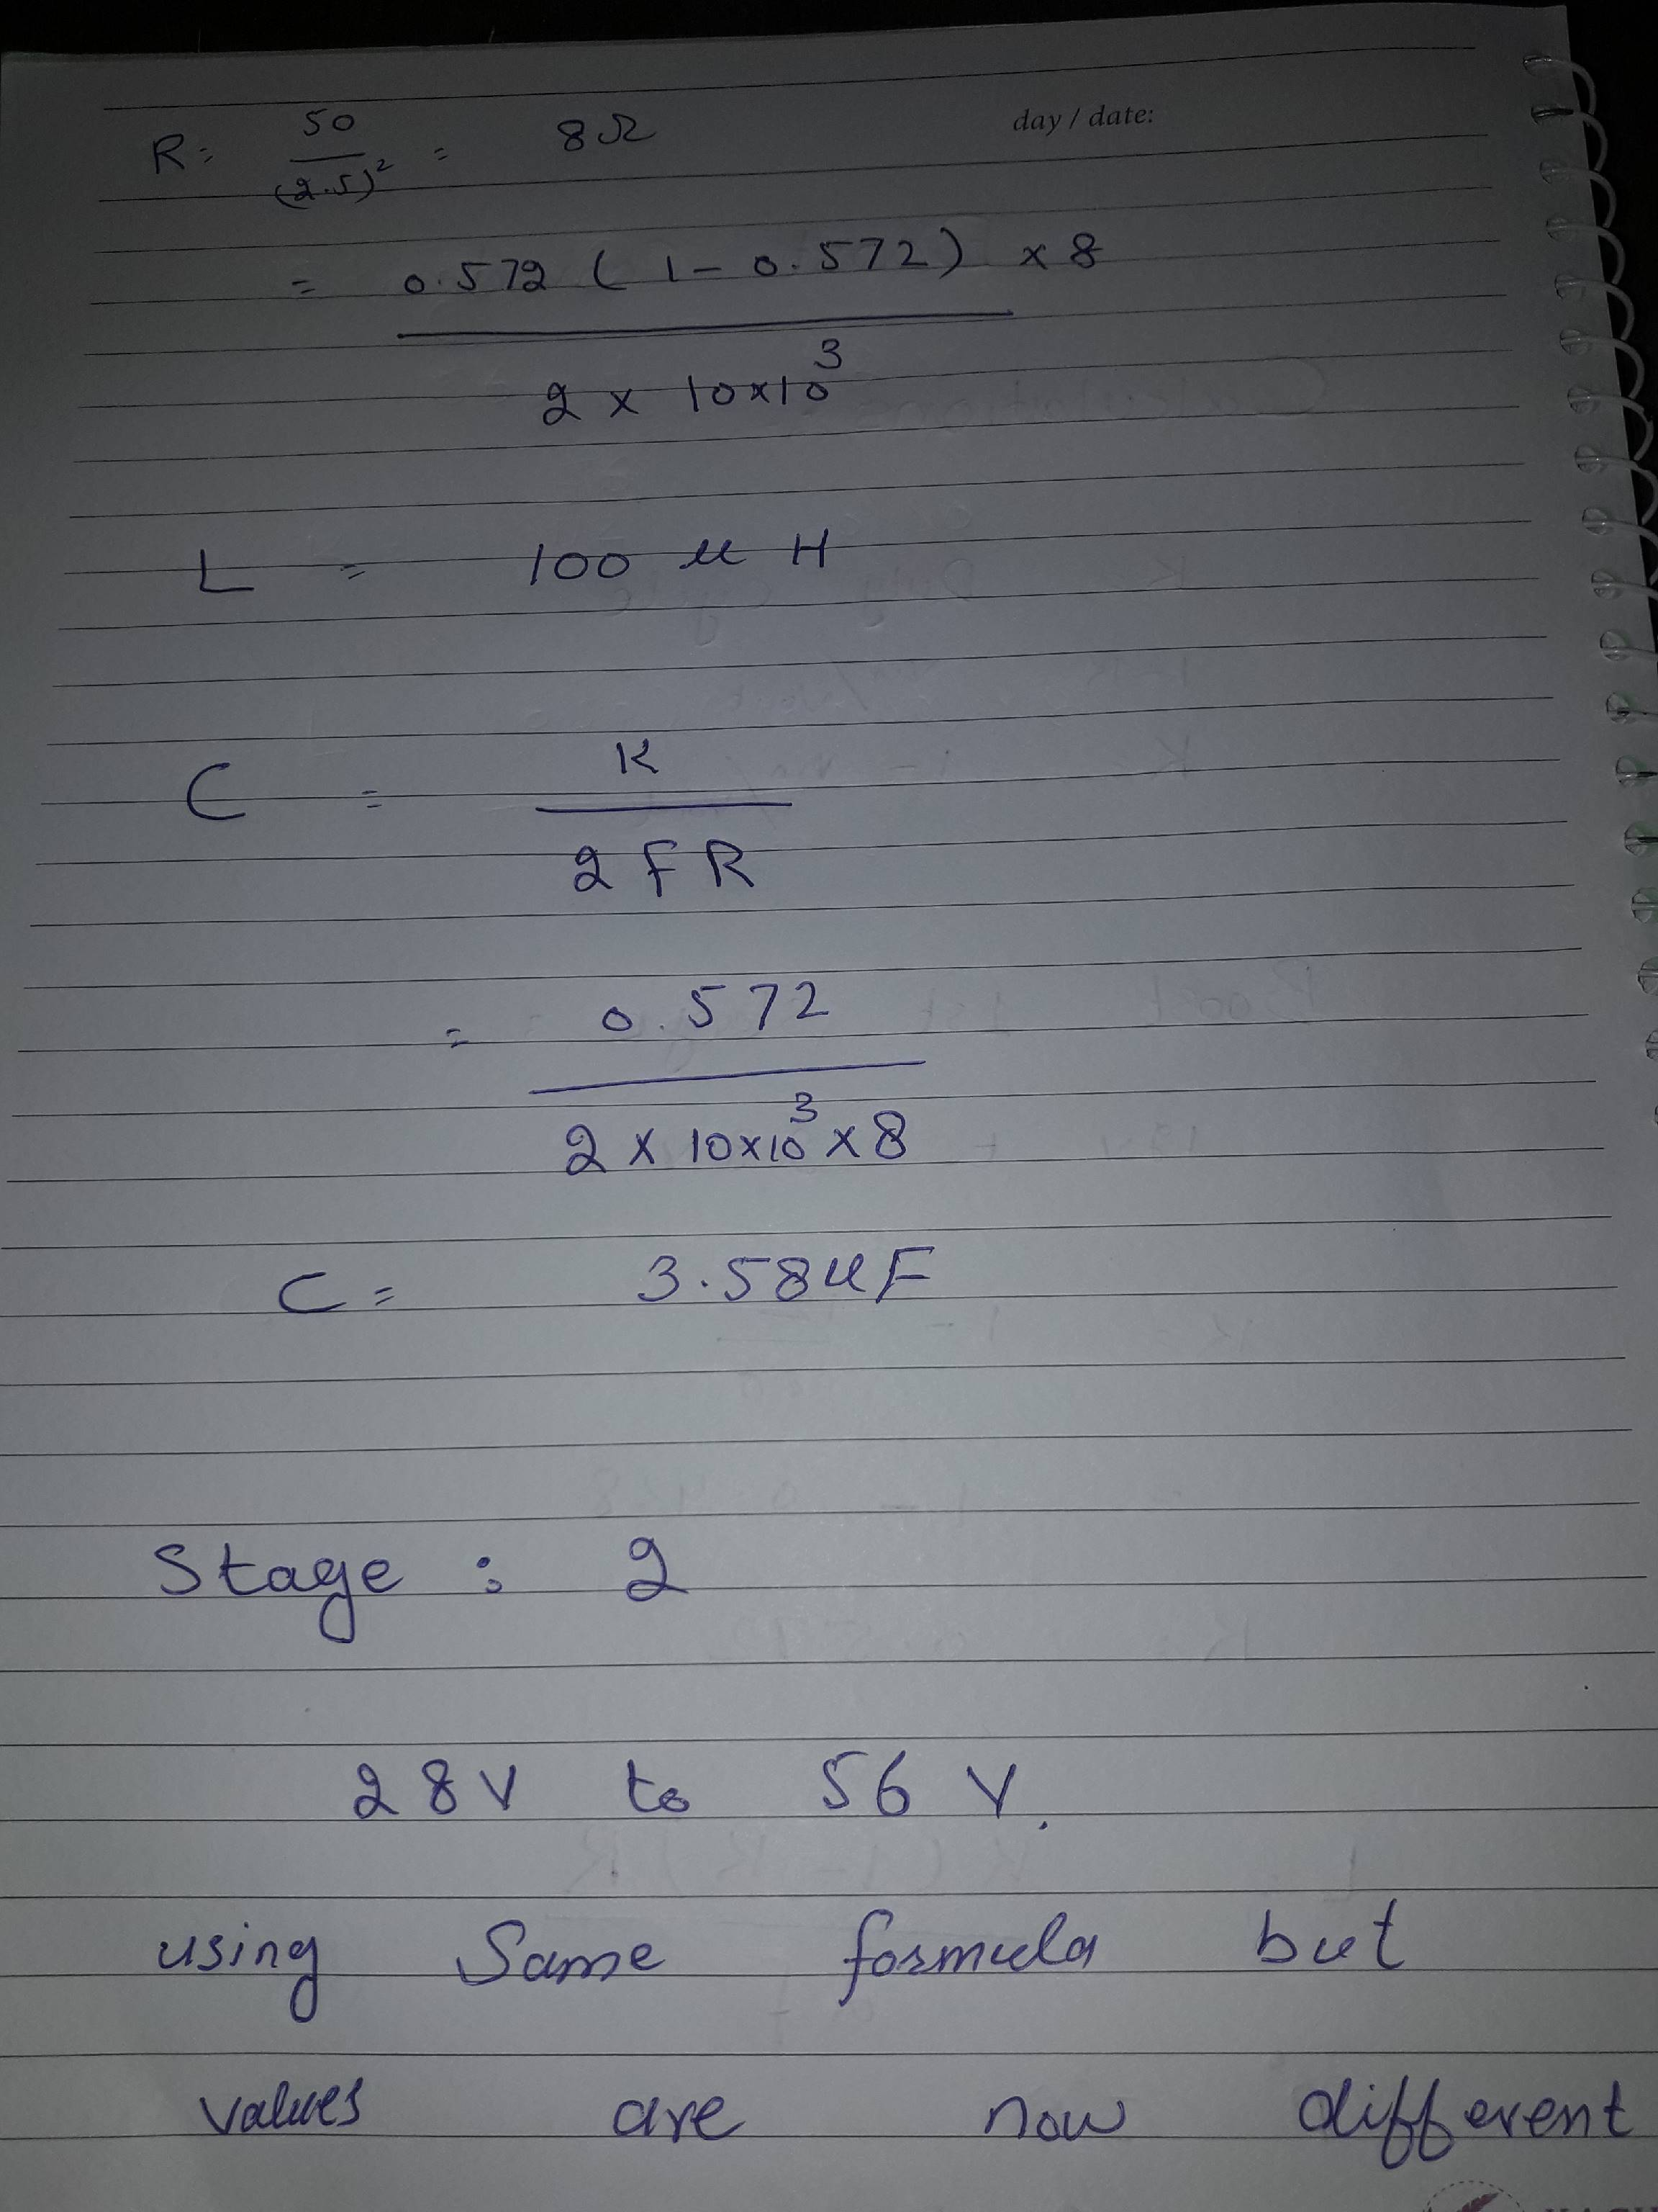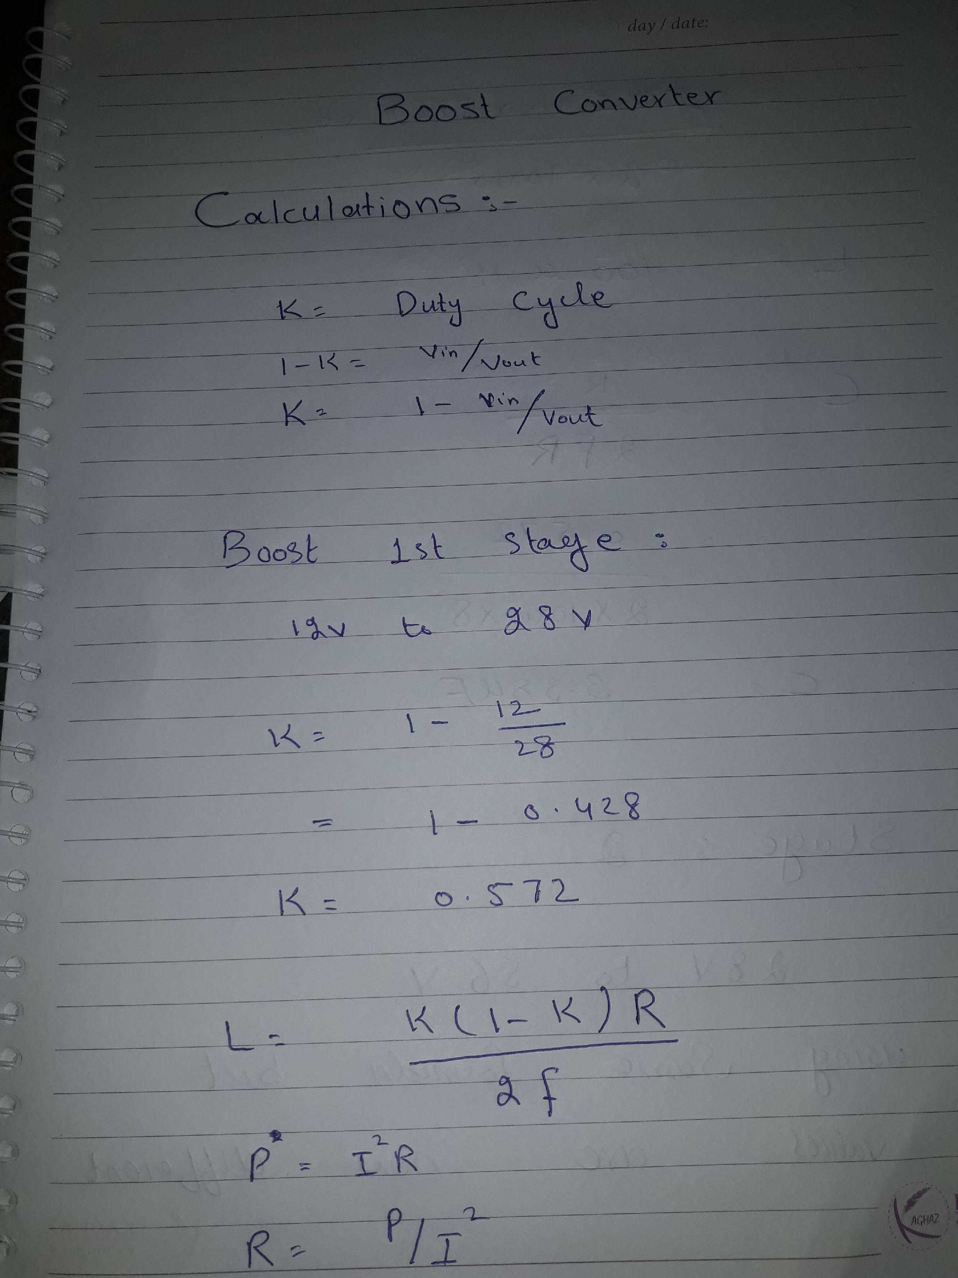

CHAPTER 9

References:
- www.ti.com/lit/an/slva535a/slva535a.pdf
- http://www.engr.colostate.edu/ECE562/98lectures/l09.pdf
- ieeexplore.ieee.org/xpls/abs_all.jsp?arnumber=7150983
- ieeexplore.ieee.org/xpls/abs_all.jsp?arnumber=1280706
- https://www.ccsinfo.com/downloads/ccs_c_manual.pdf
- http://tahmidmc.blogspot.com/2013/01/using-high-low-side-driver-ir2110-with.html
- ieeexplore.ieee.org/xpls/abs_all.jsp?arnumber=5730644
- ieeexplore.ieee.org/xpls/abs_all.jsp?arnumber=1581716

