Final Year Project Report
My Bus (A bus Tracking System)

Project Advisor:
MR ASAD RAZA USMANI
Submitted By:
ANEES MAHMOOD S2016266069
MUHAMMAD HAMZA ARSHAD S2016266072
MUHAMMAD TALHA KHAN S2016266067

Session
2016-2020

University of Management and Technology
C-II Johar Town Lahore Pakistan

Dedication
First of all we are thankful to ALLAH almighty who made us capable enough to make this kind of difficult product as a part of final year project, also we are thankful to our advisor Mr Asad Raza Usmani who supported us in our difficult tasks and made us to do everything better.

Final Approval

Panel of Examiners

- Head of Department ______________________
Department of Informatics and Systems
UMT Lahore

- Program Director ( Final Year Projects) ______________________
Department of Computer Science
UMT Lahore

- Supervisor ______________________
Department of Computer Science
UMT Lahore

- Co-Supervisor ______________________

Acknowledgment
Many efforts are undertaken for the completion of this project however, it would not have been possibly done without the support of my group members. I would like to express my special thanks of gratitude to my advisor Mr Asad Raza Usmani for his guidance and constant supervision as well as for providing the necessary information regarding the project and also for his support in completing the project.

Project Title My Bus (Bus Tracking System)
Objective Real time tracking of buses and the elistimated time will be shown on
The screen and alarm will be rang when the bus is near about the
Stop.The elistimated distance of the bus from the stop will be shown
On screen.
Undertaken by ANEES MAHMOOD S2016266069
MUHAMMAD HAMZA S2016266072
MUHAMMAD TALHA S2016266067
Supervised by
MR ASAD RAZA USMANI
Starting Date

Completion Date

Tools Used Android Studio, Firebase
Operating System Android
Documentation

Abstract
This project is aim to introduce a bus tracking system for UMT students so that the students who are using UMT transport facility can see the elistimated time and distance of the bus from the stop. We can provide the faicilty to the students that they can set alarm 5-10mints (or as they want) before the arrival of their bus on the stop.If the bus is not moving due to any fault or due to traffic a notification will be appear for the respective students after some time so that they can arrange any other transpotaion according to their schedule.

Contents
.
Contents 13
Definitions and Acronyms 55
List of Tables 15
1. Introduction 1
1.1 Motivations 1
1.2 Project Overview 1
1.3 Problem Statement 1
1.4 Objectives 1
2. Domain Analysis 2
2.1 Customer 2
2.2 Stakeholders 2
2.3 Affected Groups with social or economic impact 2
2.4 Dependencies/ External Systems 2
2.5 Reference Documents 2
2.5.1 Related Projects 2
2.5.2 Feature Comparison 2
3. Requirements analysis 4
3.1 Requirements 4
3.2 List of Actors 8
3.3 List of use cases 9
3.4 System use case diagram 10
3.5 Extended use cases 11
3.6 User interfaces (mock screens) 23
4. Data flow diagram (optional) .
4.1 Data Flow Diagram Level 0 25
4.2 Data Flow Diagram Level 1 25
4.3 Data Flow Diagram Level 2 26
5. System Design 27
5.1 System Architecture Diagram 27
5.2 Class Diagram 28
5.3 Collaboration Diagrams 29
5.4 Other UMLs 32
5.5 ERD 33
5.6 Data Dictionary 34
6. Implementation details 35
6.1 Development Setup 35
6.2 Deployment setup 35
6.3 Algorithms 35
6.4 Constraints 35
6.4.1 Assumptions 35
6.4.2 System constraints 35
6.4.3 Restrictions 36
6.4.4 Limitations 36
7. Testing 37
7.1 Extended Test Cases 37
7.2 Decision Table 41
7.2.1 Code snippet 41
7.2.2 Decision coverage table 45
7.3 Traceability Matrix 47
7.3.1 RID vs UCID (requirements vs use cases) 47
7.3.2 Prototypes (RID vs PID) 47
7.3.3 Test Cases (RID vs TID) 48
7.3.4 Coverage (UCID vs TID) 49
8. Results/Output/Statistics 50
8.1 %completion 50
8.2 %accuracy 50
8.3 %correctness 50
9. Conclusion 51
10. Future work 52
11. Bibliography 53
11.1 Books 53
11.3 Articles 53
11.5 Other References 53
12. Appendix 54
12.1 Glossary of terms 54
12.2 Pre-requisites 56

List of Tables
Table 1: table of acronyms and definitions 55
Table 2: feature comparison 9
Table 3: Functional requirement 10
Table 4: NFR-1 11
Table 5: NFR-2 11
Table 6: NFR-3 11
Table 7: NFR-4 11
Table 8: NFR-5 11
Table 9: NFR-6 11
Table 10: NFR-7 12
Table 11: NFR-8 12
Table 12: NFR-9 12
Table 13: NFR-10 12
Table 14: NFR-11 12
Table 15: NFR-12 12
Table 16:Register 14
Table 17: LOGIN 15

Introduction

Motivations
A mobile phone and mobile app playing an important role in our daily life .Everyone has a busy schedule and, they don’t have time to extra wait for their transportation. Many of our friends who are using UMT transportation service they have to wait for the bus arrival, and some time they missed the classes due to late arrival of bus. Sometime the bus maybe not coming due to any fault or something else then this app can help them in a good way.
.

Project Overview
We are designing an android based app which can help UMT students to track their bus via GPS so that they can see the time of bus arrival and the estimated distance of the bus from their stop.
- Students faced problem of late arrival of the buses
- UMT will be the customer in this project
- The goal is to develop an android based app that can facilitate students who are using UMT transportation service
- We will use GPS that will provide real time tracking of bus.
- Alarm will be rang before arrival of bus

Problem Statement
There is a big problem in countries like Pakistan that if any female student is waiting for the bus there will usually her brother or father with her for dropping her. If the bus is late her brother or father is also late but from this system if the estimated time of arrival is shown on the screen the problem can be reduced. Sometimes the bus is late or early due to the traffic flow so students can see the time of arrival and if the bus is near to the stop the alarm will be rang. Students can set the alarm time 5-10mins before arrival of their bus on bus stop.

Objectives
The objective of our system is to provide ease to the students of UMT who are using bus transportation service they can easily see the routes of all buses and can set their route according to their location. They can save their time by using this app as there is an alarm/notification they can easily see the bus on the map as they can adjust their time accordingly. After that we will extend our project outside the UMT and we will give our proposal to other bus services like speedo.

Domain Analysis

Customer
Customers are the backbone of any company our main customer is UMT. We will extend our project for different transportation companies in future.

Stakeholders
Stakeholder | Role in System
Deployment Team | They are responsible for all the installation, maintenance, and upgradation of the Application. They are also responsible for resolving every query in the app.
Admin | An admin is a specific person that can create route, Delete route, Edit route, Add bus or Delete bus. It keeps all the specified and unspecified access.
User | A user can create account, update profile, view route, set alarm set destination and gives feedback.
UMT | UMT is our main customer. We will build this app for the students of UMT who are using university bus transportation system.

Affected Groups with social or economic impact
When we will upload this app on play store it will definitely make a good impact on the students of UMT who are using UMT bus transportation service because it is a unique idea.

Dependencies/ External Systems

Reference Documents
Our project has some features which is used by some other services like UBER and CREEM.

Related Projects
To develop my Bus app we took help from some similar projects in play store.
- UBER
- CAREEM
- BAYKEA

Feature Comparison

Table 3: Feature comparison
Sr No. | Comparison Feature | UBER | CAREEM | BYKEA | Remarks
1 | Map Integration | Most of the range tasks ae covered | Most of the range tasks ae covered | Most of the range tasks ae covered | We will improve the system by specifying Buses by adding more feature.
2 | Route Selection Specification | Bus Routes Is Not Given | Do not allow this feature | Do not allow this feature | We will improve Create, view, modify feature
3 | Promotion Messages | No Textual Conversation | No Textual Conversation | No Textual Conversation | We will provide this feature.in future
4 | Android based system | Does come in android | Comes in android | Android setup | We will add android based functionalities.

Requirements analysis

Requirements
- Admin
Table 1 Admin (Functonal Requirements)
Requirement ID | Requirement Statement | Must/Want | Comments
FR1-01 | The application shall provide the access to admin for register or authenticate users. | Wish | Authenticate and check users.
FR1-02 | The application shall provide an authority or access to admin to activate or deactivate the user account. | Wish | Activate or Deactivate the accounts upon usage rules.
FR1-03 | The application shall provide an interface to edit routes | Must | Admin has an access to edit route
FR1-04 | The application shall provide an interface to both users to contact admin about their queries through feedback | Wish/must | Contact admin in case of any queries
FR1-05 | The application shall provide an access to admin to suspend routes | Must | .Admin has an option to delete route.
FR1-06 | The application shall provide an interface to admin to add new routes | Must | Admin has a + option to add routes.

- Student
Table 2 Student(Functional Requirements)
Requirement ID | Requirement Statement | Must/Want | Comments
FR2-01 | The application shall provide an interface of login/logout, signup and forgot password for users. | Must | User registered by username/email and signup with username/email and password.
FR2-02 | The application shall provide an interface select routes. | Must | All the route are shown in select route option.
FR2-03 | The application shall provide an interface to set alarm | Must | Alarm Set For Route Check
FR2-04 | The application shall provide an access or interface to set destination | Must | User set up the destination after selecting route.
FR2-05 | Maps Will be integrated to student side activities.. | Must | Student shown their selected route tracking on their screen.
FR2-06 | The Student shall also view routes after selection | Must | Student will select his route from view route option.
FR2-07 | The application shall provide an authority to students to track bus activity real time.. | Must | Tracking method allow user to Track through map and GPS.
FR2-08 | The application shall provide a box for feedback | WISH | Chat Console to send and receive messages.

Table 1 (NFR-1)
NFR-1 | Application Accessibility
NFR-1-01 | The application ‘s database should be centralized and accessible from any location in the world.
Table 2 (NFR-2)
NFR-2 | Storage Capacity
NFR-2-01 | Initially the application will not require a big storage capacity. With the increment of users we will use multiple servers to divide the workload.
Table 3 (NFR-3)
NFR-3 | Documentation
NFR-3-01 | The application’s documentation will cover all the functionality of the application and will include the complete user manual.
Table 4 (NFR-4)
NFR-4 | Disaster Recovery
NFR-4-01 | There will be a backup of the application’s data to avoid any data loss in case of any mishap.

Table 5 (NFR-5)
NFR-5 | Efficiency
NFR-5-01 | The application shall be efficient and will not take extra load time and provide fast functionality. Its database will in such a way that It will quickly access data from the database.
Table 6 (NFR-6)
NFR-6 | Extensibility
NFR-6-01 | The application will be designed in such a way that it will be flexible so we can easily extend our functionality by adding additional features.
Table 7 (NFR-7)
NFR-7 | Interoperability
NFR-7-01 | Initially the application shall be operated in Android but in future its web and iOS version will also be developed.
Table 8 (NFR-8)
NFR-8 | Availability
NFR-8-01 | The application shall be available 24/7.
Table 9(NFR-9)
NFR-9 | Maintainability
NFR-9-01 | The maintenance of the application shall be easy.

Table 10 (NFR-10)
NFR-10 | Compatibility
NFR-10-01 | The application shall be compatible with devices like PCs, Laptops, Smart Phones

Table 11 (NFR 11)
NFR-11 | Privacy
NFR-11-01 | The application shall provide maximum privacy to the user data and will protect user’s information from data theft.
Table 12 (NFR-12)
NFR-12 | Portability
NFR-12-01 | The application can be open on any Mobile.

List of Actors
The List of Actor Are Mentioned Below:
- Admin
- User/Student
Admin:
Admin has a Hard-coded access to the authoritative functionalities of this Project based on Android Based Application. Admin can change the basic User Functionalities to be able to delete route or User from the interface.
User/Student:
User Group of this android Application based project is simply based on UMT students as per identified as base users on initial stages of this Application. On Future Endeavors MyBus will cover most of Universities in Manageable Premises.

List of use cases

The List Of Use cases Along with Actors Are given Below:
Actors:
- Admin
- Student/User
- Sign Up

- Login

Login for Admin and Students
- Route Selection

- Bus Tracking

- Alarm Set
Alarm Set By Student for Bus Arrival Estimation
- Destination Set

- Set Pickup

- Set ETA

- Feedback

- Route Editing

Admin Authority to Edit Delete or Update the Route Entered By Students
- Deletion Route

3.4 System use case diagram

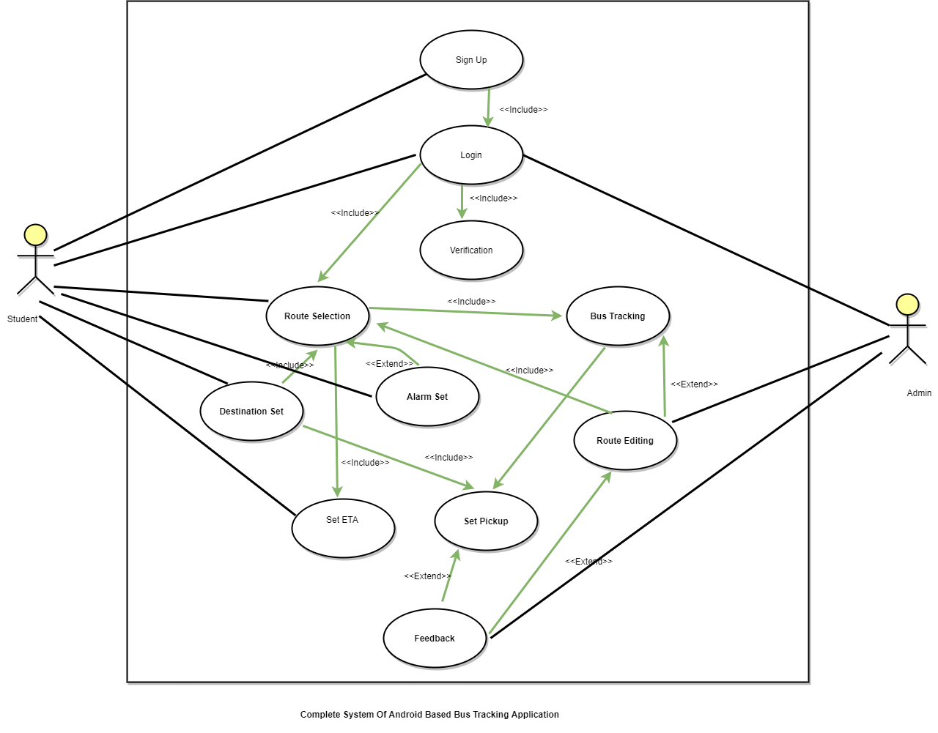
Figure 1: Use Case Diagram

Extended use case
Sign-up:
Use Case ID: | UC01
Use Case Name: | Signup
Created By: | Anees |  | Last Updated By: | Anees
Date Created: | 123 |  | Last Revision Date: | 122
Actors: |  | User
Description: |  | User can create account by giving information here
Trigger: |  | User tap on Signup
Preconditions: |  | User must have valid email address
Post conditions: |  | User can access the all features
Normal Flow: |  | - Open app  - Tap Signup  - Add Email  - add password  - Registration success
Alternative Flows:  [Alternative Flow 1 – Not in Network] |  | - Open app  - Tap Signup  - Add email  - Add password  - Login error or user is not valid  - Tap sign up  - Repeat 1-4  - Signup success
Exceptions: |  | Nil
Includes: |  | N/A
Frequency of Use: |  | Whenever user interacts the app for first time
Special Requirements: |  | No
Assumptions: |  | Nil
Notes and Issues: |  | Nil

Sign -in:
Use Case ID: | UC02
Use Case Name: | Sign-in
Created By: | Anees |  | Last Updated By: | Anees
Date Created: | 123 |  | Last Revision Date: | 122
Actors: |  | User
Description: |  | User can create account by giving information here
Trigger: |  | User tap on Sign-in
Preconditions: |  | User must have valid email address
Post conditions: |  | User can access the all features
Normal Flow: |  | - Open app  - Tap Sign-in  - Add Email  - add password
Alternative Flows:  [Alternative Flow 1 – Not in Network] |  | - Open app  - Tap Sign-in  - Add email  - Add password  - Login error or user is not valid  - Tap sign in  - Repeat 1-4  - Verifying credentials
Exceptions: |  | Nil
Includes: |  | N/A
Frequency of Use: |  | Whenever user interacts the app for sign-in.
Special Requirements: |  | No
Assumptions: |  | Nil
Notes and Issues: |  | Nil

View routes :
Use Case ID: | UC03
Use Case Name: | View Routes
Created By: | Anees |  | Last Updated By: | Anees
Date Created: | 123 |  | Last Revision Date: | 123
Actors: |  | User, Admin
Description: |  | User can see all routes of bus  Route Number  Bus Number  All Stopes  Timings Of Buses
Trigger: |  | When user or Admin wants to see the routes
Preconditions: |  | - User is Valid  - User wants to see the routes
Post conditions: |  | - User see the routes  - User see the timetable
Normal Flow: |  | - Login  - User tap the options  - Option list appears  - User tap the View Routes  - Routes appears
Alternative Flows:  [Alternative Flow 1 – Not in Network] |  | Nil
Exceptions: |  | N/A
Includes: |  | Login
Frequency of Use: |  | At the start it will be frequent after some time when the user will be familiar with the routes the use rate will be low
Special Requirements: |  | No
Assumptions: |  | User Is Valid
Notes and Issues: |  | NO

Track Bus:
Use Case ID: | UC04
Use Case Name: | Track Bus
Created By: | Anees |  | Last Updated By: | Anees
Date Created: | 123 |  | Last Revision Date: | 123
Actors: |  | User , Admin
Description: |  | User can track the bus see the route of bus
Trigger: |  | When user tap the track bus
Preconditions: |  | - User must be registered
Post conditions: |  | - user can see the bus location  - user can see the distance
Normal Flow: |  | - User login  - User tap track bus  - User see the bus status  - End
Alternative Flows:  [Alternative Flow 1 – Not in Network] |  | - User login  - User tap track bus  - User wants to change the route  - User change the bus route  - User sees the new bus route  - End
Exceptions: |  | NILL
Includes: |  | Login
Frequency of Use: |  | Every time when the user wants to track the bus
Special Requirements: |  | NILL
Assumptions: |  | User is registered
Notes and Issues: |  | NILL

Set Alarm:
Use Case ID: | UC05
Use Case Name: | Set Alarm
Created By: | Anees |  | Last Updated By: | Anees
Date Created: | 123 |  | Last Revision Date: | 123
Actors: |  | User
Description: |  | User can set the alarm for bus.  Its upon user, user can set the alarm time if he/she wants that when bus is almost 10min away from him/her the alarm rings up.
Trigger: |  | User wants to set an alarm
Preconditions: |  | - User is valid  - User is login
Post conditions: |  | - Alarm will be rung upon the user request
Normal Flow: |  | - Login  - Go to settings  - Alarm settings  - Time Set  - Success
Alternative Flows:  [Alternative Flow 1 – Not in Network] |  | No
Exceptions: |  | No
Includes: |  | Login
Frequency of Use: |  | Whenever user wants
Special Requirements: |  | No
Assumptions: |  | User is valid
Notes and Issues: |  | Nil

Set Pickup:
Use Case ID: | UC06
Use Case Name: | Set Pickup
Created By: | Anees |  | Last Updated By: | Anees
Date Created: | 123 |  | Last Revision Date: | 123
Actors: |  | User
Description: |  | User can set Pickup
Trigger: |  | When user tap to set destination.  Once user select the destination it will be saved in database however user can change the destination any time
Preconditions: |  | User is valid
Post conditions: |  | 1 User set his/her pickup point  - Bud came and pickup  - Reached at UMT
Normal Flow: |  | - Login  - Set pickup  - Pickup point saved
Alternative Flows:  [Alternative Flow 1 – Not in Network] |  | No
Exceptions: |  | If set pickup is not appearing because you have already set the pickup point and it will be saved in database and you want to change pickup point there will be change pickup point appearing you can change the pickup point
Includes: |  | Nil
Frequency of Use: |  | When user installed the app he needs to set the point once.  However user can change the point anytime
Special Requirements: |  | No
Assumptions: |  | User is Valid
Notes and Issues: |  | Nil

See ETA:
Use Case ID: | UC07
Use Case Name: | See ETA
Created By: | Anees |  | Last Updated By: | Anees
Date Created: | 123 |  | Last Revision Date: | 123
Actors: |  | User
Description: |  | User can see the estimated time/Distance of arrival of bus
Trigger: |  | The real time tracking will be done and shown on the main interface
Preconditions: |  | - User is login  - User set the pickup point
Post conditions: |  | - User see the Distance  - User see the time
Normal Flow: |  | - Login  - Set pickup (Just once)  - Time and distance will be shown
Alternative Flows:  [Alternative Flow 1 – Not in Network] |  | Nil
Exceptions: |  | Will not show if no bus is on the route
Includes: |  | N/A
Frequency of Use: |  | Every time when user is using the app and waiting for bus
Special Requirements: |  | NO
Assumptions: |  | User is Valid
Notes and Issues: |  | Nil

Feedback:
Use Case ID: | UC08
Use Case Name: | Feedback
Created By: | Anees |  | Last Updated By: | Anees
Date Created: | 123 |  | Last Revision Date: | 123
Actors: |  | User , Admin
Description: |  | User can give feedback here, admin can see all the feedbacks
Trigger: |  | When user tap on feedback
Preconditions: |  | - User must be registered
Post conditions: |  | - user can share his/her experience  - user can register complain
Normal Flow: |  | - User login  - User tap feedback  - User fill the feedback form  - User submits the feedback  - Feedback submitted
Alternative Flows:  [Alternative Flow 1 – Not in Network] |  | N/A
Exceptions: |  | NILL
Includes: |  | N/A
Frequency of Use: |  | Every time when the user wants to complain/feedback
Special Requirements: |  | NILL
Assumptions: |  | User is registered
Notes and Issues: |  | Nil

Add route:
Use Case ID: | UC09
Use Case Name: | Add Route
Created By: | Anees |  | Last Updated By: | Anees
Date Created: | 123 |  | Last Revision Date: | 123
Actors: |  | Admin
Description: |  | Admin can add new routes.  The new routes can only be added by admin.
Trigger: |  | When new route is needed to be added
Preconditions: |  | When a new route is required
Post conditions: |  | A new route is added  User can see the new route
Normal Flow: |  | - Admin Login  - Go to settings  - Route settings  - Add New Route  - Enter details of new route  - Submit details  - New Route added
Alternative Flows:  [Alternative Flow 1 – Not in Network] |  | No
Exceptions: |  | No
Includes:
Frequency of Use: |  | Whenever new a new route is required
Special Requirements: |  | No
Assumptions: |  | Admin in valid
Notes and Issues: |  | Nil

Set Destination:
Use Case ID: | UC10
Use Case Name: | Set Destination
Created By: | Anees |  | Last Updated By: | Anees
Date Created: | 123 |  | Last Revision Date: | 123
Actors: |  | User
Description: |  | User can set Destination
Trigger: |  | When user tap to set destination.  Once user select the destination it will be saved in database however user can change the destination any time
Preconditions: |  | User is valid
Post conditions: |  | 1 User set his/her destination point  - Bus pick up the user  - Reached at Destination
Normal Flow: |  | - Login  - Set destination  - Destination point saved
Alternative Flows:  [Alternative Flow 1 – Not in Network] |  | No
Exceptions: |  | If set destination is not appearing because you have already set the destination point and it will be saved in database and you want to change destination point there will be change destination point appearing you can change the destination point
Includes: |  | Nil
Frequency of Use: |  | When user installed the app he needs to set the point once.  However user can change the point anytime
Special Requirements: |  | No
Assumptions: |  | User is Valid
Notes and Issues: |  | Nil

Delete Route:
Use Case ID: | UC11
Use Case Name: | Delete Route
Created By: | Anees |  | Last Updated By: | Anees
Date Created: | 123 |  | Last Revision Date: | 123
Actors: |  | Admin
Description: |  | Admin can delete routes.  The routes can be deleted only by admin.
Trigger: |  | When Admin taps delete route
Preconditions: |  | When route is needed to be deleted
Post conditions: |  | The route is deleted  User can’t see the route.
Normal Flow: |  | - Admin Login  - Go to settings  - Route settings  - Tap Delete Route  - Select route to be deleted  - Delete confirm  - Route deleted
Alternative Flows:  [Alternative Flow 1 – Not in Network] |  | No
Exceptions: |  | No
Includes:
Frequency of Use: |  | Whenever removal of route is required
Special Requirements: |  | No
Assumptions: |  | Admin in valid
Notes and Issues: |  | Nil

Edit Route:
Use Case ID: | UC12
Use Case Name: | Edit Route
Created By: | Anees |  | Last Updated By: | Anees
Date Created: | 123 |  | Last Revision Date: | 123
Actors: |  | Admin
Description: |  | Admin can edit routes.  The routes can be edited only by admin.
Trigger: |  | When Admin taps edit route
Preconditions: |  | When route is needed to be edited
Post conditions: |  | The route is edited  User can see the new version of route.
Normal Flow: |  | - Admin Login  - Go to settings  - Route settings  - Tap Edit Route  - Select route to be edited  - Edit the information  - Edit confirm  - Route edited
Alternative Flows:  [Alternative Flow 1 – Not in Network] |  | No
Exceptions: |  | No
Includes:
Frequency of Use: |  | Whenever editing of route is required
Special Requirements: |  | No
Assumptions: |  | Admin in valid
Notes and Issues: |  | Nil

User interfaces (mock screens)
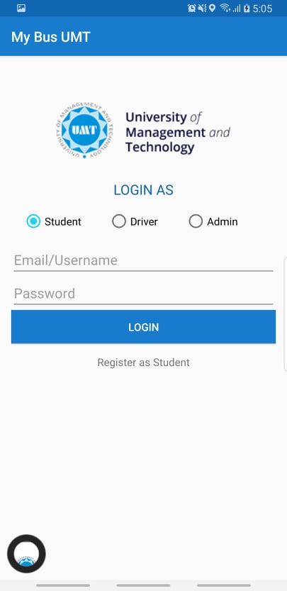


Figure 1: Splash Screen Figure 2: Login Screen
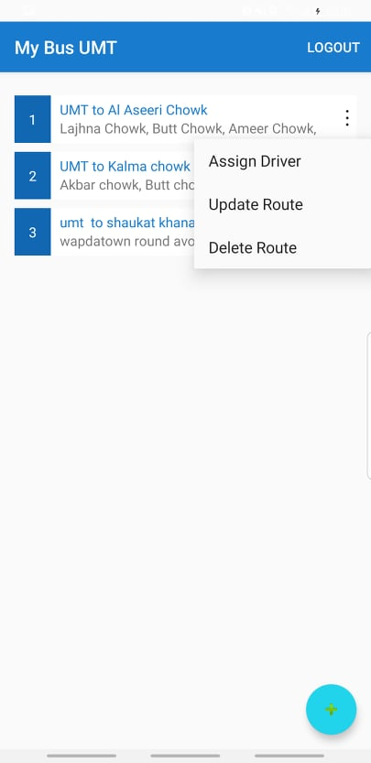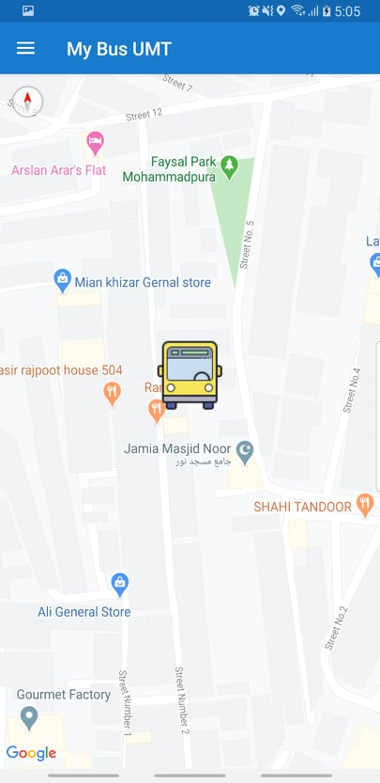

Figure 3: Admin Panel Figure 4: Tracking Screen

System Design

Data Flow Diagram Level 0

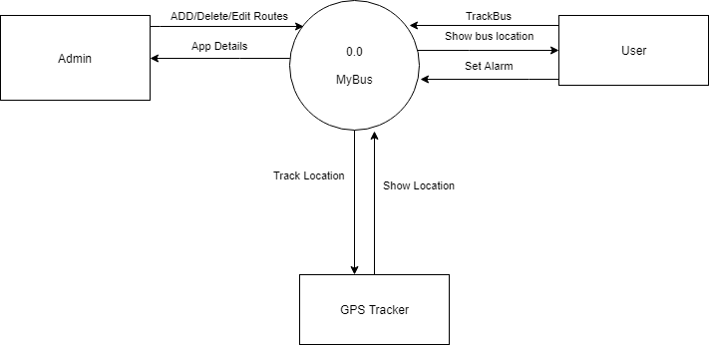

Data Flow Diagram Level 1

Data Flow Diagram Level 2

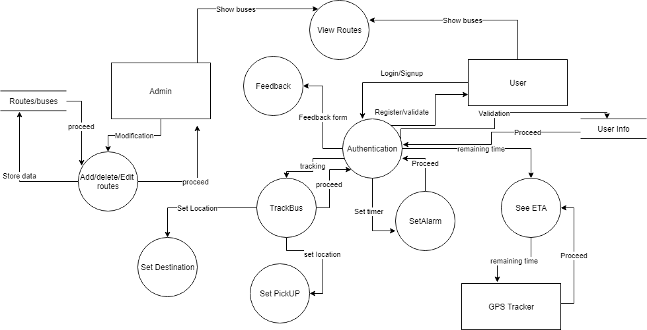

System Design

System Architecture Diagram
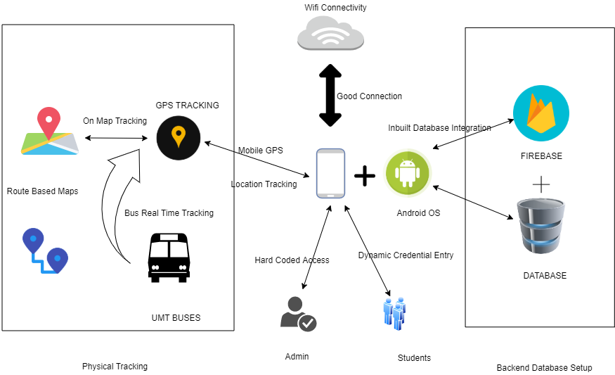
Figure 1: System Architecture

Class Diagram

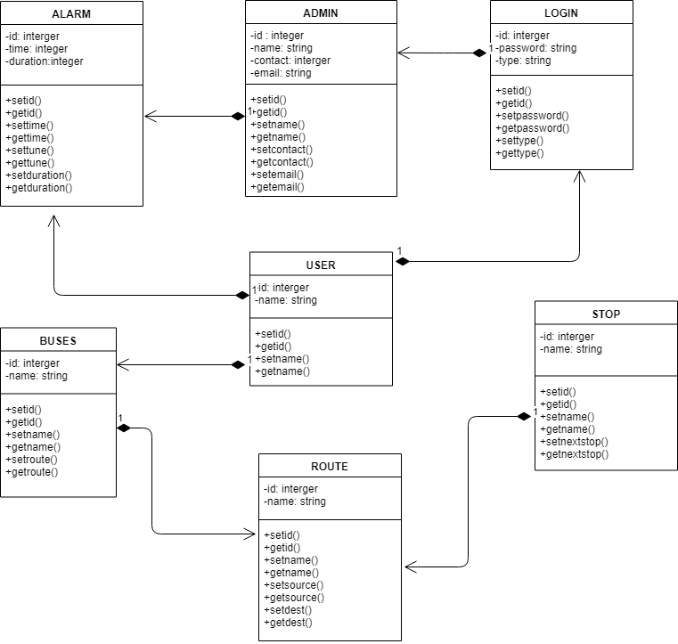

Sequence Diagrams

Track Bus

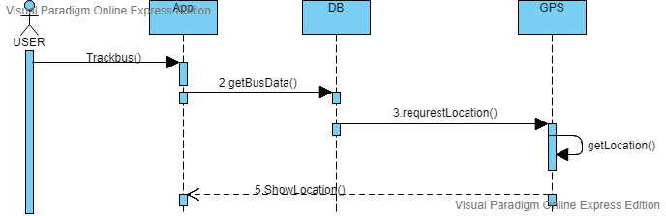
Fig1: Sequence diagram of bus tracking.
Sign-up

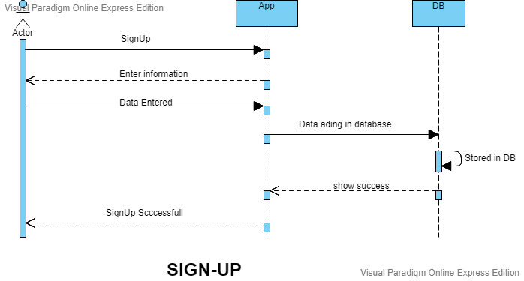

Fig 2: User registration process

Sign In
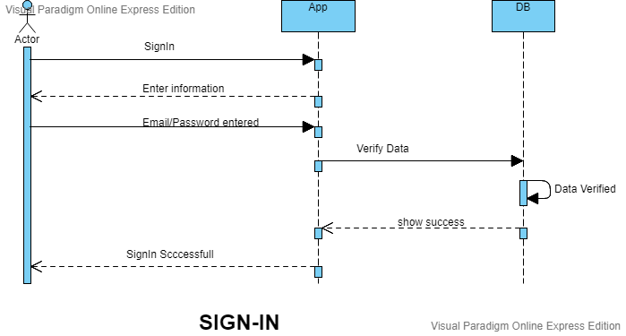
Fig 3: User Sign-in process

Set Alarm
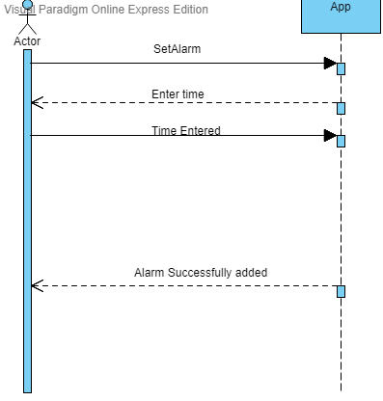
Fig 4: User Alarm requirements

Collaboration Diagrams

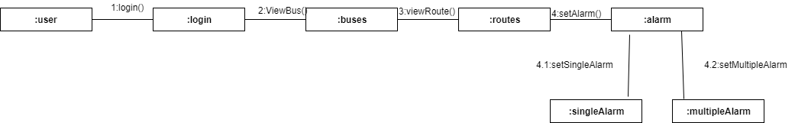

Other UMLs
Activity Diagram:
Login:
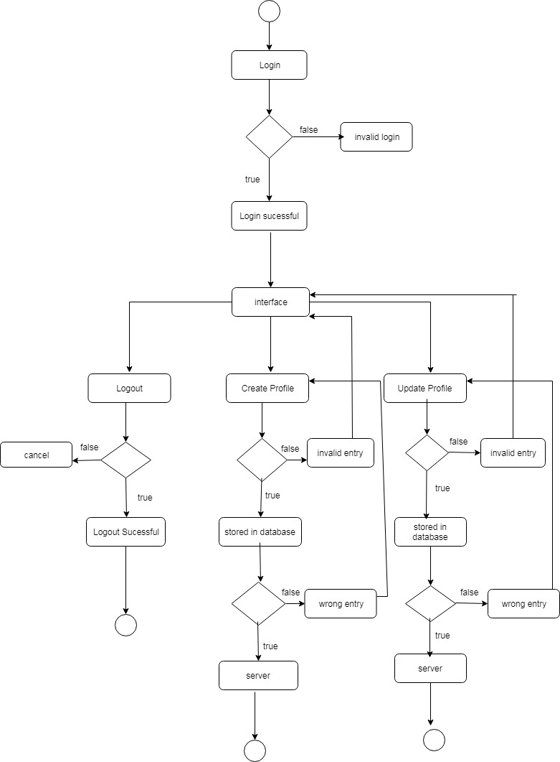

ERD
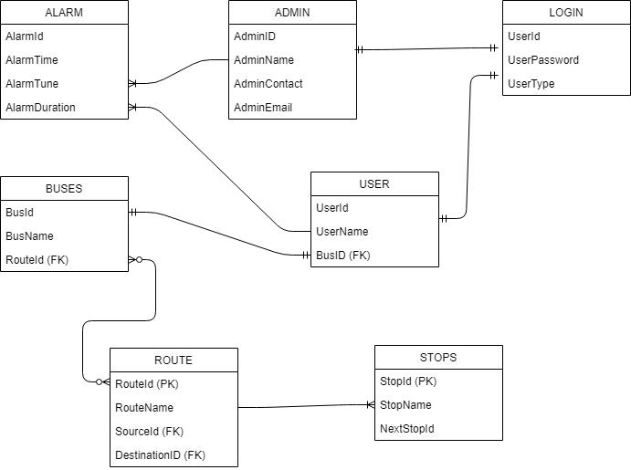

Data Dictionary
In data dictionary we describe which type of data we use in the system.

    - Participant detail:

The participant data dictionary is defined below.

Table 16: Participant detail data dictionary

Name | Type | Size | Description
Participant ID | Integer | 10 | ID of participant
Password | Varchar | 30 | Password of participant
Participant type | varchar | 20 | Admin , Participant
Register date | Date | 10 | Signup date
Phone No | integer | 20 | Contact No. of participant

Implementation details

Development Setup
- Android Studio:
Android Studio is the main tool that we use to build our APP.
- Firebase:
We use firebase in our android app as a database. Firebase stores real time tracking of buses in our app. Firebase stores the data of registered user and routes etc.
- Google Map API:
We use Google Map API for the tracking of buses, to get the location of student and their pickup and drop-off points.

Deployment setup
The app was installed on moderate mobile with android OS . Main Problems Faced are mentioned below:
- Map Integration
- Fragment handling
- Authentication
These problems were solved through repetitive testing.

Algorithms

Constraints

Assumptions
Before the main integration we assume the following things:
- Every user has the basic knowledge of running an app.
- The main area that are targeted are near to UMT..
- Every person has an android mobile.
- Internet Connectivity is Optimized

System constraints
Constraints in the project are
- Multiple payment methods
- Foreigner usage of mobile,
- Multilanguage chat
- Single Language Chat
- Runtime Feedback
- Uberize Structure
- Multi University Bus Tracking

Restrictions
Some Of the Main Restrictions are given below:
- Route Editing is not Availed To Students
- Not Randomize Access

Limitations

The system has some of the following limitations:
- Initially it is not build for large databases
- It is not on IOS Systems and have less integrations of the tracking.
- Multi Domain Bus Tracking
- Multi Language Integration.

Testing

Extended Test Cases

TC1
Description: Admin Authentication
Pre-Conditions: User should have valid username / password.
Post-Condition: Main Interface page should be shown on application after signed in.

Step | Action/ Click | Expected Response | Pass / Fail
1 | Enter/Launch URL | Application should open. | Pass
2 | Enter valid username and password | Username and password are entered in their respective fields. Password characters are hidden as dots. | Pass
3 | Login/password invalid | Show error: Please enter valid username/password | Pass
4 | Click / Enter Sign in button | The user is signed in and main page or home page should open. | Pass
Table 1: Test Case 7.1.1

TC2
Description: User Authentication
Pre-Conditions: User should have valid username / password.
Post-Condition: Main Interface page should be shown on application after signed in.

Step | Action/ Click | Expected Response | Pass / Fail
1 | Enter/Launch URL | Application should open. Showing Login as Student. | Pass
2 | Enter valid username and password | Username and password are entered in their respective fields. Password characters are hidden as dots. | Pass
3 | Login/password invalid | Show error: Please enter valid username/password | Pass
4 | Click / Enter Sign in button | The user is signed in and main page or home page should open. | Pass
Table 1: Test Case 7.1.2

TC3
Description: View Routes
Pre-Conditions: User should be on main Activity
Post-Condition: An Interface should be shown containing general maps provided by the selected Google API that have signed in

Step | Action/ Click | Expected Response | Pass / Fail
1 | Click Maps To View Routes | Interface will be shown displaying routes | Pass
2 | No route available | No route found than blank screen would be shown. Should contain back button to go to main page. | Pass
Table 2: Test Case 7.1.3

TC4
Description: set Alarm
Pre-Conditions: User should be registered.
Post-Condition: The Alarm must be set shown

Step | Action/ Click | Expected Response | Pass / Fail
1 | Select the option to order booking | Open the interface for posting a new service | Pass
2 | Enter order category | A list of categories will be displayed | Pass
3 | Not matching any particular category | Show the option to choose “Others” as category | Pass
Table 3: Test Case 7.1.4

TC5
Description: Set Destination
Pre-Conditions: User should have valid self-information and supported mobile.
Post-Condition: Upon Route Selection The Destination Must Be Considered To Enter.

Step | Action/ Click | Expected Response | Pass / Fail
1 | Enter/Launch URL | Application should open. | Pass
2 | Enter valid username, password, email address and confirm password | Username and password are entered in their respective fields. Password characters are hidden as dots. While confirm password are also dotted | Pass
3 | Destination Selection Field | Show Destination Options | Pass
4 | Selected Destination View On Route | Destination Must.be viewed in Polaris of route | Pass
Table 1: Test Case 7.1.5

TC6
Description: Student Registration
Pre-Conditions: Student should have valid self-information and supported mobile.
Post-Condition: Sign in page should be shown on application after Registration.

Step | Action/ Click | Expected Response | Pass / Fail
1 | Enter/Launch URL | Application should open. | Pass
2 | Enter valid username, password, email address and confirm password | Username and password are entered in their respective fields. Password characters are hidden as dots. While confirm password are also dotted | Pass
3 | Click / Enter Sign up button | The user is registered and sign in page should open. | Pass
Table 1: Test Case 7.1.6

TC7
Description: Map Integration for Student
Pre-Conditions: Student should be on main Activity.
Post-Condition: An Interface should be shown containing general Map view provided by google Api for the user that have signed in

Step | Action/ Click | Expected Response | Pass / Fail
1 | First Hand Map View | Interface will be shown displaying user Location | Pass
2 | No View Selected | On No View Selection Map Will not show route | Pass
Table 2: Test Case 7.1.7

Decision Table

Code snippet
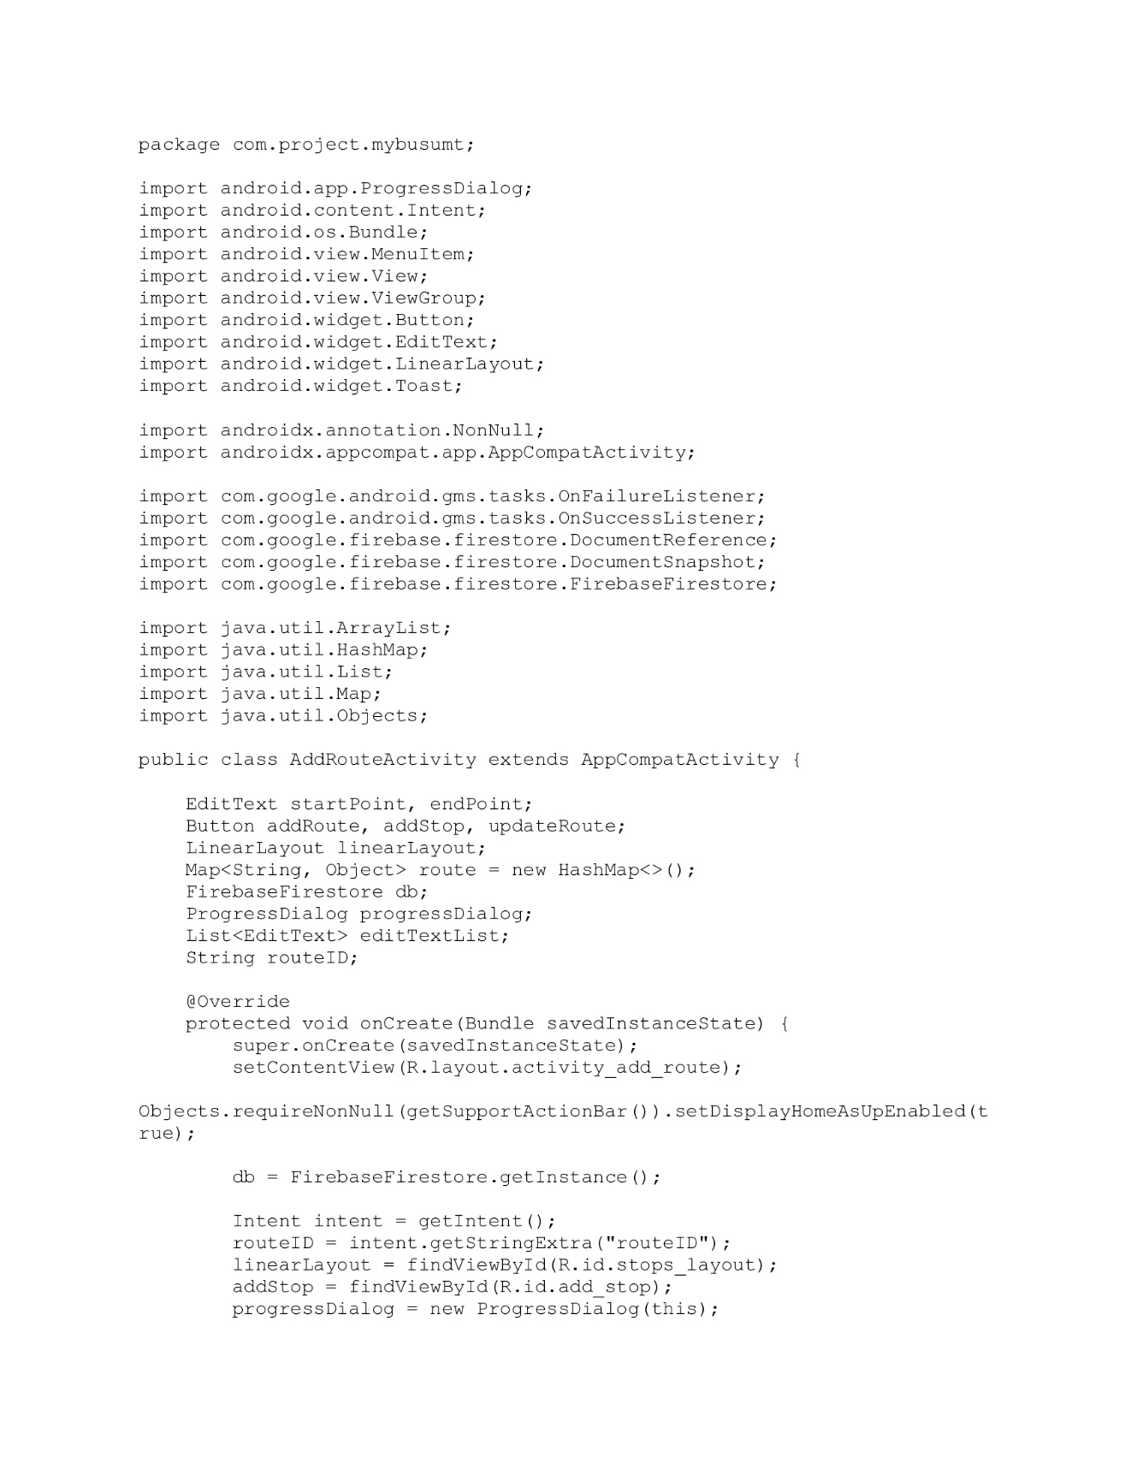
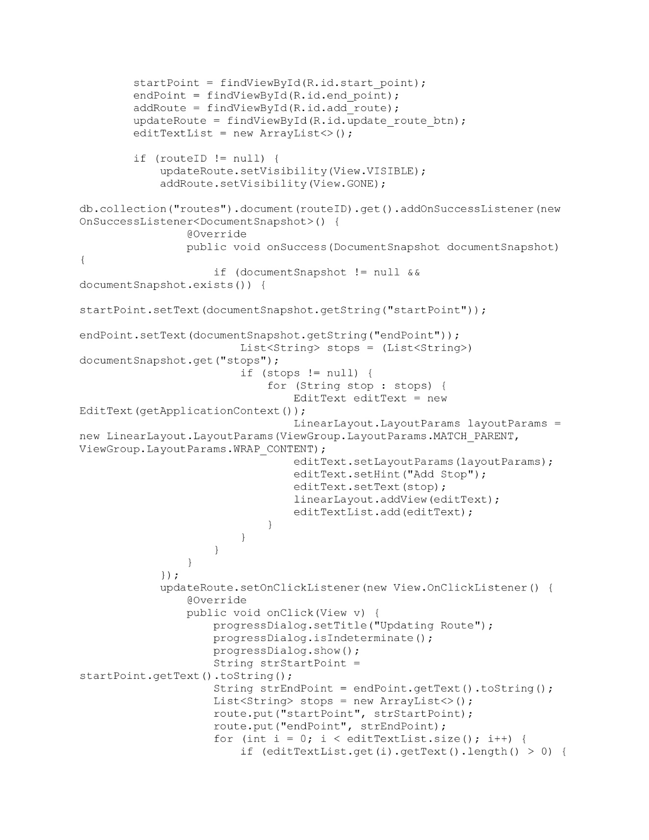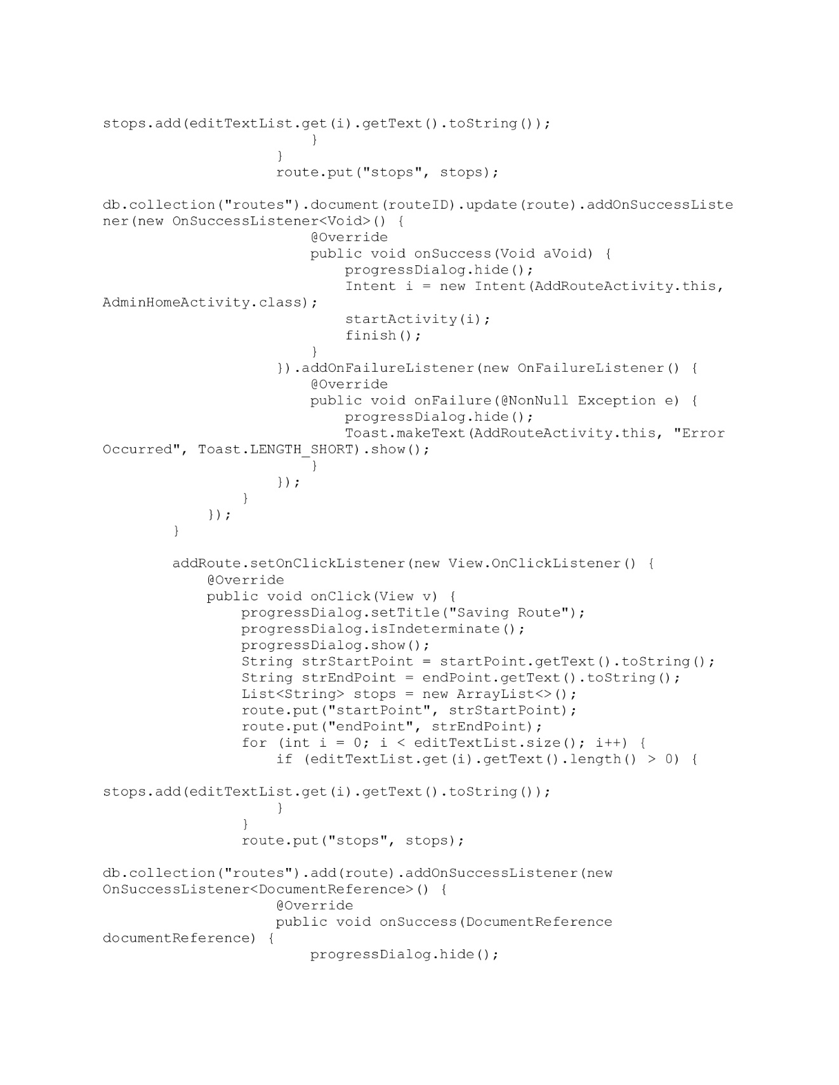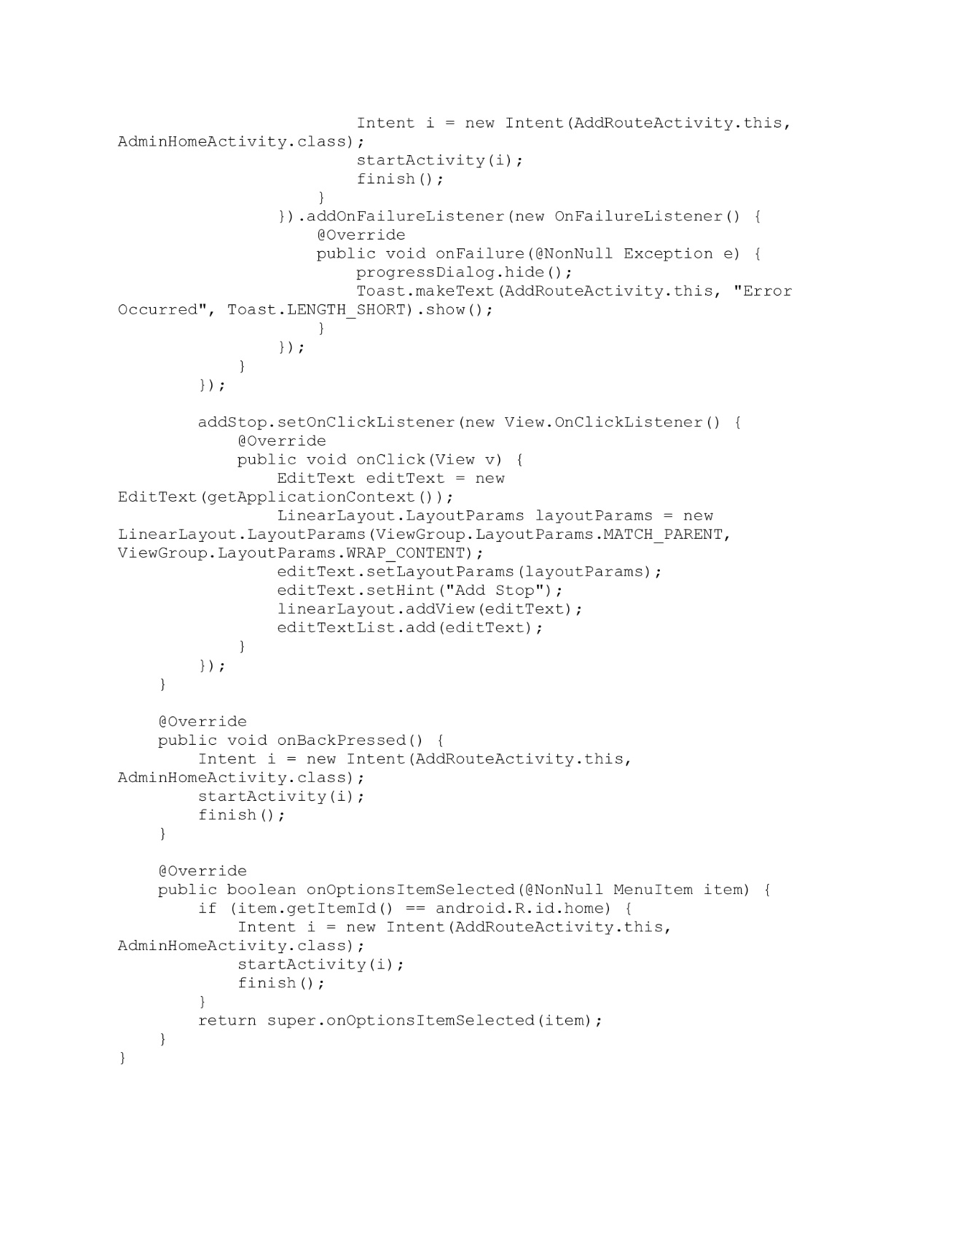

Decision coverage table
Decision coverage table covers the following factors that includes;
- Login with Student
- Login with admin

7.2.2.1) Login screen with Driver as future scoping

Condition is simple when the driver enter correct username and password he will be redirected to user control panel.

Condition | Rule 1 | Rule 2 | Rule 3 | Rule 4
Username(T/F) | F | T | F | T
Password(T/F) | F | F | T | T
Output(E/C) | E | E | E | C

Legend
- T-Correct username and password.
- F-Wrong username or password.
- E-Error message will be displayed.
- C-User control panel will be displayed

7.2.2.2) Login screen with Student

Condition is simple when the Student enter correct username and password he will be redirected to user control panel.

Condition | Rule 1 | Rule 2 | Rule 3 | Rule 4
Username(T/F) | F | T | F | T
Password(T/F) | F | F | T | T
Output(E/C) | E | E | E | C

Legend
- T-Correct username and password.
- F-Wrong username or password.
- E-Error message will be displayed.
- C-User control panel will be displayed.

7.2.2.3) Login screen with Admin

Condition is simple when the Admin enter correct username and password he will be redirected to user control panel.

Condition | Rule 1 | Rule 2 | Rule 3 | Rule 4
Username(T/F) | F | T | F | T
Password(T/F) | F | F | T | T
Output(E/C) | E | E | E | C

Legend
- T-Correct username and password.
- F-Wrong username or password.
- E-Error message will be displayed.
- C-User control panel will be displayed.

Traceability Matrix

RID vs UCID (requirements vs use cases)

UCID/RID | R  1 | R  2 | R  3 | R  4 | R  5 | R  6 | R  7 | R  8 | R  9 | R  10 | R  11
UC 1
UC 2
UC 3
UC 4
UC 5
UC 6
UC 7
UC 8
UC 9
UC 10
UC 11
UC 12

Prototypes (RID vs PID)
Following represents the functionality of RID requirements vs PID prototypes of the project:

PID/RID | R  1 | R  2 | R  3 | R  4 | R  5 | R  6 | R  7 | R  8 | R  9 | R  10 | R  11
PC 1
PC 2
PC 3
PC 4
PC 5
PC 6
PC 7
PC 8
PC 9
PC 10
PC 11
PC 12

Test Cases (RID vs TID)

Following represents the functionality of requirements vs test case ids of the project:

TID/RID | T1 | T2 | T3 | T4 | T5 | T6 | T7 | T8 | T9 | T 10 | T11 | T12
R 1
R 2
R 3
R 4
R 5
R 6
R 7
R 8
R 9
R 10
R 11

Coverage (UCID vs TID)
UCID/TID | R  1 | R  2 | R  3 | R  4 | R  5 | R  6 | R  7 | R  8 | R  9 | R  10
UC 1
UC 2
UC 3
UC 4
UC 5
UC 6
UC 7
UC 8
UC 9
UC 10
UC 11

Results/Output/Statistics

%completion
Our project is 90% complete with all the requirement gathered at start of the project.

%accuracy
Our project is 95% accurate.

%correctness
Our project is 95% correct with all the functionalities working properly.

Conclusion
After requirement gathering the next problem to tackle with was which technology to use to develop the application. We come to conclusion that since application should be asynchronous and should response quickly. Also the application should be more user friendly.

Lessons learned.
- We learned to skim required information from collected data.
- We learned to analyze data on the basis of requirements.
- We learned how to make an application as a service.
- We learned how to write documentation.
We learned how to make a good team and work with a team.

Future work
One Of The main goals that are decided are given Below in the format of a list:
- To make this app a central service for the third party buses for the perpose of student transport.
- Uberize it in the format that one can run it and can also earn through our project in future scope.
- Monetize the app to earn from it and facilitate drivers and UMT students from it.

Bibliography

Books
The list of read books are:
- Android cookbook by Ian Darwin
- Andorid application dev for dummies by Don Felker

Articles
The list is given below:
https://www.techspot.com/tag/android/
https://developer.android.com/
https://proandroiddev.com/

Other References
The website links to previous service Giants are given below:
www.uber.com
www.airlift.com
www.swvl.com
www.bykea.com

Appendix

Glossary of terms
A

Assumption: To expect or made guess about something.
Accuracy: How precise is something.
Android: Android is an operating system used in various hanset available now a days to run apps and kernel as well.
Android Studio:
Android studio is an tool that is used to develop android apps

C
Constraint: To restrict from something.

D
DFD: Data Flow Diagram
Domain: A specified area of knowledge.
Database:
Database is a storage scheme for data that is entered in the app

E
Event Listener:
A prebuilt function in java to run on an event occurrence

F
Feedback: Response of something, to comment.
Firebase:
Firebase is the database integration setup and database as well used worldwide for android app development.

I
Interface: Interaction with the other person, system etc.

P
Prototype: A model of something

S
Stakeholder: A person directly or indirectly involved with the system.

U
Use Case: List of action or event steps, typically defining the interactions between roles of different actors.
UML: Unified Modeling Language

Definitions and Acronyms

Acronym | Definition
UMT | University of Management and Technology
UC
Table 1: table of acronyms and definitions

Revision Chart

Version | Primary Author(s) | Description of Version | Date Completed
Draft | TBD | Initial draft created for distribution and review comments | (To be decided) TBD
Preliminary | TBD | Second draft incorporating initial review comments, distributed for final review | TBD
Final | TBD | First complete draft, which is placed under change control | TBD
Revision 1 | TBD | Revised draft, revised according to the change control process and maintained under change control | TBD
Revision 2 | TBD | Revised draft, revised according to the change control process and maintained under change control | TBD
Etc. | TBD | TBD | TBD

Pre-requisites
The Pre requisites are given below:
- Android Studio Understanding is a must to develop such project.
- For User Side Requirement is to know how of the usage of the applications
- Market research for the feasibility of the project
- Main Advisor should be of the same business as niche of the app
- Most market and consumer data analysis
- SWOT Analysis of the market Niche

