Final thesis project
Impact of Marketing on airline Busniess in Pakistan
Submitted to: Mr. Faiq Ahmad Submitted by: Muhammad Ahmad Hayat (15009001027)
University of Management & Technology, Lahore
4/15/2019

This project mainly focuses on the relative strengths of Pakistani airlines to do better marketing to increase their sales and business . Pakistani airlines and all the stakeholders involved in it are not emphasizing much on marketing sector because there are only three Pakistani airlines exist in the country and a very nominal competition among them. Customers just need comparatively minimum fare and better service.

Dedication
It’s an immense pleasure for me to dedicate this thesis project to my beloved parents without whom I would have not be able to achieve what I have achieved today. Their dedication and consistent support motivated me to accomplish my target. On the other hand, the guidance and assistance of my research supervisor Prof. Faiq Ahmad sb is highly commendable and appreciated. Without his able guidance and valuable instructions it was not possible. This project is constructed using all his vast knowledge and experience regarding the field and kind nature which made it easy for me to understand and word down his knowledge. Therefore, this thesis is also equally dedicated to him as well.

Project Approval

Topic: Impact of marketing on airline business in Pakistan

Submitted By:
Muhammad Ahmad Hayat 15009001027

Project Supervisor: Mr. Faiq Ahmad____________
Research Advisor: Dr. Ahmad Aizaz_____________

BS Aviation Management
Institute of Aviation Studies
University of Management and Technology, Lahore

Contents
Dedication 1
Project Approval 2
Acknowledgement 3
Abstract 4
Introduction 5
Aim 6
Objectives 6
Research Limit & Scope 6
Study Area 6
Literature Review 7
Marketing Concept in Airlines 8
Airline marketing environment 8
Pest analysis 8
The marketing mix | 4 Ps Marketing 8
Market segmentation 8
Segmentation of airline customers 9
Market research and competitive analysis 9
What do customers expect before, during and after the flight? 9
Client psychology and airline marketing 10
Airline marketing in social networks 10
Alliances between airlines 10
Why do airlines form alliances? 10
Benefits of Alliance for Airline 10
Benefits of the Alliance for the Traveler 10
Findings 11
Findings Related to Travel Agencies: 11
Findings related to passengers: 18
Findings Related to Airline Marketing Managers: 31
Conclusion 42
Recommendations 43
Bibliography 44

Acknowledgement
Firstly, I would like to thank Allah Almighty for bestowing many of His blessings. For giving me the power to learn, read and write due to which I can make this thesis happen.
Secondly, my respected teacher, my mentor Mr. Faiq Ahmad, to whom I would like to express my special thanks for believing in me and choosing me to work for this thesis because he considered my capability. This thesis wouldn’t have been easy if I didn’t have the special support of my supervisor. He guided me and enlightened with so much new information regarding our field of research that it’s my pleasure to pen it down in this thesis. And I am extremely honored to be working under his guideline.
Lastly, our parents who also believed in me and always thought better for me. They always supported me in choosing this field of Aviation for me for they knew that I would achieve more in this. There has been a great opportunity for me.

Abstract
This project mainly focuses on the relative strengths of Pakistani airlines to do better marketing to increase their sales and business. This covers all the important strategies taken out for marketing by Pakistani airlines and how they are evolving themselves with the advanced and diversified trends of marketing across the globe. The foreign airlines i.e. Emirates, Qantas & Qatar Airways etc. invest a lot of money in their marketing sector and grabbing maximum number of passengers across the globe and enhancing their business. They sponsor different International events just to make their mark and name across the globe and have partnerships with different brands and multinational companies. Pakistani Airlines have to learn from these airlines in the marketing aspect and need to do better in this area to make their mark across the globe. Currently, Pakistani airlines and all the stakeholders involved in it are not emphasizing much on marketing sector because there are only three Pakistani airlines exist in the country and a very nominal competition among them. Customers just need comparatively minimum fare and better service.

Introduction
Marketing is a business work and a lot of procedures engaged with making, conveying and imparting an incentive to clients, trailed by overseeing associations with clients, bringing about shared advantage for the organization and its parts. concerned. Promoting is additionally the investigation of target advertise determination through market examination and division, with top to bottom information of buying conduct, so as to give the best an incentive to the client.
The carrier is a piece of the movement and the travel industry administrations industry, where rivals contend to offer the best involvement in spite of comparative final results. Not at all like associations that sell substantial items, for example, autos, stationery or nourishment brands, aircraft pitch the first class involvement to their clients. The experience they give to clients is elusive and undetectable. In any case, showcasing is fruitful just when the mission, vision, undertakings, and capabilities of an organization to exploit innovation line up with one another and supplement one another, and the organiaircraftl in allbusinesste of the fact that advertising is viewed as a pointerincluderganization's prosperity, it involves viewpointOrganizations get this by persuading potential clients that their item is the nearest thing to their necessities and wants, and they do it reliably, with the outcome that the devoted client begins getting them without taking a gander at the challenge. This is the thing that all organizations long for and accomplishing this is just conceivable with a strong promoting plan set up. With the appearance of the Internet, there are a few showcasing channels accessible for organizations, notwithstanding conventional showcasing. They all attention on client commitment. The advertising system is the segment of your field-tested strategy that portrays your general course of action to discover clients for your business. Here and there the promoting technique is mistaken for an advertising plan, however they are extraordinary. An advertising technique is the general course of action of an organization to contact individuals and transform them into clients of the item or administration given by the organization. An organization's showcasing system incorporates the organization's incentive, key advertising messages, target client data and other abnormal state components. The advertising system educates the showcasing plan, which is a record that builds up the sorts and timing of promoting exercises. A showcasing system enables an organization to figure out what to state, who to state, how to state it and when.

Aim
This study is aimed to investigate impact of marketing on the busniess of airlines in Pakistan and how Pakistani Airlines are evolving themselves with the advanced and updated trends of marketing to increase their business.

Objectives
The objective of this exploration is to examine effect of promoting on the busniess of carriers in Pakistan. The targets of the investigation incorporates:
- To determine how effectively Pakistani Airlines are shaping their marketing strategy.
- To promote SMART (Specific, Measurable, Assignable, Relevant & time-Based) marketing approach for better competitiveness of airlines keeping in mind the standards across the globe.
- To recommend strategies to Pakistani airlines to increase sales.
- To determine how effectively airlines are using digital marketing tech Measurable ecommend an approach for better functioning.

Research Limit & Scope
- Subject restrictions: The goal of the examination was to look at the effect of promoting the carrier business.
- Place Limitations: The examination was completed on UMT, Multiple Travel Agencies and Marketing workplaces of Pakistani Airline news, for example, PIA, Airblue an. Serene Air.
- Time Limitations: The examination was led, primer information was gathered, the and a measurable investigation was performed amid the year (2019)

Study Area
This study was conducted in UMT, Multiple travel agencies and the Marketing offices of Pakistan, for example,i.e. PIA, Airblue & Serene Air for data collection in order to get the desired result. The researcher intends to use the students at UMT who frequently travel by Air in order to find out how they choose airlines for traveling i.e. agencies marketing, Cheap fares & Better Entertainment etc. Travel agencies were targeted in order to find out how they grab their customers through different channels when airlines offers discounted fares through banks and food courts etc. Marketing representatives of Pakistani Airlines were intended in order to find out whether they practice marketing strategies in ordrer to grab maximum number of passangers to increase their business or not because they know there are few airlines in Pakistan and customer will choose that airline with cheap fares and discounted rates.

Literature Review
For a great many people, showcasing is selling and advancing. Advertising includes deals and advancements. On the off chance that the items, in any case, have intended to address client issues, the deal and advancement will be the good to beat all. The advertising idea is a sort of secret. It is a perceived business. It works in numerous associations, however the fundamental idea of promoting Philosophy is infrequently examined. The presentation of a showcasing office for some, associations accommodate the arrangement of at least one staff individuals who sort out Promotional materials and that's it. This, it must be underscored, does not establish promoting. Advertising alludes to the connection between the purchaser and the merchant and the tasks important to finish this end. It could be talked about this, not at all like the economy that centers around the connection among supply and The inquiry advertising depends on the possibility that the client is the focal objective for everybody. The utilization of the advertising idea to an association implies putting the client at the focal point of each basic leadership process in the business. Numerous scholary articles were investigated so as to get the thought how the idea of advertising is developing in the aircraft business. Wanted outcome was found and incredibly it was discovered that the top significant carriers of the world for example Qatar Airways and Emirates Airline are centering and growing because of their viable promoting techniques. They do collabrations with various games group and support them so as to get their imprint on the planet. They are contributing and getting a great deal of benefit through various channels of promoting. On opposite Pakistani carriers are a long ways behind away in the promoting perspective. Pakistani aircrafts are simply doing ordinary promoting through web based life and boards and so on. They don't gangs such systems and brains that can give them additional edge as far as business. This exploration was intented to decide the relative qualities and shortcomings of Pakistani carriers in the showcasing angle as for elements that impact the business and offers of aircrafts and to decide how successfully Pakistani Airlines are molding their promoting system. Amid the examination diverse questionarres were made to approach from the partners for overview focusing on the passangers who fly, travel organizations and the showcasing officials of Pakistani carriers so as to get the ideal outcome. Questions were asked from the passangers at AIIAP Lahore and University of Management and innovation situated at Lahore so as to discover how clients pick carriers to fly with and through which channel they book their tickets. Strikingly, the majority of the gathering of people addressed they book their ticket through movement advisor and they pick wanted carrier to fly which has the base toll with better administrations. They are not awed by the promoting traps and strategies. They simply need modest passages and better administrations. Travel offices were asked how they deal with the clients when carrier offers limited tolls through banks, ATM cards, nourishment courts and so on. In react to which they replied, they don't manage them provided that an individual holding that ATM card he'll not going to ask from us. They essentially request that they proceed with no inclusion. Travel offices for the most part focus on the gatherings of various global organizations for example Pesticides bunch and Umrah bunch and so forth so as to get greater part of clients to pick up benefit. PIA, Serene Air and Airblue were approached to tell their promoting procedure and how they are getting clients so as to discover the viability of their showcasing plan. It was intented to ask their Frequent flyer program, advancements and promoting and so forth.

Marketing Concept in Airlines
The aircraft is a piece of the movement and the travel industry administrations industry, where rivals contend to offer the best involvement notwithstanding comparable finished results. Not at all like associations that sell substantial items, for example, vehicles, stationery or nourishment brands, carriers pitch the world class involvement to their clients. The experience they give to clients is impalpable and undetectable.

Airline marketing environment
The airlines discover information on the marketing environment through a powerful analysis model called PEST analysis.

Pest analysis
The marketing field presents a useful model for studying the marketing environment of an organization. This model proposes that factors should be classified as political, economic, social and technological (PEST). This model becomes reliable for the airline industry to understand the growth or decline of the market, the commercial position and the direction of operations.
Political factors: fear of terror and political instability in the country.
Economic factors: economic growth or instability in the country.
Social factors: population aging, changes in holiday tastes, changes in family structures.
Technological factors: high-speed electronic devices, fuel-effciient planes

Market segmentation

As an initial phase in making a market procedure, advertise division includes showcase investigation and gathering into littler areas. Subsequent to sectioning the market, the most suitable one is picked for the organization's items in connection to its qualities and upper hands. Accept the inn business for instance. A lodging network would guide its spending inns to a visitor area towards the recreation voyager, while its business inns would be coordinated to the regular explorer. Its excellent properties would be promoted by abnormal state officials.

Segmentation of airline customers
Airline customers are divided into the following segments:
Elderly travelers: they are elderly customers, probably retired and often go on vacation.
Business travelers: they are frequent travelers and form a large segment.
Loyal travelers: they travel often and, often traveling with the same airline, the company offers some advantages for them and even miles.

Market research and competitive analysis

Organizations don't work in confinement. They exist in a focused market and should keep pace with industry patterns and remain one stage in front of the challenge. Statistical surveying is fundamental for an organization to settle on educated choices. Since showcasing includes the course of assets and exercises went for fulfilling the requirements of clients, statistical surveying recognizes these necessities and discover approaches to make the perfect promoting message. It likewise adjusts and track distinctive components in the promoting technique. Along these lines, statistical surveying encourages you comprehend the challenge and exploit that learning to improve the business.

What do customers expect before, during and after the flight?
Here are a few contemplations that the client thinks before choosing an air administration:
Administration openings: delays in stuff meters and flight takeoff make an enduring negative effect on travelers.
Dependable administration ensure: the carrier's staff is resolved to administration and most extreme consumer loyalty. The nature of the administration is in every case high.
Comfort: simple enlistment and ticket booking frameworks.
Consideration: the staff of the carrier that perceives the necessities and steps forward to fulfill them usefully.
confort: enough space for knees and legs around the seat.
Meals :Free dinners in fulfilling quality flight.
Security and assurance: accentuation on security and insurance.

Customer psychology and aircraft advertising
For aircrafts, it is imperative to look after clients, increment their faithfulness and encourage positive verbal. The aircraft's promoting staff perused the evident needs and genuine needs of the client. Aircrafts can do this by offering the best flight involvement with them, as clients depend principally on their involvement with the carrier. In the event that the carrier can address the issues of its clients, at that point it makes a major name and cash for itself.

Aircraft advertising in Social networks
All aircrafts around the globe comprehend that the present clients are quite often tuned to the Internet, so carriers will in general have a stunning nearness on the Internet. Carriers are additionally abusing approaches to achieve their clients through informal communities. For instance, Cathay Pacific Airways has made a Facebook page to indicate offers, advancements, restricted time offers and aircraft recordings. Qatar Airways has a solid nearness on Twitter by sharing news, occasions, expanding deals and passing on data about the organization's execution. Turkish Airlines' showcasing strategy relies upon utilizing hashtags to make importance and credibility, while Emirates utilizes Instagram. Keeping up nearness in informal organizations is a work 24 hours per day, 7 days seven days, so carriers enlist individuals who know the organization techniques, compose ground-breaking substance and know the situating of the brand.Airlines use Meme Jacking, the idea that is transmitted from individual to individual through the Internet. It is a successful method to make a buzz around the brand.The carriers additionally make website pages and recordings dependent on the area and culture of the clients. Recordings become viral and work without expelling clients from their customary range of familiarity.
Alliances between Airlines
A coalition fundamentally implies an understanding between aircrafts to work significantly in collaboration.
Why do airlines form Alliences?
Working in association has benefits for both the aircraft and the voyagers.

Advantages of Alliance for Airline
- Reduced support costs.
- Reduction of working faculty.
- Reduction of speculation and obtaining costs.
Benefits of the Alliences for the traveller
- Lower ticket costs because of decreased working expenses
- Other flight time choices to look over.
- Other goal alternatives
- Less travel time
- Access to a wide assortment of air terminal rooms imparted to partnership individuals.
- Rewards for quicker miles in a solitary record in various administrators.

Findings

Findings Related to Travel Agencies:
 | Response | Frequency |  | Percentage
Which promotional strategy is being used by your company? | Advertising (Print, outdoor, broadcast, covert advertising & celebrity advertising) | 8 |  | 40%
Which promotional strategy is being used by your company? | Public Relations (Media, newsletter & special events) | 3 |  | 15%
Which promotional strategy is being used by your company? | Promotions (Personal selling, flyers & product demonstration | 2 |  | 10%
Which promotional strategy is being used by your company? | Publicity (Posters, word of mouths, bookmarks & banners) | 7 |  | 35%
Total |  | 20 | 100%
All collected data from the entire questionnaire (20) from multiple travel agencies were administered and used for analysis as follows in the following tables:

Q#2 Do you pass on promotional discounts to your customers?
 | Response | Frequency |  | Percentage
Do you pass on promotional discounts to your customers? | Yes | 18 |  | 90%
Do you pass on promotional discounts to your customers? | No | 2 |  | 10%
Total |  | 20 | 100%
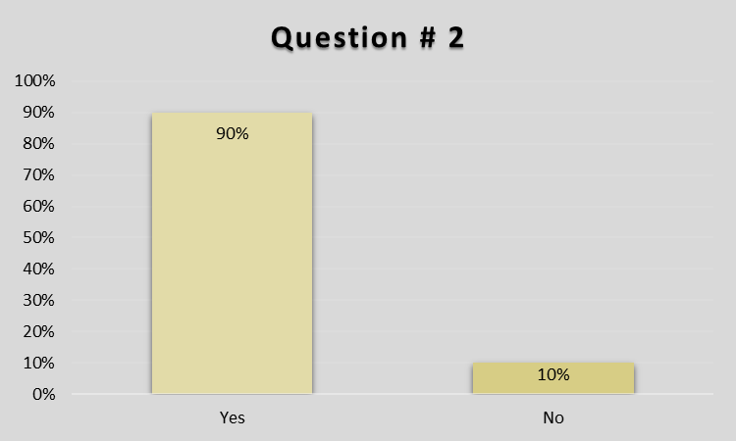

Q#3 If there were no special promotions offered, will customers still be coming to your agency?
 | Response | Frequency |  | Percentage
If there were no special promotions offered, will customers still be coming to you? | Yes | 15 |  | 75%
 | No | 5 |  | 25%
Total |  | 20 | 100%

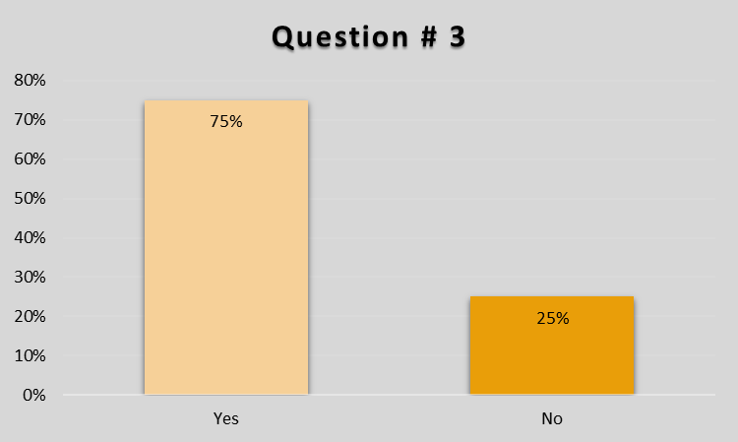

Q#4 Do you compare online rates to travel agency rates?
 | Response | Frequency |  | Percentage
Do you compare online rates to travel agency rates? | Yes | 19 |  | 95%
Do you compare online rates to travel agency rates? | No | 01 |  | 5%
Total |  | 20 | 100%
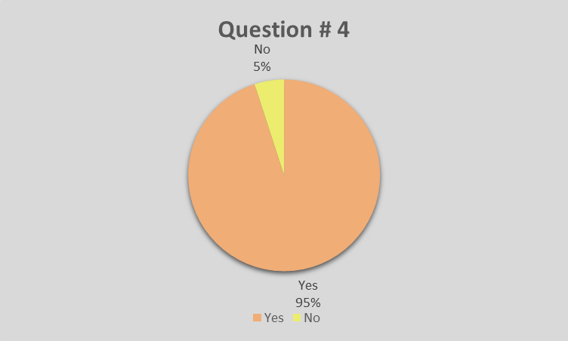

Q#5 Do you mark type of customer you want based on your marketing strategy?
 | Response | Frequency |  | Percentage
Do you mark type of customer you want based on your marketing strategy? | Yes | 19 |  | 95%
 | No | 01 |  | 5%
Total |  | 20 | 100%

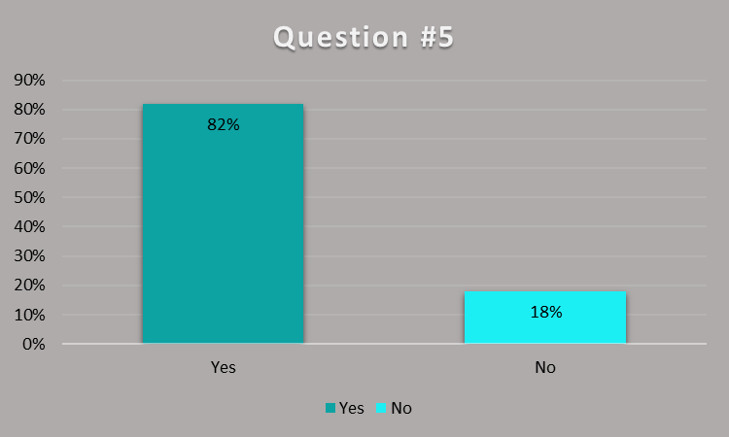

Q#6 Do you offer other travel services and solutions as well?
 | Response | Frequency |  | Percentage
Do you offer other travel services and solutions as well? | Yes | 14 |  | 70%
Do you offer other travel services and solutions as well? | No | 6 |  | 30%
Total |  | 20 | 100%

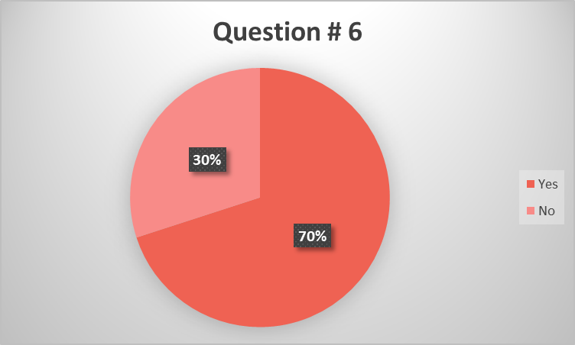

Q#7 Do you think budgeting is important in marketing strategy?
 | Response | Frequency |  | Percentage
Do you offer other travel services and solutions as well? | Yes | 12 |  | 60%
Do you offer other travel services and solutions as well? | No | 08 |  | 40%
Total |  | 20 | 100%
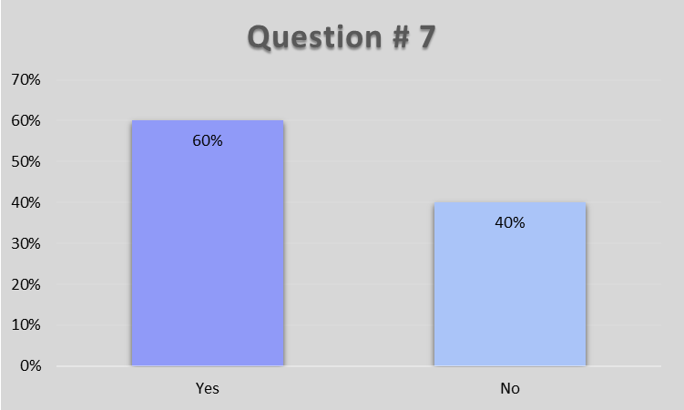

Findings related to passengers:
All collected data from the entire questionnaire (26) from different students & passengers at AIIAP Lahore.

Q#1: Your gender?
 | Response | Frequency | Percentage
Gender | Male | 15 | 58%
Gender | Female | 11 | 42%
 |  | 26 | 100%

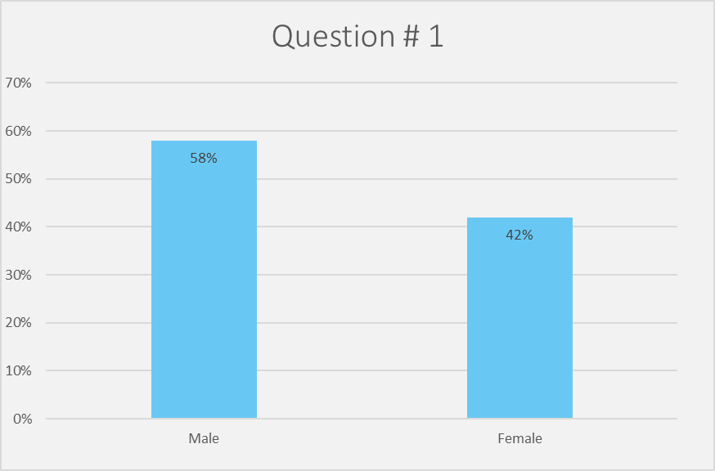

Q#2: Your highest level of education?
 |  | Response |  | Frequency |  | Percentage
Your highest level of education? |  | Diploma |  | 0 |  | 0%
 |  | Bachelor’s degree |  | 22 |  | 85%
 |  | Master’s degree |  | 4 |  | 15%
 |  | Ph.D. |  | 0 |  | 0%
Total |  |  | 26 |  | 100%

Q#3: Your profession?
 |  | Response |  | Frequency |  | Percentage
Profession |  | Private Employee |  | 12 |  | 45%
 |  | Government Employee |  | 2 |  | 10%
 |  | Businessman |  | 5 |  | 20%
 |  | Any other |  | 7 |  | 25%
Total |  |  | 26 |  | 100%

Q#4: How frequently you fly domestically?
 |  | Response |  | Frequency |  | Percentage
How frequently you fly domestically? |  | 1-2 times per year |  | 14 |  | 55%
 |  | 3-5 times per year |  | 7 |  | 25%
 |  | More than 5 times per year |  | 5 |  | 20%
Total |  |  | 26 |  | 100%

Q#5: How frequently you fly internationally?
 |  | Response |  | Frequency |  | Percentage
How frequently you fly internationally? |  | 1-2 times per year |  | 20 |  | 78%
 |  | 3-5 times per year |  | 4 |  | 12%
 |  | More than 5 times per year |  | 2 |  | 10%
Total |  |  | 26 |  | 100%

Q#6: Which airline do you prefer flying with?
 |  | Response |  | Frequency |  | Percentage
Which airline do you prefer flying with? |  | PIA |  | 12 |  | 46%
 |  | Serene Air |  | 6 |  | 21%
 |  | Air blue |  | 8 |  | 33%
 |  | Other |  | 0 |  | 0%
Total |  |  | 26 |  | 100%
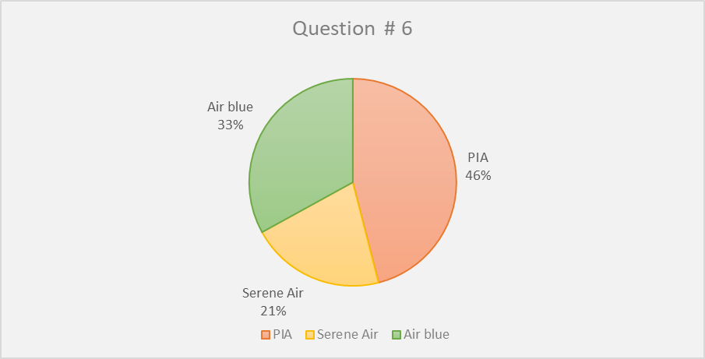

Q#7: How was this airline recommended to you first?
 |  | Response |  | Frequency |  | Percentage
How was this airline recommended to you first? |  | Travel agency |  | 11 |  | 40%
 |  | Social media |  | 6 |  | 20%
 |  | Social circle |  | 8 |  | 30%
 |  | Other medium |  | 1 |  | 10%
Total |  |  | 26 |  | 100%

Q# 8: How do you usually book your ticket?
 |  | Response |  | Frequency |  | Percentage
How do you usually book your ticket? |  | Airline website |  | 12 |  | 46%
 |  | Airline town office |  | 6 |  | 21%
 |  | Travel agent |  | 8 |  | 33%
 |  | Online discount |  | 0 |  | 0%
Total |  |  | 26 |  | 100%

Q#9: Does this airline give promotions?
 |  | Response |  | Frequency |  | Percentage
Does this airline give promotion seasonally or all year around? |  | All year round |  | 6 |  | 21%
 |  | Seasonally |  | 20 |  | 79%
Total |  |  | 26 |  | 100%

Q#10: Does this airline give promotion?
 |  | Response |  | Frequency |  | Percentage
Does this airline give promotions? |  | Yes |  | 22 |  | 87%
 |  | No |  | 4 |  | 13%
Total |  |  | 26 |  | 100%

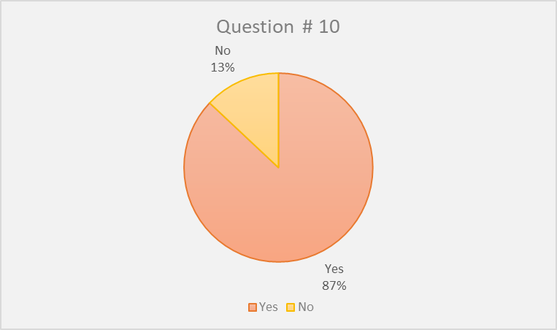

Q#11: The promotion of this airline is always attractive?
The promotion of this airline is always attractive? |  | Response |  | Frequency |  | Percentage
 |  | Yes |  | 18 |  | 69%
 |  | No |  | 8 |  | 31%
Total |  |  | 26 |  | 100%

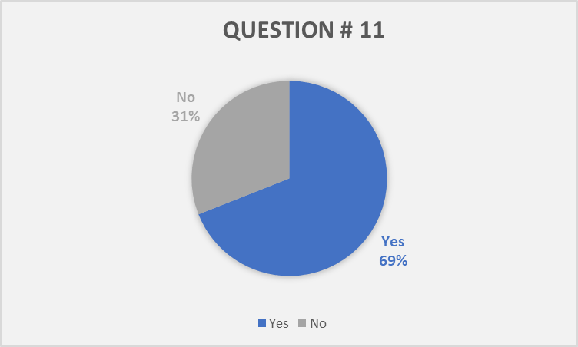

Q#12: Is this airline offers the lowest market fare on the route you fly?
 |  | Response |  | Frequency |  | Percentage
Is this airline offers the lowest market fare on the route you fly? |  | Yes |  | 20 |  | 78%
 |  | No |  | 06 |  | 22%
Total |  |  | 26 |  | 100%

Q#13: Are you satisfied with your decision to choose this airline?

 |  | Response |  | Frequency |  | Percentage
Are you satisfied with your decision to choose this airline? |  | Yes |  | 23 |  | 88%
 |  | No |  | 3 |  | 12%
Total |  |  | 26 |  | 100%

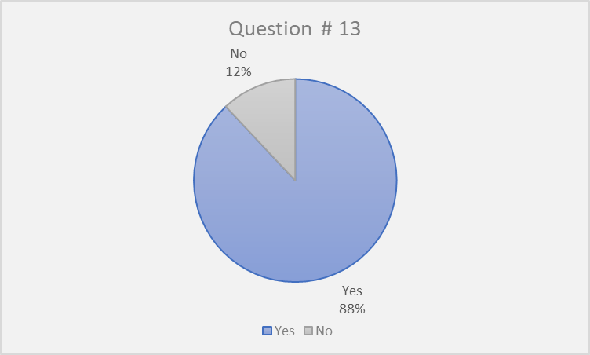

Findings Related to Airline Marketing Managers:
All collected data from the entire questionnaire (3) asked from the marketing representatives of PIA, Serene Air & Air blue administered were used for analysis as follows in the following tables:

 | Response | Frequency | Percentage
Which promotional strategy is being used by your company? | Advertising (Print, outdoor, broadcast, covert advertising & celebrity advertising) | 2 | 66%
Which promotional strategy is being used by your company? | Public Relations (Media, newsletter & special events) | 0 | 0%
Which promotional strategy is being used by your company? | Promotions (Personal selling, flyers & product demonstration) | 1 | 33%
Which promotional strategy is being used by your company? | Publicity (Posters, word of mouths, bookmarks & banners) | 0 | 0%
Total |  | 3 | 100%

 | Response | Frequency | Percentage
When does your airline use promotional activities? | All around year | 2 | 66%
When does your airline use promotional activities? | During the tourism season | 0 | 0%
When does your airline use promotional activities? | During Peak off season | 1 | 33%
When does your airline use promotional activities? | During off season | 0 | 0%
Total |  | 3 | 100%

Q#3: The promotional activities undertaken by your airline are effective?

 | Response | Frequency | Percentage
The promotional activities undertaken by your airline are effective? | Yes | 3 | 100%
 | No | 0 | 0%
Total |  | 3 | 100%

 | Response | Frequency | Percentage
Q#4 Are your packages and promos effectively different from other airlines? | Yes | 3 | 100%
 | No | 0 | 0%
Total |  | 3 | 100%
`

 | Response | Frequency | Percentage
Q#5 Do you give extra products or services to your regular customers? | yes | 3 | 100%
 | No | 0 | 0%
Total |  | 3 | 100%

 | Response | Frequency | Percentage
Q#6 Do you think that having these promotional strategies can gain more profit? | Yes | 3 | 100%
 | No | 0 | 0%
Total |  | 3 | 100%

 | Response | Frequency | Percentage
Q#7 Do you think that you gain more marketing advantages by offering great packages and promos in your airlines with greater value? | Yes | 3 | 100%
 | No | 0 | 0%
Total |  | 3 | 100%

Q#8: Do your promos and travel packages clearly communicate in what you are about to want them to know and understand?

 | Response | Frequency | Percentage
Do your promos and travel packages clearly communicate in what you are about to want them to know and understand? | yes | 3 | 100%
 | No | 0 | 0%
Total |  | 3 | 100%

 | Response | Frequency |  | Percentage
Q#9 Does your airline offer frequent flyer program? | yes | 3 |  | 100%
Q#9 Does your airline offer frequent flyer program? | No | 0 |  | 0%
Total |  | 3 | 100%

 | Response | Frequency | Percentage
Q#10 Do you know your most profitable customer and are you targeting prospects? | Yes | 3 | 100%
 | No | 0 | 0%
Total |  | 3 | 100%

Q#11: Do you think that budget has an important role to play in the process of making your own marketing strategy?
 | Response | Frequency | Percentage
Do you think that budget has an important role to play in the process of making your own marketing strategy? | Yes | 3 | 100%
 | No | 0 | 0%
Total |  | 3 | 100%

Conclusion
In conclusion, the purpose of this report is to emphasize the importance of the Marketing and illustrate the influence of marketing on the airline business. Based on the evidence of field observation, a survey of 26 Passangers incuding students of UMT, 20 Travel agencies and 3 Pakistani Airlines, it is came to know that the marketing strategies of Pakistani airlines are not that much attractive and useful that are being practiced by the world class airlines i.e. Qatar, Emirates & Qantas etc. Pakistani airlines are still investing a better amount on marketing but not allocating them properly & efficiently. Airblue allocate approximately 100 Million a year. PIA allocate 125 millions approximately and Serene Air allocate 50 to 70 millions annually. Airlines are just grabbing customers on the basis of less competition, they know there are only few airlines in Pakistan and customers have to purchase from them without having another option. Pakistani airlines assign nominal amount for marketing i.e. advertising & newsletter etc. In Pakistan, customer just need cheap fares with better services and he/she is not so much influenced by marketing. Travel agencies are targeting groups of different multinational companies to increase their sale and business through different discounted offers. Hence,impact of marketing on the busniess of Pakistani airlines is not influenced with respect to factors that influence the business and sales of airlines.

Recommendations
There are many solutions & recommendations for Pakistani Airlines to increase their sales and enhance the business in order to stand among the world class airlines and maintain the standards set across the globe in airline industry which are as the follows:
- Identify your target market; The main key for enhancing the marketing strategy is to identify your target market instead of assumptions. The analysis tools allow to gather, analyze and interpret the information needed to create complex customer profiles and make decisions based on facts rather than assumptions.
- Develop a clear insight of your customer: Airlines can start focusing on developing additional services and products that can improve the overall customer experience such as offering unique products & services, offering exculusive menus and inflight entertainment and providing self service etc.
- Increase your existing customer base; Before looking new markets, think about how your company can take full advantage of the markets you already serve to retain & increase existing customers.
- Build a value to your customers; Offer more value to your audience. Always believe that the more value your customers have, the more likely they are to recommend their brand to their loved ones.
- Understand the needs of the local market and develop a collaborative approach; Too often, operating around the world is seen as an excuse for not wasting time on understanding local cultures, customer needs and behaviors, as well as successful and less successful marketing approaches.
- Hire marketing professionals; Hiring the right person for the right job can have a great positive impact on the productiveness of any company. So, taking marketing specialist for the marketing can increase the competetivness of the airline.

Bibliography
https://www.tutorialspoint.com/aviation_management/aviation_management_airline_marketing.htm
https://www.blueskyinnovationsgroup.com/-strategies-to-help-build-the-perfect-aviation-marketing-plan/
http://www.marketing-schools.org/consumer-psychology/marketing-airlines.html
https://smallbusiness.chron.com/effective-marketing-airlines-73625.html
https://www.piac.com.pk/
https://www.airblue.com/
https://www.sereneair.com/
https://www.brecorder.com/2018/05/28/420091/pakistans-entire-travel-market-is-about-3-billion/

