

Cricket Craze Application

Project Advisor:
Fasiha Ashraf

Submitted By:
Umair Zia 111720031
Aziz Ur Rehman 111820229
Shajee Ahmed 111820142



University of Management and Technology
C-II Johar Town Lahore Pakistan

Final Approval

Panel of Examiners

- Head of Department ______________________
Department of Computer Science
UMT Lahore

- Program Director ( Final Year Projects) ______________________
Department of Computer Science
UMT Lahore

- Supervisor ______________________
Department of Computer Science
UMT Lahore

- Co-Supervisor ______________________

- External Examiner ______________________

Controller of Examinations ______________________

Dedication

In order to achieve goals and aim for them unswervingly, it takes an awful lot of determination and effort as well as guidance of elders especially those who give their valuable time to us. We dedicate our humble effort to our loving
Parents
Who spent their lives to made us what we are today, their love, inspiration and prayers made us accomplish this work and granted us such success and honor Along with all respected
Teachers
For their continuous support and hard work to bring the best out of us and to guide us on our ways to a successful future.

Acknowledgment

“Then which of the favors of your Lord will ye deny?”
. Al-Quran [16:18] - Surah Al-Rahman

First, I am very grateful to Allah (SW) for his innumerable blessings and mercy. I've been involved in this project. It would not have been possible without the kind of support and help from my project counselor Fasiha Ashraf (associate professor of computer science) for their guidance, regulation and critical thinking during the project. We are grateful to all those who have provided the equipment for this job and thanks to the department and also thanks to my dear friends who have supported every moment of time during the completion of the final year project. I would like to thank my parents for allowing me to realize my own potential. All the support they have given over the years has been the greatest gift that somebody gave me in the latter thanks to the thanks Fasiha Ashraf who taught me the value of hard work and education. Without it I have never had where I am today.

Abstract
As the life in a new age is increasingly hectic and always on the go, sitting and watching a complete match has become very difficult. Test matches and one days whilst being entertaining have to be watched while keeping your life and chores on hold. Making an application to assist the person to keep track of ball by ball action of the match and getting complete information of the game while carrying on with one’s life with the help of a light weight IOS based application will make life easy for cricket fans. An Application that is made for the fans by the fans. The impact of the application will be great on the market as it is one of the most desired application a cricket fan needs, especially after the fame of the www.cricinfo.com which is one the most viewed sport site in the world. Making an iOS application will help people become more independent from the browser based application to an on the go application that could be accessed anywhere.

Contents

Final Year Project Report 1
Project Name 1
Project Advisor: 1
Submitted By: 1
Session 1
University of Management and Technology 1
C-II Johar Town Lahore Pakistan 1
Dedication 2
Final Approval 3
Acknowledgment 4
1. Introduction 12
1.1 Project Overview 12
1.2 Problem Statement 12
1.3 Customer 12
1.4 Affected Groups 12
1.5 Assumptions 12
1.6 Dependencies/ External Systems 13
1.7 Definitions and Acronyms 13
1.8 Reference/ Source Documents 13
1.9 Goals 13
2. System Functions/ Functional Requirements 17
3. System Architecture 17
3.1 System Architecture Diagram 17
4. Data flow diagram 17
4.1 Data Flow Diagram Level 0 18
4.2 Data Flow Diagram Level 1 19
4.3 Data Flow Diagram Level 2 19
5. Use Case Model 20
5.1 List of Actors 20
5.2 List of Use Cases 20
5.3 Use Case Diagram 20
5.4 Use Case Buy Item 20
4.4.1 Use Case Add Item (to sale) 21
5.5 System Sequence Diagrams 22
5.6 User Interface 23
5.7 Data Dictionary 23
6. Conceptual Model 24
7. ClASS DIAGRAM 28
8. Function Point Analysis 33
9. Implementation 37
9.1 Prototypes (UID vs PID) 37
9.2 Descriptions (PID vs DID) 37
9.3 Traceability matrix (UID vs FID) 37
10. Testing 44
10.1 Test Cases 44
10.2 TID template 44
10.3 Decision Table 44
10.4 Traceability Matrix (TID vs UID) 44
11. Results/Output/Statistics 68
11.1 %completion 68
11.2 %accuracy 68
11.3 %correctness 68
12. Conclusion 69
13. References 70
14. Bibliography 70
15. Appendix 70

List of Figures
Figure 1 System Architecture 15
Figure 2 System Level Use Case Diagram 17
Figure 3 Conceptual Model 22

Introduction
Sports always remained interesting things for Human beings since the beginning of time. With the passage of time they evolved and now in 21st century the physical games are being mapped into digital games. People love to play and integrate physical game tournament on their devices. These days smart phones are becoming very common, so everyone want to keep himself updated about the game he loves most. Cricket is a game that is being loved by more than 40 % of world population. People who have craze for cricket want to see each and every alert and update about their favorite team and players. We aim to provide them authentic, reliable, and fast and well managed information to our users in a single application. Development of our application involves many rich concepts like IOS development, web services, API integration, data mining, UI design and application architecture. We are working to seek excellent skills in IOS development so that we can develop a good, complete, fast and efficient application to meet all the needs of cricket lovers. As we know that social media is becoming a vital part of communication and people love to share, like and comment on different game events, so we will be providing a good interface to our users so they can share their joy/feelings about any game event on famous social medias e.g. Facebook , twitter.
1.1 Project Overview
Our project is IOS based development. We will work on this project with the coordination of our advisor. First we will learn the related concepts. Then we will develop an application (Cricket Craze) which will help the cricket lover to get all information at one place easily. Our application will use a database that will be used to store the data. We will provide authentic information to user by using web services of popular and authentic web sites. Users can also share this information on social sites like Facebook and twitter and we also give an option of live streaming people can watch live match through this application. Our aim is to facilitate the user of IOS devices by uploading the application on app store. This project will change the life style of cricket lover IOS users. All it needs is hard work! We are motivated and passionate to work on this project with the coordination and guidance of our advisor.
Objectives:
Understanding necessary languages and tools
User login and registration.
Login by social sites username and password.
Store latest cricket news
Store latest match schedule
Store match summaries
Store players performance statistics
Comment on player’s past 3 to 4 matches
Facility of sharing information on social websites just like Twitter.
User can customize the app according to his/her interest.

1.2 Problem Statement
Internet technology has become very advance and is used to fulfill the need of cricket lovers. But information is scattered, so user faces problems to find specific information, which cause the wastage of time and time is money. During the net surfing users found most of the web sites which are social and comment oriented and everyone can share his/her idea there and everyone does not provide authentic information so authenticity is the big issue. Internet technology has become very advance and is used to fulfill the need of cricket lovers with the help of cricket info App cricket lovers can only be updated with live scores and for video they have to click another tab while with cricket craze app they can enjoy cricket updates with video at a time.
1.3 Customer

Facilitates the iPhone users checking latest cricket news, match schedules, match summaries, team stats, player’s stats sharing of information on social sites etc. All the users of the application will interact with the application through the iPhone, all users will have their accounts (either on application or on social site) and after signing in to the application they can do their jobs. All the users have almost the same rights, the user who will sign in through social site will have right to interact with social sites. User can also customize the app so that only required information is stored for offline use.

1.4 Affected Groups
- Cricket Viewer
- Players
- Cricket Journalist
- Cricket Bookies
- Crickets Boards
- The people who are not to want lost patient for searching different sources for different information

1.5 Assumptions

- This will be the main screen of application through which user can interact with application.
- Main screen also contain many sub screen(sub views)
- Application will be connected with social sites like face book and twitter at back end.
- User can share status on those sites through application.
- Application will use different web services to get updates.
- Updates (or any data) will be stored on data base.
Data Base will contain all the data.
- Application will get the required data from data base and will show to user on screen

1.6 Dependencies/External Systems

- Disclosed information of this app will be dependent on websites and public provided figures.
- Core features like sharing on other networks will depend on available bandwidth.
- Displaying of user comments from database on each user’s mobile will generate network traffic.
- Getting regular updates from database and from websites will consume more RAM and system resources which could slower response.

1.7 Definitions and Acronyms
- Abbreviations and shortenings will be used to display more information on a shorter display.
- Player record information will also be shown in acronyms.
- Third umpire views and comments will be displayed in definitions.

1.9 Goals

The objectives of the top management and what it hopes to accomplish from the proposed system are following
Understanding necessary languages and tools
- User login and registration
- Login by social sites username and password.
- Store latest cricket news
- Store latest match schedule
- Store Match summaries
- Store Player performance statistics
- Comment on player’s past 3 to 4 matches
- Top ratings (ODI, Twenty, Test) with respect to teams.
- Top ratings(Batsman’s, Bowler’s, Fielder’s, Catcher’s, Keepers) statistics
- History(Team, Centuries, Fifties, Most Wicket Takers, Average(Bowlers and batsman’s), Records Holder of players) statistics
- Facility of sharing information on social websites just like Twitter.
- User can customize the application according to his/her interest.
For example if user customize the app to store only player’s performance then only player’s performance will be stored.

STAKE HOLDERS
- Cricket Lover
- Cricket Boards
- International Cricket Council
- News Channels
- Other Cricket Application and websites
- Sports journalist
- News Papers
- Private League
- Creating and launching will attract quite a stake for the developers.
- As this app would be a free one so only ads would do some benefit for the stake holders.
- SEO may benefit for its popularity which could summon some ads.

Domain Analysis
Cricket is one of the most famous and passionate about world sports for many years. It is especially loved by children. They usually used to play cricket in every small open place like a road, small fields, etc. Children and kids are so eager to know about cricket and its rules and regulations. Cricket Craze is a mobile application, which will be used by iPhone users to view different types of stats, rate player’s performance, and customize the app and interaction with social sites. Through this users can get required information offline and online without wasting any time, which is not easy when they manually search the information from Internet.

Background
A person who like cricket searches a lot of sites to get cricket related news. This is time consuming process, and wasting of time increase if you want to share this information of social sites. Other than it this authenticity of information is also an issue, for example during the net surfing users found most of the web sites which are social and comment oriented, everyone can share his/her idea there and everyone does not provide authentic information so authenticity is the big issue. For all of these you have to remain online, there is no substitute available offline.
By using the mobile technology for searching the information, all the information is searched automatically by using web services of different and authentic websites, which saves the time. Some of the information is stored on database so that we can use that information offline. Users can share information on social sites on the same time. The information we have gathered is complete, reliable, and meaningful. We have visited different web sites, gather information from different ios developers and identify the scope of our project and all other necessary information regarding the actual implementation of our project. The information is reliable as it is taken from the authentic and responsible resources. The meaningfulness of our information has taken us to the complete idea about our project and its basic design. The requirements have been gathered according to the user concerns, as we have conducted a lot of meetings with cricket lovers and take all the necessary specifications that will be defined and implemented in our application.

Existing Application
Cricket is a game that is loved by over 40% of the world's population. People Crazy for Cricket They Want to See Any Warnings and Updates on Your Favorite Teams and Players There are many applications that are successfully employed in the market and were inspired by us and working on this application. The most popular application is Cricinfo. The cricinfo app provides live score cards for Cricket matches from around the world. In addition to that , you get access to news, features and editorial content. You can be a part of the conversations, by posting comments from the app. Live tile support.
This application offers a snappy access to all the live scores of matches as of now occurrence. There's an alternative that enables you to peruse through the batting line-up, with the goal that you know who is coming up next. At that point, there are photograph exhibitions, articles, and calendars covering the most recent from the universe of cricket. Since this application is not only for one nation. Cricinfo is a stage that has a great many perspectives in sites and versatile applications.
More applications that is working in market and also have a huge market shared.
- Yahoo cricket
This application offers a speedy access to all the live scores of matches as of now occurrence. There's a choice that enables you to peruse through the batting line-up, with the goal that you know who is coming up next. At that point, there are photograph displays, articles, and calendars covering the most recent from the universe of cricket.
- Cricbuzz
Cricbuzz updates you as often as possible about live scores for all the International matches. To ensure you don't miss an essential refresh, the application offers cautions by means of push warning administration. You get data on up and coming matches and even get aftereffects of late matches. It additionally accompanies Widget bolster, which implies you can bring the diversion onto your home-screen. Cricbuzz is cricket news site and application to all absolutely for the session of cricket. The site highlights news, Live extent of cricket matches including recordings and score card, player situating and gather rankings. The site also offers various flexible applications .Cricbuzz is in like manner greatest compact application for cricket news and scores in India. Cricbuzz is contains live spilling of cricket score, imminent schedule , gathering and player situating , recordings , pictures , cricket based online redirections and servile convenient applications for Android, iPhone , Windows Phone. Cricbuzz in Aug 2015 was situated 14774 globally. The site was supposedly the 7 most goggle site in India in 2014. In 2014 its versatile application cross 10 million downloads greatest in India and the website was used by more than 50 million customer worldwide and made 2.6 million pages sees in 2015.
- ICC Cricket
Yes, this is the authority application of the International Cricket Council - the overseeing collection of world cricket. It offers most recent news, live scores, exhibitions, and group data. In addition, you access select video coordinate highlights and post-coordinate question and answer session.
- Our Application
The application of Cricket Craze is mainly used to provide iPhone users with their activities related to cricket activities like watching the latest contest schedule, cricket news, standings equipment, etc., and the goal is to offer authentic information without time waste some information will be available offline. It will also ensure interaction of the user with the social sites.

System Functions/ Functional Requirements
Remembering the true objective to better grasp the method for our application and work we have sorted down the valuable and no helpful requirements of our venture. As it is fiscally related venture its essential utilitarian requirements and nonfunctional necessities are particularly pre-portrayed.
Function Requirements
Following are the function requirement for our cricket application.
- The application should be available in the device after uploading on store.
- When the user opens the application it should display home screen. This is latest news and upcoming news.
- In left menu user can see all screens button only one click to take user on that screen. Like live score, Ranking, news, team verses, Teams and setting.
- At right side of left menu our application has a sharing screen button user can shared the screen short on social media and also save in your device.
- In live score screen user can also see the statistic of player on clicking the player name and commentary ball to ball.
- In teams screen user see the top 10 teams and with team bio and team squads.
- In Ranking screen user can see the teams ranking with respect to Odi, test, or t20.
- And last screen the setting screen user have an option of caching on/off.

Non-Functional Requirements

User Interface
Cricket Craze application has a simple and very interactive user interface design likes other application. We show the all functionality in different screen that point interact the user. Our home screen show only latest cricket matches news headlines.
Performance
We focus on our application performance there are many thing that can affect our performance but we make sure to find the solution on time. Some of the services in the project are resource intensive and for them to work properly, the server should be able to provide such services accurately, independent of the connection load. Such services will be made exclusive for the Subscribed users so that when the average load on a server increases, we would have enough resources and be able to include more servers or modify the existing servers to quote with the load.
Extensibility
Application must be modifiable for future improvements.
Scalability
Scalability is the methods by which well your application oversees growing use, or size of data. So amid adaptability we additionally increment size of data for instance we can include more data about cricket watching significant others so along these lines we can get more data all through this application.so the fundamental reason for existing is that we can actualize more information amid versatility and we realize that we can utilize online database so thusly we can transfer more information quickly.
Application Programing Interface
Cricket sore card is got through web service/API. Also, social media integration is done using API integration. Functionality may stop/differ if a certain API changes its policy. We make sure that API is stable at least for 2 years; make application as much saleable so it can be upgraded/updated anytime needed.
Usability
Our project is a saleable project whose purpose is to provide efficient and effective services to all cricket loving iPhone users. This project is economically feasible because it satisfies the other factor of economic feasibility that is benefit estimation.
Security
We think our application have no critical legal and ethical issues. But we will try our level best to handle security an issue of our application is not used illegally. For this we provide user logins to all users of application.

Data Flow Diagram: Level 0

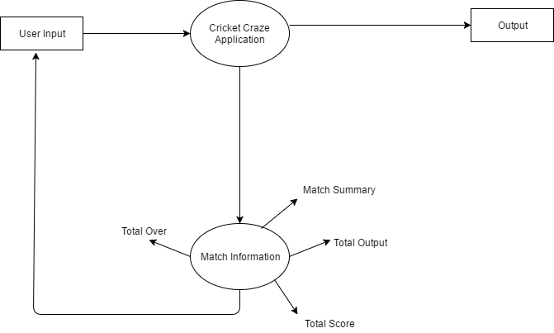

Data Flow Diagram: Level 1

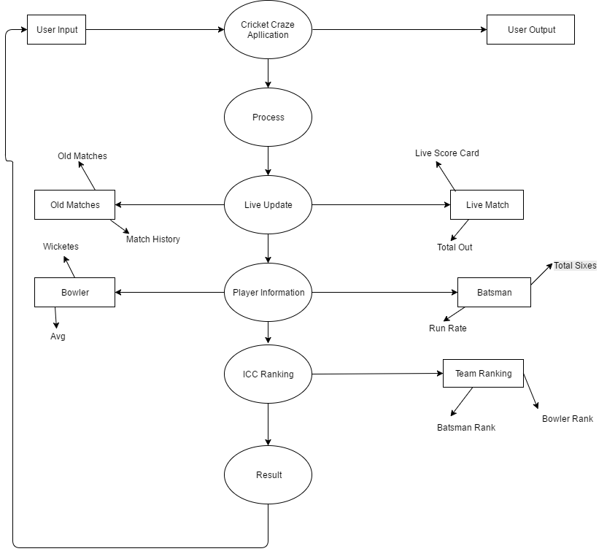

Use Case Model

List of Actors
The Actors are as follows:
- When a User accesses from a social sites or a student or the application is used
- System hits API recursively to keep score up to date
- Web Service Requesting and Returns JSON to parse and display data accordingly

Student Activity:
The Use Cases are shown in a table the series of events when student visits the website.
S No | External Entity | Initial Requirement
1 | User | Shall be able to sign up and sign in.
2 | User | Shall be able to sign in using social sites.
3 | User | Shall be able to view latest cricket news.
4 | User | Shall be able to view team stats.
5 | User | Shall be able to view player’s state.
6 | User | Shall be able to rate the player’s performance.
7 | User | Shall be able to top ratings of teams and players.
8 | User | Shall be able to customize the application.
9 | User log in by social site id | Shall be able to do all the above tasks.
10 | User log in by social site id | Shall be able to share information on social site.
11 | System | System hits API recursively to keep score up to date
12 | Web Service | Web Service Returns JSON to parse
13 | System | System parse JSON returned
14 | System | System show welcome screen
15 | System | System show app controls
16 | System | System shows customization screen
17 | System | System shows only saved customizations
18 | Web Service | Social web service authenticates User
19 | System | System store social user data
20 | Web Service | Social Web service returns data posted our app

User Activity:
The following will occur when a user will use the application.
Para # | Initial Requirement | Use Case Name
1 | A user will signup | US_Signup
2 | A user will login | UC_Signin
3 | A user will see cricket news | UC_Cricket_News
4 | A user will see match stats of ODI. | UC_Match_Stat_ODI
5 | A user will see match stats of T20. | UC_Match_Stat_T20
6 | A user will see match stats of test match. | UC_Match_Stat_Test
7 | A user will see players state. | UC_Player_Stat
8 | A user will see top rating of teams. | UC_Team_Rating
9 | A user will see top rating of players. | UC_Player_Rating
10 | A user will rate the players. | UC_Comment
11 | A user will customize the application. | UC_Customize
12 | System hits API recursively to keep score up to date | SY_API
13 | Web Service Returns JSON to parse | WB_JSON
14 | System parse JSON returned | SY_JSON
15 | System show welcome screen | SY_welcome
16 | System show app controls | SY_Controls
17 | System shows customization screen | SY_custom
18 | System shows only saved customizations | SY_Saved
19 | System store social user data/tokens | SY_Social
20 | System show requested reports and searches | SY_Report

Social Site Activity:
When a user will login through social site all of the above will occur while the following are extra.

Para # | Initial Requirement | Use Case Name
1 | A user will login through social site id | UC_Signins
2 | A user willshare the information of social site. | UC_Share_Information
3 | Social Web service returns data posted our app | WB_data
4 | Socia web service authenticates User | WB_auth

Use Case Diagram

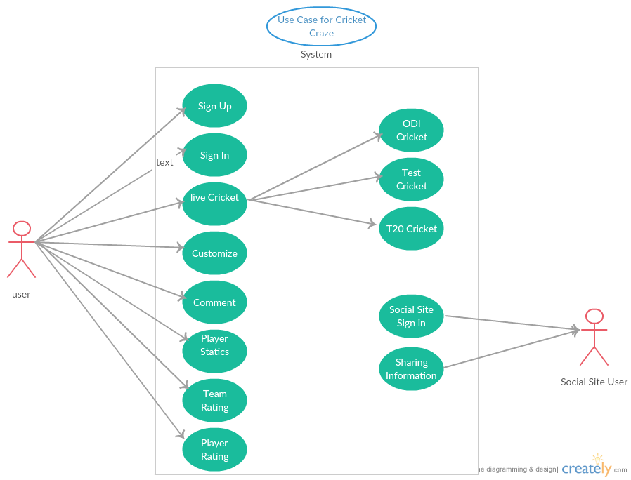

High level Use Case Diagram

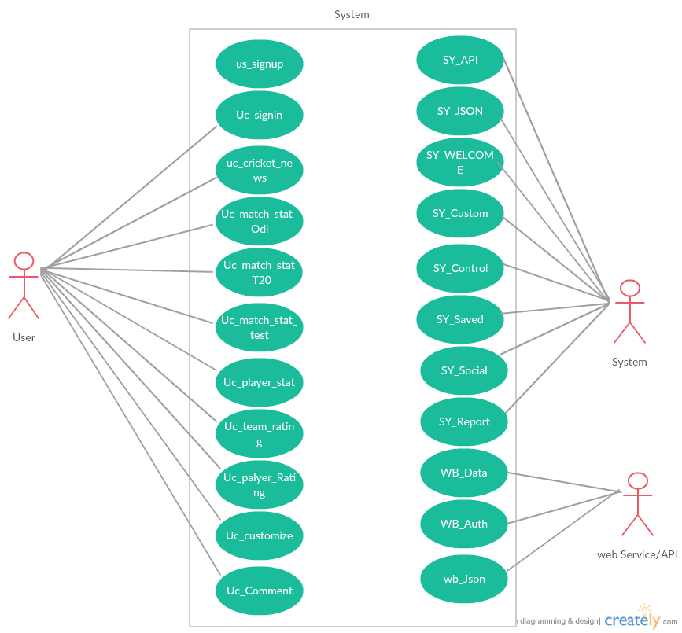

Class Diagram

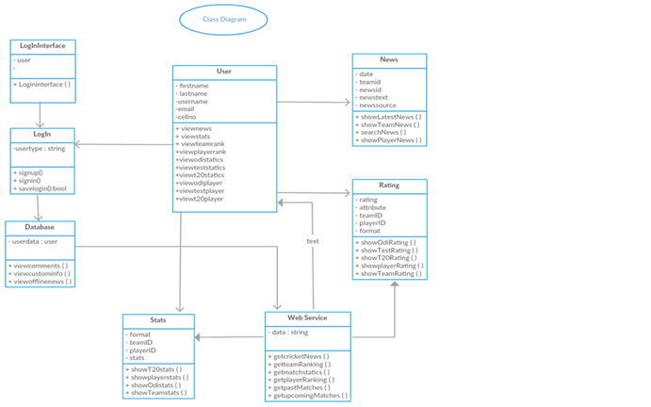

Sequence Diagrams

1: UC_Cricket_News

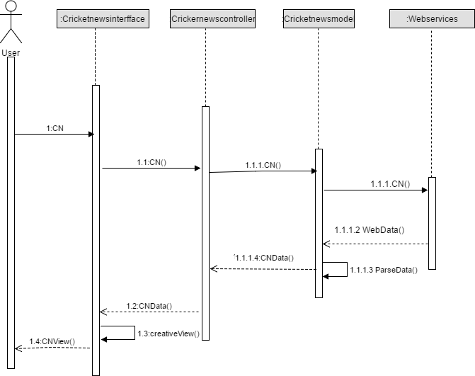
2: UC_Match_Stat_ODI

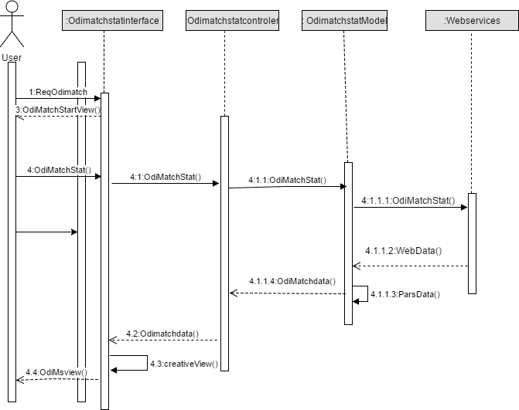
3: UC_Match_statt20

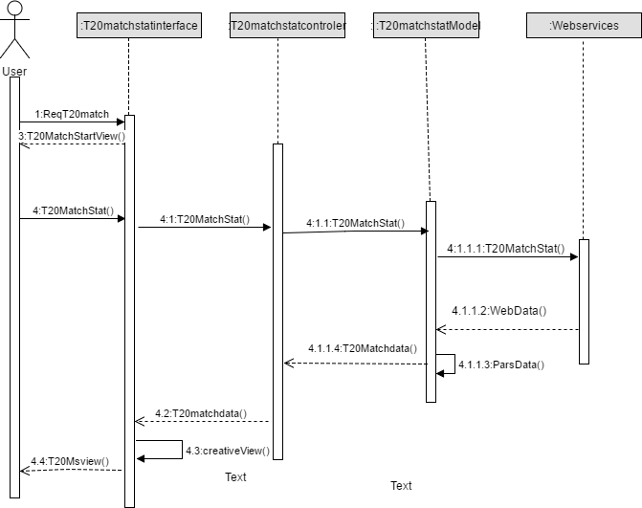

4:UC_Match_Stattest

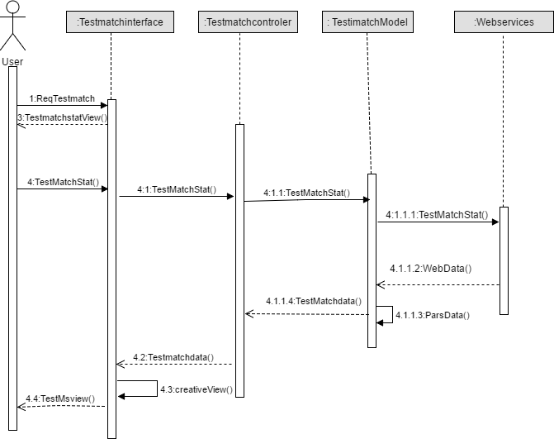

5: UC_Player_Rating

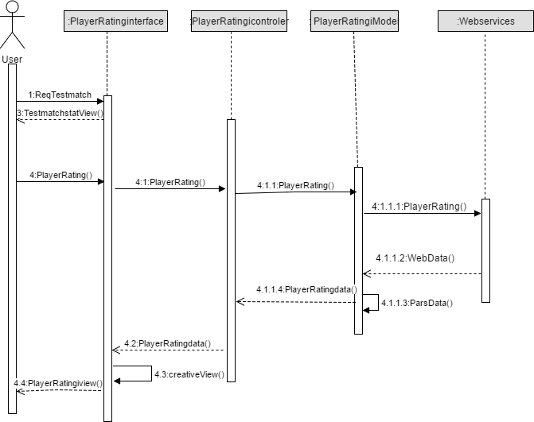

Function Point Analysis

Type of Component Complexity of Component
 | Low | Average | High | Total
External Inputs | 5*1 | 4*3 | 2*6 | 29
External Outputs | 4*2 | 3*5 | 4*7 | 51
External Inquiries | 3*3 | 4*4 | 5*6 | 55
Internal Logical Files | 2*7 | 2*10 | 4*15 | 94
External Interface Files | 5*5 | 6*7 | 7*10 | 137
Count Total |  |  |  | 366

Count Total = 366

Cost Factors:

Functionality | Degree of Influence
Data communications | 4
Distributed data processing | 0
Performance | 4
Heavily used configuration | 1
Transaction rate | 2
On-Line data entry | 3
End-user efficiency | 4
On-Line update | 1
Complex processing | 3
Reusability | 4
Installation ease | 0
Operational ease | 3
Multiple sites | 2
Facilitate change | 3
∑ Fi | = 34

Complexity Adjustment Factor (∑ Fi) = 34

Estimated Function Points:
The following relation is used to calculate the function points (FP):

FP est. = Count Total * [0.65 + 0.01 * ∑ (Fi)]

FP est. = 366* [0.65 + 0.01 * (34)] = 362
Total Function Points = 362

Labor rate = 40,000 Rupees/PM
Productivity parameter = 36 FP/PM

Total Estimated Effort:
Total Estimated effort = FP est. /Productivity parameter
Total Estimated effort= 362/36
Total Estimated effort = 10.05 PM

Cost / FP:
Cost / FP = Labor Rate / Productivity Cost / FP = 40,000/36
Cost / FP = Rs 1111.11/FP

Total Project Cost:
Total Project Cost = FP est. * (cost / FP)
Total Cost =362 * 1111.11
Total Cost = Rs 4,02,222

Implementation
The Implementation is as it is installed on the phone which is as follows:

- Home Page
- Old Matches News
- Upcoming Matches News
- Live Matches
- Live Score Card
- Teams in ICC
- ICC Country Profile
- Player Profile
- Player History
- Batting Score Card
- Balling Score Card
- Country History with respect to Ranking
- News
- Team versus

Code Snippets: (Home)

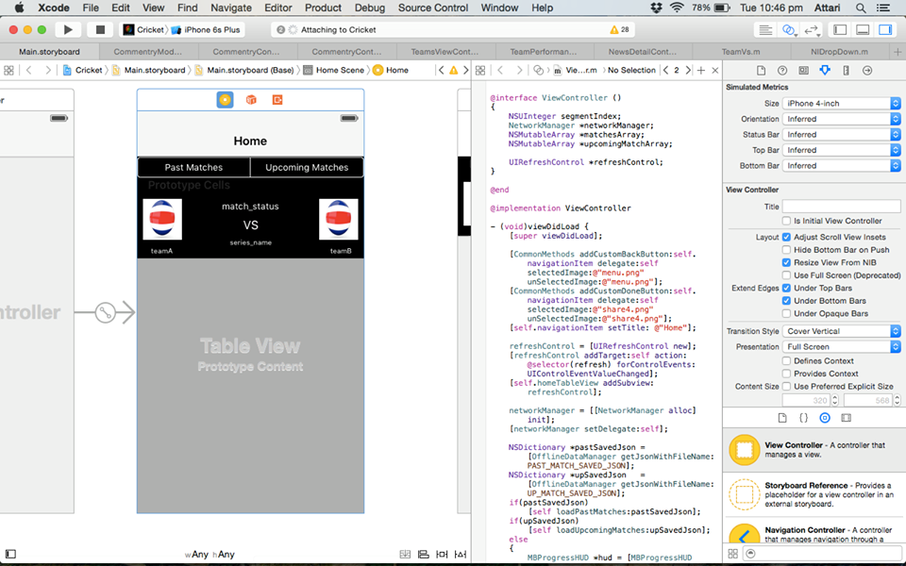

Code Snippets: (Live Match)

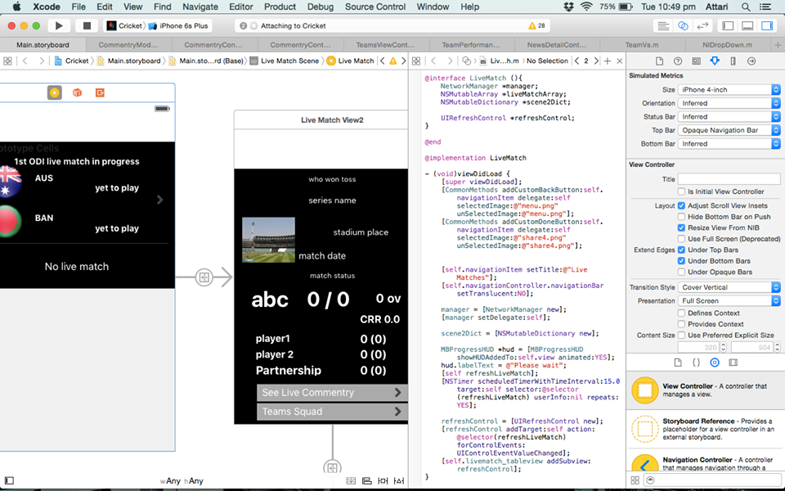

Code Snippets:( News )

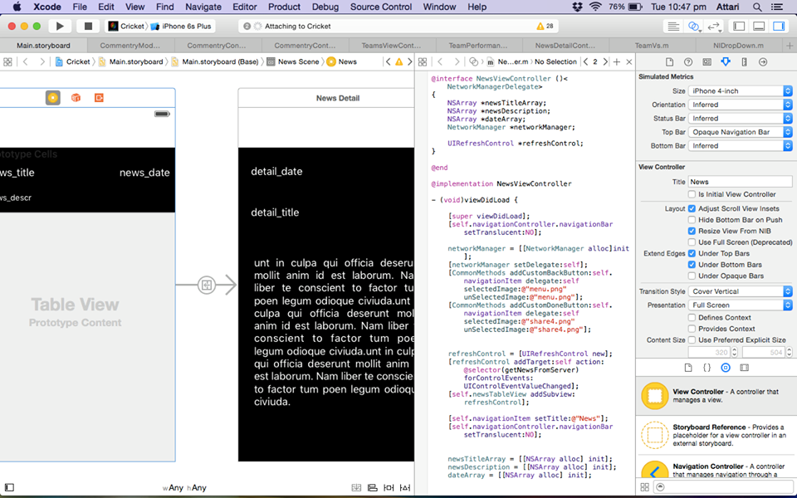

Code Snippets: (Ranking)

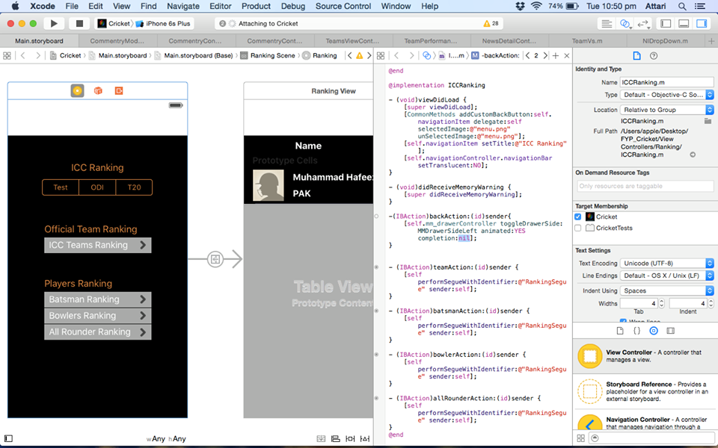

Code Snippets: (Player History)

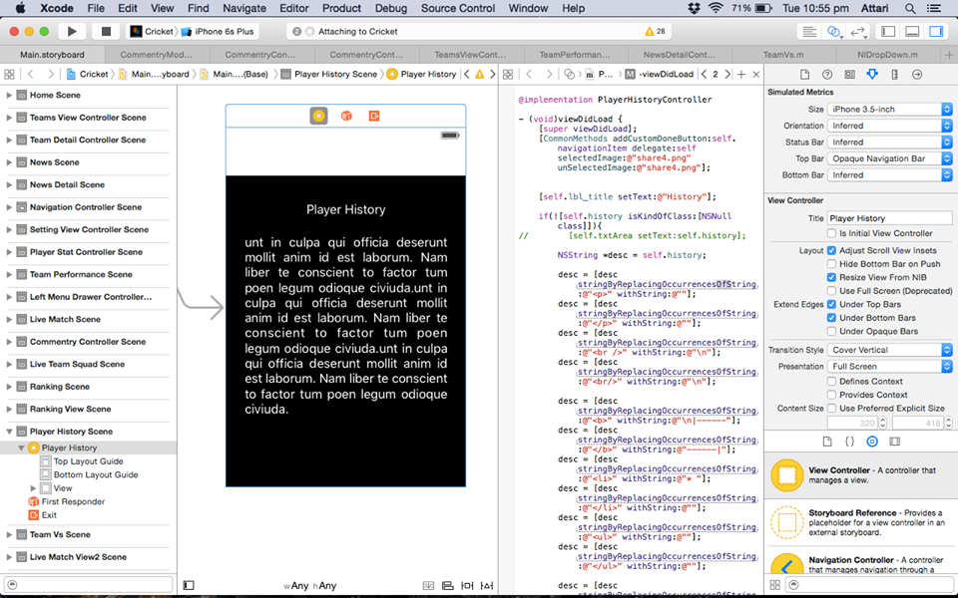

Code Snippets: (Records)

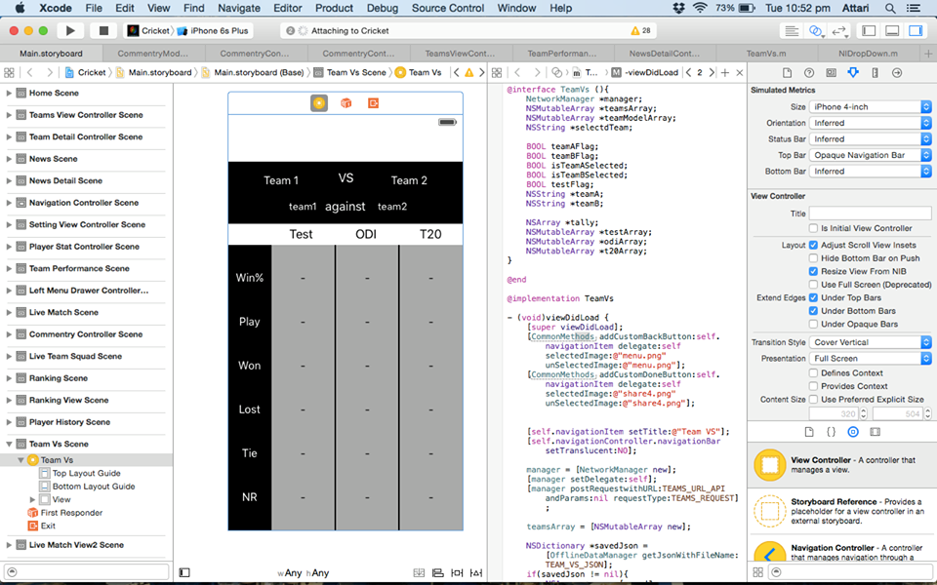

Code Snippets: (Player Statistic)

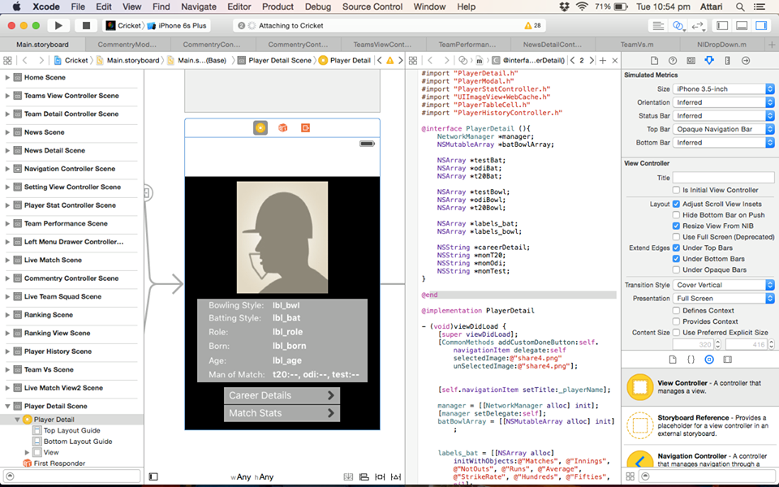
Home Page: tab(1)
The home page will show the listing of current matches that are played and the top tabs that show the old matches that have been played in the past. It was a very unique idea to share latest and upcoming matches in home screen we do it first time in our application.
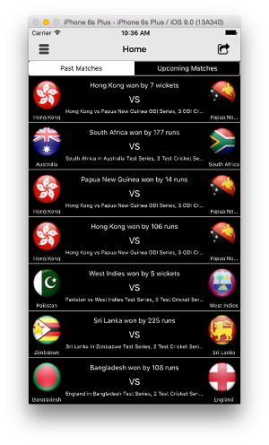
Home Page: Up Coming Matches (tab 2)
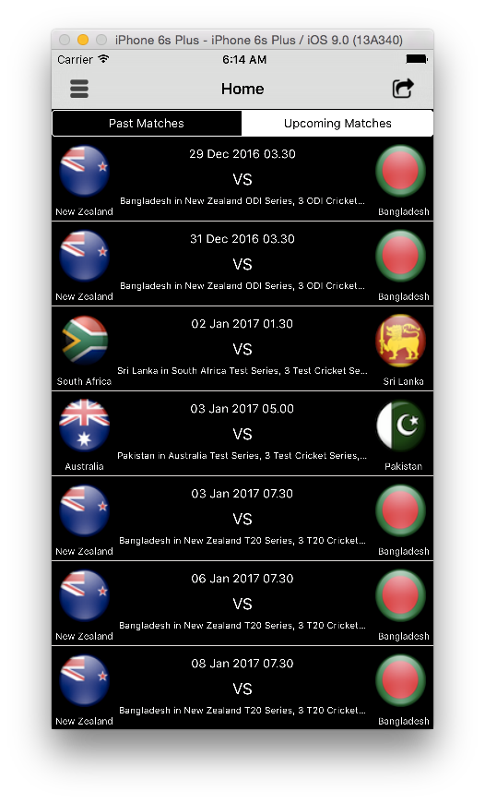

Match VS Stats:
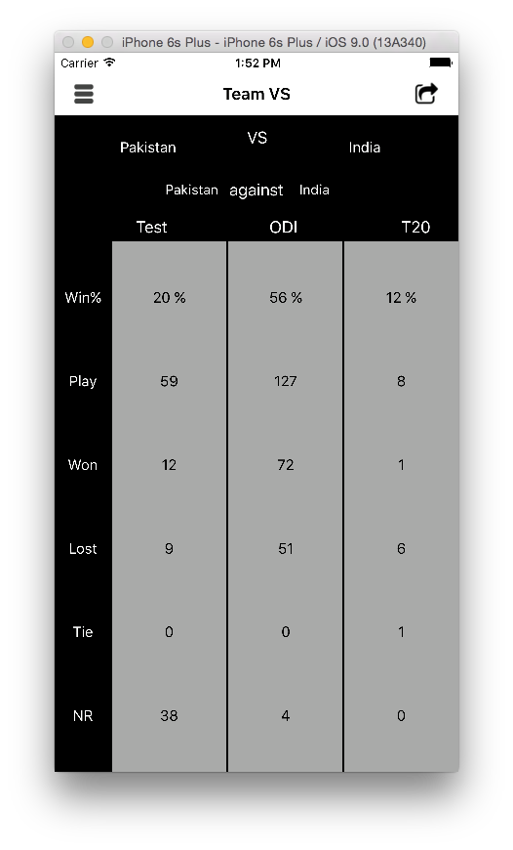
ICC Ranking:
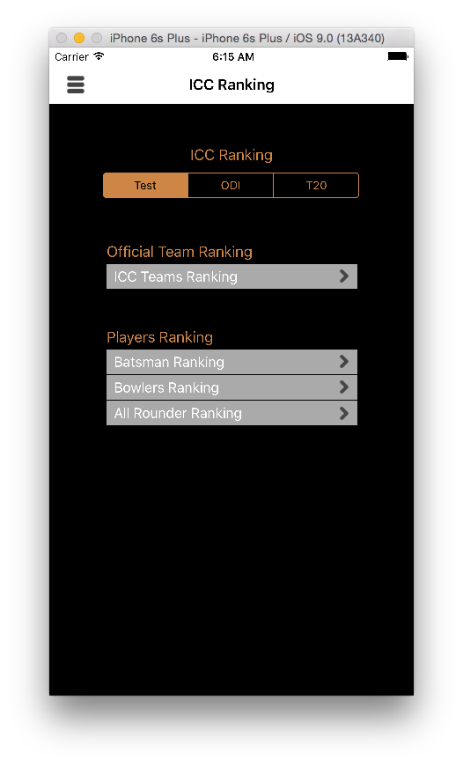
Live Matches:
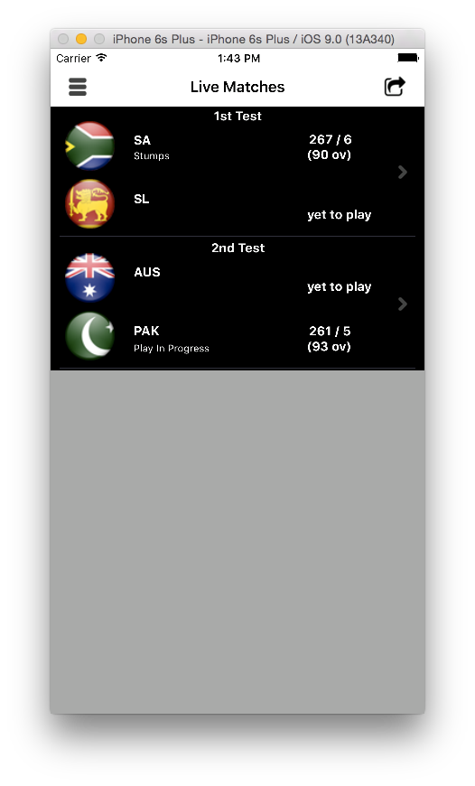
TeamSquad: (Team 1)
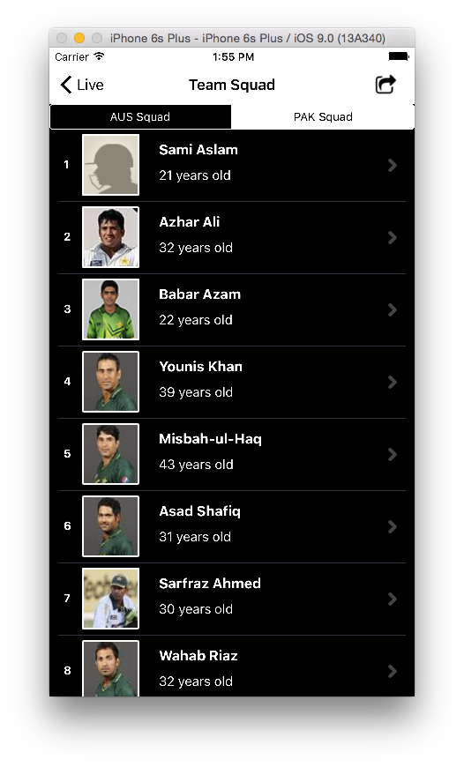
Team Squad: (Team 2)
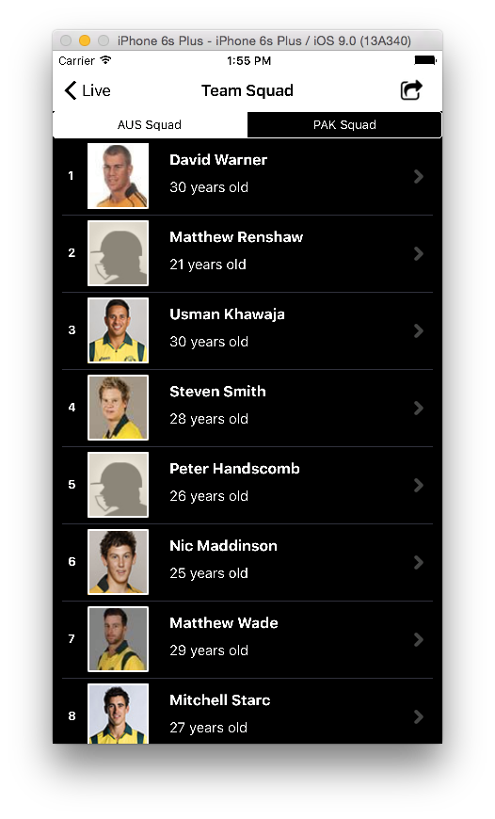
Innings:
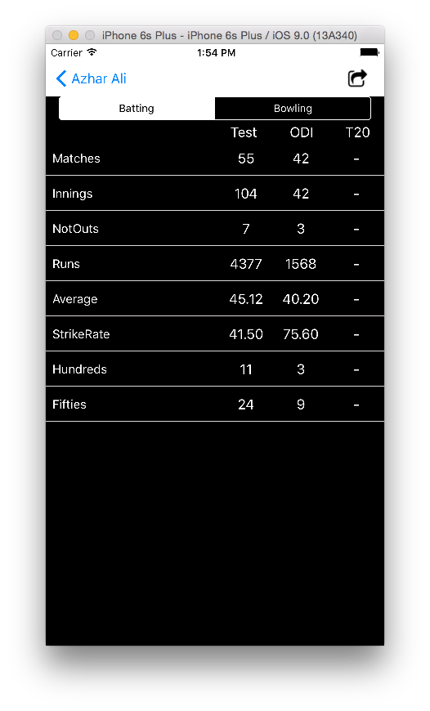
News:
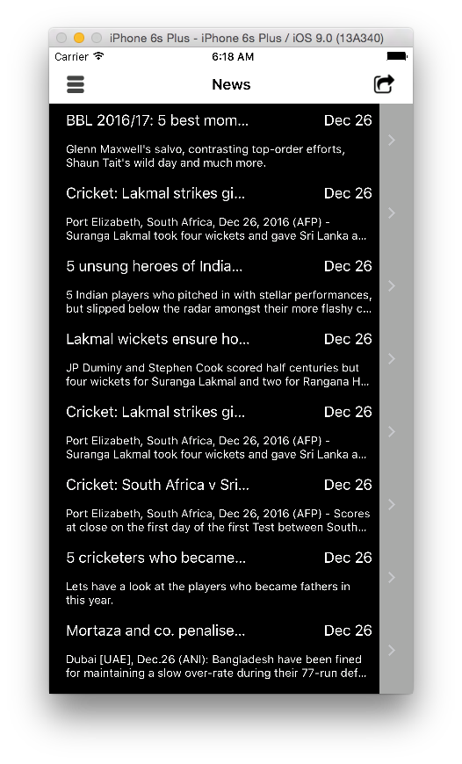
News Details:
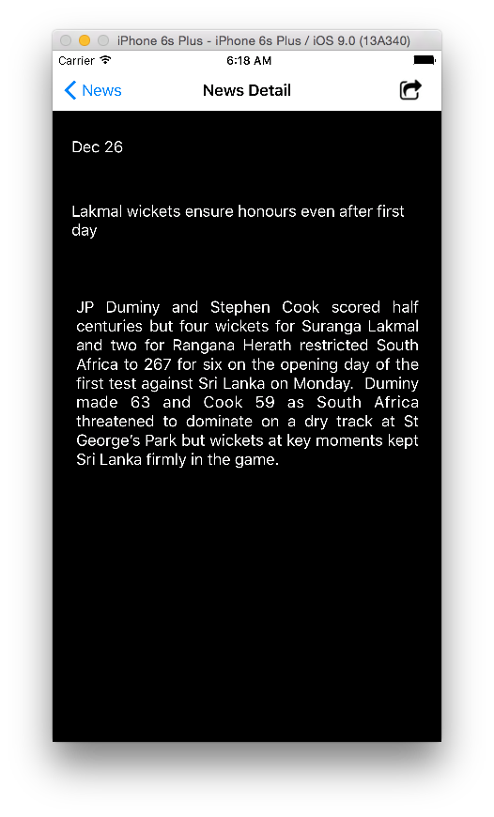
Upcoming Matches:
Clicking the Past matches tab on home page shows the old matches that have been played.
Team Members:
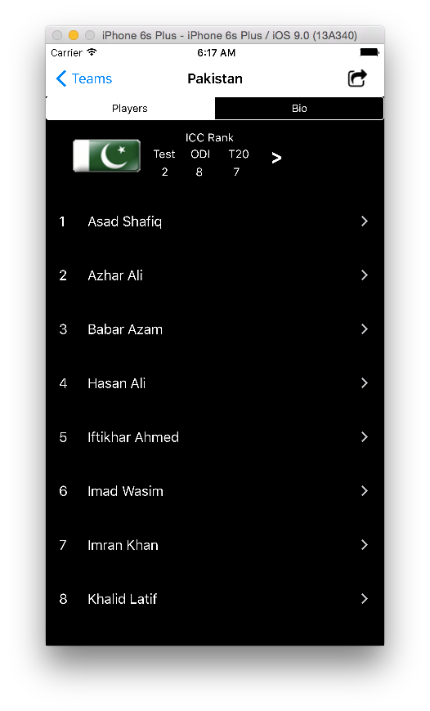
Team Member:
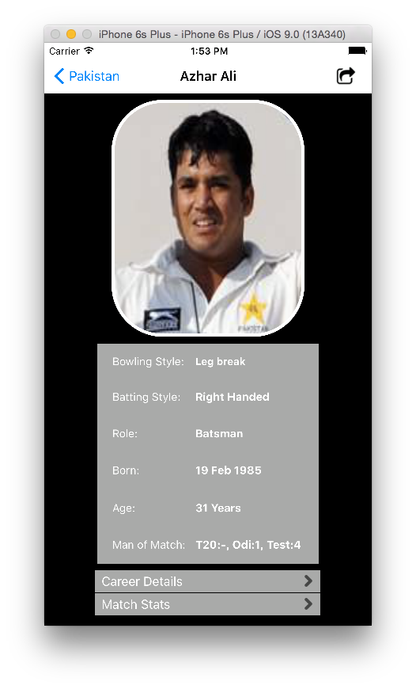
Player Stats:
Live Score Card:
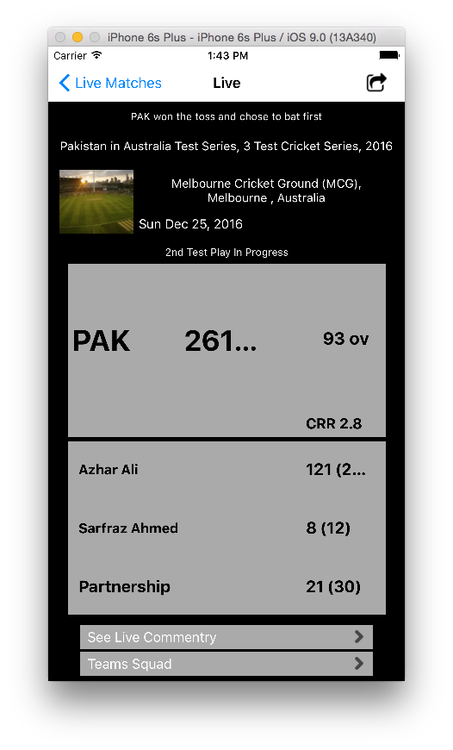
Live Player Score Record:
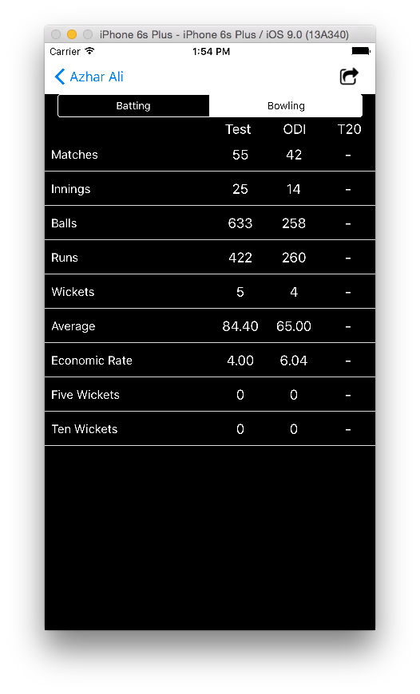
Live Commentary:
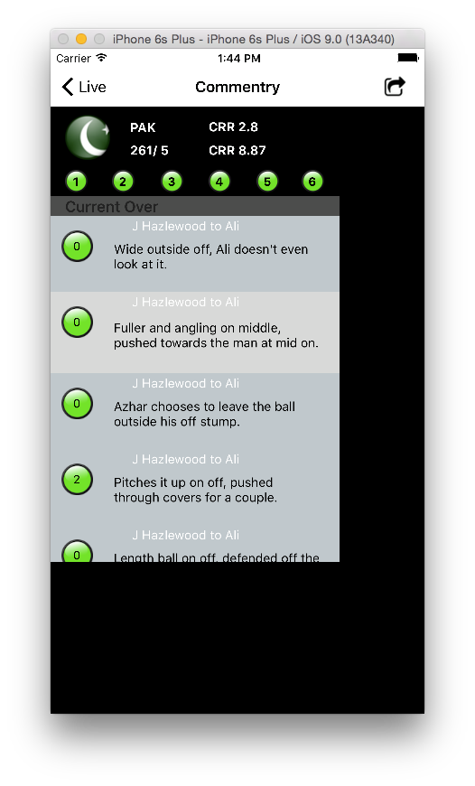
Caching On/Off Page:
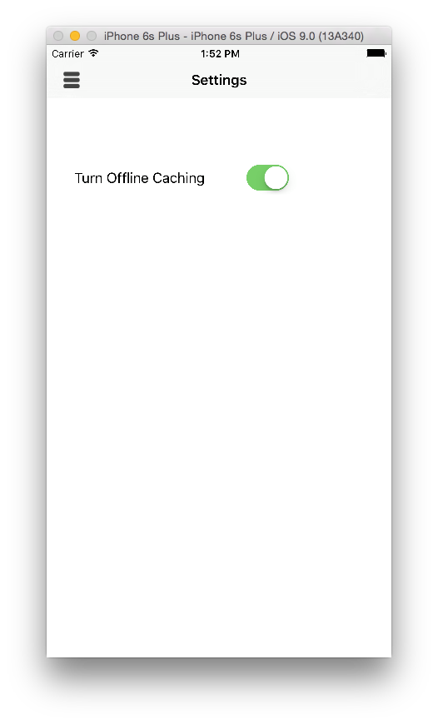
Social Sharing:
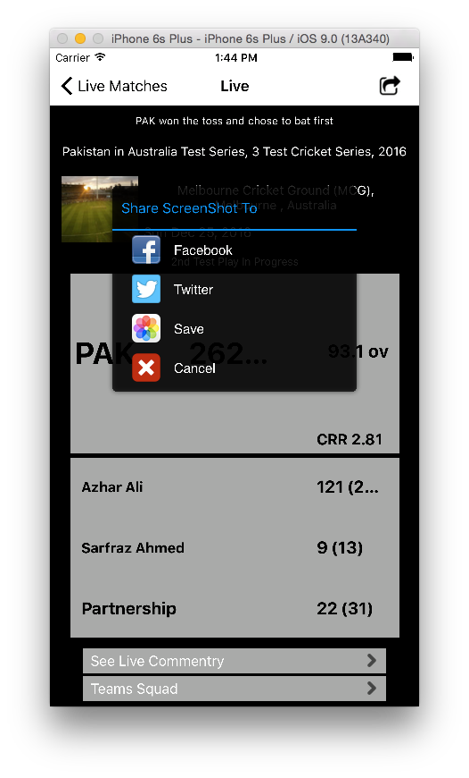
Teams in ICC:
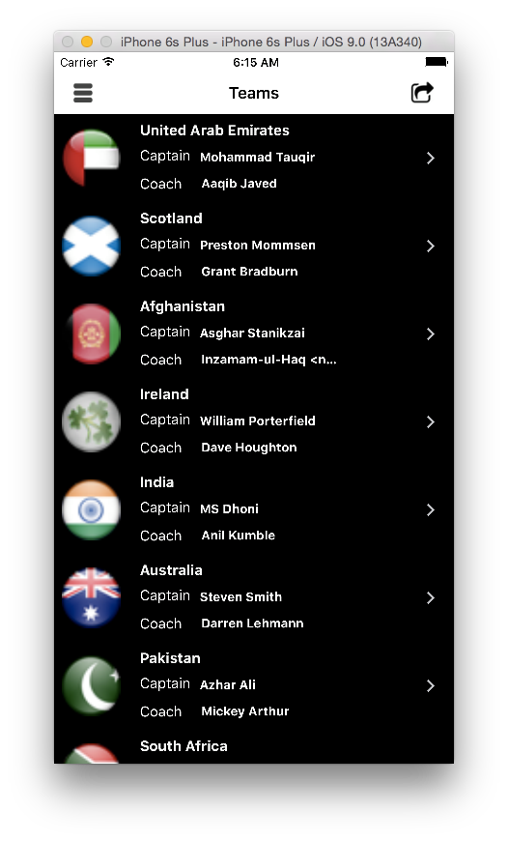
ICC Ranking:
Team History:
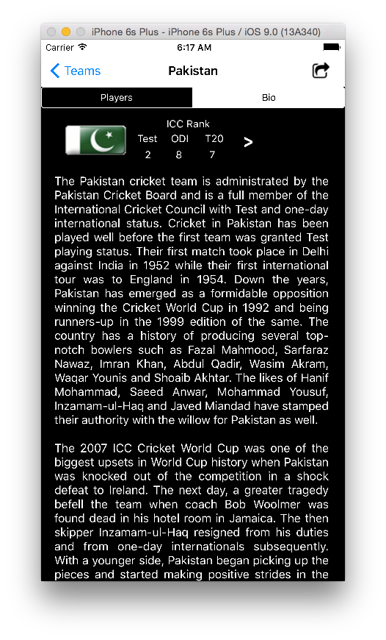
Player History:
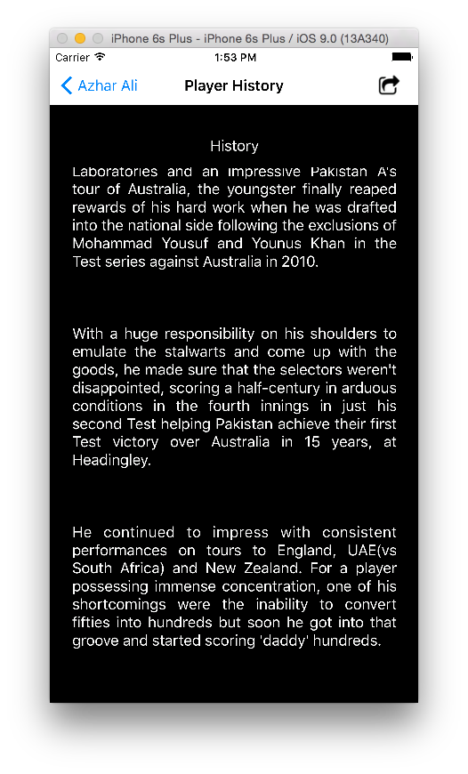

Completion\Accuracy\ Correctness

The application has been completed with the advisor onboard about the progress and completion of the project. The Application is 96% accurate to the intentions of the project and the concept of the application. The application in essence is 100% correct and working with compatible with most working Apple products. The real-time application user’s internet and at all-time connection to the internet while feeding the live matches. It has some challenges as we first had to find ways to communicate to server and get the information to display to the mobile screen. Then to keep the communication going to make the application as smooth as possible to improve the user experience. The complexity and difficulty was faced when the multiple users accessed the application. To make the application reliable and to cater hundreds of users at the same time the server was reconfigured to make smooth transactions with mobile devices. Then mobile caching to make the application useable in offline mode. Optimizing the server and client side code to make the application faster than before. This increased the application correctness and accuracy. The reliability of the application also increased as new phases of development came.

Conclusion

The application has been completed and awaiting to be uploaded onto the ios app sote. The account of ios app store is 99$ per years, this makes it diffuciult to uplaoad the application. The application has taught us about the application development life cycle and the journey that has to be taken to make an application.The application shall be usefull for users to be in contact with the live matches and know the summary of the match. Also they can see the bio and info about the matches and countries currelty in ICC. The comparision of teams with each other sets the application appart.It would be a good way to know that the application reaches the goal to reach to as many cricket lovers as it can.The application can have a positive effect on the native people of Pakistan and internatinal community as it displays the ingunity and ease of excepetnce of tecnhology in Pakitan. If given the rite marketing and media attention it can surge it’s popluarity among our fellow Pakistanies.If we can get a marketing support for the application we can make great strides in the application and make it reach out to more people that share the love of cricket.After the popularity of the cricket craze application we can switch to other sports that we can highlist and make games according to the support make our foothold stronger in moblie application arena.

Reference/Source Documents
- Hari Balakrishnan, Roshan Baliga, Dorothy Curtis, Michel Goraczko, Allen Miu, Bodhi Priyantha, Adam Smith, Ken Steele, Seth Teller, Kevin Wang MIT Computer Science and Artificial Intelligence Laboratory (CSAIL): November 7, 2003

- Nissanka B. Priyantha, Anit Chakraborty, and Hari Balakrishnan MIT Laboratory for Computer Science Cambridge, MA 02139 bodhi, achakra, hari

- Wood, G.H. (1945). Cricket scores and geometrical progression. Journal of the Royal Statistical Society, Series A, 108, 12-22.

- Cricket Analytics by Gamage Harsha Perera M.Sc., Simon Fraser University, Canada, 2011 B.Sc.(Hons.), University of Peradeniya, Sri Lanka, 2008

- Muller, E. : Paraller Manipulators- Towards New Application, I-Tech Education and Publishing, Wien (2008)

- Bhole, A.A., Mittal, R.K.: Cricket catching Drills- application of a redundantly actuated 2-DOF 3-UPS parallel platform in increase the efficacy of providing catching practice drills in cricket. In: Proceeding of the 3rd International Congress on Sport sciences research and technology support, pp.(2015)

- The Cricket Indoor Location system by Nissanka Bodhi Priyantha submitted to the deparment of electrical engineering and computer science in partial fulfillment of the requirement for the degree of doctor of philosophy in computer science and Engineering at the MIT,(2005

- Priyantha, N.B., Chakroborty, A., Balakrishnan, H.: The Cricket Location-Support system. MIT laboratory for computer science, Cambridge (2006)

- Getting Started With IBM Api Connect Concepts and Architecture Guide. Benjamin Wisnewski, Bhargav Perepa, IIene Seelemann, Kurtulus Yildirim, Rahul Gupta, Soad Hamdy, Vasfi Gucer.

- IOS Application Security, The Definitive Guide for Hackers and Developers David Thiel foreword by Alex Stamos.

- Architecture Resources for Enterprise Advantage (Functional Requirements and use cases) By Ruth Malan and Dana Bredemeyer, Bredemeyer Consulting.

- Web Development of a Cricket Progress File By Yousuf Al Hussaini MSC. Information Systems(2001/2002)

