King Edward Medical University Narowal Campus

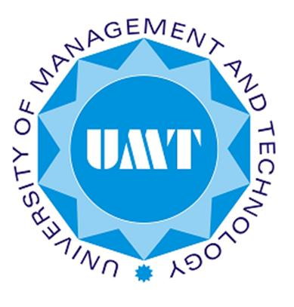

ADVISORS:
DR. SAIMA GULZAR
AR. ILYAS MALIK
AR. SARMAD SALLAHUDIN

SUBMITTED BY:
ABDUL REHMAN BUKHSH
ID.NO:13003101012

SCHOOL OF ARCHITECTURE AND PLANNING (S.A.P)
UNIVERSITY OF MANAGEMENT AND TECHNOLOGY
2018

