Hydraulic Remodelling of Irrigation Channel:
A Case Study of Upper Jhelum Canal



AUTHORS
HASEEB AKHTAR 14001132010
AAMIR SAEED 14001132036
TANEES UL HUSNAIN AHMAD 14001132024

SUPERVISOR
DR. MUHAMMAD USMAN RASHID
CHAIRPERSON OF CIVIL ENGINEERING DEPARTMENT

DEPARTMENT OF CIVIL ENGINEERING
UNIVERSITY OF MANAGEMENT AND TECHNOLOGY
LAHORE

July 2018
Hydraulic Remodelling of Irrigation Channel:
A Case Study of Upper Jhelum Canal

AUTHORS
HASEEB AKHTAR | 14001132010
AAMIR SAEED | 14001132036
TANEES UL HUSNAIN AHMAD | 14001132024

A Project submitted in partial fulfillment of the requirements for the degree of
B.Sc. Civil Engineering

SUPERVISOR
DR. MUHAMMAD USMAN RASHID
CHAIRPERSON OF CIVIL ENGINEERING DEPARTMENT
External examination signature: _______________________________
Project Supervisor signature: _________________________________

DEPARTMENT OF CIVIL ENGINEERING
UNIVERSITY OF MANAGEMENT AND TECHNOLOGY
LAHORE
July 2018

i
ABSTRACT
Hydraulic Remodelling of Irrigation Channel:
A Case Study of Upper Jhelum Canal

AUTHORS

HASEEB AKHTAR | 14001132010
AAMIR SAEED | 14001132036
TANEES UL HUSNAIN AHMAD | 14001132024

PROJECT SUPERVISOR: DR. MUHAMMAD USMAN RASHID
CHAIRPERSON OF CIVIL ENGINEERING DEPARTMENT
The thesis develops and implements the remodelling approach for large alluvial irrigation channels. The approach mainly includes in-depth analysis of original/existing design parameters, identification of existing condition of channel and hydraulic structures along with their problems, evaluating different options and finalizing the remodelling parameters by emphasizing hydraulic, structural and economic consideration. UJC in Pakistan was selected as case study channel. After visiting the UJC it was observed that canal was facing multiple problems like excessive silt deposition, erosion of banks, inadequate freeboard. The reason of these problems was canal operate at less discharge which has low velocity of flow that was not suitable for regime channel. Due to these problems bed width of the canal was enhanced and depth of the canal was reduced. The channel was modelled by HEC-RAS software at enhanced discharge for various structural scenarios and the best option was found to enhance the depth 13.55ft and keeping the bed width same 240ft to keep width to depth ratio in permissible limits due to economical consideration.
Hydraulic modelling of the hydraulic structures of the UJC including bridges were also conducted
ii
to check their suitability for remodeling of the channel at enhanced discharge. Most of the hydraulic structure were found safe to pass the enhanced discharge and only few structures required raising of their deck slab. The foundation of the hydraulic structures were checked and found safe for subsurface flow. The remodelling of UJC as per recommended parameters will ensure increased agriculture and power benefits and enhance conveyance efficiency.
Keyword-Upper Jhelum Canal, Remodelling, HEC-RAS, Alluvial channel, Hydraulic Structure.

iii
UNDERTAKING
.
We certify that research work titled “Hydraulic remodelling of irrigation channel: A case study of
UJC” is our own work. The work has not been presented elsewhere for assessment. Where material has been used from other sources it has been properly acknowledged and referred.

HASEEB AKHTAR
14001132010

AAMIR SAEED
14001132036

TANEES UL HUSNAIN AHMAD
14001132024

iv
ACKNOWLEDGEMENT
In the name of Allah the most Merciful and Beneficent
First and Foremost praise is to ALLAH, the Almighty, the greatest of all, on whom ultimately we depend for sustenance and guidance. We would like to thank Almighty Allah for giving us opportunity, determination and strength to do our research. His continuous grace and mercy was with us throughout our life and ever more during the tenure of our research.
A successful project can never be prepared by the single or the person to whom project is assigned, but it also demand the help and guardianship of some conversant person who helps in the undersigned activity or passively in the completion of successful project.
We are highly indebted to our project adviser, Dr. Muhammad Usman Rashid (Chairman of Civil Engineering Department, University of Management and Technology Lahore) for their continuous support, supervision motivation and guidance throughout the tenure of our project in spite of their hectic schedule who truly remained driving spirit in our project and their experience gave us the light in handling researched project and helped us in clarifying the abstruse concepts, requiring knowledge and perception, handling critical situations and in understanding the objective of our work.
We would also like to thank all the teachers of our Civil Engineering Department. They have supported us in this endeavor and appreciated us in our efforts during our project.
Lastly, we would like to express our deep appreciation towards our classmates and our indebt ness to our parents for providing us the moral support and encouragement.

v
TABLE OF CONTENTS
LIST PAGE NO
CHAPTER I
INTRODUCTION `
1.1 Problem statement 01
1.2 Objectives 02
1.3 Case study of UJC 02

CHAPTER II
LITERATURE REVIEW
2.2 Design discharge for remodelling of UJC 05
2.3 Evaluation of possible options 06

CHAPTER III
METHODOLOGY

3.1 Methodology for remodelling of UJC 08
3.2 Site visit to conduct condition survey of UJC 08
3.2.1 Excessive silt deposition and scouring 10
3.2.2 Erosion of banks 11
3.2.3 Inadequate freeboard 11
3.2.4 Side embayment and widened of channel section 12
3.2.5 Deteriorated condition of super structure of few hydraulic structures 13
3.3 Proposed solution 13

CHAPTER IV
INTRODUCTION HEC-RAS
4.1 Introduction of HEC-RAS 15
4.1.1 Working of HEC-RAS 16
4.1.2 Uses 16
4.2 Remodelling of UJC by HEC-RAS 16
4.3 Calibration and Validation 16
4.4 Existing condition of UJC 18
4.4.1 Design of UJC OF Existing design parameters ` 18
4.5 Average existing design parameters 20
4.6 Design of UJC by using proposed parameters (1st reach) 20
4.7 Design of UJC of Proposed design parameters (2nd reach) 22
3.8 Hydraulic modelling of hydraulic structures 24
3.7.1 Structural detail for hydraulic modelling of bridge 25

CHAPTER V
RESULTS AND DISCUSSION
5.1 Modelling on HEC-RAS OF Existing design parameters 26
5.2 Modelling on HEC-RAS OF Average design parameters 29
5.3 Modelling on HEC-RAS (1ST reach) 31
5.4 Modelling on HEC-RAS (2nd reach) 34
5.5 Modelling of Bridge 36

CHAPTER VI
CONCLUSIONS AND RECOMMENDATIONS
6.1 Conclusions and Recommendations 38

LIST OF FIGURES

LIST PAGE NO

Fig 1. Location of UJC 3
Fig 3. Widened channel section of UJC 9
Fig 2. Excessive silt deposition at UJC 10
Fig 4. Excessive Silt Deposition 10
Fig 5. Erosion of Banks 10
Fig 6 Inadequate freeboard 11
Fig 7. Inadequate freeboard 12
Fig 8. Side embayment of channel section 12
Fig 9. Methodology flow chart 12
Fig 10. HEC-RAS main window 15
Fig 11. Cross sectional profile 17
Fig 12. Bridge Cross section 25
Fig 13 Cross sectional profile 26
Fig 14. Longitudinal profile at discharge 2223 cusecs 27
Fig 15. Longitudinal profile at discharge 8893 cusecs 27
Fig 16. Longitudinal profile at discharge 12000 cusecs 28
Fig 17. Longitudinal profile at discharge 3000 cusecs 29
Fig 18. Longitudinal profile at discharge 7700 cusecs 29
Fig 19. Longitudinal profile at discharge 13000 cusecs 30
Fig 20. Cross-sectional profile 31
Fig 21. Longitudinal profile at discharge 6000 cusecs 32
Fig 22. Longitudinal profile at discharge 14850 cusecs 32
Fig 23. Longitudinal profile at discharge 16000 cusecs 33
Fig 24. Longitudinal profile at discharge 21000 cusecs 34
Fig 25. Longitudinal profile at discharge 8500 cusecs 35
Fig 26. Longitudinal profile at discharge 10671 cusecs 35
Fig 27. Longitudinal profile of Bridge 36

LIST OF TABLES

LIST PAGE NO

Table 1: Existing design parameter 18
Table 2: Average Existing Design Parameters 20
Table 3: Proposed Design Parameters 20
Table 4: Proposed Design Parameters 22
Table 5: Structural detail of bridge 25
Table 6: Existing Design Parameters 26
Table 7: Profile Summary 28
Table 8: Profile Summary 30
Table 9: Proposed Design Parameters 31
Table 10: Profile Summary 33
Table 11: Proposed Design Parameters 34
Table 12: Profile summary 36
Table 13. Profile Summary 37

CHAPTER I
INTRODUCTION
Remodelling of water system channel is a procedure of re-establishing or modernization of existing framework including every hydraulic driven structure at same/altered outline parameters. Food and Agriculture Organization (FAO) (2002) explained that complete diagnosis including the execution, current condition, unique plan and other insufficiencies are vital for renovating and modernization of any water system framework.
Pakistan is a country of over 141 million people, which is expected to grow to about 221 million by the year 2025. The increasing population will have a major impact on food, power and domestic water requirements. The Indus Basin Irrigation System comprises three major reservoirs, 16 barrages, 2 headwork’s, 2 siphons across major rivers, 12 inter river link canals and 24 canal systems (all in Punjab) and more than 107,000 watercourses. The aggregate length of the canals is 37,314 miles (60,376 Km). In addition, the watercourses, farm channels and field ditches cover another 1 million miles (1.6 million km). Halcrow, (2002) stated that watercourse commands range between 200 and 800 acres (80 to 320 ha). The System also utilizes an estimated 41.6 MAF (51.3 BCM) of groundwater pumped through more than 800,000 tube wells (mostly private) to supplement the canal supplies. In addition, there are over 200 civil canals in NWFP, which irrigate about 0.82 Ma (0.33 M ha) and are managed by local tribal populations.
Ashraf et al (1999) said that the importance of efficient use of irrigation water is necessarily increasing as the world population is increasing. At this stage the country would need more food and fiber to meet the needs of growing population. This shortfall can be met either by constructing new reservoirs or irrigation water management at canal command level. Irrigation water management includes improvement of physical infrastructure for distribution of water from source to the crops and water management at the farm level.

1.1 PROBLEM STATEMENT
The location was visited during flow and closure periods of the canal to observe existing condition of the channel and hydraulic structures. Some problems observed during the site visit include but are not limited to:
- Excessive silt deposition
- Scouring
- Erosion of banks
- Inadequate freeboards
- Side embayment
- Widened channel section
- Deteriorated condition of super structure of some hydraulic structure
The channel was unable to run at the design discharge and therefore required remodelling.

1.2 OBJECTIVES
- To study HEC-RAS software.
- Hydraulic modeling of two typical reaches of UJC at varying discharge and structural parameter.
- Hydraulic modeling of one of the bridges of UJC to check its suitability of for remodelling for the channel
at enhanced discharge.

1.3 CASE STUDY OF UPPER JHELUM CANAL
Punjab Irrigation Department (PID) (2017) UJC through put from Mangla head works of Jhelum River. It was planned in 1904 and authorized in 1915 most importantly as a feeder channel to supplement the supplies of Khanki headwork’s at Chenab River to lower Chenab Canal system. It has total length of 142 km and the original designed discharge was 12800 ft³/sec. Its total and culturally command areas were 642447 and 603749 acres respectively. However the channel was replanned in 1941. It supplied water for two hydropower stations as a Rasul and Shadiwal having power potential of 22 and 12 MW respectively built later on. UJC also fulfils the water requirement of Khanki headwork’s of river Chenab during low flows in river Chenab. After assigning of Mangla dam and Mangla power house a new channel Bong Canal having designed capacity of 49000 ft³/sec was constructed. The Bong Canal throughput from Mangla power houses for feeding irrigation requirement of UJC and the downstream water requirement at Rasul barrage. Figure 1 shows the location of UJC.
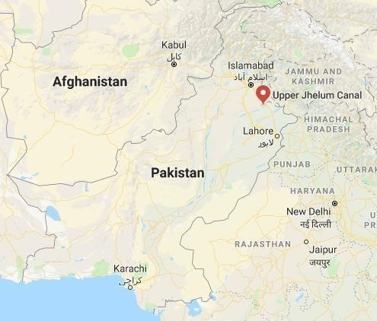
Fig. 1: Location of Upper Jhelum Canal

CHAPTER II
LITERATURE REVIEW
Shakir and Khan (2009) investigated the structural involvement for the possibility and effectiveness of Marala Ravi link canal in Pakistan. By enhancing the crest level, the sedimentation intake in Marala Link canal reduced but sediment enter into its off take canal did not reduced. Tariq and Latif (2010) recommended to reduce water losses due to high water allowances during May to July, When channel was operating at 80 to 90% of design discharge. However, it reduces to 70 to 90% during August to April.
Food and Agriculture Organization (FAO) (2000) stated that the essential parameters can change the idea, structure, and plan of irrigation system for the innovation of water system. It considered in modernization of systems, operation and support of future needs. The arrangement of sustenance and fiber necessity of individuals was one of the difficulties of this century. To satisfy these essential needs of rapidly increasing population water assets and water system framework to productively take water up to fields are most extremely critical issues. Rashid, (2014) stated that Pakistan has one of the largest irrigation system of the world, that consist of 12 interlink canal 16 barrages 45 canal systems 3 major reservoir 0.1 Million tertiary channels. This system utilized 51.3 (BCM) and 0.8 Million tube wells to fulfils the water requirement. Shakir et al (2008) proposed the current water requirement and availability for canal management includes remodelling of hydraulic structures, firming the canal banks, distributaries and minors for the development of irrigation system.
Shakir and Maqbool (2011) assessed the problem of Upper Chenab Canal. The economical solution for remodelling of channel was found to be increasing the water depth instead of width of the channel. This solution for remodelling of canal was feasible by technically and economically. Lashariteh and Murray (2000) suggested that food organization should make sure for the remodelling of channel along with monitoring and ensuring equitable distribution. Qureshi (2013) observed that the amount of sediment flows in a channel was dependent upon the nature of relationship between discharge and sediment load as well as the distribution rate of the discharge in the channel. So, determining the suitability for quantification channel forming discharge was the first step in river channel engineering.

2.1 DESIGN DISCHARGE FOR REMODELlING OF UJC
The original design discharge of the channel was 12800 cusecs (as of 1915). The channel was redesigned for 8893 cusecs due to less availability of water in 1941 according to Manning's formula. There was no provision of supplies for two power houses namely Rasul and Shadiwal when the canal was designed in 1915 and 1941. During last 10 years, the channel has been operated at less discharge. It has been noticed that only 116 m³ /s has passed downstream khokhra (77.77 3 km of UJC) against the allocated discharge of 185 m³ /s during last several years. The possible reasons for less discharge are: i) the less availability of water and ii) inability of the channel (Middle and tail reaches) for safely carrying the original design discharge. The current authorized head and tail discharges of the UJC 3 are 255.7 m³ /s (9030 cusecs) and 222.8 m³ /s (7868 cusecs). The design discharge of an irrigation channel is usually based on cultivable command area (COCA) and sanctioned water allowance. The design discharge for remodeling may be enhanced by assuring the additional water through water availability studies. Pakistan Drainage Consultants (PDC) discussed that perennial irrigation channel should be at least designed at reliability of 80% available water. The increase in CCA and commissioning of power houses necessitates updating the design discharge for the remodeling. The raising of Mangla Dam in 2009 has enhanced its live storage capacity from 4.51 to 7.39 MAF. The Mangla reservoir has 2.88 MAF additional storage available which may be used for acquiring power and agriculture benefits. The additional water may be utilized for enhancing the discharge of UJC as per Water Apportionment Accord among the provinces of Pakistan. Punjab Irrigation Department (PID) proposed the revised capacity of UJC by computing the discharges of all off takes, power houses and losses as follows:
- Discharge for off takes of Azad Kashmir = 52.93 cusecs
- Discharge for Rasul Power House = 3620 cusecs
- UJC Internal (Gujarat Branch & other off takes) = 2037 cusecs
- Shadiwal Power House = 7795 cusecs
- Approximate conveyance losses = 1355 cusecs
- Total Revised Capacity of UJC = 14850 cusecs

2.3 EVALUATION OF POSSIBLE OPTIONS
The possible options for remodeling are as follows:
- To remodel the canal for existing discharge of 7700 cusecs at existing hydraulic parameters and fulfill the needs of Shadiwal power house and Khanki headwork’s at Chenab River for Lower Chenab Canal system through some alternate route including developing new channel.
- To remodel the channel for increased discharge of 14850 cusecs by minimum variation of existing parameters i.e. bed and water levels, longitudinal slope, water depth and bed width.
The 1 option for remodeling was analyzed technically and economically. The present condition indicates that the bed width of the channel has substantially increased from 230 to 330 ft. in the middle and tail reaches and full supply has reduced from 10.2 to 5 ft. Moreover, recommended freeboard of 3 ft. was not available. The width to depth (B/D) ratio of the channel has enhanced up to 55. The channel does not provide the desired velocity and results in high conveyance losses and sediment deposition. The existing condition of the channel presents the view of a natural river. The existing dimensions and parameters of the channel including water depth, bed width, velocity and others are not considered hydraulically feasible for 3 remodeling of UJC at 7700 cusecs. The development of new channel would involve cost of acquiring new land, constructing several hydraulic structures, availability of good soil and construction material (cement, sand, crush, steel etc.) including engineering services which seems to be very expensive. The acquiring of land is also very complicated and time consuming process.
The site visit indicated few problems in technical design of the new channel in setting its alignment due to physical constraints including displacement of roads and other infrastructure. This option is not considered technically and economically feasible. The cost will be much higher as compared to the 1 option.
The 2 option of remodeling of the UJC at enhanced discharge seems to be feasible. The channel was originally designed for discharge more than 12800 cusecs. The enhanced discharge is only about 15% more than the original discharge in 1904. The channel was originally designed in 1904 on the basis of Manning's formula. The approved L-Section shows that the basis of redesign in 1941 was again on Manning's formula by keeping the roughness coefficient (n) of soil as 0.0225.
Critical review of different design approaches including Lacey regime method, Tractive force method and Manning's formula have been carried out for their suitability of redesign of UJC. These methods proposed change in bed width, full supply depth and longitudinal slope of whole channel. The change in these parameters would require re-construction of UJC along with its hydraulic structures which will increase the remodelling cost. It would also require the cost of land acquisition and construction of diversion channel. The preliminary investigation indicated that remodeling of UJC at existing parameters along with enhanced depth would be economical solution. In this case, only earthwork of banks would be desired. However, to bring the existing bed width (722 to 1180 ft.) to original bed width of 722 m would involve huge earthwork along with removing of earthwork. The remodeling of channel at existing bed width and longitudinal slope and by changing depth will reduce the remodeling cost to a great extent. However, the increased existing bed width of the channel does not provide stable and efficient design.

CHAPTER III
METHODOLOGY

3.1 METHODOLOGY FOR REMODELlING OF UPPER JHELUM CANAL
Project proposal was prepared for remodelling of alluvial irrigation channel. After proposal preparation, Literature Review was carried out and conduct the survey was conducted to access the existing condition of channel. The data was collected for the remodelling of alluvial irrigation channel along with hydraulic structure by Irrigation department. Analysis of data was carried out by different possible options. Study of HEC-RAS software was done for remodelling of irrigation channel. Hydraulic Remodelling of UJC was carried out by Manning’s approach. Finalize the remodelling of channel based on hydraulic structural economic consideration. Figure 1 shows the flow chart of methodology.

3.2 SITE VISIT TO CONDUCT CONDITION SURVEY OF UJC
The site was visited during flow and closure periods of the canal to observe existing condition of the channel and hydraulic structures. Some problems observed during the site visit include but are not limited to:
- Excessive silt deposition and scouring
- Erosion of banks
- Inadequate freeboard
- Side embayment and widened channel section
- Deteriorated condition of super structure of some hydraulic Structures
Figure 3 shows excessive silt deposition at UJC and figure 4 shows widened channel section of
UJC.
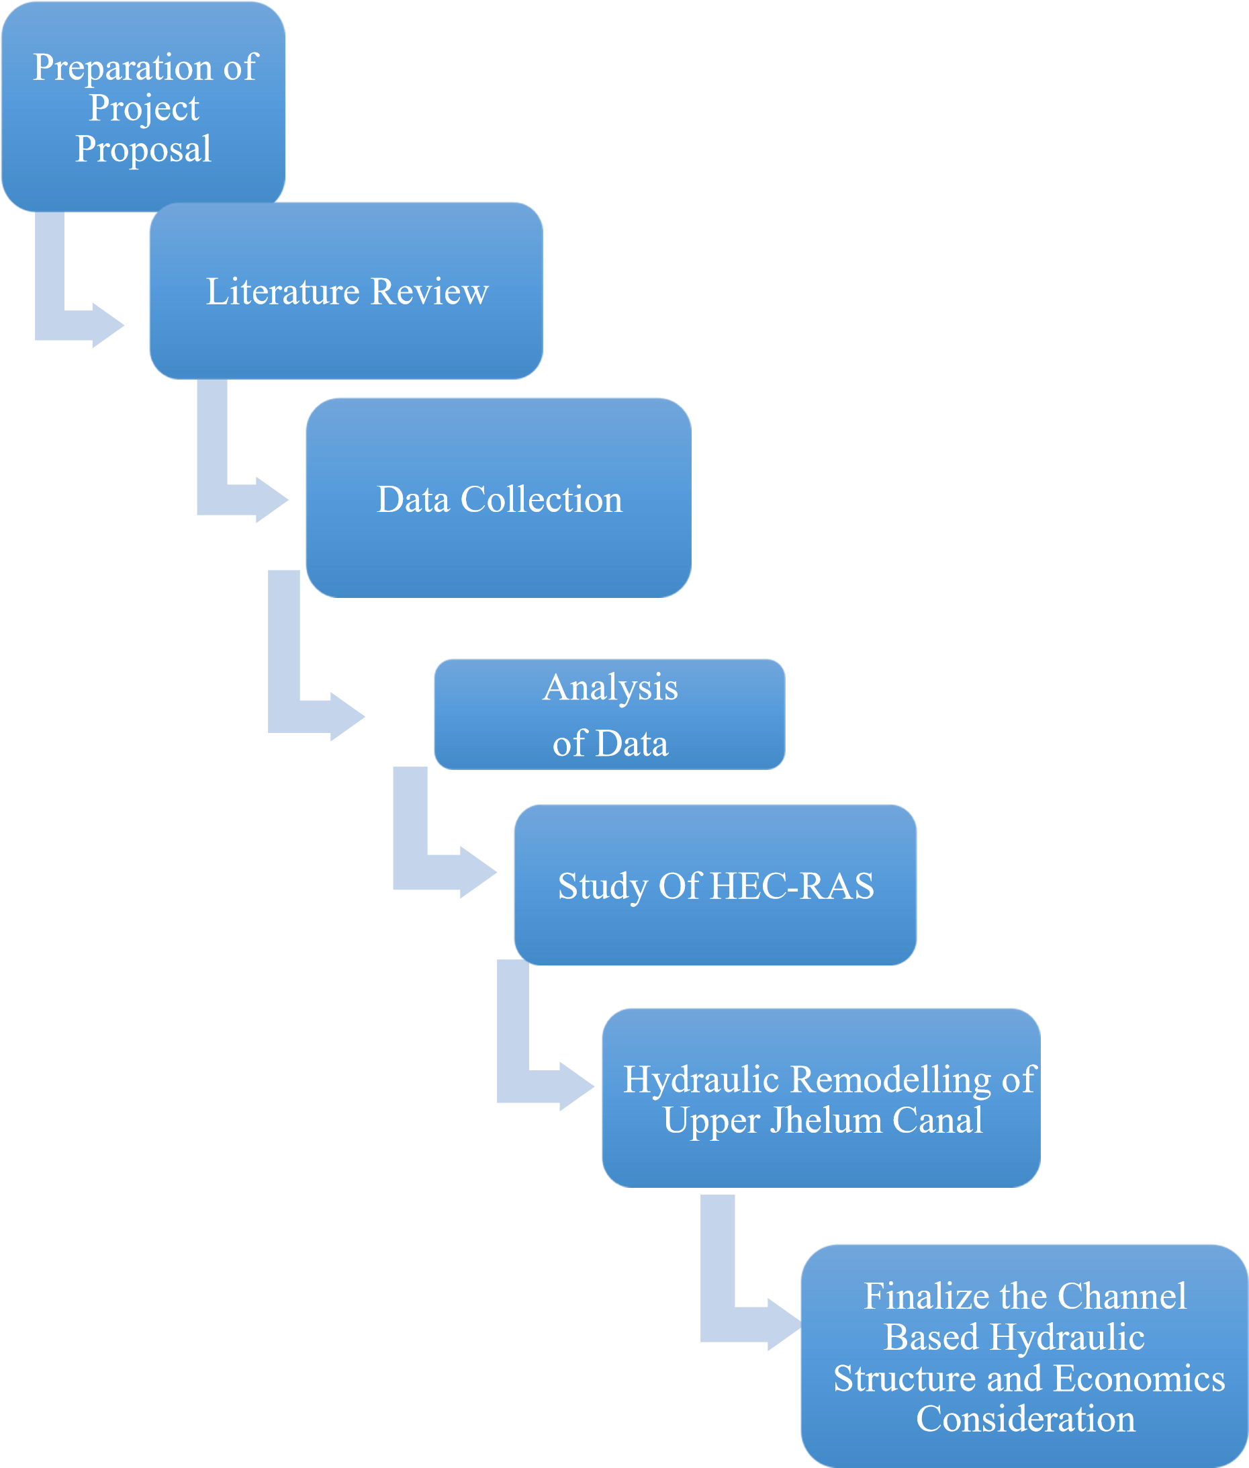
Fig. 2: Methodology Flow Chart
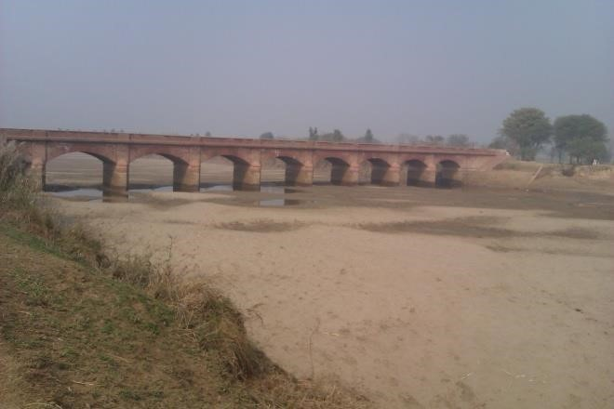
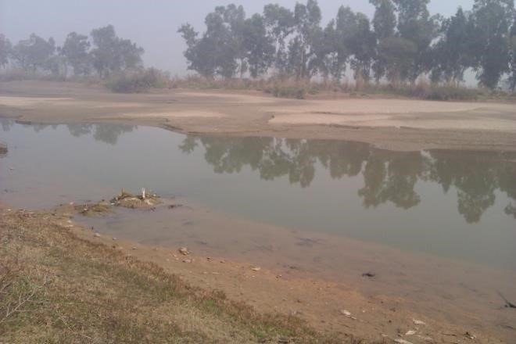

Fig. 3: Excessive silt deposition Fig. 4: Widened channel section UJC
3.2.1 EXCESSIVE SILT DEPOSITION AND SCOURING
The channel bed was found slightly scoured in few head reaches up to RD 244+000. However, excessive silt deposition was observed through the entire reach of the channel from RD 244+000 to 418+000 (Tail). The silt deposition was measured at some locations and found in the range of 35 ft. the longitudinal section of the channel shows that the head reach was constructed by cutting local soils whereas middle and tail reaches were constructed in filling of local soil. A typical photograph of excessive silt deposition of UJC is shown as figure 1. The channel was found widened oddly in tail reaches and became nonoperational at design discharge. Figure 5 shows the excessive silt deposition.
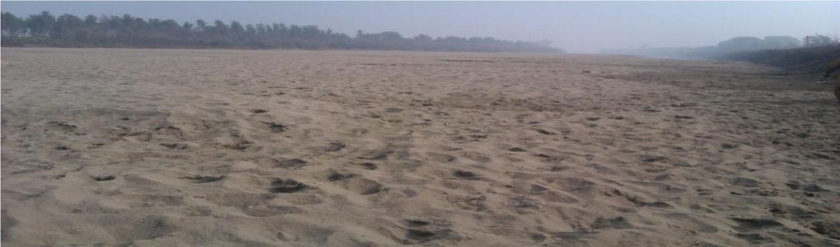
Fig. 5 Excessive Silt Deposition

3.2.2 EROSION OF BANKS
The banks of the channel were found eroded in several reaches throughout the channel and especially in the tail reaches. Apparently banks seem to be made of local soils having less cohesive particles. Excessive bank erosions have also caused excessive water losses, less efficiency of canal system and canal breaches. The erosion of banks is also one of the problems which do not allow the canal to be operated at its design discharge. Figure 5 shows erosion of banks at typical location of UJC.
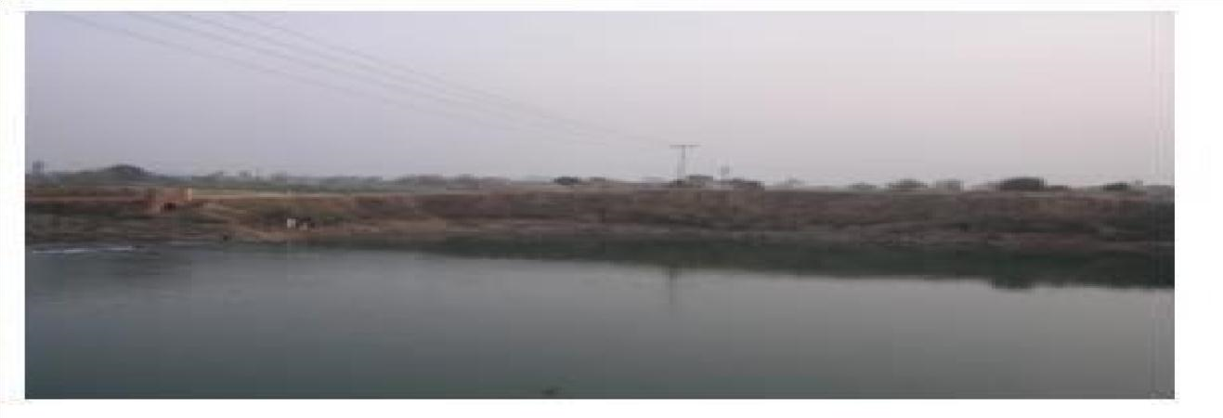

Fig. 6 Erosion of Banks

3.2.3 INADEQUATE FREEBOARD
During condition survey, the water marks on the banks confirmed that recommended freeboard of 3 ft. was not available in some reaches of the channel because of bank erosion, weather action, less maintenance and widened sections. It resulted in canal operation at lesser discharges compared with the design discharge. The canal has been run at even less than 50% of its design discharge since last 10 years. The freeboard was also found short at the upstream of some hydraulic structure. Figure 7 and 8 depict typical inadequate freeboard of UJC.
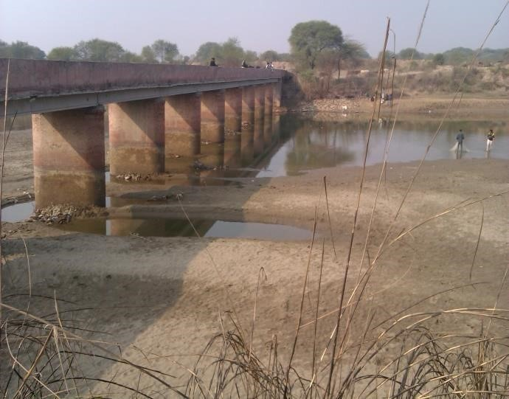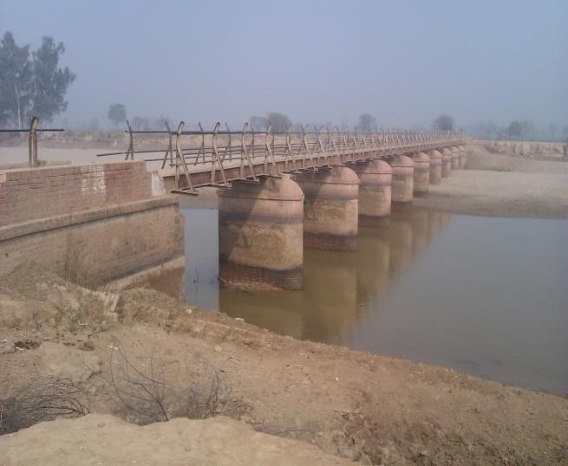
Fig.7 Inadequate freeboard Fig.8 Inadequate freeboard

3.2.4 SIDE EMBAYMENT AND WIDENED OF CHANNEL SECTION
The side embayment was observed at downstream of hydraulic structures of UJC. The channel was constructed by fluming the channel width at hydraulic structure to reduce the construction cost. The transition provided for divergence and convergence of flowing water at downstream and upstream was found unproductive. Figure. 9 shows the excessive side embayment and widened section of UJC resulting in non-operation at its required design discharge. The currents generated downstream of these structures traveled long distances along the canal before merging into normal depth of streamline flow. The undulating flow pattern generated channel instability and side embayment.

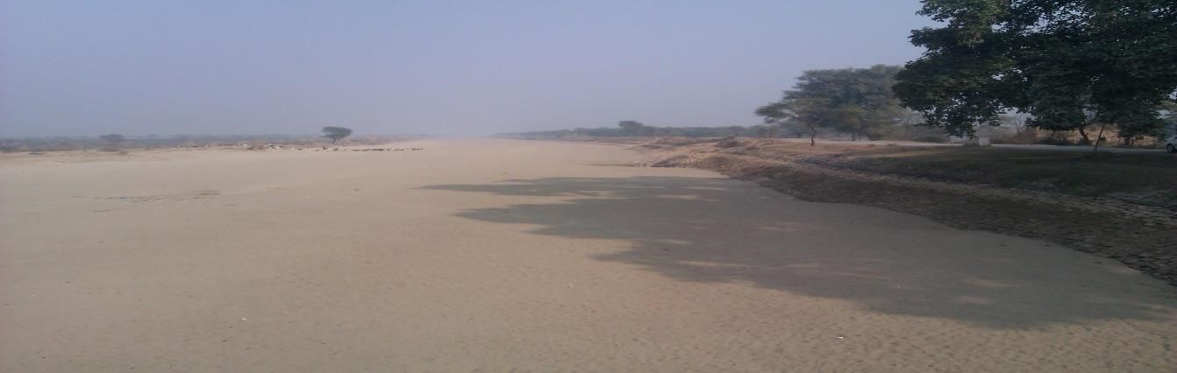
Fig 9. Side embayment of channel section

3.2.5 DETERIORATED CONDITION OF SUPER STRUCTURE OF FEW HYDRAULIC STRUCTURES
The channel has more than 100 hydraulic structures including bridges, falls, level crossings, siphons, cross-regulators and head regulators of off taking channels. Most of the hydraulic structures are as old as the canal. Silt deposition was found on the upstream (u/s) and downstream (d/s) floors of the structures. Apparently the hydraulic performance of the structures was found satisfactory. However, the superstructures including deck slab of some hydraulic structures need repair and replacement. The trend of energy dissipation arrangement of the hydraulic structures was found effective as no scouring of bed and major side embayment were observed at their downstream. As such, the present condition of piers and foundations was found satisfactory. The water marks on piers shows that 2 - 3 ft. free board is available near the hydraulic structures.
The possible reason for high silt deposition in the tail reaches and scouring in the head reaches is the entry of silt free water after the commissioning of Mangla reservoir in 1967. From historic operation of the channel, it has been observed that less discharge and less velocity have also facilitated the silt deposition and bank erosion. The reason for less discharge may be less availability of water or less demand for UJC. Proper maintenance of the channel and hydraulic structures have not been carried out. The operation of canal at substantially less discharge than its design discharge, deferred maintenance and monitoring seems to be the reasons for the said problems. All the above mentioned factors lead to reducing the efficiency and enhancing conveyance losses of UJC.

3.3 PROPOSED SOLUTION
The possible proposed solutions for remodelling are as follows:
- To remodel the canal for existing discharges of 7700 ft³/s at existing hydraulic parameters and fulfill the needs of Shadiwal Power house and Khanki head works at Chenab River for Lower Chenab Canal system through some alternate route including developing new channel.
- To remodel the channel for increased discharge of 14850 ft³/s by minimum variation of existing parameters like bed and water levels, longitudinal slopes, water depth and bed width.
- The first option for remodelling was analyzed technically and economically. The development of new channel would involve cost of acquiring new land, constructing several hydraulic structures, availability of good soil and construction materials including engineering services which seems to be very expensive. The site visit indicated few problems in technical design of a new channel in setting its alignment due to physical constraints including displacement of the roads and other infrastructure. The cost of the first option is much higher and hence, not considered technically and economically feasible.

CHAPTER IV
INTRODUCTION TO HEC-RAS

4.1 INTRODUCTION TO HEC-RAS
HEC-RAS is a computer program That models the hydraulics of water flow through natural rivers and other channels. Prior to the recent update to Version 5.0 the program was one-dimensional, meaning that there was no direct modeling of the hydraulic effect of cross section shape changes, bends, and other two- and three-dimensional aspects of flow. The release of Version 5.0 introduced two-dimensional modeling of flow as well as sediment transfer modeling capabilities. The program was developed by the US Department of Defense, Army Corps of Engineers in order to manage the rivers, harbors, and other public works under their jurisdiction; it has found wide acceptance by many others since its public release in 1995.
The Hydrologic Engineering Center in Davis, California developed the River Analysis System (RAS) to aid hydraulic engineers in channel flow analysis and floodplain determination. It includes numerous data entry capabilities, hydraulic analysis components, data storage and management capabilities, and graphing and reporting capabilities. Figure 10 shows Main HEC-RAS window.

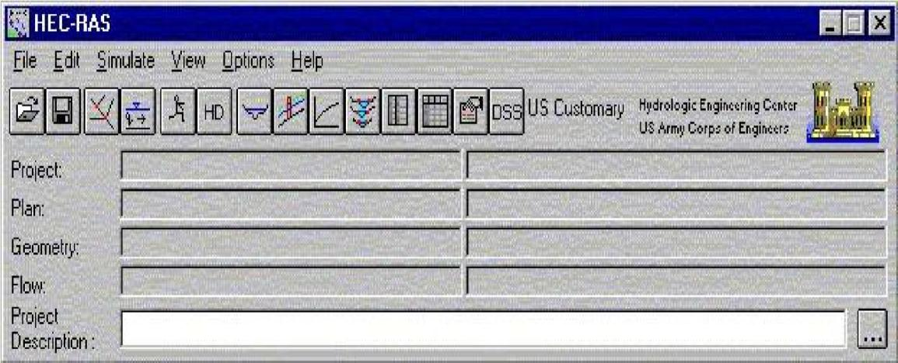

Fig. 10: HEC-RAS Main window

4.1.1 WORKING OF HEC-RAS
The basic computational procedure of HEC-RAS for steady flow is based on the solution of the one-dimensional energy equation. Energy losses are evaluated by friction and contraction / expansion. The momentum equation may be used in situations where the water surface profile is rapidly varied. These situations include hydraulic jumps, hydraulics of bridges, and evaluating profiles at river confluences.

4.1.2 USES
HEC-RAS is a computer program for modelling water flowing through systems of open channels and computing water surface profiles. HEC-RAS finds particular commercial application in floodplain management and flood insurance studies to evaluate floodway encroachments. Some of the additional uses are: bridge and culvert design and analysis, levee studies, and channel modification studies. It can be used for dam breach analysis, though other modelling methods are presently more widely accepted for this purpose.
4.2 REMODELING OF UJC BY HEC-RAS
Remodelling of UJC was done by HEC-RAS software. HEC-RAS is widely used software for modelling of irrigation channels like canals and rivers. It can also handle hydraulic structures like bridges, dams, regulators, and falls etc. It can perform both steady and unsteady flow simulations, analysis for sediments transportation and water quality analysis. This software calibrate and validate modelling on the basis of Manning roughness coefficient value (n).

4.3 CALIBRATION AND VALIDATION
Model has been calibrated and validated according to guidelines suggested by Hydraulic Engineering Center (HEC) (2017). HEC-RAS calibrate and validate the model on the basis of Manning’s roughness coefficient value (n). Manning’s roughness coefficient value (n) was adjusted for calibration and validation of the model to keep the water level of the channel nearest to the actual water level of the canal. The actual water level of the canal was 13.05 ft. (shown in figure 11 by green dash line) at a discharge of 14850 ft³/sec that was defined by the department of irrigation. The water level that was obtained after modelling was
12.75 ft. that is (shown in figure 11 by blue solid line). By comparing these two water levels, actual water level and water level after modelling, the percentage difference was 2.2%. Figure 11 shows cross sectional profile of UJC at discharge 14850 ft³/sec.
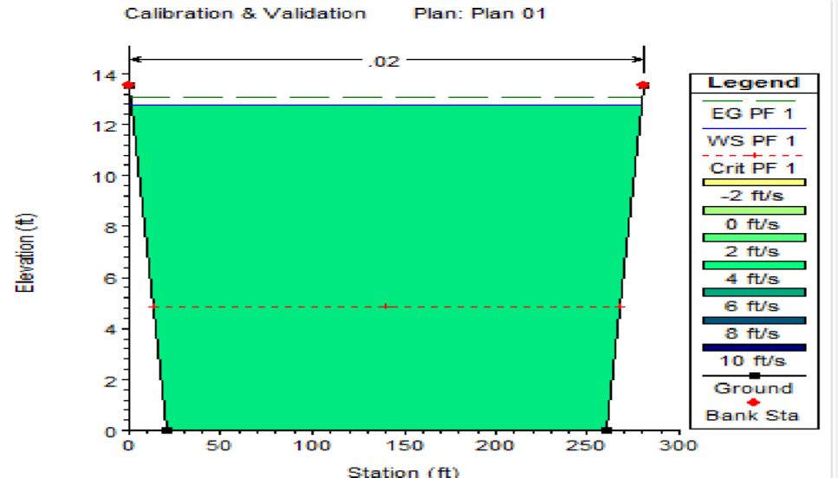

Figure. 11: Cross sectional profile

Volume at height 13.05 ft. = 44235 ft³
Volume at height 12.75 ft. = 43235 ft³
Percentage difference =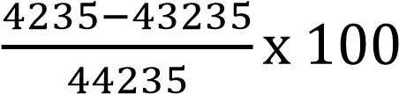 = 2.2%

4.4 EXISTING CONDITION OF UPPER JHELUM CANAL
The original design discharge of the channel was 12800 cusecs in 1904. The channel was resigned 8893 cusecs due to less availability of water in 1941 according to Manning formula.

4.4.1 EXISTING DESIGN PARAMETER
Table 1 shows existing design parameters of UJC

Table 1: Existing design parameter

Discharge  (Cs) | Width  (ft.) | Depth  (ft.) | Side slope | Longitudinal slope | B/D  Ratio
8893 | 223 | 10.2 | 1.5 | 6667 | 21.86

Solution:
Where B₁= Bottom width
B₂= Top width= B₁+ 2×S
Here S is slide slope
Width/depth Ratio = B/D = 21.8
(1.2)
Assuming B₁=B₂=B
By putting value of ‘D’. We get in Eq. (1.1)
Area= (1.3)
By putting the value of S=1.5. We get
(1.5)
Now
Hydraulic Radius 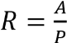
By putting (1.3) & (1.5)
By putting the value of ‘D’ in Eq. (1.6)
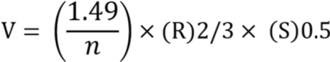

We know that Manning Equation

Q =AV
8893= {[(B+1.5) × (0.056B)] [(
By solving Eq. (1.8). We get
𝐵 = 227 𝑓𝑡
Putting value of B in Eq. (1.2)
𝐷 = 10.215
By using the value of B & D. We get different parameters
𝑉𝑒𝑙𝑜𝑐𝑖𝑡𝑦 = 3.81 𝑓𝑡/𝑠
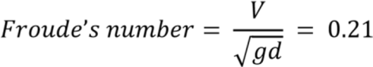
𝐻𝑦𝑑𝑟𝑎𝑢𝑙𝑖𝑐 𝑅𝑎𝑑𝑖𝑢𝑠 = 8.91
𝑃𝑒𝑟𝑖𝑚𝑒𝑡𝑒𝑟 = 259.2 𝑓𝑡
𝐴𝑟𝑒𝑎 = 2334 𝑓𝑡

4.5 AVERAGE EXISTING DESIGN PARAMETERS
Table 4 shows existing design parameters of UJC.

Table 2. Average Existing Design Parameters

Discharge  (Cs) | Width  (ft.) | Depth  (ft.) | Side slope | Longitudinal slope | B/D  Ratio
7700 | 240 | 11.5 | 1.5 | 6667 | 21

3.6 DESIGN OF UJC BY USING PROPOSED PARAMETERS (1st reach)
Table 6 shows proposed design parameters of UJC.

. Table 3: Proposed Design Parameters

Discharge  (Cs) | Width  (ft.) | Depth  (ft.) | Side slope | Longitudinal slope | B/D  Ratio
14850 | 240 | 13.55 | 1.5 | 6667 | 17.71

Solution:
Where B₁= Bottom width
B₂= Top width=
Here S is slide slope
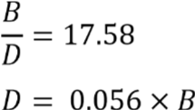 (2.2)
Assuming B₁=B₂=B
By putting value of B₂ Eq. (2.1). We get
By putting the value of side slope S=1.5. We get
(2.5)

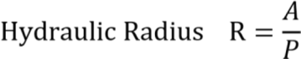
By putting (2.3) & (2.5)
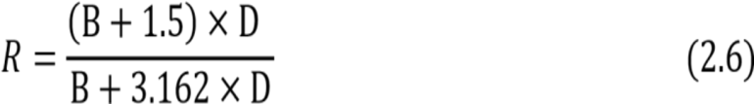
By putting the value of ‘D’ in Eq. (2.6)
(2.7)
We know that Manning Equation.
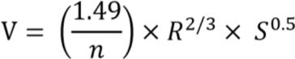

Q= AV
By solving Eq. (2.8). We get
Putting value of B in Eq. (2.2)
𝐷 = 13.60 𝑓𝑡
By using the value of B & D
We get different parameters
𝑉𝑒𝑙𝑜𝑐𝑖𝑡𝑦 = 4.75 𝑓𝑡/𝑠
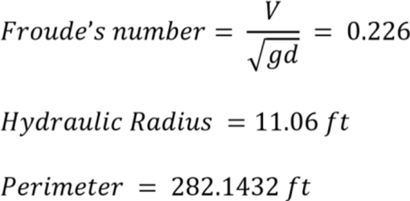
𝐴𝑟𝑒𝑎 = 3123.16 𝑓𝑡2

4.7 PROPOSED DESIGN PARAMETERS (2ND REACH)
Table 9 shows proposed design parameters of UJC for second reach.

Table 4: Proposed Design Parameters

Discharge  (Cs) | Width  (ft.) | Depth  (ft.) | Side slope | Longitudinal slope | B/D  Ratio
8500 | 230 | 10.1 | 1 | 6667 | 22.77

Solution:

Where B₁= Bottom width
B₂= Top width=
Here S is slide slope
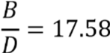
Assuming B₁=B₂=B
By putting value of B_{2 &} S=1 in (3.1). We get
Now put the value of B in (3.3)

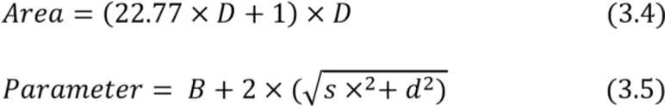
By putting the value of side slope B & S=1. We get
𝑃 = 25.59 × 𝐷 (3.6)
Now
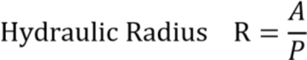
By putting Eq. (3.4) & (3.5)
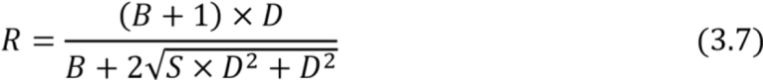
By putting the value of ‘B’ & ‘S’ in (3.7)
𝑅 = 0.889𝐷 + 0.039
We know that Manning Equation
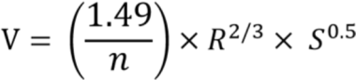
𝑄 = 𝐴𝑉
8500 = [(22.77 × 𝐷 + 1) × 𝐷] [0.889 × 𝐷 + 0.039] [0.000149^{0.5}] (3.8)
By solving (3.8). We get
Putting value of D in (3.2)

By using the value of B & D
We get different parameters.
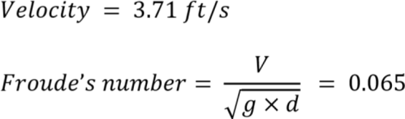
𝑃𝑒𝑟𝑖𝑚𝑒𝑡𝑒𝑟 = 255.9
𝐴𝑟𝑒𝑎 = 2287 𝑓𝑡²

3.8 HYDRAULIC MODELLING OF HYDRAULIC STRUCTURES
Hydraulic modelling of different hydraulic structures of UJC including bridges were carried out by HECRAS software. After modelling it was found that hydraulic structures safely pass the increased discharge 14850 ft³/sec and the foundation of the hydraulic structures including bridges were checked and found safe for surface and sub-surface flow. Some of the bridges were only required raising of deck slab for remodelling of UJC. Hydraulic modelling of one of the bridges of UJC was shown below. For the modelling of bridge through HEC-RAS software some structural detail was assumed including bridge length, bridge width, No. of piers, Piers width and Piers height was equal to 250 ft. , 50 ft., 6 ft., 3 ft. and 12 ft. respectively. With the help of modelling of bridge through HEC-RAS software water surface profile was obtained. Water surface profile of bridge at different discharges. (3000, 6000, 9000, 12000, 14850 ft³/sec).
This water surface profile shows the water levels at different value of discharges. The top layer expressed the water level that was 12.75 ft. at a discharge of 14850 ft³/sec. At a proposed width to depth Ratio Bridge can safely pass the discharge of 14850 ft³/sec.

4.8.1 STRUCTURAL DETAIL FOR HYDRAULIC MODELLING OF BRIDGE

Table 12 shows the structural detail of the bridge for modelling on HEC-RAS. Figure 26 shows the bridge cross section of UJC.

Table 5: Structural detail of bridge

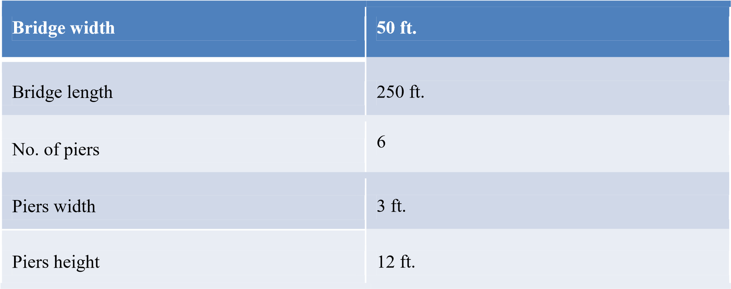

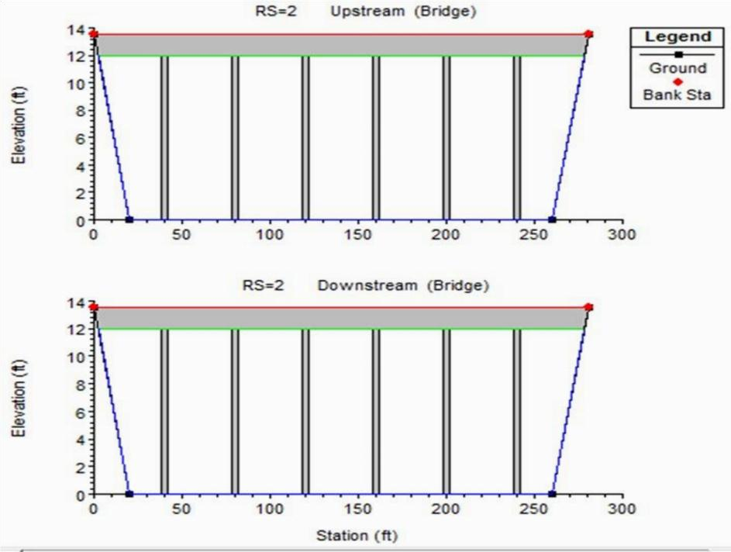
Fig. 12: Bridge Cross section of UJC
CHAPTER V
RESULTS AND DISCUSSION

5.1 MODELLING ON HEC-RAS OF EXISTING DESIGN PARAMETER
Table 2 shows existing design parameters of UJC.

Table 6: Existing Design Parameters

Discharge  (Cs) | Width  (ft.) | Depth  (ft.) | Side slope | Longitudinal slope | B/D  Ratio
8893 | 223 | 10.2 | 1.5 | 6667 | 21.86

We analyzed the existing design parameters of UJC with the help of HEC-RAS software and achieved different water surface profiles of UJC that are shown below. Figure 12 shows cross sectional profile at a discharge 2223 cusecs. Figures 13, 14 and 15 show longitudinal profile of UJC at discharge 2223, 8893 and 12000 cusecs respectively.
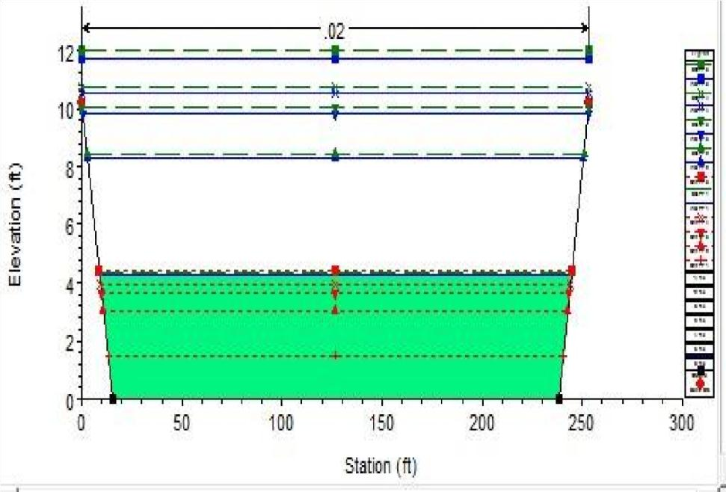
Fig. 13: Cross-sectional profile
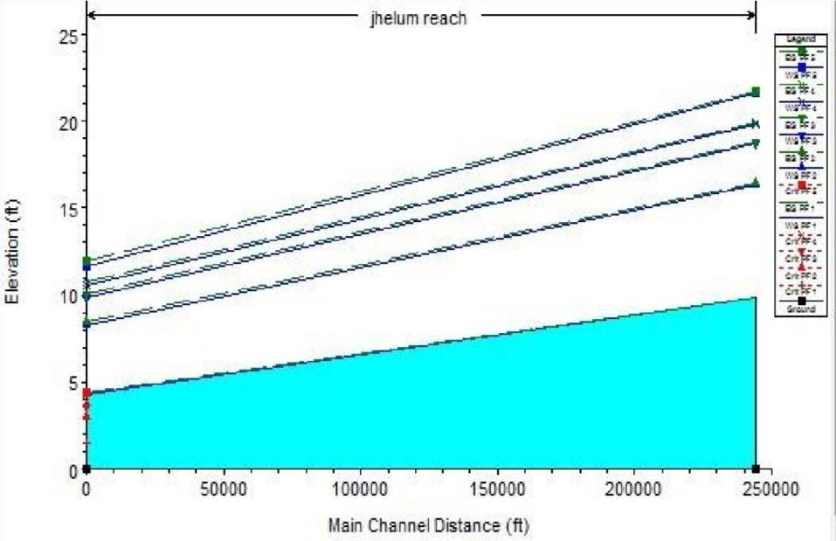

Fig. 14: Longitudinal profile at discharge 2223 cusecs

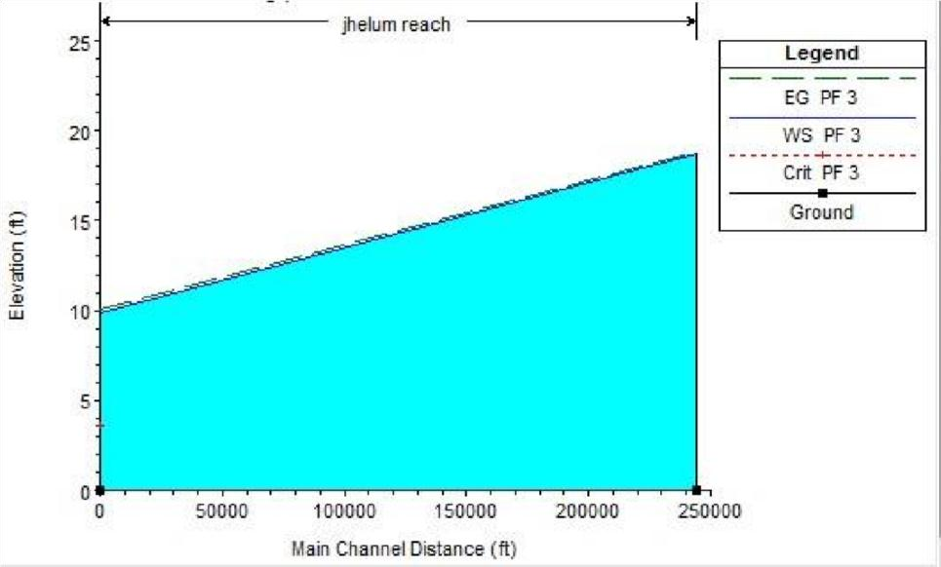

Fig. 15: Longitudinal profile at discharge 8893 cusecs

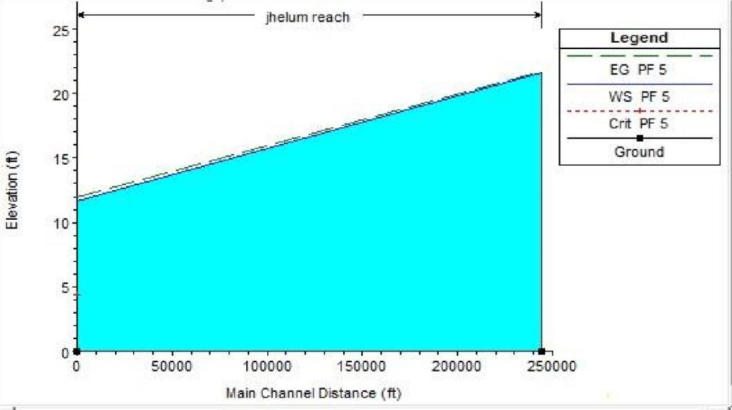

Fig. 16: Longitudinal profile at discharge 12000 cusecs
These longitudinal profiles show that existing design parameters are valid for discharge 8893 cusecs but not valid for discharge more than 8893 cusecs (12000 cusecs).Table 3 shows profile summary table at different values of discharges for existing design parameters of UJC.

Table 7: Profile Summary
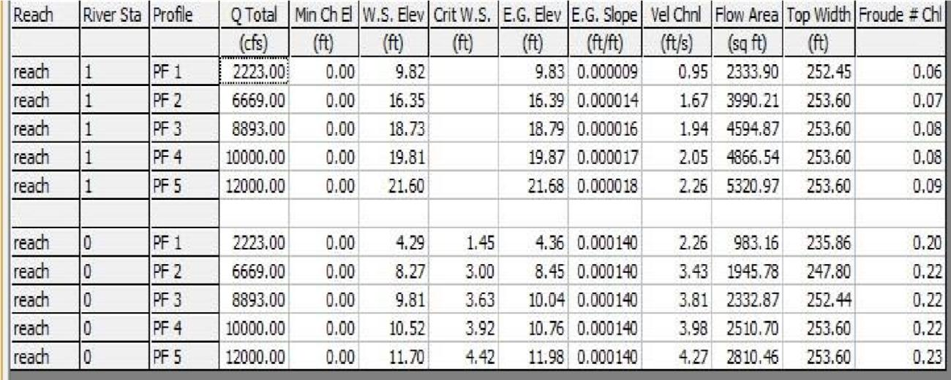

The existing width to depth ratio of UJC is not suitable to achieve parameters of regime channel. And also existing width to depth ratio of UJC is not suitable for discharge more than 8893 Cusecs (1000012000 Cs) and thus causes overflowing of water.

5.2 MODELLING ON HEC-RAS OF AVERAGE EXISTING PARAMETERS

After modelling on HEC-RAS we get different water surface profiles. Figures 16, 17 and 18 show
longitudinal profile of UJC at discharge 3000, 7700 and 13000 cusecs respectively.

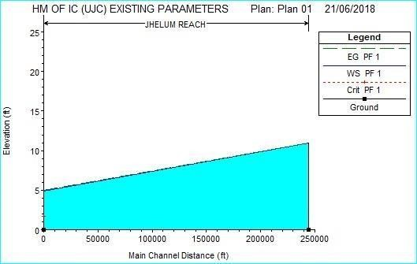

Fig. 17: Longitudinal profile at discharge 3000 cusecs

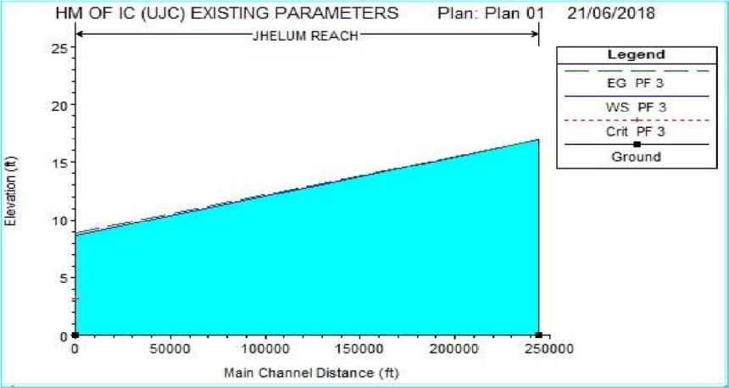
Fig. 18: Longitudinal profile at discharge 7700 cusecs
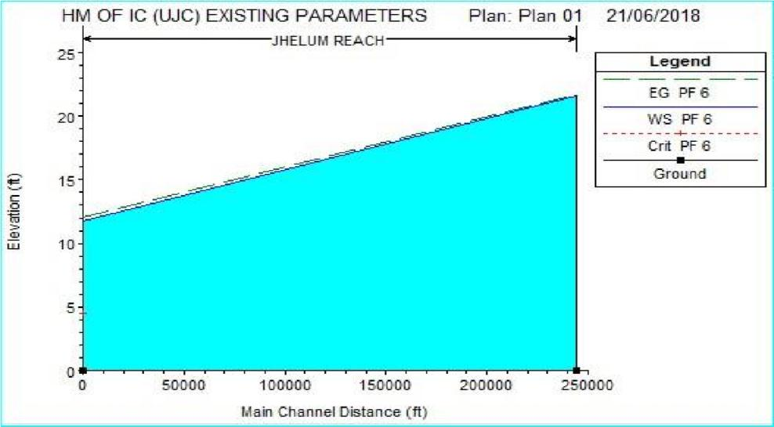

Fig. 19: Longitudinal profile at discharge 13000 cusecs
These longitudinal profiles show that existing design parameters are valid for discharge 7700 cusecs but not valid for discharge more than 13000 cusecs. Table 5 shows profile summary table at different value of discharges for existing design parameters of UJC.

Table 8: Profile Summary
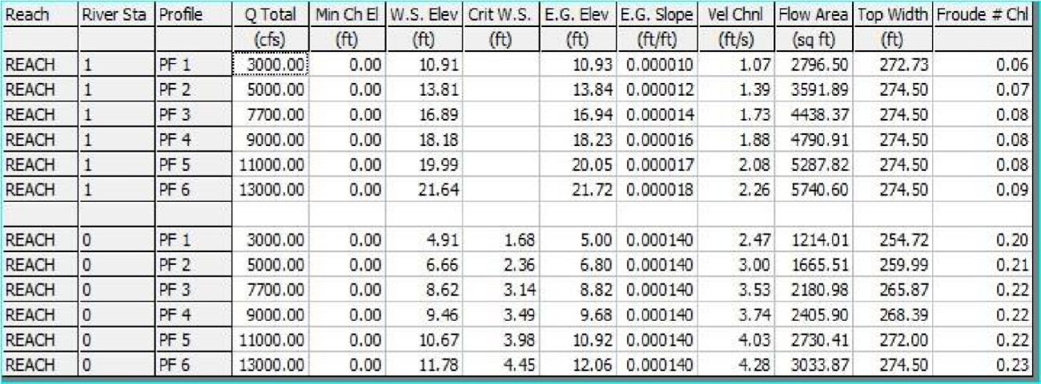
The existing width to depth ratio of UJC is not suitable to achieve parameters of regime channel. We are facing some problems like silt deposition, scouring, inadequate freeboard etc. And also existing width to depth ratio of UJC is not suitable for discharge more than 13000 Cusecs (13000 to 14000 Cs) and thus causes overflowing of water.
We proposed other design parameters for UJC by enhancing the depth of the channel its and keeping the width same. At these dimensions, canal can take discharge up to 14850 cusecs. And in this way we can overcome the problem of silt deposition, scouring and erosion of banks
5.3 MODELLING ON HEC-RAS OF 1ST REACH (PROPOSED PARAMETER)
Table 7 shows proposed design parameters of UJC.

Table 9: Proposed Design Parameters

Discharge  (Cs) | Width  (ft.) | Depth  (ft.) | Side slope | Longitudinal slope | B/D  Ratio
14850 | 240 | 13.55 | 1.5 | 6667 | 17.71

We analyzed the proposed design parameters of UJC with the help of HEC-RAS software and we get different water surface profile of UJC for proposed design parameters that are shown below. Figure 19 shows cross sectional profile at discharge 6000 cusecs. Figures 20, 21 and 22 show longitudinal profiles of UJC at discharge 6000, 14850 and 16000 cusecs respectively.
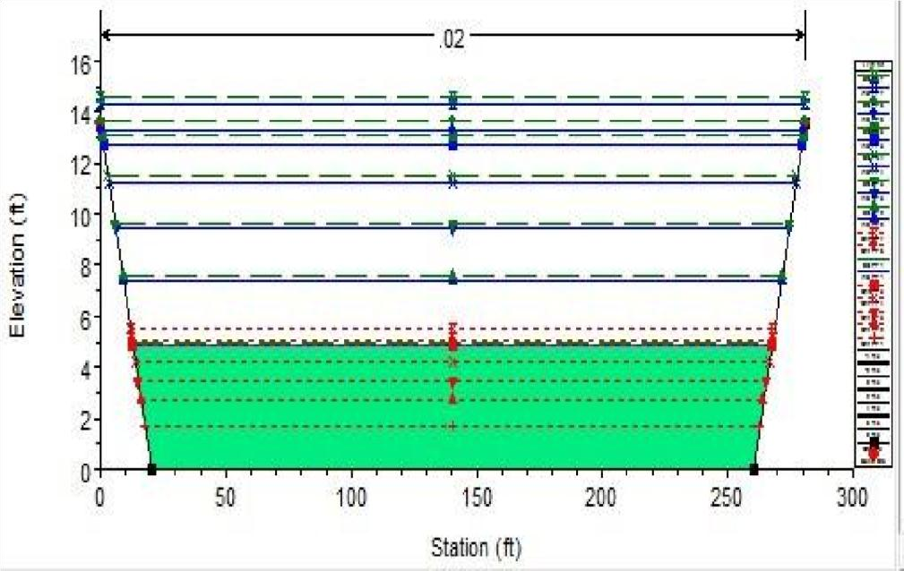
Fig. 20: Cross-sectional profile
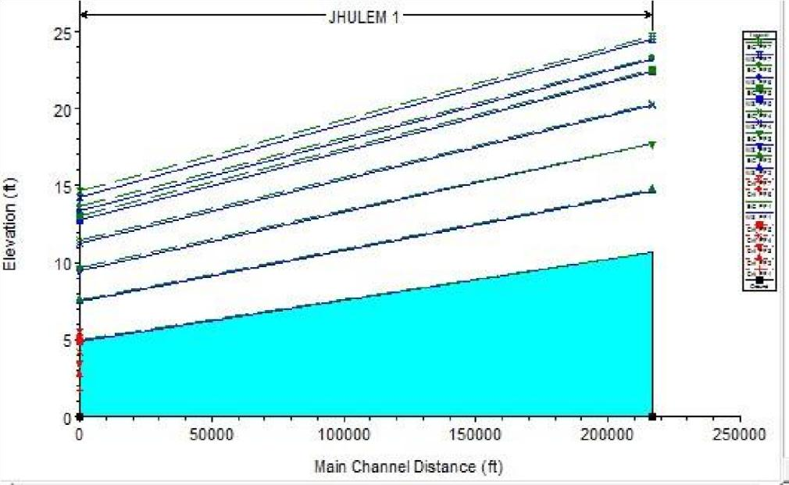

Fig. 21: Longitudinal profile at discharge 6000 cusecs

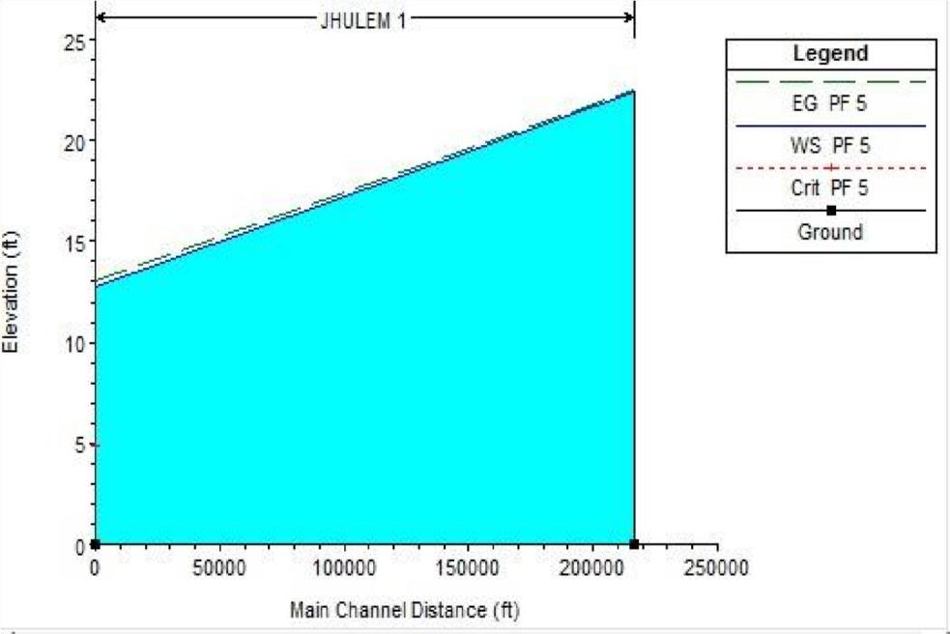
Fig. 22: Longitudinal profile at discharge 14850 cusecs
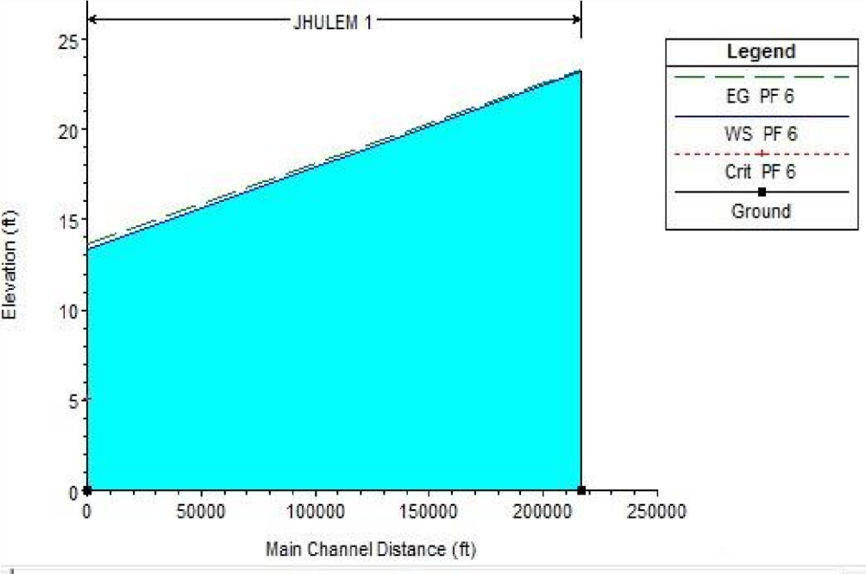

Fig. 23: Longitudinal profile at discharge 16000 cusecs
These longitudinal profiles show that proposed design parameters are valid for discharge 14850 cusecs for regime channel but not valid for discharge 16000 cusecs and cause overflowing of water. Table 8 shows profile summary table at different value of discharges for existing design parameters of UJC.

Table 10: Profile Summary
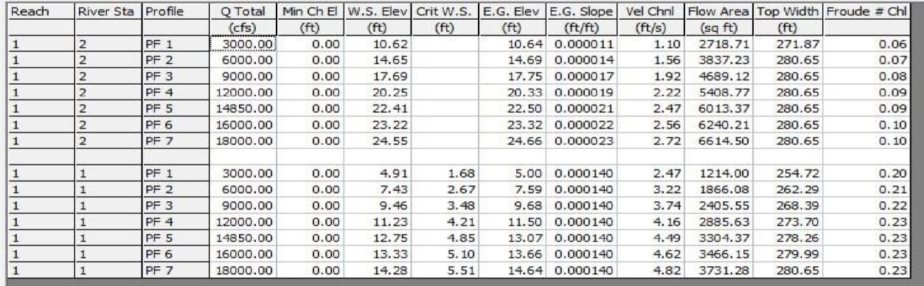

5.4 MODELLING ON HEC-RAS (2nd REACH)
Table 10 shows proposed design parameters of UJC for second reach

Table 11: Proposed Design Parameters

Discharge  (Cs) | Width  (ft.) | Depth  (ft.) | Side slope | Longitudinal slope | B/D  Ratio
8500 | 230 | 10.1 | 1 | 6667 | 22.77

After modelling on HEC-RAS, we get different water surface profile of UJC for second reach of proposed design parameters that are shown below. Figure 19 shows cross sectional profile at discharge 6000 cusecs. Figures 23, 24 and 25 show longitudinal profile of UJC at discharge 2100, 8500 and 10671 cusecs respectively.

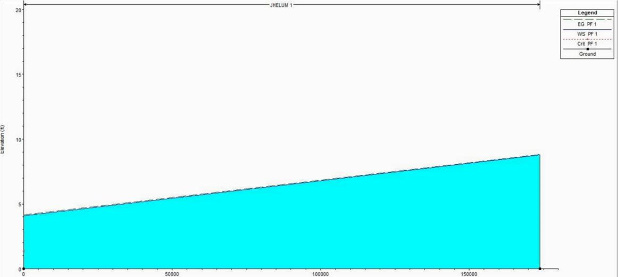

Fig. 24: Longitudinal profile at discharge 2100 cusecs
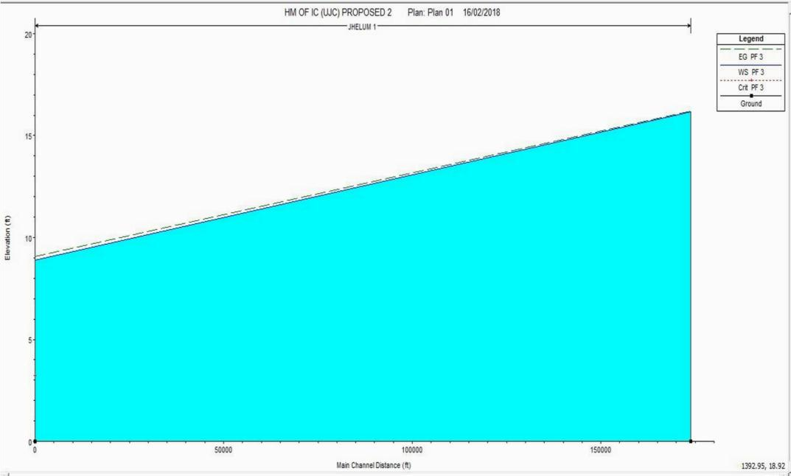

Fig. 25: Longitudinal profile at discharge 8500 cusecs

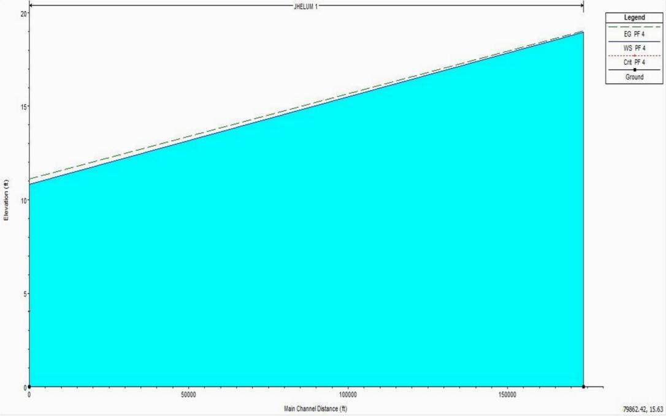

Fig. 26: Water surface profile at discharge 10671 cusecs

These longitudinal profiles show that proposed design parameters are valid for discharge 8500 cusecs for regime channel but not valid for discharge 10671 cusecs and cause overflowing of water.
Table 11 shows profile summary table at different value of discharges for proposed design parameters of UJC of second reach.

Table 12: Profile summary

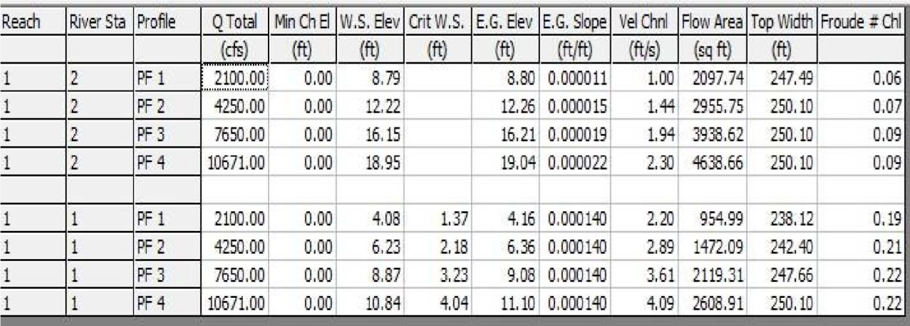

5.5 MODELING OF BRIDGE

Figure 27 shows the longitudinal profile of the bridge at different value of discharges.
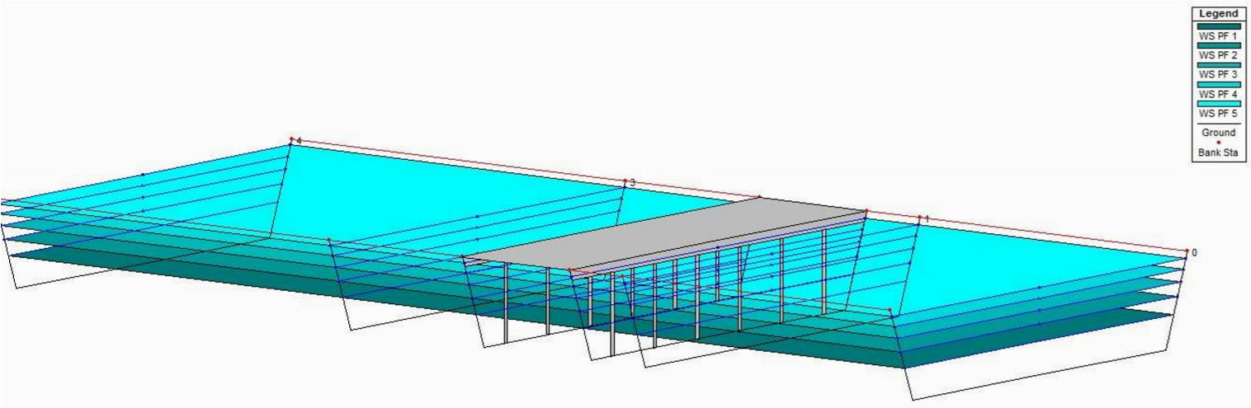Fig. 27: Longitudinal profile of Bridge
This water surface profile shows the water levels at different values of discharges. The top layer expressed the water level that was 12.75 ft. at a discharge of 14850 ft³/sec. At a proposed width to depth ratio, Bridge can safely pass the discharge of 14850 ft³/sec Table 13 shows profile summary of bridge for different values of discharges at stations (1, 2, 3, and 4).

Table 13. Profile Summary

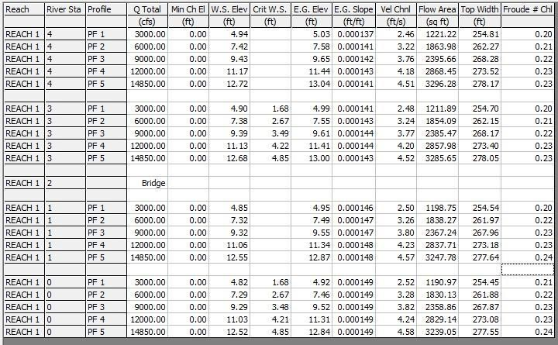

CHAPTER VI
CONCLUSIONS AND RECOMMENDATIONS
6.1 CONCLUSION AND RECOMMENDATION
- During site visit of UJC the problems of excessive silt deposition, scouring, erosion of banks and deterioration of hydraulic structures including some of the bridges were observed.
- HEC-RAS was successfully calibrated and validated for remodelling of UJC at original and enhanced discharge.
- The optimized option was found for remodelling of UJC at enhanced depth (13.55ft) and same bed width (240ft) by considering the economical solution and appropriate width to depth ratio.
- At proposed width to depth ratio of 17.71, UJC can take the discharge up to 14850 cusecs.
This discharge is suitable for regime channel and to fulfill the crop water requirement.
- All the hydraulic structure of UJC can safely pass the increased discharge of 14850 cusecs.
- Physical modelling along with detailed investigation of hydraulic structures of UJC was recommended before initiating the remodelling of the channel.
- There should be proper coordination between department of irrigation and different organizations that are involved in the completion of the project.

REFERENCES
A.S. Shakir, N. M. Khan, (2009) “Impact of Structural Interventions on Sediment Management of Large Canals: A Case Study of Marala Barrage, Pakistan” Water Resources Management December 2009, Volume 23, Issue 15, pp 3149-3163
Ashraf, M., Hassan, F.U., Saleem, A., Loan, M.I. (1999), “Water Resources Development and its Management in Barani Area of Punjab.” Proceeding of the National Workshop on Water Resources Achievements and Issues in 20th Century and Challenges for the Next Millennium. PCRWR, Islamabad, Pakistan.
B. Lashari, H.Murray, (2000). “Remodelling of Outlets in Three Pilot Distributaries- The Farmer- Managed Irrigation Project in Sind Province Pakistan” Working Paper 13. Pakistan Country Series 4
Food and Agriculture Organization, (2002). How Design, Management and Policy Affect the Performance of Irrigation Projects: Emerging Modernization Procedures and Design Standards. Bangkok.
Food and Agriculture Organization. (2000). Modernization of Irrigation System Operations: Proceedings of the Fifth ITIS Network International Meeting, Aurangabad, 28-30 October.
Halcrow, (2002), “Pakistan Water Sector Strategy”, Published by Ministry of Water and Power, Executive Summary Volume No. 1, (2002).
Hydrologic Engineering Center (HEC). “User manual HEC-RAS” (hydraulic engineering Centreriver analysis system). Version 5.0 (2017).
J. A. Tariq, M. Latif, (2010) “Improving Operational Performance of Farmers Managed Distributary Canal using SIC Hydraulic Model” Water Resources Management, Volume 24, Issue 12, pp 3085-3099
M. U. Rashid, (2014) “Optimization of Multiple Reservoir Operation with consideration to Sediment Evacuation” Ph.D. Dissertation. University of Engineering and Technology Lahore. Pakistan.
M.M. Qureshi ACE, Pakistan and University of Lahore (January 2013) “Channel Forming Discharge in Rivers: A Case Study of Jhelum River in Pakistan.
PDC: Pakistan Drainage Consultants, (2002). “Water availability study (position paper) for remodelling of Lower Chenab Canal (LCC) System, Lahore, Pakistan
Punjab irrigation department (February 2016 - October 2017) “feasibility study for remodelling of UJC”.
Punjab Irrigation Department. (2013). “Concept Paper of Remodeling of Upper Jhelum Canal”. Presented by Punjab Irrigation Department: Lahore, Pakistan
S. Shakir, M. U. Rashid and A. U. Haq, (2008). “Improving Water Management in Lower Jhelum Canal Command in Pakistan's Punjab: Issues and Options” in Proceedings of 20th International Congress on Irrigation and Drainage held in Lahore, Pakistan, 13-19 October 2008.
Shakir, A. S., Maqbool, N. (2011) “Remodelling of the Upper Chenab Canal: A Case Study from Pakistan” Journal of Irrigation and Drainage, Volume 60.

APPENDIX

Google
Evaluation of remodeling of UJC
Site of UJC

