Final Year Project Report

Multi Facilitator

Project Advisor:
Mam Emman Farooq

Submitted By:
Abdul Ahad 13005065104
Abdul Rafay Sami 13005065219
Hafiz Muaaz Ali 13005065241

Session

University of Management and Technology
C-II Johar Town Lahore Pakistan

Dedication

We dedicate our work to our parents whose words of encouragement and push have always been a source of constant motivation. We’d like to extend our dedication to our teacher who inspired us to excel in life for the completion of this project.

Final Approval

Panel of Examiners

- Head of Department ______________________
Department of Computer Science
UMT Lahore

- Program Director ( Final Year Projects) ______________________
Department of Computer Science
UMT Lahore

- Supervisor ______________________
Department of Computer Science
UMT Lahore

- Co-Supervisor ______________________

Acknowledgment

In the name of Allah, the most Gracious, the most Merciful, all praises to Allah for the strengths and His blessings in completing this project. He has helped us in every phase of life and without His blessings it was impossible to finish what we started.
We’d like to pay our gratitude to our supervisor, Emmen Farooq for providing necessary details and resources to complete project. This work would not have been possible without her guidance, kindness and encouragement.
Finally we thank all those who have helped us either directly or indirectly in completion of our project. Anyone missed in the acknowledgement are also appreciated. If we forget to mention someone’s name here, we apologize for that. Again we would like to express thanks to everyone who supported and helped us during this work.

Project Title:
Multi Facilitator.
Objective
This is the era of technology and almost everyone is using android technology in the shape of their android phones, so the main objective of this application is to shift this manually done works to online ones so that this will not waste time and will be efficient and to provide users to avail home services by ordering online.

Undertaken by:
1 Abdul Rafay Sami.
2 Abdul Ahad.
3 Hafiz Muaaz Ali.

Supervised by
Mam Emmen Farooq.
Starting Date
20-11-16
Completion Date
25-01-17
Tools Used
- Creately.com
- Draw.io
- Microsoft Word
- Android Studio
- Adobe Photoshop
- Xampp Server
- MySQL
Operating System
Android
Documentation

Plagairism Report
Abstract
In this era, everyone wants ease in life. So we are presenting an android application for the user of any age regarding to house services as car wash, plumber, electrician, glass work, ac service etc. All of these services can be availed just by using android application in android phones. These services can be ordered by selecting desired time and date on which you want service to be delivered. Because of this application, you do not have to search in the market for plumbers, car washers etc. This android application causes time saving as well as this method is reliable for the users. All you have to order desired service using android application and we will deliver you the service in safe and secured way on time.

Contents
Contents 9
Definitions and Acronyms 12
List of Figures 11
List of Tables 11
1. Introduction 13
1.1 Motivations 13
1.2 Project Overview 13
1.3 Problem Statement 14
1.4 Objectives 14
2. Domain Analysis 16
2.1 Customer 16
2.2 Stakeholders 16
2.3 Affected Groups with social or economic impact 16
2.4 Dependencies/ External Systems 17
2.5 Reference Documents 17
2.5.1 Related Projects 17
2.5.2 Feature Comparison 18
3. Requirements analysis 19
3.1 Requirements 19
3.2 List of Actors 20
3.3 List of use cases 21
3.4 System use case diagram 22
3.5 Extended use cases 23
3.6 User interfaces (mock screens) 35
4. Data flow diagram (optional) 47
4.1 Data Flow Diagram Level 0 47
4.2 Data Flow Diagram Level 1 48
4.3 Data Flow Diagram Level 2 49
5. System Design 55
5.1 System Architecture Diagram 55
5.2 Class Diagram 56
5.3 SEQUENCE DIAGRAM 57
5.4 Collaboration Diagrams 57
5.5 Other UMLs 58
5.6 ERD 58
5.7 Data Dictionary 59
6. Implementation details 62
6.1 Development Setup 62
6.2 Deployment setup 62
6.3 Algorithms 63
6.4 Constraints 65
6.4.1 Assumptions 65
6.4.2 System constraints 65
6.4.3 Restrictions 65
6.4.4 Limitations 65
7. Testing 66
7.1 Extended Test Cases 66
7.2 Decision Table 83
7.2.1 Code snippet 83
7.2.2 Decision coverage table 83
7.3 Traceability Matrix 84
7.3.1 RID vs UCID (requirements vs use cases) 84
7.3.2 Prototypes (RID vs PID) 84
7.3.3 Test Cases (RID vs TID) 84
7.3.4 Coverage (UCID vs TID) 84
8. Results/Output/Statistics 85
8.1 %completion 85
8.2 %accuracy 85
8.3 %correctness 85
9. Conclusion 86
10. Future work 87
11. Bibliography 88
11.1 Books 88
11.2 Journals 88
11.3 Articles 88
11.4 Research papers 88
11.5 Other References 88
12. Appendix 89
12.1 Glossary of terms 89
12.2 Pre-requisites 89

List of Figures
New figures that are given captions will be added to the table automatically.
- Insert caption:
  - select picture
  - right click
  - select “insert caption”
  - under “options”, choose label as “figure”
  - Under “caption”, an automatic insertion of “figure no” will appear. Give your figure an appropriate caption
- Update list of figures: To update this list in Microsoft Word, put the cursor anywhere in the table and press F9.
- Note: If you want the table to be easy to maintain, do not change it manually.
Table 1: table of acronyms and definitions 12
Table 2: list of stakeholders 16
Figure 1: sample use case diagram with explanation 22
prototype 1: (P1) register a new member 43
Figure 2: System Architecture 55

Definitions and Acronyms
Acronym | Definition
UMT | University of Management and Technology
POS | Point of Sale
MF | Multi Facilitator

Introduction

Motivations
In today’s life, everyone from any field of life remain busy in their routine work. Due to the busy schedule, they want ease in different tasks of routine. In addition to this, they want their desired work to be done with efficiency moreover with security. So that is why we developed android application named as “Multi Facilitator” which can surely not only provide ease to its users but it will also provide efficiency with secure work done related to the house hold jobs. For this purpose, in MF we are going to deliver our clients the best type of household services like carpenter, car wash, plumber, laundry etc. at their door steps. They just have to login to our MF application on their android phones then can select their desired service. They can chose service time and date too. After that we receive the request and provide them with the best quality of desired service. On the service done, they can send their reviews and feedbacks to us which can be more useful for us to improve.

Project Overview
The overview of the underlying android application “Multi Facilitator” will be as follow:
- Application is user friendly and easily understandable interface.
- It has login for the users.
- User should be registered first.
- The user select desired task with desired time and date.
- Computerized/online billing.
- Employees can check job completion/pending status.
- After getting service done, the users will give feedbacks and reviews about the services,
- Regular users can get our Memberships.
- New offers will be uploaded by the admin panel..

Problem Statement
The main reason behind the working on and developing “Multi Facilitator” is to bring ease and sense of security with guarantee to everyone’s life. In most cases, both husband and wife are on their jobs to earn their livings. Due to their busy and hectic schedules, they cannot afford to get free time from their busy schedules if they need to have house facilities like plumber, laundry, car wash, carpenter, mason and many more. Secondly, if they find extra time to do so then there is no security and guarantee of the person or service provider whether he can be trusted or not whom they choose to get their work done. So we have worked on the solution for this problem. We have made this application “Multi Facilitator” which will allow users to book their desired job which have to be done online through our application. We will provide the related person which will be our authorized worker so that user’s desired work will be done easily will full guarantee.

Objectives
From older times till now, if anyone want to have house hold facilities, then he/she will have to go to market and then search for the person who will do their desired job. This method is much time consuming and also insecure way of get work done especially related to homes. So, as this is the era of technology and almost everyone is using android technology in the shape of their android phones, so the main objective of this application is to shift this manually done works to online ones so that this will not waste time and will be efficient. Because of this technology, everyone will be facilitated irrespective to the age or profession. The purpose of automating this is to give facilities to everyone’s doorsteps. Undoubtedly, this application will provide everyone a reasonable way to get their house jobs done. In addition to these, every user will not have to worry because this method will be fully secured because the user will be getting their works done by the authorized source. Furthermore services and facilities will be provided to users according to the feedbacks and suggestions from users of “Multi Facilitator”.
Our objective is to provide:
1. Laundry
2. Carwash
3. Carpenter
4. Ac service
5. Plumber
6. Electrician
7. Glass Work
8. Users feedback
9. New offers.

Domain Analysis

Customer
1. Our application “Multi facilitator” in an android application and it will be available on play store for download and install on your android phones.
2. So, the users that will use the application will be its customers.
3. for customers, this application will be free to download through playstore.

Stakeholders

Stakeholder | Role in System
Admin | The owner of the application will be provided with different tasks like  - To provide discount.  - To check requests.  - To check requests update.  - To check and response feedback.  - To give new offers for users.
Users | The users of our application will be provided with multiple services. The clients will request their required services for having multiple facilities. Their requests will be fulfilled by the management.
Developer | The developer of the application have coded this application as well as he made suitable and user friendly design for this application.  Developer used tools like:  - Android studio.  - Photoshop studio.

Table 1: list of stakeholders

Affected Groups with social or economic impact
By the deployment of this application, one of the most important part of our lives will become secure. This application is easy to be used by any age group of the user. The interface will allow illiterate users to operate this application for their ease. This application will bring change in lifestyles of its users.

Dependencies/ External Systems
“Multi Facilitator” application will be used on android phones.
Our application will be implemented using:
- ANDROID
- MYSQL
- Draw.io tool()
- Creately.com
- PHP

Reference Documents
1. Product based project template. (Provided by UMT)

Related Projects
- Karigar.
http://www.karigar.com.pk
- Bolee.
http://www.bolee.com/plumbers-electrician-nid-259
- Mazdooronline.
http://www.mazdooronline.pk/

Feature Comparison
Sr No. | Comparison Feature | Karigar | Bolee | MazdoorOnline | Multi Facilitator | Remarks
1 | Registered member | Karigar do not allow user to have membership | Bolee don’t have many features related to home services | MazdoorOnline is an online website which do not allow user registration feature. | Our android application allows users to be registered once to use feature. | Registration of member is not available in Karigar, Bolee or MazdoorOnline facility whereas Multi Facilitator provides it.
2 | Laundry service | Karigar don’t have laundry facility | Bolee don’t have laundry facility | MazddorOnlne don’t have laundry facility | Our android application provides laundry facility | Laundry service feature is not available in Karigar, Bolee or MazdoorOnline facility whereas Multi Facilitator provides it.
3 | Car wash | Karigar don’t have car wash facility | Bolee don’t have car wash facility | MazddorOnlne don’t have car wash facility | Our android application provides car wash facility | Car Wash facility is not available in Karigar, Bolee or MazdoorOnline facility whereas Multi Facilitator provides it.

Requirements analysis

Requirements
Functional Requirements:
Sr. No | Must/want | Description
FR001 | Must | The user must have to open the android application for operation.
FR002 | Must | The user must have to register to application first.
FR003 | Must | User must have to provide username, password, CNIC, phone number to be registered.
FR004 | Must | Admin should login to his profile to do different operations related to admin.
FR005 | Must | After registration, user will login to their profile to send service requests.
FR006 | Must | For service request, user must have to select category, then service to send request.
FR007 | Must | For service request, user will must select desired time and date of getting service.
FR008 | Must | Admin and staff must have to response the received service request to deliver service.
FR009 | Must | Staff must have to receive due amount of delivered service from the user.
FR010 | Must | Staff must have to deliver the services after accepting service request.
FR011 | Must | Everyone must use sign out option after doing desired application to be exit.

Non- Functional Requirements:
Sr. No | Must/want | Requirements | Description
NFR01 | Want | User Interface | The interface of android application should be easy to use and user friendly and attractive.
NFR02 | Want | Performance | Response time of next page loading is 0.2 sec and the screen refresh time is same.
NFR03 | Want | Through put | No limit for user to be using android application at same time
NFR04 | Want | Availability | Application will be free to be downloaded from play store.
NFR05 | Want | Maintainability | The code will be flexible and have capacity to be updated when needed.
NFR06 | Want | Response | Feedback/Rating option is given to the users related to services.
NFR07 | Want | New offers | New offers and discount offers can be updated by admin for users.

List of Actors

- Admin
- Staff
- Users of Application.

List of use cases
- Sign up
The user must sign up to be registered in the application.
- Sign in
The user must signed in to use the application.
- Sign out
The user use sign out option to logout the application.
- Offer discount.
The admin will update new discount offers for the users of the application from his profile.
- Approve requests.
The admin will use the approve request option to accept the received service requests from the users.
- Feedback response.
Feedback/Rating will be received and admin can check feedbacks related to given services.
- New offers
The admin will publish new offers related to services for the users of the application.
- Manage account
The users can manage their accounts on the application.
- Category
The user can use it to choose their desired service from the categories.
- Select service
The users can select the desired service from the selected category to get service.
- Date/time
The user use date/time selection for choosing time and date on which they want to get their desired service done.
- Service request
The user will select desired service and provide information. The service request is sent.

System use case diagram

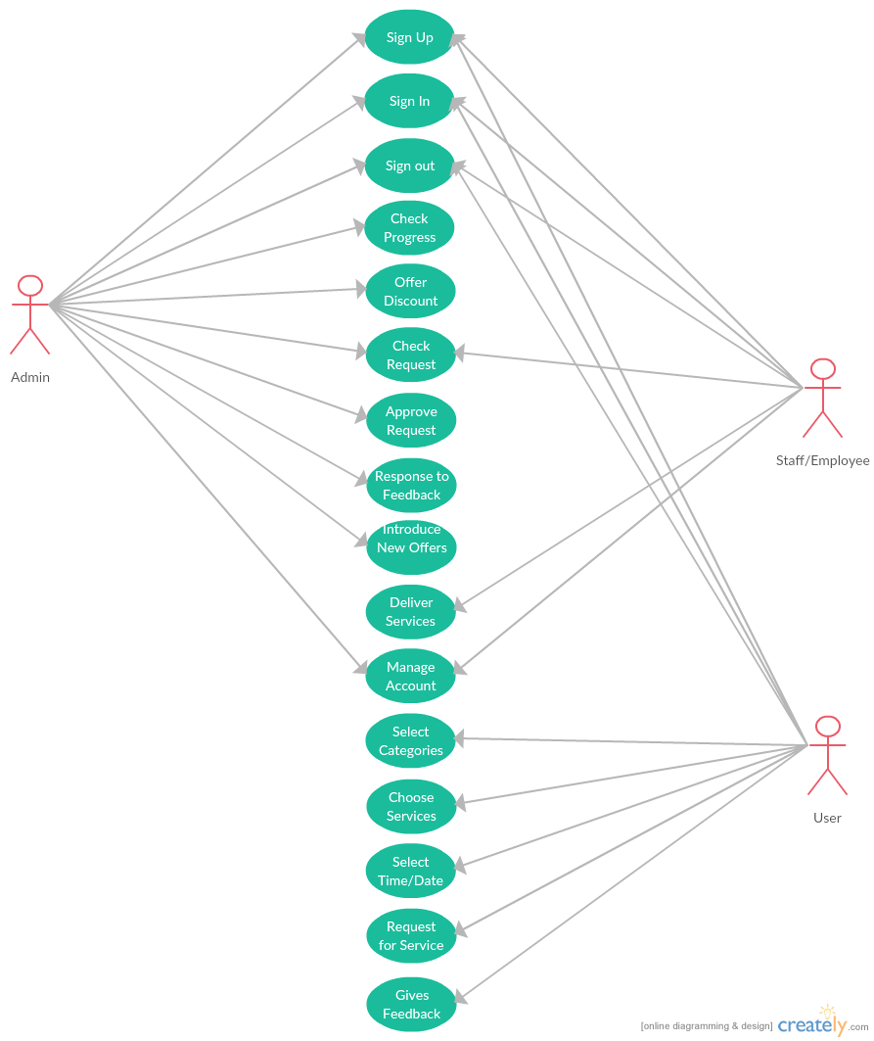

Extended use cases

Use Case ID: | UC-1
Use Case Name: | Sign up
Created By: |  |  | Last Updated By:
Date Created: |  |  | Last Revision Date:
Actors: |  | Admin, User
Description: |  | The user must sign up to be registered in the application.
Trigger: |  | Sign up button.
Preconditions: |  | Android application must be opened.  Operated device must be connected to internet.
Post conditions: |  | User is registered and in to the system
Normal Flow: |  | User has opened the android application  User will click on the sign up button on the home page  User will fill the fields.  User will click on the register button to be signed up.
Alternative Flows: |  | NA
Exceptions: |  | In step 4 of the normal flow, if the User enters invalid information  Access is disapproved  Message to user to check the filled information for correction.  Customer enters correct information and then signed up.  In step 4 of the normal flow, if the user enters correct information in the fields  Register request will be proceed and user will be registered.
Includes: |  | Use case “authentication”
Frequency of Use: |  | At the beginning of each session
Special Requirements: |  | NA
Assumptions: |  | The user must have Internet connection.
Notes and Issues: |  | NA

Use Case ID: | UC-2
Use Case Name: | Sign in
Created By: |  |  | Last Updated By:
Date Created: |  |  | Last Revision Date:
Actors: |  | Admin, User
Description: |  | The user must signed in to use the application.
Trigger: |  | Sign in button.
Preconditions: |  | Android application must be opened.  Admin/employee/user must be signed in.
Post conditions: |  | User is entered into the application
Normal Flow: |  | User has opened the android application  User will click on the sign in button on the home page  User will fill the fields related to user name and password..  User will click on the sign in button to be signed in.
Alternative Flows: |  | NA
Exceptions: |  | If the User enters invalid username or password.  Access is disapproved  Message to user to check the username or password..  Customer enters correct username and password then signed in.  If the user enters correct username and password  User will be signed in.
Includes: |  | Use Case “authentication”
Frequency of Use: |  | After sign up, user will use this sign in option to be entered to his/her profile.
Special Requirements: |  | NA
Assumptions: |  | The user must have Internet connection.
Notes and Issues: |  | NA

Use Case ID: | UC-3
Use Case Name: | Sign out
Created By: |  |  | Last Updated By:
Date Created: |  |  | Last Revision Date:
Actors: |  | Admin, User
Description: |  | The user use sign out option to logout the application.
Trigger: |  | Sign out button.
Preconditions: |  | Android application must be opened.  Admin /user must be signed in.
Post conditions: |  | Application will be logged out.
Normal Flow: |  | User has opened the android application  User will click on the sign out button on the home page  Request will proceed and user will be logged out
Alternative Flows: |  | NA
Exceptions: |  | If internet connected: user will be signed out from profile.  If internet no connected: user will not sign out and message will be shown to check internet connection.
Includes: |  | NA
Frequency of Use: |  | Sign out will be used whenever user wanted to log out his/her profile.
Special Requirements: |  | NA
Assumptions: |  | The user must have Internet connection.
Notes and Issues: |  | NA

Use Case ID: | UC-4
Use Case Name: | Offer discount.
Created By: |  |  | Last Updated By:
Date Created: |  |  | Last Revision Date:
Actors: |  | Admin.
Description: |  | The admin will update new discount offers for the users of the application from his profile.
Trigger: |  | Offer discount button.
Preconditions: |  | Android application must be opened.  Admin must be signed in.  Admin click on offer discount button.
Post conditions: |  | New discount offers will be published.
Normal Flow: |  | Admin has opened the android application  Admin will sign in.  Admin will click on the offer discount button on the home page  Request will proceed.
Alternative Flows: |  | NA
Exceptions: |  | Discount will be offered by admin only.  Discount can only offered through admin profile only.
Includes: |  | Use Case “authentication UC 4”
Frequency of Use: |  | Offer discount will be used by admin when he want to upload new discount offers.
Special Requirements: |  | NA
Assumptions: |  | The user must have Internet connection.
Notes and Issues: |  | NA

Use Case ID: | UC-5
Use Case Name: | Approve requests.
Created By: |  |  | Last Updated By:
Date Created: |  |  | Last Revision Date:
Actors: |  | Admin
Description: |  | The admin or staff will use the approve request option to accept the received service requests from the users.
Trigger: |  | Request approval button.
Preconditions: |  | Android application must be opened.  Admin/staff must be signed in.  Admin/staff click on requests approval button.
Post conditions: |  | All the selected requests from the users end will be accepted.
Normal Flow: |  | Admin/staff has opened the android application  Admin/staff will sign in.  Admin/staff will click on the approve request button on the home page  Admin/staff will be shown all requests.  Admin/staff will select request to approve and click request approval button.  Request will proceed.
Alternative Flows: |  | NA
Exceptions: |  | Request will be approved only when received.  Request can be approved only by admin or staff account.
Includes: |  | Use Case “authentication UC 5”
Frequency of Use: |  | Offer discount will be used by admin when he want to upload new discount offers.
Special Requirements: |  | NA
Assumptions: |  | The user must have Internet connection.
Notes and Issues: |  | NA

Use Case ID: | UC-6
Use Case Name: | Feedback/rating response.
Created By: |  |  | Last Updated By:
Date Created: |  |  | Last Revision Date:
Actors: |  | Admin.
Description: |  | Feedback/rating will be received and admin can check rating related to given services.
Trigger: |  | Feedback/rating button.
Preconditions: |  | Android application must be opened.  Admin must be signed in.  Admin click on feedback button.
Post conditions: |  | Ratings will be shown to admin
Normal Flow: |  | Admin has opened the android application  Admin will sign in.  Admin will be shown all ratings.
Alternative Flows: |  | NA
Exceptions: |  | Ratings are received from user side.
Includes: |  | Use Case “authentication UC 6”
Frequency of Use: |  | Admin will use this option to see the user’s ratings.
Special Requirements: |  | NA
Assumptions: |  | The user must have Internet connection.
Notes and Issues: |  | NA

Use Case ID: | UC-7
Use Case Name: | New offers
Created By: |  |  | Last Updated By:
Date Created: |  |  | Last Revision Date:
Actors: |  | Admin.
Description: |  | The admin will publish new offers related to services for the users of the application.
Trigger: |  | Offers button.
Preconditions: |  | Android application must be opened.  Admin must be signed in.  Admin click on offers button.
Post conditions: |  | New offers will be published.
Normal Flow: |  | Admin has opened the android application  Admin will sign in.  Admin will click on the offers button on the home page  Admin will upload new offers.  Admin will click publish button.
Alternative Flows: |  | NA
Exceptions: |  | New offers will be offered by admin only.  New offers can only offered through admin profile.
Includes: |  | Use Case “authentication UC 7”
Frequency of Use: |  | Admin will use this option whenever new offers are to be uploaded for users.
Special Requirements: |  | NA
Assumptions: |  | The user must have Internet connection.
Notes and Issues: |  | NA

Use Case ID: | UC-8
Use Case Name: | Manage account
Created By: |  |  | Last Updated By:
Date Created: |  |  | Last Revision Date:
Actors: |  | Users
Description: |  | The users can manage their accounts on the application using this category.
Trigger: |  | Manage account button.
Preconditions: |  | Android application must be opened.  User must be signed in.  User should click on manage account button.
Post conditions: |  | Account will be managed.  Changes will be saved.
Normal Flow: |  | User will open the android application  User will sign in.  User will click on the on manage account button.  User will manage the accounts by changing.  User will click save button.
Alternative Flows: |  | NA
Exceptions: |  | Account will be managed only if account created.  Account can only be managed through internet connection.
Includes: |  | Use Case “authentication UC 8”
Frequency of Use: |  | User will use this option whenever he/she want to make changes in their account.
Special Requirements: |  | NA
Assumptions: |  | The user must have Internet connection.
Notes and Issues: |  | NA

Use Case ID: | UC-9
Use Case Name: | Category
Created By: |  |  | Last Updated By:
Date Created: |  |  | Last Revision Date:
Actors: |  | Users
Description: |  | The user can use it to choose their desired service from the categories.
Trigger: |  | Category button.
Preconditions: |  | Android application must be opened.  User must be signed in.  User should click on category button.
Post conditions: |  | Category will be selected and related services will be shown.
Normal Flow: |  | User will open the android application  User will sign in.  User will click on the on category button.  User will service categories will be shown to user.  User will select desired service.
Alternative Flows: |  | NA
Exceptions: |  | Categories will only be seen and selected when you have account.  Categories will be selected when you have internet connection.
Includes: |  | Use Case “authentication UC 9”
Frequency of Use: |  | This option will be used whenever service is to be selected by user.
Special Requirements: |  | NA
Assumptions: |  | The user must have Internet connection.
Notes and Issues: |  | NA

Use Case ID: | UC-10
Use Case Name: | Select service
Created By: |  |  | Last Updated By:
Date Created: |  |  | Last Revision Date:
Actors: |  | Users
Description: |  | The users can select the desired service from the selected category to get service
Trigger: |  | Select service button.
Preconditions: |  | Android application must be opened.  User must be signed in.  User should click on category button.  User should choose service from category
Post conditions: |  | Service will be selected.
Normal Flow: |  | User will open the android application  User will sign in.  User will click on the on category button.  User will service categories will be shown to user.  User will select desired service.
Alternative Flows: |  | NA
Exceptions: |  | Account should be created.  Internet connection should be active.
Includes: |  | Use Case “authentication UC 10”
Frequency of Use: |  | This option will be used whenever service is to be selected by user.
Special Requirements: |  | NA
Assumptions: |  | The user must have Internet connection.
Notes and Issues: |  | NA

Use Case ID: | UC-11
Use Case Name: | Date/time
Created By: |  |  | Last Updated By:
Date Created: |  |  | Last Revision Date:
Actors: |  | Users
Description: |  | The user use date/time selection for choosing time and date on which they want to get their desired service done.
Trigger: |  | Date/time button.
Preconditions: |  | Android application must be opened.  User must be signed in.  User should click on date/time button.  User should enter the date and time.
Post conditions: |  | Date/time will be selected and updated to request.
Normal Flow: |  | User will open the android application  User will sign in.  User will click on the on category button.  User will service categories will be shown to user.  User will select desired service.  User will enter the desired time and date of the service to be provided.
Alternative Flows: |  | NA
Exceptions: |  | Date/time will be selected only for sending service request.  Date/time can only be entered in their fields.
Includes: |  | Use Case “authentication UC 11”
Frequency of Use: |  | This option will be used whenever service selected and time and date chosen by user.
Special Requirements: |  | NA
Assumptions: |  | The user must have Internet connection.
Notes and Issues: |  | NA

Use Case ID: | UC-12
Use Case Name: | Service request
Created By: |  |  | Last Updated By:
Date Created: |  |  | Last Revision Date:
Actors: |  | Users
Description: |  | The user will select desired service and provide information. The service request is sent.
Trigger: |  | Request button.
Preconditions: |  | Android application must be opened.  User must be signed in.  User should select the service.  User should click request button.
Post conditions: |  | Service request will be sent.
Normal Flow: |  | User will open the android application  User will sign in.  User will click on the on category button.  User will service categories will be shown to user.  User will select desired service.  User will enter the desired time and date of the service to be provided.  User will click on the request button to send request of service.
Alternative Flows: |  | NA
Exceptions: |  | Service should be selected first.  Internet should be available.  Account should be created.
Includes: |  | Use Case “authentication UC 12”
Frequency of Use: |  | This option will be used whenever service selected and has to be requested.
Special Requirements: |  | NA
Assumptions: |  | The user must have Internet connection.
Notes and Issues: |  | NA

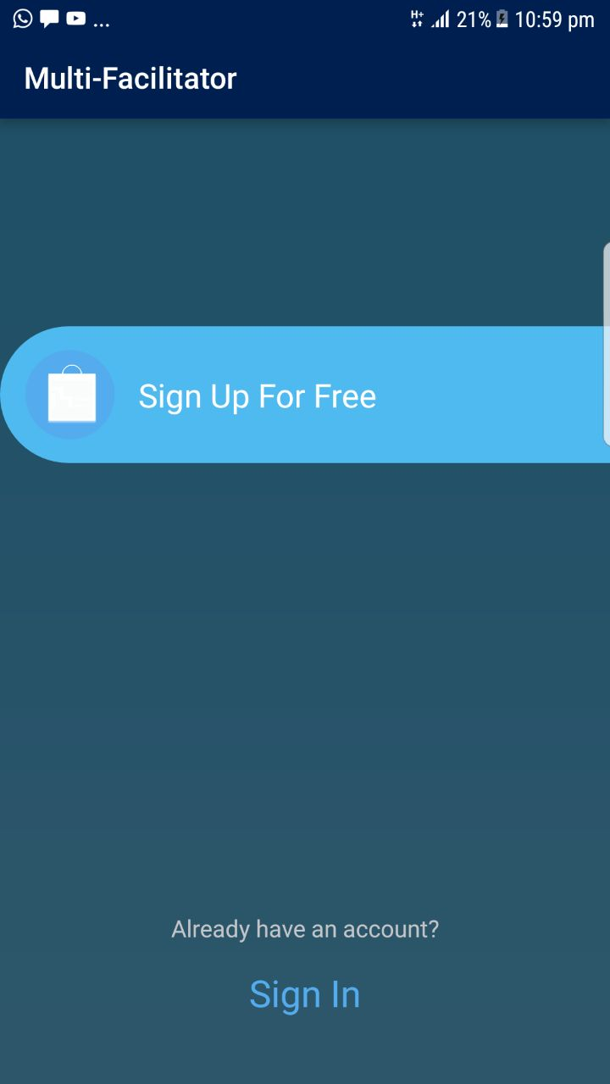
User interfaces (mock screens)

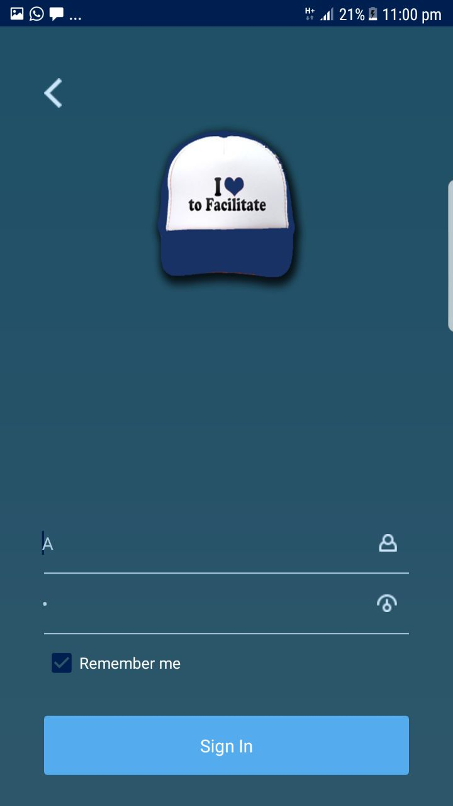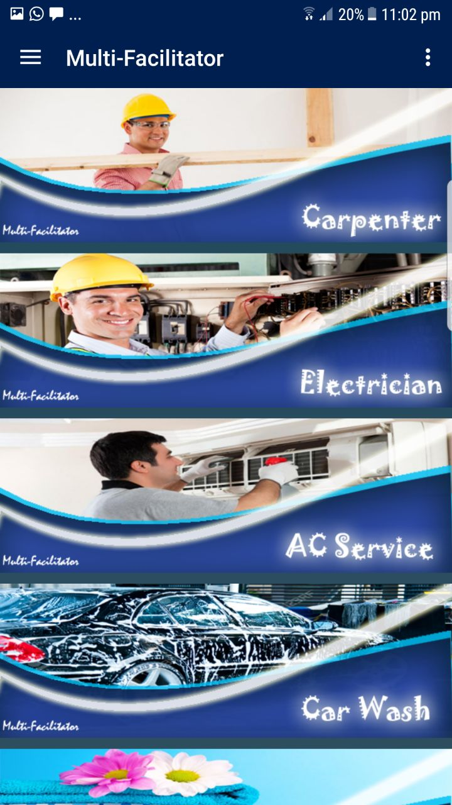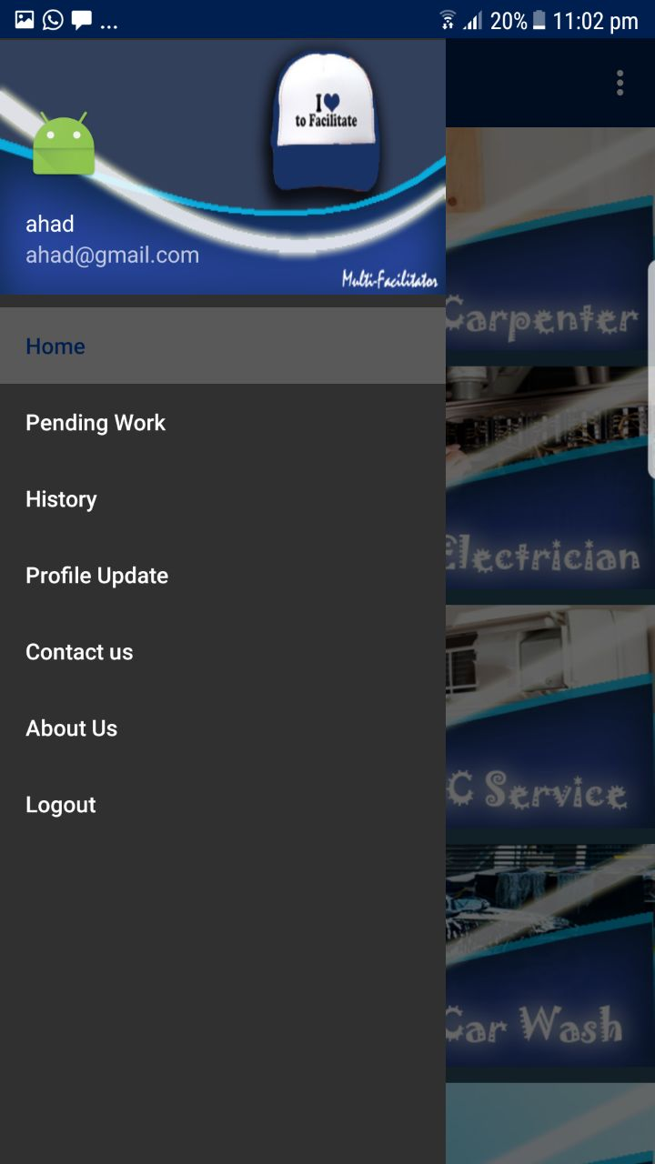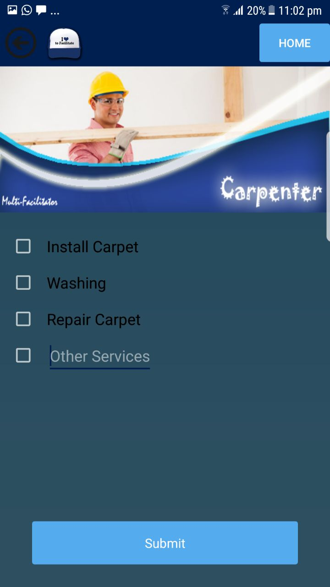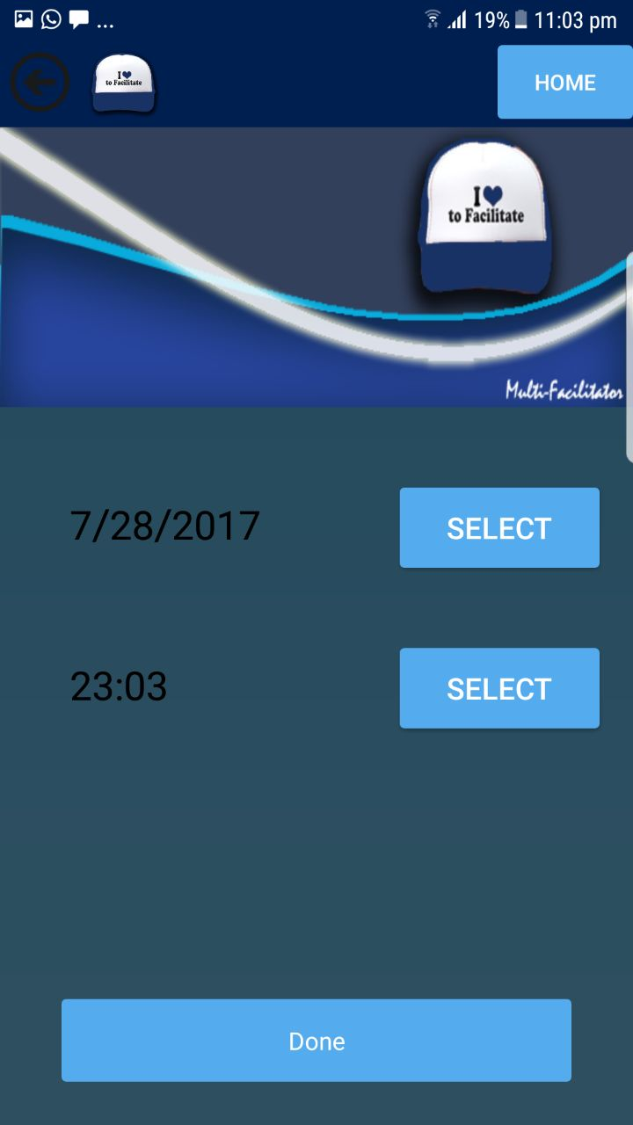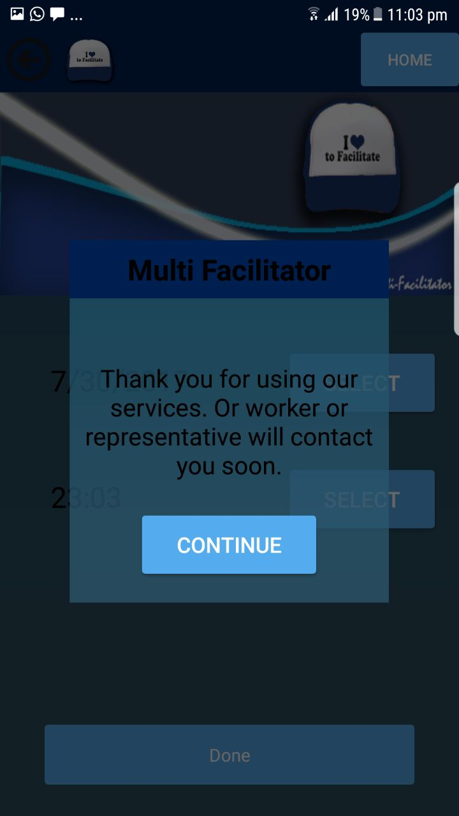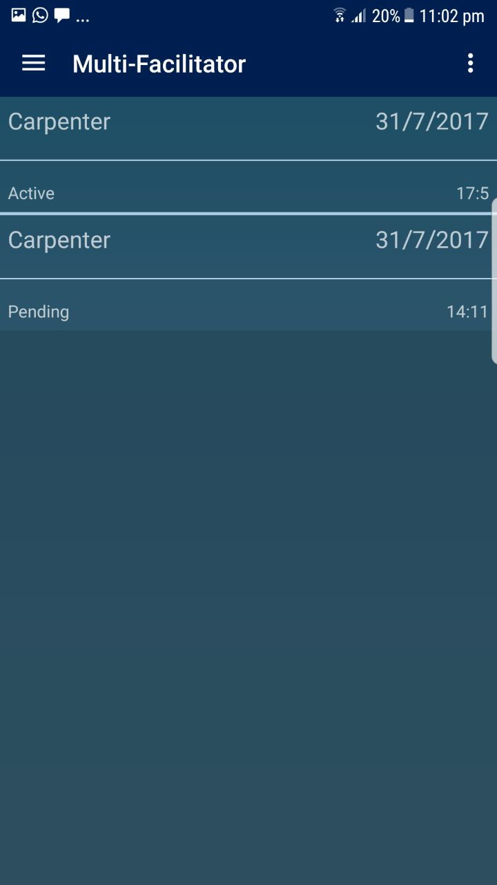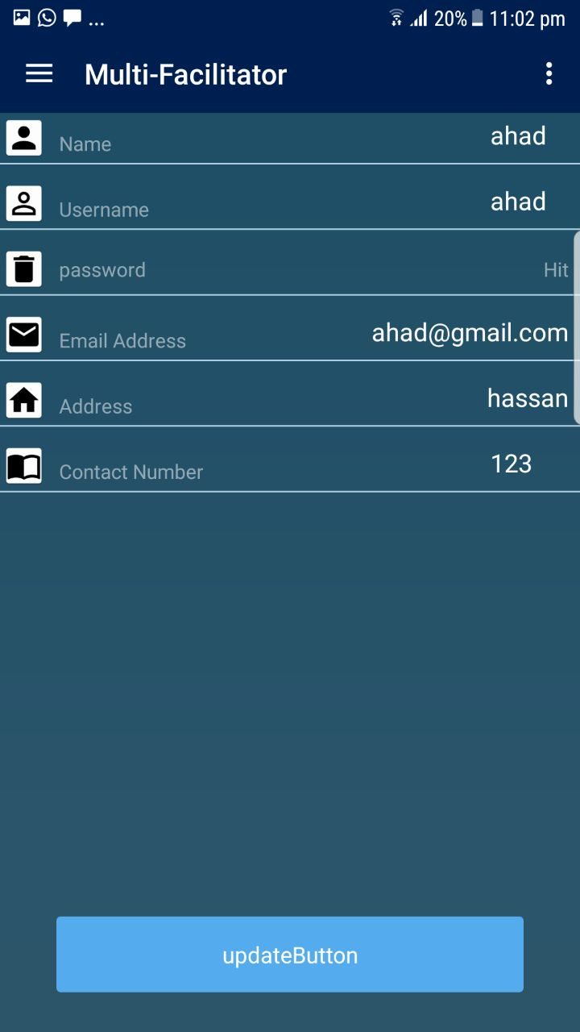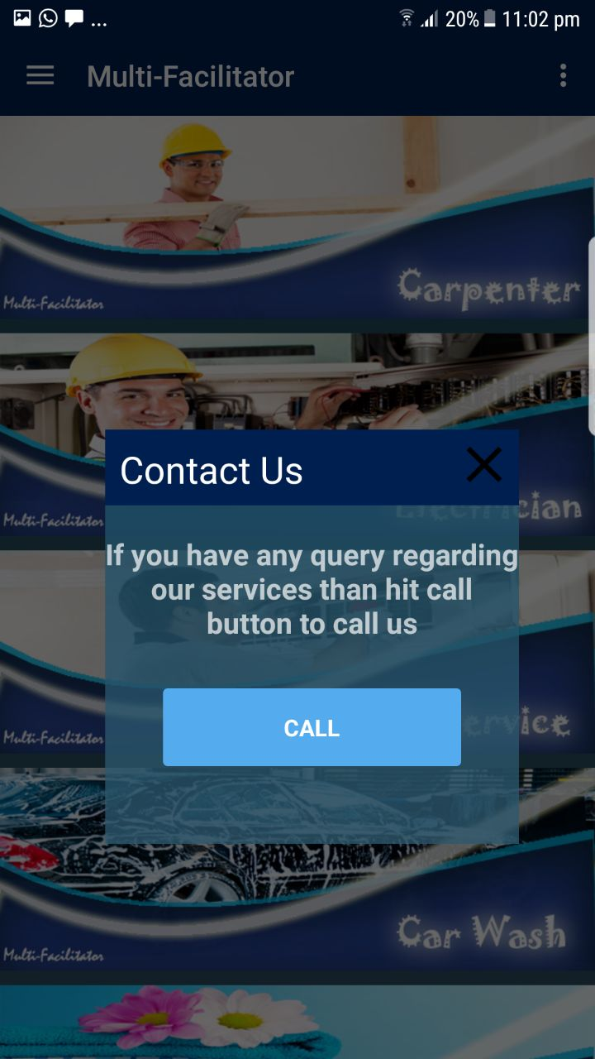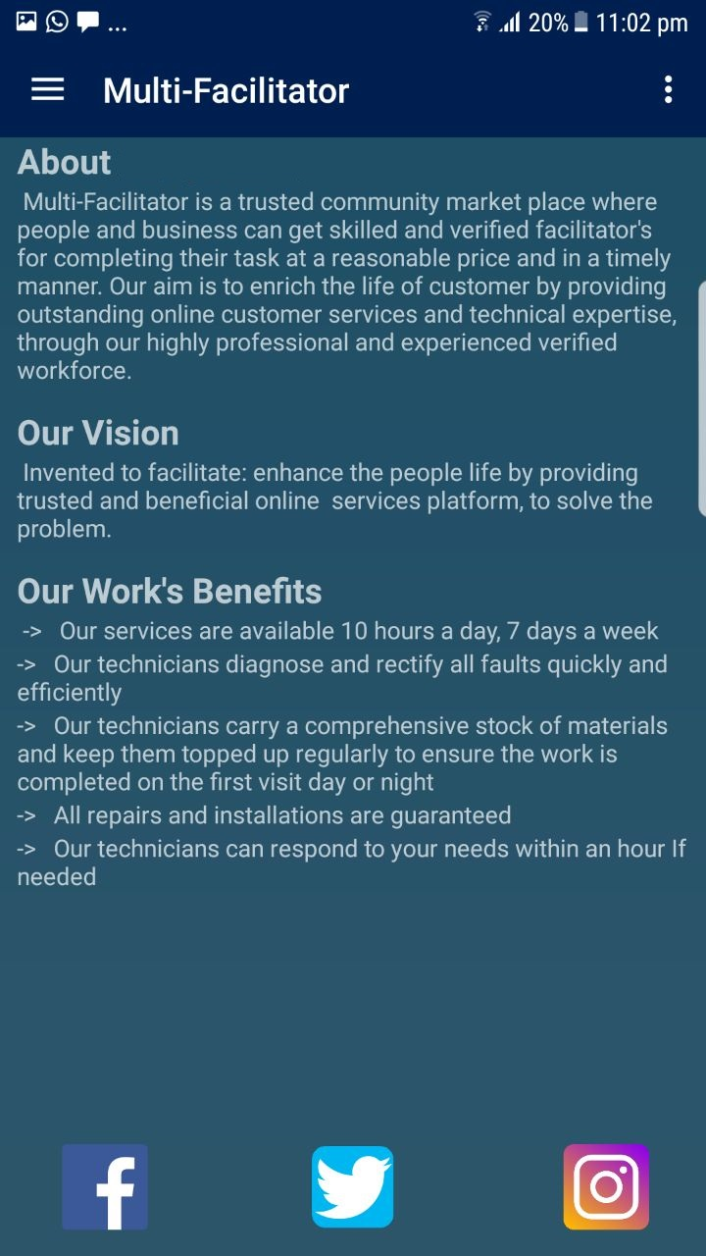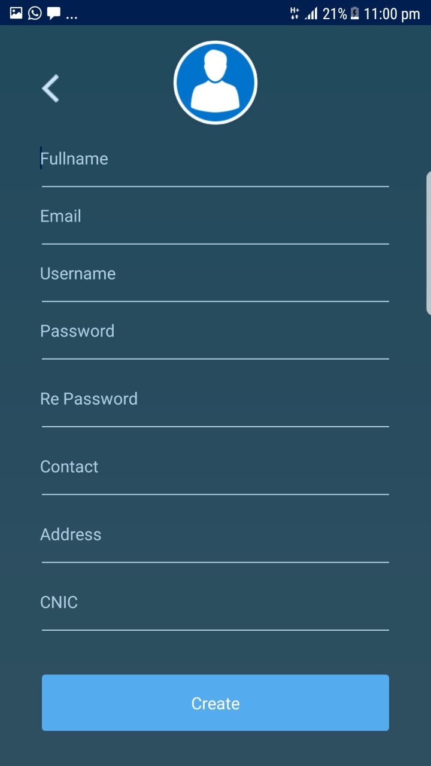Data flow 4. diagram (optional)

Data Flow Diagram Level 0

Data Flow Diagram Level 1

Data Flow Diagram Level 2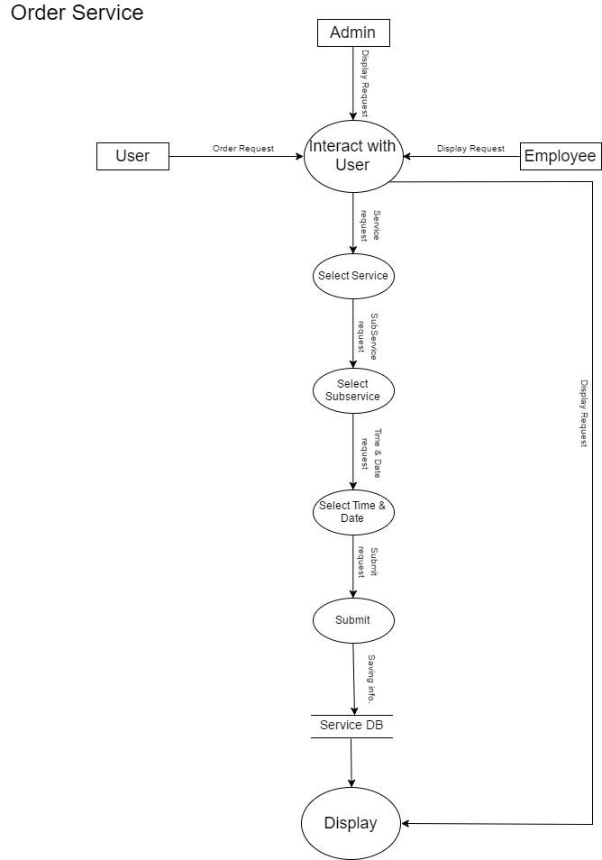

System Design
.

System Architecture Diagram
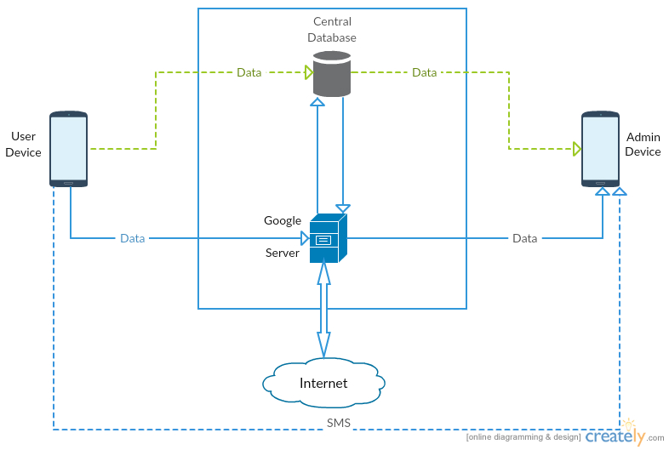

Class Diagram
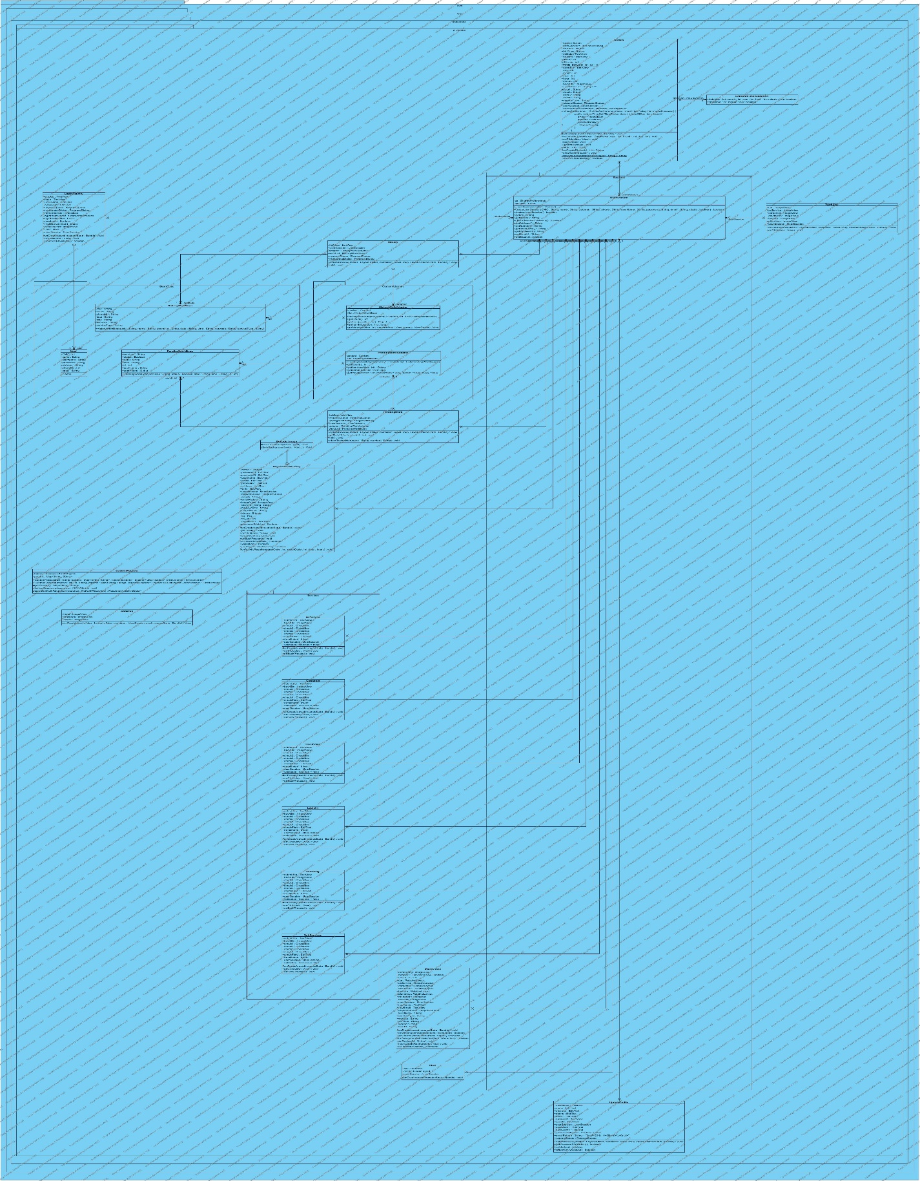

Sequence Diagrams
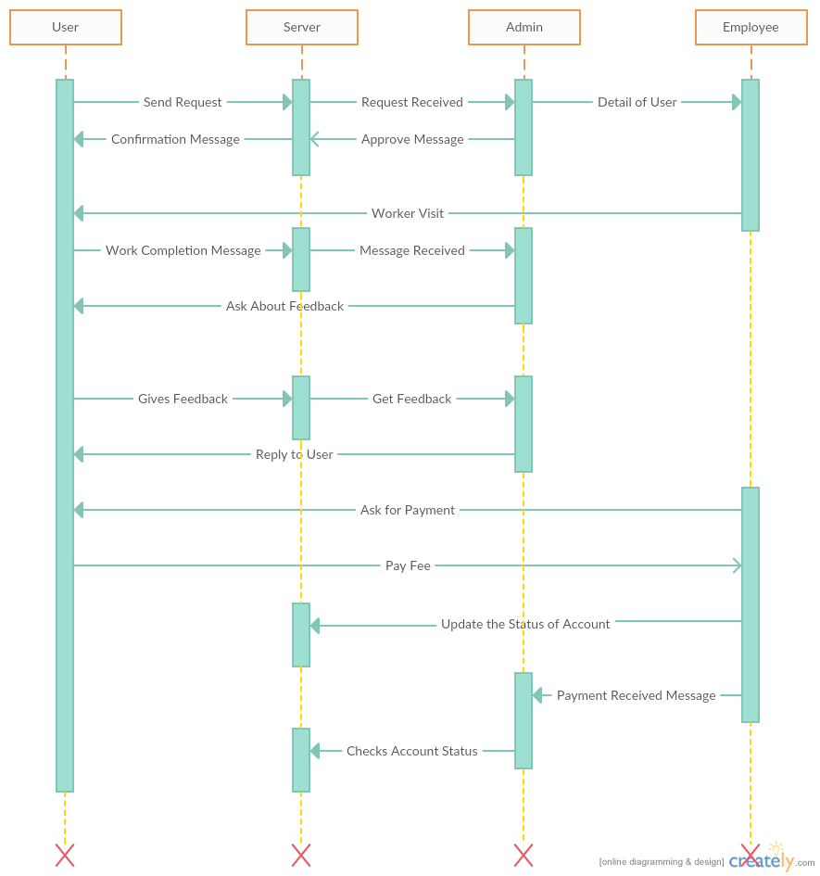

Collaboration Diagrams
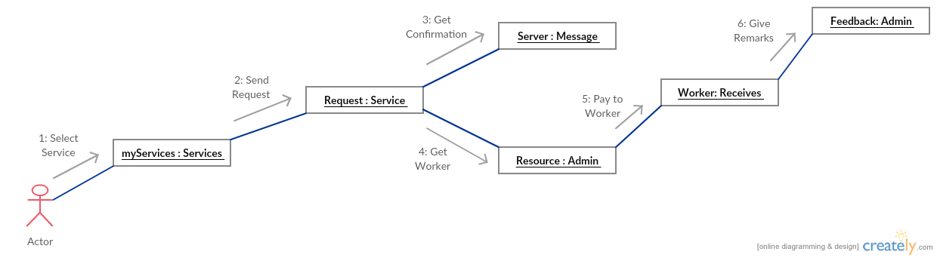

Other UMLs
This is optional. You may include any other UML to support your system.

ERD

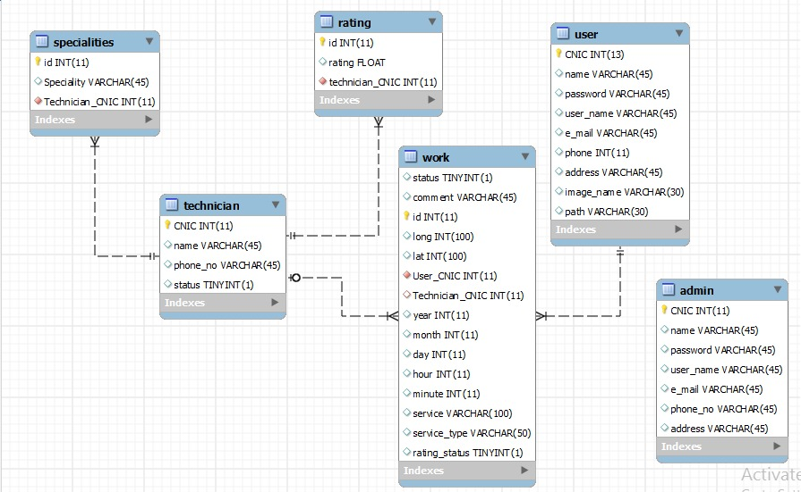

Data Dictionary

1) User Detail:
Name | Type | Size | Description
User_id | Integer |  | ID of the User
Name | Varchar | 45 | Name of the User
UserName | Varchar | 45 | User Name of the User
Password | Varchar | 45 | Password of the User
Phone No | Integer | 11 | Phone No of the User
CNIC | Integer | 13 | CNIC No of the User
Address | Varchar | 45 | Address of the User
Email | Varchar | 45 | Email of the User
2) Admin Detail:
Name | Type | Size | Description
Admin_id | Integer |  | ID of the Admin
UserName | Varchar | 45 | User Name of the Admin
Password | Varchar | 45 | Password of the Admin
Name | Varchar | 45 | Name of the admin
Email | Varchar | 45 | Email of the admin
Phone No | Integer | 11 | Phone No of the admin
Address | Varchar | 45 | Address of the admin
CNIC | Integer | 13 | CNIC of the admin

3) Work Detail:
Name | Type | Size | Description
Id | Integer | 11 | ID of the Work
Comment | Varchar | 45 | Comments of the Work
Status | Integer | 1 | Status of the Work
Longitude | Integer | 100 | Longitude of the Work
Latitude | Integer | 100 | Latitude of the Work
User CNIC | Integer | 13 | User CNIC of the Work
Technician CNIC | Integer | 13 | Technician CNIC of the work
Year | Integer | 11 | Year of the work
Month | Integer | 11 | Month of the work
Day | Integer | 11 | Day of the work
Hour | Integer | 11 | Hour of the work
Minute | Integer | 11 | Minute of the work
Service | Varchar | 100 | Service of the work
Service type | Varchar | 50 | Service type of the work
Rating Status | Integer | 1 | Rating status of the work

4) Rating Detail:
Name | Type | Size | Description
Id | Integer | 11 | ID of the Rating
Rating | Float | 5 | Rating of the technician

5) Technician Detail:
Name | Type | Size | Description
CNIC | Integer | 13 | CNIC of the technician
Name | Varchar | 45 | Name of the technician
Phone No | Integer | 11 | Phone no of the technician
Status | Integer | 1 | Status of the technician

6) Specialities Detail:
Name | Type | Size | Description
Id | Integer | 11 | ID of the specialities
Speciality | Varchar | 45 | Speciality of the specialities
Technician CNIC | Integer | 13 | Technician CNIC of the specialities

Implementation details

Development Setup
There are two users of application.
- User
- Admin
User: For user, client side and server is PHP
Admin: For admin PHP is server side and client side.

Deployment setup
There were some problems that were faced by us. These problems were related to the designing of prototype. These problems were solved by internet searching and some were processed by tutorials related to them.

Algorithms
First of all we remove the errors from edit texts then we get the data from text fields, then we check each fields
Whether they full fill the requirements or not, if any field doesn't meet the requirement then it set error on that field

public boolean validation() {
userName.setError(null);
name.setError(null);
password1.setError(null);
password2.setError(null);
address.setError(null);
phone.setError(null);
email.setError(null);
String tempUsername = userName.getText().toString();
String tempName = name.getText().toString();
String tempPassword1 = password1.getText().toString();
String tempPassword2 = password2.getText().toString();
String tempAddress = address.getText().toString();
String tempPhone = phone.getText().toString();
String tempEmail = email.getText().toString();
boolean cancel = false;
View focusView = null;
//password validation
if(!passwordMatcher)
{
password1.setError("Not Matched");
password2.setError("Not Matched");
focusView = password1;
focusView =password2;
cancel = true;
}
if (TextUtils.isEmpty(tempEmail)) {
email.setError("This field is required");
focusView = email;
cancel = true;
}
//Email Validation
if(!tempEmail.trim().matches(emailPattern))
{
email.setError("Invalid Email Address");
focusView = email;
cancel = true;
}
//Phone Validation
if (TextUtils.isEmpty(tempPhone)) {
phone.setError("This field is required");
focusView = phone;
cancel = true;
}
if (tempPhone.length()!=11)
{
phone.setError("Invalid Phone number");
focusView = phone;
cancel = true;
}
if (TextUtils.isEmpty(tempAddress)) {
address.setError("This field is required");
focusView = address;
cancel = true;
}
//Name Validation
if (TextUtils.isEmpty(tempName)) {
name.setError("This field is required");
focusView = name;
cancel = true;
}
//Username Validation
if (TextUtils.isEmpty(tempUsername)) {
userName.setError("This field is required");
focusView = userName;
cancel = true;
}
if (tempUsername.length()<6)
{
userName.setError("UserName to Short");
focusView = userName;
cancel = true;
}
if (cancel) {
focusView.requestFocus();
return false;}
else
{
return true;
}
}

Constraints

Assumptions
- All the databases will be handled by server.
- Profile management will be done the user side.
- Real time notifications provided.
- Records will be kept updated on server.

System constraints
- System should be user friendly.
- System should be responsive.
- System should be efficient.

Restrictions
The user cannot create account on application without valid email verification.

Limitations
The application can only be run on android and not on IOS.

Testing

Extended Test Cases
Extended test cases:
Test case :1

T.C Name | Sign up
Description | Sign up is used to be registered on application
Pre condition | The application should be opened.  Internet connection should be available.
Input | Sign up button is clicked
Expected result | Registration page should be opened.
Actual result | Registration page opened.
Result | Pass
Failure | Signup page not opened  Reason:  No internet connection

Test case :2

T.C Name | Sign in
Description | Sign in button is used to open login page.
Pre condition | The application should be opened.  Internet connection should be available.
Input | Sign in button is clicked
Expected result | Login page should be opened
Actual result | Login page opened.
Result | Pass
Failure | Login page not opened  Reason:  - No internet connection

Test case :3

T.C Name | Login
Description | Login button is used to be logged into application by entering username and password.
Pre condition | The application should be opened.  Internet connection should be available.
Input | Username and password entered and Login button is clicked
Expected result | Home page should be opened.
Actual result | Home page opened.
Result | Pass
Failure | Home page not opened.  Reason:  - Username or password is invalid  - No internet connection  - User not registered on application

Test case :4

T.C Name | Forget password button
Description | Forget password button will allow user to get password through user’s email.
Pre condition | The application should be opened.  Internet connection should be available.
Input | Forget password button is clicked
Expected result | Forget password page should be opened.
Actual result | Forget password page opened.
Result | Pass
Failure | Forget password not opened.  Reason:  - No internet connection

Test case :5

T.C Name | Carpenter button
Description | Carpenter button is used to register carpenter services
Pre condition | The application should be opened.  Internet connection should be available.  Homepage should be opened
Input | Carpenter button is clicked
Expected result | Carpenter services page should be opened.
Actual result | Carpenter services page opened.
Result | Pass
Failure | Carpenter services page not opened.  - Internet connection is not available.

Test case :6

T.C Name | Car wash button
Description | Carpenter button is used to register car wash services
Pre condition | The application should be opened.  Internet connection should be available.  Homepage should be opened
Input | Car wash button is clicked
Expected result | Car wash services page should be opened.
Actual result | Car wash services page opened.
Result | Pass
Failure | Car wash services page not opened.  - Internet connection is not available.

Test case :7

T.C Name | Glass work button
Description | Glass work button is used to register glass work services
Pre condition | The application should be opened.  Internet connection should be available.  Homepage should be opened
Input | Glass work button is clicked
Expected result | Glass work services page should be opened.
Actual result | Glass work services page opened.
Result | Pass
Failure | Glass work services page not opened.  - Internet connection is not available.

Test case :8

T.C Name | Laundry button
Description | Laundry button is used to register laundry services
Pre condition | The application should be opened.  Internet connection should be available.  Homepage should be opened
Input | Laundry button is clicked
Expected result | Laundry services page should be opened.
Actual result | Laundry services page opened.
Result | Pass
Failure | Laundry services page not opened.  - Internet connection is not available.

Test case :9

T.C Name | Ac service button
Description | Ac service button is used to register Ac services
Pre condition | The application should be opened.  Internet connection should be available.  Homepage should be opened
Input | Ac service button is clicked
Expected result | Ac services page should be opened.
Actual result | Ac services page opened.
Result | Pass
Failure | Ac services page not opened.  - Internet connection is not available.

Test case :10

T.C Name | Electrician service button
Description | Electrician service button is used to register electrician services
Pre condition | The application should be opened.  Internet connection should be available.  Homepage should be opened
Input | Electrician service button is clicked
Expected result | Electrician services page should be opened.
Actual result | Electrician services page opened.
Result | Pass
Failure | Electrician services page not opened.  - Internet connection is not available.

Test case :11

T.C Name | Navigation drawer button
Description | Navigation drawer button is used to open drawer.
Pre condition | The application should be opened.  Internet connection should be available.  Homepage should be opened
Input | Navigation drawer button is clicked
Expected result | Navigation drawer page should be opened.
Actual result | Navigation drawer page opened.
Result | Pass
Failure | Navigation drawer page not opened.  - Internet connection is not available.

Test case :12

T.C Name | Sign out button
Description | Sign out button is used to sign out from application .
Pre condition | The application should be opened.  Internet connection should be available.  Homepage should be opened  Navigation drawer should opened
Input | Sign out button is clicked
Expected result | Application will be signed out.
Actual result | Application is signed out.
Result | Pass
Failure | Application not signed out.  - Internet connection is not available.

Test case :13

T.C Name | Contact us button
Description | Contact us button is used to make a call to admin.
Pre condition | The application should be opened.  Internet connection should be available.  Homepage should be opened  Navigation drawer should opened
Input | Contact us button is clicked
Expected result | Contact us dialogue box will be opened.
Actual result | Contact us dialogue box opened.
Result | Pass
Failure | Contact us dialogue box not opened  - Internet connection is not available.

Test case :14

T.C Name | History button
Description | History button is used to open services history page.
Pre condition | The application should be opened.  Internet connection should be available.  Homepage should be opened  Navigation drawer should opened
Input | History button is clicked
Expected result | History button will open services history page
Actual result | History button opened services history page
Result | Pass
Failure | Service history page not opened  - Internet connection is not available.

Test case :15

T.C Name | Update profile button
Description | Update profile button enable user to update information.
Pre condition | The application should be opened.  Internet connection should be available.  Homepage should be opened  Navigation drawer should opened
Input | Update profile button is clicked
Expected result | Update profile button will open update info page
Actual result | Update profile button opened update info page
Result | Pass
Failure | Update profile button will not open update info page  - Internet connection is not available.

Test case :16

T.C Name | Date button
Description | Date button is used to select date of service.
Pre condition | The application should be opened.  Internet connection should be available.  Homepage should be opened  Service selected.
Input | Date button is clicked
Expected result | Calendar will be shown.
Actual result | Calendar is shown.
Result | Pass
Failure | NA

Test case :17

T.C Name | Time button
Description | Time button is used to select time of service.
Pre condition | The application should be opened.  Internet connection should be available.  Homepage should be opened  Service selected.
Input | Time button is clicked
Expected result | Clock will be shown.
Actual result | Clock is shown.
Result | Pass
Failure | NA

Test case :18

T.C Name | About us button
Description | About us button is used to open application owner info.
Pre condition | The application should be opened.  Internet connection should be available.  Homepage should be opened  Navigation drawer should opened
Input | About us button is clicked
Expected result | About us page will be opened.
Actual result | About us page opened.
Result | Pass
Failure | About us dialogue box not opened  - Internet connection is not available.

Decision Table

Code snippet

Decision coverage table
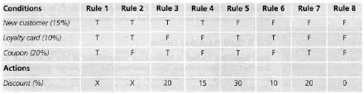

Traceability Matrix

RID vs UCID (requirements vs use cases)
UCID/RID | R  1 | R  2 | R  3 | R  4 | R  5 | R  6 | R  7 | R  8 | R  9 | R  10 | R  11 | R  12 | R  13 | R  14 | R  15 | R  16 | R  17 | R  18 | R  19 | R  20 | R  21
UC 1
UC 2
UC 3
UC 4
UC 5
UC 6
UC 7
UC 8
UC 9
UC 10
UC 11
UC 12
UC 19
UC 20
UC 21
UC 22
UC 23
UC 24
UC 25
UC 26
UC 27

Prototypes (RID vs PID)

Test Cases (RID vs TID)

Coverage (UCID vs TID)

Results/Output/Statistics

%completion
95% and in progress

%accuracy
92% estimated.

%correctness
93% estimated

Conclusion
The journey of development of this application was tough but we worked hard and overcame all the hurdles in our work. The project is like a complete package that includes all features needed or which are necessary to be in an application that claims to help users. As every other project our project has room for further improvement for and additions. It might be slow sometimes. But overall project is operational and fulfill all requirements.
In the end, we would like to thank everyone for supporting us in completion of our project.

Future work
- In future, a website will be available soon after deployment of the application which will help the user to understand the system.
- The iOS version of the application will also be made in the future.
- User interface will be made more fascinating in version to version.
- The feature will be made more reliable.
- New features will also be launched.
- Server will also updated
- The data will be recorded.

Bibliography
Abdul Rafay Sami, Abdul Ahad, Hafiz Muaaz Ali.
Multi-Facilitator_Android Application.
UMT 2016-2017

Books
- Think Java
- Learning XML
- XML in a Nutshell
- Hello Android.
- Head first android development
- Pro Android App development
- Android Studio Development Essential
- Android User Interface Design
- Head First Java
- Effective Java
- Understanding Web Services
- XML bible

Journals
- Android application development and its security.
Link:ijcsmc.com/docs/papers/March2015/V413201599a38.pdf
- Android applications using Android Studio.
Link:ijcaonline.org/rtfem2016/number1/rftem45109.pdf

Articles
- Android development from scratch: An overview odf android application development.
Link:https://code.tutsplus.com/articles/android-from-scratch-an-overview-of-android-application-development.

Research papers
- Android based application development.
Link: pdfs.sementicscholar.org/7ccd/fdd3138014400a854954325d54dbb7447ead.pdf

Other References
None.

Appendix

Glossary of terms

Pre-requisites
Good database for data storage.
Network to keep application linked and synchronized.
Android device with latest version.

