Dual Mode Forward Converter for Battery Charging Using Digital Control



Submitted By:

Hafiz M. Yahya Zahid | 15020019068
Muhammad Fahad Nadeem | 15020019046
Talha Zahid | 15020019042

Supervised by: Dr. Asif Hussain

Department of Electrical Engineering
School of Engineering
University of Management and Technology Lahore

June 2019

Dual Mode Forward Converter for Battery Charging Using Digital Control

Submitted to the faculty of the Electrical Engineering Department of the University of Management and Technology Lahore
In partial fulfillment of the requirements for the Degree of

Bachelor of Science
in
Electrical Engineering.

Project Advisor

Director Undergraduate Studies

Department of Electrical Engineering
School of Engineering
University of Management and Technology Lahore

Declaration

I declare that the work contained in this thesis is my own, except where explicitly stated otherwise. In addition, this work has not been submitted to obtain another degree or professional qualification.

Signed:

Signed:

Signed:

Date:

Acknowledgments

We are very thankful to my ultimate Lord and benefactor, ALLAH for his countless blessings that have always showered upon us. We find Him to be our strength in the times of weakness and our pride in the times of achievement.
We are highly grateful to our MS Supervisor Dr. Asif Hussain. Without his guidance and motivation, this feat would never have been possible. With his keen interest in this subject and timely guidance, we have not only been able to complete the research but also write the report with the highest level of motivation.
The most of our thanks go to our parents who have shaped us to be the persons we are today. Their prayers and support has never let us down in any walk of life.

Dedicated to our parents, without whom none of this would have been possible.

Contents

Declaration iii
Acknowledgments iv
Contents vi
List of Figures viii
List of Tables ix
Abstract x
Chapter 1: Introduction 1
1.1 AC-DC Converters 1
1.2 Forward Converter 2
1.3 Voltage Fedback Converter 4
1.4 Current Feedback Converter 5
1.5 Mode Switching in Forward Converter 7
Chapter 2: Related Literature and Problem Statement 8
Chapter 3: Proposed Approach 12
3.1 Main Rectifier 13
3.2 Auxiliary Power Supplies 14
3.3 Forward Converter 16
Chapter 4: Implementation and Methodology 18
4.1 Active and Passive Components 18
4.1.1 Bridge Rectifiers 18
4.1.2 IGBT Switch 19
4.1.3 Gate Driver 20
4.1.4 Transformer 21
4.1.5 Snubber Circuits 25
4.1.6 Schottky Diodes 25
4.1.7 Inductor for Buck Converter 26
4.1.8 Output Capacitor 27
4.1.9 Current sensor 27
4.1.10 Voltage Sensor 28
4.1.11 Microcontroller 29
4.2 Control Algorithm 30
Chapter 5: Conclusions and Future Directions 32
5.1.1 Final Implementation 32
5.1.2 Future Directions 35
References 36

List of Figures

Figure ‎1.1: Block diagram of a switch mode AC-DC converter 2
Figure ‎1.2: Basic circuit of a forward converter 3
Figure ‎1.3: ON and OFF cycles of a forward converter 3
Figure ‎1.4: A forward converter operating in voltage mode 4
Figure ‎1.5: A forward converter operating in a current mode 6
Figure ‎3.1: Main rectifier for the forward converter 14
Figure ‎3.2: Auxiliary power supplies 15
Figure ‎3.3: Measurement of 18V auxiliary power supply 16
Figure ‎3.4: Measurement of 5V auxiliary pwoer supply 16
Figure ‎3.5: Forward converter section 17
Figure ‎4.1: W08G full bridge rectifier 19
Figure ‎4.2 HGTG30N60 MOSFET 20
Figure ‎4.3: TLP250 isolated gate driver 21
Figure ‎4.4: EE40 core and bobbin for the transformer 22
Figure ‎4.5: Primary winding for the transformer 23
Figure ‎4.6: Primary side inductance with ferrite core 23
Figure ‎4.7: Secondary side of transformer 24
Figure ‎4.8: Inductance of the secondary side 25
Figure ‎4.9: MBR20100CT center tapped Schottky rectifier 26
Figure ‎4.10: Measuring the inductance of the secondary side inductor 27
Figure ‎4.11: ACS712 Hall effect current sensor 28
Figure ‎4.12: Voltage sampler circuit 28
Figure ‎4.13: Arduino Nano board 29
Figure ‎4.14: Controller algorithm 31
Figure ‎5.1: Main rectifier and auxiliary power supplies 33
Figure ‎5.2: Forward converter board 34
Figure ‎5.3: Complete circuit implementation 35

List of Tables

Table ‎4.1: Salient properties of the 30N60 IGBT 20
Table ‎4.2: Paramters of TLP250 gate driver 21
Table ‎4.3: Characteristics of MBR20100CT 26
Table ‎4.4: Properties of Arduino Nano controller 30

Abstract

In this project, the design and implementation of a forward converter is presented which can be controlled in either of the two modes, i.e. current mode and voltage mode. In the current mode, the current of the output is kept constant and similarly in the voltage mode, the voltage of the output is kept constant. The control of the output voltage and current is performed by adjusting the duty cycle of the forward converter. A feedback controller thus monitors the output parameters and updates the duty cycle of the converter at fixed, regular intervals.

Introduction

In this chapter, we explain how AC-DC switch mode power converters work. In specific, we are interested in the working of a forward converter. The output of the forward converter can be operated in one of two modes, i.e. current mode or voltage mode. The description of these modes and the various aspects of mode switching are also discussed in the following text.

AC-DC Converters
As evident from its name, an AC-DC converter converts electrical power from AC (at its input) to DC (at its output). In this project, we are not concerned with low frequency transformer approach because of its extra size, weight and cost. Rather, our interest is solely in switch mode converters, which use several intermittent steps and various conversions to arrive from AC voltage at a high level (220 VAC) to DC voltage at a low level (12 VDC). The chief advantage in terms of size and weight comes from the voltage transformation which is performed at high frequency. At frequencies around$50 kHz$, the magnetic flux required in the transformer is much less than that required at$50 Hz$, thus the magnetic core of the transformer is much smaller for the same power handling capability of the converter.
The generic block diagram of a switch mode AC-DC converter is shown in Figure ‎1.1. Here, the main conversion per se takes place in the high frequency converter. The preceding and following blocks are for conditioning and processing the voltage and current levels according to the requirements of the main converter and the output.
All practical converters have some form of control to get the output voltage and current according to specifications. This function is performed by dedicated controllers that may be implemented as analog circuits or an algorithm in a microcontroller, according to the level of sophistication in any application. The controller monitors the output voltage and currents and adjusts the conversion ratio of the main converter to keep the voltage and current levels at the output according to the requirements.
AC Input
Rectifier and Filter
High Frequency Converter
Rectifier and Filter
Output Sense
DC Output
Controller
Figure ‎1.1: Block diagram of a switch mode AC-DC converter
The rectifiers before and after the main converter have different operating voltages and frequency. The first rectifier operates at mains voltage, which is $220 VAC, 50 Hz$ and the second rectifier operates at the converter’s switching frequency and output voltage, which may be $50 kHz, 12V$ for a typical application. The output sense blocks include both the current and voltage sensors for feedback to the controller. Even when the main converter is operating in voltage feedback mode, the current feedback is usually required to maintain a realistic short circuit protection.

Forward Converter
A forward converter can be understood as the isolated implementation of a buck converter. It can convert a DC voltage at its input to a DC output voltage with a continuously controllable conversion ratio. The fundamental circuit of a forward converter is shown in Figure ‎1.2. [1]
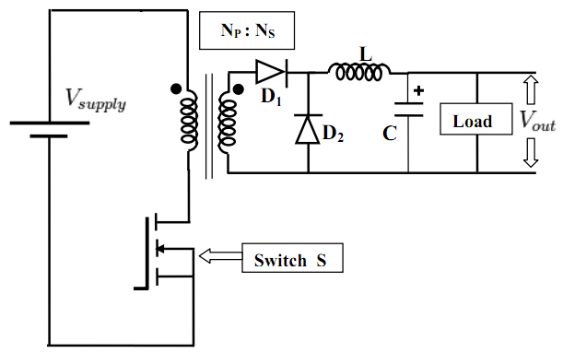
Figure ‎1.2: Basic circuit of a forward converter
The voltage conversion takes place through the flux linkage in the transformer. Thus the base line conversion ratio is given by the transformer’s turn ratio and further upon this, the duty cycle of the waveform being fed to the switch further controls the conversion ratio according to the following formula (1.2).
$\frac{V_{out}}{V_{in}}=D∙\frac{N_{S}}{N_{P}}$ (1.2)
Here, $D$ is the duty cycle of the switch’s waveform, $N_{S}$ is the number of turns on the secondary side and $N_{P}$ is the number of turns on the primary side of the transformer.
The operation of a forward converter can be understood in its two cycles of operation. The ON cycle is when the MOSFET switch is on and the OFF cycle when the switch is off. The circulation of current in these two modes is given in Figure ‎1.3. [2]
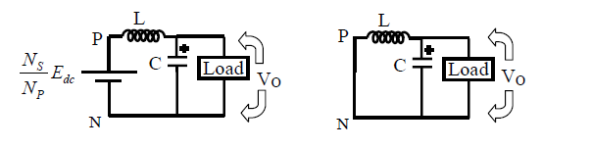
Figure ‎1.3: ON and OFF cycles of a forward converter
During the ON cycle, the switch is on, there is voltage across the transformer primary and the consequently voltage is induced in the secondary side. The diode D1 conducts and voltage is provided to the load through the inductor. In this time, the capacitor is also recovering its lost charge. During the off cycle, the switch is turned off and there is no voltage across the primary side. Consequently, there is no voltage on the secondary side of the transformer and the inductor current flows through the load with the load voltage maintained by the capacitor.
The switching frequency for the operation of the forward converter is one of the most commonly known factors that influence the overall efficiency of the converter. The operating of the switches at a high enough frequency will require a smaller inductor and the transformer due to less flux in their cores. This allows common forward converters to easily have switching frequencies in excess of 100kHz. The highest frequency possible for such switch mode power converters is due to the limited switch period and nonzero switch loss in practical switches. [2]
As we have seen earlier, the conversion ratio of a forward converter depends on the duty cycle of the waveform being fed to the switch. This duty cycle is controlled in real time by employing a controller in an appropriate feedback mode according to the voltage or current at the output. Thus, depending on the nature of the feedback, the controller can be considered to be current-mode or voltage-mode.

Voltage Feedback Converter
A basic circuit of a voltage mode converter is shown in Figure ‎1.4.
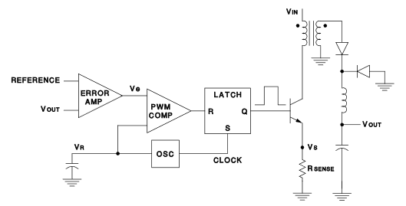
Figure ‎1.4: A forward converter operating in voltage mode
The most easily evident property of this type of feedback scheme is that there exists only one loop for feedback from the output to the input. And that feedback signal depends on the voltage sensed at the output of the converter. To limit the current from the output, there is an independent circuit, for providing feedback according to current, is needed.
Controlling a converter in voltage feedback mode brings the following advantages:
- Ease of analysis as a control system because there is only one loop for feedback.
- The magnitude of the voltage is very large relative to the error amplifier’s dynamic range. This makes it very safe from interfering noise.
- The absence of any output impedance in the converter makes it very suitable for multiple output terminals from a single transformer.
Despite these benefits, the voltage feedback mode has its own share of problems, some of which are listed in the following:
- The response to changes in load conditions is not very fast because the change in load current takes some time to be detected in the voltage at the output.
- The filter near the output of the converter is itself has a second order transfer function that brings some more poles and zeros to the original system. The result is that the system is more complicated to analyze and design for stability and controllability.
- The voltage at the input also indirectly controls the gain around the closed system loop, so this can’t be modelled as an LTI system for a wide range of operation.
Note that most practical converters used in switch mode power supplies use this kind of feedback, i.e. voltage mode. However, in recent applications, there has been an increasing trend of the use of current mode converters due to their fast response and the availability of dedicated PWM controllers for switch mode power supplies.

Current Feedback Converter
The above disadvantages are relatively significant and since all are alleviated with current-mode control, designers were highly motivated to consider this topology upon its introduction. As can be seen from the diagram of Figure ‎1.5, basic current-mode control uses the oscillator only as a fixed-frequency clock and the ramp waveform is replaced with a signal derived from output inductor current. [3]
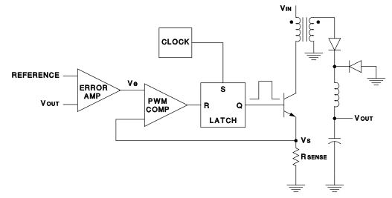
Figure ‎1.5: A forward converter operating in a current mode
The current feedback control method has the following set of benefits when compared to the voltage mode operation:
- The current in the transformer’s primary side is directly related to the voltage on the DC bus. Thus if the line voltage is increased or decreased, it can be detected by the controller as the change in transformer’s primary current within the timer period of a single cycle.
- The current control method simplifies the analysis of the filter at the output because the inductor is easier to analyze using its current as compared to the voltage in the voltage feedback mode.
- The current in the load reflects to the current in the primary side of the transformer almost in real time. This allows very fast and precise limiting of current if there is a low impedance at the output due to a malfunction or otherwise.
The disadvantages of the current mode control of a forward converter are as the follows:
- There are now two feedback loops, making circuit analysis more difficult.
- The control loop becomes unstable at duty cycles above 50% unless slope compensation is added.
- Since the control modulation is based on a signal derived from output current, resonances in the power stage can insert noise into the control loop.
- A particularly troublesome noise source is the leading edge current spike typically caused by transformer winding capacitance and output rectifier recovery current.
So from the above we can conclude that while current mode control will ease many of the limitations of voltage-mode, it also contributes a new set of challenges to the designer. However, with the knowledge gained from more recent developments in power control technology, a re-evaluation of voltage mode control indicated that there were alternative ways to correct its major weaknesses. [3]

Mode Switching in Forward Converter
None of the above discussion should leave the impression that there is no longer a place for current mode control - only which both topologies are viable choices in today’s environment. There are considerations which could point to one or the other as more optimum for each particular application. Some of these are outlined below:
The current feedback controller as the advantages in the following situations:
- The output of the converter is likely to have a large voltage or act as a source of current.
- The output voltage and current need to be controller very precisely and fast.
- The range of voltage at the input is relatively limited.
The voltage feedback control scheme is better to use in the situations where:
- The load current and the input voltage must be allowed to change significantly.
- For industrial converters where there is a lot of noise and usually the power level is quite higher than the control signals.

Related Literature and Problem Statement

With the advent of sophisticated controllers for switch mode power supplies and wide availability of high frequency, high efficiency power electronics components, there has been a lot of advancement in the topologies and implementations of the switch mode power supplies in the recent years. There has been dramatic reduction in the size and cost of power supplies and quite a significant increase in the efficiency in the last two decades. With these developments, considerable work has been done for the adaptation of power supply topologies according to the requirements and conditions of each application, with a number of dedicated single chip controllers, each focusing a narrow range of the types of power supply applications. In this chapter, we review the current work that has been done in the field of power supply topologies and develop the problem statement for our project.
In the following section, we analyze the work done in this field by various research groups around the globe. Much of the work has been in the recent times due to the inventions of high efficiency and high frequency power electronics components like MOSFETs and IGBTs. Most of the research work has been with the motivation of increasing the efficiency of the converters and design converters according to specific applications. There has been design and commercial applications of both the current mode and voltage mode converters of various topologies, including buck-boost, forward, flyback, and bridge topologies. [4] However, as we explore in the following text, there has not been much work in the design and applications of dual mode converters or mode-switching converters. The reason is that every type of converters is usually optimized to work in a single mode. Changing the mode or operating the converter in both modes is widely believed to decrease the optimization of the converter. However, with the use of highly efficient electronic switches and modern transformer cores, there has been recent explorations for converters operating in dual modes or switching the modes during live operation. These converters may be less optimal in efficiency and size at the beginning of their design life cycle, but they offer more utility and a wide range of functionalities compared to signal mode converters. Therefore in this project, we have tried to design and implement a forward converter that can switch between current and voltage modes according to the control algorithm. The result is that a single converter can operate on two modes according to the load conditions, which is quite remarkable because it eliminates a lot of hardware and added complexity corresponding to the two modes of operation that were previously implemented in two different converter sections.
There has been much work in the field of power electronic converters and they are wide spread use of switch mode power supplies for commercial and industrial applications. Much of the work has been done to increase the efficiency and reduce the cost and size of the converters suited to particular applications. Here we analyze the work done by various groups in this field and how the general working of switch mode converters has advanced in recent times.
Chutervedi et al compared the performance of isolated flyback and forward converters for application needing with low power requirements. They addressed various problems and their solutions pertaining to the applications and modelling of switching converter topologies having single switch and single phase operation. Their focus was on the converters with inherent power factor correction implanted with them and having both flyback and forward converter topologies. Their research and the results lets the designer and application engineers to choose the proper topology for low power applications up to $25W$ of output power. [5]
Seong et al described a forward converter with and active clamp circuit having current boosted clamp. This type of converter can operate at a higher efficiency than common forward converters because of an alternate, dedicated path for current during the primary recovering time. Thus they can be implemented with much higher power densities and higher efficiencies. However, the chief disadvantage of such converters is the added complexity with the additional active clamp circuits. The author and his team has proposed a special technique of boosting the current for the transformer to mitigate the effects of the aforementioned disadvantages. Their results show that such implementations are feasible and have the advantages of increased efficiency and higher power density without much addition of complexity and sophisticated output filter. [6]
Mittal et al present the design and implementation of a current fed double forward converter for high current and low voltage applications. Their principle application for this design was for use in space applications. Especially for the solid state recorder and the base data handler units of the spacecraft, where a very stable and low EMI power converter is needed. They tested their final converter design for various operating conditions and found that it produced very promising results with remarkable load and line regulation and more than $65\%$ efficiency. [7]
These researchers have mostly worked with forward converters having voltage mode operation due to their particular applications intended for the converter. In the following section, we present the analysis and brief review of some more works that have focused on current mode control of forward converters and developed the converters for their respective applications.
Fontan and his team had worked with a forward converter having an active clamp and working in current mode. They have focused on the peak current control in the forward converter with the current being sensed not from the output side but from the primary side of the transformer. They find out that the active clamp forward converter is the most popular technology for low voltage operation where the electronic switches and diodes are very small and have low peak voltage specifications. They also devised several control schemes for controlling the output voltage of the converter without the dynamic drawbacks of conventional converter topologies. [8]
Kopplou et al presented an active forward converter which was being controlled in current mode. The active clamp circuit to reset the transformer core magnetic field increases the reliability of the power electronic switches due to less voltage stress on it. The use of center tapped transformer on the secondary side also reduces the voltage spikes on the primary side during the core reset time period. They author and his team has developed a special state space model for the converter by using the technique of state space averaging to simplify the converter’s model. Their results show that their use of secondary current sensing brings an advantage of faster response and better dynamic characteristics with varying load conditions than the conventional primary side current sensing in usual current mode controller forward converters. [9]
With these researchers mostly focusing on one of the aspects of the forward converter, i.e. increasing efficiency by using a more suitable topology for a particular application, improving the dynamic characteristics of the converter by strategic placement of current sensors or improving the reliability and suitability of a converter for a particular application. However there hasn’t been much work done in the dual mode or mode switching converters that can be of great value for some applications such as power supplies, battery chargers or motor controllers. Therefore we found an opportunity to work in this area and explore how the mode switching converters can be suited for these particular applications.
Thus the problem statement of our project can by stated as to design and implement a forward converter that can be operated in both the current and voltage mode according to the control algorithm. Such a converter must not only have significant margin in the design choices of passive and active components to compensate for the differences in the two modes but also have better dynamic response to be able to operate smoothly during mode switches and continuous operation.
The designed converter must follow the battery charging curve for common flooded lead acid batteries and charge the batteries in the 2 step process, which is necessary for the longevity of the battery life and preservation of its internal structure. [10] The batteries are first being charged in the current mode, with a constant current being provided from the converter’s output. As the battery’s voltage rises to a specific voltage determined by the battery’s chemistry, the converter switches to voltage mode, maintaining a constant voltage at the output of the converter.

Proposed Approach

In this chapter we describe the design and implementation approached we had proposed for this project. With the principle objective being the design of a robust forward converter that can be operated in both current and voltage modes, the design generally carries significant margins in the design choices of both the passive and active components. These excess ratings and design margins ensure that the converter operates without any significant transients during the mode switching and can operate with acceptable performance in both modes in steady state operation.
There are several modules in the whole converter that can be designed in a compartmentalized fashion, though they are not completely independent. Thus, with some considerations of the interoperability of various circuit blocks in the whole project, the blocks can be fairly designed independently, thus simplifying the whole design process by dividing it into smaller relatively independent chunks.
This is basically an AC/DC converter, so the first block in the circuit is the full wave rectifier to convert the incoming AC supply voltage to DC voltage. This intermittent DC supply is then used by the subsequent forward converter as its input voltage. The converter converts the high DC voltage to lower voltage near the battery’s operating voltage. Then there is a pseudo buck converter after the forward converter to smooth out the pulsating DC voltage. The output of the buck converter is then fed to the load, which may be a resistive load or a battery. Before that, there are two small units that are for sampling the load voltage and the load current. These measurements are then provided to the controller that processes the measurements and runs the algorithm to control the converter’s output according to the battery charging algorithm. The controller also make sure that the converter is operating in the correct mode, i.e. current mode or voltage mode. Besides these fundament al blocks, there are two auxiliary power supply units. These small power supplies provide DC power to the electronics operating in the converter. Although these power supplies aren’t included in any way in the theoretical aspects of the forward converter, these are necessary for the operation of the converter’s active components and controller.
In the following sections we discuss the main building blocks of the whole system according to each block’s functionality and role in the operation of the forward converter. It is worth noting that at this stage, we aren’t concerned with the exact values of the passive components (resistors, capacitors, inductors and transformer) or the part numbers of the active components (transistors, diodes) because we are not designing the fine level details of the circuit here.

Main Rectifier
This is the main AC to DC converter that converts the mains 220VAC to DC. The input of this block is the mains voltage from the AC supply and its output is the rectified 310VDC. Before rectifying the AC voltage, there is an electromagnetic interference (EMI) filter to reduce the effects of incoming noise from nearby EMI sources. The filter used here is a low pass filter whose frequency is very high from the mains frequency (50 Hz) but it eliminates all the high frequency noise coming from nearby RF equipment, nonlinear electrical components or any other electromagnetic devices.
The calculation of the DC voltage from the RMS AC voltage comes from the formula (3.1.1) relating the RMS and peak voltage of a sine wave as shown in the following. The reason behind this is that the filter capacitor after the rectifier saves the peak voltage of the incoming full wave rectified signal.
${ V}_{DC}=V_{peak}=\sqrt{2}V_{RMS}$ (3.1.1)
$$V_{DC}=\sqrt{2}∙220=310 V$$
The cutoff frequency of the low pass filter preceding the full wave rectifier can be calculated using the RC filter formula$(3.1.2)$. We have $R=2Ω$ and $C=0.1 μF$.
$$f_{cutoff}=\frac{1}{2πRC} (3.1.2)$$
$$f_{cutoff}=800 kHz$$
This frequency covers most of the high frequency interference sources commonly encountered.
The calculation of the value of the filter capacitor after the rectifier comes from the following formula $(3.1.3)$. Note that the filter capacitor is $220 μF$, the load current is about $0.5 A$ and the operating frequency is $50 Hz$. We can thus calculate the ripple voltage in the DC bus using the following formula.
$$V_{ripple}=\frac{I_{L}}{2fC} (3.1.3)$$
$$V_{ripple}=\frac{0.5}{2×50×220×{10}^{-6}}$$
$$V_{ripple}=22.7 V$$
The circuit diagram of the main rectifier is show in Figure ‎3.1.
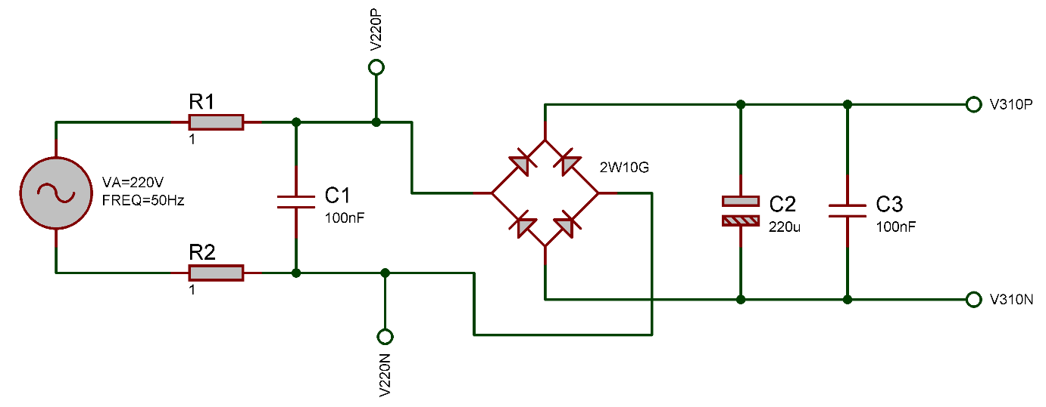
Figure ‎3.1: Main rectifier for the forward converter
The labeled nodes in the circuit are basically the connections to other parts of the circuit.

Auxiliary Power Supplies
There are two auxiliary power supplies in the circuit to provide power to the components that are necessary for the operation of the forward converter. One of the supplies provides $18 V$ for the gate drive of the electronic switch and the other is for the $5 V$ supply needed for the current sensor and the controller. Both power supplies use small mains voltage transformers to convert the 22VAC from the input to 13 VAC and then rectify it to get 18V peak full wave rectified voltage. After each rectifier, there is a filter capacitor which converts the pulsating full wave rectified signal to 18VDC level. One of the converters has a 5V voltage regulator to converter the 18V to 5V for the electronics.
The circuit diagram of the auxiliary power supplies is shown in Figure ‎3.2. Note that they are very similar just with the exception of a 5V regulator at the output of one of them.
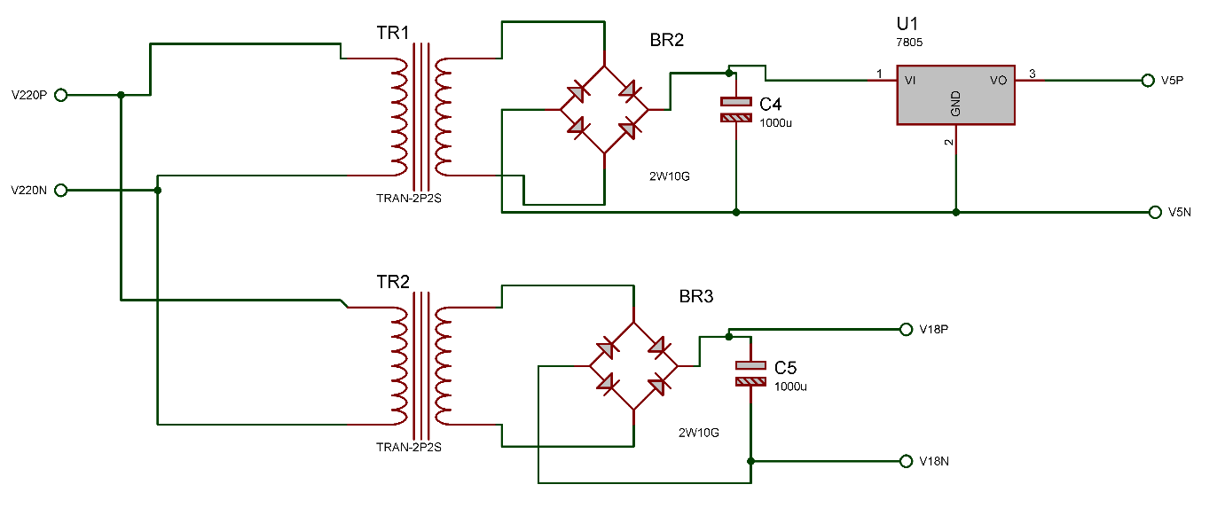
Figure ‎3.2: Auxiliary power supplies
The calculations for the filter capacitors for the auxiliary supplies is as in the following $(3.2)$.
$${ V}_{ripple}=\frac{I_{L}}{2fC} (3.2)$$
$$V_{ripple}=\frac{0.2}{2×50×1000×{10}^{-6}}$$
$$V_{ripple}=2 V$$
The output voltage of the 18 V auxiliary power supply was tested and the results are attached in the following diagram Figure 3.3.

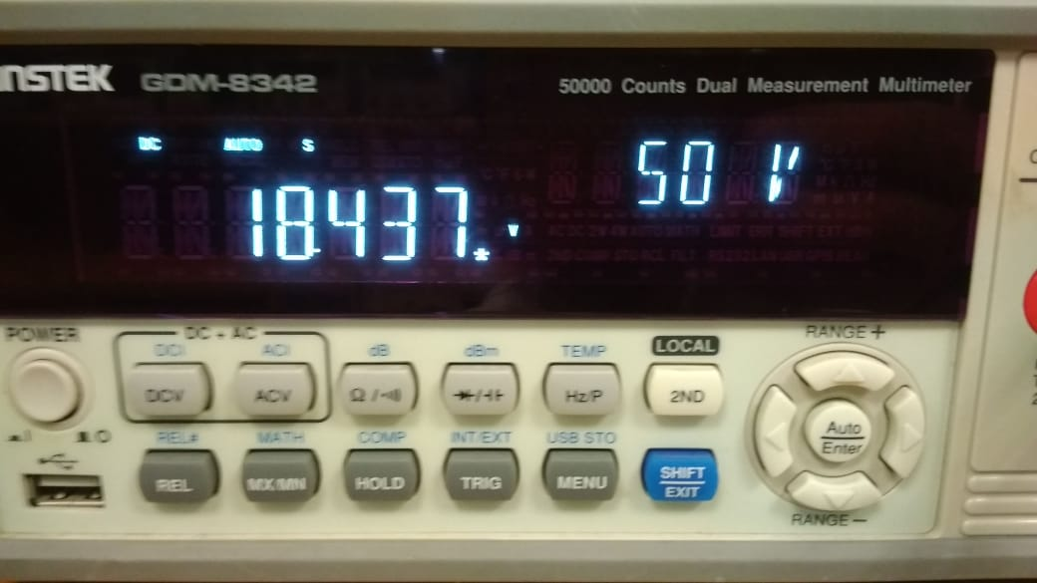
Figure ‎3.3: Measurement of 18V auxiliary power supply
Similarly, the voltage of the regulated 5V auxiliary power supply as measured and the result is shown in the following diagram Figure 3.4.
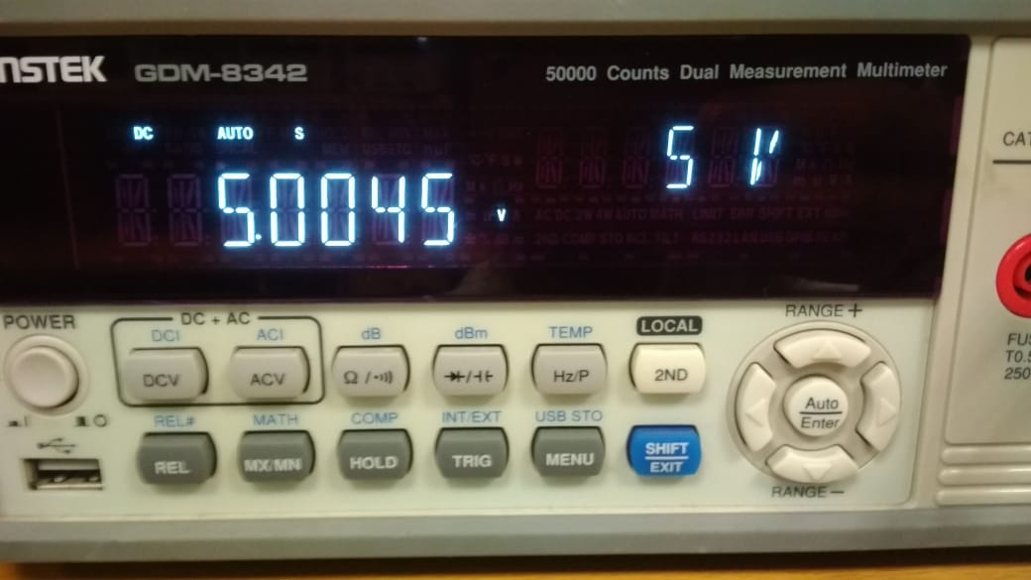
Figure ‎3.4: Measurement of 5V auxiliary power supply

Forward Converter
The heart of this circuit is the forward converter operating from the 310VDC to convert it to low voltage for the load. This is a simple forward converter topology with an IGBT as a switch. There are RC snubbers connected across the switch and the transformer’s primary to protect the electronics components from the voltage and current spikes produced by the inductors at the switching instants. The output of the forward converter is a buck converter like the classical design. This buck converter makes it possible to control the output voltage by varying the duty cycle of the PWM waveform driving the IGBT switch.
The main converter is shown in Figure ‎3.5.
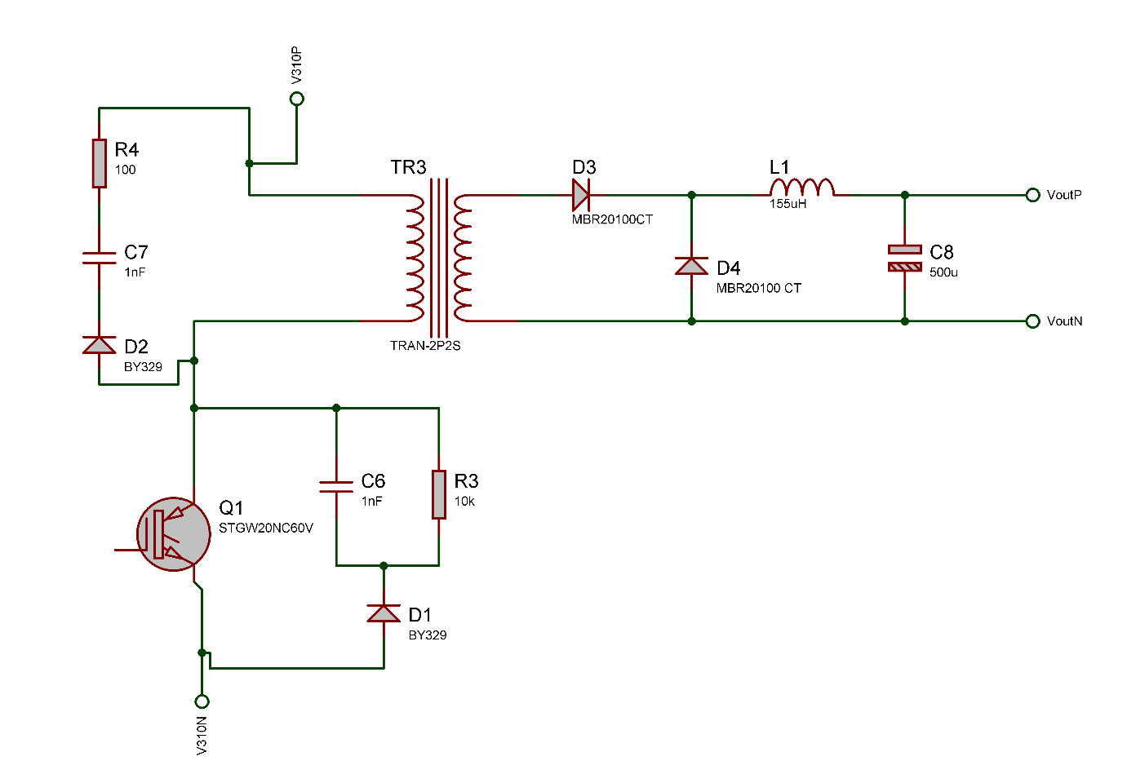
Figure ‎3.5: Forward converter section
The values of the series snubber capacitor and resistor must be such that the time constant is much smaller than the time constant $(3.3.1)$ of the IGBT switching signal.
$$RC=100×\left(1×{10}^{-9}\right) (3.3.1)$$
$$RC=100 ns$$
Similarly, the values of the parallel snubber must be such that its time constant $(3.3.2)$ is much larger than the time period of the PWM waveform.
$$RC=\left(47×{10}^{3}\right)×\left(1×{10}^{-9}\right) (3.3.2)$$
$$RC=47 μs$$

Implementation and Methodology

From the broader view of block diagram understanding of the circuit in the previous chapter, we now come to the component level description and design procedure at the lowest level. In this chapter, thus we present the component level analysis of the circuit with the description and calculation for the specification and value of each component.
The specifications for most of the components comes as minimum values. Thus, in the actual circuit, we use components with specifications more than the required values. The increased values gives better results and more reliable operation at the cost of larger size and higher cost. So the best approach is to use the component with the smallest values that are just above the minimum requirement calculated by the design specifications.

Active and Passive Components
In this section, we describe every active and passive component used in the forward converter and its supporting circuit with the calculations for the value of each component wherever applicable.

Bridge Rectifiers
There is a bridge rectifier module being used for full wave rectification of the main supply voltage to 310VDC. Using this rectifier instead of four separate diodes is the simplicity of circuit assembly and more reliability due to lesser discreet component count.
At the mains voltage, the voltage is 310 Vpeak and the current near 0.5 A. both of these come to be within the range of the commonly available W08G, so we have used this module. The Figure ‎4.1 shows the picture of one such module.
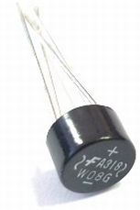
Figure ‎4.1: W08G full bridge rectifier
The same module is being used for the rectifications in the auxiliary power supplies because the current and voltage ratings at those places are also within the limits of this module.

IGBT Switch
The solid state switch is the main active element in a forward converter. It controls the flow of current through the main transformer according to the PWM waveform provided to its gate. Basically it is a transistor being used in cutoff and saturation regions.
The IGBT we are using is HGTG30N60A4. It is relatively new technology with fairly high voltage and current and voltage ratings. The Figure ‎4.2 shows a picture of this IGBT and the following Table 4.1 lists some of the salient properties of this device which we considered while choosing it for our circuit.
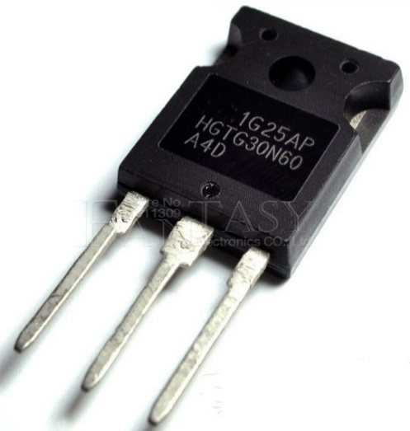
Figure ‎4.2 HGTG30N60 MOSFET
Table ‎4.1: Salient properties of the 30N60 IGBT
Quantity | Symbol | Value | Unit
Maximum collector voltage | $$V_{Cmax}$$ | $$600$$ | $$V$$
Maximum collector current | $$I_{C}max$$ | $$30$$ | $$A$$
Threshold voltage | $$V_{th}$$ | $$5$$ | $$V$$
Rise time | $$t_{r}$$ | $$12$$ | $$ns$$
Fall time | $$t_{f}$$ | 38 | ns

Gate Driver
The PWM signal for the IGBT comes from the microcontroller, but the microcontroller can’t provide neither the voltage nor the current needed by the gate terminal of the IGBT for its satisfactory operation. Thus an additional component is needed that takes the signal from the microcontroller and feeds it to the IGBT with the required voltage and current strength. Such a circuit is called a gate driver. We are using TLP250 as the gate driver in this circuit.
In addition to the increased voltage and current drive capability, the TLP250 provides isolation between the IGBT and the driving microcontroller. This isolation is necessary to prevent the output of the converter from coming in contact with the mains supply voltage, possibly resulting in an electric shock to a person touching the load at the output. The Figure ‎4.3 shows the picture of a TLP250 gate driver.
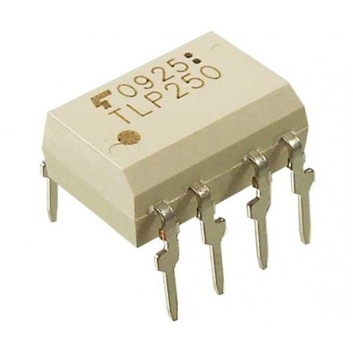
Figure ‎4.3: TLP250 isolated gate driver
The isolation in this gate driver is due to the use of an optocoupler at the input side within the driver. The Table ‎4.2 lists some of the characteristics of this gate driver.
Table ‎4.2: Parameters of TLP250 gate driver
Quantity | Symbol | Value | Unit
Maximum supply voltage | $$V_{Cmax}$$ | $$30$$ | $$V$$
Maximum output current | $$I_{C}max$$ | $$±2.5$$ | $$A$$
Isolation voltage | $$V_{iso}$$ | $$3750$$ | $$V$$
Rise time | $$t_{r}$$ | $$50$$ | $$ns$$
Fall time | $$t_{f}$$ | 50 | ns

Transformer
The transformer being used in the forward converter is of much design importance for the correct operation of the whole circuit. This was designed after consultation by various sources. Its basic function is to provide an isolated path of energy transfer from the primary side to the secondary side. This is performed by magnetic coupling of the primary and secondary windings of the transformer by being on the same core.
In the forthcoming text, we describe the design procedure used to design and build the transformer from its core to the windings.
The core being used in the transformer is EE40 ferrite core. Its picture is shown in the Figure ‎4.4. [11]
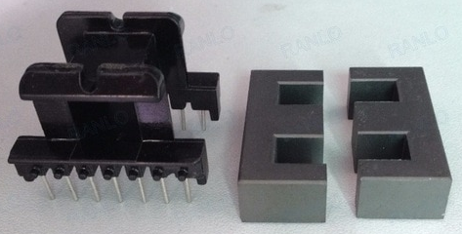
Figure ‎4.4: EE40 core and bobbin for the transformer
As the primary winding was expected to carry around 0.5 A current, it was wound using a SWG # 23 enameled wire. The number of turns at the primary side have been calculated by the following formula (4.1.4.1). Here, N is the number of turns, f is the switching frequency, B is the allowed maximum flux density in the core and A is the core area in ${cm}^{2}$. [12]
$N=\frac{V×\left({10}^{8}\right)}{4fBA}$ (4.1.4.1)
$$N=\frac{310×\left({10}^{8}\right)}{4×\left(62.5×{10}^{3}\right)×1500×1.25}$$
$$N=66$$
To be on the safer side from saturating the transformer’s core, we kept the number of turns at 90. The Figure ‎4.5 shows the primary winding on the bobbin before protective insulation tape and soldering.
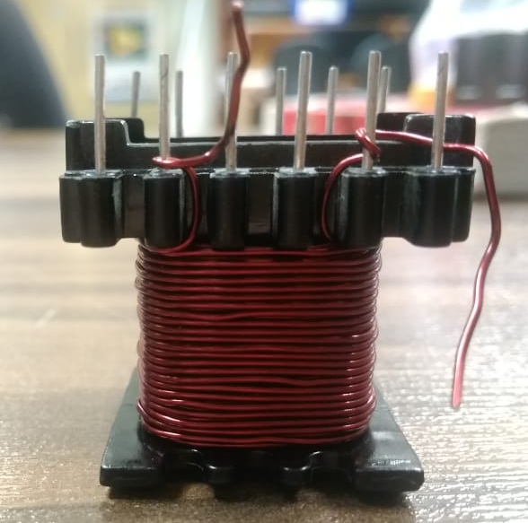
Figure ‎4.5: Primary winding for the transformer
The following Figure 4.6 shows the inductance of the primary side winding after the core was completely installed in the bobbin and the wires were properly soldered.
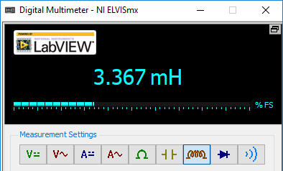
Figure ‎4.6: Primary side inductance with ferrite core
The number of turns for the secondary side were calculated by using the desired turn ratio and the expected secondary current was used to choose the secondary conductor (4.1.4.2).
${ N}_{s}=N_{p}×\frac{V_{s}}{V_{p}}$ (4.1.4.2)
$$N_{s}=90×\frac{1}{10}$$
$$N_{s}=9 turns$$
$${ I}_{s}=I_{p}×\frac{N_{p}}{N_{s}} (4.1.4.3)$$
$$I_{s}=0.5×10$$
$$I_{s}=5 A$$
The calculated $(4.1.4.3)$ current of 5 A is quite high to carry in a single conductor without seeing the perils of skin effect. Thus 6 parallel conductors of SWG # 23 enameled wire were used to wind 9 turns for the secondary side. The Figure ‎4.7 shows the secondary side winding after soldering to terminals.
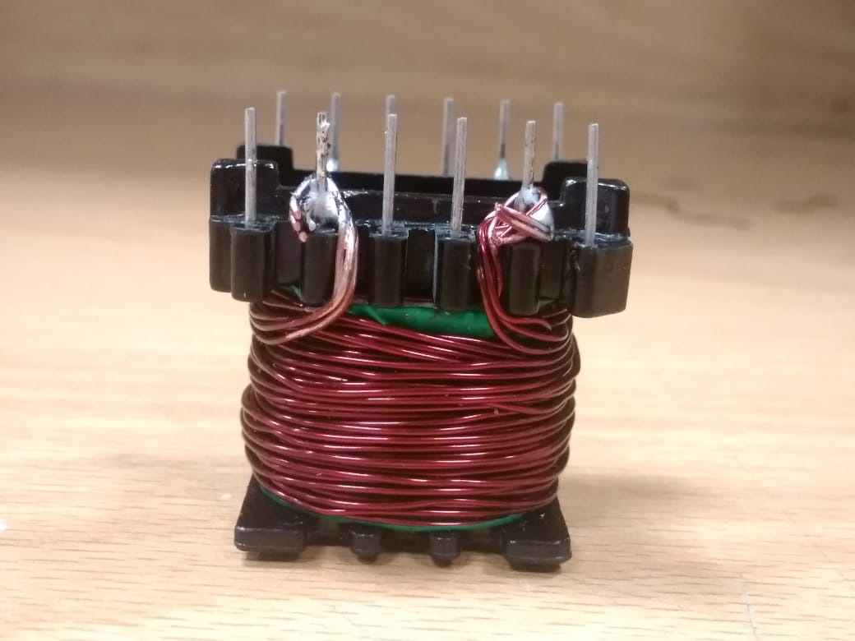
Figure ‎4.7: Secondary side of transformer
The inductance of this winding was measured after the core was inserted to its final position and the results are shown in Figure ‎4.8.
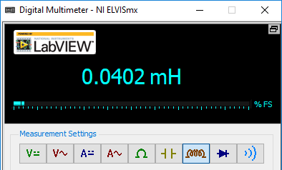
Figure ‎4.8: Inductance of the secondary side

Snubber Circuits
There are two types of snubber circuits in this converter. The first is a parallel RCD snubber connected across the IGBT collector and emitter. Like any parallel RC snubber, its time constant (4.1.5.1) must be significantly larger than the time period of the switching frequency.
$RC=\left(47×{10}^{3}\right)×\left(1×{10}^{-9}\right)$ (4.1.5.1)
$$RC=47 μs$$
The series snubber is connected across the transformer’s primary side. For it to avoid disturbing the circuit’s performance in a negative way, its time constant (4.1.5.2) must be significantly smaller than the time period of the switching frequency.
$RC=100×\left(1×{10}^{-9}\right)$ (4.1.5.2)
$$RC=100 ns$$
The choice of resistors and the capacitors for the snubber circuits, thus, fulfill the two requirements for a switching frequency of 62 kHz.

Schottky Diodes
For the conduction during the ON cycle at the secondary side and insulation during the OFF cycle, there is a Schottky diode connected from the transformer’s output to the subsequent circuit. Another diode connected in the same vicinity to act as the passive switch for the buck converter. The connection of the two diodes is such that a center tapped diode can be used as a combination of both of them. Thus an MBR20100CT Schottky rectifier has been used for this purpose. It doesn’t only fulfill the voltage and current requirements at this circuit point but also conducts with very little forward voltage drop and fast switching times. The Figure ‎4.9 shows one of such twin diodes.
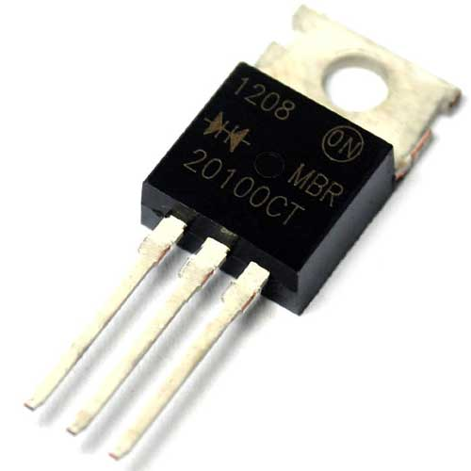
Figure ‎4.9: MBR20100CT center tapped Schottky rectifier
The parameters of the MBR20100CT are summarized in the Table ‎4.3.
Table ‎4.3: Characteristics of MBR20100CT
Quantity | Symbol | Value | Unit
Maximum reverse voltage | $$V_{Rmax}$$ | $$100$$ | $$V$$
Maximum forward current | $$I_{Fmax}$$ | $$10$$ | $$A$$
Maximum forward voltage | $$V_{Fmax}$$ | $$0.45$$ | $$V$$

Inductor for Buck Converter
The inductor at the secondary side makes the whole converter behave as a buck converter. The inductor must be able to carry enough current for the secondary side and also provide enough inductance to prevent the circuit from operating in the discontinuous mode. The required inductance was calculated using the following formula (4.1.7.1).
$L=\frac{\left(V_{in}-V_{out}\right)×V_{out}}{V_{in}×f_{sw}×r×I_{out}}$ (4.1.7.1)
$$L=\frac{\left(31-13.6\right)×13.6}{31×62,000×0.2×6}$$
$$L=102 μH$$
To get on the safe side from preventing a discontinuous mode, the inductor was chosen to be 18 turns of 6 parallel conductors of SWG # 23 enameled wire. When this was wound on a EE40 ferrite core, the inductance turned out to be $155 μH$ which is satisfactorily above the required value. The Figure ‎4.10 shows the inductance being measured from a multimeter.
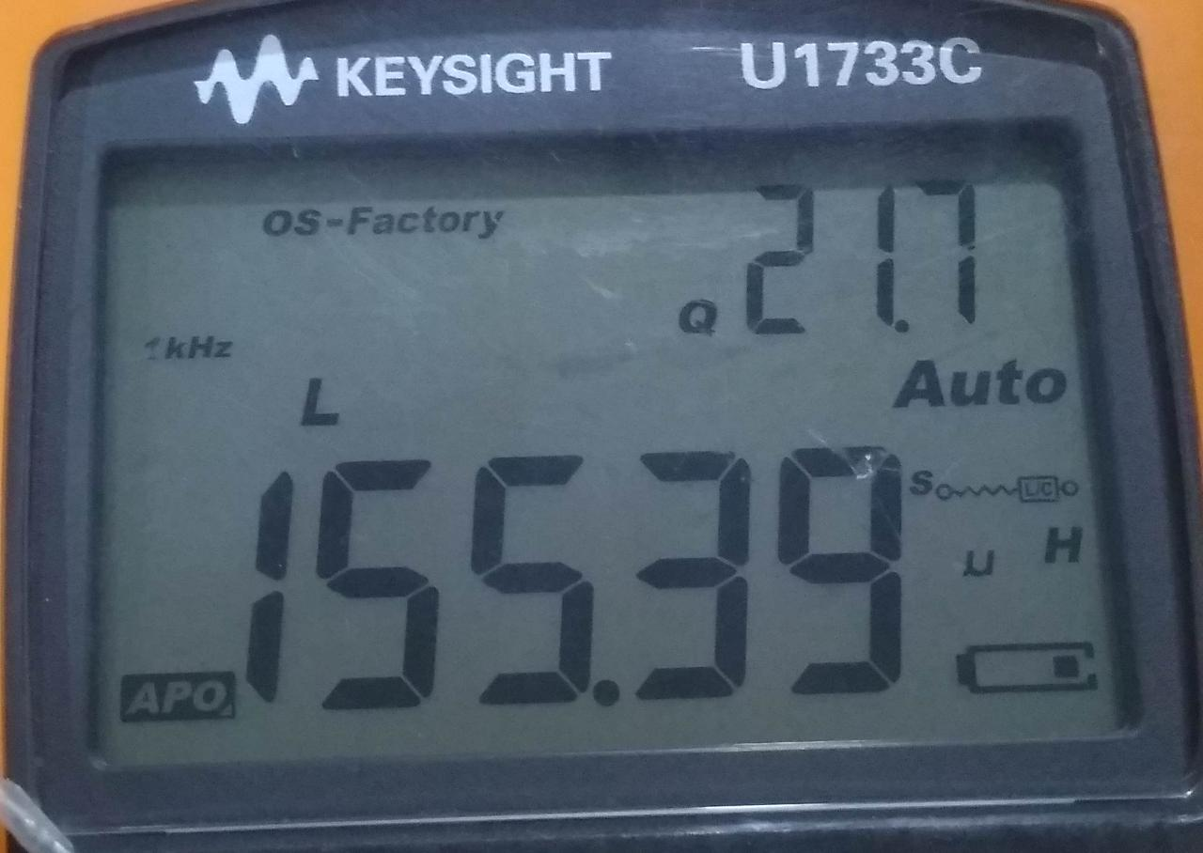
Figure ‎4.10: Measuring the inductance of the secondary side inductor

Output Capacitor
The pulsating waveform from the transformer’s secondary and the inductor must be smoothed out before providing to the load. For this purpose, the value of the output capacitor is calculated to be as the following (4.1.8.1).
$C=\frac{ΔI}{ΔV}\left(\frac{1}{8×f_{sw}}\right)$ (4.1.8.1)
$$C=312 uF$$
To be on the safe side from excessing ripple in the output voltage, we used a 500 uF capacitor. Rather than using a single capacitor, we used 5 capacitors, each having$100 uF$, in parallel. This doesn’t even increase the total current handling capacity of the capacitor bank but also decreases the equivalent series resistance (ESR) and equivalent series inductance (ESL) of the capacitors.

Current sensor
An ACS712 sensor is being used to measure the current at the output of the converter. This is an isolated hall-effect current sensor that can measure up to 20 A of bidirectional current. The picture of an ACS712 module is sown in Figure ‎4.11.
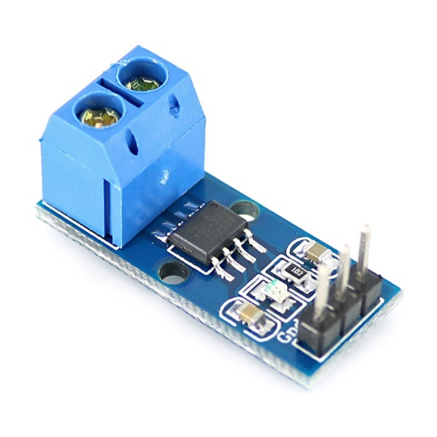
Figure ‎4.11: ACS712 Hall effect current sensor

Voltage Sensor
To detect the state of charge of the battery, the microcontroller needs to determine the voltage of the battery. For this purpose, an accurate voltage sample is used, that gives an output proportional to the battery’s voltage. The voltage sampler is implemented as a calibrated voltage divider (4.1.10.1), whose output is within the range of the microcontroller’s internal ADCs for all the expected battery voltages. The sampler is implemented as shown in the following circuit Figure 4.12 and the variable resistor is adjusted to the point where the voltage divider’s ratio is$0.12$.
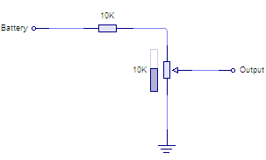
Figure ‎4.12: Voltage sampler circuit
As the following calculations (4.1.10.2) show, for every battery volt, there are 12 ADC steps for every volt at the battery. For example, the ADC would give a reading of 144 when the battery is at$12V$.

After voltage division: $1×0.12=0.12V/V$ (4.1.10.1)
After ADC conversion: ${0.12}/{256}×256=12 {steps}/{volt}$ (4.1.10.2)

Microcontroller
The master controller is implemented in an ATMEGA328 from the Atmel’s AVR8 series. This is an 8-bit microcontroller that has quite a handful of peripherals including timers, PWM generators, interrupt controllers, ADC, GPIO, UART, SPI, I2C, analog comparator among others.
The following table lists some of the properties of the microcontroller that are relevant to this application and were considered during the selection. A brief datasheet of the same microcontroller is attached at the end of this document as a reference.
Almost all of the microcontroller’s features are being used in this application, including timers, interrupts, PWM generators, built-in ADCs, internal pull-up resistors, internal clock generators, internal ADC reference etc.
The Figure ‎4.13 shows the picture of an Arduino Nano board.
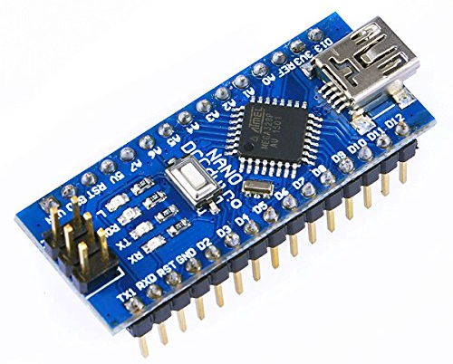
Figure ‎4.13: Arduino Nano board
The Table ‎4.4 highlights some of the properties of the ATMEGA328 taken from the datasheet that are relevant to this project.
Table ‎4.4: Properties of Arduino Nano controller
Microcontroller | ATMEGA328
Architecture | RISC
Clock Frequency | 16 MHz
Clock Type | External XTAL
Program Memory | 32768 bytes
Programming | In-system through SPI
RAM | 2048 byte SRAM
EEPROM | 1024 bytes
Operating Voltage | $$2.7-5.5V$$
8-bit Timer | 2 available
16-bit Timer | 1 with 2s PWM channels
ADC | 6 channels
ADC Resolution | 10-bit/8-bit optional
2 Wire Interface | 1 available
USART | 1 available
SPI | 1 available
IO Pins | 23
Power Consumption | $$1.8 mA$$
Power-on Reset | Available
Brown-out Reset | Optional

Control Algorithm
In this section, we describe the algorithm being used to control the forward converter in both the current and voltage mode and how the switching between the modes is being managed using the measurements of voltages and currents.
The following Figure 4.14 summarizes the algorithm running in the microcontroller to control the output voltage or current. Note that the methods are very similar for current mode and voltage mode, with the only differences in voltage and current measurements for the controller algorithm.
Figure ‎4.14: Controller algorithm
Main
Set up ADC
Set up PWM
Set up timer Interrupt
Start timer
Initialize PWM
Wait for interrupt
Timer Interrupt
Read ADC
Calculate PWM
Set PWM
Return from ISR

Conclusions and Future Directions

In this chapter we present the results and conclusions drawn from the design and implementation of the dual mode forward converter. In brief, the design was quite challenging for us at this stage because it is a bit different from conventional design of forward converters. We learned a lot about how power electronics circuits work and how their practical implementations are different from theoretical representations. There was very valuable learning and experiences gained from the whole design and implementation procedure, both in the domain of power electronics and programming of microcontrollers for use in power electronics circuits.
With improved performance and efficiency, the dual mode forward converter can find applications in a variety of places where size and efficiency are of prime concern. With the current rise in the use of power electronics in battery powered systems, the dual mode converters can provide a great leap forward in improving the performance and feasibility of high power battery operated circuits.

Final Implementation
The dual mode forward converter was implemented in 3 parts on three different Vero boards. The modular design was to ensure that each functional block performed with its desired capacity and behavior before it was integrated to the rest of the blocks to make the whole system.
The first board contained the rectifier and the auxiliary power supply circuits, as shown in the Figure ‎5.1.
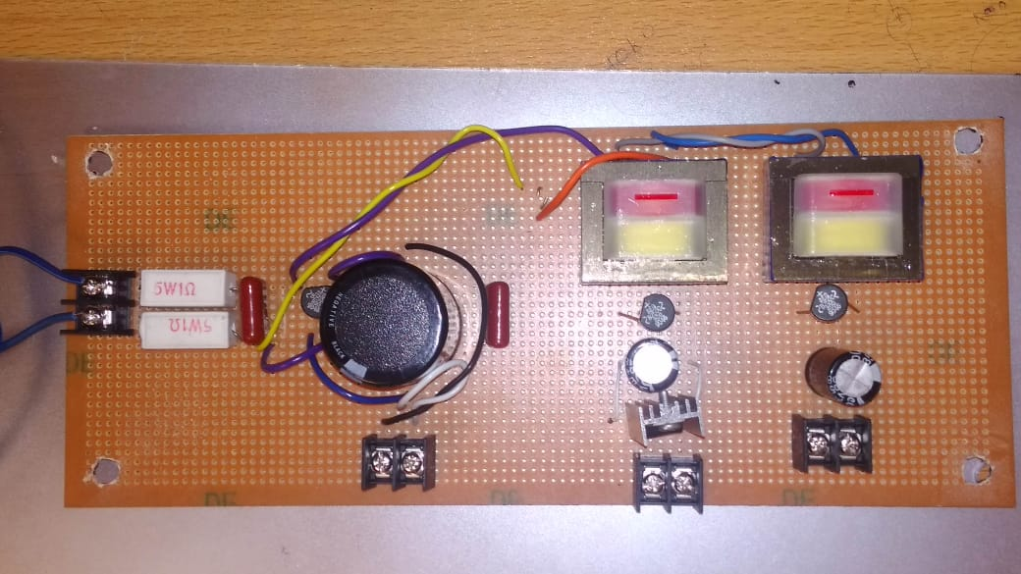
Figure ‎5.1: Main rectifier and auxiliary power supplies
The board containing the forward converter and its peripherals is shown in the Figure ‎5.2.
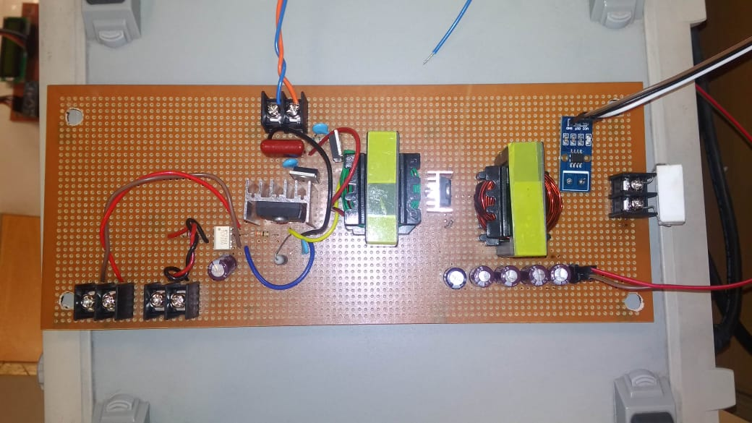
Figure ‎5.2: Forward converter board
The complete implementation of the circuit on a single platform is show in the Figure ‎5.3.
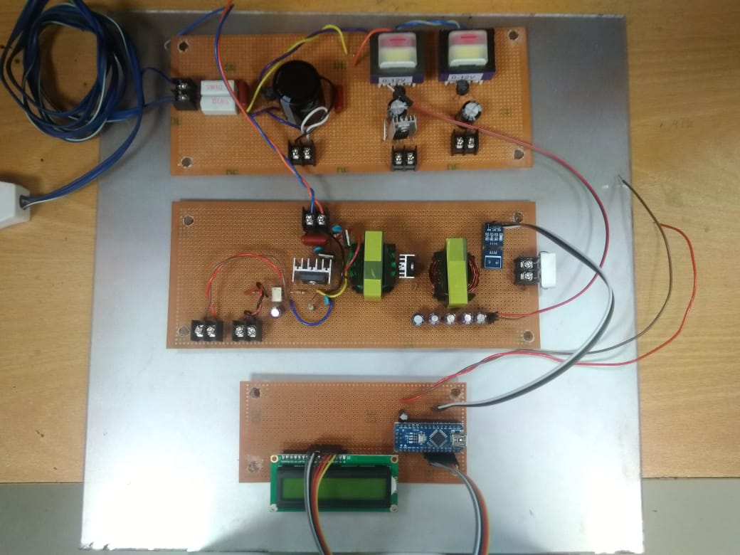
Figure ‎5.3: Complete circuit implementation

Future Directions
With the valuable insights gained from the design and implementation of dual mode forward converter, we are able to suggest a couple of directions in which further research is likely to bring fruitful results. We recommend that these avenues of power electronics may be explored to fully reap the benefits of this work.
The flyback converter is used more often in low cost, low power applications quite more often than the forward converter, its dual mode implementation must also be explored for advantages over conventional single mode operations.
The forward converter must be rigorously tested for transient and steady state behavior when the mode switching takes place more rapidly to explore the aspects like safety and EMI for real world applications.

References

[1] | D. W. Hart, Power Electronics, New York: McGraw Hill, 2011.
[2] | NPTEL, "NPTEL :: Electrical ENgineering - Power Electronics," IIT Madras, 31 Dec 2009. [Online]. Available: https://nptel.ac.in/courses/108105066/. [Accessed 04 Jun 2019].
[3] | R. Mammano, "Switching Power Supply Topologies," 1999. [Online]. Available: https://www.ti.com/lit/an/slua119/slua119.pdf. [Accessed 04 Jun 2019].
[4] | ROHM, "Control Methods (Voltage Mode, Current Mode, Hysteresis Control)," Tech Web, 06 Dec 2015. [Online]. Available: https://micro.rohm.com/en/techweb/knowledge/dcdc/s-dcdc/02-s-dcdc/97. [Accessed 04 Jun 2019].
[5] | G. D. C. Bhim Singh, "Comparative Performance of Isolated Forward and Flyback AC-DC Converters for Low Power Applications," in Joint International Conference on Power System Technology and IEEE Power India Conference, New Delhi, 2008.
[6] | S.-W. C. B.-H. L. G.-W. M. Keun-Wook Lee, "Current boosted active clamp forward converter without output filter," in IEEE Energy Conversion Congress and Exposition, San Jose, 2009.
[7] | C. L. S. M. K. J. Shruthi, "High frequency current fed double forward Low Voltage High Current DC-DC converter for spacecraft application," in IEEE International Conference on Power Electronics, Drives and Energy Systems (PEDES), Bengaluru, 2012.
[8] | S. O. ,. E. d. l. C. J. S. A. Fontan, "Peak current mode control applied to the forward converter with active clamp," in 29th Annual IEEE Power Electronics Specialists Conference (Cat. No.98CH36196), Fukuoka, 1998.
[9] | B. N. C. P. K. V. S. Rajguru, "Current mode control applied to active clamp forward-fly back converter," in International Conference on Power, Energy and Control (ICPEC), Sri Rangalatchum Dindigul, 2013.
[10] | B. University, "Charging Information for Lead Acid Batteries," Battery University, 29 May 2018. [Online]. Available: https://batteryuniversity.com/learn/article/charging_the_lead_acid_battery. [Accessed 04 Jun 2019].
[11] | TDK, "Ferrite and Accessories," Jun 2013. [Online]. Available: https://subjects.ee.unsw.edu.au/elec4123/Ferrite-core/etd_39_20_13-773379.pdf. [Accessed 04 Jun 2019].
[12] | A. Ullah, "Calculations for Design Parameters of Tranformer," 14 Oct 2016. [Online]. Available: http://engineerexperiences.com/design-calculations.html. [Accessed 04 Jun 2019].
[13] | ROHM, "Inductor Seection for Buck Converter," 27 Apr 2017. [Online]. Available: https://micro.rohm.com/en/techweb/knowledge/dcdc/dcdc_pwm/dcdc_pwm02/2244. [Accessed 04 Jun 2019].
[14] | ROHM, "Output Capacitor Selection for Buck Converter," 27 Apr 2017. [Online]. Available: https://micro.rohm.com/en/techweb/knowledge/dcdc/dcdc_pwm/dcdc_pwm02/2366. [Accessed 04 Jun 2019].
[15] | D. Inc, "Switching Converter Power Supplies Calculator," 2016. [Online]. Available: https://www.daycounter.com/Calculators/Switching-Converter-Calculator2.phtml. [Accessed 04 Jun 2019].
[16] | M. Lab, "Ferrite Transformer Turns Calculation With Example," 15 Jun 2015. [Online]. Available: https://microcontrollerslab.com/ferrite-transformer-turns-calculation/. [Accessed 04 Jun 2019].

