Metal Detector Robotic Vehicle



Submitted by:
Muhammad Naveed Ahsan | 13018019043
Ahmad Hamza | 13018019100
Abdul Qadeer | 13018019086
Muhammad Ameer-ul-Faheem | 13018019169

In the Supervision of
Sir Saleem Ata

Department of Electrical Engineering

School of Engineering

University of Management and Technology Lahore

May 2017

Metal Detector Robotic Vehicle

Submitted by:
Muhammad Naveed Ahsan | 13018019043
Ahmad Hamza | 13018019100
Abdul Qadeer | 13018019086
Muhammad Ameer-ul-Faheem | 13018019169

In the Supervision of
Sir Saleem Ata

Department of Electrical Engineering

School of Engineering

University of Management and Technology Lahore

May 2017

Submitted to the faculty of the Electrical Engineering Department of the University of Management and Technology Lahore in partial fulfillment of the requirements for the Degree of

Bachelor of Science
In
Electrical Engineering

____________ ___________

Project Advisor Director

Undergraduate Studies


University of Management and Technology

Acknowledgement

First of all, we would like to express our gratitude to Allah Almighty who helped us in every field of our life.

Secondly, we would like to thank our parents for their love and support.

And finally special thanks to Sir Saleem Ata who approved our idea and helped us a lot in everything. Without his help and support, we would never be able to do this project. His believe in us, motivates us to complete this project.

Declaration

This report is based on our own research and implementation. Any contribution of any person is indicated in acknowledgements and references.

This project is supervised by Sir Saleem Ata at University of Management and Technology.

Signed: _________

Signed: _________

Signed: _________

Signed: _________

Date: __________

TABLE OF CONTENTS

ACKNOWLEDGEMENT II
DECLARATION OF ORIGINALITY FORM III
TABLE OF CONTENTS IV
LIST OF FIGURES VI
ABSTRACT VII

CHAPTER 1: INTRODUCTION 1-4
- Background

- Problem Description
- Objectives
- Scope of Work
- High Level Description
- Report Orientation
- Software Basics
- System Necessities

CHAPTER 2: LITERATURE REVIEW 5
  - Robotic Vehicle
- Gear Motor
- Servo Motor
- Arduino

CHAPTER 3: HARDWARE DESCRIPTION 6-18
- Metal Detecting Sensor
- Arduino
  - Master Slave Combination of Arduino
  - Advantages of Arduino
- DC Gear Motor
- Nuts, Bolts and Spring Washers
- Motor Driving Module L298n
- Robotic Chassis
  - Dimensions of Robotic Chassis
- Mechanical Arm
  - Dimensions of Mechanical Arm
- Servo Motors Bluetooth Module HC-05
- Wireless Camera
- Bluetooth Module
  - Connecting Smartphone with Bluetooth Module
3.11 DC Battery

CHAPTER 4: USER MANUAL 19-20
- How to start Robotic Vehicle
- How a User can tell if the Vehicle is in Working Condition
- Troubleshooting

CHAPTER 5: CONCLUSION & FUTURE RECOMMENDATIONS 21-22

- Conclusion
- Future Recommendations
  - Circuit
  - Bluetooth Module
  - Sensor
  - Wireless Camera
  - Overall System

REFERENCES 23

APPENDIX 24

LIST OF FIGURES

Figure 3.1 Metal Detector Sensors
Figure 3.2 Metal Detector Circuit
Figure 3.3 Datasheet of Arduino UNO
Figure 3.4 Arduino UNO
Figure 3.5 Pin Configuration of Arduino UNO
Figure 3.6 Exterior Assembly of DC Gear Motor
Figure 3.7 Gears of DC Motor
Figure 3.8 Nut, Bolt and Washers
Figure 3.9 Motor Driving Module L298n
Figure 3.10 Block Diagram of H-Bridge

Figure 3.11 Chassis of Robotic Vehicle
Figure 3.12 Back Wheels of Vehicle along with DC Motors
Figure 3.13 Mechanical Arm
Figure 3.14 Servo Motor
Figure 3.15 Internal Structure of Servo Motor
Figure 3.16 Wireless Camera & Receiver
Figure 3.17 Pin Configuration of Bluetooth Module
Figure 3.18 DC Battery
Figure 4.1 Bluetooth Module not Connected
Figure 4.2 Bluetooth Module Connected

ABSTRACT

Landmines are the most destructive equipment which are laid under some feet’s or on surface of grounds. They explode once a living things’ foot make contact with the spring at the top of the mine.

These killing machines are laid in the vast fields and are very difficult to detect by naked eye .These killing machines needs to be identified and living things should be saved from this slaughtering equipment. This robot which will go into fields and detect landmines which are under ground by the help of metal detector sensor which is placed at the front of our robotic vehicle. Robot will be moved with the help of Bluetooth module which will drive motors. This robotic vehicle would be controlled by an android phone using Bluetooth RF application.

CHAPTER 1
INTRODUCTION
1.1 Background:
According to a report by CNN there are thousands of people who are killed by land mines, most of whom are civilians.Landmines contain explosive matter with eruptive system which burst when a person or vehicle make contact with it.Landmines are commonly placed 15cm below ground or sometimes on field.Majority of them are innocent and some lose their loved ones. In many cases, there are even more dangerous and heartwarming outcomes but the danger remains due to the difficulty of finding and destroying the mines. So it is very important that these death machines should be detected and removed in order to save lives of innocent civilians, and with thousands of them planted worldwide it is a challenging task. It is very compulsory to disarm them. According to ICBL(International Campaign to Ban Landmines) number of injuries across the globe rose up to 6461 in 2015, which is 75% of preceding year .According to informationcitizens, were more than three quarters and 38% were kids. ^{[1]}
1.2 Problem Description:
The main problem is the field where landmines are placed; they are placed in vast quantity. It is very difficult to mark with our naked eye because some are buried or technically design in a way to be obstructed.Diffusing mines personally on field would be hazardous especially without knowing where mines are located.
We have made a solution which will be controlled by Bluetooth module and our robotic vehicle will point out mines for us so that we could diffuse them.Our mainmotto is to keep mankind safe from this hazardous thing and by controlling it by Bluetooth it is easier for us to control it. We can afford the loss of our vehicle in the process of marking even if landmine burst but can save precious lives.However it is still very important that we make such a robotic vehicle which should not be dodged by any mine so this robot will mark at such a distance so it will be in safe hands.

1.3 Objectives:
The main objective of this project is to design and implement a robot which will intelligently detect any kind of metal or mine buried in ground. To achieve this following must be done:
- Plan and design a chassis:
- Fitting wheels using steel rod at the front so that it will be able to move freely.
- Fitting DC gear motors with wheels at the back.
- Install and fitting of arduino and other electrical components.
- Install DC battery to power up arduino, motors and other electrical components.
- Make chassis moveable by using Bluetooth Module.
- Design and install robotic arm using servo motors.
- Placement of Metal Detector Sensor.
- Attach camera.
- Testing and analyzing the results.
1.4 Scope of Work:
This metal detector robot is highly useful in detecting mines and metals. It is a portable robot and very light weight. It can easily be controlled using android mobile phones. It is the most economical robot which can be made for detecting mines. This robotic vehicle is plug and play and easy to use. It can search where human beings can go like in mine fields. Our robot can be used in battlefields for the detection of mines and any other bombs that might be installed in the battlefield area, so detection of those bombs can provide safety for soldiers and allow them to combat easily in the battlefield. It has the ability to work in demanding situations. We tried that our robot that we made should be as compact as possible so that it can be used easily at any particular place we want the robot to be used. Our robot can also be used in the shopping mall parking area for the detection of any bombs planted underneath any car which could result in causality. The design of the robot is very easy and durable so that it can be used by a common person and be used in harsh conditions. Our robot is a moveable vehicle so it can easily access areas where there is a limited reach for the humans. We have attached a camera on the robot which can be used by the person to control the robot without him being present at that particular area as the receiver that is attached has a reasonable range to be controlled. We have tried our level best to make the robot as easy to use as friendly to the environment as possible and hope that it will help the person or the military as indicated.
1.5 High Level Description:
Our Robotic vehicle will consist of two main parts.One is the robotic vehicle which consists of the following electrical and mechanical components:
- Metal Sensor
- DC Battery
- Arduino
- Motor Driving Module
- Mechanical Arm attached with Servo Motors
- Gear Motors
- Camera
- Bluetooth Module
Second part of our project deals with the controlling of the first part which is basically the main chassis or the robot. We have used an android app which is called Bluetooth RC controller and we used this app to control the robot. This app is used to communicate with the gear motors with the help of arduino that is attached on the robot. We also controlled the movement of the gear motorswith the help of Bluetooth module known as HC-05 and motor driving module called L-298n.The signal will be sent from metal detector sensor to the arduino and there is an indication LED installed on the sensor that will blink which will notify that there is a metal ahead of the robotic vehicle.
1.6 Report Orientation:
In Chapter 2, we have discussed literature review of robot.
In Chapter 3, we have given description of hardware.
In Chapter 4,we have given the details about working of hardware.
In Chapter 5,we have concluded testing, results and analysis.
In Chaptern6, we have made a user manual which will give details on installing and troubleshooting the robot.

1.7 Software Basics:
We are using Arduino in our project. We can burn code through Arduino microcontroller with the help of usb.As Arduino has enormous library which has clear edge compared to other microcontrollers.
1.8 Basic Necessities:
- Robot should in contact with the help of Bluetooth with mobile application.
- It must have battery life for about one hour of usage.
- Must Detect metals and give an alarm.
- Must not cause mines to explode.
- Should work effectively.

CHAPTER 2
LITERATURE REVIEW
2.1 Robotic Vehicle
We built a mobile robotic vehicle for the metal detection purposes and preferred to design our robot as a portable and light weight car so that it can be used and run in any terrain as the user desires. We designed our vehicle after consulting our project advisor and went to a machinist for the L-angle and metal rod for the alignment of the front wheels. Assembly of the robotic vehicle was carried out by the group members.
2.2 Gear Motor
We used gear motor in our project to control the movement of our robot and the major reason for us to use gear motor ahead of the other motors available in the market was that gear motor has a high torque producing capacity. Our project had a lot of weight and it required a motor with high torque to operate the robot and gear motor suited our requirements. This allowed us to move our robot at varying speed easily and control the speed of the robot without any difficulty.
2.3 Servo Motor
We used servo motor in our project for the movement of the mechanical arm with which our metal detector is attached. We used the servo motor ahead of other motors because we can easily control the position or the amount of rotation that need to be carried out with the help of computer programming.
2.4 Arduino
Arduino was used in our project as the main component of our project and we preferred Arduino over the other micro controllers because it had a huge library and the integration of the software is quite easy on Arduino. It was easy to burn and run the program on Arduino and the number of functions that we had to perform could be easily carried out without any difficulty on Arduino.

CHAPTER 3
HARDWARE DESCRIPTION
This portion will give complete details and equipment used in our project from arduino to tiny IC’s used in our metal detector robot.
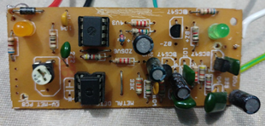
3.1 Metal Detecting Sensor:
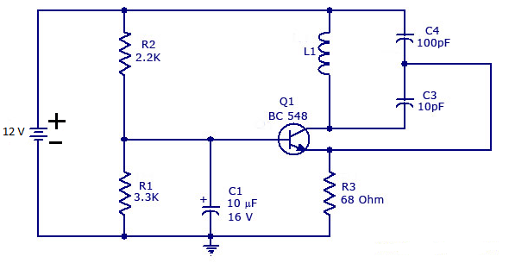
This is the main component used in our project. This sensor will detect metals on its way. The metal detector used in our project works efficiently and has the range of 1-2 inches. We used this sensor because it was economical for testing model. Our basic aim was to give an idea of how the sensor should be used or attached on the robot. If one wants to use a metal sensor with greater range then the sensors are available in the market and can be bought and installed at a bit higher cost.
Metal Detector sensor that we used in our project was bought from the market at an economical rate and the pic of the metal sensor is attached below. Metal sensor works on the magnetization core that is attached to the circuit connected. The coil attached produces an alternating current that passes through the coil attached that produces an alternating magnetic field. When there is a metal close to the coil then the eddy currents are induced in the metal, and this in terms induces a magnetic field due to the presence of the metal. This in terms produces a signal that indicates that there is metal detected and we have attached a buzzer that makes a sound whenever there is a metal sense by the metal detector.

3.2 Arduino:
Arduino is the heart of our project by which we have controlled a number of functions on our robot. We used the arduino to control the following electrical components:
Microcontroller |  | ATmega328P
Operating Voltage | 5V | Input Voltage (recommended) | 7-12V
Input Voltage (limit) | 6-20Vs | Analog Input Pins | 6
Digital I/O Pins | 8 | PWM Digital I/O Pins | 6
DC Current per I/O Pin | 20 mA | DC Current for 3.3V Pin | 50 mA
Flash Memory | 32 KB | Clock Speed | 16 MHz
SRAM | 2 KB | EEPROM | 1 KB
LED_BUILTIN | 13 | Width | 53.4 mm
Length | 68.6 mm | Weight | 25 g
- DC Gear Motors
- Servo motors
- Metal Detector arm
- Movement of Robot
- Bluetooth Module
Arduino is a computer hardware and software company. Arduino assembles microcontroller kits which can be programmed and used in our daily lives. Arduino started in 2005 as a program for students at the interaction Design Institute Ivrea in Ivrea, Italy, aiming to provide a low cost and easy way for novices and professionals to create devices that interact with their environment using sensors and actuators. ^{[2]} Arduino is the most prevalent microcontroller due to its robustness and dependability. As compared to other microcontroller arduino is the easiest to use and learn and it is the most reliable one. Moreover it’s just plug and run which makes it a special feature. Arduino uses C language for programming purpose.In this Project we mainly used two arduino which are Arduino UNO which have following technical specifications.
As it can be seen from the above table that Arduino has 14 digital input/output pins out of which six can be used for Pulse Width Modulation outputs. It also consists of six analog inputs. It operates at 5V but recommended input voltage is from 7-12V whereas it should not exceed 20V.

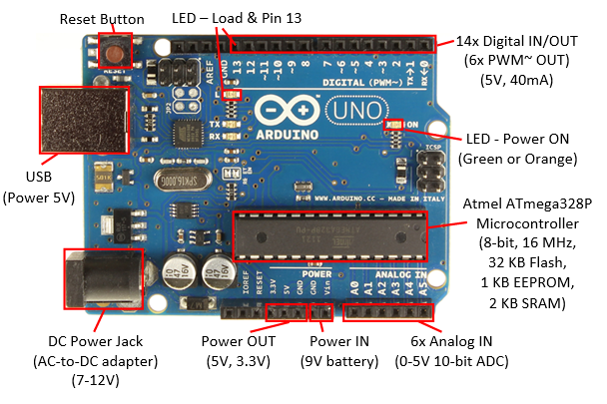
Arduino is being served to following components.
DC Gear motor
Servo motors
Metal Detector arm
Movement of Robot
Bluetooth Module
Arduino is a single core processor and have so many pins doing different tasks like PWM, Digital I/O, DC Supply 5V and 3V as shown in figure 3.5:
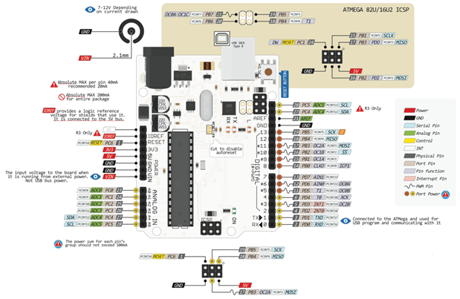
We used arduino UNO in our project. We will use Arduino to control our robotic vehicle movement. With the help of the arduino we can control the movement of the robot and move the robot as we please. We can change the direction of our robotic arm on which metal detector sensor will be placed. Arduino will send signals to appropriate device and that will function according to our coding. We have attached DC gear motors, servo motors used in robotic arm and metal detector sensor. We are using arduino because it has high level language which has vast libraries compared to other microcontrollers as PIC. Coding is also easy in arduino so we used arduino for controlling robotic vehicle used in our project.
3.2.1 Master Slave Combination of Arduino’s:
In this project we have used Master slave concept to control our servo motors. We used this concept because arduino cannot perform multiple functions at the same time and we need a couple of arduino to perform multiple tasks. We used one arduino as a master and connected the other arduino as a slave. We allotted a specific pin on the master arduino which gave signal to the slave arduino to perform the function which was the movement of the servo motors. Whenever there is a signal given on the digital pin number 10 and 11 on the master arduino it sends a signal to the slave arduino which is connected by the digital pin 6 and 7. This activates the slave arduino and that in term rotate the servo motors which allow us to control the movement of the mechanical arm as desired.
3.2.2 Advantages of Arduino:
- Ready to use is the biggest advantage of arduino over other micro controllers which includes 5v supply, an oscillator, a microcontroller, LED’s and headers for connectors.
- Arduino is a high level language which has lots of libraries and large number of examples.
- Coding is very easy in arduino compared to other micro controllers.
3.3DC Gear Motor:
A dc motor is not the same as gear motor .A gear motor may be an AC or DC motor coupled with a transmission. A gear motor adds mechanical gears to alter the speed or torque of the motor.A gear DC Motor has a gear assembly attached to the motor .Speed of the gear
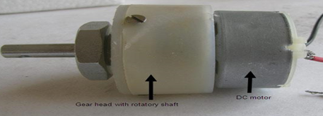
motor is considered in revolutions per minute (RPM). The gear assembly assists in increasing torque and reducing the speed. When gear reduces the speed but increases the torque is known as gear reduction. The exterior assembly of the DC Gear Motor is shown in the figure 3.6. ^{[3]}
A nut is placed near the shaft which helps in escalating the motor to the other parts of the assembly.DC gear motor works on various input voltages. Higher is the input voltage,it will give higher RPM(rotations per minute).For example if a dc motors works between 6-12V then at 6V it will give least RPM and at 12V it will give maximum RPM.
In terms of voltage, we can put it in the equation as follows,
RPM=K₁*V
Where K₁ is induced voltage constant
V is voltage applied
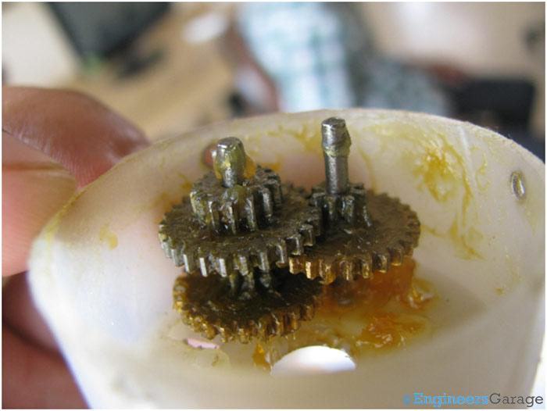
Working of DC gear motor is enlightened using the Principle of conservation of angular momentum.The gears having smaller radius will cover more RPM then the one with larger radius.However larger radius will give more torque.When two or more gears are connected it follows the conservation of energy principle.RPM and torque are inversely proportional. Hence more torque will be able to give less RPM.
The equation detailing the working and torque transfer of gears is shown below:
T_{in}*W_{in} = T_{out}*W_{out}
Where T_{in} is input torque by the driver gear
W_{in} is angular speed of the driver gear
T_{out}is output torque of the driven gear
W_{out}is angular speed of the driven gear
The apparatus interfacing the gear and the rigging head is very little; consequently it gives more speed to the bigger piece of the gear head and makes it turn. The bigger piece of the apparatus additionally turns the littler duplex part. The little duplex part gets the torque however not the speed from its antecedent which it exchanges to bigger piece of other apparatus.
We are using DC Gear Motors to move our chassis. As DC Gear motors have high torque and power so it will easily move our robotic vehicle. It is capable of bearing more weight so it will be easy for us to put weight on our vehicle like battery and robotic arm. We have attached motors to wheels of our robotic vehicle as shown in the figure:
3.4 Nuts, Bolts and Spring Washer:
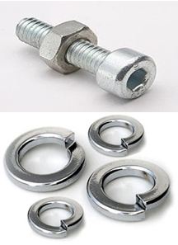
A nut is a sort of latch with a strung gap. Nuts are quite often utilized as a part of conjunction with a mating screw to secure at least two sections together.The two accomplices are kept together by a blend of their strings' grinding (with slight flexible misshaping), a slight extending of the jolt, and pressure of the parts to be held together.
They are especially used where we have to move something in our case chassis. Nut and Bolt are joined together and they held the chassis and not allow them to open up or move. Spring washer are also used to grip .A washer is a thin dish with a gap for the most part in the center that is typically used to bear the load of a strung latch, for example, a screw or nut.
3.5 Motor Driving Module L298n:
These modules are basically used for controlling speeds and directions of motors. This module can easily control two motors of up to 2A each in both directions. It is a driver which has high voltage and current which is used to run inductive loads i.e. dc and stepping motors.
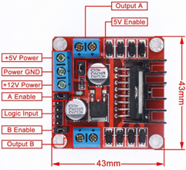
In this figure it can be seen where two H-bridges are .In this module 5v regulator is given.All the pins are labeled. This module can drive a current in both polarities and is controlled by “Pulse Width Modulation”. Electronic pulses are controlled by the means of Pulse Width Modulation. Motors can be damaged if inappropriate voltages are applied so it is compulsory to control with PWM. If motors are controlled by PWM,their lifetime will increase and will give you appropriate results.PWM has 0 to 255 ranges 0 being the minimum and 255 the maximum. ^{[4]}
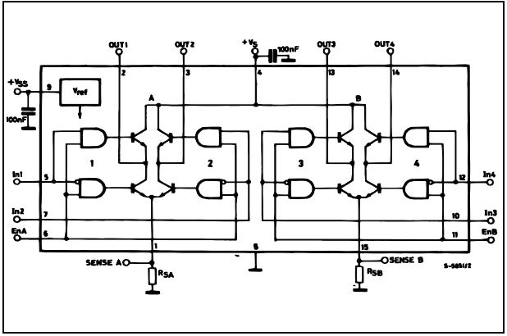

This block diagram can control two motors.In1 and In2 are inputs for one motor and out1 and out2 are outputs for first motor, while In3, In4 are inputs for second motor and Out3, Out4 are outputs for other motor. A and B are two H-bridges which consist of four transistors. Transistor has three pins which include collector, base and emitter. When voltage are given at pin 5 and EnA is always enabled so AND gate will give one and motor will run.

3.6 Robotic Chassis:
Designing of chassis is a very crucial task in making of a robotic vehicle. This is the base on which we have to place components. We can make it by using many types of material like fiber, metal, plastic and wood. Chassis is like a very basic structure having wheels and motors.
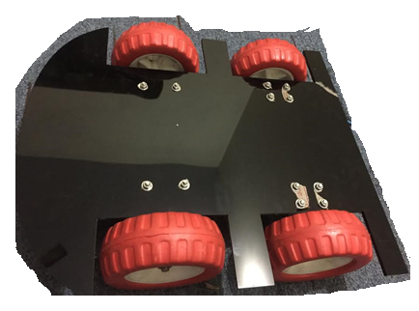
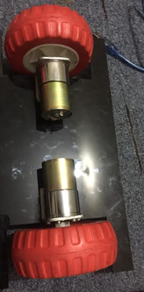
Motors can be of many types which are described below in next topic. Many types of chassis according to design and dimensions are available in the market or online stores at different costs. Two types of motor combinations can be used in robotic chassis which are two motor and four motor. In two motor combination motors are attached with the back wheels and front wheels are free to move. We can turn the vehicle to right or left by driving the motors in different directions. While in four motor combinations all the four wheels are attached with four motors and controlled as desired. To turn the vehicle right or left we need to operate two motors, one from front and other from the in opposite directions which may consume more power of the battery.
At first we wanted to buy the readymade chassis according to our need in the project. We visited so many stores but we did not find properly designed chassis according to our need or were too much costly. We wanted our project to be economical for that purpose we got an idea from our advisor to use mechano to design a chassis for our project but we did not find our desired chassis in this material too. So we decided to design it by ourselves. We choose a fiber type material to make our chassis. So we make a design a shape of our chassis and cut the fiber sheets with the help of laser cutting machine. After the designing the task was to attach wheels and motors with these sheets to make it moveable. By using aluminum pieces molded at 90º angle we attached DC gear motors combined with wheels at the back side of the sheet. Then we attached front wheels to the sheet after combining them with each other with the help of a steel rod. We made it hard enough to carry some weight of battery and robotic arm. Figure 4.2 shows the chassis with attached DC motors and wheels. We are controlling our robot by using mobile app when we give a signal it start moving forward or backward and left or right according to our need.
3.6.1 Dimensions of Robotic Chassis:
Length: 14 inches
Width: 12 inches
Height: 7 inches
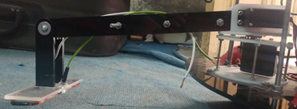
3.7 Mechanical Arm:
Metal Detector is attached to a mechanical arm and the movement of the metal detector is controlled by the mechanical arm. Mechanical arm consists of a mount at which servo motors are fixed and elongated through two fiber strips while its movement is controlled by two servo motors fixed on the mount. One servo motor controls the movement of the mechanical arm horizontally and the other one controls its movement vertically.
3.7.1 Dimensions of Mechanical Arm:
Mount Height: 3 inches
Mount Diameter: 3.5 inches
Strip Length: 12 inches
3.8 Servo Motors:
A servo motor is a motor that has a rotary actuator which is controlled to allow a precise movement of the angular and the linear position of the actuator. The servo motor is comprised of assembly of four basic components that are as follows:
- Normal DC motor
- Gear reduction unit,
- Position Sensing device (usually a potentiometer—a volume control knob),
- Control circuit.
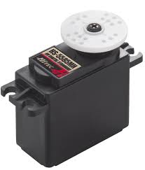
The basic function of a servo motor is to receive a control signal from a controlling device or an output circuit that signals the exact position or the amount of rotation that it need to achieve in order to perform a certain function or task by the rotation of servo haft that is attached to it stator. The signal provided supply power to its DC motor that moves it shaft to the desired position or state of action. The Position Sensing Device that is attached to the rotor sense the signal provided to it and uses the signal provided to determine the degree of the amount rotational action to be carried out. The Position Sensing Device basically is comprised of a potentiometer or a volume control knob. With the help of the position sensing device the servo motor is able to rotate according to the signal provided by the control circuit. However the shaft of a servo motor cannot rotate 360 degree like a DC motor but instead it only rotates to maximum angle of a 200 degree and then it rotates backward 200 degree and vice versa.^{[5]}
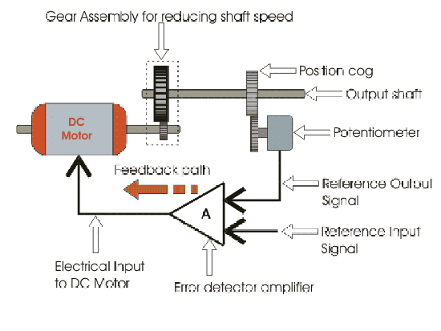
The servo motor has a 3 wire connection unlike a DC motor which has two and those include:
- Power
- Ground
- Control
The power source to a Servo motor should be constantly applied for the proper position and continuous working of the shaft. The servo motor is basically controlled by the drawn current from the power and has its own drive electronics.
The control signal that is given to a servo motor is a pulse width modulated (PWM). However the duration of the signal varies in the positive going cycle as the signal provided in the positive going cycle controls the position of the servo shaft.
The pulse that is used to control the servo motor is repeated after every 20 milliseconds. This provided ensures that after every 20 milliseconds a new impulse is given to servo motor that defines of where the shaft rotor should move. So we can control the position of the servo motor after every 20 milliseconds as a new impulse is provided often.
Servomotors are used in a number of applications such as:
- Robotics
- CNC Machinery
- Automated Manufacturing
Some say that Robotics might not exist without servos. We can see in our daily use that there is a servo controlled robot in almost every basic equipment used in Robotics. We used the servo motor to control the movement of the arm of motor robot that we built because our requirement for the movement of the arm was position controlled and there would not have been a better motor to control it than the servo motor. We used a combination of two servo motors to control the movement of the arm. One motor was used to move the arm vertically and the other horizontally.
3.9 Wireless Camera:
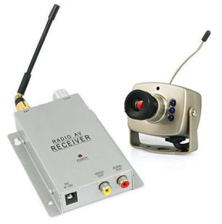
We used a wireless camera in our project that the main reason for the use of the wireless camera was that it is easy to install and it also has the benefit of flexibility. We can easily control our robot from a safe distance and move the robot accordingly without getting in to any trouble or hurdle if the robot gets out of sight. Wireless camera is a flawless device for a long distance open-airnursing.Remote camera that we operated was discreet and light that was simply introduced and did not consumed much space. Before installing the wireless camera we looked for a number of models in the market but we choose this model because it had a sufficient range and was much cheaper as compared to other models in the market. Wireless Camera that we used had the following components:
- Camera
- Radio A/V Receiver
- Display Monitor
Wireless camera that we use in our project has a Radio A/V Receiver that use Radio frequency in order to receive the signal that is transmitted from a small antenna that is attached to the camera installed on the camera. Wireless Camera is powered from a supply which is supplied from the 12V that is attaches on the Motor Robot. Radio A/V Receiver is powered by 9V power source and Display Monitor is powered by power source.
3.10 Bluetooth Module:
Bluetooth module is used to control our robotic vehicle wirelessly. For this purposes we have used HC-05 module to control it wirelessly through an app .Bluetooth is a device used to exchange data wirelessly over short range .It’s practical range is 15-20 meters which we have tested.It can be work from 3.6v-6v.
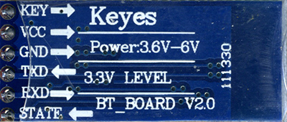
These are the pins in HC-05 module.
KEY: If this is HIGH before applying voltage,it is forced to AT command setup mode.LED blinks for 2 seconds.
VCC:+5V
GND: Connect it to ground.
TXD:It is the transmitting pin. It transmits serial data from module to Arduino serial receive.
RXD:It is the receiving pin.It receives data from Arduino.
STATE:This tells whether it is connected or not. ^{[6]}
3.10.1 Connecting Smartphone with Bluetooth Module:
Now we can connect our android phone with Bluetooth and arduino to send and receive data. Now first of all download Bluetooth RC Controller application from play store on your phone. Install it and then it will pop up “Application is requesting permission to turn on Bluetooth”. Now you have to click on yes. Then click on option menu and then select connect to car then it will show available devices .From that select HC-05 and now you are ready to go. LED indicator on the app will turn from red to green which will indicate that our Bluetooth module is connected to the app and we can easily control the movement of the robot by the options provided on the android mobile application.
3.11DC Battery:
Without power supply, our project is incomplete. We used a 12 V battery that supply power to the components used in our project. Our battery supplies current of 6.2 Ah mean it has capacity to give 6.2 A in an hour continuously, which is sufficient for testing and demo purposes of our robot.
We used the battery to power
- DC Gear Motor
- Servo Motor
- Camera ,
- Bluetooth Module and
- Designed a 5V supply.
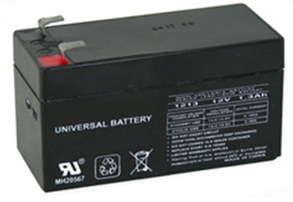
We also designed a 5V supply in our project because we needed 5V supply in order to power the servo motors that are attached on mechanical arm. We designed the 5V power supply by using voltage regulating IC 7805 and used the power to run our servo motors.
Power supply of 12V is capable of giving power for atleast one hour provided fully charged and only mentioned components are used. This allowed us to test our robot effectively and used the battery for demo purpose.

CHAPTER 4
USER MANUAL
Details are given on how one can check whether the robotic vehicle is working or not and how to start the robotic vehicle.
4.1 How to start Robotic Vehicle:
Our metal detector vehicle is easy to install and its plug and play. You only need to have a good android smartphone and a battery in good working condition.Code is already burned in Arduino. You just need to download and install Bluetooth RC Controller. When your mobile shows that Bluetooth device is connected to your mobile this ensures that your robot is working and all you need to do is use the app to control the robot. Now you need to connect our robot with your mobile using Bluetooth and its ready to search for metals.
4.2 How a User can tell if the Vehicle is in Working Condition:
Android mobile application being used has an indicator led in the user interface that indicates whether Bluetooth module is connected or not to control robot and make it perform the desired function for which it is designed.
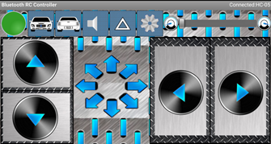
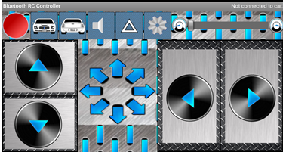
Following images serve as a user manual for the user to know if the Bluetooth module is connected to the robot or not.

Figure 4.1 Bluetooth Module Not Connected
Figure 4.2 Bluetooth Module Connected

4.3 Troubleshooting:
Whenever there is an error in the functioning or there is a power failure in the robot, we can hit and run a number of things to make sure that the robot is working or not. There can be an error in the working of the DC Gear Motors, Bluetooth Module, Servo Motors, Power Bank, Arduino and Metal Detector.
If there is an error in the DC Gear Motors then there will be no movement in the robot and then robot will stand still and will not move in any direction even if the Bluetooth module and all other things are working in the robot.
If there is an error in the Bluetooth Module then there will be no connection established with the mobile and this can be verified by the images that are connected in the above paragraph.
If there is an error in the servo motors then there will be no movement in the mechanical arm that is connected with the servo motors. Fault in the servo motors will not allow any movement of the arm which in result will result in no movement in the metal detector that is connected on the mechanical arm so there will be no metal detected by the robot.
If there is an error in the Arduino then there can be an error accepted in the DC Gear Motors and the Servo Motors because both of these components are controlled by the Arduino and will result in the malfunction of the Robot.
If there is an error in the Power Bank then there will be no power supply to the robot and nothing will work accordingly and there will be a complete BLACKOUT without any signal transmitted or received.

CHAPTER 5
CONCLUSION & FUTURE RECOMMENDATIONS
5.1 Conclusion:
We completed this project from our knowledge gained by the courses in our Engineering. It is an interesting project and we implemented all our skills to complete this project. In order we did a lot of research on how to control DC Gear Motors with the help of Arduino. In our syllabus we were not given any proper knowledge about how to use arduino so all we did was we look for a number of lectures on the internet and learnt about how to use arduino. Arduino cannot perform multithreading so we use our knowledge of MMS and use it create a master slave concept by using two arduino’s and used it to control DC Gear Motors and Servo Motors simultaneously. Our Metal Detector was not working efficiently so we tuned it for better readings and accurate results. In order to build the chassis we had a number of options for its structure as our advisor gave an idea to use mechano as a chassis but after some research we came to a conclusion that it was not strong and apart from that it was expensive. We designed our chassis by using plastic sheets which was not only strong but cheap as well.
We faced a number of problems in designing the mechanical arm because we were not able to decide the type of material to use for the arm. At first we decided to use a metal arm but later changed the material to plastic because metal in the arm might give false readings to the metal detector sensor attached to the metal arm which would have caused our project to go in vain. We thoroughly enjoyed the difficulties that we faced during the completion of this project and took them as a challenge. This was a tough job and we completed the task with the help of our advisor and teachers.
5.2 Future Recommendations:
In this section, we have given details on how we can advance this project in future so that it can be used in its anticipated field. Within few main key fundamentals we can develop our project to be used in field. Progressions of each equipment used in our project are briefly described below.

5.2.1 Circuit:
We can improve the circuit of the robot by using Buck converter instead of the voltage regulating IC 7805 for a 5V supply that we used. Buck converter is a more efficient and there are less power losses but it is an expensive device so in future one can install Buck converter instead of the voltage regulator IC 7805 for better efficiency.
5.2.2 Bluetooth Module:
Bluetooth Module used in our project has a limited range and therefore has a limited reach so in the future one can increase the range of controlling the robot by using more expensive and efficient modules for controlling the robot.
5.2.3 Sensor:
To fully use this project in its field, we should work on its sensor. Sensor should be more stable and should be more sensitive .It should be wide in range so that it could also detect metals or mines under certain depth till 5-6 m .It should be small in size so that we could make robot little compact so that it could easily dodge enemies too.
5.2.4 Wireless Camera:
For further enhancement we should use the tiniest wireless camera. Camera that we used in our project has a reasonable size but we can use a camera with smaller size and one with a better resolution if one can afford the expenses of it.
5.2.5 Overall System:
We can install wireless charging of the power bank and use a bigger battery for better speed and control. Our project design consists of plastic sheets which can be replaced by metal sheets for more strength. Strong tires can be installed in the robot for more rigid conditions and better grip of the robot. We can use fiber PCB instead of Vero board for more competent design. Arduino code in our project can also be improved in order to take more values.

References
^{[1]}http://www.bbc.com/news/world-38070207
^{[2]} https://en.wikipedia.org/wiki/Arduino
^{[3]} https://www.engineersgarage.com/insight/how-geared-dc-motor-works
^{[4]} https://forum.arduino.cc/index.php?action=dlattach;topic=366727.0;attach..
^{[5]} http://www.jameco.com/jameco/workshop/howitworks/how-servo-motors-work.html
^{[6]} https://arduino-info.wikispaces.com/BlueTooth-HC05-HC06-Modules-How-To?responseToken=7bcc2f7f2e28f191bf5762f3646e1070

Appendix
\\ Code for Master Arduino
#include <Servo.h>

const int motorA1 = 8; // Pin 14 of L298n
const int motorA2 = 7; // Pin 10 of L298n

const int motorB1 = 6; // Pin 7 of L298n
const int motorB2 = 5; // Pin 2 of L298n
int state;
const int BTState = 2;
int vSpeed=200;
int slave=11;
int slave1=10;
void setup(){

Serial.begin(9600);

//Set pins as outputs

pinMode(motorA1, OUTPUT);
pinMode(motorA2, OUTPUT);
pinMode(motorB1, OUTPUT);
pinMode(motorB2, OUTPUT);
pinMode(BTState, INPUT);

pinMode(slave, OUTPUT);
pinMode(slave1, OUTPUT);

}

void loop(){
if(digitalRead(BTState)==LOW) { state='S'; }

if(Serial.available() > 0) // Send data only when you receive data:
{
state = Serial.read();
}
Serial.println(state);

if (state == '0'){
vSpeed=0;}
else if (state == '1'){
vSpeed=100;}
else if (state == '2'){
vSpeed=180;}
else if (state == '3'){
vSpeed=200;}
else if (state == '4'){
vSpeed=255;}

if (state == 'F') {
analogWrite(motorA1, vSpeed); analogWrite(motorA2, 0);
analogWrite(motorB1, vSpeed); analogWrite(motorB2, 0);
}

else if (state == 'B') {
analogWrite(motorA1, 0); analogWrite(motorA2, vSpeed);
analogWrite(motorB1, 0); analogWrite(motorB2, vSpeed);
}

else if (state == 'S'){
analogWrite(motorA1, 0); analogWrite(motorA2, 0);
analogWrite(motorB1, 0); analogWrite(motorB2, 0);
}

else if (state == 'L') {
analogWrite(motorA1,255); analogWrite(motorA2, 0);
analogWrite(motorB1, 0); analogWrite(motorB2, 0);
}

else if (state == 'R') {
analogWrite(motorA1,0); analogWrite(motorA2,0);
analogWrite(motorB1, 255); analogWrite(motorB2, 0);
}

if (state == 'W') { /// for turning on servo rotations light button
digitalWrite(slave,HIGH);

}
if (state == 'w') { /// for turning on servo rotations light button
digitalWrite(slave,LOW);

}

if (state == 'U'){ //forward left button to turn on upper servo
digitalWrite(slave1,HIGH);
}
if (state == 'u'){ //forward right button to turn off upper servo
digitalWrite(slave1,LOW);
}
}

\\ Code for Slave Arduino
int metal=A0;
void setup()
{
pinMode(metal,INPUT);
Serial.begin(9600);
pinMode(8,OUTPUT);
digitalWrite(8, LOW);
}

void loop()
{
int b=0;
int a=0;
for(int i=0; i<7;i++){
a= analogRead(metal);
b= a/7;

}
if(b>=80)
{
digitalWrite(8, HIGH);

}
else{
digitalWrite(8, LOW);
}

Serial.println(b);
delay(100);
}

