Final Year Project Report

Automated Parking Management System


Project Advisor:
Dr Sajid Mehmood

Submitted By:
Muhammad Bin Mateen (13005065011)
Badar Sher Ali (13005065002)

Session
2013-2017

University of Management and Technology
C-II Johar Town Lahore Pakistan

Dedication

We would like to dedicate this project to our parents because they motivate us and taught us that even the largest task can be accomplished if it is done by concentration and we completed this project because of their love and trust on us. We would also like to dedicate this project to our Project advisors because they guided us in a right direction and gave their precious time to us in completion of this project. We discussed our project with them and they gave better suggestions to improve our project.

Final Approval

Panel of Examiners

- Head of Department ______________________
Department of Computer Science
UMT Lahore

- Program Director ( Final Year Projects) ______________________
Department of Computer Science
UMT Lahore

- Supervisor ______________________
Department of Computer Science
UMT Lahore

- Co-Supervisor ______________________

Acknowledgment

We truly acknowledge the cooperation and help make by Dr Sajid Mahmood, Lecturer of University of Management and Technology. He has been a constant source of guidance throughout the course of this project. We would also like to thank Dr. Masood thank Lecturer of University of Management and Technology for his help and guidance throughout this project. We are also thankful to our friends and families whose silent support led us to complete our project.

Project Title
Automated parking management system

Objective
To provide easy and advance parking solution to save time and money.

Supervised by
Dr Sajid Mehmood

Starting Date
12/10/2016

Completion Date
28/8/2017

Tools Used
- Cameras
- Sensors

Operating System
- Visual studio
- C Sharp
- Open CV

Plagairism Report

Abstract

Automated parking management system, this software is letting the user where he/she has to park the car, which floor, which slot or which lane or space is free for parking in mall, market or anywhere, where there is parking area.

In Pakistan there are hundreds of malls, plazas, universities, markets and airports etc., which surely have parking area it may be underground or consisting some ground area or it may have occupied some floors. Wherever you go, you face problems regarding parking either where to park the car or at where we can find parking space.

Parking place having cameras at possible places where detection is doing in the presence of car by image processing and then after detection that software will place an indication on screen at that particular place. This software informs user where empty space is available or where you can easily park the car.

The screens at the entrance and all around the parking area inform the people about the status of empty and filled parking slots. We will make software in shape of product which can be deployed at Malls, Markets, Universities, plaza etc.

Revision Chart

Version | Primary Author(s) | Description of Version | Date Completed
Draft | Muhammad bin mateen | Initial draft created for distribution and review comments | 06-08-2016
Preliminary | Badar sher ali | Second draft incorporating initial review comments, distributed for final review | 28-08-2016
Final | Muhammad bin mateen  Badar sher ali | First complete draft, which is placed under change control | 13-09-2016
Revision 1 | Muhammad bin mateen | Revised draft, revised according to the change control process and maintained under change control | 05-01-2017
Revision 2 | Badar sher ali | Revised draft, revised according to the change control process and maintained under change control | 15-02-2017

Contents
Contents 1
Definitions and Acronyms 4
List of Figures 5
List of Tables 6
1. Introduction 7
1.1 Motivations 7
1.2 Project Overview 7
1.3 Problem Statement 8
1.4 Objectives 9
2. Domain Analysis 10
2.1 Customer 10
2.2 Stakeholders 10
2.3 Affected Groups with social or economic impact 10
2.4 Dependencies/ External Systems 10
2.5 Reference Documents. 10
2.5.1 Related Projects 10
3. Requirements analysis 13
3.1 Requirements 13
List of use cases 15
3 Data flow diagram (optional) 22
3.2 Data Flow Diagram Level 0 22
3.3 Data Flow Diagram Level 1 22
3.4 Data Flow Diagram Level 2 23
3.5 Class Diagram 24
3.6 Sequence Diagram 25
26
4. Implementation details 27
4.1 Development Setup 27
4.2 Deployment setup 27
4.3 Algorithm 27
4.4 Constraints 30
4.4.1 Assumptions 30
4.4.2 System constraints 31
4.4.3 Restrictions and Limitations 31
5. Testing 32
Traceability Matrix 32
RID vs UCID (requirements vs use cases) 32
Prototypes (RID vs PID) 33
Test Cases (RID vs TID) 33
Coverage (UCID vs TID) 34
6. Results/Output/Statistics 35
6.1 Percentage completion 35
6.2 Percentage accuracy 35
6.3 Percentage correctness 35
7. Conclusion 36
8. Future work 37
9. Bibliography 38
9.1 Research papers 38
9.2 Other References 38

Definitions and Acronyms

API’s: Application program interface

LED: Liquid emitting diode

UHF: Ultra high frequency

RFID: Radio frequency identification

WSN: Wireless sensor network

LCD: Liquid crystal display

GSM: Global system for mobile

CCTV: Closed circuit TV

DC: Direct current

SMS: Short message service

List of Figures

Figure 1 Use Case Diagram 17
Figure 2: Use Case Diagram 2 18
Figure 3: Use Case diagram 3 19
Figure 4: DFD Level 0 21
Figure 5: DFD Level 1 21
Figure 6: DFD Level 2 22
Figure 7: Class Diagram 23
Figure 8: Sequence Diagram 24

List of Tables

Table 1: Feature Comparison 10
Table 2: Use Case 1 14
Table 3: Use Case 2 15
Table 4: Use Case 3 15
Table 5: Use Case 4 15
Table 6: Use Case 5 16
Table 7: Use Case 6 16
Table 8: RID vs UCID 31
Table 9: RID vs PID 32
Table 10: RID vs TID 32
Table 11: UCID vs TID 33

Introduction

Motivations
Metropolitan areas are now getting huge growth of visitors and patrons due to increasing amount of population in urban areas, hotels, hospitals, cinemas, restaurants many other facilities are available and increasing mobility in our society. Whereas, parking issues are becoming a major problem.

Parking patrons are concern about following matters:
- Where they can find best parking locations
- About how many hours parking is available
- what is expected cost per hour
- Whether a parking place will be available when they arrive.
.

Project Overview
The automated traffic system will inform the user about the status of parking at specific place. User will find couples of screens all around the parking area, more preferably at the entrance that where is the availability of the parking slot. The multiple views of screen will let the user empty and filled parking slot so that user save his time by finding a suitable parking space in an appropriate manner.
Our software will not include the feature if the user lost his car or forget the place where it has parked his car, the software will be able to detect the location of particular car.
Software will also be unable to provide the user the functionality of reservation of parking slot by which they cannot reserve the slot.

Features/Services

- Detection:
This will detect the vehicle at the entrance, where vehicle’s number plate will also be saved.

- Parking View:
There will be screens which will show the whole status of parking area.

- Parking Availability:
The screen all around will let user know where the empty slots are available or filled.

- Search Car:
The user will enter the car number which is mentioned on car’s number plate, so the system will tell which time it was entered and now where it is parked

Problem Statement
We have identified from the research that mostly people who are effected from the parking problems are using cars. Car parking is main problem as it needs more space to accommodate. Valet parking are very less and costly, self-parking takes a lot of time to find a suitable parking. Parking issues have psychological effects on people’s mind.
We have established that adverse effects of parking are increasing day by day. Parking issues have psychological effects on people’s mind. People need a proper parking doesn’t matter its underground or consists of floors but not so much.
Analysis shows that improper parking which is a fault by patron’s side is also bit making troubles. People need to get educate on this and proper parking directions are painted on floor to park.
An estimated cost of parking must be establish, concerned authorities must check whether determined cost is suitable keeping in view the specific place.
Most importantly, automated parking management system must be installed at every parking place in order to fight this problem. People first, must be aware from this management system. Every parking place must be strictly order to deploy this software.
As a comparison to the parking places having automated parking management system and others not, there is a huge difference. People opinions are opposite keeping in view both.

The main objective at last is that, it’s both beneficial to the ones who gets entertain and the other who have deployed this management system. Parking patrons are saving time, money and having no fear of insecurity, whereas, the parking owner generating revenues with less issues and tension.

Objectives
This software will be built on prototype model. We want patrons to be actively involved in it. The methodology we used in this different features of software are below:
- Detect the presence of car
The camera all around the parking place get focus on the slot, the particular place given for parking. The moment the car enters that place which is being captured by camera, through “IMAGE PROCESSING” the car will get detected. The image processing image will show that either it’s a car or some other vehicle or object.
- Screen hanged:
Screen all over the parking area letting the user to get updated by the parking status, either filled or empty. The animated view of every parking slot, parking floors can been seen on the screen.

- Division of slots and levels:
The API’s of Google are being used in this software, we have programmed the software that we have given about 5 feet of space in width and 15 feet of space in length for each car. The car will automatically detect the particular vehicle or object being placed in that particular space.

- Show equipped slots
The sparking slots which are being filled are shown with red lights which are place at the top of that parking slot. Screen let people know about the equipped spaces. Same goes for the empty slots.

- Guide a user to empty space
In case user doesn’t want to see the status of parking by screens. Then a guider at the entrance of parking place will tell the patron where to go, the guider will also have a glance on the views of parking.

- Number plate recognition
The moment the car will enter the parking place, the camera there will take a picture of its number plate after processing it. The number plate number can be catch from that picture. Then that number is saved in database, with the time and date the car entered. The user, in case, lost his car can easily enter the number of his car at the computer at entrance and can easily reach the place where the user has parked.

Domain Analysis

Customer
- Malls
- Plazas
- Universities

Stakeholders
- Malls
- Plazas
- Universities
- General Public

Affected Groups with social or economic impact
- Performance level of automated parking system is ideal and also user friendly.
- The screen and animation will be very clear that user can easily see the empty and filled spaces.
- This software will be able to deploy at every parking area where there is place for parking or have parking slots.
- This software is usable until there is no extension in parking area.
- The recognition of number plate.

Dependencies/ External Systems
The equipment we use in this software really depend upon the area of deployment.

Reference Documents.
Following are the related projects.

Related Projects
- www.somfy.co.in
- Somfy India Pvt. Ltd.
- Bay Area Rapid Transit (2006). Millbrae Station Parking Map.

Table 1: Feature Comparison
Functionalities  AUTHORS | Animated parking views | Division of slots and levels | Show equipped slots | Guide a user to empty space | Parking indicator | Differentiate vehicles/Objects | PROPOSED PRODUCT
Jeffery F Pariati | √ |  | √ |  | √ |  | √
Botkin Donald |  | √
Saranowjennifer | √ |  | √ |  |  |  | √
Wilber smith |  | √ |  |  | √ |  | √
Lauren |  |  | √ |  |  |  | √
Hans Roth |  |  |  | √ |  | √
Patibikashron | √ |  | √ |  | √ |  | √
Spillarsam |  | √ |  |  |  | √
Shaheen | √ |  |  |  |  | √
Susan A |  | √ | √ |  |  |  | √
Caroline j Rodier | √ |  | √ |  |  | √

Requirements analysis

Requirements
The various system design issues that have to be addressed are:
- Performance
There will be cameras at possible places where we will detect the presence of car/vehicle by image processing and then after detecting that software will place an indication that their space is occupied at that particular place. This software will inform user where empty space is or where you can easily park the car. E.g. lane, floor etc. The screens at the entrance and all around the parking area will let people know about the status of empty and filled parking slots. We will make a software of that in shape of product which can be deployed at Malls, Markets, Universities, plaza etc.
- Robustness
Automatic parking management systems have been presented to car manufacturers which are still looking for efficient information about the obstacles around the vehicle, as well as efficient methods of processing this information, in the hope of achieving a very high level of robustness
- Flexibility
The system is beneficial enough for anyone who will use it and changes can be made according to user requirements. The system is capable of storing every vehicle record and that can be used if anyone who lost his/her vehicle so that can be found by number plate or through cameras. The system save the time of the user by showing empty parking.
- Re-usability and portability
The system can be deployed in any place where electricity is available and where the parking space is enough. It can be used by a person, there is no difficult thing that an ordinary person cannot understand. The changes can be made anytime and it is also cost effective.
- Security
For security purpose all the data has a backup and there are cameras for so anyone tries to do something suspicious he can be found.

3.1.1 Functional requirements

- At the entrance vehicle’s number plate will be saved.
- There will be screens which will show the whole status of parking area.
- The screen all around will let user know where the empty slots are available or filled.
- The user will enter the car number which is mentioned on car’s number plate, so the system will tell which time it was entered and now where it is parked
- The camera all around the parking place get focus on the slot, the particular place given for parking.
- The image processing image will show that either it’s a car or some other vehicle or object.
- Screen all over the parking area letting the user to get updated by the parking status, either filled or empty.
- The sparking slots which are being filled are shown with red lights which are place at the top of that parking slot.
- Screen let people know about the equipped spaces. Same goes for the empty slots.
- Then that number is saved in database, with the time and date the car entered.

3.1.2 Non Functional requirements

- The system will work accordingly to the time
- It is maintainable
- It is reliable for the user so he can easily park the car
- Easy to find parking without wasting time
- It is user friendly and time saving

3.1.3 Constraints
- Performance level of automated parking system is ideal and also user friendly.

- The screen and animation will be very clear that user can easily see the empty and filled spaces.

- This software will be able to deploy at every parking area where there is place for parking or have parking slots.

- This software is usable until there is no extension in parking area.

- The recognition of number plate.
- None of the system is providing the information of each car (plate number). For security purpose. For example security agency want know the car that are inside the parking area for traceability.
- The system do not assign car to a specific parking lot and this result in roaming of cars inside the area in searching of parking space

List of Actors

Administrator: The system itself
User: The person who will use the system

List of use cases

Table 2: Use Case 1
UC-ID: | UC-1
UC Name: | Number Plate Recognition
Scenario: | This use case describes about the vehicle when it comes to entrance and number plate will be detected.
Primary Actor: | User
Stakeholders and Interests: | Customer
Pre-Condition: | The Customer must stop at the gate so vehicle number is saved

Table 3: Use Case 2

UC-ID: | UC-2
UC Name: | Empty and filled slots
Scenario: | This use case guide the user to the empty space and will also tell about the filled space.
Primary Actor: | User
Stakeholders and Interests: | Customer
Pre-Condition: | The customer must go to the empty space

Table 4: Use Case 3

UC-ID: | UC-3
UC Name: | Number plate recognition
Scenario: | This use case tells whenever customer goes in or out the number plate will be checked
Primary Actor: | Customer
Stakeholders and Interests: | Customer

Table 5: Use Case 4
Pre-Condition: | The number plate must be recognized before entrance and exit

UC-ID: | UC-4
UC Name: | Guide a user to empty space
Scenario: | This use case tells the customer is guided to the empty slot where the car would easily parked
Primary Actor: | Customer
Stakeholders and Interests: | Customer
Pre-Condition: | The customer should go to the empty space and follow the system
Miscellaneous: | System will be available 24/7

Table 6: Use Case 5

UC-ID: | UC-5
UC Name: | Show equipped slots
Scenario: | This use case tells that the customer will be guided that which space is equipped and which is empty
Primary Actor: | Customer
Stakeholders and Interests: | Customer
Pre-Condition: | The customer will know about the empty and equipped slot

Table 7: Use Case 6

UC-ID: | UC-6
UC Name: | Exit parking
Scenario: | This use case tells when customer will exit so the number plat will be detected and user can exit
Primary Actor: | Customer
Stakeholders and Interests: | Customer
Pre-Condition: | The customer must be in the parking area

Figure 1: Use Case Diagram

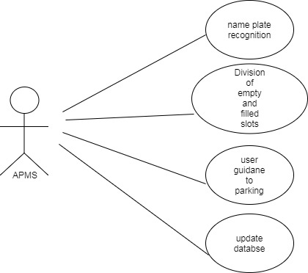

Figure 1 Use Case Diagram

Figure 2: Use Case Diagram 2

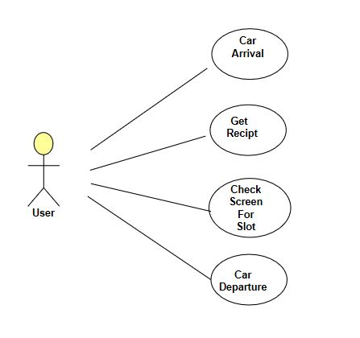
Figure 2: Use Case Diagram 2

Figure 3: Use Case Diagram 3

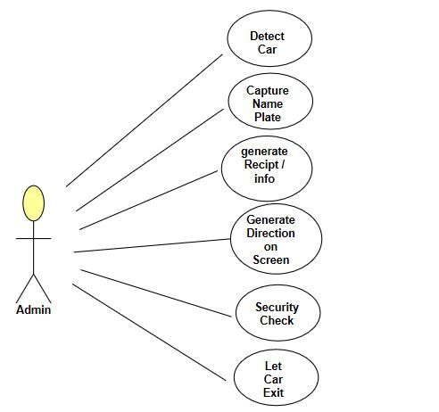

Figure 3: Use Case diagram 3

3 Data flow diagram (optional)

Data Flow Diagram Level 0
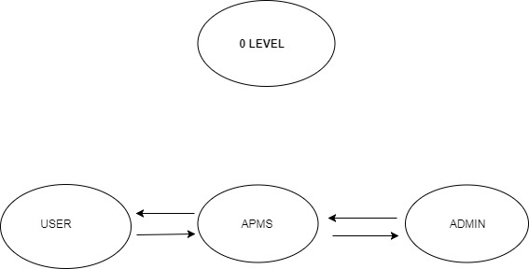

Figure 4: DFD Level 0

Data Flow Diagram Level 1
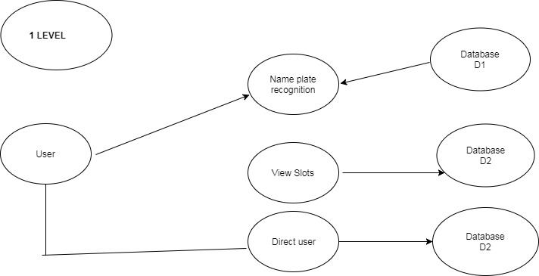

Figure 5: DFD Level 1

Data Flow Diagram Level 2

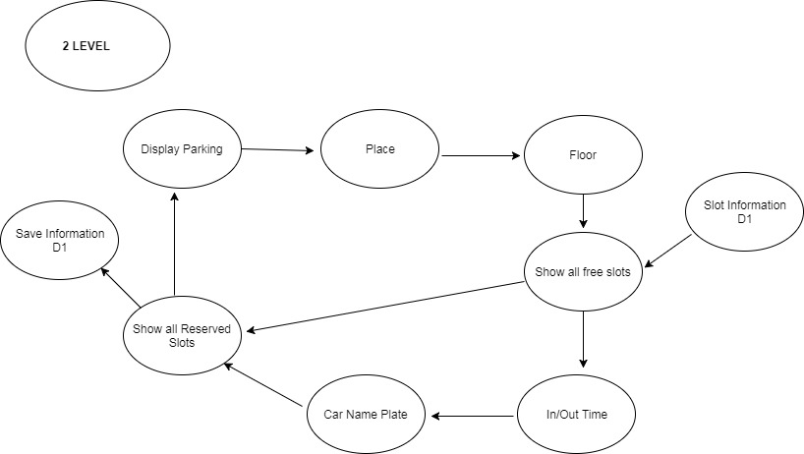

Figure 6: DFD Level 2

Class Diagram
Class diagram describes the attributes and operations of a class and also the constraints imposed on the system. The class diagrams are widely used in the modeling of object-oriented systems because they are the only UML diagrams, which can be mapped directly with object-oriented languages.
Class diagram shows a collection of classes, interfaces, associations, collaborations, and constraints. It is also known as a structural diagram.

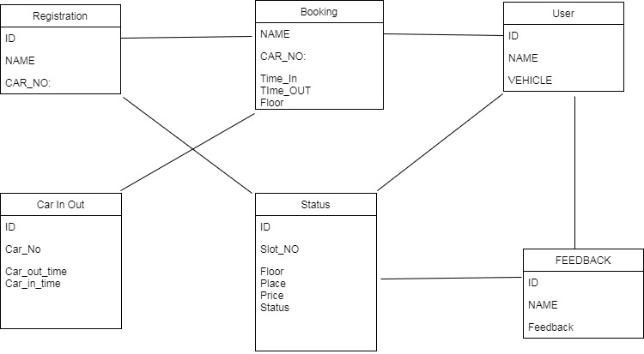

Figure 7: Class Diagram

Sequence Diagram
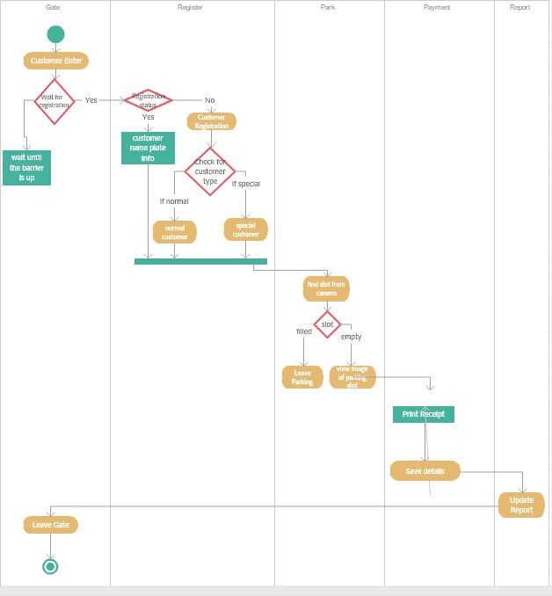
Figure 8: Sequence Diagram

ERD Figure 9: Entity Relationship Diagram (APMS)

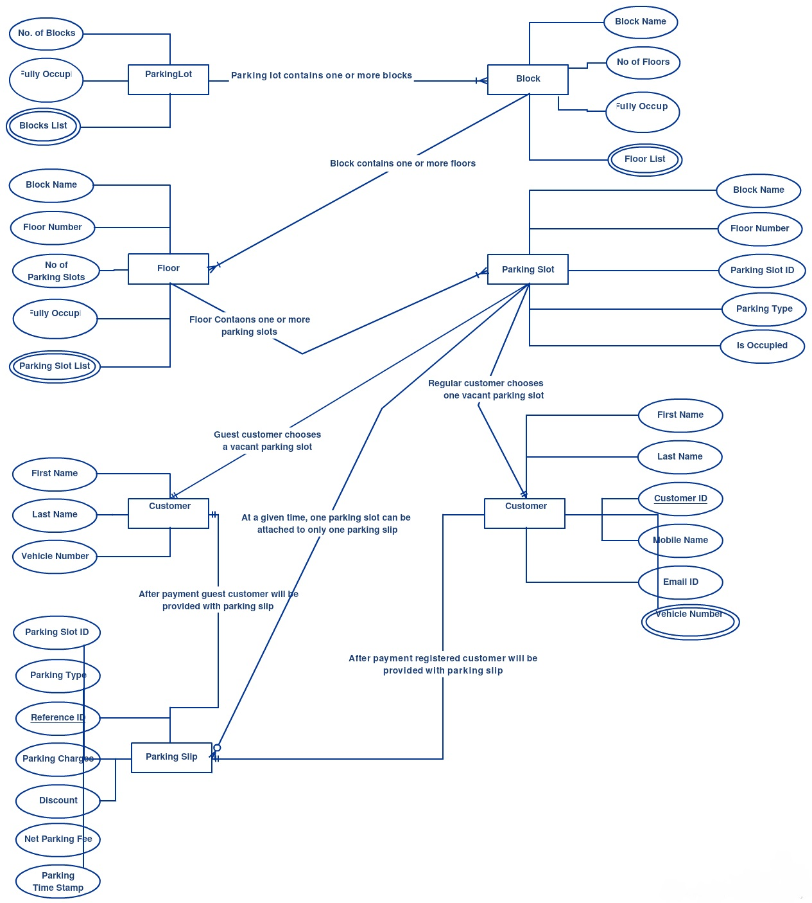

Implementation details

Development Setup
- Cameras
- C sharp
- Open CV
- Cars

Deployment setup
Deployment phase includes many thing, it was the time we need to get expected results which are being required. We were to automate the whole parking scenario which was a big task for us. We made entrance more reliable and error free, guided the user through screen guiding. Slots availability is also done. Hence, deployment setup is completed.

Algorithm

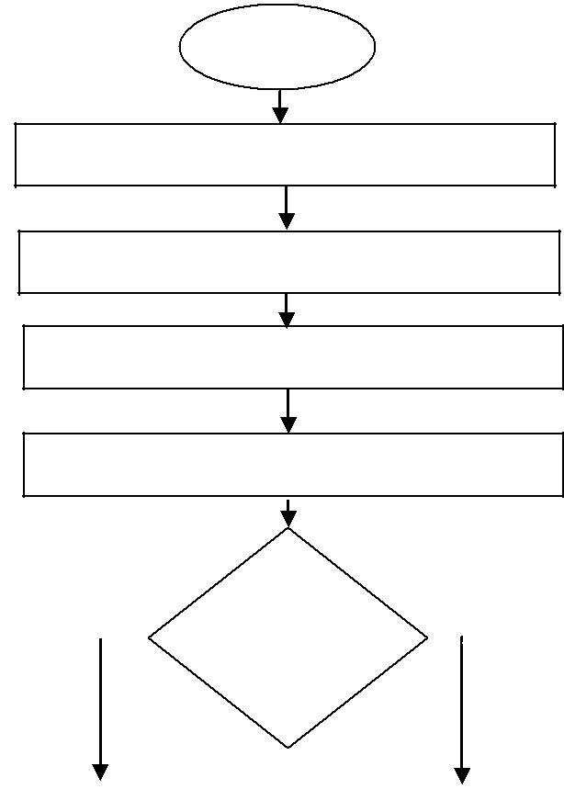
START

CAPTURE AND READ IMAGE FILE

PREROCESS THE IMAGE FILE

LOCATE THE LICENSE PLATE IN IMAGE

RECOGNIZE THE CAR PLATE NUMBER

 |  |  | Check if |  | No
Yes |  |  | Registered |  | No
 |  |  | in Database

OPEN GATE
OPEN GATE |  | DO NOT OPEN
 |  | GATE
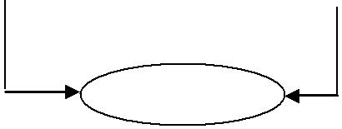

END

Flow chart
4.3.1 Snippet Code:

//Camera Capture Variables
FilterInfoCollection Sources = null;
VideoCaptureDevice EntranceCapture = null;
VideoCaptureDevice ParkingCapture = null;
VideoCaptureDevice ExitCapture = null;

//Parking Configurations
Bitmap Parking1Config = null;
Bitmap Parking2Config = null;
bool ParkingConfig = false;
int Green = 0; //Available Parking Place
int Red = 0; //Parked Car Number
bool Parking1 = false;
bool Parking2 = false;

//List of numbers of parked cars
List<string> ParkedNumbers = null;

// Get All camera sources attached to the PC
Sources = new FilterInfoCollection(FilterCategory.VideoInputDevice);

// Getting Camera Resource
EntranceCapture = new VideoCaptureDevice(Sources[0].MonikerString);
EntranceCapture.NewFrame += new NewFrameEventHandler(EntranceFrame);//Entrance Frame Registrations
EntranceCapture.Start();

ParkingCapture = new VideoCaptureDevice(Sources[1].MonikerString);
ParkingCapture.NewFrame += new NewFrameEventHandler(ParkingFrame);//Parking Frame Registrations
ParkingCapture.Start();

ExitCapture = new VideoCaptureDevice(Sources[2].MonikerString);
ExitCapture.NewFrame += new NewFrameEventHandler(ExitFrame);//Exit Frame Registrations
ExitCapture.Start();

}

// Entrance Frame Definition
private void EntranceFrame(object sender, NewFrameEventArgs eventArgs)
{
EntranceVideo.Image = new Bitmap(eventArgs.Frame);
if (!EntranceImageSet && EntranceImage == null)
{
EntranceImageSet = true;
EntranceImage = new Bitmap(eventArgs.Frame);
}
}
//LPR on Parking
if (ParkingImageSet && ParkingImage != null)
{
NumberPlateLabel.Text = LPR(ParkingImage);
foreach (var plate in ParkedNumbers)
{
if (plate.Equals(label5.Text) && label5.Text != "N/A")
{
label5.Text = "match Found";
}
}
EntranceImageSet = false;
EntranceImage = null;
}

}

//Parking Configuration
private void ConfigureParkingButton_Click(object sender, EventArgs e)
{
Parking1Config = null;
Parking2Config = null;
ParkingConfig = true;
}

//Licence Plate Recogintion Methods
private string LPR(Bitmap Image)
{
var region = "eu";
String config_file = Path.Combine(AssemblyDirectory, "openalpr.conf");
String runtime_data_dir = Path.Combine(AssemblyDirectory, "runtime_data");
AlprNet alpr = new AlprNet(region, config_file, runtime_data_dir);
alpr.DefaultRegion = "eu";
alpr.DetectRegion = true;
if (!alpr.IsLoaded())
{
return "Error initializing OpenALPR";
}

var results = alpr.Recognize(Image);
alpr.Dispose();
alpr = null;
var images = new List<Image>(results.Plates.Count());
var i = 1;
foreach (var result in results.Plates)
{

Constraints

4.4.1 Assumptions

- Performance level of automated parking system is ideal and also user friendly.
- The screen and animation will be very clear that user can easily see the empty and filled spaces.
- This software will be able to deploy at every parking area where there is place for parking or have parking slots.
- This software is usable until there is no extension in parking area.
- The recognition of number plate.

4.4.2 System constraints

- Performance level of automated parking system is ideal and also user friendly.
- The screen and animation will be very clear that user can easily see the empty and filled spaces.
- This software will be able to deploy at every parking area where there is place for parking or have parking slots.
- This software is usable until there is no extension in parking area.
- The recognition of number plate.
- None of the system is providing the information of each car (plate number). For security purpose. For example security agency want know the car that are inside the parking area for traceability.
- The system do not assign car to a specific parking lot and this result in roaming of cars inside the area in searching of parking space

4.4.3 Restrictions and Limitations

There are many parking systems and methods implemented today for managing vehicle parking. Rules and regulations are common place for vehicular parking. Such rules may include absolute prohibitions, such as areas in which no parking is permitted, or the rules may include conditional prohibitions, such as permit-only parking, free limited duration parking, and fee-based parking. Metered parking is also typical on public roadways. In addition to various types of parking restrictions, the rules may be enforced by either private or public agencies.

Testing

Traceability Matrix

RID vs UCID (requirements vs use cases)
UCID/RID | R  1 | R  2 | R  3 | R  4 | R  5 | R  6 | R  7 | R  8 | R  9
UC 1
UC 2
UC 3
UC 4
UC 5
UC 6
UC 7
UC 8
UC 9
Table 8: RID vs UCID

Prototypes (RID vs PID)
PID/RID | R  1 | R  2 | R  3 | R  4 | R  5 | R  6 | R  7 | R  8 | R  9
PID 1
PID 2
PID 3
PID 4
PID 5
PID 6
PID 7
PID 8
PID 9
Table 9: RID vs PID

Test Cases (RID vs TID)

TID/RID | R  1 | R  2 | R  3 | R  4 | R  5 | R  6 | R  7 | R  8 | R  9
TID 1
TID 2
TID 3
0TID 4
TID 5
TID 6
TID 7
TID 8
TID 9
TID 10
TID 11
Table 10: RID vs TID

Coverage (UCID vs TID)

TID/RID | UCID  1 | UCID  2 | UCID  3 | UCID  4 | UCID  5 | UCID  6 | UCID  7 | UCID  8 | UCID  9
TID 1
TID 2
TID 3
TID 4
TID 5
TID 6
TID 7
TID 8
TID 9
TID 10
TID 11

Table 11: UCID vs TID

Results/Output/Statistics

Percentage completion
We have completed our project 94%. We have met all the functional requiremets that we discussed.

Percentage accuracy
Our project is working 80% accurate. It fulfills all the functional and not functional requirements as we promised.

Percentage correctness
As we have tested all the requirements and made their test cases mentioned and clear all the mistakes so now our project is 100% correct.

Conclusion

Automated parking management system provides the facility for customers to easily find car parking without wasting time. We have shown the concept of an automated parking management system which will guide the user through the entry and exit gates and then display the number of cars in the parking lot. The sensing of entry and exit of cars is done with the help of sensors and cameras which will guide the user.

Future work
For future work we have decided to work on more features and to improve the system. We will enhance our system according to future requirements.

Bibliography

Research papers
- Sangwon Lee, Dukhee Yoon and Amitabha Ghosh, Intelligent Parking Lot Application Using Wireless Sensor Networks, Proceedings of IEEE conference, 978-1-4244-2249-4/08
- Barton, J., J. Buckley, B. O’Flynn, S.C. O’Mathuna, J.P. Benson, T. O’Donovan, U. Roedig, and C. Sreenan, The D-Systems Project – Wireless Sensor Networks for Car- Park Management, Proceedings of the 65th IEEE Vehicular Technology Conference, Dublin, Ireland, Apr 2007, pp. 170-173.
- IrisNet: Internet-scale Resource-Intensive Sensor Network Service, http://www.intel-iris.net

Other References
- Tsiaras C, Hobi L, Hofstetter F, Liniger S, Stiller B. Park IT smart: Minimization of cruising for parking. 24th International Conference on Computer Communications and Networks (ICCCN); University of Zurich, Switzerland. 2015.
- Liniger S. Parking prediction techniques in an IOT environment. Switzerland: University of Zurich; 2015 Jul 14.
- Priyanka JGV, Hasnam M, Kumara WGCW. A text messaging based parking reservation system. 8th International Conference on Ubi-Media Computing; Colombo. 2015 Aug 24-26;
- R. YusnitaFarizaNorbayaNorazwinawatiBashruddin. “Intelligent parking space detection system based on image processing”. International Journal of Innovation, Management and Technology, 3:232-235, 2012.
- M.O. Reze M.F. Ismail A.A. Rokoni M.A.R. Sarkar. “Smart parking system with image processing facility”. I.J. Intelligent Systems and Applications, 3:41-47, 2012.

