FACTORS CONTRIBUTING TO THE CHOICE OF EVALUATION TECHNIQUE FOR INVESTMENT DECISIONS IN PAKISTAN


SUBMITTED TO
SCHOOL OF BUSINESS AND ECONOMICS IN PARTIAL FULFILLMENT OF THE REQUIREMENTS FOR THE DEGREE OF
MS FINANCE

BY
AKEELA MARYAM
12003069021

UNIVERSITY OF MANAGEMENT AND TECHNOLOGY Lahore.
April, 2015
UNIVERSITY OF MANAGEMENT OF TECHNOLOGY | UMT

Factors Contributing to the Choice of Evaluation Techniques for Investment Decisions in Pakistan

Submitted to
School of Business and Economics
in Partial Fulfillment of the Requirements for the Degree of
MASTERS OF SCIENCE in FINANCE

By

Akeela Maryam (12003096021)
April, 2015

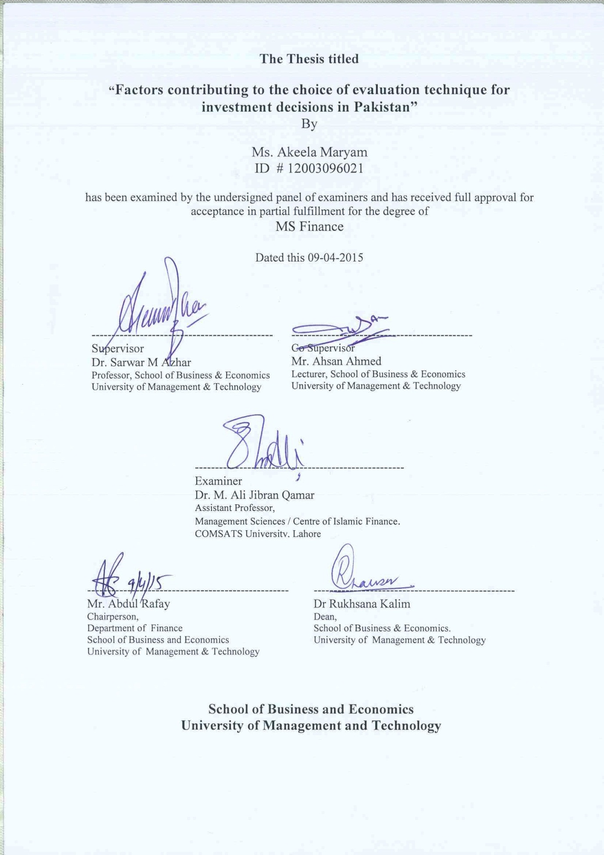

DEDICATED

To

My Parents and Teachers

Declaration

I hereby declare that the work entitled “Factors Contributing to the Choice of Evaluation Techniques for Investment Decisions in Pakistan” is my own work and no part of this dissertation has been copied from any other source except where explicit acknowledgement is made in the text.

This thesis is my original work, and the data/material presented herein has not been used for the acquisition of any other degree from any institution.

AKEELA MARYAM
9 April ,2015

