Final Year Project Report
E-Thrills (Android Based)

PROJECT ADVISOR:
Mr. Ahtsham Ali

SUBMITTED BY:
Taha Ali Irfan 13005065338
Ali Ashraf 13005065314
H.M Kashif 13005065344
SESSION:
Year 2013-2017

School of System & Technology
University of Management and Technology
Lahore
Dedication
We devote our work to our adoring guardians and extraordinary appreciation to our aware instructors, a warm appreciation to our relatives and companions, whose inspirational statements and push for determination ring in our ears. Without their collaboration it would have not been conceivable to finish the graduation and make them feel glad. We likewise commit this paper to our companions who have upheld us all through the procedure in any capacity. We will dependably welcome all they have done and how they bolstered us.

Final Approval

Panel of Examiners

- Head of Department ______________________
Department of Computer Science
UMT Lahore

- Program Director ( Final Year Projects) ______________________
Department of Computer Science
UMT Lahore

- Supervisor ______________________
Department of Computer Science
UMT Lahore

- Co-Supervisor ______________________

Acknowledgment

To start with and the preeminent, we wish to offer our most profound thanks to our venture guide Mr.Ahtsham Ali for the persistent help in our BS contemplates and in the last year extend, for his understanding, inspiration, energy and tremendous learning. His direction helped all of us the time in the last year extend and the written work of this proposal. Without him this proposition would not have been finished. We additionally might want to thank all the regarded instructors of software engineering office for their direction inside and out they control us and make us qualified to finish this theory.
We specially like to thank Mr. Ahtasham Ali who helped us every step of the way to complete this project as an adviser and as a teacher, we would also like to thank Mr. Muhammad Nabeel, Mr. Sajid Mehmood and Mr. Abu Baker.

Project Title
E-thrills (Android based)
Objective
To provide the users a proper guide/platform to manage there budget and time while discovering new places and to learn from others experiance.

Undertaken by

TAHA Ali IRFAN 13005065338
Ali Ashraf 13005065314
H.M Kashif 13005065344

Supervised by Sir Ahtsham Ali
Starting Date 9/10/16

Completion Date 30/7/2017

Tools Used
MSQL Work Bench, Adobe Photoshop, Balsamiq mockups tool, Android Studio, PHP
Operating System Windows
Documentation Microsoft word 2013, Gmail Drive

Plagairism Report
Abstract

The world is now turning into a global village. Now to travel from one place to another has become so much easier than it used to be. And things are still changing rapidly. Every year huge amount of changes are taking place. And everything around us is so connected that to access it is becoming easier.
We are coming up with the idea that will somehow help our user to discover changes around them in a far different way. It will work as a guide to those who are interested in discovering new places.

Revision Chart

Version | Primary Author(s) | Description of Version | Date Completed
0.1 | Taha Ali | Initial draft created for distribution and review comments | 1/28/2017
0.1.1 | H. Kashif | Adding Test cases | 6/22/2017
0.1.2 | Taha Ali | Conclusion and code snippet added | 6/30/2017
0.1.3 | TBD | Update section to describe new product design | 20/12/2016
0.1.4 | TBD | Update section to describe new product flow | 30/12/2016
0.1.5 | TBD | Final Inspection | 20/7/2017

Contents
Contents 1
Definitions and Acronyms 3
List of Figures 4
List of Tables 5
1. Introduction 6
1.1 Motivations 6
1.2 Project Overview 6
1.3 Problem Statement 6
1.4 Objectives 6
2. Domain Analysis 7
2.1 Customer 7
2.2 Stakeholders 7
2.3 Affected Groups with social or economic impact 7
2.4 Dependencies/ External Systems 7
2.5 Reference Documents 8
2.5.1 Related Projects 8
2.5.2 Feature Comparison 9
3. Requirements analysis 10
3.1 Requirements 10
3.2 11
3.2 List of Actors 11
3.3 List of use cases 11
3.4 System use case diagram 12
3.5 Extended use cases 13
3.5 Extended use cases 14
3.5 Extended use cases 15
3.5 Extended use cases 16
3.5 Extended use cases 17
3.6 User interfaces (mock screens) 18
3.6 User interfaces (mock screens) 19
3.6 User interfaces (mock screens) 20
3.6 User interfaces (mock screens) 21
3.6 User interfaces (mock screens) 22
4. System Design 23
4.1 System Architecture Diagram 23
4.2 Class Diagram 24
4.3 Sequence Diagrams 25
4.3 Sequence Diagrams 26
4.3 Sequence Diagrams 27
4.4 Collaboration Diagrams 28
4.4 Collaboration Diagrams 29

4.5 ERD 30
4.6 Data Dictionary 31
5. Implementation details 32
5.1 Development Setup 32
5.2 Deployment setup 32
5.3 Algorithms 33
5.3 Algorithms 34
5.4 Constraints 35
5.4.1 Assumptions 35
5.4.2 System constraints 35
5.4.3 Restrictions 35
5.4.4 Limitations 35
6. Testing 36
6.1 Extended Test Cases 36
6.1 Extended Test Cases 37
6.1 Extended Test Cases 38
6.1 Extended Test Cases 39
6.1 Extended Test Cases 40
6.1 Extended Test Cases 41
6.1 Extended Test Cases 42
6.2 Decision Table 43
6.2.1 Code snippet 43
6.3 Traceability Matrix 50
6.3.1 RID vs UCID (requirements vs use cases) 50
6.3.2 Prototypes (RID vs PID) 50
6.3.3 Test Cases (RID vs TID) 51
6.3.4 Coverage (UCID vs TID) 51
7. Results/Output/Statistics 52
7.1 %completion 52
7.2 %accuracy 52
7.3 %correctness 52
8. Conclusion 53
9. Future work 54
10. Bibliography 55
10.1 Articles 55
10.2 Other References 55
11. Appendix 56
11.1 Glossary of terms 56
11.2 Pre-requisites 56
Definitions and Acronyms

Acronym | Definition
UMT | University of Management and Technology
POS | Point of Sale
Table 1: table of acronyms and definitions

List of Figures
Figure 1: sample use case diagram with explanation…………………………………………….12
Figure 2: Mockup (Sign In)……………………………………………………………………18
Figure 3: Budget Estimate…………………………………………………………………….19
Figure 4: Category…………………………………………………………………………….20
Figure 5: Place…………………………………………………………………………………...21
Figure 6: MAPS………………………………………………………………………………….22
Figure 7: System Architecture…………………………………………………………………23
Figure 8: Class Diagram……………………………………………………………………..…24
Figure 9: Sequence Diagram (Sign Up) ………………………………………………………25
Figure 10: Sequence Diagram (Budget) …………………………………………………..….26
Figure 11: Sequence Diagram (Feedback) ……………………………………………….…27
Figure 12: Collaboration Diagram (Search Place) ……………………………………….…28
Figure 13: Collaboration Diagram (Review) …………………………………………….…29
Figure 14: ERD……………………………………………………………………………….….30
Figure 15:Code Snippet 1…………………………………………………………………….43
Figure 16:Code Snippet 1…………………………………………………………………….43
Figure 17: Book 1……………………………………………………………………………….49
Figure 18: Book 2……………………………………………………………………………….49

List of Tables
Table 1: table of acronyms and definitions………………………………………………….....3
Table 2: list of stakeholders……………………………………………………………………...7
Table 3: Feature Comparison……………………………………………………………………9
Table 4: Requirement 1…………………………………………………………………………10
Table 5: Requirement 2…………………………………………………………………………10
Table 6: Requirement 3………………………………………………………………………....10
Table 7: Functional Requirements…………………………………………………………….11
Table 8: Use Case (Sign Up) …………………………………..…………………………….…13
Table 9: Use Case (Log In) ……………………………………….………………………….14
Table 10: Use Case (Cost Estimation) ……………………………………………………….15
Table 11: Use Case (Search Place) …………………………………………….…………….16
Table 12: Use Case (Review) ………………………………………………………………..…17
Table 13: Data Dictionary………………………………………………………………………31
Table 14: Test Case (Facebook Login) ……………………………………………………….36
Table 15: Test Case (Current Location) ……………………………………………………..37
Table 16: Test Case (Layout Handling) ……………………………………………………..38
Table 17: Test Case (Data From Server) ………………………………………………….…39
Table 18: Test Case (Rating Test) ……………………………………………………………40
Table 19: Test Case (Category Test) …………………………………………………………41
Table 20: Test Case (Category 2 Test) ………………………………………………………42
Table 21: RID v/s UCID………………………………………………………………………44
Table 22: RID v/s PID…………………………………………………………………………44
Table 23: RID v/s TID…………………………………………………………………………45
Table 24: UCID v/s TID………………………………………………………………………45

Introduction

Motivations
The idea came to us that whenever we visit some new place we never have the correct or any estimation of budget or time that any activity would cost us to perform. So we planned to develop a platform, which will help its users to learn from other people experience.

Project Overview
The main idea of this project is to enable people to explore new places to have fun around. To do so the users will have to put their location in the Android based application and put their budget and time for which they are willing to have fun/entertainment. Then the app will suggest all the available options under that time, budget and the category of entertainment chosen by the user. This way people will be able to explore new places to have fun in a very good way by knowing that which place is best for them according to their situation (available budget and time) so the app will help users to decide that what is the best way to have fun/entertainment in a very precise manner. Users can also suggest new places they discover and if that place gets good reviews it can be added to the app for other users as an option to visit. So this way users will discover and add places by their selves and options will keep on increasing, more options means more user’s attraction.

Problem Statement
We are trying to build an application that will save time and budget of its users. We will do this with comparing the input of the user and the data set we have in our application. We are suggesting the price of any activity our users want to perform. To provide the exact price is the problem because prices are varying time to time and also one can ha multiple options in place like amusement parks. So we will output in form of range.
One other issue was that the data around us is changing rapidly and if need to be accurate our data must be update regularly but to update it manually takes time. So we are taking our data from Google places API and in this way we can update the data set whenever we want to.

Objectives
- At least we want this application to work in the diameter of Lahore city
- We want this application to flexible so that the in future we can expand it to further cities or may be a whole country.
- We want the result to be accurate and worthy for its users.
- We want it to be user friendly
- We are trying to make the application as much useful as it could be.
- We are trying to add features to like rating or commenting.

Domain Analysis

Customer
- Tourist
- Students
- Travel Guides
- Locals

Stakeholders
Stakeholder | Role in System
Database Manager | He is responsible to manage the backend of the application and the connections between the application and the server.
Frontend Manager | He is responsible for making the connections between the application and the web server
The designer | He is responsible for making the application user friendly and he deals with the designing of the various screen throughout the application.
Users | They will use the application. They also add place, comments and rate any location they visit.
Admin | Add locations, Delete locations, verify users.
Table 2: list of stakeholders

Affected Groups with social or economic impact
- Tourist: Our App helps the tourist to get the information about the places that are worth travelling, and by keeping then in their budget.
- Students: Our App helps the students to find places which suites their budget.
- Travel Guide: Our App helps the travel guide to gain useful information which helps in his business
- Locals: Our App helps the local to find information about the place they intend to visit.

Dependencies/ External Systems
- Google API
- Facebook graph API

Reference Documents

Related Projects
In order to start working on E-thrills we looked into several related application there details are given below.
- Tripit
Developed by Concur Technologies, Inc. The application was launched in 2006 but it was limited Organize travel plans in one place Your master itinerary has all your confirmation numbers, reservations, contact info, directions, and more in one spot. We get all this information from https://www.tripit.com/

- Citymapper
Developed by ABC. The working of this management software was observed from abcbeaconhouse.com.pk. No relevant documentation was available.
- Liveterrker
LiveTrekker is the mobile App with which you illustrate your best travels via a wide array of rich digital media, commented with your thoughts and emotions.

Feature Comparison
Sr No. | E-Thrills | Citymapper | Tripit | Liveterrker | Remarks
1 Location guider | We will fetch the longitude and latitude of the user and suggest the location. | A to b directions that humans actually use in cities. Live/real-time routing that updates every minute. The future of multimodal. | It deals with the bookings and traveling’s of its users. | Track your steps through GPS. Take photos or videos and add comments along the way. Your whereabouts, timing, speed and much more is available for a full rendering of your travels. | All these applications require there users current location except tripit in which they enter them self.
2 Cost guider | Our application will suggest a range of amount from min to max a person would need | Citymapper has nothing in comparison to our feature related to cost | Tripit has details of different packages one can use in a short interval. | liveterrker has nothing in comparison to our feature related to cost | This feature is mostly not common in apps similar to ours as it requires huge data because of changing price.s
3 Time guider | This feature will help our users to utilize their time fully.  We manage this using google maps to fetch real time data. | It also guide the time through its maps and the selected places. | Tripit includes manage travel plans it may or may not include time. | Livterrker helps to mark different points on map and it can suggest time taken from one point to the other. | It is a commonly used feature and mostly used with the halp of google palces API to get realtime information.
Table 3: Feature Comparison

Requirements analysis

Requirements

Functional Requirements | Log In
Non-Functional Requirements | Proper Interface, User friendly
Data Requirements | Our data will be saved on online server
Constraints | Cannot log in without password
External interface requirements | Our system will fetch the data from online server containing data of the user.
Table 4: Requirement 1
Functional Requirements | Cost Estimation
Non-Functional Requirements | Our system should show the appropriate currency of the country our app is being used
Data Requirements | Our data will be saved on online server
Constraints | The value cannot be negative
External interface requirements | Our system will fetch the data from online server containing data of the user.
Table 5:Requirement 2
Functional Requirements | Place Categories
Non-Functional Requirements | Our system should have proper pictures, so that no ambiguity occur.
Data Requirements | The data of the selected category will be storied on our system
Constraints | User must check at least one box
External interface requirements | Our system will fetch the data from online server containing data of the user.
Table 6: Requirement 3

RID | description | Category | Attribute | Details & Boundary Constraints
R1.1 | Sign up/Sign in. | functional | User sign in | User must enter basic information. Or signup with facebook.
R1.2 | User Location. | functional | Concurrent user load
RI.3 | Budget Estimation. | Functional
RI.4 | Time Estimation | Functional
RI.5 | Locate places. | Functional
RI.6 | Searching | Functional
RI.7 | Reviews/Suggestions from users | Functional
RI.8 | User Friendly interface | Non-Functional
RI.9 | Quick Results. | Non-Functional
RI.10 | Maintainable. | Non-Functional
RI.11 | 24/7 Availability | Non-Functional

Table 7: Functional Requirments

List of Actors
- Admin: the admin can add or delete locations and verifies the new accounts.
- Users: Users will input the budget and time. Users can also comment and add new location. They can also search new locations.

List of use cases
- Main menu: User will be asked to enter budget but it is optional. They can also click on the next button to move further.
- Signup Form: the users will have to enter there details to get registered.
- Login: Users with an existing account will use login option to use the application.
- Search for places: The search field will help the users to enter there desired location and calculate their desired results.
- Plan chart: the users can use a plan chart to manage their time in a new area

System use case diagram
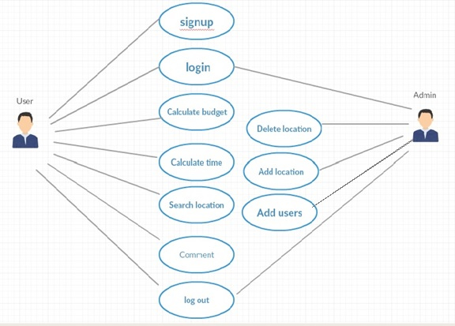

Figure 1: sample use case diagram with explanation

Extended use cases
Use Case ID: | UC-1
Use Case Name: | Sign up
Created By: | Taha Ali |  | Last Updated By:
Date Created: | 26-01-17 |  | Last Revision Date:
Actors: |  | User Admin
Description: |  | User enter his budget.
Trigger: |  | We need the user to sign up, in order to take his information which will help us in locating places which best suites him/her
Preconditions: |  | The system should be installed and have internet access
Post conditions: |  | The user is signed up
Normal Flow: |  | - The user enters his name and information  - The system checks that every information is entered completely and accurately  - The user enters the username he likes  - The system responds by allowing the username  - The user enters sign up
Alternative Flows:  [Alternative Flow 1 – Not in Network] |  | - The user enters incomplete or wrong information  - The requested username is already taken
Exceptions: |  | User name is Incorrect formant  - The user has entered an incorrect number for example -1.
Includes: |  | No
Frequency of Use: |  | 5-10 per day
Special Requirements: |  | Design must be simple.
Assumptions: |  | The user is familiar with basic computer knowledge
Table 8: Use Case (Sign Up)

Use Case ID: | UC-2
Use Case Name: | Log in
Created By: | Muhammad Adeel |  | Last Updated By:
Date Created: | 26-01-17 |  | Last Revision Date:
Actors: |  | User, Admin
Description: |  | User should login to the system so that we can maintain His/her profile
Trigger: |  | We need to maintain The profile of the user, So that user can rate
Preconditions: |  | The system should be started
Post conditions: |  | The System is logged in
Normal Flow: |  | - User enters his user name.  - User enters his password.  - System validates his user name against his password.
Alternative Flows:  [Alternative Flow 1 – Not in Network] |  | - The user has entered an Invalid Email or password.
Exceptions: |  | User name is Incorrect formant  - User left the user name blank or has entered an incorrect format for example no user name start with -1.
Includes: |  | [List any other use cases that are included (“called”) by this use case. Common functionality that appears in multiple use cases can be split out into a separate use case that is included by the ones that need that common functionality. e.g. steps 1-4 in the normal flow would be required for all types of ATM transactions- a Use Case could be written for these steps and “included” in all ATM Use Cases.]
Frequency of Use: |  | 5 to 10 hours
Special Requirements: |  | Design must fulfil login criteria
Assumptions: |  | The user is familiar with knowledge of login or log out
Table 9: Use Case (Log In)

Use Case ID: | UC-3
Use Case Name: | Cost Estimation
Created By: | Taha Ali |  | Last Updated By:
Date Created: | 26-01-17 |  | Last Revision Date:
Actors: |  | User
Description: |  | User enter his budget.
Trigger: |  | We need to check the budget of the user so that we can show him options accordingly
Preconditions: |  | The system should be logged in
Post conditions: |  | The budget is set
Normal Flow: |  | - The user enter his budget.  - He must click next
Alternative Flows:  [Alternative Flow 1 – Not in Network] |  | - The user has enter a number which is either too low or too high
Exceptions: |  | User name is Incorrect formant  - The user has entered an incorrect number for example -1.
Includes: |  | UC-1 must logged in.
Frequency of Use: |  | 5 to 10 hours
Special Requirements: |  | Design must be according to basic designs
Assumptions: |  | The user is familiar with knowledge
Notes and Issues: |  | [List any additional comments about this use case or any remaining open issues or TBDs (To Be Determined) that must be resolved. e.g.  - What is the maximum size of the that a use can have?]
Table 10: Use Case (Cost Estimation)

Use Case ID: | UC-4
Use Case Name: | Search Place
Created By: | Taha Ali |  | Last Updated By:
Date Created: | 26-01-17 |  | Last Revision Date:
Actors: |  | User
Description: |  | User enter his budget, time
Trigger: |  | This is the basic functionality of our system.
Preconditions: |  | The system should be logged in.
Post conditions: |  | The system displays the list of options
Normal Flow: |  | - The user enters his budget and time.  - The system asks the option of items(restaurants, historical etc) which the user can choose from  - The user click on his required category.
Alternative Flows:  [Alternative Flow 1 – Not in Network] |  | - The user has not entered budget or time  - The user has not selected any category
Exceptions: |  | User name is Incorrect formant  - The user has entered an incorrect number or time format.
Includes: |  | UC-1
Frequency of Use: |  | 100 to 500 per day
Special Requirements: |  | Design must be attractive
Assumptions: |  | The user is familiar with knowledge
Table 11: Use Case (Search Place)

Use Case ID: | UC-5
Use Case Name: | Review
Created By: | Taha Ali |  | Last Updated By:
Date Created: | 26-01-17 |  | Last Revision Date:
Actors: |  | User
Description: |  | User gives his/her views about a place
Trigger: |  | We want our users to help each other in finding a particular place
Preconditions: |  | The system should be logged in.
Post conditions: |  | The User is able to register his/her feedback
Normal Flow: |  | - The user enters the review option  - The system asks for the place the user want to comment about  - The user select the place and enter his review  - The system register the feedback in the database
Alternative Flows:  [Alternative Flow 1 – Not in Network] |  | - The user is not signed in
Exceptions: |  | - The place is no longer available in system
Includes: |  | UC-1
Frequency of Use: |  | 25 to 100 per day
Special Requirements: |  | Must contain proper feedback option.
Assumptions: |  | The user is familiar with feedback option
Table 12: Use Case (Review)

User interfaces (mock screens)

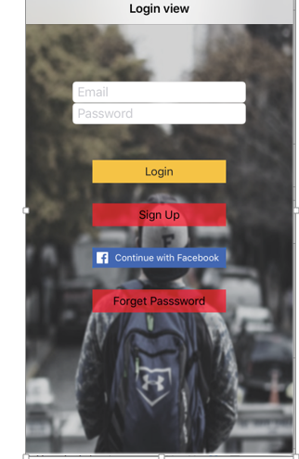
Figure 2: Mockup (Sign In)

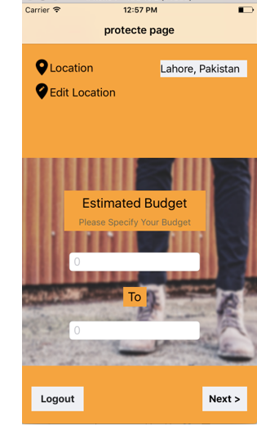
Figure 3: Budget Estimate

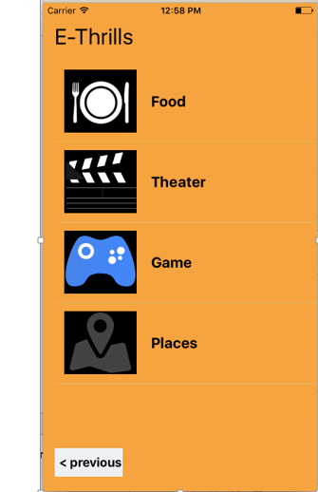
Figure 4: Category

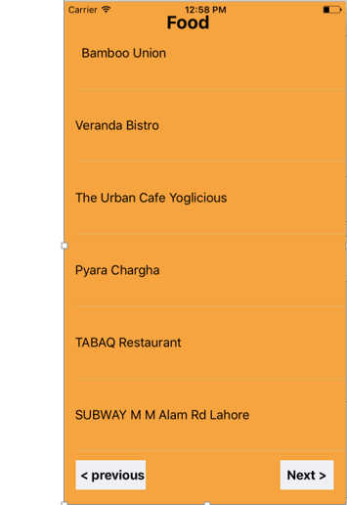
Figure 5: Place

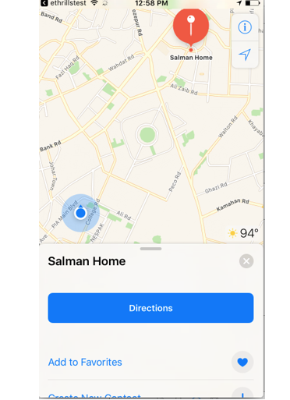
Figure 6: MAPS

System Design

System Architecture Diagram
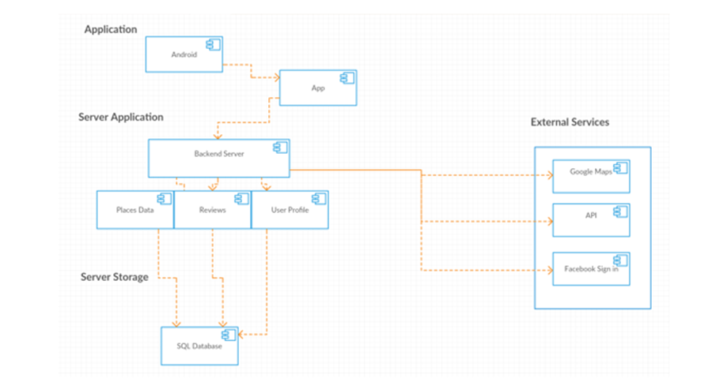
Figure 7: System Architecture

Class Diagram

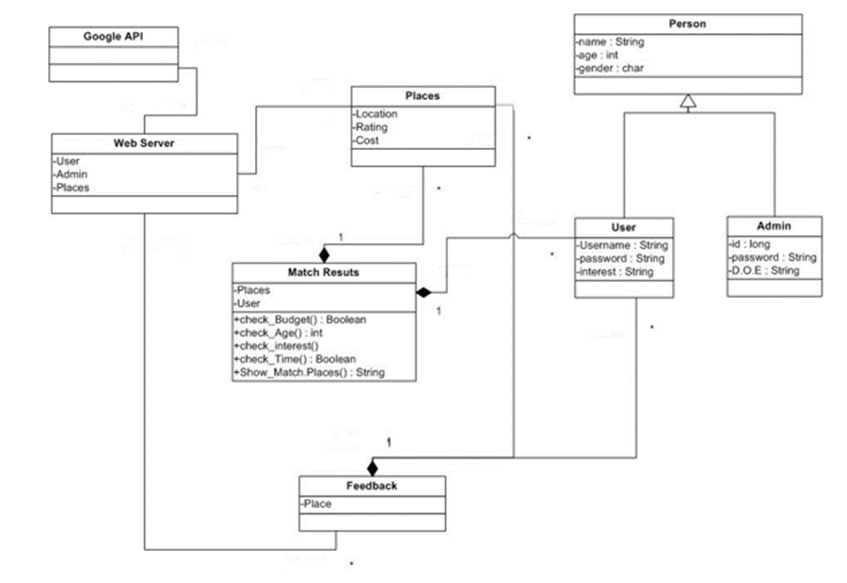
Figure 8: Class Diagram

Sequence Diagrams

Signup:

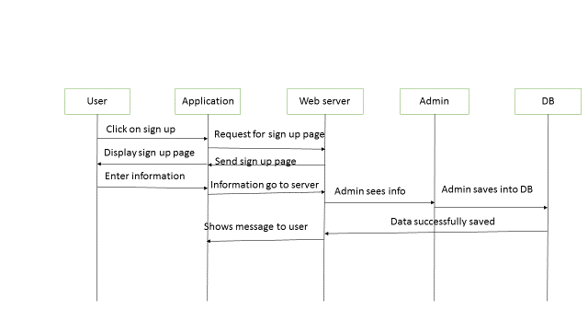
Figure 9: Sequence Diagram (Sign Up)

Budget:

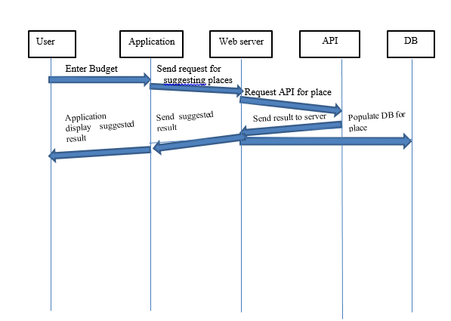
Figure 10: Sequence Diagram (Budget)

Feedback:

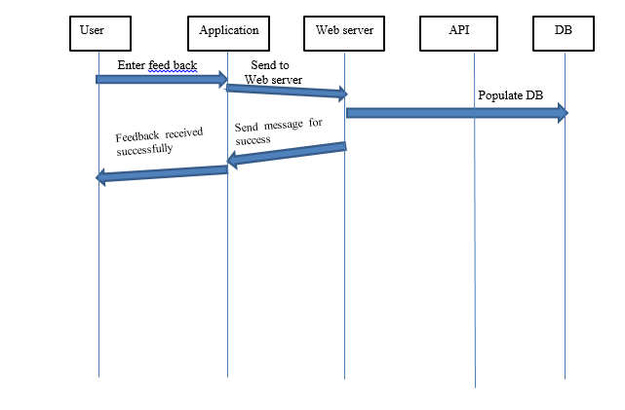
Figure 11: Sequence Diagram (Feedback)

Collaboration Diagrams

SEARCH PLACE:

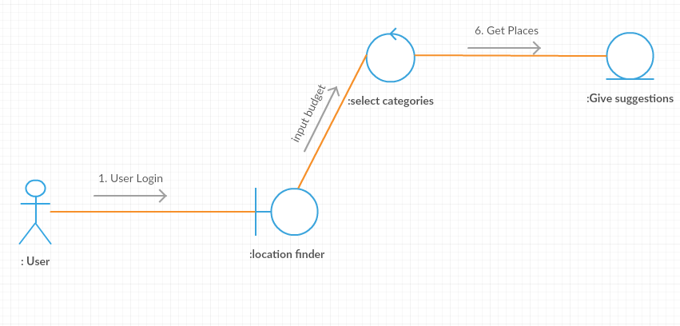
Figure 12: Collaboration Diagram (Search Place)

REVIEW:

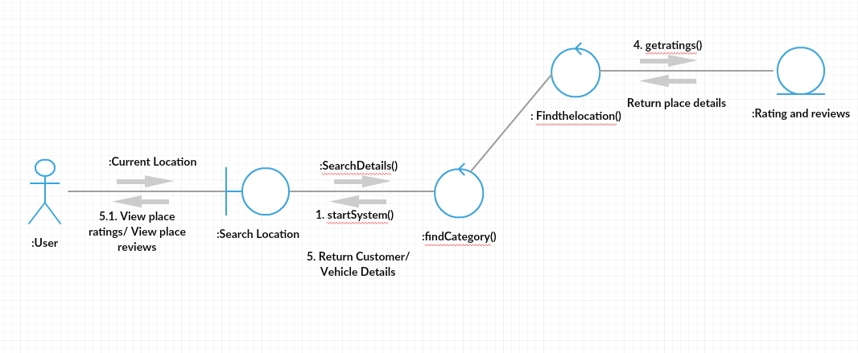
Figure 13: Collaboration Diagram (Review)

ERD

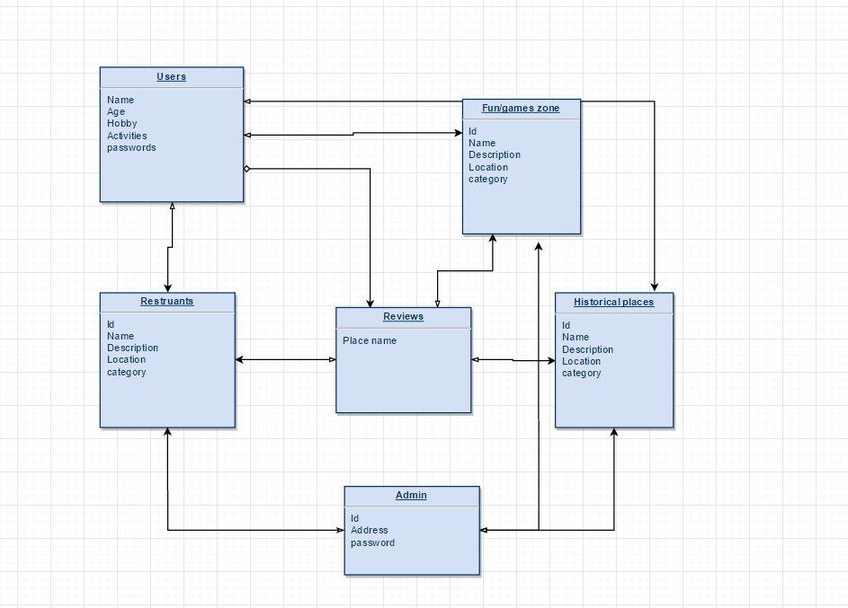
Figure 14: ERD

Data Dictionary

Element Name | Type | Validation | Mandatory | Remarks
Login through Facebook | Login | Validation through Facebook | This option will help new users to avoid filling the form and they can use our application through there Facebook account.
Screen1 | Login | Validation through Instagram | This option will help new users to avoid filling the form and they can use our application through there Instagram account.
Screen2 | Location | The location will automatically be calculated and can also be changed by the users. | This option will help us get the initial location of the user and user will also know where he at the current moment
Screen3 | Select category | The option will help the users to select a category also so that the suggestions will be more accurate. | User can also leave the boxes unchecked and the results will include all the categories.
Table 13: Data Dictionary

ImplementatiOn details

Development Setup
- Android Studio
- Jdk 8
- Adobe Photoshop

Deployment setup
Our web based is hosted on wowdukan

http://wowdukan.com/ethrills/ethrills/rest.php?action=getPlaces&categoryId=1

In future Our app will be deployed on Play Store.

The main problem occurs in the development of this project is automated data gathering for all the areas of Lahore.

Algorithms
Volley Code to get data: -
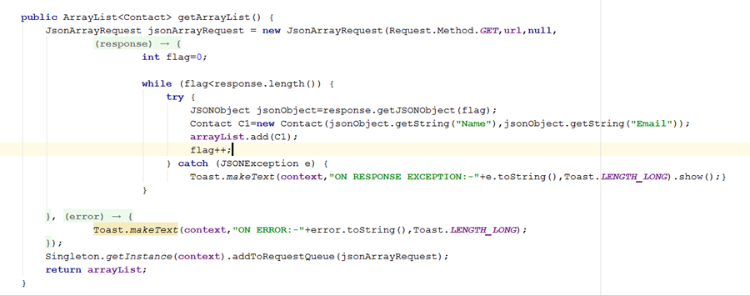
FB login: -

F.B button for layout

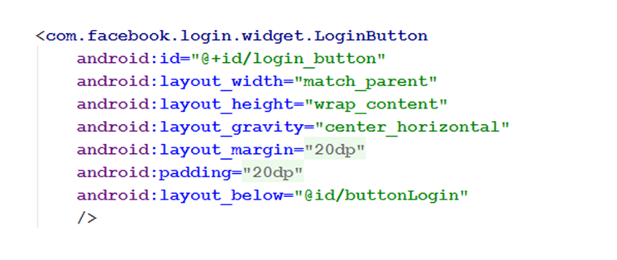
Login code (login using a PHP script)
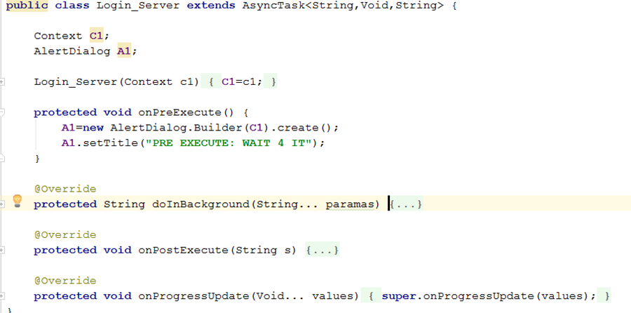

Constraints

Assumptions
- Application required GPS enabled in the mobile phone

System constraints
The mobile must be connected to Internet
Informative data must me communicated with the server side

Restrictions
The system works only in the areas of Lahore for navigating the places.

Limitations
This system cannot work globally it is just for Lahore, Pakistan
The app must require Internet connection.
The online server currently has a limitation of 20GB bandwidth per month, which can be used for uploading and downloading.

System constraints
The mobile must be connected to Internet
Informative data must me communicated with the server side

Testing

Extended Test Cases

Test case id: 1 |  |  |  | Test Design by Hafiz Muhammad Kashif
Test case name: Facebook login |  |  |  | Test design date : 21/05/2017
Test priority: High |  |  |  | Test executed by: Taha Ali Irfan
Test title: To use Facebook button |  |  |  | Test executed date : 21/5/2017
Description: To test the Facebook login button
Dependencies: The user open our E-thrills app connected to the internet connect with facbook button are display on the screen
Step | Test Step | Test data | Expected Result |  | actual | Status(pass/fail) | Notes
1 | Navigation to main screen
2 | aCTUAL button | Data capture Facebook app
3 | Click on submit button
4 |  |  | User can make now account on E-thrills |  | The user successfully make account on E-thrills | Pass

Table 14: Test Case (Facebook Login)

Test case id: 2 |  |  |  | Test Design by Hafiz Muhammad Kashif
Test case name: Current Location |  |  |  | Test design date : 21/05/2017
Test priority: high |  |  |  | Test executed by: Taha Ali Irfan
Test title: To use current location button |  |  |  | Test executed date : 21/5/2017
Description: To test the current location button
Dependencies: The user open our E-thrills app connected to the internet connect with current location button are display on the screen
Step | Test Step | Test data | Expected Result |  | actual result | Status (pass/fail) | Notes
1 | Navigation to main screen
2 | Click on current location button | Data capture from GPS Services
3
4 |  |  | The current location of the user display on the screen in a map |  | The user successfully navigate its location in map | Pass

Table 15: Test Case (Current Location)

Test case id: 3 |  |  |  | Test Design by Hafiz Muhammad Kashif
Test case name: Layout handling |  |  |  | Test design date: 21/05/2017
Test priority: high |  |  |  | Test executed by: Taha Ali Irfan
Test title: To check screen adjustment |  |  |  | Test executed date: 21/5/2017
Description: To check screen adjustment with rotation
Dependencies: The user open our E-thrills app connected to the internet connect with Facebook button are display on the screen
Step | Test Step | Test data | Expected Result |  | actual result | Status (pass/fail) | Notes
1 | Navigation to main screen
2 | Rotate phone in any direction | Mobile adjust its display with respect to the screen
3
4 |  |  | Screen adjust its display in any direction |  | The system successfully adjust its screen on any direction | Pass
Table 16: Test Case (Layout Handling)
Test case id: 4 |  |  |  | Test Design by Hafiz Muhammad Kashif
Test case name: Data From Server |  |  |  | Test design date: 21/05/2017
Test priority: high |  |  |  | Test executed by: Taha Ali Irfan
Test title: analyze data from server |  |  |  | Test executed date: 21/5/2017
Description: To test analyze data from server
Dependencies: The user open our E-thrills app connected to the internet connect with view profile button are display on the screen
Step | Test Step | Test data | Expected Result |  | actual result | Status (pass/fail) | Notes
1 | Press view profile button on screen
2 |  | Data match from fb app to e-thrills
3
4 |  |  | Profile information of e-thrills and fb app are same |  | Successfully Profile information of e-thrills and fb app are same | Pass

Table 17: Test Case (Data From Server)
Test case id: 5 |  |  |  | Test Design by Hafiz Muhammad Kashif
Test case name: Rating test |  |  |  | Test design date: 21/05/2017
Test priority: high |  |  |  | Test executed by: Taha Ali Irfan
Test title: Rating review |  |  |  | Test executed date: 21/5/2017
Description: To analyze the rating

Dependencies: The user open our E-thrills app connected to the internet search any place by category the rating popup button display on the screen.
Step | Test Step | Test data | Expected Result |  | actual result | Status (pass/fail) | Notes
1 | Press review button on popup
2 |  | All average rating on specific area are display
3
4 |  |  | The 5 start rating shall be display on the computer screen |  | Successfully the 5 start rating display on the screen | Pass
Table 18: Test Case (Rating Test)
Test case id: 6 |  |  |  | Test Design by Hafiz Muhammad Kashif
Test case name: Category test |  |  |  | Test design date: 21/05/2017
Test priority: high |  |  |  | Test executed by: Taha Ali Irfan
Test title: analyze category selection |  |  |  | Test executed date: 21/5/2017
Description: To analyze the rating category selection

Dependencies: The user open our E-thrills app connected to the internet to explore any budget estimation the category menu display on the screen.
Step | Test Step | Test data | Expected Result |  | actual result | Status (pass/fail) | Notes
1 | All category selected on by one
2 |  | All the search result relevant to the category type
3
4 |  |  | The data according to the category shall be display on the screen |  | Successfully The data according to the category displayed on the screen | Pass
Table 19: Test Case (Category Test)
Test case id: 7 |  |  |  | Test Design by Hafiz Muhammad Kashif
Test case name: Category 2 test |  |  |  | Test design date: 21/05/2017
Test priority: high |  |  |  | Test executed by: Taha Ali Irfan
Test title: analyze category selection |  |  |  | Test executed date: 21/5/2017
Description: To analyze the rating category selection

Dependencies: The user open our E-thrills app connected to the internet to explore any budget estimation the category menu display on the screen..
Step | Test Step | Test data | Expected Result |  | actual result | Status (pass/fail) | Notes
1 | All category selected on by one
2 |  | All the search result relevant to the category type
3
4 |  |  | The data according to the category shall be display on the screen |  | Successfully The data according to the category displayed on the screen | Pass

Table 20: Test Case (Category 2 Test)

Decision Table

Code snippet

static class ViewHolder {
protected ImageView imageView; Code of custom adapter for recycler view: -

public CategoryAdapter(Activity context, ArrayList<Category> list) {
super(context, R.layout.list_item, list);
this.context = context;
this.list = }

protected TextView text;
protected CheckBox checkbox;
}

@Override
public View getView(final int position, View convertView, ViewGroup parent) {
View view = null;
if (convertView == null) {

LayoutInflater inflator = context.getLayoutInflater();
view = inflator.inflate(R.layout.list_item, null);
final ViewHolder viewHolder = new ViewHolder();
viewHolder.imageView = (ImageView) view.findViewById(R.id.image);
viewHolder.text = (TextView) view.findViewById(R.id.categoryNames);
viewHolder.checkbox = (CheckBox) view.findViewById(R.id.checkbox);
viewHolder.checkbox
.setOnCheckedChangeListener(new CompoundButton.OnCheckedChangeListener() {

@Override
public void onCheckedChanged(CompoundButton buttonView,
boolean isChecked) {

Category element = (Category) viewHolder.checkbox
.getTag();
element.setIsChecked(buttonView.isChecked());
Toast.makeText(getContext(),"selected "+element.getIsChecked()+" "+element.getCategoryName(),Toast.LENGTH_SHORT).show();

if (isChecked) {

String a = element.getCategoryName();
//selectedStrings.add(element.getCategoryName());

if(!selectedStrings.contains(a))
{
selectedStrings.add(element.getCategoryName());
}

Log.v("isChecked "+"index ",position+ element.getCategoryName());

}else{

String a = element.getCategoryName();
if(selectedStrings.contains(a))
{
selectedStrings.remove(a);
}
}

}

});

view.setTag(viewHolder);
viewHolder.checkbox.setTag(list.get(position));

} else {
view = convertView;
((ViewHolder) view.getTag()).checkbox.setTag(list.get(position));

}
ViewHolder holder = (ViewHolder) view.getTag();
holder.imageView.setImageResource(list.get(position).getImageResourceId());
holder.text.setText(list.get(position).getCategoryName());
holder.checkbox.setChecked(list.get(position).getIsChecked());
//Toast.makeText(getContext(),"unselected",Toast.LENGTH_SHORT).show();

getSelectedString();
return view;
}

Volley Code for receiving data in the form of JSON

public class ResultJson extends AppCompatActivity {
final private List<places> placesList = new ArrayList<>();
List<places> gamesList;
// List<places> lv;
// private List<Movie> movieList = new ArrayList<>();
// String uri = "http://192.168.10.6/games_information/showallgames.php";

String uri = "";
String url = "";
private RecyclerView recyclerView;
private RecyclerView.Adapter mAdapter;
private RecyclerView.LayoutManager mLayoutManager;
private Toolbar mToolbar;
private String categoryId="";
ProgressBar pb;
TextView network_available_textview;
SwipeRefreshLayout mSwipeRefreshLayout;
int count = 0;

//extra code
private List<String> urls;

@Override
protected void onCreate(Bundle savedInstanceState) {
super.onCreate(savedInstanceState);
setContentView(R.layout.activity_jsonresult);
mToolbar = (Toolbar) findViewById(R.id.toolbar);
setSupportActionBar(mToolbar);
getSupportActionBar().setDisplayShowHomeEnabled(true);
network_available_textview = (TextView)findViewById(R.id.network_available_TextView);

mSwipeRefreshLayout = (SwipeRefreshLayout) findViewById(R.id.activity_main_swipe_refresh_layout);

pb =(ProgressBar)findViewById(R.id.progressbar);
pb.setVisibility(View.VISIBLE);

recyclerView = (RecyclerView) findViewById(R.id.my_recycler_view);

recyclerView.setHasFixedSize(true);
// use a linear layout manager
mLayoutManager = new LinearLayoutManager(this);
recyclerView.setLayoutManager(mLayoutManager);

//mAdapter = new MoviesAdapter(movieList);
mAdapter = new MoviesAdapter(this, placesList);

//recyclerView.setHasFixedSize(true);
RecyclerView.LayoutManager mLayoutManager = new LinearLayoutManager(getApplicationContext());
recyclerView.setLayoutManager(mLayoutManager);
//Extra line below
recyclerView.addItemDecoration(new DividerItemDecoration(this, LinearLayoutManager.VERTICAL));

//Extra line added below
recyclerView.setItemAnimator(new DefaultItemAnimator());

// recyclerView.setAdapter(mAdapter);
//preparePlaceData();

// Bundle extrass = getIntent().getExtras();
//if (extrass != null) {
// categoryId = extrass.getString("category");}

ArrayList<String> resultList = new ArrayList<String>();
Intent receivingIntent = getIntent();
resultList = receivingIntent.getStringArrayListExtra("category selection")
///////////////////////////////////////////
//Setting below empty adapter when there is no internet connectin available so that swipe-
//refresh is available and we are able to refresh the list
//once the internet connection is available it will execute the onRefresh() method and display result if we got something
//I create a EmptyAdapter class to handle this scenerio. Because swipe refresh will not work
//if the list is empty
EmptyAdapter adapter = new EmptyAdapter();
recyclerView.setAdapter(adapter);
/////////////////////////////////////////////

final ArrayList<String> finalResultList = resultList;
mSwipeRefreshLayout.setOnRefreshListener(new SwipeRefreshLayout.OnRefreshListener() {

@Override
public void onRefresh() {
network_available_textview.setText("..........");

if(isNetworkAvailable()==true) {

count = 0;
network_available_textview.setText("");

if (finalResultList.contains("Food")) {
uri = "http://wowdukan.com/ethrills/ethrills/rest.php?action=getPlaces&categoryId=1";
requestData(uri);
} else if (finalResultList.contains("Cinema")) {
uri = "http://wowdukan.com/ethrills/ethrills/rest.php?action=getPlaces&categoryId=2";
requestData(uri);
} else if (finalResultList.contains("Sports")) {
uri = "http://wowdukan.com/ethrills/ethrills/rest.php?action=getPlaces&categoryId=3";
requestData(uri);
} else if (finalResultList.contains("Historical Places")) {
uri = "http://wowdukan.com/ethrills/ethrills/rest.php?action=getPlaces&categoryId=4";
requestData(uri);
} else if (finalResultList.contains("Parks")) {
uri = "http://wowdukan.com/ethrills/ethrills/rest.php?action=getPlaces&categoryId=5";
requestData(uri);
} else if (finalResultList.contains("Markets")) {
uri = "http://wowdukan.com/ethrills/ethrills/rest.php?action=getPlaces&categoryId=6";
requestData(uri);

} else if (finalResultList.size() == 0) {
Toast.makeText(ResultJson.this, "Error : Nothing to show", Toast.LENGTH_LONG).show();
}
}
else if(isNetworkAvailable()==false){

count = count +1;

pb.setVisibility(View.GONE);
network_available_textview.setText("No Internet Connection....");
if(count >= 3)
{
if(count == 3) {
Vibrator v = (Vibrator) getSystemService(Context.VIBRATOR_SERVICE);
// Vibrate for 500 milliseconds
v.vibrate(500);
}
network_available_textview.setText("Please check your Internet Connection...");
}

}
mSwipeRefreshLayout.setRefreshing(false);

}
});

if(isNetworkAvailable()==true) {

if (resultList.contains("Food")) {
uri = "http://wowdukan.com/ethrills/ethrills/rest.php?action=getPlaces&categoryId=1";
requestData(uri);
} else if (resultList.contains("Cinema")) {
uri = "http://wowdukan.com/ethrills/ethrills/rest.php?action=getPlaces&categoryId=2";
requestData(uri);
} else if (resultList.contains("Sports")) {
uri = "http://wowdukan.com/ethrills/ethrills/rest.php?action=getPlaces&categoryId=3";
requestData(uri);
} else if (resultList.contains("Historical Places")) {
uri = "http://wowdukan.com/ethrills/ethrills/rest.php?action=getPlaces&categoryId=4";
requestData(uri);
} else if (resultList.contains("Parks")) {
uri = "http://wowdukan.com/ethrills/ethrills/rest.php?action=getPlaces&categoryId=5";
requestData(uri);
} else if (resultList.contains("Markets")) {
uri = "http://wowdukan.com/ethrills/ethrills/rest.php?action=getPlaces&categoryId=6";
requestData(uri);

} else if (resultList.size() == 0) {
Toast.makeText(ResultJson.this, "Error : Nothing to show", Toast.LENGTH_LONG).show();
}
}
else if(isNetworkAvailable()==false){

pb.setVisibility(View.GONE);
network_available_textview.setText("No Internet Connection....");
}
ItemTouchHelper.SimpleCallback simpleItemTouchCallback =
new ItemTouchHelper.SimpleCallback(0, ItemTouchHelper.LEFT | ItemTouchHelper.RIGHT) {
@Override
public boolean onMove(RecyclerView recyclerView, RecyclerView.ViewHolder viewHolder, RecyclerView.ViewHolder
target) {
return false;
}
@Override
public void onSwiped(RecyclerView.ViewHolder viewHolder, int swipeDir) {
input.remove(viewHolder.getAdapterPosition());
mAdapter.notifyItemRemoved(viewHolder.getAdapterPosition());
}
};
ItemTouchHelper itemTouchHelper = new ItemTouchHelper(simpleItemTouchCallback);
itemTouchHelper.attachToRecyclerView(recyclerView);
MediaPlayer mp = MediaPlayer.create(this, yourSoundFile);
mp.start();
*/
private void addUrls() {
urls = new ArrayList<String> ();
// add your urls here
urls.add("http://wowdukan.com/ethrills/ethrills/rest.php?action=getPlaces&categoryId=1");
urls.add("http://wowdukan.com/ethrills/ethrills/rest.php?action=getPlaces&categoryId=2");
urls.add("http://wowdukan.com/ethrills/ethrills/rest.php?action=getPlaces&categoryId=3");
urls.add("http://wowdukan.com/ethrills/ethrills/rest.php?action=getPlaces&categoryId=4");
urls.add("http://wowdukan.com/ethrills/ethrills/rest.php?action=getPlaces&categoryId=5");
urls.add("http://wowdukan.com/ethrills/ethrills/rest.php?action=getPlaces&categoryId=6");}

private boolean isNetworkAvailable() {
ConnectivityManager connectivityManager
= (ConnectivityManager) getSystemService(Context.CONNECTIVITY_SERVICE);
NetworkInfo activeNetworkInfo = connectivityManager.getActiveNetworkInfo();
return activeNetworkInfo != null && activeNetworkInfo.isConnected();
}

//Extra code
final public void requestData(final String uri) {

//Progress bar visibility visible
pb.setVisibility(View.VISIBLE);

StringRequest request = new StringRequest(uri,

new Response.Listener<String>() {

@Override
public void onResponse(String response) {
//Progree bar visibility gone
pb.setVisibility(View.GONE);
gamesList = DataJSONParser.parseData(response);
if(gamesList !=null) {
MoviesAdapter adapter = new MoviesAdapter(ResultJson.this, gamesList);
recyclerView.setAdapter(adapter);
}
else
{
network_available_textview.setText("Refresh or check network....");
Toast.makeText(ResultJson.this, "Error : Nothing to show", Toast.LENGTH_LONG).show();
} }
},

new Response.ErrorListener() {
@Override
public void onErrorResponse(VolleyError error) {

Toast.makeText(ResultJson.this, error.getMessage().toString(), Toast.LENGTH_SHORT).show();
}
});
RequestQueue queue = Volley.newRequestQueue(this);
queue.add(request);
}
@Override
public boolean onCreateOptionsMenu(Menu menu) {
// Inflate the menu; this adds items to the action bar if it is present.
getMenuInflater().inflate(R.menu.menu_main, menu);
return true;
}

@Override
public boolean onOptionsItemSelected(MenuItem item) {
// Handle action bar item clicks here. The action bar will
// automatically handle clicks on the Home/Up button, so long
// as you specify a parent activity in AndroidManifest.xml.
int id = item.getItemId();

//noinspection SimplifiableIfStatement
if (id == R.id.action_settings) {
return true;
}

return super.onOptionsItemSelected(item);
}

mAdapter.notifyDataSetChanged();
}

Traceability Matrix

RID vs UCID (requirements vs use cases)
UCID/RID | R  1 | R  2 | R  3 | R  4 | R  5 | R  6 | R  7 | R  8 | R  9 | R  10 | R  11
UC 1
UC 2
UC 3
UC 4
UC 5
Table 21: RID v/s UCID

6.3.2 PROTOTYPES: (RID. v/s PID.):
UCID/RID | R  1 | R  2 | R  3 | R  4 | R  5 | R  6 | R  7 | R  8 | R  9 | R  10 | R  11
P 1
P 2
P 3
P 4
P 5
P 6
Table 22:RID v/s PID

6.3.3 Test Cases: (RID. v/s TID.):
UCID/RID | R  1 | R  2 | R  3 | R  4 | R  5 | R  6 | R  7 | R  8 | R  9 | R  10 | R  11
TC 1
TC 2
TC 3
TC 4
TC 5
TC 6
TC 7
Table 23:RID v/s TID

6.3.4 COVERAGE: (UCID. v/s TID.):
UCID/RID | R  1 | R  2 | R  3 | R  4 | R  5 | R  6 | R  7 | R  8 | R  9 | R  10 | R  11
UC 1
UC 2
UC 3
UC 4
UC 5

Table 24: UCID v/s TID

Results/Output/Statistics

%Completion
Using the matrix of requirements v/s use case (Table 28), 90% requirements are being fulfilled.

%Accuracy
Using the matrix of requirements v/s test cases (Table 30), 80% requirements have been implemented correctly.

%Correctness

By using the matrix of use cases v/s test cases (Table 31), 80% of all requirements have been tested to be confirming to requirements

Conclusion

This Final Year project which is carried out through two semesters needed a lot of researches and learning on different technologies used to produce the applications. The main idea behind the application is that this app will somehow help our user to discover changes around them in a far different way. It will work as a guide to those who are interested in discovering new places. Any Person visiting to new city is usually not familiar with the expenditure and the place around to visit. To help the new fellows we designed a product with multiple features.
Some main features we are worked on are discussed under:
The budget estimator, the user will be asked to enter the budget and the application will suggest the affordable places to visit.
The time estimator the user will be able to enter his visit time in city and the application will calculate his current location and then suggest him/her the nearby places, he or she can visit.
The application will also allow the users to enter both time and budget at the same time and show the result accordingly. In terms of amount like minimum-maximum, a specific amount will not be suitable.
If the place selected by the users have multiple options then the budget output will be shown as a range.
We worked in Android and tried to maintain the standard provided by Google, We used standards that are used in material design
Our application will work on Android based devices while backend database will be managed on the web server.
Backend data base will be updated on regular interval and whenever the application runs, it will be able to use updated data automatically.
Our application will also allow its user to rate and comment about any place they visited.
So, these Main features are covered in the Application to make it perfect guide for new people.

We especially like to thank Mr. Ahtasham Ali who helped us every step of the way to complete this project as an adviser and as a teacher, we would also like to thank Mr. Muhammad Nabeel, Mr. Sajid Mehmood and Mr. Abu Baker.

Future work

In Future work we have many plans to improve our application in many different ways but the top most work to be done is to integrate the application with Live data such as of Google places Live data to estimate the exact time according to traffic conditions between the user and the place he/she wants to visit.

This way the Time estimation factor would become much more accurate because user would know almost the exact time to reach the destination, instead of an assumption of average time required to cover a distance in a city the application would be able to determine the exact time between user and place by noticing the shortest routes and traffic conditions on those routes.
Same way the live data could be used to make the Budget Estimation more accurate by taking the live data from places of their prices. For example if any place starts any sort of offer or discount or may be increase their prices then it would be updated in the application straight away and users would get a more accurate and up to date Estimate which would result in better response and user would start relaying on this application which would make it even a better app.
Furthermore we have a plan to extend or database for review section and allow the users to upload pictures of places and write comments about the places, which is for now rated out of 5 stars.
Allow the user to recommend new places to the other users by putting complete details of a new place into our app, which after observation would be uploaded to our database and would be available in the search or in complete list of places.

10. Bibliography

10.1 Articles:
http://www.theappguruz.com/blog/android-facebook-integration-tutorial

https://www.tutorialspoint.com/android
10.2 Other References
https://developer.android.com/

/

11. Appendix

11.1 Glossary of terms:
API: Application Programing Interface.
JSON: Java Script Object Notation.
FB: Facebook

11.2 Pre-requisites:
- User must have a smart phone with Android.
- Internet connection should be available.
- User should sign up to app.
- GPS connection should be available.
- User should have Android operating system.

