Chapter 1
Introduction

1.1 Background
It might seem a bit farfetched but world’s main focus nowadays is to automate everything. Everything we humans use in our day to day lives we want it all to be done with a press of a button. The world now apparently seem like a labyrinth of complex technological developments but in reality it is all being done in order to create a congenial atmosphere for humans to live in. home automation system is basically controlling the many or all home appliances (lights, air conditioners, electric heaters, hot plates, automatic doors and windows, house security system and etc. etc.) through computer and information technology. The main purpose of home automation system is to minimize human efforts and to provide with a more efficient and reliable way to carry out domestic or work tasks. There exists a wide range to which automation in office or at home can be implemented. It can either be a simple remote controlling system or it can also be a complex computerized micro controller based system.
Envision coming home with arms loaded with groceries and opening the door with a key seems like an arduous task and at that moment one would be wishing for the door to open up automatically. This is a very intelligent utilization of an automated system. Furthermore, visualize have an efficient security alarm system installed in the house which not only aware you when something goes wrong but also identifies the culprit Would give such a relief and
Contrary explanations are some drawbacks of an automation system. People who are not computer-savvy would not buy the computerized system for their homes so therefore price is a chief drawback. It is only affordable by high class society. In addition to that the computerized home systems controlled through internet can be hacked. Also such a system takes a lot of effort and difficulty to be installed and once installed cannot be replaced or upgraded. The parents may be happy to keep an eye on their child but it is the invasion of a child’s privacy which is objectionable in the ethical world. Reputation of automated systems has suffered a lot due to the disadvantages listed earlier and many others. Such disadvantages question the feasibility of the home automation system project and the extent to which it can actually be applied in our homes.
Therefore a way out home automation problems was instantly and intelligently given a thought and as a result of which a feasible, low cost, user friendly and apt automation system was produced by my team. This project will reduce the human effort and raise the standard of living. This project is a very feasible one since our main focus was to keep it low cost. As observed earlier home automation systems have installation issues but this project resolves that problem and can be integrated in already installed electrical systems, giving wireless control over the home appliances. The home appliances and other automated things are controlled by Bluetooth enabled devices such as android mobile phone by making an android app via serial communication with Arduino while the pc acts as a server. The chief motive of this project was to provide with a user friendly environment at homes and offices in one’s electrical system to make it more proficient.

Chapter 2
Literature Review

2.1 Problem Statement
When the question of selecting a project arises, there are several things which came into our minds. Chiefly, what can this prototype be the alternative for? Will it be useful and helpful enough to serve the people in their daily lives? How does it improve the living lifestyle of people? This project will demonstrate a design that will be solving the problem for handicapped people, the elderly and the industries.
This project provides with the trivial idea of home automated system via Bluetooth, internet and GSM module. All these three technologies will be implemented together using Arduino as the microcontroller. Along with automation of appliances using these three technologies this project also provides with an efficient automatic security system which will make the environment safer and reliable which was the main purpose behind this prototype. This design is very practical as the consumer would have a complete control over home appliances as well as the security system of the house on mobile phone and via Bluetooth, internet and also through text messages on the phone. In this particular design the all the house hold devices will be controlled using the microcontroller (Arduino mega). The prototype is designed as such to keep the implementation cost as low as possible and also is designed in a way which can be directly installed without any hassle. This project can also be installed in industries, hospitals etc. it is not only limited for homes.
2.2 Literature review
Advancements in the technological world of are at its peak nowadays. An automated system for homes and offices is one of such developments. It has raised the standard of living also enhanced the conventional. Automated system has familiarized the people with computerized systems thus revolutionized the whole world. The advancements in the technological world has intellectualized the society as the result of which people enjoy a more reliable and economic way of living their lives. On the contrary it has been observed that automation is not only part of the science world but is also gaining popularity in places like schools, hospitals, restaurants, houses and service areas, for convenience. The idea of home automation has grabbed the attention of researchers, General public and the practitioners since they are more oriented towards the implementation of the latest technology.
Furthermore, talking about home automation, it is generally perceived that it was discovered some recent years back but in actuality the home automation started during the World War 1 and progressed by the Second World War. Which was presumably a system to perform routine tasks like closing the doors automatically, switching the home appliances on and off. The research ad developments in home automation did not stop there and as a result of which better advancements have been discovered to enhance the home automation system. With time there is an increase in the number of home appliances therefore the automation system is seen a very useful and vital part of homes to interconnect different home appliances with each other.
Consequently, the home automation system is also termed as the intelligent home as it has the ability to connect the home appliances and to be able to make them operate in any way desired. In regards to the fields responsible for the home automated system, electrical and software engineering plays a vital role. Therefore, it is not surprising that home automation system has acquired popularity in the emerging market. Home automation system can be implemented in many ways, the reason being that a lot of work has been done on it ever since it was discovered. The root cause of home automation system was based on the concept of wireless communication. And over the years new developments in the wireless communication technology have introduced Bluetooth, ZIGBEE, WIFI and GSM modules for the implementation of the home automation system.. The technology most commonly used amongst the above listed is blue tooth. It has the ability of connecting up till 100 meters operating at the speed of 3Mbps.
Moreover, due to such proposals there are innumerous research papers on home automation system. Despite of its usefulness and convenience, many issues create a hindrance in the installation of home systems such as compatibility issues and possible lack of strength. These four modules help resolve the issues enlisted above. The earliest of home automation was done by using remote control or in other words was based on phone. Meaning that phone was used as an input device (remote control).
2.2.1 Bluetooth based H.A.S
The Bluetooth based home automation system was first introduced in the 1990s. Mr. N. Sriskanthan [1] ventured a model for home automation via Bluetooth. Bluetooth technology is used to implement the wireless home automation system. In such a system personal area network is created due to the connection of appliances with each other. The automation via Bluetooth functions as such that the Bluetooth sends the command to the pc, which acts as the server and on receiving the command it switches the particular appliance on or off, whatsoever is required by the user. The advantage of this proposed system was that it allowed the termination and amalgamation of the devices due to which the system became flexible. The sole purpose of this report was to cut down the cost of automated systems. Still, the issues this particular system faced were very significant ones. Namely, it had a limited range, only a limited number of devices could be operated through it. Secondly, the inadequacy in the mobile network supports.
Another such enthusiast, Pradeep G [2] , introduced a home automation system via Bluetooth. This particular design had a great advantage over the model proposed by Sriskanthan’s model in such a way that it had a better time response and conserved the excessive power by using the art to secure the preloading list. It was only after the rapid escalation of the GSM networks which made the execution of Bluetooth based automation systems possible. In contrary to the feasibility of this model as compared to the previous ones, this model has its own setbacks. The major problem in this design unraveled when the users had to memorize the commands, hence it was not user friendly. In fact, many avoided it due to it complicated way of controlling. Another major problem was faced when incase of the failure of GSM network the system was vulnerable to break down.
Taking into consideration the stumbling blocks of the previous designs, R.Piyare [3] advanced a new model of automation via Bluetooth which was not only adaptable but was also economical. The main communication was between the modules of the clients and host server via mobile phone. The execution of this system is mainly for switching on and off of the appliances also this model does not require and internet connection for the efficient working of the system. However, few sensors like light and temperature sensors control the home appliances without the human intervention and this system is deficient in these onboard sensors. Very little wireless communication range is a major drawback of this design.
A very discreet work of Shepherd [4] implied the replacement of the cable by introducing the Bluetooth wireless technology. It could be implemented with the help of radio automation method. But the details and implementations of this proposed system are not present in his thesis.
Later on Wijetunge [5] came up with a Bluetooth based remote controlled system. In his design the devices were controlled and monitored by computer. The control and sensing of the devices took place past the formulated controlling device. This system was a very feasible in such a way that the controlling device had the ability to administer and control the analog devices as well as the digital devices
2.2.2 RF based H.A.S
The monitoring based on RF is in accordance to weather conditions. The controlling unit of such a system consists of different sensors like temperature sensors, humidity sensors and pressure sensors. In RF based H.A.S the centralized control system is done so by the help of a transmitter which is remote control.
The remote-control transmitter causes the transmission of data wirelessly. All the switches can be operated with the help of a remote. This kind of H.A.S is very satisfactory for the elderly people who find it to their inconvenience to go all the way to the switch board to switch on or turn off the lights, fans etc.
2.1.3 GSM based H.A.S
After more development was made in the field of automation a remote monitoring system based on GSM was executed. This very project allowed any number of appliances to be controlled which was looked up upon as a major problem in the earlier designs, however this system is unable to withstand the strong real time applications.
A.Alheraish [6] put forward a home automation system based on GSM. This design introduced a mechanical system operated by a man or an instrument or apparatus via GSM network. RS-233 controller, used chiefly for the transmission of data in many applications, processes the succeeding data through a C++ program containing the relevant code.
Furthermore, Shahriyar, E. Houque [7] proposed a way to control the appliances on the basis of GSM communication. Since GSM works only through the AT commands, the user would have to send the AT commands in order to control the appliances. This particular design has its disadvantage in such a way that it is not user friendly, i.e, the user would have to memorize all the AT commands to control the appliances. This is the era of android phones. Bringing a down fall to the functionality of this system and making it less constructive.
Moreover, a versatile, cost effective automation system executed via cell phone and FPGA controller was proposed by Carl et.al. Utilizing a speedy computation for the engineering of this model also confers the execution of hardware results simultaneously.
In addition to that, a remote determination system was later on introduced based on GSM via text message. Putting this in straight words, the consumer could read the electricity meter readings through a text message. There are no boundaries in the type of the text message. It could be a prepaid or postpaid. This design had an attainable construction as a text message can be executed with perfection.
Neng-Shiang [8] Ling introduced an exclusive home automation system. The main objective of this system was integrated towards solving the issues faced on software levels. It did not encompass the concept of hardware implementations.
2.2.4 Internet based H.A.S
Automation system can be implemented through several technologies for several multi-functional devices. The home appliances are connected to the server through a node. This particular system is secured from the unwanted consumers by the means of SSL algorithm. The internet based home automation system is low cost and a flexible one. Despite the fact that it has resolved some of the major problems for an automated system to be installed in homes, yet there are some constraints in it related to the range of wireless communication and failure of power. This obstacle was realized when tests were carried out in a concrete building which limited the range of wireless communication to less than 100 meters.
Home automation system for electric power (PLC) was established by Zhang [9]. The mechanism of this automation system was as such that it used internet control along with electric wire and logging facilities in order to establish communication. This design was looked upon as an efficient method of home automation since it overcame the flaws of communication methods. However, there was still a need for improvement in this model.
Inauguration of framework of web based electronic device control system was done by Muhammad Izhar Ramli [10]. In this prototype the home appliances could be controlled by a web based controller. This design is not really cost effective or efficient, the reason being that it does not involve the mobile technology in the era where the use of smart phones is increasing with every passing day.
Later on a system which was web based as well a java based was proposed by Al-Rousan and Al-Ali [11]. In this system a well-defined embedded system board is connected to a server which is PC based. The major setback in this design is that the PC ought to be on at all times and needs to be connected with the server. Amul Jadhav [12] developed an application in universal XML. This application simply be connected to any mobile devices instead of focusing on a single platform.
Moreover, the control of devices was enabled by a PIC remote controlled device which was proposed by B.Hassan [13]. In this system, the work of remote control was established by a pic microcontroller. This design is not at all a feasible one since it is complex also it does not include the model for wireless communication. One minor advantage of this design is that it presents with a pin check algorithm in order to produce safety against the unapproved users.
2.2.5 ZIGBEE based H.A.S
In idea of ZIGBEE was introduced in some 1990s after the discovery of WIFI and Bluetooth. The need for self -organizing wireless communication system was realized, thus introducing ZIGBEE. Using ZIGBEE will ensure the prevention of extra power usage. Not only that the use of ZIGBEE will increase the operating range too. As mentioned above this module was introduced after Bluetooth and WIFI the reason being that it causes the elimination of all the hurdles faced in the wired home automation system. In addition to, that has a larger operating range than the Bluetooth module and saves the use of excessive power. Despite the fact that zig bee module is compatible with any microcontroller and has its own advantages yet it does not include the control of home appliances neither does it allow the remote controlling which puts a limit for it being the best technology for the home automation system.
As a result of this problem a new technique was devised in which ZIGBEE and GSM was made to operate together and I was observed that the customer could control the monitoring of the home appliances and devices using these two technologies.
Therefore a ZIGBEE based home automation system is initiated which gives customer a remote control to monitor the devices as well as the control to operate WIFI devices. One of the biggest ZIGBEE applications includes remote control for consumer electronics and industrial process monitoring and control.
2.2.6 Android based H.A.S
Home automation system based on the mobiles is a very feasible way to automate the system. It is a lot easier to install and the monitoring of the automated system using this technology is very user friendly and without any technicalities. Similar to this many scientists have proposed the use of representational state transfer (REST), simple object access protocol and also web services.
Android based home automation systems operates in such a way that the user can control the appliances from as far as possible with the help of a message with which will be sent to the computer, demanding to send the signal to the concerned to the microcontroller to function accordingly.
S.V.A Syed Anwarullah [14] introduced an android home automation system which was economical, sound and less vulnerable to errors. This particular system improved the response time and made it more energizing. This was done so by using a single chip microcontroller and blue tooth technology. Blue tooth module has a range of 10m at the frequency of 2.4Hz which is more beneficial in making a more flexible automated system. However, controlling is devices and remote monitoring is not possible in such a system.
Furthermore, another android based home automation system was introduced by Deepali Javale [15]. In this particular automated system there was no connection to the internet, instead all devices were directly connected to the Bluetooth. Taking help of Bluetooth in the connectivity, an android phone was used for the controlling of the devices. This recommended automation also had the same stumbling block as in the system proposed by Syed Anwarullah, that it did not allow the remote monitoring and controlling of the devices. In addition to that, such a system restricted the system’s mobility due to limited range of operation.
After carrying out many researches a mobile based home automation system was introduced with the main objective to overcome the problems faced in the existing designs. It worked in such a way that after receiving the commands from the smart phone the microcontroller would send signals to switch on or off the devices. In case of any abnormal behavior the, a notification would be sent to the user’s phone. It may be a text message or a miss call via Bluetooth technology. Bluetooth has its limitations with respect to the distance which is up to 100m yet it is the cheapest form of technology which can be used. Different types of sensors and microphones are used in this particular system.
As we know that this is the era of modernization and the utilization of smart phones is gaining popularity day by day. The number of people using android based smart phones is increasing rapidly. The use of android phones is so much so that it has become a convention around the world which is why the usage of smart phones have increased to 80%. Its compatibility with other modules has made it easier for smart phones to communicate with other electronic devices. Moreover, it has become a medium of communication between people as well. With the help of smart phones wireless technology is embedded in every phone and thus people now want to control their tasks with smart phones via Bluetooth or internet. As Bluetooth is also used for the implementation of a home automation system we have selected this mode of communication for its ease of interface and area of coverage. Hence forth H.A.S via Bluetooth is very economical. Bluetooth has proved to be cost effective and a flexible technology to be adapted for the implementation of the home automation. Bluetooth technology provides with a communication network for all the appliances. And to connect the appliances together to environmental changes are required.
Keeping all the scenario in it is quite evident that there are many problems faced while coming up with a reliable, cost effective, user friendly and a flexible home automation system. The interfacing and the installation process should be easy too. This can be attained by diagnosing the system thoroughly and see which one of the factors stated above are not in the system. Once the problem is diagnosed take appropriate actions to overcome those problems.

Chapter 3
Concept and Design

3.1 Proposed System
In this particular project, apart from controlling the home appliances the user can also keep a check on the security system of the house. The purpose of this project is to provide with an efficient home automated system with the incorporation of different wireless communication technologies which would help the people of all ages, professions, disabilities to be at ease. In addition to that another important aim of this project was to come up with an automated system which would be cost effective so that it benefits the majority of population world-wide.
The rudimentary concept of this project can be understood by the by idea that it has two modes of operation. One is the manual control, meaning that the appliances, lights etc. can be switched on and off with a button, which is normally the case. The other mode is the controlling of the appliances, lights, and the security system via Bluetooth, GSM module and through internet. The main idea of the project was not just to automate the house but to incorporate the different wireless communication technologies to make the home automation more efficient and advanced. The security system is an extra feature of the project.
The cost of this proposed system is minimized is actually due to the fact that the use of cell phones has become a convention and everyone as it. A cell phone contains Bluetooth and is compatible with the GSM and WIFI module. The presence of these features in a cell phone will only cost the customers the installation expense of the system and they will have an automated system. Henceforth, a low cost, flexible, secure automation system is designed with the addition of extra feature like the addition of automated security system.

Chapter 4
Hardware Implementation

4.1 Hardware for Automation System
4.1.1 Arduino
Arduino is a multiplatform microcontroller based motherboard created on an open source license based manufacturer. It has many makes and models. The most popular ones are the UNO and the MEGA. We have used the MEGA version as it has more than twice the pins as the UNO allowing us to unify our project on a single platform. These are shown below for ease of user reference:
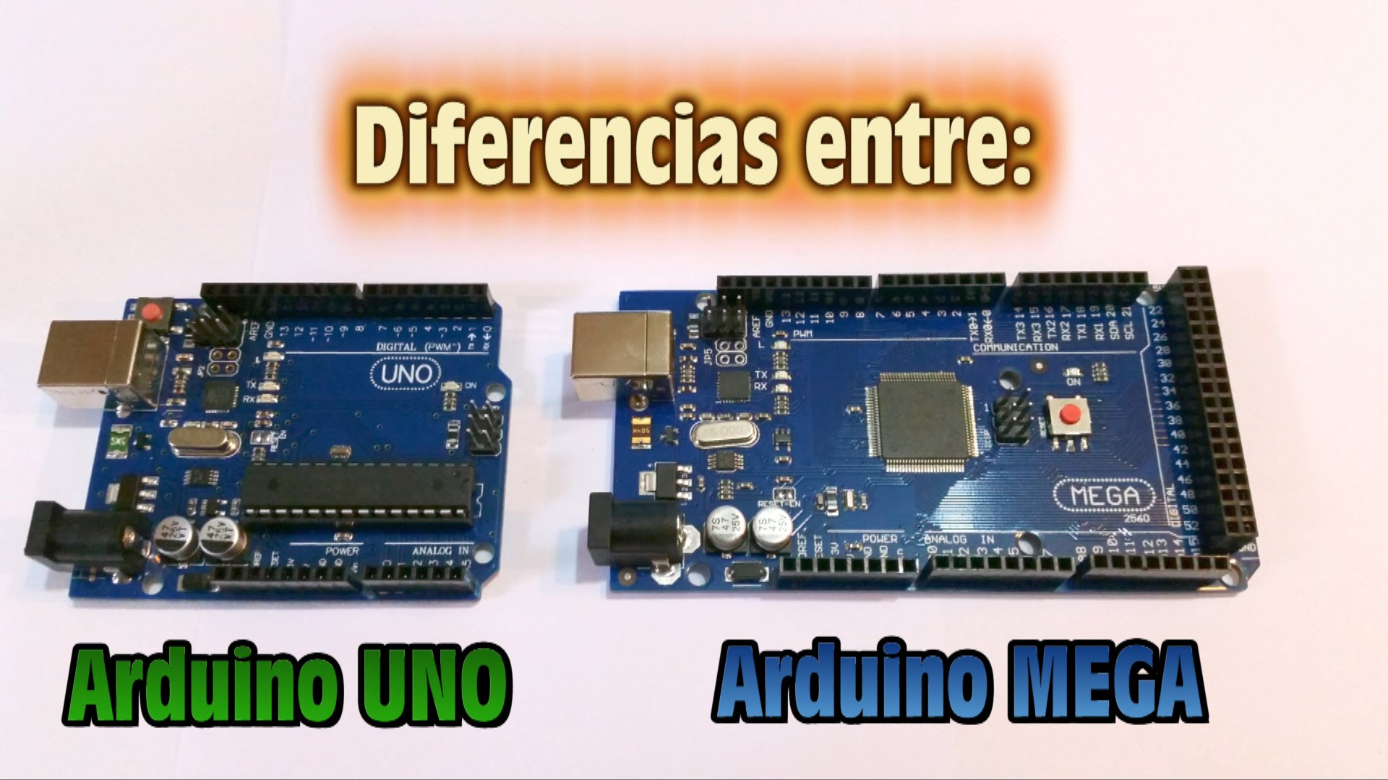
Fig 1(a) Arduino UNO Fig 1(b) Arduino MEGA
Arduino Mega lies at the heart of our project. It is the engine of the whole system. Everything is interfaced with this microcontroller board. It is an upgraded version of the Arduino UNO and Arduino NANO. Its manufacturer is Atmel and their latest chip ATmega1280 is employed on this board giving us boost in performance and a larger platform for this complex project while maintaining the compatibilities older boards had.
It is a high power and low cost solution to day to day solution to microcontroller based projects. It has a powerful 16-Mhz processor equipped with 128-Kb of flash ROM, 8-Kb of SRAM and 4-Kb EEPROM for the boot loader. A Boot loader is the program that runs every time the board is powered on. Boot loader carries specific set of instructions that are responsible for every device that has an operating system including Arduino to run flawlessly every time it is turned on and called upon to provide a computing job, without it no processor or a motherboard can even begin to function properly. This part of the memory is also responsible for enabling the Arduino to receive a new code every time we burn it on the device. It makes sure that each instruction and variables go to the correct compartment for storage and processing on the chip.The Arduino MEGA board is shown below:
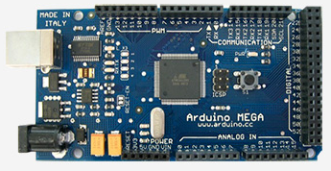
Fig 2 Arduino Mega
It is equipped with 54 digital I/O pins and 16 analogue pins. Interestingly the analogue pins can be made to behave as digital pins as well but the digital pins do not have the same functionality. Although 14 of the digital pins are PWM enabled which can be used as analogue values but only specifically for the purpose of controlling the voltage for conserving energy and high speed switching. PWM stands for Pulse Width Modulation in which the width of the pulse for logic-1 is controlled by controlling the time, for which a pulse stands on Logic-1 by the help of Arduino’s built-in counters and timers. It creates a square wave by means of switching. A typical graph for PWM is shown below:
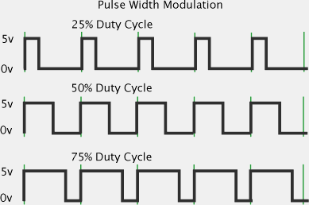
Fig 3 PWM Wave
The processor has 32 registers for quick processing and the processor is of 8-bits. This means that it can take instructions in a packet of 8-bit in each cycle. The 16-Mhz oscillator combined with a 16-Mhz processor enables this device to process information at blazing speeds that is undetectable by human standards. The Arduino is also equipped with 4 serial communication channels which enable us to connect 4 serial devices at the same time to this board. These pins are dedicated for this purpose and so have a low probability of failure in receiving and sending false data. These are digital pins that are hard-wired by the manufacturer to provide this function as well. Nonetheless we can also make as many digital pins to function as serial ports by software methods but that method is not desirable and is prone to failure as the hardware is superior in comparison to forcefully strain a digital pin to do the communication job.
It also has a 16 channeled 10-bit A/D converter. This is an absolute necessity of today since most control systems do not work on discrete states of the system the generation and processing of analogue signals has opened up another door for this device’s application. This feature enables us to process variable values other than discrete digital ON or OFF states of the system. Hence we can send variable signals to the actuators of the system that require variable values. The job of this convertor on the hardware level is to convert a voltage signal received from a sensor to 10-bit digital value that can be processed by the processor since we know that all the data is and should be in binary form that processors work on. Then provide the resulting processed variable to the same built-n D/A converter that transforms that digital value to a respective voltage level that is desirable by the actuator in the field. Controlling the speed of the fan based on the varying temperature of a room is a good example to sum up its need and usage.
A special feature on the board regarding the analogue pins is that we can use the AREF pin to manually provide the reference voltage that we are looking for to be processed. The 10-bit data measures the maximum of 5 volts and counts it as 1023 in digital value perspective. By providing voltage of our choice to that pin we can manually choose the upper limit of this digital value. The reason for that is simple. First at 5 volts we had 4.88 mV per digital value of sensitivity but if that reference voltage was 10 volts then the minimum sensitivity we will be able to get will be 9.77 mV per digital value. This means that until a change in 9.77 mV is not observed by the controller it will not take the next value in digital aspect which is a loss. But since this function is available to the user the user can always decide a trade-off among the two needs
The device achieves a throughput of 16 MIPS (16 million instructions per second) at 16-Mhz which is commendable by its power requirement standards. It can operate on voltages as low as 2.7 volts but should not be given more than 5.5 volts. It has an onboard voltage regulator that user the user a flexible range to apply voltages as high as 12-Volts to the board which will be automatically regulated to 5 volts in favor of the board. But care must be taken that the supply does not inject current more than 200 mA into the device as it is a very low powered device. Any hardware that demands more power should be given an independent supply to that hardware and the signal alone can be taken from the Arduino.
4.1.2 Relay boards
In our project we have to automate the house electrical equipment. These appliances run on high voltages that we receive from WAPDA. Since the Arduino operates on a very low dc voltage we need an intermediate device that enables us to unite these two sides of the project on a single platform while giving us the liberty to control high voltage AC via low voltage DC signals. It is well understood that a relay acts as an intermediate device. The relay board is an active low board, meaning that when a low signal is given to the pins then the relay is turned on. It has minimum three pins for operation. Two are for the supply of DC voltage and one is for controlling the operation of the relay.
A typical relay board available for the Arduino is shown below:

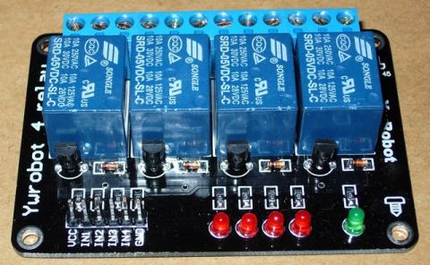
Fig 4 Relay Board
Understanding the operation of the relay that we have used in our project to control the lights and the fans of the house and consequently the heavier loads like the fridge and water motor, we need to look at the internal structure of a simple SPDT relay. SPDT stands for single pole double throw. Meaning it has one common and 2 contacts between which we can choose our needed contact. It has five terminals, two to energize the coil that operates the relay and other three are used to do the switching by a circuit of our choosing. The three terminals are normally closed (NC), normally open (NO) and common (COM). We give the phases to the COM point of the relays and then pick the disconnected circuit from the NO point. That point leads to the appliance we want to control and finally the other end of the appliance is given a neutral from the mains directly.The internal of the relay is shown below:
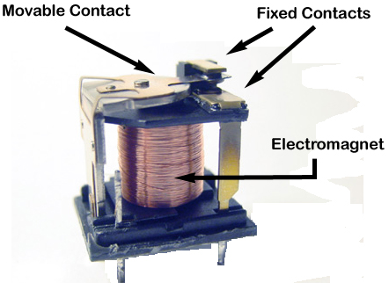
Fig 5 Relay Internal Structure
The armature rests on the NC terminal. As soon as the DC supply is given to energize the electromagnetic coil it pulls the movable contact towards itself and the Com terminals comes in contact with the NO terminal, any circuit connected among these terminals is now completed. If the dc supply to energize the coil is removed at any point the movable contact retracts to its original position.
We can control loads demanding a current of up to 10 amperes by these relays but to maintain safety requirements we will limit these currents to 2-3 Amps max for a long operation of the relay. For higher demanding loads we will use TRIAC based SSR’s. They are known as Solid State Relays. They operate on a very low voltage DC signal and demand an even smaller current than a relay. They can allow a current of up to 50 Amps through them and last longer than a relay since there are no mechanical structures inside the SSR.
4.1.3 Ethernet shield
The Ethernet shield lets us communicate over the internet. It is equipped with an RJ-45 connector female port, which can be connected over any modem or internet protocol. This shield has enabled us to take our project over the internet. The shield has a Wiznet W-5100 chip at the center; it also has an SD-Card module built onto the chip for online data logging.
Wiznet is an international company that provides small chip based internet solutions. It can communicate in both UDP and TCP protocols that are followed these days commonly for online data traffic. TCP stands for Transmission Control Protocol. This protocol ensures that each data packet that is sent from the user to the web server is numbered and in a specific order to make sure that the data is sent and received in the correct order and on top of that they also incorporate error checking mechanisms. All this eventually guarantees complete data transmission but slows down the speed of the communication to overcome this we have UDP. UDP stands for User Datagram Protocol. It is exactly the same as the TCP but it leaves out all the hassle that TCP has to go through of checking the data. It improves the speed greatly as now all the time is spent for transmission of data only but now has a higher probability of having an error in the transmission.The Ethernet shield is shown below:
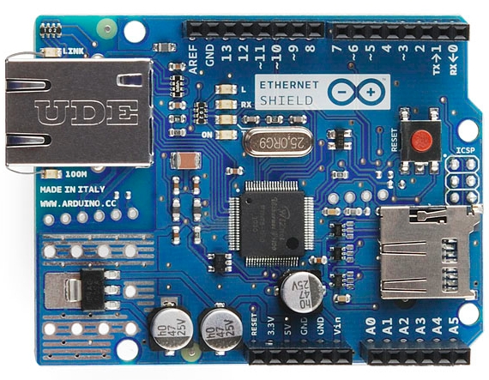
Fig 6 Ethernet Shield
This shield is compatible with all the platforms of Arduino including the UNO and MEGA. It is equipped with an onboard micro SD-card slot that can be accessed through pin-4 of the Arduino. Arduino communicates with the w5100 module and SD card slot through the ISP protocol via the ICSP headers. ISP stands for the Internet Service Provider. It is a company that provides internet facility all over the world. On the MEGA this shield communicates via pins 50, 51, 52 and 53. Pin 53 is not used for the shield but must be kept as an output or the ISP does not work, this is done due to some hardware limitations built in to the Arduino. Pin-10 is used to select the w-5100 module and pin-4 is used to select the SD card module. Hence we cannot use these pins for any other task as it will affect the performance of the system that is connected over the internet.
The shield has some on-board led lights that indicate a specific function for diagnosis by the user. The power led tells us that the board is receiving enough power for operation. TX and RX led’s extensions of the led’s that are on the mega since they are hidden under the shield they needed to be made visible on this shield. FULLD led tells us that the shield is working in full duplex mode. Duplex mode enables the shield to send and receive data at the same time improving performance.
The shield mounts on the Arduino MEGA in a manner depicted in the image below:

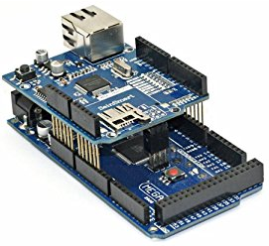
Fig 7 Shield mounted on Arduino Mega
4.1.4 Bluetooth
The Bluetooth module is available in 2 variants known as HC-05 and HC-06. The HC-05 is built to work in master mode and so interfacing it becomes a hardware level problem as it forces itself to be used as a master device while in our application we need a device that prefers to be in slave mode since we will always be sending values via an android phone and no feedback is required in our implementation. Also the HC-06 is designed at industrial grade standards so it can run for a very long time without being damaged at all. A typical HC-06 module is shown below:
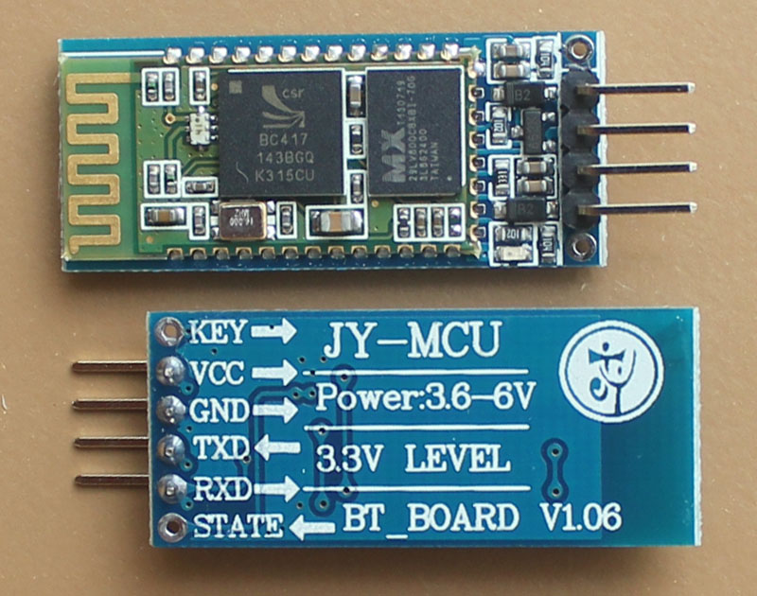
Fig 8 HC-06 Module
It draws very small amount of current, an 8-mA peak demand current. At times of communication ensures that this device is a very low powered solution. The range is very high for this device, we tested it in 5500 square feet of area (1-kanal house) with walls and doors and it worked perfectly there. It communicates over a 2.4 G-Hz frequency channel that does not interfere with the WIFI signals in the house.
The maximum voltage needs are limited to as low as 3.7 volts up to 5.5 volts; such flexible range provides users with ample range to interface this device with variable DC supplies. Care must be taken that the Bluetooth module communicates at logic levels of 3.3 volts. The Arduino on its TX pin sends logic high as 5 volts which can damage this module during communication, so a potential divider circuit is needed before connecting the TX pin from the Arduino to the module.
Since the Bluetooth is a serial communication device we connect it to the Arduino’s dedicated serial communication ports for maximum reliability and dependability. Connect the TX from Arduino to the RX of the module and the RX of the module to the TX of the Arduino. It is needed in such a manner because the TX pins only transmits signals and so it is connected in opposite manners to each module as one receives the signals and the other sends it. Utmost care must be taken as to making these connections as this a very delicate device in respects to the logic levels used for the communication purposes. If mistakenly we use 5 volts logic at the communication terminals then we will eventually burn the module let alone establish any communication.
The device has downloads and upload speeds of up to 2Mbits per second. This is enough in our case as we are only sending very small numbers via Bluetooth from our android device. It consists of a built in antenna which has ample range over the house. It has built-in error checking mechanisms that employ even odd parity checking which can be called upon by the AT commands. AT commands are instructions used to control a modem. AT is the abbreviation of AT-tention. Every command line starts with "AT" or "at". That's why modem commands are called AT commands. The block diagram of the on board chip is as follows:
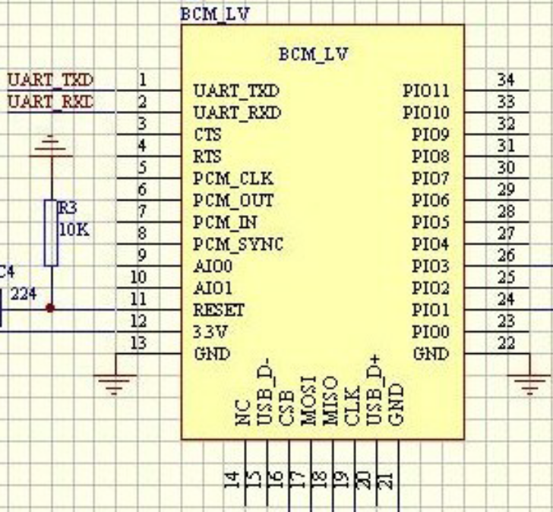
Fig 9 HC-06 Pinout
Each Bluetooth module has a unique MAC address that distinguishes it from all the other devices on the same 2.4 G-Hz channel. Every module first needs to be paired with the phone that we are going to use it with. Once it is successfully paired we can use it in our app as many times as needed. We can connect as many modules as necessary for maximum coverage of the house but each device will be unique on the channel.

4.2 Hardware for Security System
4.2.1 Arduino
Arduino is a multiplatform microcontroller based motherboard created on an open source license based manufacturer. It has many makes and models. The most popular ones are the UNO and the MEGA. We have used the MEGA version as it has more than twice the pins as the UNO allowing us to unify our project on a single platform.
These are shown below for ease of user reference:

Fig 10 (a) Arduino UNO Fig 10(b) Arduino MEGA
Arduino Mega lies at the heart of our project. It is the engine of the whole system. Everything is interfaced with this microcontroller board. It is an upgraded version of the Arduino UNO and Arduino NANO. Its manufacturer is Atmel and their latest chip ATmega1280 is employed on this board giving us boost in performance and a larger platform for this complex project while maintaining the compatibilities older boards had.
It is a high power and low cost solution to day to day solution to microcontroller based projects. It has a powerful 16-Mhz processor equipped with 128-Kb of flash ROM, 8-Kb of SRAM and 4-Kb EEPROM for the boot loader. A Boot loader is the program that runs every time the board is powered on. Boot loader carries specific set of instructions that are responsible for every device that has an operating system including Arduino to run flawlessly every time it is turned on and called upon to provide a computing job, without it no processor or a motherboard can even begin to function properly. This part of the memory is also responsible for enabling the Arduino to receive a new code every time we burn it on the device. It makes sure that each instruction and variables go to the correct compartment for storage and processing on the chip.

The Arduino MEGA board is shown below:
Fig 11 Arduino Mega
It is equipped with 54 digital I/O pins and 16 analogue pins. Interestingly the analogue pins can be made to behave as digital pins as well but the digital pins do not have the same functionality. Although 14 of the digital pins are PWM enabled which can be used as analogue values but only specifically for the purpose of controlling the voltage for conserving energy and high speed switching. PWM stands for Pulse Width Modulation in which the width of the pulse for logic-1 is controlled by controlling the time, for which a pulse stands on Logic-1 by the help of Arduino’s built-in counters and timers. It creates a square wave by means of switching. A typical graph for PWM is shown below:
Fig 12 PWM Wave
The processor has 32 registers for quick processing and the processor is of 8-bits. This means that it can take instructions in a packet of 8-bit in each cycle. The 16-Mhz oscillator combined with a 16-Mhz processor enables this device to process information at blazing speeds that is undetectable by human standards. The Arduino is also equipped with 4 serial communication channels which enable us to connect 4 serial devices at the same time to this board. These pins are dedicated for this purpose and so have a low probability of failure in receiving and sending false data. These are digital pins that are hard-wired by the manufacturer to provide this function as well. Nonetheless we can also make as many digital pins to function as serial ports by software methods but that method is not desirable and is prone to failure as the hardware is superior in comparison to forcefully strain a digital pin to do the communication job.
It also has a 16 channeled 10-bit A/D converter. This is an absolute necessity of today since most control systems do not work on discrete states of the system the generation and processing of analogue signals has opened up another door for this device’s application. This feature enables us to process variable values other than discrete digital ON or OFF states of the system. Hence we can send variable signals to the actuators of the system that require variable values. The job of this convertor on the hardware level is to convert a voltage signal received from a sensor to 10-bit digital value that can be processed by the processor since we know that all the data is and should be in binary form that processors work on. Then provide the resulting processed variable to the same built-n D/A converter that transforms that digital value to a respective voltage level that is desirable by the actuator in the field. Controlling the speed of the fan based on the varying temperature of a room is a good example to sum up its need and usage.
A special feature on the board regarding the analogue pins is that we can use the AREF pin to manually provide the reference voltage that we are looking for to be processed. The 10-bit data measures the maximum of 5 volts and counts it as 1023 in digital value perspective. By providing voltage of our choice to that pin we can manually choose the upper limit of this digital value. The reason for that is simple. First at 5 volts we had 4.88 mV per digital value of sensitivity but if that reference voltage was 10 volts then the minimum sensitivity we will be able to get will be 9.77 mV per digital value. This means that until a change in 9.77 mV is not observed by the controller it will not take the next value in digital aspect which is a loss. But since this function is available to the user the user can always decide a trade-off among the two needs
The device achieves a throughput of 16 MIPS (16 million instructions per second) at 16-Mhz which is commendable by its power requirement standards. It can operate on voltages as low as 2.7 volts but should not be given more than 5.5 volts. It has an onboard voltage regulator that user the user a flexible range to apply voltages as high as 12-Volts to the board which will be automatically regulated to 5 volts in favor of the board. But care must be taken that the supply does not inject current more than 200 mA into the device as it is a very low powered device. Any hardware that demands more power should be given an independent supply to that hardware and the signal alone can be taken from the Arduino.
4.2.2 PIR Sensors
Passive infrared sensors are designed to detect human motion only. These sensors employ the basic body radiations emitted from the surface of every object known to man. The sensors that we are using are specifically tuned for detecting human motion. It has two modes of operation. Both of these modes are hardwired onto the sensor for the sole choice being left to the user to choose from them. One is called the H mode and the other is called the L mode.
These modes are visible to the naked eye as jumper settings found at the back of these sensors .In H mode the sensor continuously sends Logic 1 to the microcontroller for further processing for the time there is motion in the field of view of the sensor. It means as long as the there is motion in front of the sensor the sensor will send Logic 1 to the microcontroller. In L mode the sensor only sends in a pulse of certain time duration to the microcontroller if the motion is detected. This pulse time can be adjusted by the user by a small potentiometer soldered on the PCB of the sensor motherboard. The smallest setting on the senor for this pulse time is of 10 seconds and the largest possible time for the pulse is around 250 seconds. But here in our system considering the practical implementation and to simplify the coding we have chosen the H mode. Below is a close up of the sensing element:
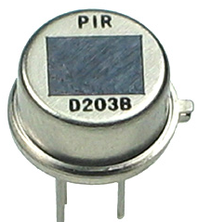
Fig 13 PIR Crystal
The second hardwired setting on the sensor is its sensitivity to the detection of motion. It determines the tolerance for the sensor as to how much motion should be made in order for the sensor to consider it a change in the environment. For maximum security and to prevent false alarms we have set that knob to the middle position. This position was selected after many hardware testing and trials until a suitable trade-off was made among the sensitivity and response time.

The 2 knobs at the center are in the diagram below:
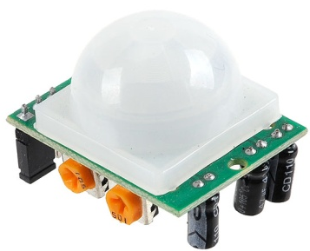
Fig 14 PIR Sensor
Strategic placement of this sensor in the house is very necessary as the sensor is sensitive to body radiations although the sensor is designed to neglect radiations from pets but to ensure maximum resistance to a false alarm we will place it in such a way that there is minimum reflection form the floor of the house. Due to its hardware construction there are limitations of this sensor regaining its operational condition almost immediately after the first detection. It takes almost 10 seconds after the first detection to come back online so that it can give the next detection to the microcontroller. Basically after the first time it has detected a human and if the human moves away from the premises within the range of the sensor then it will take almost 10 seconds or more for the sensor to reset. The reason is hidden in its hardware construction. There are 2 balanced sensing elements one is high edge triggered and the other is low edge triggered. Outputs from these two elements are being constantly monitored by a transistor circuit built onto the chip and sensing element.
Transistor is used to provide high impedance among these two sensors to nullify the loading effect for the sensing IC soldered on the PCB of the sensor. The onboard circuit near the sensing elements is shown below:
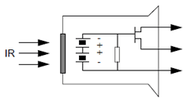
Fig 15 PIR Sensor Schematic
The sensing element does not have enough range in respect to the stereoscopic vision humans have. But it is achievable by a special lens known as the Fresnel lens as shown below. This lens basically scatters the light coming from the surroundings and spreads them evenly over the surface of the sensing element. Removing the lens will only effect the three dimensional stereoscopic range. For maximum interference on the sensing element’s surface and maximum security we have kept that lens a part of the sensor as it comes as a standard accessory with the sensor.
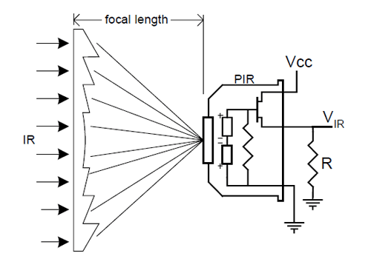
Fig 16
4.2.3 LCD Display
The LCD used in our project is 16x2 (16 cross 2) meaning 16 columns and 2 rows. Hence we can display a total of 32 characters in 2 rows, 16 in each row on the screen .Each LCD’s small pixel is made up of 8 columns by 5 columns fine pixels. Each data is sent as a character to the LCD. We cannot send integer, float and double type data directly to the LCD because the LCD is designed to handle character type data only. The LCD module has onboard RAM and ROM for processing the characters that have been received on the data pins of the LCD. It has onboard IC’s that convert characters to ASCII characters and then store in the onboard RAM and ROM for further processing for the successful display on the LCD. The method employed to display certain letters and words both capital and small is that they are sent as a character array from the microcontroller via its data pins to the LCD. This is done by using a simple for loop in the code that controls the index of the array in the microcontroller and for the LCD it controls the position of the cursor as to where will the next character will be displayed. A typical 16x2 Green LCD is shown below:

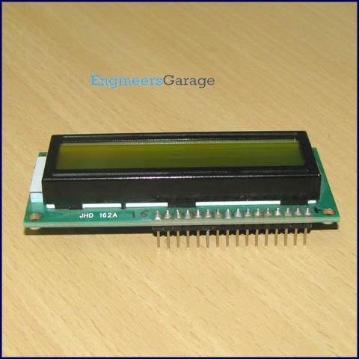
Fig 17
Data is sent to the LCD in 4-bit mode as we have to maintain high efficiency of the circuit by using as little pins as possible leaving room for other equipment to be interfaced with the microcontroller. It can also work in 8-bit mode but that is only needed for high speed operation which in our case is not needed. We have been able to achieve sufficient speed in displaying characters through 4-Bit mode.
In 4-Bit mode the data is still of 8-bits sent from the microcontroller but now it is sent in 2 nibbles form (4-Bits in each pulse). First the MSB nibble packet is transferred and then the last packet of 4-Bits, this method is called Big Endian format. In Big Endian format the MSB’s of the data are sent first, followed by LSB’s. This method is employed in today’s computers and smart phones while the operating system manages the RAM for processing by storing temporary application data by this method. Same principal is built-in here. The requirements of data pins are only 4 so our microcontroller has more free pins that can be used to interface other equipment with it. The reason this LCD was chosen is its cost, ease of use and availability. Also it has a high tolerance to experimentation; this LCD does not get damaged by vigorous and rough use so anyone can interface it with a microcontroller of his/her choice. The pin configuration of the LCD has been given below:

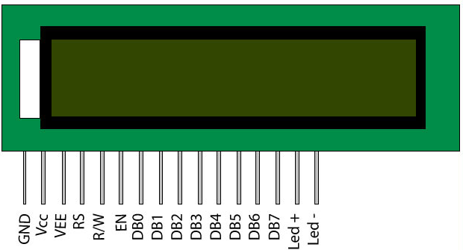
Fig 18 LCD Pinout

Table 1
Pin Description
Pin No | Function | Name
1 | Ground (0V) | Ground
2 | Supply voltage; 5V (4.7V – 5.3V) | Vcc
3 | Contrast adjustment is done through a variable resistor | V_{EE}
4 | Selects command register when low  and Data register when high | Register Select
5 | Low to write to the register  High to read from the register | Read/write
6 | Sends data to data pins when a high to low pulse is given | Enable
7 | In 8-Bit data mode all data pins are used  In 4-Bit data mode only pin 4 to 7 are used | DB0
8 |  | DB1
9 |  | DB2
10 |  | DB3
11 |  | DB4
12 |  | DB5
13 |  | DB6
14 |  | DB7
15 | Backlight V_{CC} (5V) | Led+
16 | Backlight Ground (0V) | Led-

The most interesting point of this LCD is that it can also be interfaced with analogue pins on our microcontroller and not just the digital pins. Connect the data pins to the analogue pins and we have a running set-up to display characters on the LCD. The contrast is adjustable on the LCD. It has been done by using a potentiometer by connecting its one pin with the V(ee) of the LCD pin (pin-3) and the center pin of the potentiometer to the Ground pin of the whole setup which in our case is the Arduino. Now you can move the potentiometer and see its effect on the LCD’s on-screen displayed characters. It becomes useful for the end user as its control will be given to them so that they can adjust the brightness of the screen or incase where the battery is low then the characters start to disappear from the screen so this arrangement becomes an absolute necessity for long-time operation.

4.2.4 Keypad
The keypad is an absolute necessity in our project since we are providing the built-in security system for the house. The keypad is nothing more than switches connected in a matrix form to minimize pin usage, there are 12 different digits on our keypad and normally if we place 12 switches we need 12 digital pins to interface them but we have used a built-in library for the Arduino for the keypad and it enables us to interface Arduino with only just 7 pins thus decreasing the number of total pins needed to interface a keypad. A general keypad that is available in the market is shown below:
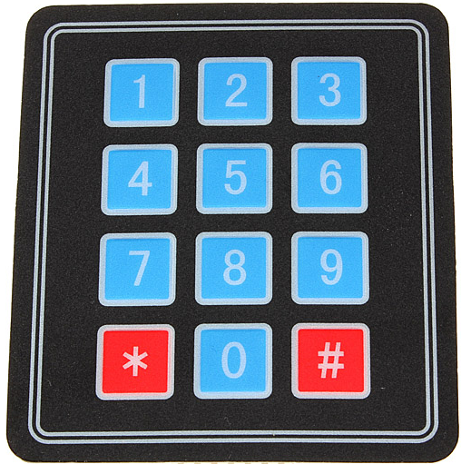
Fig 19 Keypad
The keypad is arranged in a matrix form that has 4 rows and 3 columns. When a button is pressed by the user it makes contact between one row and a column. Signaling the Arduino a short circuit among the two digital pins it is connected in. Each button when pressed exhibits around 50 ohms of electrical resistance to the circuit, and since this keypad receives logic 1 on its rows the circuit gets completed when the button is pressed and according to simple electrical principals the current passes through the circuit of minimum resistance and in our case the pathway is formed at the point of contact of the button. Hence the Arduino is signaled that which button is actually pressed. The hardware diagram is as follows:
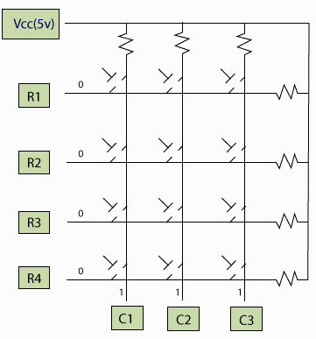
Fig 20 Keypad Layout
We can use the library for the keypad to have it on any pins we want to. It can also be used on the analogue pins as previously mentioned that analogue pins can also be used as digital as well as analogue, hence there is practically no limitation as to which pins should be used for the keypad. Attaching any of the pins to the serial communication ports should be avoided as they are used to program the Arduino and in case of any serial device connected to the board it will interfere with the operation of that device. Since we are using the Bluetooth module for in house communication and automation we have avoided the connection of the keypad to those pins. If the key map does not press the key that we wanted it to, we can simply change the mapping in the code to our needs.
4.2.5 Servo motor
Servo motor consist of a rotary actuator and in some cases a linear actuator that allows us to precisely control the position of the servo motor. It consists of a suitable geared motor coupled with a potentiometer feedback system that tells the system the position of the servo. It is a very high powered motor and is capable of moving loads up to 12 kilograms, compared to its size it is a very suitable upgrade to our system as the camera will be mounted on it and finally controlled by the user through phone or manually through a remote operated switch.
The servo can be used to rotate at angles ranging from 0 degrees to 180 degrees depending upon the command that has been sent through the Arduino. If the user needs a full 360 degree control then we can mount 2 servo motors on top of one another and get a full 360 degree rotation. A typical RC servo is shown below:
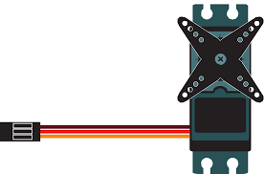
Fig 21 Servo Motor
It has three wires. Two wires are to power up the motor and one wire is used for the purpose of providing the motor with the signal for positioning purposes. Connect the +5 volts from Arduino or from any power source to the servo motors red color coded wire and the ground wire to the brown wire on the servo. The orange wire is the signal wire; this is connected to the servo from the Arduino. Since the library that enables us to use the servo motor uses PWM functionality to operate the servo motor we have used a PWM enabled pin from the Arduino for that purpose. In order to use an external supply for the servo motor over the long distance usage we can use an external 5 volt supply for powering up the motor and ensuring that it can inject the feedback signal through the same electrical wiring back to the Arduino for further processing. These servo motors are very robust and are capable of handling voltages up to 9 volts and move loads up to 12 kg’s which is more than an average weight of the component that can be mounted on top of the servo motor.
4.2.6 Potentiometer
The potentiometer is a simple variable resistor. It is different from a rheostat. The rheostat consists of a conductor coil and a movable contact over the coil by adjusting it over the length of the coil its resistance can be made to vary. While the potentiometer we are using has a carbon coating over which the contact moves via a circular knob. As shown in the image below:
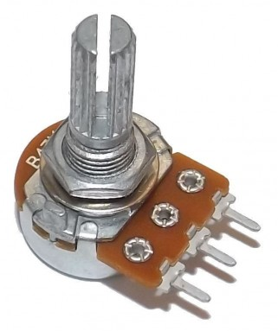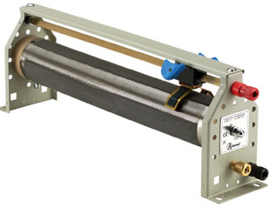
Fig 22 (a) Carbon film Potentiometer Fig 22 (b) Rheostat
The carbon potentiometer has three legs. There are two legs at the extreme positions that give us the fixed resistance that it has as standard and if we want the variable resistance function we use one pin of the extreme position and one pin that lies at the center position. Basically the center pin is the movable contact that provides the variable resistance function we need. There are two configurations in which we can use it. If we use the pin on the left and the one at the center then as we move the contact clockwise we receive increasing resistance. If we use the center leg and the one on the extreme right then as we move the contact clockwise we observe decreasing resistance. So depending upon the application we can use it in any configuration.

The electrical diagram can be seen below:
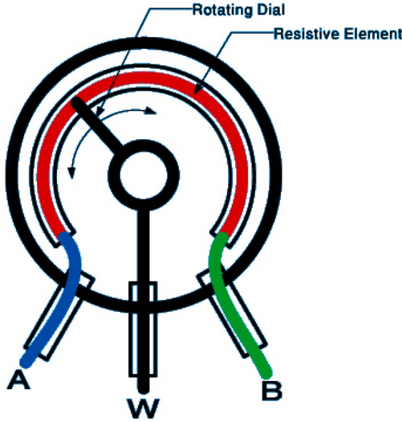
Fig 23
We have used the variable resistor in the positive arrangement in which as the pointer is moved clockwise to increase the resistance. It has been done so to change the contrast of the LCD display that we have used. It has been done so that the user can adjust the brightness according its requirements. Since the system comes with a battery backup system it may be a possibility that due to low battery the brightness is low so we have given the user the final control to fine tune the system to his/her choice.
It is connected in such a manner that we connect the center pin of the resistor to the V(ee) pin-3 of the LCD and the fixed right point to the ground, now as we move the resistor’s knob we can observe the changing contrast of the LCD in real-time. It has also been employed to change the sound intensity of the alarm system.
The most useful feature it has enabled us to provide is the manual position control of the servo motor. We connected the extreme terminals among the V(cc) and ground terminal and connected the center pin to one of the analogue pins providing the Arduino with variable voltages at that pin. Using that digital value we converted it to such a value that can be processed by the servo motor library. This feature enabled us to manually control the position of the servo and as we move the variable resistor we were able to provide variable values to the servo in real-time and consequently controlling its position at the end. The resistor was used in the positive configuration. It gives us the liberty to actually see the servo responding to those values and see the movement of the servo in real-time. The camera will be mounted on the servo

4.2.7 RDM 6300
This is the module that enables our system to scan the RFID tags. This is the final layer of security that our system has to offer. It communicates via a serial bus. Tags are previously scanned and their hidden tag is known. Using the same code in the tag and storing that in the RFID data base registers the card in the system. This module reads the cards data and then sends it serially to Arduino. Arduino then compares the card data. If it is one of the cards stored in the data bases the door lock is opened and if not then the system does not do anything. This module is very easy to interface with arduino and is very responsive when it comes to scanning the cards. The RFID tag card data start with 2 and end with 3. The typical module image is given below:
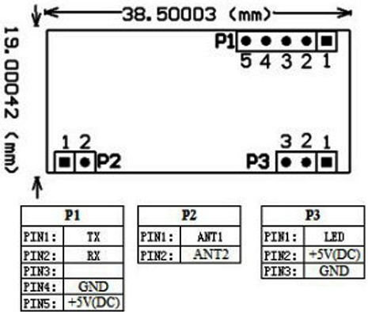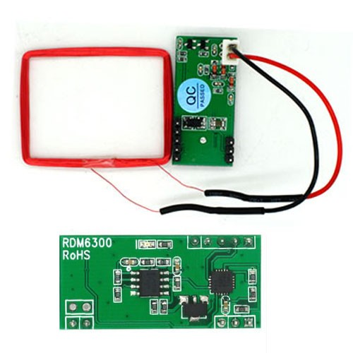
Fig 23(a) Pinout of RDM-6300 Fig 23(b) RDM-6300

Chapter 5
Boxing and Final Shape
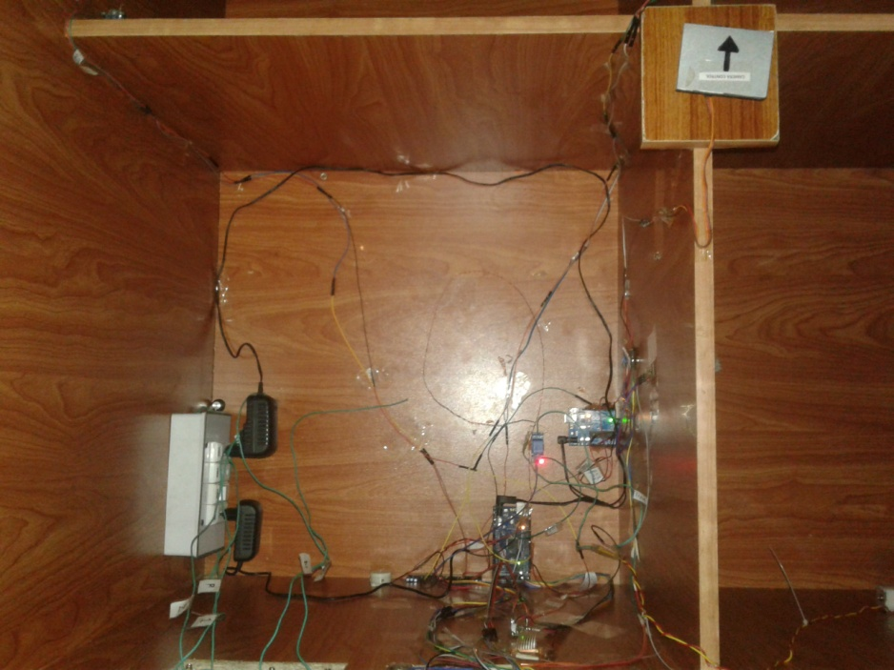
Fig 24
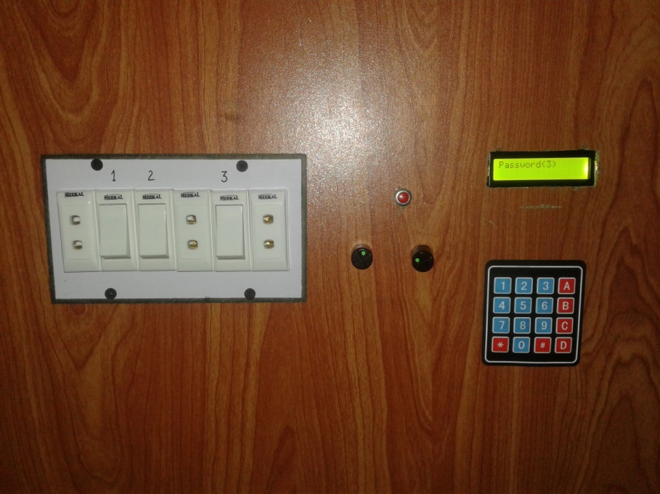
Fig 25

Chapter 6
Software Aspects

6.1 Software Implementation
Software implementation of this prototype includes the code required to interface different components and make them work as a unit. Three major portions of the code include the security system, servo motor, internet and Bluetooth code. Arduino IDE has been used to program the microcontroller. A snippet of the software is attached below:
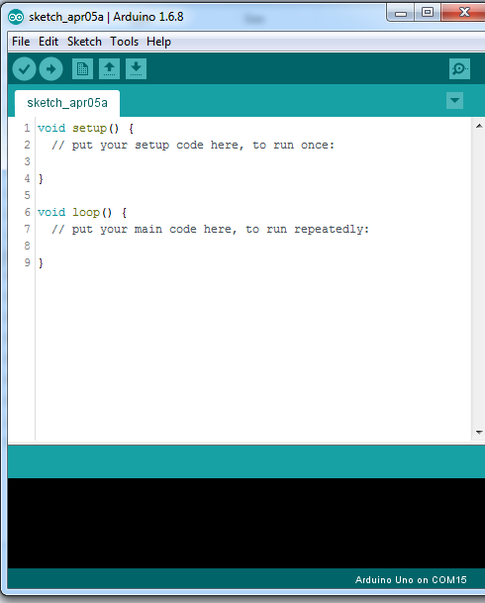

6.2 Automation Code Snippet
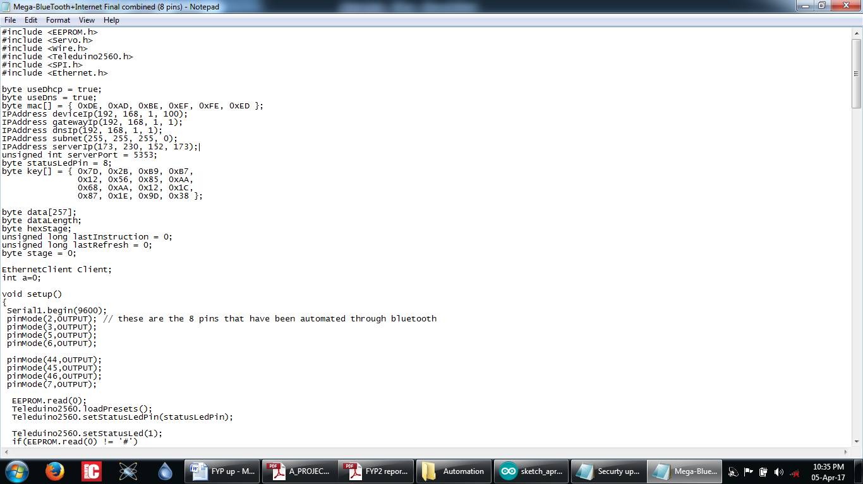The code is optimized for the Bluetooth and internet so that they can run in unison. Both interfaces are synchronized via coding so no matter what is the mode you choose to communicate by the system will execute the action the user has asked for.

6.3 Security System Code Snippet
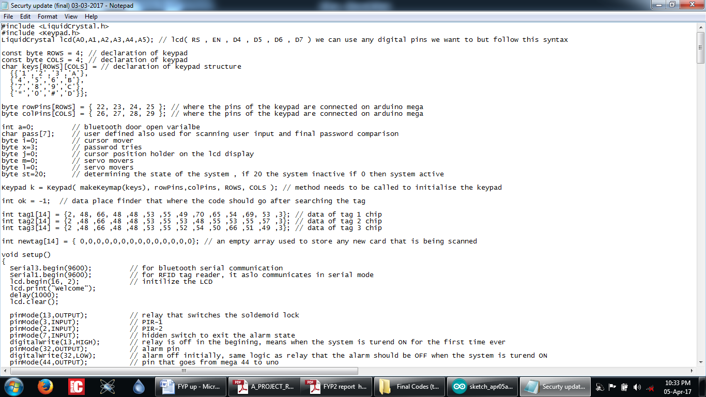

The code for security system ensures that all the sensors and actuators work in perfect synchronization and at all times the user will be given full response without any lags. The system ensures 2 modes of operation The system has three modes of communication RFID tags, Bluetooth and keypad password system. It makes sure that under no circumstances is the user left out if in case the user forgets any methods of entry.

Chapter 7
Evaluation

7.1 Project based
This design enables the automation of the house by Bluetooth interface as well as the internet. Further, security system is controlled by three different technologies, have ensured the safety of the house. In our project, we first interfaced the Bluetooth alone and testing the performance. Automation system based on the Bluetooth proved to be quite rugged and interfacing it was considerable easy. Bluetooth we used had a large range so it added to the design’s feasibility.
Furthermore, next we interfaced Ethernet shield for automation over the internet. This task was slightly tedious as it involved the Teleduino server and internet modem. It worked in a way that once the signal was sent through the phone to the web server, it first locates the device by indentifying it with its unique key. The Teleduino server would then connect with the PTCL modem. The female connector RJ-45 connects the Ethernet shield to the PTCL modem. Ethernet shield is attached to the arduino. In this way devices can be automated by arduino over the internet. The home automation system based on Bluetooth and internet are the most reliable technologies for the system. Any kind of appliances can be automated with this prototype which makes it more viable.
This prototype consists of high alert security system in such a way that door can be unlocked by entering the password, by RFID card and via Bluetooth. Moreover, in case of any intrusion within the secured premises the PIR sensor detects the human motion and servo motor with camera on it and faces towards the intruder. Which causes the alarm to switch on and the intrusion is noticed. In security system, apart from the door lock, alarm was the most essential part of it. Without alarm the owner would not be notified of the unwanted company.

7.2 Product based
This prototype was designed on the basis of its demand in the market. The world is swiftly drifting towards technological advancements day by day. The use of manual appliances, devices, gadgets is now a thing of the past and the demand of automated systems is increasing with every passing day. The pie chart below shows the demand of automation in the market.

To add to this benefit, this particular prototype is economical and the implementation cost was very less as compared other technologies in the market. The security system promises safety of the consumers which is an eye catcher for them and they are highly likely to purchase this design once advertised in the market. It is very easy to operate without any kind of complications; anyone can simply control the automated appliances with just a push of a button which adds to its advantage as a product to sell. The installation cost of this product is round about 12000-15000 per room which is quite economical with respect to other competitors in the market.

Chapter 8
Conclusion

This prototype is based on automation as well as security. It is the most feasible projects to have implemented since it enhances the standard of living. This model is designed to provide the low cost home automation system based which ensures one’s safety too. Moreover, the project is currently being implemented all over the world and majority of buildings in foreign countries are fully automated with rugged security systems. Despite its familiarity around the world, automation systems yet have to gain popularity in Pakistan. This automation system is used to control all kinds of home appliances such as lights, fans, air conditioners, refrigerators, automatic doors etc. After testing and experimentation it was clear that home automation system through the interface of Bluetooth and internet is a rugged design and can be easily implemented

Future Prospects
Automation System
The major focus of our team is to make this project as economical as possible and to reduce the manufacturing cost. Improving the response time of the internet will be the next target. Making the android app more user friendly will be the next target. The final target is to get rid of the Ethernet wire and take this interface to WIFI to reduce the wire networks. We will pursue it as an opportunity to create awareness among people to get this system installed in their houses and reap the benefits of what technology has to offer today.
Security System
Major focus like the automation system will be reducing the cost of this system followed by introducing multiple layered securities which will ensure absolute security as the user will have to go through all the stages in order for the lock to operate. The different compartments of this project can be used in universities, houses, offices and small clinics etc. The application and the market gap is huge. My team is hoping to exploit this gap and providing this system to the user at an economic price. It will ensure that people will overcome their phobia of technology which is mostly about the cost.

References
[1] N. Sriskanthan and Tan Karand. “Bluetooth Based Home Automation System”. Journal of Microprocessors and Microsystems, Vol. 26, pp.281-289, 2002.
[2] Pradeep.G, B.Santhi Chandra, M.Venkateswarao, “Ad-Hoc Low Powered 802.15.1 Protocol Based Automation System for Residence using Mobile Devices”, Dept. Of ECE, K L University, Vijayawada, Andhra Pradesh, India IJCST Vo l. 2, SP 1, December 2011
[3] R.Piyare, M.Tazil ”Bluetooth Based Home Automation System Using Cellphone”, 2011 IEEE 15th International Symposium on Consumer Electronics.
[4] R. Shepherd, “Bluetooth wireless technology in the home,” Journal of Electronics and Communication Engineering, vol. 13, no. 5, pp. 195– 203, Oct. 2001.
[5] Wijetunge, S.P., Wijetunge, U.S.; Peiris G.R.V., Aluthgedara C.S. and Samarasinghe A.T.L.K., “Design and Implementation of a Bluetooth based General Purpose Controlling Module”, 4th International Conference on Information and Automation for Sustainability, pp. 206-211, 2008.

[6] Zhang, Ai-Rong and Zhang, Jin-Lan, “The Building of Home Automation Electricity Distribution System Based on PLC,” SMIS 2011, International Conference on Smart Materials and Intelligent Systems, Chongqing, CN, Dec 23-25, 2011.
[7] Muhammad Izhar Ramli, Mohd Helmy Abd Wahab, Nabihah, “Towards Smart Home: Control Electrical Devices Online” ,Nornabihah Ahmad International Conference on Science and Technology: Application in Industry and Education (2006)
[8] Al-Ali, Member, IEEE & M. AL-Rousan,“Java-Based Home Automation System” IEEE Transactions on Consumer Electronics, Vol. 50, No. 2, MAY 2004.
[9] Amul Jadhav, S. Anand, Nilesh Dhangare, K.S. Wagh “Universal Mobile Application Development (UMAD) On Home Automation”. Marathwada Mitra Mandal’s Institute of Technology, University of Pune, India Network and Complex Systems ISSN 2224-610X (Paper) ISSN 2225-0603 (Online) Vol 2, No.2, 2012.
[10] E. Yavuz, B. Hasan, I. Serkan and K. Duygu. “Safe and Secure PIC Based Remote Control Application for Intelligent Home”. International Journal of Computer Science and Network Security, Vol. 7, No. 5, May 2007

[11] Al-Ali, Member, IEEE & M. AL-Rousan,“Java-Based Home Automation System” IEEE Transactions on Consumer Electronics, Vol. 50, No. 2, MAY 2004.
[12] Amul Jadhav, S. Anand, Nilesh Dhangare, K.S. Wagh “Universal Mobile Application Development (UMAD) On Home Automation”. Marathwada Mitra Mandal’s Institute of Technology, University of Pune, India Network and Complex Systems ISSN 2224-610X (Paper) ISSN 2225-0603 (Online) Vol 2, No.2, 2012.
[13] E. Yavuz, B. Hasan, I. Serkan and K. Duygu. “Safe and Secure PIC Based Remote Control Application for Intelligent Home”. International Journal of Computer Science and Network Security, Vol. 7, No. 5, May 2007.

[14] S.V.A Syed Anwarullah, IEEE Transactions on android based automation, vol 8, No. 9, April 2006

[15] Ms. Deepali Ravindra Jawale, IEEE transactions on home automation, volume 4, issue 9, September 2014

