Final Year Project Report
EDSYNAPSE


Project Advisor:
MAM TAYYABA ANJUM

Submitted By:
SANIA ASAD 13022020135
BAQAR BUTT 13022020114
KHUBAIB UR REHMAN 13022020131

Session
FALL 2017

University of Management and Technology
C-II Johar Town Lahore Pakistan

Dedication
This thesis work is dedicated to our teachers, who have been a constant source of support and encouragement during the challenges of graduate school and life. We are truly thankful for having such teachers in our life. This work is also dedicated to our parents, who have always loved us unconditionally and whose good examples have taught us to work hard for the things that we aspire to achieve.

Final Approval

Panel of Examiners

- Head of Department ______________________
Department of Computer Science
UMT Lahore

- Program Director ( Final Year Projects) ______________________
Department of Computer Science
UMT Lahore

- Supervisor ______________________
Department of Computer Science
UMT Lahore

- Co-Supervisor ______________________

Acknowledgment
We would like to express our deepest gratitude to God for his guidance and everything He has done to me. We are also greatly indebted to my supervisor, Mam Tayyaba Anjum, who is of fundamental importance to the completion of this dissertation. We have benefited a lot from her comments and suggestions, and for innumerable times, she puts us on the right track and gives me invaluable insight into how the study should be conducted. Without her advice and guidance, it would have been impossible for us to complete this work.
We must send our heartfelt thanks to our colleagues and friends who gave us unlimited support and encouragement. Special thanks are also due to the students who were involved in this study. Without their cooperation, the study could not have been conducted.

Project Title
Edsynapse
Objective
We expect our application to meet the following criterion:
Give facility for new students/visitors to get information about institute
Convenience for publishing information publicly
Undertaken by
Khubaib-ur-Rehman 13022020131
Muhammad Baqar Butt 13022020114
SaniaAsad 13022020135
Supervised by
Mam Tayyaba Anjum
Starting Date
Fall 2016
Completion Date
Fall 2017
Tool Used
Laravel , PHP
Operating System
Windows

Abstract
This work is designed for an institute. This work is based upon two parts making of a web application as well as Learning Management System. The work is conducted by using Laravel Framework. All the work is done by following the steps of SDLC. The work is done to promte learning .inorder to avoid any source of hindrance between learning and students. This Learning Mnagement system allows students and teacher to interact on a basic platform in order to avoid all the obstacles regarding the learning procedures.

Contents
Contents 1
Definitions and Acronyms 4
List of Figures 5
List of Tables 6
1. Introduction 8
1.1 Motivations 8
1.2 Project Overview 8
1.3 Problem Statement 9
1.4 Objectives 9
2. Domain Analysis 11
2.1 Customer 11
2.2 Stakeholders 11
2.3 Affected Groups with social or economic impact 12
2.4 Dependencies/ External Systems 12
2.5 Reference Documents 12
2.5.1 Related Projects 13
2.5.2 Feature Comparison 13
3. Requirements analysis 14
3.1 Requirements 14
3.2 List of Actors 14
3.3 List of use cases 15
3.4 System use case diagram 17
3.5 Extended use cases 18
3.6 User interfaces (mock screens) 33
4. Data flow diagram (optional) 40
4.1 Data Flow Diagram Level 0 40
4.2 Data Flow Diagram Level 1 41
4.3 Data Flow Diagram Level 2 42
5. System Design 43
5.1 System Architecture Diagram 43
5.2 Class Diagram 45
5.3 Sequence Diagrams 46
5.4 Erd 51
6. Implementation details 52
6.1 Development Setup 52
6.2 Deployment setup 52
6.3 Algorithms 53
6.4 Constraints 54
6.4.1 Assumptions 54
6.4.2 Restrictions 54
6.4.3 Limiations 55
7. Testing 55
7.1 Extended Test Cases 55
7.2 Code Snippet 71
7.3 Traceability Matrix 72
7.3.1 RID vs UCID (requirements vs use cases) 72
7.3.2 Prototypes (RID vs PID) 74
7.3.3 Test Cases (RID vs TID) 75
7.3.4 Coverage (UCID vs TID) 76
8. Results/Output/Statistics 77
8.1 %completion 77
8.2 %accuracy 77
8.3 %correctness 77
9. Conclusion 79
10. Future work 80
11. Bibliography 81
11.1 Books 81
12. Appendix 81
12.1 Glossary of terms 81
12.2 Pre-requisites 82

Revision Chart

Version | Primary Author(s) | Description of Version | Date Completed
Draft | SaniaAsad | Initial draft created for distribution and review comments | 31 Oct 16
Preliminary | Baqar Butt  SaniaAsad | Second draft incorporating initial review comments, distributed for final review | 2 Dec 16
Final | SaniaAsad  Khubaib | First complete draft, which is placed under change control | 10 Jan 17
Revision 1 | Baqar Butt  Khubaib | Revised draft, revised according to the change control process and maintained under change control | 1 Feb 17
Revision 2 | SaniaAsad  Baqar Butt  Khubaib | Revised draft, revised according to the change control process and maintained under change control | 05 July 17

Definitions and Acronyms

Acronym | Definition
UMT | University of Management and Technology
LMS | Learning Management System
DFD | Data flow diagram
ERD | Entity Relationship Diagram
Table 1: table of acronyms and definitions

List of Figures
Figure 1 : Admin Dashboard View ……………………………………………………………….33
Figure 2 : Add Audio Lectures View 33
Figure 3 : Audio Lecture View 34
Figure 4 : Add Students View 34
Figure 5 : Teachers View 35
Figure 6 : Course Outline 35
Figure 7 : Course Outline View 36
Figure 8 : Add Students View 36
Figure 9 : Students View 37
Figure 10 : Add Subject View 37
Figure 11 : Subject View 38
Figure 12 : Online View 38
Figure 13 : Admin view 39
Figure 14 : Student Online View 43
Figure 15 : System Diagram 44
Figure 16 : Class Diagram 45
Figure 17 : Manage yearly Planner 46
Figure 18 : Access to Student Portal 46
Figure 19 : Access to Teacher Portal 47
Figure 20 : Download Tasks 47
Figure 21 : Upload Tasks 48
Figure 22 : Download Audio 48
Figure 23 : Manage Live Audio 49
Figure 24 : Manage News and Announcements 49
Figure 25 : Manage Course Offered 50
Figure 26 : Manage Morning and Evening Shifts 50
Figure 27 : ERD…. 51

List of Tables
Table 1 : Table of acronyms and definitions 4
Table 2 : Stakeholders 11
Table 3 : Table of Comparison ……. 13
Table 4 : Functional Requirements 15
Table 5 : UC 1: Manage news and announcements 18
Table 6 : UC 2: Manage Courses being offered 19
Table 7 : UC 3: Manage morning and evening shifts timing 20
Table 8 : UC 4: Manage Facilities being offered 21
Table 9 : UC 5: Manage yearly planner 22
Table 10 : UC 6: Manage Live Streaming 23
Table 11 : UC 7: Viewing Live Streaming 24
Table 12 : UC 8: Viewing Information 25
Table 13 : UC 9: Accesses to Student Portal 26
Table 14 : UC 10: Accesses to Teacher Portal 27
Table 15 : UC 11: Download the Tasks 28
Table 16 : UC 12: Upload Tasks 29
Table 17 : UC 13: Download Audio Files …30
Table 18 : UC 14: Manage Information …..31
Table 19 : UC 15: View all the information …32
Table 20 : TC_01: Audio Lectures ...56
Table 21 : TC _02: Add Teachers Profile 57
Table 22 : TC _03: Add Students Profile 58
Table 23 : TC _04: Add Subjects 59
Table 24 : TC _05: Add Course Outline 60
Table 25 : TC _06: Audio Live Streaming 61
Table 26 : TC _07: Assign Subjects to Teacher 62
Table 27 : TC_08: Assign Subjects to Student 63
Table 28 : TC_09 Verify Profile 64
Table 29 : TC_09 Verify Admin 65
Table 30 : TC_10 Verify sign in 66
Table 31 : TC_11 Verify Teacher Log in 67
Table 32 : RID VS UCID 73
Table 33 : PID VS TID 74
Table 34 : Requirement vs. Use cases 75
Table 35 : Test Cases vs. Use cases 76
Table 36 : Glossary… 81

Introduction
This project focuses on developing a learning website which provides facility to institute and students in a manner that the learning does not remain limited to the four wall of a classroom.
This website works finding new ways to make an institute a center of excellence in education by providing all the study material available to students online. The students belonging to different places, unable to attend regular classes get access to educational courses along with live lectures. It provides facility and students to communicate with faculty regarding academics.
This management system is named by as Edsynapse.As function of a synapse is to link to nerve cells similarly this system is a junction between students and teachers of an institute. This system has powerful online services to bring teachers and students together on a common interactive platform.
The management system is accomplished along with making of an official website of the institute to enhance recognition of the institute.

Motivations
As everyone want things to be done in an easier and faster way so we worked on a developed strategy which aims the development of administrative and management structures in an institute.
Most of the institutes in the country are already equipped with such systems but many still need to adopt systems like these. This system aims to provide online services to bring teachers and students together on an interactive platform.

Project Overview
This Final Year Project is an external collaboration with Azzuhaa Islamic Institute (affiliated with wifaqulmidaris).Azzuhaa is a non-profitable organization working for the welfare of Islam. They have assigned us a project of making a web application along with Learning Management System for them.
- The Project is efficiently divided into two tasks.
- Making of a web application.
- Students can have access of the website for all the information they need.
- This project will help the target users to interact with one and other. This will enable the students to get online content for their learning anytime and anywhere.
Goals
- To improve learning resources and opportunities
- To make the system cost effective.
- To meet learning criteria of 2st century.
- To provide a common platform for teachers and students.
- To start a new teaching Style.

Problem Statement

When Learning is concerned there comes a limitation of the location as well as time. We are working on the slogan no time no boundaries. So a learner group can get educated without the limitations of time and location.

Objectives
We expect our application to meet the following criterion:
- Give facility for new students/visitors to get information about institute
- Convenience for publishing information publicly
- Student can take Live Lectures
- Student can easily discuss about the quires on Discussion Board/Chat rooms
Other objectives include providing teaching staff with a platform with which they can easily provide their students with the required content and they can interact with them through this platform.

Domain Analysis

Customer
This Project is an external collaboration with Az-zuhaa Islamic Institute
(Affiliated with wifaqulmidaris). This project is being prepared on a contract between us and Az- Zuhaa Islamic Institutes. This is the institute that offers Islamic learning for girls currently working in Model Town and PIA Housing Society Lahore.

Stakeholders
Following are the stake holders of the described application:
Stakeholder | Role in System
Admin | - Create Account for Data Entry Operators  - Supervise the all activities perform by Data Entry Operator
Data Entry Operator | - Perform all sort for data Entry tasks  - Data Editing also
Visitor | - Visit Site to acquire information about the institutes & their programs
Student | - Take Live Lectures  - Send their queries to instructor on Discussion Boards
Teacher/Instructor | - Deliver live lectures to viewers  - Reply to queries of viewers

Table 2: list of stakeholders

Affected Groups with social or economic impact

Following are the group of people impacted by the system:
Students
Students are the consumers of e-learning. In the context of higher education, they are undergraduate or graduate students enrolled at a university or college.
Instructors
In e-learning, as in traditional classroom learning, instructors guide the educational experiences of students. Depending on the mode of e-learning delivery, instructors may or may not have face-to-face interaction with their students.
Educational Institutions
Educational institutions, in the context of higher education, include colleges and universities. In addition to the traditional list of postsecondary institutions, the rise in popularity of e-learning has led to the creation of new, online only educational institutions.

Dependencies/ External Systems
The product depends upon the following things for its completion:
- Server Machine
- External Live Devices
- License from Live Software Company

Reference Documents

We took references from the An Nisa Institute [1]. http://www.annisa.com.pk/ and Hamna Centre [2].http://www.hamnacenter.org/ in order to build our own project. These two projects had some similar features those we wanted to incorporate into our system

Related Projects

We took references from the An Nisa Institute [1]. http://www.annisa.com.pk/ and Hamna Centre [2].http://www.hamnacenter.org/ in order to build our own project.

Feature Comparison

Sr No. | Comparison Feature | An-Nisa | HamnaCentre | Remarks
1 | Live Audio | An-Nisa covers the feature but the feature is not in working state. | Hamna Centre has covered the feature completely as desired. | Using the feature of hamnacentre along with adding the feature of automatic recording of that audio will enhance the efficiency
2 | Welcome slide | An-Nisa has a welcome slide | Hamna Centre has covered the feature completely as desired | We will be using the same feature making it more dynamic.
3 | Academic calendar | An-Nisa has a academic Calendar | Hamna Centre has covered the feature completely as desired | We will be using the same feature making it more dynamic
4 | Upcoming events | An-Nisa has a feature of upcoming events. | Hamna Centre has covered the feature completely as desired | We will be using the same feature making it more dynamic

Table 3: Comparison Feature

Requirements analysis

Requirements

Functional Requirements | Part – 1  [R1]Information About Institute (History, Branches& Location on Map also)  [R2]Motive & Aim of Institute  [R3]News & Announcements  [R4]Offered Courses & Courses in Future  [R5]Fee Structure (Free for deserving Students)  [R6]Outdoor class schedule (Mention places, with Az-Zuhaa contact)  [R7]Morning & Evening Shifts Timing  [R8]Facilities (Filtered Water/Refreshment, Pick &Drop,etc.)  [R9]Yearly Plans/ Academic Calendar (Show Months only)  [R10]Video: Az-Zuhaa Introduction Slides  [R11]Gallery: Pictures Event-wise (Both Campuses)  [R12]Student Login (Authentication)  [R13]Bayanaat of different Subjects  [R14]Other Additional Bayanaat on different Topics.  [R15]Live Audio  Part-2  [R16]Student Learning Management System  [R17]Student Login (Authentication)  [R18]Chat & Call Room with teachers with subjects  [R19]Bayanaat of different Subjects  [R20]Other Additional Bayanaat on different Topics.  Part-3  [R21]Teacher Management System  [R22]Teacher Login (Authentication)  [R23]Access Chat Room Content and can reply to questions
Non-Functional Requirements | - Secure  - Reliable  - Maintainable  - Robust  - User Friendly
Data Requirements | Data entry will be made by Data Entry Operator  And will be store on Database
Constraints | Login and password is used for the identification of users.  Only registered users, corporate users and admin will be authorized to use the services.
External interface requirements | - Connect with Live Streaming Server to provide Streaming services  - Hosting Server will contain all Files & Data  - Connected through Internet

Table 4: Functional Requirements

List of Actors
Following are the list actors:
Visitor: Browse site and see all Institute related information by going through different pages.
Admin: Do Administration tasks like. Create Accounts for other users & Maintain
Data Entry Operator: Perform all Data Entry related tasks
Student: Login to LMS and take Live Lectures and other study related operations
Instructor: Login to LMS and Respond all kind of student queries of their subjects.

List of UCs
UC 1: Manage news and announcements
UC 2: Manage courses being offered
UC 3: Manage morning and evening shifts timing
UC 4: Manage Facilities being offered
UC: 5 Manage yearly planner.
UC: 6 Manage live audio streaming
UC: 7 View Live Streaming
UC: 8 Viewing Information
UC: 9 Accesses to Student Portal
UC: 10 Accesses to Teacher Portal
UC: 11 Download the Tasks
UC: 12 Upload Tasks
UC: 13 Download Audio Files
UC: 14 Manage Information
UC: 15 View all the Information

System UC diagram

Add Course

View Teacher
Portal
View Student
Portal

Extended UCs
UC ID: 1

Name: |  | Manage news and announcements
Actors: |  | Administrator
Purpose: |  | Changing news and other announcement on the web application.
Description: |  | Administrator wants to update the news and announcements on the web application.
 |  | Admin must be logged in to the system to perform functionality
Pre-Conditions |  | To assume the state of system before the functionality is performed.
Post-Conditions  (successful) |  | To assume the state of system after the functionality is performed successfully
Post-Conditions  (Failure) |  | To assume the state of system after the functionality is performed unsuccessfully
Course of Events
Action |  |  | Response
1 | This use begins when admin logs in the admin panel.
2 | The admin selects the menu for editing news and announcements. |  | 3 | System shows the window for changing news and announcements.
4 | Admin writes the news and announcements that needs to be updated. |  | 5 | System shows the changes being made.
7 | Admin selects the buttons:  - Admin selects the save button.  - Admin selects the back button. |  | 8 | If admin selects the save button news and announcements are displayed on the web application.
 |  |  | 9 | If admin selects the back button users is taken back to the home page of admin panel.
Table 5: UC ID 1 Manage News
UC ID: 2

Name: |  | Managecourses being offered
Actors: |  | Administrator
Purpose: |  | Changing courses offered on the web application.
Description: |  | Administrator wants to update the courses being offered on the web application.
 |  | Admin must be logged in to the system to perform functionality
Pre-Conditions |  | To assume the state of system before the functionality is performed.
Post-Conditions  (successful) |  | To assume the state of system after the functionality is performed successfully
Post-Conditions  (Failure) |  | To assume the state of system after the functionality is performed unsuccessfully
Course of Events
Action |  |  | Response
1 | This UC begins when admin logs in the admin panel.
2 | The admin selects the menu for editing courses. |  | 3 | System shows the window for changing courses.
4 | Admin writes the courses that need to be updated. |  | 5 | System shows the changes being made.
7 | Admin selects the buttons:  - Admin selects the save button.  - Admin selects the back button. |  | 8 | If admin selects the save button courses are displayed on the web application.
 |  |  | 9 | If admin selects the back button users is taken back.

Table 6: UC ID 2 Manage Courses

UC ID: 3

Name: |  | Managemorning and evening shifts timings being offered
Actors: |  | Administrator
Purpose: |  | Changing morning and evening shifts timing being offered on the web application.
Description: |  | Administrator wants to update the morning and evening shifts timings being offered on the web application.
 |  | Admin must be logged in to the system to perform functionality
Pre-Conditions |  | To assume the state of system before the functionality is performed.
Post-Conditions  (successful) |  | To assume the state of system after the functionality is performed successfully
Post-Conditions  (Failure) |  | To assume the state of system after the functionality is performed unsuccessfully
Course of Events
Action |  |  | Response
1 | This UC begins when admin logs in the admin panel.
2 | The admin selects the menu for editing timings. |  | 3 | System shows the window for changing timings.
4 | Admin writes the timings that need to be updated. |  | 5 | System shows the changes being made.
7 | Admin selects the buttons:  - Admin selects the save button.  - Admin selects the back button. |  | 8 | If admin selects the save button timings are displayed on the web application.
 |  |  | 9 | If admin selects the back button users is taken back to the home page of admin panel.
Table 7: UC ID 3 Manage Shifts

UC ID: 4

Name: |  | Change in facilities being offered
Actors: |  | Administrator
Purpose: |  | Manage facilities being offered on the web application.
Description: |  | Administrator wants to update the facilities being offered on the web application.
 |  | Admin must be logged in to the system to perform functionality
Pre-Conditions |  | To assume the state of system before the functionality is performed.
Post-Conditions  (successful) |  | To assume the state of system after the functionality is performed successfully
Post-Conditions  (Failure) |  | To assume the state of system after the functionality is performed unsuccessfully
Course of Events
Action |  |  | Response
1 | This UC begins when admin logs in the admin panel.
2 | The admin selects the menu for editing facilities. |  | 3 | System shows the window for changing facilities.
4 | Admin writes the facilities that need to be updated. |  | 5 | System shows the changes being made.
7 | Admin selects the buttons:  - Admin selects the save button.  - Admin selects the back button. |  | 8 | If admin selects the save button facilities are displayed on the web application.
 |  |  | 9 | If admin selects the back button users is taken back to the home page of admin panel.

Table 8: UC ID 4 Manage Facilities

UC ID: 5
Name: |  | Manageyearly planner being offered
Actors: |  | Administrator
Purpose: |  | Changing yearly planner being offered on the web application.
Description: |  | Administrator wants to update the yearly planner being offered on the web application.
 |  | Admin must be logged in to the system to perform functionality
Pre-Conditions |  | To assume the state of system before the functionality is performed.
Post-Conditions  (successful) |  | To assume the state of system after the functionality is performed successfully
Post-Conditions  (Failure) |  | To assume the state of system after the functionality is performed unsuccessfully
Course of Events
Action |  |  | Response
1 | This UC begins when admin logs in the admin panel.
2 | The admin selects the menu for editing yearly planner. |  | 3 | System shows the window for changing yearly planner.
4 | Admin writes the yearly planner that need to be updated. |  | 5 | System shows the changes being made.
7 | Admin selects the buttons:  - Admin selects the save button.  - Admin selects the back button. |  | 8 | If admin selects the save button yearly planner are displayed on the web application.
 |  |  | 9 | If admin selects the back button users is taken back to the home page of admin panel.

Table 9: UC ID 5 Manage Yearly Plan

UC ID: 6

Name: |  | Managelive audio being offered
Actors: |  | Administrator
Purpose: |  | Changing live audio being offered on the web application.
Description: |  | Administrator wants to update the live audio being offered on the web application.
 |  | Admin must be logged in to the system to perform functionality
Pre-Conditions |  | To assume the state of system before the functionality is performed.
Post-Conditions  (successful) |  | To assume the state of system after the functionality is performed successfully
Post-Conditions  (Failure) |  | To assume the state of system after the functionality is performed unsuccessfully
Course of Events
Action |  |  | Response
1 | This UC begins when admin logs in the admin panel.
2 | The admin selects the menu for editing live audio. |  | 3 | System shows the window for changing live audio.
4 | Admin edits the audio that need to be updated. |  | 5 | System shows the changes being made.
7 | Admin selects the buttons:  - Admin selects the save button.  - Admin selects the back button. |  | 8 | If admin selects the save button changes are displayed on the web application.
 |  |  | 9 | If admin selects the back button users is taken back to the home page of admin panel.

Table 10: UC ID 6 Manage Live Audio

UC ID: 7

Name: |  | View of Live streaming
Actors: |  | Main interface
Purpose: |  | Live streaming being offered on the web application.
Description: |  | Live streaming is done on the web application.
 |  | Admin must be logged in to the system to perform functionality
Pre-Conditions |  | To assume the state of system before the functionality is performed.
Post-Conditions  (successful) |  | To assume the state of system after the functionality is performed successfully
Post-Conditions  (Failure) |  | To assume the state of system after the functionality is performed unsuccessfully
Course of Events
Action |  |  | Response
1 | The server’s main interface can load audio stream into the server’s Media Session
2 | The server’s main interface can terminate a audio stream in the server’s Media Session |  | 3 | System shows the live streaming to the viewers.
4 | The server’s main interface can collect several information from the Media Server.

Table 11: UC ID 7 View of Live Streaming

UC ID: 8

Name: |  | Viewing all the information.
Actors: |  | Viewers
Purpose: |  | Viewers can view all the information and can go to live streaming page.
Description: |  | Viewers want to see all the required information. .
 |  | Admin must be logged in to the system to perform functionality
Pre-Conditions |  | To assume the state of system before the functionality is performed.
Post-Conditions  (successful) |  | To assume the state of system after the functionality is performed successfully
Post-Conditions  (Failure) |  | To assume the state of system after the functionality is performed unsuccessfully
Course of Events
Action |  |  | Response
1 | This UC begins when viewers enter the web application’s URL.
2 | All the viewer’s select different drop down menus to see the required information. |  | 3 | System shows all the required information.
4 | Viewers go for watching live streaming. |  | 5 | System shows the live streaming being made.

Alternative flow:
Step 1: Live Streaming is not being scheduled. System generates no live session warning.
Step 2: There is some network error. System displays the network error.

Table 12: UC ID 8 View of the Information

UC ID: 9  Name  Actors: | Access to student Portal  Main interface , students
Purpose: | Student portal being offered by the system.
Description: | Student Portal is built on the application.
 | Admin must be logged in to the system to perform functionality
Pre-Conditions | To assume the state of system before the functionality is performed.
Post-Conditions  (successful) | To assume the state of system after the functionality is performed successfully
Post-Conditions  (Failure) | To assume the state of system after the functionality is performed unsuccessfully
Course of Events
Action |  | Response
1 |  | Student enters the log in. | 2 | System makes the students logged in.
3 |  | Student can have access to see all the data entered.
4 |  | Student can log out. | 5 | System makes the student logged out.

Table 13: UC ID 9 Access to Student Portal

UC ID: 10  Name  Actors: | Access to Teacher Portal  Main interface , students
Purpose: | Student portal being offered by the system.
Description: | Student Portal is built on the application.
 | Admin must be logged in to the system to perform functionality
Pre-Conditions | To assume the state of system before the functionality is performed.
Post-Conditions  (successful) | To assume the state of system after the functionality is performed successfully
Post-Conditions  (Failure) | To assume the state of system after the functionality is performed unsuccessfully
Course of Events
Action | Response
1 | Teacher enters the log in. | 2 | System makes the students logged in.
3 | Teacher can have access to see all the data entered.
4 | Teacher can log out. | 5 | System makes the student logged out.

Table 14: UC ID 10 Access to Teacher Portal

UC ID: 11  Name  Actors: | Download the tasks  Main interface , students
Purpose: | Student portal being offered by the system.
Description: | Student Portal is built on the application.
 | Admin must be logged in to the system to perform functionality
Pre-Conditions | To assume the state of system before the functionality is performed.
Post-Conditions  (successful) | To assume the state of system after the functionality is performed successfully
Post-Conditions  (Failure) | To assume the state of system after the functionality is performed unsuccessfully
Course of Events
Action | Response
1 | Student enters the log in. | 2 | System makes the students logged in.
3 | Student can have access to see all the data entered.
4 | Student can download the data. | 5 | System makes the student to download the data.

Table 15: UC ID 11 Download Tasks

UC ID: 12  Name  Actors: | Upload Tasks  Main interface , teachers
Purpose: | Teacher portal being offered by the system.
Description: | Teacher Portal is built on the application.
 | Admin must be logged in to the system to perform functionality
Pre-Conditions | To assume the state of system before the functionality is performed.
Post-Conditions  (successful) | To assume the state of system after the functionality is performed successfully
Post-Conditions  (Failure) | To assume the state of system after the functionality is performed unsuccessfully
Course of Events
Action | Response
1 | Teacher enters the log in. | 2 | System makes the students logged in.
3 | Teachers can have access to see all the data entered.
4 | Teachers can upload the data. | 5 | System makes the teacher to upload data.

Table 16: UC ID 12 Upload Tasks

UC ID: 13  Name  Actors: | Download audio files  Main interface , students
Purpose: | Student portal being offered by the system.
Description: | Student Portal is built on the application.
 | Admin must be logged in to the system to perform functionality
Pre-Conditions | To assume the state of system before the functionality is performed.
Post-Conditions  (successful) | To assume the state of system after the functionality is performed successfully
Post-Conditions  (Failure) | To assume the state of system after the functionality is performed unsuccessfully
Course of Events
Action | Response
1 | Student enters the log in. | 2 | System makes the students logged in.
3 | Student can have access to see all the data entered.
4 | Student can download the audio files | 5 | System makes the student to download audio files.

Table 17: UC ID 13 Download Audio Files
UC ID: 14  Name  Actors: | Manage information  Main interface , Teacher
Purpose: | Teacher portal being offered by the system.
Description: | Teacher Portal is built on the application.
 | Admin must be logged in to the system to perform functionality
Pre-Conditions | To assume the state of system before the functionality is performed.
Post-Conditions  (successful) | To assume the state of system after the functionality is performed successfully
Post-Conditions  (Failure) | To assume the state of system after the functionality is performed unsuccessfully
Course of Events
Action | Response
1 | Teacher enters the log in. | 2 | System makes the students logged in.
3 | Teacher can have access to see all the data entered.
4 | Teacher can manage all the information including editing and creating new tasks or deleting old tasks. | 5 | System makes the changes.

Table 18: UC ID 14 Manage Information

UC ID: 15  Name  Actors: | View all the information  Main interface , students
Purpose: | Student portal being offered by the system.
Description: | Student Portal is built on the application.
 | Admin must be logged in to the system to perform functionality
Pre-Conditions | To assume the state of system before the functionality is performed.
Post-Conditions  (successful) | To assume the state of system after the functionality is performed successfully
Post-Conditions  (Failure) | To assume the state of system after the functionality is performed unsuccessfully
Course of Events
Action | Response
1 | Student enters the log in. | 2 | System makes the students logged in.
3 | Student can have access to see all the data entered.
4 | Student can view all the information given by teacher. | 5 | System views information.

Table 19: UC ID 15 View Information

User interfaces (mock screens)
Shown below are the mock screens of LMS and Official Website of Az-Zuhaa Institute
Admin Dashboard ID: 1

Figure 1: Admin Dashboard View

Audio lectures Module ID: 2

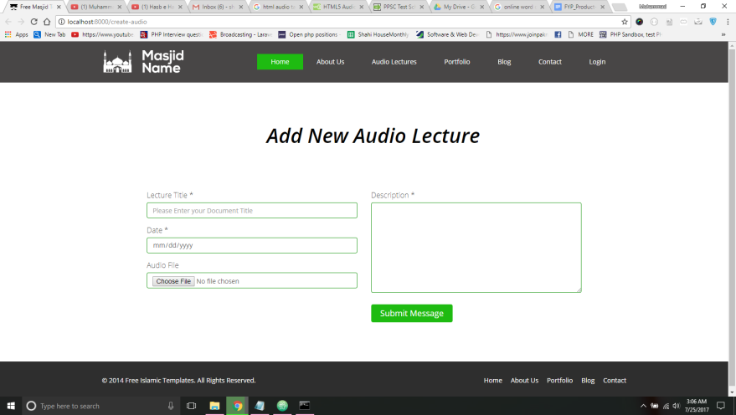

Figure 2: Add Audio Lectures view

P ID:3

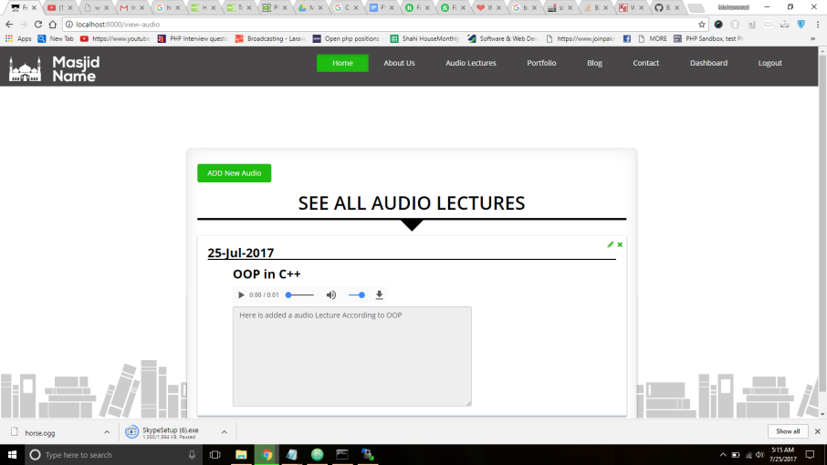

Figure 3: audio Lectures view

Teacher Module ID: 4

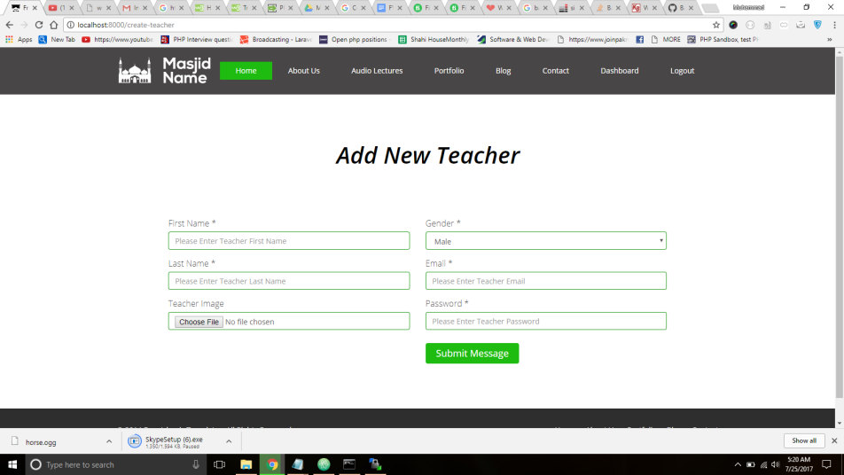

Figure 4: Add Students view

P ID: 5
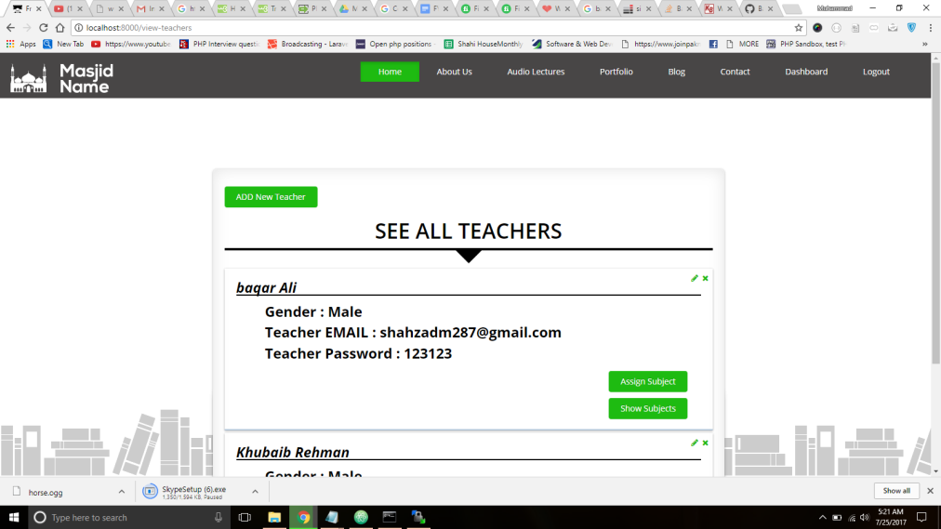

Figure 5: Teachers view

Course Outline ID: 6

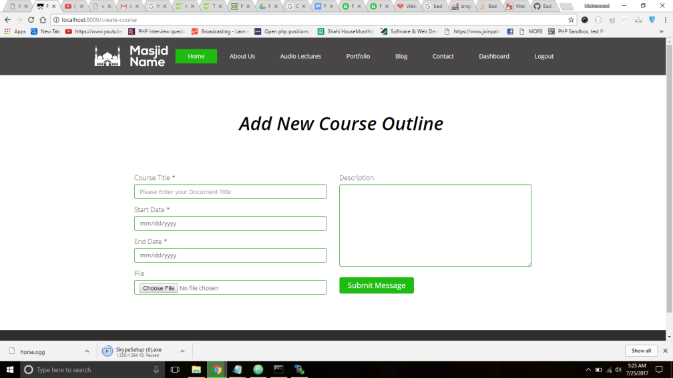

Figure 6: Course Outline

P ID: 7

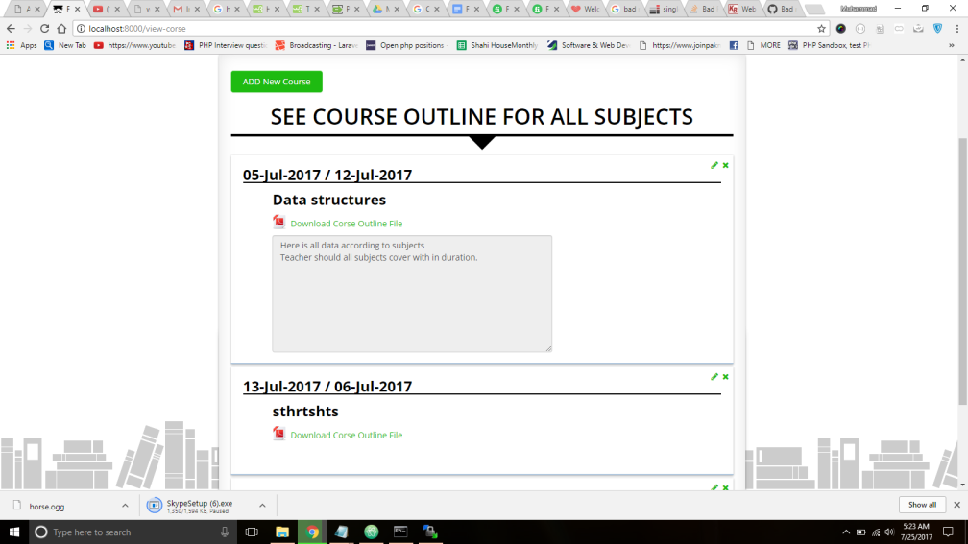

Figure 7: Course OutLine view

Student Module ID: 8

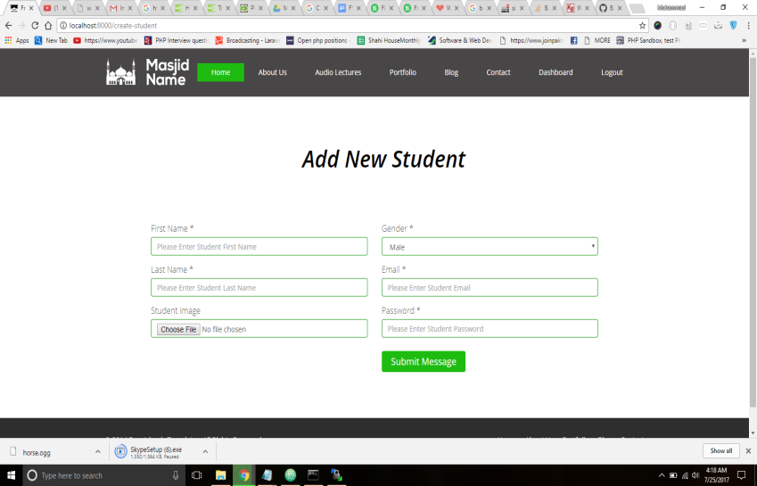

Figure 8: Add Students view

P ID: 9
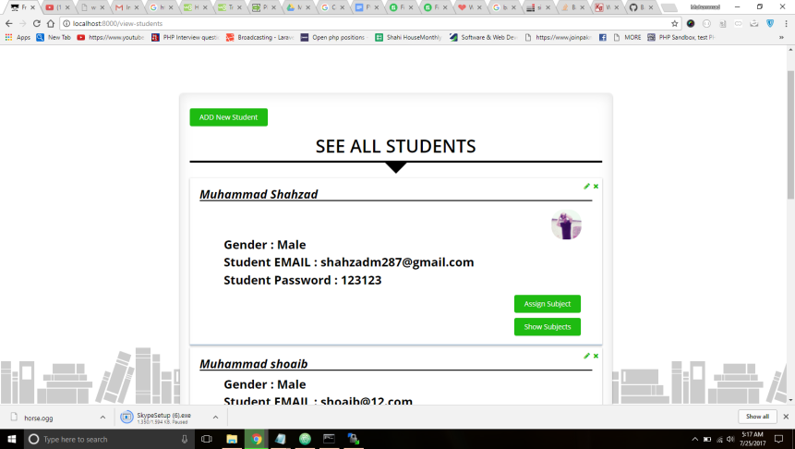

Figure 9: Students view

Subjects ID: 10
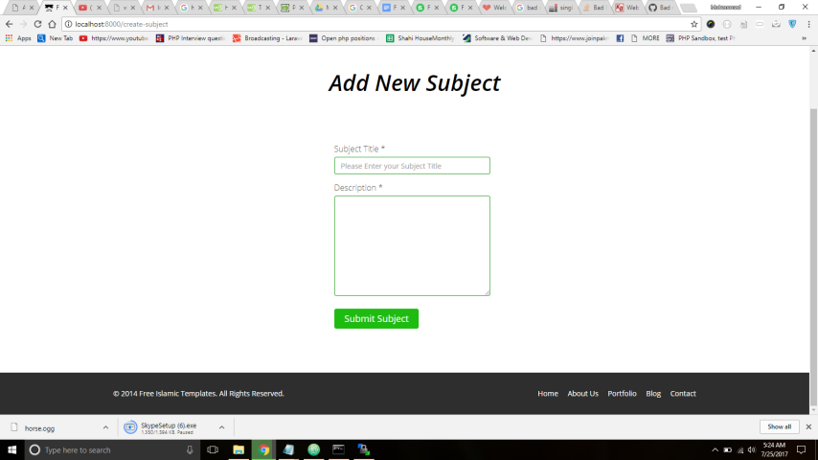

Figure 10: Add Subject view

P ID: 11

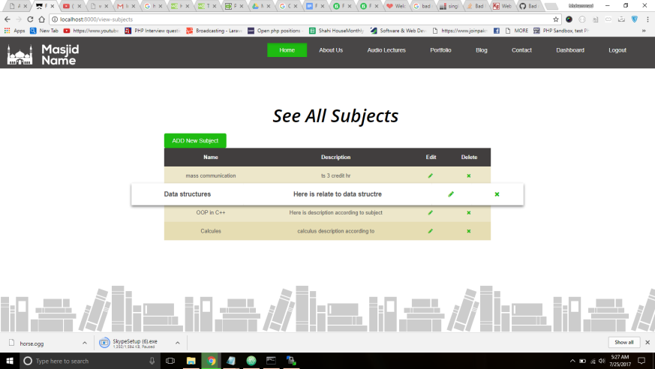

Figure 11: Subjects view

Official Website Mock Screen ID: 12



Figure 12: Home view
P ID: 13

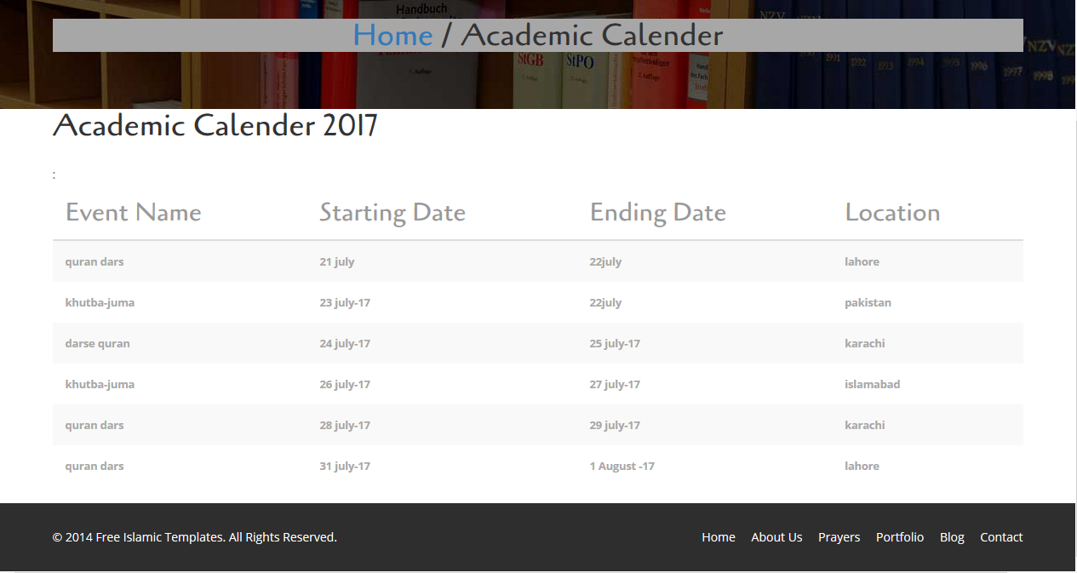

Figure 13: Course view

Data flow diagram

Data Flow Diagram Level 0(Website)

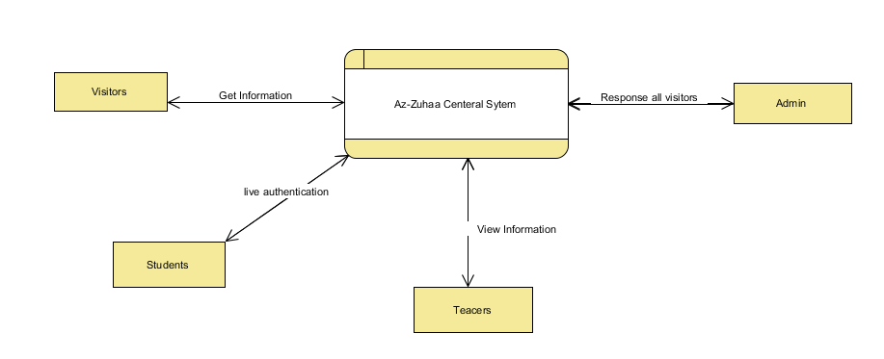

Data Flow Diagram Level 1 (Website)

Student View (Website)
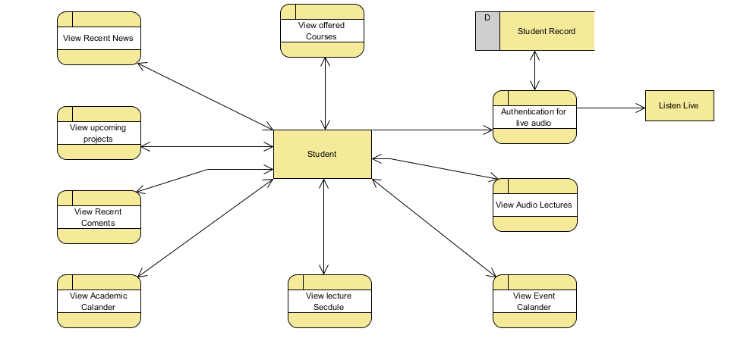
Admin View(website)

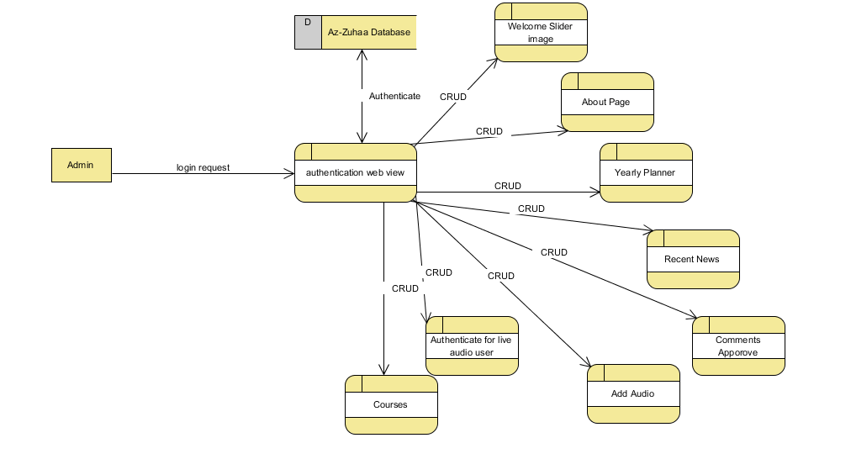

Data Flow Diagram Level 0 (Lms)
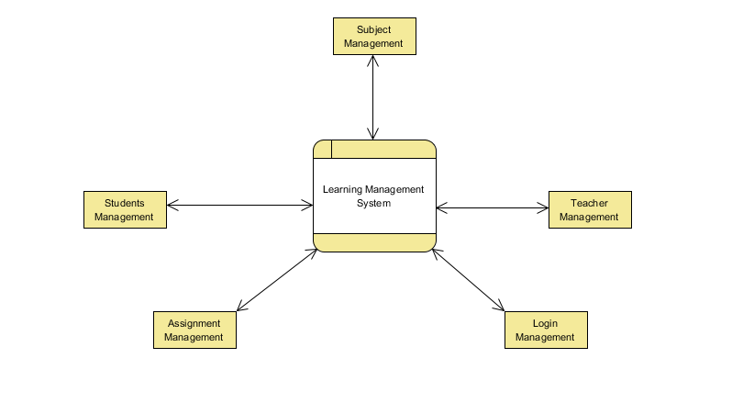

Data Flow Diagram Level 1(Lms)
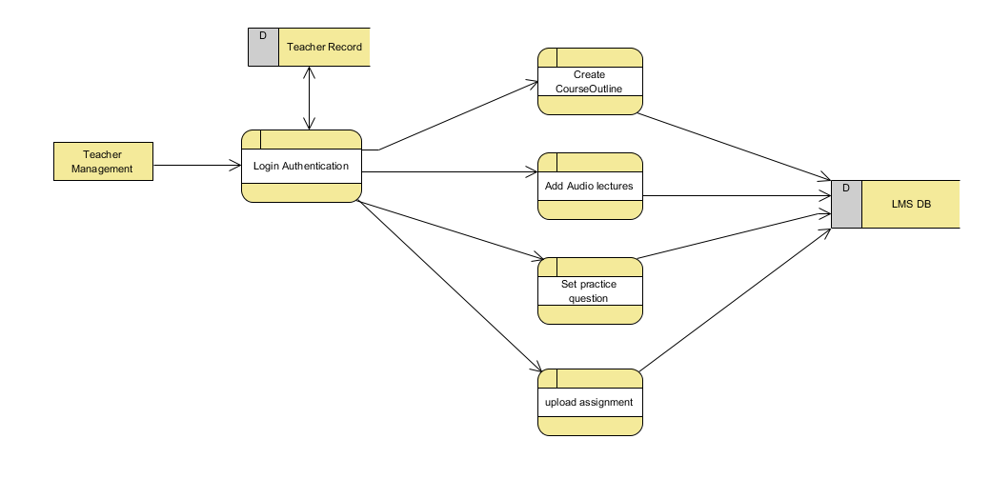

Data Flow Diagram Level 2(Lms)

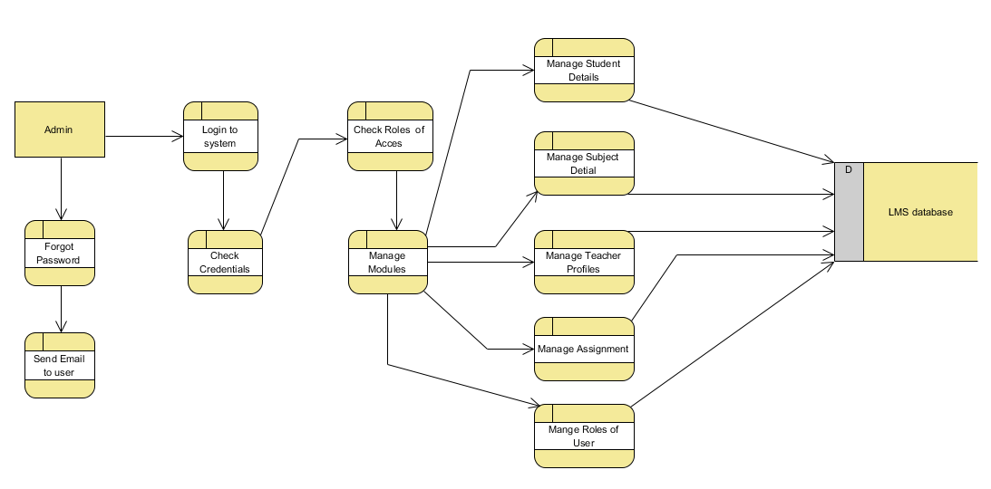

System Design
Described below is the system architecture diagram of built web application:

System Architecture Diagram

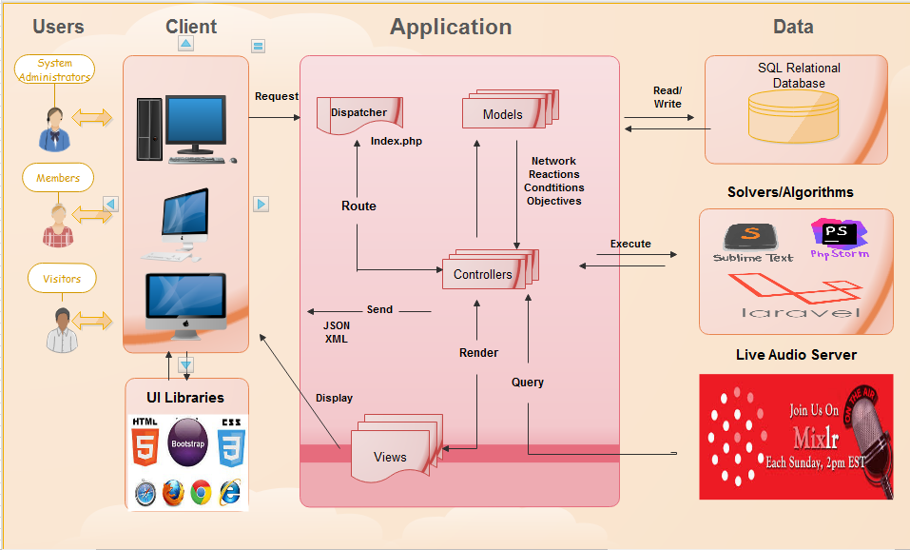

Figure 14: System Architecture for website

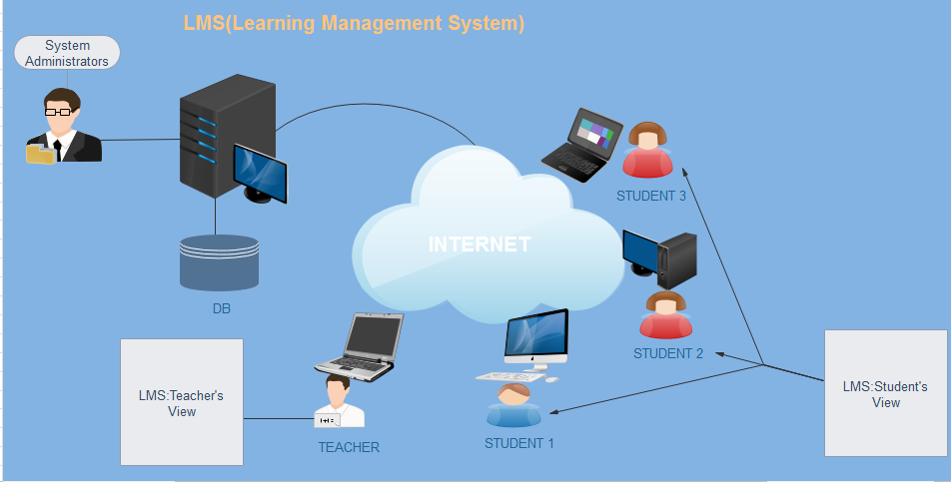

Figure 15: System Architecture for LMS

Class Diagram
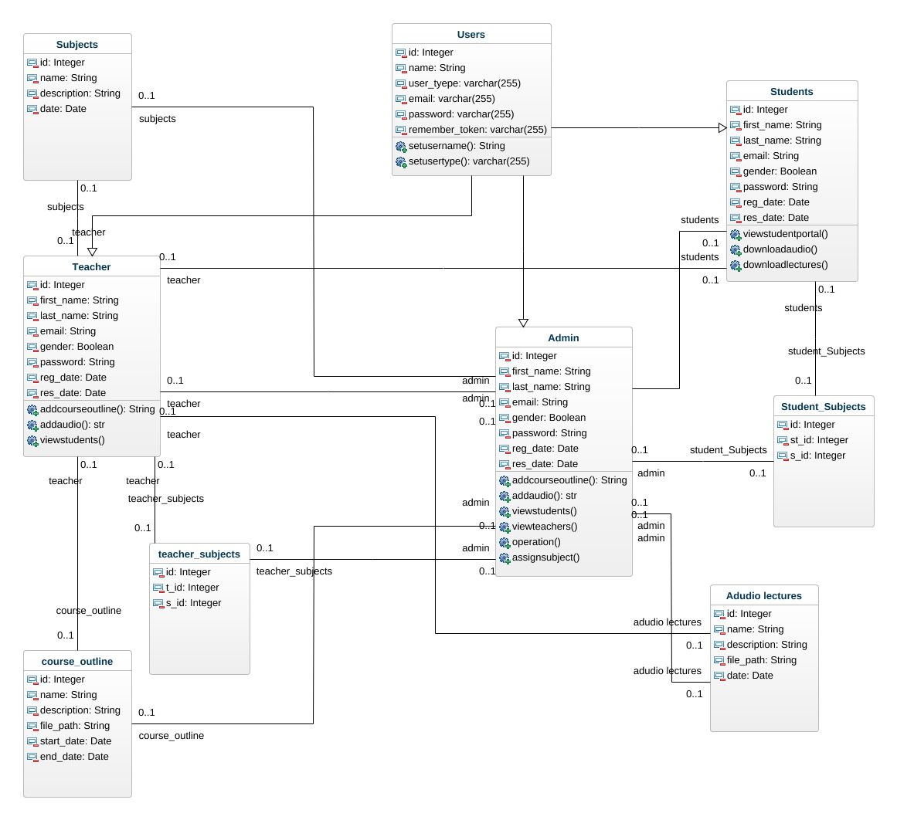

Figure 16: Class Diagram

Sequence Diagrams

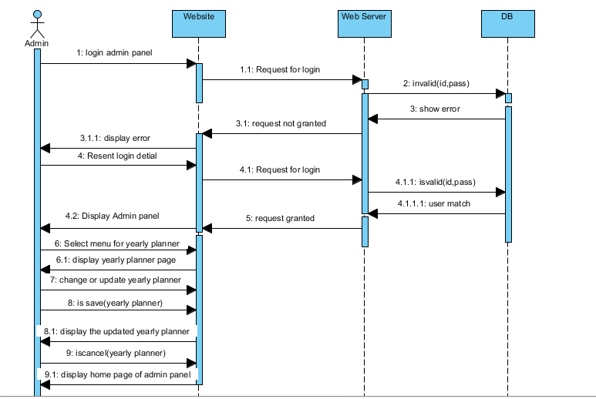
Figure 17: Manage Yearly Planner
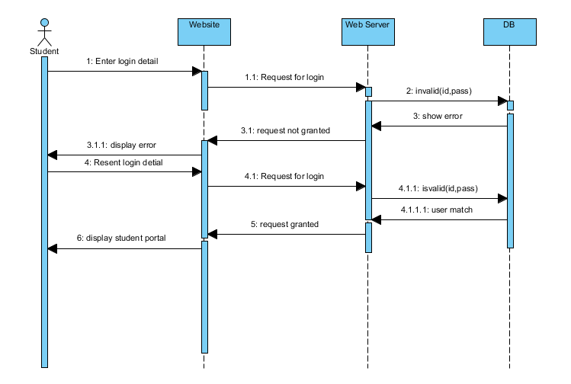Figure 18: Access to Student Portal
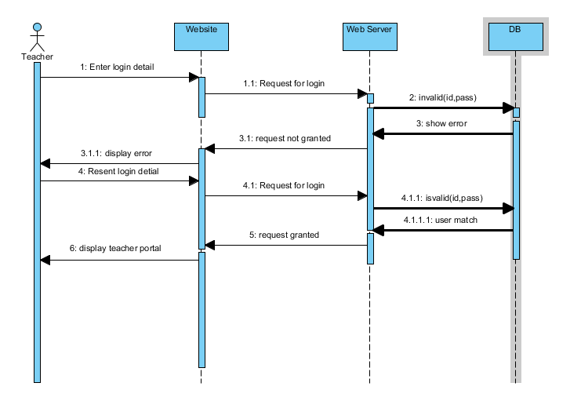
Figure 19: Access to Teacher Portal

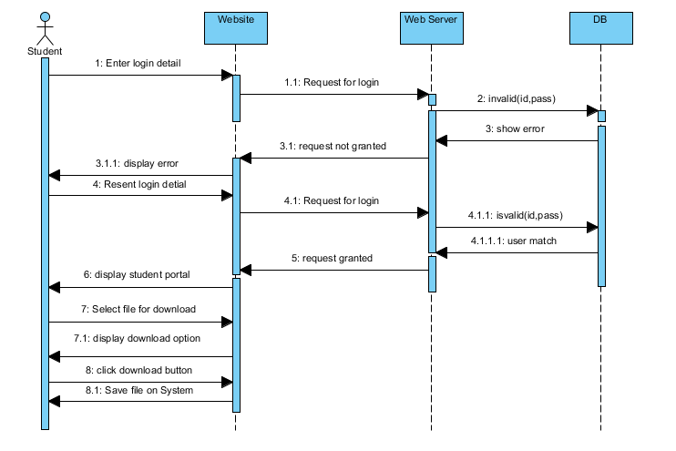
Figure 20: Download Tasks
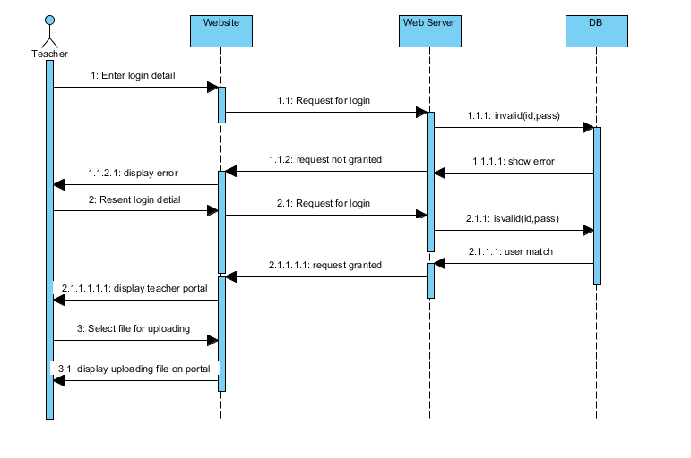
Figure 21: Upload Tasks

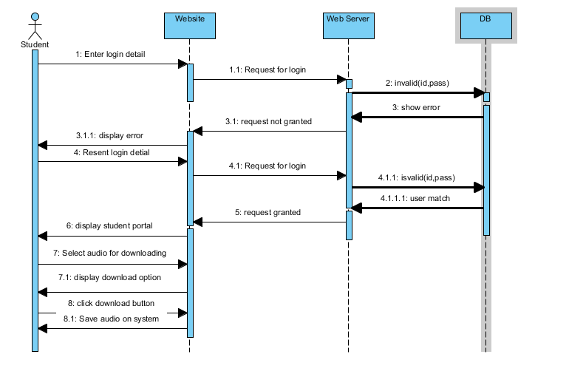
Figure 22: Download Audio Files

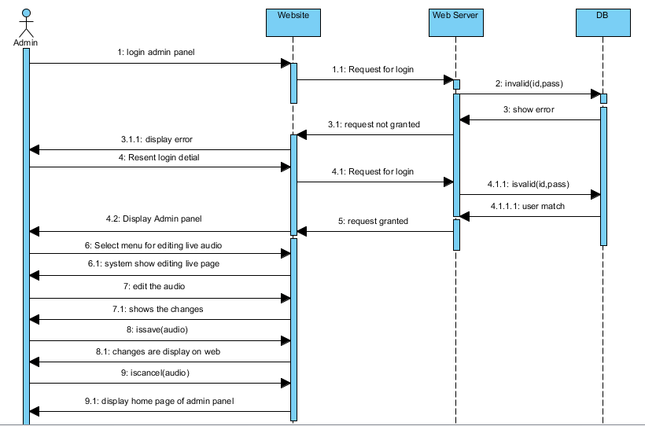

Figure 23: Manage Live Audio

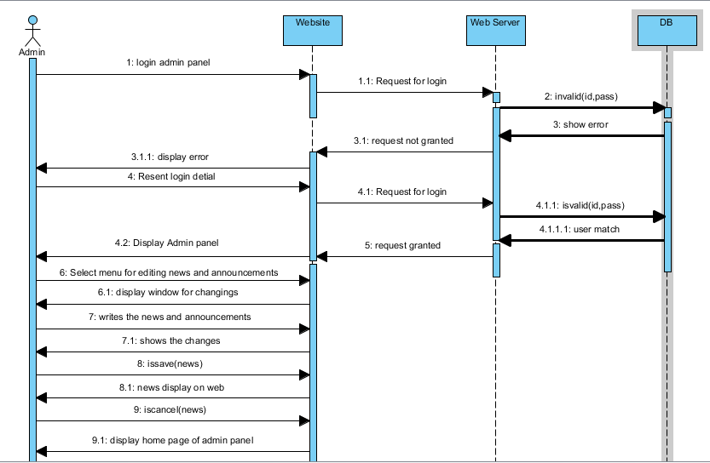
Figure 24: Manage News and Announcements
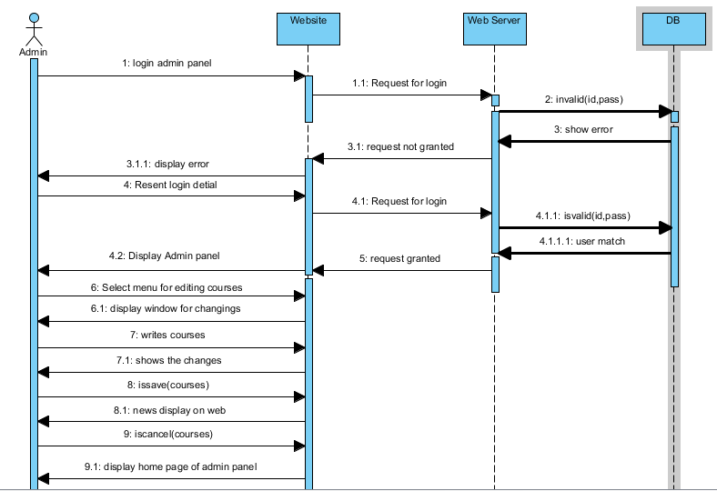

Figure 25: Manage Courses being offered

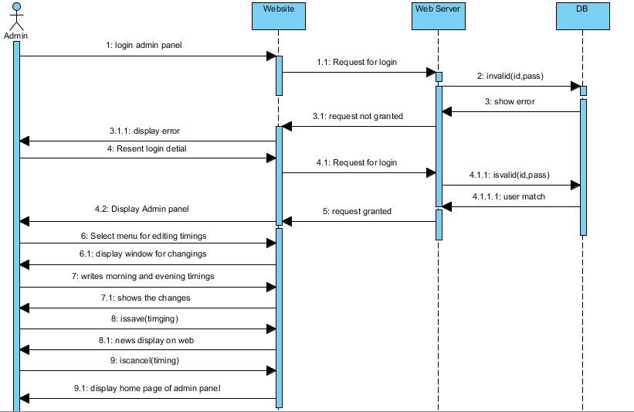Figure 26: Manage Morning and Evening Shifts

ERD

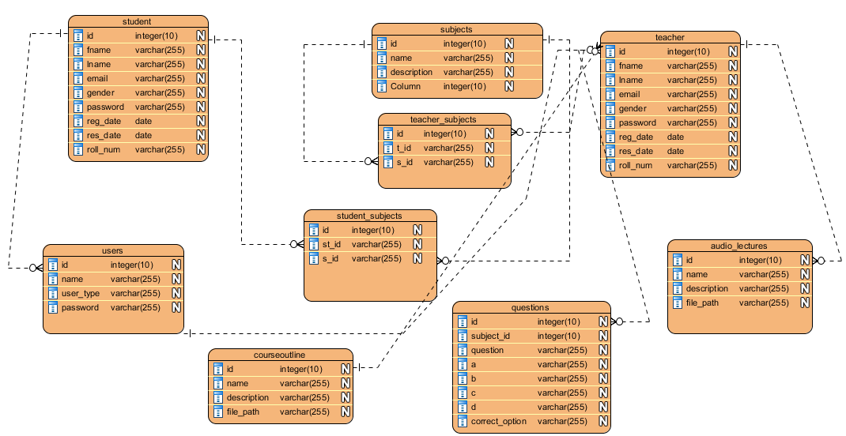

Figure 27: ERD

Implementation details

6.1 Development Setup
Our Whole team properly participated in development process.
We worked in the following set ups:
1. Editor for code writing
Sublime Text 3, PhpStorm
2. Local server Xampp
(PHP 7.0.1)

3. Live Testing Server
UBUNTU 16.04

4. Our database type is
MYSQL (5)

5. Operating System for development
Windows 10

6.2 Deployment setup

System Specifications:

- We have to configure PHP setup through local server xampp 7.0 on local machine

- We have to use database for data storing MYSQL 5

- We have to configure new Laravel5.3/5.4from git through commands and Instance configure on our local machine
Server Shifting:

- Through commands we have Laravel project folder
- In project folder, we have many folders like storage/images,audio,resources/views files, routes/path and public/css,js files folder
- In public folder we have images, css, and java script files.
- In routes folder, there is a path of our pages.
- Our Laravel instance shift from local Server to live server
- For public files, we have public path/Azzuhaa.com/public/
- In root directory like / we keep all remaining files.
- Configuration the database and its permissions
- In Laravel we have .env file where we configure the database.
Issues According to server shifting:

- Face server permissions issues after deploy the code(server file structure)

- Database Configuration issues

- Routes issues
Issues Overcome after Server Shifting:

- Set the database name according to the server.

- Create new database on our new server accordingly

- We export and import tables from our machine to live server where we have same php my admin.
- Change the name of the route.

Algorithms
- First Step to click live audio tab
- It shows the login authentication page for students
- Students login their valid id and password
- If email id and password wrong then display a message for invalid email id or password
- If email id and password right then successfully login and display the live audio player
- In this page user listen live lecture and live chat, if the lecture are going to live
- After listening live lecture, this page display shows offline and then user logout.

Constraints
A constraint specifies how the system must operate or how it must be built
- Firstly should server start

- PHP must be running on our server

- MYSQL must be running on our server

- Composer Should Proper installed on server for Laravel functionalities

6.4.1 Assumptions

Things we assume will be true.
e.g.:
- The entire database is going to be maintained by the customer.

- There is not going to be any interaction with the accounting systems

6.4.2 Restrictions

Constraints applied on the system by the client
- User must have internet

- User must have their own credentials for operate LMS portal

- All Teacher and Students create from admin users

- Students and Teachers can’t register his/her own profile

- Students can’t upload any content on system

6.4.3 Limitations
Services your software is unable to provide

- Teachers and Students have no rights for any content changes in website content

- Admin have almost access for changes in LMS portal and website but do not have all access for website content

- All users must have their own credentials for operate LMS portal

- All Teacher and Students create from admin users

- Students and Teachers can’t register his/her own profile

7. Testing

7.1Extended Test Cases
Here are some extended cases according to our running system.
- Audio Lectures
- Add Teachers Profile
- Add Students Profile
- Add Subjects
- Add Course Out Line
- Audio Live Streaming
- Assign Subjects To Teacher
- Assign Subjects To Student
- Download Lectures
- Download Course Outline
Test case ID: TID_01
Description: To verify the Admin User Functionality
Requirement ID: LMS_Login_Req_001
Designed by: Sania Asad
Designed date: 20/5/2017
Executed by: <leave blank for now>
Execution Date: <leave blank for now>
Complexity: Low
Criticality: High
Pre-requisites:
- Application URL is accessible
- A new admin user is created
- The user has not logged in to the LMS system before
Test Steps:
No | Action | Expected Behavior | Actual Behavior
1. | Enter Valid URL in the browser | Verify that login page is displayed
2. | Enter valid credentials of the newly created user and press login page | Verify that the user is taken to the welcome window
3. | Click on Dashboard tab from menu bar | Verify that the Dashboard is displayed | Display the Admin Dashboard
Post Condition: Admin Dashboard display on this site Menu.

Table 20: TID_ 01 Verify Admin User

Test case ID: TID_02
Description: To verify the functionality of User profile fields
Requirement ID: LMS_SignUp_User_002
Designed by: Sania Asad
Designed date: 20/5/2017
Executed by: <leave blank for now>
Execution Date: <leave blank for now>
Complexity: Low
Criticality: High
Pre-requisites:
- Application URL is accessible
- A new user is created
- The user has not logged in to the LMS System before
Test Steps:
No | Action | Expected Behavior | Actual Behavior
1. | Those fields are required like First Name,  Last name,  Gender,  Email,  Password,  Optional Field  Upload Image  and click the save button. | To verify that it shows the User detail on users details page (Teacher, Students) | If logout the system and display the login screen  If any users try to access LMS modules screen redirect to login screen.
Post Condition: Login Window is Display

Table 21 TID_ 02 Verify User Profile

Test case ID: TID_03
Description: Verify the image store functionality (Teacher’s/Student’s)
Requirement ID: LMS_User_Management_Req_003
Designed by: Sania Asad
Designed date: 20/5/2017
Executed by: <leave blank for now>
Execution Date: <leave blank for now>
Complexity: Low
Criticality: High
Pre-requisites:
- Application URL is accessible
- A new user is created
- The user has not logged in to the LMS System before
Test Steps:
No | Action | Expected Behavior | Actual Behavior
1. | Click the file storage field.  On Profile page and choose a particular image and click the save button. | To verify the image storage behavior and it save the image in server | It display the file explorer where I choose the particular image and it save the image and display the edit page information
2. | Click the file storage field and choose a particular document file form storage and click the save button. | Verify that the Image is save on the server | A message display,”Not a valid image format” it does not save the image file.
NOTE: Admin User can EDIT, DELETE and Update Record
Post Condition: User profile Screen is displayed.

Table 22: TID_ 03 Verify image/store Functionality

Test case ID: TID_04
Description: To verify the Student’s fields
Requirement ID: LMS_User_Management_Req_004
Designed by: Sania Asad
Designed date: 20/05/2017
Executed by: <leave blank for now>
Execution Date: <leave blank for now>
Complexity: Low
Criticality: High
Pre-requisites:
- Application URL is accessible
- A new user is created
- The user has not logged in to the LMS System before
Test Steps:
No | Action | Expected Behavior | Actual Behavior
1. | Click On Student’s tab and show the Student’s screen | Show Student’s screens | It display the Student’s  screen
2 | Enter the data in required fields  and Click on SAVE button | If every required field is filled continue the flow  and record should be saved | Continue the flow and record should be saved on database
NOTE: Admin User can EDIT, DELETE and Update Record
Post Condition: User Search window display

Table 23: TID_ 04 Verify Student Fields

Test case ID: TID_05
Description: To verify the Teacher’s fields
Requirement ID: LMS_User_Management_Req_005
Designed by: Sania Asad
Designed date: 20/05/2017
Executed by: <leave blank for now>
Execution Date: <leave blank for now>
Complexity: Low
Criticality: High
Pre-requisites:
- Application URL is accessible
- A new user is created
- The user has not logged in to the application before
Test Steps:
No
1. | Click On Teacher’s tab and show the Teacher’s screen | Show Teacher’s screens | It display the Teacher’s  screen
2 | Enter the data in required fields  and Click on SAVE button | If every required field is filled continue the flow  and record should be saved | Continue the flow and record should be saved on database
NOTE: Admin User can EDIT, DELETE and Update Record
Post Condition: User Search window display

Table 24: TID_ 05 Verify Teacher Fields

Test case ID: TID_06
Description: To verify the Teacher’s Login functionality
Requirement ID: LMS_Management_USER_006
Designed by: Sania Asad
Designed date: 20/05/2017
Executed by: <leave blank for now>
Execution Date: <leave blank for now>
Complexity: Low
Criticality: High
Pre-requisites:
- Application URL is accessible
- A new user is created
- The user has not logged in to the LMS System before
Test Steps:
No | Action | Expected Behavior | Actual Behavior
1. | When type wrong Email on Login screen | To verify the email field and expect to display the message about wrong Email | It display the user profile Screen
2. | When I click the password tab | To verify to show incorrect password message | It display the” incorrect password information. And something is omitted.
Post Condition: Teachers Profile Screen is displayed.

Table 25: TID_ 06 Verify Teacher Login

Test case ID: TID_07
Description: To verify the Student’s Login functionality
Requirement ID: LMS_Management_USER_007
Designed by: Sania Asad
Designed date: 20/05/2017
Executed by: <leave blank for now>
Execution Date: <leave blank for now>
Complexity: Low
Criticality: High
Pre-requisites:
- Application URL is accessible
- A new user is created
- The user has not logged in to the LMS System before
Test Steps:
No | Action | Expected Behavior | Actual Behavior
1. | When type wrong Email on Login screen | To verify the email field and expect to display the message about wrong Email | It display the user profile Screen
2. | When I click the password tab | To verify to show incorrect password message | It display the” incorrect password information. And something is omitted.
Post Condition: Students Profile Screen is displayed.

Table 26: TID_ 07 Verify Student Login

Test case ID: TID_08
Description: To Add Subject functionality
Requirement ID: LMS_Management_008
Designed by: Sania Asad
Designed date: 20/05/2017
Executed by: <leave blank for now>
Execution Date: <leave blank for now>
Complexity: Low
Criticality: High
Pre-requisites:
- Application URL is accessible
- A new user is created
- The user has not logged in to the LMS System before
Test Steps:
No | Action | Expected Behavior | Actual Behavior
1. | Add Required Field  Title,  Description  Click On save Button | Data Should be Enter In Data Base Subject Table  After save screen Should be Redirect On subjects detail Screen | IF required fields not filled then shows the error message according to fields
NOTE: Admin User can EDIT, DELETE and Update Record
Post Condition: Teachers Subjects Screen is displayed.

Table 27: TID_ 08 Add Subject

Test case ID: TID_09
Description: Assign Subjects T0 Teacher
Requirement ID: LMS_Management_009
Designed by: Sania Asad
Designed date: 20/05/2017
Executed by: <leave blank for now>
Execution Date: <leave blank for now>
Complexity: Low
Criticality: High
Pre-requisites:
- Application URL is accessible
- A new user is created
- The user has not logged in to the LMS System before
Test Steps:
No | Action | Expected Behavior | Actual Behavior
1. | Click on Assign Button from teacher profile screen then teacher Screen should be populate | Shows Teacher Subject screen | Teacher subject screen shown
2. | Select Teacher and Subject from drop down field and Save button | auto selected Teacher and subject should be select from admin user | After selected teacher and  subject record should be save and screen redirect on Teacher Profile screen
NOTE: Admin User can EDIT, DELETE and Update Record
Post Condition: Teachers Subjects Screen is displayed.

Table 28: TID_ 09 Assign Subjects to Teacher

Test case ID: TID_09
Description: Assign Subjects To Student
Requirement ID: LMS_Management_009
Designed by: Sania Asad
Designed date: 20/05/2017
Executed by: <leave blank for now>
Execution Date: <leave blank for now>
Complexity: Low
Criticality: High
Pre-requisites:
- Application URL is accessible
- A new user is created
- The user has not logged in to the LMS System before
Test Steps:
No | Action | Expected Behavior | Actual Behavior
1. | Click on Assign Button from Student profile screen then Student Screen should be populate | Shows Student Subject screen | Student subject screen shown
2. | Select Student and Subject from drop down field and Save button | auto selected Student and subject should be select from admin user | After selected student and  subject record should be save and screen redirect on student Profile screen
NOTE: Admin User can EDIT, DELETE and Update Record
Post Condition: Students Subjects Screen is displayed.

Table 29: TID_ 09 Assign Subjects to Students

Test case ID: TID_10
Description: To verify the Course Outline module fields
Requirement ID: LMS_Management_010
Designed by: Sania Asad
Designed date: 20/05/2017
Executed by: <leave blank for now>
Execution Date: <leave blank for now>
Complexity: Low
Criticality: High
Pre-requisites:
- Application URL is accessible
- A new user is created
- The user has not logged in to the LMS System before
Test Steps:
No | Action | Expected Behavior | Actual Behavior
1. | Fill All required fields  Title,  File upload,  Start Date,  End Date,  Optional Field  Description | Fields of Course Outline Screen displayed | Fields of Course Outline Screen displayed
2. | After Fill the required Fields and Click on SAVE button | After save records screen should be redirect on Course outline detail page | if Required fields not filled shown error message according to fields
NOTE: Admin User can EDIT, DELETE and Update Record
Post Condition: Course Out Line screen is displayed.

Table 30: TID_ 10 Verify Course Outline

Test case ID: TID_11
Description: To verify the Audio Lectures module fields
Requirement ID: LMS_Management_011
Designed by: Sania Asad
Designed date: 20/05/2017
Executed by: <leave blank for now>
Execution Date: <leave blank for now>
Complexity: Low
Criticality: High
Pre-requisites:
- Application URL is accessible
- A new user is created
- The user has not logged in to the LMS System before
Test Steps:
No | Action | Expected Behavior | Actual Behavior
1. | Fill All required fields  Title,  Audio File upload,  Start Date,  End Date,  Optional Field  Description | Fields of Audio Lectures Screen displayed | Click on audio file upload and shown just audio files
2. | After Fill the required Fields and Click on SAVE button | After save records screen should be redirect on Audio Lectures detail page | if Required fields not filled shown error message according to fields
NOTE: Admin User can EDIT, DELETE and Update Record
Post Condition: Audio Lecture screen is displayed.

Table 31: TID_ 11 Verify Audio Lectures

7.2Code snippet

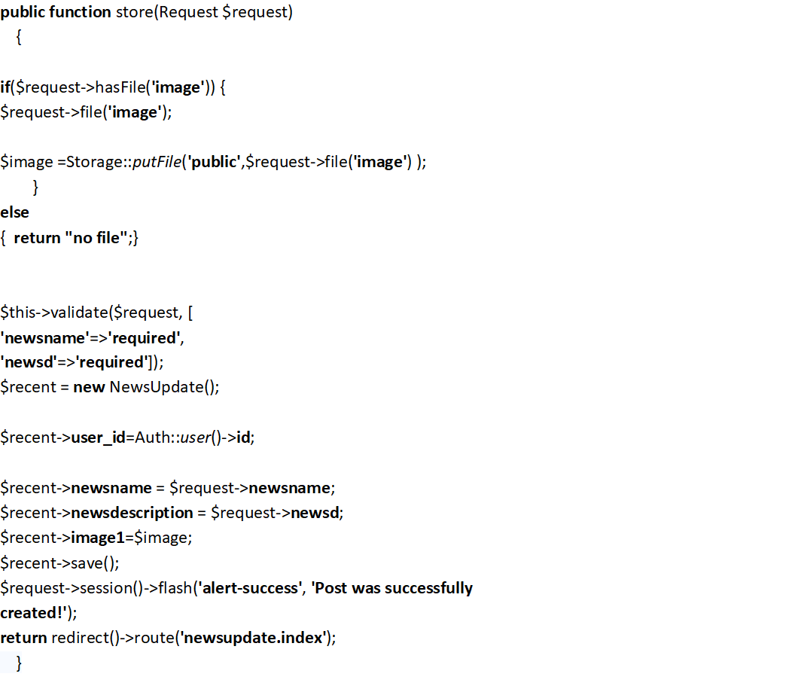
News Store Controller
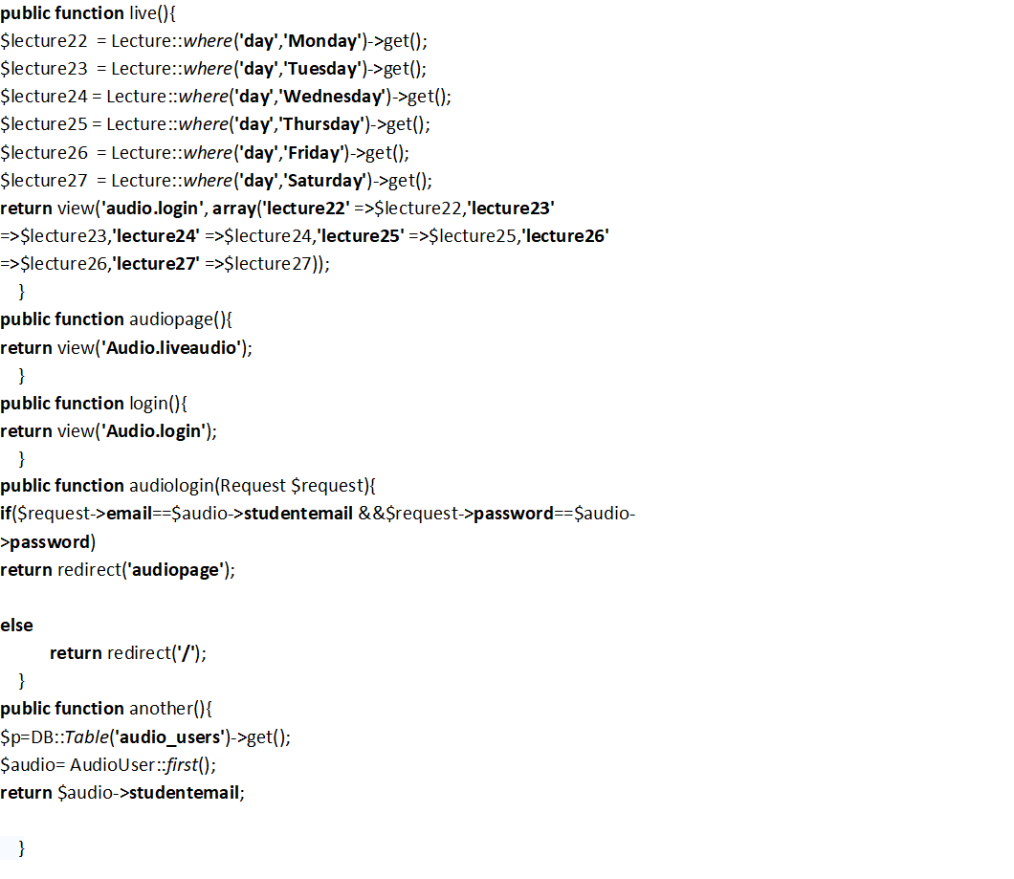
Live Audio Code

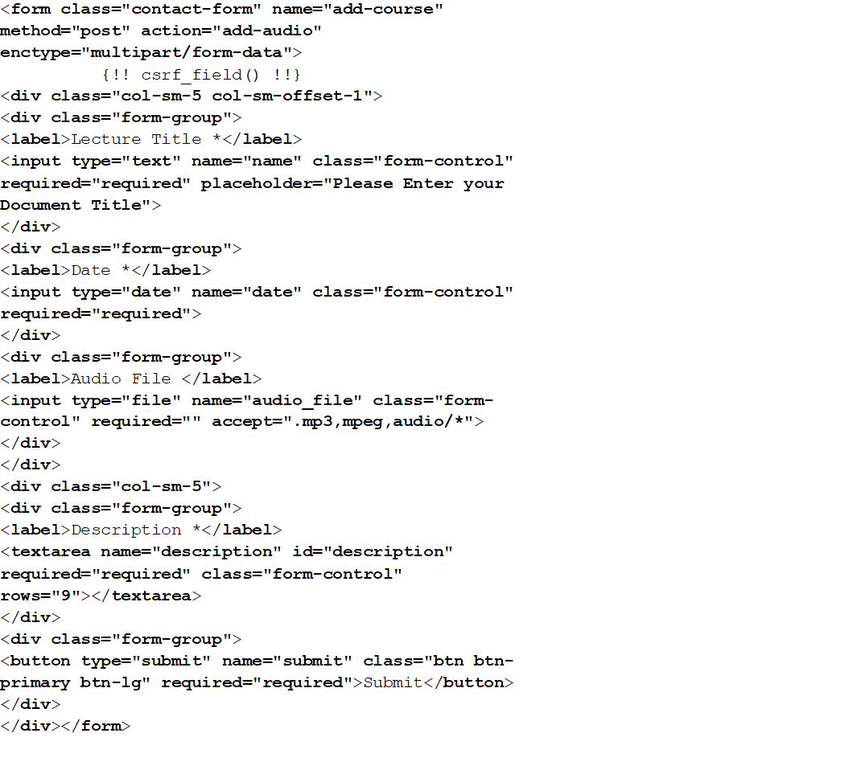
Add Audio

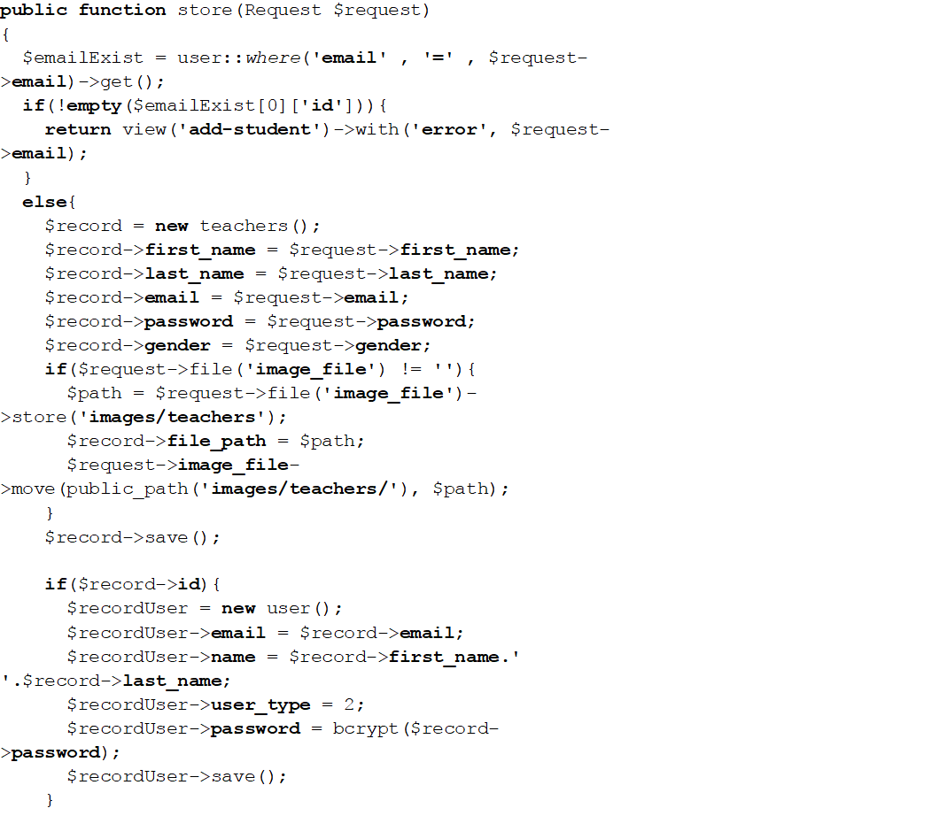
Teacher Store Controller

7.3 Traceability Matrix

7.3.1 RID vs UCID (Requirements vs UCs)
RID/UCID | R1 | R2 | R3 | R4 | R5 | R6 | R7 | R8 | R9 | R10 | R11 | R12 | R13 | R14 | R15 | R16 | R17 | R18 | R19 | R20 | R21 | R22 | R23
UC ID 1 | ×
UC ID 2
UC ID 3
UC 1D 4
UC ID 5
UC ID 6
UC ID 7
UC ID 8
UC ID 9
UC ID 10
UC ID 11
UC ID 12
UC ID 13
UC ID 14
UC ID 15

Table 32: Requirements vs.UCs

7.3.4 PID VS TID

PID/TID | TID 1 | TID 2 | TID 3 | TID 4 | TID 5 | TID 6 | TID 7 | TID 8 | TID 9 | TID 10 | TID 11
PID 1
PID 2
PID 3
PID 4
PID 5
PID 6
PID 7
PID 8
PID 9
PID 10
PID 11
PID 12
PID 13

Table 33: PID VS TID

7.3.2. Test Cases (RID vs TID)

TID/RID | R1 | R2 | R3 | R4 | R5 | R6 | R7 | R8 | R9 | R10 | R11 | R12 | R13 | R14 | R15 | R16 | R17 | R18 | R19 | R20 | R21 | R22 | R23

TID 1

TID 2

TID 3

TID 4

TID 5

TID 6

TID 7

TID 8

TID 9

TID 10

TID 11

Table 34: Requirements vs. Test cases

7.3.3. Coverage (UCID vs TID)
UCID/TID | TID 1 | TID 2 | TID 3 | TID 4 | TID 5 | TID 6 | TID 7 | TID 8 | TID 9 | TID 10 | TID 11
UC ID 1
UC ID 2
UC ID 3
UC 1D 4
UC ID 5
UC ID 6
UC ID 7
UC ID 8
UC ID 9
UC ID 10
UC ID 11
UC ID 12
UC ID 13
UC ID 14
UC ID 15

Table 35: Test cases vs. UCs

8. Results/Output/Statistics

8.1 Completion
I have checked the whole system and its working scenarios, all of these are complete and working well according to requirements and UCs. Estimation of work is 100% which we promise to complete.
Completion = $\frac{Fullfilled Requirements}{Total Requirements}$×100
Completion = $\frac{23}{23}$×100
Completion = 100%

8.2 Accuracy
Accuracy is 100% perfectly fine. I have to validate the system and its working scenarios Accurate according to requirements and UCs.
Accuracy = $\frac{Total PID}{Tested PID}$×100
Accuracy = $\frac{13}{13}$×100
Accuracy = 100%

8.3Correctness
100%data is giving authentic information. I have to validate the system and its working scenarios correct according to requirements and UCs.
Correctness = $\frac{Tested usecases}{Total Usecases}$×100
Correctness = $\frac{15}{15}$×100
Correctness = 100%

9.Conclusion

Our developing the proposed fully online computerized maintenance system for Learning
Management System (LMS) allows its maintenance personals to obtain the daily work schedule which includes the fault and routine tasks, Maintenance Administrator and all relevant departments who log faults to track the status of faults and provide feedback or to escalate. Also Examination management to monitor the ongoing maintenance issues and importantly the Examination department can see the Result and states of Student of different students. This will provide effective, reliable, efficient maintenance system which solved current ineffective, inefficient, highly time consuming, and complex procedures. Also implementing this system will dramatically reduce the usage of the paper work will give an opportunity to a step forward, towards
UMT - University of Management and Technology eco-friendly pledge.
Quickly summarizing all the efforts put into this project. We would like to conclude that this project has definitely helped us enhancing our Web Designing skills and improve our existing knowledge in PHP and its framework Laravel in a unique way. We learnt various nitty-gritty of web designing as well as learnt more of PHP, CSS and, JAVASCRIPT. We have also learnt of how to implement database handling with PHP, using various MySQL commands and its structure.
Last but not the least, we have also learnt the importance of Web Modeling and learnt the proper methodology of developing web related projects. Like any other web-application my website had errors too.
We had also performed proper testing so as to ensure that my website remains robust usable and manageable.
Working as a PHP Web application designer and Programmer proved quite of a unique experience. We sure this project would be beneficial for us in the near future.

10. Future Work
Our Current System is WEB based system and its on PHP (Hypertext Preprocessor) 7.0 and MYSQL version is 5* and frame Work is Laravel 5.4.Laravel is the most popular framework in web technologies.

Currently our system fully development according to programing rules and follow the framework.
We will integrate further these modules in our system.
- Classes
- Attendance
- Payments
- salaries
- Promotion process for junior classes to senior classes

11. Bibliography

Books
- B. Klaus and P. Horn, Robot Vision. Cambridge, MA: MIT Press, 1986.
- L. Stein, “Random patterns,” in Computers and You, J. S. Brake, Ed. New York: Wiley, 1994, pp. 55-70.
- Roger S. Pressman, Software Engineering, 5th edition (ISBN 07-510067577-1)
- Carliner, S. (1999). Overview of online learning. Amherst, MA: Human Resource Development Press.
- Khan, B. (1997). Web‐based instruction: What is it and why is it? In B. H. Khan (Ed.), Web‐based instruction
- Rosenberg, M. (2006), Beyond E John Wile & Son Inc.
- Mair, D. (2005), E‐Learning – das Drehbuch Springer‐Verlag Berlin Heidelberg.

Articles

[8.]Abrami, P. C., &Bures, E. M. (1996). Computer-supported collaborative learning and distance education. The American Journal of Distance Education, 10(2), 37-42.
[9.] Baker, M., & Lund, K. (1997). Promoting reflective interactions in a CSCL environment. Journal of Computer Assisted Learning, 13(3), 175–193. doi:10.1046/j.1365- 2729.1997.00019.x
[10.]Bender, B. (2005). Learner engagement and success in CMS environments. In P. McGee, C. Carmean& A. Jafari (Eds.), Course management systems for learning: Beyond accidental pedagogy (pp. 107-113). Hershey, PA: Information Science Publishing.
[11.]Bradford, P., Porciello, M., Balkon, N. & Backus, D. (2006-2007). The blackboard learning system: The be all and end all in educational instruction? Journal of Educational Technology Systems, 35(3), 301-314. doi:10.2190/X137-X73L-5261- 5656
[12.]Brandon, D. P., & Hollingshead, A. B. (1999). Collaborative learning and computersupported groups. Communication Education, 48(2), 109-126. doi:10.1080/03634529909379159
[13.]Curtis, D. & Lawson, M. (2001). Exploring collaborative online learning. Journal of Asynchronous Learning Networks, 5(1), 21-34.

12. Appendix

12.1. Glossary

Course Catalog | Repository of all training objects held within the system including online courses, quick courses, events, libraries, and curricula.
Event (Course) | User must complete Post‐Work or their status will be Incomplete when the session is marked complete
External Training | Training taken outside of the LMS catalog(s)
Facility | Physical space used for instructor‐led training session.
Session (Class time) | Specified scheduled instances of an event
Accessibility | The degree to which your website is easy to use.
Algorithm | A specific set of steps for carrying out certain tasks. Algorithms are used extensively in computer programming to arrive at a solution for a specific problem.
Browse | The process by which a user accesses various web resources.
Case Sensitive | A situation where it is important if a letter or a set of letters are in upper or lower case.
Chat | Communication between internet users that occurs through various mediums that allow for text-based communication such as instant message programs, chat rooms, and forums.
Database | A collection of data stored in a computer in such a way that a program or a webpage can easily find, select, and/or manipulate the desired data. Typically, databases are organized by fields, records and files. A field is one piece of data, a record is a collection of fields, and a file is a collection of records.

Table 36: Glossary

12.2. Pre requisites:
Our System’s pre-requisites are mentioned below:

- PHP 5.6* - 7.0*
- MYSQL 5*
- Local server Xampp
- Framework Laravel 5.4
- Sublime text
- Live server (Linux based - Ubuntu 16.04)

