Final Year Project Report
CashFree


Project Advisor:
Dr Khawaja Muhammad Umar Suleman

Submitted By:
Abadullah Chaudhry (F2016266218)
Abdur Razaq (F2016266013)
Hamza Fayyaz Bashir (F2016266069)

Session
BS Computer Science
(2016-2020)

University of Management and Technology
C-II Johar Town Lahore Pakistan

Dedication
We would like to dedicate this project to the members of our family and especially our advisor Dr Khawaja Muhammad Umar Suleman, who has guided us throughout our university life. Also we would like to dedicate this to UMT, A university which ranks among the top universities of Pakistan and we were lucky enough to get a chance to study in this highly renowned university.

Final Approval

- Head of Department ______________________
Department of Computer Science
School of Systems and Technology
UMT Lahore

- Director Final Year Projects ______________________
Department of Computer Science
School of Systems and Technology
UMT Lahore

- Supervisor ______________________
Department of Computer Science
School of Systems and Technology
UMT Lahore

- Co-Supervisor (if any) ______________________

Acknowledgment
We would like to acknowledge our professor and advisor, Dr Khawaja Muhammad Umar Suleman who has guided and always motivated us to do our best and give our 100% no matter what. We would also like to acknowledge the SST department for approving our idea. And lastly we would like to mention the staff of IPC and FYP lab, who provided us the software we needed to complete our project.

Project Details
Project Title:
CashFree
Objective:
CashFree’s mission is to eliminate the need of carrying cash all the time, whenever a person has to complete a certain transaction, they can use our app and within seconds, they can scan their face or thumb for confirmation and their transaction will be completed.

Undertaken by
Abadullah Chaudhry (F2016266218)
Abdur Razaq (F2016266013)
Hamza Fayyaz Bashir (F2016266069)
Supervised by
Dr Khawaja Muhammad Umar Suleman
Starting Date
15/07/2019
Completion Date
09/09/2020
Tools Used
Android Studio, Firebase
Operating System
Windows 10
Documentation
MS Word Professional 2016

Plagairism Report

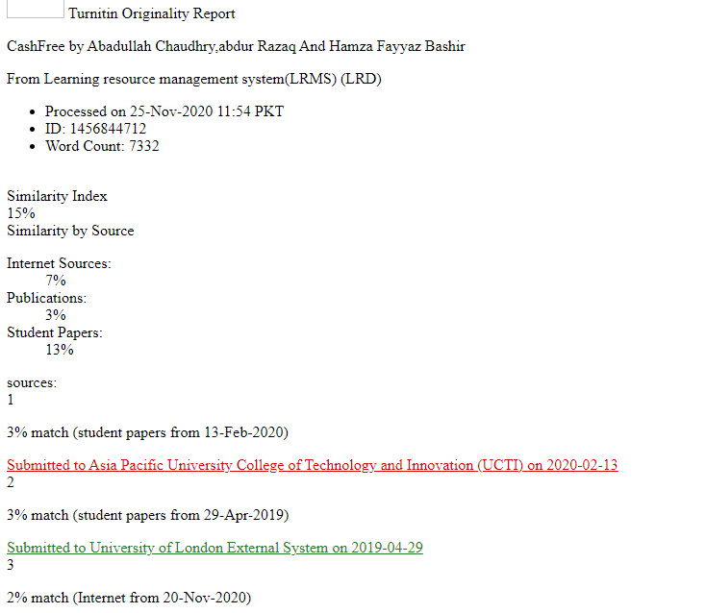

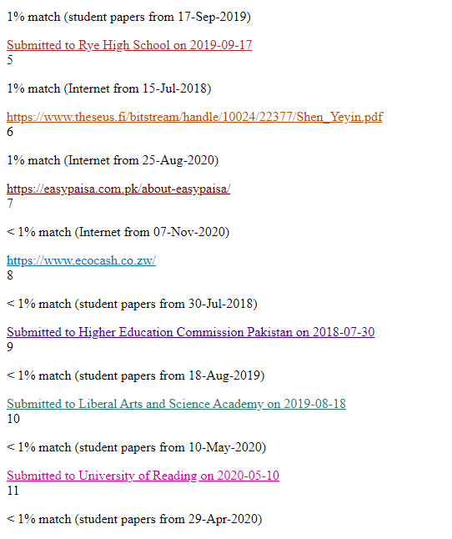

Supervisor’s Approval

I have carefully examined the documentation of the Final Year Project titled “CashFree” and I endorse that this documentation complies with the standards of an undergraduate level Final Year Project report.
Moreover, I have also checked for the plagiarism beyond Turnitin in the documentation and I am convinced that this documentation is not plagiarized.

Signature: __________________ Date: ___________________

Abstract
World is a fast growing place and to keep up with it, we need to keep up with the technologies that are emerging in this new era and taking over the world in an exponential way. The world of trading is gaining impressive speed. New methods of payment are being introduced to the world day by day. Our application “Cash Free” is also one of these latest methods with some extra and exciting features of security like face recognition, thumb impression and QR scanning. The application provide its users a secure, user-friendly, efficient and convenient environment which allows them to pay for any kind of a product with the help of QR scanning. The smartphone will act as wallets and users can carry their e-cash everywhere without any security issue. Our method of payment and the process of how we provide security is simple and elegant. The user will create an account and will have the ability to switch to the vendor side, if the need arises for the customer to be also a vendor. The vendor will generate a QR code which when scanned will tell the total amount of the bill which needs to be paid. The customer will then be asked to confirm payment with the help of thumbprint scan, face scan or pin. After confirmation the amount will be transferred to the vendor’s account. Both the customer and vendor will get a receipt of the payment in their history. If the user requires the need of cash then they simply will generate a request of cash withdrawal and after request is accepted by the admin, the user will be able to take out the cash from their account. The user can also transfer balance to any other user. If someone forgets their password, they can go to the confirm password option and change their password. CashFree is very easy to use and has a friendly user interface.

Revision Chart

Version | Primary Author(s) | Description of Version | Date Completed
Documentation and overview | Dr Khawaja Muhammad Umar Suleman | The complete overview of the documentation was followed. | 15/09/2020
Capstone 1 | Hamza Fayyaz Bashir | Complete documentation for capstone1 | 24/06/2019
Capstone 1(Revision) | Hamza Fayyaz Bashir | Revised and improved documentation | 03/01/2020
Final | Hamza Fayyaz Bashir | This tells us the sequence of how our a | 17/12/2020

Contents
Contents 1
Definitions and Acronyms 3
List of Figures 4
List of Tables 5
1. Introduction 6
1.1 Motivations 6
1.2 Project Overview 6
1.3 Problem Statement 6
1.4 Objectives 6
2. Domain Analysis 7
2.1 Customer 7
2.2 Stakeholders 7
2.3 Affected Groups with social or economic impact 7
2.4 Dependencies/ External Systems 7
2.5 Reference Documents 8
2.5.1 Related Projects 8
2.5.2 Feature Comparison 9
3. Requirements analysis 10
3.1 Requirements 10
3.2 List of Actors 13
3.3 List of use cases 13
3.4 System use case diagram 14
3.5 Use Cases 14
3.6 User interfaces (mock screens) 19
4. System Design 38
4.1 System Architecture Diagram 38
4.2 Class Diagram 39
4.3 Sequence Diagrams 40
4.4 Collaboration Diagrams 42
4.5 ERD 43
4.6 Data Flow diagram 43
5. Implementation details 47
5.1 Development Setup 47
5.2 Deployment setup 47
5.3 Algorithms 48
5.4 Constraints 53
5.4.1 Assumptions 53
5.4.2 System constraints 53
5.4.3 Restrictions 53
5.4.4 Limitations 53
6. Testing 54
6.1 Test Cases 54
6.2 Traceability Matrix 62
6.2.1 RID vs UCID (requirements vs use cases) 62
6.2.2 Prototypes (RID vs PID) 62
6.2.3 Test Cases (RID vs TID 63
6.2.4 Coverage (UCID vs TID) 63
7. Statistics 64
7.1 % Completion 64
7.2 % Accuracy 64
7.3 % Correctness 64
8. Conclusion 65
9. Future work 66
10. Bibliography 67
10.1 Books 67
10.2 Articles 67
10.3 Other References 67
11. Appendix 68
11.1 Glossary of terms 68
11.2 Pre-requisites 68

Definitions and Acronyms

Table 1: Definitions and Acronyms
Acronym | Definition
UMT | University of Management and Technology
CF | CashFree
PID | Prototype Identity
TID | Test Case ID
RID | Requirement ID
FB | Firebase
UML | Unified Modeling Language
AS | Android Studio

List of Figures

Figure 1 : CashFree Use Case Diagram 14
Figure 2: Splash Screen 19
Figure 3: Verfication Number Screen 20
Figure 4: Sign Up Screen 21
Figure 5 : Confirm Password Screen 22
Figure 6: Login Screen 23
Figure 7: Let's Start Screen 24
Figure 8: Customer Main Screen 25
Figure 9: Bill History Screen 26
Figure 10: Reset Password Screen 27
Figure 11: Share Balance Screen 28
Figure 12: Top Up Screen 29
Figure 13: Vendor Main Screen 30
Figure 14: Vendor Bill History Screen 31
Figure 15: Vendor Information Screen 32
Figure 16: Withdrawal Cash Screen 33
Figure 17: Payment Through Pin Screen 34
Figure 18: Customer Bill History Screen 35
Figure 19: Withdrawal History Screen 36
Figure 20: Vendor History Screen 37
Figure 21: System Architecture 38
Figure 22: CashFree Class Diagram 39
Figure 23: Sequence Customer Diagram 40
Figure 24: Sequence Vendor Diagram 41
Figure 25: Collaboration Diagram 42
Figure 26: Entity Relationship Diagram 43
Figure 27: Data Flow Level 0 Diagram 44
Figure 28: Data Flow Level 1 Diagram 45
Figure 29: Data Flow Level 1 Diagram 46

List of Tables
.
Table 1: Definitions and Acronyms 2
Table 2: List of Stakeholders 7
Table 3: Feature Comparison 9
Table 4: Product Requirements 10
Table 5: Functional Requirement 11
Table 6: Non- Functional Product Requirements 13
Table 7: Register Use Case 15
Table 8: Login Use Case 15
Table 9: Deposit Cash Use Case 16
Table 10: Cash Withdrawal Use Case 16
Table 11: Transaction History Use Case 17
Table 12: Payment Bill Use Case 17
Table 13: Generation of Bill Use Case 18
Table 14: Phone Verification Test Case 51
Table 15: Sign Up Test Case 52
Table 16: Confirmation Test Case 53
Table 17: Thumbprint Test Case 53
Table 18: Facial Scan Test Case 54
Table 19: Customer/Vendor Test Case 55
Table 20: Payment Test Case 55
Table 21: Create Bill Test Case 56
Table 22: Transaction Test Case 57
Table 23: Help Test Case 58
Table 24: TM RID vs. UCID 59
Table 25: TM RID vs. PID 59
Table 26: TM RID vs. TID 60
Table 27: TM UCID vs. TID 60
Table 28: Glossary of terms 65

Introduction

Motivations
Often we face a problem that we have forgotten our wallet at home. This is a very common problem faced by everyone. To solve this problem we have come up with a solution which is “CashFree” which is a mobile application which will act as your wallet in a secure and advanced manner. Advancement in technology is growing day by day. If we go and compare two decades which passed by, we will be able to see noticeable difference in terms of technology. In terms of finances, there has been huge progress with new technologies like blockchain which ensures a safe and secure way of business transactions between two people. Our team has come up with an idea of an electronic wallet which in layman terms can be explained as all your money inside a mobile but in a fully secure way.

Project Overview
The main objective of the project is to secure the payment method with the help of new technologies and latest security techniques e.g. face recognition, thumb impression and QR scanning. Our goals are carrying cash in a secure and more modern manner. We also provide a platform where both customers and vendors are involved. The process of payment through our app is very safe and also very much easily available. Our main goals are efficiency, reliability, securability, portability and top priority is to replace the need of carrying money all the time.

Problem Statement
As population is increasing by millions every month, the number of markets are growing exponentially. That means more people are roaming around with their money and are more likely of being robbed. As we have stated many times that often people tend to forget their wallet in their home so to solve that particular problem we came up with the solution which is our app “CashFree”. We found out that people do not like to carry cash with them wherever their go but at the same time they want to buy things wherever they go.

Objectives
The objectives of the CashFree are:
- Security and Convenience = these both are primary goals when it comes to the making of CashFree. We want CashFree to be a safe gateway for transactions between vendors and their customers.
- Replace your wallet with your phone = our aim is to replace the need of carrying cash all the time. All the people will need to carry is their phone, which we already know that almost everyone has their own phone.

Domain Analysis

Customer
We are targeting vendors and their customers. Both should rely on us when it comes to carrying out a transaction. Currently we face competitors, our intention is to move ahead of them and become the most secure and reliable application when it comes to an electronic wallet. All those who owns a smartphone are our customer and are involved in any kind of selling or buying.

Stakeholders
The list of stakeholders involved in our project are as follows:

Table 2: List of Stakeholders
Stakeholder | Role in System
Customer | Customer will be responsible for the main purchasing from vendor through our application and will avail all the offers given by the admin side.
Vendor | Vendor will also act as a customer to our application. The job of the vendor is to setup a virtual store on our application and start receiving payments. Also to avail all the offers given by the admin side.

Affected Groups with social or economic impact
The groups which are affected by the socially or economically are listed as follows:
- Anyone who owns a phone:
Will help everyone who are involved in some sort of buying and selling as it eliminate the limitations applies on carrying cash (paper money) with them.
- Small Business Owners:
Will save time and reduce effort of going to banks for deposit or withdrawal of cash for buying and selling.
- Students:
Will provide students with an easy and secure way to spend.

Dependencies/ External Systems
Systems and/ or products, this project depends upon for its completion:
- Internet Services
- Server
- Easypaisa.
- Smartphones

Reference Documents

Related Projects
The documents which have been used in the development for this project:

- EasyPaisa: This is Pakistan’s major and mostly used e-wallet. We used it as a guidance. Easypaisa, Pakistan’s first mobile banking platform launched in 2009, is the only GSMA mobile money certified service in the country. Initially launched as a money transfer service. Easypaisa has today become the category name for money transfers, synonymous with convenience and reliability. The link is https://easypaisa.com.pk/about-easypaisa

- EcoCash: This is a Zimbabwe based company which is similar to easypaisa and deals in micro financing. A system that is developed in Zimbabwe and is now the main source of money transfer. Eco Cash is an innovative mobile payment solution that enables customers to complete financial transactions directly from their mobile phone. Customers can send money to loved ones, buy airtime, pay for goods and services and much more. The link of this website is https://www.ecocash.co.zw/about

Moreover, we dived in other projects which are similar to ours or even remotely related to ours so that we can find something new.

Feature Comparison

Table 3: Feature Comparison
Sr. No | Comparison Feature | EasyPaisa | EcoCash | Remarks
 | Cash Deposit | Easypaisa allow its users to deposit cash into their E-wallet setup by the application | Eco cash also support this feature. | This feature also supported by our application as it is one of the most essential element of the whole idea.
 | QR scanning | Easypaisa allow its users to pay using the QR scanning option. | Eco cash do not have QR scanning payment method in it. | The feature of QR scanning payment method can be made more secure by adding a thumb impression verification which we will apply to our application.
 | Face Recognition | Present Manually | Eco cash do no support face recognition. | This feature can help us to make the system more secure and prevent it from attackers not only at the time of sign up but every time the user will try to enter into the application.
 | Cash Withdrawal | Easypaisa support this feature as it has its franchises nearly in every city of Pakistan | Eco cash also support this feature as it allow its users to withdrawal cash from their franchises. | This feature can be modified by adding discount offers on withdrawal or cashback on deposit.
 | Transaction History | Supports this feature as well | This is also present. | This feature tells us all past transactions.

Requirements analysis

Requirements

Table 4: Product Requirements
Interface Requirements | - Phone number verification Screen (appears only whenever you download the application )  - Sign up Screen ( To create the account )  - Login Screen ( If account is already created )  - Home Screen ( Select the mode Customer/Vendor )  - Vendor Screen  - Generate bill button (Tap to Generate QR for the entered amount)  - Conformation button (Tap when you receive a conformation pop-up of the received payment)  - Balance button (Tap to check balance and history)  - Customer Screen  - Scan bill button ( Tap to scan QR generated against your bill)  - Pay button ( Tap to release payment from your account)  - Balance ( tap to check balance and history
Non-Functional Requirements | - System must be accurate.  - System must be secure as it is the most important part of the whole idea.  - System must provide extra and convincing features compared to the existing systems  - System must be user-friendly.
Programming Languages | - Java  - Xml  - Java Script
Design Constraints | - System should be compatible for every device and every operating system like android and ios. Initially the system is being developed on android platform.  - System must meet all the standards of security which are mandatory for every application developed.  - System must use real-time database for fast and efficient transactions.
External interface requirements | - Phone number verification Screen ( appears only whenever you download the application )  - Sign up Screen ( To create the account )  - Login Screen ( If account is already created )  - Home Screen ( Select the mode Customer/Vendor )  - Vendor Screen  - Generate bill button (Tap to Generate QR for the entered amount)  - Conformation button (Tap when you receive a conformation pop-up of the received payment)  - Balance button (Tap to check balance and history)  - Customer Screen  - Scan bill button ( Tap to scan QR generated against your bill)  - Pay button ( Tap to release payment from your account)  - Balance ( tap to check balance and history)

Table 5: Functional Requirement
RID | Description | Category | Attribute | Details and Boundary Constraints
R1 | Verify user’s mobile number | Functional Requirement | Mobile Verification | User provide its mobile number on running the application for the first time after downloading.
R2 | Allow users to create an account | Functional Requirement | Sign Up | User provide the credentials required.
R3 | Allow users to login. | Functional Requirement | Login | User provide the username and password or thumb impression to login.
R4 | Welcome screen is displayed. | Functional Requirement | Home | User choose the mode to enter.  Vendor / Customer
R5 | Allow user to enter in customer mode. | Functional Requirement | Customer Home | Here user can perform activities related to the customers.
R6 | Application must request the mobile operating system to access camera | Functional Requirement | Get Camera | Application will get access if the phone has one in working.

R7 | Allow users to check balance. | Functional Requirement | Balance | Users can check their remaining balance and their billing history.
R8 | Application must send a request to connect to the specified database. | Functional Requirement | Connect to Firebase | Application will send a request though internet to get access to the real time database.  Internet connection is necessary.
R9 | Allow users to input their thumb impression as password. | Functional Requirement | Enter Thumb | Application will store the thumb impression for verification and password.  Device must have thumb impression option.
R10 | Allow users (Vendors) to Generate QR against total amount entered. | Functional Requirement | Generate Bill | User can tap the bill button to generate a QR bill on its screen which the other user can scan.
R11 | Allow users to enter their face as face-id | Functional Requirement | Face Recognition | Application will request device for camera access to save the face of the user using face recognition techniques.  Working camera is must
R12 | Allow users to top balance | Functional Requirement | Balance | Users can recharge their account anytime by the methods provided by the system.
R13 | Allow users to share or send balance to other users | Functional Requirement | Share | Users can share balance with each other without going to a third party.  Both ends need to create an account on the application.

Table 6: Non- Functional Product Requirements
RID | Description | Category | Attribute | Details & Boundary Constraints
NR1 | Training data for face recognition and thumb impression must be saved within the device before deleting. | Non-Functional Requirement | Data Storage | Application must request the device to get space in the memory to save files relate to face and thumb impression.  Device need to have space.
NR2 | Verify email address | Non-Functional Requirement | Verification | Application must verify the email address of the user on sign up for send emails.

List of Actors
Customer: The customer will be allowed to deposit cash into their account, check balance of account, cash withdrawal and the main function will be to payment of bills through QR in a secure manner.
Vendor: The vendor will also be able to deposit cash, withdraw cash, check balance and generate bill through QR.

List of use cases
Sign up (Customer or Vendor): New customers or vendors will enter there details and create an account.
Sign in (Customer or Vendor): Customers or vendors will login into their accounts.
Face/Thumb scanner: When making account the user will be required to scan face and thumb.
Generate Bills: Vendor will be able to generate a bill in the form of a QR. Customer will scan and pay the bill.
Cash Deposit: User will be able to deposit cash into their respective accounts.
Payment: Customer will be able to pay bills by simply scanning the QR. But before payment is official, user will be required to scan face or enter password.
Cash Withdrawal: User will be able to take out cash from his/her account through any of our authorized vendor.

System use case diagram
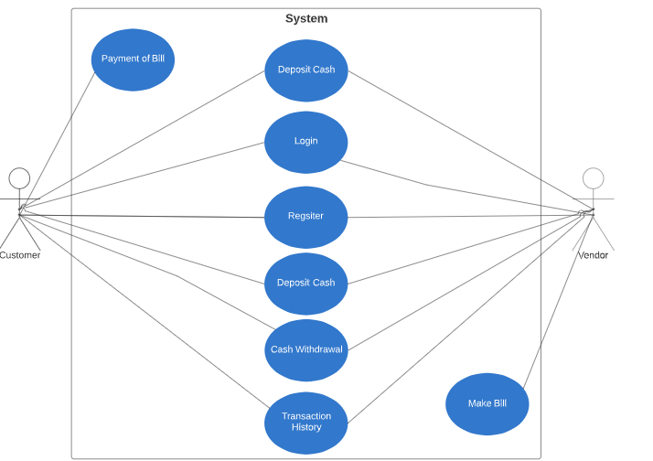
Figure 1 : CashFree Use Case Diagram

The customer when logs on will have the option to pay bill using QR. The vendor will produce a QR code, which when scanned will the amount of bill. The customer/vendor will be able to see the balance of their account.

Use Cases
Table 7: Register
Use Case ID: | UC1
Use Case Name: | Register
Created By: | Hamza Fayyaz Bashir |  | Last Updated By: | 14/04/2020
Date Created: | 17/09/2019 |  | Last Revision Date: | 13/07/2020
Actors: |  | User will register themselves as customer or vendor.
Description: |  | Whosoever wants to use our app will have to register themselves so that we have a record of everyone in our database.
Preconditions: |  | Our app must be present in the phone of the user.
Post conditions: |  | When all the details are entered the user will be asked to scan there face and thumbprint for security. There facial scans and thumbprint scans will be used during the payment stage for verification.
Normal Flow: |  | - User entering details  - User will first choose if it wants to be a customer or vendor.  - After this, all the relevant details will be entered.  - Then the user will be asked to register their facial scan as well as their thumbprint scans.  - In the end the user will be registered.
Alternative Flows: |  | -
Exceptions: |  | - It will be mandatory to enter all details of user. If not enter then error will occur. Also it will be advised that facial scan and thumbprint be registered and if not then user’s account will not be fully secure.

Table 8: Login
Use Case ID: | UC2
Use Case Name: | Login
Created By: | Hamza Fayyaz Bashir |  | Last Updated By: | 13/04/2020
Date Created: | 10/11/2019 |  | Last Revision Date: | 24/07/2020
Actors: |  | Customer and Vendor
Description: |  | User will login his/her account.
Normal Flow |  | 1. User will open app  2. Simply enter name and password or login through facial scan or thumbprint.  3. Your account opens.
Exceptions |  | If password is forgotten then user will enter mail name and a link will be sent where the user will be able to change password. If someone else tries to login then a mail will be sent to the registered email.
Frequency of Uses |  | Can be done a number of times

Table 9: Deposit Cash
Use Case ID: | UC3
Use Case Name: | Deposit Cash
Created By: | Hamza Fayyaz Bashir |  | Last Updated By: | 12/02/2020
Date Created: | 11/11/2019 |  | Last Revision Date: | 20/08/2020
Actors: |  | Customer and Vendor
Description: |  | Customer will go to a registered vendor to deposit cash or can deposit cash from any bank.
Preconditions: |  | Must be registered in CashFree and vendor must be a registered one.
Post conditions: |  | Display the user Details
Normal Flow: |  | - Customer will go the vendor  - Will give cash to the vendor  - Then vendor will enter the amount of cash that needs to be deposited.  - Money is now in account
Alternative Flows:  [Alternative Flow 1 – Not in Network] |  | Customer can also transfer money from his/her bank account.

Table 10: Cash Withdrawal
Use Case ID: | UC4
Use Case Name: | Cash Withdrawal
Created By: | Hamza Fayyaz Bashir |  | Last Updated By: | 11/03/2020
Date Created: | 11/11/2019 |  | Last Revision Date: | 22/08/2020
Actors: |  | Customer and Vendor
Description: |  | Customer will go to a vendor
Preconditions: |  | Must be registered in CashFree and have money in account
Exceptions: |  | Vendor must be a registered one.
Normal Flow: |  | - Customer will go to a registered vendor.  - Facial or thumb scan for verification.  - Vendor will then pay the money to the customer when authenticated.

Table 11: Transaction History
Use Case ID: | UC5
Use Case Name: | Transaction History
Created By: | Hamza Fayyaz Bashir |  | Last Updated By: | 11/04/2020
Date Created: | 11/11/2019 |  | Last Revision Date: | 22/07/2020
Actors: |  | Customer and Vendor
Description: |  | Check account balance
Preconditions: |  | Must be logged in.
Post conditions: |  | User redirects the relevant interface.
Normal Flow: |  | - User will open app and login  - Tap check account  - Balance of account will appear

Table 12: Payment Bill
Use Case ID: | UC6
Use Case Name: | Payment of Bill
Created By: | Hamza Fayyaz Bashir |  | Last Updated By: | 11/03/2020
Date Created: | 12/11/2019 |  | Last Revision Date: | 22/08/2020
Actors: |  | Customer and Vendor
Description: |  | The vendor will generate a bill and QR will be produced. The customer will scan the QR. Verification of customer will be asked through thumbprint or facial scan. After verification, a confirmation of payment will occur.
Preconditions: |  | Payment must be done by the account holder.
Normal Flow: |  | - User scans QR  - Facial scan or thumbprint scan  - Confirmation appears on screen
Exceptions: |  | No one other than account holder can pay the bill.

Table 13: Generation of Bill
Use Case ID: | UC7
Use Case Name: | Bill Generation
Created By: | Hamza Fayyaz Bashir | Last Updated By: | 12/04/2020
Date Created: | 11/11/2019 | Last Revision Date: | 22/07/2020
Actors: | Customer and Vendor
Description: | Vendor will be asked to type amount and the things that are being put it in the bill. A QR code will be generated for payment by customer.
Preconditions: | Must be registered in CashFree
Normal Flow | - Vendor will type amount  - Then enter things being charged  - QR will be produced  - Customer scans QR for payment.

User interfaces (mock screens)

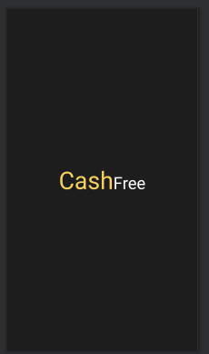
Figure 2 : Splash Screen

When the CashFree app is opened, the above screen will pop up for only a few seconds. The above screen contains the CashFree logo. After this screen, if the user is new, the phone number verification screen will open and if the user has an account already then login screen will open.

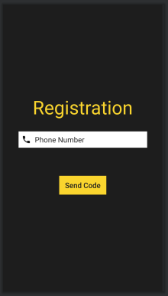
Figure 3: Verification Number Screen

In this screen, a local phone number must be entered. A code will be sent from firebase to your phone. Then a hidden bar will be shown where the user will be required to enter the code to verify their number. After doing this, the sign up page will open.
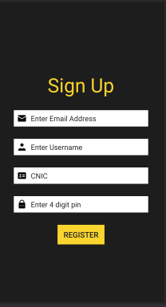
Figure 4: Sign Up Screen

At this screen, the user will have to enter the required details which are shown above. After entering the above information, the user will press register and then will be navigated to the confirm password screen.

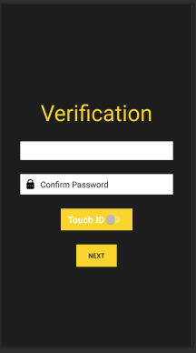
Figure 5: Confirm Password Screen

The user will have to re-enter their 4 digit pin and will have the option the enable “Touch ID” which is thumbprint scan or facial scan as per as the user wants. After enabling “Touch ID”, the user can press next and move to the next screen.

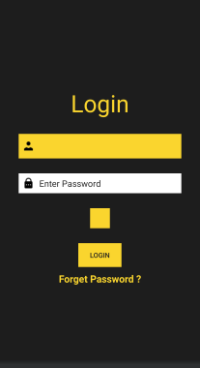
Figure 6: Login Screen

This is the login screen, this will open whenever a registered user will open the app or when a user has completed the registration. The user will have the option to login via their thumbprint or facial scan, also they can login via their 4 digit pin. If the user has forgotten their password, they can tap the “forgot password?” option and move to forgot password screen.

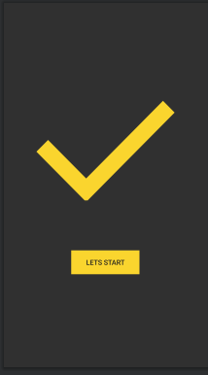
Figure 7: Let’s Start Screen

When the user has completed their registration and logged in for the first time then this screen will open. This screen will open only once during the first time login.
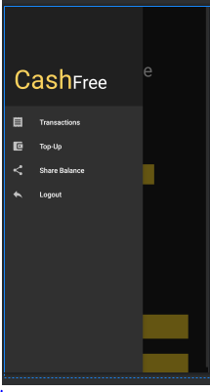
Figure 8: Customer Main Screen

The user will now be at the customer main page, the customer can tap the top left corner and a dashboard will slide open. This dashboard as shown above contains 4 options. The transactions is the transaction history for the customer. The top up is whenever the customer will require to add dummy cash in their account. The share balance option means the customer can transfer money to another user. The logout simply means the user can logout of their account.

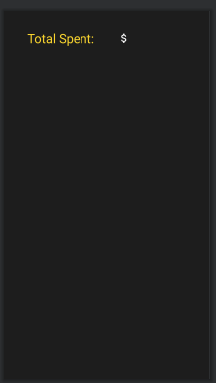
Figure 9: Bill History Screen

Whenever a transaction is carried out by the customer, it will be shown here. The total money spent by the user will also be shown here. At the moment, there are no transactions that is why there is no history showing.

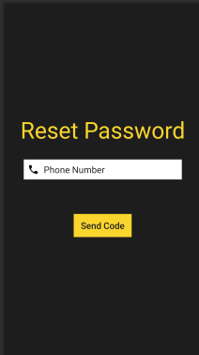
Figure 10: Reset Password Screen

If the user has forgotten their password then they will have to enter their phone number and a code will be sent to their phone. This will allow them to change their password to a new one which they can remember easily.

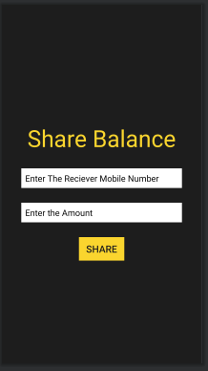
Figure 11: Share Balance Screen

Here the user can transfer cash to any other user. All they have to do is enter the receiver’s mobile number and the amount they want to send. After entering the above information and tapping the share button, money will be sent and a pop up notification will come up informing that the money has indeed been sent.
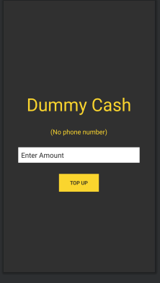
Figure 12: Top Up Screen

When the user has no or low amount of cash in their account, they will have to add money in it at this page. They will have to enter an amount and money will be added to their account. At the moment we are using dummy cash and no real money.
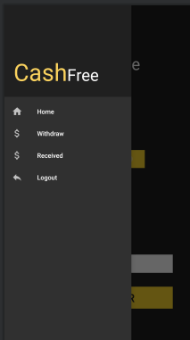
Figure 13: Vendor Main Screen

When the customer changes their role to a vendor, they will be navigated to this screen. It is very similar to the customer’s main screen, when the vendor taps at the top left corner then a dashboard will slide out. This has four options, the first will navigate the vendor to the main customer screen, the second will take the vendor to the withdrawal page, the third will show the transaction history of the vendor and the final option is for logout.

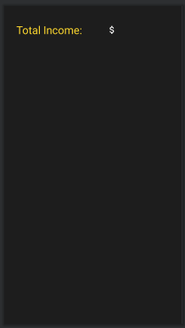
Figure 14: Vendor Bill History Screen

This is similar to the customer transaction history page. At the moment there are no transactions, hence there is no history. Here the vendor will also be able to see the total amount of income that that has been earned over a period of time.
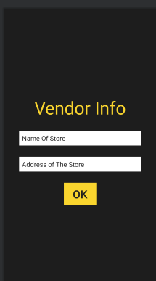
Figure 15: Vendor Information Screen

If the customer has the need to become a vendor all of a sudden then the user will have to enter the aforementioned details to successfully become a vendor. After entering the details, the user will be navigated to the vendor main screen.
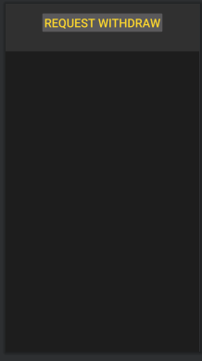
Figure 16: Withdrawal Cash Screen

Here the user can withdrawal cash by tapping the “request withdrawal”, this will take the user to another screen where they will enter an amount for withdrawal and a request will be generated which will be shown at this screen.
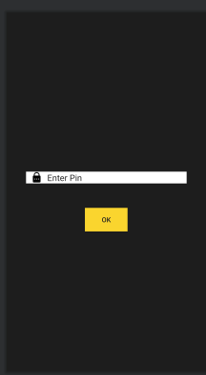
Figure 17: Payment through Pin Screen

The user if choose the pin option as payment confirmation then the user will be brought here will they will be asked to enter their four digit pin. After entering it, the payment will be confirmed.
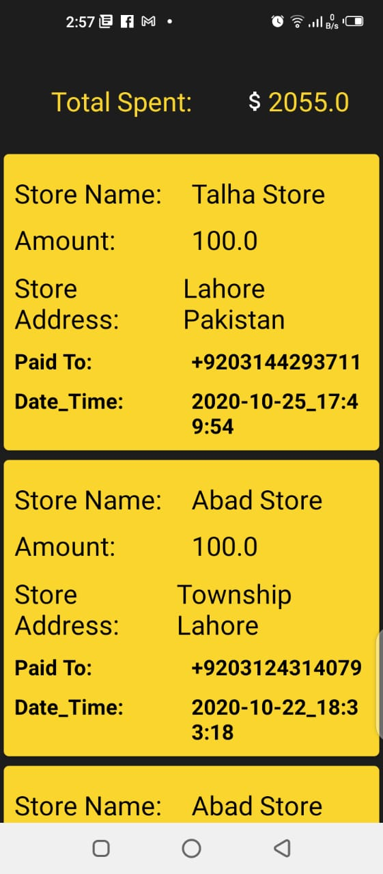
Figure 18: Customer Bill History Page

This is where the history of transactions is shown. The information shown will be the store name, amount used, name of store and data/time at which the transaction was carried out. As new transactions are carried out, the list will be grow and bills will keeping being shown.
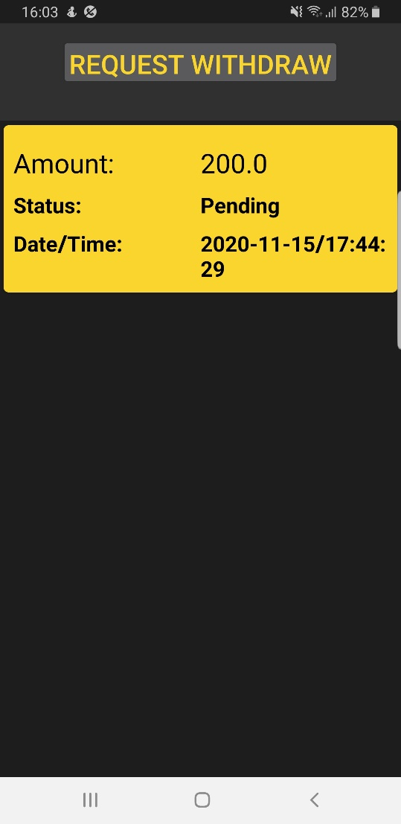
Figure 19: Withdrawal History Screen

This is the screen where the generated requests of withdrawal will be shown. As shown above, the request is pending and when the request is approved, the user can take out cash.
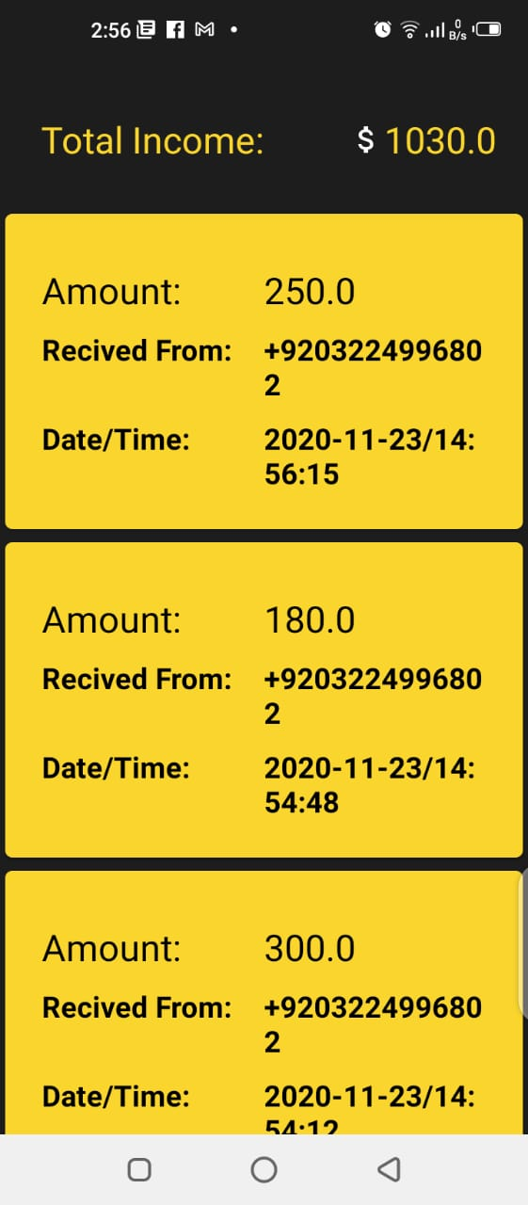
Figure 20: Vendor History Page

This is where the vendor transaction history is shown. As more transactions is carried out, more bills are added and the list grows. The amount, name of customer and the data/time will be given as shown above.

System Design

System Architecture Diagram

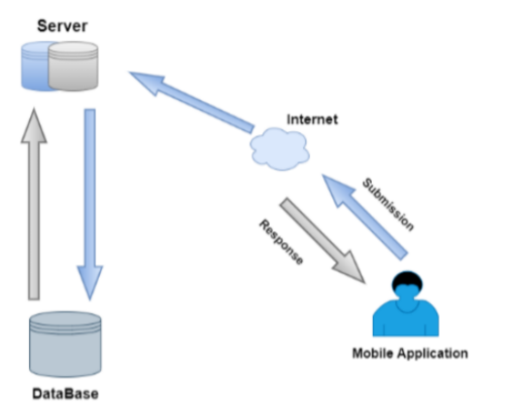
Figure 21: System Architecture

The above diagram tells us how the interaction is done by the customer/vendor and the database. It is telling us how data is sent to and from the database through the server.

Class Diagram
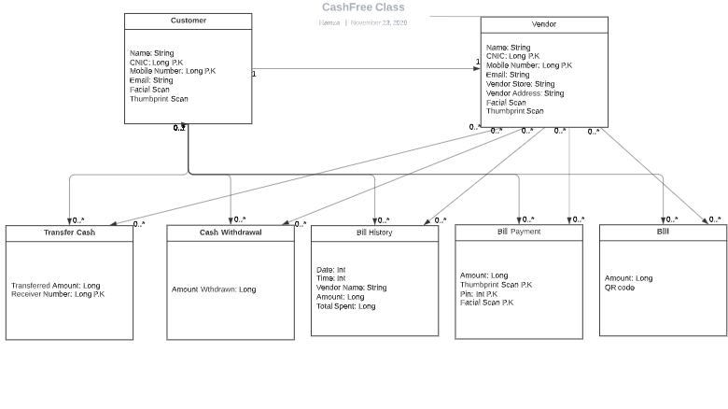

Figure 22: Class Diagram

The above class diagram tells us about the functions that are available to the customer and vendor. The customer/vendor will be able to check on their transaction history and they can also see their balance. Customer can use the app to pay a bill by scanning the QR code which is produced by the vendor.

Sequence Diagrams
- Customer
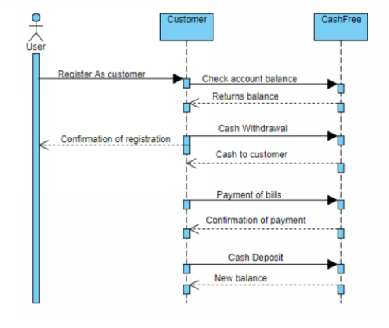
Figure 23: Sequence Customer Diagram

The above diagram shows how the user interacts with our app. The steps that the customer has to take to pay the bill, take out cash, deposit cash or even check on the bill history.

- Vendor
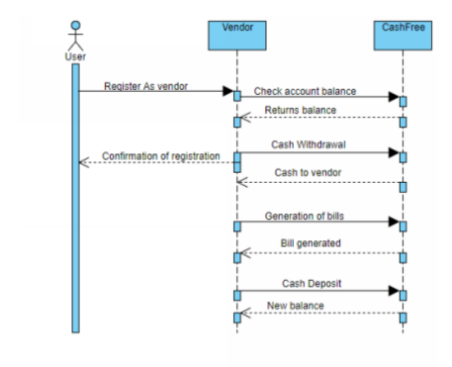
Figure 24: Sequence Vendor Diagram

The above diagram tells us about the steps the vendor has to take when using our CashFree. The vendor will be able to pay bills and also check transaction history.

Collaboration Diagrams
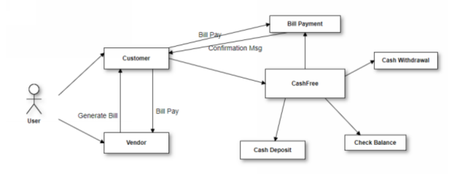
Figure 25: Collaboration Diagram

The figure 10 explains the collaboration diagram for the Pakistan Tour Spot Mobile Android operating
The above diagram tell us about the collaboration between the customer and vendor. It also tells us about how they collaborate themselves with the CashFree.

ERD

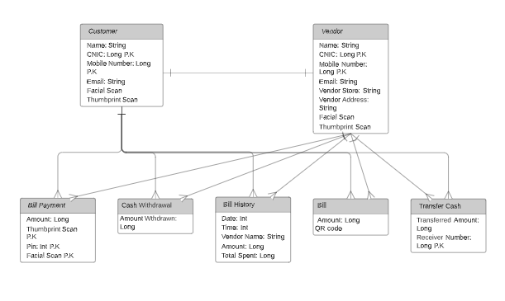
Figure 26: Entity Relationship Diagram

The diagram above shows the relationship of entities between customer and vendor. The primary keys are metioned above and the different entites are mentioned too. The attributes are given in the entities and the primary keys are mentioned too.

Data Flow Diagram

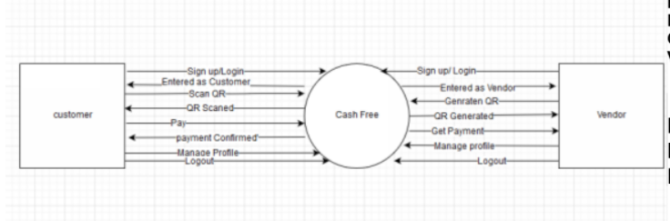
Figure 27: Data Flow Level 0 Diagram

The diagram above shows the flow of data between the customer and vendor.

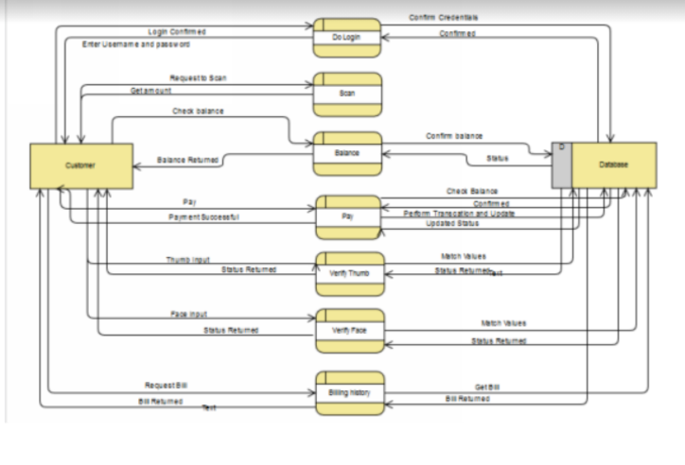
Figure 28: Data Flow Level 1 Diagram

This is the level 1 data flow diagram of customer and the database.

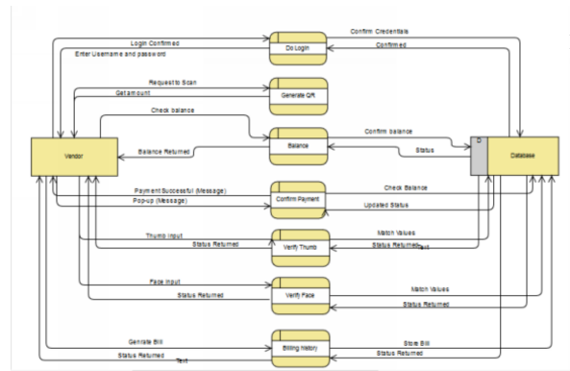
Figure 29: Data Flow Level 1 Diagram

This is the level 1 data flow diagram of vendor and the database.

Implementation details

Development Setup
Built-in-Face-Android= this is a basically a face detection/recognition function available in build in android devices. In our project, we are using the built in facial functions of android devices for face detection and recognition which is an essential part of our app.
Firebase= this is a Google made firebase which is mostly used for android applications. We are using it for our app. This is a core part of our project as all of the customers/vendors data will be present. Data will include personal data (password, number).
Android Studio = this is the platform where we our developing our android app. All the coding is done in java. This a key part for us as this is where we made our project.
- CashFree Mobile Application
- Front End: XML
- Diagrams: Draw.io
- Documentation: MS Word
- Backend: Firebase
- Coding: Android Studio

Deployment setup
CashFree is made on android studio and the database we are using is firebase. Initially, the user will have to enter his/her phone number, the phone number will be sent to firebase, where it will send a code to the phone which in return will verify the number. After this step, the user will enter personal details which also will be stored in the database. The data of face and thumbprint will be stored in the phone of the user itself. Also for facial recognition, we used built in facial functions of android which is available in android studio. For thumbprint, we used the built in thumbprint library which is available in android studio. Also we used the QR scanner which again is available in the android studio.

Algorithms
Below I have written important parts of our code. With the parts of code that are written below, I have explained them so that they are easy to understand.
Broken QR Code
public class brokenQR extends AppCompatDialogFragment {
@NonNull
@Override
public Dialog onCreateDialog(@Nullable Bundle savedInstanceState) {
AlertDialog.Builder builder = new AlertDialog.Builder(getActivity());
builder.setTitle("QR Failed")
.setMessage("QR IS BROKEN. Please Enter the correct QR.")
.setPositiveButton("Ok", new DialogInterface.OnClickListener() {
@Override
public void onClick(DialogInterface dialog, int which) {
Intent intent = new Intent();
intent.setClass(getContext(),CustomerActivity.class);
startActivity(intent);

}
});
return builder.create();
}
The above code is to stop the application from scanning any random QR generated from any other software. If the app scans a random QR, a pop notification will be displayed on the screen which will show “QR IS BROKEN. Please Enter the correct QR”.

Bill History Code
public void totalSpent(){
SharedPreferences totalSpentobj = getSharedPreferences("App_Data", Context.MODE_PRIVATE);
// int bill_Count = totalSpentobj.getInt("CustomerBill_Count", 0);
String num = totalSpentobj.getString("Phone_Key","String Not Found");
CustomerBills = database.getReference("Customer_Bills").child(num);

CustomerBills.addListenerForSingleValueEvent(new ValueEventListener() {
@Override
public void onDataChange(@NonNull DataSnapshot dataSnapshot) {
SharedPreferences totalSpentobj = getSharedPreferences("App_Data", Context.MODE_PRIVATE);
int bill_Count = totalSpentobj.getInt("CustomerBill_Count", 0);
for (int i=1 ; i<=bill_Count; i++) {
try {
newbill = "Bill";
newbill = newbill + i;
Customer_Bill customer_bill = dataSnapshot.child(newbill).getValue(Customer_Bill.class);
float spentBalance = customer_bill.getAmount();
newSpentBalanceTotal = newSpentBalanceTotal + spentBalance;
}catch (NullPointerException ignored){

}

}
sepntBalanceToSet = String.valueOf(newSpentBalanceTotal);
totalSpent.setText(sepntBalanceToSet);

}
The above code is for bill history. This will display the customer’s transaction history. This history will include the vendor’s name, date/time of money spent and amount of money spent. This also tells a total amount of cash spent by the customer.

Vendor Information Code
@Override
protected void onCreate(Bundle savedInstanceState) {
super.onCreate(savedInstanceState);
setContentView(R.layout.activity_vendor_info);

addStoreName = findViewById(R.id.NameOfStore);
addStoreAddress = findViewById(R.id.AddressOfStore);
okVendorInfo = findViewById(R.id.Vendor_Info_Ok);

database =FirebaseDatabase.getInstance();
vendorInfor = database.getReference("Vendor_Information");

okVendorInfo.setOnClickListener(new View.OnClickListener() {
@Override
public void onClick(View v) {
if (!addStoreName.getText().toString().isEmpty()){
if (!addStoreAddress.getText().toString().isEmpty()){
addVendorInfo(addStoreName.getText().toString(), addStoreAddress.getText().toString());
vendorInfo_status_check_True();
SharedPreferences info = getSharedPreferences("App_Data",Context.MODE_PRIVATE);
SharedPreferences.Editor editor = info.edit();
editor.putString("NameOfStore" , addStoreName.getText().toString());
editor.putString("AddressOfStore" , addStoreAddress.getText().toString());
editor.commit();
startActivity(new Intent(VendorInfo.this,VendorActivity.class));
finish();

}
else{
Toast.makeText(VendorInfo.this, "Please Enter The Store Address", Toast.LENGTH_SHORT).show();

}
}
else{
Toast.makeText(VendorInfo.this, "Please Enter the Store Name", Toast.LENGTH_SHORT).show();

}
}
})
The above code is for vendor information. This will ask the vendor for their store name and the address of the store. After getting this information from the vendor, the data will be sent to the firebase where it will be stored.

Share Balance Code
public void makeTransaction(String VenNo , String CusNo , final float amount) {
database = FirebaseDatabase.getInstance();
users = database.getReference("Users");
final String VendorNumber = VenNo;
final String CustomerNo = CusNo;
final float amountToPay = amount;
users.addListenerForSingleValueEvent(new ValueEventListener() {
@Override
public void onDataChange(@NonNull DataSnapshot dataSnapshot) {
if (dataSnapshot.child(VendorNumber).exists()) {
User venObj = dataSnapshot.child(VendorNumber).getValue(User.class);
float VenBalance = venObj.getBalance();
User cusObj = dataSnapshot.child(CustomerNo).getValue(User.class);
float CusBalance = cusObj.getBalance();
if (CusBalance < amountToPay) {
openDialogLowPayment();

} else {
CusBalance = CusBalance - amountToPay;
VenBalance = VenBalance + amountToPay;
HashMap CushashMap = new HashMap();
CushashMap.put("balance", CusBalance);
HashMap VenhashMap = new HashMap();
VenhashMap.put("balance", VenBalance);

users.child(VendorNumber).updateChildren(VenhashMap).addOnSuccessListener(new OnSuccessListener() {

The above code is for transferring balance to one user to another user. The user will have to enter the number of the receiver and also the amount that the user wants to send. After the relevant information is entered, the money will be sent and the receiver will get a message which says the relevant amount has been received.

Constraints
The constraints for CashFree are as follows:

Assumptions
The assumptions that can be made for CashFree are as follows:
- The data of CashFree will be maintained at firebase.
- The transaction done for the mobile application will be secure with the help of thumbprint/face recognition/pin.
- User can be both customer and vendor.

System constraints
CashFree will be operational on all android devices. They must have a minimum android version of jellybean. They should also have a front camera for face recognition and a thumbprint scanner as well. Also the phones must have the ability to scan the QR codes when generated. The phone must also be connected to the internet as data will be needed to be fetched from firebase.

Restrictions
There are multiple restriction applied on this application to maintain the quality of the application and stakeholders are restricted to follow these restrictions.
- A user with cannot login multiply with one number.
- A vendor and customer has to provide valid details and information about themselves.
- Phone must be connected to the internet.
- Android version must be a minimum of jellybean.

Limitations
CashFree users must be connected to the internet so that data can be fetched from the database. A user cannot be a customer and vendor at the same time. The QR code must be generated from CashFree, it will not accept random QR codes. User can withdrawal money when the generated request is accepted by the admin.

Testing

Test Cases

Table 14: Phone Verification
Test Case ID: 1 | Test Design By: Hamza Fayyaz Bashir
Test Module Name: Phone Verification | Test Design Date: 20/08/2020
Test Priority: High | Test Executed By: Hamza Fayyaz Bashir
Test Title/Name: Verify phone number | Test Executed Date: 21/08/2020
Description: Verify the phone number of the user

Pre-Condition: -
Dependencies: -
Step |  | Test Step |  | Test Data |  | Excepted Result |  | Actual Result |  | Status |  | Notes
1 | New users will get verification page |  |  |  |  |  |  |  | Pass
2 | Tap on the number bar and enter phone number |  | Phone number: 03224996802
3 | Click on login button |  |  |  | Code will be sent to user and their number will be verified |  | User is validated successfully and sent to user.

Post Condition: User number is now in our database

Table 15: Sign Up
Test Case ID: 2 | Test Design By: Hamza Fayyaz Bashir
Test Module Name: Sign Up | Test Design Date: 21/08/2020
Test Priority: High | Test Executed By: Hamza Fayyaz Bashir
Test Title/Name: Sign Up | Test Executed Date: 22/08/2020
Description: The user will have to enter their details.

Pre-Condition: The user must have the application.
Dependencies: Number must be verified.
Step | Test Step | Test Data | Excepted Result | Actual Result | Status | Notes
1 | User will tap on the name bar. |  |  |  | Pass
2 | Enter name | Name: Hamza Fayyaz Bashir |  |  | Pass
3 | User will tap on NIC bar. |  |  |  | Pass
4 | Enter NIC | NIC: 35202-6031728-1
5 | User will tap on the email bar.
6 | Enter email | Email: hamzafayyaz97@gmail.com
7 | User will tap on password
8 | Enter password | Password: *******
9 | Tap on submit |  | All details are saved on device and user moves to next page. | Successfully moved to next page.

Post Condition: The users can login using these details.

Table 16: Confirmation Password
Test Case ID: 3 | Test Design By: Hamza Fayyaz Bashir
Test Module Name: Conformation Password | Test Design Date: 23/08/2020
Test Priority: High | Test Executed By: Hamza Fayyaz Bashir
Test Title/Name: Password | Test Executed Date: 23/08/2020
Description: The user confirms password and can also toggle thumbprint.

Pre-Condition: Sign up details must be present.
Dependencies: The details will be needed.
Step | Test Step | Test Data | Excepted Result | Actual Result | Status | Notes
1 | User will tap on the confirm password bar. |  |  |  | Pass
2 | Enter password to confirm | Password: ******* |  |  | Pass
3 | User toggle thumbprint option |  | Data sent to firebase.  . | Data was sent successfully to firebase. | Pass

Post Condition: The user password is saved as preference.

Table 17: Thumbprint
Test Case ID: 4 | Test Design By: Hamza Fayyaz Bashir
Test Module Name: Thumbprint | Test Design Date: 23/08/2020
Test Priority: High | Test Executed By: Hamza Fayyaz Bashir
Test Title/Name: Thumbprint | Test Executed Date: 23/08/2020
Description: User’s thumbprint is scanned and saved.

Step | Test Step | Test Data | Excepted Result | Actual Result | Status | Notes
1 | User places thumb on the scanner | Thumbprint of user | Thumbprint is saved | Successfully saved | Pass
2 | User taps next button |  |  |  | Pass

Post Condition: Thumbprint is used for later uses

Table 18: Facial Scan
Test Case ID: 5 | Test Design By: Hamza Fayyaz Bashir
Test Module Name: Facial Scan | Test Design Date: 23/08/2020
Test Priority: High | Test Executed By: Hamza Fayyaz Bashir
Test Title/Name: Facial Scan | Test Executed Date: 23/08/2020
Description: The user will scan their face.

Pre-Condition: First sign up for account.
Dependencies: Facial scanner abilities must be present.
Step | Test Step | Test Data | Excepted Result | Actual Result | Status | Notes
1 | User scans the button. | Facial scan of user |  |  | Pass
2 | User stays still while face is being scanned. | Face data | Face is scanned and saved. | Face data was saved in phone successfully. | Pass

Post Condition: Facial data is used later on.

Table 19: Customer/Vendor
Test Case ID: 6 | Test Design By: Hamza Fayyaz Bashir
Test Module Name: Customer/Vendor | Test Design Date: 24/08/2020
Test Priority: High | Test Executed By: Hamza Fayyaz Bashie
Test Title/Name: Toggle button | Test Executed Date: 24/08/2020
Description: The user can toggle between customer and vendor whenever they choose to do so.

Pre-Condition: The user must have made an account
Step | Test Step | Test Data | Excepted Result | Actual Result | Status | Notes
1 | Taps toggle button to vendor |  | Screen should change to vendor screen | Screen successfully change to vendor screen | Pass
2 | Taps toggle button back to customer |  | Screen should change back to customer | Screen successfully change to customer screen. | Pass

Table 20: Payment
Test Case ID: 7 | Test Design By: Hamza Fayyaz Bashir
Test Module Name: Payment | Test Design Date: 14/09/2020
Test Priority: High | Test Executed By: Abdur Razaq
Test Title/Name: Payment | Test Executed Date: 14/09/2020
Description: Customer will scan the QR code to see the bill and then confirm payment through password or thumbprint scan.

Pre-Condition: Balance should be present in the account.
Dependencies: The customer should be connected to the internet.
Step | Test Step | Test Data | Excepted Result | Actual Result | Status | Notes
1 | Tap the scan button and scan QR code | QR scanned |  |  | Pass
2 | Amount of bill is shown | Bill: 2000 RS |  |  | Pass
3 | Scans thumbprint/face for confirmation | Face/thumbprint data checked with phone data |  |  | Pass

Post Condition: Money deducted from account

Table 21: Create Bill
Test Case ID: 8 | Test Design By: Hamza Fayyaz Bashir
Test Module Name: Bill creation | Test Design Date: 25/08/2020
Test Priority: High | Test Executed By: Hamza Fayyaz Bashir
Test Title/Name: Bill | Test Executed Date: 25/09/2020
Description: The vendor will create bill and produce a QR code.

Pre-Condition: Account must be made.
Step | Test Step | Test Data | Excepted Result | Actual Result | Status | Notes
1 | Tap create button |  |  |  | Pass
2 | Enter amount | Amount: 2000 RS |  |  | Pass
3 | Taps OK and QR code is created for customer to scan. |  | QR code produced when scanned shows the amount. | Successfully created QR code which tells us the right amount. | Pass

Table 22: Transaction
Test Case ID: 9 | Test Design By: Hamza Fayyaz Bashir
Test Module Name: History Payment | Test Design Date: 17/09/2020
Test Priority: High | Test Executed By: Hamza Fayyaz Bashir
Test Title/Name: | Test Executed Date: 17/09/2020
Description: The user will be able to check the transaction history.

Pre-Condition: The user would have carried out some transactions.
Step | Test Step | Test Data | Excepted Result | Actual Result | Status | Notes
1 | User taps the transaction button |  |  |  | Pass
2 | User will get a new screen. |  | Transaction history should be shown. | Transaction history was shown. | Pass

Table 23: Help
Test Case ID: 10 | Test Design By: Hamza Fayyaz Bashir
Test Module Name: Map Button | Test Design Date: 17/09/2020
Test Priority: High | Test Executed By: Hamza Fayyaz bashir
Test Title/Name: Help | Test Executed Date: 17/09/2020
Description: Mostly problems and their solutions

Step | Test Step | Test Data | Excepted Result | Actual Result | Status | Notes
1 | Tap on help |  | Screen being shown should tell all the solutions of any problem in help. | Screen showed should tell all the solutions of any problem in help. | Pass

Traceability Matrix

RID vs UCID (requirements vs use cases)

Table 24: TM RID vs. UCID
UCID/RID | R  1 | R  2 | R  3 | R  4 | R  5 | R  6 | R  7 | R  8 | R  9 | R  10 | R  11 | R  12 | R  13 | R  14 | R  15
UC 1
UC 2
UC 3
UC 4
UC 5
UC 6
UC 7

Prototypes (RID vs PID)

Table 25: TM RID vs. PID
PID/RID | R1 | R2 | R3 | R4 | R5 | R6 | R7 | R8 | R9 | R  10 | R  11 | R  12 | R  13 | R  14
P1 | ✓ | ✓
P2 |  | ✓ |  |  |  |  |  |  |  |  | ✓
P3 |  |  |  |  | ✓ | ✓ |  | ✓ | ✓ |  |  | ✓
P4 |  |  | ✓ |  |  |  | ✓ |  |  |  |  |  |  | ✓
P5 |  |  |  |  |  |  |  |  |  | ✓ |  |  | ✓

Test Cases (RID vs TID
Table 26: TM RID vs. TID
TID/RID | R  1 | R  2 | R  3 | R  4 | R  5 | R  6 | R  7 | R  8 | R  9 | R  10 | R  11 | R  12 | R  13 | R  14
TC 1
TC 2
TC 3
TC 4
TC 5
TC 6
TC 7
TC 8

Coverage (UCID vs TID)
Table 27: TM UCID vs. TID
TID/UCID | UC1 | UC2 | UC3 | UC4 | UC5 | UC6 | UC7
TC 1
TC 2
TC 3
TC 4
TC 5
TC 6
TC 7
TC 8

Statistics

% Completion
The status of completion of CashFree depends on some things.
The total number of uses cases are 7 and test cases are 10.
Our project is complete.

% Accuracy
CashFree is working smoothly and according to the test cases, we carried out, everything is A okay and showing an accuracy of 95%.

% Correctness
CashFree has 10 test cases and 7 use cases. The app is running perfectly, its working 100% accurately.

Conclusion
CashFree is a type of e wallet where user can pay bills without the need of having a wallet. A customer can simply scan a QR code, and scan it, within seconds the bill will be paid, it will ask for the customers fingerprint or if they want they can scan their face then the payment will be completed.
Our app has been completed, and we thoroughly tested our app for quality purposes. We are behind our app and can humbly say that this app will work accurately without any sort of hindrances.

Future work
As following great entrepreneurs like Henry Ford who always strived for perfections and wanted their product to the best and modern as it could be. That’s why we have decided that after giving our presentation, we would like to take this project with us and improve it more by developing it cross platform. We would also like to implement technologies like blockchain. We would also add more functions like payment of challans or payment of taxes.
Our final wish will be to overcome easypaisa in the e wallet monopoly in Pakistan and make CashFree as a staple way of payment and a necessity of life and forget the dependency of a wallet.

Bibliography

Websites
[1] https://easypaisa.com.pk/
[2] https://www.jazzcash.com.pk/
[3] http://www.ecocash.co.zw/

Research Paper
[1]. Kingston, T. S., Zaruba, J. D., Giordano, J. A., Sundberg, I. E., & Ashfield, J. (2010). U.S. Patent Application No. 12/362,565.
[2]. Mithe, A. (2015). Mobile financial services for microfinance institutions: Case study of easypaisa and tameer in pakistan. World Bank Group, International Finance Corporation. WashingtonDC: International Finance Corporation.
[3]. Sibghatullah, A., 2016. Telenor Easypaisa. Journal of Marketing Management and Consumer Behavior.
[4]. Ghorsi, H., Siddiqui, A., Basharat, T., Anwer, S. and Ahmad, H., 2018. Service System of Easypaisa and MobiCash: Funds Transfer System via Telecommunication Companies in Context of Service Dominant Logic. Journal of Service Science Research, 10(2), pp.249-273.
[5]. Bold, C., 2011. Branchless banking in pakistan: A laboratory for innovation.
[6]. Afghan, N., 2015. EASYPAISA: SEIZING THE WHITE SPACE AND BUSINESS MODEL INNOVATION. IBA Business Review, 10(1).
[7]. McCarty, M.Y. and Bjaerum, R., 2013. MMU case study: Easypaisa mobile money innovation in Pakistan.
[8]. Kunbher AD, Ullah S, Alam M. Multi-sector, nutrition-sensitive response to drought emergency in Pakistan. Field Exchange 55. 2017 Aug 18:98.

Appendix

Glossary of terms
Table 38: Glossary of terms
Terms | Explanation
UCID | Use case identity
TID | Test case identity
Use Case Diagrams | Set of actions
Android | Operating system of Google
Android Studio | Platform to develop Android Application
Customer | User who will pay
Firebase | Google’s database
Vendor | User who creates bill
Actor | Stakeholder

Pre-requisites
The application must have thumbprint scanner, internet and also a minimum android version of Jellybean.

