Final Year Project Report
Project Name
Online Job Cloud

Project Advisor:Ahtasham Ali

Submitted By:
M.Numan Tahir 13005065249
Mishaal Ahmed 13005065242
Abdul Habib 13005065204
M.HaroonAnees 12003065301

Session
2013-2017

School of Systems and Technology
University of Management and Technology
Lahore Pakistan

Dedication
This project is dedicated to University of Management and Technology, an esteemed institution who gave our group a chance to develop this project and also groomed and developed us for the professional life. It is also dedicated to Sir Ahtsham Ali who taught us that even the largest task can be accomplished if it is done one step at a time. Finally, dedicated to our parents who gave us moral and spiritual support.

Final Approval

Panel of Examiners

- Head of Department ______________________
Department of Computer Science
UMT Lahore

- Program Director ( Final Year Projects) ______________________
Department of Computer Science
UMT Lahore

- Supervisor ______________________
Department of Computer Science
UMT Lahore

- Co-Supervisor ______________________

Acknowledgment

Many efforts are undertaken for the completion of this project. However, it would not have been possibly done without the support of my group members Abdul Habib, Numan Tahir, M HaroonAnees I am whole heartedly thankful to all of them as without their support this project wouldn’t have been completed. I would like to express my special thanks of gratitude to my advisor Sir Ahtsham Ali for his guidance and constant supervision as well as for providing the necessary information regarding the project and also for his support in completing the project.
I am also thankful to UMT for providing well organized learning facilities which assisted to buildthis project. I am also thankful to my parents who gave me moral support.Finally; I thank my creator, God the Almighty, who gave our team the strength and the patience to complete this project.

Project Title :
- Online Job Cloud

Objective:
- To develop a complete featured Recruitment platform with extensible features
Undertaken by:
- Mishaal Ahmed
- Abdul Habib
- Muhammad Numan Tahir
- Muhammad HaroonAnees

Supervised by:
- Ahtsham Ali

Starting Date:
- 1-Oct-2016

Completion Date:
- 22-Aug-2017

Tools Used:
- Excessive Tools for Documentation,Designing and Implementation

Operating System:
- Can run on any Operating System

Documentation:
- Completed

Plagairism Report

Abstract
Online Job Cloud is platform which provides a complete set of features for recruitment related processes. User will be able to access all the features in a single platform as no website that is providing a complete set of features for recruitment related processes .The system includes two main types of users which are Job Seekers and Employers both have different specs, features and constrains to use the platform. Features like Dashboard Management, Online Video Conversation, Cloud Data Storage, Interview Management and Gateway Payment are the main features of this platform.
A user will be able to set up a company profile or a job seeker profile where they can view the list of users seeking for jobs or list of posted jobs related to the company or university in which they are interested. User will be able to search, view, apply and post jobs, provide feedback in order to rate other user, dynamically manage portfolio and profile along with their dashboard and interview management dashboard. The admin has overall rights over the system and can modify and delete any details not pertaining to University placement rules.

Revision Chart

Version | Primary Author(s) | Description of Version | Date Completed
Draft | MishaalAhmed,NumanChaudhary,AbdulHabib,HaroonAnees | A mock draft of the document was created and it was given to all the team members for next versions. | 15-Oct-2016
Preliminary | MishaalAhmed,NumanChaudhary,AbdulHabib,HaroonAnees | This was the first draft off our documentation and whole team members worked for its completion | 1-Nov-2016
Final | MishaalAhmed,NumanChaudhary,AbdulHabib,HaroonAnees | This was the finalized version of our project documentation and it included most of the work progress of our project | 17-Nov-2016
Revised Version 1 | MishaalAhmed,NumanChaudhary,AbdulHabib,HaroonAnees | This was the first reviewed version of the documentation and most of the errors were corrected from the beginning | 20-Dec-2016
Revised Version 2 | MishaalAhmed,NumanChaudhary,AbdulHabib,HaroonAnees | This was the second reviewed version of the documentation and most of the tables were corrected from the beginning | 7-Jan-2017
Revised Version 3 | MishaalAhmed,NumanChaudhary,AbdulHabib,HaroonAnees | This was the third reviewed version of the documentation and most of the missing column were fixed. | 15-Jan-2017
Revised Version 4 | MishaalAhmed,NumanChaudhary,AbdulHabib,HaroonAnees | This was the fourth reviewed version of the documentation and most of the image errors were corrected from the beginning | 17-Feb-2017
Revised Version 5 | MishaalAhmed,NumanChaudhary,AbdulHabib,HaroonAnees | This was the fifth reviewed version of the documentation and styling of the documentation was corrected. | 30-Mar-2017
Revised Version 6 | MishaalAhmed,NumanChaudhary,AbdulHabib,HaroonAnees | This was the first reviewed version of the documentation and all the document remaining mistakes were corrected from the beginning | 14-Apr-2017

Contents
Contents 9
Definitions and Acronyms: 11
List of Figures: 12
List of Tables: 13
1. Introduction 14
1.1 Motivations 14
1.2 Project Overview 14
1.3 Problem Statement 15
1.4 Objectives 15
2. Domain Analysis 16
2.1 Customer 16
2.2 Stakeholders 16
2.3 Affected Groups with social or economic impact 16
2.4 Dependencies/ External Systems 16
2.5 Reference Documents 17
2.5.1 Related Projects 17
2.5.2 Feature Comparison 17
3. Requirements analysis 18
3.1 Requirements 18
Reliability Requirements: 19
User Interface and Human Factors Requirements: 19
Performance Requirements: 19
3.2 List of Actors 20
3.3 List of use cases 20
3.4 System use case diagram 21
3.5 Extended use cases 27
3.6 User interfaces (mock screens) 57
4. Data flow diagram (optional) 67
4.1 Data Flow Diagram Level 0 67
4.2 Data Flow Diagram Level 1 68
4.3 Data Flow Diagram Level 2 70
5. System Design 74
5.1 System Architecture Diagram 74
5.2 Class Diagram 76
76
5.3 Sequence Diagrams 77
5.4 Collaboration Diagrams 78
5.5 Other UMLs 78
5.6 ERD 79
5.7 Data Dictionary 79
6. Implementation details 81
6.1 Development Setup 81
6.2 Deployment setup 81
6.3 Algorithms 82
6.4 Constraints 85
6.4.1 Assumptions 85
6.4.2 System constraints 85
6.4.3 Restrictions 86
6.4.4 Limitations 87
7. Testing 88
7.1 Extended Test Cases 88
7.2 Decision Table 112
7.2.1 Code snippet ……………………………………………………………………………………………112
7.2.2 Decision coverage table 112
7.3 Traceability Matrix 112
7.3.1 RID vs UCID (requirements vs use cases) 112
7.3.2 Prototypes (RID vs PID) 113
7.3.3 Test Cases (RID vs TID) 114
7.3.4 Coverage (UCID vs TID) 114
8. Results/Output/Statistics 116
8.1 %completion 116
8.2 %accuracy 116
8.3 %correctness 116
9. Conclusion 117
10. Future work 118
11. Bibliography 119
11.1 Books 119
11.2 Journals 119
11.3 Articles 119
11.4 Research papers 119
11.5 Other References 119
12. Appendix 120
12.1 Glossary of terms 120
12.2 Pre-requisites 120

Definitions and Acronyms:
Acronym | Definition
OJC | Online job cloud
Table 1: table of acronyms and definitions

List of Figures:

Figure 1: System Use Case Diagram 21
Figure 2: Login Use Case Diagram (Job Seeker) 22
Figure 3: Login Use Case Diagram(Employer) 22
Figure 4: Job Search Use Case Diagram 23
Figure 5: Apply For Job Use Case Diagram 23
Figure 6: Upload Resume Use Case Diagram 24
Figure 7: Post A Job Use Case Diagram 24
Figure 8: Video Call Use Case Diagram 25
Figure 9: Feedback Use Case Diagram 25
Figure 10: Gateway Payment Use Case Diagram 26
Figure 11: Cloud Data Management Use Case Diagram 26
Figure 12: Interview Management Use Case Diagram 27
Figure 15: Data Flow Diagram Level 0 67
Figure 16: Data Flow Diagram Level 1(Visitor) 68
Figure 17: Data Flow Diagram Level 1(Job Seeker) 69
Figure 18: Data Flow Diagram Level 1(Employer) 70
Figure 19: Data Flow Diagram Level 2(Video Call) 71
Figure 20: Data Flow Diagram Level 2(Feedback) 72
Figure 21: Data Flow Diagram Level 2(Cloud Data Management) 72
Figure 22: Data Flow Diagram Level 2(Interview Management) 73
Figure 23: Data Flow Diagram Level 2(Gateway Payment) 73
Figure 24: System Architecture 74
Figure 25: Class Diagram 76
Figure 26: Sequence Diagram 77
Figure 27: Collaboration Diagram 78
Figure 28: Entity Relation Diagram 79

List of Tables:

Table 1: Revision Chart 8
Table 2: Acronyms and definitions 11
Table 3: List of stakeholders 16
Table 4: Feature Comparison 17
Table 5: Requirements Analysis 20
Table 6: List of Actors 20
Table 7: List of Use Cases 27
Table 8: Extended Use Cases 80
Table 9: Extended Test Cases 88
Table 10: Traceablitity Matrix(RID vs UCID) 112
Table 11: Traceablitity Matrix(RID vs PID) 113
Table 12: Traceablitity Matrix(RID vs TID) 114
Table 13: Traceablitity Matrix(UCID vs TID) 114

Introduction

Motivations
We are going to develop “Online Job Cloud” (OJC). Our aim is to facilitate both job seeker and employer for seeking and hiring for jobs. The project is beneficial for both job seekers search and applies for a good job as well as various companies to hire people for vacancies. Our system allows job seeker to create its profile and provide his/her required personal information like Education, Experience and skills which are updated time to time till valid time of period. Whenever a company has a vacancy, employer of a company come to our system and register its company. After registration it creates company profile and post job ads for different vacancies. These vacancies are viewed to both Guest and registered users. Guest user cannot apply for a job without registering to this system. This system can easily handle the job seeker as well as employer data. It can efficiently display all the data of both job seeker and employer to its respective sides. On the other side our system provide the option of video conference to both job seeker and the employer. With the help of this option they are able to take online interviews. Our system also provides the option of payment gateway and feedback.

Project Overview
The system will interact the all activities of both job seeker and employer. This system works and fulfills the all the functionalities include in this system. The job seeker has a clear view of total job vacancies in different companies. Our system is allowing job seeker to write its resume on this system. The employer will have a clear view of total number of job seeker applied and total number of job seeker selected. All the possible features like verification, validation, performance, security and user friendly interface have been considered.
The website will allow Users to:

- Login/Register
- Upload / Modify Resume
- Search for Jobs /Apply for Jobs
- Upload / Download File
- Manage/Update portfolio
- Online Audio/Video Conversation
- Manage Data Cloud
- Download Resumes/Search Resumes
- Post Job Ads
- Online Payment
- Provide Feedback

The Major Features of this website are:
- Dynamic Dashboard/Table
- Cloud Data Management
- Online Audio/Video Conversation
- Interview Management
- Gateway Payment
- Feedback

Problem Statement
The company recruits graduates by maintaining manual records which involves many drawbacks.
1. Manual records tend to contain data which are redundant. This is because Normalization followed is consistent data base is missing feature in manual records.
2. Because of redundant data, there is no consistency in the data.
3. Maintaining each students and employees data with much number of fields is a tedious process and takes more time to retrieve back.
4. There are many cases where validation is to be performed between the existing data and yet to be entered data. Also, a graduate who appears for the interview and fails to succeed should not be reconsidered until a period of 3 months.
5. An organization data base goes through many numbers of updates each day which is hard to maintain in registers.
6. In order to maintain the information of all the employees and students who applied for different jobs a special group of employees should be hired, which ultimately tends to the waste of resources.

Objectives
Our objective is to give better services to people for searching and apply jobs. Our system provides information to people about different companies who offer jobs for different vacancies. This system provides an easiest way to registered user (Job seekers) to apply for a job. Our system also provides the option of video conference and payment gateway which are beneficial for both the job seeker and the employer.

Domain Analysis

Customer
The audience which we are going to target is people students and companies who want to have an attractive and responsive website.
Students can easily apply for a job and companies can easily get interested resume and candidates for particular job.

Stakeholders

Stakeholder | Role in System
Job seeker | The role of the job seeker in our system is he can search and apply for a good job as well as various companies to hire people for vacancies. Our system allows job seeker to create its profile and provide his/her required personal information like Education, Experience and skills which are updated time to time till valid time of period.
Employer | The role of the employer is whenever a company has a vacancy, employer of a company come to our system and register its company. After registration it creates company profile and post job ads for different vacancies. These vacancies are viewed to both Guest and registered users.
Guest user | The role of the guest user in our system is they are able to search for a job .Guest user cannot apply for a job without registering to this system.
Table 2: list of stakeholders

Affected Groups with social or economic impact
Our website will enable employers to search different job seekers using the database of our website and same as job seeker for job searching. It will affect the recruitment system on a major scale for Pakistan.

Dependencies/ External Systems
Our system depends upon the following things.
- MySQL workbench
- Microsoft word
- XAMPP
- Tortoise SVN
- Yii Framework
- PhP Strom

Reference Documents

Related Projects
In order to develop Online Job Cloud, we looked up several similar systems. Their details are given below
- ROZEE.pk
Developed by ROZEE team. Features were compared no relevant documentation was available.

- Careerbuilder.com
Developed by Careerbuilding team. the features of this system were observed from no relevant documentation was available.

Feature Comparison
Table 3
Serial No. | Comparison Feature | ROZEE.pk | Careerbuilding.com
1 | Video Call | ROZEE.pk does not support feature | Careerbuilding.com does not support feature
2 | Interview Management | ROZEE.pk does not support feature | Careerbuilding.com does not support feature
3 | Cloud Data Storage | ROZEE.pk does not support feature | Careerbuilding.com does not support feature

Requirements analysis

Requirements
Functional Requirements | The system shall provide dynamic job offer information.  The system shall be store dynamic store job offer information.  The system shall represents offering jobs.  The system shall provide a dashboard to registered user.  The system shall provide a dashboard to registered employer.  The system shall facilitate the guest user to view offering jobs.  The system shall enable to simple and advanced search for jobs.  The system shall allow jobseeker to save important contacts in dashboard.  The system shall allow jobseeker to save important documents in dashboard.  The system shall allow jobseeker to create its profile.  The system shall allow jobseeker to manage and update its portfolio.  The system shall enable employer to search resume by particular technology or field through sorting.  The system shall provide the option of video conference to both the user (job seeker &Employer).  The system shall provide the option of payment gateway and the feedback to both the user(job seeker &Employer).  The system shall provide the option of interview management to the employer.
Non-Functional Requirements | Look and Feel Requirements:  Appearance Requirements:Our website will use the core CSS and JavaScript codes for interface. There will be different interfaces for different users. Each user will have its own profile and will be able to change their profile status using our provided interface.  Style Requirements:The website will use CSS for styling the different web pages. Styling will be done according to the required design of the website and interfaces will also be styled according to the user requirements.  Usability and Humanity Requirements:  Ease of Use Requirements:This website will provide an interface which will be easy to understand and there will be a Start Guide Page for the website by which users will be able to learn about how to use our website for their ease of use.  Learning requirements:There will be a guide page for the users to learn about our website in an effective way.  Availability: All users will have 24 hours access to the website including documents, applications, and information.  Reliability Requirements:  Server is delivered to their clients throughout three specialized divisions to ensure end-to-end service delivery.  User Interface and Human Factors Requirements:  - User login  - Candidate login  All users will have access to the website (Users, and Candidates).  Each individual will have their own username and password to login into the website.  The website is user friendly; making sure it’s very easy to access as the system is regularly maintained by the webmaster to make sure clients are satisfied. Fonts, Color Schemes, Logos, Menu display, Contact us Display following simple website guideline.  Performance Requirements:  The system should be error free as reliability is necessary for more than 500 employees and clients. The system will be functional at all times. Maintaining the website is done regularly and changes made if needed accordingly to the server needs. The system has the latest software’s and hardware’s to function well through heavy workload that should causes no errors from the server’s side.  Expected Physical Environment:  This is a Web-Based product and it can run on any Operating System having internet access.  Requirements for Interacting with adjacent systems:  This website will be compatible with any browser and it will not show any kind of error in any browser.  Access Requirements:  Everyone can have access to the system. Every Job seeker and Employer must have secure and private access to his/her data. The Job seeker and employer can have access to every part of the system. All these accesses expect guest user required identification through login.
  Database System |  | (Server)
  Online Test System | (Server and website)
  Upload Roasters online |  | (Server and website)
  Available Jobs | (Server and website)
Data Requirements | Registered users and their perspective profile data will be stored in our website database  Cloud data will be stored using Firebase plug-in module
Constraints | Visitors can only search for Jobs and use Gateway Payment module unless they get themselves registered  Privileges for Job Seeker and Employer are relatively different from each other
External interface requirements | The system can be integrated into other systems if the excluding interface is based on Job Management

List of Actors
There are three types of stakeholders.
Job seeker | The role of the job seeker in our system is he can search and apply for a good job as well as various companies to hire people for vacancies. Our system allows job seeker to create its profile and provide his/her required personal information like Education, Experience and skills which are updated time to time till valid time of period.
Employer | The role of the employer is whenever a company has a vacancy, employer of a company come to our system and register its company. After registration it creates company profile and post job ads for different vacancies. These vacancies are viewed to both Guest and registered users.
Guest user | The role of the guest user in our system is they are able to search for a job .Guest user cannot apply for a job without registering to this system.

List of use cases
Use Case | Description
Job Search | Allow users to search for posted jobs
Job Seeker Login | Allow Job Seekers to login to the system
Employer Login | Allow Employers to login to the system
Apply for Job | Allow Job Seekers to apply for Job
Post A Job | Allow Employers to post a Job
Edit/Upload Files | Allow registered users to Edit/Upload files
Video Call | Allow registered users to communicate via video chat
Feedback | Allow registered users to provide feedback
Interview Management | Allow Employers to dynamically manage interviews
Cloud Data Management | Allow registered users to manage their cloud data
Hire Job Seekers | Allow Employers to hire job seekers
Manage Profile | Allow registered users to manage their profile
Manage Portfolio | Allow registered users to manage their portfolio

System use case diagram

Figure 1: System use case diagram with explanation

Login Use Case Diagrams
Job Seeker
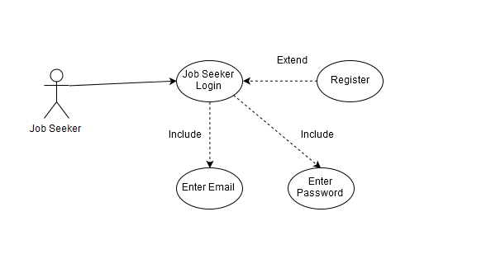
Figure 2: Jobseeker Login
Employer
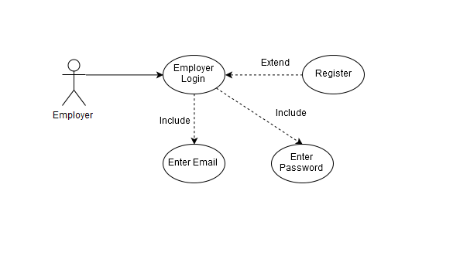
Figure 3: Employer Login

Job Search Use Case Diagram
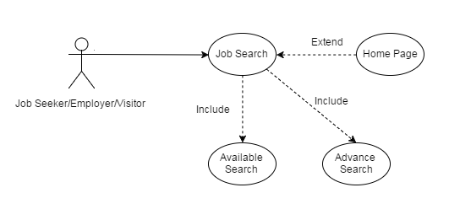
Figure 4: Job Search
Apply for Job Use Case Diagram

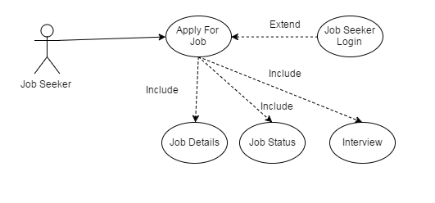
Figure 5: Apply for Job

Upload Resume Use Case Diagram
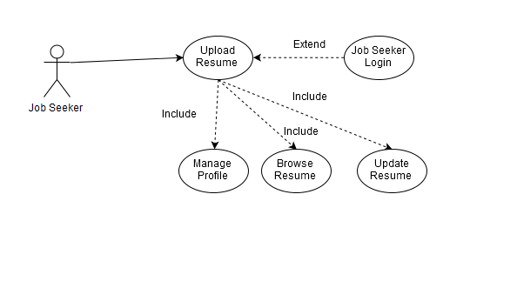
Figure 6: Upload Resume
Post a Job Use Case Diagram
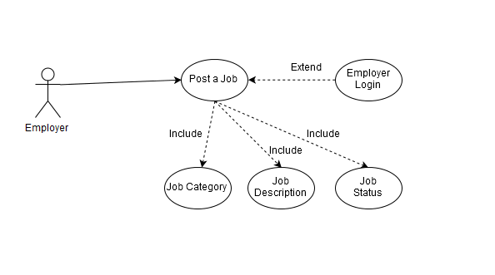
Figure 7: Post a Job

Video Call Use Case Diagram
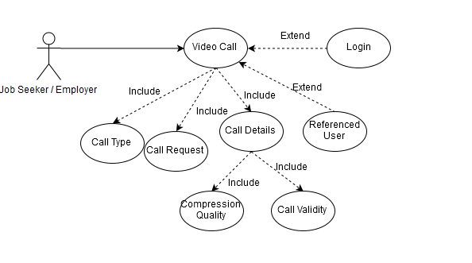
Figure 8: Video Call
Feedback Use Case Diagram
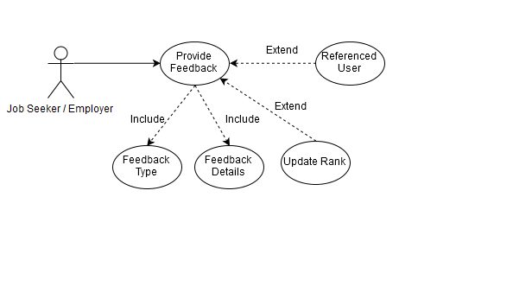
Figure 9: Feedback

Gateway Payment Use Case Diagram
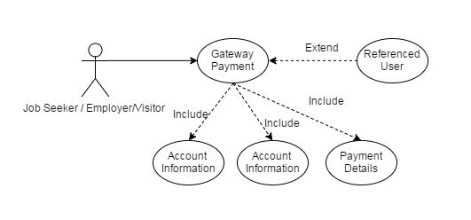
Figure 10: Gateway Payment
Cloud Data Use Case Diagram

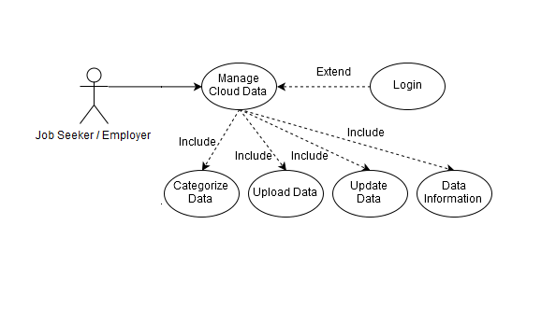
Figure 11: Cloud Data Management

Interview Management Use Case Diagram

Figure 12: Interview Management

Extended use cases
Use Case#1: Job Seeker Register

Use Case ID: | 1
Use Case Name: | Register to Website
Created By: | Numan |  | Last Updated By: | 27-1-2017
Date Created: | 15-1-2017 |  | Last Revision Date: | 28-1-2017
Actors: |  | Job Seeker
Description: |  | Job Seeker needs to register to the website for login by providing Name, Email, Password and Confirm Password.
Trigger: |  | Job seeker must open the website and click on the sign up button.
Preconditions: |  | User is on the homepage of the website
Post conditions: |  | Job Seeker will be able to use the core functionalities of the website
Normal Flow: |  | User enters first name, user enter last name, user enter email, user enter password and user enter again password for confirmation of password.  1. user open the website  2. Click on the sign up button.  3. System shows sign up page.  4. User enter his/her first name.  5. User enter his/her last name.  6. User enter his/her email address.  7. User enter his/her password.  8. User enter his/her password again for conformation.  9. User successfully register with the website.  10. System shows the dashboard screen to the user.
Alternative Flows:  [Alternative Flow 1 – Not in Network] |  | No alternative flow
Exceptions: |  | User missing one of the one field or enter wrong information for register to website (invalid email, password does not match)
Includes: |  | none
Frequency of Use: |  | On demand
Special Requirements: |  | Performance Requirements: The system should be error free as reliability is necessary for more than 500 employees and clients. The system will be functional at all times. Maintaining the website is done regularly and changes made if needed accordingly to the server needs. The system has the latest software’s and hardware’s to function well through heavy workload that should causes no errors from the server’s side.  Availability: All users will have 24 hours access to the website including documents, applications, and information.  Ease of Use Requirements:This website will provide an interface which will be easy to understand and there will be a Start Guide Page for the website by which users will be able to learn about how to use our website for their ease of use.
Assumptions: |  | We assume job seeker could not open the sign up page or may not understand the language.
Notes and Issues: |  | Any extra feature should be implemented on the base of our client requirements.

Use Case#2: Job Seeker Login

Use Case ID: | 2
Use Case Name: | Login to Website
Created By: | Numan |  | Last Updated By: | 27-1-2017
Date Created: | 15-1-2017 |  | Last Revision Date: | 28-1-2017
Actors: |  | Job Seeker
Description: |  | Job Seeker needs to register first to the website by providing username and password
Trigger: |  | Job seeker must open the website and click on the login page.
Preconditions: |  | User or job Seeker does not have enough access to website
Post conditions: |  | Job Seeker is able to search and apply for jobs
Normal Flow: |  | User enters username, password and login.  1. user open the website  2. Click on the login button.  3. System shows login page.  4. User enter his/her username.  5. User enter his/her password.  6. Click on the login button.  7. User successfully login into the system.
Alternative Flows:  [Alternative Flow 1 – Not in Network] |  | Alternative flow of job seeker login are following.  1. Job seeker open the login page.  2. Job seeker login with Facebook or Gmail.
Exceptions: |  | User cannot login to website (wrong username, password)
Includes: |  | None
Frequency of Use: |  | On demand
Special Requirements: |  | Performance Requirements: The system should be error free as reliability is necessary for more than 500 employees and clients. The system will be functional at all times. Maintaining the website is done regularly and changes made if needed accordingly to the server needs. The system has the latest software’s and hardware’s to function well through heavy workload that should causes no errors from the server’s side.  Availability: All users will have 24 hours access to the website including documents, applications, and information.  Ease of Use Requirements:This website will provide an interface which will be easy to understand and there will be a Start Guide Page for the website by which users will be able to learn about how to use our website for their ease of use.
Assumptions: |  | We assume job seeker could not open the login page or may not understand the language.
Notes and Issues: |  | Any extra feature should be implemented on the base of our client requirements.
Use Case#3: Employer Register

Use Case ID: | 3
Use Case Name: | Register to Website
Created By: | Numan |  | Last Updated By: | 27-1-2017
Date Created: | 15-1-2017 |  | Last Revision Date: | 28-1-2017
Actors: |  | Employee
Description: |  | Employer needs to register to the website by providing Name, Email, Password, Confirm Password and industry name
Trigger: |  | Employee open the website and click on employee register.
Preconditions: |  | Employer does not have enough access to the website
Post conditions: |  | Employer is able to post job Ads and perform other tasks, also is able to make some changes
Normal Flow: |  | Employer enters name, enters email, enters password, enters again password for confirmation of password and enter industry name then click on Register button.  1. user open the website  2. Click on the sign up button.  3. System shows sign up page.  4. User enter his/her first name.  5. User enter his/her last name.  6. User enter his/her email address.  7. User enter his/her industry name.  8. User enter his/her password.  9. User enter his/her password again for conformation.  10. User successfully register with the website.  11. System shows the dashboard screen to the user.
Alternative Flows:  [Alternative Flow 1 – Not in Network] |  | No alternative flow
Exceptions: |  | Employer cannot register to website if missing one of the required fields or enter wrong information (wrong email, password does not match)
Includes: |  | None
Frequency of Use: |  | On demand
Special Requirements: |  | Performance Requirements: The system should be error free as reliability is necessary for more than 500 employees and clients. The system will be functional at all times. Maintaining the website is done regularly and changes made if needed accordingly to the server needs. The system has the latest software’s and hardware’s to function well through heavy workload that should causes no errors from the server’s side.  Availability: All users will have 24 hours access to the website including documents, applications, and information.  Ease of Use Requirements:This website will provide an interface which will be easy to understand and there will be a Start Guide Page for the website by which users will be able to learn about how to use our website for their ease of use.
Assumptions: |  | We assume employer could not open the sign up page or may not understand the language.
Notes and Issues: |  | Any extra feature should be implemented on the base of our client requirements.

Use Case#4: Employer Login

Use Case ID: | 4
Use Case Name: | Login to Website
Created By: | Numan |  | Last Updated By: | 27-1-2017
Date Created: | 15-1-2017 |  | Last Revision Date: | 28-1-2017
Actors: |  | Employer
Description: |  | Employer needs to login to the website by providing username and password
Trigger: |  | Job seeker must open the website and click on the login page.
Preconditions: |  | Employer does not have enough access to the website
Post conditions: |  | Employer is able to post job Ads and perform other tasks, also is able to make some changes
Normal Flow: |  | User enters username, password and login.  1. user open the website  2. Click on the login button.  3. System shows login page.  4. User enter his/her username.  5. User enter his/her password.  6. Click on the login button.  7. User successfully login into the system.
Alternative Flows:  [Alternative Flow 1 – Not in Network] |  | Alternative flow of employer login are following.  1. Employer open the login page.  2. Employer login with Facebook or Gmail.
Exceptions: |  | Employer cannot login to website if (wrong “username, password”)
Includes: |  | none
Frequency of Use: |  | On demand
Special Requirements: |  | Performance Requirements: The system should be error free as reliability is necessary for more than 500 employees and clients. The system will be functional at all times. Maintaining the website is done regularly and changes made if needed accordingly to the server needs. The system has the latest software’s and hardware’s to function well through heavy workload that should causes no errors from the server’s side.  Availability: All users will have 24 hours access to the website including documents, applications, and information.  Ease of Use Requirements:This website will provide an interface which will be easy to understand and there will be a Start Guide Page for the website by which users will be able to learn about how to use our website for their ease of use.
Assumptions: |  | We assume employer could not open the login page or may not understand the language.
Notes and Issues: |  | Any extra feature should be implemented on the base of our client requirements.

Use Case#5: Upload Resume

Use Case ID: | 5
Use Case Name: | Upload Resume
Created By: | Numan |  | Last Updated By: | 27-1-2017
Date Created: | 15-1-2017 |  | Last Revision Date: | 28-1-2017
Actors: |  | Job Seeker
Description: |  | Job Seeker can upload their resume to the system and all the resumes are stored into the database
Trigger: |  | Job seeker firstly login into the website and then click on position for which they want to apply
Preconditions: |  | Job Seeker need to login into website before uploading their resume’s
Post conditions: |  | Job Seeker are able to search for job Ads and apply with uploaded resume
Normal Flow: |  | Job Seeker select the resume file from their system and upload it to website, they also can modify resume later.  User enters username, password and login.  1. user open the website  2. Click on the login button.  3. System shows login page.  4. User enter his/her username.  5. User enter his/her password.  6. Click on the login button.  7. User successfully login into the system.  8. User select the appropriate position for which they want to apply.  9. System show different vacant positions.  10. User click on the upload resume from there drive.  11. System successfully upload the resume.
Alternative Flows:  [Alternative Flow 1 – Not in Network] |  | Alternative flow of job seeker are given below.  1. Job seeker firstly login to website.  2. Job seeker firstly search the desired job.  3. Job seeker upload the resume.
Exceptions: |  | Limitation of resume file size does not let job applicator to upload resume
Includes: |  | Following are the use cases that have a common functionality.  1. Search Job Ads  2. Apply for a job
Frequency of Use: |  | On demand
Special Requirements: |  | Performance Requirements: The system should be error free as reliability is necessary for more than 500 employees and clients. The system will be functional at all times. Maintaining the website is done regularly and changes made if needed accordingly to the server needs. The system has the latest software’s and hardware’s to function well through heavy workload that should causes no errors from the server’s side.  Availability: All users will have 24 hours access to the website including documents, applications, and information.  Ease of Use Requirements:This website will provide an interface which will be easy to understand and there will be a Start Guide Page for the website by which users will be able to learn about how to use our website for their ease of use.
Assumptions: |  | We assume job seeker could not open the login page or may not understand the language. Job seeker do not able upload the resume.
Notes and Issues: |  | Any extra feature should be implemented on the base of our client requirements.

Use Case#6: Search for Jobs

Use Case ID: | 6
Use Case Name: | Search Job Ads
Created By: | Numan |  | Last Updated By: | 27-1-2017
Date Created: | 15-1-2017 |  | Last Revision Date: | 28-1-2017
Actors: |  | Job Seeker
Description: |  | Job Seeker can search the website’s data base for job Ads, search can be simple or advance.
Trigger: |  | Job seeker must login to the page then click on the search job.
Preconditions: |  | Job Seeker need to login to website before advanced search, but simple search is available for any user
Post conditions: |  | Job Seeker check result of their search to find the right one for applying
Normal Flow: |  | Job Seeker either can do simple search or advanced search  By giving search criteria.  User enters username, password and login.  1. user open the website  2. Click on the login button.  3. System shows login page.  4. User enter his/her username.  5. User enter his/her password.  6. Click on the login button.  7. User successfully login into the system.  8. User select the appropriate position for which they want to apply.  9. System show different vacant positions.  10. User search the desired position.  11. System show desired position.
Alternative Flows:  [Alternative Flow 1 – Not in Network] |  | Alternative flow of job seeker are given below.  1. Job seeker firstly login to website.  2. Job seeker upload the resume.  3. Job seeker search the desired job.
Exceptions: |  | Advanced search does not available for those who did not login to website, so they require to go back and login to Website
Includes: |  | Following are the use cases that have a common functionality.  1. job seeker login  2. Apply for a job  3. upload resume
Frequency of Use: |  | On demand
Special Requirements: |  | Performance Requirements: The system should be error free as reliability is necessary for more than 500 employees and clients. The system will be functional at all times. Maintaining the website is done regularly and changes made if needed accordingly to the server needs. The system has the latest software’s and hardware’s to function well through heavy workload that should causes no errors from the server’s side.  Availability: All users will have 24 hours access to the website including documents, applications, and information.  Ease of Use Requirements:This website will provide an interface which will be easy to understand and there will be a Start Guide Page for the website by which users will be able to learn about how to use our website for their ease of use.
Assumptions: |  | We assume job seeker could not open the login page or may not understand the language. Job seeker are not able to search for the desired job.
Notes and Issues: |  | Any extra feature should be implemented on the base of our client requirements.

Use Case#7: Apply for a job

Use Case ID: | 7
Use Case Name: | Apply for a Job Ad
Created By: | Numan |  | Last Updated By: | 27-1-2017
Date Created: | 15-1-2017 |  | Last Revision Date: | 28-1-2017
Actors: |  | Job Applicator
Description: |  | Job Seeker can apply for a particular job if they like any job Ads, they should provide some information plus uploaded Resume.
Trigger: |  | Job seeker must login to the page then click on the search job and then click on the apply job.
Preconditions: |  | Job Seeker requires to login to the website and upload Resume before applying for a particular job.
Post conditions: |  | Job Seeker wait for result of their application.
Normal Flow: |  | Job Seeker select apply button for particular job, then provide information and attach it to their uploaded resume.  Job Seeker either can do simple search or advanced search  By giving search criteria.  User enters username, password and login.  1. user open the website  2. Click on the login button.  3. System shows login page.  4. User enter his/her username.  5. User enter his/her password.  6. Click on the login button.  7. User successfully login into the system.  8. User select the appropriate position for which they want to apply.  9. System show different vacant positions.  10. User search the desired position.  11. System show desired position.  12. User select the desired position for which they want to apply.  13. User click on the apply button.
Alternative Flows:  [Alternative Flow 1 – Not in Network] |  | Alternative flow of job seeker are given below.  1. Job seeker firstly login to website.  3. Job seeker search the desired job.  4. Job seeker upload the resume.  5. Job seeker apply for the job.
Exceptions: |  | Job Seeker cannot apply for job, they might missed to upload resume, or provide inappropriate information to apply For that job.
Includes: |  | Following are the use cases that have a common functionality.  1. job seeker login  2. Search for a job  3. upload resume
Frequency of Use: |  | On demand
Special Requirements: |  | Performance Requirements: The system should be error free as reliability is necessary for more than 500 employees and clients. The system will be functional at all times. Maintaining the website is done regularly and changes made if needed accordingly to the server needs. The system has the latest software’s and hardware’s to function well through heavy workload that should causes no errors from the server’s side.  Availability: All users will have 24 hours access to the website including documents, applications, and information.  Ease of Use Requirements:This website will provide an interface which will be easy to understand and there will be a Start Guide Page for the website by which users will be able to learn about how to use our website for their ease of use.
Assumptions: |  | We assume job seeker could not open the login page or may not understand the language. Job seeker are not able to Apply for the desired job.
Notes and Issues: |  | Any extra feature should be implemented on the base of our client requirements.

Use Case#8: Post Jobs

Use Case ID: | 8
Use Case Name: | Post Job Ads
Created By: | Numan |  | Last Updated By: | 27-1-2017
Date Created: | 15-1-2017 |  | Last Revision Date: | 28-1-2017
Actors: |  | Employer
Description: |  | Employer can upload new job Ads with job details for particular position
Trigger: |  | Employer must login to the page then click on the post job.
Preconditions: |  | Employer must login to system in order to post new job Ads
Post conditions: |  | New job Ads provided by employer are stored in database and job applicators can find it by appropriate search
Normal Flow: |  | Employer provide sufficient information for specific job and post it in related job category, so it saved in website’s database.  User enters username, password and login.  1. user open the website  2. Click on the login button.  3. System shows login page.  4. User enter his/her username.  5. User enter his/her password.  6. Click on the login button.  7. User successfully login into the system.  8. User click on the post job button.  9. User successfully post the job  .
Alternative Flows:  [Alternative Flow 1 – Not in Network] |  | Alternative flow are the following.  1. Employer login  2. Check Interests for Job Ads  3. post job
Exceptions: |  | Employer username and password are incorrect.
Includes: |  | Following are the use cases that have a common functionality.  1. Employer login  2. Check interest for a job ads  3. Search resume
Frequency of Use: |  | On demand
Special Requirements: |  | Performance Requirements: The system should be error free as reliability is necessary for more than 500 employees and clients. The system will be functional at all times. Maintaining the website is done regularly and changes made if needed accordingly to the server needs. The system has the latest software’s and hardware’s to function well through heavy workload that should causes no errors from the server’s side.  Availability: All users will have 24 hours access to the website including documents, applications, and information.  Ease of Use Requirements:This website will provide an interface which will be easy to understand and there will be a Start Guide Page for the website by which users will be able to learn about how to use our website for their ease of use.
Assumptions: |  | We assume employer could not open the login page or may not understand the language. Employer are not able to post job.
Notes and Issues: |  | Any extra feature should be implemented on the base of our client requirements.

Use Case#9: Interest for Jobs

Use Case ID: | 9
Use Case Name: | Check Interests for Job Ads
Created By: | Numan |  | Last Updated By: | 27-1-2017
Date Created: | 15-1-2017 |  | Last Revision Date: | 28-1-2017
Actors: |  | Employer
Description: |  | Employer can check interests for job Ads to figure out the number of job seekers that are applied for that particular job
Trigger: |  | Employer must login to the page then Check Interests for Job Ads.
Preconditions: |  | Employer must post the job Ads
Post conditions: |  | By the check of every each job status
Normal Flow: |  | Employer login to the website, open job category and check the specific status, the number of job seekers who applied.  User enters username, password and login.  1. user open the website  2. Click on the login button.  3. System shows login page.  4. User enter his/her username.  5. User enter his/her password.  6. Click on the login button.  7. User successfully login into the system.  8. User click on the job category button.  9. System shows all the categories of job.
Alternative Flows:  [Alternative Flow 1 – Not in Network] |  | Alternative flow are the following.  1. Employer login  2. search Resume  3. post job
Exceptions: |  | Employer username and password are incorrect.
Includes: |  | Following are the use cases that have a common functionality.  1. Employer login  2. Post a job  3. Search resume
Frequency of Use: |  | On demand
Special Requirements: |  | Performance Requirements: The system should be error free as reliability is necessary for more than 500 employees and clients. The system will be functional at all times. Maintaining the website is done regularly and changes made if needed accordingly to the server needs. The system has the latest software’s and hardware’s to function well through heavy workload that should causes no errors from the server’s side.  Availability: All users will have 24 hours access to the website including documents, applications, and information.  Ease of Use Requirements:This website will provide an interface which will be easy to understand and there will be a Start Guide Page for the website by which users will be able to learn about how to use our website for their ease of use.
Assumptions: |  | We assume employer could not open the login page or may not understand the language. Employer are not able to search job ads.
Notes and Issues: |  | Any extra feature should be implemented on the base of our client requirements.

Use Case#10: Search Resume

Use Case ID: | 10
Use Case Name: | Search Resume
Created By: | Numan |  | Last Updated By: | 27-1-2017
Date Created: | 15-1-2017 |  | Last Revision Date: | 28-1-2017
Actors: |  | Employer
Description: |  | Employer can search for employee type or job sorting in database to find proper resumes
Trigger: |  | Employer must login to the page then click on the button of search resume.
Preconditions: |  | Employer must login to website
Post conditions: |  | Employer can contact job applicators and also provide them online test
Normal Flow: |  | Employer login to the website, by advanced search appropriate resumes are reachable.  User enters username, password and login.  1. user open the website  2. Click on the login button.  3. System shows login page.  4. User enter his/her username.  5. User enter his/her password.  6. Click on the login button.  7. User successfully login into the system.  8. User click on the job category button.  9. System shows all the categories of job.  10. User click on the search resume button.  11. system shows the resume
Alternative Flows:  [Alternative Flow 1 – Not in Network] |  | Alternative flow are the following.  1. Employer login  2. check interest for job ads  3. post job
Exceptions: |  | There is no resume belong to that specific position, thus employer require to post job ads for that job
Includes: |  | Following are the use cases that have a common functionality.  1. Employer login  2. Post a job  3. Check interest for job ads.
Frequency of Use: |  | On demand
Special Requirements: |  | Performance Requirements: The system should be error free as reliability is necessary for more than 500 employees and clients. The system will be functional at all times. Maintaining the website is done regularly and changes made if needed accordingly to the server needs. The system has the latest software’s and hardware’s to function well through heavy workload that should causes no errors from the server’s side.  Availability: All users will have 24 hours access to the website including documents, applications, and information.  Ease of Use Requirements:This website will provide an interface which will be easy to understand and there will be a Start Guide Page for the website by which users will be able to learn about how to use our website for their ease of use.
Assumptions: |  | We assume employer could not open the login page or may not understand the language. Employer are not able to search the resume.
Notes and Issues: |  | Any extra feature should be implemented on the base of our client requirements.

Use Case#11: Update Content

Use Case ID: | 11
Use Case Name: | Update Website Content
Created By: | Numan |  | Last Updated By: | 27-1-2017
Date Created: | 15-1-2017 |  | Last Revision Date: | 28-1-2017
Actors: |  | Administrator
Description: |  | Administrator must update website content by regular periods, in order to keep the website up to date and meet the needs of both employer and job applicator
Trigger: |  | Admin must enter his/her user name and password.
Preconditions: |  | Administrator require to collect information from employers to see how the content should change
Post conditions: |  | The new content available for employers and job applicators, makes easier to work with website
Normal Flow: |  | Modify or change content of the website such as texts or Pictures.  1. Admin open the admin page.  2. Enter his/her username and password.  3. Admin successfully login.  4. Click on the update button.  5. System successfully update the information.
Alternative Flows:  [Alternative Flow 1 – Not in Network] |  | None
Exceptions: |  | Admin enter Incorrect username and password.
Includes: |  | None
Frequency of Use: |  | On demand
Special Requirements: |  | Access Requirements: admin can have access to the system. Admin must have secure and private access to his/her data. Admin can have access to every part of the system.  Performance Requirements: The system should be error free as reliability is necessary for more than 500 employees and clients. The system will be functional at all times. Maintaining the website is done regularly and changes made if needed accordingly to the server needs. The system has the latest software’s and hardware’s to function well through heavy workload that should causes no errors from the server’s side.
Assumptions: |  | We assume admin enter incorrect username and password.
Notes and Issues: |  | Any extra feature should be implemented on the base of our client requirements.

Use Case#12: Video Conversation

Use Case ID: | 12
Use Case Name: | Video Conversation
Created By: | Numan |  | Last Updated By: | 27-1-2017
Date Created: | 15-1-2017 |  | Last Revision Date: | 28-1-2017
Actors: |  | Job Seeker , Employer
Description: |  | Registered users will be able to have a video conversation with each other in order to have a proper interview they will only need to click the video call button to whom a user wants to call
Trigger: |  | User must be login and click on the video conversation button.
Preconditions: |  | All the registered users must be online in order to have a video conversation.
Post conditions: |  | When any user clicks on the end call button, will be disconnected from the video conversation. Call details will be recorded in the database.
Normal Flow: |  | System allows user to have interview a job seeker or employer by having a video call using call button provided on website.  1. user open the website  2. Click on the login button.  3. System shows login page.  4. User enter his/her username.  5. User enter his/her password.  6. Click on the login button.  7. User successfully login into the system.  8. User select the appropriate person to which they want to call.  9. User click on the video button.  10. Video conversation start.
Alternative Flows:  [Alternative Flow 1 – Not in Network] |  | Alternative flow are the following.  1. user open the website  2. Click on the login button.  3. System shows login page.  4. User enter his/her username.  5. User enter his/her password.  6. Click on the login button.  7. User successfully login into the system.  8. User click on the video button.  9. User select the appropriate person to which they want to call.  10. Video conversation start.
Exceptions: |  | User enter incorrect username and password or user call the wrong person.
Includes: |  | Following are the use cases that have a common functionality.  1. Employer register to website  2. job seeker register to website  3. Employer login  4. job seeker login
Frequency of Use: |  | On demand
Special Requirements: |  | Performance Requirements: The system should be error free as reliability is necessary for more than 500 employees and clients. The system will be functional at all times. Maintaining the website is done regularly and changes made if needed accordingly to the server needs. The system has the latest software’s and hardware’s to function well through heavy workload that should causes no errors from the server’s side.  Availability: All users will have 24 hours access to the website including documents, applications, and information.  Ease of Use Requirements:This website will provide an interface which will be easy to understand and there will be a Start Guide Page for the website by which users will be able to learn about how to use our website for their ease of use.
Assumptions: |  | We assume user could not open the login page or may not understand the language .user are not able to click on the video Conversation button.
Notes and Issues: |  | Any extra feature should be implemented on the base of our client requirements.

Use Case#13: Gateway Payment

Use Case ID: | 13
Use Case Name: | Gateway Payment
Created By: | Numan |  | Last Updated By: | 27-1-2017
Date Created: | 15-1-2017 |  | Last Revision Date: | 28-1-2017
Actors: |  | Job Seeker , Employer, Visitor
Description: |  | Allows a user to pay money online using credit card just by Entering the account information
Trigger: |  | User must be login and click on the payment gateway button.
Preconditions: |  | Administrator require to collect information from user
Post conditions: |  | A successful transaction message would be displayed and details Will be recorded on database
Normal Flow: |  | It is the Simplest way of payment transaction for users.  1. user open the website  2. Click on the login button.  3. System shows login page.  4. User enter his/her username.  5. User enter his/her password.  6. Click on the login button.  7. User successfully login into the system.  8. User select the appropriate person to which they want to send money.  9. User click on the gateway payment button.  10. Money send to appropriate person via visa card credit card etc.
Alternative Flows:  [Alternative Flow 1 – Not in Network] |  | Alternative flow are the following.  1. user open the website  2. Click on the login button.  3. System shows login page.  4. User enter his/her username.  5. User enter his/her password.  6. Click on the login button.  7. User successfully login into the system.  8. User click on the gateway payment button.  9. User select the appropriate person to which they want to send money.  10. Money send to appropriate person via visa card credit card etc.
Exceptions: |  | User enter incorrect username and password or user call the wrong person.
Includes: |  | Following are the use cases that have a common functionality.  1. Employer register to website  2. job seeker register to website  3. Employer login  4. job seeker login
Frequency of Use: |  | On demand
Special Requirements: |  | Performance Requirements: The system should be error free as reliability is necessary for more than 500 employees and clients. The system will be functional at all times. Maintaining the website is done regularly and changes made if needed accordingly to the server needs. The system has the latest software’s and hardware’s to function well through heavy workload that should causes no errors from the server’s side.  Availability: All users will have 24 hours access to the website including documents, applications, and information.  Ease of Use Requirements:This website will provide an interface which will be easy to understand and there will be a Start Guide Page for the website by which users will be able to learn about how to use our website for their ease of use.
Assumptions: |  | We assume user could not open the login page or may not understand the language .user are not able to click on the gateway payment button.
Notes and Issues: |  | Any extra feature should be implemented on the base of our client requirements.

Use Case#14: Provide Feedback

Use Case ID: | 14
Use Case Name: | Provide Feedback
Created By: | Numan |  | Last Updated By: | 27-1-2017
Date Created: | 15-1-2017 |  | Last Revision Date: | 28-1-2017
Actors: |  | Job Seeker , Employer
Description: |  | Registered users can rate each other which will increase their ranking on the website
Trigger: |  | User must be login and click on the provide feedback button.
Preconditions: |  | A user must be logged in
Post conditions: |  | Profile rank updated and saved on database
Normal Flow: |  | It Updates the rank of a user.  1. user open the website  2. Click on the login button.  3. System shows login page.  4. User enter his/her username.  5. User enter his/her password.  6. Click on the login button.  7. User successfully login into the system.  8. User select the appropriate person to which they want to provide feedback.  9. User click on the feedback button.  10. Feedback should be shown to the screen.
Alternative Flows:  [Alternative Flow 1 – Not in Network] |  | 1. user open the website  2. Click on the login button.  3. System shows login page.  4. User enter his/her username.  5. User enter his/her password.  6. Click on the login button.  7. User successfully login into the system.  8. User click on the feedback button.  9. User select the appropriate person to which they want to provide feedback.  10. Feedback should be shown to the screen.
Exceptions: |  | User enter incorrect username and password.
Includes: |  | Following are the use cases that have a common functionality.  1. Employer register to website  2. job seeker register to website  3. Employer login  4. job seeker login
Frequency of Use: |  | On demand
Special Requirements: |  | Performance Requirements: The system should be error free as reliability is necessary for more than 500 employees and clients. The system will be functional at all times. Maintaining the website is done regularly and changes made if needed accordingly to the server needs. The system has the latest software’s and hardware’s to function well through heavy workload that should causes no errors from the server’s side.  Availability: All users will have 24 hours access to the website including documents, applications, and information.  Ease of Use Requirements:This website will provide an interface which will be easy to understand and there will be a Start Guide Page for the website by which users will be able to learn about how to use our website for their ease of use.
Assumptions: |  | We assume user could not open the login page or may not understand the language.
Notes and Issues: |  | Any extra feature should be implemented on the base of our client requirements.

Use Case#15: Manage Cloud Data

Use Case ID: | 15
Use Case Name: | Manage Cloud Data
Created By: | Numan |  | Last Updated By: | 27-1-2017
Date Created: | 15-1-2017 |  | Last Revision Date: | 28-1-2017
Actors: |  | Job Seeker , Employer
Description: |  | Registered users will be able to manage their space provided as Default by the website by uploading , creating and editing Their data saved on cloud
Trigger: |  | User must be click on login button.
Preconditions: |  | User must be logged in and should have clicked on the Manage Cloud Data button
Post conditions: |  | The cloud available for employers and job seekers, makes easier to work with website
Normal Flow: |  | It Edit contents of cloud such as texts or pictures or files.  1. user open the website  2. Click on the login button.  3. System shows login page.  4. User enter his/her username.  5. User enter his/her password.  6. Click on the login button.  7. User successfully login into the system.  8. User click on the update button.  9. User update the information.  10. System shows the screen information updated successfully.
Alternative Flows:  [Alternative Flow 1 – Not in Network] |  | None
Exceptions: |  | User enter incorrect username and password.
Includes: |  | Following are the use cases that have a common functionality.  1. Employer register to website  2. job seeker register to website  3. Employer login  4. job seeker login
Frequency of Use: |  | On demand
Special Requirements: |  | Performance Requirements: The system should be error free as reliability is necessary for more than 500 employees and clients. The system will be functional at all times. Maintaining the website is done regularly and changes made if needed accordingly to the server needs. The system has the latest software’s and hardware’s to function well through heavy workload that should causes no errors from the server’s side.  Availability: All users will have 24 hours access to the website including documents, applications, and information.  Ease of Use Requirements:This website will provide an interface which will be easy to understand and there will be a Start Guide Page for the website by which users will be able to learn about how to use our website for their ease of use.
Assumptions: |  | We assume user could not open the login page or may not understand the language.
Notes and Issues: |  | Any extra feature should be implemented on the base of our client requirements.

Use Case#16: Interview Management
Use Case ID: | 16
Use Case Name: | Interview Management
Created By: | Numan |  | Last Updated By: | 27-1-2017
Date Created: | 15-1-2017 |  | Last Revision Date: | 28-1-2017
Actors: |  | Job Seeker , Employer
Description: |  | Employer manage the interview of job seeker. Job seeker firstly register themselves and then they are able to apply for any job. Job seeker answer the some question. Then on the base of their answer employer assess and rate them.
Trigger: |  | Employer click on the interview management option and then the process of interview management start.
Preconditions: |  | User must be logged in and should click on the interview button.
Post conditions: |  | The online interview facility are always available for employers and job seekers that makes them easier to work with website.
Normal Flow: |  | For interview employee select the appropriate position select some questions and select the candidate and finally asses and rate the job seeker on the base of their answers.  1. Employer click on the interview management button.  2. System open the interview management screen.  3. Employer select the position.  4. System shows different position for which the job seeker apply.  5. Employer create/add some questions.  6. System shows candidates who apply.  7. Employer select the candidate for interview.  8. Employer asses the candidate on the base of their answers.  9. Employer rate the candidate on the base of their answers.
Alternative Flows:  [Alternative Flow 1 – Not in Network] |  | In the alternative flow employer firstly open the interview management screen.  1. Employer create/add some questions.  2. Employer select the position  3. Employer select the candidate for interview.  4. Employer asses the candidate on the base of their answers.  5. Employer rate the candidate on the base of their answers.
Exceptions: |  | User missing one of the one field or enter wrong information for register to website (invalid email, password does not match).
Includes: |  | The use cases that are included that have common functionality are following.  1. Select Appropriate position  2. Create/Add questions  3. Select Candidate  4. View Assessment status
Frequency of Use: |  | On demand
Special Requirements: |  | Ease of Use Requirements:This website will provide an interface which will be easy to understand and there will be a Start Guide Page for the website by which users will be able to learn about how to use our website for their ease of use.  Performance Requirements: The system should be error free as reliability is necessary for more than 500 employees and clients. The system will be functional at all times. Maintaining the website is done regularly and changes made if needed accordingly to the server needs. The system has the latest software’s and hardware’s to function well through heavy workload that should causes no errors from the server’s side.  Availability: All users will have 24 hours access to the website including documents, applications, and information.
Assumptions: |  | For the interview management user could not understand the system.
Notes and Issues: |  | Any extra feature should be implemented on the base of our client requirements.

Use Case#17: Select Appropriate position
Use Case ID: | 17
Use Case Name: | Select Appropriate position
Created By: | Numan |  | Last Updated By: | 27-1-2017
Date Created: | 15-1-2017 |  | Last Revision Date: | 28-1-2017
Actors: |  | Employer
Description: |  | Employer manage the interview of job seeker. Firstly they check the appropriate position for which job seeker apply and they conduct the interview.
Trigger: |  | Employer must click on the interview management button then process of selecting the position start.
Preconditions: |  | User must be logged in and select the appropriate position for which job seeker apply.
Post conditions: |  | Employer successfully select the appropriate position for which the job seeker apply. If the employer did not select appropriate position the system shows some error message.
Normal Flow: |  | For interview employee firstly login and select the appropriate position for which the candidate apply.  1. Employer click on the interview management button.  2. System open the interview management screen.  3. Employer select the position.  4. System shows different position for which the job seeker apply.
Alternative Flows:  [Alternative Flow 1 – Not in Network] |  | No alternative flow
Exceptions: |  | User missing one of the one field or enter wrong information for register to website (invalid email, password does not match)
Includes: |  | The use cases that are included that have common functionality are following.  1. Select Appropriate position  2. Create/Add questions  3. Select Candidate  4. View Assessment status
Frequency of Use: |  | On demand
Special Requirements: |  | Ease of Use Requirements:This website will provide an interface which will be easy to understand and there will be a Start Guide Page for the website by which users will be able to learn about how to use our website for their ease of use.  Performance Requirements: The system should be error free as reliability is necessary for more than 500 employees and clients. The system will be functional at all times. Maintaining the website is done regularly and changes made if needed accordingly to the server needs. The system has the latest software’s and hardware’s to function well through heavy workload that should causes no errors from the server’s side.  Availability: All users will have 24 hours access to the website including documents, applications, and information.
Assumptions: |  | For the interview management user could not understand the system or not understand the language.
Notes and Issues: |  | Any extra feature should be implemented on the base of our client requirements.

Use Case#18: Create /Add Questions

Use Case ID: | 18
Use Case Name: | Create /Add Questions
Created By: | Numan |  | Last Updated By: | 27-1-2017
Date Created: | 15-1-2017 |  | Last Revision Date: | 28-1-2017
Actors: |  | Employer
Description: |  | Employer create or add some questions for the job seeker Firstly they check the appropriate position for which job seeker apply and then create or add some questions for job seeker.
Trigger: |  | Employer must click on the interview management button then process of create/add questions start.
Preconditions: |  | User must be logged in and select the appropriate position for which job seeker apply and then create or add some questions for the job seeker.
Post conditions: |  | Employer successfully select the appropriate position for which the job seeker apply. Then the employer create or add some question for the job seeker then the job seeker answer these question if the questions are not show to job seeker then system shows some error message to the employer to add/create some question.
Normal Flow: |  | For interview employee firstly login and select the appropriate question for the interview of the job seeker.  1. Employer click on the interview management button.  2. System open the interview management screen.  3. Employer select the position.  4. System shows different position for which the job seeker apply.  5. Employer create/add some questions.
Alternative Flows:  [Alternative Flow 1 – Not in Network] |  | In the alternative flow employer firstly open the interview management screen.  1. Employer create/add some questions.  2. Employer select the position
Exceptions: |  | User missing one of the one field or enter wrong information for register to website (invalid email, password does not match)
Includes: |  | The use cases that are included that have common functionality are following.  1. Select Appropriate position  2. Create/Add questions  3. Select Candidate  4. View Assessment status
Frequency of Use: |  | On demand.
Special Requirements: |  | Ease of Use Requirements:This website will provide an interface which will be easy to understand and there will be a Start Guide Page for the website by which users will be able to learn about how to use our website for their ease of use.  Performance Requirements: The system should be error free as reliability is necessary for more than 500 employees and clients. The system will be functional at all times. Maintaining the website is done regularly and changes made if needed accordingly to the server needs. The system has the latest software’s and hardware’s to function well through heavy workload that should causes no errors from the server’s side.  Availability: All users will have 24 hours access to the website including documents, applications, and information.
Assumptions: |  | For the interview management user could not understand the system or not understand the language.
Notes and Issues: |  | Any extra feature should be implemented on the base of our client requirements.

Use Case#19: Select Candidate
Use Case ID: | 19
Use Case Name: | Select Candidate
Created By: | Numan |  | Last Updated By: | 27-1-2017
Date Created: | 15-1-2017 |  | Last Revision Date: | 28-1-2017
Actors: |  | Employer
Description: |  | Employer select the candidate who apply for the job. After the successful selection some question are shown on the job seeker screen.
Trigger: |  | Employer must click on the interview management button then process of selecting candidate start.
Preconditions: |  | User must be logged in and select the appropriate position for which job seeker apply and then create or add some questions for the job seeker. Then the employer select the candidate who apply for the job.
Post conditions: |  | Employer successfully select the appropriate position for which the job seeker apply. Employer select the candidate who apply for the job then some questions are shown on the job seeker screen. If the employer did not select the appropriate candidate according to their position then the system shows error message select the correct candidate.
Normal Flow: |  | For interview employee firstly login and select the appropriate candidate according to the position for which the job seeker apply.  For interview employee select the appropriate position select some questions and select the candidate and finally asses and rate the job seeker on the base of their answers.  1. Employer click on the interview management button.  2. System open the interview management screen.  3. Employer select the position.  4. System shows different position for which the job seeker apply.  5. Employer create/add some questions.  6. System shows candidates who apply.  7. Employer select the candidate for interview.
Alternative Flows:  [Alternative Flow 1 – Not in Network] |  | In the alternative flow employer firstly open the interview management screen.  1. Employer create/add some questions.  2. Employer select the position  3. Employer select the candidate for interview.
Exceptions: |  | User missing one of the one field or enter wrong information for register to website (invalid email, password does not match)
Includes: |  | The use cases that are included that have common functionality are following.  1. Select Appropriate position  2. Create/Add questions  3. Select Candidate  4. View Assessment status
Frequency of Use: |  | On demand
Special Requirements: |  | Ease of Use Requirements:This website will provide an interface which will be easy to understand and there will be a Start Guide Page for the website by which users will be able to learn about how to use our website for their ease of use.  Performance Requirements: The system should be error free as reliability is necessary for more than 500 employees and clients. The system will be functional at all times. Maintaining the website is done regularly and changes made if needed accordingly to the server needs. The system has the latest software’s and hardware’s to function well through heavy workload that should causes no errors from the server’s side.  Availability: All users will have 24 hours access to the website including documents, applications, and information.
Assumptions: |  | For the interview management user could not understand the system or not understand the language.
Notes and Issues: |  | Any extra feature should be implemented on the base of our client requirements.

Use Case#20: View assessment status

Use Case ID: | 20
Use Case Name: | View assessment status
Created By: | Numan |  | Last Updated By: | 27-1-2017
Date Created: | 15-1-2017 |  | Last Revision Date: | 28-1-2017
Actors: |  | Employer
Description: |  | After the completion of the interview employer can see the assessment report of the job seeker. On the base of his/her assessment they can rate them.
Trigger: |  | Employer must click on the interview management button then click on the select candidate then process of view assessment statue start.
Preconditions: |  | User must be logged in and select the appropriate position for which job seeker apply and then create or add some questions for the job seeker. Job seeker must be appear in the interview.
Post conditions: |  | Employer successfully select the appropriate position for which the job seeker apply. Job seeker must be appear in the interview and it is compulsory for him/her answer the question.
Normal Flow: |  | For interview employee firstly login and it is compulsory for the job seeker to appear in the interview. Because on the base of his/her answer employer can view assessment status and rate them.  1. Employer click on the interview management button.  2. System open the interview management screen.  3. Employer select the position.  4. System shows different position for which the job seeker apply.  5. Employer create/add some questions.  6. System shows candidates who apply.  7. Employer select the candidate for interview.  8. Employer asses the candidate on the base of their answers.  9. Employer rate the candidate on the base of their answers.
Alternative Flows:  [Alternative Flow 1 – Not in Network] |  | In the alternative flow employer firstly open the interview management screen.  1. Employer create/add some questions.  2. Employer select the position  3. Employer select the candidate for interview.  4. Employer asses the candidate on the base of their answers.  5. Employer rate the candidate on the base of their answers.
Exceptions: |  | User missing one of the one field or enter wrong information for register to website (invalid email, password does not match).
Includes: |  | The use cases that are included that have common functionality are following.  1. Select Appropriate position  2. Create/Add questions  3. Select Candidate  4. View Assessment status
Frequency of Use: |  | On demand
Special Requirements: |  | Ease of Use Requirements:This website will provide an interface which will be easy to understand and there will be a Start Guide Page for the website by which users will be able to learn about how to use our website for their ease of use.  Performance Requirements: The system should be error free as reliability is necessary for more than 500 employees and clients. The system will be functional at all times. Maintaining the website is done regularly and changes made if needed accordingly to the server needs. The system has the latest software’s and hardware’s to function well through heavy workload that should causes no errors from the server’s side.  Availability: All users will have 24 hours access to the website including documents, applications, and information.
Assumptions: |  | For the interview management user could not understand the system.
Notes and Issues: |  | Any extra feature should be implemented on the base of our client requirements.

User interfaces (mock screens)
Home Page
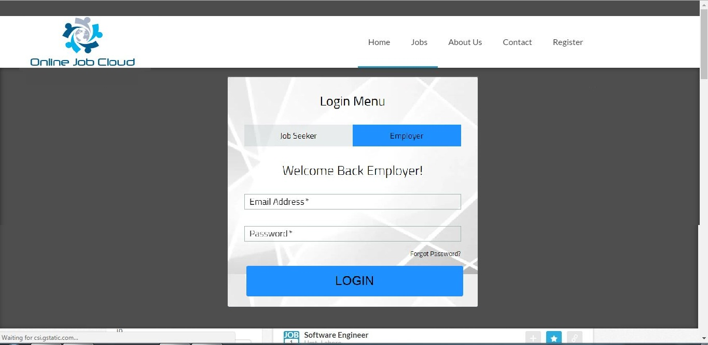
Figure 3.6.1
Search for Jobs
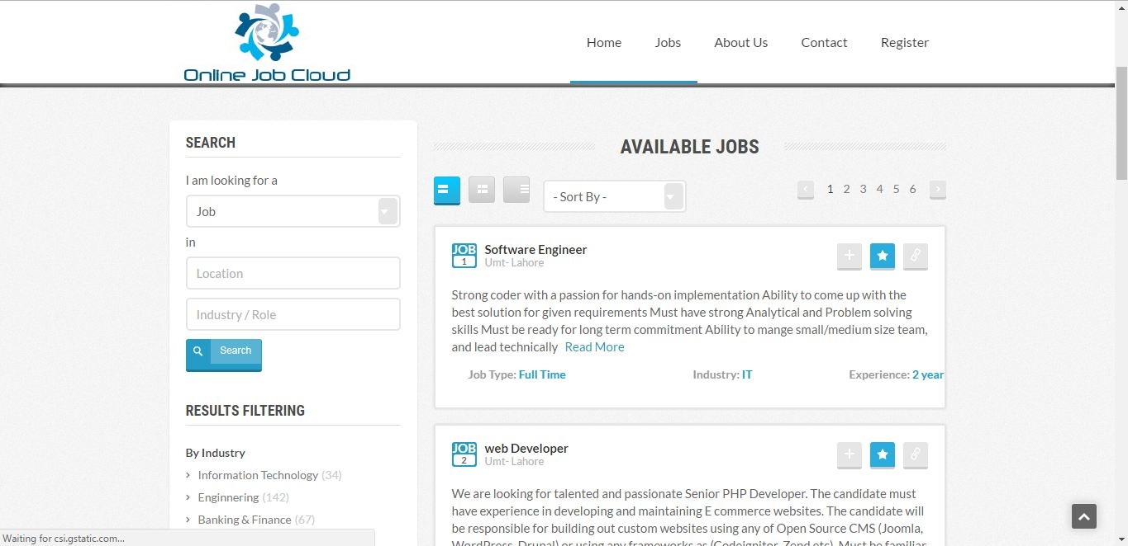

Figure 3.6.2

View Posted Jobs
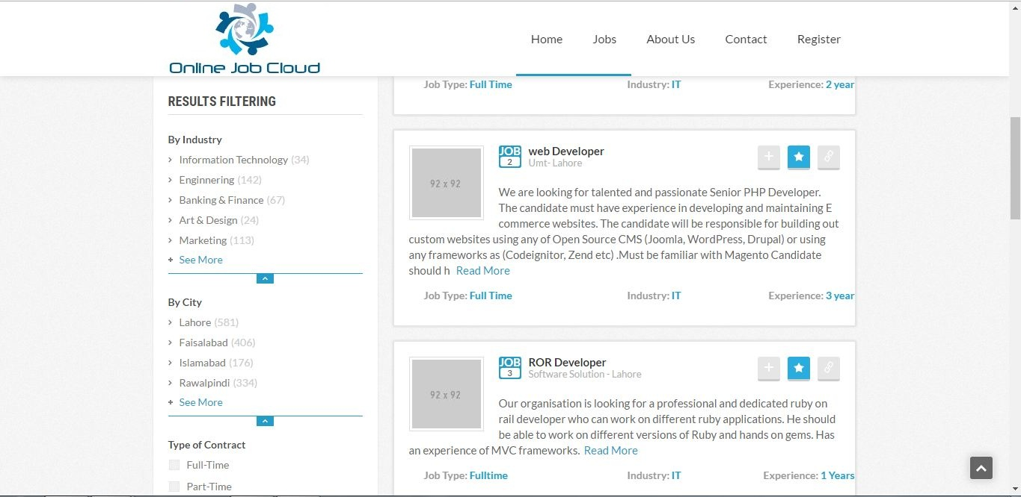
Figure 3.6.3

JobSeeker Registration
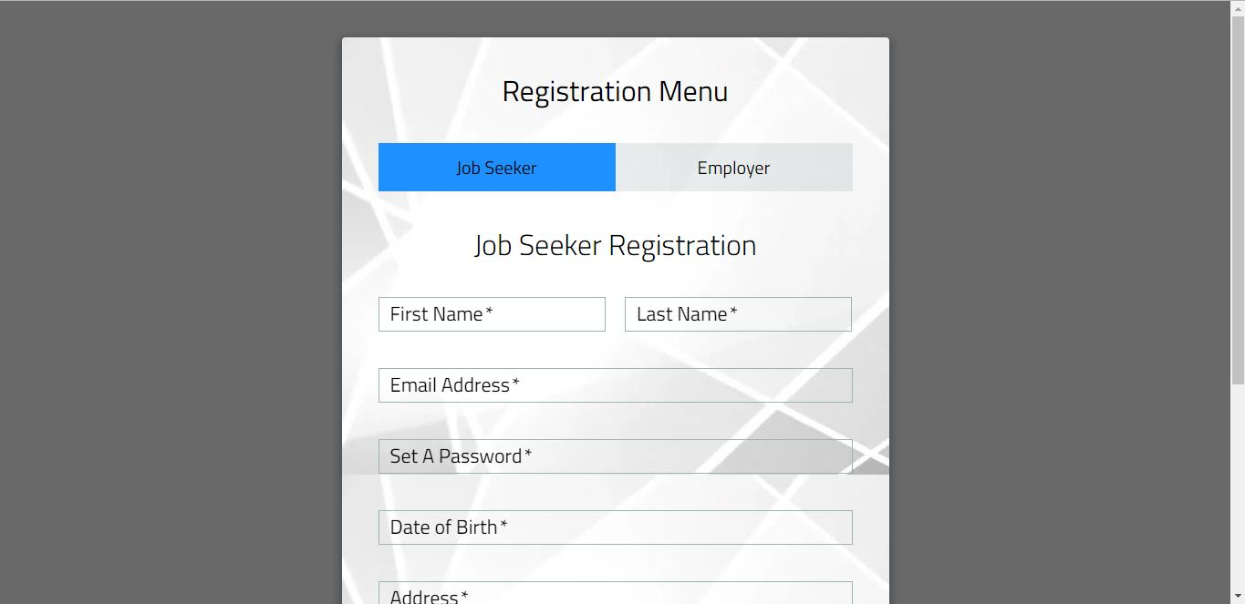
Figure 3.6.4

Employer Registration
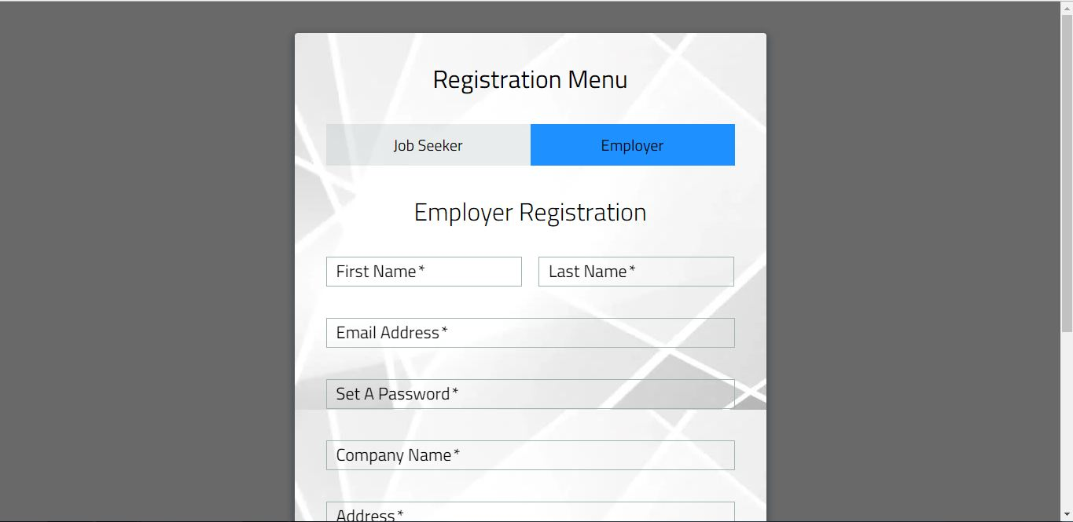
Figure 3.6.5

JobSeeker Login
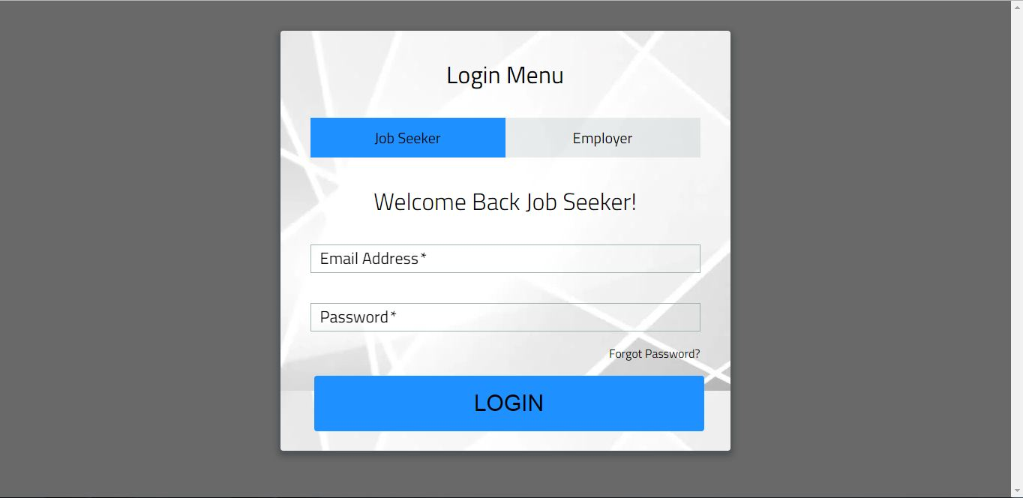
Figure 3.6.6

Employer Login
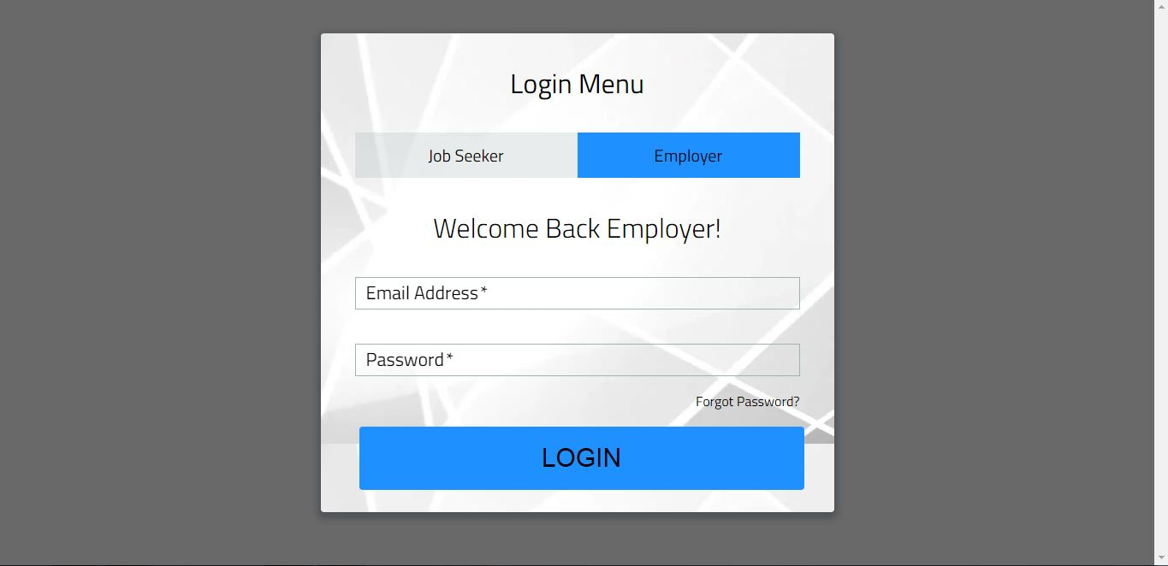
Figure 3.6.7

Advance Search
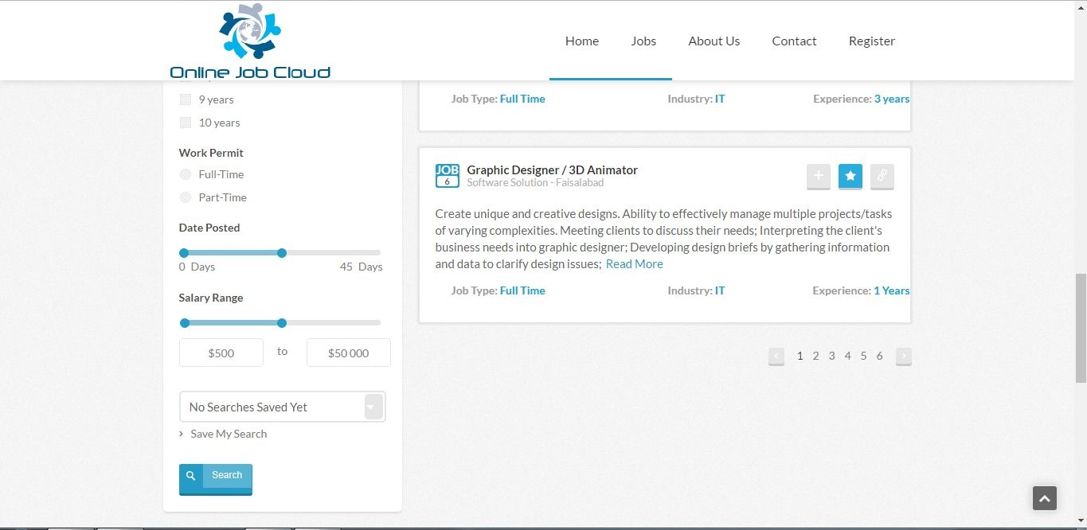
Figure 3.6.8

Website Footer
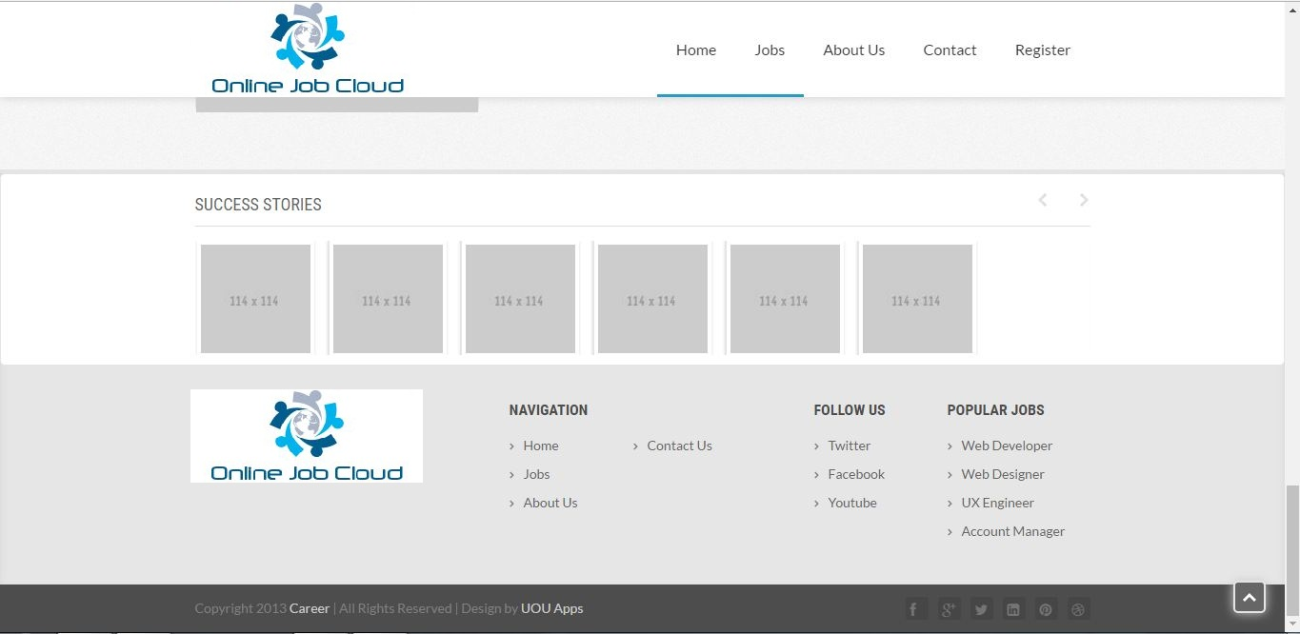
Figure 3.6.9

Contact Us
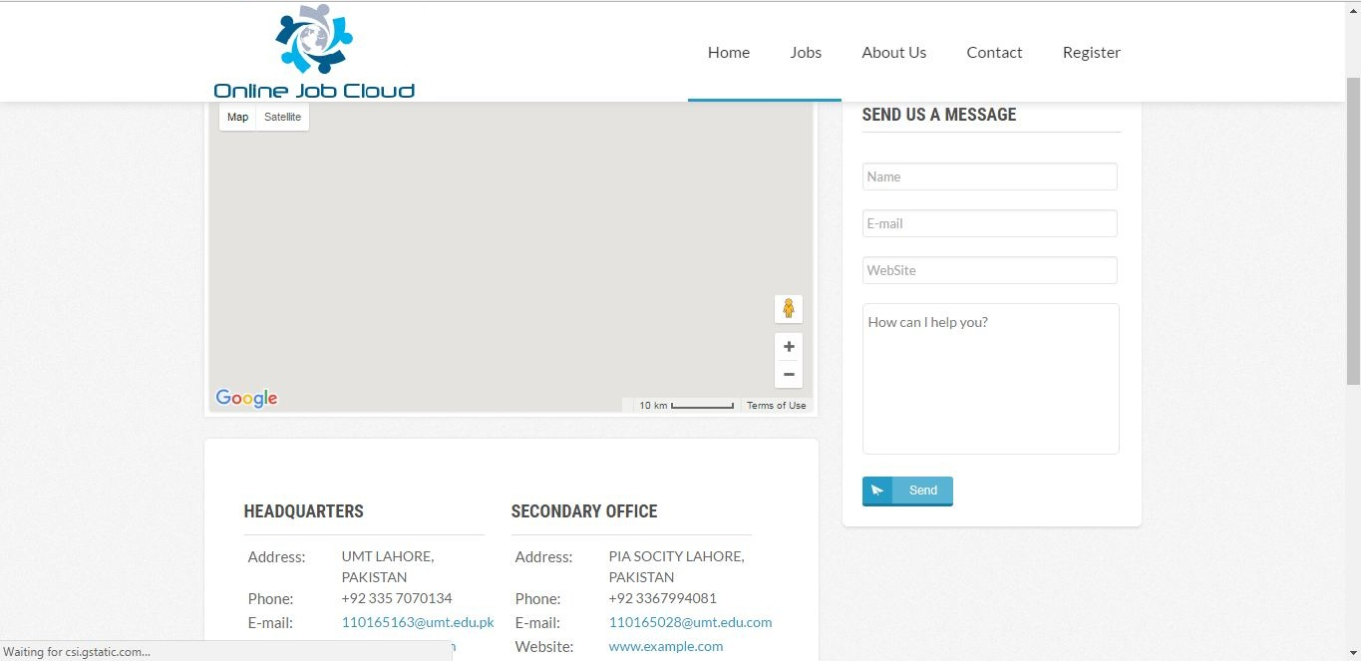
Figure 3.6.10

Post A Job
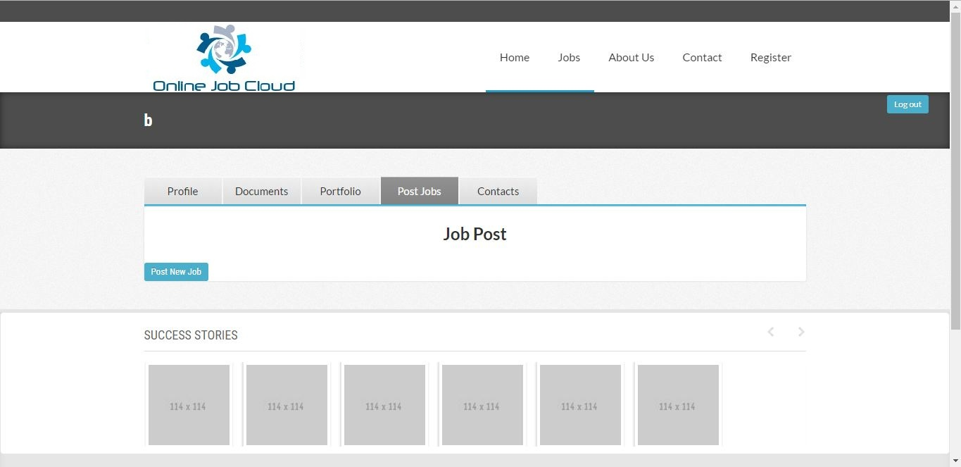
Figure 3.6.11

Apply for Job
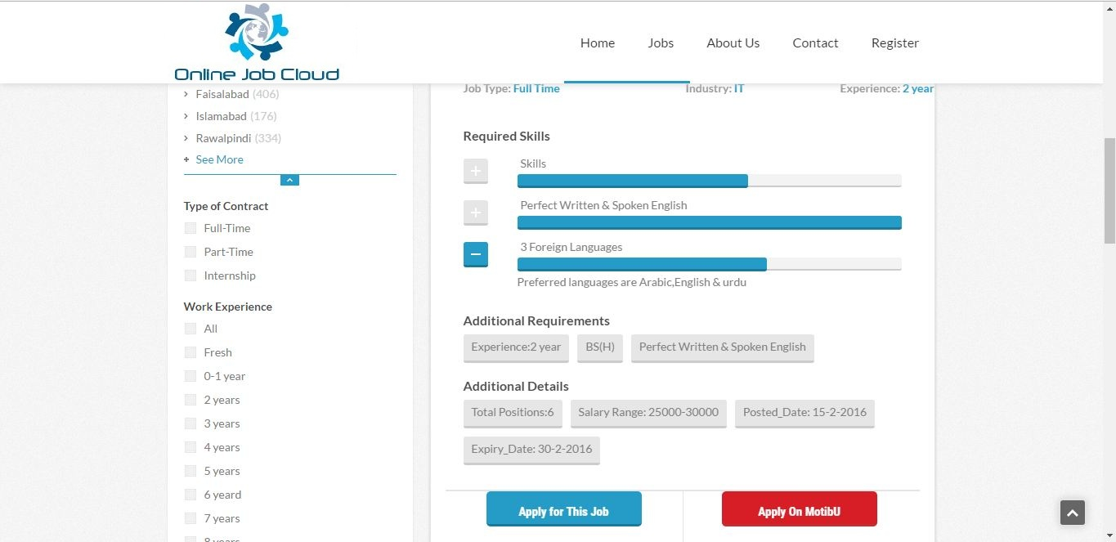
Figure 3.6.1

Update/Edit Resume
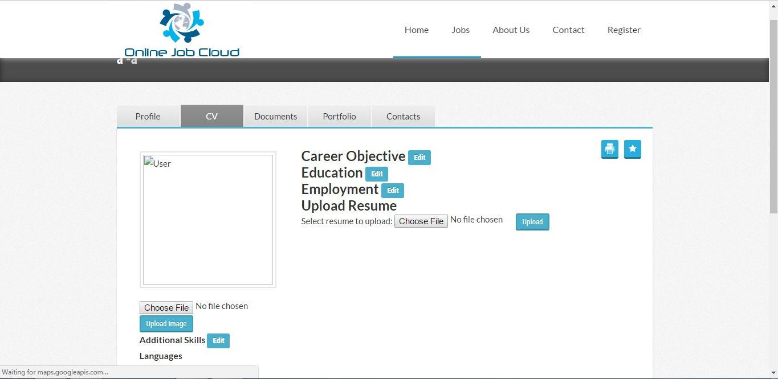
Figure 3.6.13

User Portfolio
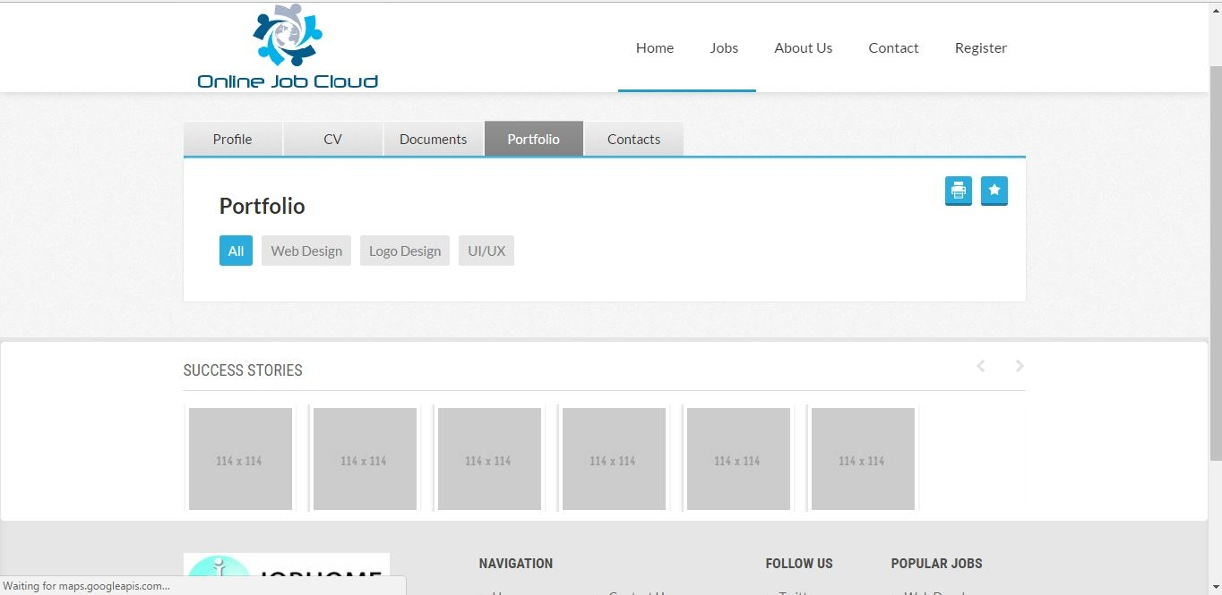
Figure 3.6.14

User Contacts
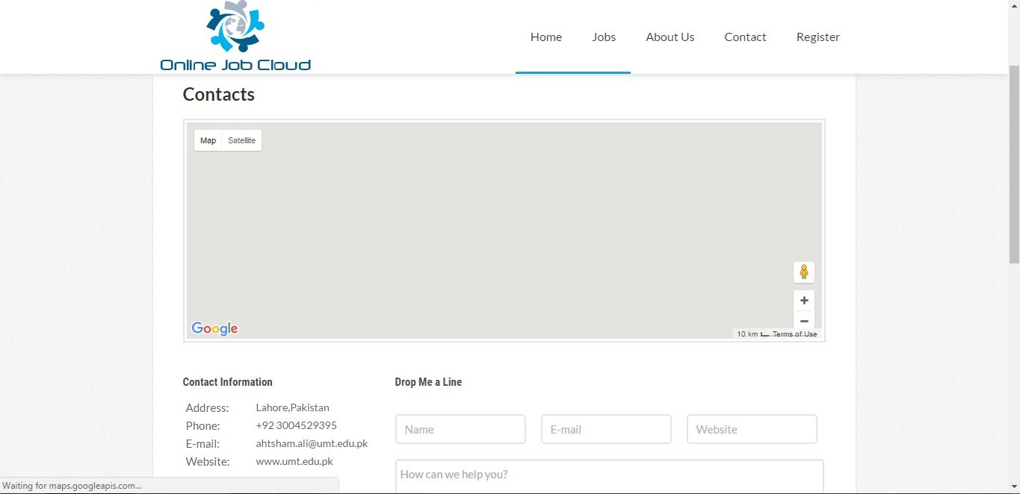
Figure 3.6.15

Video Conversation
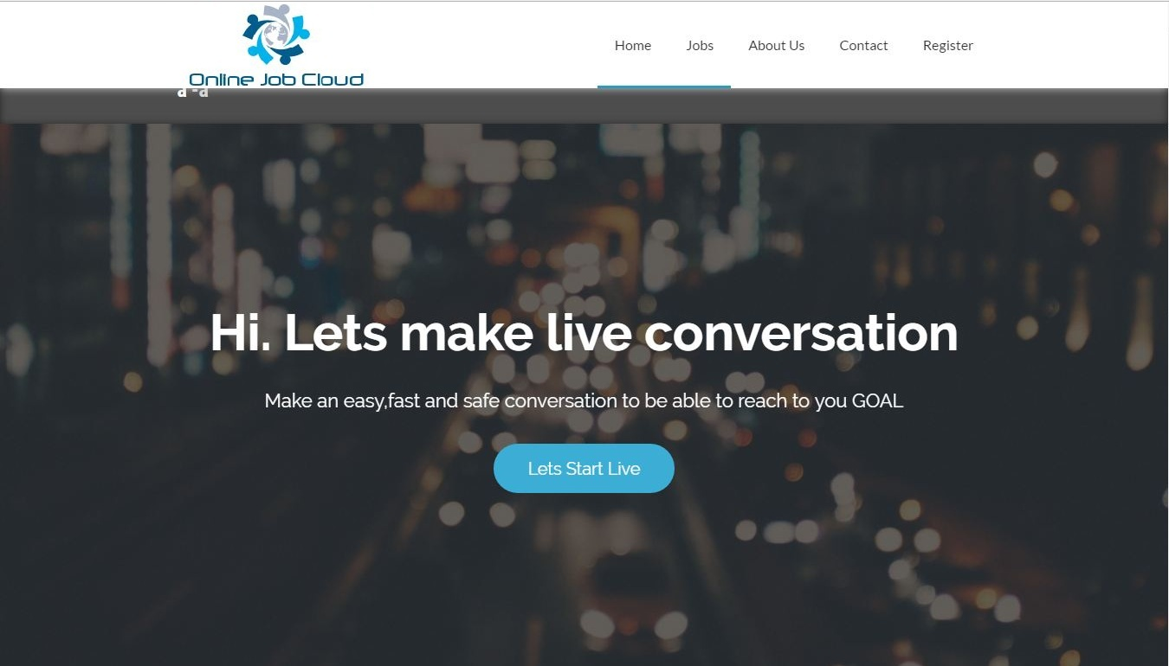
Figure 3.6.16

Interview Management
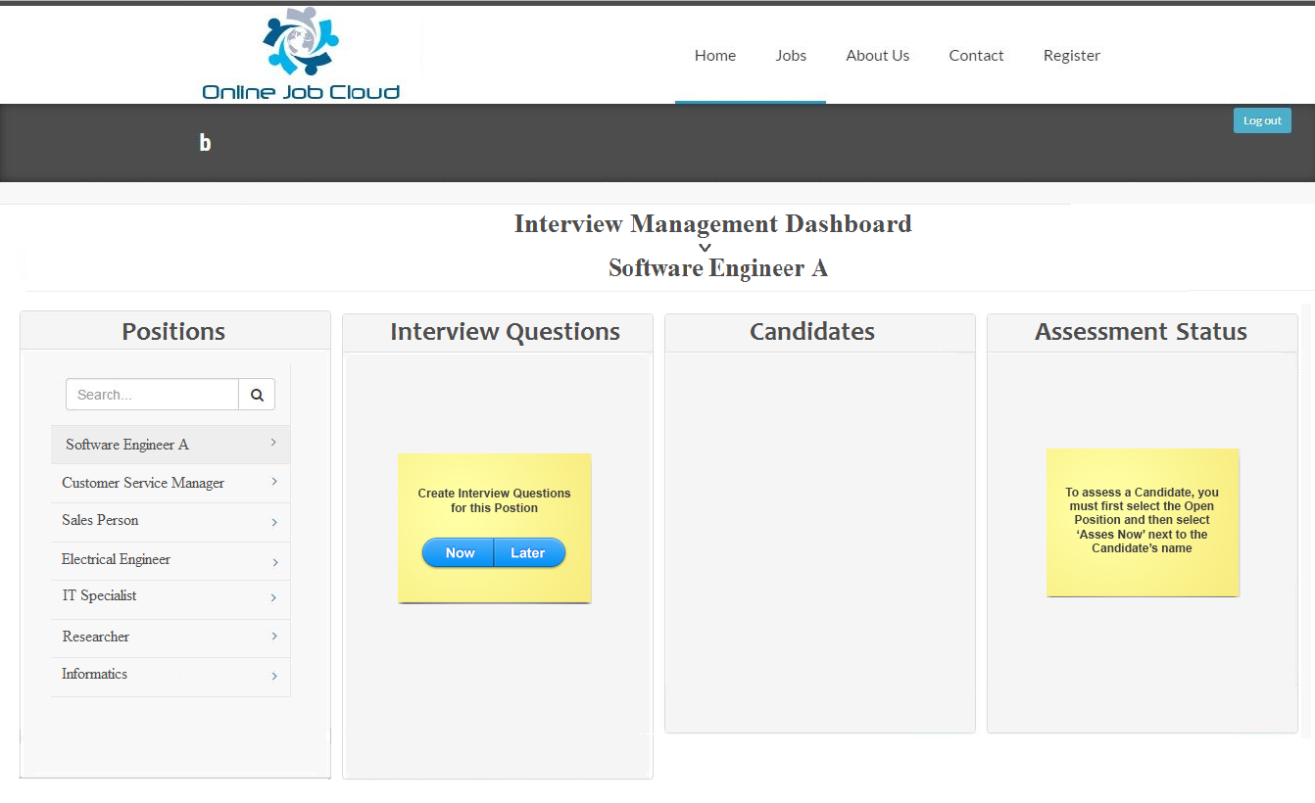
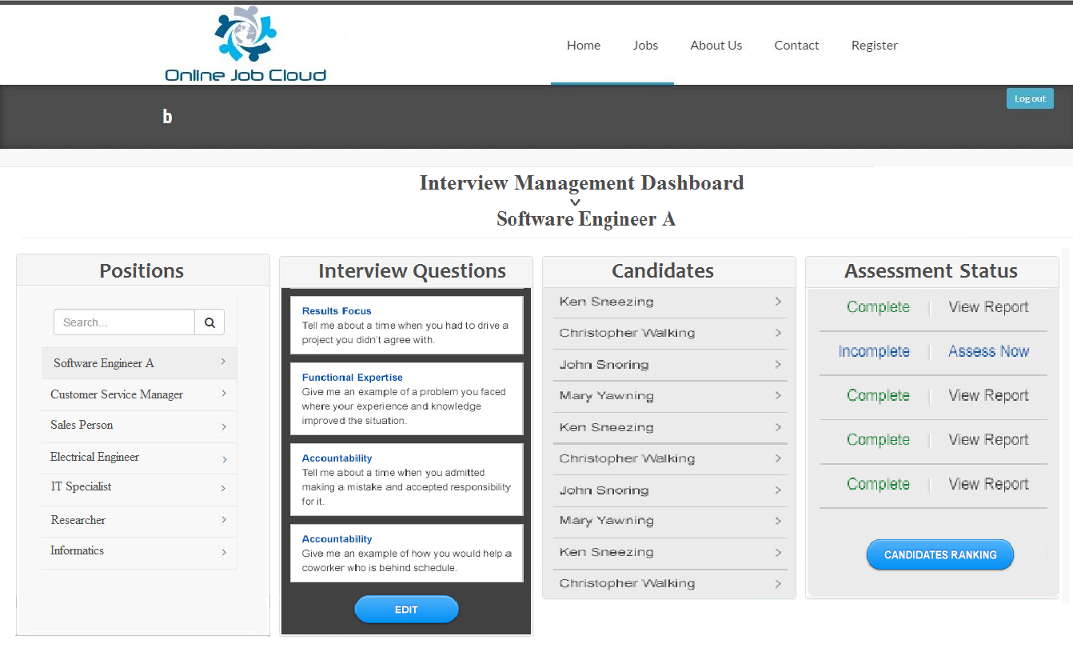
Figure 3.6.17

Gateway Payment
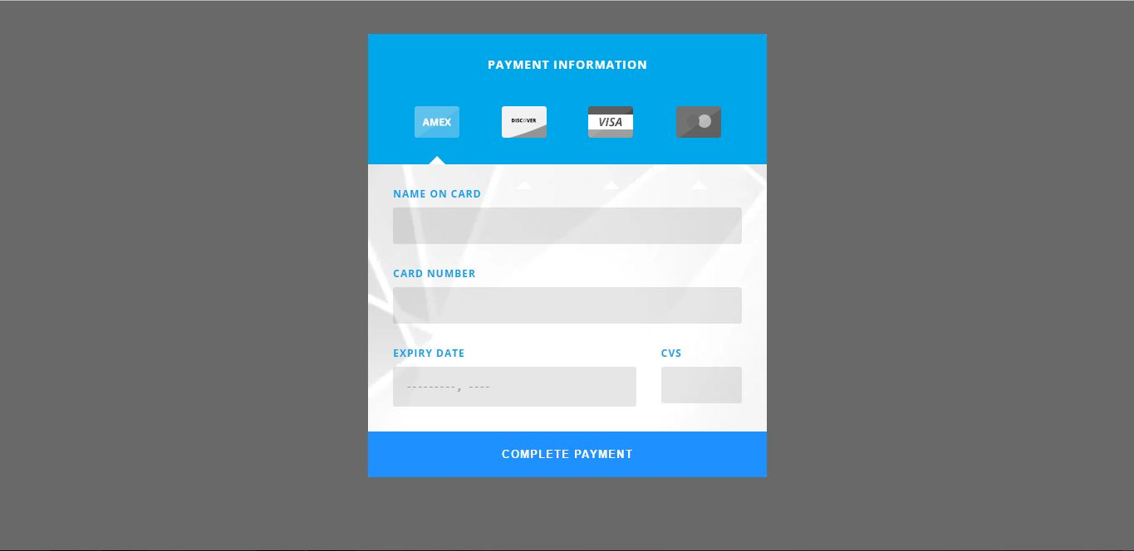
Figure 3.6.18

Feedback

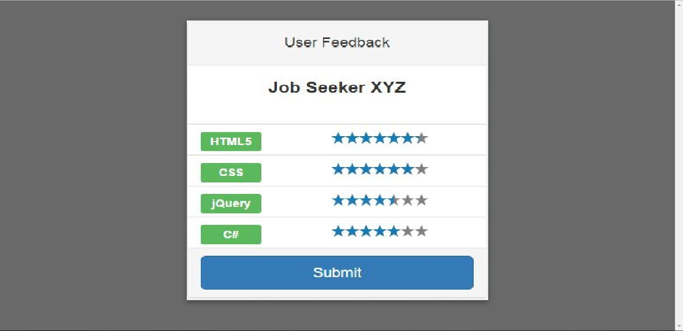
Figure 3.6.19

Data flow diagram (optional)

Data Flow Diagram Level 0
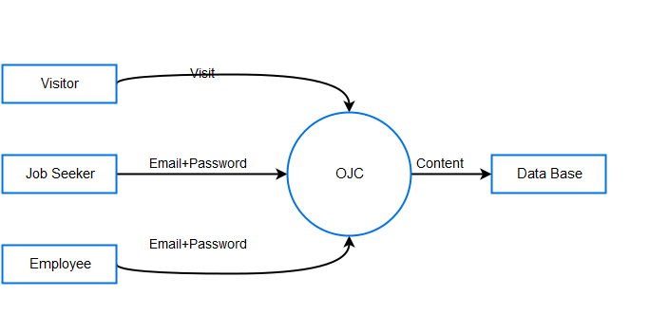
Figure 4.1.1

Data Flow Diagram Level 1

DFD 1 Visitor
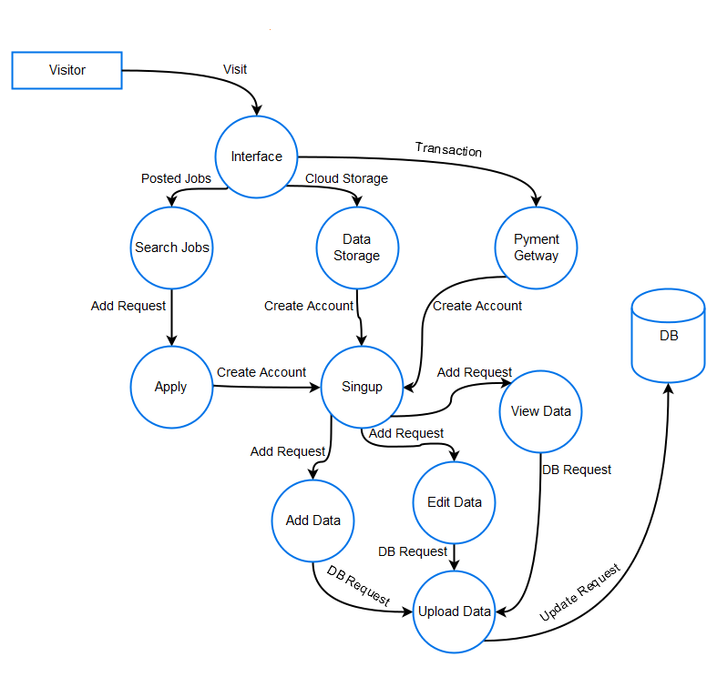
Figure 4.2.1

DFD 1 Job Seeker

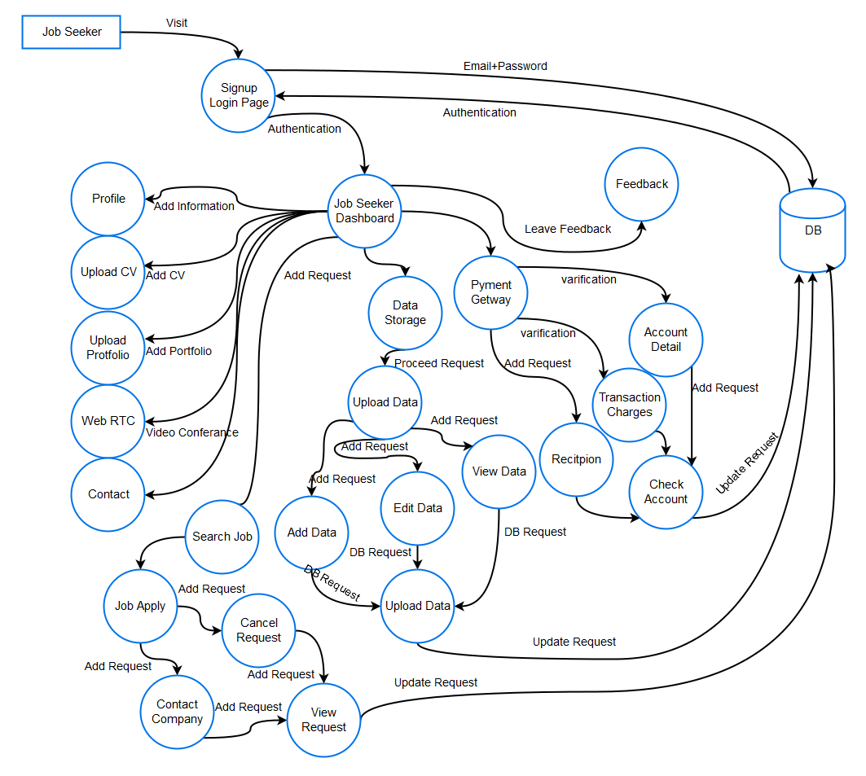
Figure 4.2.2

DFD 1 Employer
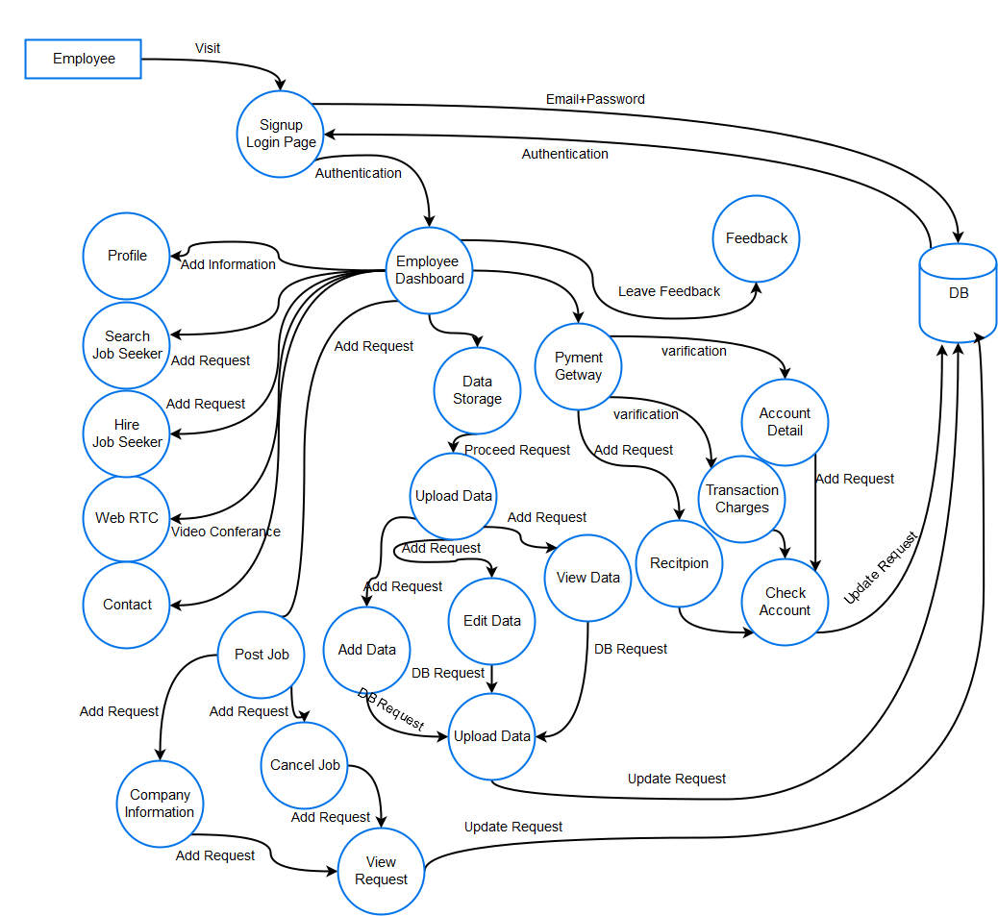

Figure 4.2.3

Data Flow Diagram Level 2

DFD 2 Video Call
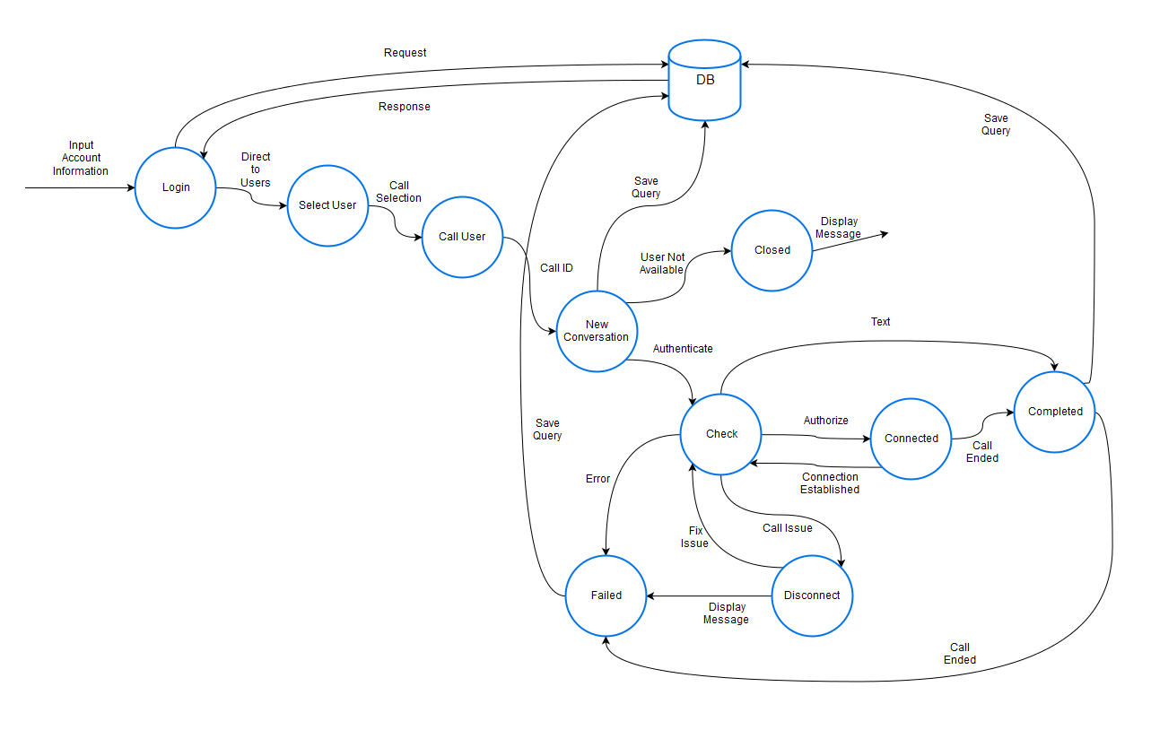
Figure 4.3.1

DFD 2 Feedback
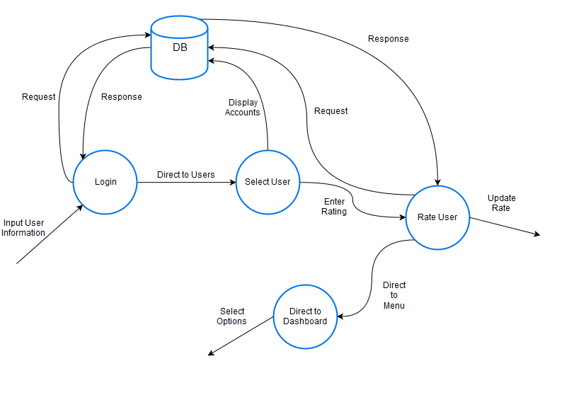
Figure 4.3.2

DFD 2 Cloud Data Management
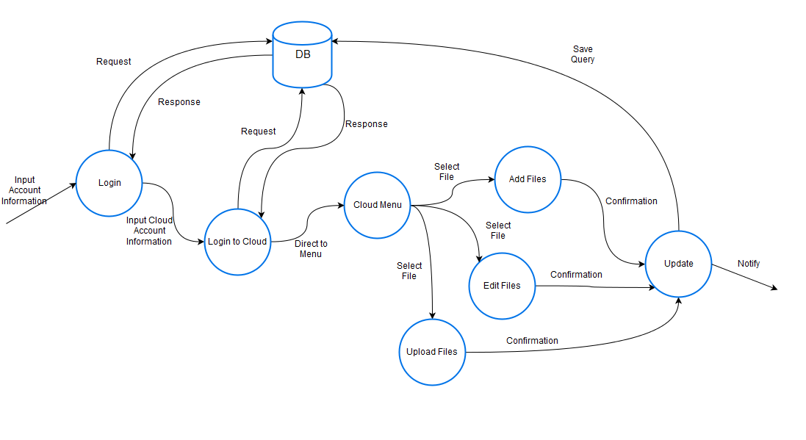
Figure 4.3.3

DFD 2 Interview Management
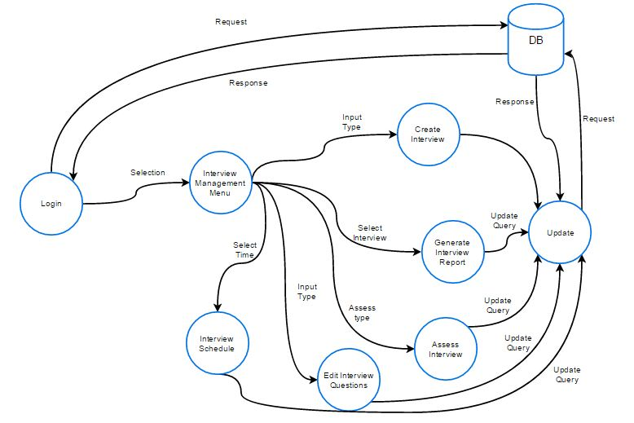

Figure 4.3.4

DFD 2 Gateway Payment
Figure 4.3.5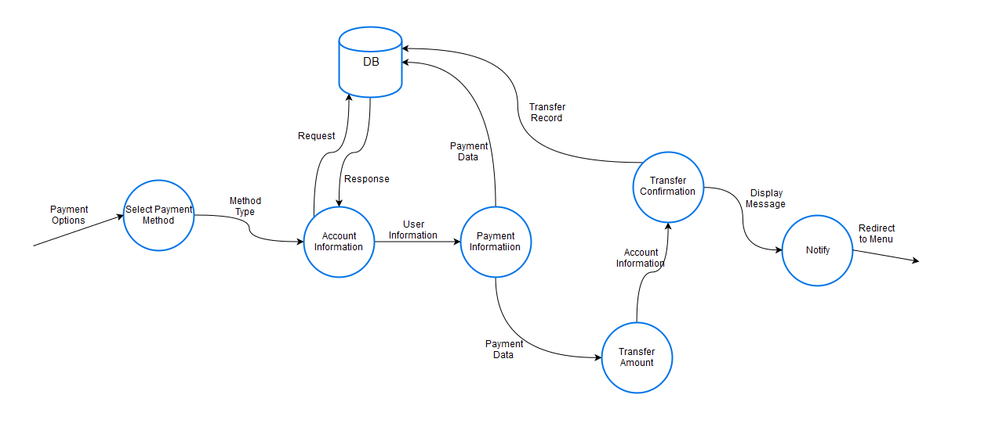

System Design

System Architecture Diagram
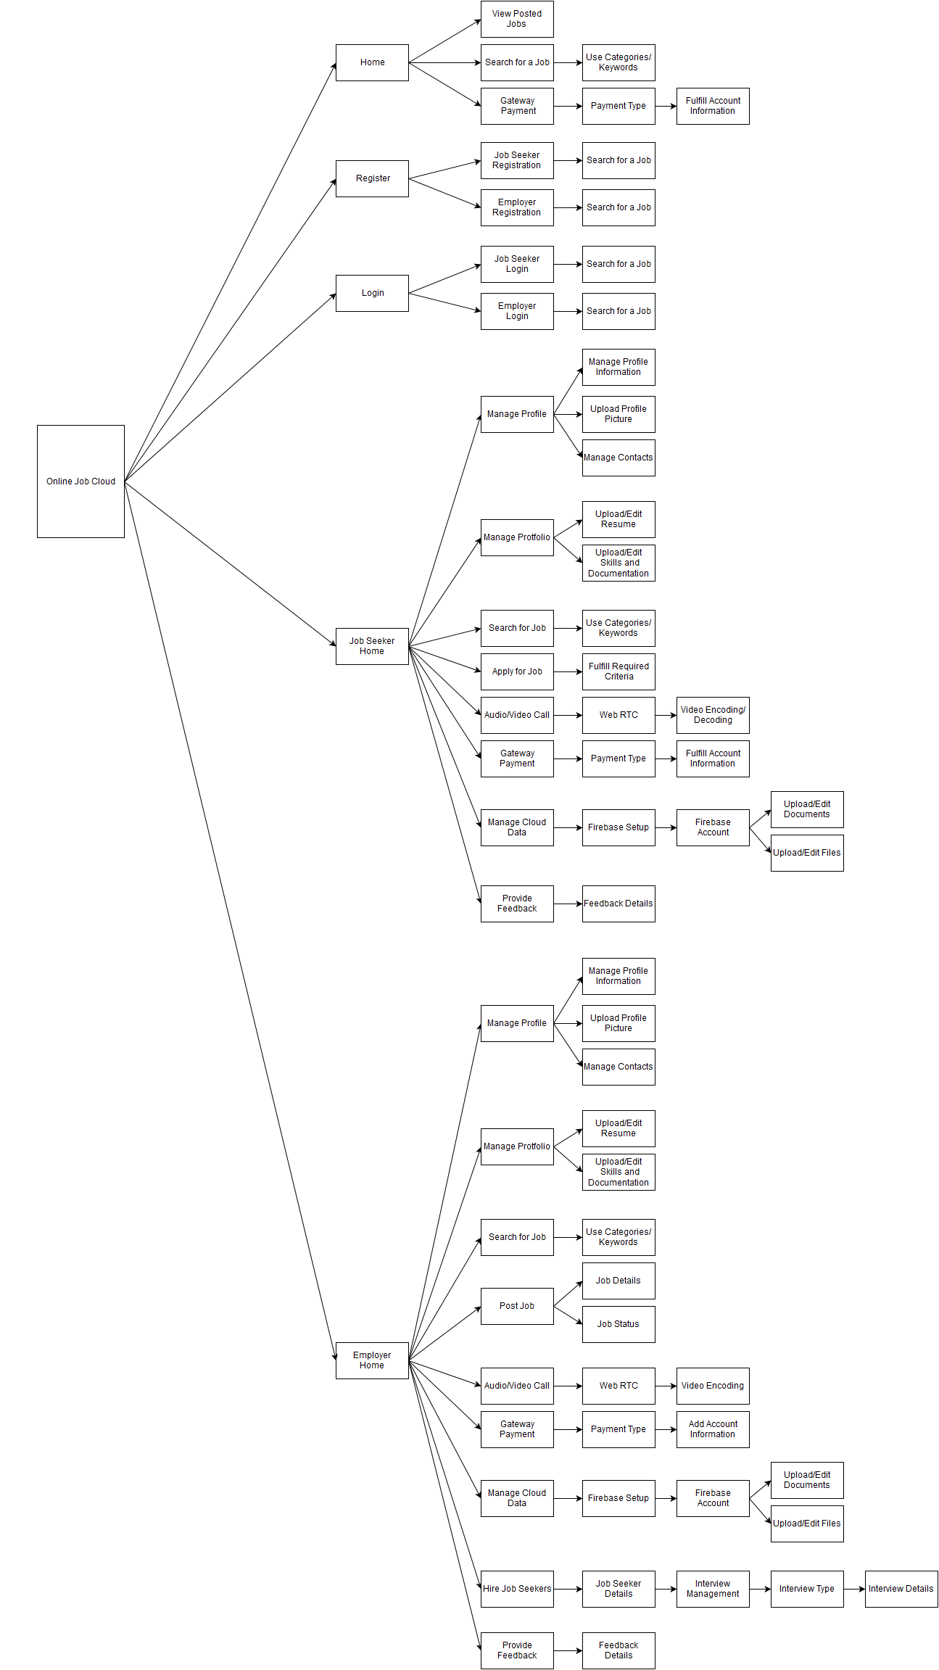

Figure 5.1.1

High Level System Architecture
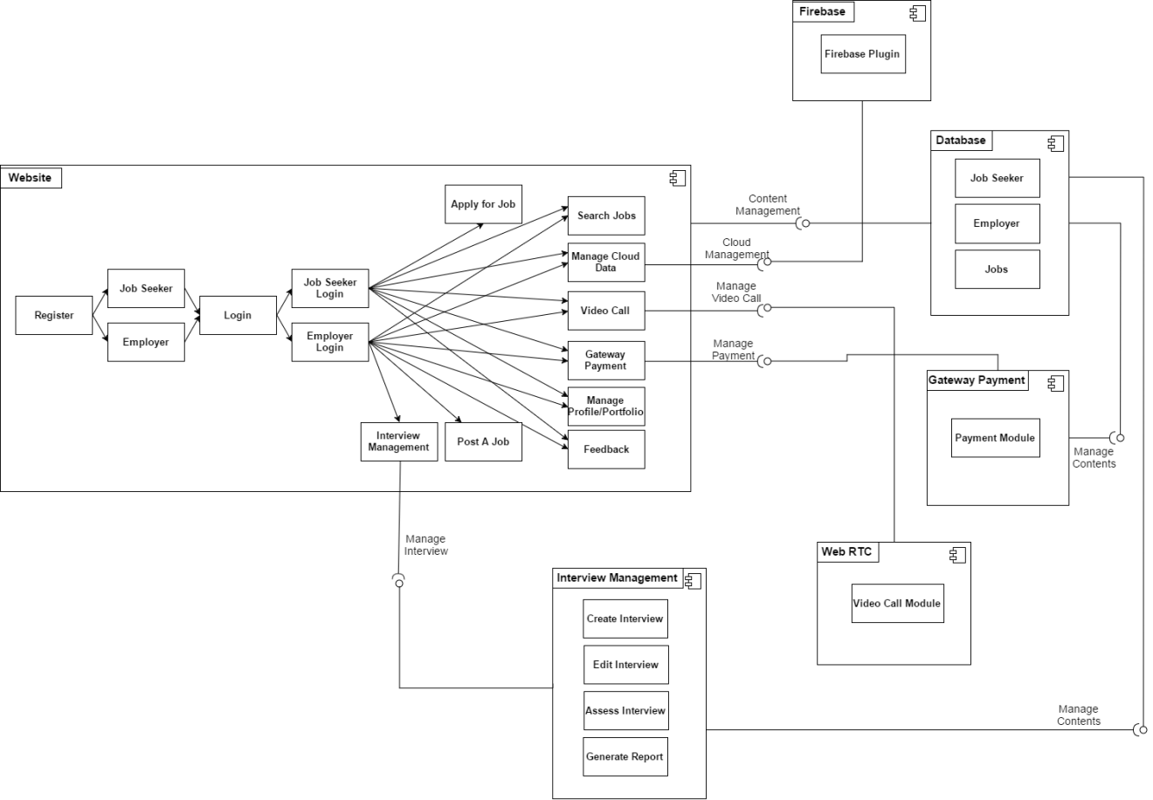

Figure 5.1.2

Component Level System Architecture

Class Diagram
Figure 5.1.3

Sequence Diagrams
Figure 5.1.4

Collaboration Diagrams
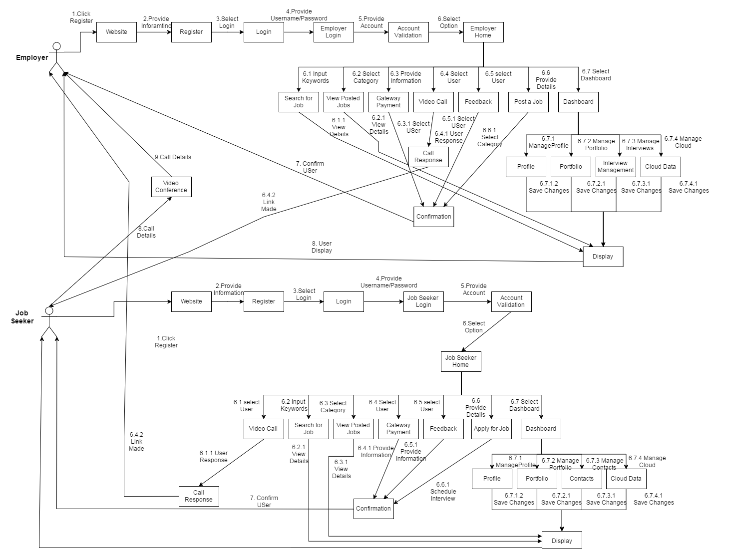
Figure 5.4.1

Other UMLs
None

ERD
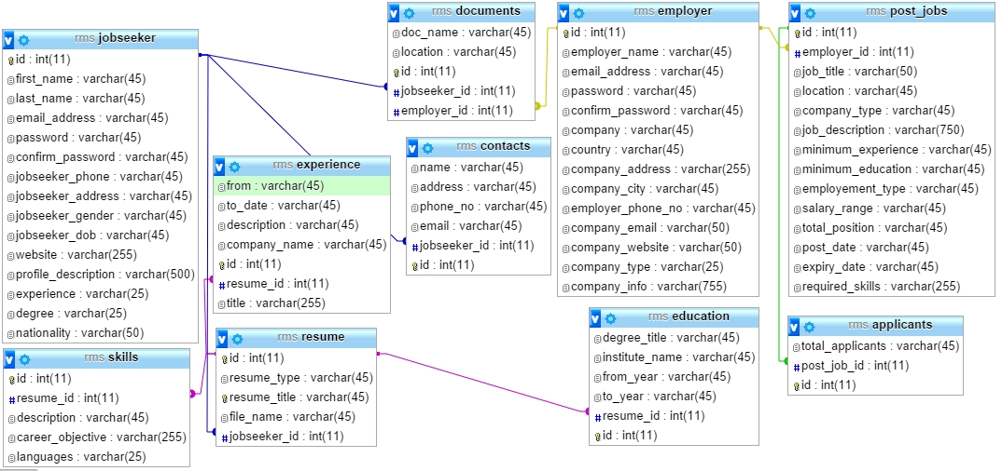
Figure 5.6.1

Data Dictionary

Element Name | Type | Validation | Mandatory | Remarks
Username | String | Yes | Yes | Input
User ID | Integer | Yes | Yes | Input
Password | String | Yes | Yes | Input
First Name | String | No | Yes | Input
Last Name | String | No | Yes | Input
Address | String | No | Yes | Input
Phone No. | Integer | Yes | Yes | Input
Country | String | No | Yes | Input
City | String | No | Yes | Input
Postal Code | Integer | No | Yes | Input
Skills | String | No | Yes | Input
Credit Card No. | String | Yes | Yes | Input
Account No. | String | Yes | Yes | Input
Date of Birth | Date | No | Yes | Input
Profile Description | String | No | Yes | Input
Degree | String | No | Yes | Input
Nationality | String | No | Yes | Input
Company Name | String | No | Yes | Input
Company Type | String | No | Yes | Input
Company Email | String | No | Yes | Input
Company Description | String | No | Yes | Input
Job Title | String | No | Yes | Input
Job Description | String | No | Yes | Input
Minimum Experience | String | Yes | Yes | Input
Minimum Education | String | Yes | Yes | Input
Employment Type | String | No | Yes | Input
Total Positions | String | Yes | Yes | Input
Post Date | Date | Yes | Yes | Input
Expiry Date | Date | Yes | Yes | Input
Required Skills | String | No | Yes | Input
Resume Type | String | No | Yes | Input
Resume Title | String | No | Yes | Input
File Name | String | Yes | Yes | Input
Languages | String | No | Yes | Input
Degree Title | String | No | Yes | Input
Institute Name | String | No | Yes | Input
From Year | Date | No | Yes | Input
To Year | Date | No | Yes | Input
Resume ID | String | No | Yes | Input
To Date | Date | No | Yes | Input

Table5.7

Implementation details

Development Setup
- Yii Framework ( Used in developing our website pages and generating necessary CRUD)
- SQL Workbench ( Used in designing database of website )
- Tortoise SVN ( Used by developers to edit the code and upload it on repository so that other group members can get the updated code)
- XAMPP ( Used as a server and also as a database repository)
- Eclipse Neon ( Used for editing the code of the website , the entire code of the website)
- GitHubRepository ( Used by group members to share and get the updated code)

Deployment setup
We deployed our website using our computer as a server. We did it using different tools and technologies like XAMPP for handling the database and online maintenance of the website, Eclipse Neon for handling the website’s internal logic and external representation of the website. We faced problem of deploying the website as there were errors of configuration linked with the server and database. We overcame these problems by again configuring the links accompanied by the website and the server. We also faced a problem of running the website on different server and this problem was occurred due to the use of different technology like WAMPP instead of XAMPP and to solve this problem we changed some of the code of the website by replacing the XAMPP in configuration links by WAMPP.

Algorithms
6.3.1 Index Page:
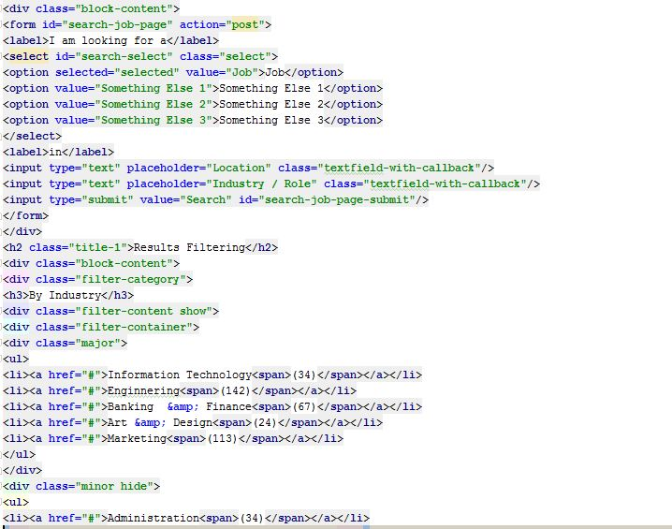

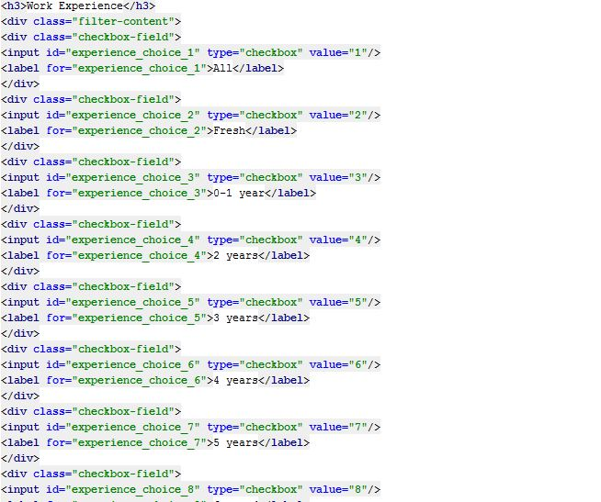
6.3.2 Jobs Page:

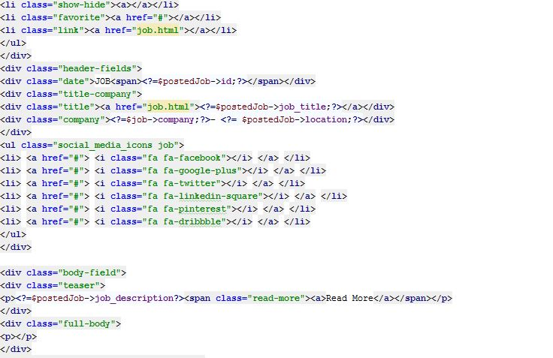
6.3.3 Login Page:

Constraints

Assumptions
- Web Page will work effectively
- Operator will be available to entertain customer queries
- Website will be available 24/7
- Developing team will work accordingly to the planning
- There will be quality repairers , developers and web managers
- Team and Staff will collaborate and work precisely
- Certified Guarantee card will be given to the customers while taking their hardware devices
- The service will be available to the prescribed cities of Pakistan
- Web Page will try to retain maximum number of users at a time
- Maintenance team will be working LIVE and available on Web Site
- A user will always be able to register for free
- A user will always be able to login after registration
- Jobs will be displayed on the main page of the website
- Users will be able to search for specific jobs
- A user can apply for jobs at anytime
- Users can upload their profile details without any interruption
- Users can upload their documents and portfolio without any interruption
- Employer can post job at any time without any interruption
- Employer can manage interview questions using question bank without interruption
- Employer will be able to allocate interview test for the jobseekers
- Interview management will always be available for users
- Interview date and time for specific jobseeker can be set at any time
- Video call can be used anytime whenever an interview is needed
- Jobseeker and Employer can contact each other via Jobs
- Employer will be able to assess the test given by the Employee
- Employee can check the result of the test without any delay
- Employer can send email to Jobseeker for job acceptance or rejection

System constraints
- A user must register to login
- A user can apply for job is he/she is registered and logged into website
- A user cannot register as both , Job seeker and Employer at a time
- A user can only enter profile details if the user is logged in
- A user can upload certain number of documents and portfolio unless he pays using Gateway payment
- A user cannot post more than 10 jobs unless he has pays the required amount to get premium access
- Only Employer can use the functionality of interview management
- Only Employer can video call perspective jobseekers and set date and time for video call
- A user can only apply for jobs if positions are available
- A posted job will be expired after certain days or can be removed by the poster itself
- Jobseeker can only entertain a test if allocated by the Employer
- Only employer can assess the Gateway Payment module
- Video conference can only be entertained if both the users have accepted the invitation of the video call
- Employer can assess the test of the jobseeker if the test has been submitted by the jobseeker

Restrictions
- A user can register either as Jobseeker or Employer
- A user cannot apply more than one job at a time
- A user can upload profile information using the restricted fields only
- A user can upload certain number of documents on the website
- If the user is Employer , can user Interview Management feature for hiring of Employees
- If the user is Employer , can use Video Call feature to interview Employees
- Employer cannot use Video Call feature unless there are Employees applied for the positions
- A user cannot check the result of the test unless forwarded by the Employer
- Employer cannot finalize decision before video conference with Employee
- A user cannot link his profile with any other website except social media websites
- A user cannot contact any other user unless interested in the same job
- A user cannot view that how many candidates have applied for job

Limitations
- Website will not be available to any overseas users
- This website is particularly for one specific country , yet it can be extended to overseas
- Our website cannot guarantee the acceptance of Jobs it is depended upon the users using the website
- Video conference can be held between two users only
- Users cannot enter any extra details which aren’t provided in the website
- Users cannot use any extra functionality which is not present in website
- Response time of the website is dependent upon user network not on the server where website will be deployed
- Our website does not allows multi or cross talk across jobs
- This website does not allow commenting on jobs
- There is no chat box for users to communicate , they can only communicate via jobs

Testing

Extended Test Cases

Test Case ID: 1 |  |  | Test Designed By: Mishaal Ahmed
Test Module Name: User Registration |  |  | Test Design Date: 1/4/17
Test Priority: High |  |  | Test Executed By: Abdul Habib
Test Title Name: To test Jobseeker register button |  |  | Test Executed Date: 2/4/17
Description: Test the register button in Website
Precondition: User open our official website and then click on sign up button and fill all the form according to the format
Dependencies:
Step | Test Step | Test Data | Expected Result | Actual Result | Status(Pass/Fail) | Notes
1 | Navigate to Sign Up page |  |  |  | Pass
2 | Click on Signup button |  |  |  | Pass
3 | Select User Type |  |  |  | Pass
4 | Fill the form according to the format | Name: abc  Email:abc@gmail.com  Password:12345 |  |  | Pass
5 | Click on Submit button |  | The user can create a new Jobseeker account on OJC | The user Successfully created an Jobseeker account on OJC | Pass
Post Condition: The user have new account on OJC and is on the main page of our website

Test Case ID: 2 |  |  | Test Designed By: Mishaal Ahmed
Test Module Name: User Registration |  |  | Test Design Date: 1/4/17
Test Priority: High |  |  | Test Executed By: Abdul Habib
Test Title Name: To test Employer register button |  |  | Test Executed Date: 2/4/17
Description: Test the register button in Website
Precondition: User open our official website and then click on sign up button and fill all the form according to the format
Dependencies:
Step | Test Step | Test Data | Expected Result | Actual Result | Status(Pass/Fail) | Notes
1 | Navigate to Sign Up page |  |  |  | Pass
2 | Click on Signup button |  |  |  | Pass
3 | Select User Type |  |  |  | Pass
4 | Fill the form according to the format | Name: xyz  Email:abc@xyz.com  Password:12345 |  |  | Pass
5 | Click on Submit button |  | The user can create a new Employer account on OJC | The user Successfully created an Employer account on OJC | Pass
Post Condition: The user have new account on OJC and is on the main page of our website

Test Case ID: 3 |  |  | Test Designed By: Mishaal Ahmed
Test Module Name: User Login |  |  | Test Design Date: 1/4/17
Test Priority: High |  |  | Test Executed By: Abdul Habib
Test Title Name: To test Jobseeker login button |  |  | Test Executed Date: 2/4/17
Description: Test the login button in Website
Precondition: User has already registered on website and clicks on Login button to go to the login page
Dependencies:
Step | Test Step | Test Data | Expected Result | Actual Result | Status(Pass/Fail) | Notes
1 | Navigate to Login  Page |  |  |  | Pass
2 | Click on Login button |  |  |  | Pass
3 | Select User Type |  |  |  | Pass
4 | Fill the form according to the format | Email:abc@gmail.com  Password:12345 |  |  | Pass
5 | Click on Submit button |  | The user can login to the created account | The user Successfully login to account on OJC | Pass
Post Condition: The user is now logged in and profile page is displayed

Test Case ID: 4 |  |  | Test Designed By: Mishaal Ahmed
Test Module Name: User Login |  |  | Test Design Date: 1/4/17
Test Priority: High |  |  | Test Executed By: Abdul Habib
Test Title Name: To test Employer login button |  |  | Test Executed Date: 2/4/17
Description: Test the login button in Website
Precondition: User has already registered on website and clicks on Login button to go to the login page
Dependencies:
Step | Test Step | Test Data | Expected Result | Actual Result | Status(Pass/Fail) | Notes
1 | Navigate to Login  Page |  |  |  | Pass
2 | Click on Login button |  |  |  | Pass
3 | Select User Type |  |  |  | Pass
4 | Fill the form according to the format | Email:abc@gmail.com  Password:12345 |  |  | Pass
5 | Click on Submit button |  | The user can login to the created account | The user Successfully login to account on OJC | Pass
Post Condition: The user is now logged in and profile page is displayed

Test Case ID: 5 |  |  | Test Designed By: Mishaal Ahmed
Test Module Name: Upload Resume |  |  | Test Design Date: 1/4/17
Test Priority: High |  |  | Test Executed By: Abdul Habib
Test Title Name: To test upload resume button |  |  | Test Executed Date: 2/4/17
Description: Test the upload resume button in user profile
Precondition: User is logged in and profile page is being displayed
Dependencies:
Step | Test Step | Test Data | Expected Result | Actual Result | Status(Pass/Fail) | Notes
1 | Click on upload resume button |  |  |  | Pass
2 | Select the desired file from drive | C:\Users\Dell\Downloads\Documents\mycv.doc |  |  | Pass
3 | Click on upload |  | User can upload CV for their profile | User successfully uploads their CV | Pass
Post Condition: The user have uploaded their CV on website

Test Case ID: 6 |  |  | Test Designed By: Mishaal Ahmed
Test Module Name: Search Button |  |  | Test Design Date: 1/4/17
Test Priority: High |  |  | Test Executed By: Abdul Habib
Test Title Name: To test the search button |  |  | Test Executed Date: 2/4/17
Description: Test the search button in Website
Precondition: User opens our official website and is on main page
Dependencies:
Step | Test Step | Test Data | Expected Result | Actual Result | Status(Pass/Fail) | Notes
1 | Navigate to Search bar |  |  |  | Pass
2 | Fill in the desired job query | Software Engineering Jobs |  |  | Pass
3 | Click on search button |  |  |  | Pass
4 | Checkout the results |  | The user gets the desired search result | The user successfully got the desired search results | Pass
Post Condition: The user is on the main page/ search_result of the website

Test Case ID: 7 |  |  | Test Designed By: Mishaal Ahmed
Test Module Name: Apply for Job |  |  | Test Design Date: 10/4/17
Test Priority: High |  |  | Test Executed By: Abdul Habib
Test Title Name: To test apply button |  |  | Test Executed Date: 11/4/17
Description: Test the apply button in Website
Precondition: User has already registered on website and logged in
Dependencies:
Step | Test Step | Test Data | Expected Result | Actual Result | Status(Pass/Fail) | Notes
1 | Navigate to Jobs page |  |  |  | Pass
2 | Select a Job | Software Developer |  |  | Pass
3 | Check Job requirements | PHP;  Larval;  5 years Experience |  |  | Pass
4 | Select the position to apply | Software Coder |  |  | Pass
5 | Click on apply button |  | The user can apply to the desired job | The user successfully applied to the desired job | Pass
Post Condition: The user is on the available jobs home page

Test Case ID: 8 |  |  | Test Designed By: Mishaal Ahmed
Test Module Name: Post a Job |  |  | Test Design Date: 10/4/17
Test Priority: High |  |  | Test Executed By: Abdul Habib
Test Title Name: To test post job button |  |  | Test Executed Date: 11/4/17
Description: Test the post job button in Website
Precondition: User has already registered on website and logged in as Employer
Dependencies:
Step | Test Step | Test Data | Expected Result | Actual Result | Status(Pass/Fail) | Notes
1 | Navigate to Post a job page |  |  |  | Pass
2 | Fill in the given form | Job title: Software Engineer  Experience Required:  5 years  Minimum Degree:  BS-SE  Job Type: Full Time  Job Position:  Software Developer  Seats Available:  2  From Date:  1/2/17  To Date:  2/2/17 |  |  | Pass
3 | Click on post button |  | The user can post a job on our website | The user successfully posted a job on our website | Pass
Post Condition: The user is on the posted jobs home page

Test Case ID: 9 |  |  | Test Designed By: Mishaal Ahmed
Test Module Name: Job Search Category wise |  |  | Test Design Date: 10/4/17
Test Priority: High |  |  | Test Executed By: Abdul Habib
Test Title Name: To Category button |  |  | Test Executed Date: 11/4/17
Description: Test the category button in Website
Precondition: User is on the main page of our official website
Dependencies:
Step | Test Step | Test Data | Expected Result | Actual Result | Status(Pass/Fail) | Notes
1 | Navigate to Search Job Page |  |  |  | Pass
2 | Select a Search Bar |  |  |  | Pass
3 | Select Category button |  |  |  | Pass
4 | Check the required job types | Software Engineering ,  Electrical Engineering |  |  | Pass
5 | Click on the submit button |  | The user gets the desired job result categorical wise | The user successfully gets the desired job result categorical wise | Pass
Post Condition: The user is on the available jobs home page

Test Case ID: 10 |  |  | Test Designed By: Mishaal Ahmed
Test Module Name: Search Resume |  |  | Test Design Date: 10/4/17
Test Priority: High |  |  | Test Executed By: Abdul Habib
Test Title Name: Test Search Resume button |  |  | Test Executed Date: 11/4/17
Description: Test the Search Resume button in User Profile
Precondition: User has already registered on website and logged in to profile page
Dependencies:
Step | Test Step | Test Data | Expected Result | Actual Result | Status(Pass/Fail) | Notes
1 | Navigate to Jobs page |  |  |  | Pass
2 | Select a Search Resume |  |  |  | Pass
3 | Fill in the given form | Resume Type: Software Engineer |  |  | Pass
4 | Click the submit button |  | The user can get all the desired CV results | The users successfully got the desired CV results | Pass
Post Condition: The user is on the available CV result page

Test Case ID: 11 |  |  | Test Designed By: Mishaal Ahmed
Test Module Name: Update Profile Content |  |  | Test Design Date: 10/4/17
Test Priority: High |  |  | Test Executed By: Abdul Habib
Test Title Name: To Test Profile Updating |  |  | Test Executed Date: 11/4/17
Description: Test the Profile Updating in Website
Precondition: User has already registered on website and logged in
Dependencies:
Step | Test Step | Test Data | Expected Result | Actual Result | Status(Pass/Fail) | Notes
1 | Navigate to Profile Page |  |  |  | Pass
2 | Click on Upload Profile Photo |  |  |  | Pass
3 | Select profile photo | E:\UCDownloads\my.jpg |  |  | Pass
4 | Click on Edit Personal Details |  |  |  | Pass
5 | Fill in the given form | First Name: Numan  Last Name: Tahir  Date of Birth: 1/3/94  Address: abc,XYZ  Nationality: Pakistani  Objectives: To become a successful developer |  |  | Pass
6 | Click on Submit button |  | The user can update their profile | The user have successfully updated their profile | Pass
Post Condition: The user is on the profile page

Test Case ID: 12 |  |  | Test Designed By: Mishaal Ahmed
Test Module Name: Video Call |  |  | Test Design Date: 15/4/17
Test Priority: High |  |  | Test Executed By: Abdul Habib
Test Title Name: To Video Call button |  |  | Test Executed Date: 16/4/17
Description: Test the video call button in Website
Precondition: User has already registered on website and logged in as Employer
Dependencies:
Step | Test Step | Test Data | Expected Result | Actual Result | Status(Pass/Fail) | Notes
1 | Navigate to Video Call Tab |  |  |  | Pass
2 | Click on Video Call button |  |  |  | Pass
3 | Select the user to start conversation | Numan Tahir |  |  | Pass
4 | Click on the User name | Nomi1234 |  |  | Pass
5 | Click on start video chat button | ABC calling Numan Tahir via OJC |  |  | Pass
6 | Click on End Video chat button |  | A user can video call another user | A user have successfully video chatted with another user | Pass
Post Condition: The user is on the Video Call page of the profile

Test Case ID: 13 |  |  |  | Test Designed By: Mishaal Ahmed
Test Module Name: Gateway Payment |  |  |  | Test Design Date: 15/4/17
Test Priority: High |  |  |  | Test Executed By: Abdul Habib
Test Title Name: To Gateway Payment Module |  |  |  | Test Executed Date: 16/4/17
Description: Test the Gateway Payment module in Website
Precondition: User has already registered on website and logged in also have posted limited jobs
Dependencies:
Step | Test Step | Test Data | Expected Result |  | Actual Result | Status(Pass/Fail) | Notes
1 | Navigate to Gateway Payment Page |  |  |  |  | Pass
2 | Click on the payment button |  |  |  |  | Pass
3 | Fill in the given form | Username:abc@gmail.com  Password:12345 |  |  |  | Pass
4 | Click on Submit button |  |  |  |  | Pass
5 | Now Fill Gateway Payment form | Username: numantahir@gmail.com  Password: XYZ_123 |  |  |  | Pass
6 | Select the amount to be transferred | Amount $5.00 |  |  |  | Pass
7 | Select the account where you want to transfer the amount | Username:junaid@gmail.com |  |  |  | Pass
8 | Click on checkout |  | The user can transfer amount to another user |  | The user successfully transferred the amount to another user | Pass
Post Condition: The user is on the main page of the gateway payment

Test Case ID: 14 |  |  | Test Designed By: Mishaal Ahmed
Test Module Name:Feedback Module |  |  | Test Design Date: 15/4/17
Test Priority: High |  |  | Test Executed By: Abdul Habib
Test Title Name: Test Feedback button |  |  | Test Executed Date: 16/4/17
Description: Test the Feedback button in User Profile
Precondition: User has already registered on website and logged in to profile page
Dependencies:
Step | Test Step | Test Data | Expected Result | Actual Result | Status(Pass/Fail) | Notes
1 | Navigate to Another User profile | 2.2 rating overall |  |  | Pass
2 | Select the required rating criteria | 3 rating ***  Out of  5 ***** |  |  | Pass
3 | Click on confirm button |  |  |  | Pass
4 | Check the user rating again | 2.3 rating overall | The user can rate others users | The user successfully rated another user | Pass
Post Condition: The user is on the profile page of the another user

Test Case ID: 15 |  |  | Test Designed By: Mishaal Ahmed
Test Module Name: Upload Documents |  |  | Test Design Date: 15/4/17
Test Priority: High |  |  | Test Executed By: Abdul Habib
Test Title Name: Test Upload Documents Module |  |  | Test Executed Date: 16/4/17
Description: Test the Upload Documents button in User Profile
Precondition: User has already registered on website and logged in to profile page
Dependencies:
Step | Test Step | Test Data | Expected Result | Actual Result | Status(Pass/Fail) | Notes
1 | Navigate to Documents Page |  |  |  | Pass
2 | Click on Folder Type | PDF Files |  |  | Pass
3 | Click on Upload Documents |  |  |  | Pass
4 | Select the documents to be uploaded | C:\Users\Dell\Downloads\my.pdf |  |  | Pass
5 | Click on submit button |  | The user can upload their documents on cloud | The user have successfully uploaded their documents on cloud | Pass
Post Condition: The user is on the Documents Page of the profile

Test Case ID: 16 |  |  | Test Designed By: Mishaal Ahmed
Test Module Name: Interview Management |  |  | Test Design Date: 15/4/17
Test Priority: High |  |  | Test Executed By: Abdul Habib
Test Title Name: Test Dashboard |  |  | Test Executed Date: 17/4/17
Description: Test the Interview Management Dashboard
Precondition: User has already registered on website and logged in to profile page as Employer
Dependencies:
Step | Test Step | Test Data | Expected Result | Actual Result | Status(Pass/Fail) | Notes
1 | Navigate to Interview Management Page |  |  |  | Pass
2 | Click on Dashboard |  |  |  | Pass
3 | Click on Posted Jobs |  |  |  | Pass
4 | Click on Applied Candidates |  |  |  | Pass
5 | Select Candidate | Numan Tahir |  |  | Pass
6 | Click on Manage Interview |  | The user can start to manage selected candidate’s interview | The user have successfully started to manage selected candidate’s interview | Pass
Post Condition: The user is on the main page ( dashboard) of Interview Management

Test Case ID: 17 |  |  | Test Designed By: Mishaal Ahmed
Test Module Name: Interview Management |  |  | Test Design Date: 1/5/17
Test Priority: High |  |  | Test Executed By: Abdul Habib
Test Title Name: Create Edit Questions |  |  | Test Executed Date: 1/6/17
Description: Test the Search Resume button in User Profile
Precondition: User has already registered on website and logged in to profile page
Dependencies:
Step | Test Step | Test Data | Expected Result | Actual Result | Status(Pass/Fail) | Notes
1 | Navigate to Interview Management |  |  |  | Pass
2 | Click on Posted Jobs |  |  |  | Pass
3 | Select a Job | Software Engineer |  |  | Pass
4 | Click on Manage Questions |  |  |  | Pass
5 | Click on Add Questions |  |  |  | Pass
6 | Fill in the form to add questions | Question#1: How many basic phases are there in Software Models  Option 1: 1  Option 2: 2  Option 3: 3  Option 4: 4  Answer: 4 |  |  | Pass
7 | Click on Submit button |  | The user can add questions in the question bank | The user have successfully added questions in the question bank | Pass
8 | Click on Question Bank
9 | Select Interview Question Sheet | Software Engineer A
10 | Select a Question | Question#1
11 | Click on Edit Button
12 | Fill in the given form | Question#1: How many basic phases are there in SRE  Option 1: 1  Option 2: 2  Option 3: 3  Option 4: 5  Answer: 5
13 | Click on Submit button
14 | Re-check question sheet questions |  | The user can edit questions in the question bank | The user have successfully edited questions in the question bank
Post Condition: The user is on the Question Bank Page of Interview Management Module

Test Case ID: 18 |  |  | Test Designed By: Mishaal Ahmed
Test Module Name: Interview Management |  |  | Test Design Date: 1/5/17
Test Priority: High |  |  | Test Executed By: Abdul Habib
Test Title Name: Test Allocation |  |  | Test Executed Date: 2/5/17
Description: Test the Allocation button
Precondition: User has already registered on website and logged in to profile page
Dependencies:
Step | Test Step | Test Data | Expected Result | Actual Result | Status(Pass/Fail) | Notes
1 | Navigate to Interview Management |  |  |  | Pass
2 | Select a Job |  |  |  | Pass
3 | Select A Candidate | Numan Tahir |  |  | Pass
4 | Click on Allocate Test |  |  |  | Pass
5 | Select the test to be Allocated | Software Engineer A |  |  | Pass
6 | Click on submit button |  | The user can allocate test to an applied candidate | The user have successfully allocate test to an applied candidate | Pass
Post Condition: The user is on the Dashboard Page of the Interview Management Module

Test Case ID: 19 |  |  | Test Designed By: Mishaal Ahmed
Test Module Name: Interview Management |  |  | Test Design Date: 1/5/17
Test Priority: High |  |  | Test Executed By: Abdul Habib
Test Title Name: Test Assessment Status |  |  | Test Executed Date: 2/5/17
Description: Test the Assessment button
Precondition: User has already registered on website and logged in to profile page
Dependencies:
Step | Test Step | Test Data | Expected Result | Actual Result | Status(Pass/Fail) | Notes
1 | Navigate to Interview Management |  |  |  | Pass
2 | Select a test to be assessed | Software Engineer A |  |  | Pass
3 | Click on assess the test button |  |  |  | Pass
4 | Check Evaluations | 7/10 = 70% |  |  | Pass
5 | Click on Confirm Assessment |  | The user can assess the test of an applied candidate | The user have successfully assess the test of an applied candidate | Pass
Post Condition: The user is on the Dashboard Page of Interview Management

Test Case ID: 20 |  |  | Test Designed By: Mishaal Ahmed
Test Module Name: Interview Management |  |  | Test Design Date: 1/5/17
Test Priority: High |  |  | Test Executed By: Abdul Habib
Test Title Name: Test Select Candidate button |  |  | Test Executed Date: 2/5/17
Description: Test the Select Candidate button in User Profile
Precondition: User has already registered on website and logged in to profile page as Employer
Dependencies:
Step | Test Step | Test Data | Expected Result | Actual Result | Status(Pass/Fail) | Notes
1 | Navigate to Interview Management |  |  |  | Pass
2 | Select a Job | Software Engineer |  |  | Pass
3 | Click on Applied Candidates |  |  |  | Pass
4 | Select a Candidate | Numan Tahir |  |  | Pass
5 | Click on Job Approval |  |  |  | Pass
6 | Click Confirm button |  | The user can hire an applied candidate | The user have successfully hire an applied candidate | Pass
Post Condition: The user is on the Dashboard of Interview Management Module

Test Case ID: 21 |  |  | Test Designed By: Mishaal Ahmed
Test Module Name: Interview Management |  |  | Test Design Date: 1/5/17
Test Priority: High |  |  | Test Executed By: Abdul Habib
Test Title Name: Test Assessment Status |  |  | Test Executed Date: 2/5/17
Description: Test the assessment status button in User Profile
Precondition: User has already registered on website and logged in to profile page
Dependencies:
Step | Test Step | Test Data | Expected Result | Actual Result | Status(Pass/Fail) | Notes
1 | Navigate to Applied Jobs Page |  |  |  | Pass
2 | Click on Assessment Tab |  |  |  | Pass
3 | Click on Assess Result button |  |  |  | Pass
4 | Click the Check Result button |  | The user can check the result of the given test | The user have successfully checked the result of the given test | Pass
Post Condition: The user is on the Profile page

Decision Table

Code snippet

Decision coverage table

Traceability Matrix

RID vs UCID (requirements vs use cases)
UCID/RID | R  1 | R  2 | R  3 | R  4 | R  5 | R  6 | R  7 | R  8 | R  9 | R  10 | R  11 | R  12 | R  13 | R  14 | R  15 | R  16 | R  17 | R  18 | R  19 | R  20 | R  21
UC 1
UC 2
UC 3
UC 4
UC 5
UC 6
UC 7
UC 8
UC 9
UC 10
UC 11
UC 12
UC 19
UC 20

Table7.3.1

Prototypes (RID vs PID)
UCID/PID | P  1 | P  2 | P  3 | P  4 | P  5 | P  6 | P  7 | P  8 | P  9 | P  10 | P  11 | P  12 | P  13 | P  14 | P  15 | P  16 | P  17 | P  18 | P  19 | P  20 | P  21
UC 1
UC 2
UC 3
UC 4
UC 5
UC 6
UC 7
UC 8
UC 9
UC 10
UC 11
UC 12
UC 19
UC 20

Table7.3.2

Test Cases (RID vs TID)
RID/TID | T  1 | T  2 | T  3 | T  4 | T  5 | T  6 | T  7 | T  8 | T  9 | T  10 | T  11 | T  12 | T  13 | T  14 | T  15 | T  16 | T  17 | T  18 | T  19 | T  20 | T  21
R 1
R 2
R 3
R 4
R 5
R 6
R 7
R 8
R 9
R 10
R 11
R 12
R 19
R 20

Table7.3.3

Coverage (UCID vs TID)
UCID/TID | T  1 | T  2 | T  3 | T  4 | T  5 | T  6 | T  7 | T  8 | T  9 | T  10 | T  11 | T  12 | T  13 | T  14 | T  15 | T  16 | T  17 | T  18 | T  19 | T  20 | T  21
UC 1
UC 2
UC 3
UC 4
UC 5
UC 6
UC 7
UC 8
UC 9
UC 10
UC 11
UC 12
UC 19
UC 20

Table7.3.4

Results/Output/Statistics

%Completion
Completion Percentage = 85.37%

%Accuracy
Accuracy Percentage = 87.19%

%Correctness
Correctness Percentage = 83.56%

Conclusion
We would like to thank our University for providing us an opportunity to implement our idea into a practical working platform and also providing us an environment where we were able to work consistently throughout our final year .We would like to thank our Advisor Sir Ahtsham Ali who motivated us and lead us throughout the development of our project. We would also thank Computer Science faulty member who guided us wherever we got stuck during the development of our project. We would also like to thank our parents who supported us spiritually and helped us in every matter throughout our university life. In the end, we are thankful to Almighty Allah, without His blessings we wouldn’t be able to complete this project.

Future work
The project we worked on is a vast project and there is no limitation to this project. As the technology develops , we will include new features in this website according to the needs of the people due to increase in technology in coming few years by including new features like HR management, Mobile application , Online transaction for users , online chat box for open volunteers . There are many other new unnamed features which might be developed for this project when the technology advances.

Bibliography

Books

Journals

Articles

Research papers

Other References

Appendix

Glossary of terms
- OJC (Online Job Cloud)

Pre-requisites
Only front end of the website and user login feature was developed by previous group. Our group worked on the whole database of the website and integrated new features including some previous missing features.

