Detection Of Epilepsy Through Deep Learning

Final Year Project Report



By
MUHAMMAD MUSTAFA AWAN (F2020266375)
MUHAMMAD HAMZA CHAUDARY (F2020266367)
Fall-2020-BSCS-UMT

Supervisor
Dr. Ghulam Mustafa,

University of Management and Technology (UMT),
C-II Johar Town Lahore, Pakistan.

Dedication

This research project is dedicated to all the research and development institutions and under developing countries who do not have enough resources to treat and diagnose epilepsy. Most of the countries do not have enough neurologists to study and classify the type of EEG. Therefore, our system helps the neurologists to detect epilepsy and classify the epileptic seizures.

Certificate of Originality

We hereby declare that this submission is my own work and to the best of my knowledge i t contains no materials previously published or written by another person, nor material to a substantial extent has been accepted for the award of any degree or diploma at Department of Computer Science at or at any other educational institute, except where due acknowledgement has been made. Any contribution made to the research by others, with whom I have worked at or elsewhere, is explicitly acknowledged in the thesis. I also declare that the intellectual content of this thesis is the product of my own work, except for the assistance from others in the project’s design and conception or in style, presentation and linguistics which has been acknowledged.



Acknowledgments

Glory be to Allah (S.W.A), the Creator, the Sustainer of the Universe. Who only has the power to honour whom He please, and to abase whom He please. Verily no one can do anything without His will. From the day, I came to UMT till the day of my departure, He was the only one Who blessed me and opened ways for me, and showed me the path of success. Their is nothing which can payback for His bounties throughout my research period to complete it successfully.

Contents

1 Introduction and Motivation 1
1.1 Incidence and Prevalence 1
1.2 Prognosis 2
1.3 Mortality 3
1.4 History 3
1.5 Seizure Types 4
1.5.1 Partial (or Focal) Seizures 5
1.5.2 Simple Partial Seizures 6
1.5.3 Complex Partial Seizures 6
1.5.4 Generalized Seizures 7
1.6 Diagnostic Evaluation 10
1.6.1 Electroencephalography (EEG) 11
1.6.2 Brain Imaging 13
2 Literature Review 15
2.1 AI based EEG Classification 15
2.1.1 Support Vector Machine (SVM) 15
2.1.2 Linear Discrimination Analysis (LDA) 16
2.1.3 Quadratic Discriminant Analysis (QDA) 17
2.1.4 k-Nearest Neighbor (KNN) 17
2.1.5 Local Binary Pattern (LBP) 18
2.2 Features Extraction Algorithm 19
2.2.1 Short Time Fourier Transform (STFT) 20
2.2.2 Root Means Square (RMS) 20
2.2.3 K-Means Cluster (K-MC) 21
2.2.4 Independent Component Analysis (ICA) 22
2.2.5 Autocorrelation Function (ACF) 22
2.2.6 Entropy 22
2.2.7 Kurtosis 22
2.3 State-of-the-Art: Seizure Detection 23
3 Surveys and Classification attempts 27
3.1 National Epilepsy Centre (NEC) 27
3.1.1 10-20 System 28
3.1.2 REM and nREM Sleep Cycles 29
3.1.3 Eye Blinking and other artefacts 30
3.2 Aga Khan Development Network 31
3.2.1 E-Health Sensor Module 32
4 Problem Definition 35
4.1 Problem Statement 35
4.2 Solution Statement 35
5 Design and Methodology 36
5.1 TUH EEG Seizure Corpus 36
5.2 Pre-Processing 37
5.3 Feature Extraction 38
5.3.1 Frequency domain analysis 39
5.3.2 Time domain analysis 39
5.3.3 Time-frequency domain analysis 40

5.3.4Statistical analysis ……………………………………………………. 38
5.4 Seizure Classification ……………………………………………………………………………. 38
5.4.1 Multi-headed attention layers ………………………….…… 39
5.4.2 Convolutional layers ………………………………..…….……. 39
5.4.3 Pooling layers …………………………………………………….. 39
5.4.4 Fully-connected hidden layers ………………….…………. 40
5.5 Model Evaluation ………………………………………………………………………… 41
5.6 Results …………………………………………………………………………..………… 42
5.6.1 Accuracy………………………………………………....………. 42
5.6.2 Precision ………………………………………………………… 42
5.6.3 Recall ……………………………………………………………. 43
5.6.4 Mathews correlation coefficient ………………………… 43
5.6.5 Threat score ……………………………………………………. 44

- EEG Data Acquisition System 45

  - Data acquisition system ………………………………………………………. 45
    - EEG Electrodes ……………………………………………………… 46
    - Signal instrumentation amplifier ……………………………. 46
    - Band-pass filter …………………………………………..………... 48
    - Variable amplifier ………………………………………………….. 48
    - Notch filter ……………………………………………………………. 49
    - Analog to digital converter ……………………………………… 50
  - Components ……………………………………………………………….……….. 50
    - INA 826 ……………………………………………………………….. 50
  - Data Acquisition System Explanation …………………………………… 54

- Results 56

- Limitations and Future Work 61
  - Lack of Demographic Dataset................................................................................... 61
  - Specialized Sensors, Integrated Circuits and Electrodes unavailable in
Pakistan.............................................................................................................. 64
  - Lack of Proper Research Funding ........................................................................... 64
- Discussion and Conclusion 66

List of Figures

  - Types of epileptic seizures ................................................................................ 5
  - Simple partial seizures ...................................................................................... 6
  - Complex partial seizures ................................................................................... 7
  - Abscence seizures .............................................................................................. 8
  - Typical seizures ................................................................................................. 8
  - Atypical seizures ............................................................................................. 9
  - This is an image from a text that uses color to teach music. ........................... 16
  - Architecture of K-NN classfier (a)simple classification (b) cluster classifi-
cation........................................................................................................................ 17
  - The curved line is the decision boundary resulting from the QDA method.. 18
  - PCA for median frequency and RMS feature discrimination ......................... 19
  - Mapping process of multiband feature matrix ................................................. 20
  - EEG reading during Eye blinking ........................................................................ 29
  - E-Health Sensor Module ...................................................................................... 30
  - Description of data collected during continuous eye blinking ....................... 31
  - Description of data collected during non-blinking state.................................. 32
5.1 Histograms of seizure types in the TUH EEG Seizure Corpus for the
evaluation and training sets. ................................................................................. 36 5.2 Model architecture ................................................................................................. 40

5.3 Confusion matrices for one-vs-all classification. .............................................. 42
  - EEG electrodes ....................................................................................................... 46
  - Instrumentation amplifier .................................................................................... 47
  - Bandpass filter ....................................................................................................... 48
  - Variable amplifier .................................................................................................. 49
  - Notch Filter .............................................................................................................50
  - Arduino Uno ........................................................................................................... 51
  - INA 826 DIP ........................................................................................................... 51
  - Function of INA pins ............................................................................................ 52
  - INA 826 datasheet ................................................................................................. 52
  - OP177 IC ................................................................................................................. 53
  - OP177 Schematics .................................................................................................. 53
  - OP177 datasheet ..................................................................................................... 54
  - Circuit Block Diagram ........................................................................................... 55

  - Results of Instrumentation amplifier ................................................................. 57
  - Result of Bandpass Filter ..................................................................................... 58
  - Results of Variable amplifier ............................................................................... 59
  - Results of Notch Filter .......................................................................................... 59
  - Aga Khan University Hospital ............................................................................. 62
  - Dr. Ziauddin Hospital ........................................................................................... 62
  - Jinnah Postgraduate Medical Centre and it’s subsidiaries ............................. 63

List of Tables

2.1 Comparison of state-of-the-art ................................................................................... 24
5.1 Model Accuracy ............................................................................................................ 44
5.3 Performance metrics .................................................................................................... 44

Abstract

Detecting and classifying epileptic seizures is crucial in the analysis, monitoring, and diagnosis of patients with epilepsy, especially when it comes to realizing and actualizing computer-aided devices. EEG system and pre-processing the data to remove artifacts and enhance the ratio of signal to noise. From the pre-processed EEG data, different fea- tures are derived, including but not limited to time-domain features, frequency-domain features, and statistical features. The accuracy of the detection and classification pro- cess plays a vital role in determining the effectiveness of these applications. Over the years, numerous approaches have been explored, suggested, and advanced to enhance the precision of these methods. In this report, the goal is to develop an Artificial- Intelligence-based epilepsy diagnosis tool that accurately classifies all subtypes under the Generalized Epilepsy (GE) and Focal Epilepsy (FE) with minimal computational complexity. To achieve this goal, the study investigates various seizure detection and classification algorithms, including the latest deep learning algorithms. The proposed model consists of a feature extraction layer that extracts critical features from the incom- ing EEG signals and a classification layer that uses the state-of-the-art Deep Learning algorithms to classify the incoming signals into its types using weighted features. The experimental findings demonstrate that the suggested model can accurately classify all eight types of epileptic seizures. The proposed model achieves an average precision of 0.933, an average specificity of 0.994, and an average F1 score of 0.876, demonstrating its high accuracy in the classification of seizures.

CHAPTER 1

Introduction and Motivation

Epilepsy, a prevalent and severe neurological disorder worldwide, affects individuals across all ages and regions. While some individuals experience remission from this dis- tressing condition, many continue to have seizures throughout their lives. The onset of epilepsy varies depending on the geographic location, with high-income countries showing a higher incidence in old age, In contrast, in development nations infants and early childhood are more commonly impacted due to obstetric complications or neonatal infec- tions.

1.1 Incidence and Prevalence

Epilepsy is a common neurological disorder that affects a substantial number of people around the globe. It is estimated that approximately 50 new cases occur each year per 100,000 individuals. About 1% of the population suffers from epilepsy, and around one- third of patients have refractory epilepsy, which means they continue to have seizures despite trying two or more suitable anti-epileptic medications or alternative treatments. [10] The likelihood of developing epilepsy is especially high during childhood, with about 75% of cases appearing during this stage of development.
Globally, nearly 70 million individuals are affected by epilepsy. In high-income countries, the lifetime risk of developing epilepsy is around 6 per 1000 individuals, with approxi- mately 45 new cases per 100,000 people each year. These numbers are almost twice as high in low- and middle-income nations, possibly due to less advanced obstetric services and an increased likelihood of cerebral infections and head trauma.
Epilepsy incidence displays notable variations according to age. Rates are higher in early childhood, lower during early adulthood, and show a second peak among individ- uals over the age of 65 (refer to the attached graph). Recent trends indicate a decline in the number of affected children and a notable rise in epilepsy cases among the el- derly. Consequently these days, the most prevalent age at which this illness develops in people is old age.

1.2 Prognosis
Prognosis, a medical term used to predict the expected progression of a disease, plays a crucial role in epilepsy. The prognosis varies depending on the underlying cause and can greatly impact patients’ lives. While a majority of individuals with epilepsy experience favorable outcomes, the course of the condition differs among patients.
In many cases, especially among children, epilepsy may remit, although a significant portion of individuals will continue to have the condition throughout their lives. After initiating treatment with antiepileptic drugs (AEDs), approximately 60-70% of patients achieve seizure freedom. Some individuals respond well to the first AED and maintain a seizure-free state, while others experience a more fluctuating pattern. Remission following AED withdrawal suggests a true resolution of the underlying causes.
However, for 30-40% of patients, seizures persist with varying frequencies and intensities. Certain patients experience a pattern of epilepsy characterized by alternating periods of seizure freedom and relapse, commonly referred to as a "remitting-relapsing" course.
There are several factors that suggest an unfavorable prognosis for controlling seizures, which include:
- Underlying symptomatic cause of epilepsy
- Pre-treatment high seizure frequency
- Inadequate response to initial anti-epileptic drug (AED) therapy
- Presence of generalized tonic-clonic seizures
- Detection of generalized epileptic form activity on the electroencephalogram (EEG)
- Family history of epilepsy
- Coexistence of psychiatric comorbidities

1.3 Mortality

Patients with epilepsy have a considerably higher mortality rate, more than three times higher than that of the population, as revealed by the standardized mortality ratio, which evaluates the difference between actual and predicted deaths. [10] While the cause of death often correlates with the epilepsy, a significant portion of fatalities can be attributed to a condition called sudden unexpected death in epilepsy (SUDEP), due to approximately 17% of all deaths related to epilepsy. SUDEP is characterized as an unforeseen and rapid death, whether witnessed or unwitnessed, not caused by trauma or drowning. It occurs in people who have epilepsy, regardless of whether there is proof of a seizure, and does not include postmortem results indicating toxicological or anatomical reasons of death.
The documented occurrence of SUDEP varies from 0.35 to 10 cases per 1000 patients annually. The risk of SUDEP is particularly elevated when the seizure disorder is uncontrolled, indicating that a majority of SUDEP cases are associated with ongoing seizure activity. Furthermore, there are other factors that contribute to deaths related to epilepsy, including incidents like drowning, burns, aspiration, pneumonia, status epilep- ticus, and even suicide.

1.4 History

Epilepsy originates from Greek term "epilambanein," which signifies "to seize" or "to assault." possesses a fascinating historical background. The earliest recorded instances of epilepsy in the Western world can be traced back to a Babylonian cuneiform treatise called "Sakikku" or "all diseases." These ancient tablets, unearthed in southern Turkey between 716 BC and 612 BC, provide insights into the understanding of epilepsy during that era. [11] Similarly, classical Chinese medical texts from 770 BC to 221 BC also acknowledged the existence of this disorder.
Across different historical periods, epilepsy has been linked to supernatural or demonic forces in various cultures, attributed to its unique combination of symptoms and signs. However, a significant turning point in understanding epilepsy from a scientific perspec- tive occurred in 1875 when the English neurologist John Hughlings Jackson made a groundbreaking discovery. [6] Jackson identified disrupted brain electrical activity as the fundamental cause of seizures. This finding marked a crucial milestone, shifting the understanding of epilepsy away from mystical interpretations and towards a scientific understanding.

1.5 Seizure Types

A seizure serves as a clinical indication of an abnormal and excessive synchronized dis- charge of cortical neurons within the brain. Determining the specific type(s) of seizures experienced by a patient holds significant implications, including:
- Selection of suitable antiepileptic drugs (AEDs)
- Assessment of underlying cerebral lesions
- Evaluation of prognosis
- Examination of potential genetic transmission

Seizures present a diverse array of sudden and temporary abnormal phenomena, with their clinical features varying based on the pattern of neuronal involvement. [5] These manifestations may encompass alterations in consciousness, as well as motor, sensory, autonomic, or psychic events.
The widely utilized electroclinical classification system, established by the International League Against Epilepsy (ILAE) almost three decades ago, remains the most widely embraced scheme. While recognized as an ongoing development by the ILAE, this classification categorizes seizures into three main groups: focal (partial), generalized, and epileptic spasms. With the aid of a comprehensive medical history, EEG findings, and supplementary information, physicians can often determine the type of seizure or epilepsy, [3] allowing for the formulation of an appropriate diagnostic evaluation and treat- ment plan.

1.5.1 Partial (or Focal) Seizures

Focal seizures originate from a specific region of the cortex and can be further catego- rized based on their impact on consciousness. There are two main types: There are

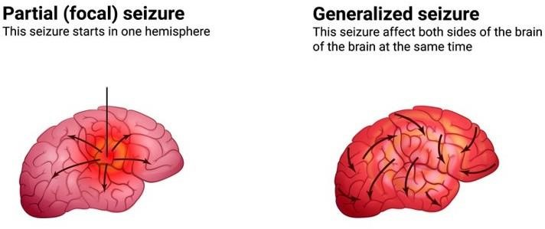

Figure 1.1: Types of epileptic seizures

Simple partial seizures that do not affect consciousness and complex partial seizures that do. Identifying patients whose safety may be compromised by loss of consciousness during seizures is aided by this classification. Additionally, partial seizures can be char- acterized by various clinical manifestations, such as focal motor symptoms. They can swiftly propagate through neuronal networks, leading to secondary generalized tonic- clonic seizures.
To provide examples, a focal seizure that originates in the occipital lobe can result in visual phenomena, while a seizure originating in the precentral gyrus may exhibit rhythmic clonic or tonic motor activity. [4] If a seizure originates from the postcentral gyrus, sensory symptoms such as paraesthesia may be experienced. When a focal seizure leads to impaired consciousness, preventing the patient from responding adequately to stimuli, it is referred to as a dyscognitive seizure (previously known as complex partial). Dyscognitive seizures are frequently observed in cases of temporal lobe epilepsy.
Before certain seizures, individuals may experience an aura, which refers to a focal seizure where the person remains conscious and encounters motor, sensory, autonomic, or psychic symptoms. The aura can occur a few seconds or minutes before a focal dyscognitive or generalized seizure, and it is frequently reported by people with temporal lobe epilepsy.

1.5.2 Simple Partial Seizures

The location of the aberrant electrical activity might cause simple partial seizures to manifest with different symptoms. For example, rhythmic motions of the arm, leg, or face on the opposite side of the body may result from a seizure that starts in the motor cortex.
This particular type of seizure was previously known as Jacksonian seizures.
On the other hand, when the seizure arises from sensory regions or areas linked to emo- tions and memory, it can lead to sensory phenomena like olfactory, visual, or auditory hallucinations. Moreover, individuals may encounter emotions such as fear, panic, or euphoria.
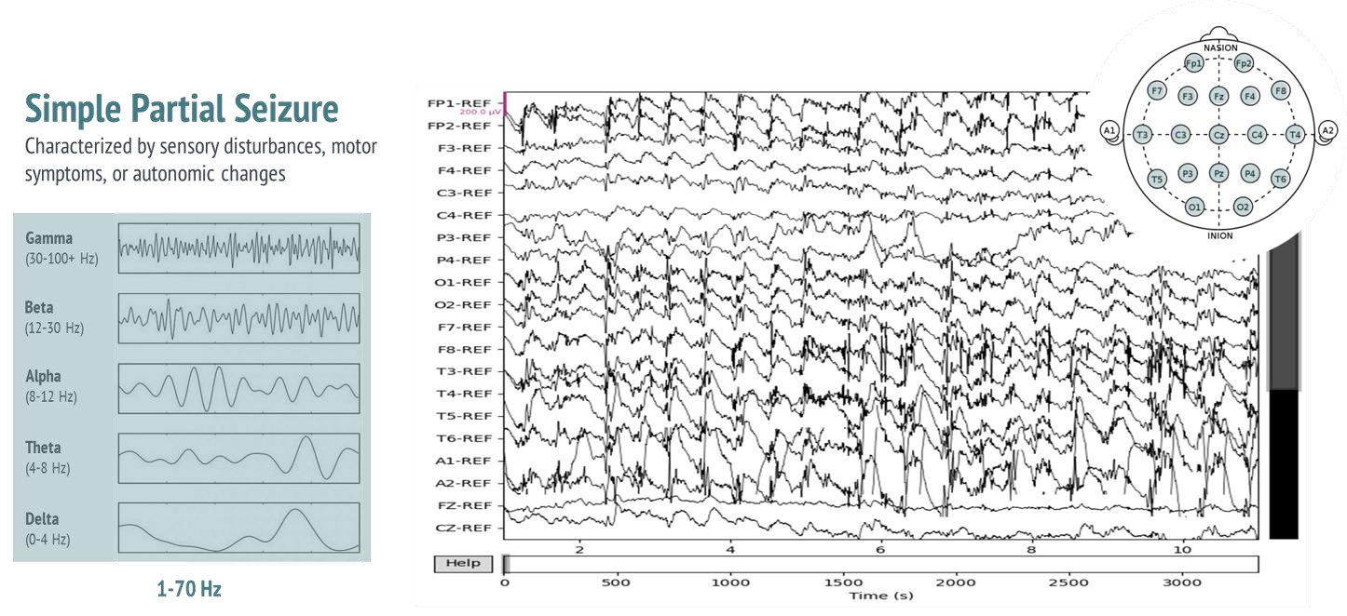
Figure 1.2: Simple partial seizures

1.5.3 Complex Partial Seizures

The most prevalent seizure type in adults with epilepsy, previously referred to as tem- poral lobe or psychomotor seizures, is known for its distinctive characteristics. These seizures often commence with a warning called an aura, which is a form of simple partial seizure that precedes the subsequent loss or reduction of awareness. The duration of complex partial seizures is typically brief, lasting only a few minutes.
During this period, individuals may exhibit an awake appearance but lose connection with their surroundings. [8] Their response to instructions or questions becomes abnor- mal. Staring is a common feature, accompanied by either immobility or repetitive semi purposeful actions known as automatisms. These automatisms can encompass facial grimacing, gestures, chewing, lip smacking, finger snapping, repetitive speech, walking, running, or even undressing. It is important to note that patients do not recall these hostile or aggressive behaviors after the seizure. Following the seizure, patients commonly experience sleepiness, confusion, and complain of headaches. This postictal state can endure for minutes to hours.
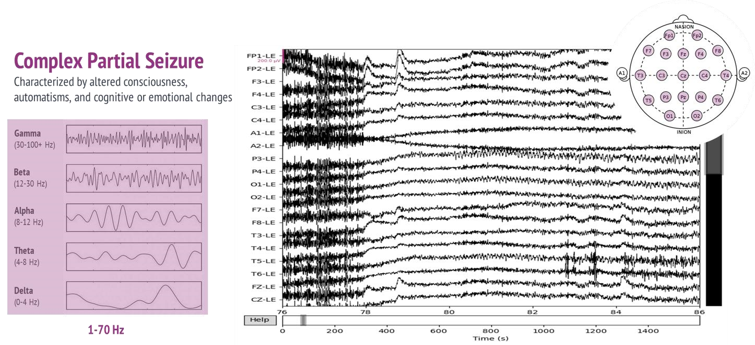
Figure 1.3: Complex partial seizures

1.5.4 Generalized Seizures

Generalized seizures are distinguished by the simultaneous engagement of cortical regions on both sides of the brain from the beginning, often resulting in a diminished level of consciousness. Among these, the well-known tonic-clonic seizure, formerly referred to as "grand mal," typically commences with an abrupt cry. The patient experiences a sudden collapse, followed by characteristic convulsive motions, which may involve tongue or mouth biting as well as urinary incontinence. Other subtypes of generalized seizures comprise absence seizures, myoclonic seizures, clonic seizures, tonic seizures, and atonic seizures.
1.5.4.1 Absence Seizures
Previously known as Pentothal, this condition mostly affects youngsters and is characterized by gazing without responding to verbal cues from outside sources, occasionally with eye blinking or head nodding.

1.5.4.2 Typical Absence Seizures
Typically occurring in clusters, typical absence seizures are brief, lasting approximately
5-10 seconds. They are characterized by a sudden onset of staring and a decrease in

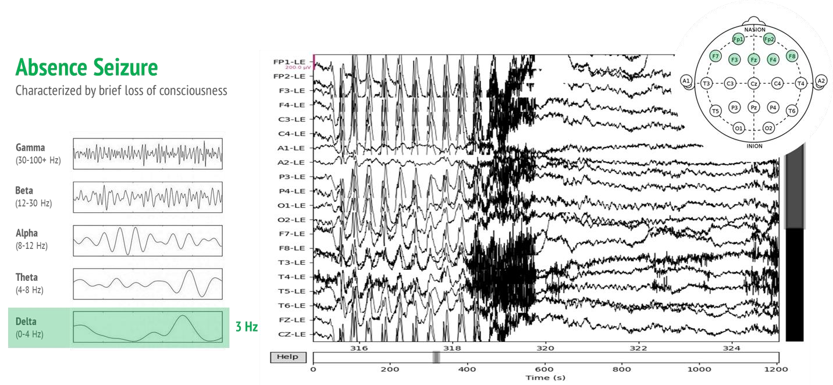

Figure 1.4: Abscence seizures

Consciousness, accompanied by potential eye blinking and lip smacking. The electroencephalogram (EEG) often reveals a distinct 3Hz spike-and-wave pattern, which is a characteristic finding. These seizures have a notable genetic predisposition, both for the occurrence of seizures themselves and for the abnormal EEG pattern.
Around 40% of patients with absence seizures experience remission during adolescence. However, it is important to note that associated tonic-clonic seizures may persist into adulthood.
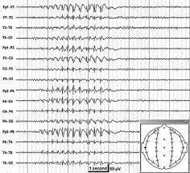
Figure 1.5: Typical seizures

1.5.4.3 Atypical Absence Seizures
Onset of these seizures commonly occurs prior to the age of 5, often alongside other forms of generalized seizures and learning disabilities. Differing from typical absence seizures, Atypical Absence Seizures tend to have a longer duration and are frequently accompanied by alterations in muscle tone.
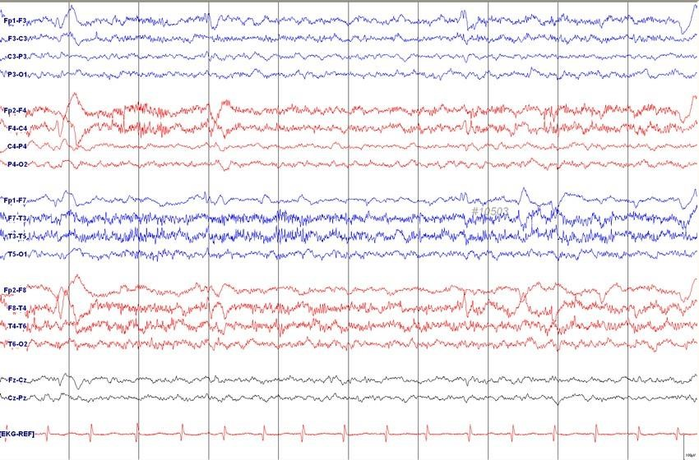
Figure 1.6: Atypical seizures

1.5.4.4 Myoclonic Seizures
Myoclonic seizures are characterized by abrupt and brief muscle contractions, occurring either individually or in clusters, which can impact any muscle group. As a result, these seizures can be either generalized or focal in nature.

1.5.4.5 Clonic Seizures
They are identified by rhythmic or semi-rhythmic muscle contractions, commonly af- fecting the upper extremities, neck, and face.

1.5.4.6 Tonic Seizures
These seizures result in sudden stiffening of the extensor muscles, frequently accompa- nied by a loss of consciousness and falling to the ground.

1.5.4.7 Generalized Tonic-Clonic (GTC)
GTC seizures, previously referred to as grand mal seizures, encompass symmetrical convulsive movements that impact all limbs. They are characterized by initial stiffness followed by jerking motions. These seizures are accompanied by a loss of consciousness.

1.5.4.8 Atonic Seizures
Often referred to as "drop attacks," atonic seizures cause an abrupt loss of muscular tone and an instantaneous collapse, which frequently results in face or other injuries.

1.6 Diagnostic Evaluation
The diagnosis of epilepsy relies on a detailed patient history and neurological examination. Witnesses’ accounts are crucial, and laboratory evaluations serve as supportive tests. Historical features and focal signs guide evaluation, treatment, and progno- sis. General physical examination helps identify underlying conditions associated with epilepsy.

1.6.1 Electroencephalography (EEG)

The neuro-electrophysiological signals known as EEG capture the brain’s electrical ac- tivities by utilizing electrodes. These electrodes can either be implanted subdurally (referred to as intracranial EEG) or positioned along the scalp (known as scalp EEG). The EEG has the capability to identify irregular electrical patterns, such as focal spikes or waves (associated with focal epilepsy), as well as diffuse bilateral spike waves (linked to generalized epilepsy). This diagnostic tool aids in confirming epilepsy and contributes to the differentiation of partial-onset and generalized seizures. Providing the electroen- cephalographer with comprehensive patient information, including age, seizure charac- teristics, and response to anti-epileptic drugs, holds significant importance.

1.6.2 Routine in EEG
Ideally, a comprehensive EEG should encompass wakefulness, drowsiness, and sleep states, as the presence of epileptiform abnormalities varies across these different levels of consciousness. It’s worth noting that routine EEGs tend to lack sensitivity, [10] with over 50% of epilepsy patients exhibiting normal traces. However, employing activation tech- niques such as hyperventilation and photic stimulation can assist in revealing underlying abnormalities. Hyperventilation-induced alkalosis has been observed to have a seizure- provoking effect, making it a valuable method for inducing absence seizures (Schuchmann et al., 2006). Similarly, photic stimulation can elicit paroxysmal epileptiform activity or even trigger generalized seizures in individuals prone to generalized epilepsy (Verrotti et al., 2012). To enhance diagnostic yield, it is also beneficial to conduct repeat record- ings if the initial EEG appears unremarkable and uncertainty surrounding the diagnosis persists. In such cases, a sleep-deprivation study is recommended.
Routine EEGs have limited utility in determining the safe tapering of antiepileptic drugs (AEDs) after a prolonged seizure-free period. However, [7] when non-convulsive status epilepticus is suspected, an EEG can offer a diagnostic advantage. Additionally, an EEG can swiftly differentiate between epileptic and psychogenic convulsive status epilepticus.

1.6.3 Video-EEG Telemetry
In the case of inpatients, video monitoring during EEG sessions can provide valuable behavioral correlation. By extending the monitoring duration to span hours or even days, the diagnostic yield can be significantly enhanced, enabling a clear differentiation between epileptic seizures and nonepileptic events. This particular investigation holds crucial importance as an integral part of the assessment process for epilepsy surgery, serving as a key method to distinguish between epileptic and non-epileptic seizures.

1.6.4 Magnetoencephalography
Recent studies have examined this method, which measures the magnetic fields connected to the intracellular current flows in neurons in between seizures. In certain circumstances. It is helpful in identifying individuals with normal neuroimaging results as surgical candidates.

1.6.5 EEG with functional MRI (fMRI)
Recent technological advancements have made it possible to concurrently record EEG and fMRI, enabling the spatial localization of interictal EEG changes. This break- through has opened up new avenues for comprehending the spatiotemporal processes underlying the generation of epileptiform activity within the brain. The utilization of simultaneous EEG and fMRI holds significant potential in enhancing the clinical management of epilepsy, particularly in identifying suitable candidates for surgical in- tervention when drug therapies prove ineffective. Ongoing research in this domain is actively exploring the application and efficacy of this approach.

1.6.6 Prolonged Ambulatory Recording
In cases where a routine EEG yields negative results, a prolonged EEG recording using portable equipment can offer improved detection of interictal and ictal events. This approach has the advantage of capturing recordings in the patient’s usual environment. However, it’s important to note that technical faults are more likely to occur, and accurate correlation with simultaneous behaviors on video can only be achieved with certain recording systems.
It is worth considering that the EEG can still appear normal in individuals with epilepsy, particularly if the seizures originate in the frontal or temporal lobe. In such cases, intracranial EEG monitoring, usually performed during presurgical evaluation, may be necessary to accurately identify the seizure focus. It’s crucial to understand that the diagnosis of epilepsy primarily relies on clinical information, with the EEG serving as a confirmatory rather than a diagnostic tool. The standard teaching is to prioritize treating the patient’s condition rather than relying solely on the EEG results.

However, there is an exception to this guideline in the case of absence epilepsy. Even if not accompanied by obvious clinical changes, brief generalized bursts of spike-wave activity in the EEG imply a high likelihood of recurring absence seizures. These seizures can go unrecognized without proper attention.

1.6.7 Brain Imaging
Computed tomography (CT) and magnetic resonance imaging (MRI) scans play a crucial role in the evaluation of individuals with seizures, complementing the clinical examina- tion and EEG findings. When it comes to identifying abnormalities, MRI is more effec- tive than CT, especially in cases of focal seizures, abnormal neurological findings, or focal discharges detected on the EEG. On the other hand, CT is valuable in acute scenarios, aiding in the detection of hemorrhages, calcifications, or tumors. Novel imaging tech- niques have emerged to assist in epilepsy assessments like functional MRI (fMRI). Mag- netic resonance spectroscopy measures neurochemical concentrations in different brain regions, aiding in seizure focus localization. Other imaging methods like positron emis- sion tomography (PET) and single-photon emission-computed tomography (SPECT) offer insights into regional glucose utilization and blood flow discrepancies, respectively, providing valuable information during seizures.
In addition to traditional EEG, magnetoencephalography (MEG) is employed to assess the dynamic electromagnetic fields of the brain, enabling improved localization of epilep- tic dipoles, including those tangential to the scalp. These advanced techniques, such as MEG and functional imaging modalities, are primarily utilized in specialized epilepsy centers during presurgical evaluations.

- Structural imaging: involves brain imaging studies to identify underlying struc- tural abnormalities, is essential in the diagnostic evaluation of most epilepsy pa- tients, particularly those presenting with partial onset seizures.
- Functional Imaging: can reveal focal abnormalities in cerebral physiology even when structural imaging results appear normal. Although their routine diagnos- tic role is limited, these techniques serve as valuable adjuncts in the workup for epilepsy surgery.
CHAPTER 2

Literature Review

Epilepsy classification is an important task in the diagnosis and treatment of epilepsy, which is a neurological disorder characterized by recurrent seizures. Machine learning classification models have been developed to identify different types of epilepsy based on electroencephalogram (EEG) signals generated by the brain during seizures. to study the different models, features extraction, accuracy and testing are the main objective to do the literature review. Different models used to extract features from the data.

2.1 AI based EEG Classification

Machine learning and deep learning models can be used to analyze and classify EEG (electroencephalogram) data, which is a type of brain wave data that is recorded by placing electrodes on a person’s scalp. These models can be used to identify patterns and features in the EEG data, which can then be used to classify the data into different categories, such as normal vs. abnormal brain activity, or different types of seizures.
Support vector machines (SVMs), decision trees, random forests, and neural networks, Convolutional neural networks (CNNs) and recurrent neural networks (RNNs) are some common models used for EEG data analysis. CNNs are particularly good at identifying spatial features in the EEG data, while RNNs can be used to analyze the temporal dynamics of the data.

2.1.1 Support Vector Machine (SVM)

Support Vector Machines (SVM) are powerful and flexible statistical learning tools pri- marily used for binary classification. SVM constructs an N-dimensional hyperplane that effectively separates data into two distinct categories. By mapping the data into a higher-dimensional space, SVM identifies an optimal separating hyperplane within this expanded feature space. One notable advantage of SVM is its ability to handle large feature spaces, where each input classifier row of feature set is considered a vector.
The most crucial stage in training an SVM is defining the hyperplane. The objective of SVM classification is to find the best hyperplane that effectively separates clusters of vectors into two non-overlapping classes. Training an SVM is generally straightfor- ward and it performs well with high-dimensional feature sets. Additionally, SVM offers manual control over the trade-off between complexity and error. The choice of a kernel plays a significant role in balancing computational performance and execution speed. Through the use of a kernel function, SVM can map the data into a different nonlinear region, allowing for separation through a more complex hyperplane.
The kernel in SVM serves as a crucial component that enables the projection of two input vectors into a higher dimensional space. This projection facilitates the separation of data points that were not linearly separable in the original feature space. By employing a more complex hyperplane, SVM with a kernel function can effectively separate the data into distinct classes. The formulation of this process can be represented by the following equation:

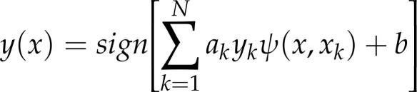 ..(2.1.1)

2.1.2 Linear Discrimination Analysis (LDA)

The linear discriminant analysis (LDA) is a widely used method for linear classification in statistics and machine learning. It extracts relevant features and reduces dimensions, aiming to maximize class separability. LDA has diverse applications, including face recognition, image retrieval, and microarray data classification. It creates a linear com- bination of datasets to optimize class differences, performing well when features follow multivariate normal distribution and share a common covariance. LDA is an effective tool for improved classification outcomes.

..(2.1.2)

2.1.3 Quadratic Discriminant Analysis (QDA)

Similar to linear discriminant analysis (LDA), quadratic discriminant analysis (QDA) is a dimensionality reduction technique that assumes regular distribution of measurements within each class. QDA offers greater flexibility in handling the covariance matrix, making it more suitable for EEG signal datasets compared to LDA. However, QDA has more parameters to estimate, resulting in a significant increase in the number of parameters. This can pose challenges when dealing with a large number of classes but limited sample points.

..(2.1.3)

Figure 2.1: This is an image from a text that uses color to teach music.

Quadratic Discriminant Analysis (QDA) is widely utilized in machine learning and statistical classification to distinguish measurements from different classes through a quadric surface. It serves as a more generalized version of the LDA classifier. While LDA employs a linear boundary to separate data points of different classes, QDA uti- lizes a quadratic surface to estimate and separate multiple classes. QDA functions as a common multivariate classification technique, providing an alternative approach to LDA in capturing complex relationships within the data.

2.1.4 k-Nearest Neighbor (KNN)

The k-nearest neighbors (k-NN) algorithm is a nonparametric learning method that is widely utilized for pattern recognition and signal pattern classification. Its primary goal is to assign an unseen data point to the predominant class based on the classification of its k-nearest neighbors from the training dataset. When compared to other classi- fication techniques such as support vector machines (SVM), artificial neural networks (ANN), linear discriminant analysis (LDA), naive Bayes (NB), and RBF neural net- works (RBFNN), k-NN stands out as the top choice for statistical pattern recognition and neighbor cluster selection. It consistently achieves high performance without any prior assumptions.
The k-NN classifier builds upon the idea of considering the k-nearest data points and determining the majority class among them. The value of "k" represents the number of neighbors that influence the classification decision. When k = 1, it is known as the nearest neighbor algorithm. In classification analysis, k-NN is categorized as a supervised learning algorithm. The following is a step-by-step outline of the k-NN learning algorithm used to classify any dataset X.

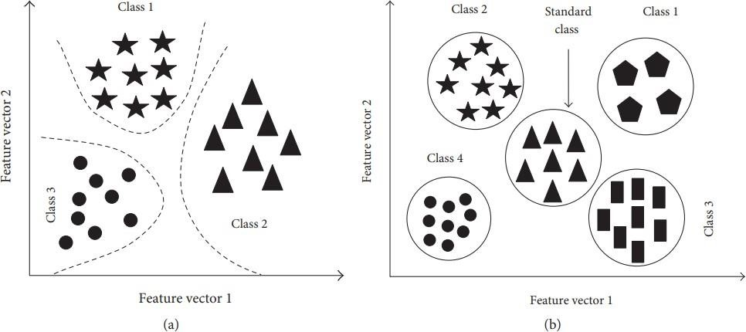

Figure 2.2: Architecture of K-NN classfier (a)simple classification (b) cluster classification

The KNN classifier is a fundamental classification method that assigns a label to an unlabeled test data point by estimating the labels of its k nearest neighbors from the training dataset. For example, in one study, the KNN classifier achieved 81.0% accuracy in distinguishing between normal and autism subjects using the Mahalanobis distance on a feature vector. In another study, EEG signals were collected from 10 individuals with ASD (aged 6-11) and nine age-matched control subjects during eyes-open condi- tions. The alpha band component (8-12 Hz), calculated using the Short-Time Fourier Transform with Bandwidth (STFT-BW), was utilized as a feature, and a KNN classifier with the Mahalanobis distance was employed. Ultimately, this algorithm achieved an impressive accuracy rate of 89.5% in accurately distinguishing between normal subjects and those with ASD.

2.1.5 Local Binary Pattern (LBP)

They originated from a comparative study of texture measures, specifically as an image operator. Initially, LBP focused on a 3x3 pixel block within an image. By thresholding the center pixel with its neighboring 8 pixels, a local weight was generated. This resulted in an 8-bit binary code, which was then converted to a decimal value known as the LBP value for that center pixel. This two-dimensional method employed in image analysis can also be applied to analyze one-dimensional sampled EEG signals.
Just as a 3x3 pixel block in an image comprises 8 neighboring points around the center pixel, the amplitude measure of 8 neighboring samples around an EEG sample point can be considered for LBP calculation. By adopting this approach, LBP can be utilized to extract meaningful information from EEG data.
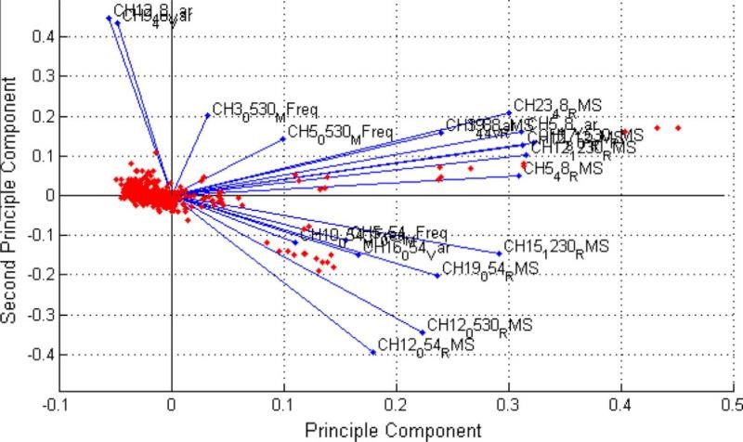

Figure 2.3: The curved line is the decision boundary resulting from the QDA method

2.2 Features Extraction Algorithm

EEG (Electroencephalogram) feature extraction is an important process in the analysis of EEG data. The raw EEG data is usually very complex and noisy, making it difficult to interpret and analyze directly. Feature extraction involves identifying and extracting relevant information from the EEG data that can be used for further analysis, such as identifying patterns and abnormalities in brain activity. There are several methods for EEG feature extraction, including time-domain analysis, frequency-domain analysis, and time-frequency analysis. These methods can be used to extract features such as spectral power, coherence, phase locking, and event-related potentials. Some of the feature extraction technique are as follows:

2.2.1 Short Time Fourier Transform (STFT)

It is a Fourier-related method used to analyze the frequency and phase characteristics of localized segments within a signal as it evolves over time. In practical terms, the STFT involves dividing a longer time signal into shorter, equal-length segments and then separately computing the Fourier transform on each segment.
By employing STFTs, it becomes possible to quantify the frequency and phase variations of non-stationary signals over time. This makes it a valuable tool for analyzing dynamic signals.
Moreover, research has indicated that STFT and time-frequency approaches can be used to identify high-frequency oscillations (HFO) and epileptic spikes in ECoG recordings of 3-year-old children. These techniques have proven effective in analyzing and detecting such neurological phenomena.

2.2.2 Root Means Square (RMS)

Root mean square (RMS) is a meaningful method for calculating the average of values over a specified time period. It has been recognized as a valuable feature for distinguish- ing between seizure and non-seizure events. RMS provides a measure of the magnitude of a varying quantity and serves as an effective estimator of signal strength in EEG frequency bands. In Python, the math and numpy libraries are commonly utilized for computing the RMS value.
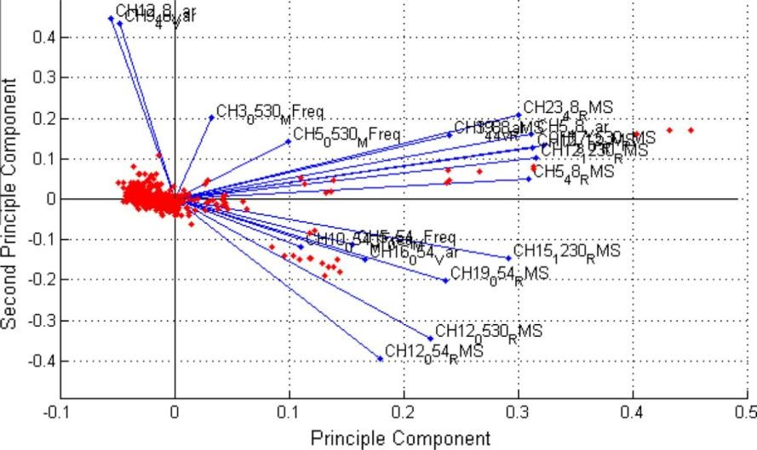

Figure 2.4: PCA for median frequency and RMS feature discrimination.

In a study focused on neonatal seizure detection, 21 features were compared for their effectiveness in classifying seizures. It was found that RMS achieved an impressive overall accuracy of 77.71%. Notably, RMS outperformed all other features that were investigated.
Moreover, Principal Component Analysis (PCA) revealed that several RMS and Median Frequency features, derived from different channels and frequency bands, were promi- nently represented in the principal component. This observation aligns with previous findings reported by Ning and Lyu, Abdul-latif et al., and Paivinen et al.

2.2.3 K-Means Cluster (K-MC)

The k-MC technique is an unsupervised learning approach that groups samples based on their shared properties, with ’k’ representing the number of clusters or classes. Each cluster consists of similar samples, distinguished from those in other clusters. This iterative process involves grouping samples based on their proximity to the mean and adjusting cluster positions until they stabilize over several iterations. An advantage of this technique is that it doesn’t require labeled input examples, and convergence is faster with a smaller ’k’. However, k-MC’s performance suffers when clusters have varying sizes, densities, or non-globular shapes. The initial placement of cluster centers also affects the results.
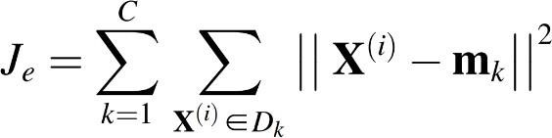

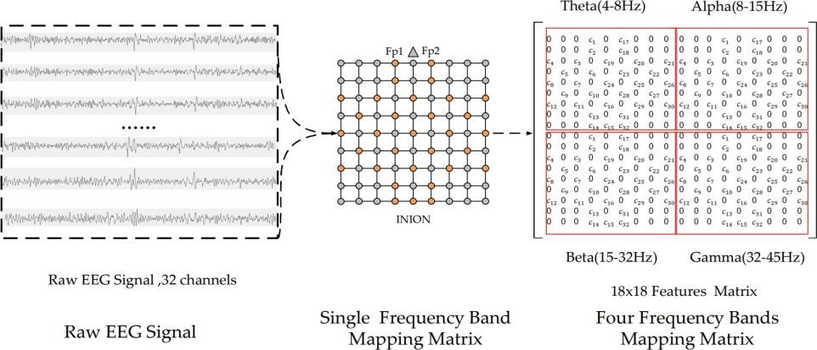

Figure 2.5: Mapping process of multiband feature matrix

2.2.4 Independent Component Analysis (ICA)

ICA, or Independent Component Analysis, is a computational technique used to separate a multivariate signal into its underlying components. With ICA, it becomes possible to extract the desired component, such as a conversation, from a mixture of multiple signals. In Python, implementing ICA is straightforward using the numpy library.
ICA has proven to be an effective method for eliminating various artifacts, including eye movement, eye blink artifacts, and muscle artifacts. Consequently, the ICA approach was employed to extract pure EEG signals originating from the human brain. The MATLAB R2012b environment alongside the EEGLAB toolbox can be used to apply this analysis technique.

2.2.5 Autocorrelation Function (ACF)
Autocorrelation (ACF) is a numerical metric that quantifies the similarity between a value in a time series and its preceding value. The Statsmodels library offers a convenient way to compute autocorrelation in Python. By utilizing the autocorrelation function, the process of measuring the amplitude difference is made more straightforward and efficient.

2.2.6 Entropy
Entropy, in machine learning and EEG signal analysis, quantifies the uncertainty or randomness in a dataset or signal. It measures the information content or complexity of a system. In machine learning, entropy helps evaluate the purity of nodes in decision trees, aiding in feature selection. In EEG analysis, entropy measures assess the irregularity and complexity of brain wave patterns, aiding in identifying brain states and abnormalities. Different entropy measures, like Shannon entropy and Renyi entropy, capture different aspects of information content and complexity.

2.2.7 Kurtosis
Skewness and kurtosis are statistical measures that provide insights into the shape and distribution of a time series. Skewness, a third-order moment, evaluates the asymmetry of the distribution, indicating whether it is skewed to the left or right. On the other hand, kurtosis, a fourth-order moment, measures the "tailedness" of the distribution, indicating whether it has heavier or lighter tails compared to a normal distribution.
In the context of seizure detection in pediatric patients, Khan et al. utilized skewness and kurtosis, along with the normalized coefficient of variation, as features. They achieved remarkable results, successfully detecting all 55 seizures in a subset of 10 patients with a sensitivity of 100%, and a low false detection rate of 1.1 per hour.
To calculate skewness and kurtosis in a dataset, Python offers convenient functions such as ‘skew()‘ and ‘kurt()‘ from the SciPy Stats library. These functions enable the computation of these statistical measures, facilitating their use in various applications, including time series analysis and medical research.

2.3 State-of-the-Art: Seizure Detection

Sriraam and Shivarudhrappa [10] collected 26 features of and trained an SVM classifier that had improved using 10-fold cross-validation to classify epilepsy-relevant activities. This technique showed an accuracy of 92.15%. Qi et al. [4] used ELM and non-linear characteristics to classify epilepsy. This method outperformed backward propagation and Support Vector Machines with a 96.5% accuracy rate in classification accuracy and training time. In [25], authors applied a random forest model to classify the data of epileptic and non-epileptic patients. They introduced a method to detect epilepsy in a noisy environment. They achieved the accuracy of sensitivity and specificity are 92%, 90%, and 93%, respectively. Lahmiri and Shmuel [11] classified recorded EEG information into seizure and non-seizure states using the Hurst exponent (HE) and got an accuracy of 97%.
Guo et al. [1] achieved 96% accuracy using ANN classifiers to classify EEG signal record- ings. In [24], a deep learning model with an independent neural network with a dense structure obtained an accuracy of 88.69%. Saminu et al. [19] It focused at a variety of automated EEG seizure detection and classification strategies, including feature ex- traction methods and statistical and machine learning classifiers. Xinghua et al. [13] used a novel independent Recurrent Neural Network (RNN) to classify epileptic and non-epileptic seizures. They used 17 channels from the CHB-MIT database of 686 EEG recordings and achieved an accuracy of 88.69%.

Choubey and Pandey [17] used HFD, sample entropy, and EAM features to compare the ANN and KNN models. They achieved an accuracy of 98% and 94%, respectively,

on two distinct EEG data sets for epileptic seizures. Chirsani and Manikandan [22] imple- mented the hierarchical attention-based convolutional neural network to classify epilep- tic seizures using single-channel EEG epochs and obtained 97.03% accuracy. Khizar et al. [12] forecasted seizures using a single robust linear characteristic as a correlation vector of seizure-like events in the brain. They used discrete wavelet transform and SVM and extracted eight features with an accuracy of 99.8%. Baffa et al. [23] created a classification model based on morphological and textural parameters for FCD on MRI. By using a multi-layer perceptron, they were able to obtain an accuracy of 96.81%.

Aslam et al. [21] used Short Term Fourier Transform (STFT) and Artificial Neural Network to classify the raw EEG into epileptic and non-epileptic seizures and achieved an accuracy of 100% in most cases. [14] used the K-means clustering method to extract DWT and classify the raw EEG data. They get an accuracy of 96.7%. Nahzat and Yaganoglu [18] used five classes of EEG patients and average persons. Then, different models were used to classify the epileptic and non epileptic seizures using the 128- channel system. They reduced the computational time using the random forest model with an accuracy of 97%. K-Nearest Neighbors (KNN) and Discrete Transform models have an accuracy of 96%, respectively. Mahjoub et al. [16] detect epileptic seizures using Machine Learning Techniques. They extract TQWT, IMFs, and MEMD features using a Support Vector Machine and get an accuracy of 98.78%.

Shoeb and Guttag [2] used SVM to identify epileptic seizures in a scalp EEG dataset. According to test data, this method had a 96%accuracy rate. In [20], an SVM classifier to categorize epileptic seizures and a Bayesian optimization approach were used to optimize the SVM’s hyperparameters. Additionally, they compared the SVM classifier’s accuracy with linear and quadratic discriminant analyses in their study and achieved an accuracy of 97.05%.

In [6] employed the dual-tree complex wavelet transform (DTCWT) to decompose the signals and generate the statistical measures, then trained a generic regression neural network classifier on all the statistical measurements and got an accuracy of 95.24%.
In [15], deep convolutional neural networks based on transfer learning and the power spectrum density energy diagrams were used to classify raw EEG data. They used the

Table 2.1: Comparison of state-of-the-art

Author | Technique | Channels | Accuracy
Sriraam and Raghu (2017) | SVM | 64 | 0.922
Tsinalis (2016) | CNN | 1 | 0.978
B.Suguna Nanthini (2017) | SVM | 16 | 0.952
Swami et al. (2021) | DTCWT | 128 | 0.952
Yandong et al. (2022) | RF | 18 | 0.92
Lahmiri (2017) | HE | 1 | 0.97
Guo et al. (2010) | ANN | 1 | 0.96
Xinghua et al. (2019) | INN | 17 | 0.887
Yuyuan et al. (2020) | Deep CNN | 23 | 0.926
Sateesh and Suchetha | DNN | 2 | 0.929
Hemant and Alpana (2020) | KNN | 1 | 0.94
Hemant and Alpana (2020) | CNN | 1 | 0.98
Usman et al. (2019) | SVM | 2 | 0.931
Kocadagli and Langari (2017) | ANN | 1 | 0.988
Senger and Tetzlaff (2016) | CNN-UM | 20 | 0.716
Shiao et al. (2017) | SVM | 16 | 0.878
Brinkmann et al. (2016) | ANN | 16-24 | 0.88

preictal I, preictal II, and interictal states as classes and achieved an accuracy of 92.6%. In [3], ANN was implemented to extract features. They used DWT at various levels to decompose the specific partitions into the detail and approximation coefficients and achieved 98.8% accuracy.
Birjandtalab et al. [7] were employed to identify epileptic seizures. A Gaussian mixture model is used to detect epileptic and non-epileptic seizures. The F-measure of the experiment was 85.1%, and accuracies of 85.1% and 85.1%. Zabihi et al. [5] processed the dataset with Fourier transform characteristics using an SVM classifier and achieved 94% preciseness and 96% efficiency.

CHAPTER 3

Surveys and Classification attempts

During the project, the team conducted several visits to hospital facilities where they had the opportunity to meet with numerous experienced neurologists. Among these professionals were Dr. Zareen Mughal, Dr. Hiba, and Dr. Khalid Sher. The knowledge and insights gained from these visits are discussed in detail below.

3.1 National Epilepsy Centre (NEC)
The medical technicians at the National Epilepsy Centre played a crucial role in enhanc- ing the team’s understanding of EEG machines. They provided a live demonstration, which involved a survey of ten patients’ EEG recordings, enabling the team to gain a better grasp of electrode placement as per the 10-20 System.
The technicians also provided detailed explanations of the different types of brain waves, such as alpha, beta, delta, theta and other waves, which occur during both REM (Rapid-Eye-Movement) and non-REM sleep cycles for unconscious or somnolent patients. The team was shown the differences in frequencies of these waves, which allowed them to better understand the significance of each.
The technicians also demonstrated how artefacts can occur due to machine or electrode misplacement, which can affect specific channels. Additionally, the team was shown how the signal morphology changes during blinking of the eye, which helped them to develop a basic understanding of EEG signals.
Overall, this demonstration was an invaluable learning opportunity for the team, and it helped them to gain a deeper understanding of EEG machines and their applications in patient care.

3.1.1 10-20 System
The 10-20 system is a universally accepted technique for positioning electrodes on the scalp to conduct EEG (electroencephalogram) recordings in a consistent and standard- ized manner. It is based on the measurements of the distances between specific points on the head and uses a set of landmarks to ensure that the electrode placement is consistent across different individuals.
The name "10-20 System" refers to the fact that electrode placement is determined by measuring the distance between 10% and 20% of the total front-back and right- left distance of the head. The distances are measured between specific landmarks on the scalp, which are identified using a set of standardized measurements based on the individual’s head shape and size.
The 10-20 system includes 21 electrode positions that are distributed across the scalp according to specific rules. The positions are labeled using a combination of letters and numbers. The letters refer to the region of the scalp where the electrode is placed, and the numbers indicate the position within that region. The regions are:
Frontal, Temporal ,Central, Parietal, Occipital
The numbers used to label the positions depend on the region of the scalp. For example, Within the frontal region, the left side of the head is where the odd-numbered electrodes are positioned, while the right side of the head accommodates the even-numbered elec- trodes. Moving to the central region, the anterior portion of the head is where the odd-numbered electrodes are placed, while the posterior portion of the head is where the even-numbered electrodes are positioned.
The 10-20 system is widely used in EEG research and clinical practice because it provides a consistent method for electrode placement that can be replicated across individuals. This allows for more accurate comparisons of EEG data between individuals and across studies.
In addition to the 21 electrode positions are placed by 10-20 system, there are also additional positions that can be added for specific research or clinical purposes. For example, the international 10-20 system includes 10% and 20% positions in between the standard electrode positions, which are labeled with a "z" to indicate their position along the front-back and right-left axes.
The 10-20 system provides a standardized approach to accurately position EEG electrodes on the scalp, enabling reliable and consistent comparisons of EEG data among different individuals and studies.

3.1.2 REM and nREM Sleep Cycles

The human sleep cycle is divided into two main stages: Rapid Eye Movement (REM) sleep and non-REM (NREM) sleep.
3.1.2.1 nREM Sleep Cycle The human sleep cycle encompasses two primary stages: Rapid Eye Movement (REM) sleep and non-REM (NREM) sleep, the latter consisting of three distinct stages, each of which exhibits unique characteristics in terms of brain wave activity and physiological alterations in the body. These are:
- Stage 1
- Stage 2
- Stage 3
In the initial stage of sleep, known as stage 1, the brain produces synchronized alpha and theta waves. Alpha waves are characterized by a moderately low frequency range (8-13 Hz) and exhibit high amplitude electrical patterns. On the other hand, theta waves have an even lower frequency range (4-7 Hz) and greater amplitude than alpha waves. Stage 1 sleep is classified as a relatively light sleep stage, susceptible to disturbances from external stimuli.
During the transition to stage 2 sleep, the body experiences a decrease in muscle activity, heart rate, and respiration. Theta waves remain the dominant pattern of brain activity during this stage, occasionally interrupted by brief bursts of higher frequency brain waves called "sleep spindles." These sleep spindles are thought to play a role in learning and the consolidation of memory. Additionally, stage 2 sleep often includes the presence of K-complexes, which are characterized by high amplitude brain activity in response to external stimuli.
Stage 3 sleep, which is also known as deep sleep or slow-wave sleep, is characterized by the presence of low-frequency (below 3 Hz) and high-amplitude delta waves. In this stage, heart rate and respiration significantly decrease. It is more difficult to wake someone from stage 3 sleep compared to earlier stages. Interestingly, individuals who experience increased alpha brain wave activity during stage 3 sleep often describe feeling unrefreshed upon waking, regardless of how long they have slept.
In relation to the frequency of EEG signals, stage 1 sleep is primarily characterized by the presence of alpha waves, whereas stage 2 sleep is characterized by theta waves. Delta waves, on the other hand, dominate during stage 3 sleep. Moreover, as the NREM sleep stages progress, there is a gradual decrease in heart rate, respiration, and overall muscle tension. These changes in EEG signals and physiological responses during the NREM sleep stages play a crucial role in understanding the diverse functions of sleep and how the body and brain undergo repair and rejuvenation during this essential period.

3.1.2.2 REM Sleep Cycle
REM sleep is characterized by rapid eye movements and brain activity similar to wake- fulness. It is the stage of sleep where dreaming occurs, but unlike wakefulness, muscle systems are paralyzed, except for those involved in circulation and respiration. This unique combination of high brain activity and muscle paralysis has led to the term "paradoxical sleep" for REM sleep. The importance of both REM and NREM sleep for learning and memory is still debated among researchers.
When individuals are deprived of REM sleep and then allowed to sleep without inter- ruption, they tend to experience a REM rebound effect, indicating that REM sleep is regulated by homeostasis. Along with its role in learning and memory, REM sleep is associated with emotional processing and regulation. The consequences of sleep depri- vation, including REM sleep deprivation, have been extensively studied and are known to negatively impact physical and cognitive functioning.

3.1.3 Eye Blinking and other artefacts
Blinking is a common event that can cause artifacts in EEG recordings. When a person blinks, there is a sudden and large amplitude change in the EEG signal, which can obscure underlying brain activity. These blink artifacts are typically observed in frontal and temporal regions of the scalp, where the muscles responsible for blinking are located.
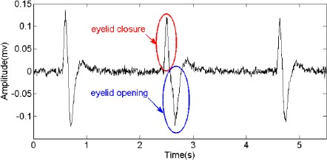
Figure 3.1: EEG reading during Eye blinking

In addition to blink artifacts, there are other types of artifacts that can be present in EEG recordings, such as movement artifacts, electrical line noise, and muscle artifacts. Movement artifacts are caused by head and body movements, while electrical line noise can be caused by power lines or other electrical equipment in the environment. Muscle artifacts are caused by contractions of facial or scalp muscles.
There are several methods that can be used to reduce artifacts in EEG recordings. One common approach is to use artifact rejection algorithms, which automatically identify and remove segments of the data that contain artifacts. These algorithms can be trained using manual annotation of the data by experts, or by using machine learning techniques to automatically identify artifacts based on their characteristics.
Another approach is to use independent component analysis (ICA), which separates the EEG signal into independent components that correspond to different sources of activity in the brain and body. The components corresponding to artifacts can then be removed from the data, leaving only the components representing brain activity.
Finally, it is important to properly prepare the subject before recording EEG data, including cleaning the scalp thoroughly, avoiding hair products that can interfere with the electrodes, and ensuring that the subject is comfortable and not moving excessively during the recording. These steps can help to reduce the amount of artifact present in the data and improve the quality of the EEG signal.

3.2 Aga Khan Development Network

The team had the opportunity to collaborate with Mr. Imtiaz, who provided valuable insights and knowledge about various types of amplifiers and filters for Single-Channel EEG Acquisition System Design. In addition, Mr. Imtiaz generously provided direction to the team to purchase Ambu Electrodes, which are specialized electrodes used in medical settings for recording bio-potential signals. The team also acquired an E-health Sensor Module, which served as a starting point for the team to collect and analyze data related to facial muscle activity.

3.2.1 E-Health Sensor Module

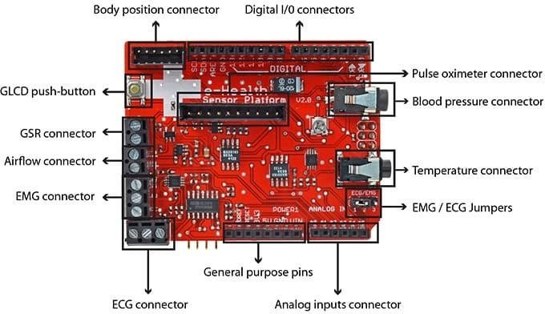

Figure 3.2: E-Health Sensor Module

The e-Health sensor kit, developed by Cooking Hacks, a division of Libelium, is specifi- cally designed to be compatible with Arduino and Raspberry Pi platforms. This versatile kit offers a cost-effective and user-friendly solution for researchers, developers, and artists
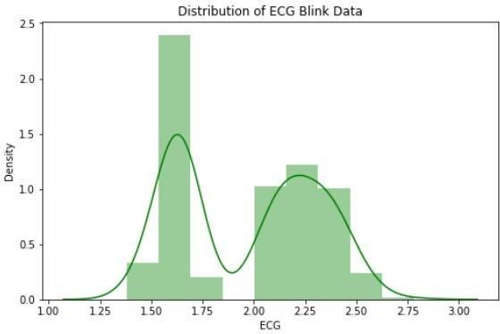
- Amplitude curve for data captured during
Blinking state
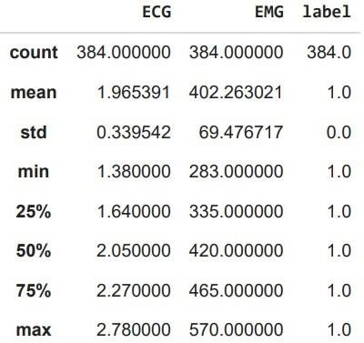
- Statistics for Blink data

Figure 3.3: Description of data collected during continuous eye blinking

who require biometric sensor data for their projects. With a total of nine sensors, the kit allows for the measurement of various biometric parameters including pulse, blood pressure, SPO2 (oxygen in blood), EKG (electrocardiogram), airflow, glucometer, GSR (galvanic skin response), patient position, and body temperature.
The primary objective behind the e-Health sensor kit is to provide an accessible and open alternative to the expensive and proprietary solutions currently prevalent in the medical market. By utilizing this kit, users can gather sensor data to monitor a patient’s condition or collect vital information for medical diagnosis. Furthermore, the collected data can be transmitted wirelessly to a laptop, smartphone, or the cloud for further analysis, using popular wireless protocols such as Wi-Fi, 3G, or Bluetooth.
The team utilized the Ambu Electrodes and E-Health Sensor Module in conjunction
- Amplitude curve for data captured during non-
Blinking state
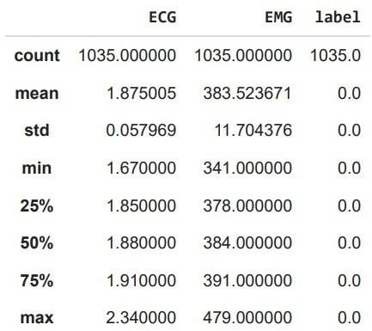
- Statistics for non-Blink data

Figure 3.4: Description of data collected during non-blinking state

with the Arduino micro-controller platform to capture facial Electromyography (EMG) data from a single individual. Specifically, two separate datasets were obtained: one while the subject continuously blinked, and another while the subject refrained from blinking.
Upon analyzing the obtained data as shown in 3.3b and 3.4b, it was discovered that the mean amplitude and other statistical values of the continuous blinking dataset were slightly different from those of the non-blinking dataset. Additionally, standard de- viation values for specific windows of data were calculated, aiding in the creation of threshold values for each dataset.
With this information, the team proceeded to implement simple if-else conditions in the code to effectively control an LED output based on the subject’s blinking activity. The mean values derived from the previously collected datasets were utilized to trigger the LED when the subject blinked. This approach allowed for a successful demonstration of the potential for utilizing facial EMG data to control electronic devices.
CHAPTER 4

Problem Definition

4.1 Problem Statement
In Pakistan, where there is a shortage of neurology experts, there is a critical need for a faster and less labor-intensive diagnosis of epilepsy. Currently there are only 250 trained neurologists according to a 2023 report. Moreover, the neurologists vs population ratio is about 1:1,000,000, which is too less as compared to the demand of our country.
To add, over 90% of medical equipment is imported to Pakistan, especially EEG Ma- chines, which are not developed locally due to limited RnD landscape in the country.

4.2 Solution Statement
Following an extensive review of relevant literature and a thorough analysis of the prob- lem at hand, we present the proposed solution statement in the following manner:
To develop a cost-effective and accessible tool for epilepsy diagnosis so as to reduce dependency on neurologists and expedite the diagnostic process.
We now present the methodology used to tackle our project as well as its design and architecture.

CHAPTER 5

Design and Methodology

This study introduces a novel CNN with multi-headed attention to solve the problem of conventional CNNs missing important features during classification. The proposed model’s multi-head attention layers receive input from the features extracted by the preceding convolutional layers. With the addition of the multi-head attention mecha- nism, more relevant features can be highlighted and identified, leading to more accurate seizure classification.

5.1 TUH EEG Seizure Corpus
The TUH EEG Seizure Corpus is used as the primary source of data. It is the largest publicly available database of interictal and ictal recordings of over 2,500 seizures from nearly 1,000 patients [8]. The dataset comprises 11 seizure types; however, we only focus on the four types: absence, myoclonic, tonic, and tonic-clonic seizures, which fall under generalized epileptic seizures [9]. Additionally, the dataset includes demographic information about the patients, such as age and gender, as well as the seizures, such as onset and duration [8].

5.2 Pre-Processing
Pre-processing is used to clean and prepare EEG signals for the model by eliminating noise and artefacts and converting the data into a format from which the model can com- prehend and learn. The first step is to remove noise and artifacts from the signals.
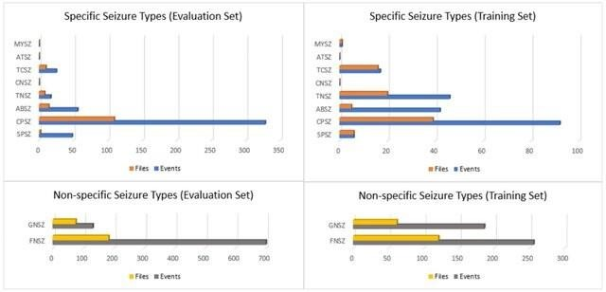

Figure 5.1: Histograms of seizure types in the TUH EEG Seizure Corpus for the evaluation and training sets.

is done by applying a band-pass filter to the signals to remove high and low-frequency noise and using independent component analysis (ICA) and principal component anal- ysis (PCA) to remove artifacts such as muscle activity and eye movements.
Next, the EEG signals are segmented into smaller, non-overlapping windows of time. This step is essential because it allows the model to learn from shorter segments of the signals, which can help detect seizures that occur over a shorter time frame. After segmenting the EEG signals, they are transformed into a format that can be input into the classification model. The last step is to normalize the data. This is done by scaling the data with a mean of zero and a standard deviation of one. This is important because it ensures that all features in the dataset have the same scale, which helps the model converge faster and improves its performance.

5.3 Feature Extraction

Feature extraction involves reducing the complex EEG dataset into relevant features that can be used to train the model. These techniques extract relevant features from the raw data, such as frequency, time, and amplitude information.

5.3.1 Frequency domain analysis

Fast Fourier Transform (FFT) decomposes the EEG signals into constituent frequency bands. The power ratio in one frequency band to the power in another helps identify EEG patterns that may indicate distinct seizure types. For example, a high power ratio in the beta frequency band may indicate a tonic seizure. The FFT of the signal is calculated using equation 5.3.1.

$X(k) =Σ^{N-1^{}} x{(n)}^{-j·2π}e^{nkN }$ (5.3.1)

n=0
where x(n) is the EEG signal x in time-domain signal and N is the number of samples . In contrast to FFT, spectral entropy measures the complexity of a signal in the frequency domain. It is calculated by estimating the signal’s power spectrum and using this information to compute its entropy as shown in equation 5.3.2.

H = X (k) log₂ X (k−) (5.3.2) ^{k=0} (5.3.2)
Where N is the number of samples in the EEG signal x and k is the frequency index of the specific frequency band.

5.3.2 Time domain analysis

The time correlation provides insight into the relationships between different EEG sig- nals of different seizure types. It measures the similarity between two signals as a function of time and is calculated using equation 5.3.3.

($q_{n}$ ) = ΣNn−=01 α(n) · β(n − τ ) (5.3.3)
($q_{n}$) = ΣN−1 2 Σ R_{αβ} τ _{n=0} α (n) · N_{n}−₌₀1 _{β} 2

where N is the number of samples and τ is the time lag between the two signals α and β. In addition, sample entropy is used to measure the signal’s complexity. It is calculated by comparing the similarity of signal segments to each other as shown in equation 5.3.4.

$S = - ln \frac{ Cm }{Cm+1}$ ..(5.3.4)

where C_{m} is the number of m-length templates in the EEG signal x that match within a tolerance level.

5.3.3 Time-frequency domain analysis

In Lifting Stationary Wavelet Transform (LSWT), the EEG signal is convolved with a wavelet waveform at different scales and locations to obtain wavelet coefficients rep- resenting the EEG signal’s contribution at each scale and location shown in equation
5.3.5.

$X_{a,b}=\sqrt[1]{\sum_{h}^{n}{}}-1 * (n)^{n-b}$ …(5.3.5)
$a_{n}=0_{a}$
where x_{a,b} is the wavelet coefficient at scale a and location b, h(n) is the wavelet scaling function, and N is the number of samples in the EEG signal x.

5.3.4 Statistical analysis

Statistical parameters such as mean and standard deviation are also used to distinguish between seizure types. Mean is the average value of a signal over time, and standard deviation measures the dispersion of a signal around its mean as shown in equation 5.3.6 and 5.3.7, respectively. Both mean and standard deviation provide insight into the variability and overall level of neural activity.

N−1
$µ = 1 Σ x(n)$ (5.3.6)
N n=0

$σ =1 .NΣ- 1 (x(n) - µ)2$ (5.3.7)
^{N} n=0
Where N is the number of samples in the EEG signal x and µ is its mean.

5.4 Seizure Classification

The overall architecture of the proposed model can be divided into two main components: the CNN component and the multi-headed attention component.

5.4.1 Multi-headed attention layers

The multi-headed attention component is a powerful tool that allows the model to selectively focus on different parts of the EEG signal at different times. By weighting the importance of different features, it helps to improve the accuracy of the model and make it more robust to variations in the input data.
The multi-headed attention component is made up of eight attention heads, each of which is responsible for attending to a different subset of the input data. The attention heads are implemented using a feed-forward approach, where they are trained to compute a weighted sum of the input data, with the weights determined by the importance of each input feature.
One of the main advantages of the multi-headed attention component is that it allows the model to learn complex patterns and relationships between different parts of the input data. This is particularly useful in our EEG signal analysis, where the data is often highly complex and difficult to interpret.

5.4.2 Convolutional layers

The CNN module plays a vital role in acquiring hierarchical representations of the input data, enabling the capture of intricate patterns within the dataset. Comprising various layers, including convolutional, pooling, and fully connected layers, the CNN performs distinct functions. Specifically, the convolutional layers are responsible for detecting local patterns in the data. By employing a set of adaptable filters, they convolve over the input data, generating a feature map as the output. The application of filters occurs through a sliding window mechanism. Furthermore, the output from the convolutional layers undergoes a non-linear ReLU activation function.

5.4.3 Pooling layers

Pooling layers are an essential component of Convolutional Neural Networks (CNNs) used in various applications of deep learning, including image recognition and EEG signal analysis. The primary purpose of the pooling layer is to reduce the spatial size of the output from the convolutional layer, resulting in fewer parameters and reduced computation time.

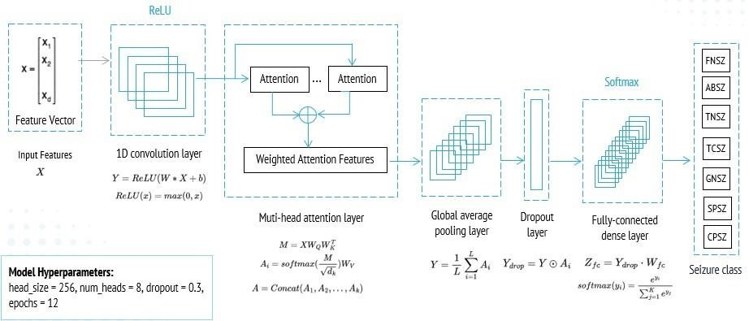

Figure 5.2: Model architecture

The pooling layer is typically applied after the convolutional layer. It takes the output from the convolutional layer, which is a feature map or activation map, and reduces its size by a specified factor. This factor is determined by the size of the pooling window and the stride value, which determines the amount by which the window moves across the input feature map.
There are various types of pooling layers, including max pooling, average pooling, and min pooling. Max pooling is the most commonly used pooling layer, where the maximum value within the window is selected as the output value. Average pooling is another type of pooling layer, where the average value within the window is selected as the output value. Min pooling, on the other hand, selects the minimum value within the window.
Pooling layers help to make the CNN more robust to small variations in the input data, such as slight changes in the position of the EEG electrodes. By reducing the spatial size of the output from the convolutional layer, pooling layers reduce the number of parameters in the model, making it easier to train. This is particularly important in EEG signal analysis, where the input data can be large, and the training process can be computationally expensive.

5.4.4 Fully-connected hidden layers

The FC layers integrate the local features to learn more complex and abstract represen- tations of the input data. These layers typically have a large number of neurons and are designed to capture higher-level features of the data that are not captured by the convolutional layers.
During training, the FC layers learn to extract these higher-level features by adjusting the weights on the inputs and biases. The weights and biases are updated iteratively using an optimization algorithm like stochastic gradient descent, which minimizes the error between the predicted output of the network and the actual output.
The number of FC layers in a CNN architecture can vary depending on the specific application. In some cases, only one or two FC layers are used, while in others, multiple FC layers are used to extract increasingly complex features from the data. Additionally, the number of neurons in each FC layer can also vary depending on the complexity of the task and the size of the input data.

5.5 Model Evaluation

To evaluate the performance of the proposed convolutional neural network (CNN) model for seizure classification, a combination of multiple metrics is used to provide a com- prehensive assessment of its efficacy [24]. Given the skewed distribution of classes, the metrics are calculated separately to test the model’s robustness and practicality.
The CNN model distinguishes between ’positive’ and ’negative’ seizures, categorizing them as generalized epileptic seizures or non-seizures. True positives (TP) refer to correctly identified positive seizures, while true negatives (TN) indicate correctly iden- tified negative non-seizures. False positives (FP) represent incorrectly classified positive seizures, and false negatives (FN) refer to incorrectly classified negative non-seizures. Evaluation metrics, discussed in the subsequent section, are derived from confusion ma- trices to assess the model’s performance.
Apart from utilizing confusion matrices, the model’s performance is evaluated through multiple metrics, including accuracy, precision, recall, and F1 score. These evaluation metrics play a crucial role in assessing the sensitivity and specificity of the model, par- ticularly in medical diagnosis scenarios. Sensitivity measures the model’s capability to accurately detect positive cases, whereas specificity gauges its ability to accurately identify negative cases. Minimizing false positives and false negatives is of utmost im- portance in medical diagnosis due to their potential implications. By considering these metrics, a deeper understanding of the model’s performance in detecting positive and negative samples can be obtained.

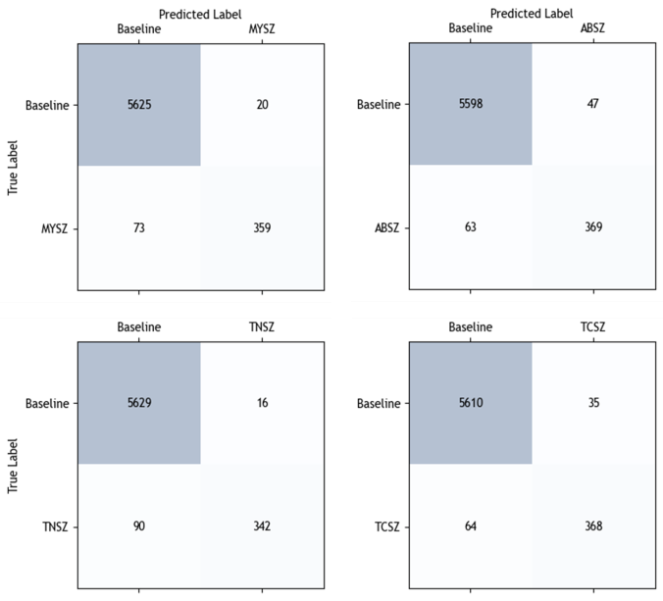
Figure 5.3: Confusion matrices for one-vs-all classification.

5.6 Results
This study uses 44 EEG recordings from three patients, split in the 60:20:20 ratio for training, validation, and evaluation. 11 files were used for each seizure class: ABSZ, TCSZ, TNSZ, and MYSZ. The dropout value of the proposed model was set as 0.4.

5.6.1 Accuracy
The accuracy (A) of the model is defined as the proportion of correctly classified seizures out of the total number of seizures. High accuracy is desirable, but it is important to note that this metric alone can be misleading as the classes are skewed. Table 5.1 shows the model’s training, validation, and evaluation accuracy.

TP + TN  A =  TP + FP + TN + FN | (5.6.1)

5.6.2 Precision
The precision (P) measures the model’s ability to correctly identify seizure classes among the total number of seizures predicted as positive. A high precision is desirable, as it means that the model can correctly identify most seizures that it predicts as positive. The model reports precision rates of 0.955, 0.913, 0.947, and 0.887 for TNSZ, TCSZ, MYSZ, and ABSZ, respectively (Table 5.2).

$P = \frac{TP }{TP + FP }$ _{(5.6.2)}

5.6.3 Recall
The recall (R), also known as sensitivity, is a measure of the ability of the model to identify all positive seizures among the total number of actual positive seizures. A high recall is desirable, as the model can identify most seizure classes. The model’s sensitivity is 0.791 for TNSZ, 0.851 for TCSZ, 0.831 for MYSZ, and 0.854 for ABSZ (Table 5.2).

$R = \frac{ TP }{TP + FN }$ (5.6.3)
F1 Score

The F1 score (F1) represents the harmonic mean of precision and recall, effectively striking a balance between the two metrics. This metric is frequently employed when dealing with imbalanced datasets, as it takes into account both precision and recall. A higher F1 score indicates a well-balanced model performance, with satisfactory precision and recall values. It can correctly identify the most positive seizures while keeping the number of false positives low. The F1 scores for TNSZ, TCSZ, MYSZ, and ABSZ are calculated as 0.866, 0.882, 0.885, and 0.870, respectively, using equation 5.3.4.
(5.6.4)
$$F_{1} = 2 ×\frac{P × R}{P + R }$$

5.6.4 Mathews correlation coefficient
The Mathews correlation coefficient (MCC) is the correlation coefficient between the actual and predicted classes. It gives more valuable insights into the model’s performance as it considers all four outcomes of the confusion matrix and therefore is not affected by class skewness. MCC for TNSZ, TCSZ, MYSZ, and ABSZ are found to be 0.873, 0.861, 0.861, and 0.873, respectively (Table 5.2).
MCC 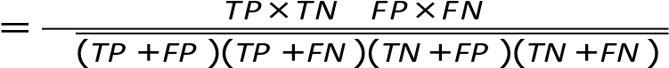 √ ⁽ ⁻ ⁾ (5.6.5)

5.6.5 Threat score
The threat score (TS) measures the ratio between the number of correctly predicted positive seizures and the sum of correctly predicted positive seizures and all incorrect predictions. TS provides insight into the model’s ability to identify positive seizures correctly and is used in conjunction with other metrics to comprehensively evaluate the proposed model’s performance. TS for TNSZ, TCSZ, MYSZ, and ABSZ is 0.782, 0.770,
0.763, and 0.788, respectively (Table 5.2).

TP
TS = (5.6.6)
TP + FP + FN

Table 5.1: Model Accuracy

Seizure Class | Train | Validation | Evaulation
ABSZ | 0.996 | 0.960 | 0.982
TNSZ | 0.996 | 0.978 | 0.983
TCSZ | 0.996 | 0.960 | 0.984
MYSZ | 0.996 | 0.969 | 0.985

Table 5.2: Performance metrics

Seizure Class | Precision | Recall | F1 | MCC | TS
TNSZ | 0.955 | 0.792 | 0.866 | 0.873 | 0.782
TCSZ | 0.913 | 0.852 | 0.882 | 0.861 | 0.770
MYSZ | 0.947 | 0.831 | 0.885 | 0.861 | 0.763
ABSZ | 0.887 | 0.854 | 0.870 | 0.873 | 0.788

CHAPTER 6

EEG Data Acquisition System

The ability to acquire, filter, and analyze low-power and random signals has improved, especially in the context of electroencephalography (EEG). However, traditional EEG systems are often expensive and not readily accessible to the general public. In this paper, we propose a low-cost EEG system design that remains affordable while main- taining robustness for neuro-psychiatric studies. We also provide an overview of the current research on EEG acquisition systems, signal processing, and their applications to inform the design of such a low-cost system.

The proposed low-cost EEG system includes scalp electrodes, a signal instrumenta- tion amplifier, a bandpass filter, a variable amplifier, a notch filter, and an analog- todigital converter. We examine the challenges associated with suitable electrodes, high-integration acquisition chips, and analysis algorithms in EEG systems.
By combining the design of a cost-effective EEG system with insights from current research, this paper aims to enhance accessibility to EEG-based diagnostics and treat- ments in neurology and psychiatry. This development holds the potential to make EEG technology more widely available and beneficial to a broader range of patients.

6.1 Data acquisition system

The main Hardware modules consist of the the following parts:
- EEG Electrodes
- Signal Instrumentation amplifier
- Band pass filter
- Variable amplifier
- Notch filter
- Analog to digital converter

6.1.1 EEG Electrodes

EEG electrodes are compact sensors that are positioned on the scalp to perceive and quantify the electrical signals originating from brain activity. To establish a reliable electrical connection between the electrode and the scalp, a specialized conductive gel or paste is applied during the attachment process.
We used Ambu company disposable electrodes. Ambu’s EEG cup electrodes feature a high-quality silver/silver chloride electrode sensor, which provides accurate and reliable EEG recordings. The electrode cups are made of a soft, flexible material that conforms to the shape of the scalp, ensuring optimal contact and reducing the risk of skin irritation.
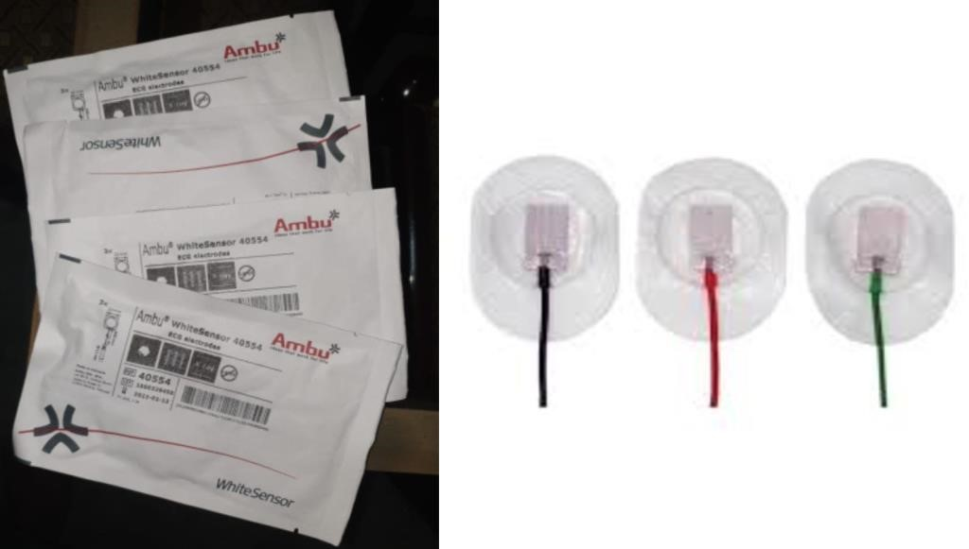
Figure 6.1: EEG electrodes

6.1.2 Signal instrumentation amplifier

The role of an instrumentation amplifier in an EEG system is to amplify the small electrical signals generated by the brain to a level that can be measured and analyzed.

These signals are typically in the microvolt range, which is much lower than the noise level in the EEG system. The instrumentation amplifier helps to amplify these signals while rejecting common-mode noise and other sources of interference.

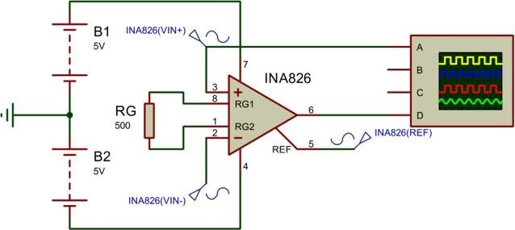

Figure 6.2: Instrumentation amplifier

An instrumentation amplifier consists of input buffer amplifiers and an output amplifier, functioning as a differential amplifier. It is designed to amplify and measure small differential signals, such as the output of a sensor, while rejecting common-mode signals, such as noise and interference.
Typically, the input stage of an instrumentation amplifier incorporates two buffer am- plifiers designed to offer high input impedance and low output impedance. This helps to minimize loading effects on the input signal and ensures that the input voltage is not affected by the characteristics of the subsequent circuitry. The output stage of an instrumentation amplifier is a differential amplifier that amplifies the difference between the two input signals and provides a single-ended output.
One of the advantages of an instrumentation amplifier is its ability to reject common- mode signals. This is achieved through the use of a balanced differential input, which cancels out any common-mode signals that are present. This makes instrumentation amplifiers particularly useful in applications where noise and interference are present, such as in medical equipment in our circuit. Instrumentation amplifiers can be configured to provide different gains, bandwidths, and input impedance levels.

6.1.3 Band-pass filter

In an EEG system to isolates the frequencies of interest, which typically range from 0.5 Hz to 50 Hz we used bandpass filter. These frequencies correspond to the different brain wave patterns associated with mental states, such as relaxation, sleep, and alertness. By filtering out the frequencies outside this range, the band-pass filter helps to increase the signal-to-noise ratio, we can effectively enhance the quality of the EEG signal.
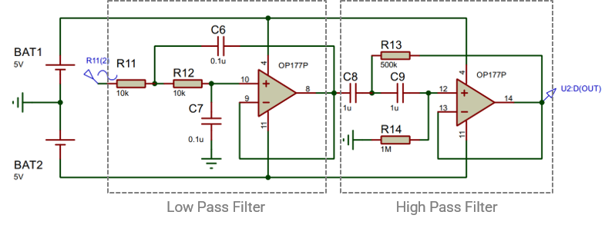
Figure 6.3: Bandpass filter

Within an EEG system, a band-pass filter serves to isolate the desired frequencies of 0.5 Hz to 50 Hz, which align with specific brain wave patterns related to various men- tal states such as relaxation, sleep, and alertness. By eliminating frequencies outside this range, the band-pass filter contributes to enhancing the signal-to-noise ratio and elevating the overall quality of the EEG signal.
In a standard band-pass filter, capacitors, inductors, and resistors are combined in a specific configuration. The frequency range of the filter is determined by the arrange- ment and values of these components. Within this range, the center frequency of the passband corresponds to the frequency at which the filter exhibits maximum attenuation or attenuation closest to zero dB.

6.1.4 Variable amplifier

The ability to modify the amplification of signals through an adjustable amplifier is crucial due to variations in the electrical activity levels generated by different brain re- gions. By adjusting the gain of the amplifier according to the magnitude of the detected signals, it ensures that all signals are adequately captured and amplified, thereby facili- tating accurate analysis and interpretation of the electrical activity across various brain regions.

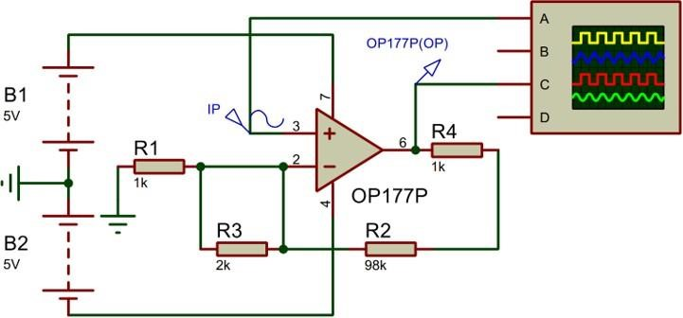

Figure 6.4: Variable amplifier

During electroencephalography (EEG), a variable amplifier is utilized to amplify the minute electrical signals produced by the brain. This amplified EEG signal is sub- sequently suitable for A/D converters. It is important to note that individuals may exhibit different ranges of EEG signals, and various A/D converters possess different input voltage ranges. The amplifier gain can be adjusted by modifying the resistance, thereby modifying the range of the EEG signal accordingly.

6.1.5 Notch filter

Notch Filter remove unwanted electrical interference at a specific frequency, typically 50 or 60 Hz. This interference is often caused by electrical equipment or power lines and can be picked up by the electrodes on the scalp, resulting in noise in the EEG signal.
In EEG, notch filters are commonly used to remove unwanted line noise from the recorded signals. Line noise is a type of interference typically caused by the power lines and electrical devices in the environment and can be present at 50 or 60 Hz, depending on the local power grid frequency.
Line noise can be a major problem in EEG recordings, as it can obscure the small electrical signals produced by the brain. Notch filters attenuate the line noise frequency while preserving the EEG signals of interest.

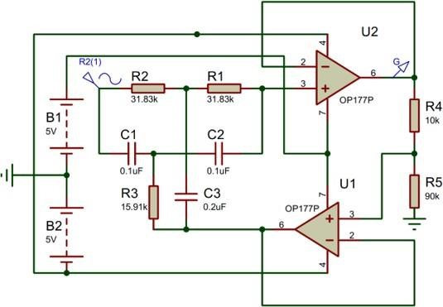

Figure 6.5: Notch Filter

The notch filter is designed to attenuate or eliminate this interference by selectively reducing the amplitude of the signal at the frequency of the interference while leaving other frequencies unchanged.

6.1.6 Analog to digital converter

In this project, Arduino is used to convert analog signal coming from brain to digi- tal signal to classify the EEG signals. Arduino acquires and process the EEG signals through non-invasive technique. It measure brain activity by detecting electrical signals generated by the neurons in the brain.

6.2 Components

6.2.1 INA 826
The INA126 is a high-precision, low-noise instrumentation amplifier manufactured by Texas Instruments. It is specifically designed for use in applications requiring high input impedance, low noise, and high common-mode rejection.

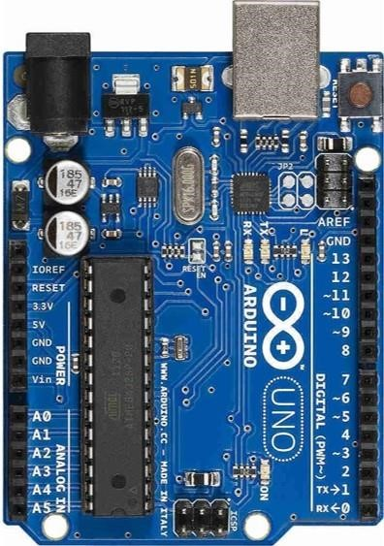

Figure 6.6: Arduino Uno

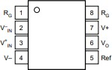

Figure 6.7: INA 826 DIP
The INA826 features a differential input with a gain range of 1 to 10000, making it suitable for amplifying signals from a wide range of sensors, including strain gauges, thermocouples, and piezoelectric transducers. It has a high input impedance of 100 G, which helps to minimize loading effects on the input signal and reduce errors caused by sensor self-heating.
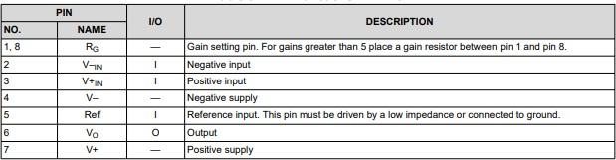

Figure 6.8: Function of INA pins

The INA826 also has a high common-mode rejection ratio of 120 dB, which allows it to reject common-mode signals such as noise and interference. This makes it well-suited for use in applications where the signal of interest is small compared to the noise and interference present in the system.
Other features of the INA826 include low offset voltage, low offset drift, and low noise, which help to ensure high accuracy and stability over time. With a single power supply voltage ranging from 2.2 V to 36 V, the OP177 is capable of functioning under various power conditions. It exhibits a wide operating temperature range, spanning from -40°C to +85°C, enabling reliable performance across a wide range of temperatures.
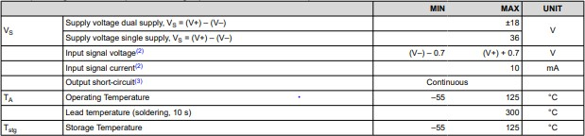

Figure 6.9: INA 826 datasheet

Ideal for applications demanding exceptional accuracy and stability, the OP177 opamp is a versatile and highly precise component. It boasts an impressively low input offset voltage, which quantifies the voltage discrepancy between the op-amp inputs when the output is at zero. The low input offset voltage of the OP177 makes it ideal for applications that require high precision and low drift over time and temperature.

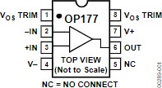

Figure 6.10: OP177 IC

The low input offset voltage, the OP177 also features low input bias current, low input noise, and high open-loop gain. These characteristics make it suitable for a wide range of precision applications, such as instrumentation, data acquisition, and control systems. The OP177 is a dual op-amp, meaning that it contains two separate op-amp circuits in a single package. This makes it convenient for applications that require multiple op-amps, as it reduces the number of components needed in the circuit.
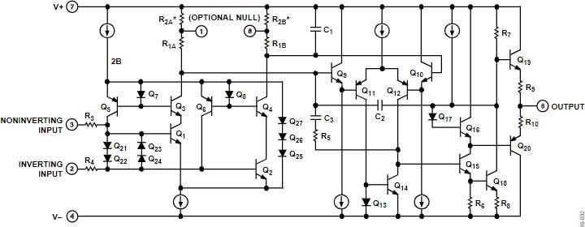
Figure 6.11: OP177 Schematics

The OP177 operates over a wide range of supply voltages, from ±2.5 V to ±18 V, and can operate at temperatures ranging from -40°C to +85°C. It also features excellent common-mode rejection ratio (CMRR) and power supply rejection ratio (PSRR), which are measures of how well the op-amp rejects common-mode signals and power supply variations, respectively. The OP177 is an operational amplifier (op-amp) that can be used in an EEG (Electroencephalogram) acquisition system. It is a precision op-amp known for its low noise, high accuracy, and excellent performance characteristics, making it suitable for sensitive applications like EEG signal processing. The OP177 can be used as an instrumentation amplifier to amplify the weak EEG signals picked up by the electrodes. The instrumentation amplifier configuration typically consists of three op- amps, and the OP177 can be used as one of them to provide amplification and accurate signal conditioning. Filters can be implemented using passive components (resistors and capacitors) and additional op-amps, and the OP177 can be used as the operational amplifier in these filter circuits. The OP177 can be utilized to implement this variable gain amplifier, allowing the user to adjust the amplification factor as needed. The OP177 can be employed in the design of the notch filter to attenuate the specific frequency (e.g., 50 Hz or 60 Hz) associated with the power-line noise.
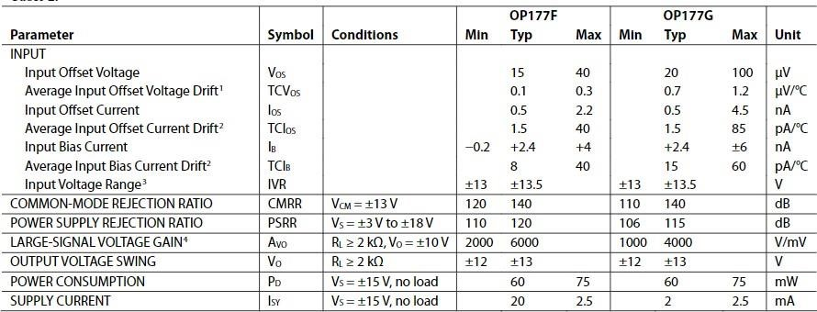
Figure 6.12: OP177 datasheet

6.3 Data Acquisition System Explanation
The process initiates by positioning electrodes on the scalp of the individual to capture the electrical signals of the brain, known as EEG (Electroencephalogram) signals. These specialized EEG electrodes are designed to detect the brain’s electrical activity, which is typically very weak, measuring in the micro-volt range. To enhance the strength of these weak signals and make them more suitable for further analysis, an instrumentation amplifier is employed. The instrumentation amplifier amplifies the amplitude of the EEG signals while preserving the integrity of the original signal. Following amplification, the EEG signals may contain unwanted high-frequency noise and artifacts that are unrelated to the brain activity we intend to analyze. To eliminate this undesirable noise, a low-pass filter is utilized. By using a low-pass filter, the low-frequency components are allowed to pass through while higher frequencies are attenuated. Similarly, a high-pass filter is employed to eliminate unwanted signals. In this case, the high-pass filter permits the passage of higher-frequency components while attenuating lower frequencies. It helps eliminate any DC offset or slow drifts in the signal.The signal strength of the EEG data may vary from person to person and also during different activities. Therefore, a variable amplifier is employed to adjust the gain of the signal as needed. This allows for optimal signal levels for further processing and analysis.Electrical power lines, such as AC mains, can introduce a 50 or 60 Hz noise into the EEG signals. To eliminate this interference, a notch filter is used. The notch filter attenuates signals at the specific frequency (50 Hz or 60 Hz) while allowing other frequencies to pass through.At this stage, the processed analog EEG signal needs to be converted into a digital format to be processed by a computer or micro-controller. An ADC is used to convert the continuous analog signal into discrete digital samples. The ADC samples the analog signal at regular intervals and assigns numerical values to represent the signal’s amplitude at each sampling point.The digitized EEG signal is then passed to a micro controller, which is a small integrated circuit that contains a processor, memory, and input/output peripherals. The micro controller can receive and process the digital EEG data, perform computations, store data, and interface with other devices or systems for further analysis or display.By following these steps, the EEG data is acquired from the electrodes, amplified, filtered to remove unwanted noise, adjusted for optimal gain, notch filtered to remove power-line interference, converted to digital form by an ADC, and finally processed by a micro- controller for further analysis or transmission to other devices or systems.

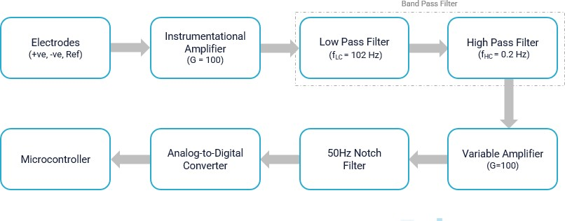

Figure 6.13: Circuit Block Diagram

CHAPTER 7

Results

The electroencephalogram (EEG) signals were obtained using cup electrodes and pro- cessed for analysis. The cup electrodes served to pick up the signals, which were then amplified and filtered before being digitized and transferred to a computer. To ensure a common reference point, a common electrode was used for signal input. The signal underwent amplification using an instrumentation amplifier, increasing its magnitude from microvolts to millivolts. The specific equation for the instrumentation amplifier can be expressed as follows:

Gain = 1+ (49.9 KW)/Rg
= 1+(49.9 KW)/500
Gain = 100

The EEG signal is characterized by its weak nature and susceptibility to strong interfer- ence from noise signals. Therefore, the design of the pre-amplifier is crucial, as it needs to possess specific qualities such as high input impedance, high common mode rejection ratio, low noise, non-linearity, strong anti-interference capability, and appropriate fre- quency and dynamic range amplifier performance. The pre-amplifier serves the essential function of extracting the valuable EEG signal while minimizing interference signals.
To meet these criteria, we chose to utilize an instrumentation amplifier, which is a spe- cific type of differential amplifier that incorporates input buffer amplifiers. This design choice eliminates the need for input impedance matching, making the amplifier highly suitable for measurement and testing equipment. Notably, the instrumentation amplifier demonstrates exceptional characteristics such as minimal DC offset, low drift, low noise,

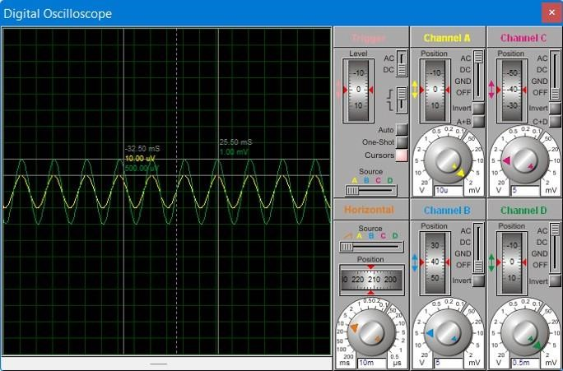

Figure 7.1: Results of Instrumentation amplifier

high open-loop gain, high common-mode rejection ratio, and high input impedance.
For our application, we selected the INA826 chip, which perfectly aligns with our re- quirements. It features a low offset voltage of 0.5uV and an impressive 120dB capability for rejecting common signals. The INA128 configuration consists of three operational amplifiers, with each input being buffered by an individual op-amp. This setup ensures proper impedance matching and generates the desired output for our application.
Subsequently, the signal from the instrumentation amplifier passed through a bandpass filter, allowing specific frequencies to pass through the system. Our system was designed to accommodate frequencies above 0.2 Hz but below 102 Hz. The calculation of the bandpass filter values can be described using the following equation:

F (low pass) =0.5RC
F=0.5(210KW0.1uF)
F=102.43Hz
F (High pass) =0.5(2CR13R1 4)
F =0.5(20.1uF (500KW1MW))
F=0.23Hz

The Result of the band pass filter is shown in the below diagram

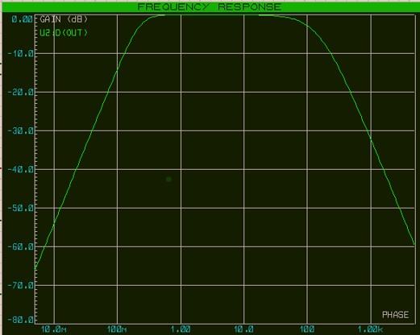
Figure 7.2: Result of Bandpass Filter

Then the signal was passed by by the variable amplifier where the certain amount of gain is required to observe and take the signal to the micro controller. This gain can be set by 100 while using calculation. The equation of variable amplifier is written as:

$$Gain =\frac{1+ (R1+R2)}{R4 Gain}= \frac{1+(1KW+98KW)}{1KW Gain}=100$$
The results of variable amplifier proteus are shown below
After signal passing through the variable amplifier, our signal can obtained but having nosie in it, which can be removed with the help of notch filter. this filter can remove the noise from the enviroment. The equation and results of notch filter are shown below.

$$f_{c}=\frac{1}{4R_{3}C_{1}}=\frac{1}{(415.91KW0.1uF)}=50.017Hz$$
To achieve effective EEG signal acquisition, the signal is directed through a notch filter.
However, even in environments with strong noise control, a persistent 50Hz interference

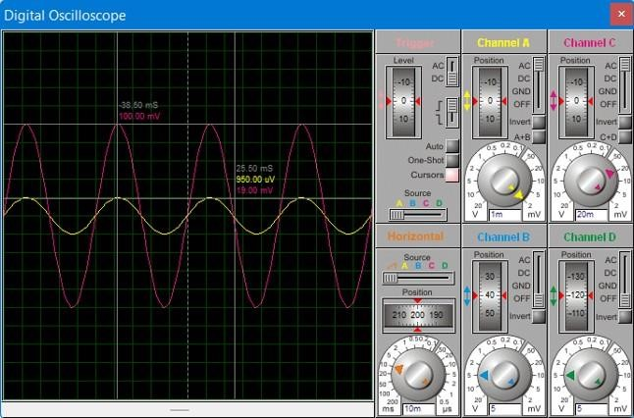

Figure 7.3: Results of Variable amplifier

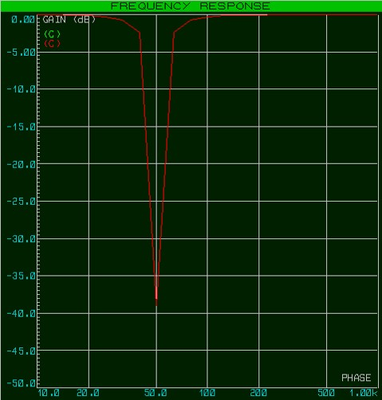
Figure 7.4: Results of Notch Filter

originating from the AC electrical line current can still be present. This interference may infiltrate the circuit and disrupt the signal. To address this issue, a notch filter, specifically designed to eliminate 50Hz activity from the signal, is employed. Given the weak nature of the EEG signal and the severity of the interference, the inclusion of a 50Hz notch filter circuit is crucial. By incorporating this circuit into the EEG amplifier, the interference can be significantly reduced, simplifying subsequent software processing stages. Subsequently, the signal is transmitted to a micro-controller for display on the screen and utilized for the classification of epileptic and non-epileptic seizures.

CHAPTER 8

Limitations and Future Work

The research project undertaken by the team was aimed at being the first in line for the upcoming Final-Year-Project groups in the coming years to expand and augment the project. However, the team encountered several challenging obstacles and limitations that impacted the research project, which may serve as tackling points for future students taking it up to expand it.

8.1 Lack of Demographic Dataset
The research project undertaken by the team was aimed at developing a deep learning model to detect and classify epileptic seizures accurately. However, the lack of demo- graphic dataset was a significant limitation, as the team needed real-world, noisy data to train and validate the model effectively. The team attempted to acquire Pakistani- collected data of epileptic patients from Aga Khan Hospital to test the accuracy of the trained models on real demographic Pakistani data.
Using real demographic data from Pakistan would have been highly beneficial in testing the model’s accuracy in detecting seizures among patients with different demographic characteristics. Furthermore, it would have provided an opportunity to evaluate the effectiveness of the model in a different clinical setting, thereby enhancing the model’s overall generalizability. Additionally, any such research has yet not been conducted, which would make it eligible for big international conferences and journals, thus adding to the body of knowledge in the field.
However, despite the team’s best efforts, the hospital declined to provide the data, citing

Figure 8.1: Aga Khan University Hospital

HIPPA violation as the primary reason. HIPPA regulations mandate that patient data must remain confidential, and any breach of these regulations can result in severe legal and financial consequences for healthcare providers. The team made several attempts to persuade the hospital management, but their efforts were unsuccessful.

Figure 8.2: Dr. Ziauddin Hospital

Undeterred, the team then approached Ziauddin Hospital and Jinnah Postgraduate Medical Centre to acquire the necessary data. JPMC showed their machine and helped the team understand the EEG acquisition process, but they declined to provide the data. According to JPMC, a key was required to access the files on any other computer than the one installed in the hospital, and purchasing the key from China was prohibitively expensive. Furthermore, they were concerned about the possibility of a virus infecting their system, which could compromise their entire network.
Despite the challenges faced by the team in acquiring the necessary data, they were able to make significant progress in the research project. The team used the cleaned

- Jinnah Postgraduate Medical Centre

- National Epilepsy Centre

Figure 8.3: Jinnah Postgraduate Medical Centre and it’s subsidiaries

data collected by TUH and CHB-MIT to train and validate the model, and the results were promising. The team is hopeful that future research will be able to overcome the limitations faced in this study and further advance the development of deep learning models for epileptic seizure detection and classification.

  - Specialized Sensors, Integrated Circuits and Electrodes unavailable in Pakistan
The research project undertaken by the team faced additional challenges and limita- tions beyond data acquisition. One major hurdle was the unavailability of specialized integrated circuits (ICs) such as the Instrumentation Amplifier (INA) and certain Oper- ational Amplifier (OPA) series within Pakistan. These ICs are crucial components in the design and development of accurate and reliable EEG signal acquisition systems. Un- fortunately, due to their unavailability domestically, the team had to consider importing them from abroad.
However, the process of importing these ICs came with its own set of obstacles. It in- volved navigating through complex taxation systems and complying with stringent im- port protocols. The team had to allocate additional time, effort, and financial resources to ensure the successful importation of these critical components. Such logistical chal- lenges added an extra layer of complexity to the research project, further highlighting the need for proper funding and resources in this domain.
In addition to the specialized ICs, the team also encountered difficulties in sourcing suitable electrodes for EEG signal acquisition. Electrodes play a vital role in ensur- ing accurate and reliable measurements of brain activity. However, they proved to be not only scarce within Pakistan but also exorbitantly expensive when available. This scarcity and high cost posed significant challenges for the team in acquiring the necessary electrodes for their research.

  - Lack of Proper Research Funding
Consequently, conducting comprehensive research in medical domain necessitated substantial funding to overcome these sourcing issues and obtain the essential components and equipment. Adequate financial resources were crucial to cover the costs associated with importing specialized ICs and procuring high-quality electrodes. Without proper funding, it would be challenging to carry out thorough investigations and make signifi- cant advancements in the field of EEG signal processing and epileptic seizure detection.
Overcoming these limitations required a multidimensional approach that involved not only addressing the data acquisition challenges but also securing the necessary resources and funding for the project. The team recognized the importance of proper financial support to conduct in-depth research and make meaningful contributions to the field of epileptic seizure detection. By ensuring adequate funding, it becomes possible to overcome sourcing difficulties and import the essential components required for the development of advanced EEG signal acquisition systems.
This study presents a novel CNN with multi-headed attention to classify generalized epileptic seizures. The performance measures show that the model minimizes the num- ber of false positive results, as they can lead to unnecessary treatments and emotional distress for the patients. High precision rates, which correspond to a low false posi- tive rate, ensure that the patients are not subjected to unnecessary interventions and treatments.
The proposed model classifies epileptic seizures as either tonic-clonic, tonic, absence, or myoclonic, with sufficiently high accuracy. The sequence of features in the attention layer is made by order of importance assigned to each feature’s weight. The model’s per- formance is critically evaluated using precision, sensitivity, specificity, F1 score, Mathews correlation coefficient, and threat score. The results demonstrate the model’s potential to digitize the labor-intensive and time-consuming process of epilepsy diagnosis.

CHAPTER 9

Discussion and Conclusion

For our Final Year Project, we aimed to classify epileptic seizures via Deep Learning using existing datasets. As a supplementary part of our work, we also designed a low cost EEG headset machine. As we know that the EEG signal is of micro-volt level and difficult to acquire. For this purpose, Instrumentation and Operational amplifiers, notch filter, bandpass filter and variable amplifier were designed.
A single-channel acquisition system has been constructed based on the described ac- quisition circuit, enabling analysis and identification of EEG signals. The system is characterized by its simplicity and affordability. Experimental results demonstrate its effectiveness, showcasing satisfactory amplification capabilities and suitability for Brain Computer Interface (BCI) applications. However, certain limitations remain within the BCI system that must be addressed in future work, particularly regarding signal iden- tification and processing enhancements. The next phase involves the development of a more robust and powerful BCI system that yields superior signal quality compared to the existing setup. Achieving this goal necessitates improved clarity in EEG signal recording and enhanced accuracy in signal processing.
Moreover to conclude, this project includes a comprehensive research on epileptic seizure detection and classification algorithms, where a range of techniques have been examined, from basic machine learning algorithms like Support Vector Machines to advanced deep learning algorithms such as neural networks. This study presents a novel CNN with multi-headed attention to classify generalized epileptic seizures. The performance mea- sures show that the model minimizes the number of false positive results, as they can lead to unnecessary treatments and emotional distress for the patients.

High precision rates, which correspond to a low false positive rate, ensure that the patients are not subjected to unnecessary interventions and treatments.
The proposed model classifies epileptic seizures as either tonic-clonic, tonic, absence, or myoclonic, with sufficiently high accuracy using Multi-Headed Attention CNN. The model’s performance is critically evaluated using precision, sensitivity, specificity, F1 score, Mathews correlation coefficient, and threat score. An accurate system was de- veloped to classify seizure types, offering potential benefits for quick patient treatment and reducing the workload of neurologists. This research marks a significant milestone in improving the efficiency and effectiveness of seizure analysis, with opportunities for further exploration and refinement in the future.

Bibliography

- Ling Guo et al. “Automatic epileptic seizure detection in EEGs based on line length feature and artificial neural networks”. In: Journal of neuroscience methods 191.1 (2010), pp. 101–109.
- Ali H Shoeb and John V Guttag. “Application of machine learning to epileptic seizure detection”. In: Proceedings of the 27th international conference on machine learning (ICML-10). 2010, pp. 975–982.
- Ting Wu, Banghua Yang, and Hong Sun. “EEG classification based on artificial neural network in brain computer interface”. In: Life System Modeling and In- telligent Computing: International Conference on Life System Modeling and Sim- ulation, LSMS 2010, and International Conference on Intelligent Computing for Sustainable Energy and Environment, ICSEE 2010, Wuxi, China, September 17- 20, 2010. Proceedings, Part I. Springer. 2010, pp. 154–162.
- Qi Yuan et al. “Epileptic EEG classification based on extreme learning machine and nonlinear features”. In: Epilepsy research 96.1-2 (2011), pp. 29–38.
- Morteza Zabihi et al. “Patient-specific epileptic seizure detection in long-term EEG recording in paediatric patients with intractable seizures”. In: (2013).
- Yong Yang et al. “Dual-tree complex wavelet transform and image block residual- based multi-focus image fusion in visual sensor networks”. In: Sensors 14.12 (2014), pp. 22408–22430.
- Javad Birjandtalab, Maziyar Baran Pouyan, and Mehrdad Nourani. “Unsupervised eeg analysis for automated epileptic seizure detection”. In: First International Workshop on Pattern Recognition. Vol. 10011. SPIE. 2016, pp. 124–128.
- Iyad Obeid and Joseph Picone. “The temple university hospital EEG data corpus”.
In: Frontiers in neuroscience 10 (2016), p. 196.
- Ingrid E Scheffer et al. “ILAE classification of the epilepsies: Position paper of the ILAE Commission for Classification and Terminology”. In: Epilepsia 58.4 (2017), pp. 512–521.
- Natarajan Sriraam and Shivarudhrappa Raghu. “Classification of focal and non focal epileptic seizures using multi-features and SVM classifier”. In: Journal of medical systems 41.10 (2017), p. 160.
- Salim Lahmiri and Amir Shmuel. “Accurate classification of seizure and seizure- free intervals of intracranial EEG signals from epileptic patients”. In: IEEE Trans- actions on Instrumentation and Measurement 68.3 (2018), pp. 791–796.
- Muhammad Khizar Abbas et al. “Seizure forecasting using single robust linear feature as correlation vector of seizure-like events in brain slices preparation in vitro”. In: Neurological research 41.2 (2019), pp. 99–109.
- Xinghua Yao, Qiang Cheng, and Guo-Qiang Zhang. “A novel independent rnn approach to classification of seizures against non-seizures”. In: arXiv preprint arXiv:1903.09326 (2019).
- Annushree Bablani et al. “A multi stage EEG data classification using k-means and feed forward neural network”. In: Clinical Epidemiology and Global Health 8.3 (2020), pp. 718–724.
- Yunyuan Gao et al. “Deep convolutional neural network-based epileptic electroen- cephalogram (EEG) signal classification”. In: Frontiers in neurology 11 (2020), p. 375.
- Chahira Mahjoub et al. “Epileptic seizure detection on EEG signals using ma- chine learning techniques and advanced preprocessing methods”. In: Biomedical Engineering/Biomedizinische Technik 65.1 (2020), pp. 33–50.
- Hemant Choubey and Alpana Pandey. “A combination of statistical parameters for the detection of epilepsy and EEG classification using ANN and KNN classifier”. In: Signal, Image and Video Processing 15 (2021), pp. 475–483.
- Shamriz NAHZAT and Mete YAĞANOĞLU. “Classification of Epileptic Seizure Dataset Using Different Machine Learning Algorithms and PCA Feature Reduc- tion Technique”. In: Journal of Investigations on Engineering and Technology 4.2 (2021), pp. 47–60.
- Sani Saminu et al. “A recent investigation on detection and classification of epileptic seizure techniques using EEG signal”. In: Brain Sciences 11.5 (2021), p. 668.
- Miao Shi et al. “EEG signal classification based on SVM with improved squirrel search algorithm”. In: Biomedical Engineering/Biomedizinische Technik 66.2 (2021), pp. 137–152.
- Muhammad Haseeb Aslam et al. “Classification of EEG signals for prediction of epileptic seizures”. In: Applied Sciences 12.14 (2022), p. 7251.
- Sateesh Kumar Reddy Chirasani and Suchetha Manikandan. “A deep neural net- work for the classification of epileptic seizures using hierarchical attention mechanism”. In: Soft Computing 26.11 (2022), pp. 5389–5397.
- Matheus de Freitas Oliveira Baffaetal. “Focal cortical dysplasia classification for refractory epilepsy detection using artificial neural network”. In: Computer Methods in Biomechanics and Biomedical Engineering: Imaging & Visualization (2022), pp. 1–5.
- Fábio Lopes et al. “Ensemble deep neural network for automatic classification of
EEG independent components”. In: IEEE Transactions on Neural Systems and Rehabilitation Engineering 30 (2022), pp. 559–568.
- Yandong Ru, Jinbai Li, and Zheng Wei. “Epilepsy Detection Based on Riemann Potato in Noisy Environment”. In: Applied Bionics and Biomechanics 2022

