AN ASSESSMENT STUDY OF MARKET-VIBRANCY: A CASE STUDY OF LAHORE



RESEARCH ADVISORS

Plnr. Mutahir Mehmood Awan
Plnr. Muhammad Shafaat Nawaz

RESEARCHERS

Muhammad Talha 15002214005
Zubair Hussain 15002214007

SESSION 2015-2019

DEPARTMENT OF CITY AND REGIONAL PLANNING
SCHOOL OF ARCHITECTURE AND PLANNING
UNIVERSITY OF MANAGEMENT AND TECHNOLOGY LAHORE

APPROVAL SHEET
This project is submitted to the Department of City & Regional Planning, University of Management & Technology, Lahore for the partial fulfillment of Bachelor’s Degree

In

City & Regional Planning

Approved on:
Chairperson:
Dr. Fariha Tariq DCRP, UMT
Dean:
Prof. Dr. Yousuf Awan SAP, UMT

DEPARTMENT OF CITY & REGIONAL PLANNING
SCHOOL OF ARCHITECTURE & PLANNING
UNIVERSITY OF MANAGEMENT & TECHNOLOGY, LAHORE 2015 – 2019

DEDICATION

This study is wholeheartedly dedicated to our beloved parents, who have been our source of inspiration and gave us strength when we thought of giving up, who continually provide their moral, spiritual, emotional and financial support.

DECLARATION

We hereby, declare that the project report is based on our own work carried out during the course of our study under the supervision of Plnr. Mutahir Mehmood Awan and Plnr. Muhammad Shafaat Nawaz. We assert the statements made are an outcome of our project work and have not been published anywhere else before.
We further certify that:
- The work contained in the report is original and has been done by us under the general supervision of our supervisors.
- The work has not been submitted to any other Institution for any other degree/diploma/certificate in this university or any other University of Pakistan or abroad.
- Whenever we have used materials (data, theoretical analysis, and text) from other sources, we have given due credit to them in the text of the report and giving their details in the references.

_______________________________________________
Muhammad Talha Zubair Hussain

ACKNOWLEDGMENTS

We would like to express our sincere gratitude to our supervisors Plnr. Mutahir Mehmood Awan and Plnr. Muhammad Shafaat Nawaz for providing their invaluable guidance, comments and suggestions throughout the course of the project and encouragement in finishing this project and also for teaching us in this course.

Table of Contents
DEDICATION iii
DECLARATION iv
ACKNOWLEDGMENTS v
ABSTRACT 2
Chapter 1. Introduction 3
1.1. Problem Statement 3
1.2. Research Question 3
1.3. Objectives 4
1.4. Justification 4
1.5. Scope & Limitation 4
Chapter 2. Literature Review 5
2.1. Factors Contributing to Vibrancy 6
2.2. Identified Factors: 8
2.3. Assessment Methods 10
Chapter 3. Study Area 11
3.1. Area Selection 11
3.2. Location Map of Area 11
3.3. Area Description 13
3.3.1. G1 Market M.A.J.T 13
3.3.1.1. Types of Shops 13
3.3.2. Main Market Gulberg 14
3.3.2.1. Types of Shops 14
3.3.3. Kareem Market A.I.T 14
3.3.3.1. Types of Shops 14
Chapter 4. Methodology 15
4.1. Introduction 15
4.2. Research Strategy 16
4.2.1. Factor Identification 17
4.2.2. Assessment Methods 17
4.2.3. Vibrancy Comparison 17
4.3. Sampling 17
4.4. Data Collection 18
4.5. Analysis 18
Chapter 5. Data Collection and Analysis 20
5.1. Data Collected 20
5.1.1. Main Market Gulberg 20
5.1.2. G1 Market M.A.J.T 22
5.1.3. Kareem Market A.I.T 24
5.2. Analysis 26
5.2.1. Main Market Gulberg 26
5.2.2. G1 Market M.A.J.T 28
5.2.1. Kareem Market A.I.T 29
Chapter 6. Findings 30
6.1. Main Market Gulberg 30
6.2. G1 Market M.A.J.T 31
6.3. Kareem Market A.I.T 32
6.4. Comparison: 33
Chapter 7. Conclusion & Recommendations 52
References: 54
Annexure – A 56

List of Figures

Figure 1: Study Area Location Map 11
Figure 2: G1 Market M.A.J.T Satellite Imagery 12
Figure 3: Main Market Gulberg Satellite Imagery 12
Figure 4: Kareem Market A.I.T Satellite Imagery 13
Figure 5: Methodology 15
Figure 6: Research Strategy 16

List of Tables
Table 1: Average Weighted Score 18
Table 2: Data Analyzing Table 18
Table 3: Main Market Gulberg Data Collection 20
Table 4: G1 Market M.A.J.T Data Collection 22
Table 5: Kareem Market A.I.T Data Collection 24
Table 6: Main Market Gulberg Analysis 26
Table 7: G1 Market M.A.J.T Analysis 28
Table 8: Kareem Market A.I.T Analysis 29
Table 9: Main Market Gulberg Score 30
Table 10: G1 Market M.A.J.T Score 31
Table 11: Kareem Market A.I.T Score 32

List of Charts
Chart 1: Accessibility Comparison 33
Chart 2: Permeability Comparison 34
Chart 3: Diversity Comparison 35
Chart 4: Readability Comparison 36
Chart 5: Flexibility Comparison 37
Chart 6: Visual Proportions Comparison 38
Chart 7: Personalization Comparison 39
Chart 8: Richness Comparison 40
Chart 9: Safety & Security Comparison 41
Chart 10: Human Scale Comparison 42
Chart 11: Environment Attractiveness Comparison 43
Chart 12: Meaningful Places Comparison 44
Chart 13: Human Presence Comparison 45
Chart 14: Density or Land Use Jam Comparison 46
Chart 15: Parking Availability Comparison 47
Chart 16: Road Signals Comparison 48
Chart 17: Sitting Areas Comparison 49
Chart 18: Public Toilets Comparison 50
Chart 19: Average Score Comparison 51

ABSTRACT

Historically urban spaces have validated their importance as the identity of our cities but in this age of transition, our urban spaces are constantly being degraded due to different factors like haphazard development and fraternization of historic and modern development. One victim of the decreasing quality of our urban spaces is urban markets. In this study, the purpose is to assess vibrancy of different markets of Lahore i.e. G1 Market M.A.J.T, Main Market Gulberg and Kareem Market A.I.T and to compare these three markets to find which market is more vibrant.
In this study, the factors which contribute to vibrancy and methods to assess vibrancy are identified from the literature. Data is collected from field by field surveys. For analysis, weighted average index is being calculated for each factor and data is standardized on a scale of 0 to 1. Vibrancy of each market is compared using weighted average index and results are generated on the basis of these analysis.
Results from this study have shown that all three markets have good vibrancy score. Comparatively Main Market Gulberg is more vibrant than G1 Market M.A.J.T and Kareem Market A.I.T. Both G1 Market M.A.J.T and Kareem Market A.I.T are equally vibrant. But there is still room for enhancement of vibrancy in these three markets. Main Market Gulberg is comparatively more vibrant than G1 Market M.A.J.T and Kareem Market A.I.T.

Introduction
In Since the beginning of modern civilization, some inexcusable interventions which have no appropriateness, have destroyed various qualities of our cities; these have been resulting from some factors like the excessive development of cities and dominance of the cars in urban life. Now in the urban life, the square and the street (two main urban spaces) are facing many conflicts and various problems, which can be seen clearly in the historical context of our urban spaces.
Historically urban centers validate their prestige and importance as a commercial, cultural and recreational center. Urban centers as the housing and shelter for millions of people and visitors will facilitate and improve human interaction. Since the city is very complex, existence and attendance of cycles of declining and wane, reform and reconstruction are obvious. At the best form, appearance of a city will be realized from its center & heart.
Urban space is not just a physical concept, but also contains citizen interactions and civic engagements. It means that public spaces bring an imagination for city fabric where is a place of establishing urban activities or an incidence of social interactions. Vibrant urban spaces can be defined as an area which enable number of persons regardless of their age and gender to perform various type of activities. Vibrancy of urban spaces depends on many factors, these can be their accessibility, diversity and adaptability.

Problem Statement
Many large cities of the world have suffered through numerous problems due to increased population as a result of urbanization over the past few years. Like many other large cities, Lahore also suffers from high land prices, traffic congestion, cramped housing, and a scarcity of open space due to the city’s rapid growth in last years. Another issue that Lahore is currently facing is decreasing quality of its urban spaces and markets due to rapid growth of city but it has not been addressed in past. Therefore, this study focusses on assessing and comparing markets-vibrancy of different markets of Lahore.

Research Question
Which factors contribute to market vibrancy and how vibrant G1 Market M.A.J.T, Main Market Gulberg and Kareem Market A.I.T are in comparison to each other?

Objectives
- To identify the factors that contributes to vibrancy through the literature review.
- To rank the identified factors on Likert scale.
- To compare vibrancy of markets of Lahore; G1 Market M.A.J.T, Main Market Gulberg and Kareem Market A.I.T.

Justification
Memories of being in an urban space or market are derived from the sense of identity and uniqueness. But unfortunately, now a days our cities have lost their identity due to some factors like the haphazard urban development and fraternization of historic spaces with modern development. The urban spaces or markets are not established for one purpose or rapid changing purpose i.e. a shopping center by day and venue for food streets at night. Urban spaces or city centers are identity of a city and often commercial, cultural, political and historical core of a city. In this study G1 Market M.A.J.T, Main Market Gulberg and Kareem Market A.I.T of the Lahore are being examine to check their vibrancy.

Scope & Limitation
This study aims to identify different factors which contribute towards vibrancy of urban markets and evaluate methods for assessment of vibrancy. This study also tends to compare vibrancy of three different markets of Lahore. There are also some limitations to study which are as follow:
- It became difficult to identify factors which contributes to vibrancy and their assessment methods due to lack of literature on market vibrancy
- This study does not offer any methods or proposals for enhancement of vibrancy.

Literature Review
This chapter mainly emphasis to explore literature related to market vibrancy to identify different factors which contributes to vibrancy and methods to assess the vibrancy of an urban center.

For many years’ cities have faced challenges in meeting the needs of local populations due to unexpected and rapid urbanization. Many old cities have lost their identity and historical importance due to change trends and lack of attention (Hashempour, 2017). Therefore, it is essential to model spatial dynamic growth to identify the land-use class of urbanized regions expansions to prepare for future urban demands. This need can be addresses by exploring the application of the remotely- sensed data and cellular automation (CA) based SLEUTH model and its effectiveness in modeling of urban growth (Rahman, Alshabeeb, Al-amoush, & Al-adamat, 2018).
By combining national policies, prefectural facilitated intermunicipal cooperation, and progressive local planning we can maintain a city center as a vibrant center for commercial and residential life (Jacobs, 2001). A vibrant city center is the symptom or consequence of a viable growing local economy. The City Centre Doctor Project will create opportunities for the partner cities to explore the processes and systems in other cities to manage growth in their local economies (Badenhorst, 2016).
As government resources become more limited, it is imperative that the private sector become more involved not only in supporting urban and community forestry, but also in taking on leadership roles in developing and implementing the strategic approaches necessary to make the Vibrant Cities & Urban Forests initiative a success (Fleming, 2016). We will be able to recover from several boom-and-bust cycles in our economy by prioritizing a vibrant downtown with a high quality of life and preservation of its natural beauty. These assets have attracted new residents, tourists, and business entrepreneurs who drive economic growth (Kramer et al., 2015).

Factors Contributing to Vibrancy
Due to a long transition period city centers are now known for commercial centers. They also act as the shelter for many people. The city structure is very complex and changes always happen but the city is always realized from its center. To make city centers more vibrant it needs adequate respondents (Moghadam, Mousavi, Solgi, & Azimi, 2014). Urban core is an important variable of vibrancy which has been ignored in literature. A vibrant urban core can affect land use and transportation patterns. In a research, vibrancy indicators are also linked with carbon footprints (Holian & Kahn, 2012).
The vibrancy of city centers depends on some environmental qualities which are as follow:

- Accessibility
- Land use diversity
- Concentration and density or land use jam
- Organizer structure
- Permeability
- Diversity
- Readability
- Flexibility
- Visual proportions
- Richness and personalization

(Moghadam et al., 2014).
Vibrancy can also be defined on the indicators what most people seek out in city centers i.e. employment, leisure and other opportunities. Studies have shown that people prefer to live near to those city centers which are graded as more vibrant (Holian & Kahn, 2012).
There are also some principles by which the development or vibrancy of city center can be assessed. These principles are:
- Connectivity
- Multiplicity of use
- Adaptability & coherence
Connectivity refers to the links of urban centers with its surroundings or other places. Increased connectivity increases the vibrancy of centers. Multiplicity of use means the cities should have more than one function which are similar to each other. The principle of adaptability & coherence encourage cities to adopt changes without losing their historical importance or significance (“Regenerating Aberdeen: a vision for a thriving and vibrant city centre 1,” 2017).
There are some strategies and policies which can be used to create or promote a vibrant and responsive environment. Those strategies are:

- Strengthen good permeability
- Strengthen the visual proportions
- Maintain and strengthen the identity and sense of place
- Creating a variety of land uses
- Create an organizing structure
- Establish & strengthen the flexibility

(Moghadam et al., 2014)
Vibrancy can be built through the concept of creative placemaking theory. Creative placemaking can help centers to become more vibrant. It is a geographically targeted restoring strategy (Placemaking & Growth, 2012). Vibrancy can also be enhanced by applying approaches of vitality and urban regeneration. The values of public spaces can be restored by emphasizing on some principles, like pedestrian-orientation, internal and infill development, using brownfields and the injection of the artistic and cultural activities (Hashempour, 2017).

Identified Factors:
The factors identified from literature which contributes to vibrancy of an urban center are as follow:
Sr. No. | Factors | Definition
1 | Accessibility | The quality of being able to be reach or enter the area. Accessibility results in possibility of growth of production and business activities (Moghadam et al., 2014).
2 | Permeability | A public space permeable not only to those who are familiar to environment but also to absorb everybody (Moghadam et al., 2014).
3 | Diversity (Land Use & Building) | Diversity in both, land use and varied kind of buildings with different forms is considered, and is absorbs different people in different times with different economic situations. In other words it increases the range of choices (Moghadam et al., 2014).
4 | Readability | The quality that makes an understanding of environment. Environments may be visible in one of two levels of physically or activity (Moghadam et al., 2014).
5 | Flexibility/Robustness | Powerful combining of places that can be used for different purposes give more range of choices, in comparison with places that are designed just for one use (Moghadam et al., 2014).
6 | Visual Proportions | If the area is clear for people in form and function, have diversity and flexibility, it can be said that visual proportions is observed (Moghadam et al., 2014).
7 | Personalization | This is the only way that most people find an environment arising from their personal concerns, values, and signs. If people use a place regularly and in long term, they will have a sense of belonging to it (Moghadam et al., 2014).
8 | Richness | Richness is a quality which makes varied sensory experiences and enhances pleasure. It includes all the senses, but because of the impact that sight has in understanding of information, it is somewhat more important than the others (Moghadam et al., 2014).
9 | Safety & Security | The state of being free from harm or injury or the surety that nothing would cause harm in a particular situation (Hashempour, 2017).
10 | Human Scale | The size, texture and articulation of physical elements that match the size and proportions of human sight and speed (Hashempour, 2017).
11 | Environment Attractiveness | Environment can be considered as attractive as it is attractive, appealing, engaging, interesting for people (Hashempour, 2017).
12 | Meaningful Places | Any place that meets the needs of people (Hashempour, 2017).
13 | Human Presence | The state of the immediate proximity of a person (Hashempour, 2017).
14 | Density or Land Use Jam | Because land values are relatively high in urban centers, to maximize the occupancy levels is important and this results in high jam and density (Moghadam et al., 2014).
15 | Parking Availability | Availability of parking spaces near markets enhance the experience of consumers (Ahmed & Ph, 2017).
16 | Road Signals | Availability of roads signals for motorized traffic and pedestrians (O, 2015).
17 | Sitting Areas | Sitting areas in markets for consumers and general public (Goliˇ & Ward, 2010).
18 | Public Toilets | Availability of public toilets near markets for consumer or general public (Kitchin, Law, Kitchin, & Law, 2001).

Assessment Methods
Vibrant urban centers are very important in attracting different professionals and entrepreneurs who run different sectors. Efforts or techniques which are aimed to increase the vibrancy of cities or their centers also increase the economic conditions of cities. Study shows a basic method of measuring vibrancy as the number of residents and jobs per acre (Placemaking & Growth, 2012).
Another paper introduces the criteria for responsive environments, characters of a vibrant city center and the main & common features using the analytic hierarchy process (AHP). In this study, data was collected through questionnaires, urban population experts and field observations, using AHP. According to the provided theoretical principles and separation and reviews of effective components, common features are offered as six criteria i.e. permeability, visual proportions, sense of place, land use variety, organizer structure, flexibility. These are also the main components of this approach. Each of them is weighted by the binary comparison using the AHP (Moghadam et al., 2014).

Study Area

Area Selection
Study area selected for examining vibrancy include 3 markets of Lahore i.e. G1 Market Muhammad Ali Johar Town, Main Market Gulberg and Kareem Market Allama Iqbal Town. These markets are selected for the study because these are some of the main markets of Lahore.

Location Map of Area
The map below shows the location of G1 Market M.A.J.T, Main Market Gulberg and Kareem Market A.I.T.
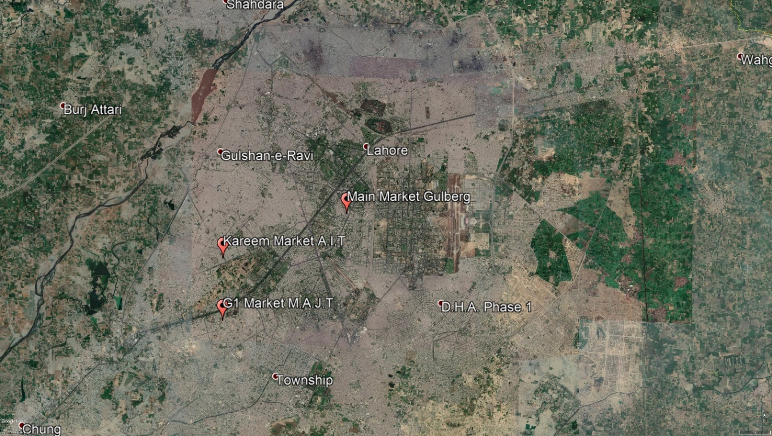
Figure 1: Study Area Location Map

Below is the Satellite Imagery of G1 Market M.A.J.T
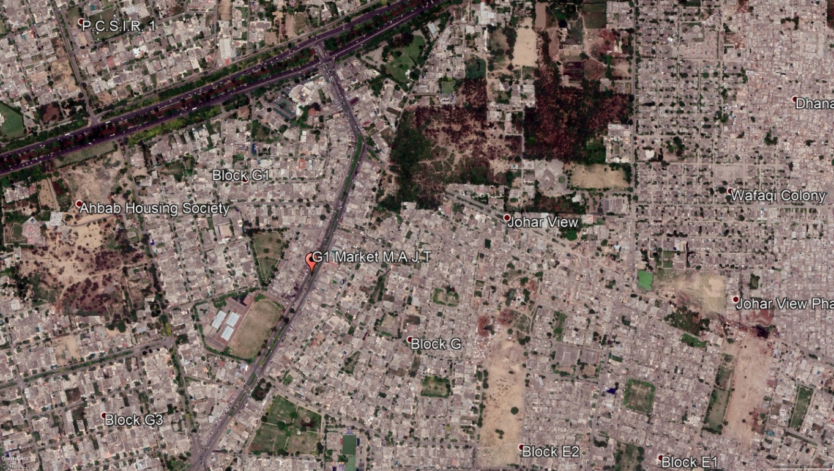
Figure 2: G1 Market M.A.J.T Satellite Imagery
Below is the Satellite Imagery of Main Market Gulberg
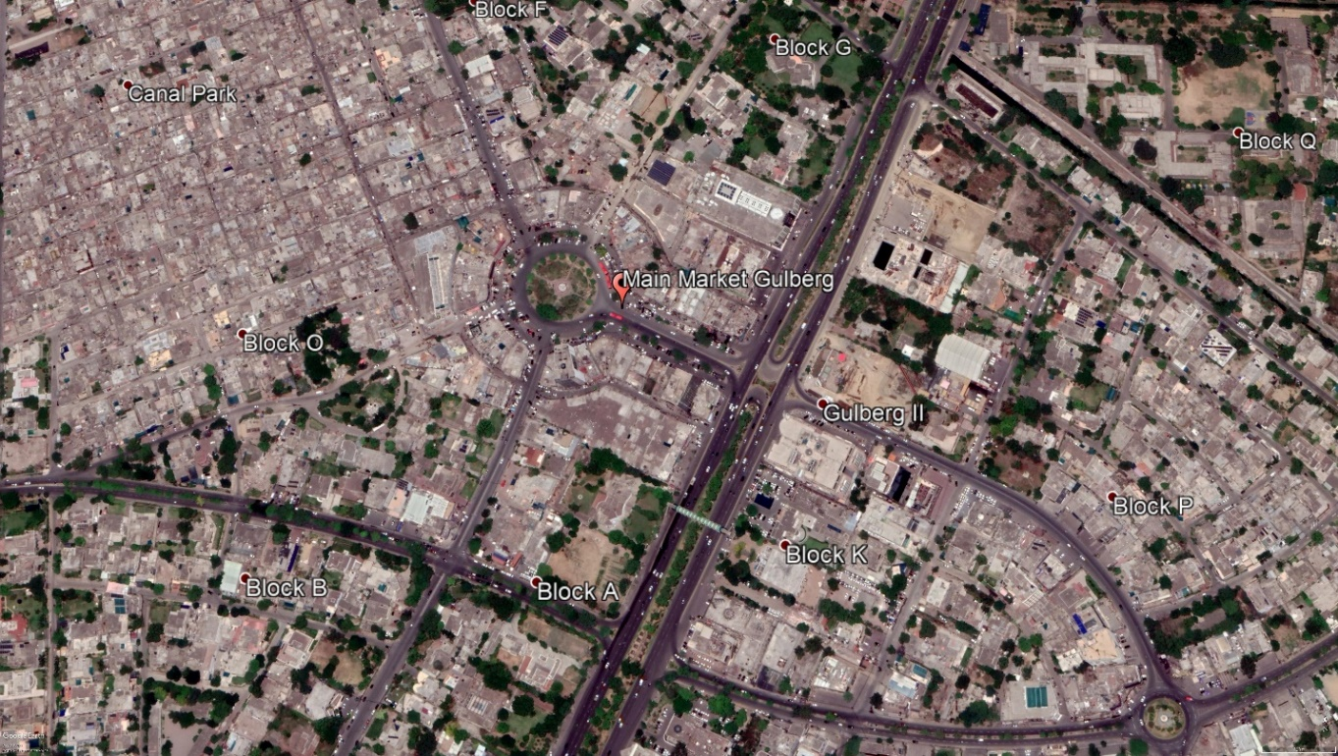
Figure 3: Main Market Gulberg Satellite Imagery

Below is the Satellite Imagery of Kareem Market A.I.T.
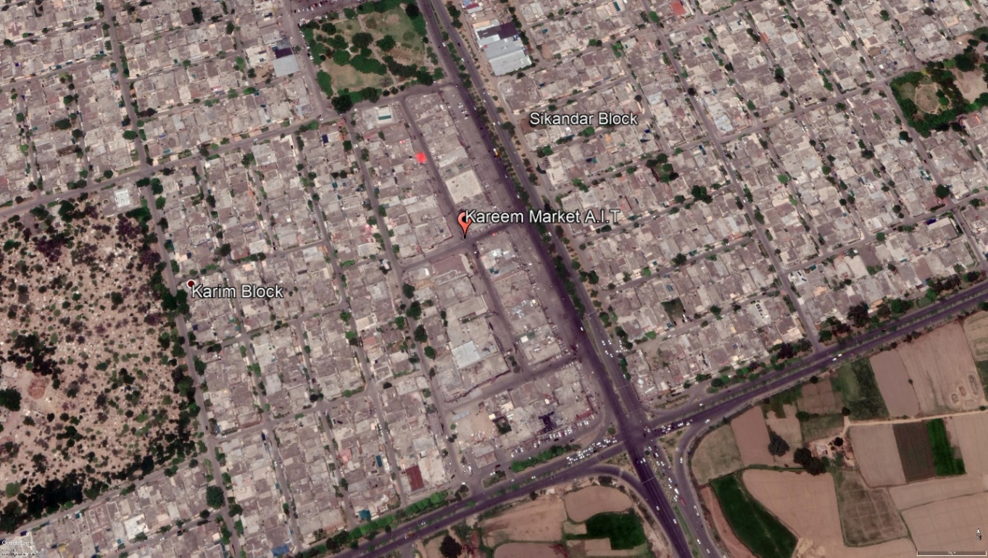
Figure 4: Kareem Market A.I.T Satellite Imagery

Area Description

G1 Market M.A.J.T
G1 market is considered to be one of the key areas for the residents from all over Johar Town and even closely situated societies such as Canal View, Tech society, Alpha Society, WAPDA Town, Judicial Colony approach this market for groceries, food and other commodities. This market is adjacent to Abdul Haq Road which leads the traffic coming from the Canal Bank Road inside Johar Town towards Khokhar Chowk. Abdul Haq Road is considerably a busy road because it caters to a large number of commuters traveling from the Canal Bank Road towards WAPDA Town, NFC, Punjab Society and Valancia.

Types of Shops
- Banks
- Book Shops
- Cosmetics Shops
- Garments Shops
- General Stores
- Restaurants

Main Market Gulberg
Gulberg is an administrative town in Lahore. It forms one of the 10 municipalities of Lahore City District. Gulberg is also the name of a union council (UC 97). It is also called land of Flowers. Beautiful parks are existed in Gulberg. It has developed significantly into a commercial area in Lahore. Main Market Gulberg is located on Main Boulevard Gulberg.

Types of Shops
- Banks
- Franchises
- Garment Shops
- Offices
- Restaurants
- Shopping Malls

Kareem Market A.I.T
Kareem Market is a local market area situated along Wahdat Road and Noor-ul-Amin Road in Karim Block of Allama Iqbal Town. The market contains a number of grocery, retail and garment shops as well as eateries and restaurants. There are also some petrol pumps and branches of the Banks, within the premises of the market. Karim Market houses many factory outlets. Many shops offer clothing for kids, men and women wear at discounted rates round the year. This market caters the need of brand conscious people and low income, salaried people alike.

Types of Shops
- Garments Shops
- Cosmetics Shops
- Shoe Shops

Methodology

Introduction
This chapter mainly portray the detailed procedure that has been adopted to collect and analyze the data. Methodology chapter is divided in four sections which include research strategy, sampling, data collection and analysis methods. The detail of each section is given in this chapter. The process adopted to carryout research is as follow:

Figure 5: Methodology

Research Strategy
This section is mainly divided in three parts i.e. factors identifications, assessment methods and comparison of vibrancy as these were the main objective of this study. The method adopted to achieve each of these objectives is as follow:

Figure 6: Research Strategy

Factor Identification
The first part is to identify factors through literature review which affect or contribute to vibrancy. After extensive review of literature, 18 factors were identified which are then used to measure vibrancy of study area. Those identified factors are discussed above in Literature review chapter.

Assessment Methods
Methods to assess vibrancy were also identified through literature which are discussed above in Chapter 2. A new method is used in this study for assessment of vibrancy which will be detailed discussed later in analysis section.

Vibrancy Comparison
After data collection and analysis vibrancy of G1 Market M.A.J.T, Main Market Gulberg and Kareem Market A.I.T is compared. The method used to compare vibrancy will be discussed later in analysis section.

Sampling
Sampling is a process used in data collection in which a certain number of observations is predetermined from a larger population. The methodology used to sample from a larger population may include random sampling or systematic sampling. For this study random sampling technique is used. Random sampling is a way of selecting a sample of observations from a population in order to make inferences about the population. Random sampling is also known as probability sampling. It involves picking a desired sample size and selecting observations from a population in such a way that each observation has an equal chance of selection until the desired sample size is achieved. The sample size considered for this study is 40 which is significant for the grounded theory research as suggest by (Thomson, 2011).
Sample Size
Area | No. Of Responses
G1 Market M.A.J.T | 40
Main Market Gulberg | 40
Kareem Market A.I.T | 40
Total | 120

Data Collection
Data is collected from field surveys with the help of google forms which is an online platform for making filling questionnaires. Data is collected on Likert scale; each factor is rated on a scale of 1 to 5 where 1 being the terrible and 5 being excellent (Annexure – A). Questionnaires are being filled by the users of study area i.e. costumers. The detail of data collected is in next chapters.

Analysis
After the collection of data, the next step was to analyze data. For this purpose, weighted average index is being calculated for each factor and data is standardized on a scale of 0 to 1 for making it easy for comparison. Weighted average index for each factor is calculated by multiplying number of responses with their average weighted score. Average weighted score for each category is as follow:
Table 1: Average Weighted Score
Average Weighted Score
Terrible | 0.2
Bad | 0.4
Tolerable | 0.6
Good | 0.8
Excellent | 1

The table below is used for analyzing data
Table 2: Data Analyzing Table
1 |  | 2 |  | 3 |  | 4 |  | 5
Terrible |  | Bad |  | Tolerable |  | Good |  | Excellent |  | Total
n | n x 0.2 | n | n x 0.4 | n | n x 0.6 | n | n x 0.8 | n | n x 1 | n | Net
Where,
n = number of responses
Net = $\frac{sum of weighted average index }{total number of responses}$
Net of weighted average index is calculated for each factor and each market as well. Net weighted average for each market is calculated by calculating sum of net weighted average index and dividing it by total number of factors.

Data Collection and Analysis
This chapter discuss the process of data collection and analysis in detail. Data is collected from field surveys by filling questionnaires with the help of google forms which is an online platform used for making and filling questionnaires. Data is collected on Likert scale; each factor is rated on a scale of 1 to 5 where 1 being the terrible and 5 being excellent. Questionnaires are being filled by the users of study area i.e. costumers. After the data collection the next step was to analyze the data. Analysis is the process of converting complex data into a simple form in order to gain a better understanding of it. For our study the analysis was done to convert data on a scale of 0 to 1 to make is more understandable and comparable.

Data Collected

Main Market Gulberg
The data collected form Main Market Gulberg is as follow:
Table 3: Main Market Gulberg Data Collection
Main Market Gulberg
Factors | Terrible | Bad | Tolerable | Good | Excellent | Total
Accessibility | 0 | 0 | 5 | 24 | 11 | 40
Permeability | 0 | 0 | 4 | 23 | 13 | 40
Diversity (both land use & building) | 0 | 0 | 9 | 17 | 14 | 40
Readability | 0 | 0 | 10 | 21 | 9 | 40
Flexibility | 0 | 0 | 7 | 17 | 16 | 40
Visual proportions | 0 | 0 | 9 | 16 | 15 | 40
Personalization | 0 | 4 | 15 | 15 | 6 | 40
Richness | 0 | 0 | 16 | 18 | 6 | 40
Safety & security | 0 | 7 | 8 | 15 | 10 | 40
Human scale | 0 | 12 | 11 | 15 | 2 | 40
Environment Attractiveness | 0 | 3 | 8 | 17 | 12 | 40
Meaningful places | 0 | 0 | 4 | 16 | 20 | 40
Human Presence | 0 | 5 | 12 | 13 | 10 | 40
Density or Land use jam | 0 | 5 | 7 | 20 | 8 | 40
Parking Availability | 0 | 2 | 3 | 24 | 11 | 40
Road Signals | 0 | 0 | 7 | 21 | 12 | 40
Sitting Areas | 0 | 0 | 0 | 26 | 14 | 40
Public Toilets | 2 | 8 | 16 | 9 | 5 | 40

G1 Market M.A.J.T
The data collected from G1 Market M.A.J.T is as follow:
Table 4: G1 Market M.A.J.T Data Collection
G1 Market M.A.J.T
Factors | Terrible | Bad | Tolerable | Good | Excellent | Total
Accessibility | 0 | 3 | 6 | 23 | 8 | 40
Permeability | 0 | 1 | 17 | 14 | 8 | 40
Diversity (both land use & building) | 0 | 0 | 21 | 10 | 9 | 40
Readability | 0 | 5 | 8 | 23 | 4 | 40
Flexibility | 0 | 0 | 20 | 12 | 8 | 40
Visual proportions | 0 | 0 | 13 | 20 | 7 | 40
Personalization | 0 | 3 | 15 | 19 | 3 | 40
Richness | 0 | 0 | 14 | 23 | 3 | 40
Safety & security | 3 | 9 | 11 | 13 | 4 | 40
Human scale | 0 | 4 | 12 | 21 | 3 | 40
Environment Attractiveness | 0 | 5 | 12 | 18 | 5 | 40
Meaningful places | 0 | 3 | 10 | 17 | 10 | 40
Human Presence | 0 | 3 | 7 | 22 | 8 | 40
Density or Land use jam | 0 | 4 | 11 | 19 | 6 | 40
Parking Availability | 0 | 3 | 12 | 14 | 11 | 40
Road Signals | 7 | 14 | 13 | 6 | 0 | 40
Sitting Areas | 11 | 14 | 12 | 3 | 0 | 40
Public Toilets | 10 | 15 | 14 | 1 | 0 | 40
Source: Field survey

Kareem Market A.I.T
The data collected from Kareem Market A.I.T is as follow:
Table 5: Kareem Market A.I.T Data Collection
Kareem Market A.I.T
Factors | Terrible | Bad | Tolerable | Good | Excellent | Total
Accessibility | 0 | 0 | 18 | 15 | 7 | 40
Permeability | 0 | 0 | 14 | 21 | 5 | 40
Diversity (both land use & building) | 0 | 1 | 10 | 29 | 0 | 40
Readability | 0 | 1 | 18 | 17 | 4 | 40
Flexibility | 0 | 4 | 12 | 21 | 3 | 40
Visual proportions | 4 | 12 | 15 | 9 | 0 | 40
Personalization | 0 | 2 | 9 | 26 | 3 | 40
Richness | 0 | 4 | 12 | 21 | 3 | 40
Safety & security | 1 | 1 | 25 | 13 | 0 | 40
Human scale | 0 | 0 | 9 | 15 | 16 | 40
Environment Attractiveness | 0 | 7 | 19 | 11 | 3 | 40
Meaningful places | 2 | 4 | 13 | 16 | 5 | 40
Human Presence | 0 | 2 | 5 | 23 | 10 | 40
Density or Land use jam | 0 | 4 | 13 | 18 | 5 | 40
Parking Availability | 2 | 3 | 22 | 11 | 2 | 40
Road Signals | 8 | 12 | 11 | 9 | 0 | 40
Sitting Areas | 13 | 11 | 12 | 3 | 1 | 40
Public Toilets | 0 | 5 | 15 | 14 | 6 | 40
Source: Field survey

Analysis
After the collection of data, the next step was to analyze data. For this purpose, weighted average index is being calculated for each factor and data is standardized on a scale of 0 to 1 as discussed above in methodology chapter. The table formed for each market after analysis are given below.

Main Market Gulberg
The analysis table of Main Market Gulberg is as follow:
Table 6: Main Market Gulberg Analysis
Main Market Gulberg
Factors | Terrible |  | Bad |  | Tolerable |  | Good |  | Excellent |  | Total
Factors | n | n x 0.2 | n | n x 0.4 | n | n x 0.6 | n | n x 0.8 | n | n x 1 | n | Net
Accessibility | 0 | 0.0 | 0 | 0.0 | 5 | 3.0 | 24 | 19.2 | 11 | 11.0 | 40 | 0.83
Permeability | 0 | 0.0 | 0 | 0.0 | 4 | 2.4 | 23 | 18.4 | 13 | 13.0 | 40 | 0.85
Diversity (both land use & building) | 0 | 0.0 | 0 | 0.0 | 9 | 5.4 | 17 | 13.6 | 14 | 14.0 | 40 | 0.83
Readability | 0 | 0.0 | 0 | 0.0 | 10 | 6.0 | 21 | 16.8 | 9 | 9.0 | 40 | 0.80
Flexibility | 0 | 0.0 | 0 | 0.0 | 7 | 4.2 | 17 | 13.6 | 16 | 16.0 | 40 | 0.85
Visual proportions | 0 | 0.0 | 0 | 0.0 | 9 | 5.4 | 16 | 12.8 | 15 | 15.0 | 40 | 0.83
Personalization | 0 | 0.0 | 4 | 1.6 | 15 | 9.0 | 15 | 12.0 | 6 | 6.0 | 40 | 0.72
Richness | 0 | 0.0 | 0 | 0.0 | 16 | 9.6 | 18 | 14.4 | 6 | 6.0 | 40 | 0.75
Safety & security | 0 | 0.0 | 7 | 2.8 | 8 | 4.8 | 15 | 12.0 | 10 | 10.0 | 40 | 0.74
Human scale | 0 | 0.0 | 12 | 4.8 | 11 | 6.6 | 15 | 12.0 | 2 | 2.0 | 40 | 0.64
Environment Attractiveness | 0 | 0.0 | 3 | 1.2 | 8 | 4.8 | 17 | 13.6 | 12 | 12.0 | 40 | 0.79
Meaningful places | 0 | 0.0 | 0 | 0.0 | 4 | 2.4 | 16 | 12.8 | 20 | 20.0 | 40 | 0.88
Human Presence | 0 | 0.0 | 5 | 2.0 | 12 | 7.2 | 13 | 10.4 | 10 | 10.0 | 40 | 0.74
Density or Land use jam | 0 | 0.0 | 5 | 2.0 | 7 | 4.2 | 20 | 16.0 | 8 | 8.0 | 40 | 0.76
Parking Availability | 0 | 0.0 | 2 | 0.8 | 3 | 1.8 | 24 | 19.2 | 11 | 11.0 | 40 | 0.82
Road Signals | 0 | 0.0 | 0 | 0.0 | 7 | 4.2 | 21 | 16.8 | 12 | 12.0 | 40 | 0.83
Sitting Areas | 0 | 0.0 | 0 | 0.0 | 0 | 0.0 | 26 | 20.8 | 14 | 14.0 | 40 | 0.87
Public Toilets | 2 | 0.4 | 8 | 3.2 | 16 | 9.6 | 9 | 7.2 | 5 | 5.0 | 40 | 0.64
Average Score |  |  |  |  |  |  |  |  |  |  |  | 0.78

Scale: 0.2 to 0.39 = very low/terrible, 0.4 to 0.59 = low/bad, 0.6 to 0.79 = high/good, above 0.8 = very high/excellent.
Where,
n = number of responses
Net = $\frac{sum of weighted average index }{total number of responses}$

G1 Market M.A.J.T
The analysis table of G1 Market M.A.J.T is as follow:
Table 7: G1 Market M.A.J.T Analysis
G1 Market M.A.J.T
Factors | Terrible |  | Bad |  | Tolerable |  | Good |  | Excellent |  | Total
Factors | n | n x 0.2 | n | n x 0.4 | n | n x 0.6 | n | n x 0.8 | n | n x 1 | n | Net
Accessibility | 0 | 0.0 | 3 | 1.2 | 6 | 3.6 | 23 | 18.4 | 8 | 8.0 | 40 | 0.78
Permeability | 0 | 0.0 | 1 | 0.4 | 17 | 10.2 | 14 | 11.2 | 8 | 8.0 | 40 | 0.75
Diversity (both land use & building) | 0 | 0.0 | 0 | 0.0 | 21 | 12.6 | 10 | 8.0 | 9 | 9.0 | 40 | 0.74
Readability | 0 | 0.0 | 5 | 2.0 | 8 | 4.8 | 23 | 18.4 | 4 | 4.0 | 40 | 0.73
Flexibility | 0 | 0.0 | 0 | 0.0 | 20 | 12.0 | 12 | 9.6 | 8 | 8.0 | 40 | 0.74
Visual proportions | 0 | 0.0 | 0 | 0.0 | 13 | 7.8 | 20 | 16.0 | 7 | 7.0 | 40 | 0.77
Personalization | 0 | 0.0 | 3 | 1.2 | 15 | 9.0 | 19 | 15.2 | 3 | 3.0 | 40 | 0.71
Richness | 0 | 0.0 | 0 | 0.0 | 14 | 8.4 | 23 | 18.4 | 3 | 3.0 | 40 | 0.75
Safety & security | 3 | 0.6 | 9 | 3.6 | 11 | 6.6 | 13 | 10.4 | 4 | 4.0 | 40 | 0.63
Human scale | 0 | 0.0 | 4 | 1.6 | 12 | 7.2 | 21 | 16.8 | 3 | 3.0 | 40 | 0.72
Environment Attractiveness | 0 | 0.0 | 5 | 2.0 | 12 | 7.2 | 18 | 14.4 | 5 | 5.0 | 40 | 0.72
Meaningful places | 0 | 0.0 | 3 | 1.2 | 10 | 6.0 | 17 | 13.6 | 10 | 10.0 | 40 | 0.77
Human Presence | 0 | 0.0 | 3 | 1.2 | 7 | 4.2 | 22 | 17.6 | 8 | 8.0 | 40 | 0.78
Density or Land use jam | 0 | 0.0 | 4 | 1.6 | 11 | 6.6 | 19 | 15.2 | 6 | 6.0 | 40 | 0.74
Parking Availability | 0 | 0.0 | 3 | 1.2 | 12 | 7.2 | 14 | 11.2 | 11 | 11.0 | 40 | 0.77
Road Signals | 7 | 1.4 | 14 | 5.6 | 13 | 7.8 | 6 | 4.8 | 0 | 0.0 | 40 | 0.49
Sitting Areas | 11 | 2.2 | 14 | 5.6 | 12 | 7.2 | 3 | 2.4 | 0 | 0.0 | 40 | 0.44
Public Toilets | 10 | 2.0 | 15 | 6.0 | 14 | 8.4 | 1 | 0.8 | 0 | 0.0 | 40 | 0.43
Average Score |  |  |  |  |  |  |  |  |  |  |  | 0.69

Scale: 0.2 to 0.39 = very low/terrible, 0.4 to 0.59 = low/bad, 0.6 to 0.79 = high/good, above 0.8 = very high/excellent.
Where,
n = number of responses
Net = $\frac{sum of weighted average index }{total number of responses}$

Kareem Market A.I.T
The analysis table of Kareem Market A.I.T is as follow:
Table 8: Kareem Market A.I.T Analysis
Kareem Market A.I.T
Factors | Terrible |  | Bad |  | Tolerable |  | Good |  | Excellent |  | Total
Factors | n | n x 0.2 | n | n x 0.4 | n | n x 0.6 | n | n x 0.8 | n | n x 1 | n | Net
Accessibility | 0 | 0.0 | 0 | 0.0 | 18 | 10.8 | 15 | 12.0 | 7 | 7.0 | 40 | 0.75
Permeability | 0 | 0.0 | 0 | 0.0 | 14 | 8.4 | 21 | 16.8 | 5 | 5.0 | 40 | 0.76
Diversity (both land use & building) | 0 | 0.0 | 1 | 0.4 | 10 | 6.0 | 29 | 23.2 | 0 | 0.0 | 40 | 0.74
Readability | 0 | 0.0 | 1 | 0.4 | 18 | 10.8 | 17 | 13.6 | 4 | 4.0 | 40 | 0.72
Flexibility | 0 | 0.0 | 4 | 1.6 | 12 | 7.2 | 21 | 16.8 | 3 | 3.0 | 40 | 0.72
Visual proportions | 4 | 0.8 | 12 | 4.8 | 15 | 9.0 | 9 | 7.2 | 0 | 0.0 | 40 | 0.55
Personalization | 0 | 0.0 | 2 | 0.8 | 9 | 5.4 | 26 | 20.8 | 3 | 3.0 | 40 | 0.75
Richness | 0 | 0.0 | 4 | 1.6 | 12 | 7.2 | 21 | 16.8 | 3 | 3.0 | 40 | 0.72
Safety & security | 1 | 0.2 | 1 | 0.4 | 25 | 15.0 | 13 | 10.4 | 0 | 0.0 | 40 | 0.65
Human scale | 0 | 0.0 | 0 | 0.0 | 9 | 5.4 | 15 | 12.0 | 16 | 16.0 | 40 | 0.84
Environment Attractiveness | 0 | 0.0 | 7 | 2.8 | 19 | 11.4 | 11 | 8.8 | 3 | 3.0 | 40 | 0.65
Meaningful places | 2 | 0.4 | 4 | 1.6 | 13 | 7.8 | 16 | 12.8 | 5 | 5.0 | 40 | 0.69
Human Presence | 0 | 0.0 | 2 | 0.8 | 5 | 3.0 | 23 | 18.4 | 10 | 10.0 | 40 | 0.81
Density or Land use jam | 0 | 0.0 | 4 | 1.6 | 13 | 7.8 | 18 | 14.4 | 5 | 5.0 | 40 | 0.72
Parking Availability | 2 | 0.4 | 3 | 1.2 | 22 | 13.2 | 11 | 8.8 | 2 | 2.0 | 40 | 0.64
Road Signals | 8 | 1.6 | 12 | 4.8 | 11 | 6.6 | 9 | 7.2 | 0 | 0.0 | 40 | 0.51
Sitting Areas | 13 | 2.6 | 11 | 4.4 | 12 | 7.2 | 3 | 2.4 | 1 | 1.0 | 40 | 0.44
Public Toilets | 0 | 0.0 | 5 | 2.0 | 15 | 9.0 | 14 | 11.2 | 6 | 6.0 | 40 | 0.71
Average Score |  |  |  |  |  |  |  |  |  |  |  | 0.68

Scale: 0.2 to 0.39 = very low/terrible, 0.4 to 0.59 = low/bad, 0.6 to 0.79 = high/good, above 0.8 = very high/excellent.
Where,
n = number of responses
Net = $\frac{sum of weighted average index }{total number of responses}$

Findings
This chapter discuss the results and findings found after analyzing the data gathered from field.

Main Market Gulberg
Results have shown that Main Market Gulberg has good level of vibrancy. Ten factors are rated as excellent i.e. accessibility, permeability, diversity (both land use & building), readability, flexibility, visual proportions, meaningful places, parking availability, road signals, sitting areas. Where other eight factors are rated as good i.e. personalization, richness, safety & security, human scale, environment attractiveness, human presence, density or land use jam and public toilets. Main Market Gulberg has an average score of good vibrancy.
Table 9: Main Market Gulberg Score
Main Market Gulberg
Factors | Terrible | Bad | Good | Excellent
Accessibility
Permeability
Diversity (both land use & building)
Readability
Flexibility
Visual proportions
Personalization
Richness
Safety & security
Human scale
Environment Attractiveness
Meaningful places
Human Presence
Density or Land use jam
Parking Availability
Road Signals
Sitting Areas
Public Toilets
Average Score

Scale: 0.2 to 0.39 = very low/terrible, 0.4 to 0.59 = low/bad, 0.6 to 0.79 = high/good, above 0.8 = very high/excellent.

G1 Market M.A.J.T
Results have shown that G1 Market M.A.J.T has good level of vibrancy. Fifteen factors are rated as good i.e. accessibility, permeability, diversity (both land use & building), readability, flexibility, visual proportions, personalization, richness, safety & security, human scale, environment attractiveness, meaningful places, human presence, density or land use jam and parking availability. Where three factors are rated as bad i.e. road signals, sitting areas, public toilets. G1 Market M.A.J.T has an average score of good vibrancy.

Table 10: G1 Market M.A.J.T Score
G1 Market M.A.J.T
Factors | Terrible | Bad | Good | Excellent
Accessibility
Permeability
Diversity (both land use & building)
Readability
Flexibility
Visual proportions
Personalization
Richness
Safety & security
Human scale
Environment Attractiveness
Meaningful places
Human Presence
Density or Land use jam
Parking Availability
Road Signals
Sitting Areas
Public Toilets
Average Score

Scale: 0.2 to 0.39 = very low/terrible, 0.4 to 0.59 = low/bad, 0.6 to 0.79 = high/good, above 0.8 = very high/excellent.

Kareem Market A.I.T
Results have shown that Kareem Market A.I.T has good level of vibrancy. Two factors are rated as excellent i.e. human scale, human presence. Where thirteen factors are rated as good i.e. accessibility, permeability, diversity (both land use & building), readability, flexibility, personalization, richness, safety & security, environment attractiveness, meaningful places, density or land use jam, parking availability, public toilets. Only three factors are rated as bad i.e. visual proportions (that can be because of open electric wires that are in Kareem Market), road signals, sitting areas. Kareem Market A.I.T has good score of vibrancy.
Table 11: Kareem Market A.I.T Score
Kareem Market A.I.T
Factors | Terrible | Bad | Good | Excellent
Accessibility
Permeability
Diversity (both land use & building)
Readability
Flexibility
Visual proportions
Personalization
Richness
Safety & security
Human scale
Environment Attractiveness
Meaningful places
Human Presence
Density or Land use jam
Parking Availability
Road Signals
Sitting Areas
Public Toilets
Average Score

Scale: 0.2 to 0.39 = very low/terrible, 0.4 to 0.59 = low/bad, 0.6 to 0.79 = high/good, above 0.8 = very high/excellent.

Comparison:
This section shows the comparison of all factors (accessibility, permeability, diversity (both land use & building), readability, flexibility, visual proportions, personalization, richness, safety & security, human scale, environment attractiveness, meaningful places, human presence, density or land use jam) between Main Market Gulberg, G1 Market M.A.J.T and Kareem Market A.I.T

Chart 1: Accessibility Comparison
Accessibility is the quality of being able to be reach or enter the area. Out of all three markets Main Market Gulberg is most accessible where Kareem Market A.I.T has comparatively least accessibility but it is still in good category.

Chart 2: Permeability Comparison
The state or quality of being permeable is known as permeability. Out of all three markets Main Market Gulberg is most permeable where G1 Market M.A.J.T has comparatively least permeability but it is still in good category.

Chart 3: Diversity Comparison
Diversity in both, land use and varied kind of buildings with different forms is considered, and is absorbs different people in different times with different economic situations. In other words, it increases the range of choices. Out of all three markets Main Market Gulberg has the highest level of land use and building diversity where G1 Market M.A.J.T has comparatively least land use and building diversity but it is still in good category.

Chart 4: Readability Comparison
Readability is the quality that makes an understanding of environment. Out of all three markets Main Market Gulberg has the highest level of readability where G1 Market M.A.J.T and Kareem Market A.I.T has an equal level of readability. All three markets are in good category.

Chart 5: Flexibility Comparison
Flexibility mean powerful combining of places that can be used for different purposes give more range of choices, in comparison with places that are designed just for one use. Out of all three markets Main Market Gulberg has the highest level of flexibility where Kareem Market A.I.T has comparatively lowest level of flexibility. All three markets are in good category.

Chart 6: Visual Proportions Comparison
If the area is clear for people in form and function, have diversity and flexibility, it can be said that visual proportions is observed. Level of visual proportion is highest in Main Market Gulberg and lowest in Kareem Market A.I.T. Main Market Gulberg has excellent visual proportions, G1 Market M.A.J.T has good visual proportion and Kareem Market A.I.T has low level visual proportions.

Chart 7: Personalization Comparison
This is the only way that most people find an environment arising from their personal concerns, values, and signs. If people use a place regularly and in long term, they will have a sense of belonging to it. Out of all three markets Kareem Market A.I.T has the highest level of readability where Main Market Gulberg and G1 Market M.A.J.T has an equal level of readability. All three markets are in good category.

Chart 8: Richness Comparison
Richness is a quality which makes varied sensory experiences and enhances pleasure. It includes all the senses, but because of the impact that sight has in understanding of information, it is somewhat more important than the others. In study area all three markets are approximately equal in richness and all of these are in good category w.r.t richness.

Chart 9: Safety & Security Comparison
The state of being free from harm or injury or the surety that nothing would cause harm in a particular situation. In study area Main Market Gulberg is comparatively more safe and secure where G1 Market M.A.J.T is comparatively less safe and secure. All three markets are in good category.

Chart 10: Human Scale Comparison
Human scale means the size, texture and articulation of physical elements that match the size and proportions of human sight and speed. In study area, Kareem Market A.I.T has very high-level human scale where Main Market Gulberg has comparatively least human scale level. Kareem Market A.I.T has excellent human scale, Main Market Gulberg and G1 Market M.A.J.T has good level of human scale.

Chart 11: Environment Attractiveness Comparison
Environment can be considered as attractive if it is appealing, engaging, interesting for people. Environment of Main Market Gulberg is more attractive to people and environment of Kareem Market A.I.T is comparatively less attractive to people but it is still in good category environment attractiveness of G1 Market M.A.J.T is between environment attractiveness of Main Market Gulberg and Kareem Market A.I.T. Environment attractiveness of all three markets is in good category.

Chart 12: Meaningful Places Comparison
Meaningful places mean any place that meets the needs of people. In study area there are comparatively more meaningful places in Main Market Gulberg and least in Kareem Market A.I.T. Main Market Gulberg is in excellent category where G1 Market M.A.J.T and Kareem Market A.I.T are in good category.

Chart 13: Human Presence Comparison
The state of the immediate proximity of a person is known as human presence. Human presence is comparatively highest in Kareem Market A.I.T and lowest in Main Market Gulberg. Kareem Market A.I.T has excellent human presence where Main Market Gulberg and G1 Market has good human presence.

Chart 14: Density or Land Use Jam Comparison
Land values are relatively high in urban centers, it is important to maximize the occupancy level and this results in high jam and density. Density or land use jam is high in all three markets and approximately equal in all three markets.

Chart 15: Parking Availability Comparison
Parking availability is high in Main Market Gulberg due to availability of parking in each mall and shops where parking availability is least in Kareem Market A.I.T due to availability of parking only on main road and parking availability is moderate in G1 Market M.A.J.T.

Chart 16: Road Signals Comparison
Road Signals are signaling devices positioned at road intersections, pedestrian crossings, and other locations to control flows of traffic. Road signals availability and working is high in Main Market Gulberg where road signals availability is same in G1 Market M.A.J.T and Kareem Market A.I.T.

Chart 17: Sitting Areas Comparison
Number of sitting areas are high in Main Market Gulberg due to presence of benches and chairs in market and shops but sitting areas are very less in G1 Market M.A.J.T and Kareem Market A.I.T because of availability of chairs only in few shops.

Chart 18: Public Toilets Comparison
Public toilets availability is high in Kareem Market A.I.T because it has public toilets for general public. Availability of public toilets is comparatively less in Main Market Gulberg because of availability of toilets is only in some buildings for public use and it is least in G1 Market M.A.J.T because toilets are available only in few buildings for public use.

Chart 19: Average Score Comparison
Average score for each market is calculated by calculating sum of net weighted average index and dividing it by total number of factors (18). All three markets have good vibrancy score. Comparatively Main Market Gulberg is more vibrant than G1 Market M.A.J.T and Kareem Market A.I.T. Both G1 Market M.A.J.T and Kareem Market A.I.T are equally vibrant.

Conclusion & Recommendations
Designing of urban spaces and markets have a direct impact on people's behavior and choices. The markets we admire as destinations offers some important clues about the things that make them attractive. Importantly, they are typically inhabited; there is life in the urban market and levels of amenity and quality that attract consumer. Equally they are walkable, with good connectivity between key places, and conveying the primacy of the pedestrian over the car. They also exhibit multiplicity of use, whereby at different times of the day the life of the street or square changes attracting different visitor groups for work and leisure. Lastly, they are adaptable, with high quality design.
In past few years Gulberg has developed significantly into a commercial area in Lahore. Results from this study have shown that Main Market Gulberg has good level of vibrancy. Factors including accessibility, permeability, diversity (both land use & building), readability, flexibility, visual proportions, meaningful places, parking availability, road signals, sitting areas are rated as excellent. Where personalization, richness, safety & security, human scale, environment attractiveness, human presence, density or land use jam and public toilets are rated as good.
G1 market is considered to be one of the key areas for the residents from all over Johar Town and even closely situated societies. Results from this study have shown that G1 Market M.A.J.T has good level of vibrancy. Fifteen factors are rated as good i.e. accessibility, permeability, diversity (both land use & building), readability, flexibility, visual proportions, personalization, richness, safety & security, human scale, environment attractiveness, meaningful places, human presence, density or land use jam and parking availability. Where three factors are rated as bad i.e. road signals, sitting areas, public toilets. G1 Market M.A.J.T has an average score of good vibrancy.
Results from this study have shown that Kareem Market A.I.T has good level of vibrancy. Two factors are rated as excellent i.e. human scale, human presence. Where thirteen factors are rated as good i.e. accessibility, permeability, diversity (both land use & building), readability, flexibility, personalization, richness, safety & security, environment attractiveness, meaningful places, density or land use jam, parking availability, public toilets. Only three factors are rated as bad i.e. visual proportions (that can be because of open electric wires that are in Kareem Market), road signals, sitting areas. Kareem Market A.I.T has good score of vibrancy.
Here are some recommendations for enhancing the vibrancy of these three markets. The administration of Main Market Gulberg, G1 Market M.A.J.T and Kareem Market A.I.T must continue to evolve and develop through interventions that assert the identity of these markets and which contribute to the creation of a vibrant, diverse, culturally rich, and economically strong markets with a tangible and distinctive sense of place. The vibrancy of these markets can be enhanced through enhancing the factors that contribute to vibrancy or by enhancing factors which have deficiency in each market. We encourage further studies to find methods for vibrancy enhancement and to give proposals to enhance vibrancy of these markets.

References:
Ahmed, H. E. I. S., & Ph, D. (2017). CAR PARKING PROBLEM IN URBAN AREAS , CAUSES AND SOLUTIONS.
Badenhorst, W. (2016). Revitalising city centres Policy context and trends relevant for partner cities in URBACT’s City Centre Doctor Action Planning Network, (February).
Fleming, K. G. (2016). Table of, 15(d), 1–221. https://doi.org/10.1016/B978-0-12-164491-8.50013-0
Goliˇ, B., & Ward, C. (2010). Landscape and Urban Planning Emerging relationships between design and use of urban park spaces, 94, 38–53. https://doi.org/10.1016/j.landurbplan.2009.07.016
Hashempour, R. (2017). Urban Regeneration ; Creating a Vibrant Urban Space by Emphasizing on the Cultural-Artistic Activities Redevelopment : Evidence from Southern Lalezar Street in Tehran, 90–104.
Holian, M. J., & Kahn, M. E. (2012). The Impact of Center City Economic and Cultural Vibrancy on Greenhouse Gas Emissions from Transportation. Retrieved from http://transweb.sjsu.edu
Jacobs, A. J. (2001). Planning for a vibrant Central City: the Case of Nayoya, Japan (Vol. 12).
Kitchin, R., Law, R., Kitchin, R., & Law, R. (2001). Public Toilets. https://doi.org/10.1080/00420980124395
Kramer, M., Bertaina, S., Dalbey, M., French, L., Susman, M., Theilacker, K., … Walsh, P. (2015). How Small Towns and Cities Can Use Local Assets To Rebuild Their Economies: Lessons From Successful Places, (May). https://doi.org/10.1017/S1053837200005022
Moghadam, M. S., Mousavi, N., Solgi, G., & Azimi, S. (2014). Recreating a Vibrant City Center in Response Urban Environments by Using AHP Model (Case Study: Qazvin City Historical Context in Iran). Sociology and Anthropology, 2(2), 41–45. https://doi.org/10.13189/sa.2014.020203
O, R. V. (2015). A Proposed Method About the Design of Road Signs `, 56–75. https://doi.org/10.1080/19439962.2014.902413
Placemaking, C., & Growth, C. (2012). Building Vibrancy : https://doi.org/10.1007/s00441-002-0644-6
Rahman, A., Alshabeeb, R., Al-amoush, H. R., & Al-adamat, R. (2018). Theoretical and Empirical Researches in Urban Management CITIES USING THE SLEUTH MODEL : A CASE, (February).
Regenerating Aberdeen: a vision for a thriving and vibrant city centre 1. (2017), 1–26.
Thomson, S. B. (2011). Sample Size and Grounded Theory Research. The Journal of Administration & Governance, 5(1), 45–52. Retrieved from http://www.joaag.com/uploads/5_1

Annexure – A

City Vibrancy

- Market Name
Mark only one oval.

Johar Town G1 Market Kareem Block Market Gulberg Main Market

- Accessibility
Mark only one oval.

Excellent Good Tolerable Bad Terrible

- Permeability
Mark only one oval.

Excellent Good Tolerable Bad Terrible

- Diversity (both land use & Building
Mark only one oval.

Excellent Good Tolerable Bad Terrible

- Readability
Mark only one oval.

Excellent Good Tolerable Bad Terrible

- Flexibility/ Robustness
Mark only one oval.

Excellent Good Tolerable Bad Terrible

- Visual Proportions
Mark only one oval.

Excellent Good Tolerable Bad Terrible

- Personalization
Mark only one oval.

Excellent Good Tolerable Bad Terrible

- Richness
Mark only one oval.

Excellent Good Tolerable Bad Terrible

- Safety & Security
Mark only one oval.

Excellent Good Tolerable Bad Terrible

- Human Scale
Mark only one oval.

Excellent Good Tolerable Bad Terrible

- Environment Attractiveness
Mark only one oval.

Excellent Good Tolerable Bad Terrible

- Meaningful Places
Mark only one oval.

Excellent Good Tolerable Bad Terrible

- Human Presence
Mark only one oval.

Excellent Good Tolerable Bad Terrible

- Density or Land Use Jam
Mark only one oval.

Excellent Good Tolerable Bad Terrible

- Parking Availability
Mark only one oval.

Excellent Good Tolerable Bad Terrible

- Road Signals
Mark only one oval.

Excellent Good Tolerable Bad Terrible

- Sitting Areas
Mark only one oval.

Excellent Good Tolerable Bad Terrible

- Public Toilets
Mark only one oval.

Excellent Good Tolerable Bad Terrible

