Use of TikTok, Social Comparison and Mental Health in Adults



BY:
NAIMA KIRAN
S2018142004
RAUHA SHABBIR
S2018142001

SUPERVISOR:
Muhammad Faran

DEPARTMENT OF APPLIED PSYCHOLOGY
UNIVERSITY OF MANGMENT AND TECHNOLOGY
LAHORE

Use of TikTok, SocialComparison and Mental Health in Adults

By

Naima Kiran
ID No. S2018142004
Session 2018-2020
RauhaShabbir
ID No. S2018142001
Session 2018-2020

Supervisor
Muhammad Faran
A thesis is submitted in partial fulfillment of the requirement for the degree of MSc in Applied Psychology
School of Professional Psychology, University of Management and Technology, Lahore

ACKNOWLEDGMENTS
All praise to Almighty Allah, the most merciful and compassionate, who enabled us to complete this thesis.
With deep gratitude we would like to thank our supervisor who has been a source of inspiration, “Muhammad Faran Ali” for helping us with his excellent research skills and guidance in completing this thesis, encouraging and supporting us. For being most supportive and caring his support enabled us to overcome setbacks and stay focused and having faith in us that we would complete this work comprehensively.
We would like to thank all our teachers who have been a source of encouragement and guidance throughout our academic years.
Most importantly, none of this would have been possible without the love and patience of our families; their love, concern, support and strength during the years of uncertainties, challenges and sacrifices needed to complete this thesis. We would like to thank our friends who helped us a lot and encouraged us throughout the time.
Next I am especially thankful to the authors who gave us permission for using their scales and for all the participants who cooperated with us and participated in our studies whole heartedly. A special thanks to this university and its entire staff as it provided us opportunity to study through motivation.
Naima Kiran&RauhaShabbir

Completion Certificate
Certificate that the research work contained in this thesis title “Use of TikTok, Social Comparison and Mental Health in Adults” has been carried out and completed by Ms. Naima Kiran and Ms. RauhaShabbir, Student No: S2018142004 & S2018142001; Student of M.Sc. Applied Psychology, session 2018 – 2020, under my supervision. This study is an independent research work and carried out under given instructions and consideration.

Dated:
Muhammad Faran  (Supervisor) | External Examiner
(Head of Department) | Prof. Dr. SadiaSaleem  (Dean School of Professional Psychology)

Declaration
We, Naima Kiran and RauhaShabbir, solemnly declare that the work submitted in this thesis is our own, and has not been presented to any other institution or university for the degree. Neither this work has been plagiarized. It is an original work.
This work has been completed at the School of Professional Psychology, University of Management and Technology, Lahore.

Naima Kiran

Rauha Shabbir

TABLE OF CONTENTS
ACKNOWLEDGMENTS ii
Completion Certificate iii
Declaration iv
List of Table and Figures vii
List of Appendices viii
List of Abbreviations and Symbols ix
ABSTRACT x
Chapter 1 1
Introduction 1
1.1 Short Music Video 2
1.1.1 TikTok 3
1.1.2 Theoretical Framework 4
1.2 Social Comparison 5
1.2.1 Theoretical Framework 5
1.3 Mental Health 6
1.3.1 Theoretical Framework 7
Chapter 2 9
Literature Review 9
2.1 Use of TikTok and Social Comparison 9
2.1.1 Use of Tiktok and Mental Health 10
2.1.2 TikTok Use, Social Comparison and Mental Health 12
2.2 Indigenous Researches 13
2.3 Rational 13
2.4 Objectives 14
2.5 Hypothesis 14
Chapter 3 15
Method 15
3.1 Research Design 15
3.2 Sample and Sampling Technique 15
3.2.1 Inclusion Criteria 15
3.2.2 Exclusion Criteria 16
3.3 Demographic Questions 16
3.4 Assessment Measures 16
3.5 Procedure 17
3.6 Ethical Consideration 18
3.7 Proposed Statistical Analysis 18
Chapter 4 19
Results 19
Descriptive Statistics and Reliability Analysis 20
Table 4.1 20
Pearson Product Moment Correlation 21
Table 4.2 21
Table 4.3 23
Mediation Analysis 24
Table 4.4 25
Table 4.5 26
Figure 1 27
Summary of Findings 27
Chapter 5 29
Discussion 29
5.1 Relationship 29
5.2 Descriptive Statistics 31
5.3 Direct effects for use of tiktok, social comparison and mental health 32
5.4 Indirect effects of use of tiktok, social comparison and mental health 33
5.5 Conclusion 34
5.6 Recommendations and limitations 35
REFERENCES 36
APPENDICES 47
APPENDIX - A 48
Permission by the Author 48
APPENDIX - B 52
Assessment Protocol 52
APPENDIX – C 61
Plagiarism Report 61

List of Table and Figures

Figure 1  Mediating role of Social Comparison between Use of TikTok and Mental Health | 27
Table 4.1  Descriptive statistics and reliability analysis | 20
Table 4.2  Correlation analysis | 21
Table 4.3  Correlation analysis of demographic variables | 23
Table 4.4  Direct effect of variables | 25
Table 4.5  Indirect effect of variables | 26

List of Appendices
Title |  | Page No.
Appendices |  | 47 – 61
Appendix-A | Permission by the Author | 48
Appendix-B | Assessment Protocol  Informed Consent  Demographic Information Sheet  TikTok Intensity Scale (TIS)  Social Comparison Orientation Scale (INCOM)  Mental Health Inventory (MHI-38) | 52
Appendix-C | Plagiarism Report | 61

List of Abbreviations and Symbols
M | Arithmetic Mean
SD | Standard Deviation
N | Sample size
α | Reliability Coefficient
β | Un-standardized coefficient
SE | Standard Error
p | Significance
d | Cohen’s measure of sample effect size
k | No. of items
% | Percentage
n | Sub-sample
R² | Coefficient of determination
f | Frequency
TIS | Tiktok Intensity Scales
INCOM | Social Comparison Orientation Scale
MHI-38 | Mental Health Inventory – 38 items

ABSTRACT
The aim of this research was to investigate the relationship between use of TikTok, Social comparison and mental health among adults. Since in Pakistan, there was no research on this concept so it was important to explore this concept. This research also investigated the new concept of TikTok which was never studied before in psychological terms. Correlational research design was used to study the relationships between variables. Convenient sampling technique was used to gather data and our sample consist of 170 participants (male: 85, female: 85). Three assessment measures were used to measure use of TikTok, social comparison and mental health, scales are used in questionnaire forms. Sample was taken from university students who also users of TikTok app. Data was analyzed into three steps, one was Pearson product moment correlation for assessing relationship among variables, second was regression for predicting variables and third was mediation analysis for assessing mediation of social comparison. Findings accept all the hypothesis of this study and states that more time spent on TikTok increase social comparison and its effect on mental health both in positive and negative way. But use of TikTok is not directly associated to psychological distress (sub-type of mental health). Women tend to be had positive effect on their psychological well-being as compared to males. The main significance of this research was to study this new concept of TikTok in relation with Psychological concepts to discover this term and there were few researches on the use of social media app and its positive effect on mental health even doing social comparison.
Keywords: Social Media, Tiktok, Mental Health, Social Comparison

Chapter 1

Introduction
The aim of this research is to explore the connection and effects among TikTok users between use of TikTok, social comparison and mental health.Video Editing is a new film-related aspect that influence new media. Video experience in social networking is greatly customized by potential of creating and editing videos. In the world of new minute based short form video apps for example, TikTok (before known as Musical.ly) has unusual editing qualities, mostly lip synching, filters, and speed control. Therefore individualization and innovation leads the video sharing to a new level (Khattab, 2019).
Modern telecommunications allows different types of expertise to learn and share from online communities (Dron& Anderson, 2014). Social media is family of web-based applications for the innovations and swapping of user generated content (UGC) (Kaplan &Haenlein, 2010). It is also describes as joint network applications and technologies which allow and motivate involvement, communication, bluntness, innovation and socialization between a group of users (Bowley, 2009). Social relationships are major aspects to convey expertise between single persons (Polanyi, 1967), social media can ease producing and sharing expertise between individuals with same objective and point of view (Wahlroos, 2010; Panahi et al., 2012), Producing different perspectives and up to date schemes in online circle (Eteläpelto& Lahti, 2008).
Short videos platforms set off an admired structure of social media applications between generations Y for sharing amusing contents (Patrick, 2018). Nearly all short video platforms are cell phone applications, where users can produce, check, share and look at short videos. Short videos have an equalize short time covering from few seconds to some minutes and the comparative benefit of content production, fast content transfer, and importance on friendliness are the visible features of short video platforms (Zhao & Wang, 2015). Apart from short video specified plans, extra social media plans also combine small videos as UGC communicating forum structure. Instagram introduced its “Instagram story” aspect, in which you can share personal photos and videos for only 24 hours (Instagram, 2019). Timing of each story restricted to 15 seconds. From the overall amount of 1 billion users this aspect is becoming achievement in 400 million energetic users (Ahmad, 2018).

1.1 Short Music Video
Small duration video ranges in seconds, mostly depending on smart phones end to finish fast capturing and checking upload, that could be used by social media. Small tune video is about the app which establish on the theme of using tunes and the content is upright to that tune. Meng (2016) outlines the major types of content used in many short video apps. He told us that there are three kinds of content (education, entertainment and promotion). According to him education is the first type and so educate the users to boost, cook and tell speech in different terms. Entertainment is the second kind in this some humorous and skit video is used to entertain users. Third type is promotion in which one user promote makeup or something else to viewers and inspire them to buy that product. Simply it is a type of online sales job. Main content of the small video application is developed from these three categories. Previous researches shows that smart phone videos give accommodation of proper camera perspectives such as an individual, may encourage leading assumptions (Maredia et al., 2018). Besides conventional social media, general healthcare section are now taking steps in purchasing short video making app for disintegrate data associated with health to communities, anticipating modification in behavior of people well-being (Zhu, Xu, Zhang, Chen, & Evans, 2020). Users of these apps favor small 60 seconds or less than that content in animated and recorded way (Zhu et al., 2020).

1.1.1TikTok
Musical.ly builds the model of the recognition of TikTok in advance of an affiliation. Alex Zhu and Luyu Yang establish this app in 2014 (Baig, 2018), In 2017 some Chinese company known as Byte Dance acquired this app and combine a homogeneous platform in 2018 and the name of that platform was TikTok (Dave 2018). It became number one small video sharing app globally (Jing 2018). It is a short smartphone app in which users are presenting lip-synching or extra innovative videos go along with themes. At present almost 1 billion users are using it and also accessible in 150 various nations (Doyle 2020).
TikTok is a sound expressive tiny video community end-user program, and it is devoted to youth. Users can select sound tracks as scenario music from this user end interface, capturing a small duration video and upload them to set up their content and be known as uploaders. Users also watch the other users videos and plus gives them likes or share their videos. It is necessary for users to sign up or create an account on this app. TikTok permit users to follow each other, encourage other users, give likes on their videos and share their videos on other platforms. Documented videos continue from 15-60 seconds in which users can dub their videos on famous sound tracks or can duet it with other users. Moreover it gives many playful challenges some of them are hashtag challenge in which users create short video on certain hashtags. Tiktok also gives three major types of content variety (educational, entertainment and promotion). It is unique in its aspects and make it contrasting from various types of homogeneous applications. This pleasure-oriented platform flourish in the mesmerizing encounter and incentive procedure. Educational videos are becoming popular on this platform and it is also unlocked chances for a up to date collective hold and constructive education encounter for users. Variety of filters and effects are also used in this app. Tiktok is basically gives an opportunity for making and sharing content that is created by users. User-generated content (UGC) gives chance to individuals so that they can generate content, transfer and build their own status. Few short videos become viral from their content and other few goes viral when people or users share them on other networks. People think that when their video become viral then they are getting online success. Fan base also takes part in this app. Therefore by using UGM (user generated media) it includes two major activities, generating the content and transmitting the content online.

1.1.2 Theoretical Framework
Self-presentation is a way through which an individual try to transfer several knowledge with respect to one’s own identity and representation of oneself to public. It indicates a kind of stimulation in human behavior. These type of stimulations are strongly arranged in individuals but they rely on environmental component to generate them. These type of stimulations are activated in presence of other human beings. There are two types of self-presentation motivations, one is pleasing the viewers in which an individual want to meet the expectancy and choices of viewers. The second one is self-construction in which an individual match personal presentation of his or her own imaginary self. In other words in self-presentation people introduce oneself to generate a specific and beneficial idea on the viewers, in preparation of effect or control the spectators to give advantage to the self-presenter. Many times this is fulfilled by making an impression on spectators as nice and skilled but sometimes for some benefits people seem to appear savage or dependent. In relation to TikTok usage this theory perfectly describes the nature of that variable, in this app people want to get more and more likes and they also want to become famous (TikTok star) so for that they become conscious while presenting themselves to the general public. Many people switch their roles to get fame. So this theory describes the phenomena that people present themselves something different to general public.

1.2 Social Comparison
According to the current perspective social comparison is confident of different actions, by one necessary or important aspect. Uniquely, social comparison is described as the way of thinking about advice about many other individual in association to the self. The expression thinking about does not suggest care full or equal aware thinking, as will be explain shortly. Social comparison associate thinking about information about many other individual in relationship to the self. Human beings compare themselves with the other individual for a collection of reason to check themselves to get from another and try correct about their hold position to name a few.
In 1954, psychologist Leon Festinger deliberates that individual equal themselves to the others in direct to achieve a basic human motive: the demand for self-assessment. The second division of social compare relates to our capacity and achievement. In these cases, the wish for self-assessment is forced through addiction principal desire: to achieve correct and correct, as Festinger (1954) focus it, “a unidirectional drive upward”. In this aspect, we equal our achievement not only to assess ourselves but also to standard our achievements related to other individual. If we note or match assume that an exact individual is doing well than us at some capacity then we perhaps drive to promote our achievement grade.Social comparison is a basic mental procedure controlling that how an individual ruminate about himself and others. Negative comparisons are the basis of jealousy.

1.2.1 Theoretical Framework
Social Comparison theory describes the phenomena of social comparison. Festinger proposed the theory of Social comparison in 1954, he did not tell us about the exact term of social comparison but it is normally conceive as people tend to compare themselves with other. People often compare themselves with others when they feel that the other person is ahead of them. Contrast with other human beings engage in remarkable part in social life. How people make contrast depend on their type of contrast. Comparisons can be made with imaginary or real personalities and sometimes don’t need any type of communication. People tend to compare themselves in their own group. According to our research people do social comparison frequently to achieve their goals, but few get success and many of them failed to achieve their goals. In our research people make contrast with other users when they are posting some videos on their app.

1.3 Mental Health
Our mental health determines how we assume, feel and act. Suitable mental health is when you experience positive about yourself and cope nicely with the regular pressures. In case you experience problems coping with regular problems, it could be a sign of a mental health problem and should be addressed without delay. Everyone can suffer from mental health issues. Whilecertain people or groups are more prone, no one is immune to poor mental health. According to the World Health Organization mental health is “a cause of health in which the person know his or her own skills, can survive with the common stress of life, keep work finally as well as fruitfully, and is good through cause an addition to his or her association”.
According to Dr. Mark Komrad (2012) “mental health issues have an effect on all members of society, no matter age, gender, education, or identity”. For a fact, every person experiences mental health issues, and people issues can make us feel distressing. Theycould negatively have an effect on our thoughts, our feelings, and our behaviors. But, nomatter the nature of the terrible times, we are able to all take rate of improving our mental health.The other definition of metal health, is an individual case of emotional well-being.
It is the personal feeling of satisfaction and life satisfaction no matter the issues, demanding, and disturbance of life.Mental disorders are common inside the U.S. and across the world. An estimated 26.2 percent of Americans ages 18 and older (approximately one in four adults) suffer from diagnose mental disorder in a given 12 months. Through any time round one in six human beings of working age inside the united kingdom have a mental health problem, day by day anxiety or depression and one man or woman in 250 will have a psychotic illness including schizophrenia or bipolar affective disorder (manic depression).
Some population with intense and permanent mental illness will maintain to have need care from experts working in partnership with the independent area and organizations which give housing, education, and employment. According to Michie and Williams ,the cause of positively related to illpsychological unwell health and observed that lengthy hours, work overload, pressure, and the results of those on personal lives, have been statistically large and expressive of absence.

1.3.1 Theoretical Framework
Many theories are relating to mental health but following are some theories which are relating to this research.Carl roger theory (1902-1987), according to this theory people want to feel experience and behave in the ways which are consistent with their self-image and which reflect what would like their ideal self. In 1959 roger added that for an individual to “develop”, their desire form society that produce with authority (openness and self-displays) acceptance and empathy. Roger admit that every individual keep attain their target, choice and love in life. When they do some small acts, self-actualization delight allocates.
Roger defined five characteristics like: Open to experience (Positive or negative emotions approved negative feelings are not reject but worked through). Existential living (About with different experiences as they happened in life, escape decide and assumptions. Being able to live and fully motivate, regularly looking back to the past or along to the future). Trust feelings (Feeling, current and basic reactions are compensated thoughts to and believed. Human beings own choices are right ones and we should believe personally to generate the right choices). Creativity (Original thinking and exposure pandemic are appearance of an individual life. An individual does not performance protected all the time this association the capacity to adapt and change explore new actions). Fulfilled life (An individual is glad and gratified with life and consistently looking for new tasks and actions).
Maslow’s motivation theory also relates this research. Maslow 1943 stated people are motivated to achieve certain need. When need one and so on. The earliest and most common version of Maslow (1943-1954) hierarchy needs includes five motivational needs often characterized levels within a pyramid.This five stages model can be divided into basic growth needs. Biological and psychological needs, safety needs, love and belongingness needs self-esteem and self-actualization need. Also the need to fulfill such needs will become stronger and longer the duration they are refuse. In this research when tiktok users get their fame through likes and comments their self-esteem will boost so their self-esteem need will be fulfilled. But if they don’t get enough likes so their self-esteem will become low.

Chapter 2

Literature Review
Unfortunately there are few studies done on use of tiktok, but it comes under the umbrella of short video apps. Closeness to social media for stuffing single’s mental gaps in their alone existence can cause dependency (Blackwell et al., 2017; Gao et al., 2017). When online group residents give emotional link and protection then attachment will come (Ren et al., 2012).

2.1 Use of TikTok and Social Comparison
Sadly there is no study on this connection, but there are studies on other social media apps and social comparison. Every person make an effort to look good from their physical beauty or internal beauty that is known as self-presentation (Goffman, 1959). To make changes in themselves a person takes part in social contrast (Buunk& Gibbons, 2007; Festinger, 1954). It has been seen through various research that social media might be perfectly associated with social contrast of looks. Further usage of social media describes significant vulnerability to different people’s selfies that gives further contrast linked knowledge. In simple words Buunk and Gibbons (2007) expressed that relational accommodation is associated to top range of social contrast orientation. Prior investigations shows that personal variation in group contrast orientation were related with distinguishing action of social media details, accompanied by persons who usually participate in online social contrasts communicating large amount of pessimistic influence(Lee, 2014), lower level of representable gratification (De Vries, Möller, Wieringa, Eigenraam, & Hamelink, 2018) and also rise in indications of depression or contemplative thinking (Feinstein, et al., 2013)(Cheung, Gilbert, & Irons, 2004). Eminently, Contemplation has been underlined as an important negotiator of social contrast actions on social media and after that indications of depression (Feinstein, et al., 2013). When someone actively take part in upward contrast actions where they differentiate themselves from those whom they think as superior, has been linked with little faith in one-self, extended negative influence and extended self-doubt (Lee, 2014;Fardouly, Pinkus, &Vartanian, 2017). Social media websites or apps gives justifications to allow an perfect environment for these pessimistic group contrast as these policies provide users to have direct supervision of their self-presentation by carefully sharing their own content that introduce themselves and their livings in a row with their perfect reflection (Vogel, Rose, Roberts, &Eckles, 2014).

2.1.1 Use of Tiktok and Mental Health
There are few studies on the use of tiktok and its effect on mental health, apparently no effect is shown through research because it is a new variable for study. Well it comes under the social media use so other apps like facebook, Instagram, snapchat and youtube etc. has both negative and positive impact on mental health. Still social media is definitely a new and suitable procedure of links (Sponcil&Gitimu, 2018). Youth portray a time of an increased danger for the beginning of mental disorder, with almost 1 out of 5 teenager hurt from a confirm mental illness (Prevalence of any Mental Illness, n.d.). Especially, the occurrence of specific mental well-being worry, for instance melancholy(Keyes, Gary, O'Malley, Hamilton, & Schulenberg, 2019) and self-murder, has enlarged remarkably between teenagers during modern times, with estimation of self-murder in adolescents (10-24 years old) now rising to 56 percent from 2007-2017 (Curtin & Heron, 2019). Investigation on social media and youth mental well-being has increased rapidly in numbers in the last few years, with countless researches investigating just in case increased persistent utilization of social media is linked with different mental well-being worries, plus melancholy(McCrae, Gettings, & Pursell, 2017), body image distress and messy eating (Holland & Tiggemann, 2016) and convey issues(Riehm, et al., 2019). Mainly discovery from these investigations have been combine with a lot of researches releasing a little but remarkable pessimistic results of social media application on mental well-being. Distinct online fellow encounters turned out to be the main topic in previous research as prospective chance elements for mental well-being distress. Cyber scam, or the encounter of being a sufferer of torment (bullying) by fellows online, has been persistently determined to linked with large levels of self-injury and self-murder(John, et al., 2018). Fellows encounter different types of social media incidents, for example social rejection and online disagreement / show(Anderson & Jiang, 2019), even these can impose threat on adolescents. Contemporary effect procedure may as well occur increased online, where adolescents might possibly approach a huge variety of their fellows to probably unsafe content. Inside the social media territory, fellow relationships can takes place with heightened constancy, contiguity and strength(Nesi, Choukas-Bradley, & Prinstein, 2018).Well countless studies of new media utilization between teenagers has highlight probable threats, the distinctive aspects of the social media surroundings have even build up to date chances for encouraging teenagers mental well-being. Well there are many possible advantages linked with social media use, together with chances for fun, self-investigation, and innovative impression (Anderson & Jiang, 2018; Anderson & Jiang, 2019; Clark, Algoe, & Green, 2018). Major validate advantages of social media use is social link, while 81 percent of adolescents state that social media enable them to sense extra attachment towards companions(Anderson & Jiang, 2019). Teenagers usually state that they feel linked with their family and companions which is basically a constructive feature of social media, and previous studies indicates that utilization of social media encourage person’s health when it is utilize to promote feelings of affirmation or affiliation (Ybarra, Mitchell, Palmer, & Reisner, 2015).

2.1.2 TikTok Use, Social Comparison and Mental Health
Studies indicates that submissive social media utilization, which includes looking more human beings online content, might reduce health, Considering energetic social media usage that includes publishing content and interconnecting with other people might rise health (Lin et al. 2016). An increasing publications indicates that creating extra contrasts to humans on social media might described half or conciliate the relationship among passing time looking social media and body image worries (Holland and Tiggemann, 2016) and melancholy signs (Steers 2016) between pre-adolescentsand youth. Still youth might create extra look contrasts than young adults (Jones 2001).Extra studies states that building contrasts on social media is reversibly associated with life contentment between youth above time (Frison&Eggermont, 2016). Single cause why social media is associated to pessimistic results might be the outcome of users doing social contrasts to different individuals on the present websites, highlighting more imaginary representations to build a constructive self-image (Vogel & Rose, 2016). Females tend to have bad results after creating social contrasts on different app or websites then males, some evidence suggests this point (Chua & Chang, 2016; Fox &Vendemia, 2016; Nesi&Prinstein, 2015). As claimed by some researchers that social contrast with individuals through social forum might be a threat for pessimistic results especially for females. In fact many researchers discovered that building social contrasts on social apps are linked to pessimistic results for users, which includes excessive amount of melancholy, bottom amount of self-worth, poor self-consciousness, and poor physical disappointment(e.g., Brunson, 2013; Cramer, Song, &Drent, 2016; Fardouly, Diedrichs, Vartanian, &Halliwell, 2015; Fox &Vendemia, 2016; Nesi&Pinstein, 2015; Smith, Hames, & Joiner, 2013; Vogel, Rose, Roberts, &Eckles, 2014; Vogel, Rose, Okdie, Eckles, & Franz, 2015). Studies have exhibit that pessimistic social contrasts is associated to excessive melancholy signs (Butzer& Kuiper, 2006) and bottom level of life contentment (Frieswijk, et al., 2004). Likely humans in melancholy participate in extra pessimistic social contrasts (Bäzner, Brömer, Hammelstein, & Meyer, 2006). Pre-adolescents and university scholars particularly express a restricted range for self-operating and an excessive threat of vulnerability to social stress. When someone tries good enough to be in someone’s group (e.g. worth, favorites, ambitions), it could be simple to push off in creating differences to be in their groups. An up to date investigation states that it might come from basic human desire to associate, with huge fear of missing out / FOMO (Roberts & David, 2019).

2.2 Indigenous Researches
In Pakistan there is no research on this topic, as well as one research is found on social comparison as a construct with mental health or social media. One study discovered that roughly 88 percent of human beings take part in creating social contrasts on FB and from this almost 88 to 98 percent contrasts were upward social contrasts. Additionally this study demonstrates that there is a powerful association among social media and self-worth. Extension in social media utilization generate less self-worth in human beings(Jan, Soomro, & Ahmad, 2017). One more study discovered the continuing mobile phone utilization was discovered notably related with observable and mental issues between children(Tariq, Tariq, Ayesha, Hussain, & Shahid, 2019).

2.3 Rational
As, there is no specific indigenous and international research on the relationship between use of tiktok, social comparison and its effect on mental health. So goal of this research is to explore that specific connection between these factors and want to figure out whether use of TikTok first effectsocial comparison and then both have an impact on mental health. It is important to discover those persons who make videos and compare themselves with others or their mentalhealth affect or not? The current study will see the impact of tiktok usage and social comparison on the mental health of university students. Findings of the research will bring the knowledge about how the use of tiktok and social comparison can bring changes in mental health of university students. This research will create awareness about the use of tiktok and social comparison, how this may affect their mental health.

2.4 Objectives
- To investigate the relationship among use of TikTok, social comparison and mental health in the university students.
- To investigate the whether use of TikTok, social comparison predicts mental health in the university students.
- To investigate the mediating role of social comparison between use of TikTok and mental health in the university students.
- To investigate the gender difference between use of TikTok, social comparison and mental health in the university students.

2.5 Hypothesis
There would be a relationship between use of tiktok, social comparison and mental health in the university students (H1).
Use of tiktok and social comparison would predict mental health in the university students (H2).
Social comparison is likely to mediate the relationship between use of tiktok and mental health in the university students (H3).
There would be gender difference between use of tiktok, social comparison and mental health in the university students (H4).

Chapter 3

Method
The present study was conducted to find out the relationship between uses of tiktok, social comparison and mental health in the university students.

3.1 Research Design
This research study used quantitative way for gathering and investigate data. Primary data was used in this research. The aim of this research was to investigate the link between use of TikTok, social comparison and mental health in university students who were also tiktok users. For this correlational research design was used to investigate the relationship between these variables.

3.2 Sample and Sampling Technique
Sample of this research was university students who were also tiktok users. Sample size for this research was 170 in which 85 were males and other 85 were females. Age Range of our sample was 18-25 years old. Sampling techniques used in this study was convenient sampling.

3.2.1 Inclusion Criteria
- Only willing participants were included.
- Participants make videos on tiktok were included.
- Participants who at least make one or more than one videos on tiktok per day were included.
- Participants who were using this app from atleast 2 months duration was included

3.2.2 Exclusion Criteria
- Famous tiktokersor Tiktok stars were excluded.
- Participants who make no videos were excluded.
- Participants have private accounts were excluded.
- Participants having age under 18 or over 25 were also excluded.

3.3 Demographic Questions
Some demographic questions were asked from them such as gender, age, family system, institution, phone (apple or android), and their video preferences (comedy, happy, lip-synching, dancing, love, sad and educational), quantity of videos they make on one day, what type of videos they make, duration of using this app and total likes they have got.

3.4 Assessment Measures
The Facebook Intensity scale was used to measure facebook usage equivalent simple measures of frequency and duration, assimilate emotional connectedness to the site and its assimilate into individuals’ every day activities. In this research there was no measure for tiktok usage so for that this scale was adapted as a tiktok scale. There were 8 items of scale, which were displayed on a Likert scale from 1 (strongly disagree)-5 (strongly agree) range. The least score of this score was 1 and achieved by computing average of all articles in scale. According to prior studies it has good reliability and Cronbach’s Alpha values at .83.
Orientation (INCOM, Iowa-Netherlands Comparison Orientation Scale), this scale has two factors, the first scale aspect “abilities” repeated an interest in achievement or capability associated comparison, whereas the second aspect “opinions” repeated interest in comparison based more on assessment. There were 11 articles of scale in which article 5, 11 are reversed. In these articles, people are given revelations about their self-contrast with others, to which they can respond on alikert scale ranging from A, strongly disagree, to E, strongly agree. From different studies and experimentations it has been proven to be valid and reliable based on a wide range of empirical tests.
Mental Health Inventory, the 38 mental health items in the MHI well represented the most prevalent symptoms of psychological distress; lose behavior and general positive affect. Each item asks about frequency or intensity of psychological symptoms during the past month. The reliability of the mental health index scores was high(0.96) is the connected location HIE sample (n=5089) when estimated using cronbach’s alpha coefficient an internal consistency method these coefficients varied across HIE sites the lowest reliability estimated observed in sites specific analysis was 0.93. Several strategies have been used to evaluate the validity of the HEI mental health scale the first studies focused on relationship among the mental health subscale and their association with conceptually related variable conceptually related variables that were also measured by self-administered questionnaire. The subscales were substantially inter correlated, but inter correctional were well below their reliability coefficients. The interpretation of subscale differs as is reflected in their differing patterns of relationship with others variables (Ware et al., 1979).

3.5 Procedure
First, we got the scale permission by mail. Then we adopted the facebook intensity scale for tiktok and used tiktok instead of the word face book. Then we created the google form and spread it to our population. Due to the COVID-19, we did online data collection. They were requested to fill the questionnaire honestly. They were informed that all information will be kept confidential and only be used for research purpose. They were also informed that they have right to leave the questionnaire if feel uncomfortable without any penalty, all the data was collected from them while not giving any monetary or reward.

3.6 Ethical Consideration
In order to conduct this research some ethical consideration were kept in mind. Informed constant was taken from participants and they were briefed about research objectives. Anonymity of the participants and confidentiality of the data was ensured.

3.7 Proposed Statistical Analysis
All the analysis was done in SPSS-21, according to our hypothesis there were four analysis containing Pearson product moment correlation, regression analysis, mediation and descriptive statistics for gender differences.

Chapter 4

Results
Data was analyzed to investigate the relationship between uses of tiktok, social comparisons and mental health in university students. The data analysis was carried out into three key steps, in step one, descriptive statistics and Cronbach’s alpha was calculated for uses of TikTok, social comparisons and mental health. While in step two Pearson product moment correlation analysis was carried out to investigate the relationship between uses of tiktok, social comparisons and mental health, whereas Pearson product moment correlation analysis was also conducted to investigate the relationship between demographic variables and mental health. In the last step mediation analysis was carried out where mediating role of social comparison was investigated between uses of tiktok and mental health.
Descriptive statistics and Cronbach’s alpha were calculated for uses of tiktok, social comparisons and mental health see table 4.1

Descriptive Statistics and Reliability Analysis

Table 4.1
Cronbach’s Alpha and Descriptive Statistics of Uses of TikTok,Social Comparisons and Mental Health in University Students (N=170)
Variables | k | M(SD) | Ranges |  | Α
Variables | k | M(SD) | Actual | Potential | Α
Uses of TikTok | 8 | 22.39(4.68) | 8-40 | 10-40 | .73
Social Comparison | - | - | - | - | -
Ability | 6 | 19.96(4.32) | 6-30 | 7-28 | .71
Opinion | 5 | 14.39(4.91) | 5-25 | 8-23 | .68
Mental Health | - | - | - | - | -
Psychological Distress | 24 | 21.95(5.83) | 24-142 | 26-122 | .71
Psychological Wellbeing | 14 | 21.88(5.09) | 14-84 | 28-80 | .72
Note. k = no. of items
The above table showed the descriptive statistics including (mean, standard deviation and ranges) and internal consistency of uses of tiktok, social comparisons (ability, opinion) and mental health (psychological distress and psychological wellbeing). The reliability evaluation exhibited the excellent reliability coefficient ranging from 68-73 for the constructs.

Pearson Product Moment Correlation
It was hypothesized that there is likely to be a relationship between uses of tiktok, social comparisons (ability, opinion) and mental health (psychological distress and psychological wellbeing) in university students. Pearson product moment correlation analysis was carried out to assess the relationship between uses of tiktok, social comparisons and mental health.

Table 4.2
Correlation between Uses of TikTok, Social Comparisons and Mental Health in University Students (N = 170)
Variables | 1 | 2 | 3 | 4 | 5
1. Uses of TikTok | - | .39*** | .29** | -.19* | .26**
Social Comparison |  | - | - | - | -
2. Ability |  | - | -.28** | -.20* | .21*
3. Opinion |  |  | - | .24** | -.12
Mental Health |  |  |  | - | -
4. Psychological Distress |  |  |  |  | -46***
5. Psychological Wellbeing |  |  |  |  | -
*p<.05, **p<.01, ***p<.001
The results of correlation analysis showed that use of tiktok was found to be significantly positively associated social comparison i.e.(ability and opinion) and psychological wellbeing. While use of tiktok was found to be significantly negatively correlated with psychological distress. Ability i.e. the sub scale of social comparison was found to be significantly negatively associated with psychological distress while significantly positively correlated with psychological wellbeing. On the other hand opinion (sub factor of social comparison) was found to be positively correlated with psychological distress.

Table 4.3
Correlation between Gender, Age, Family System, Quantity of Videos, Comedy, Happy, Lip synch, Dancing, Love, Sad, Educational, Type of Video, Duration of Uses, Likes Count and Mental Health (Psychological Distress and Psychological Wellbeing) (N = 170)
Variable | 1 | 2 | 3 | 4 | 5 | 6 | 7 | 8 | 9 | 10 | 11 | 12 | 13 | 14 | 15 | 16
1. Gender | - | .04 | .19* | .11 | .12 | .28*** | -.02 | .19* | .13 | .18* | -.12 | .08 | .29** | .29** | .06 | .22**
2. Age |  | - | .17* | -.10 | .19* | -.08 | .19* | .03 | .16* | .02 | .12 | .18* | .23** | .23** | .02 | .07
3. Family System |  |  | - | .07 | .07 | .11 | -.03 | -.12 | .04 | .13 | .09 | .06 | .19* | .19* | .10 | .08
4. Quantity of videos |  |  |  | - | .04 | .36*** | -.13 | 16* | .02 | -.02 | .34** | .09 | -.03 | .08 | -.11 | .06
5. Comedy Type |  |  |  |  | - | .01 | -.07 | -.02 | .15 | .08 | .14 | .15 | 33*** | 33*** | -.12 | .21*
6. Happy Type |  |  |  |  |  | - | -.12 | .22** | .22** | .12 | .07 | .11 | .21** | .21** | -.04 | .19*
7. Lip sycn Type |  |  |  |  |  |  | - | .37*** | .06 | -.07 | .09 | .10 | .10 | .10 | .08 | .04
8. Dancing Type |  |  |  |  |  |  |  | - | .05 | -.06 | -.11 | .17* | .19* | .19* | .12 | .11
9. Love Type |  |  |  |  |  |  |  |  | - | -.02 | .23* | .39*** | 42*** | 42*** | .07 | .18*
10. Sad Type |  |  |  |  |  |  |  |  |  | - | .12 | .55*** | 31*** | 31*** | .21* | .06
11. Educational Type |  |  |  |  |  |  |  |  |  |  | - | .61*** | 38*** | 38*** | .03 | .12
12. Type of Video |  |  |  |  |  |  |  |  |  |  |  | .66*** | 32*** | 32*** | .14 | .17*
13. Duration of Use |  |  |  |  |  |  |  |  |  |  |  | - | .34*** | .34*** | -.09 | .08
14. Likes Count |  |  |  |  |  |  |  |  |  |  |  |  |  | - | -.24** | .38***
15. Psychological Distress |  |  |  |  |  |  |  |  |  |  |  |  |  |  | - | -.46***
16. Psychological Wellbeing |  |  |  |  |  |  |  |  |  |  |  |  |  |  |  | -
Note. Gender, 0=Men, 1=Women, Family System 0 = nuclear, 1=joint, Comedy, 0=no, 1=yes, Happy, 0=no, 1=yes, Lip synch, 0=no, 1=yes, Dancing, 0=no, 1=yes, Love, Sad, 0=no, 1=yes, Educational, 0=no, 1=yes, Type of Video 0=self, 1=others.
*p<.05, **p<.01, ***p<.001
The results showed that the Gender was found to be significantly positively correlated with psychological wellbeing i.e., women had high level of psychological wellbeing. Whereas comedy, happy and love type tiktokers had high level of psychological wellbeing while sad type tiktokers had high level of psychological distress. Moreover the self tiktok videos had high level of psychological wellbeing. Likes count was found to be significantly positively correlated with psychological wellbeing while significantly negatively associated with psychological distress.

Mediation Analysis
It was hypothesized that social comparison (ability and opinion) is likely to mediate the relationship between uses of tiktok and mental health (psychological distress and psychological wellbeing).using PROCESS macro v3.4, (Hayes, 2019). See table 4.4.

Table 4.4
Standardized Estimates of Direct Effects for Use of TikTok, Social Comparison and Mental Health (N = 170).
Variables | Ability |  |  | Opinion |  |  | Psychological Distress |  |  | Psychological Wellbeing
Variables | β | SE |  | β | SE |  | β | SE |  | β | SE
Use of TikTok | .25** | 0.05 |  | .19* | 0.04 |  | -.09 | 0.04 |  | .28*** | 0.06
Ability |  |  |  |  |  |  | .11 | 0.09 |  | .20* | 0.04
Opinion |  |  |  |  |  |  | .23* | 0.08 |  | -.21* | .09
Total R² | .119 |  |  | .111 |  |  | .194 |  |  | .398
*p<.05, **p<.01, ***p<.001
Use of tiktok was found to be significant positive predictor of ability, opinion and psychological wellbeing while non-significant predictor of psychological distress. While ability was found to significant positive predictor of psychological wellbeing whereas it was found to be non-significant predictor of psychological distress. Opinion was found to be positive predictor of psychological distress and it was found to be significant negative predictor of psychological wellbeing.

-

Table 4.5
Indirect effect of Social Comparison between Use of TikTok and Mental Health (N=170)
Variables | Ability |  |  |  |  |  | Opinion
Variables | Psychological Distress |  |  | Psychological Wellbeing |  |  | Psychological Distress |  |  | Psychological Wellbeing
Variables | Β | SE |  | Β | SE |  | Β | SE |  | Β | SE
Use of TikTok | -.09 | 0.08 |  | 0.18* | 0.07 |  | 0.23** | 0.04 |  | -0.04 | 0.06
*p<.05, **p<.01, ***p<.001
The results of indirect effect showed that ability was found to be significant mediator between use of tiktok and psychological wellbeing. Which depicted that use of tiktok increase the social comparison (ability). While the increase in ability in turn increase psychological wellbeing. Whereas ability was found to be non-significant mediator between use of tiktok and psychological distress. Moreover the opinion was found to be significant mediator between use of tiktok and psychological distress. Which showed that use of tiktok increase the social comparison (opinion). While the increase in an opinion in turn increase psychological distress.

Figure 1
Mediating role of Social Comparison between Use of TikTok and Mental Health (N=170)
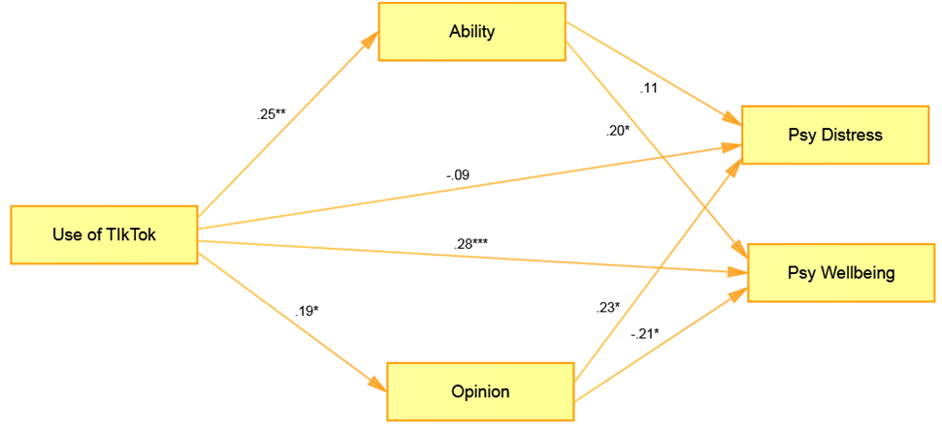

Summary of Findings
- The results of correlation analysis showed that use of tiktok was found to be significantly positively associated ability, opinion and psychological wellbeing. While use of tiktok was found to be significantly negatively correlated with psychological distress. Ability was found to be significantly negatively associated with psychological distress while significantly positively correlated with psychological wellbeing. On the other hand opinion was found to be positively correlated with psychological distress.
- Gender was found to be significantly positively correlated with psychological wellbeing i.e., women had high level of psychological wellbeing. Whereas comedy, happy and love type tiktokers had high level of psychological wellbeing while sad type tiktokers had high level of psychological distress. Moreover the self tiktok videos had high level of psychological wellbeing. Likes count was found to be significantly positively correlated with psychological wellbeing while significantly negatively associated with psychological distress.
- Mediation analysis showed that the ability was found to be significant mediator between use of tiktok and psychological wellbeing. Moreover the opinion was found to be significant mediator between use of tiktok and psychological distress.

Chapter 5

Discussion
The aim of this research was to investigate the relationship between use of TikTok and mental Health among university students, whereas social comparison was mediating this relationship. From our intense research there was no study on the concept of tiktok use and its relationship with social comparison and mental health, but our research was the one which unite all these concepts into testable model. From our hypothesis we came to know that there was a direct or indirect relationship between social comparison and mental health. Here two sub-terms of social comparison was described one is ability and the other one is an opinion. Ability social comparison is based on one type of thinking “What am I doing?” while comparing this from oneself or other people. Opinion social comparison is based on comparing self-beliefs, attitudes, thoughts, behaviors with others. So our research showed us that use of tiktok brings more social comparison (ability, opinion) and then they effect on mental health in either negative or positive ways.

5.1 Relationship
There was a relationship between tiktok use, social comparison and mental health in university students. More time spent on TikTok brings more social comparison (ability, opinion) and more psychological wellbeing. However our research findings also described that psychological distress becomes less effective while spending more time on TikTok. Ability the subscale of social comparison reduces the effect of psychological distress while gives more psychological wellbeing on mental health. Whereas opinion subscale of social comparison induces more psychological distress and subtracting psychological well-being.
As TikTok comes under the umbrella of social media so according to this previous studies states that teenagers feel linked with their family and companions which is basically a constructive feature of social media, and previous studies indicates that utilization of social media encourage person’s health when it is utilize to promote feelings of affirmation or affiliation (Ybarra, Mitchell, Palmer, & Reisner, 2015).Considering energetic social media usage that includes publishing content and interconnecting with other people might rise health (Lin et al. 2016).Investigation on social media and youth mental well-being has increased rapidly in numbers in the last few years, with countless researches investigating just in case increased persistent utilization of social media is linked with different mental well-being worries, plus melancholy (McCrae, Gettings, & Pursell, 2017) , body image distress and messy eating (Holland & Tiggemann, 2016) and convey issues (Riehm, et al., 2019). Mainly discovery from these investigations have been combine with a lot of researches releasing a little but remarkable pessimistic results of social media application on mental well-being.Prior investigations shows that personal variation in group contrast orientation were related with distinguishing action of social media details, accompanied by persons who usually participate in online social contrasts communicating large amount of pessimistic influence (Lee, 2014), lower level of representable gratification (De Vries, Möller, Wieringa, Eigenraam, & Hamelink, 2018) and also rise in indications of depression or contemplative thinking (Feinstein, et al., 2013)(Cheung, Gilbert, & Irons, 2004). Eminently, Contemplation has been underlined as an important negotiator of social contrast actions on social media and after that indications of depression (Feinstein, et al., 2013). When someone actively take part in upward contrast actions where they differentiate themselves from those whom they think as superior, has been linked with little faith in one-self, extended negative influence and extended self-doubt (Lee, 2014; Fardouly, Pinkus, &Vartanian, 2017).
There were some researches described the positive relationship between social media and mental health and also social comparison. But TikTok is new technology which also comes under the umbrella of social media but according to our results it actually bring out positive effect on mental health also. From our some results states that social comparison of opinion brings negative effects on mental health.

5.2 Descriptive Statistics
According to our research there was a positive effect of gender on psychological well-being. However women had high level of positive effect on mental health while using TikTok. People who made love, comedy or happy type videos and also who liked those videos had high level of positive effect on their mental health. But people who liked sad type videos or create those videos had high level of negative effect on their mental health. Moreover people who create their own videos on TikTok had high level of positive effect on mental health. More likes on videos of tiktokers brings more high level of psychological wellbeing and reducing the effect of psychological distress. In simple words people associate likes count with their self-worth and through comparison of their likes they have a positive effect on their mental health.
Some previous studies suggests that there are many possible advantages linked with social media use, together with chances for fun, self-investigation, and innovative impression (Anderson & Jiang, 2018; Anderson & Jiang, 2019; Clark, Algoe, & Green, 2018). Major validate advantages of social media use is social link, while 81 percent of adolescents state that social media enable them to sense extra attachment towards companions (Anderson & Jiang, 2019). Studies indicates that submissive social media utilization, which includes looking more human beings online content, might reduce health, Considering energetic social media usage that includes publishing content and interconnecting with other people might rise health (Lin et al. 2016). Few studies suggests positive effect on mental health while spending more time on social media apps, but many of them were stating that use of social media and social comparison had negative effect on mental health. Females tend to have bad results after creating social contrasts on different app or websites then males, some evidence suggests this point (Chua & Chang, 2016; Fox &Vendemia, 2016; Nesi&Prinstein, 2015). As claimed by some researchers that social contrast with individuals through social forum might be a threat for pessimistic results especially for females. In fact many researchers discovered that building social contrasts on social apps are linked to pessimistic results for users, which includes excessive amount of melancholy, bottom amount of self-worth, poor self-consciousness, and poor physical disappointment (e.g., Brunson, 2013; Cramer, Song, &Drent, 2016; Fardouly, Diedrichs, Vartanian, &Halliwell, 2015; Fox &Vendemia, 2016; Nesi&Pinstein, 2015; Smith, Hames, & Joiner, 2013; Vogel, Rose, Roberts, &Eckles, 2014; Vogel, Rose, Okdie, Eckles, & Franz, 2015). So according to previous researches females have more tendency to actively take part in social comparison that had negative effect on mental health? But no studies highlight this point that females had positive effect on their mental health while actively participating in social comparisons on social media just like TikTok than males. Our study states that there was a gender difference in use of tiktok, social comparison and mental health. From our findings we came to know that as compare to males, females tend to have more positive effect on mental health while doing social comparison.

5.3 Direct effects for use of tiktok, social comparison and mental health
Time spend on TikTok brings more social comparison (ability and opinion) and positive effect on mental health (more psychological well-being) while according to our results use of tiktok wouldn’t predict psychological distress. In other words using of tiktok doesn’t bring negative effect on mental health. Ability social comparison brings more positive effect on mental health (psychological well-being) while also subtracting psychological distress. When people compare their profile growth and amount of likes or followers they get positive effect on their mental health. While opinion social comparison brings more psychological distress than psychological well-being. When people engage themselves in thinking about other tiktokers beliefs and thoughts plus judging their videos from own beliefs they bring negative impact on their own mental health.
According to previous studies social media and youth mental well-being has increased rapidly in numbers in the last few years, with countless researches investigating just in case increased persistent utilization of social media is linked with different mental well-being worries, plus melancholy(McCrae, Gettings, & Pursell, 2017) , body image distress and messy eating (Holland & Tiggemann, 2016) and convey issues (Riehm, et al., 2019). Mainly discovery from these investigations have been combine with a lot of researches releasing a little but remarkable pessimistic results of social media application on mental well-being. Distinct online fellow encounters turned out to be the main topic in previous research as prospective chance elements for mental well-being distress. Cyber scam, or the encounter of being a sufferer of torment (bullying) by fellows online, has been persistently determined to linked with large levels of self-injury and self-murder (John, et al., 2018). Fellows encounter different types of social media incidents, for example social rejection and online disagreement / show (Anderson & Jiang, 2019), even these can impose threat on adolescents. Contemporary effect procedure may as well occur increased online, where adolescents might possibly approach a huge variety of their fellows to probably unsafe content. Inside the social media territory, fellow relationships can takes place with heightened constancy, contiguity and strength (Nesi, Choukas-Bradley, & Prinstein, 2018). So when people engage themselves in opinion based social comparison then different harmful threats come under their way just as bullying or cybercrime. But use of Tiktok brings more positive effect on individual’s mental health as suggested by our results.

5.4 Indirect effects of use of tiktok, social comparison and mental health
Ability based social comparison was mediating the relationship between use of tiktok and positive effect on mental health. More time spend on tiktok increase ability based social comparison which has positive effect on mental health or psychological well-being. But ability did not bring psychological distress or negative effect on mental health. Whereas, opinion based social comparison brings negative impact on mental health or psychological distress, when people spend more time on Tiktok that increasing the opinion based social comparison brings negative impact on mental health.
According to previous studies states that building contrasts on social media is reversibly associated with life contentment between youth above time (Frison&Eggermont, 2016). Single cause why social media is associated to pessimistic results might be the outcome of users doing social contrasts to different individuals on the present websites, highlighting more imaginary representations to build a constructive self-image (Vogel & Rose, 2016). One study discovered that roughly 88 percent of human beings take part in creating social contrasts on FB and from this almost 88 to 98 percent contrasts were upward social contrasts. Additionally this study demonstrates that there is a powerful association among social media and self-worth. Extension in social media utilization generate less self-worth in human beings (Jan, Soomro, & Ahmad, 2017). From investigating previous studies social comparison brings more negative impact on mental health but some positive impact on mental health whiles spending more time on social media.

5.5 Conclusion
In this research the whole new concept was use of Tiktok and its relationship between social comparison and mental health. Our study discovered that use of tiktok brings both positive and negative effect on mental health whiles increase amount of social comparison. But people on tiktok compares their fan following and their total amount of likes with others they feel good and superior to them and also they have large level of psychological well-being. But some people judge their opinions and beliefs with other tiktoker’s profile or videos whom they getting viral so these people had negative impact on their mental health and bringing more psychological distress in their lives. Video preferences also brings effect on mental health, people who liked funny, comedy, happy, love type videos they are more happy and they had positive effect on their mental health as compared to people who preferred sad videos. Women tend to be had positive effect on their psychological well-being as compared to males. So overall the conclusion of this research is that more time spend on Tiktok brings both positive and negative effect on mental health and also increased in social comparison. Overall use of tiktok will not bring negative effect on health but with the usage of tiktok and opinion based social comparison brings high level of psychological distress in people’s lives.

5.6 Recommendations and limitations
There were some limitations in this research such as data is collected online so some errors can also occur while self-reporting data. Due to Covid-19 all people were in their houses so there is a chance of confounding variables to occur. So recommendations of further research is to discover and define the use of Tiktok concept and also its relationship with different psychological concepts. Moreover more studies were needed to discover this concept properly and people needed to get knowledge for their own beliefs and opinions so that they doesn’t indulge in opinion based social comparison.

REFERENCES

Ahmad, S. (2018). Instagram stories crosses 400 Million Active Users.
Anderson, M., & Jiang, J. (2019). Teens’ Social Media Habits and Experiences. Pew Research Centre, 1-4.
Anderson, M., & Jiang, J. T. (2018). Social Media and Technology. Pew Research Centre Website.
Baig, & Mirza, M. (2018). How did the Founders of Musical.ly made $1b in 2016.
Baumeister, R. F. (1982a). A self-presentational view of social phenomena. Psychological Bulletin, 91, 3-26.
Blackwell, D., Leaman, C., Tramposch, R., Osborne, C., & Liss, M. (2017). Extraversion, neuroticism, attachment style and fear of missing out as predictors of social media use and addiction. Personality Individual Difference, 116, 69=72.
Blank, L., Peters, J., Pickvance, S., Wilford, J., & MacDonald, E. (2008). A systematic review of the factors which predict return to work for people.
Bowley, R. C. (2009). A comparative case study: Examining the organizational use of social networking sites.
Brunson, E. (2013). The impact of social networks on parents’ vaccination decisions. Pediatrics, 131(5), 1397-1404.
Butzer, B., & Kuiper, N. A. (2006). Relationships between the frequency of social comparisons and self-concept clarity, intolerance of uncertainty, anxiety, and depression. Personality and Individual Differences, 41(1), 167-176.
Buunk, A., & Gibbons, F. (2007). Social Comparison: The end of a theory and the emergence of a field. Organizational Behavior and Human Decision Processes, 102, 3-21.
Bӓzner, E., Brömer, P., Hammelstein, P., & Meyer, T. D. (2006). Current and former depression and their relationship to the effects of social comparison processes: Results of an internet based study. Journal of Affective Disorders, 93, 97-103.
Cheung, M., Gilbert, P., & Irons, C. (2004). An exploration of shame, social rank and rumination in relation to depression. Personality and Individual differences, 36(5), 1143-1153.
Chua, T. H., & Chang, L. (2016). Follow me and like my beautiful selfies: Singapore teenage girls’ engagement in self-presentation and peer comparison on social media. Computers in Human Behavior, 55(Part A), 190-197.
Clark, J. L., Algoe, S. B., & Green, M. C. (2018). Social Network Sites and Well-Being: The Role of Social Connection. Current Directions in Psychological Science, 27(1), 32-37.
Corcoran, K., Crusius, J., & Mussweiler, T. (2011). Social comparison: Motives, standards and mechanisms. Theories in Social Psychology, 119-139.
Coyne, S. M., McDaniel, B. T., & Stockdale, L. A. (2017). “Do you dare to compare?” Associations between maternal social comparisons on social networking sites and parenting, mental health, and romantic relationship outcomes. Computers in Human Behavior, 70, 335-340.
Cramer, E. M., Song, H., & Drent, A. M. (2016). Social comparison on Facebook: Motivation, affective consequences, self-esteem, and Facebook fatigue. Computers in Human Behavior, 64, 736-746.
Curtin, S., & Heron, M. (2019). Death rates due to suicide and homicide among persons aged 10–24 : United States, 2000–2017. NCHS Data Brief, no 352.
Dave, & Paresh. (2018). China's Bytedance Scrubs Musical.ly Brand in Favor of TikTok.
Davies, A. R., Sherbourne, C. D., Peterson, J. R., & Ware Jr., J. E. (1988). Mental Health Inventory Scoring note. RAND, 47-81.
De Vries, D., Möller, A., Wieringa, M., Eigenraam, A., & Hamelink, K. (2018). Social comparison as the thief of joy: emotional consequences of viewing strangers' Instagram posts. Media Psychology, 21(2), 222-245.
Doyle, B. (2020). Tiktok staistics. Retrieved from wallaroomediacom.
Dron, J., & Anderson, T. (2014). Teaching crowds: Learning and social media. Athabasca University Press.
Ellison, N. B., Steinfield, C., & Lampe, C. (2007). The benefits of Facebook "friends:" Social capital and college students use of online social network sites. Journal of Computer-Mediated Communication, 12, 1143-1168.
Eteläpelto, A., & Lahti, J. (2008). The resources and obstacles of creative collaboration in a long-term learning community. Thinking skills and creativity, 3(3), 226-240.
Fardouly, J., Diedrichs, P. C., Vartanian, L. R., & Halliwell, E. (2015). Social comparisons on social media: The impact of facebook on young women's body image concerns and mood. Body Image, 13, 38-45.
Fardouly, J., Magson, N., Johnco, C. J., Oar, E. L., & Rapee, R. M. (2018). Parental Control of the Time Preadolescents Spend on Social Media: Links with Preadolescents’ Social Media Appearance Comparisons and Mental Health. Journal of Youth and Adolescence, 47(7), 1456-1468.
Fardouly, J., Pinkus, R., & Vartanian, L. (2017). The impact of appearance comparisons made through social media, traditional media, and in person in women's everyday lives. Body Image, 20, 31-39.
Feinstein, B., Hershenberg, R., Bhatia, V., Latack, J., Meuwly, N., & Davila, J. (2013). Negative social comparison on Facebook and depressive symptoms: Rumination as a mechanism. Psychology of Popular Media Culture, 2(3), 161.
Festinger, L. (1954). A theory of Social Comparison Processes. Human Relations, 7, 117-140.
Fox, J., & Vendemia, M. A. (2016). Selective Self-Presentation and Social Comparison through photographs on Social Networking Sites. Cyberpsychology, Behavior, and Social Networking, 19(10), 593-600.
Frieswijk, N., Buunk, B. P., Steverink, N., & Slaets, P. (2004). The effect of social comparison information on the life satisfaction of frail older persons. Psychology and Aging, 19(1), 183-190.
Frison, E., & Eggermont, S. (2016). “Harder, Better, Faster, Stronger”: Negative Comparison on Facebook and Adolescents' Life Satisfaction Are Reciprocally Related. Cyberpsychology, Behavior, and Social Networking., 19(3), 158-164.
Galderisi, S., Hainz, A., Kastrup, M., Beezhold, J., & Sartorius, N. (2015). Toward a new definition of mental health. World Psychiatry, 14(2), 231-233.
Gao, W., Liu, Z., & Li, J. (2017). How does social presence influence SNS addiction? A belongingness theory perspective. Coumpter in Human Behavior, 77, 347-355.
Gibbons, F. X., & Buunk, B. P. (1999). Individual Differences in Social Comparison: Development of a scale of Social Comparison Orientation. Personality and Social Psychology, 76(1), 129-142.
Holland, G., & Tiggemann, M. (2016). A systematic review of the impact of the use of social networking sites on body image and disordered eating outcomes. Body Image, 17, 100-110.
Holland, G., & Tiggemann, M. (2016). A systematic review of the impact of the use of social networking sites on body image and disordered eating outcomes. Body Image, 17, 100-110.
Hou, L. (2018). Study on the Percieved Popularity of TikTok. Thesis, Bangkok University, Bangkok.
Instagram Help center. (2019). Retrieved from Instagram.
Introduction to mental health. (2020). Retrieved from nidirect.
Jan, M., Soomro, S. A., & Ahmad, N. (2017). Impact of Social Media on Self-Esteem. European Scientific Journal, 13(23), 329-341.
John, A., Glendenning, A. C., Marchant, A., Montgomery, P., Stewart, A., Wood, S., . . . Hawton, K. (2018). Self-Harm, Suicidal Behaviours, and Cyberbullying in Children and Young People: Systematic Review. Journal of Medical Internet Research, 20(4), e129.
Jones, D. C. (2001). Social Comparison and Body Image: Attractiveness Comparisons to Models and Peers Among Adolescent Girls and Boys. Sex Roles, 45, 645-664.
Kaplan, A., & Haenlein, M. (2010). Users of the world unite! The challenges and opportunities of Social Media. Business horizons, 53(1), 59-68.
Keyes, K., Gary, D., O'Malley, P. M., Hamilton, A., & Schulenberg, J. (2019). Recent increases in depressive symptoms among US adolescents: trends from 1991 to 2018. Social Psychiatry and Psychiatric Epidemiology, 54, 987-996.
Khattab, M. (2019). Synching and Performing: Body (Re)-Presentation in the Short Video App TikTok. WiderScreen, 21, 1-2.
Lee, S. (2014). How do people compare themselves with others on social network sites? The case of Facebook. Computers in Human Behavior, 32, 253-260.
Lin, L. Y., Sidani, J. E., Shensa, A., Radovic, A., Miller, E., Colditz, J. B., . . . Primack, B. A. (2016). ASSOCIATION BETWEEN SOCIAL MEDIA USE AND DEPRESSION AMONG U.S. YOUNG ADULTS. Depression & Anxiety, 33(4), 321-331.
Maredia, M. K., Reyes, B., Ba, M. N., Dabire, C. L., Pittendrigh, B., & Bello-Bravo, J. (2018). Can mobile phone-based animated videos induce learning and technology adoption among lowliterate farmers? A field experiment in Burkina Faso. Information Technology for Development, 24(3), 429-460.
Maslow, A. (1943). A theory of human motivation. Psychological Review, 50(4), 370-396.
Maslow, A. (1954). Motivation and personality. Harper and Row.
McCrae, N., Gettings, S., & Pursell, E. (2017). Social Media and Depressive Symptoms in Childhood and Adolescence: A Systematic Review. Adolescent Research Review, 2, 315-330.
McNee, S., & Woods, H. (2019). Pre-sleep Cognitive Influence of Night-time Social Media Use and Social Comparison Behavior in Young Women.
Meng, X. (2016). Development status and reflection of short video APP in new media environment. People's Daily Press, 12(1), 53-54.
Miller, Monica, Reichert, Jenny, & Flores, D. (2015). Social Comparison Theory.
Nesi, J. (2020). The Impact of Social Media on Youth Mental Health. North Carolina Medical Journal, 81(2), 116-121.
Nesi, J., & Prinstein, M. J. (2015). Using Social Media for Social Comparison and Feedback-Seeking: Gender and Popularity Moderate Associations with Depressive Symptoms. Journal of Abnormal Child Psychology, 43, 1427-1438.
Nesi, J., Choukas-Bradley, S., & Prinstein, M. J. (2018). Transformation of Adolescent Peer Relations in the Social Media Context: Part 1—A Theoretical Framework and Application to Dyadic Peer Relationships. Clinical Child and Family Psychology Review, 21, 267-294.
Omar, B., & Dequan, W. (2020). Watch, Share or Create: The Influence of Personality Traits and User Motivation on TikTok Mobile Video Usage. 14(4), 121-137.
Patrick, M. S. (2018). Tiktok video app has become a petri dish for youth culture. The Japan Times, p. 1.
Peterson, T. (2019). Mental health defintion: what is mental health? . Retrieved from Healthy Place.
Prevalence of any Mental Illness. (n.d.). Retrieved from National Institute of Mental Illness.
Ren, Y., Harper, F., Drenner, S., Terveen, L., Kiesler, S., Reidl, J., & Kraut, R. (2012). Building member attachment in online communities: applying theories of group identity and interpersonal bonds. MIS Q, 841-864.
Riehm, K. E., Feder, K. A., Tormohlen, K. N., Crum, R. M., Young, A. S., Green, K. M., . . . Mojtabal, R. (2019). Associations Between Time Spent Using Social Media and Internalizing and Externalizing Problems Among US Youth. JAMA Psychaitry, 76(12), 1266-1273.
Robert, J. A., & David, M. E. (2020). The Social Media Party: Fear of Missing Out (FoMO), Social Media Intensity, Connection, and Well-Being. International Journal of Human–Computer Interaction, 36(4), 386-392.
Rogers, C. (1951). Client-centered therapy: Its current practice, implications and theory. London Constable.
Rogers, C. (1959). Client-centered therapy, personality and interpersonal relationships as developed in the client-centered framework. A study of science, 3.
Self Presentation Theory: Self-Construction and Audience Pleasing. (n.d.). In R. F. Baumeister, & D. G. Hutton, Theories of Group Behavior (pp. 71-87).
Smith, A. R., Hames, J. L., & Joiner jr., T. E. (2013). Status Update: Maladaptive Facebook usage predicts increases in body dissatisfaction and bulimic symptoms. Journal of Affective Disorders, 149(1-3), 235-240.
Smith, R., & Kim, S. (2007). Comprehending envy. Psychology Bulletin, 133, 46-64.
Sponcil, M., & Gitimu, P. (2018). Use of social media by college students: Relationship to communication and self-concept. 13.
Steers, M.-L. N. (2016). ‘It's complicated’: Facebook's relationship with the need to belong and depression. Current Opinion in Psychology, 9, 22-26.
Suls, J., & Wheeler, L. (2000). Handbook of Social Comparison: Theory and research New York.
Tariq, K., Tariq, R., Ayesha, Hussain, A., & Shahid, M. (2019). Effects of smartphone usage on psychological wellbeing of school going. JPMA, 69(7), 955-958.
Vogel, E., & Rose, J. P. (2016). Self-reflection and interpersonal connection: Making the most of self-presentation on social media. Translational Issues in Psychological Science, 2, 294-302.
Vogel, E., Rose, J. P., Okdie, B. M., Eckles, K., & Franz, B. (2015). Who compares and despairs? The effect of social comparison orientation on social media use and its outcomes. Personality and Individual Differences, 86, 249-256.
Vogel, E., Rose, J., Roberts, L., & Eckles, K. (2014). Social comparisons, social media, and self-esteem. Psychology of Popular Media Culture, 3(4), 206.
Wahlroos, J. K. (2010). Social media as a form of organizational knowledge sharing. A case study on employee participation at Wartsila.
Wang, Y. (2020). Influence of camera view on TikTok user's presence, immersion and adoption intent. Computers in Human Behavior.
Wang, Y. H., Gu, T. J., & Wang, S. Y. (2019). Causes and characteristics of Short Video Platform Internet Community taking the TikTok short video application.
Wood, J. V. (1996). What is social comparison and how should we study it? Personality and Social Psychology Bulletin, 22(5), 520-537.
Ybarra, M. L., Mitchell, K. J., Palmer, N. A., & Reisner, S. L. (2015). Online social support as a buffer against online and offline peer and sexual victimization among U.S. LGBT and non-LGBT youth. Child Abuse & Neglect, 39, 123-136.
Zea, Q., & Heekyoung, J. (2019). Learning and Sharing Creative Skills with Short Videos: A Case Study of User Behavior in TikTok and Bilibili. 1-15.
Zhao, Y., & Wang, Y. (2015). Duanshipin de chuanbo xianzhuang fenxi (The research on the dissemination of short video). Research on Digital Media, 32(3), 54-58.
Zhou, Q. (2019). Understanding User Behaviors of Creative Practice on Short Video Sharing Platforms – A Case Study of TikTok and Bilibili.
Zhu, C., Xu, X., Zhang, W., Chen, J., & Evans, R. (2020). How health communication via TikTok makes a difference: a content analysis of TikTok accounts run by Chinese Provincial Health Committees. International Journal of Environmental Research and Public Health, 17(1), 192.

APPENDICES

APPENDIX-A

Permission by the Author

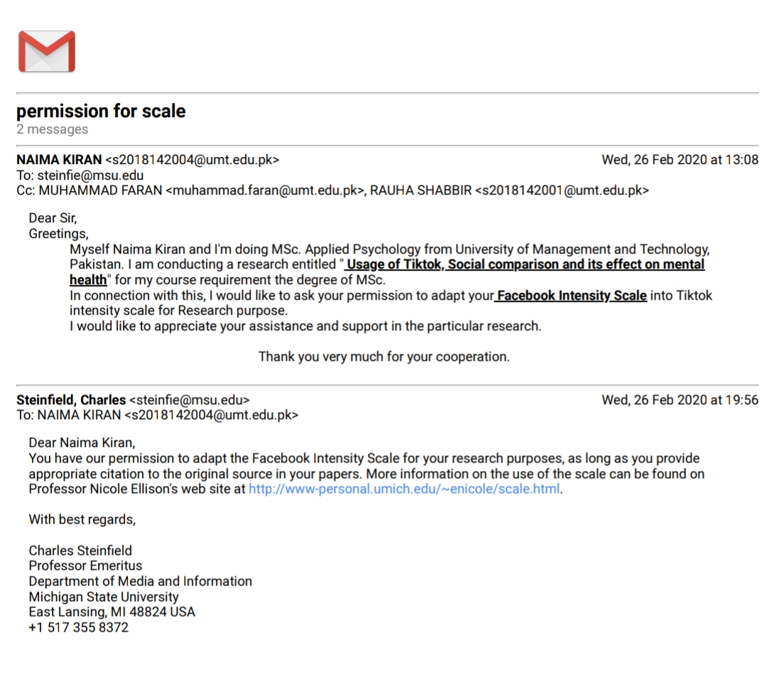

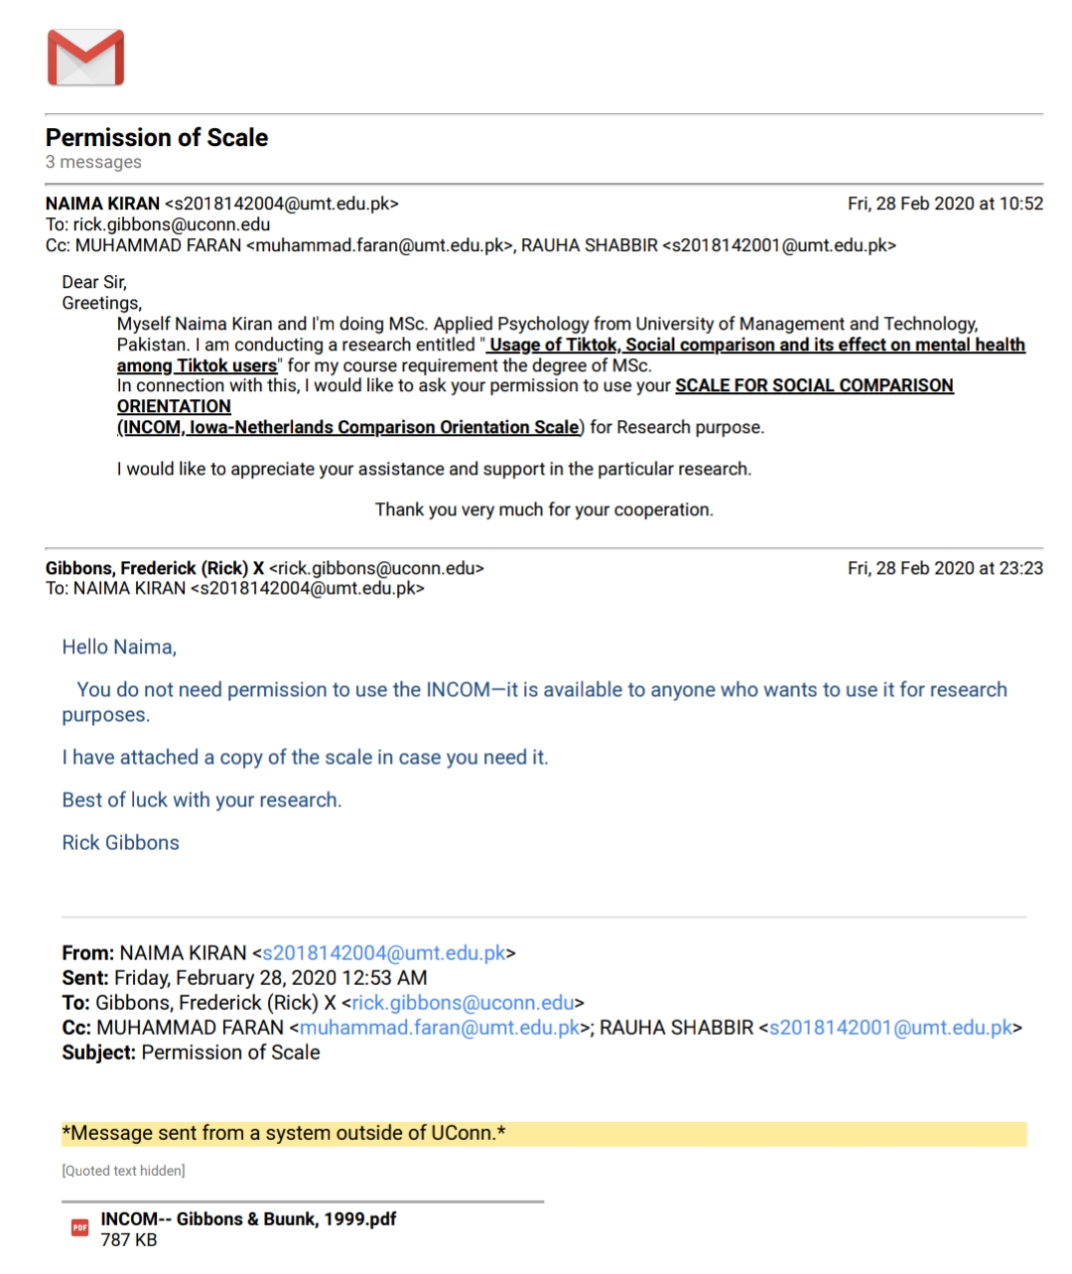

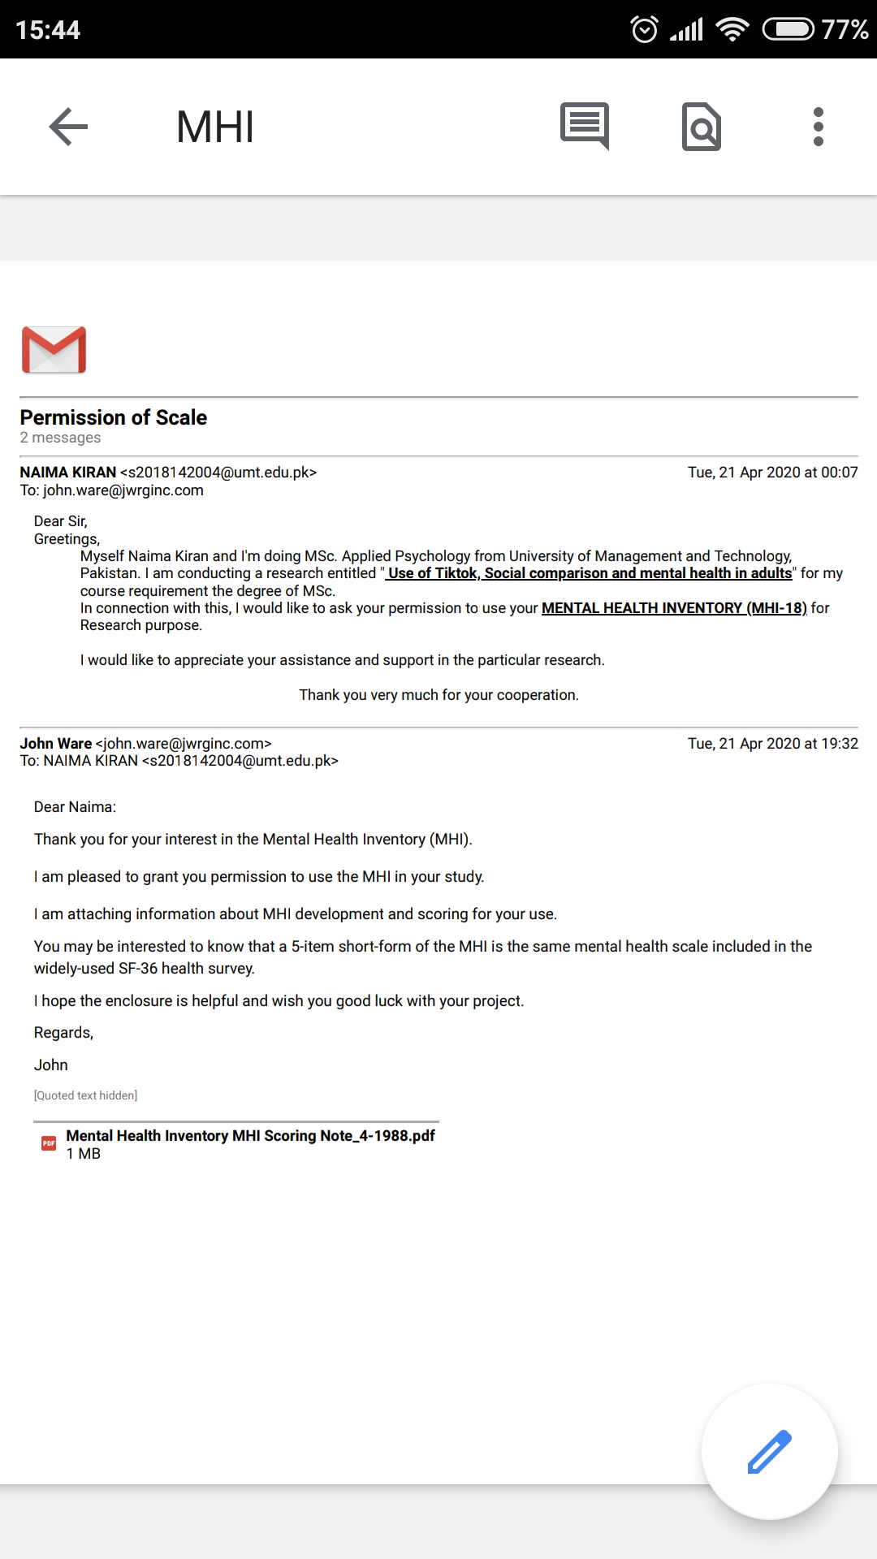

APPENDIX -B

Assessment Protocol

Informed Consent
We are students of MSc. in the Department of Applied Psychology, University of Management and Technology, Lahore. We are conducting research on "Use of TikTok, Social Comparison and Mental Health in Adults" under the supervision of Muhammad Faran. You are invited to take part in this research study. Your participation is voluntarily and you have right to withdraw from participation at any time without giving the reason. The purpose of the study is to explore relationship between use of tiktok, social comparison and mental health in adults.
State that I voluntarily agree to participate in this research entitled "Use of TikTok, Social Comparison and Mental Health in Adults" conducted by Naima Kiran and RauhaShabbir under the supervision of Muhammad Faran, Department of Psychology, University of Management and Technology, Lahore. State your name below.
Name:

Demographic Information Sheet
Gender
- Male
- Female
- Prefer not to say
Age

Family System
- Single
- Joint
- Separated
Institution / Department

Which Phone do you use?
- Android
- Iphone
How many videos you make per day?

What type of videos do you like?
- Comedy
- Happy
- Lip – synching
- Dancing
- Love
- Sad
- Educational
What type of Videos do you make?
- Personal Videos
- Someone else Videos
How long have you been using TikTok?

How many likes do you have?

TIKTOK INTENSITY SCALE (TIS)
This scale is adopted from Facebook intensity scale and it is used to measure Facebook usage beyond simple measures of frequency and duration, incorporating emotional connectedness to the site and its integration into individuals’ daily activities.
- Tiktok is part of my everyday activity
- I am proud to tell people I’m on Tiktok
- Tiktok has become part of my daily routine
- I feel out of touch when I haven’t logged onto Tiktok for a while
- I feel I am part of the Tiktok community
- I would be sorry if Tiktok shut down
- Approximately how many TOTAL Tiktok friends do you have?
- In the past week, on average, approximately how much time PER DAY have you spent actively using Tiktok?
Response Categories:
1=strongly disagree, 2=disagree,3= neutral,4=agree,5=strongly agree

SOCIAL COMPARISON ORIENTATION SCALE (INCOM)
“Most people compare themselves from time to time with others. For example, they may compare the way they feel, their opinions, their abilities, and/or their situation with those of other people. There is nothing particularly “good” or “bad” about this type of comparison, and some people do it more than others. We would like to find out how often you compare yourself with other people. To do that we would like you to indicate how much you agree with each statement below, by using the following scale.”
1=strongly disagree, 2=disagree, 3= neutral,4=agree,5=strongly agree
- I often compare myself with others with respect to what I have accomplished in life
- I want to learn more about something, I try to find out what others think about it
- I always pay a lot of attention to how I do things compared with how others do things
- I often compare how my loved ones (boy or girlfriend, family members, etc.) are doing with how others are doing
- I always like to know what others in a similar situation would do
- I am not the type of person who compares often with others (reversed)
- If I want to find out how well I have done something, I compare what I have done with how others have done
- I often try to find out what others think who face similar problems as I face
- I often like to talk with others about mutual opinions and experiences
- I never consider my situation in life relative to that of other people (reversed)
- I often compare how I am doing socially (e.g., social skills, popularity) with other people

MENTAL HEALTH INVENTORY (MHI-38)
1=all of the time,2=most of time,3=a good bit of the time,4=some of the time, 5= a little of the time,6=none of the time
- How happy, satisfied, or pleased have you been with your personal life during the past month?
- How often did you become nervous or jumpy when faced with excitement or unexpected situations during the past month?
- When you got up in the morning this past month about how often did you expect to have an interesting day?
- How much of the time during the past month, were you able to relax without difficulty?
- During the past month, how much of the time have you generally enjoyed the things you do?
- How much of the time, during the past month, has your daily life been full of things that were interesting to you?
- During the past month, how much of the time have you felt loved and wanted?
- How much of the time, during the past month, have you been a very nervous person?
- During the past month, how much of the time have you felt that the future looks hopeful and promising?
- During the past month, how much of the time did you feel depressed?
- During the past month, how much of the time have you felt tense or high-strung?
- During the past month, how much of the time have you been in firm control of your behavior, thoughts, emotions, feelings?
- How often during the past month did you feel that nothing turned out for you the way you wanted it to?
- During the past month, how much of the time did you feel that you had nothing to look forward to?
- How much of the time, during the past month, have you felt calm and peaceful?
- How much of the time, during the past month, have you felt emotionally stable?
- How much of the time, during the past month, have you felt downhearted and blue?
- How often have you felt like crying during the past month?
- During the past month have you had any reason to wonder if you were losing your mind, or losing control over the way you act, talk, think, and feel of your memory?
- During the past month, how often did you feel that others would be better off if you were dead?
- How much of the time, during past month did you feel relaxed and free of tension?
- During the past month, how much of the time did you feel that your love relationships, loving and being loved were full and complete?
- How much have you been bothered by nervousness, or your nerves, during the past month?
- During the past month, how much of the time has living been a wonderful adventure for you?
- How much of the time, during the past month, have you felt so down in the dumps that nothing could cheer you up?
- During the past month, did you ever think about taking your own life?
- During the past month, how much of the time have you felt restless, fidgety, or impatient?
- During the past month, how much of the time have you been moody or brooded about things?
- During the past month, how often did you get rattled, upset, or flustered?
- How often during the past month have you waking up feeling fresh and rested?
- During the past month have you been under or felt under any strain, stress or pressure?
- During the past month, how much of the time have you been a happy person?
- How often during the past month did you find yourself having difficulty trying to calm down?
- During the past month, how much of the time have you been in low or very low spirits?
- How much of the time, during the past month, have you felt cheerful, lighthearted?
- During the past month how often did you feel that you had nothing to look forward to?
- During the past month how often, did your hands shake when you tried to do something?
- During the past month, how often did you feel isolated from others?

APPENDIX – C

Plagiarism Report

