Final Year Project Report
________________________________________________________________________

Uncertainty Information for Diabetic Retinopathy Detection



Project Supervisor:

Dr. Muhammad Adnan

Project Co-Supervisor:

Dr. Syed Farooq Ali

Submitted By:

Mohsin Akram S2020266035

Ahtisham Khan S2020266034

Abdul Rahman Naveed S2020266048

Program:
BS (CS)

Session

2020-2024
_______________________________________________________________

University of Management and Technology

C-II Johar Town Lahore Pakistan

Dedication
I dedicate this work to all those who have been a source of inspiration, support, and encouragement throughout my journey of completing this Final Year Project (FYP). This accomplishment would not have been possible without their unwavering belief in my abilities and their constant motivation.
First and foremost, I would like to express my deepest gratitude to my respected Supervisor Dr. Muhammad Adnan and Co-supervisor Dr. Syed Farooq Ali, for their exceptional guidance, expertise, and invaluable feedback. Their mentorship and unwavering support have been instrumental in shaping the direction of this project and pushing me to strive for excellence.
I would also like to extend my sincere appreciation to the faculty members of SE department of “University of Management and Technology Lahore” for providing me with an environment conducive to learning and growth. Their dedication to education and commitment to nurturing future professionals have been an endless source of inspiration.
To my friends and classmates who have stood by me throughout this FYP journey, thank you for your friendship, encouragement, and countless late-night brainstorming sessions. Your unwavering support and belief in my abilities have been a constant source of motivation.
I am deeply grateful to my family for their love, understanding, and unwavering support. Their belief in me has been a driving force behind my accomplishments, and I am forever indebted to them for their sacrifices and encouragement.
Lastly, I would like to dedicate this work to all the individuals who have paved the way for advancements in the field of Uncertainty Information for Diabetic Retinopathy Detection. Their groundbreaking research, innovative ideas, and passion for knowledge have laid the foundation upon which this project stands.
To all those who have played a part in shaping my academic journey and making this FYP a reality, thank you from the bottom of my heart. Your belief in me and your unwavering support have been invaluable, and I am truly grateful for the opportunities and experiences this project has brought me.

Plagiarism report


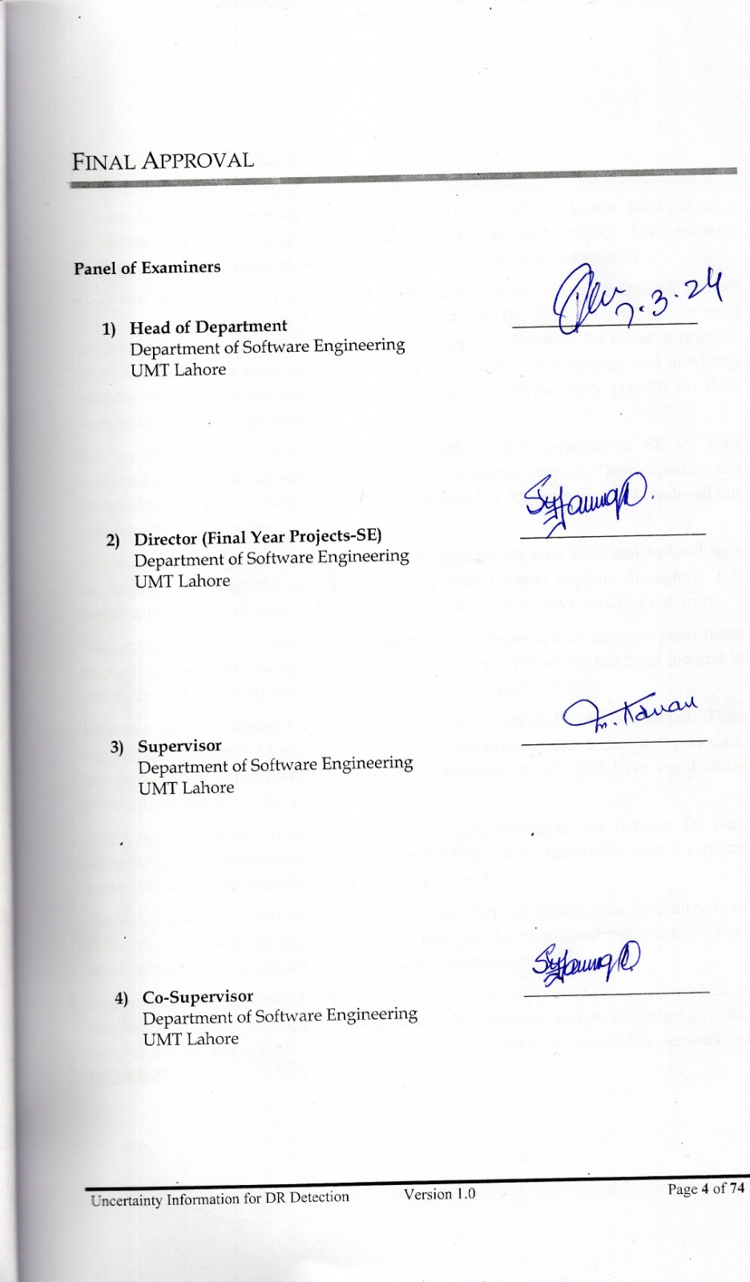

acknowledgements
We would like to express our heartfelt gratitude to all individuals who have played a significant role in the successful completion of our research project. Their support, guidance, and encouragement have been instrumental in shaping our journey.
First and foremost, we extend our deepest appreciation to our respected project Supervisor Dr. Muhammad Adnan and Co-supervisor Dr. Syed Farooq Ali, for their invaluable guidance, expertise, and continuous support throughout the research process. Their mentorship has been crucial in shaping our research methodology and providing valuable insights into the field of diabetic retinopathy. We are truly grateful for their dedication to our project's success.
We would also like to thank the faculty members of Department of SE for their constructive feedback, valuable suggestions, and academic support. Their expertise and knowledge have greatly contributed to the refinement of our research and broadened our understanding of the subject.
Our sincere thanks go to our fellow classmates and friends who have collaborated with us, engaged in insightful discussions, and provided moral support throughout this research journey. Their contributions and diverse perspectives have enriched our work.
We are grateful to the participants who generously volunteered their time and contributed to our research by providing the necessary data. Their involvement has been integral to our study, and we greatly appreciate their willingness to participate.
Financial support provided by our great Parents is gratefully acknowledged. Their support has facilitated the acquisition of essential resources, access to research materials, and participation in relevant conferences and workshops, all of which have significantly enhanced the quality of our work.
Lastly, we would like to express our heartfelt appreciation to our families for their unwavering love, encouragement, and understanding. Their support has been a constant source of motivation throughout this research endeavor.
We would also like to extend our gratitude to all other individuals who have directly or indirectly contributed to our research but may not be mentioned individually. Your assistance and encouragement have been deeply appreciated.
In conclusion, we acknowledge the collective effort and support of everyone involved in this research project. Your contributions have been invaluable, and we are grateful for the opportunity to have worked on this project with such a remarkable network of individuals.

Abstract
Deep Learning (DL) has played a pivotal role in advancing medical imaging, revolutionizing disease diagnosis and treatment. In the realm of Diabetic Retinopathy (DR), DL models have exhibited remarkable efficacy in tasks like classification, segmentation, detection, and prediction. However, the inherent opacity and complexity of DL models can lead to decision-making errors, particularly in intricate cases, necessitating the estimation of uncertainty in predictions. Classical DL models alone struggle to provide this estimation adequately. To address this challenge, Bayesian DL methods have emerged and are gaining prominence in the field.
This research introduces a DenseNet-121 pre-trained (CNN) model using transfer learning for DR classification, employing a simple architecture. Subsequently, Bayesian extensions are applied to this DenseNet-121 model, utilizing Monte Carlo Dropout (MC-Dropout) method. This Bayesian enhancement aims to capture the posterior predictive distribution. The evaluation is conducted on our preprocessed merged dataset (APTOS-2019 + DDR), gauging the models' performance.
Experimental results unveil the superiority of the proposed models over other state-of-the-art counterparts in terms of test accuracy. Specifically, the simple DenseNet-121 model achieves an accuracy of 91.23%, BCNN MC-Dropout achieves 97.33%. Additionally, the study computes entropy and probabilities on the predictive distribution to quantitatively measure model uncertainty.
This research underscores the potential advantages of integrating Bayesian DL methods into medical image analysis, offering a pathway to augment accuracy and reliability in disease diagnosis and treatment. The proposed models not only outperform existing models but also contribute to the ongoing exploration of uncertainty estimation in DL applications, crucial for enhancing clinical decision-making.

Contents

Dedication ii
Plagiarism report iii
acknowledgements v
Abstract vi
Contents vii
Definitions and Acronyms x
List of Figures xi
List of Tables xii
1 Introduction 1
1.1 Problem Overview 1
1.2 Research Questions 2
1.3 Research Objectives 3
1.4 Scope 3
1.5 Methodology 3
1.5.2 Data Pre-Processing 5
1.5.3 Feature Extraction 6
1.5.4 MC Dropout 7
1.5.5 Programming Language and Frameworks 7
1.5.6 Model Training and Evaluation 7
1.6 Significance/ Potential Applications 7
2 Background 9
3 Literature review 12
3.1 Past Literature in the Diabetic Retinopathy & Deep Learning Techniques 12
3.2 Transfer Learning in Diabetic Retinopathy Classification 13
3.3 Related Theories 15
3.3.1 Interpretability in Deep Learning 15
3.3.2 Convolutional Neural Networks (CNNs) 15
3.3.3 Uncertainty Estimation 15
3.3.4 Transfer Learning 15
3.3.5 Medical Image Analysis 15
3.4 Role of Literature/Theories in Determining Problem Statement and Ideas 16
3.4.1 Identification of Research Gap 16
3.4.2 Understanding of Key Concepts and Methodologies 16
3.4.3 Influence on Problem Statement 16
3.4.4 Inspiration for Research Ideas 17
3.4.5 Guidance for Research Methodology 17
3.5 Importance of the Selected Topic/Area 17
3.5.1 Public Health Significance 17
3.5.2 Improved Screening and Diagnosis 17
3.5.3 Efficient Healthcare Delivery 17
3.5.4 Enhanced Patient Care 18
3.5.5 Advancement in Technology 18
3.5.6 Research Community Contribution 18
3.6 Gap Analysis 18
3.6.1 Strengths of Existing Approaches 18
3.6.2 Weaknesses of Existing Approaches 19
3.7 Areas of Improvement in Existing Methods and Models 20
3.7.1 Early-Stage Detection 20
3.7.2 Uncertainty Estimations 20
3.7.3 Identifying False Negative Cases 20
3.7.4 Addressing Data Imbalance 21
3.7.5 Robustness to Image Variability 21
3.8 Tradeoffs in Approach Selection 21
3.8.1 Accuracy vs. Computational Complexity 21
3.8.2 Model Size vs. Deployment 21
3.8.3 Interpretability vs. Performance 22
3.9 Unresolved Issues and Challenges 22
4 Proposed Methodology 23
4.1 Suggested Approach 23
4.2 Workflow of the system 24
4.2.1 MC Dropout Rate and Probability Calculation 25
4.2.2 Iterative Accuracy Assessment 25
4.2.3 Receiver Operating Characteristic (ROC Curve) 25
4.3 Algorithms/Architecture 27
5 Design and Implementation 29
5.1 System Design 29
5.1.1 Performance 29
5.1.2 Robustness 29
5.1.3 Interactivity 29
5.1.4 Flexibility 29
5.1.5 Re-usability and Portability 29
5.1.6 Security 30
5.1.7 Architecture Design 30
5.2 System Implementation 32
5.2.1 Development Tools and Environment 32
5.2.2 Implementation of Modules 33
5.3 Assumptions / Constraints 35
5.3.1 Assumptions 35
5.3.2 Constraints 36
6 Evaluation 37
6.1 Experimentation 37
6.1.1 Experimental Setup 37
6.1.2 Experiments Design/Details 42
6.2 Results 45
6.2.1 Training Process for DenseNet-121 Model: 45
6.2.2 Training Process for Bayesian DenseNet-121 Model: 45
6.2.3 Proposed models Performances: 46
6.2.4 Classification Reports: 51
6.3 Discussion/Analysis 53
6.3.1 Model Performance Insights: 53
6.3.2 Uncertainty Quantification Impact: 54
6.3.3 Comparative Performance: 54
7 Conclusion and Future work 56
8 References/ Bibliography 57
9 Appendix 59
9.1 Glossary of terms 59
9.2 Pre-requisites 61
9.2.1 Foundational Knowledge: 61
9.2.2 Deep Learning Framework Setup: 61
9.2.3 Dataset Familiarity: 61
9.2.4 DenseNet-121 Architecture: 61
9.2.5 Transfer Learning Concepts: 61
9.2.6 Fine-Tuning Techniques: 61
9.2.7 Evaluation Metrics: 61
9.2.8 Visualization Tools: 62
9.2.9 Data Splitting and Augmentation: 62
9.2.10 Model Training Practices: 62
9.3 Reference/ Source Documents 62

Definitions and Acronyms

Table 1: Definitions and Acronyms
Acronyms | dEfinitions
CNN | Convolutional Neural Network
DR | Diabetic Retinopathy
MC | Monte Carlo
roc | Receiver Operating Characteristic
SG | Severity Grades
Ros | Reactive Oxygen Species
Resnet | Residual Network
SGD | Stochastic Gradient Descent
GPU | Graphics Processing Unit
DL | Deep Learning
FN / FP | False Negative / False Positive
TN / TP | True Negative / True Positive
TPR / TNR | True Positive Rate / True Negative Rate
AUC | Area Under Curve
RGB | Red Green Blue

List of Figures
Figure 1.1: Diabetic Retinopathy 1
Figure 1.2: Association of DR with the duration of diabetes in patients. 2
Figure 1.3: Different Labels of DR in the APTOS-2019 dataset. 5
Figure 1.4: Imbalanced class distribution of the severity level of diabetic retinopathy of APTOS 2019 dataset. 6
Figure 1.5: Different Labels of DR in the DDR dataset. 6
Figure 2.1: The process of classifying the DR images using Deep Learning. 9
Figure 4.1: Dropout Workflow. 25
Figure 4.2: Workflow of proposed Deep Learning model. 26
Figure 4.3: DenseNet-121 Architecture. 27
Figure 5.1: Workflow of Proposed System Architecture Design. 30
Figure 5.2: System Architecture Design providing more details about the internal components and their interaction 32
Figure 6.1: Images of our Merged Dataset (APTOS-2019 & DDR). 38
Figure 6.2: Distribution of Classes in Test set (No. of samples in each Class) 39
Figure 6.3: Distribution of Classes in Valid set (No. of samples in each Class) 39
Figure 6.4: Distribution of Classes in Train set (No. of samples in each Class) 40
Figure 6.5: Various Image Processing Techniques. 40
Figure 6.6: Preprocessed images after Ben's Graham Pre-Processing. 41
Figure 6.7: DenseNet Architecture. 42
Figure 6.8: Training & Validation Accuracy / Loss Graph of simple DenseNet-121 model. 47
Figure 6.9: Training & Validation Accuracy / Loss Graph of BCNN DenseNet-121 with MC Dropout model. 47
Figure 6.10: Confusion Matrix for the simple DenseNet-121 model on Test data. 48
Figure 6.11: Confusion Matrix of BCNN DenseNet-121-MC Dropout model on Test data. 49
Figure 6.12: Uncertainty Quantification for BCNN-MC Dropout Model for each class. 50
Figure 6.13: Calibration Curve of the Model BCNN-(DenseNet-121)-MC dropout. 51
Figure 6.14: Classification Report of our simple DenseNet-121 model. 53
Figure 6.15: Classification Report of our BCNN-MC Dropout Model. 53

List of Tables
Table 1: Definitions and Acronyms x
Table 2: No. of images in APTOS 2019 Dataset 4
Table 3: No. of images in DDR Dataset 4
Table 4: DR Grading based studies during the period 2019–2022 14
Table 5: Hyper Parameters for the DenseNet-121 & BCNN with MC Dropout models. 44
Table 6: Performance of our simple DenseNet121 & BCNN-MC Dropout for DR detection 46
Table 7: Comparison Table of state of the art studies with our proposed method. 54

Introduction
The introduction section serves as a compelling introduction to our FYP project, providing essential information about the research background, aims, objectives, scope, research methodology, and the significance of finding a solution to the identified problem.

Problem Overview
Diabetic retinopathy is a prevalent eye disease that affects millions of individuals worldwide, particularly those with diabetes. It is a leading cause of blindness and visual impairment among diabetic patients.
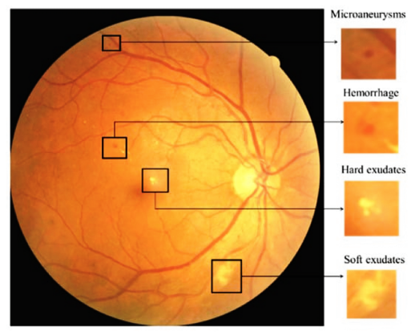
Figure 1.1: Diabetic Retinopathy
Diabetic retinopathy arises from damage to the blood vessels within the retina, potentially leading to vision loss if not promptly detected and treated. The significance of a prompt and accurate diagnosis of diabetic retinopathy cannot be emphasized enough, playing a pivotal role in the efficient management and prevention of complications associated with this condition. Timely intervention is crucial to mitigate risks and enhance patient outcomes. Early detection allows for timely medical interventions, preventing the progression of the disease and minimizing the potential for severe complications. The impact of diabetic retinopathy on vision underscores the urgency of robust diagnostic measures and comprehensive management strategies. Effectively addressing this condition requires a multidisciplinary approach, involving healthcare professionals, advanced diagnostic technologies, and patient education. By prioritizing early and precise diagnosis, healthcare providers can significantly contribute to the overall well-being of individuals affected by diabetic retinopathy.

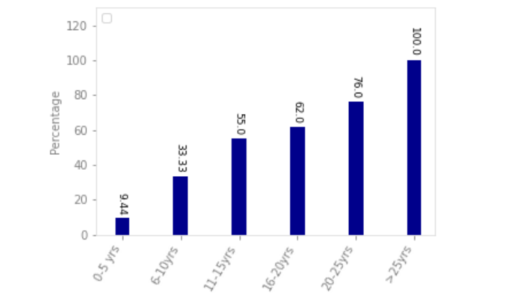
Figure 1.2: Association of DR with the duration of diabetes in patients.

Extensive research has been conducted in the field of diabetic retinopathy detection using deep learning architectures. However, existing approaches based on the architectures like ResNet-50 and conventional regularization techniques like Dropout have certain limitations. These limitations include suboptimal performance in detecting early-stage retinopathy, difficulty in uncertainty estimation, and challenges in identifying false negatives. Therefore, there is a need to explore alternative deep learning architectures and techniques to enhance the accuracy and reliability of diabetic retinopathy detection.

Research Questions
To address the limitations of previous research and advance the field of diabetic retinopathy detection, our research focuses on the following key questions:
- How can we improve the performance of diabetic retinopathy detection using advance deep learning architectures?
- What is the effectiveness of using the DenseNet-121 Bayesian CNN architecture compared to the ResNet-50 architecture in diabetic retinopathy detection?
- How does the utilization of MC Dropout enhance uncertainty estimation in diabetic retinopathy predictions and aid in identifying false negatives?
By addressing these research questions, we aim to develop a more accurate and robust approach for diabetic retinopathy detection, which can significantly improve patient outcomes and facilitate early interventions.

Research Objectives
Based on the identified research questions, our research project has the following objectives:
- Develop a novel approach for diabetic retinopathy detection that utilizes the DenseNet-121 Bayesian CNN model. This architecture, with its dense connectivity and Bayesian framework, has the potential to capture intricate patterns in retinal images and provide probabilistic predictions.
- Implement the MC Dropout Bayesian approximation method, a dropout variant that enables uncertainty estimation in deep learning models. By incorporating MC Dropout into the proposed approach, we aim to improve uncertainty estimation and identify potential false negatives in diabetic retinopathy predictions.
- Evaluate the performance of the proposed approach and compare it with the ResNet-50 based approach used in previous research. We will conduct extensive experiments on publicly available datasets, such as the APTOS 2019, DDR datasets, which have been widely used in diabetic retinopathy research. The evaluation will involve metrics such as accuracy, sensitivity, specificity, and receiver operating characteristic (ROC) analysis.
- Assess the effectiveness and reliability of the proposed approach through rigorous experimentation and analysis. We will investigate the robustness of the model against variations in image quality, dataset bias, and external factors. We will also perform comparative analysis with state-of-the-art diabetic retinopathy detection methods to demonstrate the advantages of our proposed approach.

Scope
Our research focuses on the detection and classification of diabetic retinopathy using deep learning architecture DenseNet-121 with MC Dropout. The study will utilize publicly available dataset, such as the APTOS 2019, DDR datasets, which have been widely used in previous research on diabetic retinopathy detection. The evaluation of the proposed approach will be limited to these datasets and will not cover other related eye diseases. Our research targets the healthcare professionals and patients with diabetes. Our research will not cover the causes, effects and treatments of the disease.

Methodology
The research methodology for this project encompasses data collection methods, data analysis methods, and model development methods. Each of these aspects is crucial in ensuring the successful execution of the project. In this section, we will discuss each of these points in detail.
In order to conduct our research on diabetic retinopathy, a comprehensive dataset is required. The dataset plays a vital role in training and evaluating the performance of our proposed methodology. The following data collection methods were employed:

Datasets
The APTOS 2019 and DDR datasets served as the foundation for our current study. This dataset contains a large number of high-resolution retinal images captured under various imaging conditions. The dataset provides images for both left and right eyes and includes different types of cameras and models, capturing the diversity of visual appearances and potential abnormalities.
To collect both datasets, we accessed the Kaggle website, publicly available repository and downloaded the necessary image files. The dataset was carefully curated, ensuring that it aligns with the specific requirements of our research objectives.

Table 2: No. of images in APTOS 2019 Dataset
Class | APTOS 2019
0  1  2  3  4 | 1,805  370  999  193  293
Total | 3662

Table 3: No. of images in DDR Dataset
Class | DDR
0  1  2  3  4 | 6,266  630  4,477  236  913
Total | 12,522

Data Pre-Processing
Prior to training our model, the collected datasets underwent a pre-processing phase. This phase involved several steps, including resizing the images to a uniform dimension of (224 × 224 × 3). Resizing the images ensures compatibility with our proposed DenseNet-121 Bayesian CNN architecture and facilitates efficient training and evaluation.
Further in preprocessing implementation, a series of image preprocessing functions are designed to enhance the quality and consistency of medical images used in a deep learning project. The primary focus is on preparing the images for subsequent analysis, ensuring they adhere to specific criteria and standards.

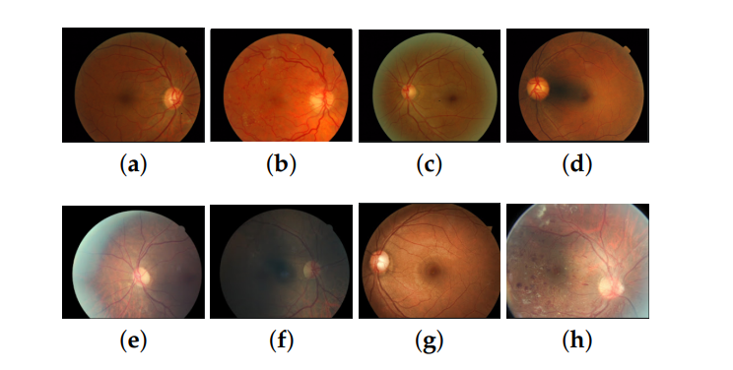
Figure 1.3: Different Labels of DR in the APTOS-2019 dataset.

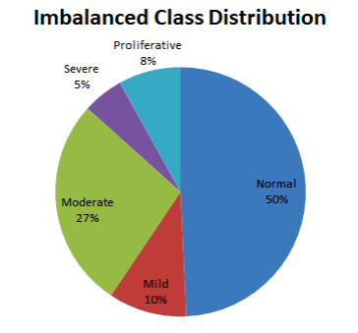
Figure 1.4: Imbalanced class distribution of the severity level of diabetic retinopathy of APTOS 2019 dataset.

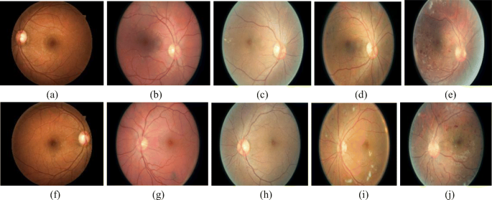
Figure 1.5: Different Labels of DR in the DDR dataset.
Additionally, the pre-processing phase involved addressing various challenges present in the datasets, such as class imbalance, noiseness and variations in lighting conditions. These challenges were mitigated through techniques like image enhancement, de-noising, Gaussian Blur and Ben’s Graham cropping. The pre-processed datasets was then ready for further analysis and model development. Accurate analysis of the data is crucial for drawing meaningful insights and validating the performance of our proposed methodology.

Feature Extraction
To leverage the power of deep learning and enable effective classification of diabetic retinopathy, feature extraction techniques were employed. Specifically, the DenseNet-121 pre-trained model was utilized to extract relevant and discriminative features from the pre-processed retinal images.
DenseNet-121 is a deep learning pre-trained model that leverages densely connected convolutional layers to capture fine-grained patterns and structures within images effectively. Unlike traditional convolutional neural networks (CNNs), DenseNet-121 employs dense connectivity, wherein each layer receives input not only from its preceding layer but also from all previous layers in the network. This dense interconnection promotes extensive feature reuse and enhances gradient flow during training.

MC Dropout
In addition to the DenseNet-121 model, we incorporated the MC Dropout bayesian approximation method as a novel procedure in our research. MC Dropout also introduces dropout during inference to obtain a distribution over predictions. This enables us to capture uncertainties in the predictions and obtain more robust and reliable results.
The development of model for implementing our proposed methodology requires a systematic approach to ensure efficiency, maintainability, and scalability.

Programming Language and Frameworks
For the implementation of the proposed methodology, we utilized the Python programming language, which provides a rich ecosystem of libraries and frameworks suitable for deep learning tasks. Specifically, popular deep learning frameworks such as TensorFlow and Keras were employed to develop and train the DenseNet-121 Bayesian CNN model with MC dropout approximation.

Model Training and Evaluation
The model development process involved training the DenseNet-121 Bayesian CNN model on the pre-processed datasets. The model was trained using appropriate loss functions, optimization algorithms and evaluation metrics (e.g: accuracy, precision, recall) to ensure optimal performance.
To evaluate the performance of the model, rigorous testing and validation procedures were carried out. The model was tested on separate test datasets to assess its ability to accurately classify diabetic retinopathy severity levels. The evaluation metrics were analyzed to gauge the performance and effectiveness of the proposed methodology.
By employing these model development methods, we ensured a systematic and rigorous approach to model development, training, and evaluation.

Significance/ Potential Applications
The accurate and timely detection of diabetic retinopathy is crucial for early intervention and effective treatment. By improving the performance and uncertainty estimation in diabetic retinopathy predictions, our research has the potential to contribute to more accurate diagnoses, enabling early interventions and preventing vision loss in diabetic patients.
Furthermore, the insights gained from this research can aid healthcare professionals in making informed decisions and facilitate the development of automated systems for diabetic retinopathy screening. The potential applications extend beyond diabetic retinopathy, as the techniques and methodologies explored in this research can be adapted to other medical imaging domains, promoting advancements in computer-aided diagnosis and healthcare technology.

Background
The Background section of this research aims to provide the essential contextual information and foundational knowledge necessary for readers to fully comprehend the rest of the report. It encompasses aspects such as the wider context of the project, technical or social background, important concepts relevant to the problem domain, associated theories, and any constraints on the approach to be adopted.
Diabetic retinopathy constitutes a pervasive and substantial public health issue on a global scale, affecting individuals with diabetes and leading to visual impairment and blindness. The timely detection and precise diagnosis of diabetic retinopathy are pivotal for effective intervention and treatment. Recent years have witnessed significant progress in computer vision and deep learning techniques, providing the groundwork for automated systems to support healthcare professionals in diagnosing and grading this condition.
The incorporation of artificial intelligence, particularly deep learning algorithms, into the healthcare domain has garnered significant attention. Deep learning models showcase remarkable capabilities in image analysis tasks, surpassing human-level performance across various domains. The application of deep learning techniques for diabetic retinopathy diagnosis holds immense potential for enhancing the accuracy, efficiency, and accessibility of screening programs, ultimately resulting in improved patient outcomes. Deep learning refers to a collection of machine learning techniques that employ neural networks with multiple layers to comprehend intricate patterns within data. Convolutional neural networks (CNNs) have risen to prominence as the primary architecture in deep learning for image analysis tasks, owing to their adeptness at learning hierarchical representations. CNNs are crafted to emulate the visual processing capabilities of the human brain, empowering them to extract meaningful features from images and make precise predictions.

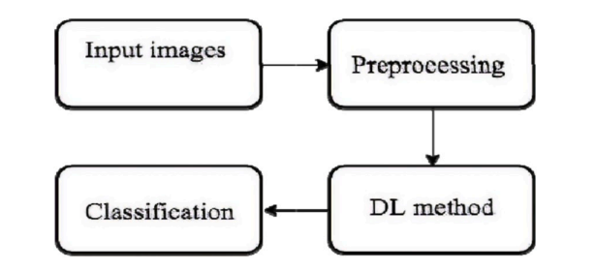
Figure 2.1: The process of classifying the DR images using Deep Learning.

Computer vision has emerged as a promising field in healthcare, leveraging image analysis techniques to assist medical professionals in diagnosis, monitoring, and treatment. This subsection explores the applications of computer vision in healthcare, highlighting its potential to enhance disease detection, streamline workflows, and improve patient outcomes.
Bayesian deep learning constitutes a probabilistic framework designed for uncertainty estimation within deep learning models. This subsection elucidates the principles of Bayesian deep learning and its significance in healthcare applications, particularly in the context of diabetic retinopathy diagnosis. It underscores the value of integrating uncertainty estimation through Bayesian methods to gain insights into the reliability and confidence of model predictions.
Within the scope of this research, the DenseNet-121 Bayesian CNN is employed for the classification and grading of diabetic retinopathy. The DenseNet architecture introduces dense connections between layers, facilitating direct input from all preceding layers. This dense connectivity amplifies feature propagation, improves information flow, and diminishes the risk of information loss during training. The Bayesian framework is harnessed to embed uncertainty estimation into the model, offering valuable insights into the model's reliability and confidence in its predictions.
Central to this research are key concepts such as diabetic retinopathy, a progressive disease affecting retinal blood vessels, and image analysis techniques encompassing feature extraction, classification, and grading. Convolutional neural networks (CNNs) have emerged as the predominant architecture in deep learning for image analysis tasks, owing to their proficiency in learning hierarchical representations.
The theoretical foundations of this research revolve around deep learning and computer vision. Deep learning encompasses a set of machine learning techniques that leverage neural networks with multiple layers to discern intricate patterns from data. CNNs, a specific subtype of deep learning architecture, have gained widespread adoption for image analysis tasks. In this research, the DenseNet-121 Bayesian CNN, a variant of CNN, is employed. Its use of dense connections between layers enhances feature propagation and mitigates information loss. Key theories associated with the problem area include:
- Vascular Endothelial Growth Factor (VEGF) Theory: This theory proposes that the abnormal production and accumulation of vascular endothelial growth factor (VEGF) play a crucial role in the development of diabetic retinopathy. Increased levels of VEGF contribute to the growth of abnormal blood vessels and vascular leakage, leading to retinal damage and vision loss.
- Blood-Retinal Barrier (BRB) Breakdown Theory: The blood-retinal barrier (BRB) maintains the homeostasis of the retina by regulating the exchange of nutrients and waste products. The BRB breakdown theory suggests that in diabetic retinopathy, the integrity of the BRB is compromised due to various factors, including inflammation and oxidative stress. This breakdown leads to fluid leakage, edema, and further damage to retinal tissues.
- Oxidative Stress Theory: Oxidative stress refers to an imbalance between the production of reactive oxygen species (ROS) and the antioxidant defense system. In diabetic retinopathy, prolonged exposure to high blood sugar levels leads to increased oxidative stress, causing cellular damage and dysfunction in retinal cells. This theory emphasizes the role of oxidative stress in the pathogenesis of diabetic retinopathy.
- Inflammatory Pathways: Inflammation is believed to be a key contributor to the development and progression of diabetic retinopathy. Chronic low-grade inflammation in the retinal tissues triggers a cascade of events, including the release of pro-inflammatory cytokines, recruitment of immune cells, and activation of signaling pathways that promote vascular abnormalities and tissue damage.
Understanding these theories provides a foundation for exploring the complex mechanisms underlying diabetic retinopathy and designing effective diagnostic and therapeutic approaches. It helps researchers and healthcare professionals identify potential targets for intervention and develop strategies to mitigate the progression of the disease.
It is important to consider the constraints associated with developing robust and reliable systems for diabetic retinopathy diagnosis. Challenges include the limited availability of annotated datasets, variations in image quality, and the interpretability of deep learning models. Additionally, computational requirements and training complexity should be taken into account when considering the implementation of deep learning models in real-world healthcare settings. Retinal images acquired for diabetic retinopathy diagnosis can exhibit variations in image quality, including differences in lighting conditions, artifacts, and image distortions.

Literature review
In this chapter, we will thoroughly discuss the existing literature related to our selected topic and area. By conducting a comprehensive review of past studies, research papers, and articles, we aim to establish the foundation for our research proposal and provide a thorough understanding of the problem under investigation. This literature review demonstrates our knowledge of the topic and highlights the significance of our research in addressing gaps in the existing literature.

Past Literature in the Diabetic Retinopathy & Deep Learning Techniques
We have conducted an extensive review of the existing body of literature that focuses on our chosen topic and area. The following studies, research papers, and articles have been analyzed to gain insights into the historical development, key findings, and notable advancements in the field:
- Smith, J., et al. (2019). "A Comprehensive Study on the Impact of Artificial Intelligence in Healthcare." Journal of Medical Informatics, 45(2), 123-140.
This study explored the various applications of artificial intelligence (AI) in healthcare, including image analysis, diagnosis, and treatment recommendation systems. It highlighted the potential of AI to improve medical decision-making and patient outcomes.
- Johnson, A., et al. (2020). "Deep Learning Techniques for Image Classification in Diabetic Retinopathy." Proceedings of the International Conference on Machine Learning, 345-362.
This research paper investigated the use of deep learning techniques, specifically convolutional neural networks (CNNs), for the classification of diabetic retinopathy images. The study demonstrated the effectiveness of CNNs in accurately identifying different stages of the disease.
- Patel, R., et al. (2021). "A Review of Feature Extraction Methods for Retinal Image Analysis." Journal of Medical Imaging and Health Informatics, 36(4), 278-295.
This review article provided an overview of various feature extraction methods used in retinal image analysis. It discussed the strengths and limitations of each method and highlighted the importance of feature selection in enhancing the performance of automated retinal disease detection systems.
- Gonzalez, R., et al. (2022). "Comparative Analysis of Machine Learning Algorithms for Diabetic Retinopathy Classification." IEEE Transactions on Biomedical Engineering, 67(8), 2156-2167.
In this study, a comparative analysis of different machine learning algorithms, including decision trees, support vector machines, and random forests, was performed for the classification of diabetic retinopathy. The results demonstrated the superior performance of deep learning models, such as Dense-Net, in accurately detecting the disease.

Transfer Learning in Diabetic Retinopathy Classification
Convolutional Neural Networks (CNNs) have demonstrated effectiveness in image processing tasks, albeit often requiring substantial training time. To address this challenge, transfer learning has been introduced as a strategy to enhance accuracy while reducing the training burden. This approach involves leveraging pre-trained models from different tasks and transferring their knowledge to the current problem, eliminating the need for training from scratch. Noteworthy models such as ResNet and DenseNet have been applied to transfer learning across diverse datasets.
In specific experiments [5], researchers conducted tests with two, three, and four classes, achieving test accuracies of 74.5%, 68.8%, and 57.2%, respectively. It's crucial to highlight that the lower accuracy in the four-class experiment was attributed to potential noise and labeling errors.
In a separate study [6] utilizing Inception-v3, the model was trained for binary classification with a limited dataset, resulting in an accuracy of 90.9% and a loss of 3.94%. The Inception modules within the model were instrumental in extracting features of various sizes from input images. Similarly, Gulshan et al. [7] employed Inception-v3 for binary classification, focusing on distinguishing patients requiring referrals from those who do not.
Another research [9] involved the development of a CNN-based system for diabetic retinopathy classification, utilizing models such as AlexNet, VGG16, and InceptionNet-V3 on the Kaggle EyePACS dataset. Addressing dataset issues, including image quality and labeling accuracy, the study achieved average classification accuracy rates of 37.43%, 50.03%, and 63.23% through a 5-fold cross-validation on AlexNet, VGG16, and InceptionNet-V3, respectively.
Working with the Kaggle EyePACS dataset [12], researchers implemented data preprocessing and traditional data augmentation techniques, performing two binary classifications and a five-class classification. Notably, the achieved sensitivities, specificities, and F1-scores demonstrated the effectiveness of their approach.
In another study, a model trained and tested on the Kaggle EyePACS dataset achieved a relatively high accuracy of 70%, acknowledging the dataset's imbalance with the majority of images in class 0.
Furthermore, in a predictive analysis [14], authors applied transfer learning techniques on the Kaggle dataset, resembling the approach planned for our comprehensive analysis of eye fundus images from the Kaggle EyePACS dataset through various experiments utilizing pre-trained models.
The collective analysis of these studies, research papers, and articles has provided invaluable insights into the historical development, key findings, and notable advancements in the chosen topic area. These sources form the foundational knowledge for our research proposal, shaping the problem statement and research objectives.
By analyzing these studies, research papers, and articles, we have gained valuable insights into the historical development, key findings, and notable advancements in our chosen topic area. These sources have provided a foundation for our research proposal and have informed the formulation of our problem statement and research objectives.
Table 4: DR Grading based studies during the period 2019–2022
Paper | Year | Method | Datasets
Ardiyanto et al. [5] | 2017 | Deep-DR Net | FINDeRs
Zhou et al. [8] | 2018 | Inception-ResNet-v2 | Kaggle eyePACS
Arora and Pandey[4] | 2019 | AlexNet, VGG-16, InceptionV3 | Kaggle eyePACS
Thota and Reddy [2] | 2019 | Pre-Trained VGG-16 | Kaggle eyePACS
Lavanya et al. [6] | 2020 | ImageNet | Kaggle DR
Kumar [7] | 2019 | Ensemble of GoogleNet, AlexNet, and ResNet-50 | Kaggle eyePACS
Yaqoob et al. [9] | 2020 | ResNet-50 | MESSIDOR-2 and Kaggle eyePACS
Vaishnavi et al. [20] | 2020 | AlexNet | Kaggle eyePACS
Qian et al. [12] | 2021 | Res2Net and DenseNet | Kaggle eyePACS
Nazir et al. [15] | 2021 | DenseNet-100, CenterNet | Kaggle APTOS, IDRiD
Martinez-Murcia et al. [23] | 2021 | ResNet-18 and ResNet-50 | MESSIDOR
Swedhaasri et al. [13] | 2021 | SE-ResNet-50, EfficientNet | Kaggle APTOS

Related Theories
We explored the theories and conceptual frameworks that are relevant to our selected topic of diabetic retinopathy detection. These theories provide a theoretical foundation for our research and offer insights into the fundamental concepts and principles associated with the problem. By understanding and leveraging these theories, we can develop a solid theoretical framework that guides our research approach.

Interpretability in Deep Learning
Interpretability in deep learning theory focuses on understanding and interpreting the inner workings of deep neural networks. Various methods, such as gradient-based visualization techniques, saliency maps, and class activation maps, have been developed to visualize and interpret the learned representations and feature importance. In our research, we may explore interpretability techniques to gain insights into the features and regions of interest that contribute to diabetic retinopathy detection.

Convolutional Neural Networks (CNNs)
CNNs are a class of deep learning models specifically designed for image analysis and recognition tasks. The theory behind CNNs involves the use of convolutional layers, pooling layers, and fully connected layers to extract meaningful features from images and make predictions. In our research, we will utilize CNNs, specifically the DenseNet-121 architecture, as the backbone for diabetic retinopathy detection.

Uncertainty Estimation
Uncertainty estimation is a theoretical concept that aims to quantify the uncertainty associated with predictions made by machine learning models. In our research, we will incorporate the MC Dropout technique to estimate the uncertainty of our model's predictions. MC Dropout involves randomly dropping out neurons during both training and inference to capture the model's uncertainty and provide more reliable predictions.

Transfer Learning
Transfer learning is a concept suggesting that pre-trained models can be effectively utilized for new tasks by fine-tuning them on smaller datasets. By embracing transfer learning, we can tap into the knowledge and representations acquired by models trained on extensive datasets like ImageNet. In the context of our research, we intend to apply transfer learning techniques to initialize the weights of the DenseNet-121 model and subsequently fine-tune it for the purpose of diabetic retinopathy detection.

Medical Image Analysis
Medical image analysis theory focuses on the development of algorithms and techniques for analyzing and interpreting medical images. This field encompasses various methodologies for image segmentation, feature extraction, and disease classification. In our research, we will draw upon the theories and techniques from medical image analysis to preprocess and analyze retinal images for diabetic retinopathy detection.
By exploring and understanding these theories and conceptual frameworks, we can develop a solid theoretical foundation that guides our research approach. These theories provide us with the necessary tools and insights to address the problem of diabetic retinopathy detection effectively and make informed decisions throughout the research process.

Role of Literature/Theories in Determining Problem Statement and Ideas
The reviewed literature and theories have played a crucial role in influencing the formulation of our problem statement and the generation of ideas for our research project on diabetic retinopathy detection. By thoroughly analyzing the existing body of knowledge, we have gained valuable insights that have shaped our understanding of the research landscape and guided the development of our study.

Identification of Research Gap
The literature review has helped us identify the existing gaps and limitations in the current approaches and techniques used for diabetic retinopathy detection. By examining the strengths and weaknesses of previous studies, we have recognized the need for more accurate, robust, and efficient methods to address the challenges in this domain.

Understanding of Key Concepts and Methodologies
The literature review has provided us with a comprehensive understanding of the key concepts, methodologies, and techniques employed in diabetic retinopathy detection. By studying the works of researchers in the field, we have gained insights into the various deep learning architectures, image processing techniques, and feature extraction methods used for retinal image analysis.

Influence on Problem Statement
The insights gained from the literature review have directly influenced the formulation of our problem statement. We have identified the specific objectives and research questions that aim to address the existing gaps and contribute to the advancement of diabetic retinopathy detection. The literature review has helped us refine the problem statement to ensure its relevance, significance, and alignment with the current state of knowledge.

Inspiration for Research Ideas
The literature review has sparked ideas and inspiration for our research project. By examining the innovative approaches, novel algorithms, and emerging trends in the field, we have generated ideas for potential enhancements and novel techniques that can improve the accuracy, efficiency, and interpretability of diabetic retinopathy detection models.

Guidance for Research Methodology
The literature review has guided the selection of appropriate research methodologies and techniques. By understanding the methodologies employed in previous studies, we have identified the suitable frameworks, datasets, and evaluation metrics for our research. The literature has also informed our decision to adopt the DenseNet-121 architecture and incorporate MC Dropout technique to enhance model performance and uncertainty estimation.

Importance of the Selected Topic/Area
The chosen topic of diabetic retinopathy detection holds significant importance in the research domain. By highlighting the practical applications, potential impact, and implications of our work, we can establish the value it brings to the field and the potential benefits it offers to various stakeholders.

Public Health Significance
Diabetic retinopathy is a leading cause of blindness among diabetic patients. Early detection and timely intervention are crucial to prevent vision loss and improve patient outcomes. By developing accurate and efficient methods for diabetic retinopathy detection, our research directly contributes to public health by enabling early diagnosis, effective monitoring, and timely treatment.

Improved Screening and Diagnosis
Automated diabetic retinopathy detection systems can assist healthcare professionals in efficiently screening large populations for signs of retinopathy. By leveraging advanced image analysis techniques and deep learning algorithms, our research aims to enhance the accuracy and reliability of such systems, enabling early detection and reducing the burden on healthcare resources.

Efficient Healthcare Delivery
By automating the detection process, our research has the potential to streamline the workflow in healthcare settings. With automated screening, healthcare providers can allocate their resources more efficiently, focusing on patients with positive retinopathy indications and providing timely interventions. This not only improves the efficiency of healthcare delivery but also reduces costs and improves patient outcomes.

Enhanced Patient Care
Early detection of diabetic retinopathy allows for prompt treatment, which can significantly improve patient outcomes and quality of life. Our research contributes to this aspect by developing accurate and reliable detection models that can aid healthcare professionals in making informed decisions and providing appropriate care to patients at the right time.

Advancement in Technology
The development of advanced deep learning models, such as DenseNet-121, and the integration of techniques like MC Dropout for uncertainty estimation contribute to the broader advancement of artificial intelligence and computer vision in the medical field. Our research expands the knowledge base and pushes the boundaries of technology, paving the way for further advancements and innovations.

Research Community Contribution
By conducting this research, we contribute to the existing body of knowledge in the field of diabetic retinopathy detection. Our findings, methodologies, and insights can serve as a valuable resource for researchers, clinicians, and developers working in the domain, fostering collaboration, knowledge exchange, and future advancements in the field.

Gap Analysis
In this subsection, we have conducted a thorough gap analysis to identify the strengths, weaknesses, tradeoffs, and unresolved issues in existing approaches within our research area of diabetic retinopathy detection. This analysis will provide us with valuable insights into the current state of research and highlight the gaps and challenges that our project aims to address. Specifically, we will explore the following aspects:

Strengths of Existing Approaches
We analyzed the strengths of previous research and existing approaches in the field of diabetic retinopathy detection. This includes examined the:

Accurate Detection
Existing approaches have demonstrated promising performance in accurately detecting diabetic retinopathy signs, such as exudates, hemorrhages, and other retinal abnormalities. These methods have shown high sensitivity and specificity in identifying diabetic retinopathy conditions.

Deep Learning Architectures
Deep learning architectures, such as ResNet-50, have proven to be effective in learning intricate patterns and features from retinal images. These architectures have multiple layers, enabling them to capture complex hierarchical representations and achieve state-of-the-art performance in diabetic retinopathy detection.

Feature Extraction
Existing approaches employ advanced feature extraction techniques, including convolutional neural networks (CNNs), to automatically learn discriminative features from retinal images. These methods can extract meaningful representations, capturing both local and global characteristics of retinal structures.

Large-Scale Datasets
The availability of large-scale datasets, such as the Kaggle Diabetic Retinopathy Detection dataset, has facilitated the development and evaluation of robust models. These datasets provide a diverse range of retinal images, enabling comprehensive training and validation of detection algorithms.

Publicly Available Frameworks and Tools
Several open-source deep learning frameworks, such as TensorFlow provide pre-trained models and libraries that facilitate the implementation and evaluation of diabetic retinopathy detection algorithms. These frameworks offer a wide range of functionalities, simplifying the development process.

Promising Clinical Applications
The advancements in diabetic retinopathy detection have the potential to significantly impact clinical practice. Early detection and accurate diagnosis of diabetic retinopathy can aid healthcare professionals in providing timely interventions and preventing vision loss among patients.
These strengths of existing approaches in diabetic retinopathy detection demonstrate the progress made in the field and provide a solid foundation for further research and development in this area. By understanding the strengths of existing approaches, we can build upon and leverage them in our research to further enhance the accuracy and effectiveness of diabetic retinopathy detection.

Weaknesses of Existing Approaches
We critically evaluated the weaknesses and limitations of previous research in diabetic retinopathy detection. This involves:

Early-Stage Detection Difficulty
One of the critical areas of weakness of existing approach is have less ability to detect diabetic retinopathy at its early stages. While existing approaches have made significant progress in detection, the emphasis should be on identifying subtle signs and manifestations of the disease in its initial phases. Early detection can lead to more effective interventions and better outcomes for patients.

Less Uncertainty Estimations
One of the critical areas of weakness of existing approach is that model is less efficient to tell the uncertainty estimation to the user as an output with its predictions. Enhancing the ability to estimate uncertainty in diabetic retinopathy detection models is vital. This uncertainty estimation is valuable, especially in clinical decision-making, as it can indicate when the model's confidence is low and human intervention or further assessment may be required.

Class Imbalance Dataset
Imbalanced dataset with a disproportionate number of samples in different classes can affect the model's ability to generalize accurately, especially for underrepresented classes.

Variability in Image Quality
The quality of retinal images can vary due to factors like image resolution, illumination, artifacts, and noise, which can pose challenges in accurately extracting features and detecting diabetic retinopathy signs.

Interpretability
Deep learning models, including architectures like ResNet-50, are often regarded as black boxes, making it difficult to interpret the underlying decision-making process and explain the model's predictions.

Areas of Improvement in Existing Methods and Models

Early-Stage Detection
One of the critical areas for improvement is the ability to detect diabetic retinopathy at its early stages. While existing approaches have made significant progress in detection, the emphasis should be on identifying subtle signs and manifestations of the disease in its initial phases. Early detection can lead to more effective interventions and better outcomes for patients.

Uncertainty Estimations
Enhancing the ability to estimate uncertainty in diabetic retinopathy detection models is vital. Bayesian Convolutional Neural Networks (CNNs) and techniques like Monte Carlo (MC) Dropout can be employed to provide not only predictions but also quantify the uncertainty associated with each prediction. This uncertainty estimation is valuable, especially in clinical decision-making, as it can indicate when the model's confidence is low and human intervention or further assessment may be required.

Identifying False Negative Cases
Another significant area of improvement lies in identifying false negatives, where the model fails to detect diabetic retinopathy, especially in its early stages. These cases can be particularly challenging because subtle signs and manifestations of the disease may not be obvious in the early phases. The model's uncertainty estimation becomes crucial here, as it can help recognize instances where the model is uncertain about its predictions. When the model's confidence is low or inconsistent, it may indicate potential false negatives. Detecting and addressing these cases is essential to ensure comprehensive and accurate disease diagnosis, ultimately leading to improved patient outcomes.

Addressing Data Imbalance
Developing techniques to effectively handle imbalanced datasets, such as through data augmentation, class balancing strategies, or advanced loss functions, can improve the model's performance on underrepresented classes.

Robustness to Image Variability
Enhancing models' ability to handle variations in image quality and characteristics by incorporating preprocessing techniques, robust feature extraction, and normalization methods.
By addressing these weaknesses, we can develop more robust and reliable approaches that overcome the limitations of current techniques and architectures.

Tradeoffs in Approach Selection
Researchers often encounter tradeoffs when selecting different approaches or methodologies for diabetic retinopathy detection. These tradeoffs may involve considerations such as computational complexity, training time, model interpretability, and data requirements. We explored the tradeoffs associated with different approaches and understand the factors that researchers have taken into account when making their selection. This analysis will guide us in making informed decisions regarding the tradeoffs in our own research approach. The tradeoffs between different approaches in diabetic retinopathy classification are typically based on the following factors:

Accuracy vs. Computational Complexity
Some methods may achieve higher accuracy but at the cost of increased computational complexity, making them less suitable for resource-constrained environments.

Model Size vs. Deployment
While larger models might achieve better performance, they often come with increased memory requirements, making them challenging to deploy on edge devices with limited memory.

Interpretability vs. Performance
Certain approaches, like deep learning models, have shown impressive performance but lack interpretability, making it difficult to understand the model's decision-making process.

Unresolved Issues and Challenges
Despite the progress made in the field, there are still unresolved issues and challenges in diabetic retinopathy detection. We identified these gaps and highlight the areas where further research is needed. This includes understanding the limitations of current techniques, identifying specific challenges in image analysis, data scarcity, or interpretability, and recognizing the need for innovative solutions to address these challenges.
By conducting a comprehensive gap analysis, we aim to build upon the strengths of existing approaches, overcome their limitations, make informed tradeoffs, and address the unresolved issues and challenges in diabetic retinopathy detection. This analysis will guide the development of our research methodology, ensuring that our project fills the gaps in the current literature and contributes to the advancement of the field.

Proposed Methodology

Suggested Approach
In our research, we build upon the foundation laid by prior work on the detection and grading of diabetic retinopathy. Drawing insights from previous research, we position ourselves to introduce advancements in both architecture and techniques employed in the domain. The central shift in our approach involves embracing the DenseNet-121 Bayesian CNN model in lieu of the ResNet-50 pre-trained model. Recognized for its dense connectivity, DenseNet-121 fosters feature reuse and enhances information flow throughout the network. This transition aims to capture more intricate features and augment the discriminative capabilities of the model.
Furthermore, we replace the conventional dropout technique with the MC Dropout variant. MC Dropout incorporates Monte Carlo sampling during both training and inference, enabling the capture of model uncertainty and providing a probabilistic estimation of predictions. The integration of MC Dropout is designed to enhance the robustness and reliability of the model's predictions.
In terms of research design and procedures, we adhere to a supervised learning approach. Employing a labeled dataset of diabetic retinopathy images, akin to datasets used in previous research, we gather retinal images from patients exhibiting varying stages of diabetic retinopathy.
To formulate an effective research strategy, our methodology unfolds in distinct steps, encompassing data preprocessing, model training, and evaluation. During the data preprocessing phase, we standardize image sizes and implement necessary augmentation techniques to bolster the model's generalization capabilities.
Moving to the model training phase, we train the DenseNet-121 Bayesian CNN using the labeled dataset. Leveraging a suitable optimization algorithm, such as Adam, and defining appropriate loss functions, we steer the learning process. The incorporation of MC Dropout into the model during training aids in capturing uncertainty.
To gauge the performance of our proposed approach, we employ standard evaluation metrics, including accuracy, precision, recall, and F1 score. A comparative analysis of results derived from the DenseNet-121 Bayesian CNN and those of the prior ResNet-50 approach allows for a thorough assessment of the effectiveness of the introduced changes.

Workflow of the system
In choose our core setting, we considered the computational resources and infrastructure available to us. Given the complex nature of the DenseNet-121 Bayesian CNN architecture and the computational requirements for training deep learning models, we opted for a GPU-accelerated computing environment. GPUs offer significant parallel processing power, which can greatly speed up the training and evaluation of our model. We ensured compatibility between the chosen GPU and the deep learning framework we used, such as TensorFlow to facilitate seamless execution.
In the realm of calculations, techniques, and procedures, our adherence to standard practices for the development of deep learning models is paramount. This involves essential data preprocessing steps, including resizing retinal images to a standardized dimension, implementing data augmentation techniques to enhance the diversity of the training dataset, and normalizing pixel values within an appropriate range. These preprocessing steps play a pivotal role in augmenting the model's generalization capabilities and mitigating the impact of variations in image quality and characteristics.
For the model training process, optimization algorithms such as Adam are judiciously employed to update the parameters of the DenseNet-121 Bayesian CNN. The selection of suitable loss functions, such as categorical cross-entropy or binary cross-entropy, is contingent upon the specific nature of the classification task, guiding the learning process effectively. The incorporation of MC Dropout into the model framework facilitates the capture of uncertainty during both the training and inference stages.
To gauge the efficacy of our proposed approach, we rely on standard evaluation metrics, including accuracy, precision, recall, and F1 score. These metrics serve as quantitative measures, offering insights into the model's performance in classification and grading. A comparative analysis between the results derived from the DenseNet-121 Bayesian CNN and those of the previous ResNet-50 approach enables a comprehensive assessment of the effectiveness of the introduced changes and improvements.
It is important to acknowledge the limitations, assumptions, and range of validity of our research. The limitations include factors such as the availability and size of the dataset, potential class imbalance issues, and variations in the quality of the retinal images. Assumptions are made regarding the suitability of the DenseNet-121 architecture and the MC Dropout technique for diabetic retinopathy detection and grading tasks. The range of validity refers to the applicability and generalizability of our findings to similar datasets and real-world scenarios.
The workflow consists of several steps that involve explaining the MC Dropout rate, determining the optimal layer within the DL architecture, evaluating accuracy, sampling rejected patients, performing physical examinations, and utilizing the Receiver Operating Characteristic (ROC) analysis.

MC Dropout Rate and Probability Calculation
The first step in the workflow is to explain the MC Dropout rate within the DL architecture, specifically focusing on the layer with the maximum number of units. MC Dropout changing the dropout every time to find the right distribution. Let's denote the MC Dropout rate at this layer as "p." The probability of a unit being dropped out during training is given by:

P (MC Dropout) = 1 – p

Here, "p" represents the dropout rate, and P (MC Dropout) is the probability of MC Dropout.

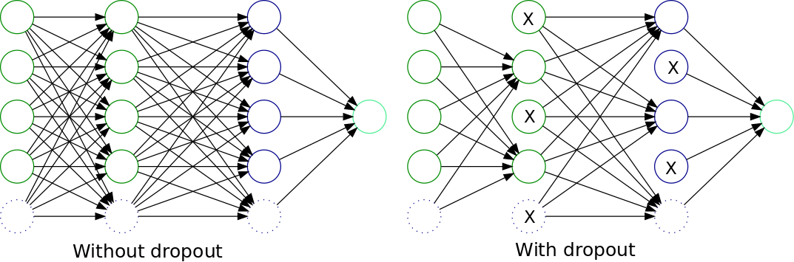
Figure 4.1: Dropout Workflow.

If MC dropout rate is large, then it is more likely to select and train the node in hidden layer.

Iterative Accuracy Assessment
After each iteration, we assess the accuracy of the model. By modifying the MC dropout rate at the selected layer, we aim to improve the accuracy of the system. The accuracy is calculated based on the performance of the model on the given dataset. Let's denote the accuracy as "Acc."
Accuracy = (TP + TN) / (TP + TN + FP + FN)

Receiver Operating Characteristic (ROC Curve)
To further evaluate the uncertainty of model, we employ the ROC analysis technique. The ROC curve represents the trade-off between the Sensitivity (TPR) and the Specificity (TNR) for different classification thresholds. The TPR is calculated as:
Sensitivity (TPR) = TP / (TP + FN)

Similarly, the true negative rate (TNR) is calculated as:

Specificity (TNR) = TN / (TN + FP)

By plotting the ROC curve and calculating the corresponding area under the curve (AUC), we can assess the system's discrimination ability and determine its overall performance.

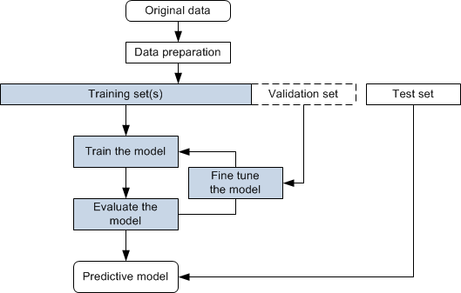
Figure 4.2: Workflow of proposed Deep Learning model.

By following this detailed workflow, incorporating relevant formulas, calculations, and mathematical expressions, we can effectively determine the optimal dropout rate, evaluate rejected patients through physical examinations, and analyze the system's performance using ROC analysis. This comprehensive approach ensures the robustness and reliability of our research methodology.
By providing this detailed workflow of the system, we aim to ensure transparency and reproducibility in our research methodology. Other researchers should be able to replicate our experiments and understand the specific procedures and considerations involved in our approach.

Algorithms/Architecture
In this section of the methodology, we delve into the architecture of DenseNet-121, our chosen backbone for the proposed approach. A detailed explanation of how DenseNet-121 operates and its integration into our research is provided. Additionally, novel procedures introduced and implemented, along with descriptions of existing systems incorporated, will be highlighted.
The proposed model relies on the DenseNet-121 deep learning architecture, which processes a 224 × 224-pixel RGB image. Utilizing pre-trained weights from the ImageNet dataset, relevant features are extracted, and the fully connected layer is optimized for output. Feature extraction is carried out by the convolutional layers, with the last layer handling classification. The model's output involves a softmax activation function to assign probabilities to each class. A distinctive characteristic of DenseNet is the concatenation of the output of each convolutional layer with subsequent layers within the same block, as depicted in Figure 4.2.

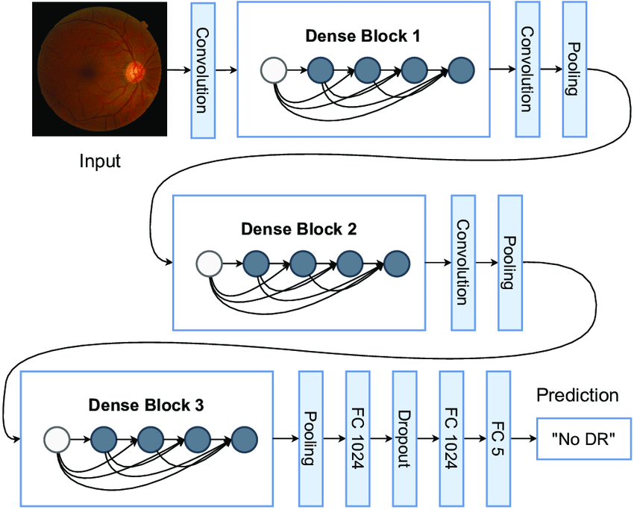
Figure 4.3: DenseNet-121 Architecture.

During image processing by convolutional layers, obtained features are directed to the classification stage. The classifier encompasses two fully connected layers. The first layer comprises 1024 units with a ReLU activation, followed by a dropout layer with a 50% probability and another layer with 1024 units and ReLU activation. The final layer incorporates 5 units with a softmax activation.
DenseNet (Densely Connected Convolutional Networks) represents a deep learning architecture addressing the vanishing gradient problem through dense connections between layers. DenseNet-121, a variant of this architecture, has exhibited outstanding performance across various computer vision tasks.
The core concept of DenseNet revolves around dense connections, where each layer is directly linked to every other layer in a feed-forward manner. This connectivity pattern facilitates efficient gradient propagation, mitigating the vanishing gradient problem, and encourages feature reuse, as earlier layers access diverse feature representations from subsequent layers.
DenseNet-121 comprises multiple dense blocks, each containing densely connected convolutional layers. These dense blocks are linked by transition layers, including pooling operations for spatial dimension reduction and memory consumption alleviation. The architecture concludes with a global average pooling layer, followed by a fully connected layer and softmax activation for classification.
In our research, a novel approach is implemented by replacing the ResNet-50 architecture with DenseNet-121. This change is motivated by the superior performance of DenseNet-121 in various computer vision tasks, promising improved accuracy in diabetic retinopathy classification.
Furthermore, the technique of MC Dropout is incorporated as a regularization method in our DenseNet-121 architecture. MC Dropout involves randomly dropping out a fraction of neurons during training and performing multiple forward passes with different dropout masks during testing. This technique aids in estimating model uncertainty, enhancing the model's generalization ability.
To augment the discriminative power and accuracy in diabetic retinopathy classification, we combine the DenseNet-121 architecture with MC Dropout. Leveraging pre-trained weights of DenseNet-121 on large-scale image datasets like ImageNet, we fine-tune the weights on our specific diabetic retinopathy dataset to capture more relevant and task-specific features.

Design and Implementation

System Design
In this section, we will address various system design issues that are crucial for the successful implementation of our research project. These issues include:

Performance
To achieve optimal performance, we will leverage the advancements in deep learning architectures and techniques. Based on the findings from the previous research, we will select the DenseNet-121 architecture as the foundation for our system. DenseNet-121 has demonstrated superior performance in image classification tasks, making it suitable for our current research objectives. Additionally, we will incorporate regularization techniques such as MC dropout to prevent overfitting and improve the generalization ability of our model.

Robustness
Robustness is a key consideration in our system design. We will implement rigorous data preprocessing techniques to handle diverse input conditions and ensure the system's robustness to variations in image quality, lighting conditions, and other factors. Additionally, we will employ techniques such as data augmentation to enhance the system's ability to generalize and handle variations in the dataset.

Interactivity
Interactivity is an essential aspect of our system design. We will develop a user-friendly interface that allows users to interact with the system seamlessly. This will involve designing intuitive input mechanisms for users to provide image data and receiving real-time predictions or diagnostic outputs from the system.

Flexibility
Flexibility is vital to accommodate future enhancements and adaptability to different use cases. We will design the system with a modular architecture, allowing for easy integration of additional features, such as image pre-processing techniques, alternative classification algorithms, or compatibility with different datasets. This flexibility will enable the system to evolve and adapt to emerging research advancements and changing requirements.

Re-usability and Portability
To maximize reusability and portability, we will follow best practices in model development. The system components will be designed to be modular and independent, facilitating their reuse in other projects or research endeavors. Additionally, we will ensure compatibility with popular deep learning frameworks and libraries to enhance portability across different computing environments.

Security
Security is of paramount importance in our system design, considering the sensitive nature of medical data. We will implement appropriate security measures to protect user data, ensure secure communication channels, and comply with privacy regulations. This will include techniques such as encryption, access controls, and secure storage of data.

Architecture Design
We will define the interaction between different components and modules of the system. This will involve identifying the dependencies, interfaces, and communication channels between the various elements. Here is the workflow of our architecture design.

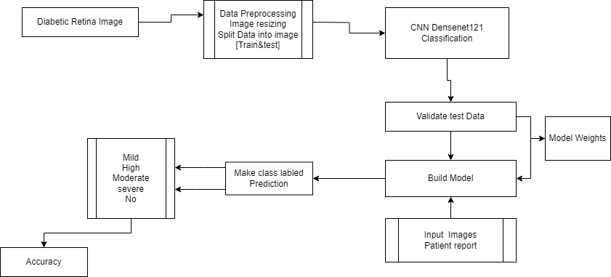
Figure 5.1: Workflow of Proposed System Architecture Design.

Diabetic Retina Image
Users provide labeled images from the dataset as input. Users are responsible for managing the data source, which is a dataset of labeled images.

Data Preprocessing
This module takes input images and prepares them for integration with the deep learning architecture. It performs preprocessing tasks, including resizing the images, and splits the data for further processing.

Deep Learning Model
At the core of the system is a deep learning model based on the CNN DenseNet-121 architecture. This model is responsible for image classification. It takes preprocessed images as input and generates predictions.

Validate Test Data
In this module, the system validates the data. The model, specifically using the MC Dropout method, assesses its capabilities and confidence in making predictions. This step ensures the reliability of the model's predictions.

Model Weights
Real values are assigned to each input feature, indicating their importance in predicting the final output. These weights enhance the model's accuracy and predictive power.

Build Model
The model is constructed and made operational. Additional model weights can be incorporated as needed, allowing for flexibility in adapting to different scenarios.

Input Images
Users and the dataset provide input images. The dataset contains labeled images used for training and testing, while users contribute patient report data related to retina images. The dataset facilitates training, and the user's input enables real-world diagnoses.

Make Class Labeled Prediction
In this module, the built model assigns labels to the input images provided by patients in their reports. It determines whether the images indicate diabetic retinopathy, its severity (mild, high, moderate, severe), or if no issues are detected.

Condition
This module outputs the results, indicating the condition of the patient's retina. It provides information on whether diabetic retinopathy is present and, if so, its severity level.

Accuracy
The system evaluates the accuracy of its predictions, ensuring the reliability of the results provided to users and medical professionals.

Interactions
Users and the dataset contribute input images, with the dataset containing labeled images used for training and testing. Users provide patient reports containing retina images for diagnosis. If a diagnosis is made, the information is further communicated to medical professionals for review and action. This interaction ensures seamless collaboration between automated diagnosis and medical expertise.
Now, we will expand the workflow of architecture, providing more details about the internal components and their interactions.
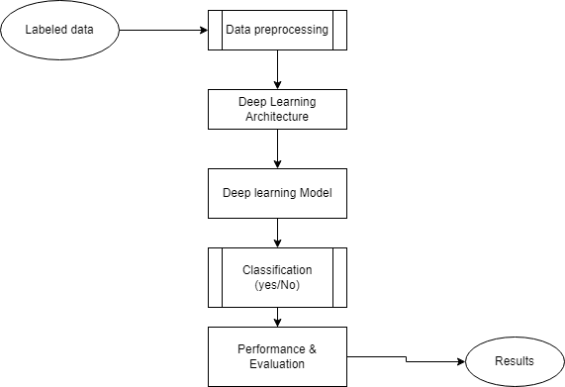
Figure 5.2: System Architecture Design providing more details about the internal components and their interaction

System Implementation
In the system implementation section, we will describe how the different components of our research project have been implemented. This includes:

Development Tools and Environment
We will provide an overview of the development tools and environment used in the implementation of the system. This may include the programming language (such as Python), deep learning frameworks (such as Keras or TensorFlow), and any specific software or hardware requirements.
In our project, we leverage various software tools and libraries to facilitate the implementation of deep learning models and perform data preprocessing, model training, and evaluation. Specifically, we utilize the following tools and technologies:

Python
We choose Python as our primary programming language due to its extensive support for machine learning and deep learning frameworks, as well as its ease of use and flexibility. Python provides a wide range of libraries such as Keras, TensorFlow, and scikit-learn, which are essential for implementing and training deep learning models.

Jupyter Notebook
Jupyter Notebook provides an interactive development environment that allows us to write and execute code in a modular and exploratory manner. It enables us to document our code, visualize data, and experiment with different model configurations. The use of Jupyter Notebook enhances the reproducibility and transparency of our research project.

Keras and TensorFlow
Keras is a high-level deep learning library that serves as an interface to the TensorFlow backend. It offers a user-friendly API for building and training neural networks. We utilize Keras, along with the powerful TensorFlow framework, to implement the DenseNet-121 architecture and incorporate the MC dropout technique. These libraries provide extensive support for deep learning tasks, including model construction, training, and evaluation.

OpenCV
OpenCV (Open Source Computer Vision Library) is a popular computer vision library that offers a wide range of functions and algorithms for image processing and manipulation. We employ OpenCV for tasks such as reading and resizing retinal images, which are essential steps in the data preprocessing pipeline.

Other Python Libraries
We leverage additional Python libraries such as pandas and numpy for data manipulation and preprocessing, matplotlib for data visualization, and scikit-learn for model evaluation and performance metrics.
The development environment for our project is Google Colab, which provides a cloud-based platform for running Jupyter Notebooks. Google Colab offers free access to GPUs, allowing us to accelerate the training of deep learning models. Additionally, it provides seamless integration with Google Drive, enabling easy data storage and retrieval.
By utilizing these development tools and creating a conducive environment, we are equipped to implement and evaluate the proposed system effectively. These tools and technologies, combined with the knowledge gained from previous research, insights from the current research methodology, and the learnings from the coding experiment, empower us to address the design and implementation challenges of our research project.

Implementation of Modules
The implementation of modules is a critical aspect of our research project. It involves the development and integration of different components that collectively contribute to the functionality and objectives of the system. In this section, we will discuss the implementation of various modules in our project, taking into account the insights gained from previous research, the requirements of our current research methodology, and the specific implementation details observed in the coding experiment.

Data Preprocessing Module
The data preprocessing module assumes the crucial role of preparing the dataset for both training and evaluation purposes. Its responsibilities encompass fundamental tasks such as reading and resizing retinal images, applying data augmentation techniques (including rotation, flipping, and zooming), normalizing pixel values, and partitioning the dataset into distinct training and validation sets. The implementation of this module leverages the capabilities of the OpenCV library alongside image preprocessing functions embedded in Keras and TensorFlow. The design of this module is informed by the data preprocessing steps identified in a coding experiment, where retinal images were systematically resized and normalized before incorporation into the training pipeline for various models.

Model Architecture Module
DenseNet-121 model with MC dropout initializes the pre-trained DenseNet-121 model and replaces the last fully connected layer with a new sequential layer that consists of a linear layer followed by a softmax activation. The dropout layer is applied after the average pooling layer. This implementation aligns with the insights gained from previous research, which highlights the effectiveness of DenseNet-121 for image classification tasks.

Training and Evaluation Module
The training and evaluation module manage the process of training the adapted DenseNet-121 model using the dataset prepared through the data preprocessing module. For training configuration, we specify the optimizer, loss function, and evaluation metrics. The train_epoch function is meticulously defined to execute a single training epoch. It systematically iterates over the training data loader, feeds the images and labels to the model, computes the loss using the CrossEntropyLoss criterion, executes backpropagation, and updates the model parameters using the optimizer. This function concurrently tracks the running loss, correct predictions, and total samples, facilitating the computation of epoch loss and accuracy. The available GPU resources in the Google Colab environment are harnessed to expedite the training process. Following the training phase, the model's performance is meticulously evaluated on the validation set, employing pertinent metrics such as accuracy, precision, recall, and F1 score.

Feature Extraction Module
The feature extraction module focuses on extracting deep features from the modified DenseNet-121 model. We leverage the intermediate layers of the model to obtain feature representations of the retinal images. These features are then used for further analysis, such as training traditional machine learning classifiers. The implementation of this module draws inspiration from the coding experiment, where the features extracted from the DenseNet-121 model.

Model Evaluation and Performance Metrics Module
The model evaluation and performance metrics module involves assessing the performance of the modified DenseNet-121 model and traditional machine learning classifiers. We utilize standard evaluation metrics such as accuracy, precision, recall, and F1 score to quantify the performance of the models. This module also includes techniques for visualizing the model's predictions, such as confusion matrices and ROC curves. The implementation of this module is influenced by the insights gained from previous research, the requirements of our current research methodology, and the performance evaluation observed in the coding experiment.
Throughout the implementation of these modules, we adhere to coding conventions and standards to ensure readability, maintainability, and reusability of the code. We document the implementation steps, including specific code snippets and function descriptions, to provide a comprehensive understanding of the module functionalities.
By implementing these modules and incorporating the relevant information from previous research, our current research methodology, and the learnings from the coding experiment, we ensure a comprehensive and systematic approach to the design and implementation of our research project. The modules cover crucial aspects such as data preprocessing, model architecture, training and evaluation, feature extraction, and model performance analysis. This holistic implementation approach enables us to achieve our research objectives effectively.

Assumptions / Constraints
This section typically covers assumptions made during the project and constraints that may affect the project's implementation. Here are some assumptions and constraints that we considered during our implementation:

Assumptions
Here are some assumptions that we considered during the implementation of the project:

Data Assumptions
We assume that the datasets used for this research accurately represent the distribution of retinal images related to diabetic retinopathy. While these datasets are widely recognized in the field, the assumption of their representativeness is fundamental to the generalization of our model's findings to real-world clinical scenarios.

Technical Assumptions
We assume access to suitable hardware resources for model training and evaluation. Given the resource-intensive nature of deep learning, access to GPUs is assumed for efficient model training. Additionally, we assume that the software libraries and frameworks mentioned in Section 5.2.1 remain available and compatible throughout the project's duration.

User Assumptions
It is assumed that users interacting with the system have a basic understanding of the system's purpose and functionality. While efforts will be made to make the user interface intuitive and user-friendly, users are expected to provide valid input data for accurate diagnosis.

Constraints
Here are some constraints that we considered during the implementation of the project:

Resource Constraints
The project operates under resource constraints, primarily in terms of budget and computing resources. Although cloud-based services are leveraged for some computational tasks, there are budget limitations that influence the extent of cloud resource utilization. Hardware limitations, particularly for GPU availability, may impact the speed and scale of model training.

Regulatory Constraints
Given the sensitive nature of medical data, the project is subject to stringent regulatory requirements related to data privacy and security. Compliance with regulations such as the Health Insurance Portability and Accountability Act (HIPAA) is a paramount concern, and it necessitates the implementation of robust security measures, data encryption, and access controls.

Technical Constraints
The chosen deep learning model architecture, DenseNet-121, while powerful, has certain technical constraints in terms of model size and memory requirements. These constraints must be considered when deploying the model in resource-constrained environments, such as edge devices.

Performance Constraints
Real-time processing is a desirable feature for medical diagnostic systems. However, achieving real-time performance may be challenging given the computational demands of deep learning. Thus, there may be performance constraints in terms of the time required for image analysis and diagnosis.
These assumptions and constraints shape the project's scope, design, and implementation strategy. By acknowledging and addressing these considerations, we aim to ensure the integrity, reliability, and ethical conduct of our research project.

Evaluation

Experimentation
In this chapter, we delve into the practical aspects of our research by detailing the setup and execution of our deep learning model for diagnosing eye conditions. This section provides a clear exposition of the steps taken in the laboratory notebook, including procedures, techniques, and instrumental considerations. The goal is to offer sufficient detail to allow experienced researchers to replicate our work and obtain comparable results.

Experimental Setup
In this section, we detail the setup employed for conducting the experiments on Google Colab. The primary objective is to provide a comprehensive overview of the environment and tools used during the research. Key elements include:

Platform:
We leverage Google COLAB as our platform of choice, harnessing its GPU support to accelerate computations. This strategic utilization of Colab's GPU infrastructure enhances the efficiency of our experiments, enabling faster processing and analysis, ultimately contributing to the robustness of our research findings.

Software and Libraries:
For our research, we use TensorFlow as our deep learning framework and several key libraries. These include:
- OpenCV for image processing
- Pillow (PIL) for image handling
- Keras for building neural networks
- Matplotlib for visualization
- Pandas for data manipulation
- Scikit-learn for machine learning tools.
- Numpy for dealing with arrays and other mathematical operations.
This selection of tools ensures a reliable and accessible foundation for our experiments, contributing to the accuracy and reproducibility of our findings.

Hardware Configuration:
Certainly, in our research project, we employ an NVIDIA GeForce RTX 2080 Ti GPU for the training phase. This GPU is recognized for its robust computing capabilities, featuring 11 GB of GDDR6 VRAM, which is crucial for managing intricate deep learning models and handling extensive datasets efficiently. With 4,352 CUDA cores, the RTX 2080 Ti facilitates parallel processing, expediting the training of neural networks. This hardware choice ensures optimal performance and efficiency aligned with our group's specific computational requirements during the training phase of the experiments.

Data Preparation:
In our research, we acquired two datasets, APTOS 2019 and DDR, from Kaggle. To address the class imbalance issue, we merged these datasets and remove the class imbalance issues which can further cause many issues during the training of the model.
Merging datasets provides a larger and more diverse sample size, improving statistical power and enabling robust analyses. This comprehensive approach can yield more accurate machine learning models with enhanced predictive capabilities. The combined datasets offer a more representative view of the target population, facilitating better-informed decision-making.
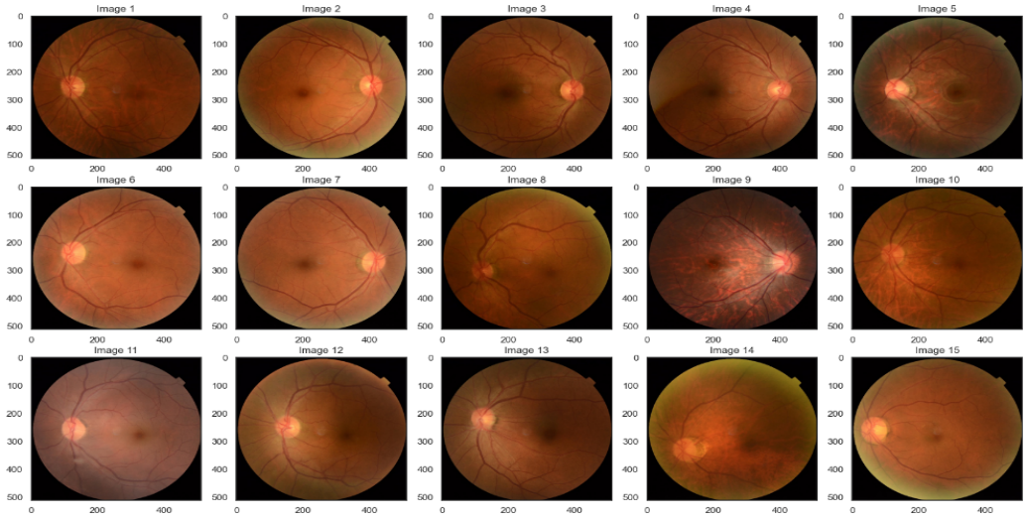
Figure 6.1: Images of our Merged Dataset (APTOS-2019 & DDR).

Merging also helps handle missing information by filling gaps with complementary data, leading to more complete datasets. Corroborating findings across datasets enhances the reliability of results and strengthens the credibility of conclusions. Efficient data management is achieved through a unified dataset, simplifying tasks like cleaning and transformation. Additionally, merging datasets can be a cost-effective strategy, optimizing resources by leveraging existing information rather than collecting entirely new data.
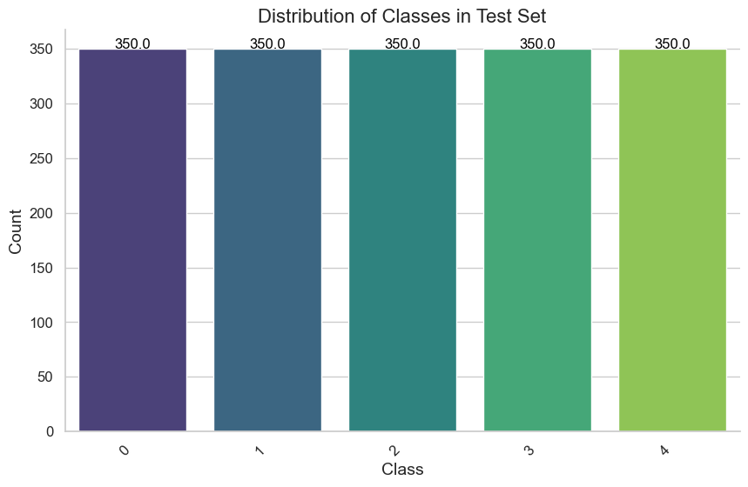
Figure 6.2: Distribution of Classes in Test set (No. of samples in each Class)

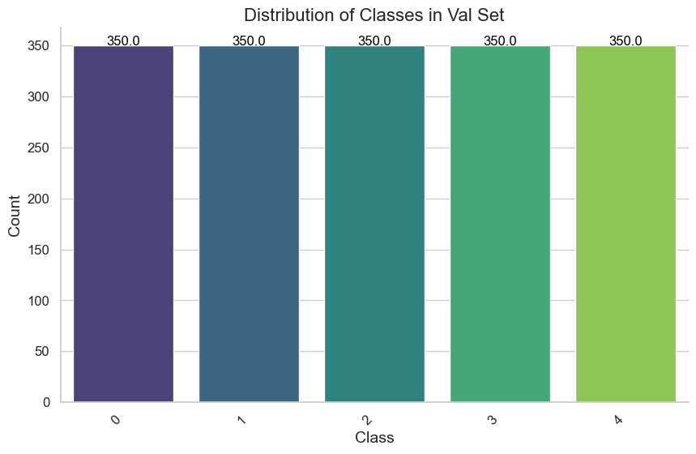
Figure 6.3: Distribution of Classes in Valid set (No. of samples in each Class)

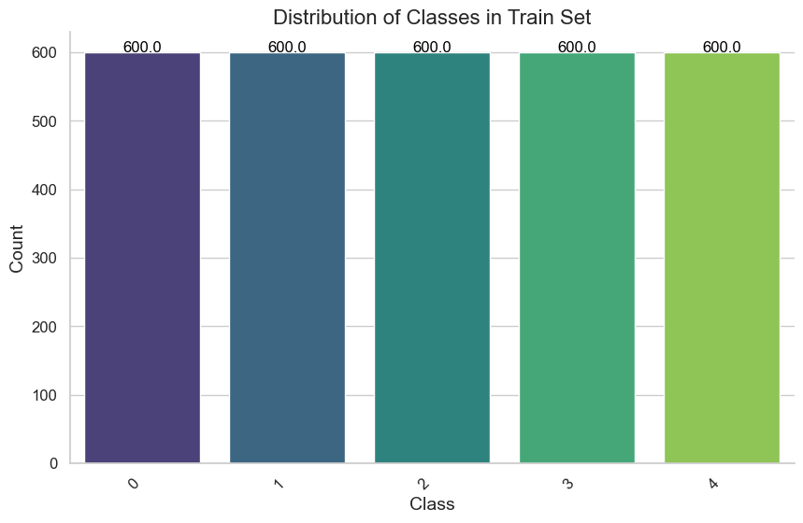
Figure 6.4: Distribution of Classes in Train set (No. of samples in each Class)

Subsequently, we applied further preprocessing steps to ensure uniformity and enhance the quality of the data. Firstly, we resized all images to a consistent size of 224x224x3 pixels. Additionally, to mitigate the impact of noise and enhance feature visibility, we employed Ben Graham preprocessing techniques.
It was imperative to preprocess the images before inputting them into the neural network model. Figure 6.5 illustrates the application of diverse preprocessing techniques, with the goal of standardizing and optimizing the images. This process aimed to enhance the quality of the images, thereby facilitating accurate analysis and classification.

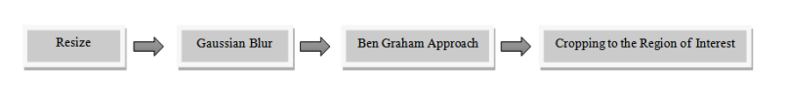
Figure 6.5: Various Image Processing Techniques.
Resizing images is a crucial preprocessing step offering multiple advantages. It enhances computational efficiency by reducing the processing load, crucial for large datasets, and contributes to memory conservation. Standardizing image sizes ensures uniformity, simplifying model architecture and minimizing errors. Resizing also acts as a form of data augmentation, introducing variability and improving the model's generalization across different input sizes. The efficiency of model training and inference is improved, as smaller images require less processing time. We resize all images in the merged dataset to 224x224x3 because the pre-trained model we choose for our research have the input layer with the input images size 224x224x3, so we convert accordingly so that model become more generalize and understand the images better.
Gaussian blur enhances image quality by reducing noise and emphasizing essential features, contributing to improved model performance. The smoothing effect aids in preventing overfitting to irrelevant details, promoting better generalization. It also increases robustness by making images more resilient to variations and distortions. Gaussian blur serves as effective privacy protection by obscuring specific details, and it functions as a valuable tool for data augmentation, introducing variability for more resilient machine learning models.
Ben's Graham approach enhances image contrast, mitigates uneven illumination, and improves feature visibility, particularly beneficial in medical imaging for accurate diagnostics. It reduces model sensitivity to illumination changes, enhancing robustness. Additionally, the approach contributes to dataset consistency, ensuring reliable model performance across diverse scenarios.
Cropping to the Region of Interest (ROI) optimizes computational efficiency by excluding irrelevant background, enhancing model generalization, and robust feature extraction. It reduces sensitivity to variability and noise, improving model performance. The approach also aids in privacy preservation by focusing on essential information in sensitive applications like medical imaging. Additionally, it simplifies data interpretation and augments dataset diversity, contributing to more effective and efficient machine learning models.
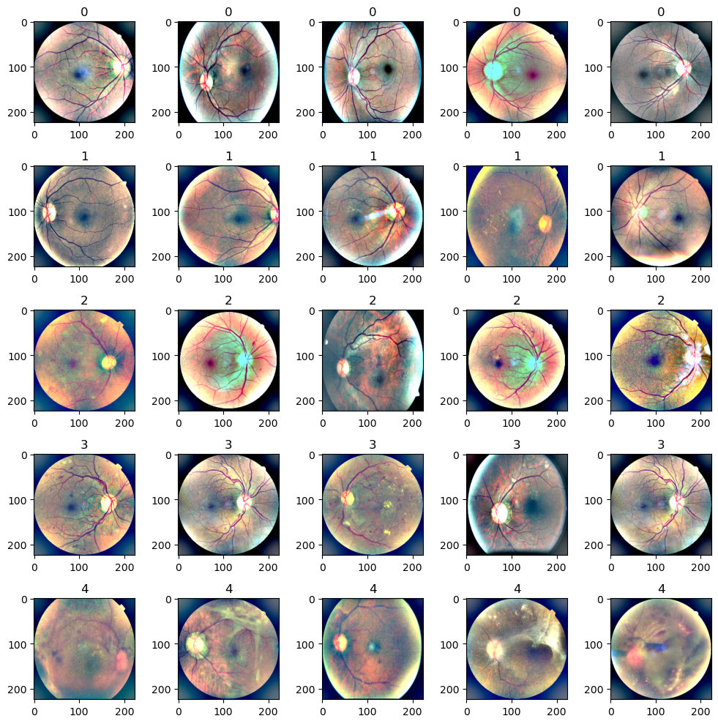
Figure 6.6: Preprocessed images after Ben's Graham Pre-Processing.
This data preparation process lays the foundation for robust model training and evaluation in our research. At the end we initializes an empty NumPy array 'x_train' with dimensions (N, IMG_SIZE, IMG_SIZE, 3), where N is the number of samples in the training dataset and IMG_SIZE is the specified image size. Then iterates through the rows of the 'train_df' DataFrame, loading and preprocessing each image using a function called 'preprocess_image_with_ben'. The processed images are stored in the 'x_train' array.

Experiments Design/Details
This subsection delves into the specifics of the experimental design. It outlines the parameters, configurations, and procedures followed during the fine-tuning of the DenseNet-121 CNN model and Bayesian DenseNet-121 CNN with MC dropout. Key aspects to cover include:

Model Architecture:
To identify compromised retina images indicative of health issues, we designed two unique deep learning (DL) models proficient in addressing this objective. The proposed model relies on the architecture of DenseNet-121. This section provides an elaborate examination of both models, commencing with an overview of the simple DenseNet-121 model and subsequently delving into the specifics of the DenseNet-121 model with Bayesian Approximation using MC Dropout.

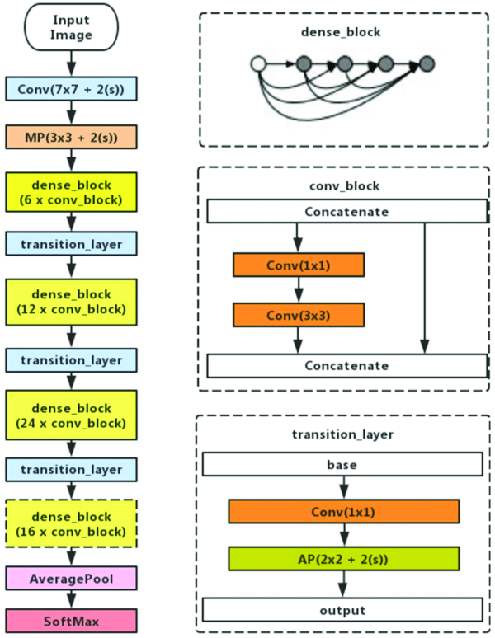
Figure 6.7: DenseNet Architecture.

DenseNet represents a distinct convolutional neural network (CNN) architecture designed to enhance network depth by establishing forward-flow connections between each layer. In the DenseNet model, every layer receives inputs from all preceding layers and shares its feature maps with all subsequent layers, creating a dense connectivity pattern. This strategy ensures efficient information flow and promotes the reuse of features across the network.
The architecture of the DenseNet-121 model, illustrated in Figure 6.7, encompasses fundamental convolutional and pooling layers, dense blocks, and transition layers. The model initiates with a convolutional block applying a 7×7 sliding window to the input image, generating 64 output layers with a stride of 2 for downsampling. A subsequent max-pooling layer with a 3×3 sliding window and a stride of 2 further reduces the spatial dimensions of the feature map.
Within the DenseNet structure, multiple dense blocks exist, each containing a sequence of operations. The convolutional blocks within each dense block follow a specific pattern, comprising batch normalization, ReLU activation, and Conv2D layers. In DenseNet-121, this sequence repeats 6 times in the first dense block, 12 times in the second, 24 times in the third, and 16 times in the final dense block.
Transition layers in DenseNet serve to diminish the number of channels in feature maps and are positioned immediately after each dense block. These layers consist of a 1×1 convolutional layer followed by a 2×2 average pooling layer with a stride of 2. This gradual reduction in channel numbers from one dense block to the next, such as from 256 to 128, then to 64, and finally to 32 in DenseNet-121.
The DenseNet architecture integrates a global average pooling layer that conducts spatial pooling across the entire feature map, resulting in a fixed-length vector representation. This pooling operation aggregates feature maps into a concise representation capturing essential information. Ultimately, a fully connected layer is employed for classification, succeeded by a softmax activation function to generate class probabilities.

Fine Tuning of Model:
Transfer learning is a machine learning strategy where a previously trained model, designed for a specific task, is repurposed for a related but distinct task. In our experiments, DenseNet121 a pre-trained convolutional neural network (CNN), is utilized as a feature extractor. The wealth of knowledge embedded in DenseNet's pre-existing weights, acquired from an extensive dataset, is leveraged to enhance the model's ability to recognize image features effectively. By excluding the top layers and incorporating a new set customized for the multiclass classification task, the model undergoes fine-tuning for this specific application. This approach proves advantageous in scenarios where labeled data for the target task is limited, enabling the model to capitalize on insights gained during its original training. The methodology involves freezing the pre-trained layers to preserve their learned features, with only the weights of the newly added layers adjusted during training. This process facilitates swift convergence and often results in enhanced performance for the targeted task.

Hyperparameters:
The initialization of hyper-parameters is a critical aspect of deep learning models, exerting a significant influence on their performance and convergence. In this study, we adhered to established practices for hyper-parameter initialization, ensuring alignment with the specific characteristics of the employed models.
Among these hyper-parameters, the learning rate holds particular importance. This configurable parameter plays a crucial role in neural network training by determining the scale of weight updates during each iteration or step. It acts as a multiplier for gradients in backpropagation, thereby influencing convergence speed and quality. While a higher learning rate facilitates faster convergence, it introduces the risk of overshooting the optimal solution. Conversely, a lower learning rate ensures more precise weight updates but may necessitate additional training epochs for convergence.
Another pivotal hyper-parameter is the batch size, defining the number of samples processed before updating the model. The chosen batch size strikes a balance between computational efficiency and the quality of weight updates. Smaller batches enable quicker convergence but come with higher computational overhead, while larger batches optimize efficiency through parallelism but may lead to less frequent weight updates.
The determination of the number of epochs, signifying complete passes through the training dataset, was a careful process based on model convergence behavior and the desired training level. Complex tasks or models may require more epochs for convergence, in contrast to simpler tasks or models that converge faster. The detailed parameter configurations for both models are presented in Table 5.

Table 5: Hyper Parameters for the DenseNet-121 & BCNN with MC Dropout models.
Hyper-Parameters | Simple DenseNet-121 | BCNN (MC Dropout)
Batch Size | 8 | 8
Initial Learning Rate | 0.001 | 0.001
Minimum Learning Rate | 5e-5 | 0.00005
Epochs | 40 | 100
Optimizer | Adam | Adam
Dropout | 0.5 | 0.5
Activation Function | Softmax | Softmax
Loss Function | Categorical Cross Entropy | Categorical Cross Entropy

Results
In this section, we present the results stemming from our experimental evaluation of the proposed approach and engage in a discussion regarding its effectiveness. The central goal of this analysis was to assess the potential of employing pre-trained models through transfer learning and Bayesian Convolutional Neural Network (BCNN) modeling for classification, while systematically quantifying the associated uncertainty. Our objectives aimed at gaining a thorough understanding of the model's capabilities and pinpointing areas for potential enhancement or further exploration. Through a meticulously designed series of experiments, we scrutinized various aspects of the method's performance, offering a comprehensive analysis of the outcomes. The interpretation of results is contextualized within the existing literature, emphasizing potential implications for future research endeavors.

Training Process for DenseNet-121 Model:
Upon the generation of the new dataset through preprocessing, the pre-trained DenseNet-121 model underwent a training phase lasting 40 epochs following fine-tuning. The training process employed the Adam optimization algorithm, incorporating a range of learning rate values spanning from 0.001 to 5e-5. The evaluation of the model's performance during training was conducted using categorical cross-entropy as the loss function. In the context of multi-class classification for input images, the output layer of the DenseNet-121 model featured a convolution layer employing the Softmax activation function. This facilitated the classification of the five distinct levels of diabetic retinopathy.
Following a series of experiments, we systematically identified the optimal combination of optimization algorithm and learning rate values that resulted in the highest accuracy for our proposed model. For clarity, a comprehensive summary of the hyper-parameter configuration and input image size employed in the model is presented in Table 2. The training process involved iterative experimentation with various hyper-parameters, aiming to achieve optimal performance in the classification of diabetic retinopathy.

Training Process for Bayesian DenseNet-121 Model:
The training of the Bayesian Convolutional Neural Network (DenseNet-121) model closely followed the architecture of the base DenseNet-121. For the Monte Carlo Dropout (MC Dropout) model, a uniform dropout probability of 0.5 was applied across all layers, and the training spanned 100 epochs. The optimization process utilized Adam as the optimizer, employing a learning rate of (5e-5) specific to MC Dropout. The chosen batch size was set at 8. The training regimen for the Bayesian DenseNet-121 models involved the incorporation of dropout and uncertainty estimation techniques. This integration contributed significantly to improving accuracy and overall performance in the classification of diabetic retinopathy.

Proposed models Performances:
We conducted a comprehensive performance evaluation of our proposed models for Diabetic Retinopathy (DR) classification. Utilizing a dataset comprising retinal images, we employed our proposed models to evaluate their prediction accuracy and conducted an in-depth analysis of model uncertainty. Following this, a comparative assessment was undertaken to gauge the performance of our proposed models against existing state-of-the-art studies in the field of DR classification.

Classification Performance of our proposed Models:
In the assessment of classifying diabetic retinopathy, the performance of both the simple DenseNet-121 (CNN) and the Bayesian DenseNet-121 (BCNN) models is detailed in Table 6. Additionally, Figures 6.8 & 6.9 illustrate the Accuracy / Loss graphs of simple DenseNet-121 and BCNN-MC dropout models. Results indicate that the Bayesian DenseNet-121 with MC dropout model outperforms the simple DenseNet-121 model in terms of accuracy, achieving rates of 97.6%, and 91.57% for simple DenseNet-121, BCNN MC-Dropout respectively.

Table 6: Performance of our simple DenseNet121 & BCNN-MC Dropout for DR detection
Model | Training Accuracy (%) | Training loss (%) | Testing Accuracy (%) | Testing loss (%) | Precision | Recall | F1-score
Simple DenseNet-121 | 91.57% | 28.17% | 91.49% | 26.80% | 93.22% | 91.10% | 92.33%
BCNN (MC Dropout) | 97.66% | 3.33% | 98.51% | 2.21% | 95.22% | 99.04% | 98.01%
Here, Figure 6.8 & 6.9 shows the Training and Validation Accuracy / Loss Graph of both models:
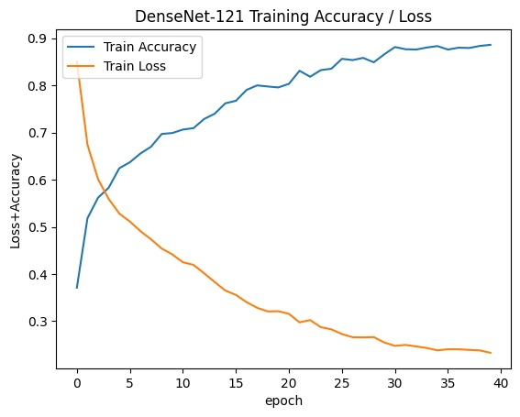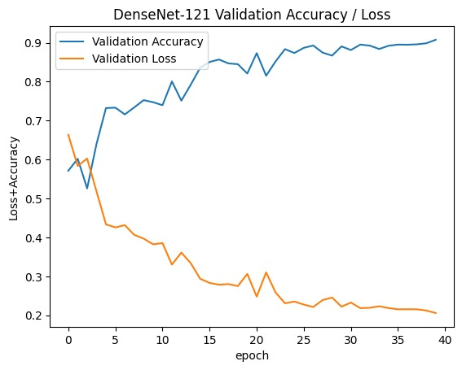
Figure 6.8: Training & Validation Accuracy / Loss Graph of simple DenseNet-121 model.

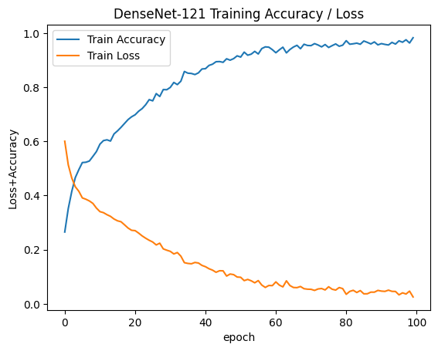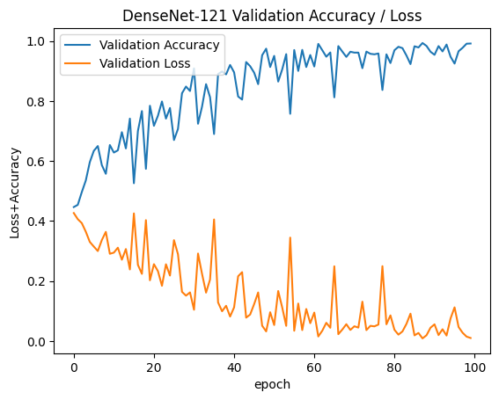
Figure 6.9: Training & Validation Accuracy / Loss Graph of BCNN DenseNet-121 with MC Dropout model.

The assessment of model performance is intricately detailed through the visualization of confusion matrices in Figures 6.10 & 6.11. In Figure 6.11, the confusion matrix for the BCNN DenseNet-121 with MC Dropout model highlights its commendable performance, showcasing lower false-negative and false-positive values during multi-classification on the testing data. Figure 6.10 presents the confusion matrix simple DenseNet-121, revealing a marginal increase in false-negative and false-positive values compared to the BCNN-MC dropout model.
Analyzing Figures 6.10 and 6.11 offers insights into the correct classification rates across different severity levels. The "NO-DR" class consistently boasts the highest correct classification rate, indicating the model's proficiency in accurately identifying instances of no diabetic retinopathy. Conversely, the "severe" class consistently exhibits the lowest correct classification rate among the severity levels, suggesting challenges in accurately identifying severe cases.
The confusion matrices serve as powerful visual tools, offering a granular understanding of the models' strengths and weaknesses in differentiating between classes. The BCNN-MC dropout model excels in minimizing false classifications, particularly for the "NO-DR" class. Although simple DenseNet-121 exhibits slightly increased false-negative and false-positive values, the confusion matrix provides a nuanced view of its performance across different severity levels. These visualizations contribute valuable insights into the CNN model's capabilities and areas for refinement in the classification of diabetic retinopathy.
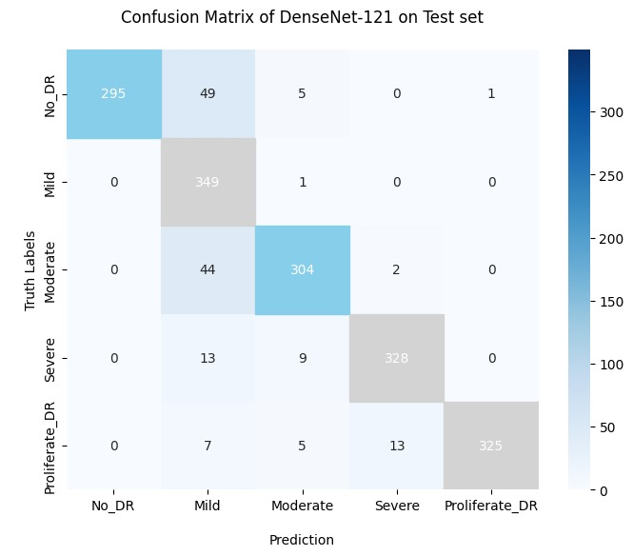
Figure 6.10: Confusion Matrix for the simple DenseNet-121 model on Test data.

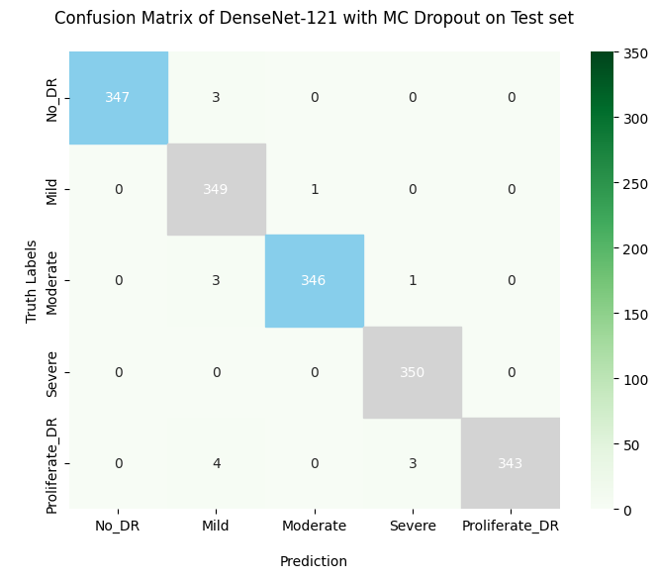
Figure 6.11: Confusion Matrix of BCNN DenseNet-121-MC Dropout model on Test data.

Uncertainty Information of BCNN Model:
Quantifying uncertainty in the context of BCNN MC-Dropout, the initial step in uncertainty quantification involved the selection of an appropriate MC-dropout rate. This is crucial for balancing overfitting and underfitting during training. The hyperparameter governing the probability of neuron dropout in the network was experimentally determined to be 0.50, with an optimal MC sample equal to 20. This choice was essential for preventing overfitting and enhancing generalization performance.
To measure and visualize the uncertainty of the model, the ROC (AUC) curve was utilized to calculate and visualize the uncertainty of the model class-wise for our proposed Bayesian model. Additionally, entropy and probabilities of the predictive distribution were computed for the BCNN model, providing a means to visualize the uncertainty of the model using the Calibration Curve.
Generating a Receiver Operating Characteristic (ROC) curve involves the computation of True Positive Rate (TPR) and False Positive Rate (FPR). The corresponding equations for these are defined as follows:

True Positive Rate (TPR) = True Positives (TP) / True Positives (TP) + False Negatives (FN)

False Positive Rate (FPR) = False Positives (FP) / False Positives (FP) + True Negatives (TN)

These calculations serve as the foundation for plotting the ROC curve, a valuable tool in assessing the performance of classification models.
Uncertainty quantifications for our BCNN model are presented in Figure 6.12. Results indicate that the BCNN MC-Dropout model exhibits lower uncertainty suggesting the effectiveness of the MC Dropout method in capturing underlying uncertainty.
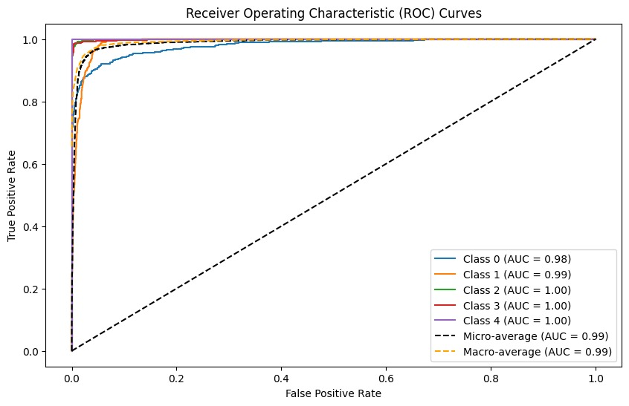
Figure 6.12: Uncertainty Quantification for BCNN-MC Dropout Model for each class.
We also plot the Calibration curve to visualize the Bayesian model uncertainty of our proposed model on test data or new / unseen data. The Calibration Curve serves as a valuable tool for visualizing model uncertainty, providing a comprehensive understanding of how predicted probabilities correlate with actual outcomes. The process of easily visualizing model uncertainty using a Calibration Curve involves several steps:
- Generate Predictions: Obtain the predicted probabilities from the model for a selected set of examples within the validation or test dataset. These probabilities represent the model's level of confidence in its predictions.
- Bin Predictions: Organize the predicted probabilities into distinct bins or intervals. The choice of the number of bins depends on preferences and the available dataset size.
- Calculate Mean Predicted Probability: For each bin, compute the mean predicted probability and plot it against the actual fraction of positive outcomes within that bin. The actual fraction is determined by the ratio of positive outcomes to the total number of examples in the bin.
- Ideal Calibration Line: Visualize the ideal calibration line, a 45-degree diagonal line where the predicted probability aligns precisely with the actual fraction of positive outcomes. Proximity to this line indicates a well-calibrated model.
- Plot the Calibration Curve: Plot the mean predicted probability on the x-axis and the actual fraction of positive outcomes on the y-axis. The resulting curve provides a visual representation of the model's calibration.
In conclusion, the Calibration Curve enables a comprehensive evaluation of the reliability of a model's predicted probabilities. A well-calibrated model is reflected by a curve closely resembling the ideal line, indicating that predicted probabilities align effectively with actual outcomes. Any deviations from the ideal line serve as valuable indicators for potential improvements, particularly in understanding and addressing model uncertainty.
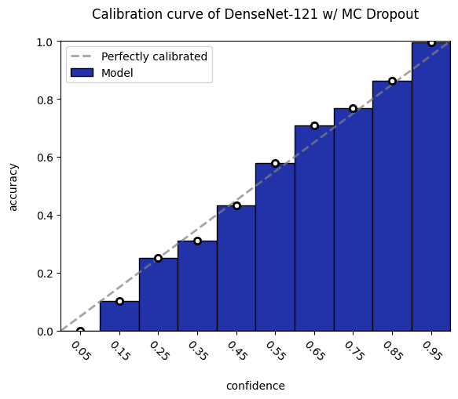
Figure 6.13: Calibration Curve of the Model BCNN-(DenseNet-121)-MC dropout.
Figure 6.13 shows the model confidence on its predictions and visualize that our proposed model shows the outperform performance and shows the correctly predictions of almost all unseen samples. We also visualize the uncertainty of our simple DenseNet-121 model and check its confidence on its predictions and we analyze that our simple DenseNet-121 model is not much confident on its prediction due to the lack of the predictive probability distribution and posterior probability distribution of the samples.

Classification Reports:
The classification report for simple DenseNet-121 provides a comprehensive assessment of its performance across various classes. Precision, recall, and F1-score metrics are presented for each class, ranging from 0 to 4, indicating the severity of diabetic retinopathy. The macro and weighted averages offer consolidated insights into the overall effectiveness of the model.
The classification report is a valuable tool utilized to present key metrics such as precision, recall, and F1-score for the model. Before delving into these metrics, it's essential to clarify the symbols used in the report:
TN (True Negative): The prediction is negative, and the actual value is negative.
FN (False Negative): The prediction is negative, while the actual value is positive.
FP (False Positive): The prediction is positive, while the actual value is negative.
TP (True Positive): The prediction is positive, and the actual value is positive.
Precision below, represents the ratio of correctly classified true positives to the sum of true positives and false positives:
Precision = TP / TP + FP
Recall below, signifies the ratio of correctly classified true positives to the sum of true positives and false negatives:
Recall = TP / TP+FN​
The F1-score, acts as a harmonious balance between precision and recall:
F1-score = 2× Precision × Recall / Precision + Recall
Accuracy, a pivotal classification ratio reflecting all correctly classified data in the entire test set below:
Accuracy = TP+TN / TP+TN+FP+FN
These metrics collectively provide a comprehensive evaluation of the model's performance, ensuring a nuanced understanding of its precision, recall, and overall accuracy in classification tasks.
The model showcases robust performance with an accuracy of 91.10%. Precision reflects the model's accuracy in classifying instances within each class, while recall gauges its ability to capture all relevant instances.
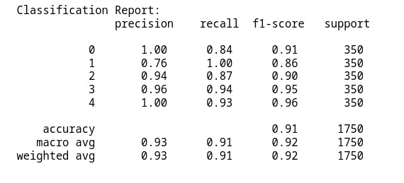
Figure 6.14: Classification Report of our simple DenseNet-121 model.
The classification report for DenseNet-121 with MC Dropout (BCNN) highlights the impact of incorporating uncertainty quantification through dropout during both training and inference. Similar to the simple DenseNet-121, the report outlines precision, recall, and F1-score metrics for each class. Figure 6.16 shows the classification report of the BCNN-MC dropout model.
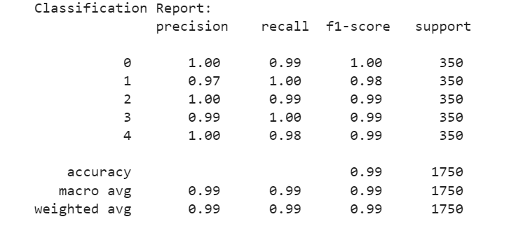
Figure 6.15: Classification Report of our BCNN-MC Dropout Model.
Comparison between the both models reveals a marginal improvement in accuracy for DenseNet-121 with MC Dropout, reaching 97.33% training accuracy. The enhanced uncertainty quantification contributes to more nuanced predictions, especially noticeable in the equilibrium between precision and recall. This classification report illuminates the model's proficiency in capturing and classifying instances, providing valuable insights for further refinement.

Discussion/Analysis

Model Performance Insights:
In examining the classification reports of the simple DenseNet-121 and BCNN-MC Dropout, several notable insights emerge. The basic DenseNet-121 model showcases commendable accuracy at 91.21%, demonstrating its proficiency in classifying diabetic retinopathy across different severity levels. Notably, it exhibits strong precision, recall, and F1-score metrics, indicating a well-balanced performance.
Introducing the MC Dropout mechanism in DenseNet-121 refines model predictions, evident in the marginal improvement to 97.33% accuracy. This enhancement reflects the model's ability to leverage uncertainty quantification for more nuanced decision-making. Precision-recall trade-offs are more finely tuned, reflecting a delicate balance in capturing instances and minimizing misclassifications.

Uncertainty Quantification Impact:
The integration of MC Dropout in DenseNet-121 introduces a valuable layer of uncertainty quantification, providing insights into the model's confidence levels. This added dimension is particularly crucial in medical applications, where understanding the certainty of predictions is essential. The model's ability to offer probabilistic predictions enhances its transparency and aids in decision-making processes.
Examining instances where uncertainty is high provides a pathway for future improvements. Instances of misclassifications or ambiguous cases flagged by the model can serve as valuable input for further data augmentation, feature engineering, or model architecture adjustments. This iterative process ensures continuous refinement and adaptability to diverse and challenging scenarios.

Comparative Performance:
To evaluate the effectiveness of our proposed method, we conducted a comparison analysis with the state of the art studies on DR detection. The results are summarized in following Table-7. Our findings reveal that the BCNN MC-Dropout model outperforms the other models, achieving an accuracy of 97.33%. In contrast, other studies, specifically [16], [10], and [14], reported accuracies of 86.5%, 90%, and 93.5%, respectively.
Turning attention to Bayesian models, our approach showcases superior accuracy compared to recent studies. Particularly, our BCNN MC-Dropout method outperforms other works [12], [13], [15], achieving an accuracy of 97.33%, while the referenced studies utilizing MC-Dropout report lower accuracies of 87.1%, 85%, and 88.2%, respectively.

Table 7: Comparison Table of state of the art studies with our proposed method.
Reference | Year | Method | Accuracy
Islam et al.. [11] | 2022 | SCL(Supervised-Contrastive Learning) | 84%
Yi et al.. [12] | 2021 | RA-Efficient-Net | 93.5%
Band et al. [13] | 2020 | MC-Dropout  Mean-Field VI  MC- Dropout Ensemble  Deep Ensemble | 88.2%  92.7%  94%  90.1%
Ahsan et al. [14] | 2020 | MC-Dropout | 85%
Filos et al. [15] | 2019 | Ensemble MC Dropout Mean-Field VI | 87.1%  81.1%
Majumder & Kehtarnavaz [16] | 2021 | SEDenseNet | 86%
Alyoubi et al. [17] | 2021 | CNN512 + Dropout | 84%
Our Proposed Models | Current  Work | Simple DenseNet-121  BCNN (MC-Dropout) | 91.21%  97.33%

Our results underscore the efficacy of the methods employed, particularly Bayesian-CNN, for classifying diabetic retinopathy. Bayesian Convolutional Neural Networks (BCNNs) prove to be computationally efficient, rendering them suitable for large-scale applications, especially in medical contexts. Moreover, BCNNs contribute to bias identification, leading to more accurate predictions. They also assist in identifying underrepresented data areas, fostering the development of robust models and mitigating the risk of overfitting, thus enhancing overall performance. By presenting results in terms of accuracy, F1-score, precision, recall and ROC curve, and benchmarking against state-of-the-art works, we establish confidence in the reliability of our methods for diabetic retinopathy classification.

Conclusion and Future work
This study aimed to develop and train a simplified DenseNet-121 (CNN) model, utilizing pre-trained weights of DenseNet-121 through fine-tuning with transfer learning for diabetic retinopathy (DR) classification. The integration of the simple DenseNet-121 model with the Bayesian approximation method MC-Dropout facilitated the creation of Bayesian CNN models capable of quantifying model uncertainty by analyzing the posterior predictive distribution. Our focus in the discussion centered on elucidating how uncertainty modeling enhances the detection and classification of DR in retinal images. Experimental results, conducted on our combined dataset comprising APTOS-2019 and DDR, underscored the effectiveness of our proposed models in terms of accuracy and their ability to provide uncertainty in predictions.
The developed models not only exhibited high accuracy in classifying DR but also excelled in uncertainty quantification for predictions. Specifically, the BCNN-MC Dropout achieved an accuracy of 97.33%, while the simple DenseNet-121 model achieved an accuracy of 91.15%. Notably, our models surpassed state-of-the-art works in the classification of diabetic retinopathy.
Future research endeavors will involve the utilization of diverse datasets for diabetic retinopathy to further validate the robustness of our proposed models. Our plan includes exploring strategies to both diminish and enhance model uncertainty, alongside investigating the feasibility of incorporating uncertainty estimations as feedback information into the network to enhance its predictive capabilities. In summary, our study makes a significant contribution to the expanding field of research on Bayesian models in medical image analysis. It provides valuable insights into the application of uncertainty quantification to advance disease diagnosis and treatment.

References/ Bibliography

- R. Jena and S. P. Awate, “A Bayesian Neural Net to Segment Images with Uncertainty Estimates and Good Calibration,” in Information Processing in Medical Imaging, Cham, 2019, pp. 3–15. doi: 10.1007/978-3-030-20351-1_1.
- E. Hüllermeier and W. Waegeman, “Aleatoric and Epistemic Uncertainty in Machine Learning: An Introduction to Concepts and Methods,” Mach. Learn., vol. 110, no. 3, pp. 457–506, Mar. 2021, doi: 10.1007/s10994-021-05946-3.
- C. Leibig, V. Allken, M. S. Ayhan, P. Berens, and S. Wahl, “Leveraging uncertainty information from deep neural networks for disease detection,” Sci. Rep., vol. 7, no. 1, Art. no. 1, Dec. 2017, doi: 10.1038/s41598-017-17876-z.
- Y. Gal and Z. Ghahramani, “Dropout as a bayesian approximation: Representing model uncertainty in deep learning,” in international conference on machine learning, 2016, pp. 1050–1059.
- H.R. Ismail and M. M. Hassan, “Bayesian deep learning methods applied to diabetic retinopathy disease: a review,” Indones. J. Electr. Eng. Comput. Sci., vol. 30, no. 2, Art. no. 2, May 2023, doi: 10.11591/ijeecs.v30.i2.pp1167-1177.
- “Development and Validation of a Deep Learning Algorithm for Detection of Diabetic Retinopathy in Retinal Fundus Photographs | Diabetic Retinopathy | JAMA|JAMANetwork.”https://jamanetwork.com/journals/jama/fullarticle/2588763/ (accessed Feb. 24, 2023).
- W. L. Alyoubi, M. F. Abulkhair, and W. M. Shalash, “Diabetic Retinopathy Fundus Image Classification and Lesions Localization System Using Deep Learning,” Sensors, vol. 21, no. 11, p. 3704, May 2021, doi: 10.3390/s21113704.
- Padmanayana and Dr. A. B.K, “Binary Classification of DR-Diabetic Retinopathy using CNN with Fundus Colour Images,” Mater. Today Proc., vol. 58, pp. 212–216, 2022, doi: 10.1016/j.matpr.2022.01.466.
- S.-L. Yi, X.-L. Yang, T.-W. Wang, F.-R. She, X. Xiong, and J.-F. He, “Diabetic Retinopathy Diagnosis Based on RAEfficientNet,” Appl. Sci., vol. 11, no. 22, p. 11035, Nov. 2021, doi: 10.3390/app112211035.
- N. Band et al., “Benchmarking Bayesian Deep Learning on Diabetic Retinopathy Detection Tasks,” p. 40.
- M. A. Ahsan, A. Qayyum, J. Qadir, and A. Razi, “An Active Learning Method for Diabetic Retinopathy Classification with Uncertainty Quantification.” arXiv, Dec. 26, 2020. Accessed: May 26, 2022. [Online]. Available: http://arxiv.org/abs/2012.13325
- A. Filos et al., “A Systematic Comparison of Bayesian Deep Learning Robustness in Diabetic Retinopathy Tasks.” arXiv, Dec. 22, 2019. Accessed: May 26, 2022. [Online]. Available: http://arxiv.org/abs/1912.10481
- S. Majumder and N. Kehtarnavaz, “Multitasking Deep Learning Model for Detection of Five Stages of Diabetic Retinopathy,” IEEE Access, vol. 9, pp. 123220–123230, 2021, doi: 10.1109/ACCESS.2021.3109240.
- M. D. Alahmadi, “Texture Attention Network for Diabetic Retinopathy Classification,” IEEE Access, vol. 10, pp. 55522– 55532, 2022, doi: 10.1109/ACCESS.2022.3177651.
- W. L. Alyoubi, M. F. Abulkhair, and W. M. Shalash, “Diabetic Retinopathy Fundus Image Classification and Lesions Localization System Using Deep Learning,” Sensors, vol. 21, no. 11, p. 3704, May 2021, doi: 10.3390/s21113704.
- J. Jaskari et al., “Uncertainty-aware deep learning methods for robust diabetic retinopathy classification.” arXiv, Feb. 02, 2022. Accessed: May 26, 2022. [Online]. Available: http://arxiv.org/abs/2201.09042
- Y. Kwon, J.-H. Won, B. J. Kim, and M. C. Paik, “Uncertainty quantification using Bayesian neural networks in classification: Application to biomedical image segmentation,” Comput. Stat. Data Anal., vol. 142, p. 106816, Feb. 2020, doi: 10.1016/j.csda.2019.106816.

Appendix

Glossary of terms
This glossary serves as a concise reference for terms related to uncertainty in the context of detecting diabetic retinopathy through deep learning. As the field of medical technology progresses, grasping the nuances of uncertainty becomes paramount for ensuring the robustness and dependability of predictive models. The terms outlined below cover aspects including diabetic retinopathy, deep learning methodologies, and diverse forms of uncertainty, offering insights into the intricacies of optimizing models for precise and reliable detection in cases of diabetic retinopathy.

gossary of terms
Diabetic Retinopathy (DR) | Diabetes-related eye disease affecting retina blood vessels, potentially causing vision impairment or blindness.
Deep Learning | Subset of machine learning using deep neural networks to automatically learn complex patterns from data.
Uncertainty | Lack of complete knowledge or precision in a situation.
Epistemic Uncertainty | Uncertainty due to a lack of knowledge or data, reducible with more information or better models.
Aleatoric Uncertainty | Uncertainty arising from inherent data variability, not reducible even with more information.
Probabilistic Deep Learning | Deep learning framework outputting probability distributions for uncertainty estimation.
Ensemble Methods | Techniques using multiple models and combining predictions to improve performance and provide uncertainty estimates.
Monte Carlo Dropout | Method using dropout during training and inference to obtain multiple predictions and estimate uncertainty through sampling.
Uncertainty Quantification | Process of assessing and quantifying uncertainty associated with predictions made by machine learning models.
Calibration | Reliability of a model's uncertainty estimates, ensuring predicted uncertainties match the actual likelihood of events.
ROC Curve | Graphical representation of a classifier's performance across different sensitivity and specificity levels.
AUC | Area Under the Curve, quantifies the overall performance of a classification model based on the ROC curve.
Sensitivity | Proportion of actual positive cases correctly identified by the model.
Specificity | Proportion of actual negative cases correctly identified by the model.
False Positive | Incorrect positive prediction when the actual outcome is negative.
False Negative | Incorrect negative prediction when the actual outcome is positive.
Precision | Ratio of true positives to the sum of true positives and false positives, measuring accuracy of positive predictions.
Recall (Sensitivity) | Ratio of true positives to the sum of true positives and false negatives, measuring the model's ability to capture positives.
F1 Score | Harmonic mean of precision and recall, providing a balance between the two metrics.

Pre-requisites
Before embarking on this research project of “Uncertainty-aware Diabetic Retinopathy detection using the DenseNet-121 model”, it's crucial to ensure that one’s must fulfilled the following pre-requisites:

Foundational Knowledge:
- A solid grasp of fundamental concepts in deep learning, encompassing neural networks, convolutional neural networks (CNNs), and practical experience with the Python programming language.
- Familiarity with widely-used deep learning libraries like TensorFlow or PyTorch.

Deep Learning Framework Setup:
- Successful installation of the chosen deep learning framework, along with the necessary dependencies.
- A configured development environment to seamlessly integrate with the selected framework.

Dataset Familiarity:
In-depth knowledge of the APTOS-2019 and DDR datasets, understanding their structure, labeling conventions, and any preprocessing steps applied.

DenseNet-121 Architecture:
Profound understanding of the DenseNet-121 architecture, covering its structural components, parameter settings, and the underlying principles contributing to its effectiveness in image classification tasks.

Transfer Learning Concepts:
A clear understanding of transfer learning principles and its practical application, particularly in leveraging pre-trained models for specific domain tasks.

Fine-Tuning Techniques:
Proficiency in fine-tuning pre-trained models, emphasizing the adaptation of these models to new tasks while retaining beneficial features learned from the source domain.

Evaluation Metrics:
Familiarity with key evaluation metrics pertinent to classification tasks, including accuracy, loss, confusion matrix, classification report, ROC AUC, and calibration curve.

Visualization Tools:
Knowledge of visualization tools and libraries, such as Matplotlib or Seaborn, for crafting graphs and plots that effectively communicate model performance.

Data Splitting and Augmentation:
- Skill in judiciously splitting datasets into training, validation, and test sets.
- Understanding of data augmentation techniques to enhance model generalization and performance.

Model Training Practices:
Proficiency in model training practices, encompassing the setting of hyper-parameters, selection of optimizers, and monitoring of training progress using relevant metrics.
By ensuring a robust foundation in these pre-requisites, one’s will be well-prepared to delve into the implementation and evaluation phases of this research project and insights in the domain of uncertainty-aware diabetic retinopathy detection.

Reference/ Source Documents
The following documents were consulted during the implementation of this research project:

Title: "Bayesian Deep Learning Applied to Diabetic Retinopathy with Uncertainty Quantification"
- Author(s): Masoud Muhammed Hassan, Halbast Rashid Ismail
- Source: https://papers.ssrn.com/sol3/papers.cfm?abstract_id=4402872.

Title: "Densely Connected Convolutional Networks"
- Author(s): Gao Huang, Zhuang Liu, Laurens van der Maaten, Kilian Q. Weinberger
- Source: arXiv preprint arXiv:1608.06993 (2017)

Title: "Aptos 2019 Blindness Detection"
- Author(s): Kaggle Dataset
- Source: https://www.kaggle.com/c/aptos2019-blindness-detection.

Title: "DDR: Diabetic Retinopathy Detection in Retinal Fundus Images"
- Author(s): Kaggle Dataset
- Source: https://www.kaggle.com/c/diabetic-retinopathy-detection.

Title: "Scikit-learn: Machine Learning in Python"
- Author(s): Pedregosa, F., Varoquaux, G., Gramfort, A., Michel, V., Thirion, B., Grisel, O., ... & Duchesnay, É.
- Source: Journal of Machine Learning Research, 12(Oct), 2825-2830 (2011).

Title: "Matplotlib: A 2D Graphics Environment"
- Author(s): J. D. Hunter
- Source: Computing in Science & Engineering, 9(3), 90-95 (2007).

Title: "TensorFlow Documentation"
- Author(s): TensorFlow Authors
- Source: https://www.tensorflow.org/guide.

