FINAL YEAR PROJECT PRESENTATION 2
Smart Glasses with audio aid for Visually Impaired and Blind Persons


Submitted by:
Mohsin Ali 2015 – Elec – 105
Farrukh Diaf 2015 – Elec – 083
Ahmed Akram 2015 – Elec – 064

Supervised by: Sir Hassan Tariq

Department of Electrical Engineering
School of Engineering
University of Management and Technology Lahore.19

Smart Glasses with audio aid for Visually Impaired and Blind Persons
Submitted to the faculty of the Electrical Engineering Department of the University of Management and Technology Lahore
In partial fulfillment of the requirements for the Degree of

Bachelor of Science
In
Electrical Engineering.

Project Advisor Co-Advisor

Director Undergraduate Studies

Department of Electrical Engineering
School of Engineering
University of Management and Technology Lahore

Declaration

We hereby declare that this report entitled “Smart Glasses with audio aid for Visually Impaired and Blind Persons” is the result of our(group members) own project work except for quotations and citations which have been duly acknowledged. I also declare that it has not been previously or concurrently submitted for any other degree at University of Management and Technology, Lahore Campus.

__________________

Farrukh Diaf

__________________

Mohsin Ali

__________________

Ahmed Akram

Acknowledgement

We would like to begin by praising and thanking Allah (S.W.T.) for everything. We also would like to acknowledge and express my sincere gratitude to my project advisor, Sir Waseem Iqbal, whose guidance and support was crucial for enabling me to successfully complete this project.
Besides that, we would also like to express my appreciation to University of Management and Technology Lahore Campus, especially the Faculty of Engineering for providing excellent research facilities as well as a large variety of laboratory resources.
We would also like to express greatest gratitude to our families for supporting and encouraging us throughout our whole lives, without their support we wouldn’t have been able to achieve this and anything.
Lastly, we would also like to appreciate the help and assistance of our friends for always showing up whenever we needed their help and support.

DEDICATION

We thank Almighty Allah, from the core of our heart, without, Whose help nothing is possible and achievable. He is the one, Who has always helped us in our difficult times.

We would like to express our deepest gratitude to our advisor Mr. Nauman Ahmad for the confidence, guideline and support he has provided us during our project and took time from his busy schedule to guide us through various troubleshoots and provided us with valuable knowledge along with motivation that kept us going through hard times.

We would also like to extend our gratitude to our faculty members who provided us with various ideas and practical knowledge. We have found them very helpful while discussing the issues in this dissertation work

We are thankful to our honorable Director of projects Dr. Irfan Ullah for keeping us timely updated at different phases of the project. In particular, our special thanks to him for giving us some positive criticism and guidance during our project reviews.

Last but by no means the least, our deepest love and thanks to our families for their unconditional love, support, motivation and confidence in us during all these years. We are also thankful to our parents without their love, support and encouragement completing this project would not have been possible.

Thank you! Allah, for always being there for us.
Contents
Acknowledgement
Abstract
Chapter 1 14
INTRODUCTION 14
1.1 Result and Discussion ……………………………………………………………………..15
1.2 Taking Care of the Issue …………………………………………………………………..15
Chapter 2 16
SYSTEM REQUIREMENTS AND SPECIFICATIONS 16
2.1 HARDWARE REQUIREMENT ………………………………………………………….16
2.1.1 Raspberry pi 16
2.1.2 Power Bank 17
2.1.3 Camera Module 19
2.1.4 Headphones 20
2.2 SOFTWARE REQUIREMENTS …………………………………………………………21
2.2.1 Raspbian Operating System 21
2.2.2 Python IDLE 22
2.2.3 Open-CV Library 23
2.2.4 Haar Cascade Models 23
2.2.5 Money Trained Mode 23
2.2.6 Tesseract-OCR 24
2.2.7 Pyttsx3 25
Chapter 3 26
Designing 26
3.1 Capturing Image …………………………………………………………………………..28
3.2 Enhancing Image ………………………………………………………………………….29
3.3 Segmentation ……………………………………………………………………………...29
3.4 Feature Extraction …………………………………………………………………………29
3.5 Matching Features …………………………………………………………………………30
3.6 Image to Text ……………………………………………………………………………...30
3.7 Text to Speech …………………………………………………………………………….30
3.8 Audio output ………………………………………………………………………………30
Chapter 4 31
PRACTICAL IMPLEMENTATION 31
Chapter 5 33
Future Enhancement 33
Chapter 6 34
SYNOPSIS & CONCLUSION 34
6.1 Advantages ……………………………………………………………………………….34
6.2 Less Space…………………………………………………………………………………35
6.3 Conclusion ………………………………………………………………………………...35
References 36
Appendix A 38
Project coding …………………………………………………………………………………38
(1) Text reading from the paper 38
(2) Currency Recgnition 41

LIST OF FIGURES
Figure 1 Raspberry PI 3B 16
Figure 2 Power BANK 18
Figure 3 USB 2.0 Camera 20
Figure 4 Head Phones 21
Figure 5 Raspbian Operating System Logo 22
Figure 6 Pyrhon IDLE 23
Figure 7 Tesseract flow of process 25
Figure 8 System Configuration 27
Figure 9 Flow of Process 28

Abstract :

The assistive innovation is a standout amongst the most fundamental and vital framework that helps an individual with a handicap to work around his challenges.This paper exhibits the text reader,money recognition and person’s emotion identification for visually impaired individuals, created on Raspberry Pi with the help of Image processing techniques.The money recognition and person’s identification is done through train model(database).Person’s emotion is real time.Text reading and money recognition is done through still images. It employments the Optical character recognition innovation for printed character identification using Pi camera and computer programming.It changes over pictures of composed and printed content into machine encoded content.In this project these pictures are changed over into the sound yield (Speech) using OCR and Text-to-Speech synthesis Pyttsx3.The change of printed archive into text documents is done utilizing Raspberry Pi which again utilizes Tesseract library library and Python programming. The text file is handled by OpenCV library and python programming language and sound yield is accomplished.

Chapter 1

INTRODUCTION

A key reality by WHO, 285 million individuals are assessed to be outwardly weakened around the world: 39 million are visually impaired and 246 have low vision. With all the different issues confronted by visually impaired individuals, the issue of text reading and money handling is our field of intrigue. We are progressing in innovation and science, yet regardless of such advancement the methods utilized by the blinds are antiquated. The greater part of the reading materials accessible for the visually impaired are as Braille. An individual needs to get the hang of utilizing Braille only for reading, and if an individual is unfit to learn Braille then he will be unfit to peruse.

Another inconvenience is that a mistake in comprehension will bring about reading incorrect information. The last hindrance is that the books, archives and so forth must be changed over into a type of raised specks for the incognizant in regards to read. The books and papers accessible for the visually impaired in Braille group are very less in contrast with the tremendous pool of books which are printed day by day.Moreover,it is very difficult to do daily routines independently for visually impaired and To identify Pakistani banknote, particularly while accepting their money back when they are shopping for their daily needs is a very challenging task.

Subsequently a device to help the visually impaired in reading as well as money recognition is a need. This report gives insights regarding utilizing raspberry pi as the fundamental unit which has an inbuilt camera that is utilized to check any composed archive and uses Optical character acknowledgment (OCR) to change over the picture into a advanced content. We at that point utilize a content to sound framework that will empower us to change over the computerized content into a blended voice. We are utilizing a raspberry pi which is a charge card estimated single-board PC. It is a finished PC in itself with a working framework. The working framework can vary according to the utilization of the device. In our project we have utilized Raspbian working framework inside raspberry pi and have composed the code in python language. The camera in the pi is utilized for examining any composed report (books, bank proclamations, menus etc.), money as well as person’s face.The captured picture experiences image processing for acquiring the region of interest,feature extraction and Segmentation of the letters from the word. The segmented letters experience OCR. The yi
eld is joined to acquire the person words as it was available initially in the report.The words acquired are given to a text-to-Speech converter that enables us to acquire the voice changed over yield as per the composed report and money.

1.1 Result and Discussion
- About 92% accuracy and precision is obtained
- Image quality is improved so as sound accuracy

1.2 Taking Care of the Issue
Blind persons are struggling with great issues like reading and money handling because of this about 60% of blind or visually impaired persons are uneducated and they remain helpless in their daily life chores. Especially when a visually impaired person go out for a shop and when a time come to give a money it become hard nut to crack for a visually impaired person. So this project is going to be really helpful for such issues

Chapter 2

SYSTEM REQUIREMENTS AND SPECIFICATIONS

2.1 HARDWARE REQUIREMENT
The hardware consist of four components:

2.1.1 Raspberry pi
The Raspberry Pi is an ease, charge card measured PC that connects to a PC screen or TV and utilizes a standard console and mouse. It is a proficient little device that empowers individuals of any age to investigate processing, and to figure out how to program in dialects like Scratch and Python.Raspberry Pi is playing the central processing unit in this project.
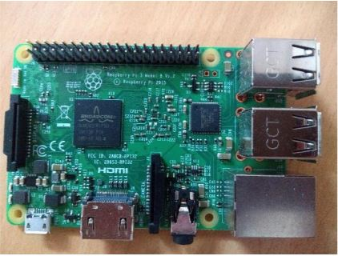
Figure 1 Raspberry PI 3B
These are the following specification as :

A 1.2GHz 64-bit quad-core ARMv8 CPU
• 802.11n Wireless LAN
• Bluetooth 4.1
• Bluetooth Low Energy (BLE)
• 4 USB ports
• 40 GPIO pins
• Full HDMI port
• Ethernet port
• Combined 3.5mm audio jack and composite video
• Camera interface (CSI)
• Display Interface (DSI)
• Micro SD card slot
• VideoCore IV 3D graphics core

2.1.2 Power Bank
Since the Raspberry is being used which require regulated power source. Raspberry pi do not compromise with insufficient power supply. So Power bank of 5.1 volt and 2.5 ampere has been used. In beginning of the project a lot of problems concerning power supply has been faced. Because as you make the more interface the Raspberry pi is going to demand more and more supply with regular current. It is noticed that ordinary chargers similar to mobile the charger which is use to charge mobile have not substantial amount of current that Raspberry pi wants. As it is mentioned on the charger that it will give 5 volt and 2.5 Ampere. But that is not the case.
These are the following specification as :
The Anker® Advantage: Join the 6 million+ powered by Amazon's #1 charging brand.
Exclusive PowerIQ Technology: Detects your device to deliver its fastest possible charge speed up to 2 amps (four times faster than a computer USB port).
High Capacity: Add two charges to an iPhone 6 or 5s, at least one full charge to a 6
Incredibly Compact: The size of a small candy bar (3.8 × 1.7 × 0.9in, 4.2oz) it fits perfectly in your pocket. Recharges in 5 hours with a 1A adapter (not included) .

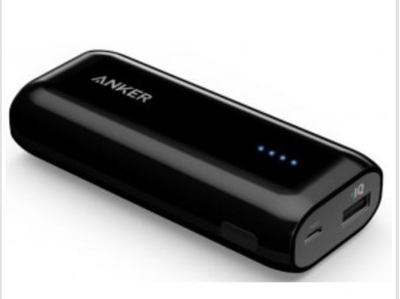
Figure 2 Power BANK

2.1.3 Camera Module
The Raspberry pi camera v2 and USB camera has been used.Pi camera is a high quality 8MP camera.USB camera has been deployed for the purpose of ease.This will capture the image. But there is one problem encountered with this camera is that it does not give good quality image when comes to action moreover the accuracy reduces to 62%.

There is one very critical problem associated with camera is that if we are standing on the earth and have direct contact with it will instantly burn down the camera and that happened for 2 times because we have static charge it is good practice to rub it on some metal before use but it does not make the system robust.

So it is concluded that to use typical USB 2.0 camera which is also 8MP and will give good quality image with about 92% accuracy.
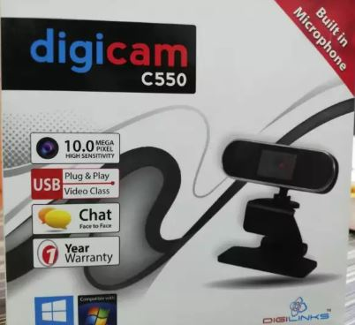
Figure 3 USB 2.0 Camera

2.1.4 Headphones
The headphone is utilized in this project to inform visually impaired person in form of sound about the written text written on the paper and about money. The voice obtained is actually a robotic voice or computer generated voice. The voice is very low but it is very fined.
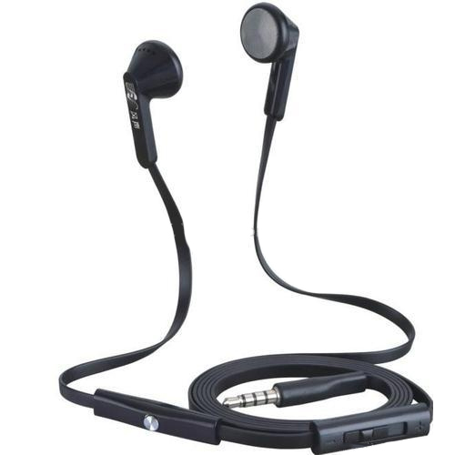
To get louder voice it is better to connect a mini speaker in output Jack. The jack is about 3.5mm.
Figure 4 Head Phones

2.2 SOFTWARE REQUIREMENTS

These are the following software requirements:

2.2.1 Raspbian Operating System
This is the operating which had been installed in Raspberry pi.All the proposed work has been done under this Operating system.It is derived from Debian operating system. There are various reasons of using this operating system. Because when we insert memory card into having OS to be installed in Raspberry pi the speed of Raspberry pi completely depends on the quality of memory card and the operating system to be installed.

So Raspbian operating system has been installed through NOOBS because it makes the operating system to installed with complete dependencies.

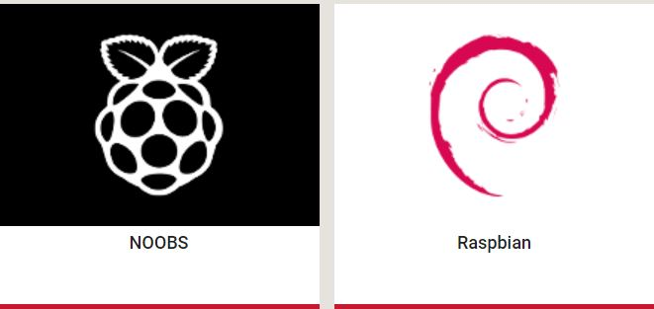
One very important reason to use Raspbian operating system Is that it comes with pre-install python IDLE having various versions and many more features.
Figure 5 Raspbian Operating System Logo

2.2.2 Python IDLE
Python is an interpreted,high-level,general purpose programming language.Python 3.6.1 shell has been used in this project.All the algorithms has been written in python language which is a script language.

Basically the main theme of our project is Image processing all is the need of programming. There are many languages which have been deploying for image processing but the different lies in difficulty, development, resources and many more. So the selection of right language is necessary. As C sharp can be used for image processing but the problem is that it will become very difficult to use opencv library there and many function.

In python, there is only one command that is “import opencv” and almost all of
your will be done.In similar way there are a lot of many function which create difficuly when use in other languages.It is thus concluded that python is found to be best for image processing.


Figure 6 Pyrhon IDLE

2.2.3 Open-CV Library
OpenCV is an open source computer vision library, which is written under C and C++ and runs under Linux, Windows and Mac OS X. OpenCV was designed for computational efficiency and with a strong focus on real-time applications. OpenCV is written in optimized C and can take advantage of multi-core processors.All the function that is written in algorithms has been called from OpenCV.

2.2.4 Haar Cascade Models
The Haar Cascade is actually a classifier with output label.It is used to detect for object detection for which it has been trained.In this project money paper’s Haar cascade model has been developed.

2.2.5 Money Trained Mode
For the purpose of MONEY identification it is needed to have hundred pictures of each currency like 10 rs with negative pictures and 500 rs like the same.Then all pictures had been saved in their respective currency name’s folder.Which, then trained to have have trained model that is going to be used in program.

2.2.6 Tesseract-OCR
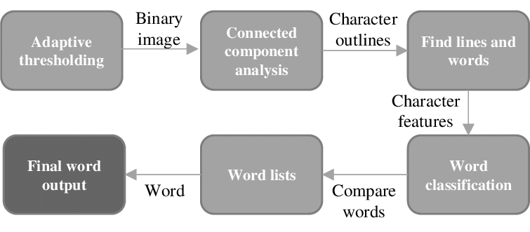
Optical character acknowledgment, typically abridged to OCR, is the mechanical or electronic change of filtered pictures of written by hand, typewritten or printed content into machine encoded content.The core reason for using this is to extract text from the image.It is broadly utilized as a type of information passage from some kind of unique paper information source, regardless of whether archives, deals receipts, mail, or any number of printed records. It is significant to the computerization of printed messages with the goal that they can be electronically sought, put away more minimalistically, showed on-line and utilized in machine procedures, for example, machine interpretation, text-to- speech and content mining. OCR is a field of research in example acknowledgment, computerized reasoning and PC vision. Optical character acknowledgment (OCR) frameworks permit wanted control of the checked content as the yield is coded with ASCII or some other character code from the paper based information content. For a particular language dependent on some letters in order, OCR strategies are either gone for printed message or written by hand message.
Figure 7 Tesseract flow of process

2.2.7 Pyttsx3
The text-to-speech in python is done with Pyttsx3 module.It is very efficient text-to-speech conversion library in python.

Chapter 3

Designing

As the startup begins with installing of operating system. First of all the Raspbian operating system has been installed through NOOBS in memory card.After installing operating system in memory card it is inserted in Raspberry pi. Now open the Python IDLE version 2.7 rather 3.5 the reason is that there are a lot of libraries like Opencv we are supposed to install it is easier to install in version 2.7 than 3.5 as it takes almost 3-4 hours for installation. After installation other libraries or modules like numpy, imutils, scipy, pytesseract, pytxx, sys has been installed through pip command by running command on terminal.

Sudo pip install xxxxx

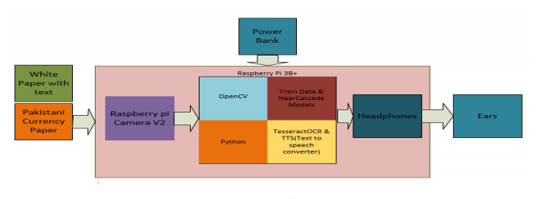
Figure 8 System Configuration

After installing all the dependencies that are needed to be use by the program, now there is time of enabling all the interfaces as we have to connect camera USB 2.0 before connecting there is need to enable camera port either it will be CSI or USB port. For that run command on the terminal.
“Sudo raspi-config”

This will take you into raspberry pi configuration so enabled camera here. Now we can take frame from the camera.

Now it is time to write algorithm first for having conversion of text from image then convert it in the form of voice.
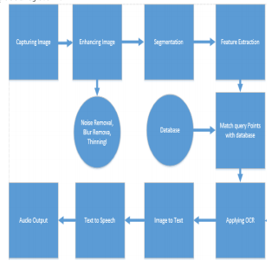
Figure 9 Flow of Process

3.1 Capturing Image
Whenever the blind person wants to know about the object he will place the object either it will be the money paper or A4 paper containing text in front of camera.Then the blind person will press the button and image will be captured as RGB picture and is changed over to gray scale

3.2 Enhancing Image
Then the captured image will be enhanced.Enhancing image means adjusting image in such a way that they are more suitable for further analysis.It includes noise removal.Gaussian obscuring is utilized.The equation of Gaussian function in two dimension is as follow: P(x) = 1 σ √ 2π e −(x−µ) 2 /2σ 2

LBPHF filter has been utilized in the algorithm for money recognition

3.3 Segmentation
With a particular ultimate objective to expel the money paper as well as the paper on which text is written from the background , the image is changing over to binary structure.Canny edge detector and Sobel detection is utilized to extract the regions.The mathematical equation is shown below for these detections.Finding the Intensity Gradient of the captured Image. Smoothened picture is then isolated with a Sobel kernel in both level and vertical heading to get first subordinate dimension way and vertical bearing. From these two pictures, we can find edge slope and heading for each pixel as takes after: EdgeGradient = q G2 x + G2 y Angle(θ) = tan−1 Gy Gx

3.4 Feature Extraction
Feature extraction is the specific kind of dimensionality decrease procedure. It is the technique for getting the visual substance of picture for recuperation and ordering. At the point when commitment to the count is too broad to even think about continuing and it is having much data yet not more information. By then information data will be changed over into decreased depiction set of features. Feature extraction makes direct the proportion of resources required to depict the tremendous arrangement of data

3.5 Matching Features
with Database The Features which has been extracted from the image is then it will be matched to train model .For money identification it will be matched to Haar Cascade model same as traineed model.

3.6 Image to Text
The features that will be matched is then converted to text.The feature extracted image which contains text is then converted to text by applying Tesseract-OCR.The python has built in library which is imported in the program.

3.7 Text to Speech
After obtaining text from image then by using Pyttsx which is module to be used for converting text-to speech.

3.8 Audio output
The speech that has been converted from text is an audio output to visually impaired person to inform about money, text written on paper and person’s emotion

Chapter 4

PRACTICAL IMPLEMENTATION

As this is the input image to the system the paper containing text is captured by the USB camera then processed by the image processing techniques.
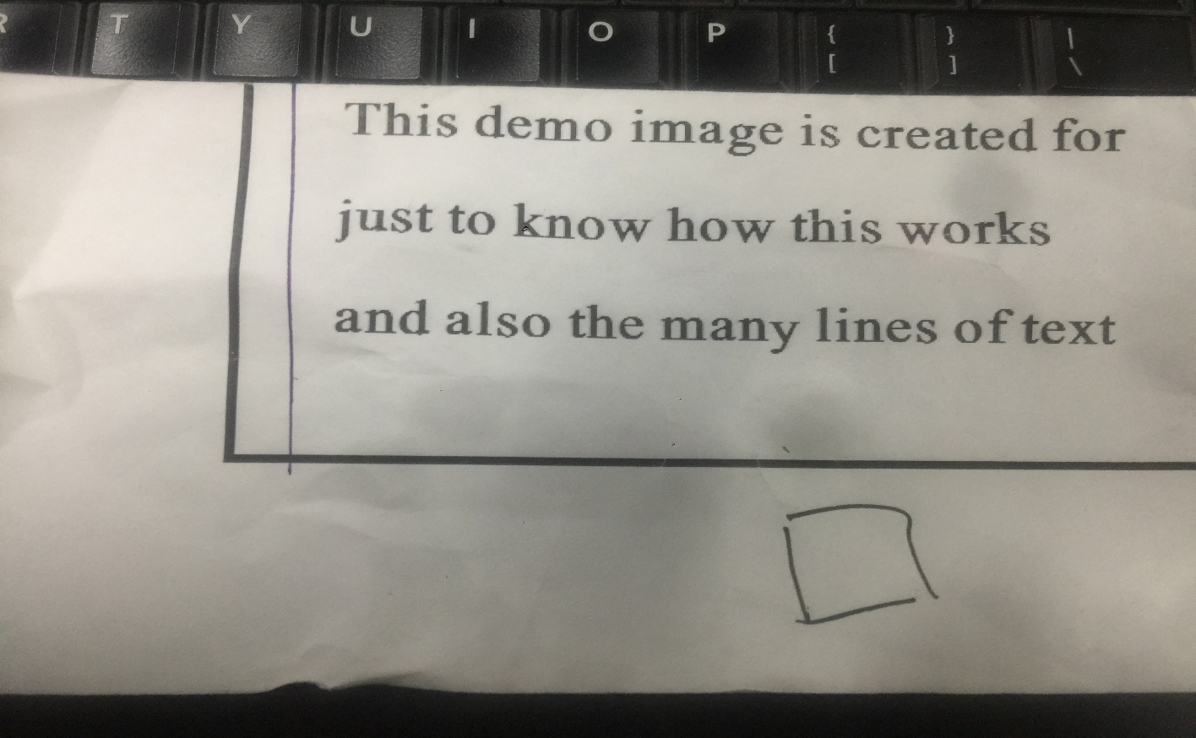

The following image is the output image out of the python command one showing canny edge detector. And the output is obtained with voice having 92 % accuracuy

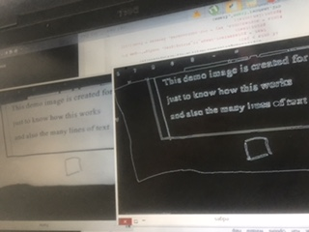
The following picture is classifier for training model for money recognition

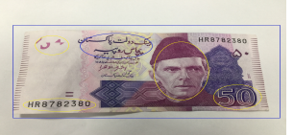

Chapter 5

Future Enhancement

According to available technology and skills, the project has delivered its milestone as promised but everything has a room for improvement and enhancement. As in this prototype only computer written text can be read with present algorithm it is impossible to read hand written text. So convolutional Neural Networks can be deployed to that this will give about 98% accuracy with hand written text and with handwritten text it will give about 90% accuracy and this can be very helpful for them in their daily life. As this project does not deal with the problem of navigation which we are supposed to cover in this project but due to lack we could not do it. So a model can be trained for a visually impaired person to walk around in specific place so it can be very helpful for them.

Chapter 6

SYNOPSIS & CONCLUSION

Generally speaking, we feel the venture met the majority of our desires, when we began we have decided to make a complete package for a blind including navigation but we have proposed text reading as well as money recognition aid.

This was additionally enormous learning background for us, particularly with Raspberry pi. We take in a gigantic sum about computer vision frame works, proficient python, and algorithms. We additionally took in a considerable measure about programming. Through this task, we got important involvement in creating productive programming utilizing memory and run-time advancements, something that can’t be increased through routine assignments.

Smart system with audio aid for visually impaired persons enables reading and money recognition for visually impaired persons, it has been made with made about 92 % accuracy and precision.

6.1 Advantages

As the money recognition has been performed real time so it is very massive advantage for the audience and in marketing point of view so visually impaired persons just have to place money in front of camera and they will get the voice that how much amount of money he is holding in his hand .

Moreover, there is about 98% accuracy in money recognition and it has very quick response than text reading. The best part is frame per second that fps is very fine regardless of the Raspberry pi processor.
Last but not the least, the programming that has been deployed is very easiest and has very much resources on the internet so any error can be overcome.

6.2 Less Space

One of the best things about this project is that the system has equal to having no component. It just consist of one module Raspberry pi weight about 50 gram which will be highly benefit for the person who is wearing it.

6.3 Conclusion

The assistive innovation is a standout amongst the most fundamental and vital framework that helps an individual with a handicap to work around his challenges.This paper exhibits the text reader and money recognition for visually impaired individuals, created on Raspberry Pi with the help of Image processing techniques.The money recognition is done through train model(database).It is real time.Text reading is done through still images. It employments the Optical character recognition innovation for printed character identification using Pi camera and computer programming.It changes over pictures of composed and printed content into machine encoded content.In this project these pictures are changed over into the sound yield (Speech) using OCR and Text-to-Speech synthesis Pyttsx3.The change of printed archive into text documents is done utilizing Raspberry Pi which again utilizes Tesseract library library and Python programming. The text file is handled by OpenCV library and python programming language and sound yield is accomplished.

References

[1] LEVY Aron. Visual aid, September 26 2013. US Patent App. 13/770,560.

[2] Jinqiang Bai, Shiguo Lian, Zhaoxiang Liu, Kai Wang, and Dijun Liu. Smart guiding glasses for visually impaired people in indoor environment.
IEEE Transactions on Consumer Electronics, 63(3):258–266, 2017.

[3] Wolfgang Fink and Mark Humayun. Digital object recognition audio-
assistant for the visually impaired, September 22 2005. US Patent App.
11/030,678.

[4] Lilit Hakobyan, Jo Lumsden, Dympna O’Sullivan, and Hannah Bartlett.
Mobile assistive technologies for the visually impaired.Survey of ophthal-
mology, 58(6):513–528, 2013.

[5] Rabia Jafri, Syed Abid Ali, Hamid R Arabnia, and Shameem Fatima. Computer vision-based object recognition for the visually impaired in an indoors environment: a survey.The Visual Computer, 30(11):1197–1222, 2014.

[6] Noura A Semary, Sondos M Fadl, Magda S Essa, and Ahmed F Gad. Currency recognition system for visually impaired: Egyptian banknote as a
study case. In 2015 5th International Conference on Information & Communication Technology and Accessibility (ICTA) pages 1–6. IEEE, 2015.

[7] Chucai Yi and Yingli Tian. Assistive text reading from complex background for blind persons. In International workshop on camera-based document analysis and recognition, pages 15–28. Springer, 2011.

[8] Chucai Yi, Yingli Tian, and Aries Arditi. Portable camera-based assistive
text and product label reading from hand-held objects for blind persons.
IEEE/ASME Transactions On Mechatronics
, 19(3):808–817, 2013

Appendix A

Project coding

(1) Text reading from the paper

import cv2
import sys
import pytesseract
import imutils
import os
import numpy as np
import pyttsx3
engine = pyttsx3.init()

video_capture = cv2.VideoCapture(0)
#video_capture.set(3,320)
#video_capture.set(4,240)

if __name__ == "__main__":
while(True):
ret, frame = video_capture.read()
if ret:
gray = cv2.cvtColor(frame, cv2.COLOR_BGR2GRAY)
edged = cv2.Canny(gray, 30, 200) #Perform Edge detection
#kernel = np.ones((5,5),np.uint8)
#edged = cv2.dilate(edged,kernel,iterations = 3)
cnts = cv2.findContours(edged.copy(), cv2.RETR_TREE, cv2.CHAIN_APPROX_SIMPLE)
cnts = imutils.grab_contours(cnts)

for c in cnts:
area = cv2.contourArea(c)
x,y,w,h = cv2.boundingRect(c)
if area > 2500 and area < 5000:
cv2.rectangle(frame,(x,y),(x+w,y+h),(0,0,255),2)
## if cnts > 260:
## text = pytesseract.image_to_string(gray, config='--psm 3')
## print(text)
#cnts = sorted(cnts, key = cv2.contourArea, reverse = True)[:10]
#print(len(cnts))
cv2.imshow('frame',frame)
cv2.imshow('edges',edged)
k = cv2.waitKey(1)
if k & 0xFF == ord('q'):
cv2.destroyAllWindows()
break
elif k & 0xFF == ord('d'):
text = pytesseract.image_to_string(gray, config='--psm 3')
print(text)
engine.say(text)
engine.runAndWait()

else:
sys.stderr.write("No frame from camera")
break
# When everything done, release the capture
video_capture.release()
sys.exit(0)

(2) Currency Recgnition

import cv2
import sys

import imutils
import os
from os import listdir
from os.path import isfile, join
import numpy as np

video_capture = cv2.VideoCapture(1)

video_capture.set(3,320)

video_capture.set(4,240)

directory = "neg"
train_cnt = 1
reco = cv2.face.LBPHFaceRecognizer_create()
img_array = []
label_array = []

isTrain = False

def getAllImages(mypath,userID):
onlyfiles = [ f for f in listdir(mypath) if isfile(join(mypath,f)) ]
images = np.empty(len(onlyfiles), dtype=object)
for n in range(0, len(onlyfiles)):
images[n] = cv2.imread( join(mypath,onlyfiles[n]),0 )
img_array.append(images[n])
label_array.append(userID)
return images

def mse(imageA, imageB):
# the 'Mean Squared Error' between the two images is the
# sum of the squared difference between the two images;
# NOTE: the two images must have the same dimension
err = np.sum((imageA.astype("float") - imageB.astype("float")) ** 2)
err /= float(imageA.shape[0] * imageA.shape[1])

# return the MSE, the lower the error, the more "similar"
# the two images are
return err

if __name__ == "__main__":

while(True):
ret, frame = video_capture.read()

if ret:
gray = cv2.cvtColor(frame, cv2.COLOR_BGR2GRAY)
th, dst = cv2.threshold(gray, 157, 225, cv2.THRESH_BINARY+cv2.THRESH_OTSU)
contours, hierarchy = cv2.findContours(dst,cv2.RETR_TREE,cv2.CHAIN_APPROX_SIMPLE)

if(len(contours)>0):
# Find the index of the largest contour
areas = [cv2.contourArea(c) for c in contours]
max_index = np.argmax(areas)

cnt=contours[max_index]
x,y,w,h = cv2.boundingRect(cnt)
cv2.rectangle(frame,(x,y),(x+w,y+h),(0,255,0),2)
Cropped=gray[ x:x+h,y:y+w]

resized_image = cv2.resize(Cropped, (150, 100))
cv2.imshow('Cropped',resized_image)

if isTrain:
nbr_predicted, conf = reco.predict(resized_image)
#print(nbr_predicted)
#print("conf"+str(conf)+",id="+str(nbr_predicted))
if conf<75 and nbr_predicted>1:
print("conf"+str(conf)+",id="+str(nbr_predicted))
else:

cv2.imwrite('./'+directory+'/'+str(train_cnt)+".jpg",resized_image)
train_cnt = train_cnt+1

# print('currency detected')

#

cv2.imshow('frame',frame)

#cv2.imshow('edges',thresh)
k = cv2.waitKey(1)
if k & 0xFF == ord('q'):
cv2.destroyAllWindows()
break

else:
sys.stderr.write("No frame from camera")
break
# When everything done, release the capture
video_capture.release()
sys.exit(0)

import cv2
import sys

import imutils
import os
from os import listdir
from os.path import isfile, join
import numpy as np

video_capture = cv2.VideoCapture(0)

video_capture.set(3,320)

video_capture.set(4,240)

directory = "sub2"
train_cnt = 1
reco = cv2.face.LBPHFaceRecognizer_create()
img_array = []
label_array = []

isTrain = True

def getAllImages(mypath,userID):
onlyfiles = [ f for f in listdir(mypath) if isfile(join(mypath,f)) ]
images = np.empty(len(onlyfiles), dtype=object)
for n in range(0, len(onlyfiles)):
images[n] = cv2.imread( join(mypath,onlyfiles[n]),0 )
img_array.append(images[n])
label_array.append(userID)
return images

def mse(imageA, imageB):
# the 'Mean Squared Error' between the two images is the
# sum of the squared difference between the two images;
# NOTE: the two images must have the same dimension
err = np.sum((imageA.astype("float") - imageB.astype("float")) ** 2)
err /= float(imageA.shape[0] * imageA.shape[1])

# return the MSE, the lower the error, the more "similar"
# the two images are
return err

if __name__ == "__main__":
sub4=getAllImages("sub4",10)
print(len(sub4))
sub2=getAllImages("sub2",500)
neg=getAllImages("neg",1)
print(len(neg))
print(len(sub2))
print("training")
reco.train(img_array, np.array(label_array))
print("complete")
while(True):
ret, frame = video_capture.read()

if ret:
gray = cv2.cvtColor(frame, cv2.COLOR_BGR2GRAY)
th, dst = cv2.threshold(gray, 157, 225, cv2.THRESH_BINARY+cv2.THRESH_OTSU)
contours, hierarchy = cv2.findContours(dst,cv2.RETR_TREE,cv2.CHAIN_APPROX_SIMPLE)

if(len(contours)>0):
# Find the index of the largest contour
areas = [cv2.contourArea(c) for c in contours]
max_index = np.argmax(areas)

cnt=contours[max_index]
x,y,w,h = cv2.boundingRect(cnt)
cv2.rectangle(frame,(x,y),(x+w,y+h),(0,255,0),2)
Cropped=gray[ x:x+h,y:y+w]

resized_image = cv2.resize(Cropped, (150, 100))
cv2.imshow('Cropped',resized_image)

if isTrain:
nbr_predicted, conf = reco.predict(resized_image)
#print(nbr_predicted)
#print("conf"+str(conf)+",id="+str(nbr_predicted))
if conf<75 and nbr_predicted>1:
print("conf"+str(conf)+",id="+str(nbr_predicted))
if nbr_predicted == 10:
os.system("echo '"+str('Your Currency is ten Rupees')+"' |festival --tts")
elif nbr_predicted == 500:
os.system("echo '"+str('Your Currency is five hundred Rupees')+"' |festival --tts")
else:

cv2.imwrite('./'+directory+'/'+str(train_cnt)+".jpg",resized_image)
train_cnt = train_cnt+1

# print('currency detected')

#

cv2.imshow('frame',frame)

#cv2.imshow('edges',thresh)
k = cv2.waitKey(1)
if k & 0xFF == ord('q'):
cv2.destroyAllWindows()
break

else:
sys.stderr.write("No frame from camera")
break
# When everything done, release the capture
video_capture.release()
sys.exit(0)

