Final Year Project Report

Submitted to the Faculty of Aviation at the University of Management and Technology in partial fulfillment of the
Requirements for the degree of

BS
in
Aviation Management

By
Muhammad Adnan Khurshid
Shazeena Fatima
Session
2012-2016

Practicum Supervisor
Prof. Faiq Ahmad

Practicum Report
On
AIRLINE MARKETING STRATEGIES IN PAKISTAN

Submitted in the partial fulfillment of the award of
BS-Aviation Management
University of Management and Technology, Lahore
In
Department of Aviation
June, 2016
SUBMITTED TO: SUBMITTED BY:
Prof. Faiq Ahmad Muhammad Adnan Khurshid
12003001037
Shazeena Fatima
12003001019


INTRODUCTION OF THE MEMBERS


Adnan Khurshid (Researcher)
BS-Aviation Management
University of Management and Technology, Lahore
My passion about aircraft, their Operations and Management urged me to choose Aviation as a Bachelor’s degree and took admission in University of Management and Technology in 2012.
I’m very vibrant student and throughout my four years degree of Bachelors of Sciences in Aviation Management, I have achieved “Rector Merit Award and Dean Merit Award.”
I did work in Gerry’s Dnata for 3 months at Allama Iqbal International Airport, Lahore. I observed so many issues there specially related to Marketing which Pakistani carriers are facing due to poor Marketing Strategies, Customers don’t have proper awareness about their Products and Services.
The main objective to choose “Airline Marketing Strategies in Pakistan” topic for final practicum is to discuss and analyze problems of Pakistani carriers, Marketing Strategies which they are currently facing.
My degree subject “Airline Marketing and Aviation Strategy & policy help me a lot to use Marketing knowledge in effective way, and try to give competitive recommendation after research.
Hardworking and Self-Motivation attributes help me to achieve objective of final practicum efficiently.
E-mail:Adnankhurshid9@gmail.com


Shazeena Fatima (Researcher)
BS-Aviation Management
University of Management and Technology, Lahore
I joined University of Management and Technology in 2012 with the admission in BS-Aviation Management. My passion about airport operation forced me to join Aviation and get chance to gather as much knowledge about it. I have been academically proactive and has been awarded with “Rector Merit Award and Dean Merit Award” every time by offices of controller of examination, UMT. I have shown keen interest in “Airline Marketing” and Aviation Strategy & policy subject which help me to analyze and understand the marketing strategies in better way.
My purpose to choose “Airline Marketing Strategies in Pakistan” Is to discuss the problems that Pakistani carriers are facing today. Globally Airlines are performing outstanding in Marketing but in Pakistan, Airlines are neglecting this power and effective tool, due to which they are losing major portion of Customer.
I believe in continuous hard work and struggle because there’s not substitute of hard work and a person can achieve anytime with this attribute.
I also give some recommendations which will help Airlines to develop competitive Marketing Strategies.
E-mail: shazinafatima5@gmail.com

CONTENTS

- Introduction 2
  - Marketing 2
  - Marketing in Pakistan 2
  - Airline Marketing 3
  - Airline Marketing in Pakistan 4
- Literature Review 4
  - Marketing Mix and 7 P’s 4
    - Definition 4
    - Product 5
    - Price 5
    - Place 5
    - Promotion 6
    - People 6
    - Process 7
    - Physical Evidence 7
    - Use of Marketing Mix by Pakistani carriers 7
  - Industrial Buying Behavior 12
  - Segmentation 13
2.1.1. Labor Class 13
2.1.2. Time Conscious Passengers 13
2.1.3. Tourism 14
2.1.4. Business Community 14
2.4. Fleet and Schedule Related Product Features 15
2.4.1. Aircraft Classes Configuration 15
2.4.2. Network and Number of Frequencies 16
2.4.3. Punctuality 17
2.5. Customer Related Product Features 17
2.5.1. Point of Sale Service 18
2.5.2. Airport Services 18
2.5.3. In-flight Services 18
2.5.4. Feedback Process 19
2.6. Marketing Environment-PESTLE Analysis 19
2.6.1. Political Factors 19
2.6.2. Economic Factors 20
2.6.3. Social Factors 20
2.6.4. Technological Factors 20
2.6.5. Legal Factors 21
2.6.6. Environmental Factors 21
2.7. Relationship Marketing 21
2.7.1. Advocate Relationship 22
2.7.2. Destroyer Relationship 22
2.7.3. Steps for Developing Advocate Relationship 22
2.7.3.1. Straight Dealing of Airlines 23
2.7.3.1. Delivering Promises 23
2.7.3.3. Caring Attitude towards Customers 23
2.7.3.4. Delight Customers 24
2.7.4. Components for Relationship Marketing Strategy 24
2.7.4.1. Database Management 24
2.7.4.2. Quality Management 25
2.7.4.3. Customer Relations 26
2.7.4.4. Communication with Customers 26
2.8. Porter’s five forces 27
2.8.1. Threat of New Entrants 27
2.8.2. Bargaining Power of Buyers 28
2.8.3. Bargaining Power of Suppliers 28
2.8.4. Threat of Substitutes 28
2.8.5. Rivalry among Existing Competitors 29
2.9. Three Generic Strategies 29
2.9.1. Differentiation Strategy Approach 30
2.9.2. Low Cost Leadership Strategy Approach 31
2.9.3. Niche Strategy Approach 32
- Research Objective 33
- Data Collection 33
  - Sponsorship 34
  - Websites 36
    - Benefits of having Websites 36
      - Cost saving 36
      - Easily accessible 37
      - Provide convenience to customers 37
      - Enhance sales 37
      - Build advocates for company 37
  - Brand Ambassador 38
    - Importance of Brand Ambassador for Airlines 38
      - High degree of professionalism 38
4.3.1.2. Passion to build relationships 38
4.3.1.3. Increase awareness among customers 39
4.3.2. Examples of Airlines globally 39
4.4. Television Commercial Ads 41
4.4.1. How audience analyze Commercials? 41
4.4.2. Importance of Commercial Ads 41
4.4.3. Six things for developing Effective Commercial Ads 45
- Data Analysis 47
5.1. Analysis of PIA and Emirates Websites 48
5.1.1. No Modification 49
5.1.2. Language Translation Option 49
5.1.3. Improper Advertisement of Social Media 50
5.1.4. No promotion of Mobile Application 52
5.1.5. No need of Fare Summary 52
5.2. Airblue and Shaheen Airways Website Analysis 53
5.2.1. Attractive Promotion of Services 53
5.2.2. Deliverance of Message in attractive way 54
5.2.3. Attractive Color Scheme 55
5.2.4. Facility to make Multi-city Reservation 55
5.2.5. Information about Company’s News 57
5.2.6. Language Change Option 59
5.3. Air Indus Website Analysis 59
5.3.1. No attractive Color Scheme 59
5.3.2. Boring Graphics 60
5.3.3. Improper use of Social Media 61
5.4. Promotional Setbacks of Upcoming Airlines 61
5.4.1. No Uniqueness in Brand Name 61
5.4.2. No appropriate Address 62
5.4.3. Old Advertisement 62
5.4.4. Copied Uniform from PIA 63
5.4.5. Advertise Wrong Aircraft 63
- Ethical Considerations 64
- Results 64
- Conclusion 65
- Recommendations 65
- References 72

ACKNOWLEGEMENT:
We would like to express special thanks to our University “University of Management and Technology” and our “Aviation Department” to give us wonderful opportunity to do practicum on “Airline Marketing Strategies in Pakistan.” We did a lot of research for this practicum which helped us to come know about so many new things.
We are highly thankful to our supervisor “Professor Faiq Ahmad” for his previous time, attention guidance in selecting topic and constantly provide information related to topic which helps us to complete practicum within limited time frame.
We are also grateful to our industry people who gave us their precious time and provide real time information.
Our warm thanks and appreciations also go to our colleagues who help us in completing project by using their abilities.
OBJECTIVE:
Marketing is considered as an integral part of any business. Organizations use it as an effective tool for delivering message to customers in attractive way by understanding and satisfying their needs and wants. But unfortunately, Pakistani carriers aren’t giving any kind of special attention towards this important tool.
Our objective in selecting Airline Marketing Strategies in Pakistan for final practicum is to discuss the mistakes of marketing that Pakistani carriers are committing, the problems in marketing strategy due to which customers are switching to foreign carriers like Emirates, Etihad, Qatar, Turkish and so many others.
We also quote examples of successful airlines and analyze their marketing strategies with Pakistani airlines and discuss that they should modify or change their ancient marketing strategies.
In the end, we give some recommendations that how Pakistani carriers can make effective marketing strategies to attract more customers and strengthen relations with loyal customers because without loyal customers, no airline will touch the heights of success.

- INTRODUCTION
In the beginning, we will give introduction about the practicum topic “Airline Marketing Strategies in Pakistan.” Here, we will discuss that what is the definition of marketing? And why it is an integral part in airline industry?
- WHAT IS MARKETING?
Marketing is about putting the right things in the right place in the right time in the right price.
Marketing is an activity or process for identifying, anticipating, communicating, delivering and retaining the customers by adding values in the products.
When we talk about marketing, we can’t ignore the concepts of needs, wants and the market demand. Needs are basic necessities for the customers like clothing food and shelter and wants are one step ahead from the needs that what customers desires to have. Similarly, organization should understand the market demands that when the customers are ready to accept the product before launching a new product.
Marketing is a dynamic activity and for marketing, it’s important for every organization to know about the customers’ needs and wants because customers’ needs and wants change continuously like sometimes, customers become more conscious about quality and stick to one organization but on the other hand, many times, customers prefer those organizations which offers low prices and discounts especially when families are planning for vocations.
- WHAT IS MARKETING IN PAKISTAN?
In Pakistan, organizations have misconception about marketing that it is not very helpful activity. In early time in Pakistan, “marketing was just about producing the things that really didn’t satisfy the customers’ needs or to some extend satisfy needs but not completely and then sold those things to customers by deceitful advertisements.”
The advertisements don’t clearly inform customers about requirements attached with the products. Let’s take an example that a company is producing the cell phones and that cell phones don’t have as much qualities that organization explained in advertisement just for attracting customers. Similarly, cellular service providers claim to offer the world’s cheapest call rate but this claim is itself a questionable that the call is the cheapest in terms of national, local or international. Organizations thought that developing, maintaining and sustaining good relations with customers wasn’t the core center of marketing, they just wanted to sell their products in any way.
But now in Pakistan, according to Competition Ordinance, 2009, Section 10, deceptive marketing is prohibited in Pakistan. After that, the organizations try to develop products according to customers’ demands and try not to give misleading information to customers about the product like its quality, suitability to use, price and properties. This will encourage the customers to make decisions about buying a specific product on the basis of sufficient and accurate information. Now, giving attention to the customers’ needs and wants has become the center of any business.
- WHAT IS AIRLINE MARKETING?
In airlines, the main focus is on the travelling passengers and the main goal of airlines is to identify, attract the customers and retain them by delivering values and satisfy the customers’ requirements.
As we have already discussed earlier that customers’ needs and wants are in changing process because customer always demand something new and expect uniqueness in services. Successful airlines in the industry are those who understand this change earlier and deliver values according to their demands. Unsuccessful airlines fail to do so as they are in wait that when any other organization brings any kind of change in the market related to customers and we just imitate it.
Here, we are going to take the examples of famous airlines who advertise their products in best way that they attract the minds of the customers like Emirates, Etihad, Qatar, Southwest, Turkish airlines. Their marketing techniques make them able to attract, maintain and retain their customers. They use the best market tactics to understand what is going on in customers’ mind and how to delight the customers. They use the attractive colors for soothing their minds, make the websites more attractive and simple, display the seasonal and vocational discount deals properly to attract and retain more customers, offer special deals to all customers, develop frequent flyer programmes to retain the loyal customers and develop a friendly environment that their customers feel relaxed.
- AIRLINE MARKETING IN PAKISTAN:
Now, we are going to throw some light on the airline marketing in Pakistan and give some brief knowledge about their marketing strategies. Currently, Pakistan International Airlines, Airblue and Shaheen airlines are operated at national as well as international levels. Air Indus has operations at national level. All these airlines have some marketing issues which lowers their chances to gain attention of maximum customers and to satisfy the customers’ needs and wants in best way. They don’t market their products and services in efficient way.
PIA is national flag carrier of Pakistan but PIA isn’t giving any attention towards attracting the customer and retaining them. On the other hand, private airlines, Airblue and Shaheen, are doing their best for identifying the needs and want of customers and then market the services, offers and products according to their demands. They also keep their websites updated because when customers see the website because they leave the first impression in their minds as a well- known sentence says that “first impression is the last impression.” In future, two more airlines, Pakistan Airways and Serene Air, will start operations in Pakistan which increase the competition among carriers and the lapses in marketing will also fill-up.
- LITERATURE REVIEW
- MARKETING MIX AND 7 P’s:
- DEFINITION:
“Marketing mix” is a tool an organization use to promote the service or product. It can also be defined as “Marketing mix is used to describe the choices that an organization has to make for promoting the product or service.”
Marketing mix needs a lot of understanding, market research because all the elements of marketing mix are inter-linked and influence each other. Typically the organizations use 4 P’s: price, place, promotion and product. Here we discuss 7P’s: price, place, promotion, product, process, people and physical evidence for better understanding.
- DESCRIPTION OF 7 P’S:
- PRODUCT
Product refers to the item that is actually being sold by the company. Many companies first decide what product is to offer and then find out the market for product but Successful companies first find out the needs and want of the customers and then decide to offer the product according to their requirements. In product/service offerings, organizations need to identify what customers want from the product, which features attract the customers more and which features aren’t attractive to the customers in product and most important thing is to focus on the differentiation of product in the market. Airlines should give attention towards the quality of the service that is offering and need to create differentiation in product for attracting more customers in competitive environment.
- PRICE
Price is the value that customer are willing to pay for a product. The pricing strategy depends on many factors like costs of production, ability of the market to pay and demand-supply. The price needs to be competitive. Many organizations compete with the rivals by offering some additional services and values. Pricing is the only aspect in the marketing mix that gives revenue to the organization, so it’s important for companies to manage them in best way. The organizations need to answer the questions like how to get access to the right distribution channels? Is the customer price sensitive or give more priority to quality and what price the competitors are offering for the same products? Organizations should also give attention to the discount patterns that when we have to offer discounts and how much, allowances and payment periods.
- PLACE
The place refers to the point where customers buy a product a service. The organizations try to grab the attention of the customers by making the place strategy simple and easily accessible for the customers. Delivering performance is the most important thing in choosing a company for product, so the companies are more concerned about the channels of distribution. In today’s advance environment, “time is money” for everyone and many people even don’t have enough time to visit travel agents or offices for flight information, booking a ticket, so many organizations give the customers online access to the products as it saves time of the customer and allow them to get a quick view of the products like airlines offer online booking facility, websites and other mobile applications facilities that create an easiness for passengers to get a quick view of the fares, flight schedules and airline offers.
- PROMOTION
Promotion refers to all activities that are used to communicate that what the products are offering to the customers. It includes branding, advertisement, special offers, personal relations, word of mouth, social media and direct marketing. Promotion of company must be powerful that it can gain attention of the customers, be convincing and deliver a clear and consistent message to the ears of the customers in such a way that they just want to choose and buy that product at the spot. Promotion should communicate the benefits that a customer can enjoy from a particular product. Airlines use this element wisely. Website is the first impression of any airline as whenever a passenger visits the website of an airline, the first impression will stick in his/her mind. Airlines also use the online promotion at larger scale as today is the era of IT and people prefer to use social media.
- PEOPLE
People refer to the staff and employees of an organization that are working in it. Every member of your organization who come in-contact with the customers leaves an impression in the customers’ minds. Many customers give more priority to the staff members’ behaviors rather than product or service. The attitude of the employees has a profound effect on the customer satisfaction, either positive or negative. The staff of the organization is the representative of brand, so the organizations should give proper training, motivation for efficient performance. The employees who deal the customers must be suitable to the role, well-groomed and have good interpersonal skills, behavior and service knowledge. Only by this way, the customers make the judgments about the services and the companies create customers as advocates for business.
- PROCESS
Process refers to the systems that are used to deliver the product/service. The process of delivering the product and the behavior of those people who deliver it are crucial to the customer satisfaction. An efficient service that maximizes the productivity encourages the customer loyalty and brand image of the company. Online experience, attitude of employees, information provided to the customers makes them happy and satisfies because they aren’t interested that how the business works, they just want good quality of services. Organizations should ensure that the processes are designed according to the customers’ benefits, not according to the company’s ease. Companies should also have feedback process, get the complaints and also reply their complaints as it also creates goodwill in customers’ minds.
- PHYSICAL EVIDENCE
Physical evidence refers to the places from where the services/products are delivered from. The intangibility of services makes it difficult for customers to evaluate the offerings based on quality. For this, companies need to manage some physical evidence that accompanies the service. Physical evidence includes service/product offering buildings, facilities, staff appearance and their uniforms. Promotional materials such as broachers, advertisements flexes are also the elements of physical evidence. This physical evidence allows potential customers to evaluate the quality of service. The appearance of physical structure, vehicles, interior furnishing, equipment, uniforms, printed materials and other visible cues provide the evidence of service quality.
- USE OF MARKETING MIX BY AIRLINES OPERATED IN PAKISTAN
PIA, Shaheen Air, Airblue and Air Indus carriers are currently doing their operations in Pakistan in which Air Indus has operations at national level. In today’s dynamic environment, the airlines are trying to understand 7 P’s and implement to promote the product and services in best way to compete with the competitors. Here, we are going to describe each element of marketing mix individually for giving the better understanding that how Pakistani airlines use this powerful tool.

- PRODUCT:
All airlines are offering several products and services for attracting more customers and satisfy the target market. The airlines are competing with one another especially on services because only services can retain the customer and build advocates for airlines. PIA offers a variety of products to its customers like:
- Creating Segments in Aircraft for passengers like Business Class, Economy plus Class and Economy Class for targeting all groups. These three classes have different prices and quality of services for every segment of customers.

PIA Cargo Services in which the Maxload is one of the kind product which is specially designed to cater the needs of customers with high density cargo.
- PIA Speedex services for delivering the documents and parcels to the doorstep of the customers
- PIA Engineering
Similarly Airblue is providing Economy class in Aircraft to its customers and offering e-cargo services where agents book cargo directly on-line which saves time and cost.
- PRICE:
Pricing is the major source of revenue for airlines, so setting the reasonable price for inventory is very challenging for airlines, especially in Pakistan where the income level is low. All airlines set their fares on routes on the basis of:
- Booking trends
- Demand
- Seasonality
- Competitor Fare Strategy
- Cost Estimation
Another pricing strategy adopt by airlines is to charge different prices for every class like business class has highest fair as compared to economy class. In this way, all the groups of market get satisfaction by airlines and in return, airlines get revenue. Additionally, Airblue is offering three type of pricing to its customers:
Discount Pricing in which no bags are allowed
Standard Pricing where one bag is allowed
Premium Pricing in which two bags are allowed
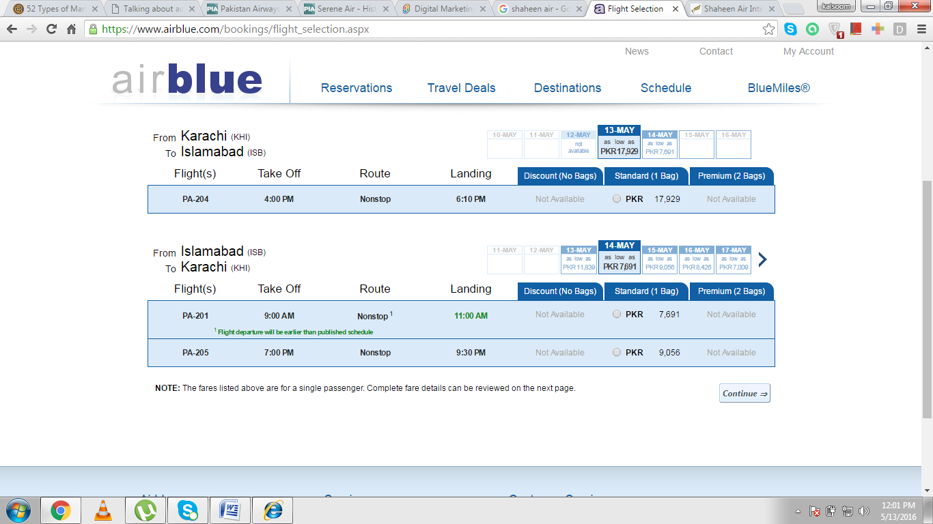
- PLACE:
Airlines use different distribution channels for selling their products and give awareness to customers about their products. All the airlines have offices in different cities all around Pakistan and also internationally. This provides platform to the customers for their easiness where they can come, buy tickets and also get information about the flight schedules. Shaheen Air has 9 domestic stations and 14 international stations. Additionally, airlines use internet for online booking which saves the time of customers. Airlines also use travel agents for selling the ticket to customers because many people in Pakistan don’t have access to internet or maybe they get satisfaction when visit office. Airlines also provide facility of call-centers where the persons are available 24/7 for customers where they can ask any question, complaint about anything and also provide feedback. Complaints and feedbacks are obliging for airlines for making their operations more efficient. Unfortunately, almost all airlines aren’t give proper attention towards customers’ complaints and feedback and ultimately, lose the customers.

- PROMOTION:
All airlines in the world give attention towards promotion as this element creates long-lasting perception about brand in customers’ minds. Advertisement is major component of this element because it gives an ability to airlines to promote their products/services in best way to the target audience.
But Pakistani airlines fail in doing astonishing advertisement for attracting the attention of customers. Airlines are not advertise properly even about their flight schedules in their main offices. PIA is only full service carrier and national flag carrier in Pakistan but still its advertising tactics are not up-to-mark, no proper management of websites, no proper promotion of their products, no attractive ads are being made by PIA like other airlines which market their services and values through ads and proper advertise them on social media and TV channels.
The next important things in promotion are direct marketing, sales promotion, interactive marketing, PR and events. Carriers of Pakistan are giving attention towards sales promotion, interactive marketing and direct marketing but not giving attention towards developing PR with customers by satisfying them.
- PEOPLE:
The employees of airlines play an important role in promoting brand in preeminent way as airlines are providing more services to customers. Their behaviors leave long-term perception in their minds and help to retain the airlines’ loyal customers. Airlines use this element as a powerful tool and hire well-educated, professional and experienced people. The employees of an airline depict the culture which makes the cultural differences in competitors.
Unfortunately, Pakistani carriers aren’t using this element sensibly. PIA staff doesn’t know how to deal with customers and how to react at their questions and complaints. Its faculty isn’t well-educated and well-groomed, which creates a bad perception about brand. The employees standing at counters at airports represent culture of airlines but in PIA employees standing at counters deal with passengers imperfectly. The cabin crew is also the representative of airlines and builds a good perception, that’s why airlines worldwide hire competent and well-groomed cabin crew. But, unfortunately Pakistani airlines aren’t giving as much attention towards it for enhancing quality and customer satisfaction.
- PROCESS:
The airlines processes also play a significant role in satisfying the customers. As we all know that airlines main focus is to deliver best services to its customers at any cost and retain their customers by delighting them. It’s important for an airline to keep all processes customer-oriented, provide special services for business class, baggage services and assisting disabled passengers.
In Pakistan, the carriers are trying to keep processes customer-oriented, try to develop the good customer relations, starting from check-in. Pakistani carriers provide platform for complaints to passengers but unluckily, airlines fail to reply those complaints, give them a satisfactory answer and ensure them to make process better in future. This kind of non-serious behavior leads to customer dissatisfaction. Here we want to quote an example of EasyJet where a passenger complaint against EasyJet on twitter about baggage lost of his father. The airline replied back him within 24 hours, make an apology, find out the baggage and send that baggage to his home. These kind of processes leads to customer satisfaction but in Pakistan, if a passenger lost his baggage, he will never get that baggage back especially in case of PIA which is the national flag carrier of Pakistan.
- PHYSICAL EVIDENCE:
Physical evidence is an important element of marketing mix which enables the customers to evaluate the quality of service. As in airline industry, we consider the ambiance and personnel competence as physical evidence. Ambiance refers to the complete environment in which the airlines operate like the conditions of aircraft. Worldwide, airlines are trying to keep the aircraft up-to-date and try to acquire new aircrafts as they are more efficient but the aircraft of Pakistani carriers are in poor condition. They always try to acquire aircraft on lease instead of buy new aircraft. Furthermore, ambiance includes physical facilities in departure and arrival. Most important thing which Pakistani carriers should adopt where they loss maximum customers is to keep inside environment of aircraft customer-friendly as the good ambiance of aircraft helps passengers to reduce stress, increase customer satisfaction and loyalty.
Competent employees represent their airlines and develop good relationships with customers. Employees can build long-term relations with customers by handling the customers’ problems and complaints which benefits both the passengers and airlines. But in Pakistan, airlines aren’t investing as much on this major factor and not giving focus on building good and long-lasting relations with customers which ultimately a loss for airline.
- INDUSTRIAL BUYING BEHAVIOR:
Pakistan faces many ups and downs in the economy due to several factors like political instability, terrorism, high inflation and unemployment. The present condition of Pakistan’s economy is not as bright as it should be. Unemployment leads to poverty and this effects economy very poorly. These factors also affect the travelling patterns of people by air because when people don’t have money in pockets, how will they spend and how will airlines make profits.
Many people prefer to travel at domestic routes like Lahore, Karachi, Faisalabad, Islamabad, Sialkot, Multan by road for saving cost as travel by road is cheaper than by air at domestic routes. Only few businessmen prefer to travel at domestic routes for saving time because for them, “time is money.” People prefer to use air travel for long routes because for long flights, air travel is time saving and safe.
People prefer to use air travel only when they want to travel:
- For vocations in Bangkok, Malaysia, Middle East or Thailand
- For Umrah and Hajj in Saudi Arabia
- For working purpose in Saudi Arabia and Middle East
Currently, the buying power of people living in Pakistan is not high but in Future, the chances of increase in economy of Pakistan due to Pak-China corridor. After the completion of Pak-China corridor, the economy of Pakistan will grow which reduces the percentage of unemployment in Pakistan. The business property will also boost-up, increase in business and changes in trends of travelling will also happen.

- SEGMENTATION:
Airlines target several segments in Pakistan and try to satisfy all their target markets by understanding their needs and want delight customers and retain them by building long-term relations with customers.
Here, we want to add some segments are available in Pakistan which are being targeted by airlines and make marketing strategies according to the target market:
- LABOR CLASS:
In Pakistan, the rate of unemployment is high. For this, many people prefer to go to other countries on contracts with companies for earning. Major labor class is moving towards Muslim countries like Saudi Arabia, Middle East, Iran and Iraq. Pakistani carriers target this segment and almost all Pakistani airlines have flights to these countries and promote their services in best way but they aren’t giving any attention towards people that are living in backward areas like Jhang, Bahawalpur, Laiya.
They should give advertisements of their flight schedules and discount offers on radio because in those areas, people love to listen radio. This technique benefit both airlines and customers as airlines deliver their message to target market and customers will also get awareness from advertisement. Another thing that airlines can do, to get maximum labor class passengers, is to start flights from Peshawar Airport and Sialkot Airport because of maximum labor class movement.
- TIME CONSCIOUS PASSENGERS:
This segment includes the businessmen, politicians and people with legal matters. They are worried about their time instead of money as they believe in the phrase, “time is money.” On domestic routes, Pakistani carriers focus on businessmen. According to the target market, Pakistani carriers design their:
- Flight schedule
- Slot timings
- Number of frequencies in a week or in a day
- Pricing
Similarly, on long-haul flights, businessmen are more conscious about the safety, time, comfort and quality of services instead of money. But unluckily, our carriers aren’t providing excellent services which allow customers to move towards other airlines especially towards Emirates, Qatar and Etihad. PIA has an advantage of direct flights to Europe which saves time of connecting flights and many people prefer to avoid the procedure of connecting flights.
- TOURISM:
In Pakistan, there are many places in Northern areas like Sakardu, Gilgit, Swat, Narran Kaghan, Hunza valley for tourism where people love to go and spend some time there especially in hot weather. PIA has flights towards northern areas like Gilgit, Sakardu which is a good strength of PIA because by road, the estimated time is 12 hours and people feel stressed after such a long journey. People travel to Gwadar through charters because no direct flight is operating by any airline. This is an opportunity for airlines to enhance the revenues and attract more customers. Furthermore, some people love to spend their vocations in Malaysia, Bangkok, Middle East and Thailand. That’s why, airlines designs special discount offers in vocational season for these places for delighting their customers. Pakistani carriers fail to attract and retain customers due to its poor marketing of their offers.
Airlines should do market study that from which airport, which segment love to travel more frequently like for tourism, passengers often use Karachi, Lahore as well as Islamabad airports because elite class community prefer vocations oversees . After complete analysis, Pakistani carriers should increase the number of frequencies of flights for earning more revenue and grabbing the attention of more customers.
- BUSINESS COMMUNITY:
Pak-China corridor project will enhance the business community in Pakistan. People invest more and for this, they will travel towards China as well. Pakistani carriers should take advantage from this opportunity and start the flights between Pakistan and China for satisfying this segment. Carriers should study the market deeply, plan the strategy according to the demand that which days are more suitable for businessmen and when they like to travel. But the development of strategy is not enough, the implementation of strategy is more important. For this purpose, airlines should use marketing as a powerful tool and promote new service in more attractive way that Pakistani carriers can compete their competitors.
- PRODUCT FEATURES:
We have already defined the segments of the target market which are being target by airlines and airlines are doing their best to satisfy the needs and wants of customers. Here, we will focus on the supply side of the products. The airlines try to produce best products that can attract more customers but it is more costly process. That’s why, airlines take decisions to make trade-offs between product quality and cost of product. These trade-offs depends on the strategy of business as might be, trade-offs are different for cost Leadership airline than the airline who wants to different products by adopting Differentiation strategy.
Here, we classify the product features into two classes:
- Fleet and Schedule related product features
- Customer-service related product features
- FLEET AND SCHEDULE RELATED PRODUCT FEATURES
Here, we will discuss many factors which Pakistani airlines use in their aircraft and how to utilize them in efficient way to attract more customers.
- AIRCRAFT CLASSES CONFIGURATION:
PIA is full service carrier airline, that’s why, PIA classify Aircraft in three classes of service for satisfying all segments of target market:
- Economy Class
- Economy Plus Class
- Business Class
Every class is different from other on the basis of services quality and prices. In Business class, the seat pitch is comparatively greater than Economy and Economy Plus class which makes customers more comfortable and relax during flight. These kinds of differentiations attract more customers and meet the needs and wants of all segments. But airlines face higher costs in installation of comfortable and costly seats for business which require more seat pitch of about 48-50 inch. Due to poor quality of services in business class, PIA unable to retain customers and get less return from Business class seats because when passengers will pay higher, they expect higher standards of quality.
Airblue and Shaheen Air are neither Low Cost Carriers nor Premium Carriers. These airlines are the mixture of both concepts. Both airlines are offering one Economy class onboard in Aircraft because for economy class, required standard seat pitch is 28 inch which lowers their unit cost. It gives extra space to airlines to install more seats in Aircraft which increase revenue per unit cost. But these airlines charge on their inventory like premium airlines and offers in-flight entertainments.
- NETWORK AND NUMBER OF FREQUENCIES:
The scheduling planning is very crucial part for airlines. There are many constraints that airlines face to expand network and number of frequencies to meet needs and wants of customers. Start flights at new destination is also very challenging for airlines as the attractive slot timings are being captured by major carriers new carriers face disadvantage.
These factors attract more customers as if an airline has more destinations, it will attract more customer market and satisfy more customers’ needs and wants. The number of frequencies that airlines increase depends on the demand forecasting. If the passenger flow is high, airlines increase the number of frequencies like Qatar Airways has specially increased the frequency of flights from Islamabad, Karachi, and Lahore in days of PSL.
Airblue and Shaheen Air are now expanding their operations in Middle East and also planning to expand in Europe. Recently, Shaheen Air starts flight between Islamabad and Manchester which increases the profitability and growth of airline.
Additionally, PIA had strong network globally in past but now due to its poor standards of safety and qualities; PIA is facing loss and shrinking its route network.
Passengers also like to travel on long-haul routes through direct flights. Airlines take it as a competitive advantage. PIA had many direct flights to Europe destinations but due to poor safety standards, PIA isn’t maintaining its competitive advantage. Now PIA has limited flights to Europe like Manchester, JFK. The airlines prefer to use long range Aircraft like Airbus family Aircraft A-340 and Boeing family Aircraft B-777 for 16-17 hours flight.
- PUNCTUALITY:
The planning of on-time arrivals and departures is the central part of airline business strategy, satisfy customers and improve the goodwill of airlines. Almost all airlines in the world experience some punctuality problems due to many factors like weather, airport congestion, and technical problem. Airlines try to mitigate the punctuality problems by using advance and new Aircraft for operations.
In Pakistan, PIA fleet is aged and that’s why PIA faces a large of departure and arrival delays due to technical problems. This creates bad perception in customers’ minds as customers are more concerned about on-time flights and get satisfaction from it. PIA should make a policy to replace old Aircraft with new one like Singapore Airline because of fleet age limit, to improve the flight delays. This will definitely improve the negative image of PIA in customers’ minds.
Other private carriers of Pakistan like Airblue and Shaheen Air are trying their best to make on-time flights. That’s why; Airlines make one time investment and purchase new Aircraft for operations because every Aircraft has an age limit. If airlines use aged fleet for operations, there are more chances of technical problems and ultimately, Airlines face losses in terms of finance and customers.
- CUSTOMER RELATED PRODUCT FEATURES:
This refers to all features that allow airlines to attract, satisfy and retain them by satisfying their needs and wants and build long-lasting relations with them. In airline industry, the customer is the central and core parts of business strategy because without customers, how will the inventory be used by passengers and how will airlines earn profits. Here, we discuss some important features to which airline give special attention for ensuring the excellence of service for customers:

- POINT OF SALE SERVICE:
It refers to the place where customers can make bookings. As airlines have many offices globally for making reservations and purchasing ticket, but still airlines now try to give facility of online booking. This facility really capture the customers’ attention as in today’s advance environment, every passenger wants to make booking online on just one click without going outside. This promotes the “self-service” concept which benefits both customers and airlines as airlines face their costs and customers can save their time.
- AIRPORT SERVICES:
The airlines try to provide maximum facilities at airports for the comfort of customers. Private and premium airlines try to keep maximum counters for check-in, hire efficient and highly professional employees for this process for saving passengers’ time. Airlines give special attention to all segment of customers as for business class and First class travelers, airlines provide separate counter to reduce their ambiguity and save time. These kinds of services at airports delight customers and leaves strong positive image as we know that “first impression is the last impression.” The self-check-in kiosks at airports also save passengers’ time which again build positive perception about brand.
Pakistani carriers aren’t giving special attention towards these services which creates negative perception. Like at PIA counter, ill-mannered employees are available which represent the whole culture of airline in unattractive way, no one is paying attention towards customers’ questions and waste their time by slow process.
- IN-FLIGHT SERVICES:
The next thing that develops long-lasting relations with customers is in-flight services and attitude of cabin crew. Comfortable seats, ambiance of aircraft, color scheme for seats fabric, the behavior of cabin crew that how they reply to your questions, how they guide you during emergency situation or during take-off and landing, all effect the perception of brand.
Pakistan International Airline isn’t giving any kind of attention towards in-flight services which effects its profitability and unable to retain loyal customers. Other private carriers are giving attention towards in-flight services. That’s why; customers are switching towards Airblue and Shaheen Air.
- FEEDBACK PROCESS:
Airlines should give attention towards customers’ complaints and feedback and provide platforms where customers can give their feedback because only in this way, they can improve quality of services and smooth their operations.
Pakistani carriers are also giving such kind of platforms to customers like call center, 24/7 where customers can record their complaints and ask any question. Additionally, they are using social media as an effective tool for listening the feedbacks and complaints of customers, welcome their suggestions and take them into considerations. This activity enhances the relationship between airline and customer as its human psychology that whenever airlines give importance to customers, they become more loyal to airline and act as advocates for airlines.
Here, we want to quote an example of Southwest Airline. Aviation industry faced lot of crisis after 9/11 incident. Like all other airlines, Southwest also faced troubles because no flight could be flown and airlines had to refund customers’ tickets. But in those days, Southwest’s customers sent money in packets for help instead of claiming for refunds. That was good example of customer satisfaction.
- MARKETING ENVIRONMENT-PESTLE ANALYSIS:
PESTLE analysis is an analytical tool that helps to identify the external factors that an organization should take in order to achieve goals successfully. We are going to explain it that how it helps to organizations.
- P=POLITICAL FACTORS:
Pakistan has a democratically ruled government where the ruling government is Pakistan Muslim League (N). The political condition of Pakistan is unstable and the old perception is that weak government can change anytime. Law and order and corruption are at worst. The government owned organizations like PIA has political influence in its matters which makes the whole processes of organization worse. The private airlines aren’t influenced by political interference which gives them an advantage over PIA.
- E=ECONOMIC FACTORS:
Pakistan is facing many ups and downs in economy due to factors like political instability, high inflation and unemployment. The growth in economy is quite slow as the inflation is at its peak. These factors lower the standard of living and GDP of Pakistan. The gap between poor and rich is increasing day-by-day and the percentage of poverty is increasing rapidly. The government is in debt with heavy loans.
But in future, Pak-China Corridor will grow the economy of Pakistan as it enhances the business opportunities and reduce the unemployment rate. This is a great opportunity for airlines to expand operations and start more flights in future. The coming airlines, Serene Air and Pakistan Airways will also get an advantage from this project.
- S=SOCIAL FACTORS:
Social factors concern to values, beliefs and culture that helps industry to understand the demands of customers. In Pakistan, majority population is Muslims and their religion is Islam, so Pakistani carriers take special of this thing and offer meals according to their culture. Dresses of female cabin crews are according to Islamic culture.
As Pakistan is an Islamic state, so the major events include Eid-ul-Fitr and Eid-ul-Azha. Other national events include Independence Day, Pakistan Resolution Day, Quaid’s Day and Labor Day. The airlines offer special discount offers at these events and delight the customers by providing the services beyond the expectations. Similarly, many people along with their families like to travel in vocations to other countries. This is also big opportunity for airlines to attract customers and retain them by offering best discount deals than competitors, offer special meals for kids and give them some free toys.
- T=TECHNOLOGY FACTORS:
Technology is growing rapidly in Pakistan. Pakistan is registered as one of top countries that have registered a high growth of penetration of internet. Almost every 2 out of 4 persons have smart phones and access to internet which allows customers to analyze different airlines’ offers and choose the best one according to their needs and wants. This technology growth creates challenges for airlines as they have to keep their websites updated, start flights on new routes according to the market demand and offer the best discount offers than competitors. But unfortunately, Pakistani carriers are failing to retain customers and Middle East carriers get the maximum customers from Pakistan.
- L=LEGAL FACTORS:
In Pakistan, there are many legal problems in marketing which limited the marketing media and create challenges for airlines. Let’s take an example of legal problem in Lahore where government has reduced billboards in Cant area as they think it creates visual pollution. But in other areas, the billboards are available for marketing media. This also creates challenges for Pakistani airlines because when the marketing media is limited, how airlines market their products and services in best way.
- E=ENVIRONEMNT FACTORS:
The people living in Pakistan prefer oversees vocations or in northern areas especially in June, July because of hot climate. This gives airlines an opportunity to develop attractive discount offers and market them in more efficient way by using different marketing tactics than competitors.
- RELATIONSHIP MARKETING
It is defined as “tool for maintaining and retaining long-term relations with customers by satisfying their needs and wants and also give focus on search of new customers.”
Relationship marketing is strategy that organizations adopt for building long-term relations with customers and create loyalty rather than focus on sales and short-term profits. The customer is considered as most important part of any organization business model as if the customers aren’t satisfied; they will switch towards other brands after a short period of time.

- ADVOCATES RELATIONSHIP
Advocates relationship is defined as “the customers who not only travel with airline but also strongly advising other people to travel with that airline.” Having large number of advocates will be an advantage for airlines because “Word of mouth” promotion plays an important role in promoting airlines’ brand. Airlines give special attention towards them as they are the precious assets for airlines.
Successful airlines adopt many effective strategies and make processes efficient for developing advocates like on-time flights, increase customers satisfaction, excellent services and good attitude of staff.
- DESTROYERS RELATIONSHIP
Destroyer relationship is defined as the customers who strongly against the airline, not love to travel with it and strongly persuade other customers not to travel with that airline. These kinds of destroyers will loss customers as major promotion of airlines depend on “Word of mouth.” There are many factors that lead to develop destroyers for airlines like:
- Delay in flights
- Poor quality of services
- Wrong attitude of employees with customers which lead to customer dissatisfaction
Many Pakistani carriers develop destroyers due to above mention factors. PIA isn’t performing well due to poor service quality, long delays in flights and wrong attitude of employees. That’s why, the number of destroyers for PIA is greater in number than advocates.
Similarly, Shaheen Air due to poor quality of services creates destroyers for airline which is biggest handicap for airlines.
- STEPS FOR DEVELOPING ADVOCATE RELATIONSHIP
Developing effective advocate relationships with customers is challenge for airlines because without advocates, airlines aren’t able to promote brand in attractive way.
Here we are mentioning some important steps that Pakistani carriers should adopt for advocate relationship
- STRAIGHT DEALING OF AIRLINES
Straight dealing is fundamental part for building advocates. The customers feel angry when they find out that airline charged higher fares from them and offered lower fares on same offer. When airlines are unable to sell whole inventory at same highest fares, airlines drop fares at lowest level which creates bad perception in customers’ minds. Airlines should have same strategy of fares on offers for maintaining advocates and lowering fares at optimum level.
- DELIVERING PROMISES
Successful airlines advertise their services in more attractive way that every customer loves to experience it. Many airlines with poor performance claim in their advertisements that travelling with them will be the most outstanding experience for their customers like with the facilities of excellent services at airports and during flight, the behavior and attitude of staff, good quality food and safety. Customers get satisfaction and become advocates when they experience same kind of services on-board which are being advertised by airlines. But those airlines advertise wrong promises because of poor quality of services, disgusting staff attitude and low standard of their food onboard which force customers to build negative perception about airline. These kind of wrong promises dissatisfy customers and build destroyer relationship with them.
PIA is doing the same thing as it advertise its products and services in good way but when customers experience services on-board and longer delays in flight, become destroyers and they persuade other passengers not to travel with PIA in future.
- CARING ATTITUDE TOWARDS CUSTOMERS
Customers get satisfaction when airlines show caring attitude towards them. Customers think that if airlines inform them about the new services and offers, special deals and the delay timings about flights, is showing caring and positive attitude toward customers.
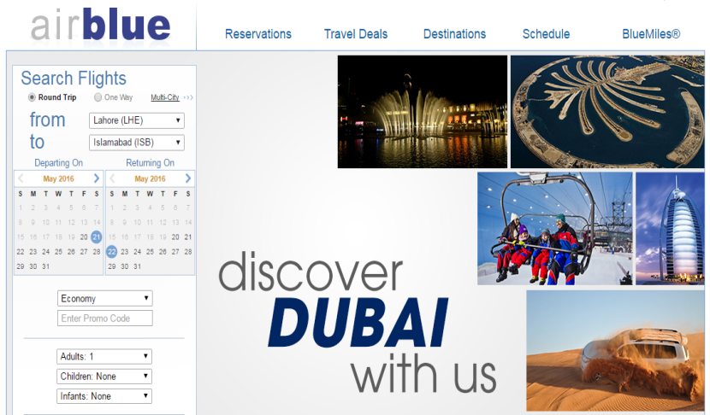
Kind attitude of cabin crew or staff at airport counters or employees sitting in offices also impacts the perception of brand as if cabin crew is kind to passengers, guide them in good way without making laugh of them will automatically help customers to create positive perception about that brand. Similarly, the staff at airport counters or employees in offices is the representatives of brand. If they aren’t helpful to customers, customers won’t prefer that brand in future.
Here, we want to quote the example of Airblue which shows caring attitude toward customers by updating every new service as much attractive as they can.

- DELIGHT CUSTOMERS
As airline industry involve service related facilities and everyone is competing with other on the quality of services and tries to offer excellence in services. But all airlines are advertising service quality in, somehow, same style. The things which attract more customers about the additional amenities that some airlines are offering to delight customers by identifying their true needs and satisfy them beyond their expectations.
- COMPONENTS FOR RELATIONSHIP MARKETING STRATEGY:
Here, we will discuss some important components that help airlines to develop good long-lasting relationships with customers and also allow them to retain those relations.
- DATABASE MANAGEMENT:
An airline can only be successful in developing good relations with customers when it has clear idea of main customers. For this, airlines will need to know about the demographics of customers like name, address, income level and social styles. Airlines should keep data up-to-date and accurate; otherwise it will affect the brand image.
Another important thing that airlines should know about customers is the preferences of customers like their needs and wants, likes and dislikes because customers don’t like to tell everything again and again like preferred seat and dietary requirements.
Another type of data which is important to collect be the “buying behavior of customers” that from which means they make booking like by using online media or through travel agents.
Another important thing that airlines need to know is the “travelling patterns of customers” that which route they use frequently and fly. Only in this way, airlines can get maximum information about customers and airlines able to build-up marketing communication material for engaging and satisfying customers.
The next important step is to integrate the customers’ data properly according to their demographics and buying patterns. Keep customers’ accurate address and telephone numbers. Customers should also co-ordinate with airlines in such a way that if they change address or numbers, they should inform airlines. In today’s fast growing world, keeping customers’ data is cheap and affordable which is an advantage for airlines. It also helps airlines to develop and retain good customer relations.
- QUALITY MANAGEMENT:
“Delivering the promises to customers” is the central part of airline business model. If airlines deliver what they promise to customers like flight punctuality, safety, quality of food and services, they will be successful to develop and sustain long term advocate relationships with customers. If they fail to do so, airlines will lose their loyal customers and develop destroyer relationship with customers.
Quality management is very important in service industry particularly in aviation industry where outputs are consumed at the same time when they are produced, no time to make amendments and check the quality of output. Quality management is now becoming an important part of aviation industry. Airlines should adopt proper quality standards for good perception of brand in the market. Quality management is being done by top management of an organization. Its top management responsibility is to update quality standards with time, make changes with the passage of time. Only, this way airline can satisfy their customers and retain them in best possible way.
But Pakistani carriers fail to maintain the excellence in quality standards. Private carriers are now trying to meet and maintain good quality standards to satisfy and retain he customers for long period. But PIA isn’t doing anything for maintaining quality standards like no punctuality in flights, the quality of food is so miserable and the attitude of staff is very disappointing which leads to customer lose.
- CUSTOMER RELATIONS:
“Developing good relations with customers” is core of any airline. Customers play significant role in the growth and decline of an airline. If an airline gets success in satisfying needs and wants of customers, that airline will be able to enjoy profitability in future. Here are some points towards which airlines give special attention for satisfying customers in best possible way:
- Offer free call service for complaints and questions. This help customers to make call to airlines anytime without any hesitation and fear.
- Airlines should also provide facility of e-mailing for building more strong relations with customers.
- The quick response to complaints is very important and pays attention towards them for enhancing the efficiency of processes and re-maintaining the strength of relations with the customers. These help customers to build positive perception about brand.
But again Pakistani carriers aren’t performing well in this area. They aren’t giving attention towards customers complaints due to which they face customer lose problems. Successful carriers can’t bear unhappy customers because if customer won’t happy, he/she will prefer to switch to another airline which is the greater lose for airline. For maintaining advocate relations with them, airlines take note their complaints, pay attention towards them and give some benefits as compensations like free ticket to customers or extra miles on travelling.
- COMMUNICATION WITH CUSTOMERS:
Delivering message to customers in more effective way is very important and crucial part of marketing. Airlines use different means of communication to deliver message to customers and remain them in-contact with airlines. In today’s advance environment, airlines use social media as a most powerful tool for communication because every customer has an access to internet and keep in-touch with social media sites. For this, airlines use this tool very carefully as there are many competitors in the market and one wrong thing will lead to huge loss of customers.
Airlines also make telephone calls to frequents flyers to keep them update about news offers and deals, e-mail customers to keep remembering them about special deals and fares, text them to update them about the flight status and delay in flight.
- PORTER’S FIVE FORCES
Airline industry transport people from one place to another with convenience and efficiency that any other substitute can’t be provided this kind of services. Airlines try to provide excellence in services to their customers. Many airlines have defined their target market at global level while other airlines focus on smaller geographical areas.
Porter’s five forces is a framework developed by Michael Porter in 1979 which is used to analyze the level of competition within the industry and helps to develop effective business strategy. Threat of new entrants, bargaining power of buyers, bargaining power of suppliers, threat of substitutes and rivalry among competitors are major factors of Porter’s Five Forces. In order to analyze the airline industry in Pakistan, we need to understand each force:
- THREAT OF NEW ENTRANTS:
New entrants in an industry put pressure on prices, cost and rate of investment which is necessary to compete by incumbents. The barriers of entry in airline industry is high as it needs a large amount of capital and without strong customer base, the chances of making profits will less and airline has to face loss in first few years. Convenience and safety are major concerns of aviation industry, that’s why people may prefer major brands. Here are following factors act as barriers for new entrants:
- Restrictive government policy
In airline industry, the licensing requirements, high standards for safety, buying of aircraft and their worthiness, permit on international routes
- Resource barriers
In aviation, the airport slots act as a major resource barriers. It is difficult for new entrants to gain the slots of attractive timings at airports.
- Capital requirements
In Airline industry, a new entrant needs a large amount of financial capital which act as a huge barrier for new entrants.
- Customer loyalty to established brands
People prefer to buy tickets from major brands because for them, the safety, comfort and quality of services are top priority.
- Industry profitability
The aviation industry is highly regulated industry and chance of making profit is just about 5%. This also discourages new entrants because I first few years, new entrants will face loss.
- BARGAINING POWER OF BUYERS:
This force looks as a power for the customers as this gives ability to customers to put pressure on airlines. The bargaining power is high when there are more alternatives available in the industry and bargaining power is low when the limited firms are available.
In airline industry, many airlines are doing their operations and try to achieve maximum customer share. This increases the bargaining power of customers as they have more choices in the industry and can switch to any airline which offers better quality at low cost.
- BARGAINING POWER OF SUPPLIERS:
The main suppliers of airline industry are aircraft manufacturers and fuel suppliers. Two aircraft manufacturing companies are famous named as Airbus and Boeing. These companies are focusing on producing more advanced aircraft to minimize risk levels and differentiate their products by offering enmities in aircraft.
Similarly, the airlines has to use fuel for the operations of aircraft and airlines make long-term agreements with fuel supplier companies at fixed price to lower their cost like in Pakistan PSO and Shell companies are major fuel suppliers. As there are limited suppliers available in airline industry, the bargaining power of them is high.
- THREATS OF SUBSTITUES:
There are several substitutes are available in airline industry. Many customers use other means of transportation at domestic routes like buses, cars, and trains to go to destinations because of their low prices. This lowers the industry profitability. Sometimes, the cost by travelling other transportations is costly than travelling by air and airlines take complete advantage of this thing.
In early times, the ships are the substitutes on long flight but now customers give a high range of preference to airlines for long flights because of safety issues on ships. Airlines take complete advantage from this thing, improve the quality of services and focus on safety of their lives, try to offer more direct flights to Europe. PIA had daily direct flight to Europe in early times and now PIA has just limited flights to Europe but still has an advantage over other Pakistani carriers.
- RIVALRY AMONG EXISTING COMPETITORS:
In airlines industry, the rivalry among players is highly intensive because all airlines are providing the same services to its customers. More airlines in the industry give more choices to customers and they can easily switch to other airlines for small cost. This starts the price wars among airlines for retaining more passengers. Furthermore, the companies can’t exit the industry easily due to higher fixed cost and long-term loans with banks and agreements with aircraft manufacturing companies that force airlines to stay in industry competitors remains the same in long-term.
Every airline is trying to improve its services to attract more customers and retain them. The airlines also lower their price fares to compete in the industry. In Pakistan, Airblue and Shaheen are competing with one another by improving the quality of services and lower the fares to attract more customers and make them advocates for airlines. Now the airlines are also competing by introducing new technology like Airblue is the first airline that has introduced e-ticketing and self-check-in kiosks in Pakistan.
- THREE GENERIC STRATEGIES:
Michael Porter suggested three generic strategies for developing effective and competitive strategy which will help-out the company to engage previous customers and attract new customers and strengthen competitive market positions. In the beginning, companies failed to develop an effective and competitive strategy and that ineffective strategy not allowed airlines to gain dominance in the competitive environment. Additionally, top management of the organizations weren’t give special attention towards strategy development and unaware of the benefits of strategy. To reduce this ambiguity, Porter suggested three generic strategies according to needs and wants of organizations and all three strategies have three different approaches:
- Low Cost Leadership Approach
- Differentiation Approach
- Niche Strategy Approach
These all three strategies approaches strive to get the market position in the industry. Two approaches such as differentiation Approach and Low Cost Leadership Approach are used to capture broad range of customers and to target a large amount of customers. On the other hand, Niche Strategy Approach is used to target a small range of customers. In other words, Niche Approach is used to get a smaller portion of buyers.
Here, we will discuss each strategy approach individually.
- DIFFERENTAITION STRATEGY APPROACH:
By adopting Differentiation Strategy Approach, the company competes with competitors by offering something unique in products or services in the industry. The uniqueness can be in features of products or anything that add values to customers and delight them. Differentiation Approach allows companies to offer distinguishable things to retain customers by delivering values to them and encourage them to pay for that value. In differentiation strategy, companies should give attention towards the satisfaction of perceived customer values as if the brand is well-known and has excellent “word of mouth” promotion, customers expect and perceive that this organization product or service must be better in features and add values than other brands.
Here, we want to quote an example of JetBlue Airways, U.S based airline, which was the first airline to offer “DIRECTV” facility in-flight and installed small TV screens in front of customers. This facility allows customers to watch live TV during flight.
Now-a-days, every airline is offering this kind of facility but JetBlue Airways was the one who create differentiation in the industry. By adopting Differentiation Strategy, companies are able to compete with competitors on the basis of uniqueness in products and services, not on costs.
Additionally, airlines are trying to do unique things in marketing because marketing is powerful tool to communicate message to customers in more effective and attractive way. Like Emirates has adopted new marketing concept of “Hello tomorrow” where Emirates is trying to convince customers to travel with them because Emirates will explore and make future experiences more beautiful and memorable. This creates differentiation in the industry and attracts customers towards it unintentionally which allow Emirates to enjoy more market share, growth and profitability.

Additionally, Etihad has designed “fixed headrest support” for customers’ comfort which creates Differentiation in the industry and delight customers.

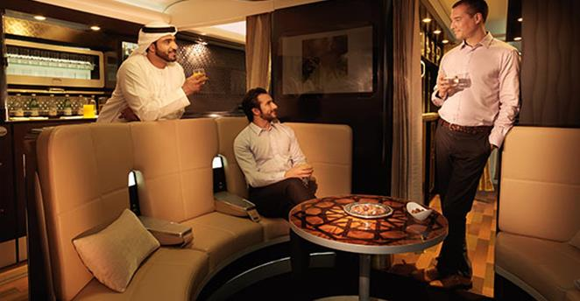

Furthermore, Etihad has offered “The Residence” suite in A-380 which is the best example of Differentiation Strategy.
- LOW COST LEADERSHIP APPROACH:
Low cost leadership strategy works when customers in the industry are price sensitive. The main objective of adopting low cost leadership strategy is to reduce the cost of organization at lowest and try to offer low prices to customers. The effective and efficient low cost leadership strategy can only be achieved if companies develop strategy in such a way that no other organization try to imitate it. As, we know that airline industry is highly regulated industry and the profit margin is very low that is about 3%-5%, which means that adopting low cost leadership model without competitive strategy is very difficult for airlines. An airline with low cost leadership strategy has two options for gaining profit in the industry:
First option is that airline charge less fare on same route than its competitors. This can only be happened if the customers are truly price-sensitive and the flight schedules are also convenient to them. Obviously, it will work best and airline with best low cost leadership strategy will gain the maximum market share.
The second option is to charge same price on route as other competitors do. In this way, the competitors try to offer more less fares on the same route and price war will begin. But after certain time, the competitors fail to drop down more prices and face tough competition in the industry.
Here, we want to quote example of “Southwest Airline” which is known to be the best airline example of Low Cost Leadership Strategy Approach. In the era of full service carriers, Southwest came-up with the concept of “Low Cost Carriers” which gave new dimension to the industry. Southwest Airline dropped its fares at as much lower level that about two decades, no airline was able to imitate its model. Now, there are many players in the industry with Low Cost Carriers which shows that now majority ratio of customers are price conscious and airlines are trying to shift towards Low Cost Leadership Strategy.
Being Low Cost leaders, airlines prefer to use social media for advertising because of low cost and the fact is that in today’s advance environment, everyone has access to internet. Airlines try to make online marketing strategies more attractive and effective that at least once, websites and other marketing campaigns are able to grab the attention of customers.
- NICHE STRATEGY APPROACH:
The third and most important generic strategy of Michael Porter is Niche Strategy, which allow companies to adopt either a low cost Leadership Strategy or Differentiation Strategy but for a smaller target market or for a limited range of customers. Three primary ways are being used to segment a market for companies who wish to adopt Niche Strategy.
- Geographical Niche Strategy
- Customer-Type Niche Strategy
- Product-line Strategy
Niche Strategy help companies to become experts in the particular market, get idea about needs and wants of that market and also get knowledge that how to anticipate them. It helps airlines to develop brand loyalty among customers which is good thing for brand perception because if company decides to expand business in future and enter in the market at larger scale, it will be an advantage for new entrants.
- RESEARCH OBJECTIVE
Before last few years, only PIA had monopoly over aviation industry of Pakistan. Now, Pakistani aviation industry is growing from last few years as there are many new airlines like Air Indus, Airblue and Shaheen Air have started their operations in last ten years and many new airlines like Serene Air and Pakistan Airways are also planning to start operations in the territory of Pakistan. It means that customer demand is increasing rapidly in Pakistan and major portion of customers are using Air travel, passenger has more choices in the industry which increase competition in the market and limited the chances of profitability.
As we all know that airlines get maximum customers by identify their needs and wants and satisfy them in attractive and efficient way. Globally, airlines prefer effective marketing strategies for grabbing customers’ attentions and retain them for long-time. But in Pakistan aviation industry, airlines aren’t giving enough attention towards adopting attractive and efficient marketing strategies.
Here, we will discuss some problems of marketing that Pakistani carriers are facing, not giving enough attention towards customers’ needs and wants and if they are giving attention, not market services and products in effective way. Due to this, many customers are switching towards Middle East carriers.
- DATA COLLECTION:
Here, we collect data about the problems of Marketing Strategies of Pakistani carriers that why they are losing their customers. As we know that Pakistan aviation industry is at growth stage from last few years. Many new carriers have started operations and few new carriers are planning to enter in the industry with unique set of qualities. This increases the choices for customers but due to some problems in marketing strategy, Pakistani carriers are losing their customers as many customers even don’t have clear awareness that which airlines are operating in Pakistan. Customers have just awareness of PIA and due to bad perception; they don’t like to waste their money and time to choose it for travel.
Here, we will discuss the problems in marketing strategy and compare Pakistani carriers with other successful airlines globally.
MARKETING COMMUNICATION STRATEGIES:
Airlines use different marketing strategies for communicating the features and overall values of the product/services to their target market for attracting maximum number of customers like Emirates and Qatar, being government owned airlines, spend a large amount of money to adopt best marketing strategies for communicating the values of products to their customers and make them more attractive than competitors.
Here, we are going to explain some marketing communication techniques that airlines adopt for attracting and retaining their customers:
- SPONSERSHIP:
Sponsorship is the situation where airlines have associated their names with an event or a team in exchange of money for advertising. Airlines may sponsor sport team, charity events and sport tournaments. This may not improve the profitability of an airline but it’s a good way to give awareness of an airline and build good brand image which may enhance the number of customers. All carriers shouldn’t involve in any activity and sponsor any event which effect the environment as it creates a negative image in customers’ minds.
In Pakistan, the airlines aren’t giving attention towards this powerful marketing communication tool because when an airline sponsors an event, a large volume of audience gets to know about the brand. The fast growing airlines like Emirates, Qatar and Etihad, sponsor so many sport events as this helps them to give awareness about their brands.
Recently, Pakistan has launched Pakistan Super league named as PSL which is highly professional Twenty20 men’s cricket in Pakistan. Qatar airways has signed a long-term partnership with PSL. Additionally, Qatar airways offered 10% discount offer to enjoy Pakistan Super League to its customers. This sponsorship helps Qatar airways to reach new customers with power of sports.
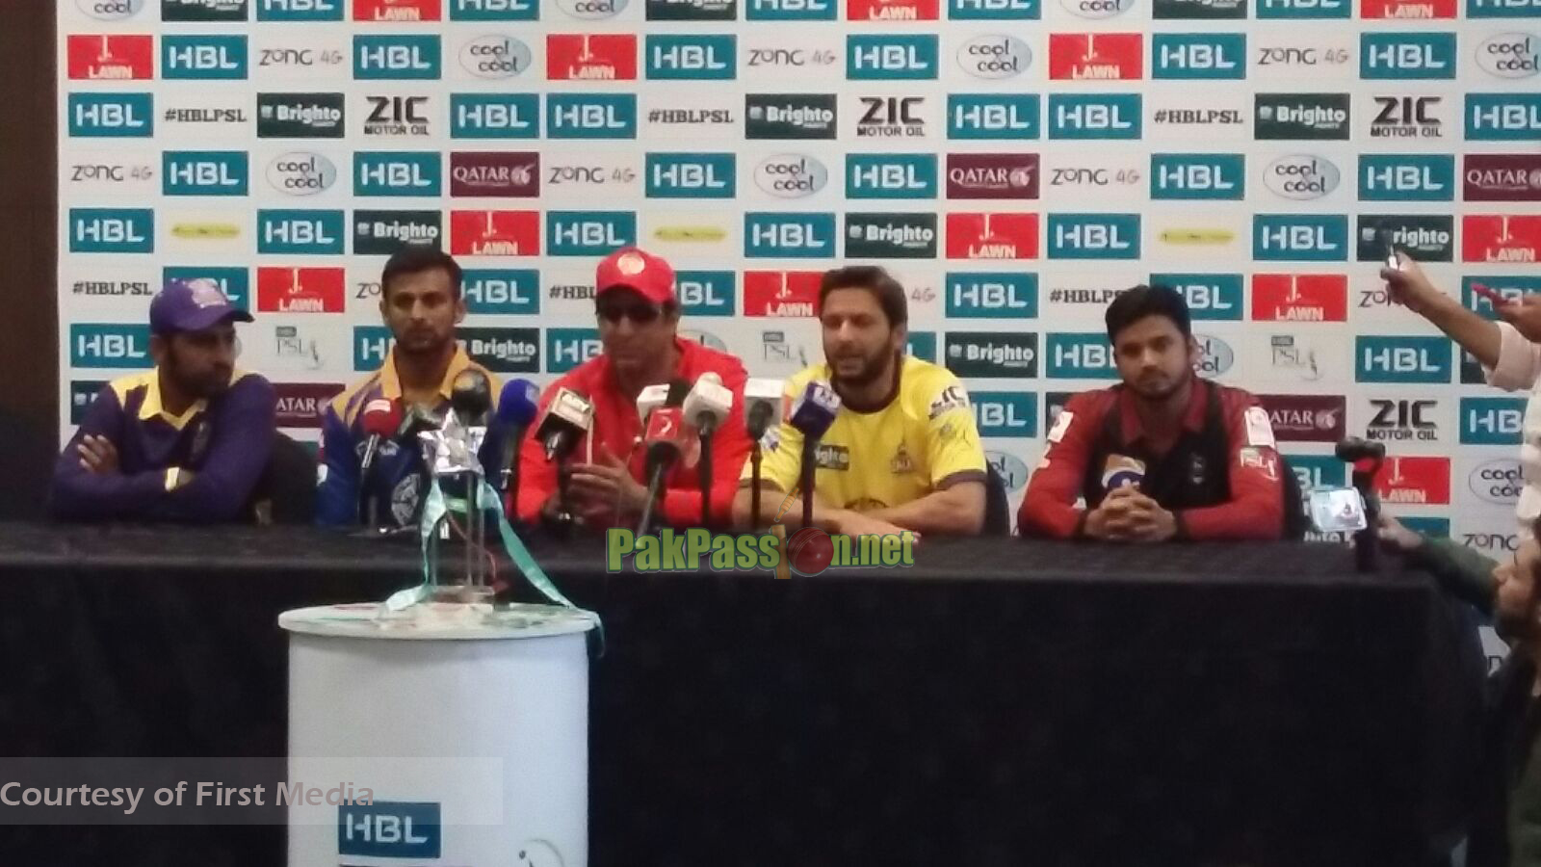
Airblue has flights to Dubai and Sharjah where all matches of PSL were played, Shaheen has flights to Dubai and PIA also has flight on these routes but our Pakistani carriers didn’t sponsor PSL. As PSL is launched by Pakistan but Pakistani carriers didn’t take advantage from opportunity to give awareness about their brands to all over the world and improve the image of brand.
Additionally, Emirates was an official partner of ICC Twenty20 world cup in 2016 which position its brand image in more efficient way and helps Emirates to give awareness about its brand to maximum people and build good perception in people’s minds. Emirates was an official partner of ICC World cup in 2011 and 2015.
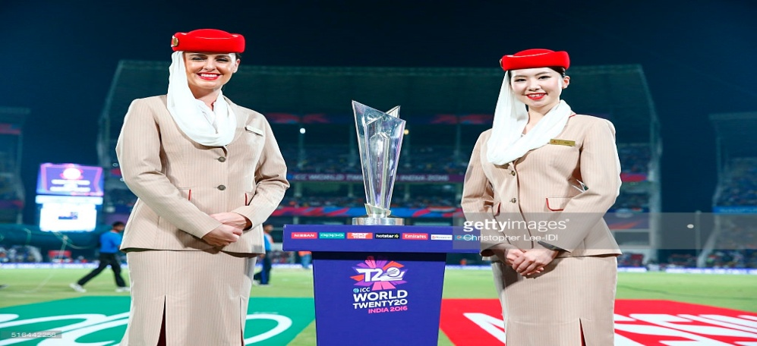
But Pakistani carriers didn’t sponsor any sport event which limited their profitability and market share. When people don’t get awareness about the airlines, how will they buy tickets from those particular airlines?
Similarly, Pakistani players travel with Emirates for any ICC World Cup. Here, Pakistani carriers especially should give some attention as if our national team will travel with PIA, national flag carrier of Pakistan, will leave a positive image at least in Pakistani passengers and they will prefer PIA for future travelling.
- WEBSITES:
Website is one of the powerful online communication tool that organizations use for communicating the excellence of services and products to their target market in more efficient way. Website also allows airlines to give maximum information about them, their new products, new flights, excellence of services, achievements and much more on just one click without visiting any travel agent. In today’s competitive and internet popularity environment, where time is money, the airlines are trying to use effective marketing tactics to develop their websites strategically and keep them updated, attractive and more useful for their customers. This allows customers to review new offers, service quality and new products of airlines.
- BENEFITS OF HAVING WEBSITE:
Websites facilitate customers to get quick review of airline and build perception about it, either positive or negative. It all depends on the effective usage of marketing strategies. Here, we mention some benefits of having effective website:
- COST SAVING:
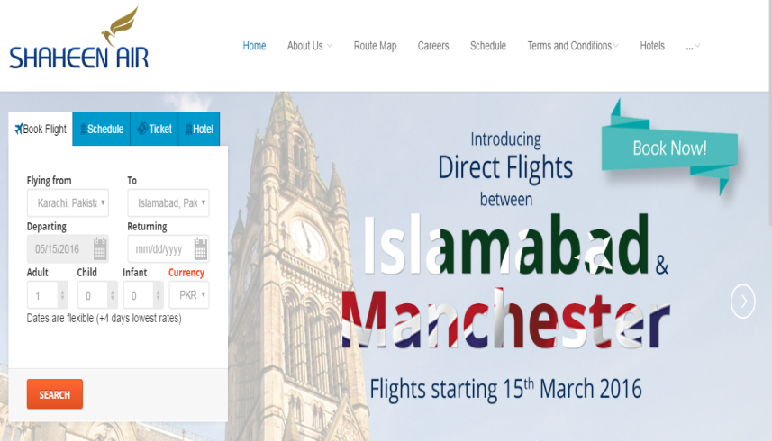
The airlines save the cost of extra offices, staff and other variable costs by giving facility of website to its customers. In today’s busy life, many customers don’t have enough time to visit offices and make reservations. Airlines take advantage from this great opportunity and save a lot of costs by giving all information about the new products like the acquisition of new Aircraft or change previous old seats with new comfortable seats, promote new flight routes like Shaheen Air International is promoting its new flight from Islamabad to Manchester on front page.
These kind of activities give quick awareness to customers and also benefit airlines in terms of cost saving.

- EASILY ACCESSIBLE:
Website allows customers to make reservation any time, review the new products and services on one click because airlines’ websites and social media accounts are accessible 24/7 and every day of a year. This enhances the loyalty of customers towards brand. Imagine a customer wants to purchase a ticket and office of airline is closed or too far from customer’s reach, there’ a lot of chances that customer will move towards another airline.
- PROVIDE CONVIENCE TO CUSTOMERS:
Websites allow customers to view features and values of airline’s product and services in more comfortable way. It is more convenient for customers to review company’s products and make reservations in comfort of house than to go outside for booking. This also encourages potential customers can browse online and purchase tickets. This again facilitates airline to develop loyal customers.
- ENHANCE SALES:
When airlines are failed to make profits for 2 to 3 years, the company will face a lot of loss and may be, it will be doomed in future. As aviation is highly regulated industry and profit margin is very limited just 3-5%. For this, airlines try to cut-down their extra costs as much as they can for enhancing the chances of revenues. Now-a-days, many successful airlines, especially the Low Cost Carriers are using online sales process to reduce cost of extra staff and offices. The online selling processes also save the customers’ time and allow them to purchase a ticket anytime anywhere without any limitations. The airlines’ main focus is to attract more customers for enhancing sales because when sales are high, airlines are able to generate more revenues and ultimately they gain profits.
- BUILD ADVOCATES FOR COMPANY:
Having a website gives a lot of advantages to airlines. The airlines use social media pages to pay attention towards customers’ complaints, feedback and also reply back to them which show the caring and serious attitude of airline towards customers. This kind of attitude builds advocates for airlines. This also enhances “positive word-of-mouth” promotion as customers who receive kind behavior from airline employees must recommend other people to travel with that particular airline.

- BRAND EMBASSADOR:
Brand ambassador is the person who is being hired by organizations to represent company name, its products and services to customers in positive way and increase brand awareness among customers. Brand ambassadors use their excellent marketing abilities to promote the brand in such a way that trustworthy and positive perception that will build-up in customers minds and will force them to travel with them in future.
Brand Ambassador is become norm in Aviation Industry. Famous celebrities like actors, famous sport players and models are being used as brand ambassadors. Its’ important for every airline to have a brand ambassador as if a famous personality represents your brand, the potential customers will definitely attract towards that brand as that famous personality capture the customers’ attention by adopting effective promotional strategies. Brand ambassadors are the spokespersons and become the advocates of an airline which influence the consumers and attract them.
- WHY BRAND AMBASSADORS ARE IMPORTANT FOR AIRLINES:
There are many advantages of having a brand ambassador but here, we will discuss some important reasons that why brand ambassadors are important and how they affect goodwill of airlines:
- HIGH DEGREE OF PROFESSIONALISM:
Brand ambassadors are the representatives of your airline brand. They will talk about your brand, represent it by using smart marketing strategies, encourage customers to review the products and services and influence them in such a way that they will use that brand in future for travelling. For this, brand ambassadors use a high degree of professionalism because their non-serious will develop a negative perception about brand.
- PASSION TO BUILD RELATIONSHIPS:
Brand ambassador responsibility isn’t just to attract maximum customers. They also use marketing skills in such a way that they can build long-term, loyal and strong relations between the brand and customers because only in this way, airlines are able to retain good relations with customers and increase the “word-of-mouth” promotion.
- INCREASE AWARENESS AMONG CUSTOMERS:
Brand ambassadors act as spokespersons, leaders and influencing personality. They represent the brand at their events, shows which increase the awareness of brand among the customers and people would love to travel with the airline whose brand ambassador influence the customers in more attractive and turn them into potential customers.
- EXAMPLES OF AIRLINES GLOBALLY:
Now UAE airlines like Etihad, Emirates has hired Hollywood famous personalities as brand ambassadors because these airlines target elite class and they have strong positive perception about Hollywood personalities.
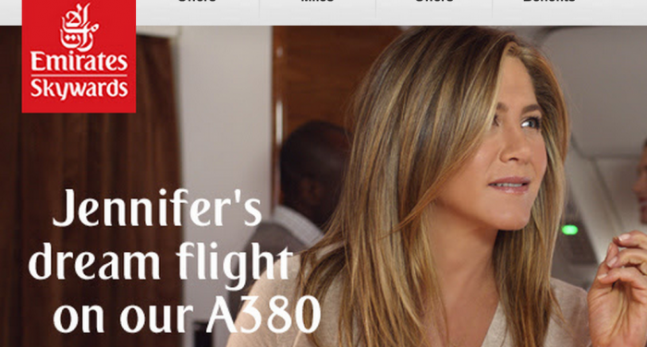
- EMIRATES:
Emirates has signed Jennifer Aniston, American famous actress, as a new brand ambassador and for advertising campaigns globally. Emirates advertise Airbus A-380 features by using Jennifer Aniston. Aniston connections with the audience globally force Emirates to hire her as a brand ambassador and use her in new marketing campaigns. Her professional attitude and comedic talent pleased the customers and encourage them to prefer Emirates in future.

- ETIHAD AIRWAYS:
Additionally, Etihad has recently hired new face of Nicole Kidman, Oscar winning Australian actress, as a brand ambassador who creates positive perception about brand. Etihad hired Nicole Kidman for promoting “The Residence” class of Airbus A-380.

- TURKISH AIRLINE:
Turkish Airline has announced Leo Messi, Argentina Soccer star, as a global brand ambassador in 2012 which improves brand image because Turkish airline is growing rapidly and declared as Europe’s best airline at 2015 Skytrax Passenger Choice Award. For this, Airlines hire famous personalities as brand ambassadors for promoting brand image. This helps to convert customers as advocates for airlines.
These all above examples explain that how Brand Ambassadors help to promote the image and awareness of airlines among customers and how much they are giving benefits to customers. But unluckily, Pakistani carriers aren’t giving any kind of serious attention towards this important marketing communication tool. As aviation is at growing stage, Pakistani carriers need these kinds of marketing techniques to promote brand and awareness globally. Recently, Pakistan has launched PSL as highly professional cricket event. PSL was held in Dubai and Sharjah and every Pakistani airline has weekly flights at U.A.E. but Pakistani carriers give no attention towards this event. Carriers should hire famous cricketers as brand ambassadors for promotion of brand.

- TELEVISION COMMERCIAL ADS:
Commercial ads are powerful source for organizations to convey their message, culture, values and quality of services to its customers in best possible way.
It’s a kind of advertising in which programme running on TV for specific time which may ends after some seconds or minutes. Ads act as a selling tool as audience get to know about the values of products and services that are being delivered by airlines. TV commercial ads are old but effective means of communication because every individual love to watch TV shows like talk shows, news, business programmes and in this way, organizations are able to convey their message to its customers.
They also create awareness about the brand in customers’ minds that what kind of products/services is delivering by airlines and also able to analyze the airlines on the basis of ads which one is better.
- HOW AUDIENCE ANALYZE COMMERCIALS:
Pakistani carriers aren’t developing good ads for conveying message to customers. When airlines won’t try to improve the brand image in customers’ minds, how they come to know about the services of them. PIA has few ads which aren’t enough attractive to attract customers, Airblue doesn’t have any TV Ad which really limits the profitability of company. Shaheen Airways has just one TV ad TV commercial ad is ancient but an effective mode of communication even in today’s advance environment. Pakistani airlines should give attention to design and develop attractive TV ads that can attract audience and convince them.
- WHY COMMERCIAL ADS ARE IMPORTANT?
Commercial ads create a positive perception in customers’ minds and airlines get successful to grab the attention of them by using different exciting concepts, force them to prefer that particular airline in future for travelling. Many airlines sponsor special sport events and develop commercial ads on those events. These force customers to build a strong positive perception in their minds.
Like Emirates sponsor and design ads on the football concept and football loving customers will prefer to travel with Emirates as its human psychology that whenever any company gives as much importance towards customers’ interest, they will definitely prefer that particular airline.
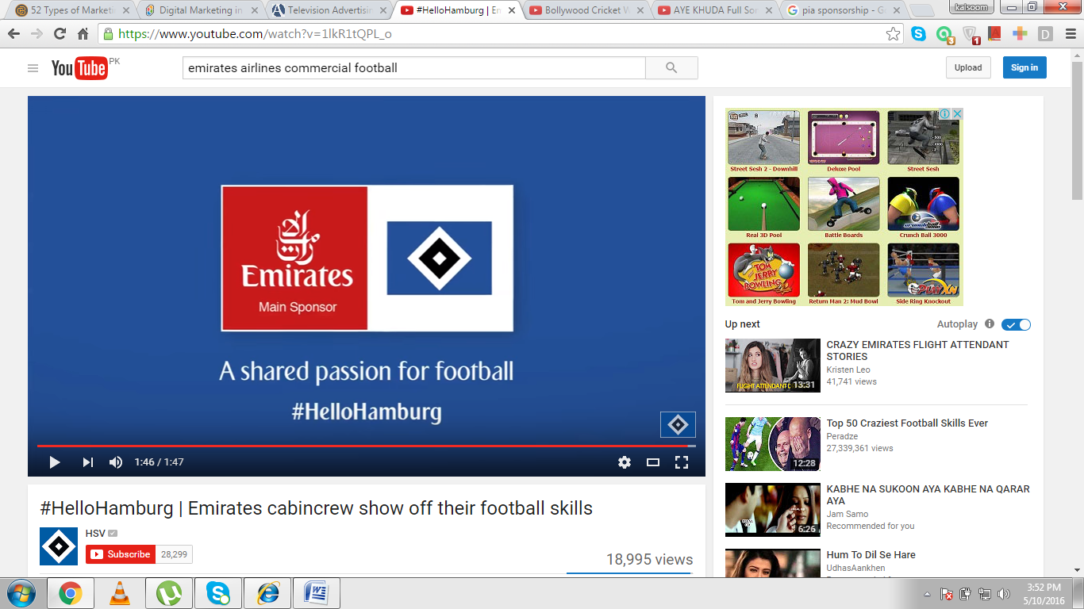
Many airlines all around the world like Emirates, Turkish, and Etihad develop their ads based on the sport events and festivals as they attract more customers’ interest and customers prefer that particular airline whenever they will plan for travelling due to good perception in minds.
Similarly, Turkish Airline developed ad by using concept of basketball in days of matches in 2014 to grab the attention of basketball lovers and force them to think that Turkish airline is more concerned about the customers’ interest, deliver message to its customers in more attractive way as almost many customers love these kinds of thrilling sport activities. So, good airlines take complete advantage from these kinds of opportunities and also make their ads successful.
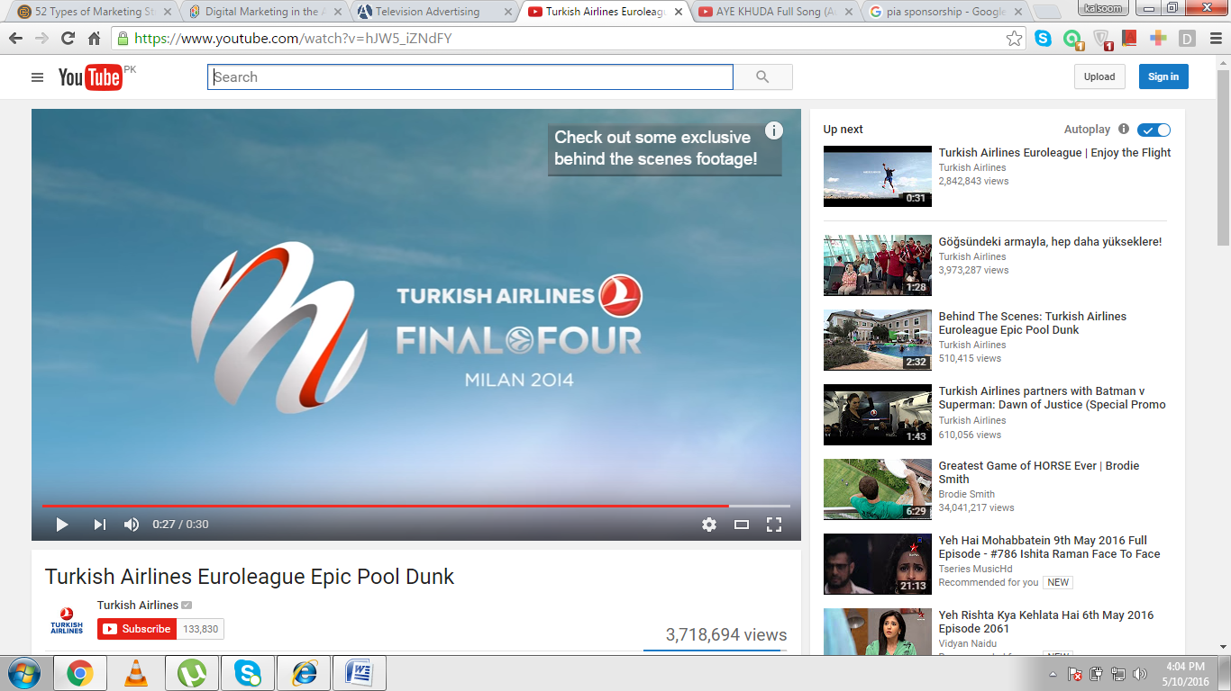
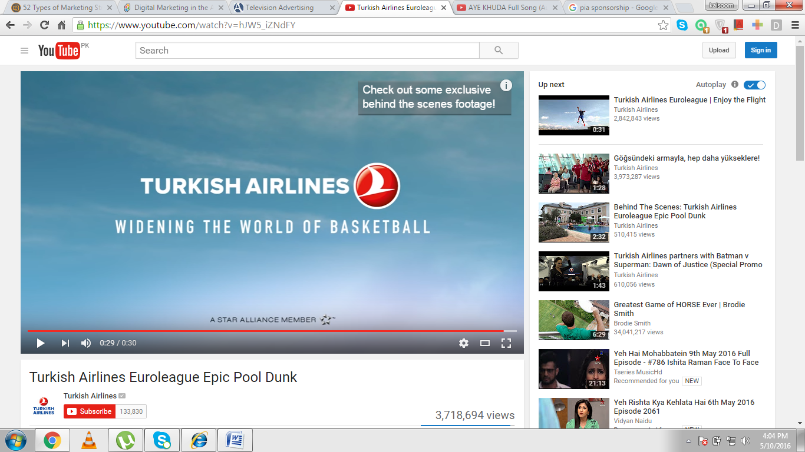
Additionally, we add the picture of Turkish airlines that how it promoted Eid Mubarak festival on its Airbus A321 which flies over 34 destinations in Middle East and South Africa and allow customers to feel like family as airline is concerned about its customers festivals and celebrate them with customers.
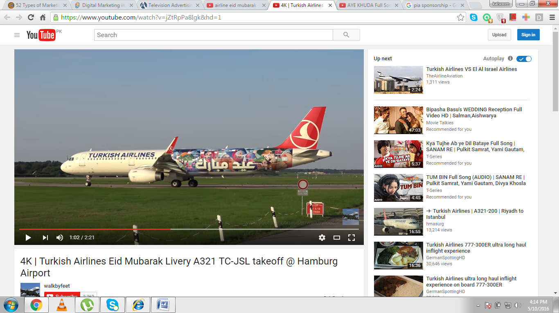
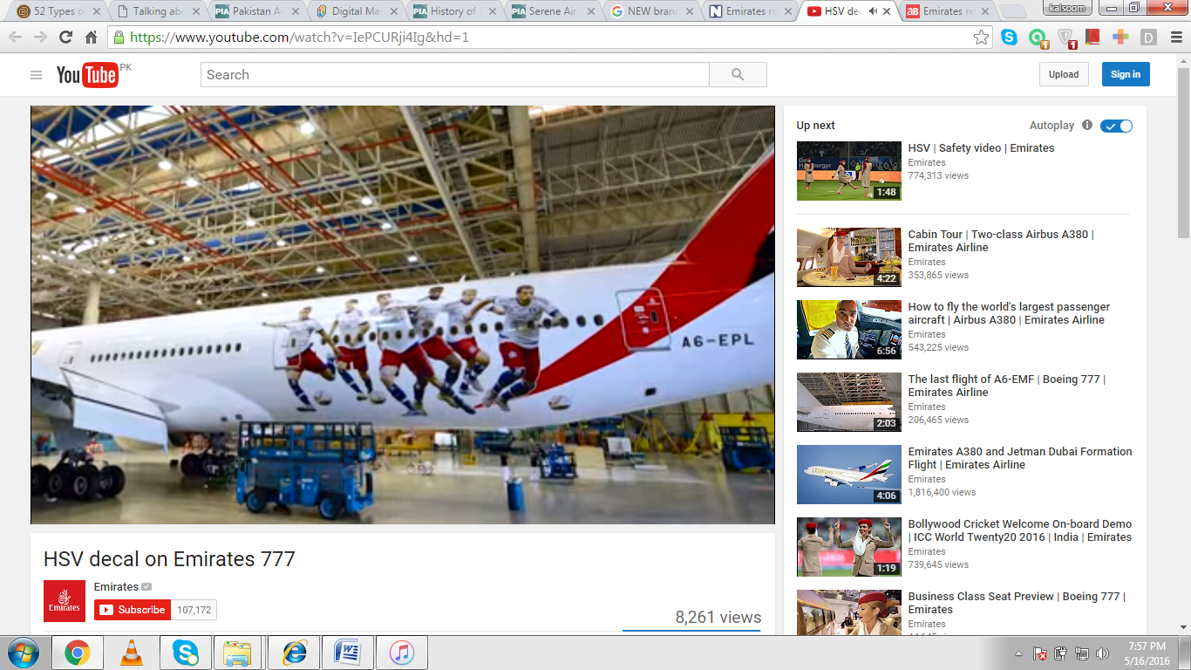
Similarly, Emirates celebrated decade partnership with Hamburg and football club on Boeing777aircraftdecalby designing the images of six players. This improves the brand image globally and also shows the professional attitude of airline. This creates a positive image all across the world in customers’ minds.
But unfortunately, Pakistani airlines aren’t performing such kind of activities on special events which seems like boring. Recently, Pakistan has launched PSL, highly professional cricket event. Pakistani carriers didn’t take advantage from PSL and didn’t develop good TV commercial ads as this creates a good perception in customers’ minds and they will prefer to choose that airline whenever travel in future.

- SIX THINGS FOR DEVELOPING EFFECTIVE COMMERCIAL ADS:
Pakistani Carriers should give focus on below mentioned six things in developing effective commercial ads to attract audience and leave a long-lasting image about brand.
- What is the product or service is being sold?
Airlines should give clear message about the products and services which they are going to market through TV ads. Without clear message, audience won’t be able to get know about the message and creates a bad perception about the company. In message deliverance, Pakistani carriers are doing their good jobs as they give clear message about their products and services.
- Who is the airline being sponsored the product or service?
Carriers should make sure that audience easily recognize the organization name that which one is sponsoring the product/service. Now-a-days, the airlines are trying to compete and get positive position in competitive environment. For this, they are giving focus on promoting services and new products by developing commercial ads in more attractive way to get maximum customers’ attentions. All carriers are giving focus on this major element to give awareness about the brand name to the audience.
- Who is the target market for television commercial?
Whenever an airline is planning to design a commercial ad, it should have proper information of the target market for which the organization is going to develop commercial ad. Carriers should consider demographic characteristics like gender, income level and segments. Like in Pakistan, the major segments are:
- Labor class which is price conscious
- Time conscious class
- Business community and
- Tourism
Pakistani carriers should develop ads according to their needs and wants. Pakistani carriers should advertise the fares of every class with services in more attractive way that customers love to travel with them and offer special discounts on events to retain them.
- What is the idea of Commercial Ad?
Carriers should make sure that the central idea of the commercial is delivered to audience in attractive way. Without clear message and idea, customers loss their attention in ad and this leaves a bad image in customers’ minds. Here, we take the example of Emirates commercial ad about “We Care” where Emirates deliver a clear and concise message about the things for which its cabin crew shows special attention. This leaves a positive perception about brand and customers get to know about the excellence of in-flight services.
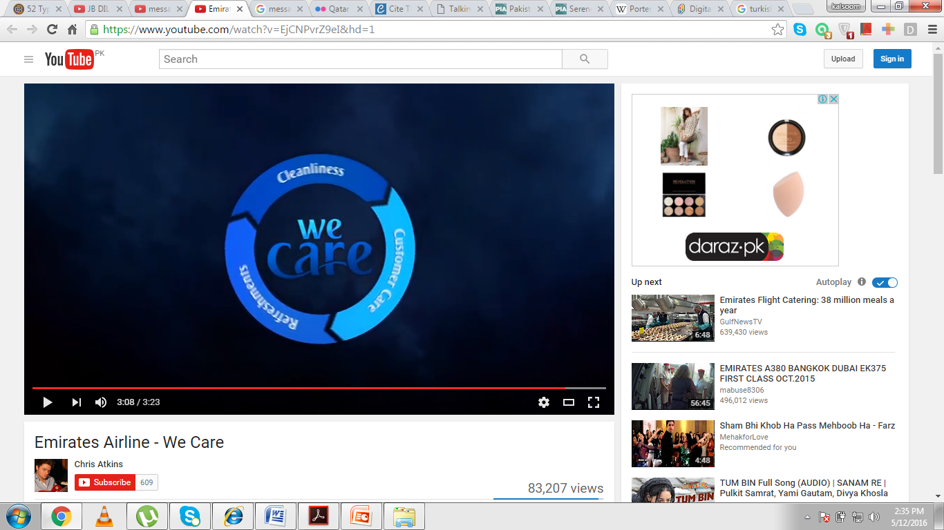
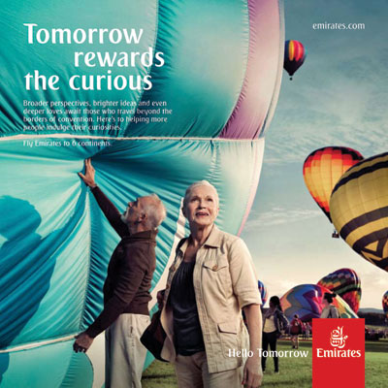
Additionally, Emirates launched new brand platform globally “Hello Tomorrow.” This concept is designed for customer engagement and their empowerment and come up with new ideas, phrases that build strong perception in customers’ minds.
But unfortunately, Pakistani carriers don’t develop their commercial ads for attracting more customers which creates no awareness among customers. Pakistani carriers should make more successful airlines as a benchmark and design ads with new innovative and creative ideas.
- How commercials will grab the attention of customers?
This element plays a significant role in analyzing TV ad Airlines give special attention towards the graphics, music and actors of the commercial ads. The attractive and colorful graphics attract the attention of customers, change the way they see the world by using story line or by adding special effects. The soundtrack and back ground music in commercial also grab the attention and change the perception about brand. Airlines use cheery and excited music according to the commercial message.
- How the actors affect brand perception?
Successful airlines cast sport stars and cabin crew for making commercials more attractive and use them as a reflection of brand. Airlines use actors from different background, convey message in different languages that force customers to think that this particular airline is caring all its customers.
Pakistani carriers use beautiful graphics and excellent soundtrack that soothes the customers and capture their attention. They also use story line for conveying the message to customers in more attractive way like Shaheen airline use story line of an actor, Noman Habib, in commercial for attracting more customers as it’s a human psychological behavior that whenever famous celebrity performing commercial, he/she will definitely attract more customers towards that brand and customers would love to rush towards that brand.
- DATA ANALYSIS:
Here, we will analyze all carriers’ websites with global airlines’ marketing strategies to explore the lapses in marketing strategies in more effective way.

- ANALYSIS OF PIA WEBSITE WITH EMIRATES WEBSITES:
In early days, the people didn’t give a highest level of preferences to websites because of less internet access and awareness. Passengers prefer to go to travel agents and get information about flight schedules. But after the advancement in IT, people get awareness and access to internet. This creates a challenge for airlines to keep websites updated and attractive because websites creates image about the brand, either positive or negative.
All airlines are trying to do their best to make websites more attractive by giving so much information about the organization, special offers, and destinations, fight schedules, and share their experiences and achievements. This leaves a good image about brand in customers’ minds.
Here, we are going to analyze the websites of PIA and Emirates because both are government owned airlines but there’s a lot of difference in their performances.
- NO MODIFICATION IN WEBSITE:
PIA website is same since from the beginning. No changes in color scheme as colors play an important role in getting the attention of customers. No changes in the design of website.
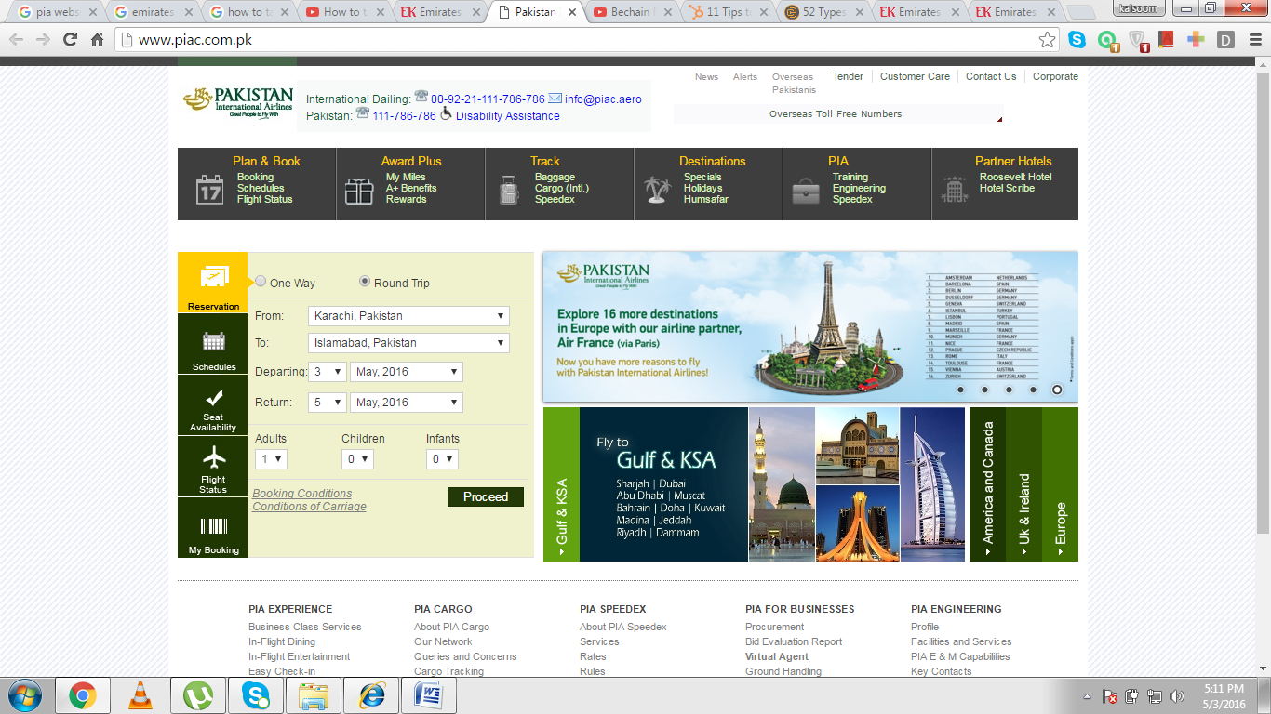

Emirates modify its website according to market demands.
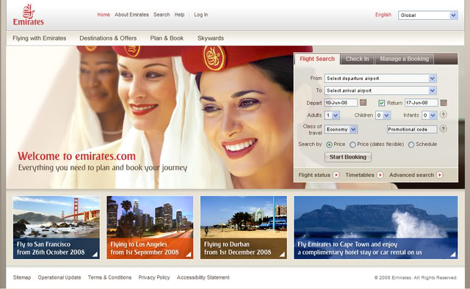
Now Emirates has changed its logo style, share the experience, give facility of online check-in, check the status of flights, give more information to customers about brand and introduce new brand platform for its customers “Hello Tomorrow” which enables Emirates to connect globally and share experiences with customers. This enhances the customer engagement and satisfaction towards brand. And the best thing is that Emirates has changed the whole website design for this brand platform and advertise Hello Tomorrow at the top with logo which grab the customers’ attention for a while.
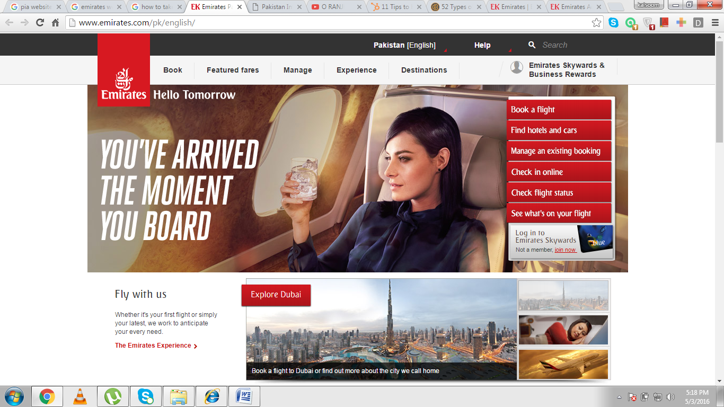
PIA is not promoting their new offers at websites in more attractive way. The new offers and services should be advertised at websites in such a way that customer get full interest in them.
- NO LANGUAGE TRANSLATION OPTION:
The next thing that PIA should adopt is the introduction of an option to translate the website in different languages like Emirates and many other airlines give this option on the top of their websites. This also builds a positive image in customers’ minds because people from different countries visit airlines’ websites and everyone don’t know English language. That’s why, this option solve the problems of many customers and build long-term relations with them. This also creates advocates for airlines.
- IMPROPER ADVERTISEMENT OF SOCIAL MEDIA SITES:
In today’s advance world, airlines use social media as an influential marketing tool. All airlines use this tool wisely and try to use all social media sites by making their official pages. Emirates has official pages at Facebook, twitter, Google plus, Linked In and You Tube where Emirates share videos, pictures, achievements and experiences with customers. This helps airline to attract, retain maximum customers and build long lasting relations with customers. Today’s customers use social media, get maximum information about airlines from them instead of visiting travel agents and get information about airlines’ offers. PIA has official pages on just Facebook and twitter and isn’t maintaining their pages properly. They just discuss about their history, not focus on present condition and promote its services.
Additionally, Etihad maintains its pages very smartly, especially Facebook page where Etihad members promptly reply to customers’ questions and say thank you to them when they appreciate their products and services and also listen feedback of the customers. This kind of behavior from airlines delights the customers and psychologically builds positive perception in their minds.
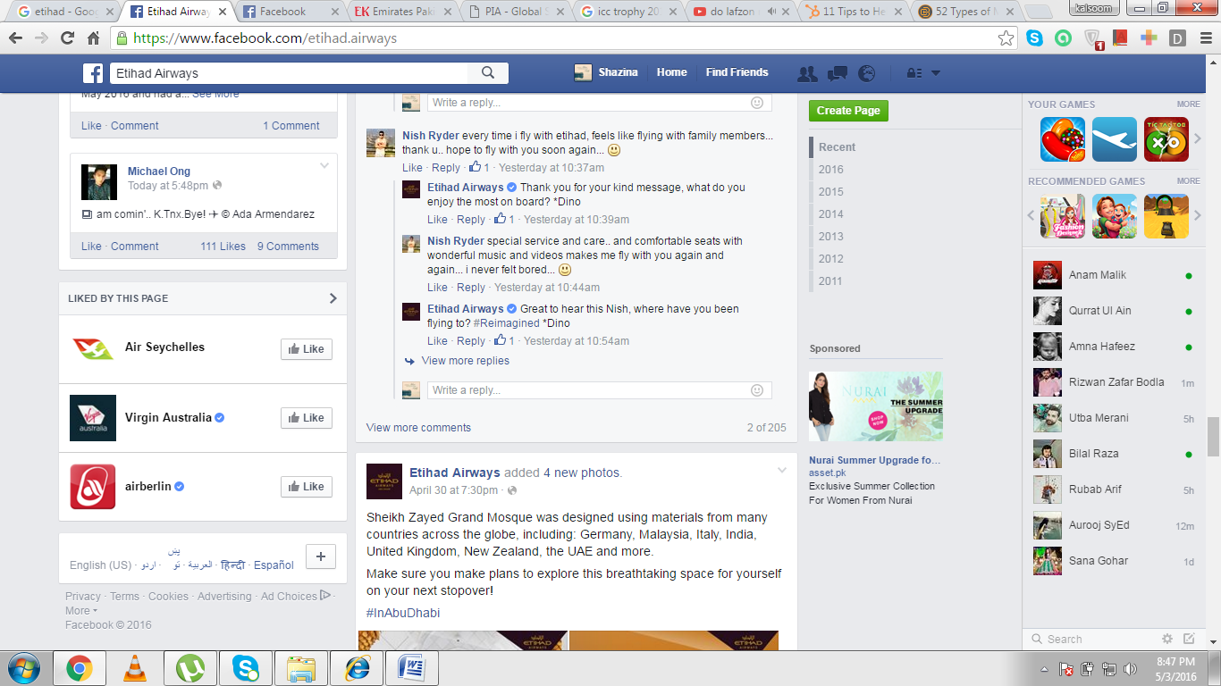
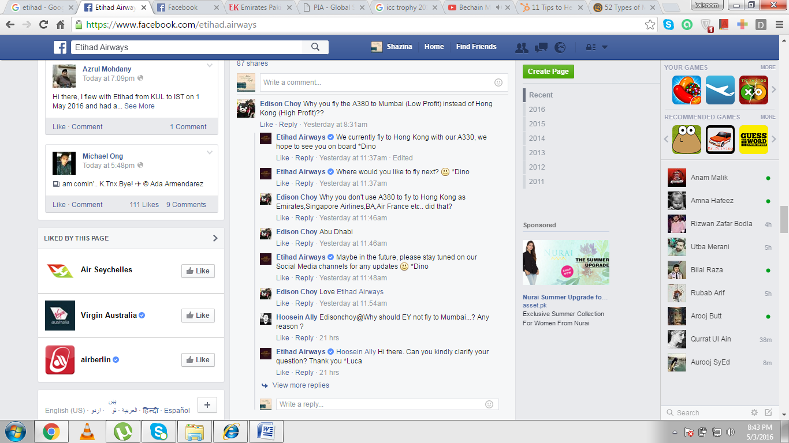
But PIA doesn’t response to the questions of PIA as it creates a bad perception about brand in customers’ minds and disappoints them. Here, we want to add pictures from PIA Facebook official page where a lady, Beenish Ramzan ask one statement three times in different timings but not get answer which automatically leads to customer dissatisfaction and customer will switch to another carrier.

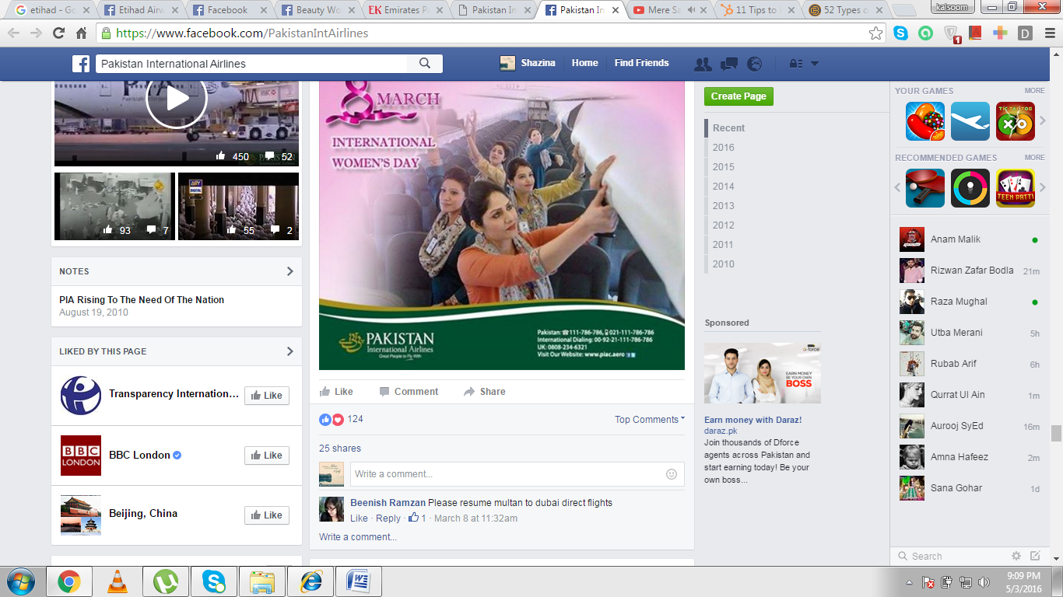
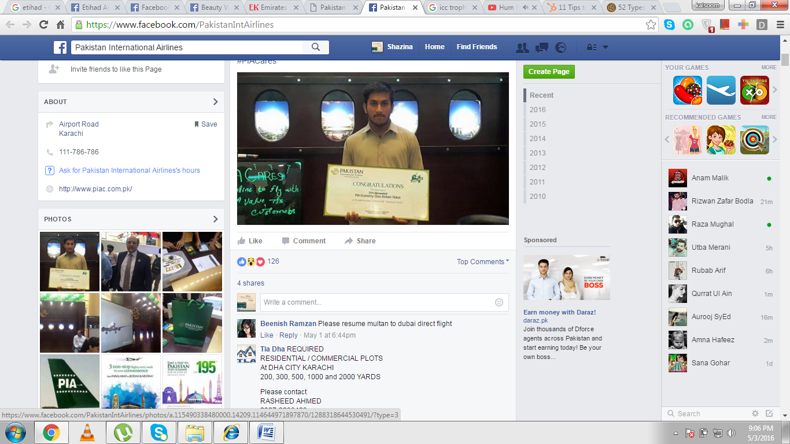
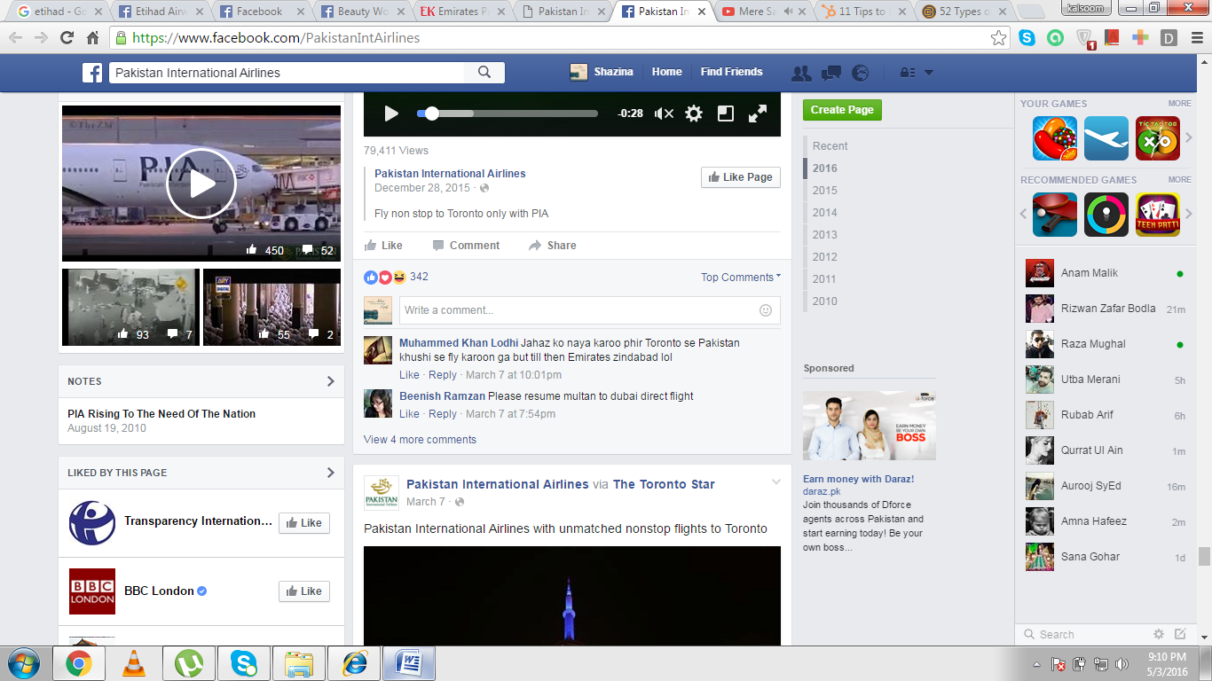
- NO ADVERTISEMENT OF MOBILE APPLICATION:
PIA has recently launched mobile application for android named as Friends of PIA. PIA takes this step specially to take feedback from its customers that will help PIA to improve the quality of services. PIA also offers 500 free air miles to those who get register on this application. It’s a good step by PIA to listen the complaints and feedbacks about services and to improve them but customers get to know about this product only through advertising and it’s the responsibility of airline is to promote this product in such a way that every customer get register on this app. But unfortunately, PIA has given no information about this app on website, Facebook page and Twitter page.
- NO NEED OF PRICE SUMMARY:
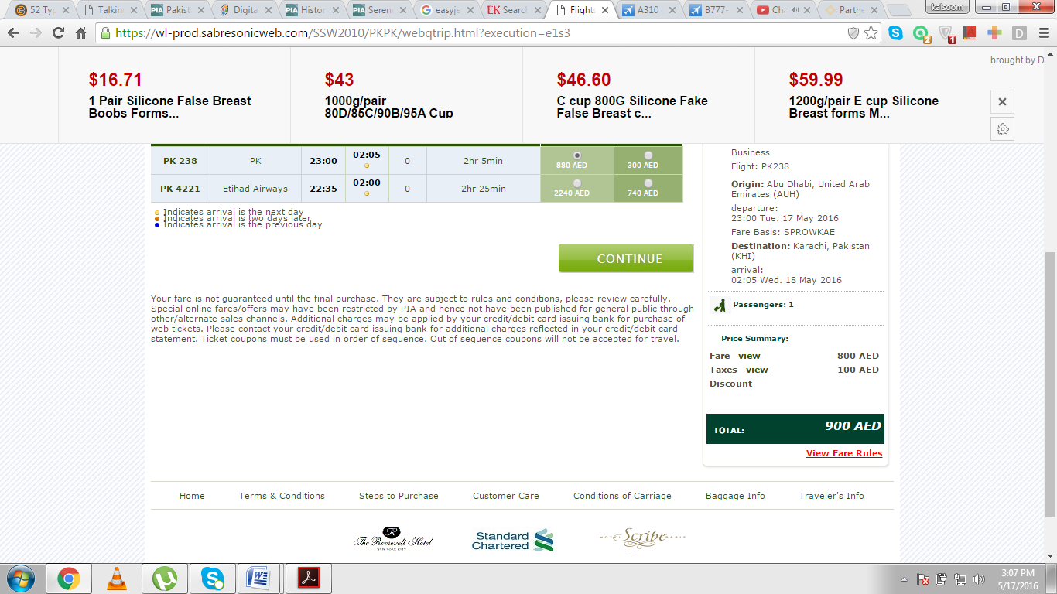
PIA isn’t using most important marketing tool, website, in effective way which effect its perception. All airlines charge taxes from its customers on every flight but they don’t show fare summary because when customers get to know about the taxes prices, no one would like to travel with them. Like when you book flight at Emirates website online, there’s no fare will be shown by airline because in this way, airlines lose their customers.
But if you book flight at PIA website, the fare summary will be shown at the right side which lose customers and force them to switch other carriers. This shows unprofessionalism of airline.
- ANALYSIS OF AIRBLUE AND SHAHEEN AIRWAYS WEBSITES:
Shaheen Air International and Airblue are private airlines in Pakistan. Airblue started its operations in 2003 and now becoming the second largest growing airline in Pakistan. Similarly, Shaheen Air International is also growing rapidly in Pakistan and expanding its operations across the world. Here, we will discuss the websites of both airlines that how they are using the marketing tactics to attract and retain the customers, because for airlines, core business strategy is to identify, satisfy and retain customers by anticipating their needs and wants.
- ATTRACTIVE PROMOTION OF SERVICES:
Both airlines promote their new offers and flight routes in attractive way. Like, Airblue promotes the flights between Multan and Karachi in very unique way by designing a colorful paper plane which represents the culture of both cities that can grab the attention of any customer for a minute.
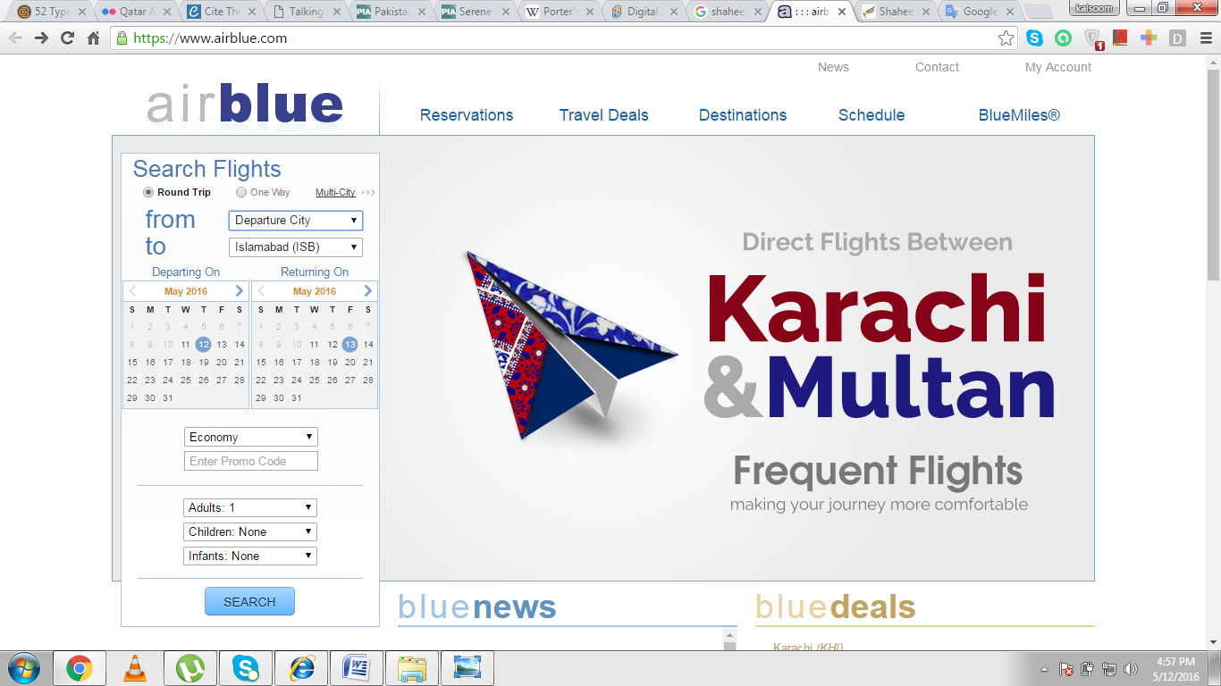

Similarly, Airblue advertise its flight between Peshawar and Jeddah in more attractive way by using the famous places of both cities in their advertisement and also use the regional language of Peshawar “Pashto” in its promotion for saying “Welcome” to its people which really shows the caring and kind behavior of Airblue towards its customers and ultimately, build advocates for airlines.
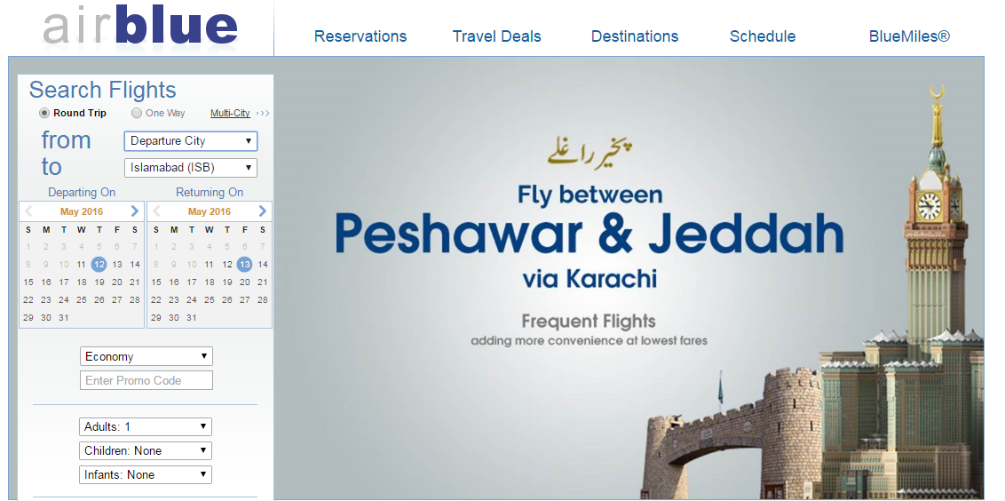
- DELIVERENCE OF MESSAGE IN ATTRACTIVE WAY:
Furthermore, Airblue use marketing tactics in very smarter way and deliver message of comfort to its customers in such a way that it attract the customers because customers are more concerned about comfort and safety during flight. If the basic necessities of customers aren’t fulfilled by airline, customer won’t travel in future with that airline, no matter how well your food or in-flight entertainment systems.
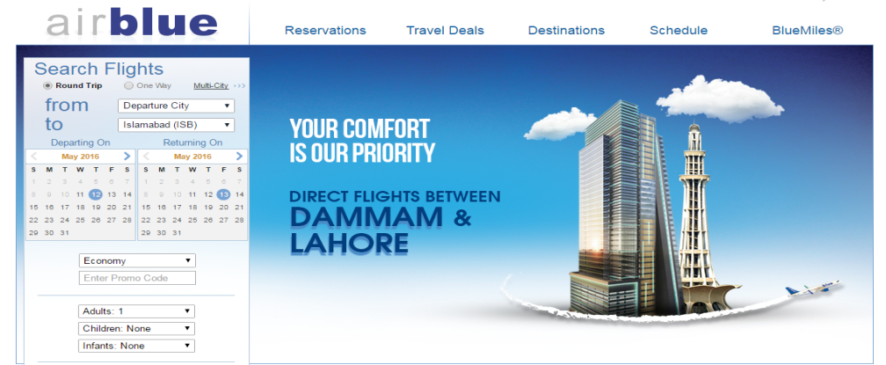
- ATTRACTIVE COLOR SCHEME:
Shaheen Air International is also promoting its services for customers in best way and use attractive color scheme for clutching the customers’ attention. Here, we add the picture where Shaheen Air International promotes its flight to Kuala Lumpur with free visa. This is really attractive for capturing the customers’ attention.
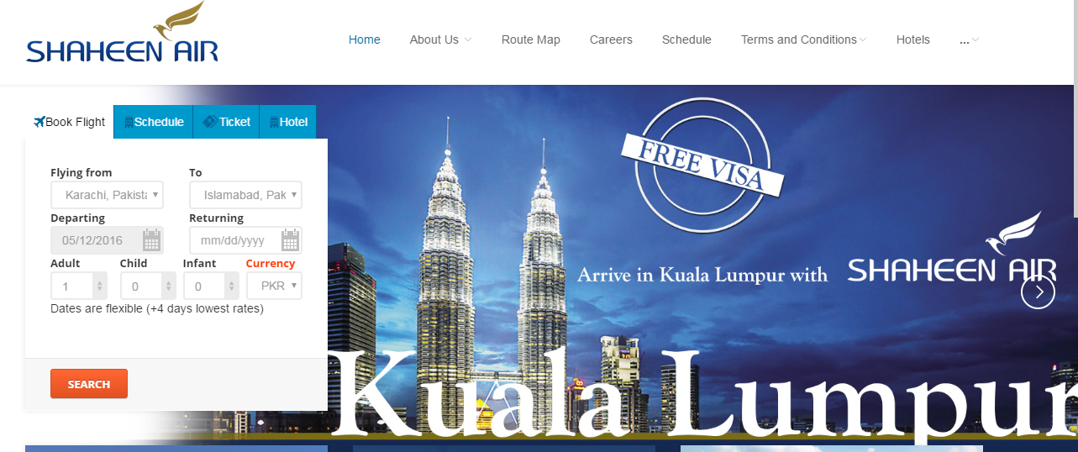
- FACILITY TO MAKE MULTI-CITY RESERVATION:
Furthermore, Airblue is offering facility of “multi city” with one way and round trip in reservation where customers can travel more than one city and make all reservations. This facility delights the customers and airlines can build advocates for airlines in future.
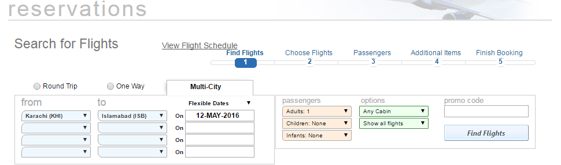

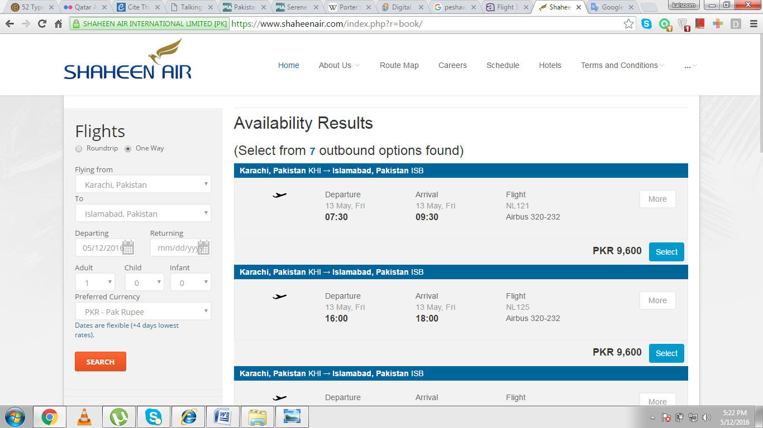
But Shaheen air International is not offering this facility which might be not attractive for customers.

- PROMOTION OF MOBILE APPLICATION:
Shaheen Air international has introduced "Shaheen Air Mobile App” for customers and advertise it properly on website. This is good example of “customer engagement strategy.” The application is available for android, window smart phones as well as for iPhone which satisfy all segments of target market because everyone has different kind of smart phones and in this way, every customer get benefit from this app.
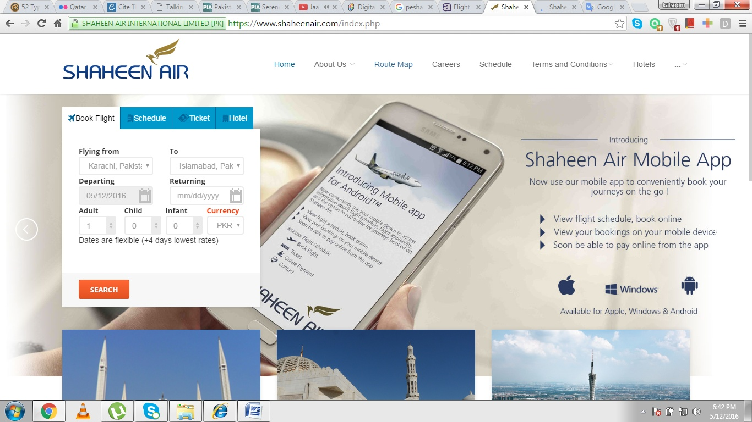

- PROMOTE NEW SERVICES:
Additionally, Shaheen Air International is advertising new service of direct flights between Islamabad and Manchester at website for updating customers. It’s a good step to attract the customers because only PIA has direct flight to Manchester but due to its poor quality of services, customers are switching to foreign Middle East airlines.
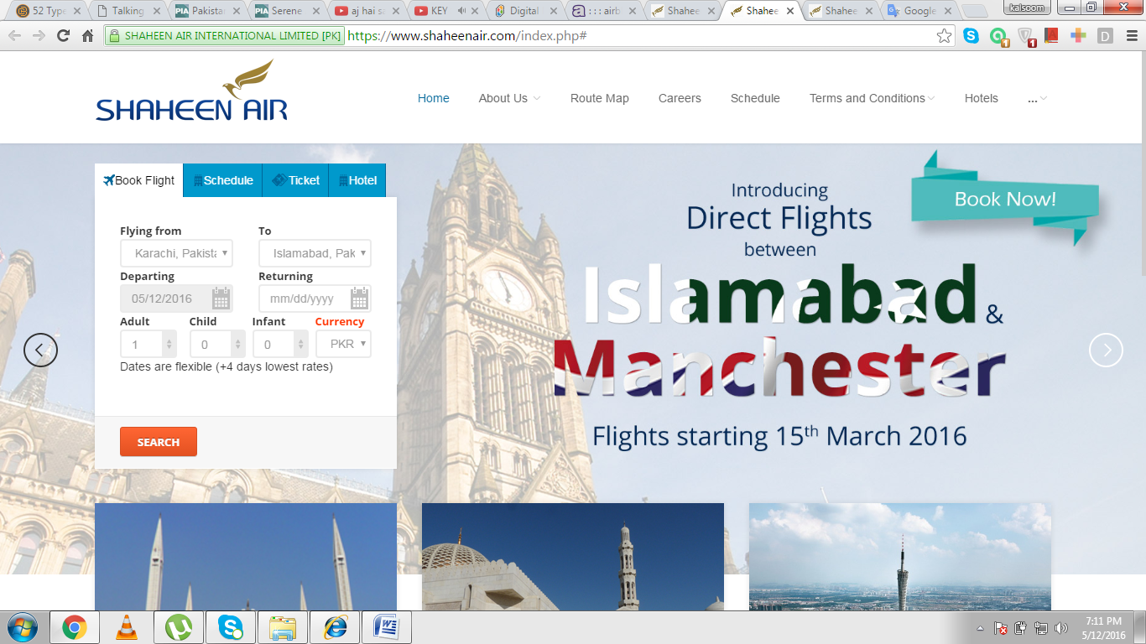
- INFORMATION ABOUT COMPANY LATEST NEWS:
The next thing where Airblue has an advantage over Shaheen Air International is that Airblue is providing all the news, achievements and events with details and image which really attract more customers’ attention and help them to get maximum information about the organization at website and build positive perception about brand.
- PART OF EVENT FOR COMSAT GRADUATES
Recently, Airblue marketing became part of an event for COMSAT graduates where executives from different organizations along with Airblue were invited for career counseling of students. This gives awareness to customers especially to students and businessmen.

- PART OF ROYAL RECEPTION AT NEW DUBAI TERMINAL:
Similarly, Airblue became the part of Royal reception at New Dubai Terminal which improves the perception of airline; customers will become curious to know about its services and automatically a positive perception will build-up in customers’ minds.
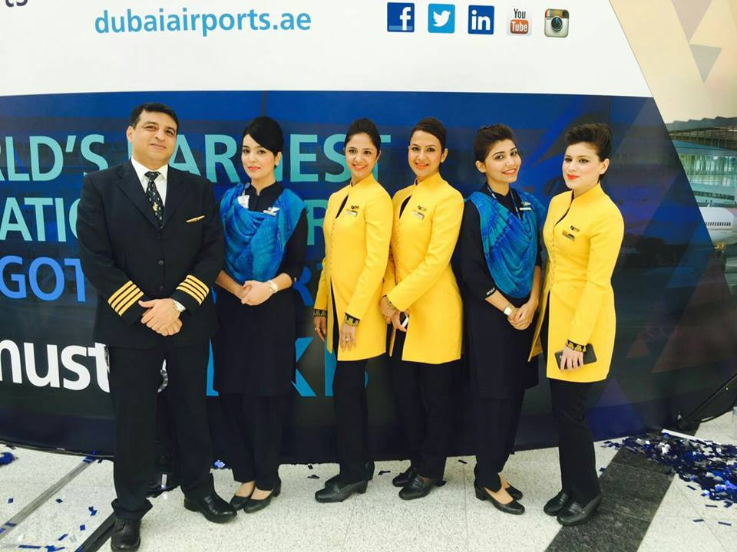

- CLEANING COMPAIGN AT ALLAMA IQBAL INTERNATION AIRPORT:
Airblue is also performing its best towards “Corporate Social Responsibility” by driving “Cleaning Campaign” at Allama Iqbal International Airport, which shows that airline is also responsible towards environment cleanliness along with the business.
Additionally, Airblue conducted “Child Enrichment Program” for delivering counseling session to children and opportunities which they could follow after the studies. These kinds of events develop a soft corner in customers’ heart that this airline is caring the society and they prefer to travel with it in future because of its caring and friendly environment. But Shaheen Air International isn’t advertise this kind of any event on its website due to which customers unable to know about company activities that what it is doing for society and its environment.
- LANGUAGE CHANGE OPTION:
One major thing that both airlines, Airblue and Shaheen Air International, aren’t providing on websites is the facility of “language change” option where airlines give facility to its customers to review website in their region- based language. This facility delights the customers and unintentionally, positive image about brand will develop in customers’ minds.
Airblue and Shaheen Air are using social media pages for advertising new products and services for customers in more attractive way. They are operating their accounts on different social media websites like Facebook, Twitter, and Linked in, instagram and Google plus, in lively way, update every post and advertise job opportunities. They also reply to customers’ questions, complaints and give attention to their suggestion as feedback.
- AIR INDUS AIRLINE WEBSITE ANALYSIS:
Air Indus is private and low cost carrier in Pakistan, who started its operations with first flight from Karachi to Lahore on 28 July, 2013. Air Indus is currently doing operations at domestic level as according to National Aviation Policy, initially airline has to perform its operations at domestic level and after that, expand operations at international level too.
Here, we will discuss that how Air Indus is using marketing techniques to attract more customers and how to adopt “customer engagement strategy” by understanding the consumer-behavior.
- NO ATTRACTIVE COLOR SCHEME:
If we take a look at Air Indus website, the color combination isn’t like soothing the customers’ mood and grabs their attention for a while. Airlines try to choose such calm colors instead of bright which make them comfortable because some colors relax the customers’ mood and some colors make customers’ mood intense.
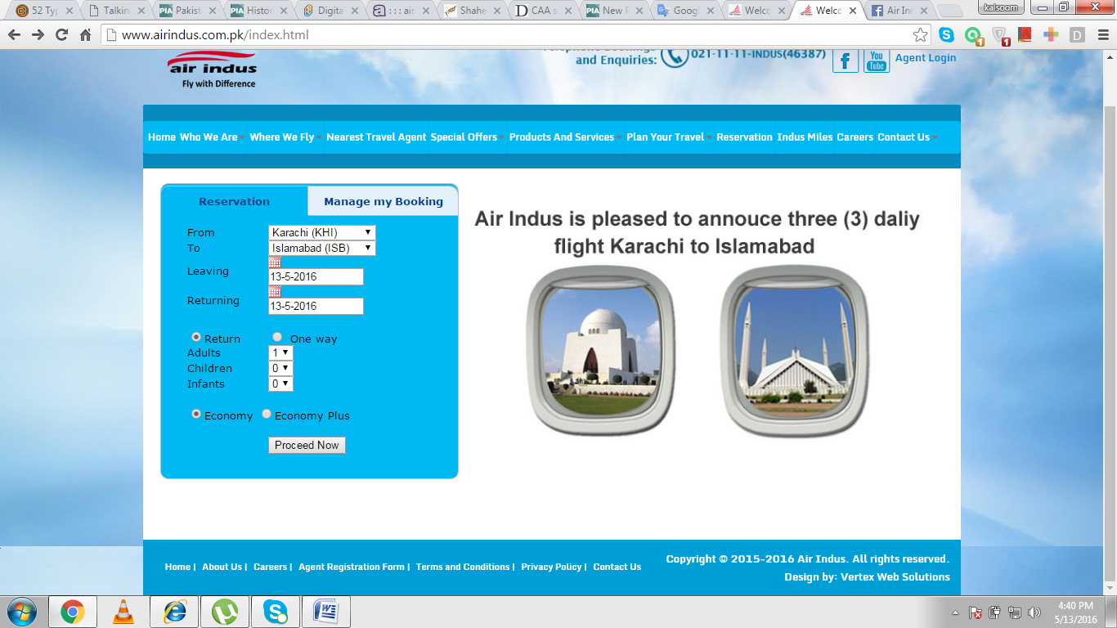
The next thing where Air Indus should give some attention is towards the addition of attractive graphics. As on front page, Air Indus is performing well by using unique concept but still it can become better and more attractive if Air Indus will utilize all space for promoting its service and add graphics in more attractive way. The pictures in small circles won’t attract as much customers.
Air Indus will start operations internationally in future, so it has time to improve the marketing area by advertising its services in more attractive way and gain maximum customer share. It should make any successful airline whose marketing strategy is strong enough, as a benchmark and try to design professional and effective marketing strategy.
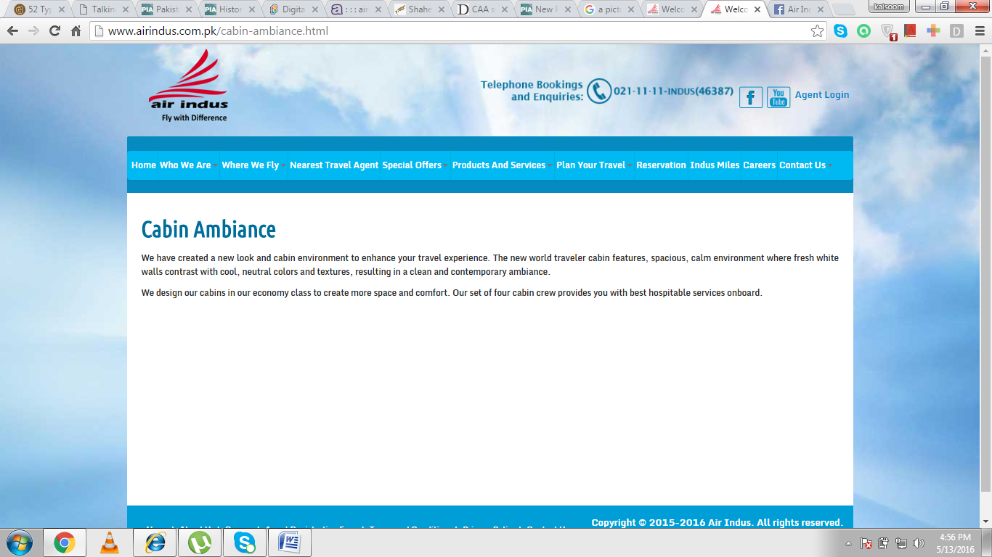
- BORING GRAPHICS:
Moreover, Air Indus isn’t promoting its services on website in effective way. No graphics and images are being used for attractive marketing. Here, we mention an example that Air Indus classifies in-flight entertainment into cabin ambiance and safety and comfort. But when you open any option for review, no images are available for capturing the attention of customers.
Reading the text seems like boring and no customer would like to read long sentences or paragraphs. Images define more clearly about the excellence of services than words, as well known phrase “a picture is worth a thousand words.”
- IMPROPER USE OF SOCIAL MEDIA:
Furthermore, Air Indus is just using Facebook as a social media tool which also limits its future growth and profitability of airline in future. Today is the world of technology and everyone is participating actively at social media sites, for this, all airlines are using maximum social media sites like Facebook, twitter, and Linked in. Air Indus isn’t operating its Facebook account properly which creates bad perception about brand in customers’ mind and heart, no reply to customers’ complaints and ultimately lose them. This isn’t good for Air Indus as it is planning to start operations at international level because when customers have bad image about airline, how will they prefer to travel with it in future.
- PROMOTION SETBACKS OF UPCOMING AIRLINES:
Two new airlines are going to start their operations in Pakistan which are named as Serene Air and Pakistan Airways. Serene Air will be a private airline and Pakistan Airways will act as a premium service subsidiary of Pakistan International Airline. Both airlines have many setbacks in their promotion which leads to bad perception in customers’ minds.
- NO UNIQUENESS IN BRAND NAME:
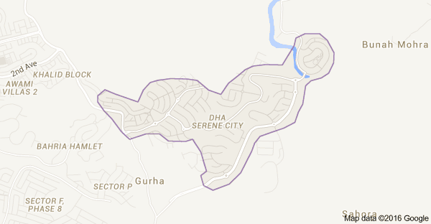
Brand name plays an important role in building positive perception. It should be unique one and airlines should make sure that no other organization is already using your brand name. All airlines give special attention towards it as it creates first impression in customers’ minds but Serene Air fails to do so. There’s a city with the name of Serene City in DHA, Rawalpindi. This thing damages the brand image very badly which ultimately fails to attract and retain customers.
- NO APPROPRIATE ADDRESS:
Serene Air office address is similar to the “Education World” office in Islamabad which confuses the customers that either at that place, there’s office of Education World or Serene Air. Some people claim that due to Chinese Joint Venture, their office addresses are same but still it’s not an attractive thing for customers and an effective marketing strategy. The address of an airline should be appropriate that customers can’t confuse its office address with any other organization address because it will limit the growth of company.
- OLD ADVERTISEMENT:
Pakistan Airways which will act as a premium subsidiary of PIA, is doing advertisement of jobs in Black and White which look like that we are living in 1970’s. This kind of advertisement isn’t attractive for capturing the attention and customers build negative perception about airline. Here, we are going to add some pictures of their advertisement where the whole picture in ad looks like a hospital promo instead of any lounge.
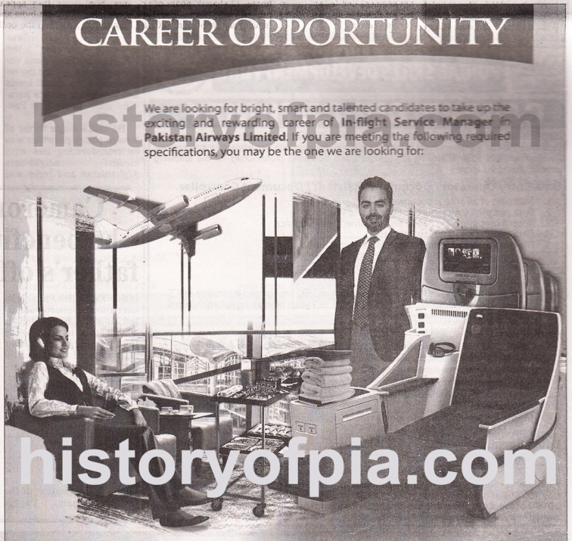
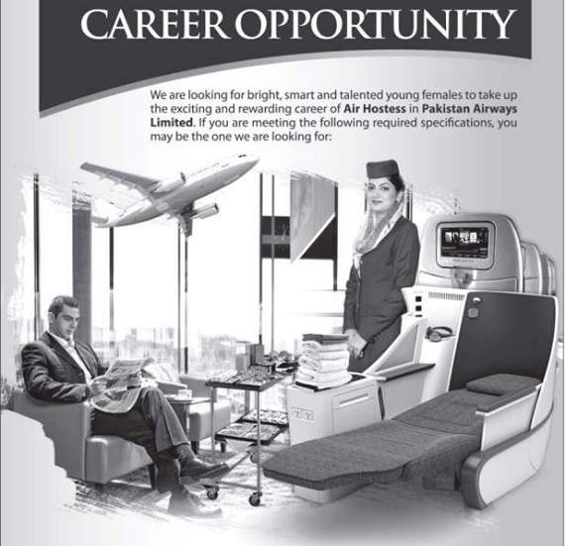
Marketing is very critical but effective tool for capturing the customers’ eyes and then build a positive image in their minds but unfortunately, Pakistan Airways, being a premium airline, fails to use professional advertisement and not develop a proper strategy for it. As we all know the common phrase that “first perception is the last perception” and if the advertisement is unattractive and colorless, how airline would expect to enjoy the profits in the industry and get the maximum customers. Another big error that Pakistan Airway has committed during advertisement is using the same image for both ads, just the persons are being changed which again shows its unethical and non-serious behavior towards marketing.
- COPIED UNIFORM FROM PIA:
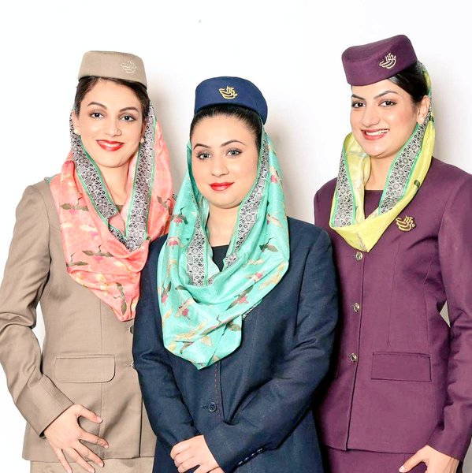
No doubt, Pakistan Airways will be launched as a premium subsidiary of PIA but still Pakistan Airways should design its own uniform instead of copy PIA uniform for female cabin crew which is again a big marketing drawback of Pakistan Airways advertisement. We want to add picture of uniform here:
Pakistan Airway has just removed PIA logo from their uniforms in advertisements and rest of uniform is similar to PIA. This again creates bad image about brand in customers’ heart and ultimately customers will be forced to think that it won’t be efficient and effective in marketing like PIA.
- ADVERTISE WRONG AIRCRAFT:
Similarly, as a premium airline, Pakistan Airways should have new Aircraft for operations and advertise them properly but Pakistan Airways used Airbus A-321 for advertisement. This is again marketing setback of it as if airlines try to introduce new aircraft for operations to ensure customers that airline will use new and more efficient aircraft which will be more safer, customers automatically will prefer to travel with that airline and unintentionally build positive perception in their minds and hearts.

- ETHICAL CONSIDERATIONS
Ethics are the behavior or ways that a participant should adopt while interacting with others in research process. Here are some ethical considerations to which we give special attention in research process:
- Honestly collect data for all research, avoid errors and negligence in collecting data
- Make sure to use organizations’ data in more accurate way
- Discuss problem, collect data, analyze data and give results without any biases
- Give special attention towards organizations’ reputation and not to use such kind of words which harm their reputations
- Avoid any kind of deception in research objectives
- Respect colleague ideas and suggestions
- RESULTS:
From all data collection and analysis, we find out that Pakistani carriers are giving not as much importance towards marketing area. Private carriers like Airblue and Shaheen Air are trying to give attention towards marketing and develop effective and competitive strategies to grab maximum customers. They are giving special attention towards usage of social media, update websites properly and also provide feedback facility to customers but not responding their feedbacks and questions properly, not rake their complaints seriously. This is the bigger risk for their brand image.
Additionally, Pakistan International Airlines, government owned airline, not giving any kind of attention towards marketing sector. As we analyze websites of PIA and Emirates, we find out that PIA’s marketing department isn’t performing well. There are many lapses in marketing, no proper updates in websites and even not giving any kind of attention towards customers’ complaints and their needs and wants.
Furthermore, upcoming airlines are also not giving attention towards effective marketing strategies as it’s an edge for new carriers to develop competitive marketing strategy to compete with existing carriers.
- CONCLUSION:
It is concluded that private carriers are giving attention towards effective marketing strategies, change marketing campaigns timely, update websites according to new services and offers, and try to give maximum information about company. But on the other hand, PIA, being the only premium airline in Pakistan, is performing worse and not give even little attention towards marketing strategies.
Similarly, Air Indus is also not performing well in marketing which is a disadvantage for Air Indus. Pakistani carriers need to give attention towards marketing department as it is considered as very effective and powerful tool for communication in today’s world. Globally, airlines use it efficiently to communicate the message to customers but Pakistani carriers aren’t using it efficiently.
- RECOMMENDATIONS:
Here, we are going to give some recommendations that Pakistani carriers should adopt to make marketing strategies more effective and competitive that they can compete globally and able to attract maximum customers.
- LISTEN VOICE OF CUSTOMERS:
Listen customers’ ideas, complaints and suggestions because without customer loyalty and support, no airline will be able to get prosperity in the industry. Pakistani carriers should provide platforms for feedback and complaints and also give attention towards customers’ complaints that which factors irritate them and make them uncomfortable during flight like
- Rude attitude of cabin crew,
- Poor quality of food or
- Longer delay in flight.
After complaints of customers, airlines should reply back gently to their complaints for developing positive image about management and brand that they are really care about customers’ comfort. This action will reduce the level of anger and create a soft corner about brand in customers’ heart unintentionally.
All successful airlines globally pay special kind of attention towards customers as they are central part of business and without them, the airlines aren’t able to generate money. Pakistani carriers should also pay attention towards customers because without loyal passengers, airlines can’t generate profits.
- WELCOME CUSTOMERS’ CONTENT:
The next thing towards which Pakistani airlines should pay attention is to welcome customers’ any kind of content at social media for using “Customer Engagement” strategy more effectively. Listen what customers suggest for the improvement of brand image, collect their innovative and creative ideas and also say warm thank you to them for their precious suggestions and ideas. Additionally, Pakistani carriers should also give importance to the content which is being generated by airline customers either in the form of pictures or something in written on social media.
This kind of step from Pakistani carriers will encourage customers to share what is in their minds without any hesitation and also build positive perception about brand which help airlines to capture more customers’ attention.
- IN-FLIGHT MICRO EVENTS:
Pakistani carriers should arrange some kind of surprising events during flight as these events will give customers such kind of travelling experience to which they won’t forget in life. This also forces customers to talk about airline at social media sites which builds good and attractive image about airline. This will help airlines to maintain long-term good relations with customers and attract new customers.
As we all know that Pakistani people are crazy about cricket, so Pakistani carriers should take advantage from this opportunity and invite variety of celebrities to allow customers to play small cricket shots with those celebrities. Another thing which Pakistani carriers can do is “comedy shows.” It’s a big opportunity for Airblue as it has already sponsored “comedy night” where the guest was Mr. Saad Haroon, second funniest person in the world. Airblue should organize this kind event on-board for making passengers travel more entertaining and unforgettable.
Additionally, Pakistani carriers should arrange “music performances shows” of famous singers. Airlines will face a lot of advantage from this step because passengers would like to record every moment of show in their personal devices and then share on social media sites. The more people view those videos, the more customers will attract towards airline and more passengers will love to travel in future.
- VISUAL CULTURE:
As we all know that “a picture is worth one thousand words.” Images define things more clearly than text. In today’s advance world, people love to add more image than long text paragraphs and share on multiple platforms.
Pakistani carriers should develop such kind of strategy which allows customers to “click their selfies and add airline destination backgrounds of pictures on their choice basis with the help of special designed software’s.” As Pakistani carriers has variety of beautiful destinations globally especially Malaysia which is most amazing place for tourism. This enhances the awareness of destinations among customers.
Additionally, Pakistani carriers can “design application for customers where they can take their selfies and then change background features with backgrounds available in the application.” This will give an illusion that customer is actually available that place and customers love to share it on social media sites. This enhances popularity of airline, develop attractive perception in customers’ minds and engage them smartly.
- USE PEOPLE POWER:
As we all know that today is the era of technology and people power is considered as biggest power in the growth or destruction of an airline. As every customer has awareness about the circumstances that what is happening in the industry and which airline is performing better or not. Airlines give special attention towards customers and use people power for promotion of brand and destinations.
Pakistani carriers should use this power smartly and develop effective marketing strategies for attracting more customers. Here, we want to recommend strategy that can be used effectively.
Pakistani carriers can offer special fares for 200 seats at various destinations like Manchester, Chicago, Middle East, Saudi Arabia and allow customers to lower the fares for favorite destination by selected it every time whenever he/she will log-in with any social media site like Facebook, Twitter, Google+. Every year only 10 seats will be unlocked by airline. This kind of curiosity that might be my name will be one who will enjoy lower fares force customers to select that destination every time and unconsciously, the positive image will stick in his mind.
- DEVELOP MEMEORIES WITH CUSTOMERS:
Developing memories with customers allow airlines to build good and long-lasting relations with customers. All around the world, successful airlines give special attention towards it and take every possible step to build effective relations with customers and retain them for lifetime. Pakistani carriers should also give attention towards this powerful tool of marketing and develop strategies. Here, we recommend strategy through which Pakistani carriers can promote their brands, give awareness and develop memorable experience with customers.
Pakistani carriers can take pictures of children on-board and upload their pictures in the form of albums on social media sites like Facebook, Instagram and ask their families to like pictures on social media sites. Airlines can offer any attractive deal like free tickets to whole family whose child pictures will like more than other pictures.
In this way, airlines develop memories with customers and help airlines to promote brand in best attractive way. This helps airlines to attract, strengthen, maintain and retain good relations with customers.
- FOCUS ON QUALITY MANAGEMENT:
Aviation is service-based and highly regulated industry. It involves the safety of lives of human beings. Airlines need to focus on quality of services and adopt appropriate standards for quality management. Here, we want to add example of PIA whose fleet is aged, no quality in catering and in-flight services. Private carriers, Airblue and Shaheen Air, are giving focus towards the quality and also follow proper standards of quality.
As aviation is service-based industry and airlines don’t have time to check the quality of services when they are produced, they are consumed at the same time, so, we will recommend PIA to give focus on quality and should follow some standards properly because without quality, no customers will prefer to travel with PIA in future.
- FOCUS ON VIRAL MARKETING:
Viral marketing is “marketing where airlines come-up with new ideas constantly to keep customers engaged.” It’s very important for airlines as they are competing with one another on prices and routes but airlines fail to attract as much customers by adopting effective pricing strategies and through expanding network. For this, now airlines are trying to attract more customers by offering uniqueness in products through innovative and creative ideas. This allows airlines to attract more customers and engage them through effective marketing strategies.
Pakistani carriers should also adopt such kind of marketing techniques effectively to attract more customers. Private carriers in Pakistan are trying to do creative things and keep websites and other social media accounts more attractive for grabbing customers’ minds.
On the other hand, PIA, being a premium airline, is doing nothing for grabbing customers’ attention. That’s why; we recommend that at least PIA should change online boring marketing techniques, update website with attractive graphics and come-up with new innovative ideas in marketing.
- AUTHENTIC COMMUNICATION:
Communication is considered as a powerful tool for conveying message to customers in effective way. If airlines aren’t delivering what they promise to customers will definitely lose customers and negative image will build-up in their minds. Pakistani carriers aren’t taking this competitive weapon seriously.
Here, we want to quote an example of Airblue who advertised wrong flights in its office. This looks like that no updated information is being delivered to offices or just wants to fill-up the extra space of the offices. This leaves bad image in customers’ minds and seems like disloyalty of airline with customers.
Pakistani carriers should avoid these kinds of mistakes and give importance to authentic and accurate communication and should promise what they can deliver to customers. Wrong and false promises will lose customers and not allow airlines to develop good and effective relations with customers.
- SOCIAL CARE:
Successful airlines give special attention to customers, their needs and wants, their problems and make continuous changes to satisfy customers in best way they can and retain effective and long-term advocate relations with them. Ten years back, only telephone lines were available for complaints which made customers frustrated and angry due to busy lines. But now, airlines facilitate customers by providing platforms for feedback and complaints.
Pakistani carriers provide platforms for feedback but no airline, private or government-own, give attention towards customers’ complaints. All airlines have provided platforms for feedback but no airline is operating that platform properly. They should give proper attention towards customers’ complaints and reply back to them gently, solve their problem and say sorry warmly. This thing will automatically cool-down customer’s anger and develop soft corner for airline.
- STORYTELLING STRATEGY:
Content marketing is defined as “the marketing in which airlines create and deliver interesting, valuable and memorable content to attract and engage their customers so that they can satisfy customers in best possible way and generate handsome profits by retaining loyal customers.”
Pakistani airlines should try to use original and true content to engage customers, build good relations with them and give memorable experiences to passengers as content marketing trend is increasing rapidly globally and now many airlines prefer to promote customers’ generated videos in which they share their experiences.
Pakistani carriers should also give leverage to customers to create their own content by using social shares, give credit to customers for creating more energetic content, convert that content into a complete story and then promote on social media sites for promotion of goodwill of brand.
This strategy will engage the customers and encourage them to participate in marketing of airline. It will also help airlines to retain loyal customers and help airlines to explore new customers.
- GIVE FOCUS TOWARDS TELEVISION ADS:
All around the world, airlines are giving importance to television marketing by developing attractive ads for customers. Attractive ads help to grab the attention of customers and improve image of brand. Pakistani carriers should give importance towards Television ads and try to develop attractive ads to deliver message in clear way, to interact with customers in best way, to engage them by offering new services and delivering safety message in the form of commercials. Like Emirates deliver complete safety message about in-flight by developing Football commercial.

- REFERENCES:
REFERENCE BOOK:
- Shaw, S. (2007). Airline Marketing and Management (6th ed.). Burlington,VT: Ashgate.
REFERENCES:
- HBR's 10 must reads. (2011) (pp. 23-33). Boston, Mass.
- Porter's five forces analysis. Wikipedia. Retrieved 6 May 2016, from https://en.wikipedia.org/wiki/Porter%27s_five_forces_analysis
- Shaw, S. (2007). Airline Marketing and Management (6th ed., pp. 158-174). Burlington, VT: Ashgate.
- Shaw, S. (2007). Airline Marketing and Management (6th ed., pp. 244-248). Burlington, VT: Ashgate.
- 'Friends of PIA' mobile app launched to improve services. (2016). Dawn.com. Retrieved 12 May 2016, from http://www.dawn.com/news/1234012
- Television Advertising. (2016). Agencymatch.org. Retrieved 12 May 2016, from http://agencymatch.org/resources/television-advertising.html
- Qatar to host new Pakistan Twenty20 cricket league - Doha News. (2015). Doha News. Retrieved 12 May 2016, from http://dohanews.co/qatar-to-host-new-pakistan-twenty20-cricket-league/
- Tourist, E. (2015). Emirates releases new ad featuring Jennifer Aniston - Everybody Hates A Tourist. Everybody Hates A Tourist. Retrieved 15 May 2016, from http://everybodyhatesatourist.net/travel-news-tips-deals-contests/travel-news/emirates-releases-new-ad-featuring-jennifer-aniston/#.Vzny1vl97IU
- 2015, T. (2016). Turkish Airlines - Press Release Detail - turkishairlines.com. Turkishairlines.com. Retrieved 17 May 2016, from http://www.turkishairlines.com/en-int/corporate/press-room/press-releases/press-release-detail/argentine-soccer-star-leo-messi-named-global-brand-ambassador-for-turkish-airlines
- Fergus, S. (2016). 6 Key Characteristics of a Successful Brand Ambassador. Getambassador.com. Retrieved 14 May 2016, from https://www.getambassador.com/blog/6-key-characteristics-successful-brand-ambassador
- Marketing and 7P's. (2015). Retrieved 7 May 2016, from https://www.cim.co.uk/files/7ps.pdf
- Cultbrandingcom. (2016). Cultbrandingcom. Retrieved 20 May, 2016, from http://cultbranding.com/ceo/52-types-of-marketing-strategies/
- (2016). airlinetrends.com. Retrieved 29 May 2016, from http://www.airlinetrends.com/wp-content/uploads/2015/04/State-Of-Airline-Marketing-2014_airlinetrends_simpliflying.pdf
IMAGES REFERENCES:
- [PICTURES/VIDEOS] Pakistan Super League trophy unveiling ceremony. (2016). Pakpassion.net. Retrieved 10 May 2016, from http://www.pakpassion.net/ppforum/showthread.php?239119-PICTURES-VIDEOS-Pakistan-Super-League-trophy-unveiling-ceremony
- (2016). Historyofpia.com. Retrieved 14 May 2016, from http://www.historyofpia.com/board/april_16/pa_apr8a.jpg
- (2016). Historyofpia.com. Retrieved 14 May 2016, from http://www.historyofpia.com/board/april_16/pa_apr8b.jpg
- PIA°® ••••••✈ on Twitter. (2016). Twitter. Retrieved 17 May 2016, from https://twitter.com/PIAplanes/status/664041498099458048/photo/1
- (2016). Cdn.ek.aero. Retrieved 15 May 2016, from http://cdn.ek.aero/newsimages/HelloTomorrow3_tcm133-838969.jpg
- Etihad Airways,. ⎫ http://www.etihad.com/en-au/experience-etihad/flying-reimagined/the-residence/.
- Etihad Airways⎫. Retrieved 28 May 2016, from http://www.etihad.com/en-au/experience-etihad/flying-reimagined/

