UNIVERSITY OF MANAGEMENT AND TECHNOLOGY | UMT

“Forecasting stock index movement using Machine learning techniques: Evidence from Pakistan Stock Exchange”



Submitted to
School of Business and Economics
in Partial Fulfillment of the Requirements
for the Degree of
MASTER OF SCIENCE
In
FINANCE
By

NOUMAN SARFRAZ (F2016096007)

RESEARCH COMPLETION CERTIFICATE

It is certified that the research work contained in the thesis “Forecasting stock index movement using Machine learning techniques: Evidence from Pakistan Stock Exchange” has been conducted under my supervision to my satisfaction by Mr. Nouman Sarfraz, ID: F2016096007, of MS Finance program.

Signature_____________________________
Date_____________________________
Supervisor’s Name_____________________________

DECLARATION

I Nouman Sarfraz ID #. F2016096007 Session 2016 - 2018, hereby certify that this thesis is being submitted in partial fulfillment of the requirements for the MS degree in Finance.
This thesis is my original work, and the data/material presented herein has not been used for the acquisition of any other degree from any institution.
The Similarity Index is below permissibly limited.

Researcher Signature ____________________
Date ____________________
Researcher (Name) Nouman Sarfraz

Confirmed by

Supervisor’s Signature____________________

ABSTRACT
Due to economic conditions of every country stock market is gaining more and more importance day by day. As the stock prices are being considered the most important factor while making investment so prediction of stock price movement becomes necessary before investment. Stock market is very complex in nature and its Prediction has been remain an area of interest for many researchers. Change in stock market due to automatic buying and selling across the globe make it more daring to predict the market.
Predicting the direction of next closing price of Karachi stock exchange index is the aim of this study. Two supervised machine learning methods have been employed in the study for the prediction and also for comparison among these methods namely Random Forest (RF) and Support Vector Machine (SVM). Checking the best performance among the two algorithms is carried out by the process of cross-validation. In related literature there are many studies that have applied different machine learning techniques at different stock markets. According to best of my knowledge, comparison of Random Forest and Support Vector Machine in predicting the direction of Karachi stock exchange 100 index has not been examined before. Technical indicators computed from the closing price, opening price, high price and low price are used as input variables for this study. 70% of data has been used to train the models and generate predicted labels as output. Then predicted labels reveal the direction of the closing price of the next day. This will create hit rate for both algorithms on which basis the best model can be selected. Results for this study revealed that among both algorithms random forest outperforms the support vector machine in regards of the performance. Support vector machine has better predicted the direction for stock market with the 79.76% hit ratio.

Keywords: Random forest; Support vector machine; cross-validation; Karachi stock exchange; hit ratio

DEDICATED TO
First of all I would like to pray GOD who gave me courage to complete my tasks. I would like to dedicate this thesis to my affectionate Parents who try to bring light in every darker aspect of my life. This thesis is also dedicated to my siblings who have always there for me in every challenge of my life and motivated me.

ACKNOWLEDGEMENTS
Foremost, thanks a lot to Almighty Allah for his countless blessings in every aspect of my life through which I accomplished this task. It is a gigantic pleasure for me to thanks all the people who have spent their time, effort and support for the completion of this dissertation.
I would like to express my sincere gratitude and appreciation for my supervisor Dr Rubeena Tashfeen for her guidance, support, patience and immense knowledge. For the completion of this thesis her guidance helped a lot to me in all the time.
Beside my supervisor, I would also like to thanks a lot to my co supervisor Mr Saqib Farid for his guidance, support and encouragement. Without his support the completion of this dissertation would not be possible.
Then I would like to thank my parents and friends who have helped me with their valuable suggestions and guidance which has been helpful in various phases of the completion of this project.

Table of Contents
RESEARCH COMPLETION CERTIFICATE ii
DECLARATION iii
DEDICATED TO v
ACKNOWLEDGEMENTS vi
CHAPTER 1 9
1.1 Introduction 9
1.2 Problem statement 11
1.3 Research Gap 12
1.4 Objective of the study 12
CHAPTER 2 13
2.1 Literature Review 13
2.2 Theoretical background 25
2.2.1 Random Walk Theory 25
2.2.2 Chartist theory 26
2.2.3 Machine Learning 26
Algorithmic Trading 26
Portfolio Management 27
Loan / Insurance Underwriting 27
2.3 Conceptual framework 29
CHAPTER 3 30
3.1 Data& Methodology 30
3.1.1 Technical indicators 31
3.2 Machine Learning Algorithms 36
3.2.1 Random forest 36
3.2.2 Support Vector Machine 38
3.3 Performance measurement 39
CHAPTER 4 40
4.1 Results 40
4.1.1Random Forest algorithm 40
4.1.2 Support Vector Machine algorithm 43
4.1.3 Real VS Prediction by the classification models 44
4.1.4 Confusion Matrix of Models 47
4.1.5 Prediction performances 48
4.1.6 Day-ahead Prediction 49
CHAPTER 5 50
5.1 Conclusion 50
5.2 Future work 51
5.3 Implications 51

List of Figures
Figure 1 Top 20 ML Packages download 28
Figure 2 Conceptual framework 29
Figure 3 tree construction 37
Figure 4 OOB error rate graph showing decreasing in error 41
Figure 5 variable importance according to accuracy 43
Figure 6 random forest algorithm experimented by training data set. 45
Figure 7 random forest algorithm experimented with respect to test data set 45
Figure 8 support vector machine algorithm trained by training data set. 46
Figure 9 support vector machine algorithm with respect to test data set. 46

List of Tables
Table 1 30
Table 2 39
Table 3 41
Table 4 44
Table 5 48

CHAPTER 1

1.1 Introduction

A country’s economic condition is indicated by one of the primary indicator i-e, stock market (Perwej, 2012). It provides grounds to companies and brokers to invest which is the science and art of growing money by putting money to work. Nature of stock market discontinue, non-linear and have polynomial components with high frequency due to its interaction with many influential factors like general economic conditions, political occasions, and expectations of traders (Hadavandi, Shavandi & Ghanbari, 2010). According to Preethi & Santhi (2012,) stock market is a place where shares and derivatives are interchanged at set price. Investment in stock market could be high-risk because stock prices are highly fluctuating and the movement of a stock price depends upon several factors, such as currency exchange rate, economic situation, and flow of funds.
Investment decisions are taken on the base of stock market conditions which are not always stable, therefore investors have to keep an eye on changes takes place in equity market. However, investors could earn a high return if they can invest on a suitable time. One thing that needs to know is the advanced future knowledge about stock price fluctuation to put down the risk involved in investment. Prediction of stock price movement is an essential part of investment which has always been a challenging task, however, vast research has been conducted for such predictions (Maberly, 1986; Wu and Zhang, 1997; O’Connor, 1997). It is seen that the peak investment market is the Robust and Agile Market due to the possibility of high returns and therefore highly desired in the financial field, mathematics and engineering. Many techniques that are employed by many researchers for prediction of stock market include fundamental and technical method, time series prediction method and machine learning methods (Prasanna & Ezhilmaran, 2013). To evaluate investment decisions and financial data, many organizations have adopted new techniques, (Suresh, Kumar & Elango, 2012).
Due to the preeminent learning ability and broad applicability of so many business problems, many non-linear methods had been greatly utilized for financial time series analysis. As the studies proceeds, many disadvantages of these methods started appearing which includes the number of processing elements in layers, the need for determination value of controlling parameters and the risk of over fitting problem. To avoid these problems machine learning methods were introduced by computer sciences field which later on adopted by finance to deal with massive time series data.
This research aimed at the prediction of direction of KSE 100 index movement using support vector machine and random forest regression. There exist many methods in machine learning field and every method has its own pros and cons. In many studies, Support vector machine has been used for financial time series forecasting (Mukherjee et al. 1997, Tay and Cao 2001, Kim 2003. Vapnik (1997) was the first to develop SVM algorithm and it is based on Statistical Learning Theory. While random forest algorithm also proved to be best performer in many studies like Creamer and Freund (2004) and Lariviere and Poel (2004). Random forest algorithm was first developed by Breiman (2001). With the use of these two machine learning techniques, question of modeling the underlying distribution has been avoided. Also it focuses on prediction for some variables given other variables accurately. Furthermore, Random forest and Support vector machine might be worldwide optimal solution while neural network models are local optimums. Thus, over fitting problem is unlikely to occur with Support vector machine and random forest.
To yield trading signals, technical indicators are often used to train machine learning algorithms. Technical analysis is a process of predicting the future direction of prices or market indexes by studying historical data. A technical approach adopted by Yao et al. (1999) which uses delayed time series data by means of input and also the technical indicators such as momentum (M), moving average (MA), Relative Strength Index (RSI) and stochastics (%K), and moving average of stochastics (%D). Kuala Lumpur composite index (KLCI) was forecasted by neural network trained by above mentioned technical indicators. Historic data consists of moving average values was used by Chakraborty et al. (1992) and Refenes et al. (1993), Kimoto et al. (1990), Barr and Mani (1994) and Grudnitski and Osborn (1993) to train the different algorithms. The purpose is to anticipate some relationship between past and present behavior that better expresses a framework. Five technical indicators (MA5, MA10, MA20, MA60, MA120 and Xi) using neural networks were utilizes by Kamruzzaman and Sarkar (2004) to forecast six currency rates against Australian dollar. Hence it can be seen above that many technical parameters have been employed by almost all researchers due to have major impact on stock prices and index regardless of the technique being used.
This study is about forecasting the direction of KSE100 index using Support vector machine and Random forest model along with technical indicators and compare the accuracy ratio of both the models to evaluate which one predicts better than other. Results revealed that random forest model performance shows high accuracy ratio than that of support vector machine model, which means that random forest model can better predict the stock market. Moreover, estimation problem have been solved by using SVM and random forest regression and seems to perform with excellence. Thus it arrives that considering the complicated nature of emerging stock market, SVM and random forest regression techniques can improve the predictability of Pakistan stock exchange Index direction movement.

1.2 Problem statement
Nowadays, it’s turning into a lot of common for people to invest their money into stock markets around the world. There seems a significant impact of national economies on the performance of their stock market. Look back at the history of stock market, it acts as an investment tool not only for investors but also for common people. Several type of algorithms and methodologies are accessible to assist investors to allocate their funds for more profit making stocks.
Stock pricing and its fluctuation depends upon so many factors. As stock market is continuously changing on daily basis, the prediction system of machine learning algorithm uses the dependent stock markets data with the stock’s historical data to predict the direction of stock price.
Technical analysts believe that future prediction of prices of stock market is based on historical prices of stock market. They uses several calculations and charts to identify the trend of change in historical prices which aimed at the prediction of future prices of stock market. However, for technical analysis, this study states a hypothesis for that it is possible to predict stock market.
For this, it is necessary to use huge amount of collected data i-e, Big Data which must be ﬁltered to remove information that does not affect stock market forecasts. Understanding the collected data is an important factor in improving the predictive capabilities of the model. For configuration of model, the data collected over the years can be used for predicting the direction of a share for the next day.

1.3 Research Gap

There are many articles that aimed at predicting the stock market and also prices of financial instruments but many of them focused on accurate prediction of underlying stock. There is lack of studies which worked on predicting the direction of stock index movement.
Meager gap of this study according to best of our knowledge “predicting the stock price trend by using machine learning algorithm has not been done in Pakistan before”.

1.4 Objective of the study
The purpose of this research study is to make comparison between the performances of two machine learning algorithms RF and SVM on the base of their predicting ability of the direction of closing price of KSE 100. Based on past ten years data that has been collected, main focus is to predict whether the direction of market for the next day are going to be either up or down than the previous day.
Goal of this study is to check, which techniques among both SVM and RF is the most eﬀective at predict data labels and which can give a hit ratio of accuracy at maximum.
Thus accurate prediction of direction of closing price can be helpful for investors as it guide them to invest their money at best. In this study, it is assumed that the best prediction rate can be achieved by using two machines learning techniques i-e, Support Vector Machine and Random Forest.

CHAPTER 2

2.1 Literature Review
Buying and selling decisions of stock has always being a very difficult task for market researchers and investors due to highly noisy, random, irregular, nonlinear and chaotic nature of stock market. Large scale evidences shows that to some extent, stock market returns are predictable. Data from highly developed stock exchanges of US, Japan, and Western Europe has been mostly used for conducting such research.
According to Preethi & Santhi (2012) stock market is a common market for public to trade shares and derivatives at some specific price. Primary indicator of an economic condition of a country is stock market (Perwej & Perwej, 2012) and it provides neutral ground opportunities to brokers and companies for investments. It gets interacted with many extrinsic factors like general economic conditions, political events and trader’s expectations, therefore, nonlinearity, discontinuity and high frequency multi-polynomial are considered the characteristics of Stock market (Hadavandi, Shavandi, & Ghanbari, 2010). Due to high return possibility of Robust and Agile market, it is seen as a peak investment market and also highly desired in engineering, mathematical and financial field. Many researchers make use of fundamental analysis, technical analysis, time series prediction and machine learning techniques to investigate the predictability of stock market (Prasanna & Ezhilmaran, 2013). Beyond this, many companies have adopted new methods for evaluation of investing decisions and financial data (Suresh Kumar & Elango, 2012).
There exists wide literature concentrating on prediction of stock market return. Deviation of forecast value from actual value is used to measure the performance metrics and acceptability of proposed model in most of the cases. Different trading strategies are adopted by traders and investors. Trading that is accompanied by accurate prediction of direction of stock market is extra profitable for investors and dealers in comparison with the trading that depend upon the model which rank first in term of minimum forecasted error. So for developing effective market trading strategies, prediction of stock market direction seems very important. (Leung et al. 2000).
Cross-sectional relationship between fundamental variables and stock returns were focused by many studies for US. Cash flow yield, earning yield, book to book market ratio and size are some variables that have grip in prediction of stock returns. Banz and Breen (1986), Jaffee et al. (1989), and Fama and French (1992) are exemplary studies in this area.
Study by Ferson and Harvey (1993) shown that stock returns over the most European markets (e.g., UK, France, and Germany) are somehow foreseeable. A specific study on prediction of UK stock exchange by Jung and Boyd (1996) revealed justifiable results recommending the acceptability of their stock return models.
Similarly, a practical analysis of Japanese stock exchange, by Jaffe and Westerfield (1985) and Kato et al. (1990) found some authentication in forecasting of stock exchange.
Fama and Schwert (1977), Rozeff (1984), Keim and Stambaugh (1986), Campbell (1987), Fama and Bliss (1987), and Fama and French (1988, 1988, 1990) used time series analysis and revealed stock exchange movement is influenced by major indicators of economic conditions like expected inflation, dividend yields, short-term interest rates, yield spreads between long- and short-term government bonds, lagged price–earnings ratios, yield spreads between low- and high-grade bonds, , and lagged returns.
Predicting stock prices plays a central role for worthwhile futures purchasing and selling strategy. Current study reveals that standard erratic walk presumption about futures prices in real be only a randomness veil wrapping a nonlinear noisy mechanism [see, for example, Savit (1990) and Tvede (1992) for an explanation of the apparent randomness in these price time series, and Frank and Stenzos (1989), Blank (1991), and DeCoster et al. (1992) for evidence of the existence of nonlinear structures of rates of return]. This veil could only be removed by applying non linear models to make forecasting of prices possible.
Some researchers believe that by assimilating ideas of major futures trading parties nonlinear forecasting can be enhanced [e.g., Leuthold et al. (1989) and Turner et al. (1992). This study investigate the practicality of exercising neural network technique to predict the variations in prices of Standard & Poor’s 500 stock index, gold futures based on past price changes and also historical open interest patterns that will express the views of large number of dealers in markets.
Selecting input features is necessary for prediction of stock market. Usually technical indicators are used as input in many machine learning techniques. In the section below, we have a look on some techniques which researcher have used in their studies for prediction. A lot of interest of researchers has been developed in forecasting of stock index since recent years due to changing and unpredictable nature of stock market. A number of techniques have been developed for prediction but not even a single of them gave satisfactory results. However, machine learning techniques have nonlinear mapping ability due to which it proved better than other methods. For prediction of a particular stock price, machine learning techniques uses technical variables over fundamental variables while stock market index is predicted by using microeconomics variables.
Kar reveals that ANNs will be more accurate when data does not vary frequently. Patel and Yalamalle concurred on the accuracy of prediction by ANN which is little more than 50%, but as it is noted that variations in stock market are sudden and nonlinear therefore, forecasting with advance approaches like ANNs becomes difficult.
Traders focuses on using best ever techniques of forecasting in order to optimize stock market returns. To get multiple indications about stock market variations, traders no longer depend upon a single mode or technic of forecasting, but look for multiple techniques that provide better information to them. To yield trading signals, technical indicators are often used to train neural networks. A technical approach adopted by Yao et al. (1999) which uses input by means of delayed time series data and also technical indicators i-e, momentum (M), moving average (MA), Relative Strength Index (RSI) and stochastic (%K), and moving average of stochastic (%D). Kuala Lumpur composite index (KLCI) was forecasted by neural network trained by above mentioned technical indicators.
Historic data consists of moving average values was used by Chakraborty et al. (1992) and Refenes et al. (1993), Kimoto et al. (1990), Barr and Mani (1994) and Grudnitski and Osborn (1993) to train the neural network. The purpose is to anticipate some relationship between past and present behavior that better expresses a framework.
Five technical indicators using neural networks were utilizes by Kamruzzaman and Sarkar (2004) to forecast six currency rates against Australian dollar. These indicators are MA5, MA10, MA20, MA60, MA120 and Xi, namely, moving average of one week, two weeks, one month, one quarter, half year and last week's closing rate, respectively.
According to Donaldson and Kamstra (1996), Refenes et al (1994) and Yoon et al (1993), many machine learning techniques like neural networks and decision trees were employed to constitute a forecasted model for prediction of stock market. Among those technique, neural networks technique got more attention. Studies have shown that neural network defeated many other statistical approaches like regression and discriminated analysis.
By Refenes et al. (1994), many statistical techniques are unable to predict stock market index due to its nonlinear nature. An application in association with artificial neural network (ANN) was started accepting for both corporate and academic research.
Egeli, Ozturan, and Badur (2003) explained ANN in literature more precisely. Six different ANNs including multi-layer perceptron (MLP) were used for ISE market index prediction. As input, authors used TL/USD exchange rate, index value, and overnight interest rate of previous days each and 5 dummy variables. Each of the variable is representing the working days of the week. Accuracy was obtained by 1 hidden layer according to results and Accuracy of results was given by ANN models more than moving averages.
ISE National-100 was forecasted by Yildiz, Yalama, and Coskun (2008) utilizing ANN. Input variables used by them were the exchange rate (as the US dollar), highest and lowest prices paid during the day, the ending price, and response rates. According to results, stock market prediction accuracy lies in between 60%-76%. To increase accuracy of prediction in Turkish stock exchange, more robust model of ANN is needed.
Similarly, Taiwaan stock market was forecasted using ANN by Aldin, Dehnavi, and Entezari (2012).Technical indicators were obtained by the conversion of ending price, and high and low price index for predicting stock market position. In hidden layers, neuron numbers were empirically determined.
Iran stock exchange was evaluated by Dastgir and Enghiad (2012) by focusing on predicting the most remarkable price index of Iran stock market i-e, Tehran Stock Exchange. Many architecture combos of two hidden layers were used in a study. There is a change in number of neurons from one to sixteen in every hidden layer. In ANN model, best performance in Iran stock exchange were achieved by three hidden neurons on the first hidden layer and four hidden neurons on the second hidden layer according to results.
Ruxanda and Badea (2014) while forecasting Bucharet stock market introduced different patterned Artificial Neural Networks and make comparison of them on the base of forecasting errors. Based on a stepwise forward regression, input variables were set.
Of Brazilian power distribution companies, its top most and least stock prices of a day was predicted by Laboissiere, Fernandes, and Lage (2015) using Artifical Neural Network. Input variables were selected on the base of correlational analysis. Empirical testing of many ANN architecture was also conducted. Only one hidden layer and fine hidden neuron performed the best.
Index price on Tehran stock exchange were forecasted by Zahedi and Rounaghi (2015) by applying Artificial Neural Network and through analysis of principal component. Study revealed that ANN dominated other techniques. Also, accurate stock price prediction of Tehran Stock Exchange can be done through principal component analysis method by employing 20 accounting variables.
Tsaihet et al. integrated rule-based technique and ANN to forecast S&P 500 stock index on everyday basis. A ruled trading system incorporated with neural network market predictor was established by Bergerson and Wunsch in which they forecast market by using back propagation. To reduce trading loss, they also utilize a risk management rule. Moreover, they spend much of their efforts in taking out examples regarding training and in also choosing parameters for architecture of neural network system. Thus, they heavily relies on manual procedures.
In a similar study, an intraday trading system based on neural network was designed by Trippi and Desieno that is composed of several rules regarding trading decisions. This model resulted to generate recommendations for current day’s position.
An ANN stock selection system was introduced by Quahand Srinivasan to select the stock that out performs the market while ignoring the selection of underperformed stock. Hence came to conclude that proposed model’s portfolio performed the best over the portfolios of bench mark model in term of compounded actual returns overtime.
Massive study aimed at focusing on prediction of stock market using different techniques. By Karymshakov & Abdykaparov (2012), for handling complicated, nonlinear and highly changing data of stock market, ANN is the most appropriate technique among others if it is specialized as data driven. So assumption concerning data is no longer required.
Detailed description of input variables was used by Wei Huang, Kin Keung Lai, Yoshiteru Nakamori, Shouyang Wang, and Lean Yu to predict stock market. For prediction, they also used different models of ANN and make comparison of their performance. There are two approaches of prediction according to them. First among them is relationship between microeconomic indicators and stock market prices while the second is non-linear relationship between trading volume, stock price, and dividends. They examine the application of ANN to predict stock market index and tried to come up with variables that affect stock market.
Capability of Neural network to predict stock prices was presented by Kunwar & Dr. Ashutosh Kumar Bhatt. They employed neural networks and statistical techniques to model and predict daily prices of stock market. After then results of both models were compared. By the use of MSE, RMSE and MAPE, prediction ability of these two models was accessed. According to results, training to neural network with proper inputs, adequate data and proper architecture enhances its ability to predict stock prices very well. Thus neural network is a better technique for predicting stock prices on daily basis as compared to even well-built statistical technique. Because, as series become complex predicting ability of Statistical technique is reduced.
For time series forecasting neural network is one of the better tools that can be employed for this purpose. Numerous studies (Refenes et al. (1987); Kimoto et al. (1990); Kryzanowski et al. (1993); McCluskey (1993); Bansal and Viswanathan (1993); Refenes (1994); Donaldson and Kamstra (1996); Zirilli (1997)) observed NN model for stock market forecasting and revealed that importance of model was supported by results. Deficiencies that were remained with traditional techniques were being overcome by ANN, thus it contributed as good model for prediction.
ANN model in conjunction with MLP, hybrid neural network and dynamic ANN were compared by Guresen, Kayakutlu, and Daim (2011). They examined that more reliable results are given by classical ANN model MLP as compared to the other models that were employed.
In multi agent framework, a new intelligent model was introduced by Hafezia et al in his article i-e, bat-neural network multi agent system to forecast stock market. The model predicts eight years OF DAX stock index in quarters by four layer multi-agent framework. Through the performance, it is revealed that BNNMAS gives reliable and accurate results remarkably.
A model generated by Amin et al, was a composite of two algorithms i-e, neural network and genetic algorithm neural network. It uses input from nine indicators. This model was used to predict Tehran stock index.
A model generated by Amin et al, was a composite of two algorithms i-e, Genetic algorithm neural network and neural network. It uses input from nine indicators. This model was used to predict Tehran stock index.
Preferable performance was shown by Tsai et al, in pattern recognition classifier integration and machine learning as compared to single independent categories. To inspect stock market returns, Tsai in 2011 examined the forecasting performance by the employment of classifier ensembles method. The fusion methodology of majority voting and bagging was examined. A comparison between performance of using classifier ensembles of two types and those of using baseline classifier (decision trees, logistic regression and neural network) were made. Through the results, it is revealed that in term of accurate forecasting and return on investment, multiple classifiers performs the best as compared to single classifier.
For financial time series modeling, artificial neural networks (ANN) have been prosperously used in later years (Cheng et al. (1996), Sharda and Patil (1994), Van and Robert (1997).
Hence it can be seen in above literature that many technical parameters have been employed by almost all researchers due to have major impact on stock prices and index regardless of the technique being used. Artificial neural network alone or with the association of other methods were applied to predict stock market. Some of the studies suggested that ANN had some constraints that it is unable to learn the patterns of stock market data due to its noisy and complex nature. ANN also exposes incoherent and unforeseeable results on noisy data.
Exchange of stock that is commanded by forecasting of price changes will generate more profit and will be more effective, therefore reliable forecasting of financial instruments is necessary before trading. Forecasting of direction of variation in future spot exchange rate was inspected by Wu and Zhang (1997). A relationship between directions of inter-day and intra-day price variations on the base of S&P 500 futures was analyzed by Maberly (1986). Finally, in a study on All Ordinaries Index futures that is traded at the Australian Associated Stock Exchanges, Hodgson and Nicholls (1991) suggested to hold an evaluation of the economic significance on the direction of price changes in future research.
In the field, a later research introduced another technique of forecasting that is alternate to ANN, and is known as Support vector machine. ANN models attempts to reduce classification error in the training data, but on SVM side, classification error was made by SVMs in the training data so as to avoid an overall error across test data. Beside this, a major benefit of SVMs is that it finds universal optimum, whereas neural networks may only find a local optimum.
Many recent studies utilize the SVM regression model from Ding (2012), and came up with pleasing outcomes indicating extensive profitability and competing ability of model. All these techniques provide supportive outcomes but undergo complications in modulating their variables, in choosing the most fitted input and due to decreased accountability of derived predictors which cannot be examined by professional further.
Many distensions and hybrid approaches have been suggested to blow over the constraints of simple artificial intelligence techniques. Yeh, Huang, and Lee (2011) and Choudhury et al. (2014), deployed clustering method or multiple Kernel Functions along with SVMs to enhance its performance and to get more accurate results. Beside this, many integrated approaches that merges meta-heuristic algorithm with SVM and ANN have been suggested. Variables of deployed artificial intelligence predictor were modulated by using these techniques that employed the meta-heuristic algorithms. Also these techniques were used to choose best input for them. Most exemplary techniques of these integrated algorithms are the hybrid association of ANN and GAs (Karathan et al. 2010), of SVM and GAs (Dunis et al. 2013) and the fusion of e-SVR and GAs (Yuan 2012). Many of these techniques only focus at the achievement of optimum statistical results of the mined predictions and did not focus in optimizing their tradeoff performance. Moreover, only as autoregressive inputs of a single financial index were used by them. Also they use only simple meta-heuristic algorithms whose convergence properties would be upgraded.
Impact of news articles on stock index was tried to find out by Robert P. Schumaker, Hsinchun Chen. They have studied news articles that were related to stock market and came up with their meanings. Then they supplied it as input along with stock quotes to support vector machine. Mean square error is used to calculate error.
A novel algorithm called Support Vector Machines (SVM) has been used for forecasting financial time series (Mukherjee et al. (1997), Tay and Cao (2001), Kim (2003). Another technique called Random Forest method have been found to perform better in many studies like Creamer and Freund (2004) and Lariviere and Poel (2004). SVM technique was developed by Vapnik and colleague (1997) and Random forest method was developed by Breiman (2001). These machine learning methods such as RF and SVM have been effective because problem of modeling the underlying distribution has been avoided and it focus on predicting some variables given others variables with accuracy. Moreover, solutions of SVM and RF may be optimum globally while the solutions of other neural network models are locally optimum. Thus, it is unlikely that over fitting occur with SVM and random forest regression. Though, these models have been experimented in the research work, no attempt has been made to compare the performance of these models for predicting the direction of financial time series like stock market. Moreover, attempt to use random forest method has not been examined for predictability of stock market time series.
Enke and Thawornwong (2005), Kim et al (2003) and Wang and Chan (2006) stated that there have been developed many techniques for stock trend prediction since many years. Due to non-stationary time series data of stock market, nonlinear machine learning techniques such as ANN and SVM algorithms have also been widely used for prediction of movements of stock price index.
A later study by Kara, Boyacioglu, and Baykan (2011) suggested the better performance of ANN than Support Vector Machine in term of predicting the movement of stock prices in the ISE. ANN parameters i-e, numbers of neurons in the hidden layer were empirically determined.
It was mentioned by Lee, Yeh, and Huang (2014) that if internal parameters i-e, Lagrange multipliers and Kernel functions can be changed in SVR model, it can outperform and give profitable output in forecasting the Taiwan Capitalization stock exchange index.
A model based on Back propagation technique and Support Vector Machine was developed by Shom Prasad Das and Sudarsan Padhy for predicting the prices of futures traded in Indian Stock Market. Back propagation technique had lack of convergence in learning. Results show the better performance of Support vector machine as compared to back propagation technique.
Artificial neural Network was used by authors Karymshakov et al. to predict the stock index movement. Prices of Istanbul Stock exchange were forecasted through a model developed by the authors Kara et al to make comparison between the performances of SVM and ANN. With the Support vector machine and Genetic algorithm and, another hybrid model was developed for prediction of stock market. For Face recognition problem, hybrid model based on support vector machine and particle swarm optimization was employed.
Direction of stock price movement of S&P CNX NIFTY Market of National Stock Exchange on daily basis was predicted by Manish and Thenmozhi (2007) using Support Vector Machine and Random Forest. Results of these techniques were compared with Logit models, traditional discriminant and ANN. Technical indicators were same in their study as used by Kim (2003). Performance of SVM is best among random forest, ANN and other traditional models.
In the study of Huang, Nakamori, and Wang (2005), predictability of direction of financial movement was investigated using SVM on the base of prediction of direction of NIKKEI 225 Index on weekly basis. Evaluation of SVM was made by comparing its results with the linear discriminant analysis, Elman backpropagation neural networks and quadratic discriminant analysis. SVM outperformed among the other classification methods.
Research by Ferson and Harvey (1993) shown that stock returns are somehow foreseeable over most of European markets (e.g., UK, France, and Germany). A specific study on prediction of UK stock exchange by Jung and Boyd (1996) revealed justifiable results recommending the acceptability of their stock return models. In Latin American markets, prediction of performance and quantifying corporate governance risk is made by practicing Random forest Approach by Creamer and Freund (2004) in their study. One sample is taken from Latin American Depository Receipts (ADRs) by them and second from Latin American banks and conducts tenfold cross-validation experiments on both of them. Then a comparison was made between the results of random forest with logistic regression. Random forest regression outperformed the logistic regression.
Random forest technique was used by Lariviere and Poel (2004) to investigate customer retention and profitability returns. Through results author revealed that better results were achieved by random forests techniques for validation and estimation sample as compared to ordinary linear regression and logistic regression model. Some believe that by assimilating ideas of major futures trading parties nonlinear forecasting can be enhanced [e.g., Leuthold et al. (1989) and Turner et al. (1992).
In 2003, two applications on SVM financial time-series forecasting were introduced. Cao and Tay, 2003 has forecasted many future contracts of Chicago Mercantile market were forecasted by using SVM exhibiting its dominancy over Back Propagation regularized Radial Basis Function Neural Networks.
In between stock returns and fundamental variables, Cross-sectional relationship was examined by various studies for US. Banz and Breen (1986), Jaffee et al. (1989), and Fama and French (1992) are exemplary studies in this area. A study on European market also concluded the same. Among the mostly used algorithms such as Support vector machine, Neural Network, , Linear Regression, KNN, Linear Discriminant Analysis and Naive Bayesian Classifier for used for stock market prediction, literature revealed that algorithm mostly used in this area of study is the Support Vector Machine. In 2014, stock prices sensitivity to external conditions like quotes of commodity prices (gold, crude oil, natural gas, corn and cotton) in two foreign currencies (EUR, JPY) on daily basis was considered by Li, Li and Yang (2014). Furthermore, daily 2666 U.S stocks trading (or once traded) at NYSE or NASDAQ from 1-1-2000 to 11-10-2014 was also collected by them which include everyday opening price, closing price, highest price, lowest price and trading volume of every stock. They found that logistic regression was best model having rate of success 55.65%
Dai and Zhang (2013) uses data of 3M stock in their research study that contains information on daily basis that ranges from 1-9-2008 to 11-8-2013 (1471 data points). Prediction system is trained by multiple algorithms including Logistic Regression, Quadratic Discriminant Analysis, and SVM which are applied to the model of next day which predicts the stock prices output for the next day and for the prediction of the stock prices outcome for next n days, algorithms were applied to the long term model. Accurate results ranging from 44.52% to 58.2% are produce by the next day prediction model. Results were justified by Dai and Zhang (2013) that both fundamental and technical analysis cannot be employed for superior gains due to semi strong efficiency of US stock market. However, by using the results of long term prediction model, better results were achieved and peaked when time window was 44. Among those algorithms, highest accuracy of 79.3% was reported by SVM.
In Xinjie (2014), three stocks data (AAPL, MSFT, AMZN) of time period available from 1-4-2010 to 12-10-2014 were used by author. Various technical indicators were used as features which include RSI, on balance Volume, Williams’s %R. Geurt and Louppe (2011) described that an extremely randomized tree algorithm was used for selecting the most relevant feature. These features were trained by rbf Kernelized SVM. A comparison between Random forest, Artificial Neural Network, Support Vector Machine and Naive-Bayes was made by Patel et al. (2015) and they concluded that Random Forest outperforms in case of continuous valued data as compared to the other three models , and in case of trend deterministic data it is ranked second.
Study by Kumar &Thenmozhi (2006) focused on prediction of change in S&P CNF NIFTY INDEX on daily basis and found that in term of hit ratio, Random Forest gave better results than Logit Models, Neural Networks, and Discriminant Analysis. However, SVM outperformed. Both the Random Forest and SVM gave good results but no consensus is reached that which of themperform best. On yearly stock data, Ballings et al.(2015) made comparison of seven machine learning techniques and revealed that Random forest gave the top performance among others.
A hybrid cuckoo search with Support Vector Machine (Gaussian kernel) was used by a model to optimize its parameters and it was proposed by Devi, Bhaskaran and Kumar (2015). Technical indicators used by the model were Money Flow Index, RSI, Stochastic Oscillator, EMA and MACD. Data for this model was closing prices of BSE-Sensex and CNX – Nifty on daily basis from Yahoo finance ranging from January 2013 to July 2014.

2.2 Theoretical background
As the main motivation study is to predict the direction of stock market movement, there are some theories that are effective and also against to each other. The theory of random walk states that price of a security can’t be forecasted using the past data. It supports the argument that the difference between old price and current price of a security is completely independent. On the contrary, the chartist theories say there is some hidden information in the historical prices of a security that gives a clue to future price of that security.

2.2.1 Random Walk Theory
The Random Walk Theory is a mathematical model of the stock market. Supporters of the theory trust that the securities prices in the stock market change base to a random walk.
A "random walk" is a statistical phenomenon in which a variable does not follow observable trend and moves randomly. The theory of the random walk applied to trading, most clearly define by Burton Malkiel, professor of economics at Princeton University, said that the price of securities varies randomly, and therefore any effort to predict the upcoming price direction, whicheverdone through technical analysis or fundamental, is needless.
The suggestion for brokers is that it is difficult to outperform the overall market average other than by chance. Those who subscribe to the random walk theory recommend using a “buy and hold” strategy, by investing in stock selection that represents the overall market.

2.2.2 Chartist theory
According to technical or chartist theories it is very likely that past share prices will repeat after a certain time. Therefore it is possible to study these past changes of stock behavior in order to use past data for your future actions and decisions.
The basic statement of all the chartist theories are that past tends to replication itself, that is, previous changes of price will repeat in the future. Therefore the method to forecast stock prices is to develop awareness with previous trends of price in order to identify conditions of likely repetition the many chartist theories assume that the order of price changes before a day is help to forecasting today's price change.

2.2.3 Machine Learning
"Machine learning is the science of making computers learn and behave like humans, with learning being enhanced over time by providing data and information in the form of observations and interactions in the real world."
Application of machine learning in finance

Algorithmic Trading

Portfolio Management

Fraud Detection

Loan / Insurance Underwriting

Algorithmic Trading
Algorithmic trading (sometimes referred to as "automated trading systems") includes the use of difficult artificial intelligence systems for very fast choices.
Algorithmic often perform millions of trade in one day, so the term "high frequency trading" (HFT) is knownas subsection of algorithmic trading. Many hedge funds and financial organizations do not share their artificial intelligence trading methods, but machine learning likely to playmore and more important role in decisions making for trading in real.

Portfolio Management
Online consultants are use algorithms designed to standardize a financial collection of securities with the user's goal line and risk acceptance.
Investors only enter their goals (e.g. retirement age of 65 with savings of250, 000), age, pay and short-term financial assets. The consultant (referred to in particular as the "Allocator") then distributes the funds which want to investment all asset classes and financial tools to fulfill the customer's objectives.
The system is then calibrated in real-time according to the evolution of user goals and market evolution to discovery the finest option for the investor's goals. Robotics consultants have find a strong position among consumers who do not want a physical consultant to feel relaxed and who have a lower ability to pay human consultants.
Fraud Detection
By combining more computing power, the Internet is being used more frequently, and more and more valuable corporate data is being stored online, creating a "perfect tempest" for the safety. Whereasearlier fraud exposure systems relied deeply on multifaceted and robust rules, recent fraud detection is not limited, it actively pick up and adjusts to fresh potential security threats.

This is the area of machine learning in the give some fight against fraud threats, similar rules apply to further data security difficulties. Machine learning allows organizations to identify exceptional actions or behaviors and identify them for safety teams.

Loan / Insurance Underwriting
In particular, in big size companies (banks and listed insurance companies), machine learning algorithms used on the basis of many examples of customer data (age, occupation, married status, etc.) and the financial or insurance outcomes(lander will be default, or repay of loan?)
Underlying trends can be evaluated using machine learningtools (algorithms) and analyzed incessantly to identify trends that may affect loans and sustainability.
We are using algorithmic trading in this thesis for predicting stock market, earlier disused the concept of algorithmic trading, now discuss how algorithmic trading use.
Machine Learning gains popularity in Algorithmic Trading

Machine learning algorithm can be used for trading using software programming languages ​​such as C ++, Python, R. The packages of machine learning are developed by inside companies for company private use or by third parties that offer them freely to the public users. In current years, the number of machine learning packages has improved, allowing the developer community to access of machine learning algorithm and apply them according to their trading requirements.

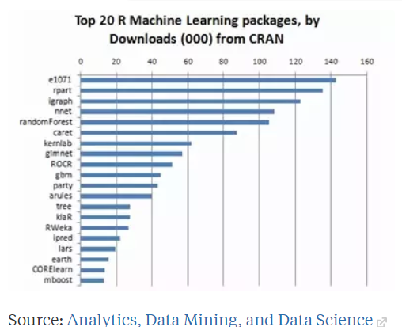

Figure 1 Top 20 ML Packages download

There are many of machine learning algorithms. These algorithms can be separated into many categories depend on their operation. For example, algorithms of regression are used to find the relationship between variables. The decision tree algorithms used for regression and classification problems. Some of these are namely Random Forests, Support Vector Machine, Classification and Regression Tree, Deep learning, Linear Regression and Logistic Regression

2.3 Conceptual framework
%D
%sD
DIS5
DIS10
OSCP
ROC
CCI
%K
MO
%R
ABT

Prediction Model
(Random forest, Support vector Machine)

Up/ Down

Figure 2 Conceptual framework

CHAPTER 3

3.1 Data& Methodology
The Technical indicators and direction of change in the daily closing prices for the KSE 100 index are used as the research data for this study.The prices of the required stock data are downloaded from Google and Yahoo ﬁnance. Data has been taken from 2January 2008 to 29December 2017 computing total 2431 trading days. The total number of days with upward direction is 1307 the totalnumber of days with downward direction is 1125. In additional words, in 53.76% the all number of days market has an upward direction, in 46.28% the number of days it has a downward direction. The number of day with ups and down positon for each year is given in Table.

Table 1
Year | Increase | Decrease |  | Total
2008 | 83 | 105 |  | 188
2009 | 128 | 119 |  | 247
2010 | 143 | 107 |  | 250
2011 | 128 | 119 |  | 247
2012 | 142 | 107 |  | 249
2013 | 153 | 93 |  | 246
2014 | 135 | 109 |  | 244
2015 | 123 | 132 |  | 255
2016 | 150 | 107 |  | 257
2017 | 121 | 127 |  | 248
Sum | 1307 |  | 1125 | 2431

Data is divided for in-sample (training) and out-of-sample (test) purposes as 1418 observations are used for model estimation in in-sample and remaining 1013 observations are used for forecasting and evaluation in out-of-sample. 60% data use in-sample data and 40% add in out-sample. Normally used 50 to 70 percent samples as a training sample and remaining 50 to 30 percent as a test sample. There is no specific limit regarding that. In holdout method, we cannot decide which data points can be taken as training sample or as a test sample. It works on randomly. The model randomly selects the data points for training sample and testing sample.
For input variables technical indicators are being use in this study to predict the direction of daily price change in the stock market index. To specify the movement in the direction of KSE 100 index at any time t direction of stock market is used and as direction is categorical variable so twocategories ‘1’ or ‘2’ is used as labels. ‘1’ indicates that the next day’s index is lower than today’s indexed while ‘2’ indicates that the next day’s index is higher than today’s index.
The system needsforecast labels to be used in the trading strategy. The forecast labels are produced using two machine learning algorithm, random forest RF and support vector machine SVM. The aim is to compare the hit ratio to check which algorithm is the most eﬀective at forecast data labels, which have to maximum hit ratio of accuracy. The system calculates the hit ratio of accuracy of a machine learning technique by comparing the producedforecasted labels with the actual labels in the test (unseen) data set. We calculate the hit ratio using confusion matrix.

3.1.1 Technical indicators
To forecast financial market technical indicators considered to be the most important parameters which are calculated from stock market data. These indicators are widely used by investors to avoid inconvenient signals. Technical indicators which are used in this study are mentioned below:
- Commodity channel index (CCI)
This technical indicator calculates the security’s price variation from its statistical mean. The Commodities Channel Index (CCI) was developed in 1980 by Donald Lambert and published in Commodities magazine. It is indicator that can expose a new change or be warned of risky conditions. In general, CCIs measure the recent price level compared to an average price level during a define time period. The ICC is high when prices are well above average. The ICC is low when prices are well below its average. In this way, CCI can be used to find overbought and oversold levels.
CCI calculate the change between the price change of a security and its change in the average price. High positive scores show that prices are well more than their average, which is show power. Low negative values ​​show that prices are well lowers their average, which showsweakness.
$$\frac{M_{t}-{SM}_{t}}{0.015D_{t}}$$
$$where;$$
$$Mt =\frac{H_{t}+L_{t}+C_{t}}{3}$$
$${SM}_{t}=\frac{\sum_{i=1}^{n}{M_{t-i+1}}}{n}$$
$$D_{t}=\frac{\sum_{i=1}^{n}{\left\lfloor M_{t-i+1}-{SM}_{t}\right\rfloor }}{n}$$

- Stochastic %K (X.K)
This technical indicator in a given time period, compares the security’s price with that of its price range. The speed or the momentum of the price tracks by stochastic oscillator. According to a rule, before the change in the price occur, momentum changes. It also computes the closing price level related to low and high range given in a specified time.
The stochastic oscillator is available in three versions. The fast stochastic oscillator is based on George Lane's original formulas for %K and %D.
The stochastic oscillator was introduced by George C. Lane in the 1950s is a momentum indicator that indicates the position of the close relative to the range of high to low for a defined time period.
It Follow the moment or speed of the price. In general rule, the momentum changes before the price.
Lane also used this oscillator to find configurations of bulls and bears to anticipate a future investment. Because the stochastic oscillator is linked to the area, it is also useful to identify overbought and oversold levels.
$$\frac{C_{t}-{LL}_{t-n}}{{HH}_{t-n}-{LL}_{t-n}}*100$$

Where;
Ct = Current close price
LLt = lowest low
HHt = highest high
- Stochastic %D (X.D)
% D is a simple moving average t-day of %K. Transaction signals are generated when% K goes through a period of moving average called% D.
In fact, Lane has used %D to produce buy or sell signals. %D is used in the fast stochastic oscillator for signals.
$$\frac{\sum_{t=0}^{n-1}{\%K_{t-i}}}{n}$$

- Stochastic slow s%D (S.D)
The slow stochastic oscillator smoothes %K by SMA of t-days that closely matches %D in the stochastic fast oscillator. %K in the slow stochastic oscillator same %D in the fast stochastic oscillator.
$$\frac{\sum_{t=0}^{n-1}{\% D_{t-i}}}{n}$$

- Price rate of change (ROC)
The rate of change indicator calculates the percentage change in the price from one period to another. The calculation of the ROC compares the today close price with the close price "n", time ago. As a momentum oscillator, ROC signs include crosses in the central axis, deviations, and overbought or oversold measurements. The detection of overbought or oversold extremes depends naturally on the oscillator with the rate of change.
$$\frac{C_{t}}{C_{t-n}}*100$$

Where;
Ct = Current close price
Ct-1 = Close price n day ago
- Disparity 5 (DIS5)
Disparity 5 measure the change of the today closing price and the moving average of 5 days. It checks the change in today price from last 5 days price.
$$\frac{C_{t}}{{MA}_{5}}*100$$
Where;
Ct = Current close price
MA5 = 5-day Exponential Moving Average

- Disparity 10 (DIS10)
Disparity 10 measure the change of the today closing price and the moving average of 10 days. It checks the change in today price from last 10 days price.
$$\frac{C_{t}}{{MA}_{10}}*100$$
Where;
Ct = Current close price
MA5 = 5-day Exponential Moving Average

- Price oscillator (OSCP)
The percentage price oscillator (OSCP) is a momentum oscillator that calculates the change among moving averages of 5 days and 10 days. The oscillator percentage is displayed with signal line, histogram, and center line. The signs are produced with signal line intersections, centerline intersections and deviations.
$$\frac{{MA}_{5}-{MA}_{10}}{{MA}_{5}}$$

- Larry William’s %R (X.R)
The Williams %R introduced by Larry Williams is a momentum indicator that is the opposite of the fast stochastic oscillator. Williams %R represents the degree of closure comparative to the highest high of the reference period.
%R modifies for the inversion by multiplying with -100. As a result, the fast stochastic oscillator and Williams %R make the same lines, only the scale is dissimilar. Williams %R varies from 0 to -100. Value from 0 to -20 is known as overbought. Value between -80 and -100 is known as oversold.
$$\frac{H_{n}-C_{t}}{H_{n}-L_{n}}*100$$
Where;
LLn = lowest low
HHn = highest high
- Momentum (MO)
Momentum measure the amount of the variation in the price of a security for a certain period of time.
"Momentum" generally refers to prices that are constantly trend. The Momentum indicators show a tendency to remain positive while the upward trend is maintained or negative while maintaining a downward trend.
$$\frac{C_{t}}{C_{t-i}}$$

Where;
Ct = Current close price
Ct-1 = Close price n day ago

- Momentum Average (ABT)
It is a measure of variation in momentum with respect to price in n days ago.
$$\frac{\sum_{t=0}^{n-1}{\% {MO}_{t-i}}}{\sum_{t=0}^{n-1}{{MO}_{t-i}}}$$

This study includes a ﬁnancial information system that forecasts the direction ofstock priceof the next day. The system is assembled using software “R studio”, and use R packages for building model “random forest” package for random forest algorithm and “e1071” package for support vector machine. And also use many other packages for exploring results.
Study shows an attempt for predict the direction of stock price using machine learning algorithm Random Forest (RF) and Support Vector Machine (SVM). As these models are used here for prediction so they both have capability to make the probability of group membership however both are based on different statistical techniques. In simple words these models can estimate the chances of the movement (upward/downward) in the stock index (Prassana, 2013; Bonde, 2013; Kim, 2003). Following section will explain the machine learning and its use in finance.

3.2 Machine Learning Algorithms

3.2.1 Random forest
In a random forest there is a classifier which is combination of tree arranged classifiers {h(x, $θ_{K}$),k=1,….} in which {$θ_{K}$} acts as an autonomous random vectors and every created tree votes on behalf of the majority accepted class at input x.
Breiman (2001) proposed random forest algorithm in which it states that firstlygenerated a random vector $θ_{K}$ which is autonomous from past random vectors$θ_{1}$,., $θ_{K}-1$ but with the similar distribution. Then a tree is grown taking x as an input vector by using training set which result a classifier h(x,$θ_{K}$). When random selection is happening, $θ$ consist of aamount of independent integers among 1 and K. The dimensionality of $θ$ depends upon that how it is being usage in tree construction. So when huge number of trees produced, maximum popular class being voted. All of this process called random forest.

Tree1
Tree n
Featur (f)
Featur (f)

Pn (C/F)
P1 (C/F)

∑

$p\left(\frac{c}{f}\right)=\sum_{i}^{n}{pn(\frac{c}{f})}$
Figure 3tree construction
Decision trees shows prone to over fittingwhen they were used alone so random forest overcome this issue by resolving the possible over fitting that could occur. Multiple decision trees are being used in random forest with different predictions, a random forest is being generated to give the final result. Variance and over fitting in random forest is reduced by applying an algorithm called bagging on decision trees.
Moreover in this study’s experiment, every tree is splitted using 3 indicators chosen randomly. Afterward‘n’ number of trees is being created then test data is applied and the decision with which larger part of trees voted is consider as ultimate output. This process is also reason for less over fitting.

3.2.2 Support Vector Machine
The Support vector machine (SVM) is amachine learning algorithm build on statistical idea for data classification. It implements nonlinear class boundaries by using linear models and out input vectors x in the space of large function. In the new space a linear model is built capable to show a nonlinear boundary in the real space. And then an optimal separating hyper plane is built in the new space. The Points on the both sides of hyper plane have distances to the hyper plane. And the smallest distance between a point and the hyper plane is called margin of separation. For example suppose that x is the margin of the hyper plane. So data points which are distance x from the optimal separating hyper plane are called support vectors.
In present study, kernel function of SVM, built on Gaussian radial basis function is used. Parameters which playsignificant role in performance of SVM in this study use two kernel parameters C (regularization constant) and sigma. Under fitting and over fitting problems could be occur if parameters are used improperly. Kernel function is being used in it to feature higher dimensions and situate finest hyper plane to separate two classes of samples. In this study this algorithm is put into operation by the e1071 R package.

3.3 Performance measurement
Confusion matrix
Confusion matrix represents a table which shows the performance of algorithm onthe test data set for which the actual values are identified. Table shows predicted class labels (labels predict by model) and on the other side actual class labels (actual label of market index), labels are positive or negative, in this study positive label is 2 and negative label is 1. For example in first condition if actual label is negative and our model also predict label negative, it means both class labels are same with negative label. In second condition if actual label is negative but our model predict positive it means that at this point model make misclassification, in third condition if actual label is positive but model predict negative, as they are opposite to each other it means model make misclassification at this point. In fourth condition if actual label is positive and model also predict positive, it mean both class labels are same with positive labels. So then calculate hit ratio using formula given bellow:

Table 2
Confusion matrix
 |  | Predicted Class
 |  | - | +
Actual Class | - | TN | FP
Actual Class | + | FN | TP
Above table is showing confusion matrix with actual and predicted classes

TN = True Negative (How many time actual label is - and model also predict -)
FP = False positive (How many time actual label is - and model also predict +)
FN = False Negative (How many time actual label is + and model also predict -)
TP = True Positive (How many time actual label is + and model also predict +)
Hit Ratio = $\frac{TP+TN}{T data set value}*100$

CHAPTER 4

4.1 Results
In this section firstly show curve of random forest model, how error rate decrease when number of trees increase in forest and also show this in table2, and then algorithms are separately showing their accuracy ratios through training data set as well as test data set. In the end hit ratio is explainingboth algorithms Random forest and Support vector machine are showing their accuracy ratios by using test data sets, the predictability power of each algorithm.

4.1.1Random Forest algorithm
Error curve of random forest model has been shown in fig.4 as the number of tree grows. It shows the running relative rate of error for the random forest model. In the beginning first tree shows an average error rate of .32 but gradually trees increases from 0 to 100 it decreases the error rate. At the 100 number of trees error rate showing almost.15 and after that it decreases and put an end to average .13 error rate.

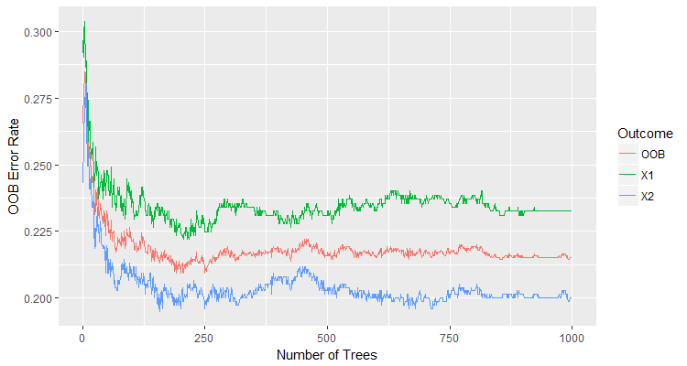
Figure 4OOB error rate graph showing decreasing in error

The parameters assigned to the number of predictors are by default given by software which is for each node is 3 and minimum cases of parent node are selected 2. These numbers of predictors are tested with different number of trees which varies from 600 to 1000. So out of sample data in case of random forest shows 78.18% prediction performance.

OOB error rate table
Table 3
Sample size | Number Of trees | OOB error
600 | 5 | 33.33%
600 | 100 | 27.71%
600 | 300 | 24.57%
600 | 500 | 26%
600 | 1000 | 25.71%
800 | 5 | 31.74%
800 | 100 | 23.55%
800 | 300 | 23.13%
800 | 500 | 23.34%
800 | 1000 | 22.7%
1000 | 5 | 30.04%
1000 | 100 | 22.51%
1000 | 300 | 23.02%
1000 | 500 | 23.37%
1000 | 1000 | 22.51%

Convergence is used by algorithm to calculate out of bag error(OOB) of the classes relative to the data set as when increases the amount of trees in the forest. Table shows the observations after which the prediction is to be made, number of trees in the forest and OOB error rate.
Fig.5 is showing that how worse the model performs without each variable. Means it shows that how much every variable has maximum importance in terms of contributing towards accuracy. Decrease in every variable will cause the decrease in accuracy ratio of the Random forest model. As in this graph %R is showing the highest value which means that the most important variable in the model is %R and elimination of this variable will cause high decrease in accuracy ratio.
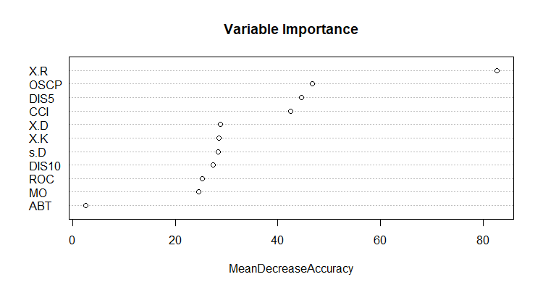
Figure 5variable importance according to accuracy

4.1.2 Support Vector Machine algorithm
To discover the best performance of SVM by using kernel parameters and constants different set of experiments is being used in this study. To check out the top performance of SVM with parameters and constants Kernel parameter $∂^{2}$ is tested within the range of 40 and 140. While regularization constant C was tested between 1 and 5.
In following table it can be seen that top prediction performance of the test data is showed when value of$∂^{2}$ is50 is and value of C is 1. In these values it can also be noticed that when $∂^{2}$ increase up to certain value with given value of C, SVM prediction performance increases and after that certain point it started decreasing. So this showed that SVM prediction performance is somehow responsive to kernel parameter$∂^{2}$. It is showed that SVM prediction performance on the test data is 79.76% when C is 1and $∂^{2}$ is 50.

The prediction performance of SVMs onparameters
Table 4
Hit Ratio
C/$∂^{2}$ | 40 | 50 | 60 | 70 | 80 | 90 | 100 | 110 | 120 | 130 | 140
1 | 79.37 | 79.76 | 79.37 | 79.57 | 79.57 | 79.47 | 77.79 | 78.18 | 77.99 | 78.08 | 78.08
2 | 78.97 | 79.17 | 79.07 | 79.57 | 79.47 | 79.27 | 78.28 | 78.38 | 78.87 | 78.97 | 78.97
3 | 79.27 | 79.37 | 79.27 | 78.48 | 78.38 | 78.48 | 79.07 | 79.27 | 79.37 | 78.97 | 79.37
4 | 79.27 | 79.37 | 78.97 | 78.28 | 78.28 | 78.38 | 79.47 | 78.94 | 79.17 | 79.07 | 78.97
5 | 79.37 | 79.37 | 78.68 | 78.18 | 78.38 | 77.89 | 79.37 | 79.17 | 79.07 | 79.27 | 79.37

4.1.3 Real VS Prediction by the classification models
Both machine learning techniques were applied separately on the datasets. The following figures show the real and predicted performances of the market. Figures X-axis is showing the amounts of data set while Y-axis is showing the classes.
Usually, prediction model work on test data which was assembled by using train data set but test data uses hidden occurrences which are different from training data set. Therefore, Random forest appears to be more effective in forecasting the market by using training data set. And also random forest outperform support vector machine algorithm when prediction calculated by test data set.
Support vector machine and random forest algorithms are separately applied firstly on training data set then on test data set. Below mentioned figures are showing the first 100 actual and predicted values of the stock market performance. Negative and Positive classes are represented by 1 and 2 respectively.

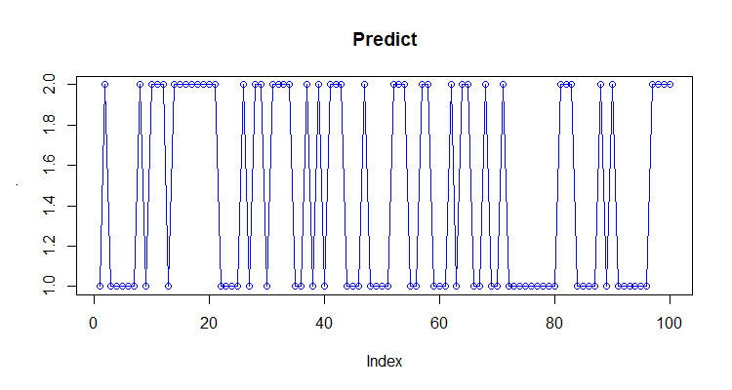
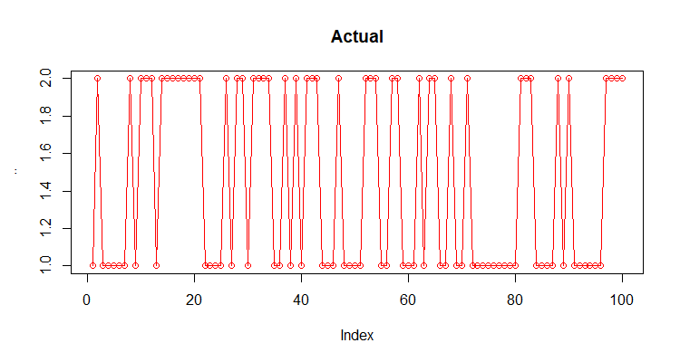
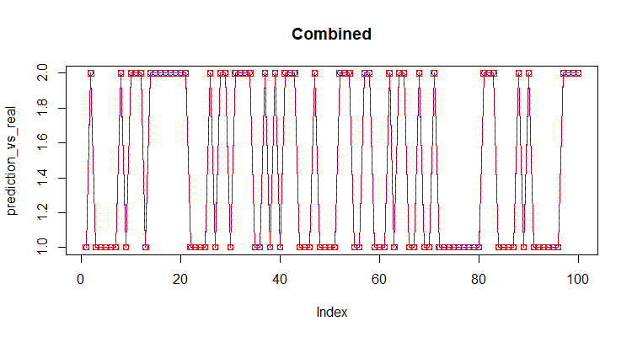

Figure 6 random forest algorithm experimented by training data set.

Figure shows the random forest algorithm experimented by training data set. It gives 100% prediction accuracy ratio with respect to train data set.
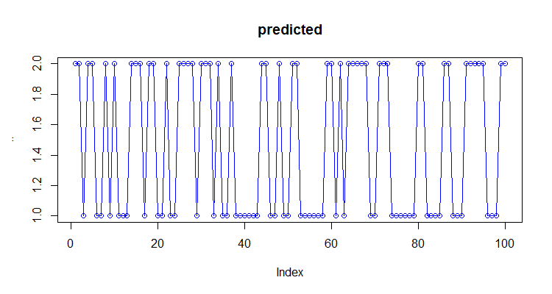
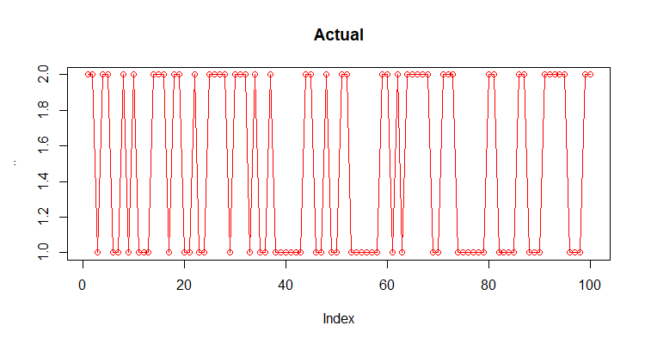
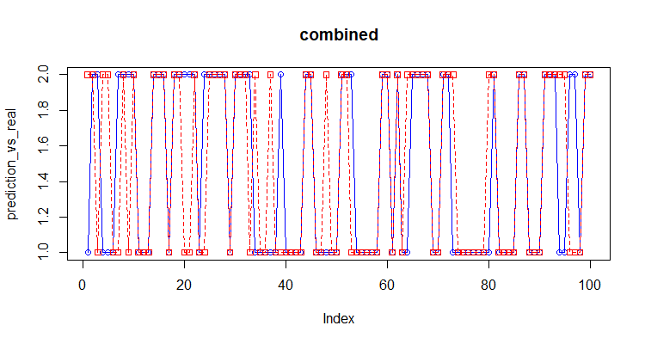

Figure 7random forest algorithm experimented with respect to test data set

Figure depicts the results of random forest algorithm experimented on test data set and further predicted. This model is showing 78.18% prediction accuracy ratio on test dataset.
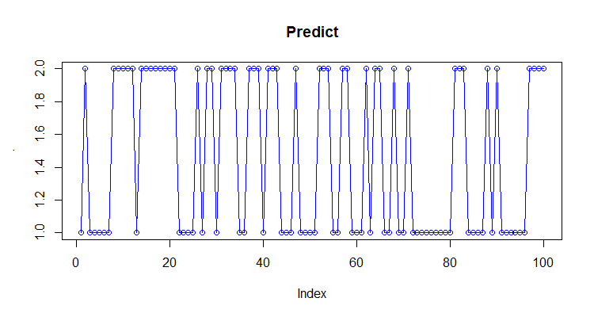
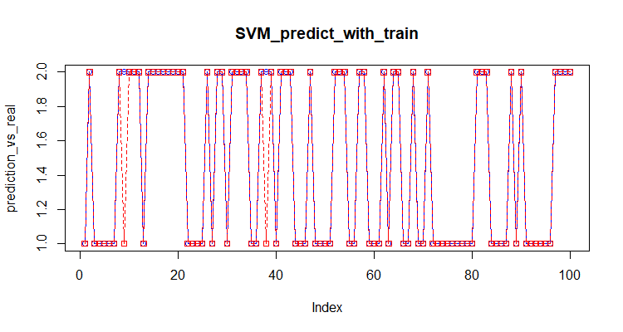

Figure 8support vector machine algorithm trained by training data set.

Figure shows the support vector machine algorithm trained by training data set. It gives 83.29% prediction accuracy ratio with respect to train data set.
Figure 9support vector machine algorithm with respect to test data set.
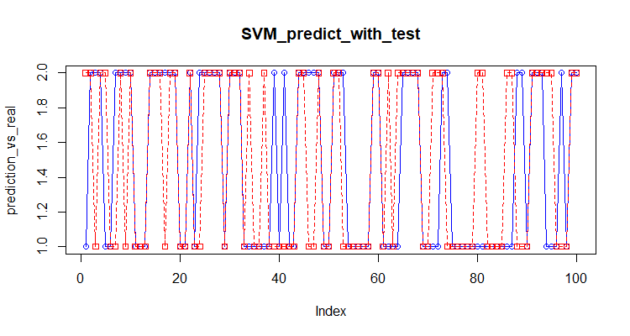

Figure depicts the results of support vector machine algorithm predict on test data set and further predicted. This model is showing 79.76% prediction accuracy ratio on test dataset.

4.1.4 Confusion Matrix of Models
Confusion matrix SVM
Confusion matrix RF

1
2
2
1
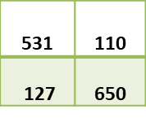
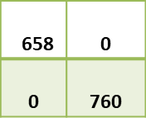
1
Hit ratio = $\frac{531+650}{1418}*100$
= 83.29%
1
2
Hit ratio = $\frac{658+760}{1418}*100$
= 100%

2

2
1
1
2
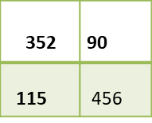
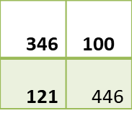
1
Hit ratio = $\frac{352+456}{1013}*100$
= 79.76%
1
2
Hit ratio = $\frac{346+446}{1013}*100$

= 78.15%

2

Confusion matrix of random forest with train data set is showing hit ratio 100% which means model predicts 100% accurate labels with actual class, and hit ratio with test data set is 78.15%. On the other side, the confusion matrix of support vector machine shows 83.29% hit ratio with train data set and 79.76% with test data set. It means SVM out preform on test data set.

4.1.5 Prediction performances
Now we will compare the hit ratio of both algorithms (classification method) random forest (RF) and support vector machine (SVM) with both data set in-sample (Training), and out-sample (Test). We get the hit ratio using confusion matrix function in R.
For the KSE 100 Index series forecast the direction of one period ahead, produced by the two machine learning algorithm random forest and support vector machine. Check out the best predictability power of both algorithms.
Forecasting performance of Machine learning algorithm (classification method)
Table 5
Algorithm | Hit ratio
SVM | 79.76%
RF | 78.18%

Experimental results can be seen in table 4 in which it is shown that Support vector machine and Random forest have almost alike prediction power, random forest hit ratio on train data set is 100% and 78.18% on test data set, and support vector machine give hit ratio on train data set is 83.29% and 79.76% on test data set. Support vector machine has a little bit higher prediction power if compared with Random forest.It’s means that Support vector machine has better predictability power.

4.1.6 Day-ahead Prediction

Actual Stock Labels
Predicted Stock Labels
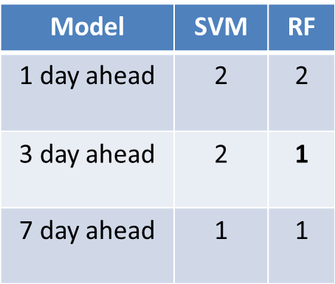
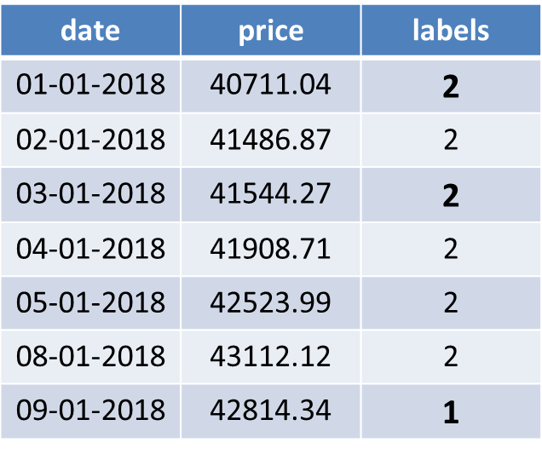

Table is showing the predicted labels against the actual labels shown before with the sequence of 1 days ahead, 3 days ahead and 7 days ahead.

Above tables are showing the comparison of actual and predicted labels of KSE 100 index which are generated by algorithms used in the study for future prediction. As short term prediction is done in this study so prediction for next seven days is calculated and above is the representation of the selected three days which are 1 day ahead, 3 days ahead and 7 days ahead respectively. For support vector machine (SVM) algorithm show same prediction labels as the actual labels had shown for the KSE 100 index. And random forest algorithm show one misclassification prediction labels as the actual labels had shown for the KSE 100 index.

CHAPTER 5

5.1 Conclusion
To prepare the finest market trading solutions, the matter of exactly predicting the stock market price movement direction is highly important. In present study, two existing machine learning techniques, support vector machine and random forest are being used for the time series analysis for stock market prediction. Results showed that figure4 the error rate of random forest model as the number of tree grows. At the beginning, error rate is on average of .32 but trees gradually increase from 0 to 100 which decrease the error rate. After that it decreases at the 100 number of trees error rate showing almost.15 and ends to average error rate is 0.13.
Table2 shows the observations after which the prediction is to be made, the number of trees in the forest and OOB error rate. As the increases the amount of trees in the model, the error rate decreases.Figure 5 shows the importance of variable in the model. Indicate the importance of each variable in terms of accuracy. The reduction of each variable decreases the accuracy rate of the random forest model. The variable %R shows the highest value, which means that the most important variable in the model is %R.
Table6 to find the best SVM performance using kernel parameters and constants different set of experiments is being used in this study. It is showed that SVM prediction best performance for the test data is 79.76% when C is 1 and $∂^{2}$ is 50.
In the final comparison of both algorithm table4 resultsshowed that for the same input data, accuracysupport vector machine is higher than that ratioof random forest. It shows that for Pakistan’s stock market support vector machine algorithm has more predictive power and it can better predict the direction of stock market movement. However, each algorithm has its own pros and cons, but the algorithms like support vector machine, random forest and other machine learning techniques can be helpful for traders, investors and borrowers etc. so that they can make better investment decisions.

5.2 Future work
In future, researches make automate trading strategy for investing in stock, this strategy use information from our model labels and investing in stock. If last three days labels showing stock direction going up word then strategy giving the sign purchase the stock and if labels show the last three days stock direction going down strategy giving sign sell the stock. It might be help full for investor to take the timely action buy or sell stock according to market situations.
In future, can also be done by testing the other different machine learning algorithms that whether they put any change and also the input data can be increase or decrease for same techniques to find out the predictability power of algorithms that whether findings change or not. In Pakistan a lot of research related to machine learning and Pakistan’s stock exchange can be done in order to help out the investors and traders in Pakistan.

5.3 Implications
The focus of this study is to provide the fund manager, traders, borrowers, and treasurer’s better planning capabilities by predicting the future movements of the stock market.

REFERENCES
Aldin, M. M., Dehnavi, H. D., &Entezari, S. (2012). Evaluating the employment of technical indicators in predicting stock price index variations using artificial neural networks (case study: Tehran Stock Exchange). International Journal of Business and Management, 7(15), 25.
Amin, V., Hasan, S. S., Mehrdad, V., & Saber, N. (2014).Predicting Direction of Stock Price Index Volatility Using Genetic Algorithms and Artificial Neural Network Models in Tehran Stock Exchange. International Journal of Business and Technopreneurship, 4(3), 451-465.
Ballings, M., Van den Poel, D., Hespeels, N., &Gryp, R. (2015). Evaluating multiple classifiers for stock price direction prediction. Expert Systems with Applications, 42(20), 7046-7056.
Bansal, R., & Viswanathan, S. (1993). No arbitrage and arbitrage pricing: A new approach. The Journal of Finance, 48(4), 1231-1262.
Banz, R. W., & Breen, W. J. (1986). Sample‐dependent results using accounting and market data: some evidence. The Journal of Finance, 41(4), 779-793.
Barr, D. S., & Mani, G. (1994).Using neural nets to manage investments. Ai Expert, 9(2), 16-21.
Bergerson, K., &Wunsch, D. C. (1991, July). A commodity trading model based on a neural network-expert system hybrid. In Neural Networks, 1991., IJCNN-91-Seattle International Joint Conference on (Vol. 1, pp. 289-293). IEEE.
Blank, S. C. (1991).“Chaos” in futures markets?A nonlinear dynamical analysis. Journal of Futures Markets, 11(6), 711-728.
Breiman, L. (2001). Random forests.Machine learning, 45(1), 5-32.
Campbell, J. Y. (1987). Stock returns and the term structure. Journal of financial economics, 18(2), 373-399.
Cao, L. J., &Tay, F. E. H. (2003). Support vector machine with adaptive parameters in financial time series forecasting. IEEE Transactions on neural networks, 14(6), 1506-1518.
Chakraborty, K., Mehrotra, K., Mohan, C. K., &Ranka, S. (1992). Forecasting the behavior of multivariate time series using neural networks. Neural networks, 5(6), 961-970.
Cheng, W., Wagner, W., & Lin, C. H. (1996). Forecasting the 30-year US treasury bond with a system of neural networks. NeuroVe $ t Journal, 1(2).
Choudhury, S., Ghosh, S., Bhattacharya, A., Fernandes, K. J., & Tiwari, M. K. (2014). A real time clustering and SVM based price-volatility prediction for optimal trading strategy. Neurocomputing, 131, 419-426.
Dastgir, M., &Enghiad, M. H. (2012). Short-term prediction of Tehran Stock Exchange Price Index (TEPIX): using artificial neural network (ANN). Quarterly Journal of Securities Exchange, 4(14), 237-261.
Decoster, G. P., Labys, W. C., & Mitchell, D. W. (1992).Evidence of chaos in commodity futures prices. Journal of Futures Markets, 12(3), 291-305.
Devi, K. N., Bhaskaran, V. M., & Kumar, G. P. (2015, March). Cuckoo optimized SVM for stock market prediction. In Innovations in Information, Embedded and Communication Systems (ICIIECS), 2015 International Conference on (pp. 1-5).IEEE.
Di, X. (2014).Stock Trend Prediction with Technical Indicators using SVM. Independent WorN Report, Stanford Univ.
Diebold, F. X., & Mariano, R. S. (2002).Comparing predictive accuracy. Journal of Business & economic statistics, 20(1), 134-144.
Ding, Z. (2012). Application of support vector machine regression in stock price forecasting.In Business, Economics, Financial Sciences, and Management (pp. 359-365).Springer, Berlin, Heidelberg.
Donaldson, R. G., &Kamstra, M. (1996). A new dividend forecasting procedure that rejects bubbles in asset prices: the case of 1929’s stock crash. The review of financial studies, 9(2), 333-383.
Donaldson, R. G., &Kamstra, M. (1996). A new dividend forecasting procedure that rejects bubbles in asset prices: the case of 1929’s stock crash. The review of financial studies, 9(2), 333-383.
Dunis, C. L., Likothanassis, S. D., Karathanasopoulos, A. S., Sermpinis, G. S., &Theofilatos, K. A. (2013). A hybrid genetic algorithm–support vector machine approach in the task of forecasting and trading. Journal of Asset Management, 14(1), 52-71.
Egeli, B., Ozturan, M., &Badur, B. (2003).Stock market prediction using artificial neural networks.In Proceedings of the 3rd Hawaii international conference on business (pp. 1–8). Hawaii, USA.
El Shazly, M. R., & El Shazly, H. E. (1999). Forecasting currency prices using a genetically evolved neural network architecture. International review of financial analysis, 8(1), 67-82.
Enke, D., &Thawornwong, S. (2005). The use of data mining and neural networks for forecasting stock market returns. Expert Systems with applications, 29(4), 927-940.
Fama, E. F., & Bliss, R. R. (1987).The information in long-maturity forward rates. The American Economic Review, 680-692.
Fama, E. F., & French, K. R. (1988). Dividend yields and expected stock returns. Journal of financial economics, 22(1), 3-25.
Fama, E. F., & French, K. R. (1988).Permanent and temporary components of stock prices.Journal of political Economy, 96(2), 246-273.
Fama, E. F., & French, K. R. (1989). Business conditions and expected returns on stocks and bonds. Journal of financial economics, 25(1), 23-49.
Fama, E. F., & French, K. R. (1992). The cross‐section of expected stock returns. the Journal of Finance, 47(2), 427-465.
Fama, E. F., &Schwert, G. W. (1977). Asset returns and inflation. Journal of financial economics, 5(2), 115-146.
Ferson, W. E., & Harvey, C. R. (1993).The risk and predictability of international equity returns. Review of financial Studies, 6(3), 527-566.
Ferson, W. E., & Harvey, C. R. (1993).The risk and predictability of international equity returns. Review of financial Studies, 6(3), 527-566.
Frank, M., &Stengos, T. (1989).Measuring the strangeness of gold and silver rates of return. The Review of Economic Studies, 56(4), 553-567.
Geurts, P., &Louppe, G. (2011).Learning to rank with extremely randomized trees. In JMLR: Workshop and Conference Proceedings (Vol. 14, pp. 49-61).
Göçken, M., Özçalıcı, M., Boru, A., &Dosdoğru, A. T. (2016).Integrating metaheuristics and artificial neural networks for improved stock price prediction. Expert Systems with Applications, 44, 320-331.
Grudnitski, G., &Osburn, L. (1993). Forecasting S&P and gold futures prices: An application of neural networks. Journal of Futures Markets, 13(6), 631-643.
Guresen, E., Kayakutlu, G., &Daim, T. U. (2011).Using artificial neural network models in stock market index prediction. Expert Systems with Applications, 38(8), 10389-10397.
Hadavandi, E., Shavandi, H., &Ghanbari, A. (2010).Integration of genetic fuzzy systems and artificial neural networks for stock price forecasting. Knowledge-Based Systems, 23(8), 800-808.
Hafezi, R., Shahrabi, J., &Hadavandi, E. (2015). A bat-neural network multi-agent system (BNNMAS) for stock price prediction: Case study of DAX stock price. Applied Soft Computing, 29, 196-210.
Hodgson, A., & Nicholls, D. (1991). The impact of index futures markets on Australian share market volatility. Journal of Business Finance & Accounting, 18(2), 267-280.
Huang, W., Lai, K. K., Nakamori, Y., Wang, S., & Yu, L. (2007). Neural networks in finance and economics forecasting. International Journal of Information Technology & Decision Making, 6(01), 113-140.
Huang, W., Nakamori, Y., & Wang, S. Y. (2005).Forecasting stock market movement direction with support vector machine. Computers & Operations Research, 32(10), 2513-2522.
Jaffe, J., &Westerfield, R. (1985). Patterns in Japanese common stock returns: Day of the week and turn of the year effects. Journal of financial and quantitative analysis, 20(2), 261-272.
Jaffe, J., Keim, D. B., &Westerfield, R. (1989). Earnings yields, market values, and stock returns. The Journal of Finance, 44(1), 135-148.
Jung, C., & Boyd, R. (1996).Forecasting UK stock prices.Applied Financial Economics, 6(3), 279-286.
Kamruzzaman, J., &Sarker, R. A. (2004).ANN-based forecasting of foreign currency exchange rates. Neural Information Processing-Letters and Reviews, 3(2), 49-58.
Kar, A. (1990). Stock prediction using artificial neural networks. Dept. of Computer Science and Engineering, IIT Kanpur.
Kara, Y., Boyacioglu, M. A., &Baykan, Ö. K. (2011).Predicting direction of stock price index movement using artificial neural networks and support vector machines: The sample of the Istanbul Stock Exchange. Expert systems with Applications, 38(5), 5311-5319.
Karathanasopoulos, A. S., Theofilatos, K. A., Leloudas, P. M., &Likothanassis, S. D. (2010, September). Modeling the ase 20 Greek index using artificial neural nerworks combined with genetic algorithms. In International Conference on Artificial Neural Networks (pp. 428-435).Springer, Berlin, Heidelberg.
KARYMSHAKOV, K., & ABDYKAPAROV, Y. (2012).FORECASTING STOCK INDEX MOVEMENT WITH ARTIFICIAL NEURAL NETWORKS: THE CASE OF ISTANBUL STOCK EXCHANGE.Trakya University Journal of Social Science, 14(2).
Kato, K., Ziemba, W., Schwartz, S., Day of the week e4ects in Japanese stocks. In: Elton E, Grubber M, editors. Japanese capital markets. New York: Harper & Row, 1990.
Keim, D. B., &Stambaugh, R. F. (1986). Predicting returns in the stock and bond markets. Journal of financial Economics, 17(2), 357-390.
Kim, E., Kim, W., & Lee, Y. (2003).Combination of multiple classifiers for the customer's purchase behavior prediction. Decision Support Systems, 34(2), 167-175.
Kim, K. J. (2003). Financial time series forecasting using support vector machines. Neurocomputing, 55(1-2), 307-319.
Kimoto, T., Asakawa, K., Yoda, M., &Takeoka, M. (1990, June).Stock market prediction system with modular neural networks. In Neural Networks, 1990., 1990 IJCNN International Joint Conference on (pp. 1-6). IEEE.
Kryzanowski, L., Galler, M., & Wright, D. W. (1993).Using artificial neural networks to pick stocks. Financial Analysts Journal, 21-27.
Kumar, M., &Thenmozhi, M. (2006). Forecasting stock index movement: A comparison of support vector machines and random forest.
Kumar, M., &Thenmozhi, M. (2007). Support vector machines approach to predict the S&P CNX NIFTY index returns.
Laboissiere, L. A., Fernandes, R. A., &Lage, G. G. (2015). Maximum and minimum stock price forecasting of Brazilian power distribution companies based on artificial neural networks. Applied Soft Computing, 35, 66-74.
Larivière, B., & Van den Poel, D. (2005).Predicting customer retention and profitability by using random forests and regression forests techniques. Expert Systems with Applications, 29(2), 472-484.
Leung, M. T., Daouk, H., & Chen, A. S. (2000). Forecasting stock indices: a comparison of classification and level estimation models. International Journal of Forecasting, 16(2), 173-190.
Leuthold, R. M., Junkus, J. C., &Cordier, J. E. (1989). The theory and practice of futures markets.Free press.
Li, H., Yang, Z., & Li, T. (2014). Algorithmic Trading Strategy Based On Massive Data Mining.
Literature
Maverly, E. D. (1986). The informational content of the interday price change with respect to stock index futures. Journal of Futures Markets, 6(3), 385-395.
McCluskey, P. C. (1993). Feedforward and recurrent neural networks and genetic programs for stock market and time series forecasting.Master's thesis, Brown University.
Mukherjee, S., Osuna, E., &Girosi, F. (1997, September).Nonlinear prediction of chaotic time series using support vector machines.In Neural Networks for Signal Processing [1997] VII. Proceedings of the 1997 IEEE Workshop (pp. 511-520). IEEE.
Müller, K. R., Smola, A. J., Rätsch, G., Schölkopf, B., Kohlmorgen, J., &Vapnik, V. (1997, October).Predicting time series with support vector machines.In International Conference on Artificial Neural Networks (pp. 999-1004).Springer, Berlin, Heidelberg.
O'CONNOR, M. A. R. C. U. S., Remus, W., & Griggs, K. (1997). Going up–going down: How good are people at forecasting trends and changes in trends? Journal of Forecasting, 16(3), 165-176.
Osuna, E., Freund, R., &Girosit, F. (1997, June). Training support vector machines: an application to face detection. In Computer vision and pattern recognition, 1997. Proceedings.1997 IEEE computer society conference on (pp. 130-136).IEEE.
Padhy, S. (2012).Shom Prasad Das.
Patel, J., Shah, S., Thakkar, P., &Kotecha, K. (2015). Predicting stock market index using fusion of machine learning techniques. Expert Systems with Applications, 42(4), 2162-2172.
Patel, M. B., &Yalamalle, S. R. (2014).Stock price prediction using artificial neural network. International Journal of Innovative Research in Science, Engineering and Technology, 3(6), 13755-13762.
Perwej, Y., &Perwej, A. (2012). Prediction of the Bombay Stock Exchange (BSE) market returns using artificial neural network and genetic algorithm. Journal of Intelligent Learning Systems and Applications, 4(02), 108.
Prasanna, S., &Ezhilmaran, D. (2013).An analysis on stock market prediction using data mining techniques. International Journal of Computer Science & Engineering Technology (IJCSET), 4(3), 49-51.
Preethi, G., &Santhi, B. (2012). STOCK MARKET FORECASTING TECHNIQUES: A SURVEY. Journal of Theoretical & Applied Information Technology, 46(1).
Quah, T. S., & Srinivasan, B. (1999). Improving returns on stock investment through neural network selection. Expert Systems with Applications, 17(4), 295-301.
Refenes, A. N., Azema-Barac, M., Chen, L., &Karoussos, S. A. (1993). Currency exchange rate prediction and neural network design strategies. Neural Computing & Applications, 1(1), 46-58.
Refenes, A. N., Azema-Barac, M., Chen, L., &Karoussos, S. A. (1993). Currency exchange rate prediction and neural network design strategies. Neural Computing & Applications, 1(1), 46-58.
Refenes, A. N., Azema-Barac, M., Chen, L., &Karoussos, S. A. (1993). Currency exchange rate prediction and neural network design strategies. Neural Computing & Applications, 1(1), 46-58.
Refenes, A. N., Zapranis, A., & Francis, G. (1994). Stock performance modeling using neural networks: a comparative study with regression models. Neural networks, 7(2), 375-388.
Refenes, A. N., Zapranis, A., & Francis, G. (1994). Stock performance modeling using neural networks: a comparative study with regression models. Neural networks, 7(2), 375-388.
Rozeff, M. S. (1984). Dividend yields are equity risk premiums.
Ruxanda, G., &Badea, L. M. (2014).Configuring artificial neural networks for stock market predictions. Technological and Economic Development of Economy, 20(1), 116-132
Schumaker, R. P., Zhang, Y., Huang, C. N., & Chen, H. (2012).Evaluating sentiment in financial news articles. Decision Support Systems, 53(3), 458-464.
Sharda, R., &Patil, R. B. (1992). Connectionist approach to time series prediction: an empirical test. Journal of Intelligent Manufacturing, 3(5), 317-323.
Sureshkumar, K. K., &Elango, N. M. (2012).Performance analysis of stock price prediction using artificial neural network.Global journal of computer science and Technology.
Tay, F. E., & Cao, L. (2001). Application of support vector machines in financial time series forecasting. Omega, 29(4), 309-317.
Trippi, R. R., &DeSieno, D. (1992).Trading equity index futures with a neural network.Journal of Portfolio Management, 19, 27-27.
Tsai, C. F., Lin, Y. C., Yen, D. C., & Chen, Y. M. (2011). Predicting stock returns by classifier ensembles. Applied Soft Computing, 11(2), 2452-2459.
Tsaih, R., Hsu, Y., & Lai, C. C. (1998).Forecasting S&P 500 stock index futures with a hybrid AI system. Decision Support Systems, 23(2), 161-174.
Turner, S. C., Houston, J. E., & Shepherd, T. L. (1992). Supplementary information and markov processes in Soybean futures trading. Journal of Futures Markets, 12(1), 61-74.
Tvede, L. (1992). What ‘Chaos’ Really Means in Financial Markets. Futures, 21(2), 34-36.
Vaisla, K. S., Bhatt, A. K., & Kumar, S. (2010). Stock Market Forecasting using Artificial Neural Network and Statistical Technique: A Comparison Report. IJCNS) International Journal of Computer and Network Security, 2(8), 50-55.
Van E, Robert J. The application of neural networks in the forecasting of share prices. Haymarket, VA, USA: Finance & Technology Publishing, 1997.
Wang, J. L., & Chan, S. H. (2006).Stock market trading rule discovery using two-layer bias decision tree. Expert Systems with Applications, 30(4), 605-611.
Yangru, W., & Zhang, H. (1997). Forward premiums as unbiased predictors of future currency depreciation: a non-parametric analysis. Journal of International Money and Finance, 16(4), 609-623.
Yao, J., Tan, C. L., &Poh, H. L. (1999). Neural networks for technical analysis: a study on KLCI. International journal of theoretical and applied finance, 2(02), 221-241.
Yeh, C. Y., Huang, C. W., & Lee, S. J. (2011). A multiple-kernel support vector regression approach for stock market price forecasting. Expert Systems with Applications, 38(3), 2177-2186.
Yeh, C. Y., Huang, C. W., & Lee, S. J. (2011). A multiple-kernel support vector regression approach for stock market price forecasting. Expert Systems with Applications, 38(3), 2177-2186.
Yildiz, B., Yalama, A., &Coskun, M. (2008).Forecasting the Istanbul stock exchange national 100 index using an artificial neural network. World Academy of Science, Engineering and Technology, 46, 36-39.
Yoon, Y., Swales Jr, G., &Margavio, T. M. (1993).A comparison of discriminant analysis versus artificial neural networks. Journal of the Operational Research Society, 44(1), 51-60.
Yuan, F. C. (2012). Parameters optimization using genetic algorithms in support vector regression for sales volume forecasting. Applied Mathematics, 3(10), 1480.
Zahedi, J., &Rounaghi, M. M. (2015).Application of artificial neural network models and principal component analysis method in predicting stock prices on Tehran Stock Exchange.Physica A: Statistical Mechanics and its Applications, 438, 178-187.
Zirilli, Josephs., Financial Prediction Using Neural Network, London, International Thompson Computer Press, 1997.

