Final Year Project Report
ERecipe

Project Advisor:
M Nabeel Nasar
Submitted By:
Aliza Fatima 13005065404
Samia Manzoor 13005065360

Session

2013-2017

University of Management and Technology
C-II Johar Town Lahore Pakistan

Dedication

Project is dedicated to all the mothers.

Final Approval

Panel of Examiners

- Head of Department ______________________
Department of Computer Science
UMT Lahore

- Program Director ( Final Year Projects) ______________________
Department of Computer Science
UMT Lahore

- Supervisor ______________________
Department of Computer Science
UMT Lahore

- Co-Supervisor ______________________

Acknowledgment

We want to thanks to our adviser Mr Nabeel Nasar and Ms Tanzeela Shakeel for their great contribution of time and knowledge. They gave us good advices to complete this project. Moreover, we want to thank to our parents for their prayers and moral support. These all efforts made us possible to finish this project.

Project Title ERecipe Book

Undertaken by

Supervised by
Starting Date

Completion Date

Tools Used
Operating System
Documentation

Plagairism Report
Abstract

The main objectives of our recipe book is to provide an ease for housewives and specially for hostilities Because due to busy schedule of life people don’t have time to go for proper cooking classes. So our app can reduce their time and give them a platform. As in our society women are not allowed to go outside and earn money but by using our app they can earn money. They can make those dishes which are available in our recipe book and by delivering them to customer. For those people who are so much conscious about their health so we are providing them diet plans. Erecipe book is also targeting different provinces. Also links of video tutorials will be available.

Contents
Contents 1
Definitions and Acronyms 3
List of Figures 4
List of Tables 5
1. Introduction 6
1.1 Motivations 6
1.2 Project Overview 6
1.3 Problem Statement 6
1.4 Objectives 6
2. Domain Analysis 7
2.1 Customer 7
2.2 Stakeholders 7
2.3 Affected Groups with social or economic impact 7
2.4 Dependencies/ External Systems 7
2.5 Reference Documents 7
2.5.1 Related Projects 7
Feature Comparison 8
3. Requirements analysis 10
3.1 Requirements 10
3.2 List of Actors 12
3.3 List of use cases 13
3.4 System use case diagram 13
3.5 Extended use cases 14
User interfaces (mock screens): 36
4. Data flow diagram (optional) 42
4.1 Data Flow Diagram Level 0 42
1.1 Data Flow Diagram Level 1 43
1.2 Data Flow Diagram Level 2 43
5. System Design 47
5.1 System Architecture Diagram 47
5.2 Class Diagram 47
Sequence Diagrams 48
5.3 Collaboration Diagrams 49
5.4 Other UMLs 49
5.5 ERD 49
5.6 Data Dictionary 50
6. Implementation details 51
6.1 Development Setup 51
6.2 Deployment setup 51
6.3 Algorithms 51
6.4 Constraints 51
6.4.1 Assumptions 51
6.4.2 System constraints 51
6.4.3 Restrictions 52
6.4.4 Limitations 52
7. Testing 53
7.1 Extended Test Cases 53
7.2 Decision Table 73
7.2.1 Code snippet 73
7.3 Traceability Matrix 73
7.3.1 RID vs UCID (requirements vs use cases) 73
7.3.2 Prototypes (RID vs PID) 76
Test Cases (RID vs TID) 77
7.3.3 Coverage (UCID vs TID) 80
8. Results/Output/Statistics 83
8.1 %completion 83
8.2 %accuracy 83
8.3 %correctness 83
9. Conclusion 84
10. Future work 85
11. Bibliography 86
11.1 Articles 86
11.2 Other References 86
12. Appendix 87
12.1 Glossary of terms 87
12.2 Pre-requisites 87

Definitions and Acronyms
e.g
Acronym | Definition
UMT | University of Management and Technology
POS | Point of Sale
Table 1: table of acronyms and definitions

List of Figures
Table 1: table of acronyms and definitions 3
Table 2: list of stakeholders 8
Figure 1: sample use case diagram with explanation 11
prototype 1: (P1) register a new member 14
Figure 2: System Architecture 17

List of Tables
Table 1: table of acronyms and definitions 3
Table 2: list of stakeholders 8

Introduction

Motivations
Our motivation for making this app is when we observed problems facing by house wives and hostilities as we are also living in hostel we came across many times when there is no good cooked food and it is also unhygienic and even there is timings of our mess if we are not able to come on time we have to remain hungry till other meal. Now a day’s people don’t have time to learn how to cook as we are so busy in our studies and our routine is so hectic we can’t afford to waste our time in these kinds of activities. So for this purpose we decided to make a recipe book so they could learn how to cook and are able to feed them on uneven timings For all those house wives who are not allowed to go out of their houses to earn they can make money by sitting home we are giving a platform from which they can interact with customers and cook food for them all those recipes which are available in our recipe book and deliver it to customer. For those who cannot understand English for them we are providing Urdu recipes as well. As girls are so conscious about their health for this reason we are providing them diet plans. As it is era of technology so we decided to make an android app so every girl or house wives could just install the app and make the dish they want to eat.

Project Overview
Cooking is the necessary part to describe any culture, for this purpose we need a complete knowledge of every recipe that we want to cook. Now a day’s due to wide range of food there are very rare chances to cook every food without recipe. Sometime when we dine out for our favorite meal it becomes difficult to maintain ourselves due to high calories, so we are going to make a recipe book in which every recipe will tell us proper calories by which we can maintain our health.

Problem Statement
We aim to develop “Erecipe’’ to target the hostilities and housewives and the problems they are facing. Because now a days life is so much that they don’t have time to take proper classes to learn how to cook food, also a platform to earn money without going outside.

Objectives
The main objectives of our recipe book is to provide an ease for housewives and specially for hostilities Because due to busy schedule of life people don’t have time to go for proper cooking classes. So our app can reduce their time and give them a platform. As in our society women are not allowed to go outside and earn money but by using our app they can earn money. They can make those dishes which are available in our recipe book and by delivering them to customer. For those people who are so much conscious about their health so we are providing them diet plans. Erecipe book is also targeting different provinces. Also links of video tutorials will be available.

Domain Analysis

Customer
None

Stakeholders
List of all stakeholders along with their roles in making of the system e.g
Stakeholder | Role in System
User | Add, view, request ,order and search
Administrator | Add recipe, approve
Aleeza Fatima | She is responsible for documentation & product development.
Samia Manzoor | She is responsible for UML modeling & product development.
Mr. Muhammad Nabeel | He is responsible for directing & testing the product.
Table 2: list of stakeholders

Affected Groups with social or economic impact
Housewives: They can make and deliver food and earn money by using this app.
Hostilities: this app can make their life easy, because they don’t need to wait for food or go for proper cooking classes.

Dependencies/ External Systems
Online server

Reference Documents
Recipe Management System: Common Requirements and Benchmark 2007
International SEMATECH Manufacturing Initiative

Related Projects
Pakistani Recipes:
Developed by kooky droid Apps.
Indian Recipes
Developed by Edutainment ventures.

Feature Comparison
Sr No. | Comparison Feature | Pakistani recipe | Indian Recipe | remarks
1 | Ingredients list | Does not support this feature | It support this feature | Using this feature will help the user to distinguish different ingredients used in our recipe
2 | Request a recipe | It does support this feature | Does not support | Using this feature the user can request a recipe which is not available in the recipe book
3 | Search by popularity | Does not support | Does support | By using this feature user can search by the most popular recipes
4 | Cook with | Does not support | Does support | Add ingredients and recipe will generate
5 | Tips | Does not support | Does support | Tips include Beauty, Food, household and remedy
6 | Notification | Does support | Does not support | The top ranked recipe notification will come when connected to net so it would be easier to know the top recipe
7 | Request a recipe | Does support | Does not support | We can send a request by mail or massage to know about any recipe

Requirements analysis

Requirements
Customer Level:
Customer Level:
R-ID | Description
F-R 1.1 | Customer will register itself through our application.
F-R 1.2 | Customer will first log in the application.
F-R 1.3 | Customer can search recipe of its choice.  - Search can be by province wise.  - It can also be by categories wise.
F-R 1.4 | Customer can save the recipe of its choice.
F-R 1.5 | Customer can add recipe if it’s not present in recipe book.
F-R 1.6 | Customer can rate the specific recipe.
F-R 1.7 | Customer can rate our application as well.
F-R 1.8 | For English user’s there is a voice to text recognition.
F-R 1.9 | Customer can select Diet plans.
F-R 1.10 | Customer can have recipes both in English and in Urdu.
F-R 1.11 | Customer can avail the facility of delivery of food by contacting the other customer.
F-R 1.12 | Customer will recover his password
System Level:
R-ID | Description
F-R 2.1 | Admin can access all the logs of Customers.
F-R 2.2 | System will send the authentication message to customer
F-R 2.3 | System will display all the recipes that customer searched.
F-R 2.4 | System will pop a message if searched recipe is not in the recipe book.
F-R 2.5 | System will also pop a message to add recipe.
F-R 2.6 | System will display all the favorite recipes of customer.
F-R 2.7 | System will display all the saved recipes.
F-R 2.8 | System will also display diet plans.
F-R 2.9 | System will display all the recipes that added by customer to deliver.

Admin Level:.
R-ID | Description
F-R3.1 | Admin can login through his application.
F-R3.2 | Admin can approve the recipes that customer added.
F-R3.3 | Admin can cancel the add request of recipe.
F-R3.4 | Admin can update the recipe list.
F-R3.5 | Admin can recover his password
F-R3.6 | Admin can add diet plans
F-R3.7 | Admin can view diet plans
Non Functional Requirements

Sr. No | Requirements | Description
NF-R1 | Robustness | Robustness of our system is very high.
NF-R2 | Rendering | Response timing of our system is near about 4 to 5 sec.
NF-R3 | Output | More than 1000 users can response and access at a single time at a moment.
NF-R4 | Availability | This app is available 24/7.
NF-R5 | Maintainability | The quality of our code is best.
NF-R6 | Reliability | We tried to make our system highly reliable.

List of Actors
User: the people who use our recipe book to search recipe, place order, add recipe which is not available can add a recipe into its favorites, can place order and can rate our app.
Admin: Add recipe, approve user login, approve added recipe by user, reject the added recipe by user maintain user’s record and update the recipe book

List of use cases
Register: Allows user to register into account to use all the features of our app
Login: Allows user to use all the restricted features
Login: Allows Admin to use the restricted features

System use case diagram
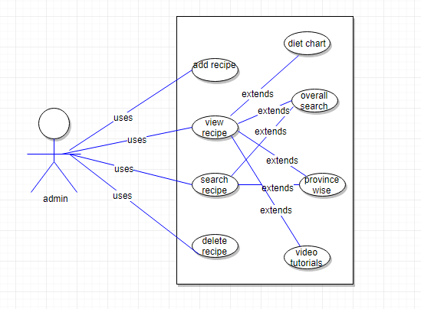
Admin use case diagram

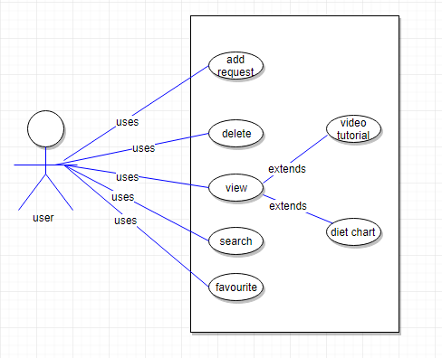
User use case diagram

Figure 1: sample use case diagram

Extended use cases

Use Case ID: | UC-1
Use Case Name: | Login
Created By: | Aliza Fatima  SamiaManzoor |  | Last Updated By:
Date Created: |  |  | Last Revision Date:
Actors: |  | User
Description: |  | User will perform login
Trigger: |  | Sign in button
Preconditions: |  | - Connected to internet  - User must login first  - User must register
Post conditions: |  | - User logged in  - Search recipe  - Add recipe
Normal Flow: |  | - User enter login credentials  - Confirm login  - Open menu  - Search recipe  - Add recipe  - Place order  - Payment
Alternative Flows:  [Alternative Flow 1 – Not in Network] |  | - User register first  - Continue normal flow from 1 to 7
Exceptions: |  | In step 1of normal flow if user enter invalid credentials  - Login is disapproved  - Message to user to re-enter credentials or register first  - User enter correct credentials  - Use case resumes fro step 3 of normal flow
Includes: |  | Includes
Frequency of Use: |  | On demand
Special Requirements: |  | NA
Assumptions: |  | User must connected to internet first  User must be register first
Notes and Issues: |  | NA

Use Case ID: | . UC-2
Use case name | Login
Created By: | SamiaManzoor Aliza Fatima |  | Last Updated By:
Date Created: |  |  | Last Revision Date:
Actors: |  | Admin
Description: |  | - Admin will login to add recipe  - Admin will login to check user record  - Admin will login to update recipe
Trigger: |  | Sign in button
Preconditions: |  | - Admin connected to internet.  - Open Application
Post conditions: |  | - Admin logged in  - Main menu opened  - Add/update recipe
Normal Flow: |  | - Admin enter login credentials  - Conformed login  - Main menu open  - Apply CRUD operation to recipe
Alternative Flows:  [Alternative Flow 1 – Not in Network] |  | NA
Exceptions: |  | In step 1of normal flow if user enter invalid credentials  Login is disapproved  Message to user to re-enter credentials or register first  User enter correct credentials  - Use case resumes from step 3 of normal flow
Includes: |  | Includes
Frequency of Use: |  | On demand
Special Requirements:
Assumptions: |  | User must connected to internet first  User must be register first
Notes and Issues:

Use Case ID: | . UC-3
Use case name | Sign up
Created By: | SamiaManzoor Aliza Fatima |  | Last Updated By:
Date Created: |  |  | Last Revision Date:
Actors: |  | User
Description: |  | User will enter his registration details
Trigger: |  | Sign up button
Preconditions: |  | - Connected to internet  - User must not be registered first
Post conditions: |  | - User logged in  - Search recipe  - Add recipe  - Order  - Save recipe  - Favorite  - Rate app/recipe  - See Diet chart
Normal Flow: |  | - First name  - Last name  - Email  - Password
Alternative Flows:  [Alternative Flow 1 – Not in Network] |  | - User connected to internet first  - Continue normal flow from 12 to 14
Exceptions: |  | In step 1of normal flow if user enter invalid Email  - Signup disapproved  - Invalid email  - Invalid Password
Includes: |  | Includes
Frequency of Use: |  | On demand
Special Requirements:
Assumptions: |  | User must connected to internet first  User must be register first
Notes and Issues:

Use Case ID: | . UC-4
Use case name | Call
Created By: | SamiaManzoor Aliza Fatima |  | Last Updated By:
Date Created: |  |  | Last Revision Date:
Actors: |  | User
Description: |  | - Search the desired recipe and contact the owner.
Trigger: |  | Call button
Preconditions: |  | User should be logged in
Post conditions: |  | Successfully placed the call
Alternative Flows:  [Alternative Flow 1 – Not in Network] |  | - User connected to internet first  - User have credit
Normal Flow |  | - Search recipe  - Select the desired recipe  - Call the recipe owner  - Successfully place the call
Exceptions: |  | NA
Includes: |  | Extends
Frequency of Use: |  | On demand
Special Requirements: |  | NA
Assumptions: |  | User have credit  Successfully placed call
Notes and Issues: |  | NA

Use Case ID: | . UC-5
Use case name | Forget password
Created By: | SamiaManzoor Aliza Fatima |  | Last Updated By:
Date Created: |  |  | Last Revision Date:
Actors: |  | Admin
Description: |  | To set new password
Trigger: |  | Forget password button
Preconditions: |  | User already have a account
Post conditions: |  | Successfully change password
Alternative Flows:  [Alternative Flow 1 – Not in Network] |  | - Already connected to internet  - Continue from 2 to 5
Normal Flow |  | - Connect to internet  - Click forget password  - Enter registered user name  - Enter new password  - Submit
Exceptions: |  | NA
Includes: |  | Includes
Frequency of Use: |  | On demand
Special Requirements: |  | NA
Assumptions: |  | Password successfully changed
Notes and Issues: |  | NA

Use Case ID: | . UC-6
Use case name | Add recipe
Created By: | SamiaManzoor Aliza Fatima |  | Last Updated By:
Date Created: |  |  | Last Revision Date:
Actors: |  | Admin
Description: |  | To add recipe
Trigger: |  | Submit button
Preconditions: |  | Connected to internet  Login to account
Post conditions: |  | Successfully recipe added
Alternative Flows:  [Alternative Flow 1 – Not in Network] |  | - Add recipe  - Chose categorization  - Add description  - Submit recipe
Normal Flow |  | - Connected to internet  - Loged in  - Add recipe  - Chose categorization  - Add description  - Submit recipe
Exceptions: |  | NA
Includes: |  | Includes
Frequency of Use: |  | On demand
Special Requirements: |  | NA
Assumptions: |  | Recipe successfully added
Notes and Issues: |  | NA

Use Case ID: | . UC-7
Use case name | Add recipe
Created By: | SamiaManzoor Aliza Fatima |  | Last Updated By:
Date Created: |  |  | Last Revision Date:
Actors: |  | User
Description: |  | To add recipe
Trigger: |  | Submit button
Preconditions: |  | Connected to internet  Login to account
Post conditions: |  | Successfully recipe added
Alternative Flows:  [Alternative Flow 1 – Not in Network] |  | - Add recipe  - Chose categorization  - Add description  - Submit recipe
Normal Flow |  | - Connected to internet  - Loged in  - Add recipe  - Chose categorization  - Add description  - Submit recipe
Exceptions: |  | NA
Includes: |  | Includes
Frequency of Use: |  | On demand
Special Requirements: |  | NA
Assumptions: |  | Recipe successfully added
Notes and Issues: |  | NA

Use Case ID: | . UC-8
Use case name | Recipe approve
Created By: | SamiaManzoor Aliza Fatima |  | Last Updated By:
Date Created: |  |  | Last Revision Date:
Actors: |  | Admin
Description: |  | To approve recipes
Trigger: |  | Approve button
Preconditions: |  | - Connected to internet  - Login to account  - List of recipes to approve
Post conditions: |  | Successfully recipe approved
Alternative Flows:  [Alternative Flow 1 – Not in Network] |  | - Already connected to internet  - Continue from 8 to 11
Normal Flow |  | - Connect to internet  - Logged in  - Go to approve tab  - Select the recipe to approve  - Click approve button
Exceptions: |  | NA
Includes: |  | Extends
Frequency of Use: |  | On demand
Special Requirements: |  | NA
Assumptions: |  | Recipe successfully approved
Notes and Issues: |  | NA

Use Case ID: | . UC-9
Use case name | Recipe disapprove
Created By: | SamiaManzoor Aliza Fatima |  | Last Updated By:
Date Created: |  |  | Last Revision Date:
Actors: |  | Admin
Description: |  | To disapprove recipes
Trigger: |  | dispprove button
Preconditions: |  | - Connected to internet  - Login to account  - List of recipes to approve
Post conditions: |  | Successfully recipe approved
Alternative Flows:  [Alternative Flow 1 – Not in Network] |  | - Already connected to internet  - Continue normal flow from 2 to 5
Normal Flow |  | - Connect to internet  - Logged in  - Go to approve tab  - Select the recipe to approve  - Click approve button
Exceptions: |  | NA
Includes: |  | Extends
Frequency of Use: |  | On demand
Special Requirements: |  | NA
Assumptions: |  | Recipe successfully disapproved
Notes and Issues: |  | NA

Use Case ID: | . UC-10
Use case name | Search Recipe
Created By: | SamiaManzoor Aliza Fatima |  | Last Updated By:
Date Created: |  |  | Last Revision Date:
Actors: |  | User
Description: |  | To search recipes
Trigger: |  | Search button
Preconditions: |  | - Connected to internet  - Login to account
Post conditions: |  | Successfully recipe found
Alternative Flows:  [Alternative Flow 1 – Not in Network] |  | - Already connected to internet  - Continue normal flow from 2 to 5
Normal Flow |  | - Connect to internet  - Logged in  - Click the search button  - Enter the desired recipe name  - Click the desired recipe from the list
Exceptions: |  | NA
Includes: |  | Includes
Frequency of Use: |  | On demand
Special Requirements: |  | NA
Assumptions: |  | Recipe successfully found
Notes and Issues: |  | NA

Use Case ID: | . UC-11
Use case name | Voice Search Recipe
Created By: | SamiaManzoor Aliza Fatima |  | Last Updated By:
Date Created: |  |  | Last Revision Date:
Actors: |  | User
Description: |  | To search recipes
Trigger: |  | Search button
Preconditions: |  | - Connected to internet  - Login to account
Post conditions: |  | Successfully recipe found
Alternative Flows:  [Alternative Flow 1 – Not in Network] |  | - Already connected to internet  - Continue normal flow from 2 to 5
Normal Flow |  | - Connect to internet  - Logged in  - Click the search button  - Speak the desired recipe name  - Click the desired recipe from the list
Exceptions: |  | NA
Includes: |  | Includes
Frequency of Use: |  | On demand
Special Requirements: |  | NA
Assumptions: |  | Recipe successfully found
Notes and Issues: |  | NA

Use Case ID: | . UC-12
Use case name | Punjab view button
Created By: | SamiaManzoor Aliza Fatima |  | Last Updated By:
Date Created: |  |  | Last Revision Date:
Actors: |  | User
Description: |  | To view Punjab recipes
Trigger: |  | View Punjab recipe button
Preconditions: |  | - Connected to internet  - Login to account  - Click on Punjab recipe category button
Post conditions: |  | Successfully Punjab recipe found
Alternative Flows:  [Alternative Flow 1 – Not in Network] |  | NA
Normal Flow |  | - Connect to internet  - Logged in  - Click the Punjab recipe button  - Search the desired recipe
Exceptions: |  | NA
Includes: |  | Includes
Frequency of Use: |  | On demand
Special Requirements: |  | NA
Assumptions: |  | Punjab Recipe successfully found
Notes and Issues: |  | NA

Use Case ID: | . UC-13
Use case name | Sindh view button
Created By: | SamiaManzoor Aliza Fatima |  | Last Updated By:
Date Created: |  |  | Last Revision Date:
Actors: |  | User
Description: |  | To view Sindh recipes
Trigger: |  | View sindh recipe button
Preconditions: |  | - Connected to internet  - Login to account  - Click on sindh recipe category button
Post conditions: |  | Successfully sindh recipe found
Alternative Flows:  [Alternative Flow 1 – Not in Network] |  | NA
Normal Flow |  | - Connect to internet  - Logged in  - Click the sindh recipe button  - Search the desired recipe
Exceptions: |  | NA
Includes: |  | Includes
Frequency of Use: |  | On demand
Special Requirements: |  | NA
Assumptions: |  | Sindh Recipe successfully found
Notes and Issues: |  | NA

Use Case ID: | . UC-14
Use case name | KPK view button
Created By: | SamiaManzoor Aliza Fatima |  | Last Updated By:
Date Created: |  |  | Last Revision Date:
Actors: |  | User
Description: |  | To view KPK recipes
Trigger: |  | View KPK recipe button
Preconditions: |  | - Connected to internet  - Login to account  - Click on KPK recipe category button
Post conditions: |  | Successfully KPK recipe found
Alternative Flows:  [Alternative Flow 1 – Not in Network] |  | NA
Normal Flow |  | - Connect to internet  - Logged in  - Click the KPK recipe button  - Search the desired recipe
Exceptions: |  | NA
Includes: |  | Includes
Frequency of Use: |  | On demand
Special Requirements: |  | NA
Assumptions: |  | KPK Recipe successfully found
Notes and Issues: |  | NA

Use Case ID: | . UC-15
Use case name | Baluchistan view button
Created By: | SamiaManzoor Aliza Fatima |  | Last Updated By:
Date Created: |  |  | Last Revision Date:
Actors: |  | User
Description: |  | To view Baluchistan recipes
Trigger: |  | View Baluchistan recipe button
Preconditions: |  | - Connected to internet  - Login to account  - Click on Baluchistan recipe category button
Post conditions: |  | Successfully Baluchistan recipe found
Alternative Flows:  [Alternative Flow 1 – Not in Network] |  | NA
Normal Flow |  | - Connect to internet  - Logged in  - Click the Baluchistan recipe button  - Search the desired recipe
Exceptions: |  | NA
Includes: |  | Includes
Frequency of Use: |  | On demand
Special Requirements: |  | NA
Assumptions: |  | Baluchistan Recipe successfully found
Notes and Issues: |  | NA

Use Case ID: | . UC-16
Use case name | Baluchistan add button
Created By: | SamiaManzoor Aliza Fatima |  | Last Updated By:
Date Created: |  |  | Last Revision Date:
Actors: |  | User
Description: |  | To add Baluchistan recipes
Trigger: |  | Add Baluchistan recipe button
Preconditions: |  | - Connected to internet  - Login to account  - Click on Baluchistan recipe category button
Post conditions: |  | Successfully Baluchistan recipe added
Alternative Flows:  [Alternative Flow 1 – Not in Network] |  | NA
Normal Flow |  | - Connect to internet  - Logged in  - Click the Baluchistan recipe button  - Add the desired recipe details
Exceptions: |  | NA
Includes: |  | Includes
Frequency of Use: |  | On demand
Special Requirements: |  | NA
Assumptions: |  | Baluchistan Recipe successfully added
Notes and Issues: |  | NA

Use Case ID: | . UC-17
Use case name | KPK add recipe button
Created By: | SamiaManzoor Aliza Fatima |  | Last Updated By:
Date Created: |  |  | Last Revision Date:
Actors: |  | User
Description: |  | To add KPK recipes
Trigger: |  | Add KPK recipe button
Preconditions: |  | - Connected to internet  - Login to account  - Click on KPK recipe category button
Post conditions: |  | Successfully KPK recipe added
Alternative Flows:  [Alternative Flow 1 – Not in Network] |  | NA
Normal Flow |  | - Connect to internet  - Logged in  - Click the KPK recipe button  - Add the desired recipe details
Exceptions: |  | NA
Includes: |  | Includes
Frequency of Use: |  | On demand
Special Requirements: |  | NA
Assumptions: |  | KPK Recipe successfully added
Notes and Issues: |  | NA

Use Case ID: | . UC-18
Use case name | Sindh add recipe button
Created By: | SamiaManzoor Aliza Fatima |  | Last Updated By:
Date Created: |  |  | Last Revision Date:
Actors: |  | User
Description: |  | To add Sindh recipes
Trigger: |  | Add sindh recipe button
Preconditions: |  | - Connected to internet  - Login to account  - Click on sindh recipe category button
Post conditions: |  | Successfully sindh recipe added
Alternative Flows:  [Alternative Flow 1 – Not in Network] |  | NA
Normal Flow |  | - Connect to internet  - Logged in  - Click the sindh recipe button  - Add the desired recipe details
Exceptions: |  | NA
Includes: |  | Includes
Frequency of Use: |  | On demand
Special Requirements: |  | NA
Assumptions: |  | Sindh Recipe successfully added
Notes and Issues: |  | NA

Use Case ID: | . UC-19
Use case name | Punjab add recipe button
Created By: | SamiaManzoor Aliza Fatima |  | Last Updated By:
Date Created: |  |  | Last Revision Date:
Actors: |  | User
Description: |  | To add Punjab recipes
Trigger: |  | Add Punjab recipe button
Preconditions: |  | - Connected to internet  - Login to account  - Click on Punjab recipe category button
Post conditions: |  | Successfully Punjab recipe added
Alternative Flows:  [Alternative Flow 1 – Not in Network] |  | NA
Normal Flow |  | - Connect to internet  - Logged in  - Click the Punjab recipe button  - Add the desired recipe details
Exceptions: |  | NA
Includes: |  | Includes
Frequency of Use: |  | On demand
Special Requirements: |  | NA
Assumptions: |  | Punjab Recipe successfully added
Notes and Issues: |  | NA

Use Case ID: | . UC-20
Use case name | Forget password
Created By: | SamiaManzoor Aliza Fatima |  | Last Updated By:
Date Created: |  |  | Last Revision Date:
Actors: |  | User
Description: |  | To rest password
Trigger: |  | Forget password button
Preconditions: |  | - Connected to internet  - Account already exist
Post conditions: |  | Successfully password changed
Alternative Flows:  [Alternative Flow 1 – Not in Network] |  | NA
Normal Flow |  | - Connect to internet  - Open application  - Click on forget pass button
Exceptions: |  | NA
Includes: |  | Includes
Frequency of Use: |  | On demand
Special Requirements: |  | NA
Assumptions: |  | Password successfully changed
Notes and Issues: |  | NA

Use Case ID: | . UC-21
Use case name | View diet chart button
Created By: | SamiaManzoor Aliza Fatima |  | Last Updated By:
Date Created: |  |  | Last Revision Date:
Actors: |  | User
Description: |  | To view the diet charts
Trigger: |  | Diet chart button
Preconditions: |  | - Connected to internet  - Logged in  - Click on diet chart button
Post conditions: |  | Successfully viewed the diet chart
Alternative Flows:  [Alternative Flow 1 – Not in Network] |  | NA
Normal Flow |  | - Connect to internet.  - Enter Email and Password for login.  - After successfully login click the diet chart button.  - View the diet chart plans
Exceptions: |  | NA
Includes: |  | Includes
Frequency of Use: |  | On demand
Special Requirements: |  | NA
Assumptions: |  | successfully diet plans viewed
Notes and Issues: |  | NA

Use Case ID: | . UC-22
Use case name | View diet chart button
Created By: | SamiaManzoor Aliza Fatima |  | Last Updated By:
Date Created: |  |  | Last Revision Date:
Actors: |  | Admin
Description: |  | To view the diet charts
Trigger: |  | Diet chart button
Preconditions: |  | - Connected to internet  - Logged in  - Click on diet chart button
Post conditions: |  | Successfully viewed the diet chart
Alternative Flows:  [Alternative Flow 1 – Not in Network] |  | NA
Normal Flow |  | - Connect to internet.  - Enter Email and Password for login.  - After successfully login click the diet chart button.  - View the diet chart plans
Exceptions: |  | NA
Includes: |  | Includes
Frequency of Use: |  | On demand
Special Requirements: |  | NA
Assumptions: |  | successfully diet plans viewed
Notes and Issues: |  | NA

Use Case ID: | . UC-23
Use case name | Add diet chart button
Created By: | SamiaManzoor Aliza Fatima |  | Last Updated By:
Date Created: |  |  | Last Revision Date:
Actors: |  | Admin
Description: |  | To add the diet charts
Trigger: |  | Diet chart button
Preconditions: |  | - Connected to internet  - Open Application  - Logged in
Post conditions: |  | Successfully viewed the diet chart
Alternative Flows:  [Alternative Flow 1 – Not in Network] |  | NA
Normal Flow |  | - Connect to internet.  - Enter Email and Password for login.  - After successfully login click the add diet chart button  - Enter details for diet.  - Click add to add diet plans in diet chart
Exceptions: |  | NA
Includes: |  | Includes
Frequency of Use: |  | On demand
Special Requirements: |  | NA
Assumptions: |  | successfully diet plans added
Notes and Issues: |  | NA

Use Case ID: | . UC-24
Use case name | Baluchistan edit button
Created By: | SamiaManzoor Aliza Fatima |  | Last Updated By:
Date Created: |  |  | Last Revision Date:
Actors: |  | Admin
Description: |  | To edit Baluchistan recipes
Trigger: |  | edit Baluchistan recipe button
Preconditions: |  | - Connected to internet  - Login to account  - Click on Baluchistan recipe category button  - Edit the recipe
Post conditions: |  | Successfully Baluchistan recipe edited
Alternative Flows:  [Alternative Flow 1 – Not in Network] |  | NA
Normal Flow |  | - Connect to internet  - Open Application  - Enter email password for login  - Go to Baluchistan category button  - Edit the desired recipe from this category
Exceptions: |  | NA
Includes: |  | Includes
Frequency of Use: |  | On demand
Special Requirements: |  | NA
Assumptions: |  | Baluchistan Recipe successfully edited
Notes and Issues: |  | NA

Use Case ID: | . UC-25
Use case name | KPK edit recipe button
Created By: | SamiaManzoor Aliza Fatima |  | Last Updated By:
Date Created: |  |  | Last Revision Date:
Actors: |  | Admin
Description: |  | To edit KPK recipes
Trigger: |  | edit KPK recipe button
Preconditions: |  | - Connected to internet  - Login to account  - Click on KPK recipe category button  - Edit recipe
Post conditions: |  | Successfully KPK recipe edited
Alternative Flows:  [Alternative Flow 1 – Not in Network] |  | NA
Normal Flow |  | - Connect to internet  - Open Application  - Enter email password for login  - Go to Baluchistan category button  - Edit the desired recipe from this category
Exceptions: |  | NA
Includes: |  | Includes
Frequency of Use: |  | On demand
Special Requirements: |  | NA
Assumptions: |  | KPK Recipe successfully edited
Notes and Issues: |  | NA

Use Case ID: | . UC-26
Use case name | Sindh edit recipe button
Created By: | SamiaManzoor Aliza Fatima |  | Last Updated By:
Date Created: |  |  | Last Revision Date:
Actors: |  | Admin
Description: |  | To edit Sindh recipes
Trigger: |  | Edit sindh recipe button
Preconditions: |  | - Connected to internet  - Login to account  - Click on sindh recipe category button
Post conditions: |  | Successfully sindh recipe edited
Alternative Flows:  [Alternative Flow 1 – Not in Network] |  | NA
Normal Flow |  | - Connect to internet  - Open Application  - Enter email password for login  - Go to Baluchistan category button  - Edit the desired recipe from this category
Exceptions: |  | NA
Includes: |  | Includes
Frequency of Use: |  | On demand
Special Requirements: |  | NA
Assumptions: |  | Sindh Recipe successfully edited
Notes and Issues: |  | NA

Use Case ID: | . UC-27
Use case name | Punjab edit recipe button
Created By: | SamiaManzoor Aliza Fatima |  | Last Updated By:
Date Created: |  |  | Last Revision Date:
Actors: |  | Admin
Description: |  | To edit Punjab recipes
Trigger: |  | edit Punjab recipe button
Preconditions: |  | - Connected to internet  - Login to account  - Click on Punjab recipe category button
Post conditions: |  | Successfully Punjab recipe edited
Alternative Flows:  [Alternative Flow 1 – Not in Network] |  | NA
Normal Flow |  | - Connect to internet  - Open Application  - Enter email password for login  - Go to Baluchistan category button  - Edit the desired recipe from this category
Exceptions: |  | NA
Includes: |  | Includes
Frequency of Use: |  | On demand
Special Requirements: |  | NA
Assumptions: |  | Punjab Recipe successfully edited
Notes and Issues: |  | NA

User interfaces (mock screens):
P-1
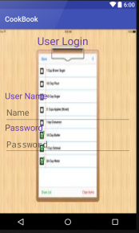
User login

P-2
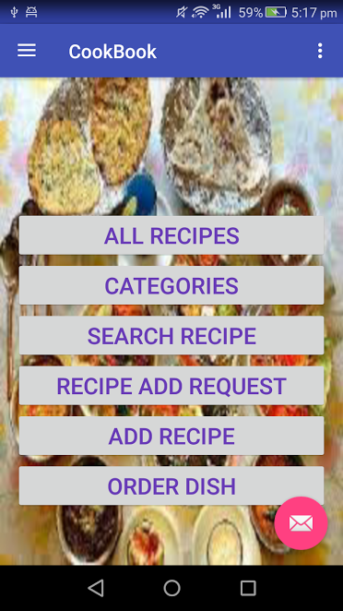
Dashboard

P-3

Search recipe
P-4
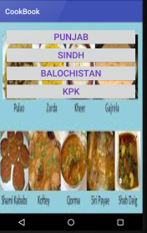\
Province wise
P-5
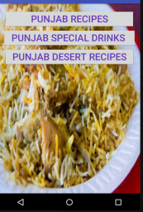
Punjab recipe
P-6
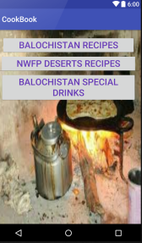
Blochistan Recipe
P-7
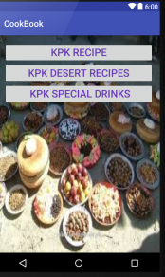
KPK Recipe
P-8
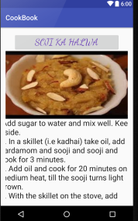
Punjab Desert Recipe
P-9
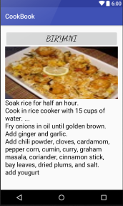
Punjab Recipe
P-10
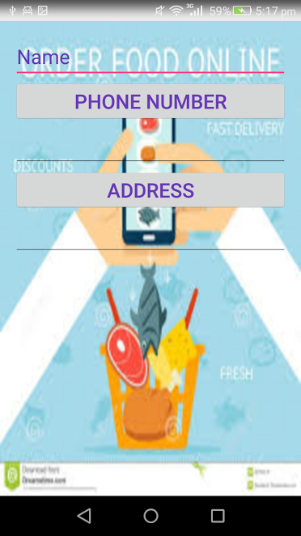
Registration Form

Data flow diagram (optional)

Data Flow Diagram Level 0
DFD level 0A:
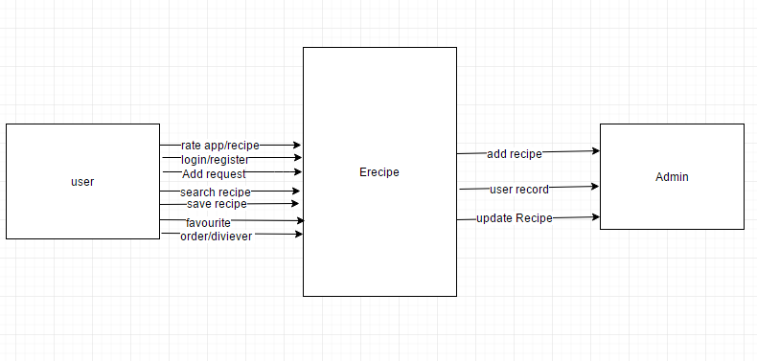
DFD level 0B:
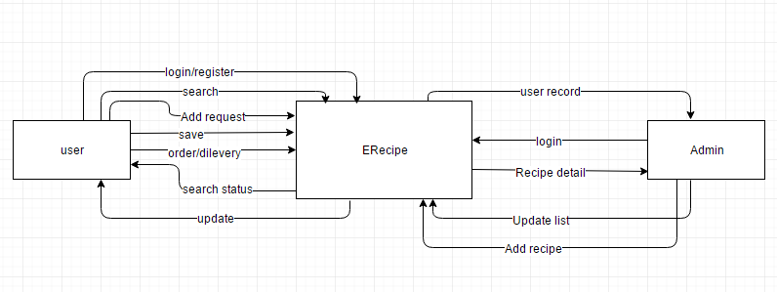

Data Flow Diagram Level 1
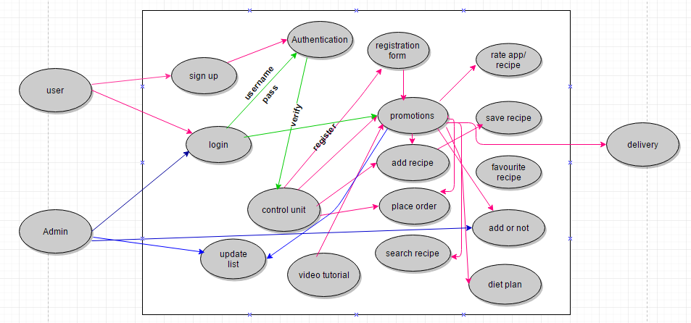

Data Flow Diagram Level 2

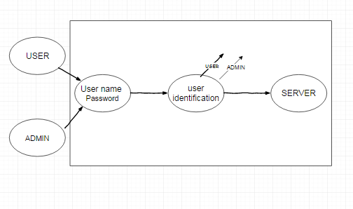
Control unit
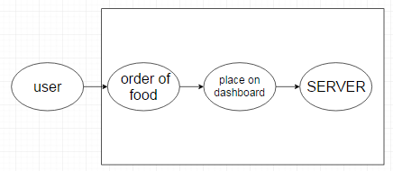
Order Food

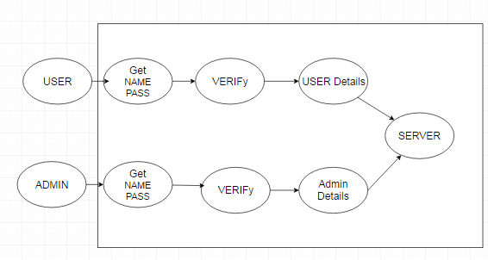
User login
s
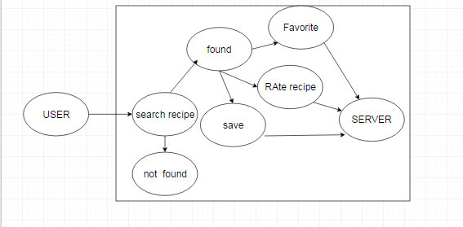
Other operations
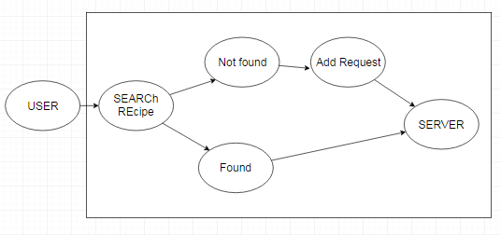
Search Recipe
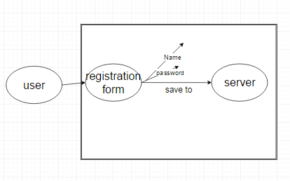
Registration

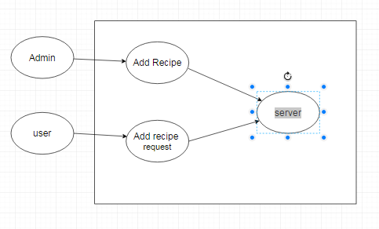
Add recipe

System Design

System Architecture Diagram
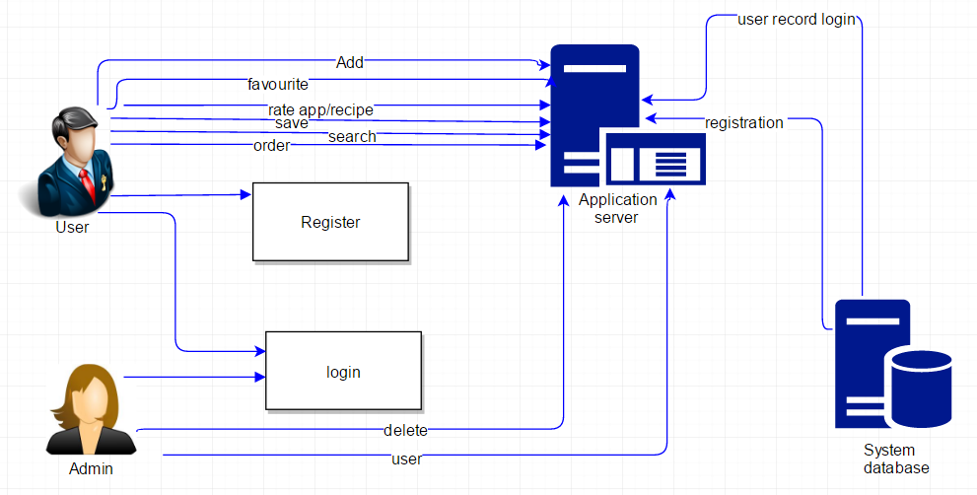
Figure 2: System Architecture

Class Diagram
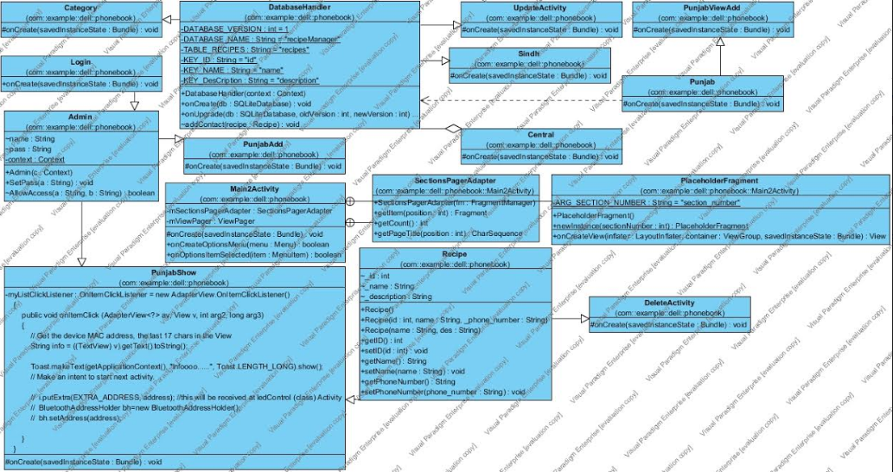

Sequence Diagrams
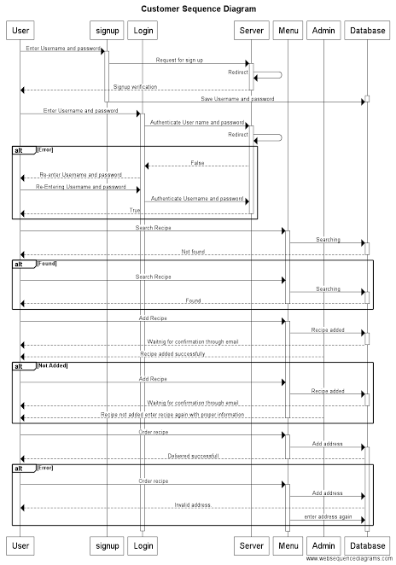

Collaboration Diagrams
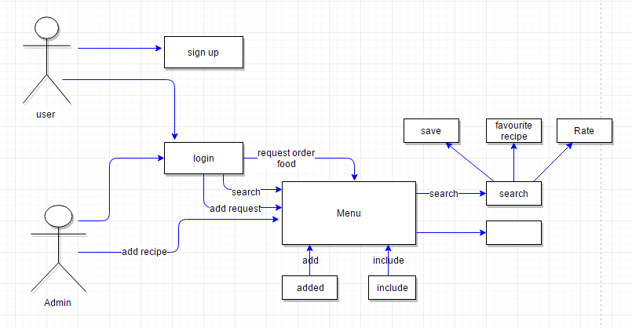

Other UMLs
None

ERD
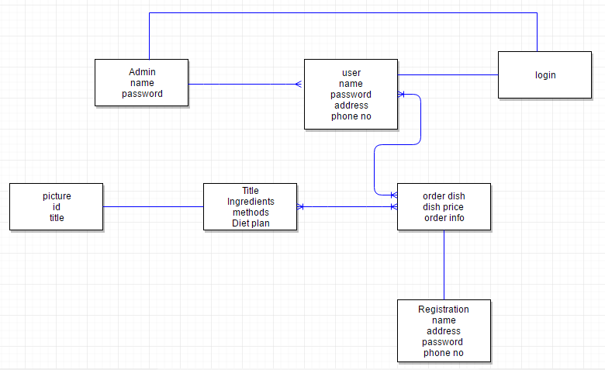

Data Dictionary

Element Name | Type | Validation | Mandatory | Remarks
Add recipe | submit | yes | yes | User/admin will use this button to add recipe
delete | delete | yes | yes | Admin will delete a recipe if not correct
view | view | yes | yes | Admin/user will use this button to view recipe
approve | approval | yes | yes | Admin will approve the recipe if correct
disapprove | disapproval | yes | yes | Admin will disapprove the recipe

Implementation details

Development Setup
Android studio
Java for coding
SQl lite for the database
Android studio version
Web server database

Deployment setup
After completing our project we will upload on Google play store

Algorithms
Step 1: Start
Step 2: Create Objects of Edit Text, Button
Step 3: Create Boolean Variable found
Step 4: Create Object of Database Handler
Step 5: Set Click Listener on Button
Step 6: If found
Get text from field
Call the DB function delete and pass into it
Update the TextField
Call intent to Previous Activity
Else
Not Found
Step 7: Stop

Constraints

Assumptions
- No real database
- Database is maintained by only admin not the customer
- Fields are properly filled when you login to your account for adding the recipe purpose

System constraints
- Recipe is only added when admin approves the recipe
- System will not allow user to create multiple account with same name
- There is no web order
- It is not a desktop application
- Internet is required

Restrictions

Limitations
- No direct communication through our app between customers to customer
- No direct Delivery is done through our app two users will communicate for this purpose
- Only Pakistani cuisine is targeted

Testing

Extended Test Cases

Test case Id:1 |  |  |  | Test Design by:Aliza Fatima
Test model name: login button on mobile application |  |  |  | Test design date: 7/19/2017
Test priority: High |  |  |  | Test Executed by: Samia Manzoor
Test title/name: to test the login button |  |  |  | Test Executed date: 8/19/2017
Description: test the login button in mobile applications
Pre-conditions:Application should be installed on the mobile and working properly, and user must have account already in the application.
Dependencies:
step | Test step | Test data | Expected result |  | Actual  result | Status (pass/fail) | Notes
1 | Run the application |  | Application Run |  | Application Run | Pass
2 | Click to login button
3 | Fill the login details | Name: hina  Password:hina | Text field filled |  | Text field filled | pass
4 | Click on login button |  | User login to their account |  | User successfully login to their account
Post condition: user/admin can access its account.

Test case Id:2 |  |  |  | Test Design by: Aliza Fatima
Test model name: signup button on android application |  |  |  | Test design date:7/19/2017
Test priority: High |  |  |  | Test Executed by: Samia Manzoor
Test title/name: to test the signup button |  |  |  | Test Executed date:8/19/2017
Description: test the signup button in mobile applications
Pre-conditions: Application should be installed in mobile and in proper running form.
Dependencies:
step | Test step | Test data | Expected result |  | Actual  result | Status (pass/fail) | Notes
1 | Run the application |  | Application Run |  | Application Run | Pass
2 | Enter user name and password | Username: aiza  Password: aiza | Text field filled |  | Text field filled | Pass
3 | Click on signup button |  | Successfully signup |  | Successfully signup | pass
Post condition: The user have new account on application and signed in.

Test case Id: 3 |  |  |  | Test Design by: Aliza Fatima
Test model name: forget password button on android application |  |  |  | Test design date: 7/19/2017
Test priority: High |  |  |  | Test Executed by: Samia Manzoor
Test title/name: to test the forget password button |  |  |  | Test Executed date: 8/19/2017
Description: test the forget password button in mobile applications
Pre-conditions: Application should be installed in mobile and in proper running form, and should have account already in the app.
Dependencies:
step | Test step | Test data | Expected result |  | Actual  result | Status (pass/fail) | Notes
1 | Run the application |  | Application Run |  | Application Run | Pass
2 | Enter user name and password | Username: hina | Text field filled |  | Text field filled | Pass
3 | Click on the forget password button |  | Successfully recovered |  | Successfully recovered | pass
Post condition: The user/admin have new account on application and signed in.

Test case Id: 4 |  |  |  | Test Design by: Aliza Fatima
Test model name: call button on android application |  |  |  | Test design date: 7/19/2017
Test priority: medium |  |  |  | Test Executed by: Samia Manzoor
Test title/name: to test the call button |  |  |  | Test Executed date: 8/19/2017
Description: test the call button in mobile applications
Pre-conditions: user must login the application, and main menu should be working.
Dependencies:
step | Test step | Test data | Expected result |  | Actual  result | Status (pass/fail) | Notes
1 | Press call button |  | Dial pad open with number |  | Dial pad open with number | pass
Post condition: user can access his order details

Test case Id: 5 |  |  |  | Test Design by: Aliza Fatima
Test model name: Add recipe button on android application |  |  |  | Test design date: 7/19/2017
Test priority: high |  |  |  | Test Executed by: Samia Manzoor
Test title/name: to test the add recipe button |  |  |  | Test Executed date: 8/19/2017
Description: test the add recipe button in mobile applications
Pre-conditions: user must login the application, and main menu should be working and connected to internet.
Dependencies:
step | Test step | Test data | Expected result |  | Actual  result | Status (pass/fail) | Notes
1 | User must be login |  | User login |  | User login | pass
2
Post condition: user can add recipe successfully.

Test case Id: 6 |  |  |  | Test Design by: Aliza Fatima
Test model name: view recipe button on android application |  |  |  | Test design date: 7/19/2017
Test priority: high |  |  |  | Test Executed by: Samia Manzoor
Test title/name: to test the view recipe button |  |  |  | Test Executed date: 8/19/2017
Description: test the view recipe button in mobile applications
Pre-conditions: user must login the application, and main menu should be working and connected to internet.
Dependencies:
step | Test step | Test data | Expected result |  | Actual  result | Status (pass/fail) | Notes
1 | Click view button |  | Recipe would be viewed |  | Recipe would be viewed | Pass
Post condition: user can view recipe successfully.

Test case Id: 7 |  |  |  | Test Design by: Aliza Fatima
Test model name: favorite recipe button on android application |  |  |  | Test design date: 7/19/2017
Test priority: medium |  |  |  | Test Executed by: Samia Manzoor
Test title/name: to test the favorite recipe button |  |  |  | Test Executed date: 8/19/2017
Description: test the favorite recipe button in mobile applications
Pre-conditions: user must login the application, and main menu should be working and connected to internet.
Dependencies:
step | Test step | Test data | Expected result |  | Actual  result | Status (pass/fail) | Notes
1 | Click on favorite button. |  | Recipe added to favorites |  | Recipe added to favorites | Pass
Post condition: user can favorite recipe successfully.

Test case Id: 8 |  |  |  | Test Design by: Aliza Fatima
Test model name: submit recipebutton on android application |  |  |  | Test design date: 7/19/2017
Test priority: high |  |  |  | Test Executed by: Samia Manzoor
Test title/name: to test the submit recipe button |  |  |  | Test Executed date: 8/19/2017
Description: test the submit recipe button in mobile applications
Pre-conditions: user must login the application, and main menu should be working and connected to internet.
Dependencies:
step | Test step | Test data | Expected result |  | Actual  result | Status (pass/fail) | Notes
1 | All text fields are filled properly |  | Text fields are properly filled |  | Text fields are properly filled | pass
Post condition: user can submit recipe successfully.

Test case Id:9 |  |  |  | Test Design by: Aliza Fatima
Test model name: search recipebutton on android application |  |  |  | Test design date: 7/19/2017
Test priority: high |  |  |  | Test Executed by: Samia Manzoor
Test title/name: to test the search recipe button |  |  |  | Test Executed date: 8/19/2017
Description: test the search recipe button in mobile applications
Pre-conditions: user must login the application, and main menu should be working and connected to internet.
Dependencies:
step | Test step | Test data | Expected result |  | Actual  result | Status (pass/fail) | Notes
1 | Enter recipe name |  | Recipe found |  | Recipe found | pass
Post condition: user can search recipe successfully.

Test case Id:10 |  |  |  | Test Design by: Aliza Fatima
Test model name: voice search recipebutton on android application |  |  |  | Test design date: 7/19/2017
Test priority: medium |  |  |  | Test Executed by: Samia Manzoor
Test title/name: to test the voice search recipe button |  |  |  | Test Executed date: 8/19/2017
Description: test the voicesearch recipe button in mobile applications
Pre-conditions: user must login the application, and main menu should be working and connected to internet.
Dependencies:
step | Test step | Test data | Expected result |  | Actual  result | Status (pass/fail) | Notes
1 | Enter recipe name (voice) |  | Recipe found |  | Recipe found | pass
Post condition: user can search recipe successfully.

Test case Id:11 |  |  |  | Test Design by: Aliza Fatima
Test model name: approve recipebutton on android application |  |  |  | Test design date: 7/19/2017
Test priority: high |  |  |  | Test Executed by: Samia Manzoor
Test title/name: to test the approve recipe button |  |  |  | Test Executed date: 8/19/2017
Description: test the approve recipe button in mobile applications
Pre-conditions: user must login the application, and main menu should be working and connected to internet.
Dependencies:
step | Test step | Test data | Expected result |  | Actual  result | Status (pass/fail) | Notes
1 | Admin login |  | Admin login successfully |  | Admin login successfully | pass
2 | Check recipe which has to be approved |  | Recipe approved |  | Recipe approved | Pass
Post condition: admin can approve recipe successfully.

Test case Id:12 |  |  |  | Test Design by: Aliza Fatima
Test model name: disapprove recipebutton on android application |  |  |  | Test design date: 7/19/2017
Test priority: high |  |  |  | Test Executed by: Samia Manzoor
Test title/name: to test the disapprove recipe button |  |  |  | Test Executed date: 8/19/2017
Description: test the disapprove recipe button in mobile applications
Pre-conditions: user must login the application, and main menu should be working and connected to internet.
Dependencies:
step | Test step | Test data | Expected result |  | Actual  result | Status (pass/fail) | Notes
1 | Admin login |  | Admin login successfully |  | Admin login successfully | pass
2 | Check recipe which has to be disapproved |  | Recipe disapproved |  | Recipe disapproved | Pass
Post condition: admin can disapprove recipe successfully.

Test case Id:13 |  |  |  | Test Design by: Aliza Fatima
Test model name: KPKview button on android application |  |  |  | Test design date: 7/19/2017
Test priority: medium |  |  |  | Test Executed by: Samia Manzoor
Test title/name: to test the KPK view button |  |  |  | Test Executed date: 8/19/2017
Description: test the KPK view button in mobile applications
Pre-conditions: user must login the application, and main menu should be working and connected to internet.
Dependencies:
step | Test step | Test data | Expected result |  | Actual  result | Status (pass/fail) | Notes
1 | Click on KPK view button |  | Recipe is viewed |  | Recipe is viewed | pass
Post condition: user can view KPK recipe successfully.

Test case Id: 14 |  |  |  | Test Design by: Aliza Fatima
Test model name: Punjab viewbutton on android application |  |  |  | Test design date: 7/19/2017
Test priority: medium |  |  |  | Test Executed by: Samia Manzoor
Test title/name: to test the Punjab view button |  |  |  | Test Executed date: 8/19/2017
Description: test the Punjab view button in mobile applications
Pre-conditions: user must login the application, and main menu should be working and connected to internet.
Dependencies:
step | Test step | Test data | Expected result |  | Actual  result | Status (pass/fail) | Notes
1 | Click on Punjab view button |  | Recipe is viewed |  | Recipe is viewed | pass
Post condition: user can view punjab recipe successfully.

Test case Id: 15 |  |  |  | Test Design by: Aliza Fatima
Test model name: Sindh viewbutton on android application |  |  |  | Test design date: 7/19/2017
Test priority: medium |  |  |  | Test Executed by: Samia Manzoor
Test title/name: to test the Sindh view button |  |  |  | Test Executed date: 8/19/2017
Description: test the Sindh view button in mobile applications
Pre-conditions: user must login the application, and main menu should be working and connected to internet.
Dependencies:
step | Test step | Test data | Expected result |  | Actual  result | Status (pass/fail) | Notes
1 | Click on Sindh view button |  | Recipe is viewed |  | Recipe is viewed | pass
Post condition: user can view sindh recipe successfully.

Test case Id: 16 |  |  |  | Test Design by: Aliza Fatima
Test model name: Baluchistan viewbutton on android application |  |  |  | Test design date: 7/19/2017
Test priority: medium |  |  |  | Test Executed by: Samia Manzoor
Test title/name: to test the Baluchistan view button |  |  |  | Test Executed date: 8/19/2017
Description: test the Baluchistan view button in mobile applications
Pre-conditions: user must login the application, and main menu should be working and connected to internet.
Dependencies:
step | Test step | Test data | Expected result |  | Actual  result | Status (pass/fail) | Notes
1 | Click on Baluchistan view button |  | Recipe is viewed |  | Recipe is viewed | pass
Post condition: user can view Baluchistan recipe successfully.

Test case Id: 17 |  |  |  | Test Design by: Aliza Fatima
Test model name: KPKrecipe add button on android application |  |  |  | Test design date: 7/19/2017
Test priority: medium |  |  |  | Test Executed by: Samia Manzoor
Test title/name: to test the KPK recipe add button |  |  |  | Test Executed date: 8/19/2017
Description: test the KPK recipe add in mobile applications
Pre-conditions: user must login the application, and main menu should be working and connected to internet.
Dependencies:
step | Test step | Test data | Expected result |  | Actual  result | Status (pass/fail) | Notes
1 | Click on KPK recipe add button |  | Recipe is added |  | Recipe is added | pass
Post condition: user can add KPK recipe successfully.

Test case Id: 18 |  |  |  | Test Design by: Aliza Fatima
Test model name: Punjab Recipe addbutton on android application |  |  |  | Test design date: 7/19/2017
Test priority: medium |  |  |  | Test Executed by: Samia Manzoor
Test title/name: to test the Punjab Recipe add button |  |  |  | Test Executed date: 8/19/2017
Description: test the Punjab Recipe add button in mobile applications
Pre-conditions: user must login the application, and main menu should be working and connected to internet.
Dependencies:
step | Test step | Test data | Expected result |  | Actual  result | Status (pass/fail) | Notes
1 | Click on Punjab Recipe add button |  | Recipe is added |  | Recipe is added | pass
Post condition: user can add punjab recipe successfully.

Test case Id: 19 |  |  |  | Test Design by: Aliza Fatima
Test model name: Sindh recipe addbutton on android application |  |  |  | Test design date: 7/19/2017
Test priority: medium |  |  |  | Test Executed by: Samia Manzoor
Test title/name: to test the Sindh recipe add button |  |  |  | Test Executed date: 8/19/2017
Description: test the Sindh recipe add button in mobile applications
Pre-conditions: user must login the application, and main menu should be working and connected to internet.
Dependencies:
step | Test step | Test data | Expected result |  | Actual  result | Status (pass/fail) | Notes
1 | Click on Sindh recipe add button |  | Recipe is added |  | Recipe is added | pass
Post condition: user can add sindh recipe successfully.

Test case Id: 20 |  |  |  | Test Design by: Aliza Fatima
Test model name: Baluchistan addedbutton on android application |  |  |  | Test design date: 7/19/2017
Test priority: medium |  |  |  | Test Executed by: Samia Manzoor
Test title/name: to test the Baluchistan view button |  |  |  | Test Executed date: 8/19/2017
Description: test the Baluchistan add button in mobile applications
Pre-conditions: user must login the application, and main menu should be working and connected to internet.
Dependencies:
step | Test step | Test data | Expected result |  | Actual  result | Status (pass/fail) | Notes
1 | Click on Baluchistan add button |  | Recipe is added |  | Recipe is added | pass
Post condition: user/dmin can add Baluchistan recipe successfully.

Test case Id:21 |  |  |  | Test Design by: Aliza Fatima
Test model name: KPKrecipe edit button on android application |  |  |  | Test design date: 7/19/2017
Test priority: high |  |  |  | Test Executed by: Samia Manzoor
Test title/name: to test the KPK recipe edit button |  |  |  | Test Executed date: 8/19/2017
Description: test the KPK recipe edit in mobile applications
Pre-conditions: admin must login the application, and main menu should be working and connected to internet.
Dependencies:
step | Test step | Test data | Expected result |  | Actual  result | Status (pass/fail) | Notes
1 | Click on KPK recipe edit button |  | Recipe is a edit ed |  | Recipe is edit ed | pass
Post condition: admin can edited KPK recipe successfully.

Test case Id: 22 |  |  |  | Test Design by: Aliza Fatima
Test model name: Punjab Recipe editbutton on android application |  |  |  | Test design date: 7/19/2017
Test priority: high |  |  |  | Test Executed by: Samia Manzoor
Test title/name: to test the Punjab Recipe edit button |  |  |  | Test Executed date: 8/19/2017
Description: test the Punjab Recipe edit button in mobile applications
Pre-conditions: admin must login the application, and main menu should be working and connected to internet.
Dependencies:
step | Test step | Test data | Expected result |  | Actual  result | Status (pass/fail) | Notes
1 | Click on Punjab Recipe edit button |  | Recipe is edit ed |  | Recipe is edit ed | pass
Post condition: admin can edit punjab recipe successfully.

Test case Id: 23 |  |  |  | Test Design by: Aliza Fatima
Test model name: Sindh recipe editbutton on android application |  |  |  | Test design date: 7/19/2017
Test priority: high |  |  |  | Test Executed by: Samia Manzoor
Test title/name: to test the Sindh recipe a edit button |  |  |  | Test Executed date: 8/19/2017
Description: test the Sindh recipe edit button in mobile applications
Pre-conditions: admin must login the application, and main menu should be working and connected to internet.
Dependencies:
step | Test step | Test data | Expected result |  | Actual  result | Status (pass/fail) | Notes
1 | Click on Sindh recipe edit button |  | Recipe is edit ed |  | Recipe is edit ed | pass
Post condition: admin can edit sindh recipe successfully.

Test case Id: 24 |  |  |  | Test Design by: Aliza Fatima
Test model name: Baluchistan editbutton on android application |  |  |  | Test design date: 7/19/2017
Test priority: high |  |  |  | Test Executed by: Samia Manzoor
Test title/name: to test the Baluchistan edit button |  |  |  | Test Executed date: 8/19/2017
Description: test the Baluchistan edit button in mobile applications
Pre-conditions: admin must login the application, and main menu should be working and connected to internet.
Dependencies:
step | Test step | Test data | Expected result |  | Actual  result | Status (pass/fail) | Notes
1 | Click on Baluchistan edit button |  | Recipe is viewed |  | Recipe is viewed | pass
Post condition: admin can edit Baluchistan recipe successfully.

Test case Id: 25 |  |  |  | Test Design by: Aliza Fatima
Test model name: Diet chart viewbutton on android application |  |  |  | Test design date: 7/19/2017
Test priority: high |  |  |  | Test Executed by: Samia Manzoor
Test title/name: to test the Diet chart view button |  |  |  | Test Executed date: 8/19/2017
Description: test the Diet chart viewbutton in mobile applications
Pre-conditions: admin must login the application, and main menu should be working and connected to internet.
Dependencies:
step | Test step | Test data | Expected result |  | Actual  result | Status (pass/fail) | Notes
1 | Click on Diet chart view button |  | Diet chart is viewed |  | Diet chart is viewed | pass
Post condition: user/ admin can view diet chart successfully.

Test case Id: 26 |  |  |  | Test Design by: Aliza Fatima
Test model name: Diet chart addbutton on android application |  |  |  | Test design date: 7/19/2017
Test priority: high |  |  |  | Test Executed by: Samia Manzoor
Test title/name: to test the Diet chart add button |  |  |  | Test Executed date: 8/19/2017
Description: test the Diet chart add button in mobile applications
Pre-conditions: admin must login the application, and main menu should be working and connected to internet.
Dependencies:
step | Test step | Test data | Expected result | Actual  result | Status (pass/fail) | Notes
1 | Click on Diet chart add button |  | Diet chart is added | Diet chart is added | pass
Post condition: admin can add diet chart successfully

Decision Table

Code snippet
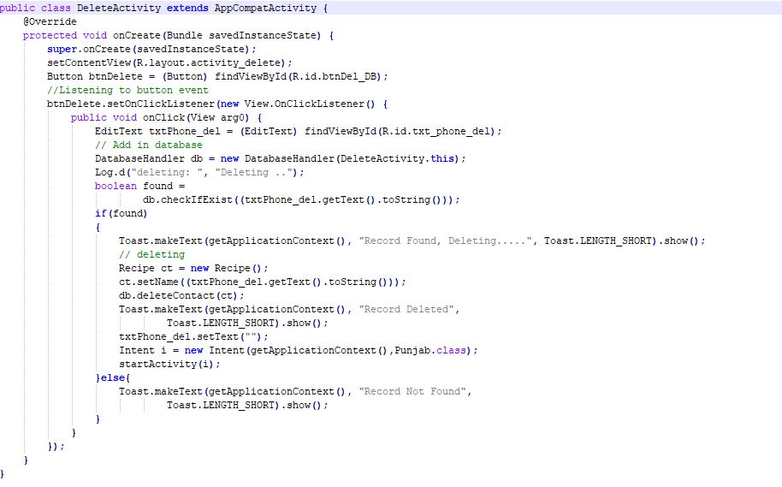

Traceability Matrix

RID vs UCID (requirements vs use cases)
UCID/RID | R  1.1 | R  1.2 | R  1.3 | R  1.4 | R  1.5 | R  1.6 | R  1.7 | R  1.8 | R  1.9 | R  1.10 | R  1.11 | R  1.12 | R  2.1 | R  2.2 | R  2.3 | R  2.4 | R  2.5 | R  2.6 | R  2.7 | R  2.8 | R  2.9 | R  3.1 | R  3.2 | R  3.3 | R  3.4 | R  3.5 | R  3.6 | R  3.7
UC 1
UC 2
UC 3
UC 4
UC 5
UC 6
UC 7
UC 8
UC 9
UC 10
UC 11
UC 12
UC 19
UC 20
UC 21
UC 22
UC 23
UC 24
UC 25
UC 26
UC 27
UC
28

Prototypes (RID vs PID)
PID/RID | R  1.1 | R  1.2 | R  1.3 | R  1.4 | R  1.5 | R  1.6 | R  1.7 | R  1.8 | R  1.9 | R  1.10 | R  1.11 | R  1.12 | R  2.1 | R  2.2 | R  2.3 | R  2.4 | R  2.5 | R  2.6 | R  2.7 | R  2.8 | R  2.9 | R  3.1 | R  3.2 | R  3.3 | R  3.4 | R  3.5 | R  3.6
P1
p2
p3
p4
p5
p6
p7
p8
p9
p10
P 11

Test Cases (RID vs TID)
TID/RID | R  1.1 | R  1.2 | R  1.3 | R  1.4 | R  1.5 | R  1.6 | R  1.7 | R  1.8 | R  1.9 | R  1.10 | R  1.11 | R  1.12 | R  2.1 | R  2.2 | R  2.3 | R  2.4 | R  2.5 | R  2.6 | R  2.7 | R  2.8 | R  2.9 | R  3.1 | R  3.2 | R  3.3 | R  3.4 | R  3.5 | R 3.6 | R3.7
T
1
T2
T3
T4
T 5
T 6
T 7
T 8
T 9
T 10
T 11
T 12
T 13
T14
T15
T16
T17
T18
T19
T20
T21
T22
T23
T24
T25
T26

Coverage (UCID vs TID)
UCID/TID | T1 | T2 | T3 | T4 | T5 | T6 | T7 | T8 | T 9 | T10 | T.11 | T12 | T13 | T1.4 | T1.5 | T1.6 | T1.7 | T1.8 | T1.9 | T2.0 | T2.1 | T2.2 | T2.3 | T2.4 | T2.  5 | T  2.  6
UC1
UC2
UC3
UC4
UC5
UC6
UC7
UC8
UC9
UC10
UC11
UC12
UC13
UC14
UC15
UC16
UC17
UC18
UC19
UC20
UC21
UC22
UC23
UC24
UC25
UC26
UC27

Results/Output/Statistics

%completion
Our project is 93% complete

%accuracy
Our project is 94% accurate

%correctness
Our project is 92% correct

Conclusion
As we are hostilities and we faced many problems related to food, Sometimes it was due to timing or sometimes due to taste, life becomes so busy that its not possible if we wanted to take proper classes to learn how to cook food. So this was reason that we decided to make an Application in which we can resolve both the problems. ERecipe is also providing a platform for those women who wants to earn money without going outside. So we succeeded in achieving our aim. This project is led by Mr. Muhammad Nabeel. We learned a lot during this time period. For example, we deeply explored MySQL with android. Which is amazing experience for us
Thanks to our advisor who helped us in achieving this project and our team who worked together to successfully complete this project.

Future work
In future we planned to collaborate with some restaurants that they can use our application for delivery purpose either its about the delivery of all recipes that includes in our recipe book or some other recipes that they added and want to sale.

Bibliography

Articles
- https://dev.mysql.com/doc/connector-net/en/connector-net-tutorials-sql-command.html
- https://www.zaiqa.com/recipes/chef-zakir/

Other References
- https://stackoverflow.com/

Appendix

Glossary of terms

Pre-requisites
- Android
- Internet connection
- Supported kitkat 4.4.2 or above

