
Overprotective Parenting, Identity, and Assertiveness in University Students

Participant Name: Ayesha
Participant ID: F2019381145

Supervisor’s Name: Ms. Asma Ijaz

--------

Department of Clinical Psychology
School of Professional Psychology

University of Management and Technology
Lahore
2023

DECLARATION
I, Ms. Ayesha, ID: F2019381145, BS Clinical Psychology student session 2019-2023, hereby declare that the information contained in the thesis titled "Overprotective Parenting, Identity, and Assertiveness in University Students" is entirely original and has not been previously printed, published, or submitted as a research work thesis or publication in any form at any university, research institution, etc. in Pakistan or abroad.

Dated: Signature of Deponent


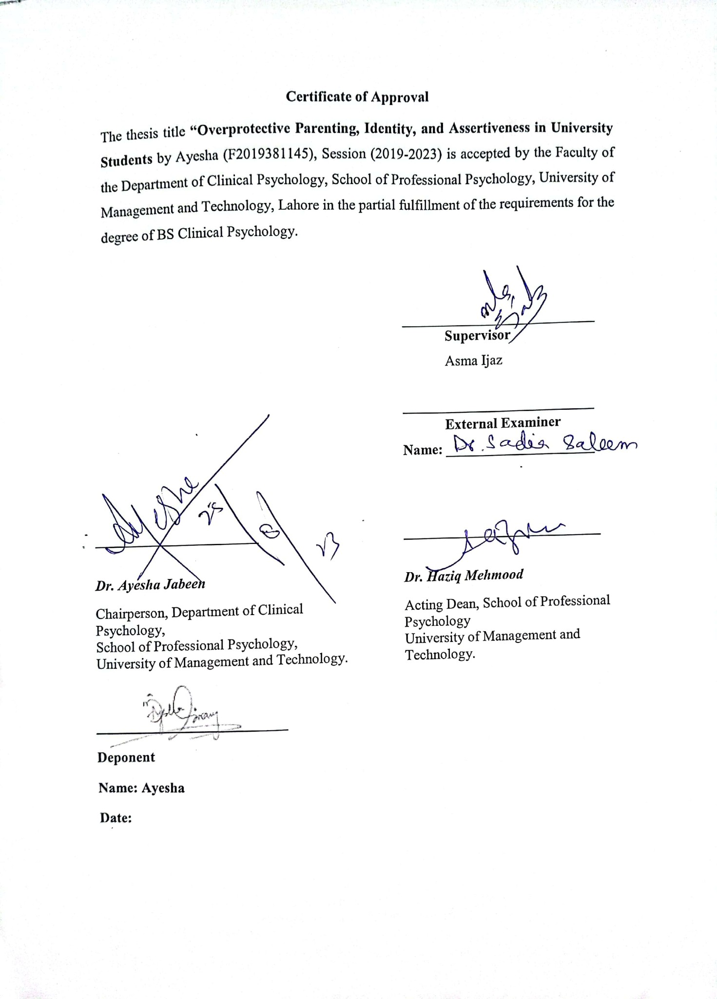


Table of Content
 | Content | Page No
 | Acknowledgements
 | Declaration
 | Abstract | I
 | List of Tables | II-III
 | List of Abbreviations | IV-V
 | List of Appendices | VI
Chapter I | Introduction | 1
 | Aim | 10
 | Objectives | 10
 | Implication of Current Research | 10
Chapter II | Literature Review | 12
 | Rationale of the Research | 30
 | Research Question | 30
 | Hypotheses | 30
 | Operational definitions | 32
Chapter III | Methods | 33
 | Research Design | 33
 | Setting and Participants | 33
 | Inclusion and Exclusion Criteria | 33
 | Measures | 34
 | Ethical Considerations | 35
 | Procedure | 36
 | Statistical Data Analysis | 36
Chapter IV | Results | 37
 | Section I: Sample Description | 38
 | Section II: Testing the Main Hypotheses | 42
 | Section III: Testing the Secondary Hypotheses | 45
Chapter V | Discussion | 63
 | Conclusion | 71
 | Limitations and Recommendations | 72
 | References | 74
 | Appendices

Acknowledgement
I'd want to take this chance to offer Allah Almighty, the origin of all understanding, wisdom, and direction, my sincere gratitude and admiration. I am really grateful for all of the chances and blessings that have come my way while I've worked towards finishing my thesis. I will always be grateful to Allah for his grace since his divine presence has been a continual source of courage, inspiration, and consolation.
Additionally, I would like to convey my deep gratitude to Asma Ijaz, my academic adviser, for their significant advice, knowledge, and mentorship during this project. Their astute comments, helpful critique, and commitment to my academic improvement have had a significant impact on how this thesis turned out. I consider myself really lucky to have had the chance to work under their direction.

DECLARATION
I dedicate my thesis to those who have supported me in life, who have shown me the way and who have been my constant sources of love and inspiration. I owe a lot to my soulmate from the bottom of my heart. His unfailing confidence in me, support, and encouragement have been crucial to my academic endeavors. He have served as a daily reminder of the strength of love and partnership through his patience, understanding, and readiness to give up his own time and energy to assist me. I sincerely appreciate him being a part of my life and supporting me in this endeavor.
I want to thank, parents. My successes have been fueled by your constant support, selfless acts, and unshakable faith in my talents. You have given me a loving atmosphere from the beginning, emphasized the value of education to me, and encouraged me to always aim high. The foundation of my success has been laid by your unwavering support, wisdom, and sacrifices, and I will always be appreciative of your being in my life.
To my uncle, whose unflagging support, words of inspiration, and faith in my potential have been a continual source of bravery. His presence in my life has given me the stability, humor, and support I've needed to get through this journey's highs and lows. I appreciate his love, patience, and never-ending support.
Abstract
This research investigates the relationship between overprotective parenting, identity, and assertiveness in university students. Random stratified sampling was used in this research. Here, 300 male and female university students between the ages of 18 and 27 had participated. The scales used for data collection were Early Memories of Up-Bringing-Adult Version (Arrindell et al., 1991), Identity Scale for College Students (Ijaz & Rizvi, 2015), and Assertiveness Scale for University Students (Ijaz & Khalid, 2020). The findings indicated that there is a negative relationship of overprotective parenting with arrogant identity, social identity and independent identity. And arrogant-identity has a positive significant relationship with social identity, independent identity, assertiveness and self-regulation assertiveness. Those students who were in 4th years of the programs were more assertive than other years of university students. Men university population were more assertive than women university population. The implications of the research study is to help parents learn about various parenting styles and their effects, particularly how overprotective parenting affects a person's identity and assertiveness. The study's findings will captivate both clinical and non-clinical samples in a big way. Additionally, it will assist the therapist in changing the attachment patterns linked to parenting practices. Furthermore, parents would discuss how to raise their children properly through seminars and awareness campaigns.
Keywords: overprotective parenting, identity, assertiveness, university students, attachment patterns, well-being.

List of Tables
Table No Page No
Table 1……………………………………………………………………………...37
Mean and Standard Deviation of Age of Participants (N=300)
Table 2……………………………………………………………………………..38-39
Frequencies and Percentages of the Demographics Characteristics of the Participants (N=300)
Table 3 ……………………………………………………………………………42
Correlation between Overprotective Parenting, Identity, and Assertiveness in University Students (N=300)
Table 4…………………………………………………………………………….45
Mean, Standard Deviation, t-value, Sig. value, 95% Confidence Interval of the Difference, and Cohen’s d of Men and Women on Overprotective Parenting, Identity, and Assertiveness Scale Three Factors (N=300)
Table 5……………………………………………………………………………..47
Mean, Standard Deviation, t-value, Sig. value, 95% Confidence Interval of the Difference, and Cohen’s d of Age on Overprotective Parenting, Identity, and Assertiveness Scale Three Factors (N=300)
Table 6……………………………………………………………………………..49
Mean, Standard Deviation, t-value, Sig. value, 95% Confidence Interval of the Difference, and Cohen’s d of Institution on Overprotective Parenting, Identity, and Assertiveness Scale Three Factors (N=300)
Table 7……………………………………………………………………………..51
Mean, Standard Deviation, t-value, Sig. value, 95% Confidence Interval of the Difference, and Cohen’s d of Family System on Overprotective Parenting, Identity, and Assertiveness Scale Three Factors (N=300)
Table 8…………………………………………………………………………….53
Mean, Standard Deviation, t-value, Sig. value, 95% Confidence Interval of the Difference, and Cohen’s d of Mother’s Occupation on Overprotective Parenting, Identity, and Assertiveness Scale Three Factors (N=300)
Table 9……………………………………………………………………….…...55
One Way Analysis of Variance for Four Levels of Classes (1styear, 2nd year, 3rd year, and 4th year) and Factors of Assertiveness Scales (N=300)
Table 10………………………………………………………………………….57
One Way Analysis of Variance for Three Levels of Father’s education (Matric, Intermediate, and Graduation) and Factors of Assertiveness Scales and Identity Scale (N=300)
Table 11………………….……………………………………………………….59
One Way Analysis of Variance for Three Levels of Father’s Occupation (Government, Private, and Business) and Factors of Assertiveness Scales and Identity Scale (N=300)
Table 12………………………………………………………………………….61
One Way Analysis of Variance for Four Levels of Mother’s Education (Middle, Matric, Intermediate, and Graduation) and Factors of Assertiveness Scales and Identity Scale (N=300)

List of Abbreviations
SPSS Statistical Package for Social Sciences
ANOVA One-Way Analysis of Variance
PSED Psychosocial Experiences of Dysmenorrhea
EMBU-A Early Memories of Up-Bringing-Adult Version
ISCS Identity Scale for College Students
ASUS Assertiveness Scale for University Students
N Number of Sample Size
M Mean
SD Standard Deviations
Sig Level of Significant
LL Lower Limit
UL Upper Limit
CI Confidence Interval
OP Overprotective Parenting
AI Arrogant Identity
SI Social Identity
II Independent Identity
PA Prosocial Assertiveness
SA Self-regulation Assertiveness
ICA Interpersonal Competence Assertiveness
List of Appendices
Appendix A ……………………………..Permission Letter
Appendix B ……………………………..Early Memories of Up-Bringing-Adult Version
Appendix C …………………………......Identity Scale for College Students (ISCS)
Appendix D …………………………......Assertiveness Scale for University Students
Appendix E………………………………Plagiarism Report

Introduction
The human lifetime, which starts at age 20 and lasts until age 60, is known as adulthood. A person experiences a variety of changes throughout this era, including physical, mental, emotional, social, and biological changes. In this day and age, it's crucial to maintain equilibrium among all these changes. Every period of life involves obstacles and problems, but early adulthood may have been the toughest because it is filled with so many hardships for a person. The adolescent period is when a person begins to define who they are; this is typically a make-or-break situation. A person begins to recognize his or her uniqueness at this period of life and begins to make decisions and choices for the future (Arnett, 2019).
The transition to adulthood is fraught with difficulties, including concerns with stress, romantic relationships, cognitive growth, careers, friendships, and even societal adjustment. These are the difficulties that everyone faces as they become older. The economical and cognitive development of adult accomplishments is significantly influenced by parents. The behaviors and personalities of the children are impacted by various parenting techniques. Interaction between parents and children, emotional warmth, control, and neglect have an impact on how children connect with others, cope with obstacles, accomplish goals, and arrive at their destination (Arzt, 2020).
In every stage of a child's development, their parents can have an impact on them. From childhood to adulthood. During this time, a parent makes decisions on how and with whom the kid will engage, as well as about what to dress, where to go, what to do, and what values to uphold. Parents are extremely important in shaping a child's emotions, behaviours, personality, and sense of self from infancy through maturity. When we talk about family life, it represents the parents who are always looking for a special approach that will help the interaction between parents and children to reach its optimum state. Positive parenting practices assist to grow children with high ethics, moral values, and discipline, which is the ideal parental upbringing that all parents aspire to. The process of nurturing a kid from birth till maturity is known as parenting. Parenting is defined as putting the child's needs first, providing for their needs, nurturing them, giving them a safe and secure environment to grow in, helping them develop their personalities and identities, and preparing them for a life on their own (Peterson, 2022).
Children are significantly impacted by parenting practices. Children with varied coping mechanisms may experience a range of outcomes, from academic achievement to behavioural and mental health problems. It's important to comprehend the different parenting styles and how they affect your child before choosing which parenting style is best for you and your family. Child up-bring styles may typically be categorized into seven categories based on how well they support a child's development: High demands and minimal communication are characteristics of authoritarian parenting. Here, kids are expected to obey rules and directives without of justification. This parenting style produces children that are obedient, well-behaved, and academically successful, but who frequently lack social skills. The youngster acts irrationally and is unable to control their frustration (Cherry, 2022).
Demanding and responsiveness are traits of authoritative parenting. As a result, parents establish some regulations that are supported by justifications. A child raised with this kind of parenting has stronger social skills, strong academic achievement, and fewer mental health issues. Parenting practices that are permissive tend to be low in demands and strong in responsiveness. When it comes to creating norms and disciplines, they are pretty lax. As a result, these parents give their kids more independence, which can help them socialize better and have less issues in school and with adjustment (Dagnew, 2017).
The goal of an overprotective parenting style is to shield the kids from all types of suffering and injury, whether they are emotional, mental, or physical. Due to their stringent rules and conviction that they are the finest parents, these parents give their kids tunnel vision in their pursuit of objectives. A child raised with this kind of parenting has low self-esteem, trouble handling failure, worry, tension, and difficulties controlling their emotions. Spiritual parenting styles treat their kids with respect because they think they are gods. These parents raise their kids according to religious values. These parenting styles encourage moral principles in kids and teach them how to act morally. This type of parenting up brings a child with high self-esteem, generous in sprit, low level of aggression, and sense of responsibility.
Slow living movement is a hallmark of slow parenting. These parents provide their kids a stress-free atmosphere. Instead of quantity of time, quality time is their main priority. A youngster raised in this manner develops self-reliance, confidence, and a lack of stress and worry. Aside from that, individuals could have trouble forming friends and might revolt against the authorities. A parenting style known as being uninvolved involves parents having little to no emotional contact with their offspring. These parents seldom put any expectations on their kids and are frequently unavailable emotionally and physically. This parenting style results in a child that uses drugs, has high mental health problems, and a low sense of self-worth. A youngster with absentee parents feels unsupported and uneasy in this life situation.
Helicopter parenting is another name for the parenting style known as overprotective parenting. Parents that are too protective involve themselves actively in their kids' life. They strive to look after the kids' needs by hanging out with them constantly. This parenting approach has both beneficial and bad consequences on kids, much like other parenting philosophies. This approach disregards the child's preferences and ideas. They lack the freedom to experiment on their own, which inhibits their originality and inventiveness. This may cause the youngster to lose confidence. They could also find it tough to deal with failure since they are shielded their entire lives. In addition, some professional medical advice states that this type of parenting can lead to anxiety, stress, and difficulty regulating emotions (Daily, 2022).
In Pakistan, a collectivist society, overly protective parents is quite common. In the name of love and concern, they are attempting to educate their children how to deal with disappointment, anxiety, and despair. According to a research in the Journal of Affective illnesses, overprotection, particularly from mothers, is the main contributor to mental illnesses in kids. Some research claim that overprotective parents give their kids issues including inadequate self-confidence and self-reliance (Saleem, 2019).
Parenting that is too overly protective has a lot of negative effects on children. Lack of a child's growth and development into a well-adjusted, autonomous adult is the scenario consequence that occurs most frequently. In addition, overprotective parenting is followed by concern, anxiety, and lack of coping skills, social anxiety, and poor self-esteem, low determination, fear of failure, mental health issues, low self-confidence, fewer social skills, identity crises, and arrogance. Children who are too protective have low self-esteem and lack confidence in their abilities to address difficulties on a daily basis. The way that other people treat them in their interactions has a big impact on how confident a person feels about themselves. Children who get excessive protection are told they lack the skills or capacity to handle their lives independently.
These kids won't be able to completely trust their accomplishments in gaining a feeling of autonomy and competence until they get the chance to demonstrate to themselves that they can accept responsibility. They thus lack the fortitude, self-efficacy, self-identity, and self-motivation needed to deal with the outside world on their own. The fear of making errors is common in kids of overly cautious parents. Because they are afraid of failing, being hurt, or getting rejected, they are hesitant to attempt new things and leave their comfort zone. Kids could pass up opportunities. These children grow reliant on their parents rather than overcoming obstacles and finding solutions on their own. Their unwillingness to take risks keeps them from developing into competent individuals (Li, 2022).
A youngster who receives excessive protection is unlikely to develop the skills necessary to create their own identity and learn how to handle situations on their own. They lack the critical thinking abilities necessary to handle a variety of circumstances in life. Let's clarify identify since they can have a low threshold for annoyance while having a high level of worry. A person's subjective sense of identity, which is made up of experiences, connections, beliefs, values, and memories, is referred to as their identity. This helps create a solid self-image that endures throughout time even when new aspects of the self-get stronger or develop (Cherry, 2022).
The memories, encounters, connections, and ideals that foster self-awareness are all part of identity. As new elements are produced and merged into one's identity over time, this fusion gradually gives one a feeling of stability. In its widest sense, identity may be described as a person's sense of self, which is shaped by their particular characteristics, affiliations, and social positions. Furthermore, despite numerous environmental changes, people continue to feel that they are the same person throughout time, which is a continuity of identity. An individual's ideas, desires, memories, perceptions, consciousness, and beliefs all make up their identity. Racial identity, ethical identity, geographic identity, sexual orientation, familial identity, ability, physical identity, generational identity, class identity, educational identity, professional identity, and gender identity are some common kinds of identity, socioeconomic identity, cultural identity, and political identity (Yilmaz, 2021).
During a person's formative years, when their careers have the most impact on them, the roots of their identity are planted. But as people go from childhood to adolescence, they start to wonder who they are and where they belong in society. Teenagers as a result start to explore their sense of self by trying out various roles and behaviours. Adults continuously evaluate who they are, although their identities haven't altered much throughout the course of their life. Therefore, this fundamental identity formation throughout adolescence is essential for creating a positive self-concept and determining one's course in life, according to famous psychologist Erik Erikson (Yilmaz, 2021).
Identity helps an individual to know about their future goals, needs, wants, likes and dislikes. When a person knows his needs, strengths and goals then he will be confident to achieve his future goals and will be on the way to achieve them by his assertive skills of communication, information conveying, idea representation, and by speaking for rights with high assertiveness (Indeed, 2019).
People with developed identities frequently exhibit specific features and qualities that enable them to embrace their desire for personal growth as well as to be in touch with their emotions. They have an adaptable self-concept and the capacity to change as a result of experience, the capacity to live in harmony with others, the desire to make realistic adjustments, the capacity to properly interpret their experiences, the capacity to put their confidence in their experiences, assertiveness, and unwavering self-esteem (Cherry, 2022). On the other hand, person with identity diffusion may wandering aimlessly, lack of self-esteem, externally oriented, less autonomy, less personal responsibility for own life, and less assertive (Vinney, 2018).
There are some consequences of identity problem which may include: low self-esteem, feelings of frustration, identity confusion, being stuck, feelings of inadequacy, and lacking meaningful progress. Those who struggle with identity problems often have difficulty developing intimacy with others. Low self-esteem can have detrimental repercussions on a person's identity, including a lack of self-awareness and personal boundaries. They may find it challenging to establish relationships as a result. Feeling unsupportive or meaningless in a relationship is another issue that people with identities face in relationships. It is common for people with identity problem to feel "empty" inside. They may find it difficult to find significance in their connections with friends, family, and love partners as they fight to find meaning in themselves. Moreover, an identity diffused person face difficulty finding future goals, needs, and likes. When an individual’s identity is diffused then it will be difficult for him to work on his goals because they are unclear, unable to communicate and unable to convey ideas, he will be less assertive (Salters, 2021).
An individual's capacity to advocate for their own interests without feeling overly anxious is demonstrated by their assertive behaviour. They allow for "the exercise of one's rights without depriving others of their rights" when they are in effect (Sutton, 2021). A person who is assertive will be able to better handle themselves, other people, and situations. They can use it to persuade people to accept them, give them permission, or modify their behaviour. It is the capacity to firmly and positively articulate one's own point of view.
People that are assertive are in charge and truthful with both themselves and others. In a society that values individualism, being assertive entails respecting oneself and acknowledging that someone is prepared to defend their rights and interests by speaking their minds in ways that are constructive and don't cause harm to others. Whereas, in collectivistic culture, rather we say in Pakistani culture, assertiveness is something that refers dishonored for alders, shameless, rude, and discourteous. These are the words which are used for assertive person in Pakistani culture. Assertiveness plays an important role in causing depression in Pakistan. Our culture supports not being assertive. Women, in particular, are often insecure and depressed (Mueen et al, 2006).
Finding the ideal balance between passivity (lack of confidence) and aggression (hostile behaviour) is the essence of being assertive. It entails having a firm feeling of your own value and realizing that you are deserving of your goals. This entails defending your rights in all circumstances, no matter how challenging.
Assertive people are confident, peaceful, and resistant to stress. They don't worry too much, but that's not the same as apathy. They are goal-oriented and want to be successful, but they usually don't let tension get in the way of their achievement. They are less inclined to dwell on their prior decisions or acts for an extended period of time. Depending on the confident personality type. A nonassertive person, on the other hand, is someone who is frequently chosen by others, feels powerless, and answers queries from everyone. They also say yes to insensitive and careless demands. People who lack emotional confidence are indirect, self-denying, and restricting. They experience hurt, worry, and sometimes anger as a result of their acts.
You can stop individuals from taking advantage of you by being assertive. Additionally, it might assist you in avoiding bullying behaviour. You can become more confident and self-assured by being assertive. You can also feel empowered, understand and recognize your feelings, gain the respect of others, improve communication, create win-win scenarios, sharpen your decision-making abilities, establish trustworthy relationships, and experience greater job satisfaction (Mayo, 2022). The downside of assertiveness is that there is no guarantee that things will work out; sometimes some people are uncomfortable with your directness and honesty. Sometimes, if it's not conveyed correctly people will think it's rude, it can also reflect overconfidence, can prove to be counterproductive, and a person may look arrogant (Shukla, 2019).
Self-esteem and assertiveness are directly related. If we don’t believe in ourselves, we are less likely to be confident and express our feelings. Without knowing the outcome, we're less likely to take a risk because we don't believe we can handle it. The positive results of taking a risk and taking accretive action will help boost your confidence in yourself and boost your self-esteem (Karan, 2016).
Aim
To find out the relationship between overprotective parenting, identity and assertiveness in university population.
Objectives
- To examine how gender disparities in identity, assertiveness, and parenting styles affect university students.
- To investigate whether overprotective parenting, identity, and assertiveness have a positive or negative effect on university students.
- To examine whether overprotective parenting have an impact on identity.
- To examine whether assertiveness is associated with overprotective parenting.
Implications of the current research
This research study is supportive for parents to know about different parenting styles and its consequences especially how overprotective parenting affect the person’s assertiveness and identity. The findings of the study will be of great engrossment to clinical and non-clinical samples. Moreover, it will help the clinician to modify the attachment patterns related to parenting styles. It will also assist students to become assertive in different situations. Furthermore, through seminars, and awareness campaigns parents would brainstorm about the child's correct parenting.

Literature Review
A university education is crucial for developing new social and emotional skills, unique thinking patterns, and a sense of independence (Arnett, 2000). However, due to changes in their surroundings, independence, maturity, academic load, and profession choosing, this time poses a number of difficulties for students (Gore & Metz, 2008). These issues further create problem in student’s psychosocial life. An individual's autonomous examination of many life options defines this period. The peak of willpower development occurs between the ages of ten and twenty, although adult growth and societal norms might impede this process. A developing adult before to adulthood is supposed to have a subjective feeling of uncertainty and instability. Being self-sufficient requires having the capacity to take on responsibilities and to act independently (Rice, et al., 2006).
In addition, Parents play an important role in a child’s life. When we talk about family life, it reflects the parents who are always in search that how they can find out a unique way that leads the relationship between parents and children to an ideal relationship (Spear, 2000). An ideal parenting raising that all parents dreamed of is positive parenting, as it helps to raise children with good ethics, moral values, and discipline. However, it is not an easy step (Arnett, 2000). Parental participation in children's education improves students' morals, attitudes, and academic performance in all subject areas. It also encourages behavioural development and social adaption in many communities and cultures. Involving families in educational environments may help students develop into responsible and effective citizens in all of these ways (Wartman & Savage, 2008).
In addition, according to Henderson and Berla (2021), the most precise indicator of student achievement is not socioeconomic standing but rather the degree to which the student's family is involved, enthusiastic, and supportive of their child's learning in the home and in the community.
Parents are encouraged to actively participate in their child's education at the University as they play a crucial role in fostering their learning and supporting it. Since their children are taught at various institutions, parents are full partners in their children's education and are included because they contribute as appropriate to decision-making and advisory committees. Facts are mounting that show how crucial family connection is to students' engagement and growth, which will result in a well-groomed, resilient, and productive personality (Harvard, 2016).
In addition, family involvement raises student success and social skills as well as learner confidence and institutional preparation. The road to student achievement is provided through family participation, a self-driven, participatory process (Shibata, 2019). Parent-teacher conferences and other opportunities to get involved in promoting student performance and problem-solving are some of the ways that families and educational institutions may connect with one another. Family involvement doesn't happen by accident. Through this shared responsibility, educational institutions reach out to families and meaningfully engage with them, and in return, families actively contribute to fostering children's learning and development (Harvard, 2019).
When it comes to parental involvement in an individual’s life, it ultimately focuses on parenting styles and human upbringings. Mainly it is considered that parenting styles are of five types; Permissive, authoritative, authoritarian, neglectful, and overprotective (Arnett, 2000).
A theory of parenting was presented by Diana Baumrind (2022). Baumrind observed that preschoolers displayed a wide range of behaviour. Each behaviour has a strong relationship to a certain parenting approach. According to Baumrind's idea, there is a direct correlation between a child's behaviour and the parenting style used. Different parenting practices influence how children develop and how they turn out. She defined three parenting philosophies—authoritarian parenting, permissive parenting, and authoritative parenting—based on extensive observations, interviews, and analysis. Although Marilyn Baumrind the classification work is well known, but Maccoby and Martin (2022) used a two-dimensional framework to expand parenting styles to this three-parenting-style model. They increased Baumrind's permissive parenting approach by one, creating two more parenting philosophies: permissive and inattentive.
According to Ginott (2021) teenage and parents suggested the term "helicopter parenting" or “overprotective parenting” in which teens said their parents would be like helicopters hovering over their heads. Similar terms include "lawnmower parenting," "doting parenting," or "bulldozer parenting." researchers define overparenting, or "helicopter parenting" as a parenting style that shares traits with both parents emotionally over-engaged and contains unique qualities, including risk aversion, focus on children's well-being, and motivation to solve problems for children (Raskin & Terry, 2019).
Overprotective parenting during the infancy has been identified as a common causing problems in early adulthood stage. Parenting that interferes with "the child's age-normative autonomy and emotional independence and encourages overreliance on parents" is referred to as overprotective parenting (Farber, 2019). A kid's possibilities to develop healthy independence and psychosocial skills are limited by an excessive focus on preventing damage, even if overprotection frequently has the good aim of keeping a child safe (Bizet, 2021).
Additionally, excessive protection encourages avoidance and restricts possibilities for socialization and self-expression, increasing sensitivity to psychiatric problems, particularly anxiety (Srivastava, 2020). Poor mental health in adulthood has also been connected to excessive protection and indulgence. In meta-analyses, internalizing issues, depression, and anxiety in childhood and adolescence are linked to overprotective parenting, as are psychopathology and attachment insecurity in adulthood (Bruysters, 2022).
Moreover, a research done by Yao et al. (2022) in the city of Zhejiang Province, China, examined the moderating influence of academic-social student-faculty interactions on undergraduate students' ability to regulate their emotions. This information came from a survey of 4,462 undergraduate students. This study studies how various parenting philosophies affect students' ability to regulate their emotions and examines the mediating impact of teacher-student interactions. The findings demonstrated that Chinese parents favor an excessively protective parenting approach for their children. According to the findings, which are in line with other worldwide research (Efstratopoulou et al., 2022), parental rearing practices and social situations at school do have an impact on students' emotional development.
Similarly, Saleem et al (2015) performed studying Pakistani teenagers in Lahore, Pakistan, the cross-cultural validity of the EMBU-C on perceived parental practices and mental health issues. The study sample was collected from 1279 adolescents with the age range of 12-18. Additionally, this study attempts to look into links between alleged parenting practices and teenage mental health issues. Survey results parental warmth revealed to be a negative predictor rejection and parenting anxious parenting are positives predictors of adolescent mental health problems are consistent with the literature (Huppert et al., 2010).
Parenting styles have demonstrated identity development of a child. According to theoretical perspectives and attachment theory (Bowlby, 2021), parenting style quality was found to be a factor in variations in identity exploration. The main tenet of attachment theory is that better parenting fosters positive sentiments about oneself and other people, creating a safe foundation for exploration (Yagon, 2011).
Furthermore, identity status research backs up the idea that loving parenting encourages high-quality inquiry and follow-up commitment (Gerald et al., 2020). The link between parenting style and identity formation has received little scientific attention. Teenagers who identify as information-oriented were found to view their parents as authoritative and receptive to conversation (Berzonsky, 2004).
A normative identity style was linked to views of authoritarian parenting, according to Berzonsky (2019), who also discovered that these teenagers believed their families lacked sentiments of openness. Unexpectedly, authoritative and solid, trustworthy familial ties were also strongly correlated with normative style. Last but not least, avoidant communication patterns were discovered to be connected to authoritarianism, indulgence, and a lack of expressiveness in family interactions. Although this little research offers some insights into the parenting circumstances connected to each identity style, it neglects to establish a connection between identity style and crucial parenting style characteristics.
Moreover, a person's committed objectives, values, and beliefs make up their well-developed identity. It is the gradual realization of one's own coherence and the acceptance of that coherence by others (James, 2018). Identity formation is a process that occurs on an individual and social level (Adams & Marshall, 2000).
A large portion of this process is thought to occur during adolescence, when cognitive growth enables people to create a "theory of self" (Elkind, 2017) based on identity choices and role models. According to Elkind (2017), this stage of development is marked by an "identity crisis," a crucial juncture at which the person must advance in some way, propelling the adolescent towards growth and distinctiveness (Sarwar, 2019).
Additionally, identity is developed via the act of evaluating choices or possibilities and making a decision based on the findings of the evaluation (Diana, 2019). Identity uncertainty might result from a lack of a strong sense of self (Benedict, 2021). Those who struggle with identity confusion are unsure of who they are or what their place in society is (Mower, 2006).
A "theory of self" based on identity choices and role models was also put out by Erikson (2019). Erikson claimed that our concept of self, or what he called self-identity, is influenced by how we connect with others. Psychosocial theory states that from early childhood through late adulthood, humans go through eight developmental phases. We must settle any tasks or problems at each level. Each developmental activity that is completed successfully results in a sense of competence and a positive personality. Feelings of inadequacy might result from not being able to do these activities (Bukhalenkova, 2021).
The development of identity, in Erik Erikson's view, is the primary psychological job of adolescence. Identity and role uncertainty, which teenagers must overcome as they navigate the challenges of discovering their unique selves, is what Erikson refers to as life's fifth psychosocial job. According to Erikson, it is a time of uncertainty and experimenting with one's identity and course in life. Adolescence is the transitional period between childhood and maturity, and how each person deals with their prior psychosocial crises as a kid will have an impact on how their identities grow (Jiang, 2019).
In addition, Marcia's identity by characterizing identity formation in adolescence as requiring investigation and commitment to ideologies and jobs, status theory (2020) expanded Erikson's theory. According to Marcia, people have little knowledge of or experience with their expectations for identity exploration or commitment as they begin the process of forming their identities. Those whose identities have been foreclosed have made a commitment to an identity without considering alternative identities. Young teenagers frequently go through a foreclosure phase where they may choose an identity without devoting themselves to the process of exploration. People who successfully establish identification experience self-acceptance, a steady sense of self, and devotion to their identity.
Similarly, Jeffrey Arnett's theory (2021) states that identity formation is most prominent during emerging adulthood between the ages of 18-25. According to Arnett, identity formation involves indulging in different life opportunities and possibilities, culminating in making important life decisions. He argues that this stage of life includes a wide range of opportunities for identity formation, particularly in three distinct domains. Identity explorations, instability, self-focus, feeling in-between, and possibilities/ optimism are the five normative characteristics of emerging adulthood. It is common for people in early adulthood to attend college there they may be exposed to a different worldview than the one they grew up with and be willing to change their previous worldview. Those who did not go to college also believed that, as adults, they too should decide what their beliefs and values are.
Further a research by Pellerone et al, (2016) on Parenting, identity formation, internalizing symptoms, and alcohol use among Italian teenage participants in a cross-sectional research. A little Italian village called Caltanissetta served as the site of this investigation. 198 Italian students, ages 16 to 19, comprised of 104 males and 94 women participated in the study. In a study of 198 Italian students, this cross-sectional study explored potential connections between identity development, parenting, and adolescent issues that may manifest as internalizing (phobias, OCD, depression, eating disorders, and entropy) and externalizing (alcohol and school malaise) symptoms. The findings of this study looked at potential connections between identity formation, parenting, and internalizing-externalizing symptoms in adolescence. Perhaps as a result of a lack of critical appraisal of multiple identity possibilities, adolescents who are experiencing foreclosure show increased caring compulsions that result in relationship addiction and dread of being incorrect. Students who were placed on hold felt more inadequate, as is usual for individuals who had started to consider different identities but had not yet committed to any of them.
Moreover, a research done by Passmore et al, (2005) to find out among Austrian adult adoptees and non-adoptees, parental attachment and identity style serve as predictors of self-esteem. The sample size was selected among the adoptees were 66 women and 34 men, spread over age 18-70 years old, average 38.10 years old year. Participants who were not adopted included 68 women 32 Men, aged 18-74 years old, with an average age of 37.89 years. The findings showed that, despite the fact that dad's automobile has no bearing, adoptees report poorer self-esteem and greater mother care than non-adopters. Additionally, adoptees report greater degrees of overprotective mothering.
There was another research done by Embalsado (2021) based on emerging adulthood: European parenting practices and identity status. The sample size was consisted 203 individuals and age ranged was 18 to 25 year old. This study set out to identify distinct clusters between parenting practices and identity status. Results suggested that liberal parenting was substantially linked with identity dispersion, authoritarian parenting with identity de-identification, and authoritative parenting with identity suspension.
Further, Berzonsky et al. (2007) published an investigation on the identity-processing preferences, psychosocial supports, and Dutch teenage views of parent-child relationships. 938 early adolescents and 393 middle adolescents made up the sample size. Early adolescents with high diffuse avoidance scores have poor levels of commitment and self-regulatory resources, and they believe their parents to be untrustworthy, uncommunicative, and supervising. These findings are based on studies on early adolescents. Normative style appears to be more adaptive than informational style when compared to studies of late adolescents (Berzonsky, 1990, 2004b). Normative scores are positively correlated with levels of commitment and self-regulation, whereas informational scores are negatively correlated with efficient self-regulation.
In contrast, Meeus et al. (2014) conducted a research on Parenting practices and adolescent identity development: Longitudinal associations between autonomy, parent-child warmth, and identity processes in America. The findings showed that good identity development in teenagers, including exploration and commitment, is connected with parenting that encourages autonomy. According to Baumrind (1991), authoritative parenting was linked to favorable outcomes in children, including good self-esteem and academic success. This parenting style is characterized by high levels of excitement and responsiveness as well as appropriate amounts of control and autonomy.
Hence, Kim and Jeong, (2019) published a study on the effects of overprotective parenting on teenagers' perceptions of stress, self-worth, and academic success in South Korea. The findings showed that in South Korean teenagers, overprotective parenting was linked to greater levels of felt stress, worse levels of self-esteem, and worse academic achievement.
However, several researches has being conducted on national the level in which a research by Akhtar and Fatima (2019) was done to find the connection between overprotective parenting and identity problems in adolescence: Several research have looked at the connection between overprotective parenting and identity issues in adolescence in Pakistan. The findings showed a strong positive association between identity conflict and overprotective parenting. Additionally, the study found that teenagers who had overly protective parents had worse levels of self-esteem and mental health.
Similarly, a study by Maunder and Harackiewicz (2016) on parental overprotection and impact on identity on American adolescents. The result found that parental overprotection was associated with higher levels of identity confusion, a type of identity conflict. In contrast, adolescents who experienced parental autonomy support reported greater degrees of identity discovery and less identity uncertainty.
Furthermore, a study by Ahmad and Khalid (2018) on overprotective parenting and adolescent identity formation: a study on Pakistani adolescents. Results revealed that overprotective parenting was negatively associated with identity achievement, which is a positive outcome of identity development. The study also showed that adolescents who experienced overprotective parenting had lower levels of emotional well-being and higher levels of psychological distress.
Similarly, a study of by Aslam and Khalid (2020) on parenting styles, identity conflicts, and psychological well-being among adolescents in Pakistan. The sample size was 200 (100 men’s, and 100 women’s) with the age range of 14-18 years old. The results showed that adolescents who had experienced authoritarian parenting had higher levels of identity conflict compared to those who had experienced authoritative or permissive parenting. The study also found that teens who had experienced authoritarian parenting had lower levels of mental health compared to those who had experienced authoritative or permissive parenting. In addition, adolescents who experienced identity diffusion and exclusion had lower levels of mental health compared with adolescents who experienced identity fulfillment or suspension.
In addition, a research by Zafar and Assad (2019) on parenting styles, identity conflicts, and self-esteem among Pakistani adolescents. Results found that authoritarian parenting was positively associated with identity loss, a type of identity conflict. Adolescents who experienced authoritarian parenting reported lower levels of exploration and commitment to their own identities. In contrast, authoritative parenting was negatively associated with identity exclusion. Adolescents who experienced authoritative parenting reported higher levels of exploration and commitment to their identities. Additionally, the study found that permissive parenting was not significantly associated with any status.
In the same way, Identity and assertiveness are two interconnected concepts that are important for personal growth and development. Identity refers to how individuals define themselves, including their personality, values, beliefs, and experiences, among other things. Assertiveness, on the other hand, refers to the ability to communicate one's thoughts, feelings, and needs in a direct and confident manner, while respecting the boundaries and opinions of others. A strong sense of identity can promote assertiveness by providing individuals with a clear understanding of their values and beliefs, which can help them to communicate their needs and boundaries more effectively (Cote, 2006).
In contrast, a weak sense of identity can make it difficult for individuals to assert themselves and communicate their needs clearly, as they may lack confidence and clarity about who they are and what they want. At the same time, assertiveness can also play a role in shaping one's identity. When individuals are assertive and communicate their needs and boundaries effectively, they are more likely to have their values and beliefs respected, which can reinforce their sense of identity. Conversely, when individuals are not assertive and do not communicate their needs clearly, they may feel like their values and beliefs are not being acknowledged, which can lead to confusion or doubt about their sense of self. Overall, developing both a strong sense of identity and assertiveness are important for personal growth and well-being (Mclean and Whelton, 2022).
Typically, the initial theoretical background of assertiveness can be go back to the work of Ivan Pavlov. Pavlov tried to determine properties of the nervous system allow animals and humans to adapt to changing conditions in their environment. He postulates that nerves have two sides systems: Genetic, and Conditional (Fensterheim and Baer, 1975). Through the characteristics of inheritance, Pavlov realized that biological force affects sensitivity to stimuli, energy levels and tendency to various emotions, such as depression and aggression. He proves that these inherited features are modifiable, influenced and changed by life experiences. Pavlov's discovery that a person needs positive relationships with his environment. He pointed to changes in the environment corresponding changes in the nervous system are required. Ability learning to adapt to one's environment Pavlov called "conditional reflection".
Additionally, Wolpe (2022) suggested the term "confidence" for the location of the term "excitation". He defines self-confidence as "external expression of almost every emotion except anxiety." Wolpe showed that anxiety is related to interpersonal response capability. He assumes that a man knows what he should do, but because of his anxiety, he cannot express it adequately. At facile given the confidence, Wolpe is trying to build an 'excitement point' controlling the "Inhibition" process by limiting anxiety block the "excitement" process.
Moreover, Gladding (2019) pointed out that the psychological concept of assertiveness has been the social and counseling fields of psychology, primarily because of its multidimensional definition covers the spectrum of human expression: behaviour, cognition and affectation. A study of Angarani et al. (2019) explained that parenting style is a factor that influences children's behavior and mood. Assertive behavior can be learned naturally from one's environment. Environment the family mentioned here is the first social environment that children come into contact with. Also that said, there are other factors that can affect a person's level of confidence, such as culture, age, and gender.
According to Farman model (2017) there are three distinct communication modalities exist: passive, aggressive, and assertive. Aggressive communication refers to a technique of expressing oneself and advocating for one's demands but also violating the rights of others by expressing their sentiments and ideas. Passive communicators never speak; instead, they constantly listen to what others have to say. In assertive communication, people make their thoughts and sentiments known and stand up for the needs and rights of others without compromising their own.
A model presented by, Simon Black's (2017) model of assertiveness includes four types of responses. Each appears at a different point on the self-confidence scale, classified as effective or self-defeating behaviors: self-defeating aggressive/passive behaviour and successful assertive/responsive ones. You may use a variety of green, win-win behaviours to persuade people when you are assertive. Being assertive or responsive enables an individual to effectively influence others; this can be as simple as providing information or answers, asking questions, supporting answers with good reasons, or being persuasive. Aggressive and passive behaviors such as sarcasm, condescension, self-deprecation, and avoidance can eventually backfire. They harm personally and those around them.
In addition, a research conducted by Menesini, Nocentini, & Camodeca (2010) on parental overprotection, perceived competence, and assertiveness in Italian adolescents. The study involved 225 Italian adolescents (111 men and 114 women) between the ages of 14 and 17. Findings show that parental overprotection is negatively associated with perceived competence and assertiveness among Italian adolescents. Furthermore, perceived ability was positively correlated with the assertiveness of Italian adolescents. And, the study found that the relationship between parental overprotection and assertiveness was mediated by perceived competence.
Moreover, a research was done by Liu, Fang, & Yu (2014) on perceived parenting styles and assertiveness among Chinese adolescents. The study involved 375 Chinese adolescents (178 men and 197 women) aged 13 to 17. The results showed that perceived authoritative parenting was positively related to adolescent self-confidence. In contrast, perceived authoritarian and permissive parenting styles were negatively associated with adolescent self-confidence. Additionally, sex differences were found in the relationship between perceived parenting styles and self-confidence. Specifically, authoritative parenting styles and self-confidence are positively correlated for both men and women, but the negative relationship between authoritative parenting style and permissive parenting style and self-confidence is stronger for men than for women.
In addition, Kuru & Pehlivan (2015) proposed a research on the effects of overprotective parenting on the personality characteristics of adolescents: A cross-cultural study. The study had a cross-cultural design with a sample of 500 adolescents (250 men and 250 women) from two countries, Turkey and the United States. Findings showed that overprotective parenting was negatively associated with multiple personality dimensions in Turkish and American adolescents. Specifically, in all cultures, higher levels of overprotective parenting were linked to lower levels of agreeableness, extraversion, and conscientiousness and higher levels of neuroticism. However, the relationship between overprotective parenting and openness experiences varied across cultures, with a significant negative association found only in the Turkish sample.
Similarly, a research conducted by Zhu & Chen (2015) on overprotective parenting, perceived competence, and peer relations in Chinese adolescents. The study involved 542 Chinese adolescents (255 men and 287 women) between the ages of 12 and 14 years. The results showed that parental overprotection was negatively associated with perceived competence and peer relationship. Adolescents who perceive their parents to be overprotective have lower levels of self-awareness and are more likely to experience peer rejection. The study also found that perceived competence mediated the relationship between parental overprotection and peer bonding.
Moreover, a study conducted by Park, Lee, & Oh (2018) on the effects of overprotective parenting on the mental health and academic achievement of South Korean adolescents. The study involved 810 Korean adolescents (371 men and 439 women) between the ages of 14 and 18. The results showed that overprotective parenting was negatively associated with the mental health and academic performance of Korean adolescents. The study found that the more overprotective parents were, the lower their mental health and academic performance. In addition, the study found that overprotective parenting was particularly detrimental to the mental health and academic performance of men adolescents.
However, several researches has being conducted on national the level in which a research by Nadeem, M., & Akhtar, N. (2016) studied on overprotective parenting and assertiveness in Pakistani adolescents: moderating role of gender. The study involved 200 Pakistani adolescents (100 men and 100 women) between the ages of 14 and 18. The study found that overprotective parenting was negatively associated with assertiveness in both men and women adolescents. However, negative relationships were stronger among women adolescents. The study also found that men teens reported higher levels of assertiveness compared to women teens.
Further, a study conducted by Khan, M. M., & Khan, N. N. (2019) on overprotective parenting and assertiveness among adolescents: The moderating role of emotional intelligence. The study involved 200 adolescents (100 men and 100 women) between the ages of 15 and 19. The results showed that overprotective parenting was negatively associated with adolescent assertiveness. Emotional intelligence was found to moderate this relationship, suggesting that adolescents with high EQ are less affected by overprotective parenting. The study also found that emotional intelligence has a direct positive impact on assertiveness.
Moreover, a study by Akkaya & Dost (2021) conducted a research on an examination of university students’ level of assertiveness according to self-construal and five-factor personality traits in the state university in Ankara. Using a correlative design, 507 undergraduate students (194 men and 313 women) were participated. The results revealed that extraversion, neuroticism, agreeableness, and openness to experience are personality qualities that statistically significantly predict university students' assertiveness levels, as do both individual and group self-construal. Additionally, there was no difference in the assertiveness of undergraduate students at according to their class level and gender at a statistically significant level.
There was another research done by Iqbal et al. (2019) on overprotective parenting, self-esteem, and assertiveness in Pakistani adolescents. Using a correlative design, the study collected data on 500 Pakistani adolescents aged 14 to 18. The study result found that overprotective parenting was negatively associated with self-esteem and self-confidence among Pakistani adolescents. Self-esteem partially moderated the association between overprotective parenting and self-confidence, according to regression analysis, which also revealed that overprotective parenting was a substantial negative predictor of self-confidence. These findings suggest that overprotective parenting negatively affects the development of self-confidence in Pakistani adolescents, and that this effect may be mediated by self-esteem.

Rationale
As there were few kinds of research conducted on a national level on this topic so to fulfil the gap this study would be conducted. The various theory and western articles stated the different parenting styles linked how poorly or strongly with identity and assertiveness. The study will be carried out to find out overprotective parenting impact on identity, and assertiveness along with its comparison to our collectivistic culture. The study will also help in finding the gender differences in the light of overprotective parenting, identity, and assertiveness in university students. The research will aware people of the importance of a positive parenting style and how it helps in developing many life skills like identity and assertiveness. It will also help university students to communicate feelings in different situations by being assertive.
Research Question
What connections exist between overprotective parenting, identity and assertiveness in university students?
Hypotheses
- It is hypothesized that university students' assertiveness and overprotective parents have a detrimental association.
- It is hypothesized that adulthood who perceive overprotective parenting would have identity crisis.
- Considerable gender disparities in overprotective parenting and assertiveness are predicted.
- It is predicted that overprotective parenting and identity would have a beneficial association.

Operational definitions
Overprotective parenting. Overly regulating a child's behaviour is referred to as overprotective parenting. (Arzt, 2020).
Identity. Identity refers to a person's characteristics that help identify who that person is and acknowledge about the abilities, strengths, weaknesses, thoughts and emotions (Satterfield, 2017).
Assertiveness. Assertiveness is the ability to stand up confidently to assert rights, needs, wants, and desires without acting aggressively (Clinical Intervention Center, 2019).

Method
Research Design
The research design used in this study was correlational. This design was chosen to investigate the relationship between overprotective parenting, identity, and assertiveness in university students. Using a correlational study design allows for the exploration of associations between variables without manipulation.
Setting and Participants
The sampling technique used in this study was stratified random sampling. Participants were recruited from among students enrolled in private and government universities of Lahore. The data was equally collected from both BS men and women students. Participants in the study were 300 women and men university students between the age range of 18 and 27 of bachelors from 11 different private and government institutions of Lahore. Participants were recruited through direct interaction with faculty and in the university campus. Participation was voluntary and participants were informed that their responses will be kept confidential.
Inclusion and Exclusion Criteria
Inclusion and exclusion criteria was set to obtain better results and achieve desired goals. Included inclusion and exclusion criteria;
Inclusion criteria:
- Participants must be university students with the age range of 18-27.
- Participants were enroll in BS program from 1 to 10 semester.
Exclusion criteria:
- Participants with any physical disability were excluded
- Participants enrolled in MS and PH.D were excluded
Measures
Demographic Form
Demographic form were developed to collect personal information related to age, gender, education level, institutional and family system, number of siblings, birth order, father's education, father's occupation, mother's education, and mother's occupation.
Early Memories of Up-Bringing-Adult Version ([EMBU-A]; Arrindell, Veen & Emmelkamp, 1991)
Early Memories of Up-Bringing - Adult Version EMBU-A, which was used to assess a child's parenting style and perceived parenting style, is a 27-item questionnaire. The scale has three factors per parent: emotional warmth, rejection, and overprotection, but the factor of overprotective parenting was selected in the current results. It is scored on a 4-point Likert scale with 6 questions, each with four options for fathers and mothers. The options in the scale are "never" equals "0", "sometimes" equals "1", "mostly" equals "2", and "always" equals "3".
Identity Scale for College Students ([ISCS]; Ijaz & Rizvi, 2015)
The Identity Scale for College Students, ISCS, was used to assess the identity development of university students. This is a 21-item questionnaire. The scale has two dimensions of "conformity" and "individualism". In addition, it has three factors of identity development and identity crisis of "independent identity", "arrogant identity" and "social identity". The ISCS is scored using a 4-point Likert scale with 21 questions, each with four options. The options on the scale are "x" equal to "4" for the option "not necessary for you", "very low" equal to "5", "occasionally" equal to "6", and "more" equal to "7". The split-half reliability of the scale is 0.7, and the overall internal consistency is 0.81.
Assertiveness Scale for University Students ([ASUS]; Ijaz & Khalid, 2020)
Assertiveness Scale for University Students, ASUS used to measure the assertiveness of university students. This is a 30-item questionnaire. The scale consisted of three factors, including "prosocial," "self-regulation," and "interpersonal competence." ASUS uses a 5-point Likert scale for scoring, with a total of 30 questions and five options for each question. The scale options are "never" equals "0", "sometimes" equals "1", "often" equals "2", and "always" equals "4". The scale has a half-reliability of 0.92 and an overall internal consistency of 0.96.
Ethical Considerations
Prior to doing research, obtain consent from the institution (the institution of the prospective researcher and the institution on which the study was done) by giving correct information and research plan. Participants in study had the freedom to opt out of taking part. Participants were under no obligation to continue with the research and had leave at any time. An informed consent form was given to students, providing information about the study and letting them choose whether or not to participate. That included information about the study, its significance and purpose of the study, expected duration, procedures, risks and institutional approval. There was no personal contact between researcher and study participants. The anonymity of the subjects was been guaranteed by not obtaining personal information such as names, phone numbers, addresses, emails, photos, videos and any other items. Participants were guided by their important personal data and their confidentiality.
Procedure
Permission has been obtained from the department and data collection agency. The researcher assured the authorities that the information would be kept confidential and used for research purposes only. Once licensed, university authorities were asked to provide participants randomly selected from all eight semester BS honors. Tests were managed in personal settings. Each was guided on the objectives of the study and was assured that information will be kept confidential. They were also told that they might leave the study at any moment and under no obligation. A brief introduction, which ensures anonymity, and demographic tables and scales, including (OPPS, ISCS, and ASUS), were used to establish the order of study administration. They was asked to rate each item according to a given criterion. The average test time was 20 minutes and debriefs to the participants upon completion of the study.
Statistical Analyses
Data analyses was performed using SPSS version 25. Compute descriptive statistics for all variables. Pearson correlation was used to investigate the relationship between overprotective parenting, identity, and self-confidence. To find differences, a t-test and ANOVA was applied.
Results
This chapter describes the results of the main study. The main study used three scales to collect participant data: Early Memories of Up-Bringing-Adult Version (EMBU-A), Identity Scale for College Students (ISCS), and Assertiveness Scales for University Students (ASUS), and demographic performa. The chapter is based on three sections: sample description, testing the main hypothesis and testing the secondary hypothesis.
Section I: Sample Description
The participant's demographic details are included in this section. Prior to highlighting the frequencies and percentages of categorical variables, the means and standard deviations of continuous variables were examined.
Section II: Testing the Main Hypotheses
This section consists of testing of the main hypotheses to reveal the relationship between overprotective parenting, identity, and assertiveness variables and to find the relationship between these three variables.
Section III: Testing the Secondary Hypotheses
This section includes testing of secondary hypotheses to find out the relationship between these variables and demographic data.

Section I: Sample Description
This section provides descriptive statistics and statistical characteristics for demographic variables including age, gender, and years of education, institution, and family system, number of siblings, birth order, father's education, father's occupation, mother's education, and mother's Profession.
Table 1
Mean and Standard Deviation of Age of Participants (N=300)
Variable | M | SD
Age | 21.3 | 1.63
Note. N= Number of Sample Size, M= Mean, SD= Standard Deviation
The above table shows that most of the university students of current research fall in the age range of 19-23 years.

Table 2
Frequency and Percentages of Demographic Characteristics of Participants (N= 300)
Variable | n | %
Gender
Men | 145 | 48.3
Women | 155 | 51.7
Age
Late adolescence (16- 19 years) | 40 | 13.3
Early young adulthood (20- 26 years) | 260 | 86.7
Semester
1st year | 42 | 14.0
2nd year | 90 | 30.0
3rd year | 76 | 25.3
4th year | 92 | 30.7
Institution
Private | 167 | 55.7
Government | 133 | 44.3
Family system
Joint family | 135 | 45.0
Nuclear family | 165 | 55.0
Father’s education
Matric/Below matric | 101 | 33.7
Intermediate | 55 | 18.3
Graduation | 128 | 42.7
Father’s occupation
Government job | 39 | 13.0
Private job | 89 | 29.7
Bussiness | 158 | 52.7
Mother’s education
Middle/Below Middle | 44 | 14.7
Matric | 83 | 27.7
Intermediate | 51 | 17.0
Graduation | 106 | 35.3
Mother’s occupation
Working | 48 | 16.0
Non-working | 236 | 78.7
Note. n= Number of Sample Size
The current study shows that most of the participants belonged to the private institutes (55.7%), and majority of the participants belonged to the nuclear family system. Additionally, the table above concluded that the foremost participants were from early young adulthood 20-26 years (86.7%). Most of the university students were in 4th year of BS. However, the survey results showed that mostly fathers of university students were graduated and mainly of the fathers running their own bussiness and very less fathers were doing government jobs. Likewise, the very few mother’s in the whole sample were working mothers rest of them were the housewives.

Section II: Testing the Main Hypotheses
This section describes the testing of the main hypotheses to reveal the relationship between overprotective parenting, identity, and assertiveness variables and to find the relationship between these three variables. An analysis of hierarchical correlation was used to determine the link. The following hypotheses were put out to investigate how identity and assertiveness variables relate to one another.
Hypotheses 1
It is hypothesized, that overprotective parenting tends to have a negative relationship with social identity of university students.
Hypotheses 2
It is hypothesized, that the relationship between overprotective parenting and arrogant identities, seems to have negative association in adulthood.
Hypotheses 3
It is hypothesized, that the overprotective parenting is negatively associated with the development of an independent identity in adulthood.
Hypotheses 4
It is hypothesized that there would be a strong inverse relationship between overprotective parenting and university students' prosocial assertiveness.

Table 3
Correlation between Overprotective Parenting, Identity, and Assertiveness in University Students
Variables | N | M | SD | 1 | 2 | 3 | 4 | 5 | 6 | 7 | 8
1 OP | 300 | 16.0 | 5.64 | - | -.09 | -.04 | -.03 | .04 | .05 | .00 | .04
2 F1 AI | 300 | 42.1 | 11.0 | - | - | .79*** | .79*** | .11* | .02 | .14** | .15
3 F2 SI | 300 | 36.46 | 9.39 | - | - | - | .75*** | .10 | -.01 | .12* | .22***
4 F3 II | 300 | 34.10 | 7.73 | - | - | - | - | .22*** | .14** | .23*** | .21***
5 Assertiveness total | 300 | 77.41 | 16.62 | - | - | - | - | - | .88*** | .85*** | .77***
6 F1 PA | 300 | 35.18 | 8.58 | - | - | - | - | - | - | .58*** | .50***
7 F2 SA | 300 | 24.67 | 6.46 | - | - | - | - | - | - | - | .59***
8 F3 ICA | 300 | 17.56 | 4.57 | - | - | - | - | - | - | - | -
Note. M= mean, SD= Standard Deviation, N= sample size. OP= Overprotective Parenting, AI= Arrogant Identity, SI= Social Identity, II= Independent Identity, PA= Prosocial Assertiveness, SA= Self-regulation Assertiveness, ICA= Interpersonal Competence Assertiveness. *p<0.05, **p<.01, ***p<001
The above table shows that students who have overprotected parents will experience less likely to have arrogant identity, social identity, and independent identity. Those university students whose parents are overprotected about their parenting will communicate less assertively with their colleagues and others. Students, who have high arrogant identity, are more likely to have high level of social identity, independent identity, and assertiveness. Moreover, the students, who have high social identity, are more likely to have high level of independent identity, self-regulation assertiveness, and interpersonal-competence assertiveness. The university students, who have high independent identity, are more likely to have high level of assertiveness, prosocial assertiveness, self-regulation assertiveness, and interpersonal competence assertiveness. On the other hand, students who have high assertiveness, are more likely to have high level of prosocial assertiveness, self-regulation assertiveness, and interpersonal competence assertiveness.

Section III: Testing the Secondary Hypotheses
This section is about testing secondary hypotheses. The two groupings of demographic variables will differ from one another. To identify differences, demographics were used to understand participant characteristics such as age, gender, semester, institution, family system, and family type, number of siblings, birth order, father's education, father's occupation, mother's education and, mother's occupation. T-tests were performed for age, gender, semester, institution, father's education, mother's education, father's occupation, and mother's occupation. Differences were found in all factors of assertiveness.
Hypotheses 5
It is hypothesized, the men university students tend to display higher levels of assertiveness than women.

Table 4
Mean, Standard Deviation, t-value, Sig. value, and 95% Confidence Interval of the Difference of Men and Women on Overprotective Parenting, Identity, and Assertiveness Scale Three Factors (N=300)
Variable | Men  (N=145) |  | Women  (N=155) |  |  |  | 95% CI
 | M | SD | M | SD | t | p | LL | UL
OP | 16.0 | 5.87 | 16.1 | 5.43 | -.12 | .92 | -1.36 | 1.20
AI | 41.8 | 11.2 | 42.3 | 10.9 | -.33 | .73 | -2.95 | 2.08
SI | 36.0 | 9.82 | 36.8 | 8.97 | -.76 | .44 | -2.96 | 1.30
II | 33.6 | 8.94 | 34.5 | 6.40 | -1.0 | .29 | -2.70 | .81
Assertiveness total | 78.3 | 17.2 | 76.5 | 16.0 | .97 | .33 | -1.91 | 5.65
PA | 35.2 | 8.77 | 35.0 | 8.43 | .20 | .83 | -1.74 | 2.16
SA | 25.2 | 6.51 | 24.1 | 6.38 | 1.52 | .12 | -.32 | 2.60
ICA | 17.8 | 4.57 | 17.3 | 4.58 | .99 | .32 | -.51 | 1.56
Note. N= Number of Participants, M= mean, SD= Standard Deviation, p= Significance Level, LL= Lower Level, UL= Upper Level, CI= Confidence Interval, OP= Overprotective Parenting, AI= Arrogant Identity, SI= Social Identity, II= Independent Identity, PA= Prosocial Assertiveness, SA= Self-regulation Assertiveness, ICA= Interpersonal Competence Assertiveness.
Table 4 shows that there was non-significant difference was find out across gender but if we see the mean differences than the male university students have more mean score than it will be slightly assertive (78.3, 76.5). The women university students have an image about themselves as an independent identity they perceived themselves as independent (34.5). The women students tend to have more arrogant identity as compare to men university students (42.3, 41.8). Whereas, men university students have more self-regulation assertiveness than women university students according to the mean value (25.2, 24.1).

Table 5
Mean, Standard Deviation, t-value, Sig. value, 95% Confidence Interval of the Difference, and Cohen’s d of Age on Overprotective Parenting, Identity, and Assertiveness Scale Three Factors (N=300)
Variable | Late adolescence  (N=40) |  | Early young adulthood  (N=260) |  |  |  | 95% CI |  | Cohen’s d
 | M | SD | M | SD | t | p | LL | UL
OP | 15.9 | 5.22 | 16.1 | 5.71 | -.22 | .82 | -2.10 | 1.67 | -
AI | 72.3 | 11.6 | 78.2 | 17.1 | -2.0 | .03* | -11.3 | -.34 | 0.4
SI | 40.5 | 10.6 | 42.3 | 11.1 | -.99 | .32 | -5.56 | 1.82 | -
II | 36.2 | 9.48 | 36.4 | 9.39 | -.16 | .86 | -3.41 | 2.87 | -
Assertiveness total | 33.1 | 7.42 | 34.2 | 7.79 | -.81 | .41 | -3.65 | 1.51 | -
PA | 31.8 | 7.42 | 35.7 | 8.64 | -2.6 | .00 | -6.68 | -1.0 | -
SA | 23.1 | 4.92 | 24.9 | 6.64 | -1.6 | .10* | -3.93 | .375 | 0.3
ICA | 17.3 | 3.56 | 17.6 | 4.72 | -.31 | .75** | -1.77 | 1.28 | 0.0
Note. N= Number of Participants, M= mean, SD= Standard Deviation, p= Significance Level, LL= Lower Level, UL= Upper Level, CI= Confidence Interval, OP= Overprotective Parenting, AI= Arrogant Identity, SI= Social Identity, II= Independent Identity, AI= Prosocial Assertiveness, SA= Self-regulation Assertiveness, ICA= Interpersonal Competence Assertiveness. *p<0.05, **p<.01
The above table show that the early young adulthood university students have more overprotective parenting than the late adolescence university students according to the mean scores (16.1, 15.9). Early young adulthood students are more assertive towards communicate with their colleagues and others people around (72.3, 78.2).

Table 6
Mean, Standard Deviation, t-value, Sig. value, and 95% Confidence Interval of the Difference of Institution on Overprotective Parenting, Identity, and Assertiveness Scale Three Factors (N=300)
Variable | Private  (N =167) |  | Government  (N =133) |  |  |  | 95% CI
 | M | SD | M | SD | t | p | LL | UL
OP | 16.6 | 5.48 | 15.3 | 5.77 | 2.00 | .04 | .02 | 2.59
AI | 76.7 | 15.8 | 78.2 | 17.6 | -.74 | .46 | -5.23 | 2.37
SI | 40.9 | 11.7 | 43.6 | 9.95 | -2.1 | .03 | -5.23 | -.20
II | 35.9 | 9.54 | 37.0 | 9.20 | -.96 | .33 | -3.20 | 1.09
Assertiveness total | 33.7 | 8.11 | 34.5 | 7.24 | -.92 | .35 | -2.59 | .94
PA | 34.9 | 8.27 | 35.4 | 8.99 | -.46 | .64 | -2.43 | 1.49
SA | 24.1 | 6.35 | 25.3 | 6.55 | -1.6 | .10 | -2.68 | .26
ICA | 17.6 | 4.50 | 17.4 | 4.68 | .45 | .65 | -.80 | 1.29
Note. N= Number of Participants, M= mean, SD= Standard Deviation, p= Significance Level, LL= Lower Level, UL= Upper Level, CI= Confidence Interval, OP= Overprotective Parenting, AI= Arrogant Identity, SI= Social Identity, II= Independent Identity, AI= Prosocial Assertiveness, SA= Self-regulation Assertiveness, ICA= Interpersonal Competence Assertiveness.

The above table show no-significant difference in private and government institution. Students in private universities have more overprotective parenting than the government universities according to the mean scores (16.6, 15.3). Students from government universities tend to have more assertiveness (78.2, 76.7).
Table 7
Mean, Standard Deviation, t-value, Sig. value, 95% Confidence Interval of the Difference, and Cohen’s d of Family System on Overprotective Parenting, Identity, and Assertiveness Scale Three Factors (N=300)
Variable | Joint Family  (N=135) |  | Nuclear Family  (N=165) |  |  |  | 95% CI |  | Cohen’s d
 | M | SD | M | SD | t | p | LL | UL
OP | 16.5 | 6.0 | 15.6 | 5.23 | 1.35 | .17* | -.40 | 2.17 | 0.1
AI | 77.3 | 16.2 | 77.4 | 16.9 | -.08 | .93 | -3.96 | 3.64 | -
SI | 42.5 | 12.0 | 41.7 | 10.2 | .65 | .51 | -1.6 | 3.37 | -
II | 36.4 | 9.19 | 36.4 | 9.58 | -.03 | .97 | -2.18 | 2.11 | -
Assertiveness total | 34.1 | 8.25 | 34.1 | 7.31 | .01 | .98 | -1.75 | 1.78 | -
PA | 34.5 | 8.28 | 35.7 | 8.81 | -1.1 | .24 | -3.12 | .79 | -
SA | 25.1 | 6.35 | 24.3 | 6.54 | 1.0 | .27 | -.65 | 2.29 | -
ICA | 17.6 | 4.53 | 17.4 | 4.62 | .35 | .72 | -.85 | 1.23 | -
Note. N= Number of Participants, M= mean, SD= Standard Deviation, p= Significance Level, LL= Lower Level, UL= Upper Level, CI= Confidence Interval, OP= Overprotective Parenting, AI= Arrogant Identity, SI= Social Identity, II= Independent Identity, AI= Prosocial Assertiveness, SA= Self-regulation Assertiveness, ICA= Interpersonal Competence Assertiveness. *p<0.05

The above table show no-significant difference in family system. Students living in joint families experience significant differences in overprotective parenting than the nuclear family’s university students according to the mean scores (16.5, 15.6).
Table 8
Mean, Standard Deviation, t-value, Sig. value, 95% Confidence Interval of the Difference, and Cohen’s d of Mother’s Occupation on Overprotective Parenting, Identity, and Assertiveness Scale Three Factors (N=300)
Variable | Working  (N=48) |  | Non-working  (N=236) |  |  |  | 95% CI |  | Cohen’s d
 | M | SD | M | SD | t | p | LL | UL
OP | 13.9 | 5.83 | 16.5 | 5.50 | -2.86 | .00 | -4.25 | -.79 | -
AI | 74.8 | 18.87 | 77.8 | 16.18 | -1.14 | .25 | -8.22 | 2.16 | -
SI | 44.1 | 8.98 | 41.6 | 11.51 | 1.43 | .15* | -.94 | 5.99 | 0.2
II | 37.1 | 9.52 | 36.2 | 9.43 | .66 | .50 | -1.95 | 3.93 | -
Assertiveness total | 34.7 | 7.12 | 34.0 | 7.70 | .56 | .57 | -1.69 | 3.04 | -
PA | 34.3 | 9.78 | 35.4 | 8.41 | -.77 | .43 | -3.76 | 1.63 | -
SA | 23.5 | 6.94 | 24.85 | 6.36 | -1.30 | .19 | -3.34 | .68 | -
ICA | 17.0 | 4.53 | 17.6 | 4.56 | -.88 | .37 | -2.05 | .78 | -
Note. N= Number of Participants, M= mean, SD= Standard Deviation, p= Significance Level, LL= Lower Level, UL= Upper Level, CI= Confidence Interval, OP= Overprotective Parenting, AI= Arrogant Identity, SI= Social Identity, II= Independent Identity, AI= Prosocial Assertiveness, SA= Self-regulation Assertiveness, ICA= Interpersonal Competence Assertiveness. *p<0.05

Table 8 show non-significant differences in students’ mother’s occupation. But there is a significant difference in arrogant identity of university students’ working mothers as compare to university students’ non-working mothers according to the mean scores (16.5, 13.9).
ANOVA
Hypothesis: 4rd year students would be more assertive than all other university students.
Table 9
One Way Analysis of Variance for Four Levels of Classes (1styear, 2nd year, 3rd year, and 4th year) and Factors of Assertiveness Scales (N=300)
Variable | 1st YR  N=42 |  | 2nd YR  N=90 |  | 3rd YR  N=76 |  | 4th YR  N= 92 |  | f | ŋ²
Variable | M | SD | M | SD | M | SD | M | SD
OP | 16.9 | 5.15 | 16.0 | 5.56 | 15.7 | 5.29 | 16.0 | 6.23 | .39 | -
Assertiveness total | 73.5 | 15.8 | 74.8 | 14.5 | 79.8 | 16.5 | 79.7 | 18.3 | 2.65* | .04
AI | 38.5 | 11.8 | 42.0 | 11.4 | 43.5 | 9.54 | 42.6 | 11.3 | 1.98 | -
SI | 33.1 | 10.4 | 36.4 | 9.04 | 37.0 | 8.44 | 37.4 | 9.75 | 2.17 | -
II | 32.4 | 8.99 | 33.8 | 7.01 | 35.3 | 6.75 | 34.0 | 8.46 | 1.30 | -
PA | 33.6 | 9.30 | 34.1 | 8.00 | 36.5 | 8.41 | 35.7 | 8.84 | 1.64 | -
SA | 23.1 | 5.87 | 23.4 | 5.79 | 25.4 | 6.06 | 25.9 | 7.33 | 3.50** | .01
ICA | 16.6 | 3.81 | 17.2 | 4.61 | 17.8 | 4.66 | 18.0 | 4.78 | 1.61 | -
Note. N= Sample Size, M= mean, SD= Standard Deviation, OP= Overprotective Parenting, AI= Arrogant Identity, SI= Social Identity, II= Independent Identity, PA= Prosocial Assertiveness, SA= Self-regulation Assertiveness, ICA= Interpersonal Competence Assertiveness.*p<0.05, **p<.01, ŋ²= eta squared
From the table above, it can be seen that there is a significant class differences found in assertiveness and self-regulation assertiveness according to the scores of university students.

ANOVA
Hypothesis: University students' fathers who are matriculated will experience more overprotection.
Table 10
One Way Analysis of Variance for Three Levels of Father’s education (Matric, Intermediate, and Graduation) and Factors of Assertiveness Scales and Identity Scale (N=300)
Variable | Matric  N=101 |  | Intermediate  N=55 |  | Graduate  N=128 |  | f | ŋ²
Variable | M | SD | M | SD | M | SD
OP | 15.8 | 5.48 | 16.1 | 5.48 | 16.2 | 5.73 | .16 | -
Assertiveness total | 79.3 | 16.8 | 78.3 | 13.9 | 75.0 | 17.7 | 2.04 | -
AI | 40.9 | 11.8 | 43.9 | 12.6 | 42.3 | 9.73 | 1.33 | -
SI | 35.6 | 9.53 | 36.7 | 9.89 | 36.9 | 9.31 | .61 | -
II | 33.4 | 8.23 | 34.4 | 7.52 | 34.5 | 7.22 | .62 | -
PA | 36.2 | 8.87 | 34.9 | 7.52 | 34.0 | 8.87 | 1.77 | -
SA | 25.1 | 6.61 | 25.3 | 5.07 | 23.9 | 6.92 | 1.44 | -
ICA | 17.9 | 4.51 | 18.0 | 4.26 | 17.0 | 4.74 | 1.52 | -
Note. N= Sample Size, M= mean, SD= Standard Deviation, OP= Overprotective Parenting, AI= Arrogant Identity, SI= Social Identity, II= Independent Identity, PA= Prosocial Assertiveness, SA= Self-regulation Assertiveness, ICA= Interpersonal Competence Assertiveness, ŋ²= eta squared
From the table above, it can be seen that there is no significant education differences found in overprotective parenting and assertiveness according to the scores of university students.

ANOVA
Hypothesis: Student’s fathers with businesses will suffer more overprotection.
Table 11
One Way Analysis of Variance for Three Levels of Father’s Occupation (Government, Private, and Business) and Factors of Assertiveness Scales and Identity Scale (N=300)
Variable | Government  (N=39) |  | Private  ( N= 89) |  | Business  (N=158) |  | f | ŋ²
Variable | M | SD | M | SD | M | SD
OP | 13.6 | 4.86 | 16.6 | 6.24 | 16.2 | 5.44 | 4.02 | -
Assertiveness total | 82.4 | 14.9 | 76.4 | 16.9 | 76.6 | 16.9 | 2.10 | -
AI | 44.2 | 7.27 | 41.9 | 10.6 | 41.7 | 12.1 | .82 | -
SI | 37.4 | 7.36 | 35.9 | 9.80 | 36.5 | 9.75 | .33 | -
II | 36.5 | 4.57 | 33.9 | 7.96 | 34.0 | 7.68 | 1.49 | -
PA | 36.3 | 7.92 | 35.2 | 8.24 | 34.6 | 9.0 | .63 | -
SA | 27.2 | 5.57 | 24.1 | 7.00 | 24.4 | 6.37 | 3.57 | -
ICA | 18.8 | 4.20 | 17.0 | 4.76 | 17.5 | 4.48 | 1.98 | -
Note. N= Sample Size, M= mean, SD= Standard Deviation, OP= Overprotective Parenting, AI= Arrogant Identity, SI= Social Identity, II= Independent Identity, PA= Prosocial Assertiveness, SA= Self-regulation Assertiveness, ICA= Interpersonal Competence Assertiveness, ŋ²= eta squared

From the table above, it can be seen that there is no significant occupation differences found from the scores of university students.

ANOVA
Hypothesis: In comparison to other children, the children of matriculating mothers will suffer more overprotection.
Table 12
One Way Analysis of Variance for Four Levels of Mother’s Education (Middle, Matric, Intermediate, and Graduation) and Factors of Assertiveness Scales and Identity Scale (N=300)
Variable | Middle  (N=44) |  | Matric  (N=83) |  | Intermediate  (N=51) |  | Graduation  (N= 106) |  | f | ŋ²
Variable | M | SD | M | SD | M | SD | M | SD
OP | 15.2 | 5.89 | 17.6 | 5.61 | 15.7 | 5.28 | 15.4 | 5.49 | 3.03 | -
Assertiveness total | 78.6 | 18.6 | 77.7 | 15.0 | 75.2 | 15.9 | 77.7 | 17.7 | .39 | -
AI | 42.1 | 11.6 | 40.9 | 12.3 | 42.0 | 10.2 | 42.8 | 10.4 | .46 | -
SI | 37.5 | 8.59 | 34.6 | 9.39 | 37.0 | 9.31 | 36.8 | 9.93 | 1.32 | -
II | 34.3 | 6.93 | 33.1 | 7.71 | 34.2 | 7.36 | 34.9 | 7.78 | .81 | -
PA | 35.2 | 8.74 | 35.8 | 7.95 | 33.5 | 8.77 | 35.5 | 9.09 | .80 | -
SA | 25.4 | 7.73 | 24.3 | 6.08 | 24.2 | 5.10 | 24.7 | 6.86 | .35 | -
ICA | 17.9 | 4.66 | 17.6 | 4.19 | 17.4 | 4.71 | 17.4 | 4.81 | .17 | -
Note. N= Sample Size, M= mean, SD= Standard Deviation, OP= Overprotective Parenting, AI= Arrogant Identity, SI= Social Identity, II= Independent Identity, PA= Prosocial Assertiveness, SA= Self-regulation Assertiveness, ICA= Interpersonal Competence Assertiveness, ŋ²= eta squared
From the table above, it can be seen that there is no significant difference in mother’s education on child’s overprotection.
Discussion
University education, the development of new social and emotional skills, the growth of specialized thought patterns, and a sense of independence are all essential outcomes (Arnett, 2000). However, due to changes in their surroundings, independence, maturity, academic load, and choice of job, students face a number of problems throughout this time (Gore & Metz, 2008). In addition to learning and opportunities, university students also face problems like depression, anxiety, and hopelessness, when they face the educational burden which might impact the psychosocial and educational functioning of the students (Rice, et al., 2006). This study looked at the association between identity, assertiveness, and overprotective parenting among university students. The study was carried out to find out overprotective parenting impact on identity, and assertiveness along with its comparison to the collectivistic culture.
The results from the correlational analysis the study indicated that students who have overprotected parents will experience less likely to have arrogant identity, social identity, and independent identity. The more overprotection there is with children, the more dependent the child will be on his parents. There independency will be so low, and there will be less self-esteem about their selves. The child is already dependent on his parents due to which he did not consider anyone else concern that will hinder in development of his arrogant identity. According to Greene et al., (2018) the children seek guidance on every aspect or problems of their life from parents, they can’t talk much with others which will alternatively effect their way of communication and interpersonal skills for that reason their social identity will not be developed in the particular way. Literature support the statement, according to Chao (1994) overprotection can weaken a child's sense of autonomy and ability, leading to low self-esteem. According to Baumrind's theory of parenting styles (Baumrind, 1991), Children with authoritarian parenting approaches, characterized by intense control and coldness, have low self-esteem. Overprotective parenting can overlap with authoritarian parenting, limiting children's opportunities for exploration and self-discovery, which can negatively affect their self-esteem. Excessive overprotection can foster dependency in children, as they may rely on their parents to make decisions and solve problems. This dependence can hinder the development of independence and self-reliance (Darling & Steinberg, 1993). Research has shown that children who experience high levels of overprotection may have difficulty making autonomous decisions and taking responsibility for their actions (Darling et al., 2005).
Overprotective parenting can hinder a child's development of independence and authentic identity. Erikson's theory of psychosocial development emphasizes how crucial it is for adolescents to acquire a sense of self. Overprotection can limit a child's exposure to new experiences, challenges, and opportunities for self-discovery, and may prevent the formation of a strong and well-rounded identity (Erikson, 1968). Moreover, when their parents take decisions on the behalf of the child and talk to other instead of the child direct interaction with people. When every move is being overly produced and monitored by parents’ then it reduces their own exposure to the external world (Nadeem et al., 2022). Then how will they know how to interact with people when they don't interact with them? So the result will be that they will not be able to communicate assertively with people (Eisenberg et al., 2010). According to the literature interacting with different people in different social settings is critical to developing social skills, including assertive communication. Children learn to navigate social situations, understand nonverbal cues, express their needs and opinions, and resolve conflict through direct interaction. When parents overly control and mediate their children's interactions, they limit opportunities for children to practice and develop these basic social skills (Rubin et al., 2009).Direct interaction with people from different backgrounds helps children develop emotional intelligence and empathy. When children are exposed to different perspectives and experiences due to overprotection, it can be difficult for them to understand and connect with others on an emotional level (Saleem et al., 2019). Empathy and emotional intelligence play important roles in assertive communication because they involve understanding the feelings of others and expressing one's own emotions effectively (Goleman, 1995).Overprotection can sap a child's self-confidence and self-expression. When a parent constantly controls and monitors a child's behavior and decisions, it sends a message that the child's opinions and ideas are not being valued. This can lead to a lack of self-confidence and an inability to express oneself confidently in social interactions (Baumrind, 1991).
Overprotective parenting shows negative relationship with identity development and assertiveness. A study by Akram, (2017) highlighted reasons that includes cultural factors, in Pakistan, social norms often emphasize respect for elders and authority figures. Regardless of parenting style, this cultural background can lead to limited expression of assertiveness. Identity formation may also be influenced by cultural factors, such as religion, community, and traditional values, which may mask the effects of overprotective parenting (Liaqat & Bashir, 2019). University life exposes students to a variety of experiences, perspectives, and influences beyond the immediate family. Students interact with peers, participate in extracurricular activities, and encounter new ideas. These external factors can play an important role in shaping identity and self-confidence, possibly attenuating the effects of overprotective parenting (Petegem et al., 2022). Some university students develop resilience and independence while coping with overprotective parenting styles. They may recognize the need to assert their own autonomy and make their own decisions. This self-driven motivation to assert oneself and shape one's own identity can counteract any potential negative effects of overprotective parenting (Soenens &Vansteenkiste, 2010).It is worth mentioning that research on this topic in Pakistan is limited and that various other factors can also affect students' identity and self-confidence. In addition, the effects of overprotective parenting on individuals may vary based on their unique circumstances and subjective experiences (Saleem et al, 2015).
On the bases of gender there is no difference regarding the overprotective parenting. The parents are mostly overprotected towards their children regardless of the gender. It used to be in the past that people gave more importance to men’s, but now our society sees men and women as equal. In the case of both genders, there is overprotection, but the diamonds of both are different therefore, there is no difference in overprotection in regard with gender. According to McHale et al, (2006) despite progress towards gender equality, traditional gender stereotypes still shape parenting practices. Research suggests that parents may display different levels and types of protectiveness toward their sons and daughters (Nelson et al., 2006). For example, some studies have found that parents may be more likely to limit their daughters' mobility and independence due to concerns about their daughter's safety and social expectations of their behavior these overprotective gender differences can affect the development of autonomy and independence (Laurie & Brotman, 2017). Cultural influences play an important role in shaping parenting practices and attitudes towards gender. While there may be growing awareness of gender equality, cultural norms and beliefs can still perpetuate different expectations for boys and girls (Selin, 2014). In our culture, overprotection of sons may stem from notions of protecting their masculinity and preparing them for future responsibilities, while overprotection of daughters may stem from concerns about their safety and concerns about femininity concerns about social norms (Belsky et al., 2007).
According to the mean value, men are found more assertive as compared to women. In our culture women are more sensitive, reactive to situations, easily affected, and they do not have many social interactions due to which they tend to have less occurrence of assertiveness, on the other hand, men are socially more active, diplomatic, bold, and decisive due to which they tend to have more assertiveness as compare to women (Lalwani et al., 2006). Sociocultural factors, including cultural norms and expectations, play an important role in shaping gender differences in assertiveness. Social norms and gender roles may differ across cultures, leading to differences in assertive expression. It is worth noting that these cultural norms change over time as societies develop (Eagly &Karau, 2002).Gender socialization through family, peers and wider society can influence the development of self-confidence. From an early age, children are socialized into gender-specific behaviors and expectations. This socialization affects how assertive and assertive an individual displays in social interactions (Leaper, 2015).Gender socialization through family, peers and wider society can influence the development of self-confidence. From an early age, children are socialized into gender-specific behaviors and expectations. This socialization affects how assertive and assertive an individual displays in social interactions (Leaper, 2015).
However, the current study found that overprotective parenting, prosocial assertiveness, self-regulating assertiveness, and interpersonal competence assertiveness were not associated with certain demographics such as gender, age, or semester and it can still provide important and valuable information after analysis (Kivisto et al., 2015). Since the variables mentioned above were not relatedly different from each other, other external factors not considered in the current study may also have influenced the results (Fadilah et al., 2021). It is also possible that the sample size was insufficient to identify a significant difference.
Early young adulthood students are more assertive towards communicate with their colleagues and others people around. Early in adulthood, people frequently create a variety of social networks outside of their immediate family (Mousavi et al., 2016). Opportunities for assertive communication may be found when people interact with one another in many social circumstances, including with peers, coworkers, mentors, and other people. Young people may negotiate and communicate themselves well in a variety of social contexts thanks to these encounters (Crocetti et al., 2015).
Private university students have more overprotective parenting than the government university students according to the mean scores. Students from government universities tend to have more assertiveness (Walker & Nelson, 2012). Through a variety of elements, including academic culture, social relations, and extracurricular activities, the university environment can influence students' assertiveness. Government colleges may provide students more opportunity to build assertiveness skills through involvement in debates, group projects, and leadership activities since they frequently have bigger student populations and more diversified social contacts (Pruitt et al., 2017). On the other hand, private colleges could employ alternative pedagogical strategies or cultural norms that could have an impact on the development of assertiveness. It is important to understand, nevertheless, that university environments and cultures can differ greatly amongst schools (Darling, 1998).
There is a notable class difference found assertiveness and self-regulation assertiveness in the semesters according to the scores of university students. Students of 4 years tend to have more assertiveness and self-regulation assertiveness as compared to other educational years. According to Kouros and Colleagues (2017) this is due to the exposure, academic achievement, learning, and sharing characters with peers in the educational settings and surrounding. As students’ progress through their academic journey, they accumulate knowledge, skills and experiences that contribute to their confidence and self-regulation (Liem et al., 2010) Years of higher education often provide additional opportunities to be exposed to a variety of academic challenges, group projects, presentations and interactions with peers and staff. These experiences can enhance self-confidence, assertiveness, and the ability to effectively regulate one's behavior (Pintrich, 2000).The university environment provides a unique setting for socializing and peer interaction. As students spend more time in higher education, they are exposed to different perspectives, engage in collaborative work, and have the opportunity to learn from their peers (Muris et al., 2003). These interactions develop self-confidence and self-regulation skills in students as they navigate group dynamics, express their views, and develop effective communication strategies (Kuncel et al., 2005).The university experience is a time of personal and intellectual growth. As students’ progress through the school year, they experience important developmental milestones that contribute to their overall self-confidence and self-regulation (Yagon, 2011). They gain a better understanding of their strengths, interests, and goals, which can positively affect their confidence and ability to regulate thoughts, emotions, and behavior (Arnett, 2000).

Conclusion
In conclusion, this study sheds important light on the connections between overprotective parenting, identity formation, and assertiveness of university students. According to research, student’s development of their identities and levels of assertiveness are significantly impacted by overly protective parenting throughout their formative years. This research leads to the conclusion that overprotective parenting is harmful to adults' mental health and is connected with adults' identity and assertiveness for development is impacted. For parents and others, this overprotective parenting style probably appears to be beneficial, but it has likely resulted in a variety of problematic behaviours and psychological problems among teenagers and adults. Keeping in view about the previous literature it is demonstrating the need to stop using this overprotective parenting approach that is popular especially in collectivistic cultures. This finding adds to the growing body of scholarship on the topic and broadens our understanding of the concept of overprotective parenting. The research strengthened the significance of avoiding such parenting style and upholding authoritative parenting by achieving a satisfactory balance between affection and authority. The findings, might also be a great first step for parents in encouraging the art of independence.
Limitations
- Lack of diversity in the sample e.g. one particular age group, one particular gender, or one particular cultural background.
- Inability to control extraneous factors/ confounding factors can be introduced by elements like participant behaviour, the environment, or outside events, which restrict the capacity to establish causal links.
- The study concentrated primarily on overprotective parenting, identity, and assertiveness, academic achievement, social support, and mental health are just a few of the many additional aspects that affect students' success and general well-being. The thorough knowledge of the larger environment in which overprotective parenting occurs may be hampered by the omission of these factors.
- There was no any control group on which the changes can easily seem and differentiated
Recommendations
- Increase the sample's diversity by including university students from a wider range of nations, cultures, and socioeconomic statuses. This will improve the findings' generalizability and provide researchers a better grasp of how overprotective parenting affects identity and assertiveness in various circumstances.
- Carefully consider how to control as many auxiliary factors as you can in the investigation. To improve internal validity and establish more solid causal linkages, use control groups, random assignment, or other experimental methods.
- To lessen the detrimental impacts of overprotective parenting on identity and assertiveness, conduct intervention studies to examine the efficacy of tailored therapies.
- Create and implement initiatives that encourage independence, self-expression, and assertiveness in university students with overprotective parents.
- To compare the impact of overprotective parenting on identity and assertiveness, include comparison groups of university students with various parenting styles, such as authoritative or permissive parenting. This would make it easier to identify the particular effects of overprotective parenting techniques.
- Examine how overprotective parenting interacts with contextual elements to affect identity and assertiveness. Contextual factors include peer connections, academic contexts, and cultural standards. Understanding these contextual factors can help us grasp the relationship's intricacies in a more sophisticated way.
- Gain a thorough grasp of the relationships between overprotective parenting, identity, and assertiveness by including the viewpoints of parents and educators. Consider doing research in tandem that examine parental perspectives, drives, and experiences with overprotective parenting.

References
70 (4, Serial No. 282)
Adams, G. R., Berzonsky, M. D., & Keating, L. (2006). Psychosocial Resources in First-Year University Students: The Role of Identity Processes and Social Relationships: Erratum. Journal of Youth and Adolescence, 35(4), 679–680. https://doi.org/10.1007/s10964-006-9077-y
Akkaya, M., & Dost, M.T. (2021). An examination of university students’ level of assertiveness according to self-construal and five-factor personality traits. . Kastamonu Education Journal, 29(2), 480-489. Doi: 10.24106/kefdergi.718520
Akram. M. (2017). The effect of parental conflicts on adolescent’s personality development in Punjab, Pakistan. Higher education commission, 4(1), 1-378. http://prr.hec.gov.pk/jspui/bitstream/123456789/16627/1/Madieha%20Akram%20sociology%202019%20gcuf.pdf
Alayi, Z., Khamen, A. B. Z., & Gatab, T. A. (2011). Parenting style and self-assertiveness: Effects of a training program on self-assertiveness of Iranian high school girls. Procedia - Social and Behavioral Sciences, 2(30),1945-50. https://www.sciencedirect.com/science/article/pii/S1877042811022038?via%3Dihub
Ali, T. S., Krantz, G., Gul, R., Asad, N., Johansson, E., & Mogren, I. (2011). Gender roles and their influence on life prospects for women in urban Karachi, Pakistan: A qualitative study. National library of medicine, 4(10), 48-74. https://www.ncbi.nlm.nih.gov/pmc/articles/PMC3208374/
Allen, J. P., & Land, D. (1999). Attachment in adolescence. In J. Cassidy, & P. R. Shaver (Eds.), Handbook of
Arnett, J. J. (2000). Emerging adulthood: A theory of development from the late teens through the twenties. American Psychologist, 55(5), 469–480. https://doi.org/10.1037/0003-066X.55.5.469
Arnett. J. J. (2000). Emerging adulthood: A theory of development from the late teens through the twenties. American Psychological Association, 55(5), 469-480. http://www.jeffreyarnett.com/ARNETT_Emerging_Adulthood_theory.pdf
Arnett. J. J. (2014). Emerging adulthood: The winding road from the late teens through the twenties (1st ed). Oxford University Press. https://doi.org/10.1093/acprof:oso/9780199929382.001.0001
Assessing relevance across time, method, and culture. Monographs of the Society for Research in Child Development,
attachment: Theory, research, and clinical applications (pp. 319–335). New York: Guilford Press.
Barber, B. K., Stolz, H. E., & Olsen, J. A. (2005). Parental support, psychological control, and behavioral control:
Bashir, S., & Mattoo, M. (2020). Socio-economic development and changing role of women in Jammu and Kashmir. International journal of research in social sciences, 10(2), 16-30.https://publishing.globalcsrc.org/ojs/index.php/jbsee/article/view/1823
Batool, S., & Khalid, M. (2019). The relationship between women's empowerment and their perception of their socio-economic status in Pakistan. Pakistan journal of gender studies, 14(2), 49-64.https://bmcpublichealth.biomedcentral.com/articles/10.1186/s12889-021-11376-6
Baumrind, D. (1991). The influence of parenting style on adolescent competence and substance use. Journal of early adolescence, 11(1), 56-95.https://journals.sagepub.com/doi/abs/10.1177/0272431691111004
Belsky, J., Hsieh, K. H., & Crnic, K. (1998). Mothering, fathering, and infant negativity as antecedents of boys' externalizing problems and inhibition at age 3 years: Differential susceptibility to rearing experience? Development and psychopathology, 10(2), 301-319.https://pubmed.ncbi.nlm.nih.gov/9635226/
Berzonsky. D. M. (2004). Identity style, parental authority, and identity commitment. Journal of youth and adolescence, 33(3), 213–220. https://www.researchgate.net/publication/226853410_Identity_Style_Parental_Authority_and_Identity_Commitment
Bioh, R., Durowaa, R., Kumasenu, B., &Gyekye, C. (2018). Influence of parenting styles on behavioural and emotional outcomes among university of Ghana undergraduate students. Asian journal of education and social studies, 2(4), 1-8. https://www.researchgate.net/publication/328391487_Influence_of_Parenting_Styles_on_Behavioural_and_Emotional_Outcomes_among_University_of_Ghana_Undergraduate_Students
Bowlby. J. (1969). Attachment and loss (2nded, vol. 1). Basic book. https://mindsplain.com/wpcontent/uploads/2020/08/ATTACHMENT_AND_LOSS_VOLUME_I_ATTACHMENT.pdf
Bruysters. F. Y. N. (2022). Overprotective parenting experiences and early maladaptive schemas in adolescence and adulthood: A systematic review and meta-analysis. Wiley online library, 1(5), 102-130. https://onlinelibrary.wiley.com/doi/full/10.1002/cpp.2776
Bussey, K., & Bandura, A. (1999). Social cognitive theory of gender development and differentiation. Psychological review, 106(4), 676-713.https://psycnet.apa.org/record/1999-11924-002
Chao, R. K. (1994). Beyond parental control and authoritarian parenting style: Understanding Chinese parenting through the cultural notion of training. Child development, 65(4), 1111-1119.https://srcd.onlinelibrary.wiley.com/doi/10.1111/j.1467-8624.1994.tb00806.x
Cherry. K. (2022). Identity vs. Role confusion in psychosocial development. Verywell mind, 1(2), 50-69. https://www.verywellmind.com/identity-versus-confusion-2795735
Cherry. K. (2022). Key characteristics of a fully functioning person. Very well mind, 2(1), 200-215. https://www.verywellmind.com/fully-functioning-person-2795197
Cherry. K. (2022). What is an identity crisis? Very well mind, 2(10), 56-85. https://www.verywellmind.com/what-is-an-identity-crisis-2795948
Crocetti, E., Rubini, M., Luyckx, K., & Meeus, W. (2015). Identity formation in early and middle adolescents from various ethnic groups: From three dimensions to five statuses. Journal of Youth and Adolescence, 44(10), 1982-1994. https://www.researchgate.net/publication/225329530_Identity_Formation_in_Early_and_Middle_Adolescents_From_Various_Ethnic_Groups_From_Three_Dimensions_to_Five_Statuses
Dagnew, A., & Asrat, A. (2017). The role of parenting style and gender on assertiveness among undergraduate students in Bahir Dar University. Saudijournal of humanities and social sciences, 2 (3), 223-229. http://scholarsmepub.com/wp-content/uploads/2017/04/SJHSS-23223-229.pdf
Dagnew. A., & Asrat. A. (2017). The role of parenting style and gender on assertiveness among undergraduate students in Bahir Dar University. Saudi journal of humanities and social sciences, 2(3), 223-229. https://saudijournals.com/media/articles/SJHSS-23223-229_cSEmAaX.pdf
Darling, N., & Steinberg, L. (1993). Parenting style as context: An integrative model. Psychological bulletin, 113(3), 487-496.https://pepparent.org/wp-content/uploads/2014/01/Parenting-style-as-context-An-integrative-model-1993.pdf
Darling, N., Cumsille, P., & Martínez, M. L. (2005). Individual differences in adolescents' beliefs about the legitimacy of parental authority and their own obligation to obey: A longitudinal investigation. Child development, 76(4), 893-910.https://pubmed.ncbi.nlm.nih.gov/18717909/
Eagly, A. H., & Karau, S. J. (2002). Role congruity theory of prejudice toward women leaders. Psychological review, 109(3), 573-598.https://psycnet.apa.org/record/2002-13781-007
Embalsado, J. V. M. (2021). Emerging adulthood: Identity status and parenting styles. Journal of education health and community psychology,10(4), 704-725. https://www.researchgate.net/publication/357479902_Emerging_Adulthood_Identity_status_and_Parenting_Styles
Erikson, E. H. (1968). Identity: Youth and crisis. Norton. https://onlinelibrary.wiley.com/doi/10.1002/bs.3830140209
Erikson, E. H. (1969). Identity, youth and crisis. New York, NY: Norton, 2(14), 154-159. https://onlinelibrary.wiley.com/doi/10.1002/bs.3830140209
Fadilah., Priyanda, R., & Amalia, R. (2021). Analysis of external factors affecting students’ achievement student of mathematics education of Samudra University. International conference on mathematics and science education, 1(1), 14-28. doi:10.1088/1742-6596/1806/1/012050
Feingold, A. (1994). Gender differences in personality: A meta-analysis. Psychological bulletin, 116(3), 429-456.https://psycnet.apa.org/record/1995-09434-001
Gauvain, M., & Huard, R. D. (1999). Family interaction, parenting style, and the development of planning: A longitudinal analysis using archival data. Journal of Family Psychology,13(1), 75–92. https://doi.org/10.1037/0893-3200.13.1.75
Gerald. R. A., Patricia. D., & Layne. D. B. (1990). Parent-adolescent relationships and identity formation. American psychological association Psycnet, 5(10), 1-16,https://psycnet.apa.org/record/1990-97529-001
Goleman, D. (1995). Emotional intelligence. Bantam, 1(2), 122-132. https://asantelim.files.wordpress.com/2018/05/daniel-goleman-emotional-intelligence.pdf
Grundman. J. K. (2010). Does parenting style predict identity and emotional outcomes in emerging adulthood? Gustavus Adolphus College, 6(3), 1-37. https://gustavus.edu/psychology/documents/JennyGrundman.pdf
He, P., Jiang, C., Xu, Z., & Shen, C. (2021). Knowledge hiding: current research status and future research directions. Front. Psychology, 12(2), 200-219.https://doi.org/10.3389/fpsyg.2021.748237
Hoskins. D. H. (2014). Consequences of parenting on adolescent outcomes. Bridgewater College, 4(3), 506-531; https://doi.org/10.3390/soc4030506
Indeed. (2019). Skills in assertiveness: Definition, tips, and examples. Indeed career guide, 5(9), 509-519. https://www.indeed.com/career-advice/career-development/assertiveness-skills
Joussemet, M., Landry, R., & Koestner, R. (2008). A self-determination theory perspective on parenting. Canadian Psychology association, 49(3), 194–200. https://selfdeterminationtheory.org/SDT/documents/2008_JoussemetLandryKoestner_CanPsych.pdf
Karan. P. L. (2016). Side effects of being assertive. LinkedIn. https://www.linkedin.com/pulse/side-effects-being-assertive-lalit-prasad-karan
Kol. S. (2016). The effects of the parenting styles on social skills of children aged 5-6. The Malaysian online journal of educational sciences, 4(2), 200-216.https://files.eric.ed.gov/fulltext/EJ1096005.pdf
Kuncel, N. R., Credé, M., & Thomas, L. L. (2005). The validity of self-reported grade point averages, class ranks, and test scores: A meta-analysis and review of the literature. Review of Educational Research, 75(1), 63-82. https://journals.sagepub.com/doi/10.3102/00346543075001063
Laurie, S., & Brotman, L. M. (2017). Mothering and fathering in the urban African American family: Links with school readiness. Early Education and Development, 28(1), 43-61.https://pubmed.ncbi.nlm.nih.gov/21291441/
Leaper, C. (2015). Gender and social-cognitive development. In R. M. Lerner (Ed.), Handbook of child psychology and developmental science, 2(7), 863-918). Wiley.https://www.wiley.com/en-us/Handbook+of+Child+Psychology+and+Developmental+Science%2C+Volume+2%2C+Cognitive+Processes%2C+7th+Edition-p-9781118136782
Leung. Y. T. J. (2021). Overparenting, parent-child conflict and anxiety among Chinese adolescents: A cross-lagged panel study. National library of medicine, 18(22) 11-87. https://www.ncbi.nlm.nih.gov/pmc/articles/PMC8622127/
Li, P. (2022). Overprotective parents- Causes, signs and effects. Parenting for brain, 2(3), 194–200. https://www.parentingforbrain.com/overprotective-parents/
Malik, R. S., Yasmeen, N., & Fatima, S. (2019). The role of education in women empowerment: A case study of Pakistan. Bulletin of education and research, 41(1), 79-96.https://pjer.org/index.php/pjer/article/view/22
Marcia, J. E. (1980). Identity in adolescence Adelson, J. (Ed.). New York: John Wiley & Sons. http://doughertyconsulting.com/Psychology_Course_Resources/documents/Identity/Identity%20in%20Adolescence%20-%20Foundational%20Article%20-%20J.Marcia.pdf
Maskur, S., Faisal, M., Said. K., & Hazriyanto. (2020). Parents’ over protective attitudes towards social development of children. European journal of molecular & clinical medicine 7(6), 2515-8260. https://ejmcm.com/article_2798_02678a41efcb0d2f82fd7686ab081a5c.pdf
Mayo Clinic. (2022).Being assertive: Reduce stress, communicate better. Mayo clinic, 210-222. https://www.mayoclinic.org/healthy-lifestyle/stress-management/in-depth/assertive/art-20044644
McHale, S. M., Crouter, A. C., & Tucker, C. J. (2001). Free‐time activities in middle childhood: Links with adjustment in early adolescence. Child development, 72(6), 1764-1778.https://pubmed.ncbi.nlm.nih.gov/11768144/
Mom news daily. (2022). 7 different parenting styles and their effects on kids. Mom news daily, 4(3), 1-37.https://www.momnewsdaily.com/parenting/7-different-parenting-styles-and-their-effects-on-kids/
Moore. K. A., Hudson. E. E., & Smith. B.F. (2003). The relationship between assertiveness and social anxiety in college students. Research journal Hung Ton University 1(3), 109-126.https://www.kon.org/urc/v6/moore.html
Mueen. B., khurshid. M. & Hassan. I. (2006). Relationship of depression and assertiveness in normal population and depressed individuals. Aks publication 1(2), 223-235. https://www.akspublication.com/paper03_jul-dec2006.htm
Onyeizugbo, E. U. (2003). Effects of gender, age, and education on assertiveness in a Nigerian sample. Psychology of women quarterly, 27(1), 12–16. doi:10.1111/1471-6402.t01-2-00002
Peterson, J. T. (2022). What is parenting? What does it mean to be a parent? Healthy Place, 9(2), 48-56. https://www.healthyplace.com/parenting/parenting-skills-strategies/what-is-parenting-what-does-it-mean-to-be-a-parent
Pintrich, P. R. (2000). Multiple goals, multiple pathways: The role of goal orientation in learning and achievement. Journal of Educational Psychology, 92(3), 544-555. https://ssrlsite.files.wordpress.com/2018/02/pintrich-2000-multiple-goals-multiple-pathways-the-role-of-goal-orientation-in-learning-and-achievement.pdf
Rajabi Jourshari R, R., Arya, A. M., Alavizadeh S. M., Entezari. S, Hosseinkhanzadeh A. A., & Amirizadeh S. M. Structural relationships between assertiveness and parenting styles with mediating self-esteem and anxiety of singleton children. Iranian rehabilitation journal, 20(4), 539-548. http://dx.doi.org/10.32598/irj.20.4.1584.1
Rubin, K. H., Bukowski, W. M., & Parker, J. G. (2009). Peer interactions, relationships, and groups. Child and adolescent development, 419-491.https://www.researchgate.net/publication/242408974_Peer_Interactions_Relationships_and_Groups
Saleem, F. (2019). Bad parents destroying our future: 3 most common parenting problems in Pakistan. Naya daur, 2(1), 55-60. https://nayadaur.tv/2019/06/bad-parents-destroying-our-future-3-most-common-parenting-problems-in-pakistan/#:~:text=Overprotective%20parenting%20is%20an%20epidemic,of%20mental%20disorders%20among%20children
Saleem, S., Mahmood, Z., & Subhan, S. (2015). Perceived parental practices and mental health problems: Cross-cultural validation of EMBU-C on Pakistani adolescents. FWU Journal of Social Sciences,9(1), 44-52. https://www.researchgate.net/publication/310596844_Perceived_Parental_Practices_and_Mental_Health_Problems_Cross-Cultural_Validation_of_EMBU-C_on_Pakistani_Adolescents
Salters. K. (2021). What is identity disturbance? A painful symptom of borderline personality disorder. Very well mind, 1(2), 20–25. https://www.verywellmind.com/borderline-personality-disorder-identity-issues-425488
Sankah, E. (2007). Relationship between parenting styles, adolescents self-esteem, emotional state and assertiveness. University of Ghana, 1(5), 70–75. https://ugspace.ug.edu.gh/handle/123456789/34814
Sarwar, S. (2016). Influence of Parenting Style on Children’s Behaviour. Journal of Education and Educational Development, 3(2), 222–249. https://files.eric.ed.gov/fulltext/EJ1161470.pdf
Schwartz. S. J., Cote. J. C., & Arnett. J. J. (2005). Identity and agency in emerging adulthood: Two developmental routes in the individualization process. Youth & society, 37(2), 201-229. https://journals.sagepub.com/doi/10.1177/0044118X05275965
Shaffer. D. R., & Kipp. K. (2010). Developmental psychology: Childhood and adolescence (8thed). Wadsworth Cengage learning. http://elibrary.bsu.edu.az/files/books_163/N_44.pdf
Shukla. A. (2019). Be assertive, not aggressive. Paggu, 1(2), 22–24. https://www.paggu.com/getting-into-roots/be-assertive-not-aggressive/
Smits. I., Soenes. B., Luyckx. K., & Duriez. B. (2008). Perceived parenting dimensions and identity styles: Exploring the socialization of adolescents' processing of identity-relevant information. Journal of adolescence, 31(2), 64-151. http://dx.doi.org/10.1016/j.adolescence.2007.08.007
Soenens, B., & Vansteenkiste, M. (2010). A theoretical upgrade of the concept of parental psychological control: Proposing new insights on the basis of self-determination theory. Developmental Review,30(1), 74-99.
Spokas, M., & Heimberg, R.G. (2009). Overprotective parenting, social anxiety, and external locus of control: cross-sectional and longitudinal relationships. Cognitive Therapy and Research, 33(6), 543-551. https://www.researchgate.net/publication/225326235_Overprotective_Parenting_Social_Anxiety_and_External_Locus_of_Control_Cross-sectional_and_Longitudinal_Relationships
Srivastava, S., Tamir, M., McGonigal, K. M., John, O. P., & Gross, J. J. (2009). The social costs of emotional suppression: A prospective study of the transition to college. Journal of Personality & Social Psychology, 5(96), 883-897. Doi: 10.1037/a0014755
Steinberg, L. (2001). We know some things: Parent-adolescent relationships in retrospect and prospect. Journal of research on adolescence, 11(1), 1-19.https://www.researchgate.net/publication/227527682_We_Know_Some_Things_Parent-Adolescent_Relationships_in_Retrospect_and_Prospect
Sutton. J. (2021). What is assertiveness in psychology? 5 practical examples. Positive psychology, 30(1), 74-99. https://positivepsychology.com/assertiveness-psychology/
Tajfel, H., & Turner, J. C. (1979). An integrative theory of intergroup conflict. The social psychology of intergroup relations, 33(47), 74.https://www.scirp.org/(S(351jmbntvnsjt1aadkposzje))/reference/ReferencesPapers.aspx?ReferenceID=757561
Vinney. C. (2018). What is identity diffusion? Definition and examples. Thoughtco, 3(5), 10-15. https://www.thoughtco.com/identity-diffusion-definition-examples-4177580#:~:text=Identity%20diffusers%20tend%20to%20lack,and%20withdraw%20from%20the%20world
Xien, T. L., & Zakaria, N. S. (2022). Relationship between parenting styles, assertiveness and attitudes towards seeking professional help among university students. Asian journal of university education, 18(3), 100-112. https://files.eric.ed.gov/fulltext/EJ1348446.pdf
Yagon. A. M. (2011). Adolescents’ subtypes of attachment security with fathers and mothers and self-perceptions of socioemotional adjustment. Scientific research, 2(4), 223-319. https://www.scirp.org/(S(lz5mqp453edsnp55rrgjct55))/journal/paperinformation.aspx?paperid=6287
Yilmaz. E. (2021). Identity: Definition, types, & examples. Berkeley well-being institute, 2(2), 256-300. https://www.berkeleywellbeing.com/identity.html

Appendices A

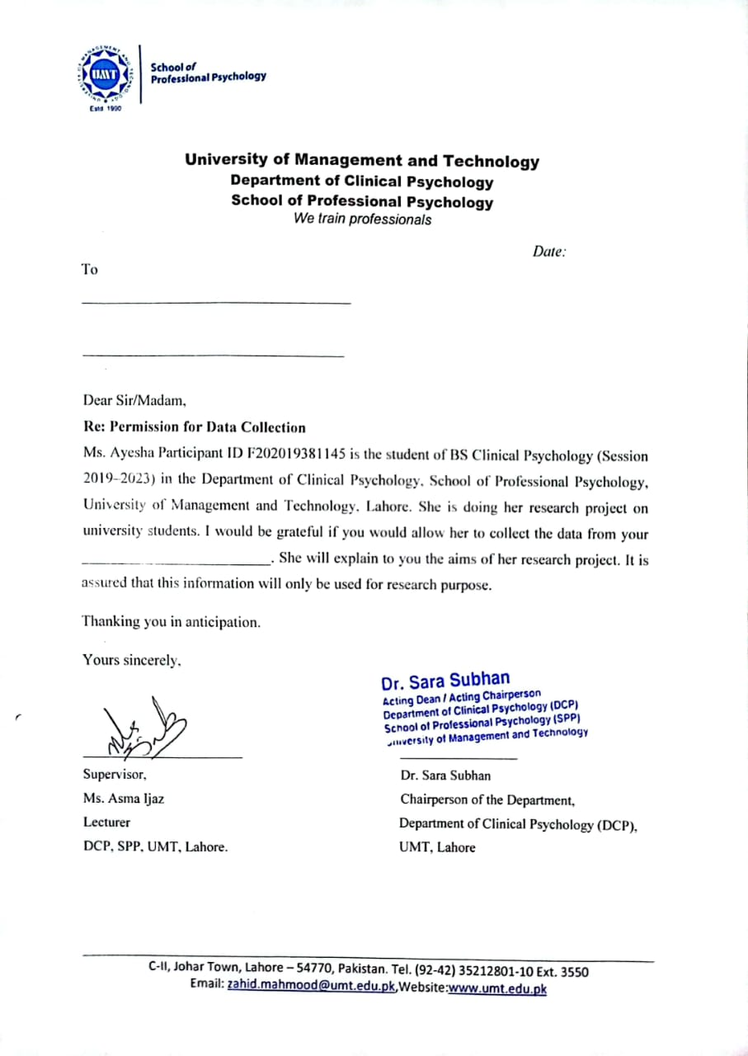
Appendix B

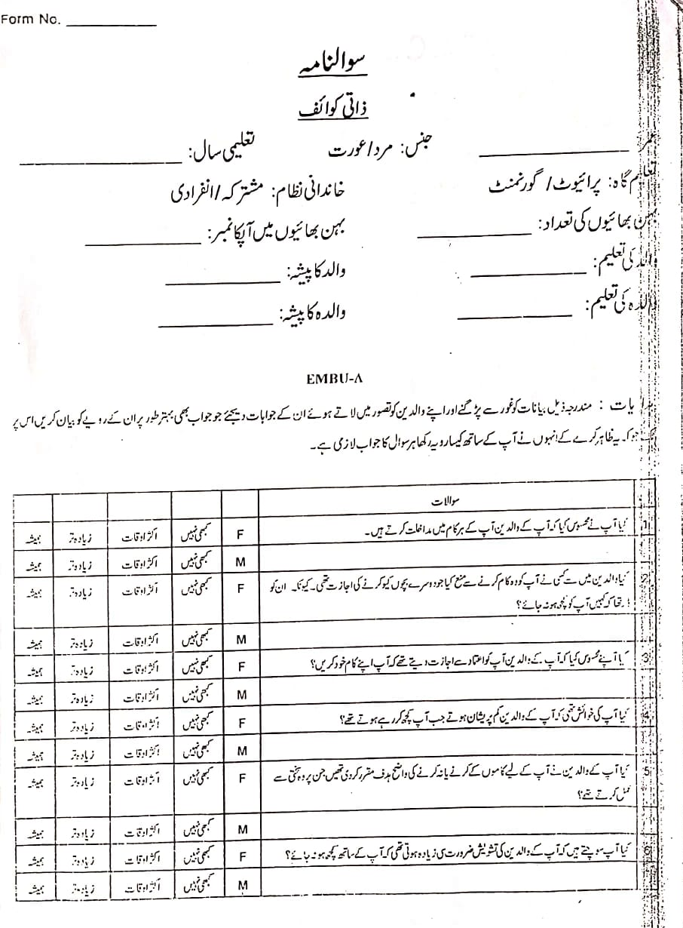
Appendix C
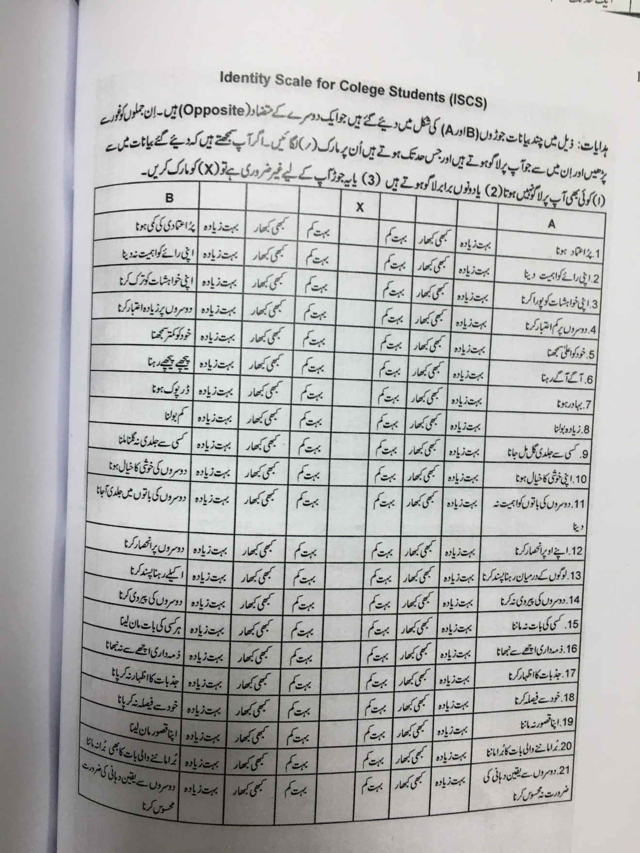
Appendix D
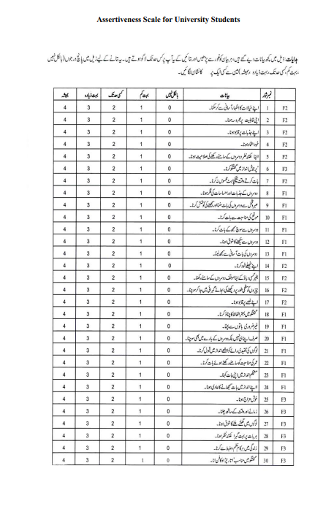
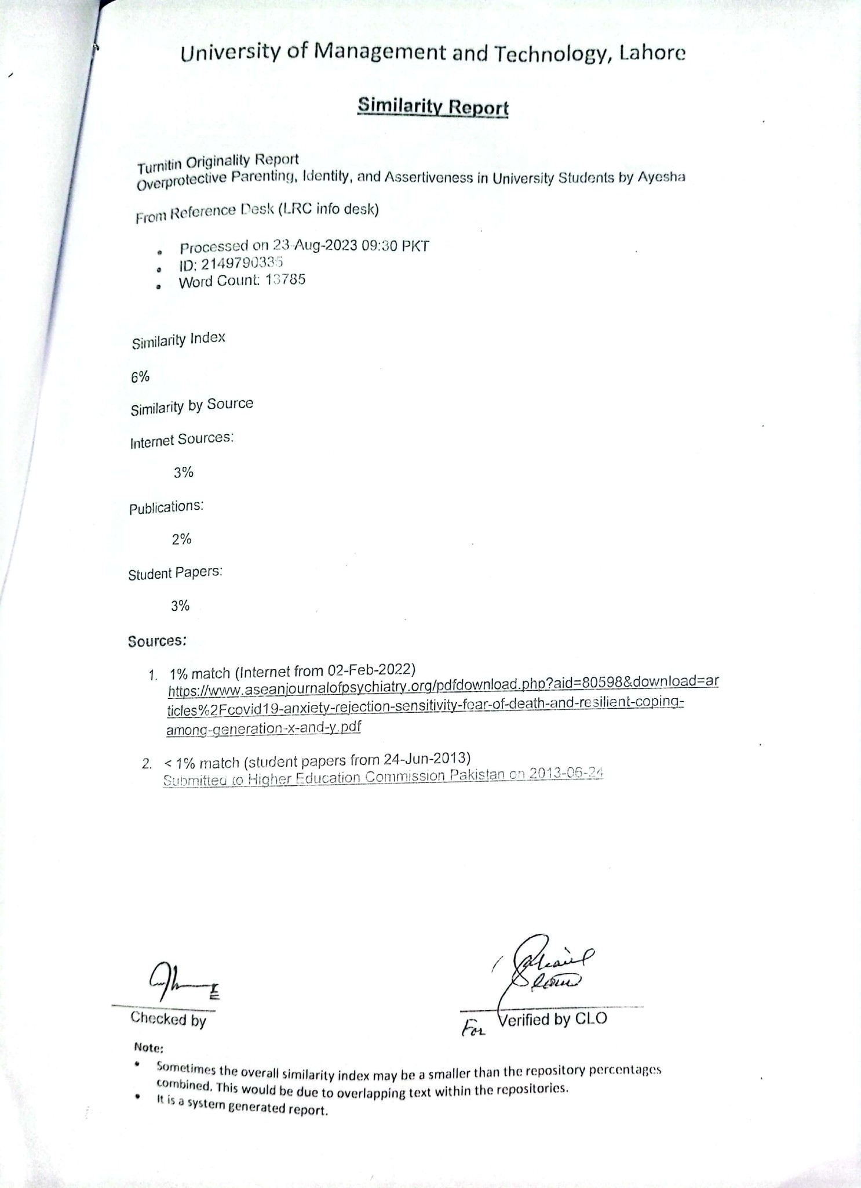
Appendix E

Department of Clinical Psychology
School of Professional Psychology
University of Management and Technology
We train Professionals
Certificate of Approval of Thesis
Name of Participant/Candidate: Ayesha
Participant ID: F2019381145
APA Format
✦ Title Page |  | Yes |  | No
✦ Table of Content |  | Yes |  | No
✦ Font size |  | Yes |  | No
✦ Spacing |  | Yes |  | No
✦ Margins |  | Yes |  | No
✦ Page numbers |  | Yes |  | No
✦ Alignment |  | Yes |  | No
✦ Reference citation |  | Yes |  | No
✦ Grammar Check (by using software e.g. Ginger) |  | Yes |  | No
✦ Quality of Expression |  | Yes |  | No

Research work
1. Introduction |  |  | Yes |  |  | No
- Aim |  |  | Yes |  |  | No
1.2 Implications of the current research |  |  | Yes |  |  | No
2. Literature Review |  |  | Yes |  |  | No
- Recent local and international literature |  |  | Yes |  |  | No
- Rationale of the study |  | Yes |  |  |  | No
- Research Question/s |  | Yes |  |  |  | No
- Hypotheses |  | Yes |  |  |  | No
3. Method |  | Yes |  |  |  | No
3.1 Research design |  | Yes |  |  |  | No
- Setting & Participants (sampling strategy) |  | Yes |  |  |  | No
- Measures |  | Yes |  |  |  | No
3.5 Procedure (ethical considerations) |  | Yes |  |  |  | No
4. Analyses of the results |  | Yes |  |  |  | No
5. References |  | Yes |  |  |  | No
6. Appendices |  | Yes |  |  |  | No
7. Plagiarism report |  | Yes |  |  |  | No
- Objectives |  | Yes |  |  |  | No
- This document is approved/not approved to be presented to the committee:
Approved

Signature of the Participant/ Candidate
Date:
Signature of the Supervisor
Date:

