Dedication

First of all we dedicates this project to almighty ALLAH, WHO gave us the ability to achieve this end line. I also dedicates this “Rejuvenation and Revitalization; the Modern Community Club” to community of Faisalabad and FDA. Without whom the reason to construct this project might not have had any purpose. Hopefully this will work in the betterment of the society. Although the completion of this project is not possible without affections of ALLAH and hardworking of all dedicated bodies.

Final Approval

Panel of Examiner
- Dean of Architecture and Town Planning ______________________
School of Architecture and Town Planning
UMT Lahore

- Head of Department ( Final Year Projects) ______________________
School of Architecture and Town Planning
UMT Lahore

- Supervisor ______________________
School of Architecture and Town Planning
UMT Lahore

- Co-Supervisor ______________________
School of Architecture and Town Planning
UMT Lahore

Acknowledgment

First of all I want to thank our Dean Prof. Dr. Yousaf Awan for his continuous support for this project. He was always there to listen my problems and hurdles and to give me advice on how to solve the issues .He is responsible for involving us in this entire project throughout. He taught us different ways to explore the problems and need to be persistent to accomplish any goal. I also appreciate the department faculty who was there constantly to help us on almost daily basis especially Sir Sajjad Haider, Mam Memoona Rashid, And Mam Faiqa Khilat who gave us permission to keep up different ideas. Most important thing we used Architecture Studios which have been specified for final year student of Architecture from our Organization University of Management and Technology on the behalf of Head of Department of Architecture and Town Planning.

Abstract

Faisalabad is famous for its industrial development in textile sector .a community club for the third largest population of Pakistan (2,506,595). Faisalabad is growing dramatically and is developing at a very fast rate compared to other cities. Compared to Lahore even though it has less than ½ the population it however cater more of the business class population.

Table of Content
Contents
Dedication 1
Final Approval 2
Acknowledgment 3
Abstract 4
Table of Content 5
List of Figures 8
Introduction 11
1.0 Project Introduction 11
1.1 Project: 11
1.2 Location of Site: 11
1.3 Client: 11
1.4 User: 11
1.4.1 Culture of Faisalabad 12
1.4.2 Festivals 12
1.4.3 Attire 12
1.4.4 Literacy 13
1.4.5 Cuisine 13
1.5 Project Name and Logo 14
1.6 Concept 14
1.7 Motivation: 16
1.8 Scope of the Project 17
1.9 Thesis Statement 17
1.10 Feasibility 17
1.11 Methodology 17
1.12 Scope of Work 18
1.13 Project Philosophy 19
1.14 Aims and Objective 20
Literature Review 22
2.1 What is Community Club? 22
2.2 What are different function of community club? 22
2.3 Who owns and organize a community center/Club? 23
2.3.1 How does a community owned community club/centers works? 23
2.3.2 How does a government owned community club/center works? 23
2.3.3 What is a sponsored community club/center? 23
2.3.4 How does a commercial owned community club works? 23
2.4 What is the difference between a Country Club and Community Club? 24
2.5 What is the concept behind community gathering and why is it important? 24
2.6 What are the categories of a Community Centre/Club? 25
2.6.1 Recreational Activity based 25
2.6.2 Educational Activity based 26
2.6.3 Youth Clubs or Youth Centre 26
2.6.4 Political activity based Community Club 26
2.6.5 Community development based 27
2.6.6 Cultural based Community Centers 27
2.7 Culture 27
2.7.1 Description 28
2.8 Activity based Community Centers can be classified as follow 28
2.9 Information Related to Shigeru Ban Paper Board Tubes 29
2.9.1 Paper Tube Manufacturing and Primary Uses 30
2.9.2 Application of Paperboard Tubes in Architecture 32
2.9.3 Paperboard Tubes in Construction Engineering 33
Case Studies 35
3.1 The Chenab Club Pvt. Ltd. 35
3.1.1 Introduction 35
3.1.2 History 35
3.1.3 Facilities 38
3.1.4 Reason for Selection 43
3.2 Nine Bridges Country Club 45
3.2.1 General Information 45
3.2.2 Introduction 45
3.2.3 Design 46
3.2.4 Structure 47
3.2.5 Reason for Selection as Case Study 50
3.3 The Lahore Gymkhana 50
3.3.1 Introduction 50
3.3.2 History 52
3.3.3 Facilities 54
3.3.4 Reason for Choosing Lahore Gymkhana 55
4.1 Area Calculation 58
4.2 Area Calculations for the Project 58
4.3 Grouping of requirement according to area (zoning) 59
4.3.1 Groups 59
5.1 Justification of Selected Site 63
5.1.1 Why the site have been selected in Faisalabad? 63
5.2 Climate of Faisalabad 64
5.2.1 Extremes of the Weather Elements 65
5.3 Location of Selected Site 67
5.3.1 Distance of site from Famous landmarks 68
5.4 Site Analysis 69
5.4.1 Geology of the selected site 69
5.4.2 Aesthetic Factors 69
5.4.3 Infrastructure 69
5.5 Climatic Analysis of Selected Site 71
5.5.1 Sun path 71
5.5.2 Wind directions on site 72
5.5 Graphical analysis W.R.T Site 74
5.6.1 Neighborhood 74
5.6.2 Population 74
5.6.3 Traffic 76
5.6.4 Site 77
6.2 Master Plan 80
6.2 Site plan 81

List of Figures
Figure 1 Users 11
Figure 2 logo 14
Figure 3 interlocking concept 14
Figure 4 topiary art 15
Figure 5 logo concept 15
Figure 6 Sonotubes 30
Figure 7 Spiral paper tube manufacturing 31
Figure 8 Paper tube architecture 32
Figure 9 Chenab Club 35
Figure 10 Chenab Club entrance 35
Figure 11 Cinema 38
Figure 12 Bowling Alley 38
Figure 13 Rooftop Bar B Que 38
Figure 14 Dining Hall 39
Figure 15 Marriage Hall 39
Figure 16 Marquee 39
Figure 17 Café Gup Shup 40
Figure 18 Palm Garden 40
Figure 19 Library 40
Figure 20 Guest Room 41
Figure 21 Tennis court 41
Figure 22 Squash Court 41
Figure 23 Male Gym 41
Figure 24 Chess room 42
Figure 25 Swimming pool 42
Figure 26 badminton Court 42
Figure 27 Table Tennis 42
Figure 28 Master plan of Chenab Club 44
Figure 29 Side Elevation 45
Figure 30 Nine Bridge Country Club 45
Figure 31 timber roof Structure 46
Figure 32 timber roof Structure 46
Figure 33 Section of Nine Bridges 47
Figure 34 Interior of Nine Bridges Country Club 48
Figure 35 Ground Floor Plan Of Nine Bridges Country Club 49
Figure 36 Golf 54
Figure 37 swimming pool 54
Figure 38 Squash Court 54
Figure 39 Pool Table 55
Figure 40 Tennis Court 55
Figure 41 Lahore Gymkhana plan explained 56
Figure 42 table showing climate of Faisalabad 65
Figure 43 Bar chart of Monthly climate in Faisalabad 66
Figure 44 Location of Site 67
Figure 45 Site Images 69
Figure 46 Site Images 70
Figure 47 Sun Path and wind direction 71
Figure 48 Wind Direction in Summers and Winters 73
Figure 49 Neighborhood around Site 74
Figure 50 Population in 1998 and 2017 74
Figure 51 Population per square kilometer 74
Figure 52 Residential settlement of population around site 75
Figure 53 Traffic on average day (day time) 76
Figure 54 Traffic flow around site 76
Figure 55 Average traffic flow of Faisalabad 76
Figure 56 Site Dimensions 77
Figure 57 Site Byelaws 77
Figure 58 Site Visibility from inside and outside 78
Figure 59 Site Zoning 78
Figure 60 Master plan 80
Figure 61 Site plan 81

INTRODUCTION

(Chapter 1)

Introduction

1.0 Project Introduction

1.1 Project:
The Modern Community Club

1.2 Location of Site:
Faisalabad, Punjab, Pakistan

1.3 Client:
Faisalabad Development Authority FDA, Govt. of Pakistan

1.4 User:
The community of Faisalabad



Figure 1 Users

1.4.1 Culture of Faisalabad
Faisalabad, the third most populated metropolis in Pakistan, after Karachi and Lahore, is an epic centre for trade that has gained popularity for its colonial heritage sites. In 1982, the Government of Punjab established the Faisalabad Arts Council, a division of the Punjab Arts Council which is overseen administratively by the Information, Culture and Youth Affairs Department

1.4.2 Festivals
The Punjabi people celebrate a variety of cultural and religious festivals throughout the Punjab region, such as arts and craft, music, local events, and religious celebrations. The city of Faisalabad customarily celebrates its independence day on 14 August every year by raising the Pakistan flag at the clock tower in the Commissioner Office compound. Bazaars are colorfully decorated for the celebration, government and private buildings are brightly lit, and there are similar flag–raising ceremonies that are typically held in the district and its tehsils.

1.4.3 Attire
Traditional attire in Faisalabad is Punjabi clothing such as the dhoti, kurta and pagri. Faisalabadi men wear white shalwar kameez as do women but also with a dupatta (scarf). The more conservative women wear burqas that may or may not cover the face. Combinations of Pakistani and Western attire are worn by women, such as an embroidered kurta worn with jeans or trousers, and half sleeve or sleeveless shirts with Capri pants. Men have adopted some of the modern Western styles for both casual and formal business dress such as dress pants, trousers, T-shirts and jeans.

1.4.4 Literacy
According to a report by the United Nations Educational, Scientific and Cultural Organization (UNESCO), the 2015 literacy rate for Pakistan ranked 160th which is among the lowest literacy rates in the world.
In 1981, Faisalabad was among four districts in Punjab, which included Gujranwala, Jhelum and Gujarat that were experiencing low literacy rates, due primarily to either a lack of resources or family pressure; the latter of which may also be attributable to illiteracy.
In 1998, Faisalabad progressed to a higher literacy rate with the most improvement realized at the primary school level. In 2008, Faisalabad District ranked 51.9% which placed the district 9th in literacy out of the 34 Punjab districts.
In 2014, the city held its first literary festival which brought a number of writers to the city to encourage the community to follow the arts. Two literary groups were established, the Faisalabad Union of Column Writers and Faisalabad Union of Journalists, to bring together printed media personalities for the purpose of providing training to budding writers from the city

1.4.5 Cuisine
Faisalabadi cuisine is very much Punjabi cuisine, with influences from the realms of the Mughal and Colonial empires. Key ingredients include rice or roti (flatbread) served with a vegetable or non-vegetable curry, a salad consisting of spiced tomatoes and onions, and yogurt. This is usually accompanied by a variety of South Asian sweets such as jaggery, gajar ka halwa, gulab jamun, and jalebi. Tandoori barbecue specialties consist of a variety of naan bread served with tandoori chicken, chicken tikka or lamb shish kebab served with a mint chutney.
A typical breakfast in Faisalabadi is halwa poori comprising a deep fried flatbread served with a spicy chickpea curry and sweet orange colored halwa. It is customarily accompanied by a sweet or salty yoghurt based drink called lassi. During winter, a common breakfast is roghni naan bread served with paaya curry.

1.5 Project Name and Logo
Project Name: Topiary Community Club
Project Logo: 
Figure 2 logo

1.6 Concept
The concept behind designing spaces: A concept of puzzling spaces and functions in a clustered building, open spaces and flexible functional spaces are interlocking with each other. The interlocking acts as the branches of a tree which are all linked to the trunk of the tree.
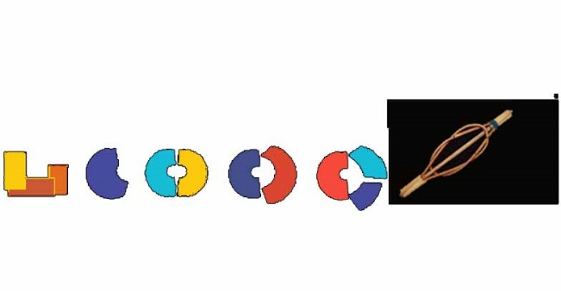
Figure 3 interlocking concept
The concept behind name: The word “Topiary” comes from the horticultural practice of training perennial plants by clipping the foliage and twigs of trees, shrubs and subshrubs to develop and maintain clearly defined shapes, whether geometric or fanciful. Associating a project with nature explains that it will grow and as topiary is an art, it will not only grow but always maintain its shape.
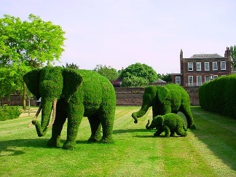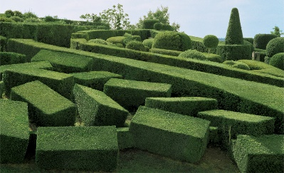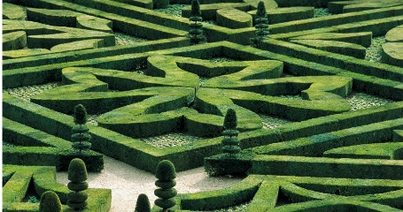
Figure 4 topiary art
The concept behind logo: The logo represent the people as the branches of the community club. To form any community the solidarity and the support of the members of the society is of epitome importance. Without these branches the tree would fall apart. The trunk represents the main body of a community club who will hold all of them together. The colorful theme gives an effect of something entertaining, something fun, something having an atmosphere of enthusiasm, liveliness and excitement.

Figure 5 logo concept

1.7 Motivation:
Faisalabad is the city of Pakistan with third largest population. Compared to other major cities like Karachi and Lahore, given by the population count Faisalabad deserves a community club to cater and enhance the lives of the people living there. It is also one of the fastest growing city of Pakistan in terms of Industrial development. The already existing community club with the region is the Chenab club which was built in 1909 and over hundred year of time period, it fails to provide a rhythmic master plan and elevation design, as over time the needs of people have expanded. Pakistan is no more under the rule of British and it’s high time it need to make a modern community club.
Faisalabad, the third most populated metropolis in Pakistan, after Karachi and Lahore, is an epic Centre for trade that has gained popularity for its colonial heritage sites. This trading and market in textile sector attracts many people from bourgeois class of Pakistan and different other nations to settle in Faisalabad. In 1982, the Government of Punjab established the Faisalabad Arts Council, a division of the Punjab Arts Council which is overseen administratively by the Information, Culture and Youth Affairs Department.

1.8 Scope of the Project
The scope of the project is to provide a community club for the third largest population of Pakistan (2,506,595). Faisalabad is growing dramatically and is developing at a very fast rate compared to other cities. This city is famous for its industrial development in textile sector. Compared to Lahore even though it has less than ½ the population, it still caters more of the business class population.

1.9 Thesis Statement
Revitalization and Rejuvenation of Community club in Faisalabad

1.10 Feasibility
The purpose of this project is to Revitalize and rejuvenate the community club in Faisalabad. As the only two existing community clubs in Faisalabad are:
- The Chenab Club
- The Minerva Club
The Chenab club was built in 1909 by the British and is one of the very known clubs in Faisalabad, but over the period of 100+ years the master plan is not very effective. But more importantly this club alone could not cater the growing population of Faisalabad and there is a dire need for another well-constructed club.

1.11 Methodology

- Case Studies
- Online Research
- Library Research
- On site survey
- Books
- Articles
- Interview/Discussions
- Maps

1.12 Scope of Work

- 3d Cineplex Cinema
- Bowling Alley
- BBQ area and rooftop BBQ
- Lounge for parties
- Wedding halls and Marquees
- Meeting and conference halls
- Dining halls
- Café (informal)
- Jacuzzi, Steam bath, Sauna bath
- Billiard room
- Table tennis room
- Coffee and tea café with the option of open air sitting
- Common rooms
- Library
- Barber shop
- Guest rooms
- Masjid
- Tennis court
- Badminton hall
- Swimming pools
- Gymnasium
- Squash Complex
- Chess room
- Ladies Gymnasium
- Card room
- Common garden for events
- Parking

1.13 Project Philosophy

The philosophy behind the creation of this Community center is to facilitate the people of Faisalabad as well as the people who are coming from another nation or another city for business or tourism purpose. The project seek to provide a facility of recreational skill development and education for community and a public space as to engage them in foster civic development. The Club will have the facilities like Hotel, Library, Mini Golf, Bowling Alley, Tennis Court, Badminton Court, Cineplex, Bar B Que, Wedding Hall/ Marquee, Swimming pool, Jacuzzi etc. The Club will also have an open garden for concert or event purposes, Auditorium for the seminars related to business activities, new research, society development etc. It will also have restaurants and café.

1.14 Aims and Objective

- Offer activities that promote social interaction, culture, wellness and recreation for mainly youth and the Faisalabadi community
- Create a multi-use facility through flexible scheduling and programs that respond to the interest and growth of the community.
- Foster a healthy social community by providing interactive spaces, good public spaces on project site
- Foster civic engagement by providing place based education to the community
- Architecture can both dictate and facilitate our behaviours
- Programs to be incorporated in the facility by looking at the interests needs and skills of the user which will help in fostering development of the community civic engagement
- Thinking along the lines of oasis there should be a place that is not about transition, but of dormancy, contemplation and rest. This is a community where many people are social and political refugees. This would be a space where the mind and body can be at peace.

Literature Review

(Chapter 2)

Literature Review

2.1 What is Community Club?
A place where people from particular area can meet for social events, education classes, or recreational activities. They are basically centers in public location where members of a community tend to gather for group activities, social support, public information and other purposes.

2.2 What are different function of community club?
Community clubs or community centers may sometimes be open for the whole community or for a specialized group within a greater community it can be a religious based community center, social activity based, educational based, political based, recreational based, youth club, housing and local volunteer activity based etc. the list goes on and on within the radius of the activity a community prefer.

2.3 Who owns and organize a community center/Club?
A community club can be community owned, it can be government owned or it can also be sponsored, it can also be part of commercial entity

2.3.1 How does a community owned community club/centers works?
A community owned community club is directly owned and run by the local community through an organization separate from governmental institutions

2.3.2 How does a government owned community club/center works?
A government owned is a public facility owned and run by the government. These sorts of community club are always funded by the government and there development budget is never a problem as long as it is justified and for the sake of community.

2.3.3 What is a sponsored community club/center?
A sponsored community club/center is a community club that is often funded by the rich citizen or Commercial Corporation. In both the cases the land and building is owned by the citizen or Commercial Corporation and is donated to the community for the reason of charity or public relation.

2.3.4 How does a commercial owned community club works?
Commercial is when community center/club is purely owned for commercial entity which tries to profit from renting its facilities to various community groups on terms suitable for such use. This sort of community club/center is not for charity but to provide profit to an organization or body who owns it.

2.4 What is the difference between a Country Club and Community Club?
A club is defined as an establishment where people associate to pursue social, political, or sporting activity. A Country Club includes all the facilities provided in a club but it is located in city’s outskirts or suburbs. The concept of the Country Club is same as Community club but it is always located in an isolated area, away from the busy city and it has recreational activities and halls for dining. In a Country Club a community gathering for entertainment is the primary focus rather than community club gather for seminars and new research. A Community club include all the social activities, recreational activities, educational activities, political activities etc which are the need of a community gathering and a community club is always located in a city and that too as preferred in center of a city and close from travelling terminals such as railways station, bus station and Airport.

2.5 What is the concept behind community gathering and why is it important?
The traces of community gathering goes way behind that it is hard to track where it begun but the basic concept of community gathering is to gather people for group activity, decision making, social support, public information etc. All of which are beneficial for uplifting the society.

2.6 What are the categories of a Community Centre/Club?
A community center can be of various types depending upon its function. The functions however can be subcategorized as follow
- Recreational activity based
- Educational activity based
- Youth Club/Centers
- Political activity based
- Community development based
- Cultural based

2.6.1 Recreational Activity based
Recreation is an activity of leisure, leisure being discretionary time. The “need to do something for recreation” is an essential element of human biology and psychology. These type of community club contain recreational activities often done for enjoyment amusement, pleasure and are considered “Fun”. Recreational activities can be communal or solitary, active or passive, outdoors or indoors, healthy or harmful, useful for society or detrimental. A list of typical activities could be reading, playing or listening to music, watching movies, or TV, gardening, hunting, sport, studies, and travel. Some recreational activities which are harmful include gambling, recreational activities drug use or delinquent activities- these violate societal norms and laws. Different king of recreational activities include camping scuba diving, fishing, surfing, wind surfing, skiing, parasailing etc.

2.6.2 Educational Activity based
It is basically a Community Centre where member share ideas, practices and information. They develop support groups, create awareness about something new, learn about newest research, share research, and network with others having similar career goals. Such Community Centers often features guest speakers who are professionally affiliated with a certain topic or knowledgeable about it whereabouts. Member of such community club also enjoy social event which have both an educational sessions and social events. These social events can feature fund raising activities to help provide fund for educational sector within a community or a city.

2.6.3 Youth Clubs or Youth Centre
Youth club or Youth Centre is a place where young people can meet and participate in various activity such as football, spectator sports, swimming, table football (foo’s ball), Snooker, Basketball, Tennis, Gymnasium etc. The activities of youth club varies across the globe and have diverse histories based on shifting culture, political, and social context and relative level of state funding or voluntary action. Some youth club also focuses on keeping the street children or homeless children off the streets by providing them with jobs.

2.6.4 Political activity based Community Club
These types of community clubs are like usual community clubs but in these clubs gambling, card games, alcohol bars and party halls are primary focus. As the nature of majority of the politician around the world and there type of gather is slightly different from the middle class people of the society. These type of community clubs also have seminar halls, auditorium and conference halls for reducing the communication gap.

2.6.5 Community development based
These are the type of community club dedicated to certain community. In such clubs people often gather and share their ideas regarding the growth of a community. In case of disastrous situations like earth quake, suicide bombing, robbery etc. these community club are also sort of place people seek for relief. The sole purpose of such clubs is to gather a community in one place for helping and looking after each other. Fund raising events are also part of such community clubs. Such community clubs have more educational based facilities like libraries conference halls compared to other recreational activities like cinema bowling alley.

2.6.6 Cultural based Community Centers
Culture is basically the customary beliefs, social forms, and material traits of a racial, religious, or social group. The characteristic features of everyday existence (such as diversions or a way of life) shared by people in a place or time. A community club that is cultural based often caters to one type of culture for example a Pashtun culture or Punjabi culture. However there are many community clubs that caters more that one culture. These clubs host different activities related to each culture like Afghan cultural dance, Classical musical nights, clothing exhibition etc.

2.7 Culture
Culture is a very vast and complex form of living styles as they vary from region to region and nation to nation. But there are some terms which can define different cultures in same defined characteristics. We can understand there philosophies and manifestations if we can categorize a “Culture” according to them

2.7.1 Description
Culture refers to the following Ways of Life, including but not limited to:
Language: the oldest human institution and the most sophisticated medium of expression.
Arts & Sciences: the most advanced and refined forms of human expression.
Thought: the ways in which people perceive, interpret, and understand the world around them.
Spirituality: the value system transmitted through generations for the inner well-being of human beings, expressed through language and actions.
Social activity: the shared pursuits within a cultural community, demonstrated in a variety of festivities and life-celebrating events.
Interaction: the social aspects of human contact, including the give-and-take of socialization, negotiation, protocol, and conventions. ETC.

2.8 Activity based Community Centers can be classified as follow
- A place for all community celebration at various occasion/tradition
- A place for public meetings of the citizen on various issues
- A place where politicians or other official leaders come to meet the citizens and ask for their opinion, supports and votes during elections
- A place where community members meet each other socially
- A place for housing local clubs and volunteer activities
- A place where member can rent cheaply halls for private family function or private parties
- A place that passes on and tells local history
- A place where local non-governmental activities are organized
- A place of relief in instances of community tragedies

2.9 Information Related to Shigeru Ban Paper Board Tubes
Paperboard tubes are ubiquitous and are found in every aspect of modern day life. In the industry, the terms paperboard ‘tube’ and paperboard ‘core’ are used interchangeably. They are produced for a myriad of industrial applications and consumer products and are sometimes considered to be commodity products, but most are actually highly engineered. On a global basis, the majority of paper tubes are used in industrial winding operations. In these applications, immediately after being manufactured, either paper, film or textile yarn is wound directly onto paper tubes. The paper tube helps the wound material develop a stable roll structure and enables transportation of the manufactured material to a converting operation. These tubes range from small (10 – 25 mm diameter with 0.5 – 1.5 mm wall thickness) to wind paper, plastic, aluminum, cloth and yarn consumer products, to large industrial cores (70 – 200 mm diameter having 10 – 25 mm wall thickness) to wind rolls of printing paper, plastic film, textiles, and specialty metals. Such tubes are designed to be used in interior environments for winding, transportation and finishing operations; not exterior environments where they are exposed to rain or high humidity. Most tubes for industrial markets are structurally optimized and engineered products. This is achieved by selecting proper paperboard strength and stiffness, tube thickness, ply positioning in the wall, and adhesive type in the design process. For example, certain paper mill cores are designed both for fatigue strength to support a heavy cyclic load from winding a large roll of paper and also sufficient axial modulus to prevent core vibrations when unwinding the paper roll on high-speed rotogravure presses. Such cores generally require thick walls (10 - 15 mm) and fabrication from high strength paperboards.

Figure 6 Sonotubes

2.9.1 Paper Tube Manufacturing and Primary Uses
Spiral paper tubes are manufactured using a continuous process as illustrated in Figure 7 (Wang, et al. 1995). The belt is stretched and rotated to drive the entire manufacturing process. The belt pulls the paper plies through an adhesive station onto a stationary winding mandrel to form a continuous tube. The newly formed tube is cut to the desired length at the end of the mandrel. Paper tubes are typically used to wind materials such as paper, film, metal sheet or textile yarn into a roll immediately after they are manufactured. Typically, the wound rolls are then transported to a converting operation, such as a printing operation for paper or a coating operation for film. In some applications, the wound roll is shipped for direct use after winding, such as a film roll used in (a) (b) stretch wrapping operations. Paper tubes are also used in consumer markets to wind products like paper towels and bathroom tissue. These tubes are typically small diameter and manufactured using only a few plies of paper.
For these typical uses, paper tubes and the wound rolls are used inside manufacturing facilities or in the household. Paper tubes are not designed for exterior use. Exterior applications are quite challenging as paper tubes experience significant strength and stiffness loss when exposed to water or even high humidity conditions. Since paper tubes are typically not treated to inhibit moisture penetration, it is the paper’s strength loss when combined with water that enables paper tubes to be easily recycled using standard pulping operations. Recycled paper tubes are an important raw material source for manufacturers of recycled paperboard
Figure 7 Spiral paper tube manufacturing

2.9.2 Application of Paperboard Tubes in Architecture
Paper strength is significantly reduced when it is exposed to elevated humidity environments, so the use of large paperboard tubes in load–bearing architectural structures is uncommon. Nevertheless, such applications are quite well-known due to the unique and pioneering work of the 2014 Pritzker prize-winning Japanese Architect Shigeru Ban (Anon, 2014a) who has designed and constructed many temporary or semi-permanent paperboard tube structures for exhibition spaces
Figure 8 Paper tube architecture

2.9.3 Paperboard Tubes in Construction Engineering
The use of paperboard tubes in construction engineering is much more well-known than in structural engineering primarily due to the popularity of paperboard tubular forms for concrete columns for building frame construction. Often called “SONOTUBES,” they were originally trademarked by Sonoco Products Company in 1945 (SONOTUBE®) and a US patent was granted in 1954 patent for a design with an improved inside tube surface (polyethylene) (Copenhaver et al, 1954). Such tubes are now produced worldwide by many manufacturers. Forms are commercially available in standard diameters ranging from 50 to 1500 mm and in lengths up to 18 m. Paper tubes can also be used in the construction of voided-slabs

Case Studies

(Chapter 3)

Case Studies

3.1 The Chenab Club Pvt. Ltd.

3.1.1 Introduction
The Chenab Club is an exclusive club whose membership comprises government officials, diplomats and the elite of Faisalabad. Spread over an area of 72 Kanals. The diplomatic enclave and government offices are nearby. The site area is 501,927.04 sqft. The site is situated at tail end of Jinnah garden Faisalabad. The site is connected with Sargodha road and Bilal road. It has around 2900 members. It is situated in the heart of the city. It is at a distance of 1 Km from the Railway Station and 13 kms from the Airport.
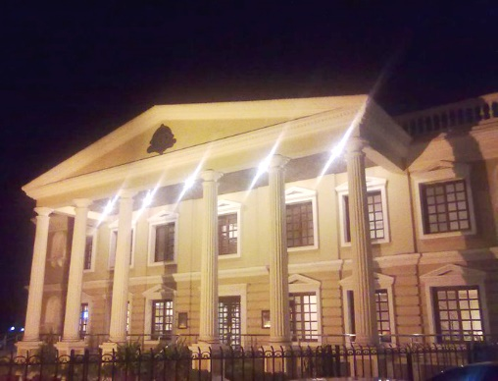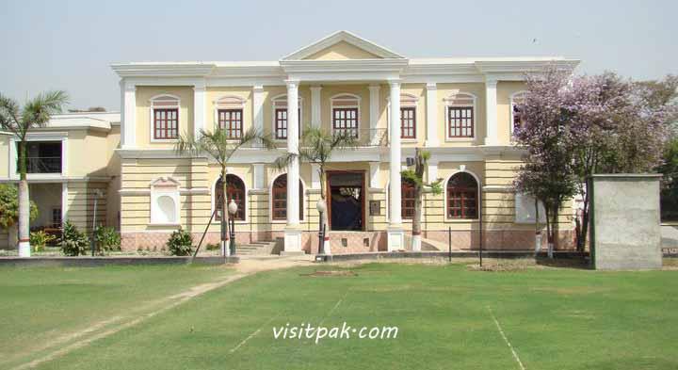
Figure 9 Chenab Club

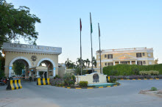
3.1.2 History
Figure 10 Chenab Club entrance
During the first decade of the 20th century, Mr. Henry Cues (1904–1906), the first deputy commissioner (D.C.) of Lyallpur (now Faisalabad), established a social club where the British officers serving in "Sandal Bar" could gather at their leisure. In December 1909, Captain Dugglis was appointed as new D.C. of Lyallpur.
The club is the focal point of the western culture in the absence of which westerners feel as fish without water. However a day dawned for this historic event. The club was built for off-duty British officers and the cost of construction was paid for by the officers themselves. 36 club hungry persons sat together to collect individual funds to plant a club. The individual maximum contributing figure was Rs.500 the minimum contribution was Rs.10 Thus a meager amount of Rs.2080 was collected
In March 1910, the club was established in Qaisary Bagh (Now Company Bagh/Jinnah Garden). The land for this purpose was acquired from Irrigation Department.
The land of the club is 72 Kanals. The club was established in 1910 and ever since has been promoting social, cultural and sports activities in the region for the last more than 100 years. It has around 2900 members. It is situated in the heart of the city. It is at a distance of 01 Kms from the Railway Station and 13 Kms from the Airport. As regards the level of excellence and adequacy required of international norms, the Chenab club conforms to all the requisite standards measured by any yardstick. It may confidently be vouchsafed as a symbol of high social order.
There are two distinct epochs in the century – old existence of the club viz. before partition (1910 – 1947) and the post partition (1947- to date). Regardless of this division, it has always been a centre of gravitation for a variety of social, cultural, sports and other recreational activities in town. Up to the year 1942, the membership of the club was restricted to the white members of the (crown) civil service. In 1942 when the mysterious curtain surrounding the club and it inmates, was slightly lifted when few Ibdian, for the first time, were admitted in the club excepting three Muslims, two Hindus all the rest were Sikhs including Sardar Balwanat Singh a graduate from Oxford University.
Afterwards the native elite began to be inducted on the club roll. Over the years, the club membership has assumed a distinctive group character with major groups being those of businessmen, doctors, professors, lawyers, intellectuals and government officers.
After the independence, 1947 there came a wave of widening club membership. A new dimension of a very high order was introduced in 1960, in club life intellectuals + literary activities under English influence. A tiny humorous and satirical journal in the club, entitled as the “Chenab Chatter”
Claiming that I contained facts, Fancy, Sense, Nonsense, of the Chenab Club. Its life period was short but its influence widely enlivening, rather hilarious.
A bright break through towards intellectual activities in the historic, rich, memorable of 1960 when Indo-Pakistan mushairs found footing and popular response of the club members. During that high pitch period top-notch intellectuals visited the club to introduce Talent Display in the club atmosphere. Amongst the visitors were Qurat ul Ain Haider, Mushtaq Usafi, Abdullah Hussain Bilraj Mehra, Jelani Kamran, Wazir Agha, Shahzad Qaiser, Partoo Roheela, Porf. Irshad Ahmad Khan, Dr. Mubasher Hasan, Dr. Mubarak Ahmad, Nelofer Bakhtiar, Ata ul Haq Qasmi, Munnu Bhai, Mustansar Hussain Tarar.
After the independence 1960’s, literature, music, mushaira and intellectual moots became the focus of club activities besides sports, exhibitions and indoor chatting. Golf, polo, dancing and bar were gradually deleted from the charter of club activities and now lawn tennis, squash, billiards, badminton and swimming have become the official sports of the club instead of golf and polo.
Earlier expansion of the building had started in the mid 1950’s which continues to date to meet the requirements of an ever growing enrolment. Presently the club has beautiful club buildings including sports complex, restaurants, lounges, auditorium and 40 guest rooms.

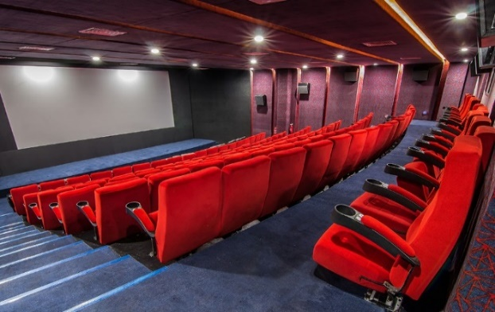
3.1.3 Facilities
- 3-D Cineplex has been started and latest movies are being screened. The cinema consist of Sofa Seats
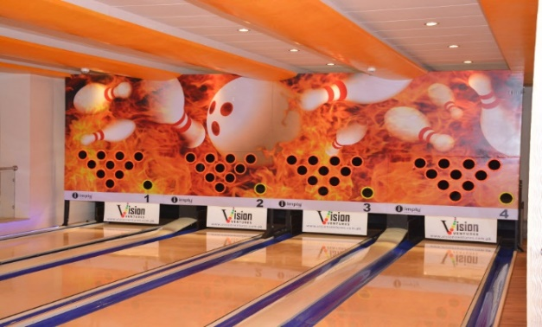
Figure 11 Cinema
- The Bowling alley in any renowned club in Pakistan with the latest and the most beautiful Equipment imported from Brazill.

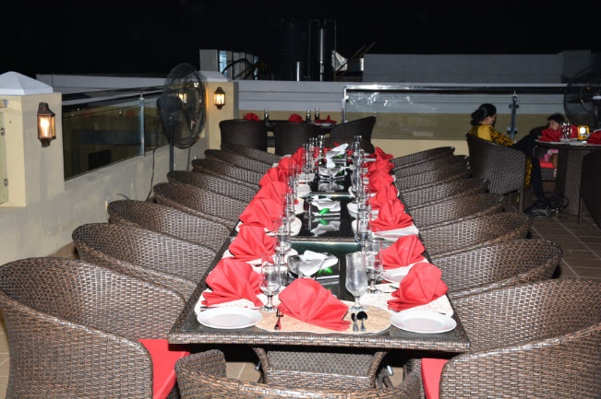
Figure 12 Bowling Alley
Figure 13 Rooftop Bar B Que
- The Roof top barbecue (Rachna Grill) has been started. Members & their families are being entertained with Lebanese Cuisine & Traditional Barbecue.
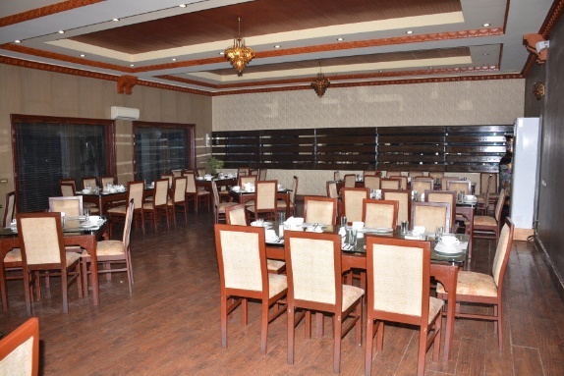
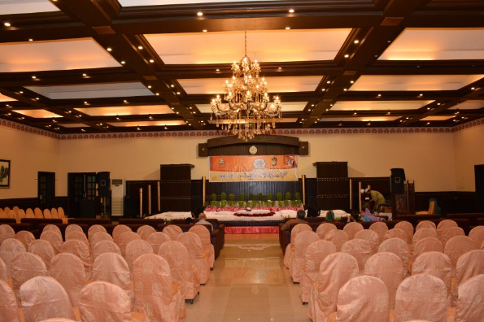
- The club has three lounges, one is the Sitting Lounge with wooden floor which has historic value as it was laid in 1910. This Lounge is furnished with high quality furniture. The second lounge is T.V. lounge. The third lounge is Ladies sitting loungr equipped with T.V. and excellent furniture.
Figure 14 Dining Hall
Figure 15 Marriage Hall
- A beautiful multipurpose pillar less hall titled as Lyallpur Hall social gatherings. It has been named after the name of Sir James Broadwood Lyall the then Governor of the Punjab
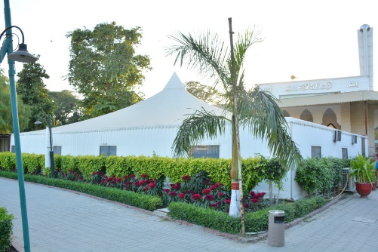
- An air-conditioned eautiful Marquee has been constructed for parties. which is sufficient to cater the needs of about 120 persons. Moreover meetings / conferences can also be arranged in this air conditioned hall.
Figure 16 Marquee
- The Club consist of two dining halls. Both the dining halls are air-conditioned. One hall is meant for Pakistani and continental dishes and the other one serves Chinese cuisine. The dress code is observed at dining halls
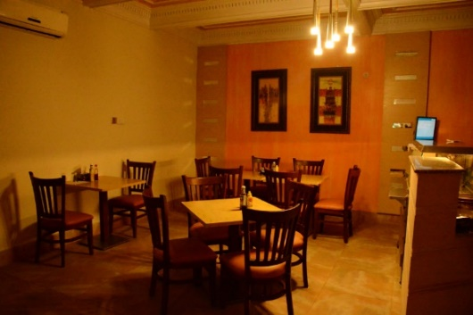
- The Café Gup Shup Lounge is capable to cater the needs of about 50 persons. Soups, Salads, Appetizers, Steaks, Pizzas, Fish, Burgers, Sandwiches, Deserts, Hot Beverages & Cold Beverages will be available.
Figure 17 Café Gup Shup
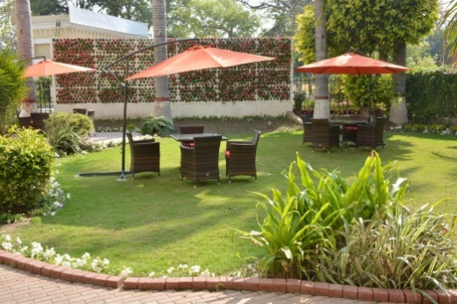
- In Palm Garden only Tea, Coffee and Juice are being served during Lunch time and afternoon
Figure 18 Palm Garden
- An air conditioned common room has been constructed and furnished with special furniture. The room is being used for meetings, conferences and dining parties upto 30 club members.
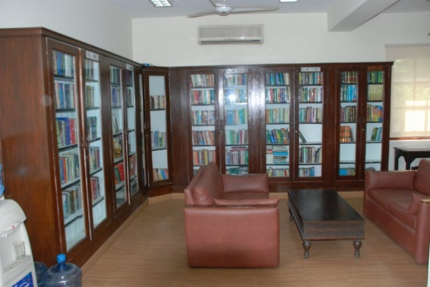
- The club has one of the best Bar B Que. It is provided in an open air sitting, rooftop and indoor sittings as well
Figure 19 Library
- The club has an air conditioned well-furnished library. Spacious seating arrangement and large variety of books have been provided. The books have been computerized and can be instantly traced.
- A well furnished air conditioned barber shop is available to facilitate our honourable male members.

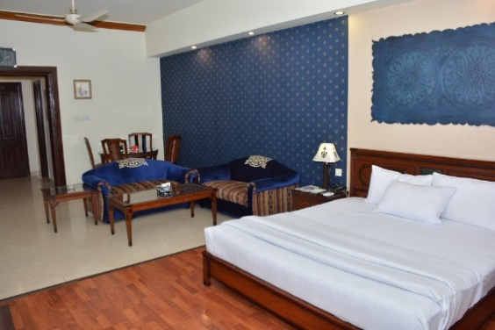
- 40 Air conditioned guest rooms are available for the guests of worthy members. All facilities of international standard are available.
Figure 20 Guest Room
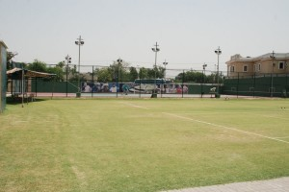
Total Guest Rooms= 40
Twin Bed= 11
Deluxe= 19
Normal= 21
- A most beautiful and air-conditioned Mosque has been constructed for its members.
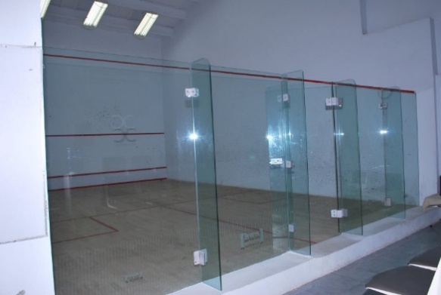
- There are 08 International Standard grass tennis courts and one hard court with latest flood lights facility. Markers and pickers are there to extend their services.
Figure 21 Tennis court
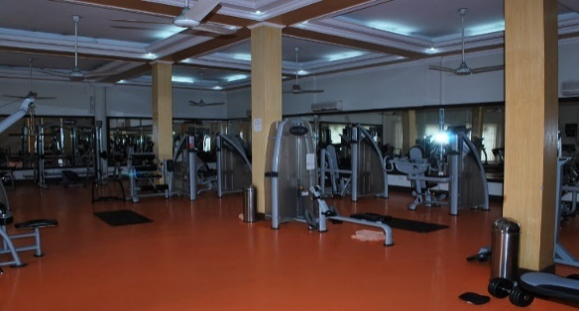
- A squash complex comprising 03 squash courts with wooden floor and glass walls are available for honorable members and their children.
Figure 22 Squash Court
- An air conditioned gymnasium with most modern machines, has been provided to attract the attention of our members
Figure 23 Male Gym
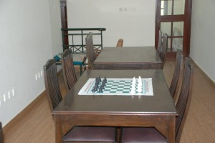
- An air conditioned Ladies Gymnasium with most modern machines has been provided.
Figure 24 Chess room
- The facilities of Chess are available in the first floor of Library Building. A coach of international standard has been employed.
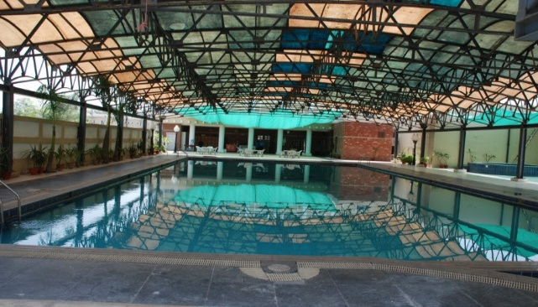
- Another important entertainment place is the card room which is fully air conditioned with special tables & Lights.
Figure 25 Swimming pool
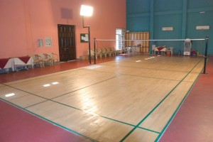
- A very high standard swimming pool for all the seasons, is available for the use of the members and their families. Filter plant has been installed and pool has been covered proper roof. Gas Heaters have also been provided.
Figure 26 badminton Court
- The facilities of Jacuzzi, steam bath and sauna bath have been provided in the vicinity of swimming pool
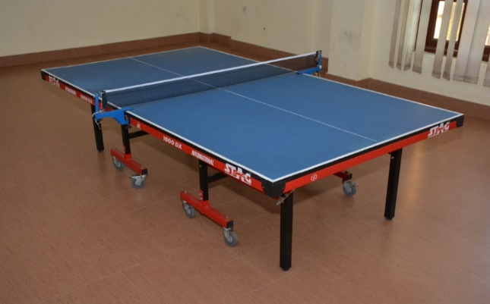
- A badminton hall of International standard with wooden courts is available.
Figure 27 Table Tennis
- A spacious air conditioned Billiards Room with 02 tables is there for the entertainment of members and their children.
- A spacious air conditioned Table Tennis Room with 02 tables is available for interested members and their children.
- The Chenab Forum is one of the sub-committees of the club. It has been assigned the task of inviting notables, Scientists, Educationalists, Economists, Scholars, writers and politicians to address a selected gathering on a given topic.
- Weekly Tambola is arranged on every Friday. Grand Tambolas are arranged frequently. Members and their families enjoy the Tambolas. About two thousand persons consisting on members and their families participate in Grand Tambolas.

3.1.4 Reason for Selection
The Chenab club is one of the oldest community center of Pakistan which was constructed during British Colonial time period in Faisalabad and almost majority of the bourgeois class who are lucky to get hold of membership enjoy the facility provided by the club. This club also reflect upon the user of Faisalabad as to what facility they prefer. Through my survey at the site I was able to interview several people about their experience with respect to club. Many of them pointed out both the pros and cons related to the Club.
As the site I selected for my project is also located in the city of Faisalabad, the Chenab club became a good case study.
Further the facilities provided at the club are vibrant and interesting which do not fail in fascinating the visitors. Being able to view an already existing community center also resulted in my inspiration for my thesis project as lots of good changes can be implemented.

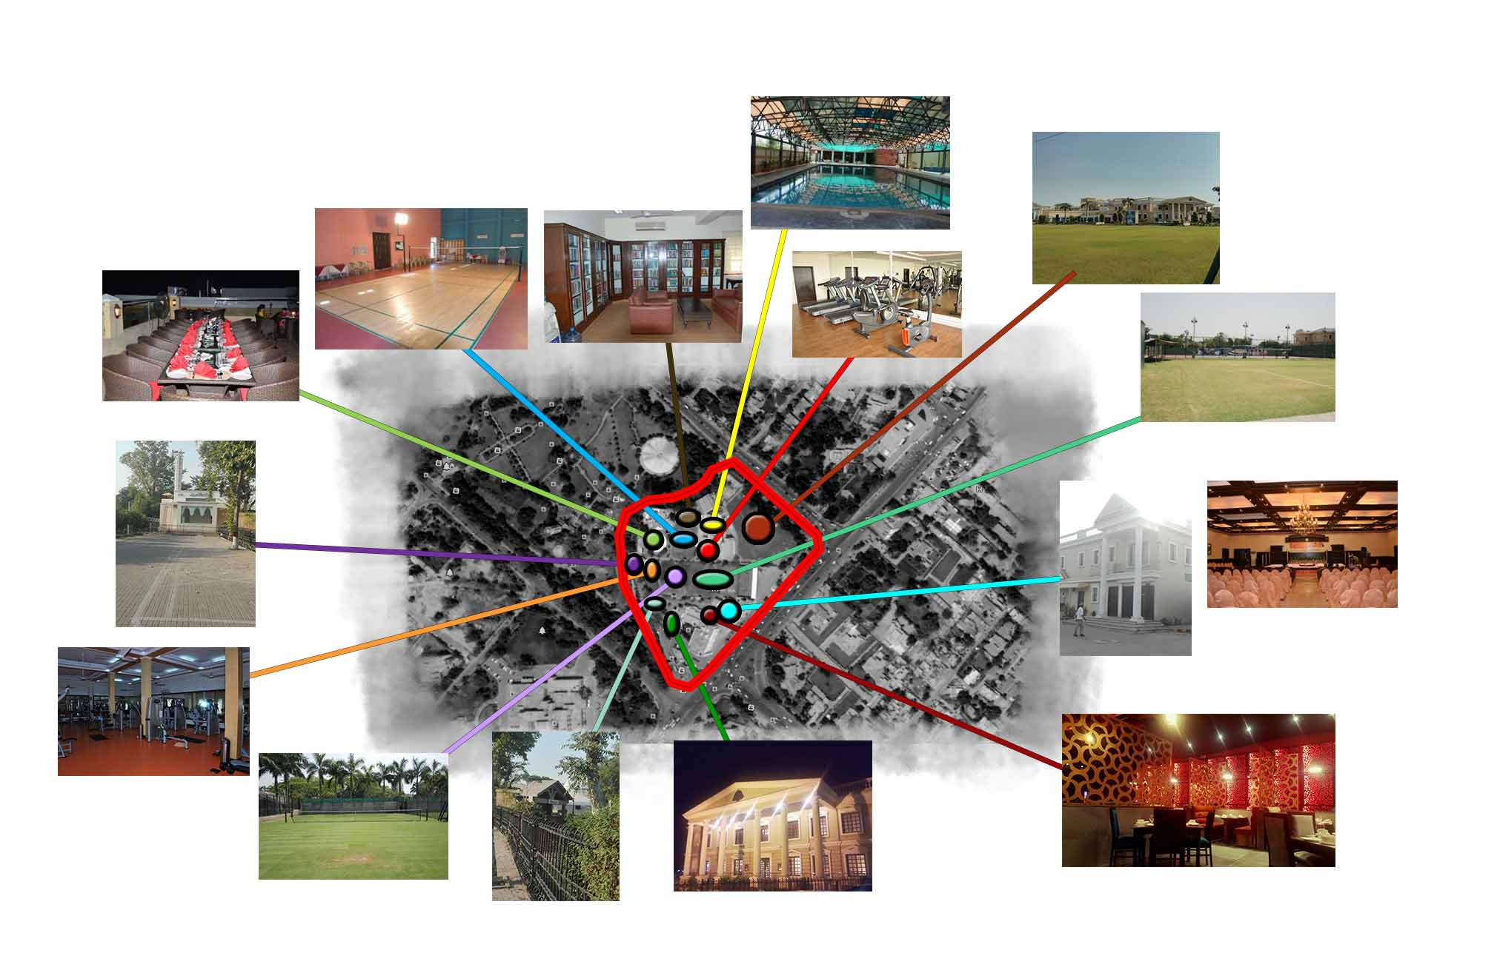
Figure 28 Master plan of Chenab Club

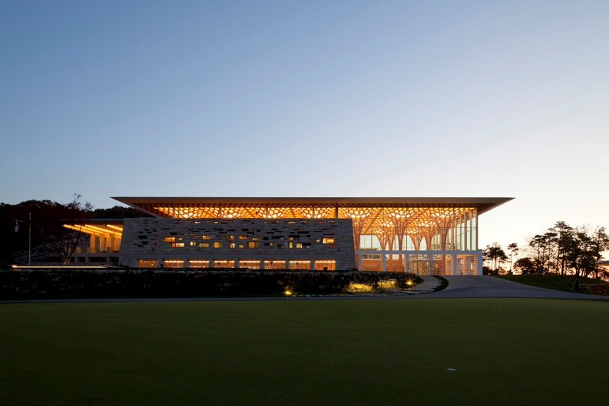
3.2 Nine Bridges Country Club

3.2.1 General Information
- Architects: Shigeru Ban Architects
- Location: Yeoju-gun, Gyeonggi-do, South Korea
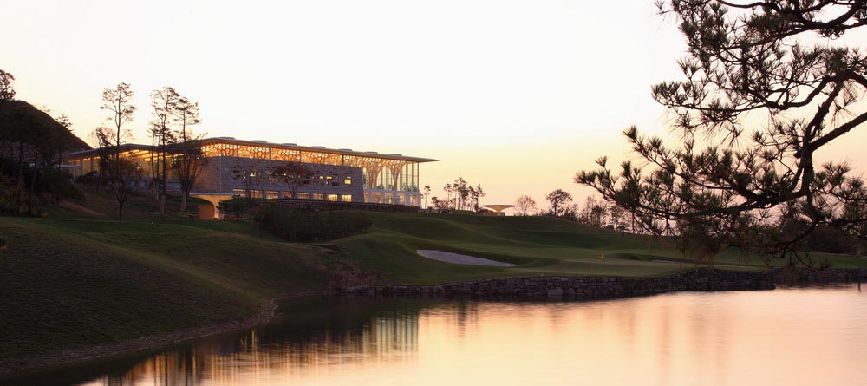
- Architect in Charge: Shigeru Ban
Figure 29 Side Elevation
- Collaborator: KACI International, Inc.
- Client CJ Group
- Area 20977.0 m2
- Project Year 2009
- Manufacturers Blumer Lehmann
Figure 30 Nine Bridge Country Club

3.2.2 Introduction
This is a new clubhouse for a premier golf course located two hours from Seoul by car. It is composed as three buildings: the main clubhouse for regular members, a VIP member’s area, and accommodations VIP members. Each building is composed of a different structural system and are presented in a modern sense of traditional construction methods in South Korea

3.2.3 Design
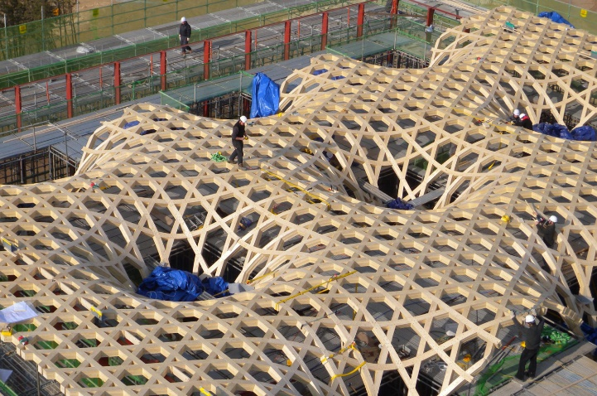
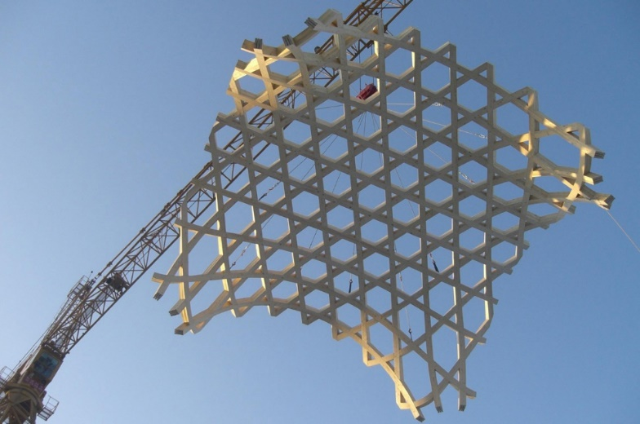
The Nine Bridges Country Club-Clubhouse is a 16,000-squaremeter facility that serves a golf course. It has an underground level and three floors above grade. There is a main building, VIP lobby building, and a structure with private suites. The atrium and the upper portion of the main building include timber columns and a glass curtain wall, while the base is made of stone (random rubble masonry typical of Korea). The timber area includes the reception zone, a member’s lounge, and a party room. The stone podium houses locker rooms, bathrooms, and service areas. The roof over the main building measures 36 x 72 meters. The unusual tree-like timber columns in the atrium reach to a height of three stories. The partial-timber structure was used to conform to Korean regulations that do not allow timber buildings to exceed 6 000 square meters in size. The first floor of the atrium has 4.5-meter-wide glass shutters that open fully.
Figure 31 timber roof Structure
Figure 32 timber roof Structure
Shigeru Ban Architects, quite well known for their innovative use of traditional building materials, unveiled their new masterpiece- Nine Bridges Country Club for a premier golf course in Yeoju-gun, Gyeonggi-do, South Korea in the year 2009. Built on an area of about 21,000 sq. meters, the program for the clubhouse includes three main spaces-a clubhouse for regular members, a VIP members area, and accommodations for the club’s VIP members.

3.2.4 Structure
A different structural and constructional system that uses Reinforced Cement Concrete, Steel and Wood, has been conceived to distinguish each of the three otherwise continuous spaces. Clearly visible from the outside through a mere glass wall is the the main atrium space in the clubhouse. This atrium space contains radially arranged exposed wooden columns that climb up and change orientation to become horizontal members flowing across the entire ceiling space in a hexagonal grid. Reflected in the clear water body immediately in front of the atrium space, these wooden members almost appear to float and are reminiscent of some kind of medieval fairy-tale forest of trees.
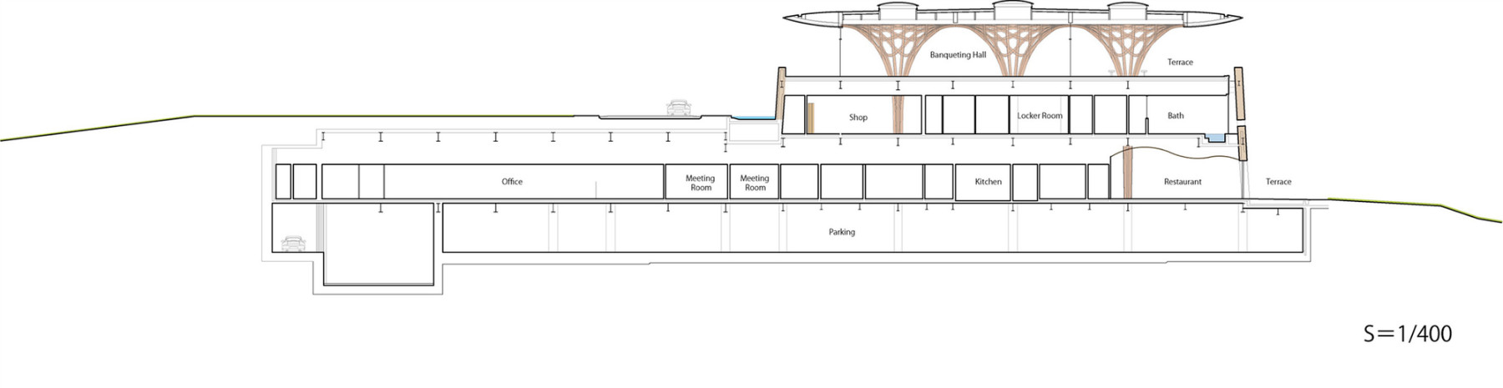
Figure 33 Section of Nine Bridges
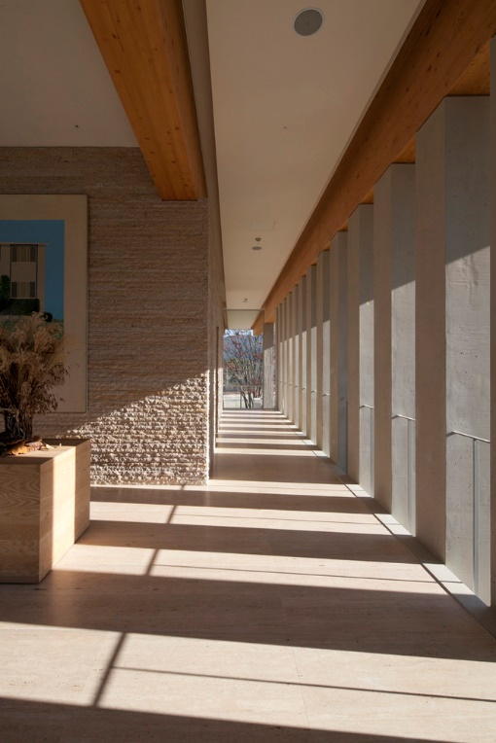
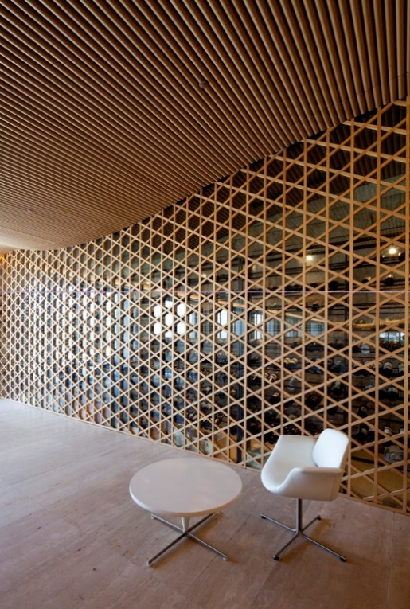
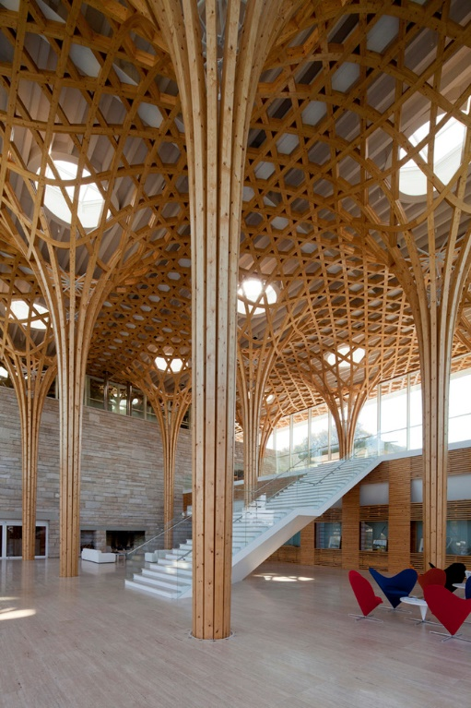
Figure 34 Interior of Nine Bridges Country Club
- The open atrium’s transparent curtain wall utilizes stacking glass shutters that enables the atrium to open completely to the outside. The terrace at the upper level uses full-height sliding glass doors to connect the party room interior seamlessly with the outdoors.
- The transparency and openness of the timber portion serves as the reception area, the members’ lounge and party room. The enclosure of the stone podium includes the more private Locker room area, bathrooms, a spa and building services, and parking is provided in the basement.
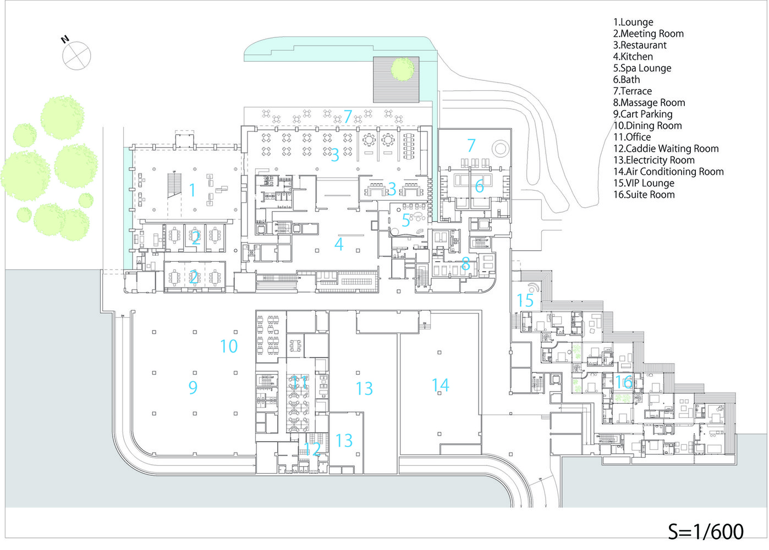
- The three story high timber structure is exposed as the interior finish material, and received fire department approvals by way of oversizing the timber members to act as the fireproofing material. The warmth and texture of the wood is felt in the interior throughout the building.
- The atrium space of the main clubhouse is composed of timber columns and roof with an envelope of clear glass providing a transparent and open space. The laminated timber columns arranged in radially climb vertically and curve to become horizontal members at the roof plane forming a hexagonal grid. The lower podium is constructed as a wall of large local stone built like tradtional stone setting of South Korea, gradually slanting inwards towards the top.
Figure 35 Ground Floor Plan Of Nine Bridges Country Club

3.2.5 Reason for Selection as Case Study
Shigeru Ban is famous for his work with Paper Board Tubes (Sonotube) and timber. Timber columns are flexible and can be used as frame structure due to high strength. They are not only flexible but also aesthetically please element. In this case study the office of Shigeru ban has proper utilized the natural light and at the same time made the space interesting. This case study is however of a country club but the design elements are too attractive and are also possible for construction in Pakistan.

3.3 The Lahore Gymkhana

3.3.1 Introduction
Originally founded as The Lahore & Mian Mir Institute in 1878, the Lahore Gymkhana was based in the Lawrence and Montgomery Halls in the expanse of Lawrence Gardens, opposite the sprawling estate of the Governor’s House. It aimed to provide social and recreational activities to residents of Lahore and its Cantonment. Its current name was adopted on 23rd March 1906. The Halls were taken over the Punjab Government in 1972, which shifted the club to its present picturesque premises on the Upper Mall – previously the Golf Club of Lahore Gymkhana spread over an area of 117 acres. The two Halls have been adapted for re-use as the Quaid-e-Azam Library since the 1980’s.
Bagh-e-Jinnah itself a historical garden, provided a befitting setting for the new-classical Lawrence and Montgomery Halls. These were built in memory of Sir John Laird Mair Lawrence, first Chief Commissioner (1853-57) and Viceroy of India (1863-69) and Robert Montgomery, second Lt. Governor of the Punjab (1859-65).
Lawrence Hall, the building fronting the Mall, was built in 1861-62 as a tribute to Lawrence’s role in ensuring a regular supply of troops from the Punjab to Delhi during the First War of Independence in 1857. The coice of design, prepared by G. Stone, then Chief Engineer, was deliberate as the British East India Company shaken by the events of The First War of Independence, was eager to re-establish a position of power and authority through the use of a classical architectural vocabulary earlier successfully employed in the subcontinent by the ‘Kampany Bahadur’ to portray its might. Lawrence Hall, with a hall size of 65’ x 32.5’ (costing Rs. 34,000/-) was used for public meetings and theatrical entertainment, and for all intents and proposes was Lahore’s town hall until the construction of Jubilee Town Hall.
The foundation stone of the existing Gymkhana building was laid on 5th March, 1968, by Nawab Muzaffar Ali Khan Qizilbash, the then Chairman of Lahore Gymkhana. The building was completed and occupied on 16th January, 1972, the cost of which was borne by its members. The Lahore Gymkhana Cricket Ground arguably the most beautiful in the country, is located in the Bagh-e-Jinnah on 73 Kanals of land leased by the Punjab Government.
The second building at the rear of Lawrence Hall facing the central avenue of the sprawling Bagh-e-Jinnah, is Montgomery Hall. It was built in 1866 from contributions made by the native chiefs. The conformity of style with the earlier building was ensured by Mr. Gordon, Chief Engineer, who, in order to present a single unified whole, linked the space between the two halls by a covered corridor. Montgomery Hall, 106’x46’ in size, constructed and refurbished at a cost of Rs. 108,000 and Rs. 66,000 respectively, was re-roofed and a ‘splendid teak floor for rinking and dancing’ was laid in time for the visit of the Prince of Wales in 1876. These halls became the center of festivities for the rulers, particularly during the Christmas and winter months.

3.3.2 History
Lahore, the magical City of the Twelve Gates, has a glorious past, adorned with countless epics, legends and romantics tales. Its greatness is a culmination of centuries of happenings and experiences, its culture and people combined with the physical form of the city. Its awesome maturity is reflected in its monuments, bazaars, trees, gardens and in the old buildings lining the Mall. With its unrivaled universe and saturated by the greate Lahori Spirit, it is not just a city but a whole universe in itself. Few cities of the world, if indeed any, can lay claim to such a wonderful past or present.
Origin to Loh, the son of Rama Chandra, the Hero of the Ramayana, but history records that it began as a dependency of the 8th century AD Hindu ruler, Lalitditya. Later it was governed by Mahmud of Ghazni (1021-1186) and the Ghazniavid dynasty, the Ghoris and varios Sultans of Dehli during which period it evolved as a center of Islamic culture and learning as well as trade and commerce. In the 13th century it was depopulated and razed to the ground by the Tarter-Mongol hordes of Genghis Khan.
During the period of the MOghul Empire the City attained its full glory and flourished. aAkbar the Great (1584-1598) made Lahore his capital, during which Lahore Fort was built and the old city demarcated, which practically remained the same size ever since. Jahangir (1605-1627), Akbar’s son, expanded the fort and retained a strong link with the city, choosing to be buried here in 1627. His beloved wife Noor Jehan is also buried at Shahdra Close by. Emperor Shah Jahan (1647) embellished the city with elegant architechtural monuments, Sheesh Mahal and the Shalamar Gardens being two of his special projects. He also encouraged his noblemen to patronize the city, for which Hakim Alimuddin, populary known as Wazir Khan would always be remembered for his most enduring contribution the the city, the bejeweled Wazir Khan Mosque. It is to Emperor Aurangzeb’s piety and largesse that the city owes it’s most glorious and imposing monument The badshahi Mosque (1694-1695). After the collaps of the Mughal Empire following Aurangzeb’s death, the second renaissance of Lahore occurred during the rule of Maharaja Ranjit Sing (1780-1839) who restored the city of Lahore to the level of a stat capital.
During the 19th Century, Lahore developed into the cultural center of the area, becoming visible through the manifestation of buildings such as Aitchison College, Lawrence and Montgomery Halls, Lahore Museum and General Post Office because of the British concern with social uplift and improvement. The aesthetic sense of British architects and artistic brilliance of Indian workers gave birth to a new form of architecture, the fine blend of ‘Moghul, Gothic and Victorian architechture’. The buildings of Supreme Court, the High Court and the Government College are the legacies of the same fine art.
The creation of Pakistan left and indelible mark on the city of Lahore. The Lahore Declaration in march, 1940 at the Annual Meeting of the All India Muslim League started a movement which eventually led to the partition of the Sub-Continent in August 1947. Since independence, Lahore has continued to thrive, graduating from being a commercial enterprises to one with a widespread industrial base, encompassing textile, medium and light engineering, footwear and packaging factories. The city has modernized in recent years with dozens of satellite colonies and development schemes stretching its peripheral limits to several kilometers on all side of the old city. This continues to further enrich the architectural format of Lahore. It remains a centre of excellence in education, of which University of the Punjab, University of Engineering & Technology, King Edward Medical College, Lahore University of Management Sciences, Government College Lahore, Aitcheson College and National College of Arts are the prime examples.

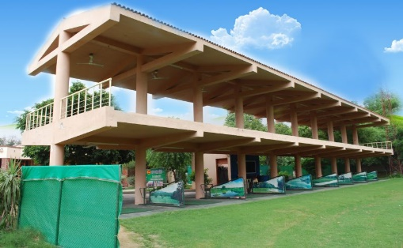
3.3.3 Facilities
- Golf
- Tennis
- Billiards
- Card Room
Figure 36 Golf
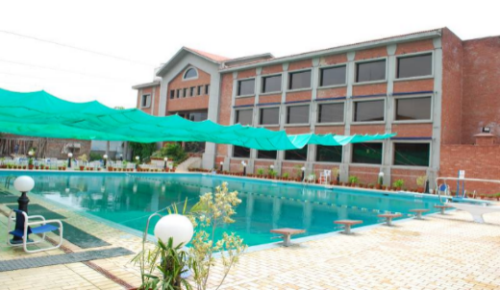
- Swimming Pool
- Squash Courts
- Gymnasium
- Cricket
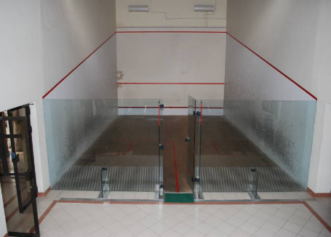
- Family Café
Figure 37 swimming pool
- 3Chandni Café
- The Terrace
Figure 38 Squash Court
- Main Dining Hall
- The lounge
- Chandni Lounge
- Banquet hall
- Rose hall
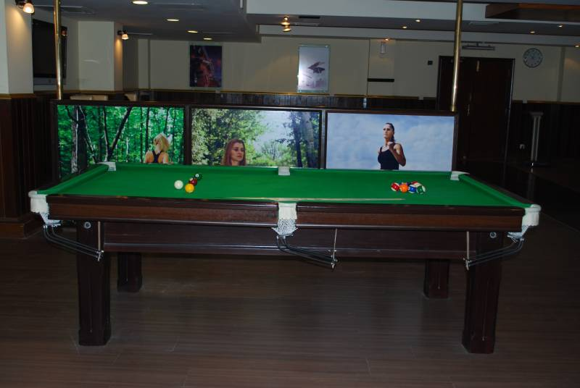
- Main hall
- Jasmine hall
- The shoppe
- Admin Block
Figure 39 Pool Table
- Guest House
- Sauna
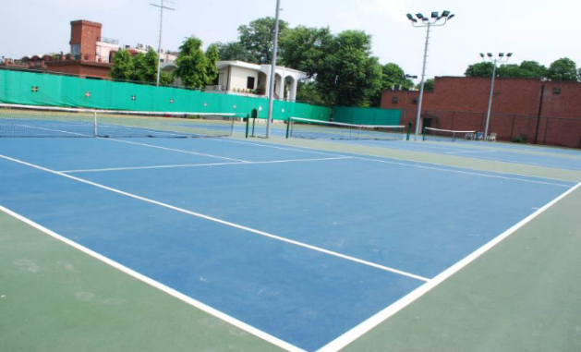
- Wellness centers
- Multi-purpose rooms
- Lounge
- Party Rooms
Figure 40 Tennis Court
- Mosque

3.3.4 Reason for Choosing Lahore Gymkhana
Lahore Gymkhana is one of the good example of a Community Club in Lahore Pakistan featuring Golf course, Dining hall, Banquet hall, Party Lounges and other recreational activities like tennis, badminton, squash courts etc.
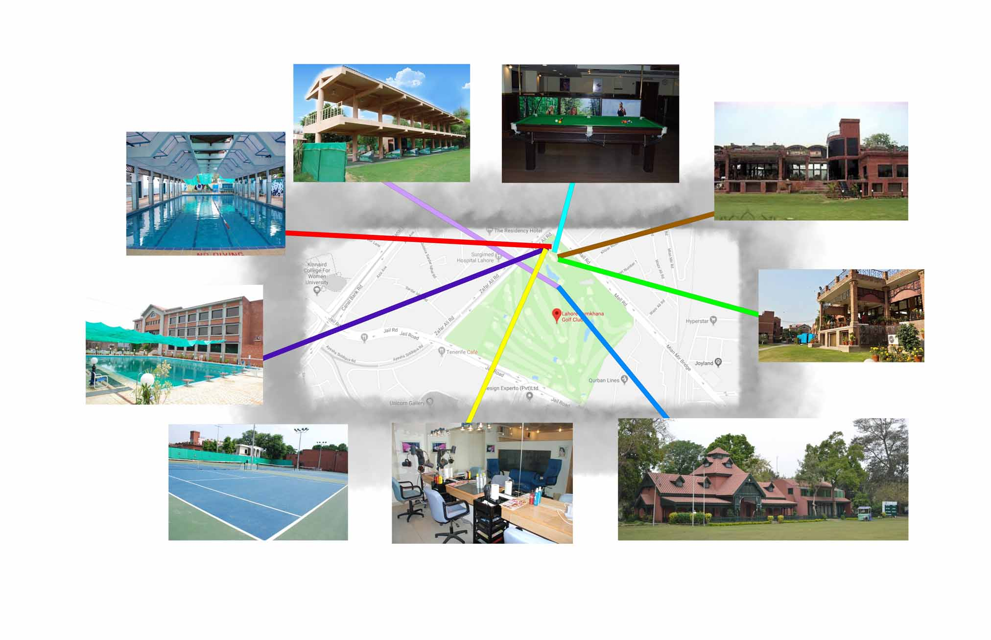
Figure 41 Lahore Gymkhana plan explained

Area Requirements for Project

(Chapter 4)

4.1 Area Calculation
The area calculation is purely done from the survey of different community clubs having identical requirements. The area however is calculated after figuring out both the pros and cons of already existing community clubs. According to the case study the overall requirement of the project are identical to Chenab Club Faisalabad, Lahore Gymkhana, Jacaranda Club Islamabad, Johar town sports Complex Lahore.

4.2 Area Calculations for the Project
- Common garden for event 67000sqft
- Tennis court 12000sqft
- BBQ area + Kids playing area 15000sqft
- Library 6000sqft
- Masjid 2500sqft
- Guest house 7000sqft
- Bowling alley 10000sqft
- Swimming pool 15000 sqft
- Lounge for parties 1000-2000sqft
- Wedding halls and marquees 23000sqft 27000sqft
- Mini Golf 12000sqft
- Parking 50000 sqft
- Meeting and conference halls 4500sqft
- Dining halls 6000sqft each
- Café 1200sqft
- Jacuzzi, steam bath and Sauna bath 1200sqft
- Billiard room 3000 sqft
- Table tennis room 1500sqft
- Coffee and tea Café 1000sqft
- Common rooms 600sqft
- Barber shop 200sqft
- Badminton halls 2500sqft
- Gymnasium 3500sqft
- Squash complex 2000sqft
- Chess room 800sqft
- Card room 800sqft
- Administration block 6000sqft
- Reception hall 5000sqft
- Drinking Bar 1200sqft
- Tuc Shop 100sqft
- 3D Cineplex Cinema 26000sqft
- Auditorium 28000sqft

4.3 Grouping of requirement according to area (zoning)

4.3.1 Groups
Group 1
- Swimming pool 15000 sqft
- Badminton hall 2500 sqft x 2
- Squash complex 2000 sqft x 2
- Gymnasium 3500 sqft x 3
- Billiard room 3000 sqft
- Table tennis room 1500 sqft
- Common Room 600 sqft x 4
Total Area 41400 sqft
Group 2
- Wedding Hall/ Marquees 25000 sqft x 4
- Parking 50000 sqft
- Bar B Que area 15000 sqft
- Rooftop Bar B Que area 15000 sqft
- Tennis Court 12000 sqft x 2
- Garden for Event 67000 sqft
Total Area 271000 sqft
Group 3
- Dining hall 6000 sqft x 4
- Coffee and tea shop 1000 sqft
- Meeting and Conference hall 4500 sqft x 3
- Private party lounge 1500 sqft x 3
Total Area 43000 sqft
Group 4
- Library 6000 sqft
- Masjid 2500 sqft
- Administration block 6000 sqft
- Reception Hall 5000 sqft
- Hotel/Guest house 7000 sqft x 2
- Jacuzzi, Steam Bath, Sauna Bath 1200 sqft
Total Area 34700 sqft
Group 5
- Bowling Alley 10000 sqft
- Café 1200 sqft
Total Area 11200 sqft
Group 6
- Card Room 800 sqft
- Chess Room 800 sqft
- Drinking Bar 1200 sqft
Total Area 2800 sqft
Group 7
- Barber Shop 200 sqft
- Tuc Shop 100 sqft
Total Area 300 sqft
Group 8
- 3D Cineplex Cinema 26000 sqft x 2
- Auditorium 28000 sqft
Total Area 80000 sqft
Total Area of All the groups 473400 sqft

Characteristics of Selected Site

(Chapter 5)

5.1 Justification of Selected Site

5.1.1 Why the site have been selected in Faisalabad?
- Faisalabad is recognized as the center of the textile industry in Pakistan, contributing to half of Pakistan’s total textile shipments.
- Faisalabad is the third largest population of Pakistan after Karachi and Lahore.
- The population of Faisalabad is one third of Lahore and currently there are not enough community clubs to cater the population of Faisalabad
- Faisalabad contributes over 20% toward Pakistan's annual GDP; therefore, it is often referred to as the "Manchester of Pakistan”
- Faisalabad's average annual GDP is $20.55 billion (USD). Suggesting that this city has a higher concentration of bourgeois class
- Faisalabad is a producer of industrial goods and textile manufacturing including cotton and silk textiles, super phosphates, hosiery, dyes, industrial chemicals, clothing, pulp and paper, printing, agricultural equipment, ghee (clarified butter), and beverages. Which all attracts different businessman
- This city experience lots of business trips from different users of different city and nation
- It is assisted by the expanding transport network which includes newly-built motorway and highways.
- The city has it major Dry Port and International Airport.
- 300,000 upper looms and 225,000 power looms are running in Faisalabad. About 75,000 auto and shuttle less looms are busy in making export fabric in Faisalabad.
- Pakistan has a history of world class craftsmanship and brilliant innovation in the field of wooden furniture. Furniture from Chiniot (city near to Faisalabad) is exported all over the world.
- China has newly introduced the trade route of CPEC, which is going through just near from the city of Faisalabad. And CPEC has decided to open their office in the city of Faisalabad.
- There are numerous textile and chemical industries near Khurrian Wala (13-14km from Faisalabad) consisting of thousands of people working there who live in Faisalabad. The selected site is roughly 20 to 30min drive away from Khurrian Wala.

5.2 Climate of Faisalabad
The climate of Faisalabad features a Semi-arid climate (BWh) in Köppen-Geiger classification, with very hot and humid summers and dry cool winters. The average maximum and minimum temperature in June are 40.5 °C (104.9 °F) and 26.9 °C (80.4 °F), respectively. In January it the average maximum stands at 19.4 °C (66.9 °F) and 4.1 °C (39.4 °F), respectively. The summer season starts from Mid-April and continues till late-October. May and June are the hottest months, while July, August and the first half of September can be oppressively humid, except for the days when it rains. June is the hottest month in Faisalabad when conditions are dry and dust storms are common. While the coldest month is January, which is also a dry month with significant foggy days. The fog is particularly dense at night and early morning hours. The winter season starts from November and continues till early-February. Spring sets in after Mid February and lasts usually till late March when temperatures begin to warm up and conditions become drier and sunnier. The average annual rainfall lies only at about 375 millimetres (14.8 in), which is highly seasonal since approximately half of the yearly rainfall takes place in July and August during the monsoon season.
Figure 42 table showing climate of Faisalabad

5.2.1 Extremes of the Weather Elements
The temperature range of the city ranges from a summer maximum record temperature of 48.0 °C (118.4 °F), which was observed on 9 June 1947 and again on 26 May 2010.[4]An extreme minimum temperature of −4.0 °C (24.8 °F) was recorded on 15 January 1978. The record 24-hour rainfall stands at a massive 264.2 millimetres (10.40 in) recorded 5 September 1961, which is roughly 70 percent of its annual average rainfall. The highest wind gust ever recorded in Faisalabad occurred during a severe dust-thunderstorm on 2 June 2000, when the maximum wind gust touched 151 kilometres per hour (94 mph).
The driest month is November. There is 3 mm of precipitation in November. Most of the precipitation here falls in July, averaging 102 mm.
Figure 43 Bar chart of Monthly climate in Faisalabad

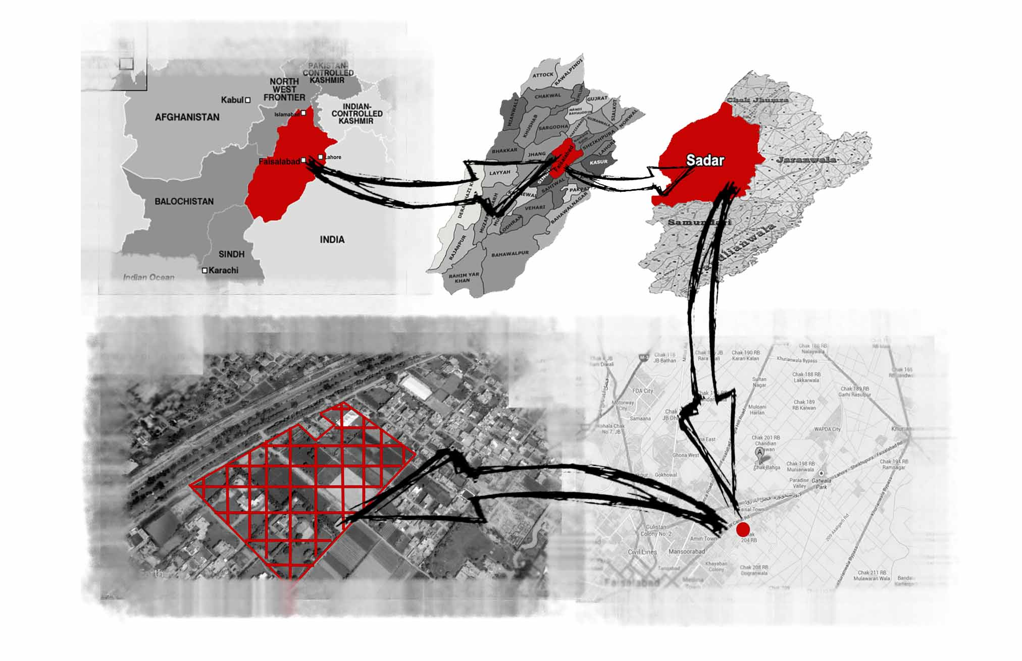
5.3 Location of Selected Site
Figure 44 Location of Site

5.3.1 Distance of site from Famous landmarks
- The site is located on the west canal road Faisalabad
- The site is approximately 6.4km from railway station
- The site is approximately 10.5 km from Daewoo bus station
- The site is around 6.5 km from Bilal travel and other bus station
- The site is 4.8 km from Gatwala
- The site is 13.1 km from Khurrian wala
- The site connects to Motorway from Sahianwala road at Pindi Bhattian at a distance of 29km and travelling time of roughly 20min in a car
- The site is 18km away from Motorway exit on Sargodha road
- From airport the site is 22km away
- The famous place in Faisalabad include D-ground which is the main market area, Kohinoor which is the shopping plaza and Clock tower(Ghanta Ghar) which is most famous point in Faisalabad
- D-Ground is at a distance of 7km from the site and 10-15min drive on usual day
- The clock tower (Ghanta Ghar) is 8.3km from the site
- Kohinoor is 6.5km from the project site
- Closest hospital is Faisalabad international hospital which is 1.3km away from the project site
- Other well-known hospital which is close from the site is Faisal Hospital which is 5.5km away and at a 5 to 8min drive
- Faisalabad institute of cardiology is 7.2km from project site
- Shifa International Hospital is 10km from the site

5.4 Site Analysis

5.4.1 Geology of the selected site
- LAND FORM: Flat & barren land
- SOIL BEARING CAPACITY: Very low
- WATER TABLE: At the depth of 28 Meters
- SOIL COMPOSITION: dry land and trees or bushes
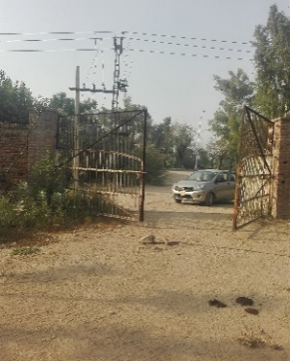
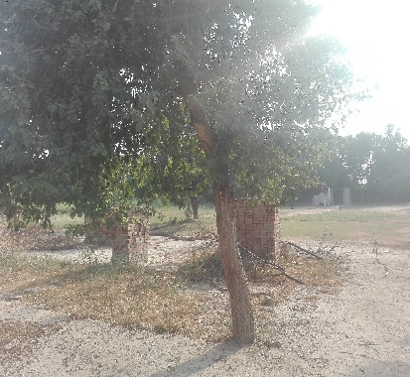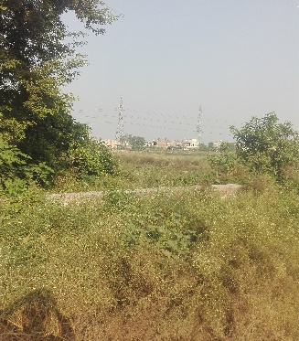
Figure 45 Site Images

5.4.2 Aesthetic Factors
- SPATIAL PATTERN: Open/Flat
- BEDROCK: N/A
- WATER AVAILABILTY: Sufficient
- GREENERY: Sufficient(trees & bushes) &also dry or barren land

5.4.3 Infrastructure
- ELECTRICITY LINES: Available
- GRID STATION: Available
- GAS LINES: Available
- TELEPHONIC LINES: Available
- UNDERGROUND CABLES: Not Available
- DRAINAGE LINES: Available
- ROAD NETWORK: Available
- OVERHEAD TANKS: Not available
- WATER SUPPLY: Available
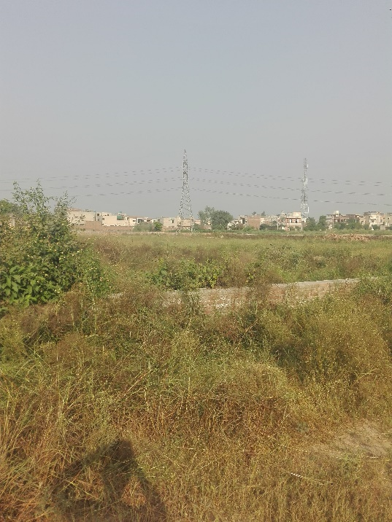
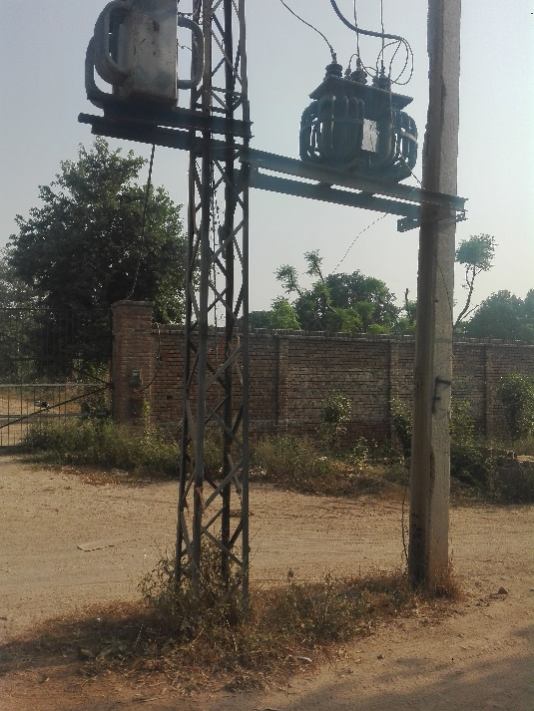
Figure 46 Site Images

- PEOPLE DENSITY: Normal
- WILDLIFE: Present (Dogs, Cow, Goats, )
- VEGETATION: Trees or Bushes
- ZONING: Yes
- ZONING REGULATIONS: Available
- DEVELOPMENT AUTHORITY: Faisalabad Development Authority (FDA)
- NEIGHBOURHOOD ATTITUDE: Positive 7/10
- TRAFFIC: Moderate
- TRANSPORT MEANS: Public & Private
- PARKING PROVISION: Not available
- LAND CONDITION: Dry land

5.5 Climatic Analysis of Selected Site

5.5.1 Sun path
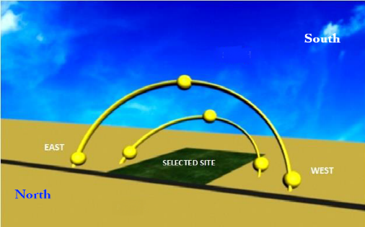
The pictures below are showing that how sun path direction will cover the site and what will be the direction of a sun arc in summer and what will be the direction of sun arc in winters. Both directions are given with the solartice angle that what will be the length of an arc in both seasons. 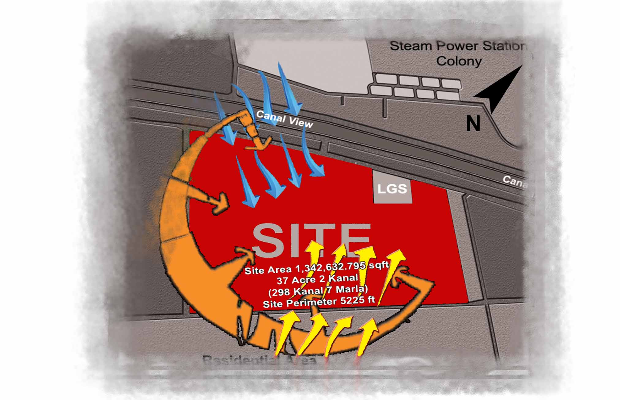
Figure 47 Sun Path and wind direction

Climate of Faisalabad greatly fluctuate during summer and winter season. Here are some interesting facts about the climate of Faisalabad;
- Maximum temperature in summer reaches up to 50 C (122 F)
- Minimum temperature in winter fall below freezing point i.e. O C
- Mean maximum & minimum temperature in summer are 39 & 27 C
- Mean maximum and minimum temperature in winter are 21 & 6 C
- Summer season starts from April and remain till October
- Hottest months are May, June and July
- Winter season starts from November and remain till March
- December, January and February are the coldest months

5.5.2 Wind directions on site
Apart from temperature and rainfall records, the winds in Faisalabad are generally light. It lies in an area with low wind speeds. Westerly breeze dominates the afternoon times, while the nights are calm. South East / Easterly winds are common here during the monsoon season. Faisalabad, however, being in the plains can experience severe thunderstorms and high wind gusts that can be damaging to its crops. The site which has been selected is open from all four sides. The land is barren or have trees and bushes so the landscape elements of the project should be considered importantly.
Figure 48 Wind Direction in Summers and Winters

5.5 Graphical analysis W.R.T Site

5.6.1 Neighborhood
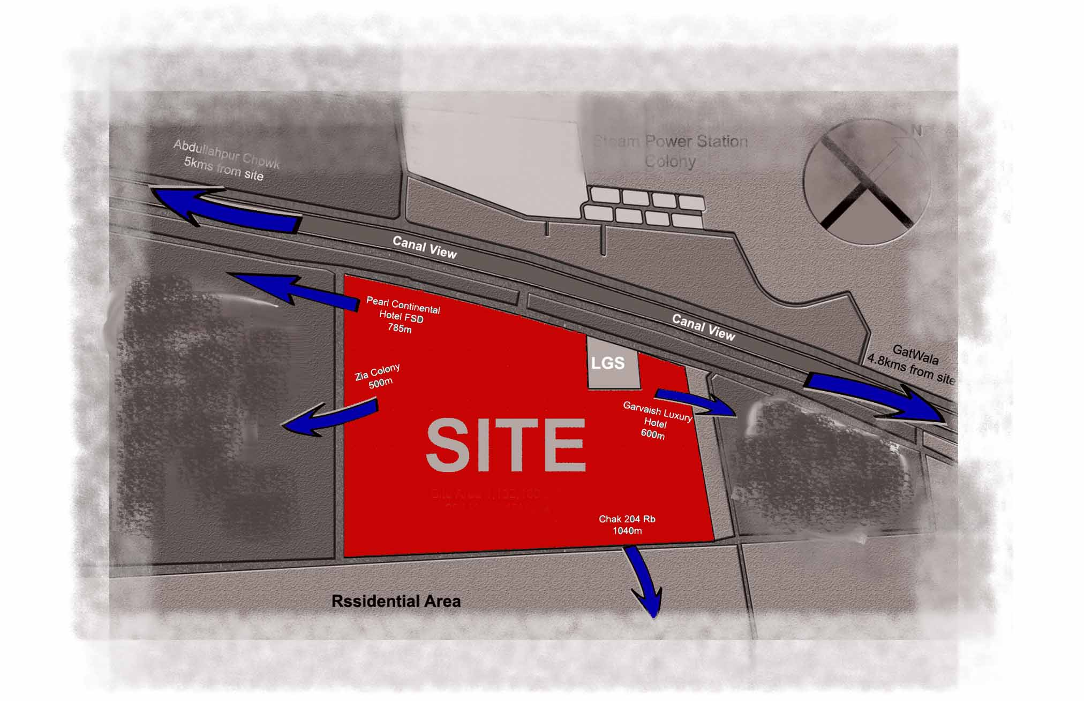
Figure 49 Neighborhood around Site

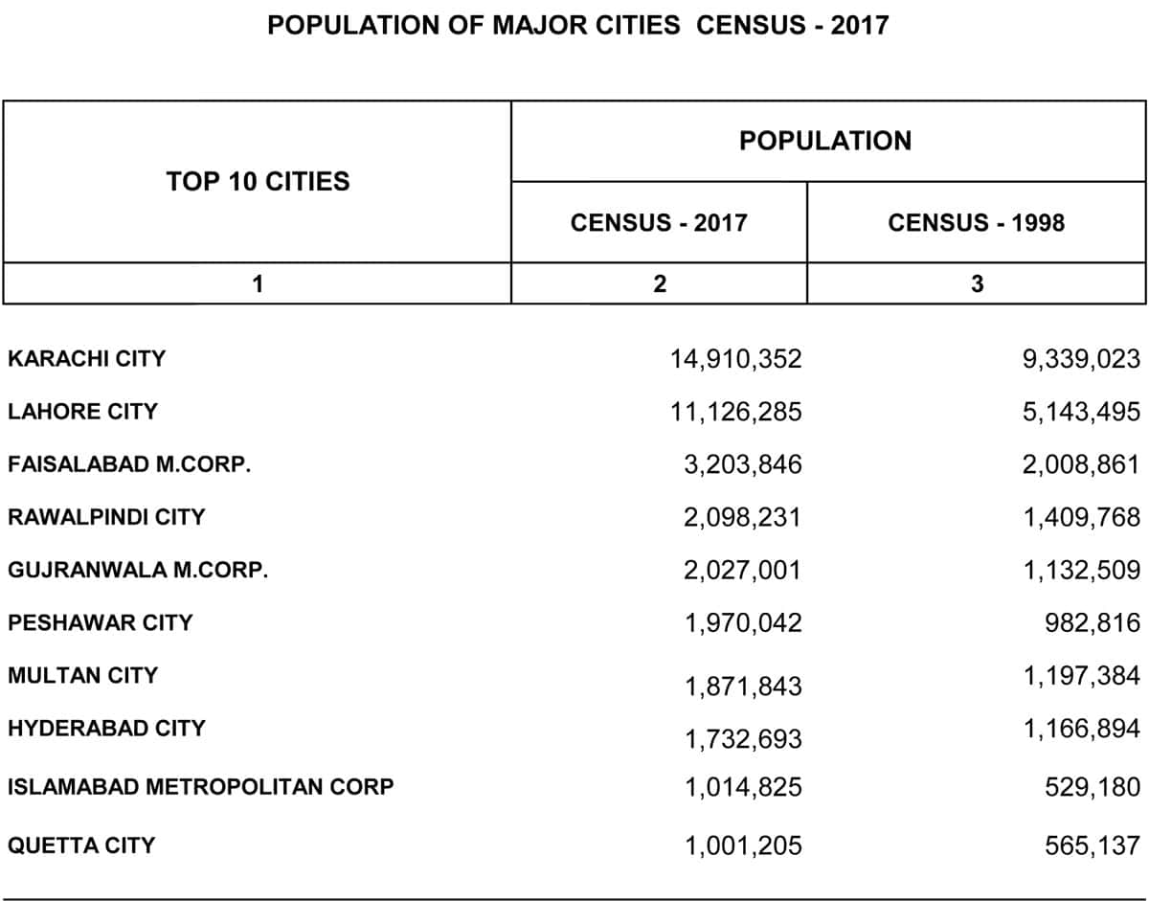
5.6.2 Population
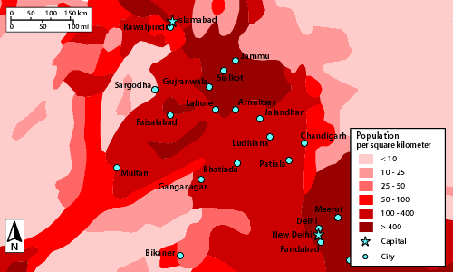
Figure 50 Population in 1998 and 2017
Figure 51 Population per square kilometer
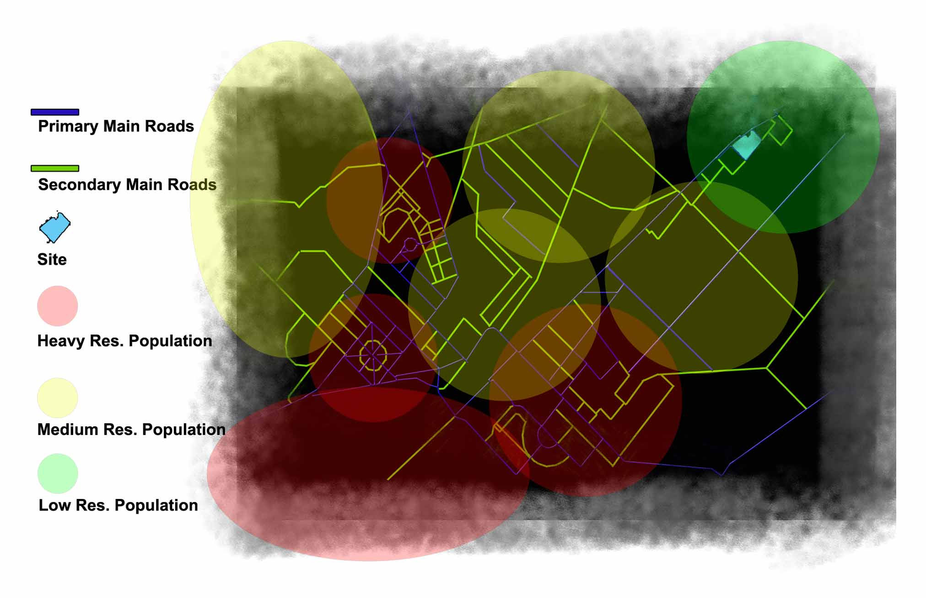
Figure 52 Residential settlement of population around site

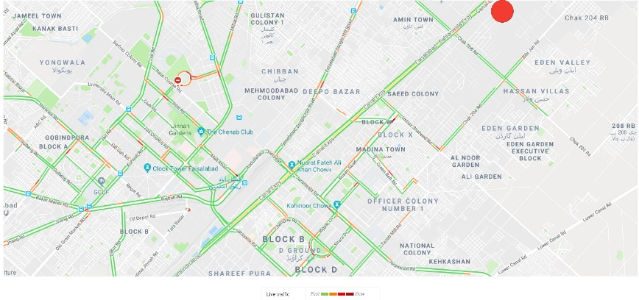
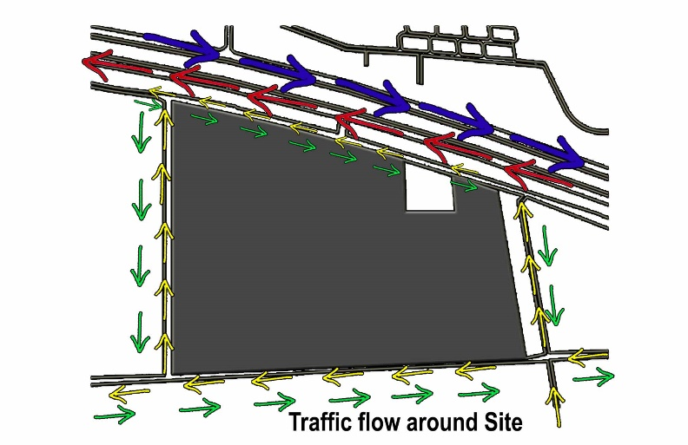
5.6.3 Traffic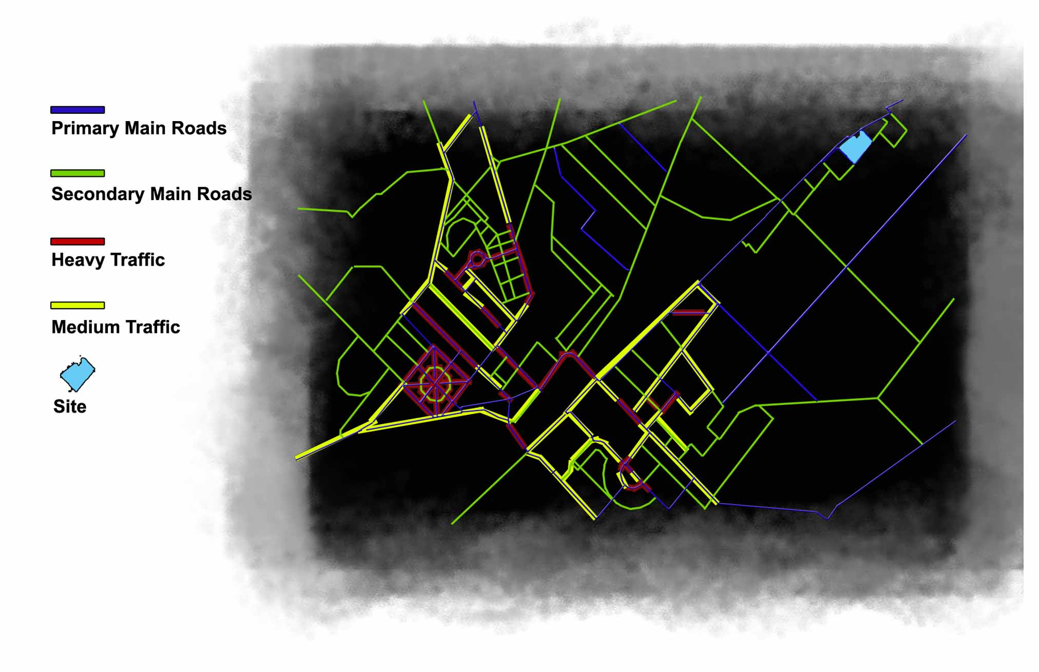
Figure 53 Traffic on average day (day time)
Figure 54 Traffic flow around site
Figure 55 Average traffic flow of Faisalabad

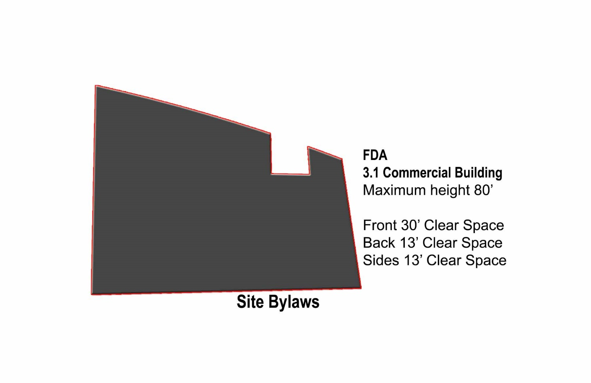
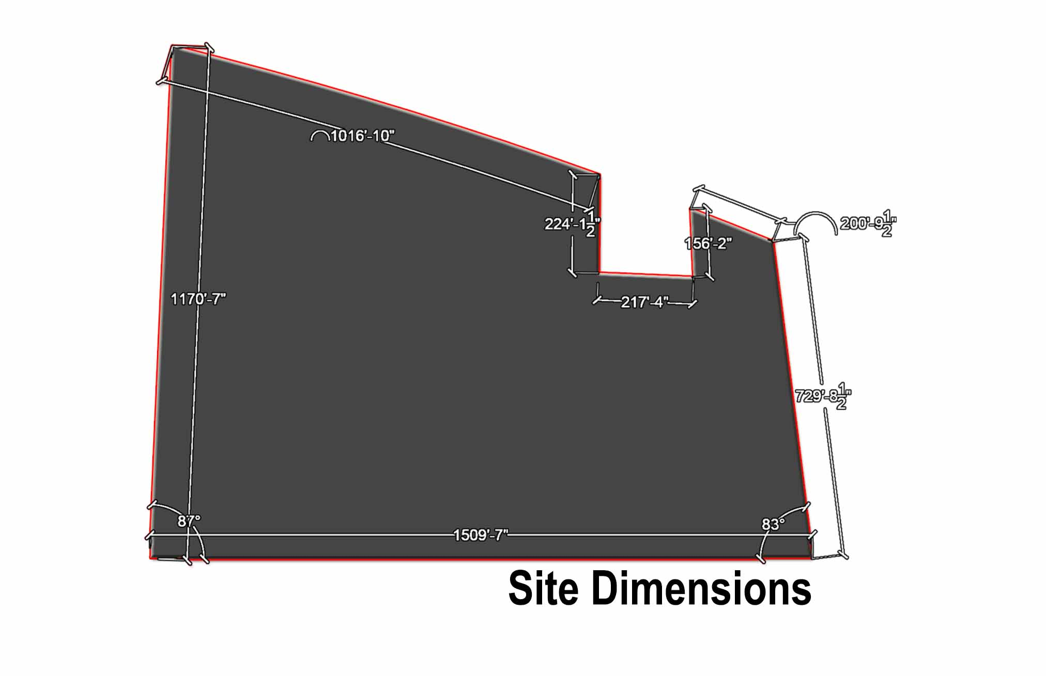
5.6.4 Site
Figure 56 Site Dimensions
Figure 57 Site Byelaws

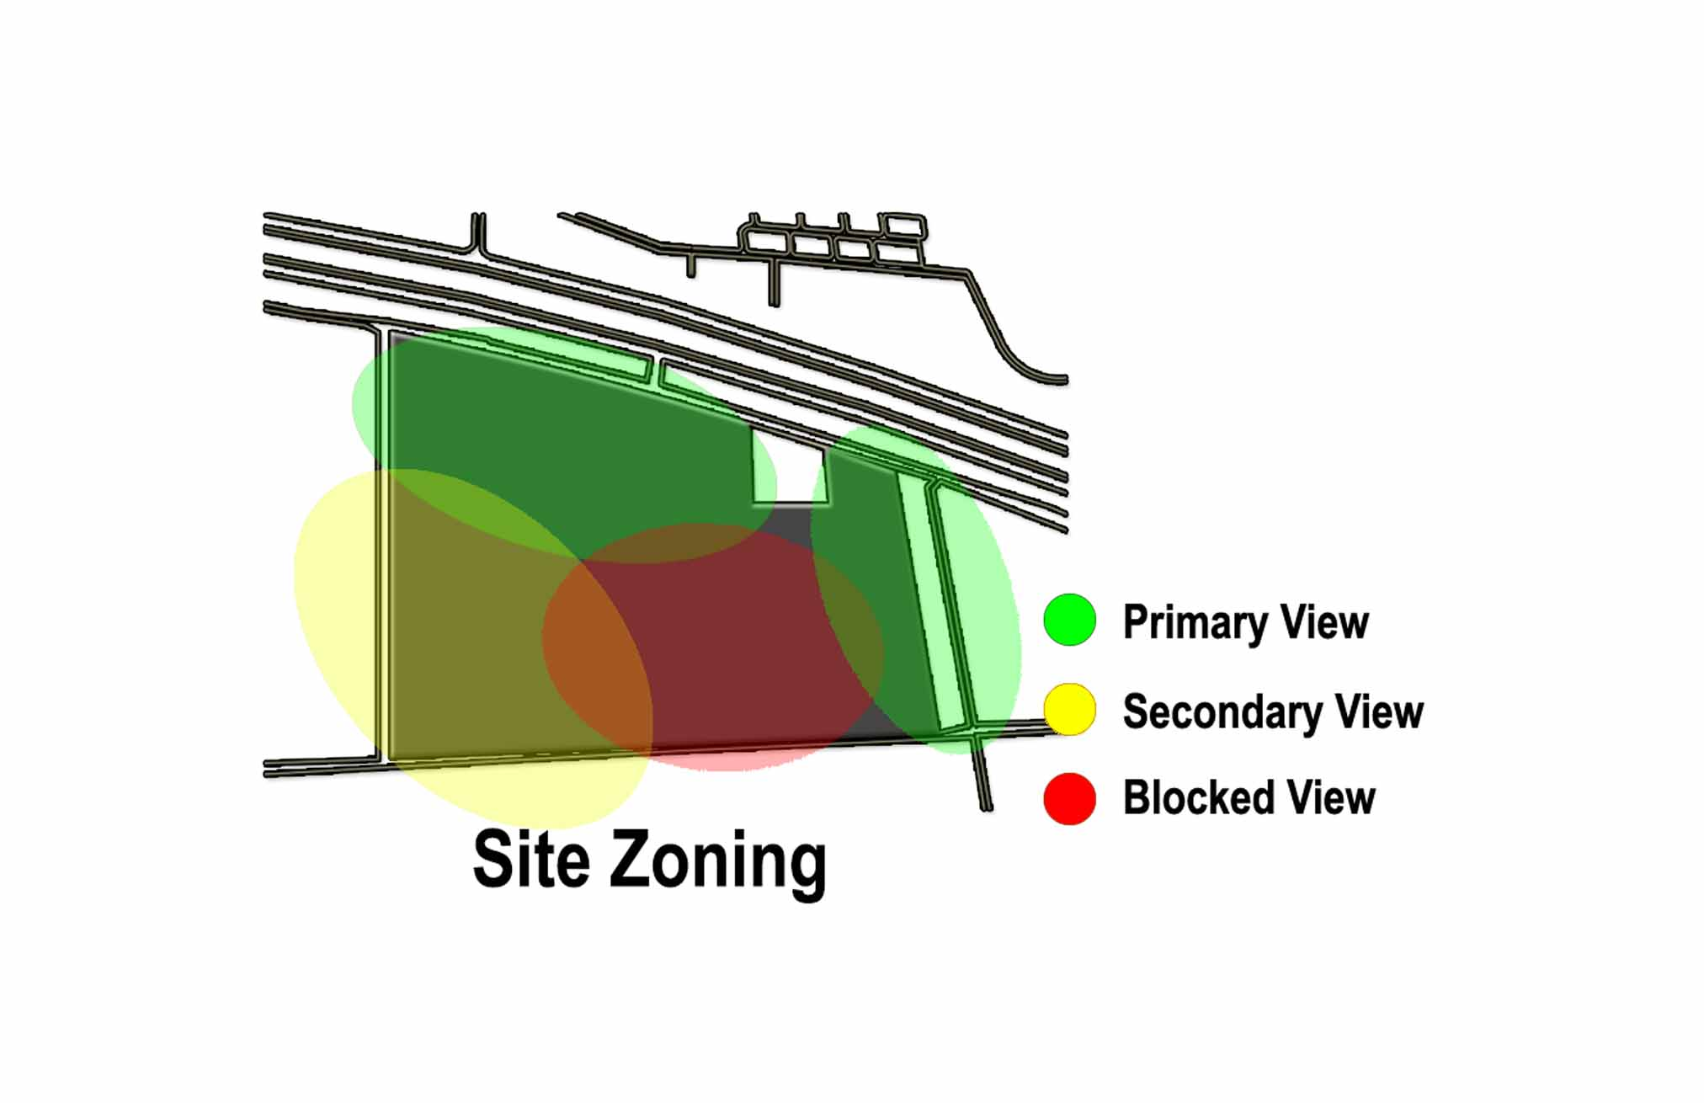
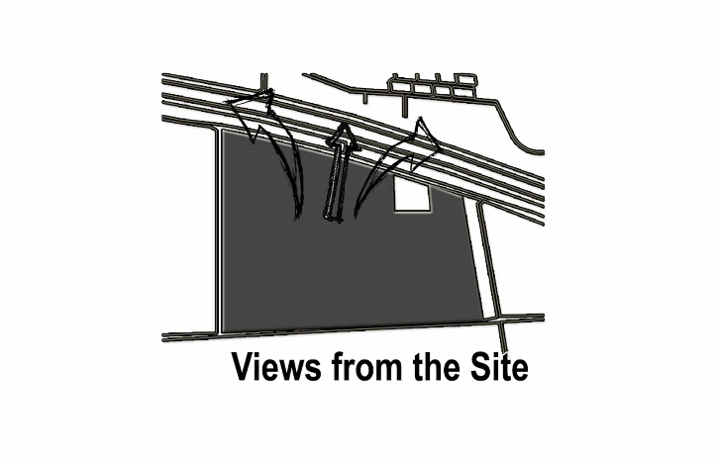
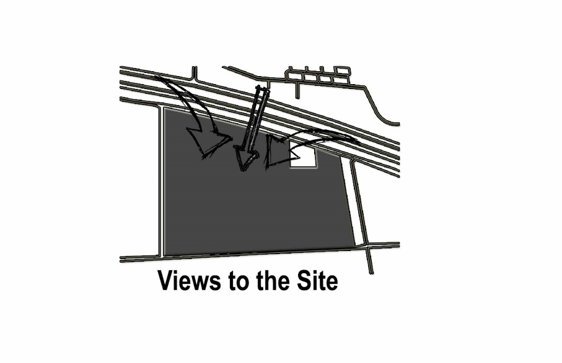
Figure 58 Site Visibility from inside and outside
Figure 59 Site Zoning

Design Proposal

(Chapter 6)

6.2 Master Plan
Figure 60 Master plan

6.2 Site plan
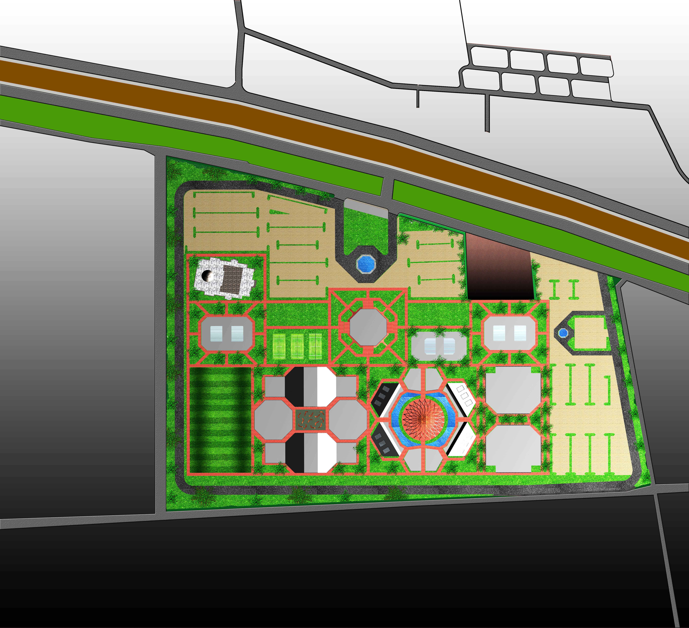
Figure 61 Site plan

6.3 3D Views

Bibliography
- https://www.thefreedictionary.com/Community+Club

https://en.wikipedia.org/wiki/Community_centre
- https://en.oxforddictionaries.com/definition/community_centre
- https://en.oxforddictionaries.com/definition/community_centre
- https://www.archdaily.com › ArchDaily › Architecture Projects › Community center
- https://www.google.com.pk/search?q=gymkhana+beauty+Salon&source=lnms&tbm=isch&sa=X&ved=0ahUKEwiG4puYr7DYAhWBPhQKHRm7AAsQ_AUICigB&biw=1366&bih=588#imgrc=wEEdbC-sKBzbnM:
- https://www.google.com.pk/search?q=gymkhana+beauty+Salon&source=lnms&tbm=isch&sa=X&ved=0ahUKEwiG4puYr7DYAhWBPhQKHRm7AAsQ_AUICigB&biw=1366&bih=588#imgdii=Ls9-cxxpqGflsM:&imgrc=wEEdbC-sKBzbnM:
- https://www.google.com.pk/search?q=gymkhana+beauty+Salon&source=lnms&tbm=isch&sa=X&ved=0ahUKEwiG4puYr7DYAhWBPhQKHRm7AAsQ_AUICigB&biw=1366&bih=588#imgdii=yZ4lYi4ApJ1nYM:&imgrc=wEEdbC-sKBzbnM:
- https://www.google.com.pk/search?q=gymkhana+beauty+Salon&source=lnms&tbm=isch&sa=X&ved=0ahUKEwiG4puYr7DYAhWBPhQKHRm7AAsQ_AUICigB&biw=1366&bih=588#imgdii=YriLRbKv-SijeM:&imgrc=wEEdbC-sKBzbnM:
- https://www.google.com/maps/place/Lahore+Gymkhana+Golf+Club/@31.5387987,74.3542967,19.25z/data=!4m5!3m4!1s0x0:0x889a1dde55c81def!8m2!3d31.5351276!4d74.3543485
- https://www.google.com/maps/place/Lahore+Gymkhana+Golf+Club/@31.538643,74.354326,19.25z/data=!4m5!3m4!1s0x0:0x889a1dde55c81def!8m2!3d31.5351276!4d74.3543485
- https://www.google.com/maps/place/Lahore+Gymkhana+Golf+Club/@31.5384373,74.3545471,18.25z/data=!4m5!3m4!1s0x0:0x889a1dde55c81def!8m2!3d31.5351276!4d74.3543485
- https://www.google.com/maps/place/Lahore+Gymkhana+Golf+Club/@31.5353288,74.3537477,16z/data=!4m5!3m4!1s0x0:0x889a1dde55c81def!8m2!3d31.5351276!4d74.3543485
- https://www.google.com/maps/place/Lahore+Gymkhana+Golf+Club/@31.5351276,74.3543485,15z/data=!4m2!3m1!1s0x0:0x889a1dde55c81def?sa=X&ved=0ahUKEwiH4_KIr7DYAhUEPxQKHXPHABYQ_BIIhAEwDw
- https://www.google.com.pk/search?q=lahore+Gymkhana+map&source=lnms&sa=X&ved=0ahUKEwjB-fL-rrDYAhXO-KQKHZ8ODP0Q_AUICSgA&biw=1366&bih=588&dpr=1
- https://www.google.com.pk/search?biw=1366&bih=588&tbm=isch&sa=1&ei=8MxGWrWYHYGXsAfGvrPwDQ&q=lahore+Gymkhana+the+shoppie&oq=lahore+Gymkhana+the+shoppie&gs_l=psy-ab.3...8836.9992.0.10376.7.7.0.0.0.0.443.443.4-1.1.0....0...1c.1.64.psy-ab..7.0.0....0.gUwOtlIuca8 - imgrc=_
- https://www.google.com.pk/search?biw=1366&bih=588&tbm=isch&sa=1&ei=8MxGWrWYHYGXsAfGvrPwDQ&q=lahore+Gymkhana+the+shoppie&oq=lahore+Gymkhana+the+shoppie&gs_l=psy-ab.3...8836.9992.0.10376.7.7.0.0.0.0.443.443.4-1.1.0....0...1c.1.64.psy-ab..7.0.0....0.gUwOtlIuca8 - imgdii=WHjblclUrYjmMM:&imgrc=jAUFpLtCW15ovM:
- https://www.google.com.pk/search?biw=1366&bih=588&tbm=isch&sa=1&ei=8MxGWrWYHYGXsAfGvrPwDQ&q=lahore+Gymkhana+the+shoppie&oq=lahore+Gymkhana+the+shoppie&gs_l=psy-ab.3...8836.9992.0.10376.7.7.0.0.0.0.443.443.4-1.1.0....0...1c.1.64.psy-ab..7.0.0....0.gUwOtlIuca8 - imgrc=jAUFpLtCW15ovM:
- http://locallylahore.com/wp-content/uploads/103723873.jpg
- https://www.google.com.pk/url?sa=i&rct=j&q=&esrc=s&source=images&cd=&ved=0ahUKEwj_9KbWrbDYAhUBKuwKHan3CBMQjBwIBA&url=http%3A%2F%2Flocallylahore.com%2Fwp-content%2Fuploads%2F103723873.jpg&psig=AOvVaw1NB8A722KF57pJ1TtRjpXC&ust=1514675836921248
- https://www.google.com.pk/search?biw=1366&bih=588&tbm=isch&sa=1&ei=8MxGWrWYHYGXsAfGvrPwDQ&q=lahore+Gymkhana+the+shoppie&oq=lahore+Gymkhana+the+shoppie&gs_l=psy-ab.3...8836.9992.0.10376.7.7.0.0.0.0.443.443.4-1.1.0....0...1c.1.64.psy-ab..7.0.0....0.gUwOtlIuca8 - imgdii=KsPMPOn-bTVjNM:&imgrc=_KH_iYqpXPPUcM:
- http://www.lahoregymkhana.com.pk/wp-content/gallery/swimming/s10.jpg
- http://magazine.luxuryretreats.com/punta-mita-villas-casa-koko/?src=socm_fcbk_paid-artl-punta-mita-villas-casa-koko&utm_source=facebook&utm_campaign=paid-artl-punta-mita-villas-casa-koko&utm_medium=social
- https://www.google.com/maps/place/Lahore+Gymkhana+Golf+Club/@31.5352467,74.3522023,16z/data=!4m5!3m4!1s0x0:0x889a1dde55c81def!8m2!3d31.5351276!4d74.3543485
- https://www.google.com.pk/search?q=chenab+club+female+gym&source=lnms&tbm=isch&sa=X&ved=0ahUKEwiAw_6Sj7DYAhUSGOwKHUdqAPQQ_AUICigB&biw=1366&bih=588 - imgrc=T80-IhEG4fWAHM:
- https://www.google.com.pk/search?biw=1366&bih=588&tbm=isch&sa=1&ei=ZqxGWqi_KamXgAan9o4I&q=Chenab+club+library&oq=Chenab+club+library&gs_l=psy-ab.3...87600.90318.0.91021.24.9.0.0.0.0.611.1858.2-1j0j2j1.4.0....0...1c.1.64.psy-ab..21.0.0....0.F1QVqG_P0cM
- https://www.google.com.pk/search?biw=1366&bih=588&tbm=isch&sa=1&ei=F6tGWq61M4jLkgWH9ILoDw&q=Chenab+club+BBQ+open+air&oq=Chenab+club+BBQ+open+air&gs_l=psy-ab.3...76123.80503.0.80654.20.15.2.0.0.0.533.1698.2-2j2j0j1.5.0....0...1c.1.64.psy-ab..15.0.0....0.kyVq1WmhGZE - imgrc=7-vK1YLxaDTO-M:
- http://www.thechenabclub.com/facilities/img/3.jpg
- https://www.facebook.com/zmarchitects1/photos/a.1029480177196132.1073741829.1017487345062082/1132850880192394/?type=3&theater
- https://www.google.com.pk/search?q=chenab+club+marriage+hall&tbm=isch&source=iu&ictx=1&fir=G3vRGM612d3cCM%253A%252C7nsNrHyw12VJAM%252C_&usg=__dQYovJQvh6cuD7EK8I2-T_iHvGA%3D&sa=X&ved=0ahUKEwjv28SqibDYAhXBDOwKHXUxAGAQ9QEIKDAA - imgrc=G3vRGM612d3cCM:
- http://www.lahoregymkhana.com.pk/about-lahore-gymkhana/committee-of-management/
- https://www.google.com.pk/search?q=thesis+topic+for+architecture+community+center&source=lnms&tbm=isch&sa=X&ved=0ahUKEwiJr_HMo9bWAhXGQY8KHQ9cDQYQ_AUICigB&biw=1366&bih=637 - imgrc=ij86BW8DT42RtM:
- https://www.archdaily.com/search/projects/categories/community-center
- https://www.google.com.pk/search?q=agha+khan+architectural+award+community+club&oq=agha+khan+architectural+award+community+club&aqs=chrome..69i57.11622j0j7&sourceid=chrome&ie=UTF-8
- https://www.archdaily.com/567130/de-trefkoele-community-center-moederscheimmoonen-architects-spring-architects
- https://www.archdaily.com/search/projects/text/Clubs/categories/community-center
- https://www.archdaily.com/567130/de-trefkoele-community-center-moederscheimmoonen-architects-spring-architects/5463f41ee58ece126900010e-site-plan
- https://www.archdaily.com/782762/community-centre-kastelli-lahdelma-and-mahlamaki
- https://www.archdaily.com/155797/mannedorf-community-hall-sam-architekten-und-partner-ag
- https://www.archdaily.com/782762/community-centre-kastelli-lahdelma-and-mahlamaki - _=_
- https://www.archdaily.com/155797/mannedorf-community-hall-sam-architekten-und-partner-ag/50151b9728ba0d02f0000212-mannedorf-community-hall-sam-architekten-und-partner-ag-section
- https://www.google.com.pk/search?q=Architecture+project+on+community+clubs&oq=Architecture+project+on+community+clubs&aqs=chrome..69i57.13179j0j7&sourceid=chrome&ie=UTF-8
- https://www.google.com.pk/search?ei=yRALWqqwPIPOwALMsbCAAw&q=community+clubs+in+Faisalabad&oq=community+clubs+in+Faisalabad&gs_l=psy-ab.3...20719.22661.0.22952.10.8.0.0.0.0.0.0..0.0....0...1.1.64.psy-ab..10.0.0....0.WJigDr27OWU
- https://www.google.com.pk/search?ei=yRALWqqwPIPOwALMsbCAAw&q=community%20clubs%20in%20Faisalabad&oq=community+clubs+in+Faisalabad&gs_l=psy-ab.3...20719.22661.0.22952.10.8.0.0.0.0.0.0..0.0....0...1.1.64.psy-ab..10.0.0....0.WJigDr27OWU&npsic=0&rflfq=1&rlha=0&rllag=31434167,73052713,3595&tbm=lcl&rldimm=12316153667436798543&ved=0ahUKEwiflY_Ttb7XAhWOKlAKHVvDApsQvS4ITDAB&rldoc=1&tbs=lrf:!2m1!1e2!2m1!1e3!3sIAE,lf:1,lf_ui:2 - rlfi=hd:;si:12316153667436798543;mv:!1m3!1d22059.317619032936!2d73.07281984999999!3d31.423668049999996!2m3!1f0!2f0!3f0!3m2!1i734!2i311!4f13.1;tbs:lrf:!2m1!1e2!2m1!1e3!3sIAE,lf:1,lf_ui:2
- https://www.google.com.pk/search?q=community%20clubs%20in%20Faisalabad&sa=X&ved=0ahUKEwjSkq_ptb7XAhXDYlAKHazRBbUQvS4ITDAB&biw=1366&bih=588&npsic=0&rflfq=1&rlha=0&rllag=31434167,73052713,3595&tbm=lcl&rldimm=12316153667436798543&rldoc=1&tbs=lrf:!2m1!1e2!2m1!1e3!3sIAE,lf:1,lf_ui:2 - rlfi=hd:;si:12316153667436798543;mv:!1m3!1d22059.317619032936!2d73.07281984999999!3d31.423668049999996!2m3!1f0!2f0!3f0!3m2!1i734!2i311!4f13.1;tbs:lrf:!2m1!1e2!2m1!1e3!3sIAE,lf:1,lf_ui:2
- https://www.google.com.pk/search?sa=X&biw=1366&bih=588&q=community+clubs+in+Faisalabad&npsic=0&rflfq=1&rlha=0&rllag=31434167,73052713,3595&tbm=lcl&ved=0ahUKEwjSkq_ptb7XAhXDYlAKHazRBbUQjGoIWQ&tbs=lrf:!2m1!1e2!2m1!1e3!3sIAE,lf:1,lf_ui:2&rldoc=1 - rlfi=hd:;si:;mv:!1m3!1d7853.268522853068!2d73.16427958860459!3d31.450642177753135!3m2!1i946!2i443!4f13.1
- https://www.google.com.pk/url?sa=t&rct=j&q=&esrc=s&source=web&cd=5&cad=rja&uact=8&ved=0ahUKEwivpPusyOHXAhXQERQKHbARBewQFghAMAQ&url=https%3A%2F%2Fwww.thefreedictionary.com%2FCommunity%2BClub&usg=AOvVaw31FoFE3QSPn7IwaCzw939N
- https://www.google.com.pk/url?sa=t&rct=j&q=&esrc=s&source=web&cd=8&cad=rja&uact=8&ved=0ahUKEwivpPusyOHXAhXQERQKHbARBewQFghSMAc&url=https%3A%2F%2Fen.oxforddictionaries.com%2Fdefinition%2Fcommunity_centre&usg=AOvVaw32OG3dfSFFlx8pSl7Yn3cP
- https://en.wikipedia.org/wiki/Community_club
- https://www.google.com.pk/search?q=difference+between+country+club+and+community+club&oq=difference+between+country+club+and+community+club&aqs=chrome..69i57.17143j0j2&sourceid=chrome&ie=UTF-8
- http://hestia2011.blogspot.com/2011/03/difference-between-group-community-and.html
- https://www.google.com.pk/search?q=how+did+the+concept+of+community+center+emerged&oq=how+did+the+concept+of+community+center+emerged&aqs=chrome..69i57.16203j0j7&sourceid=chrome&ie=UTF-8
- https://en.wikipedia.org/wiki/Community_development
- http://bahriatown.com/index.php?option=com_content&task=view&id=353&Itemid=127
- https://www.google.com.pk/search?q=where+did+the+concept+of+community+gather+first+appeared%3F&oq=where+did+the+concept+of+community+gather+first+appeared%3F&aqs=chrome..69i57.20904j0j7&sourceid=chrome&ie=UTF-8
- https://www.google.com.pk/url?sa=t&rct=j&q=&esrc=s&source=web&cd=2&cad=rja&uact=8&ved=0ahUKEwiguZew7JjYAhXSpqQKHbZ4DyEQFgguMAE&url=http%3A%2F%2Fwww.seattle.gov%2FDocuments%2FDepartments%2FParksAndRecreation%2FPoliciesPlanning%2FCommunityCenterStrategicPlan9-1-16.pdf&usg=AOvVaw2shu6rxTF1s-yG_ApuAjjQ
- https://enggunit.iitm.ac.in/oldsite/Community Centre.pdf
- https://www.google.com.pk/search?q=community+center.pdf&oq=community+center.pdf&aqs=chrome..69i57j69i60l3j0l2.6512j0j2&sourceid=chrome&ie=UTF-8
- https://www.google.com.pk/search?ei=RXI7WsDHGo3SkgWP56DYDw&q=Pakistan+community+clubs.pdf&oq=Pakistan+community+clubs.pdf&gs_l=psy-ab.3..33i160k1.12406.23615.0.23887.30.28.0.0.0.0.618.5306.2-7j4j2j2.15.0....0...1c.1.64.psy-ab..15.15.5304...0j38j46j0i46i67k1j46i67k1j0i67k1j0i131i67k1j0i131k1j0i46k1j0i10k1j0i22i30k1j0i22i10i30k1.0.XVKn5jao_Fo
- https://www.google.com.pk/search?q=thesis+community+centre+report&oq=thesis+community+centre+report&aqs=chrome..69i57.13962j0j7&sourceid=chrome&ie=UTF-8
- https://www.google.com.pk/search?q=site+analysis+for+community+center&tbm=isch&source=iu&ictx=1&fir=f1Zp4Z2ioxwpCM%253A%252CHaqfCQvmlSsdbM%252C_&usg=__9NDL5h1R_JXS9UgdqRLpKBi9bNo%3D&sa=X&ved=0ahUKEwjOmJzuhKXYAhXE8qQKHUlmCyQQ9QEIKDAA - imgdii=w8bQaHT2zw-pVM:&imgrc=f1Zp4Z2ioxwpCM:
- https://www.google.com.pk/search?q=site+analysis+for+community+center&tbm=isch&source=iu&ictx=1&fir=f1Zp4Z2ioxwpCM%253A%252CHaqfCQvmlSsdbM%252C_&usg=__9NDL5h1R_JXS9UgdqRLpKBi9bNo%3D&sa=X&ved=0ahUKEwjOmJzuhKXYAhXE8qQKHUlmCyQQ9QEIKDAA - imgdii=g9gPzmEhqCdEEM:&imgrc=f1Zp4Z2ioxwpCM:
- https://www.google.com.pk/search?q=site+analysis+for+community+center&tbm=isch&source=iu&ictx=1&fir=f1Zp4Z2ioxwpCM%253A%252CHaqfCQvmlSsdbM%252C_&usg=__9NDL5h1R_JXS9UgdqRLpKBi9bNo%3D&sa=X&ved=0ahUKEwjOmJzuhKXYAhXE8qQKHUlmCyQQ9QEIKDAA - imgdii=3NshFkeLAdK6lM:&imgrc=f1Zp4Z2ioxwpCM:
- https://www.google.com.pk/search?q=site+analysis+for+community+center&tbm=isch&source=iu&ictx=1&fir=f1Zp4Z2ioxwpCM%253A%252CHaqfCQvmlSsdbM%252C_&usg=__9NDL5h1R_JXS9UgdqRLpKBi9bNo%3D&sa=X&ved=0ahUKEwjOmJzuhKXYAhXE8qQKHUlmCyQQ9QEIKDAA - imgdii=vD-WU0c9SAYkVM:&imgrc=f1Zp4Z2ioxwpCM:
- https://www.google.com.pk/search?q=site+analysis+for+community+center&tbm=isch&source=iu&ictx=1&fir=f1Zp4Z2ioxwpCM%253A%252CHaqfCQvmlSsdbM%252C_&usg=__9NDL5h1R_JXS9UgdqRLpKBi9bNo%3D&sa=X&ved=0ahUKEwjOmJzuhKXYAhXE8qQKHUlmCyQQ9QEIKDAA - imgdii=Ff0p73VRes4yjM:&imgrc=f1Zp4Z2ioxwpCM:
- https://www.google.com.pk/search?q=site+analysis+for+community+center&tbm=isch&source=iu&ictx=1&fir=f1Zp4Z2ioxwpCM%253A%252CHaqfCQvmlSsdbM%252C_&usg=__9NDL5h1R_JXS9UgdqRLpKBi9bNo%3D&sa=X&ved=0ahUKEwjOmJzuhKXYAhXE8qQKHUlmCyQQ9QEIKDAA - imgdii=foZsqBhnEPMbuM:&imgrc=f1Zp4Z2ioxwpCM:

