SYNTHESIS AND BIOLOGICAL SCREENING OF SOME AZOMETHINE DERIVATIVES OF 2,4-DIMETHYLCARBOLIC ACID



By:
ATA UR REHMAN
ID: 13001140002

SUPERVISOR:
DR. SOHAIL NADEEM

DEPARTMENT OF CHEMISTRY
SCHOOL OF SCIENCE
UNIVERSITY OF MANAGEMENT AND TECHNOLOGY, LAHORE, PAKISTAN
2015
SYNTHESIS AND BIOLOGICAL SCREENING OF SOME AZOMETHINE DERIVATIVES OF 2,4-DIMETHYLCARBOLIC ACID

Submitted to University of Management and Technology Lahore
In partial fulfillment of the requirements
For the award of degree of

MASTER OF PHILOSOPHY
IN
CHEMISTRY

BY
ATA UR REHMAN

ID
1 | 3 | 0 | 0 | 1 | 1 | 4 | 0 | 0 | 0 | 2

SESSION: 2013-2015

DEPARTMENT OF CHEMISTRY
SCHOOL OF SCIENCE
UNIVERSITY OF MANAGEMENT AND TECHNOLOGY, LAHORE, PAKISTAN



In the name of
Allah,
The most Compassionate,
The most merciful

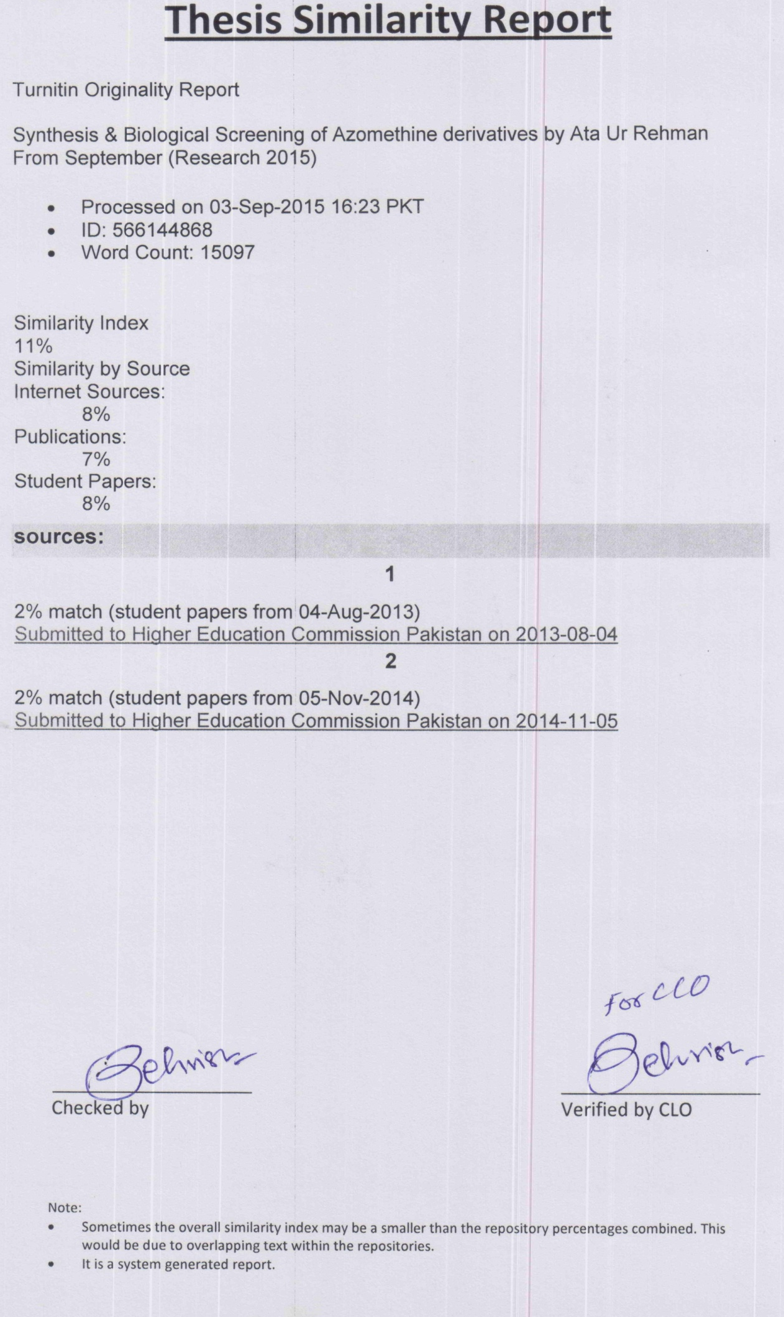

DECLARATION

I Ata Ur Rehman S/O Muhammad Anwar ID: 13001140002 Session 2013-2015 hereby declare that the matter printed in the thesis titled “Synthesis and Biological Screening of some Azomethine Derivatives of 2,4-Dimethylcarbolic Acid” is my own work and has not been printed, published and submitted as research work, thesis or publication in any form in any University, Research institution etc. in Pakistan or Abroad.

Dated: 07/09/2015 _______________

(Ata Ur Rehman)

RESEARCH COMPLETION CERTIFICATE

Certified that the research work contained in this thesis titled, “Synthesis and Biological Screening of some Azomethine Derivatives of 2,4-Dimethylcarbolic Acid” has been carried out and completed in by Ata Ur Rehman, ID:13001140002. The quantum and the quality of the work contained in this thesis is adequate for the award of Degree of M.Phil.

_____________________ ___________________

Supervisor External Examiner

___________________________ ___________________________

Dr Sammia Shahid Dr Muhammad Azhar Iqbal

Chairperson, Dean
Department of Chemistry, School of Science,
UMT, Lahore. UMT, Lahore.

Dedication

Affectionately Dedicated to My adorable & caring Parents and late Sister due to whom Prayers and Cooperation I am able to reach this status.

ACKNOWLEDGEMENT

With modest and most indebted words, I am thankful to Almighty Allah, the only Initiator of the whole universe, the most Compassionate & most Merciful, who created us as a Muslim and blessed us with knowledge to discriminate between right and wrong. Countless daroods upon the Holy Prophet Hazrat Muhammad (P.B.U.H), the source of knowledge and blessings for entire mankind.
I owe my deep gratitude to my honored research supervisor Dr. Sohail Nadeem, for his keen guidance, sympathetic attitude and enlightened supervision. His efforts, hard work and maintenance of professional integrity enabled me to complete my research work without any problem or hindrance.
I pay my profound respect and thankful to respectable co-supervisor Dr. Aziz Ur Rehman, Govt. College University Lahore, who’s gentle favour, friendly encouragement; suggestions enable me to complete this research work.
I thankful to Dr. Sammia Shahid, chairperson of chemistry department, for providing me necessary facilities for my research work.
I feel great delight to say my recognition to my friend and lab fellow Mr. Shahid Rasool who support and helped me during my research work.
I am also grateful to my very close friends, who are not here with me, but their support, encouragement and prayers are continuously with me.
I have no words to acknowledge the sacrifices, efforts, lot of prayers, guidance, support, encouragement and firm dedication from my loving Father and my caring Mother whose moral support encouraged me to complete my thesis. Many thanks are due to my cute sisters who helped me to achieve success in every sphere of life progressively. Words become meaningless when I look at them as icons of strength for being what I am today.

ATA UR REHMAN

ABSTRACT
The molecules comprising azomethine group are famous to possess biological activities. In the present work, the synthesis of N'-Substituted benzylidene-2-(2,4-dimethylphenoxy) acetohydrazide (5a-d) has been performed using 2,4-Dimethylphenol (1) as precursor. The molecule 1, was transformed into ethyl 2-(2,4-dimethylphenoxy)acetate (2) on refluxing with ethyl 2-bromoacetate in ethanol medium in the presence of base KOH. Ethyl ester 2, was refluxed with hydrated hydrazine (80%) in ethanol medium to produce 2-(2,4-dimethylphenoxy) acetohydrazide (3). The target molecules 5a-d, were manufactured by stirring 3 with phenyl/aryl carboxaldehyde (4a-d) in methanol medium in the presence of glacial acetic acid. The synthesized molecules were characterized by physical spectral data and estimated for antibacterial and anti-enzymatic activities.

OVERALL SCHEME FOR SYNTHESIS OF AZOMETHINE DERIVATINES
Scheme 1: Outline for synthesis of N'-Substitutedbenzylidene-2-(2,4-dimethylphenoxy) acetohydrazide (5a-d); Reagents and conditions: (A) Ethyl 2-bromoacetate/EtOH/ KOH/Reflux for 6 hours (B) 80% Hydrated hydrazine/EtOH/Reflux for 4 hours (C) Phenyl/aryl carboxaldehydes (4a-d)/MeOH/Glacial acetic acid/Stir for 3-4 hours.

Table of contents

Serial No. | Chapter /Title | Page No.
1.0 | INTRODUCTION | 1-12
1.1 | History of Azomethines | 2
1.2 | Chemistry of Azomethines | 2
1.3 | Stability of Azomethines | 2
1.4 | Classification of Azomethines | 2
1.5 | Synthesis of Azomethines | 3
1.5.1 | General Mechanism of Formation | 3
1.5.2 | Biological formation of Azomethines | 4
1.6 | Mechanism of Anti-Microbial Action of Azomethines | 4
1.7 | Applications of Schiff bases | 5
1.7.1 | Applications in Medicine and Pharmacy | 5
1.7.2 | Biological Activities | 5
1.7.3 | Antibacterial Activities | 5
1.7.4 | Antifungal Activities | 6
1.7.5 | Antiviral Activities | 6
1.7.6 | Antimalarial Activities | 6
1.7.7 | Anticancer and Cytotoxic Activities | 6
1.7.8 | Biocidal Activities | 7
1.7.9 | Pesticidal Activities | 7
1.7.10 | Anti-inflammable Activities | 7
1.7.11 | Applications in Modern Technology | 7
1.7.12 | Applications in Organic Synthesis | 8
1.7.13 | Plant Growth Regulator | 8
1.7.14 | Intermediates for Amino Acids | 8
1.7.15 | As Catalysts | 8
1.7.16 | As Flexidentate Lingand | 9
1.7.17 | Applications in Dyes | 9
1.7.18 | As Corrosion Inhibitor | 9
1.7.19 | Photochromism and Thermochromism | 9
1.7.20 | Reagents for Solvent Extraction | 9
1.7.21 | Applications in Polymerization | 10
1.7.22 | Applications in Organic Electronics | 10
1.7.23 | Sorbents in Solid Phase Extraction | 10
1.7.24 | Applications in HPLC | 11
1.7.25 | Nonlinear Optical Response | 11
1.7.26 | Miscellaneous Applications | 11
1.8 | Aims & Objective of Research | 12
2.0 | REVIEW OF LITERATURE | 13-29
3.0 | MATERIALS AND METHODS | 30-37
3.1 | General | 30
3.2 | Synthesis of ethyl 2-(2,4-dimethylphenoxy)acetate (2) | 31
3.3 | Synthesis of 2-(2,4-dimethylphenoxy)acetohydrazide (3) | 31
3.4 | Synthesis of N'-Substitutedbenzylidene-2-(2,4-dimethyl phenoxy) acetohydrazide (5a-d) | 32
3.4.1 | Synthesis of N'-Benzylidene-2-(2,4-dimethylphenoxy) acetohydrazide (5a) | 33
3.4.2 | Synthesis of N'-(2,3-Dimethoxybenzylidene)-2-(2,4-dimethylphenoxy)acetohydrazide (5b) | 34
3.4.3 | Synthesis of N'-(2,5-Dimethoxybenzylidene)-2-(2,4-dimethylphenoxy)acetohydrazide (5c) | 34
3.4.4 | Synthesis of N'-(3,4-Dimethoxybenzylidene)-2-(2,4-dimethylphenoxy)acetohydrazide (5d) | 35
3.5 | Overall Scheme For Synthesis Of Azomethine Derivatives | 36
3.6 | Antibacterial Assays | 36
3.7 | Lipoxygenase Inhibition Activity | 37
3.8 | Statistical Analysis | 37
4.0 | RESULTS AND DISCUSSION | 38-69
4.1 | Interpretation of ethyl 2-(2,4-dimethylphenoxy) acetate (2) | 39
4.2 | Interpretation of 2-(2,4-dimethylphenoxy) acetohydrazide (3) | 42
4.3 | Interpretation of N'-Substitutedbenzylidene-2-(2,4-dimethylphenoxy) acetohydrazide (5a-d) | 45
4.3.1 | Interpretation of N'-Benzylidene-2-(2,4-dimethylphenoxyacetohydrazide (5a) | 45
4.3.2 | Interpretation ofN'-(2,3-Dimethoxybenzylidene)-2-(2,4-dimethylphenoxy)acetohydrazide (5b) | 51
4.3.3 | Interpretation ofN'-(2,5-Dimethoxybenzylidene)-2-(2,4-dimethylphenoxy) acetohydrazide (5c) | 57
4.3.4 | Interpretation of N'-(3,4-Dimethoxybenzylidene)-2-(2,4-dimethylphenoxy) acetohydrazide (5d) | 62
4.4 | Antibacterial and anti-enzymatic activity (in vitro) | 66
4.5 | Conclusion | 69
5.0 | REFERENCES | 70-77

LIST OF FIGURES

Serial No. | Title | Page No.
1.1 | Formation of Azomethine from primary amine and aldehyde/ketone through condensation | 1
1.2 | General structure an Azomethine | 2
1.3 | General mechanism of Azomethine formation | 3
1.4 | Mechanism of Azomethine formation in the Presence of Base | 4
1.5 | Formation of Azomethine in biological system | 4
2.1 | Complex Azomethine Derivative | 16
2.2 | Showing Schiff Base as Ligand | 17
3.1 | Melting Point Apparatus | 30
3.2 | NMR Spectrometer | 30
3.3 | IR Spectrometer | 30
3.4 | EMIS Spectrometer | 30
3.5 | TLC Chromatogram | 30
3.6 | Reflux through Condenser | 31
3.7 | Showing Condenser | 32
3.8 | Magnetic Stirrer | 33
3.9 | Showing Inhibition Zones | 36
4.1 | ¹H-NMR spectrum of 2 | 40-41
4.2 | Mass fragmentation pattern of compound 2 | 41
4.3 | ¹H-NMR spectrum of 3 | 43-44
4.4 | Mass fragmentation pattern of compound 3 | 44
4.5 | ¹H-NMR spectrum of 5a | 46-47
4.6 | ¹³C-NMR spectrum of 5a | 47-50
4.7 | Mass fragmentation pattern of compound5a | 50
4.8 | ¹H-NMR spectrum of 5b | 52-53
4.9 | ¹³C-NMR spectrum of 5b | 53-56
4.10 | Mass fragmentation pattern of compound 5b | 57
4.11 | ¹H-NMR spectrum of 5c | 59-60
4.12 | Mass fragmentation pattern of compound 5c | 60
4.13 | EIMS spectrum of 5c | 61
4.14 | ¹H-NMR spectrum of 5d | 63-64
4.15 | Mass fragmentation pattern of compound 5d | 65
4.16 | EIMS spectrum of 5d | 65-66

LIST OF TABLES

Serial No. | Title | Page No.
4.1 | %age inhibition of antibacterial activity | 67
4.2 | MIC values of antibacterial activity | 68
4.3 | Enzyme inhibition against LOX | 68

NOMENCLATURE

Serial No. | Abbreviations | Detail
1 | NMR | Nuclear Magnetic resonance
2 | FTIR | Fourier transform infrared
3 | EIMS | Electron Impact Mass Spectrometry
4 | MIC | Minimum inhibitory concentration
5 | LoX | Lipoxygenase
6 | IC₅₀ | 50% enzyme Inhibition Concentration

