Project Title:

IMPROVEMENT IN YARN QUALITY WITH THE HELP OF ROOT CAUSE ANALYSIS

Participants
Waseem Khalid
Syed M.Najamul Hassan
M.HussnainHaider

Supervisor Mr. NoumanMuneer


UNIVERSITY OF MANAGEMENT AND TECHNOLOGY LAHORE
ABSTRACT

Spinning is the process of changing of fiber into yarn. The spinning mills includes many
processes like cotton mixing, carding, combing, drawing, winding. Winding is the final process in spinning mill where the yarn of small quantity is wound into a big package known as cones. The important aspect in all departments is to remove basic defects to improve yarn quality. In blow room there is improper mixing, in spindles there is speed variation issue, in moisture room there is insufficient supply, and in mixing there is no defined method. Root cause analysis is lean manufacturing tool by using this we remove all these errors. By doing this the proper mixing improves, moisture standard maintained and by proper opening yarn quality can be improved. The drawback of basic errors that we find can reduce the fiber length and it reduces the operating efficiency of the whole process. This leads to reduction in quality of yarn. The aim of the proposed work is to implement the root cause analysis and thus the quality of yarn improved.

ACKNOWLEDGEMENT

We are very thankful to many person for their expert helps and for providing knowledge for our project,for this we are especially thankful to the management of Sufi Textile Mills Limited Jhang,who gave us useful information about our project.We are also thankful to our University of Management and Technology for their support and guidance for completion of our project.

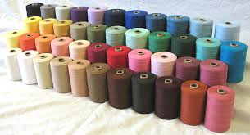

Dedicated To
The immeasurable Love
And
Ever Strengthening Prayers
Of
Our Parents

CONTENTS
Chapter 1
  - Introduction
  - Root Cause Analysis
  - Useful tools for Root Cause Analysis
CHAPTER 2
2.1 Purpose of the project
2.2 Different terms and definitions
2.2.1 Imperfection of Yarn
2.2.2Thin Places & Thick Places
2.2.3Strength of Yarn
2.2.4 Neps
2.2.5 Hairiness
2.2.6 U%
2.2.7 CV%
2.2.8 Moisture meter
2.2.9 Moisture
2.2.10 Relative humidity
2.2.11 Trash Content
2.2.12 Length Staple
2.2.13 Uniformity Ratio
2.2.14 UR%Classification
2.2.15 Fiber Moisture
2.2.16 Non-lint content
2.2.17 Fiber Fineness
2.2.18 Moisture Content
2.2.19 Yellowness
2.2.20 Micronaire
2.2.21 Micronaire
2.2.22 DIAGRAMS
Chapter 3
3.1 Literature Review
Chapter 4
4.1 Process of yarn spinning
4.1.1 Flow Chart of Process
4.1.2 Blow room
4.1.3 Carding room
4.1.4 Drafting room
4.1.5 Combing department
4.1.6 Simplex frame
4.1.7 Ring frame
4.1.8 Auto cone/Winding process
CHAPTER 5
5.1 Methodology
5.2FISHBONE DIAGRAM
5.3 Detail explanation
5.4 Improper opening of cotton bales
5.5 Insufficient supply of moisture
5.6 Malfunction machine parts
5.7 QUALITY GRAPH
5.8 PRODUCTION GRAPH
5.9 Improper mixing
5.10 Results and findings before implementation
5.11 Results and findings before implementation:
5.12: Conclusion

CHAPTER 1
1.1 INTRODUCTION
Organizations look for ways to improve their quality and management processes in order to remain competitive in the market. This calls for ways to reduce production cost, enhance productivity and improve product quality. Therefore, organizations must utilize all the available resources efficiently and effectively in order to cater their customers with high quality products at a low price. For these reasons, researchers all over the world proposed several improvement strategies and tools to satisfy organization’s needs. Such initiatives include Total Quality Management, Quality Awards, Total Preventive Maintenance (TPM), Lean and Six Sigma,Root Cause Analysis.
We choose the textile industry located at Jhang that is Sufi Textile Mills Limited. In Sufi Textile Mill there is the production of yarn by spinning process.
But in our project we improve the yarn quality with help of root cause analysis.In root cause analysis we find out the basic problems which defects the yarn quality.By using the tool root cause analysis we removed the defects from the yarn and from different processes and improved the yarn.

1.2 Root Cause Analysis
Root cause analysis (RCA) is a method of problem solving that tries to identify the root causes of faults or problems.RCA practice tries to solve problems by attempting to identify and correct the root causes of events, as opposed to simply addressing their symptoms. Focusing correction on root causes has the goal of preventing problem recurrence. RCFA (Root Cause Failure Analysis) recognizes that complete prevention of recurrence by one corrective action is not always possible.
1.3Useful tools for Root Cause Analysis
• The “5 Whys”
• Pareto Analysis (Vital Few, Trivial Many)
• Brainstorming
• Flow Charts / Process Mapping
• Cause and Effect Diagram
• Tree Diagram

CHAPTER 2
2.1 Purpose of the project
In this project, it is required to improve the quality of the yarn by removing basic errors with the help of root cause analysis by considering the factors such as,
- Improper opening of raw material.
- Difference in the quality of raw material
- Yarn Breakage.
- Malfunction machinery parts.
- Improper and insufficient supply of moisture to the Yarn.

2.2 Different terms and Definitions
2.2.1 Imperfection of Yarn:
Yarns spun from staple fibers contain “IMPREFECTIONS”. They are also referred to as frequently occurring yarn faults. They can be subdivided into four groups:
- Thin Places
- Thick places
- Neps
- Hairiness
2.2.2Thin Places & Thick Places:
The yarn imperfection includes thin places, thick places which have great influence on the yarn breakage and quality of the fabric.
It is generally observed that all thick and thin places in the yarns are weak places, because at thick place there is no T.P.I and at thin place more T.P.I than normal.
2.2.3Strength of Yarn:
The most important factor that influence yarn breakage. It is the force required to break the yarn. Can be calculated by the following method:
1. Single yarn tensile strength
2. Lea Strength

- Single yarn tensile strength:
The yarn of each type is important in weaving because every yarn has to withstand high stress strain during different processes. The strength of yarn should be good otherwise it will affect the quality of fabrics and the efficiency of the machine.
CV% of the single yarn strength influences warp stoppages more than any other factor. If the single yarn strength is high than yarn breakage will be less. If optimum performance is required than single yarn strength should not exceed 8% and variability of single yarn twist should not exceed 6%.
- Lea Strength:
The strength of 120 yards of yarn made on wrap reel his lea is tested on the strength tester. Lea strength is also consideredduring section of yarn for the manufacturing of fabric. More the Lea strength lesser will be yarn breakages.
2.2.4 Neps:

Neps are maydue to entanglement of fibers in ginning process or immature fibers. Entangled fibers can be sorted out by careful processing but, neps due to immature fiber will stay on, in the end product and cause the level of yarn defects to go higher.These should not exceed 1000 - 1200 per km for carded yarns and 300 per km for combed yarns.

2.2.5 Hairiness:
Hairiness is due to the high level of short fibers and faster processing speed. In weaving the yarn used should have very low hairiness and has uniform distribution of hairs throughout the yarn length. The yarn with minimum hairiness have good quality of fabric and have low yarn breakage. So during the yarn section this factor should be considered and hairiness of yarn should be tested on hairiness determining apparatus, so the quality of the end product may consistent by controlling the breakages. Unevenness of yarn affects fabric appearance and preferably be around 12%-15%. U% depending on whether we are using combed yarn or carded yarn. Doubled yarns should have significantly lesser U% and lesser number of yarn defects.
2.2.6 U%:
The average value for all the deviations from the mean is calculated & then expressed in percentage of the overall mean.
2.2.7 CV%:
The standard deviation is calculated by squaring the deviation from the mean and this is then expressed as percentage of the overall mean (coefficient of variation).
Higher fiber uniformity and lower of short fiber percentage will be beneficial to keep C.V at lows.

2.2.8 Moisture meter:
Cotton Moisture Meter used to check moisture in all kind of raw cotton to finished procedure, from farming to finished yarn spinning stage.
The Cotton Moisture Meter is a valuable testing instrument during the cotton collection, processing and when buying or selling cotton.
2.2.9 Moisture:
Moisture refers to the presence of a liquid, especially water, often in trace amounts. Small amounts of water may be found, for example, in the air (humidity).Moisture also refers to the amount of water vapors present in the air.
Moisture= Original wt-dry wt/original wt *100
2.2.10 Relative humidity:
The amount of water vapor in the air at any given time is usually less than that required to saturate the air.The relative humidity is the percent of saturation humidity,generally calculated in relation to saturated vapor density.
2.2.11 Trash Content:
The HVI system measure trash or non-lint content by use of video camera to determine the amount of surface area to the sample that is covered with dark spots.As the camera scans the surface of the sample, the video output drops when a dark spots encountered (COUNT) and the per cent of the covered area covered by the dark spots (AREA).

2.2.12 Length Staple:
If the length of fiber is longer, it can be spun into finer counts of yarn witch can fetch higher prices. It also gives stronger yarn.
2.2.13 Uniformity Ratio:
If the ratio is high. The yarn is more even and there is reduced end-breakage.
2.2.14 UR%Classification

Below 42 Very Low
42 ~ 43 Low
44 ~ 45 Average
46 ~ 47 High
Above 47 Very High
2.2.15 Fiber Moisture:
Fiber moisture is another important characteristic of cotton and is an index of development of the fibers. As in case in other fiber properties, the maturity of cotton fiber varies not only between fibers of different samples but also between fibers of same seed. The causes of the differences observed in maturity is due to variations in the degree of the secondary thickening or deposition of cellulose in a fiber.

2.2.16 Non-lint content:
Low percentage of trash will reduced the process waste in blow room and cards. There will be fewer chances of yarn defects.
2.2.17 Fiber Fineness:
Finer fiber produced fine count f yarn and it also helps to produce stronger yarn.
2.2.18 Moisture Content:
Moisture content is more than Standard value of 8.5%, there will be more invisible loss. If moisture is less than 8.5%, then there will be tendency of fiber resulting in frequent yarn breakages.
2.2.19 Yellowness:
When value of yellowness is more, the grade becomes lower and lower grades produce weaker and inferior yarn.
2.2.20 Micronaire:
The unit is micro gram per inch. The average weight of one inch length of fiber, expressed in micro gams (0.000001)
Denier man-made fibers: Weight in grams per 9000 meters of fibers.
• Denier = Weight in grams / 9000 meters
• Denier = Grains / 637.6 yards
• Micron (wool) = Fineness is expressed as fibers diameter in micron (0.001mm)
• Denier = 0.354 * Micron Value
• Micronaire value = 2.824 * Denier
2.2.21 Micronaire:
Below 3.0 Very fine
3.0 ~ 3.9 fine
4.0 ~ 4.9 average
5.0 ~ 5.9 coarse
6.0 And above very coarse

2.2.22 DIAGRAMS

Thick and Thin Places:
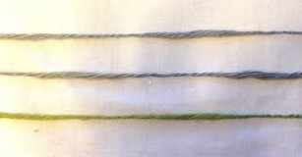

Neps:

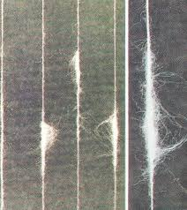

Hairiness:
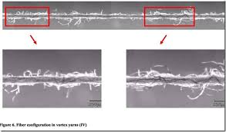

Cotton bales:

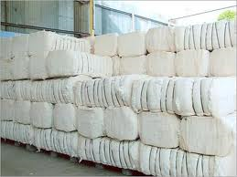

Chapter 3
3.1 Literature Review
In textile industry spinning process is the main part.In this process a lot of fibers twist together to form yarn. Quality is an important factor in any industries.The card is the heart of spinning mill” and “well carded is well spun” (Vijykumar, 2007).(1)
Tajama-ul-Hussain worked on the improvement of yarn quality by implementing different management techniques like profitability, market share, sale volume, rejection rate, and organizational performance.
Tatikonda, L. and Tatikonda (1996) measure the performance of different organizations, so profitability is considered the performance indicator in improving yarn quality.(2)
Compact spinning systems were first presented at the International Textile Machine Fair ITMA’99. However, investigations into compact spinning have been carried out since 1991, whereas the first spinning frame adapted for compact spinning and dedicated to industrial use were built in 1995. At present, the writer, Suessen, and Zinser companies have produced compact ring spinning frames. Over 330,000 spindles of ring spinning frames with the Elite compact drawing apparatus from Suessen are currently operating in spinning mills all over the world to increase the quality of yarn.(3)

Department of Fiber Technology, University of Agriculture, Faisalabad and at Nishat Textile Mills Ltd., Faisalabad during the year 2000-2001 proposed the method of Programmable Logic Control to design an automatic waste removal system to remove dust and improved the yarn quality. This process is installed in autoconer system and maintained at 60 mbar.
Ujala Textile Mills uses the DMAIC tool technology that is define,measure,analysis and implement these technologies to our process to improve the process and remove defects from all departments.As in Six Sigma methodology, if we decrease the opportunities in the final product then we can increase the Sigma value which shows that the process improvement.
In 1790, William Kelly of Glasgow used a new method to assist the draw stroke.[10] First animals and then water was used as the prime mover. Wright of Manchester moved the head stock to the center of the machine, allowing twice as many spindles; a squaring band was added to ensure the spindles came out in a straight line. He was in conversation with John Kennedy about the possibility of a self-acting mule. Kennedy, a partner in McConnell & Kennedy machine makers in Ancoats, was concerned with building ever larger mules. McConnell & Kennedy ventured into spinning when they were left with two unpaid-for mules;[12] their firm prospered and eventually merged into the Fine Spinners &Doublers Association. In 1793, John Kennedy was addressing the problem of fine counts. With these counts, the spindles on the return traverse needed to rotate faster than on the outward traverse. He attached gears and a clutch to implement this motion.(7)
The art of spinning originated in prehistoric times. The technique of cotton spinning crystallized at the beginning of the industrial revolution says Rohlena(1974). Revolutionary changes in spinning technology took place during the 1950sand 1960s, following the post war boom, views Lord (2004). During the 1970s, there appeared to be a myriad of spinning systems, such as twist less spinning, selftwistspinning, fascinated yarns, composite yarns, wrap-spun yarns, pot spinning, continuously felted yarns and the many possible variants in open-end spinning such as rotor, electrostatic, friction spinning, and vortex spinning.
At the same time, there were continued developments in ring spinning, with ventures into rotating ring and traveler systems, individual spindle drives, high draft systems, modified travelers, double roving spinning, and hybrid systems. A look at today’s industry reveals that while some systems have established a successful but small niche- wrap spinning for fancy yarns and friction spinning for specialty industrial markets -very few systems have survived.
Until the early 60s, the main type of spinning machines were ring spinning frames, which were used in all types of spinning systems. In the 70s, open end spinning was developed, mainly rotor spinning, with reference to cotton and cotton like yarns. However, ring spinning frames are still competitive in relation to rotor spinning machines, and in some systems they are impossible to replace says Lewandowski et al (2010).Today, infact ring spinning is by far the most widespread spinning process, setting clear standards in terms of yarn quality, field of application and flexibility. Ring spinning has become a truly high-tech process revealsStalder (2003).
Grosberg and Iype (1999) mention that only ring spinning will be considered as the most widely used method of spinning. Because of ring spinning’s versatility in terms of fiber types that can be handled, the range of counts that can be spun and the quality of the yarns produced, it is the standard against which other systems of spinning are judged. A ring-spinning machine is an uncomplicated, flexible, low cost device that is well established in the nineteenth century.

Chapter 4
4.1 Process of yarn spinning:
4.1.1 Flow Chart of Process:
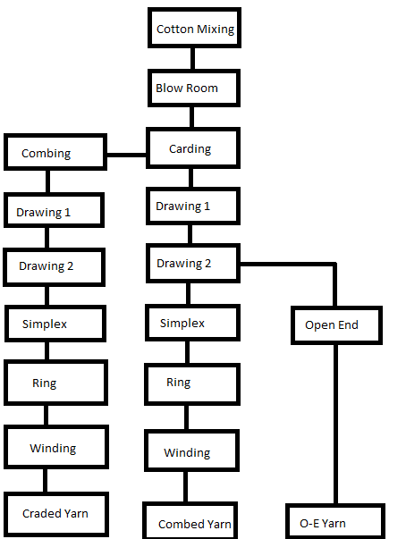
4.1.2 Blow room
In Blow room, different lots of cotton are mixed to achieve homogeneity & then passed through different stages of beating and blowing to reduce the tuft size and move trash from the fibrous material. Blow Room consists of series of machine specially designed for opening and cleaning the fiber by heating and certain beating and cleaning elements. It is called Blow room because the material is transported from one machine to the next by means of air current, usually generated by centrifugal fans if required, blending of different fibers can also be carried out in the blow room.
Objectives:
Followings are the basic objective of blow room:
- Opening (To reduce the tuft size)
- Cleaning (To remove the trash)
- Mixing / Blending (To achieve homogeneity)
- Micro dust removal
- Uniform feed to the carding machine
- Recycling the wast
Cleaning efficiency in blow room:
The key objective of the blow room is to reduce the luft size from machine to machine and opening of the fiber which results in a removal of trash hence the cleaning efficiency is the most important consideration in blow room. In blow room excessive weight loss occurs as most of the trash are removed in blow room hence production efficiency in blow room decreases but the cleaned material results to increase the production efficiencies of further process machines. Cleaning efficiency of blow room essentially depends upon the trash in raw material.
Cleaning efficiency:
Cleaning Efficiency % =((trash in feed%-trash in delievery%))/(trash in feed%) x 100

4.1.3 Carding room
The proverb of the expert “The Card is the heart of the Spinning Mill” and it demonstrate immense significance for final result of the spinning operation.
This process plays very important role in spinning mill. It helps to remove the impurities and neps as well as to open the tuft into a single fiber.
Card feeding is done by two ways.
- Manually system
- Chute system
Manual system:
In manual system the lap produces in Blow room is feed to the Card.
Chute System:
In Chute feed system the material is feed through air flow system to card machine.
It is important to say that carding quality will be better if feed variation is lower. Lower the feed variation then draft variation is also less. Then yarn quality consistent. If Card have auto leveler then nominal draft should properly selected. In some circumstances card also act as a cleaner and remove a certain amount short fiber. Approximately 90% of the cleaning can be achieved by carding machine.

The task of the Carding:
- Opening of individual fibers, this enables elimination of impurities & performance of other operation.
- Elimination of impurities occurs mainly in the region of the taker-in. Thedegree of cleaning is achieved by modern card is very high, in the range of 90-95%.
- Dust removal, which is bound to fibers. Significant fiber-metal and fiber-fiber friction is needed in order to loosen such particles; this is available in carding operation.
- Sliver formation of further processing.
- Elimination of short fibers, his may occur at flats. Long fiber have main contact with the clothing of the main cylinder than the short fibers. Thus longer fibers. Thus longer fibers are continuously caught & carried along the main cylinder, where the short fibers stay caught in flats clothing , press into it & leave the machine in the flat stripping. The Card eliminates very small percentage of short fibers about 01%.

4.1.4 Drafting room
Purpose of Drawing is to straighten the fibers & remove any curls. This takes place by passing the slivers through different sets of rollers that are revolving at different speed. The speed of the roller increase as the sliver moves from one stage to the next.
Draw frame is a very critical machine in the spinning process. Its influence on quality especially on evenness is very big. If draw frame is not set properly, it will also result in drop in yarn strength and yarn elongation at break. The faults in the sliver that come out in draw frame cannot be corrected. It will pass into the yarn.
Objectives of Draw Frame
- Parallelization of fiber
- Evenness of sliver
- Blending of different fiber
Draft:
Draft is the attenuation of fibrous strand. It is defined as weight per unit length or increase in the length per unit weight. Draft calculated by the ratio of linear densities of feed and delivered material is called actual draft while the draft calculated by the ratio of the surface speeds of feed and delivery drafting rollers is called mechanical draft. Actual draft is always greater than mechanical draft.

Draw Frame Auto-leveler:
Auto-leveler is an additional device which is meant for correcting the linear density variations in the delivered sliver by changing either the main draft or break draft of the drafting system, according to the feed variation. This system is an electronic leveling system.
Blending:
The blending of polyester and cotton is carried out in draw frame in the ratio of 52/48 PC for 30s yarn. The doubling of sliver was 8 slivers in which 4 cans are of cotton and 4 are of polyester. The blending is carried out on the breaker draw frame. Then sliver passed through the inter draw frame for more Parallelization finally the sliver is passed through the finisher draw frame.

4.1.5 Combing Department
In this operation dirt and short fibers are removed from sliver lap by following ways:
- In a special designed jaws, a narrow lap of fiber is firmly gripped across its width.
- Closely spaced needles are passed through the fiber projecting from jaws.
Short fiber which are removed is called comber noil. The comber noil can be recycled in the production of carded yarn. The yarn get from comber sliver is called comber yarn. Carded sliver are combined into comber lap in single combine comber stage.
There are different ways by which value of combing is used in the manufacturing of cotton. By spinning point of view combing process makes more uniformity in the yarn. Strength of yarn is also high because in combing process short fiber are removed and only fiber having good strength remains. So it play very important role for increasing the yarn strength. Because of straightened condition of fibers combing makes possible spinning smoother and more lustrous yarn. In combing process length of fiber are strong so it need less twist produced then carded yarn.

Important points to be considered:
Noil%age:
Higher Noil %age always improves the imperfections in the final yarn, but the strength and other quality parameters improve up to certain noil %age. Further increase in noil %age results in quality deterioration. Higher noil %age will lead to higher end-breakage rate at ring spinning frame.
Nep removal:
Nep removal efficiency of comber should be least 55 or more.
Needle of top comb:
Needles of top comb have effect on noil %age. More the needles more the noil %age.
Draft between comb and card:
Total Draft b/w card and comber cab be form 9.5 ~ 11 depending upon the fiber and the lap weight. But it should not be more than 12. It must be kept minimum to get good quality.
Damage top comb:
If the top comb is damaged, the slub will be produced in sliver.
Nipper body:
The nipper body setting affects the thin places in the yarn.

Micronaire:
If micronair is less than 3.8, the lap licking tendency will be more. For such fiber the total draft b/w card can comber should be kept as low as possible i.e. 8.5

4.1.6 Simplex Frame
The roving frame is an intermediate machine between draw frame and ring frame, the main objective of this machine is to convert sliver into thinner sliver for the convenience of subsequent processes. The sliver we obtain from draw frame is still thicker sliver which is not good for yarn manufacturing.
Objective of Simplex Frame:
Following are the main objective of the draw frame:
- Drafting the Sliver into Roving
- Twisted the drafted stand called roving
- Winding the twisted roving on a bobbin

4.1.7 Ring Frame
Ring spinning is the final stage from which yarn is obtain in its proper count & twist. Four actions take place in this stage. First is roving delivery. Second is drafting that is process in which the linear density of the roving is decreased by controlling the surface speed of the input & output machine components. Thirdly, twist insertion into yarn & final action is winding.
Objective of Ring Frame:
Are the basic objectives of the ring frame:
- Drafting the roving into the yarn
- Twisting the yarn to impart strength in it
- Winding the twisted yarn to the bobbin

4.1.8 Auto cone/Winding process
It is the last section of yarn manufacturing process where auto cone machines are installed and take an input material from ring spinning section as a yarn bobbin and give a yarn on paper cone after passing detecting instrument as output. In winding section, there are lot of heads in auto cone machines use to wound the yarn from ring bobbin yarn to paper cone yarn.
Ring spinning produces yarn in a package form called cops. Since cops from ring frames are not suitable for further processing, the winding process serves to achieve additional objectives made necessary by the requirements of the subsequent processing stages.
Objectives:
- Extraction of all disturbing yarn faults such as the short, long thick, long thin, spinner doubles, etc
- Manufacture of cones having good drawing – off properties and with as long a length of yarn as possible
- Paraffin waxing of the yarn during the winding process
- Introduction into the yarn of minimum number of knots
- Achievement of high machine efficiency i.e. high production level

CHAPTER 5
5.1 Methodology
By using root cause analysis the problems that we fined can be solved by the different method.
Here there are four to five methodologies which we used, by using these methodologies we can improve the process of yarn and by improving the process the yarn quality can be improved.
First of all we see the working of the whole spinning process of different departments.
· Blow room
· Carding room
· Spinning room
· Drawing frame room
· Moisture room
· Packing room
By the survey of all these departments here we see different basic errors

5.2FISHBONE DIAGRAM

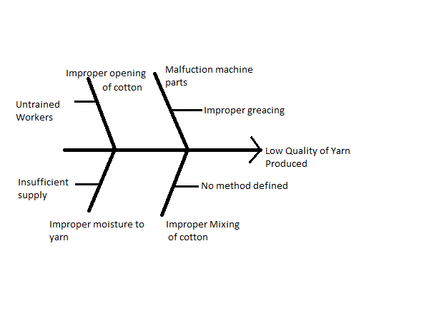

5.3 Detail explanation:
First of all we see the working of the whole spinning process of different departments blow room,spinningroom,autoconeroom,drawing frame room, here we see different basic errors.
- The first issue is improper opening and for this we arranged the training for workers on daily basis for one month and 15 to 20 minutes daily and trained by existing fully trained workers.By doing this the further process can be worked properly and the chances of breakage of the yarn can be minimized and quality can be improved.
- The second issue is difference in the quality of raw material.The difference in the quality of raw material occurs due to the selection of different vendors.The raw material comes from different places and vendors,which have different qualities.
- The third issue is the use of malfunctioning machine parts which has very bad impact on yarn quality.This issue is resolved by the method, that the malfunctioning parts can be maintained and give proper time to these parts and should be maintained on the daily basis properly in the workshop.
- The fourth issue is moisture problem which is very important for yarn.Here the moisture is giving to the yarn cones in an open hall and can be placed in the form of cubicstructure.By doing this the outer autocones can take moisture properly but the inner cones can not take the proper moisture and by not taking proper moisture the quality of yarn become not efficient.The methodology we use here is that, we use the hanging system in the hall and hang the yarn auto cones on the hangers and we introduced the rack system on the walls and placed other cones on these racks.By doing this the proper moisture can be achieved.
5.4 Improper Opening Of Cotton Bales
In blow room there is opening process of cotton bales. There are two types of opening,
- Manual opening
- Mechanical opening
But here we discuss the manual opening also called hand opening.
Opening of cotton bales is an important factor. First of all the bales of cotton are opened of equal pieces of 250 or 200 gram then put them on conveyor for further process. Opening of cotton is a manual process (by hands) so cotton should open carefully and properly in such a way that fiber would not break,this should be done slowly & softly by doing this the length of the fiber increases. The length of fiber plays an important role in the quality of yarn,

5.5 Insufficient Supply Of Moisture
Similarly moisture is very important factor. After opening all these pieces are moved to the humidification hall, the proper standard of moisture is 7% to 9% for cotton. So the cotton pieces are placed in the hall for 8-12 hours and takes the moisture.
5.6 Malfunction machine parts:
In the machine maintenance main issue is speed variation.Machine maintenance solved by the definition of preventive maintenance.
 | Lubrication/Greasing | Quality | rpm
After 6 days | Not required | Constant | Constant
After 8 days | Required | Little variation | Fluctuation
After 10 days | Highly required | Decreases | Increased

5.7 QUALITY GRAPH

In the above graph it shows that as the speed increases of machinery and speed of rotation of spindle also changes than TPI (Twist per inch) changes and quality decreases.

5.8 PRODUCTION GRAPH

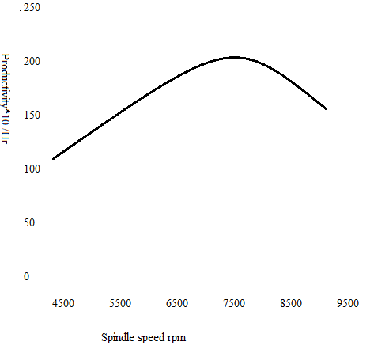
- In the above graph it shows that as the speed increases of machinery and speed of rotation of spindle also changes than TPI (Twist per inch) changes and due to increase in speed the yarn ware out and all the process stops that’s why production decreases.

- If the malfunction parts like belts, bearings, chains maintained on regular basis and properly greased to these parts and works on the principle of preventive maintenance. By doing this machine works properly than there is less chance of speed variation.

5.9 Improper Mixing Of Cotton
First of all the cotton bales comes from different suppliers and of different quality. The mixing of these bales is very necessary to achieve the quality. The mixing method named as is sandwich method.
“Sandwich method”
In this method count the number of bales of different qualities for example,
- Quality A has 4 bales
- Quality B has 3 bales
- Quality C has 3 bales
Than, from all these bales take cotton layers of equal ratio and place on each other and than opened it into small pieces of 200 or 250 gram.

5.10 Results and Findings Before Implementation:

 | 1 | 2 | 3 | 4 | 5 | 6 | 7
U% | 15.74 | 15.98 | 14.24 | 14.21 | 14.76 | 13.60 | 14.21
Neps | 29 | 18 | 33 | 56 | 18 | 14 | 79
Thin | 46 | 32 | 26 | 15 | 31 | 17 | 23
Thick | 34 | 38 | 26 | 24 | 9 | 15 | 32

5.11Results and Findings After Implementation:

 | 1 | 2 | 3 | 4 | 5 | 6 | 7
U% | 12.61 | 11.34 | 11.67 | 11.23 | 10.34 | 12.23 | 11.7
Neps | 13 | 8 | 9 | 17 | 12 | 11 | 10
Thin | 2 | 2 | 5 | 7 | 1 | 0 | 3
Thick | 7 | 7 | 6 | 8 | 9 | 4 | 5

5.12 Conclusion
In this paper, we have achieved a lot of results regarding to process problems during manufacturing of yarn in different departments. The main thing in our paper is to reduce the defects rate and also reduce fault opportunities in the final yarn; we have worked in every department to reduce these opportunities and improve the quality. As in Root Cause Analysis methodology, if we decrease the defects in the final product then we can increase the overall process and improve the yarn quality. We have also applied a basic tool of Root Cause Analysis likefishbone diagram in our thesis in which highlighted the different processes and importance in the manufacturing of yarn. All the department where we have applied Root Cause Analysis tool is critical as compared to other departments in the process as it cause an increase defects rate percentage in the final product of yarn. It’s better to implement Root Cause Analysis tool to eliminate or reduce the defects from different departments. After this section, we can’t improve the quality or reduce the defects in the final product.

References:
1)http://www.iosrjournals.org/iosr-jmce/papers/vol6-issue1/H0615065.pdf
2)http://prr.hec.gov.pk/Thesis/406S.pdf
3)Jackowski T., Cyniak D., Czekalski J. ‘Compact Cotton Yarn’, Fibres and Te¬xtiles in Eastern Europe. Vol.12, 2004, No.4, p.22
4)http://www.google.cm/url?sa=t&rct=j&q=&esrc=s&frm=1&source=web&cd=1&ved=0CCMQFjAA&url=http%3A%2F%2Fwww.ijareeie.com%2Fupload%2Ffebruary%2F22_Quality%2520Improvement%2520of%2520Yarn.pdf&ei=njr3U9KVMuzZ4QTQyoGoAw&usg=AFQjCNHLmlg66TRx_4OB8qIpyqMeXjJ-sg&bvm=bv.73612305,d.bGE
5)http://ptj.com.pk/Web%202003/1-2003/art-shad.htm
6)http://www.iosrjournals.org/iosr-jmce/papers/vol6-issue1/H0615065.pdf
7)http://repository.lib.ncsu.edu/ir/bitstream/1840.16/5780/1/etd.pdf
8)http://en.wikipedia.org/wiki/Spinning_mule#Improvements
9) http://shodhganga.inflibnet.ac.in/bitstream/10603/18790/10/10_chapter2.pdf

