Small Scale Wind Energy Conversion System


Submitted by:
Shahzaib Abbas 14019019030
Nusrat Abbas 14019019028
Muhammad Ahsaan Ilahi 14019019038

Supervised by:Dr. Irfan Ullah

Department of Electrical Engineering
School of Engineering
University of Management and Technology Lahore
June 2018

Chapter 1
Introduction
Now-a-days the alarming situation for the mankind is the pollution from the chimneys of factories and power generation plants which causes the acid rain and also effect the fresh air which is inhaled by the people living close to those areas. So there was a need to made an efficient power generating source from which we can generate power without the allowance of pollution in the atmosphere. A significant reduction in dependence on oil and coal based energy cannot be achieved easily in a short period of time with the introduction of renewable energy sources only. A synergistic approach for the problem should be made, which also includes enhanced efficiency of equipment, processes and practices used in the production of electricity. The question which troubled the engineers the most was that how the capacity of energy that is produced from coal and oil would be generated by the renewable resources. That was answered firstly by generating the power by water and then by wind and solar power. So the main invention by the mankind for the solution of this problem was the generation of electricity by using the Wind. As all of the wind in the coastal and hilly and deserted areas left useless so mankind thinks of availing it and made a Wind turbine. This is called efficient way to produce electricity because there are no losses in generation and no heat dissipation and also the main thing is no pollution at all. The production of electricity by this process is mostly free of energy losses. Same the concept is generated by us as we want our society pollution free by just placing the small wind turbine at their homes even and at the highways to glow the lights on road sides. We tried to improve our project by just adding protections of overcharging of battery and overloading protection. Also the unique design of Vertical Axis Wind Turbine(VAWT) made by the rotor and steel blades. VAWT is non oriented turbine towards wind unlike the HAWT which needs the proper direction of wind and classified into the Upwind and Downwind HAWT. For the HAWT a large poles and a vast area is also required for the implementation.
Small wind turbines are developed around the world and are mainly used in rural areas. Remote settings in national and international markets. Small wind turbines can be used in the force, community, business, school, clinic, separate house, farm and various instruments. Small wind turbines can be prepared to meet specific specifications for national and international markets and the development market. The aim of our project is to generate electricity from the natural resource which is wind in our case and free of cost source of energy. For designing purpose, we screwed L shaped clamps with blades and that clamps are welded with the rim of bicycle and each blades are 60 degrees apart from other. DC Generator is coupled with the rim of bicycle by using belt and the diameter of rim is 26 inches and diameter of generator’s shaft is 3.25 inches. The speed of the turbine will depend upon the speed of wind, greater the speed of wind greater will be the rpm of generator. To get the desired volts i.e. 12V from generator we need rpm of generator to be 86.4.
12V DC from the generator is stored in the battery connected with it and from that battery we stepped it down to 5V by the voltage regulator circuit and gave the 5V supply to Relay, Arduino and LCD circuit. Also the 12V supply is given to the inverter circuit which consists of OSC, FET and stepped-up transformer, which will give us 220V AC at 50 Hz frequency. We also use filter capacitors to purify the DC in various circuits. We also implement the charger controller circuit to avoid the overcharging of the battery and OVL Relay is used for the cut-off purpose. After this we attached the AC load like Bulbs and Fan. These loads are attached with the two relays at the normally open normally closed and common pins and the relay will get the current as analogue signal from the CT and charge module via Arduino. Our system can bear the load of 500W maximum. Our project (Wind energy conversion system) model may be principally classified in these components namely:
- Turbine (including blades)
- Generator
- Mechanical drives (if needed)
- Inverter (FET, OSC, Transformer)
- Load
- Battery
- Relays
- Charge Controller
- Arduino
- LCD
- CT
- PT
Today a new way of transmission of electrical power is introduced i.e. HVDC which is more efficient as there are no compensators used for reactive power [1], [2]. Designs of wind turbine is categorized by the speed of generator its controllability selection of generator by which the power from the aerodynamics can be controlled [3]–[4]. Since the last 30 years the power electronics field in wind turbines has increased vastly and interestingly with the fast increase in capacity [5],[6],[7],[8]. Control functions of wind energy like the current control voltage stabilization grid synchronization should perform rapidly [9],[10],[11]. As told by World Wind Energy Association (WWEA), based on the growth rates, in 2016, the capacity will increase globally up to 450`000 MW. By the end of 2020, at least 700’000 MW is expected to be insert in worldwide grids .And it will continue to grow approximately 24% per year globally. Multilevel converters are being in use for power converters of full scale in wind turbines with the ability to convert higher power and voltages [12],[13]. The increase of generation of electricity worldwide by the wind, the impact on utility grids has also enhanced. Till the end of 2015, six countries including China (145362 MW), Spain (23,025 MW), Germany (44,947 MW), USA (74,471 MW), India (25,088 MW) and UK (13,603 MW) had over 10,000 GW of the installed capacity. Various devices are used for the small signal stability purpose which are Power system stabilizer (PSS), Static Synchronous Compensator (STATCOM), Series dynamic braking resistor (SDBR) and different controllers can be used. Hugh voltage alternating current (HVAC) and High voltage direct current (HVDC) can also be used for the enhancement of performance of our system. HVDC transmission used a smart converter [14], [15], called the modular multilevel converter (MMC), which can be used for power utilization and distribution also in transmission in near future. Optimization techniques for the purpose of tuning of controllers like Genetic Algorithm (GA) and Particle Swarm Optimization (PSO) can also be used. Power quality, stability, security and reliability should have no effect with the increased penetration level of the wind energy. Wind power system when applied at small scale, has almost negligible and insignificant effect on the stability of the system as it is just generating the power of 200W-10KW.

Chapter 2
Methodology and Components
2.1 Methodology
This part will cover the detailed explanation of method that is being used in making this project complete and working in a right manner. Many ways of methodology from the field of Wind Energy has already published for others to avail and use them as upcoming studies. The method is basically used to achieve the objective of project from which one can get a perfect result. In order to evaluate this project, the methodology used is based on System Development Life Cycle (SDLC) having three major steps which are planning, implementing and analysis as shown in Figure 2.1.
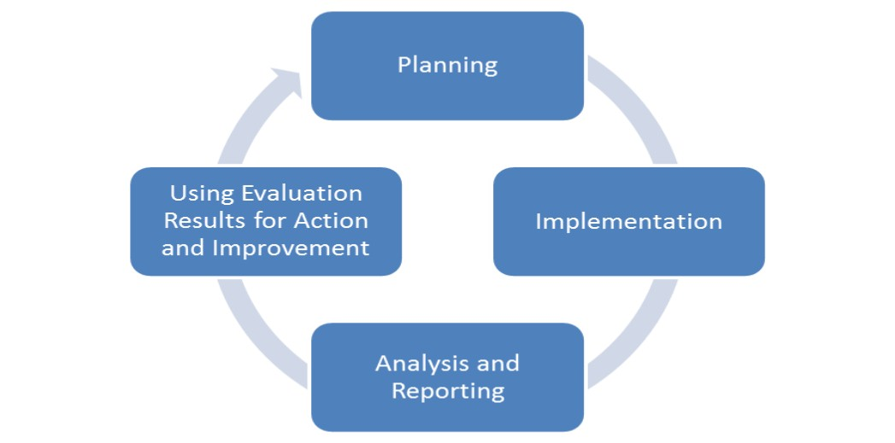
Figure 2.1. System development lifecycle methodology technique.
2.1.1 Steps Include in Implementation
Our final year project used three major steps to implement project as shown in Figure 2.2 starting from planning, implementing and Analysis. All the methods used for finding and analyzing data regarding the project.
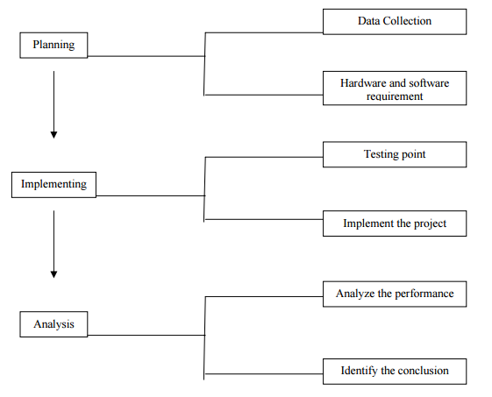
Figure 2.2.Implementation process.
2.1.2 Planning
To identify and then implementing all the information and basic requirement of project such as hardware and software, planning must be done in the proper way. The planning phase has got two main parts namely
a) Data collection.
b) Requirements of Hardware and software.
2.1.3 Data collection
It is the most initial step towards the idea of our project and in this part all the data that is gathered from all the resources will be showcased.
2.1.4 Primary and Secondary Data
There are two methods of collecting data i.e. Primary data and Secondary Data. WECS project data is collected from both of these sources as shown in Figure 2.3 and let us now see what are these types. In primary data collection, the data is collected using methods such as interviews and questionnaires. There are many methods of collecting primary data (observed or collected directly from firsthand experience).As we are going to find the Wind speed and power calculations so that’s why this is basically a Quantitative Primary Data. Published data and the data collected in the past or by other parties is called secondary data. The links and the websites and all other helping material that we got for our project comes under the secondary data and the data we got personally by self-experimenting and observations is primary data.
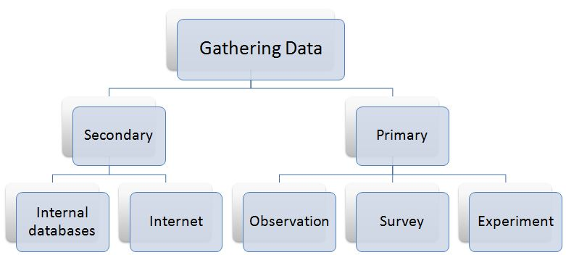
Figure 2.3. Methods of data collecting.
2.2 Interfacing and Electronics
2.2.1 Hardware and Software
This is the heart and in short the appearance of our project. In this section we will see that what can we add why we add and how will we add components in the system. As we are just doing planning’s here so we’ll just see that which sort of hardware we are going to use and what will be the structure of Small Scale Wind Energy Conversion System and which software we are using for the simulation and analysis and designing purpose.
2.2.2 Hardware
The first step in making our project is the design of whole system. Wind Energy Conversion system generally is made up of
- Wind Turbine
- Blades
- Generator
- Inverter
- Converter
- Battery
- Relay circuit
- Charge Controller
- Arduino UNO
- CT/PT
- LCD
2.3 Analysis
Analysis is based on SWOT which is the sum of our project Strengths, Weaknesses, Opportunities and Threats
Strengths
- Good wind conditions
- High interest among Investors
- Low running cost
Weaknesses
- Low power output
- High investment cost
Opportunities
- Increased demand of commercial and residential areas
- Technological progress causing efficient WECS
Threats
- Difficulties of connection with grid
- Dangerous for birds
2.4 Components
Following are the components that are being used in our project:
2.4.1 DC Generator
We used the DC generator for the generation purpose as it is coupled with the turbine with the help of belt so by the rotation of turbine the generator changes the mechanical rotation into the electrical power and 12V DC. Then this 12V will charge its respective battery of 9Ah.
2.4.2 LCD Display
A liquid crystal is a material (normally organic for LCD’s) that will flow like a liquid but whose molecular structure has some properties normally associated with solids. The Liquid Crystal Display (LCD) is a low power device and operated at 5V DC. The power requirement is typically in the order of microwatts for the LCD. However, an LCD requires an external or internal light source. We are making use of LCD in our project to display the output of CT, PT, gained Voltage and respective currents. Below is the 16×4 LCD Pin configuration and original LCD as shown in Figure 2.5 and 2.6 respectively which is being used in our project.
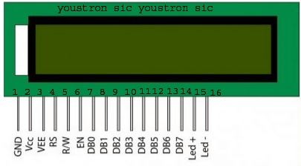
Figure 2.5. 16×4 LCD Pin Configuration.

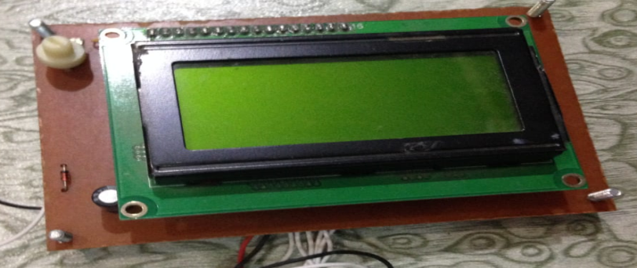
Figure 2.6. 16×4 LCD.
2.4.3 Relays Coordination
A relay is an electrically operated switch. Many relays use an electromagnet to operate a switching mechanism. Relays are used where it is necessary to control a circuit by a low-power signal. In our system we have used OVL relay for the protection of load. Also another relay is used which is overcharging relay it works on 5V DC and its functions is to cut-off the circuit while the battery is fully charged as shown in Figure 2.7. This relay is programed with Arduino and will get DC voltage from the power supply.
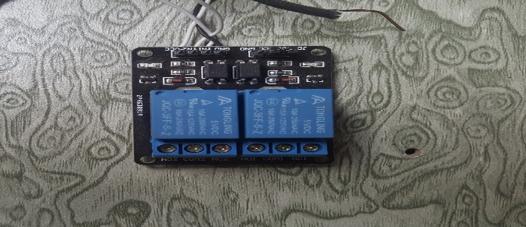
Figure 2.7. Relays Circuit.
2.4.4 Power Supply
Power supply block consists of following units:
- Regulator IC-7805
- Bridge rectifier circuit
- Capacitor as an Input filter
- Capacitors as an Output filter
It will get 12V DC from battery and will provide 5V DC to Arduino, LCD and Relays as shown in Figure 2.8.

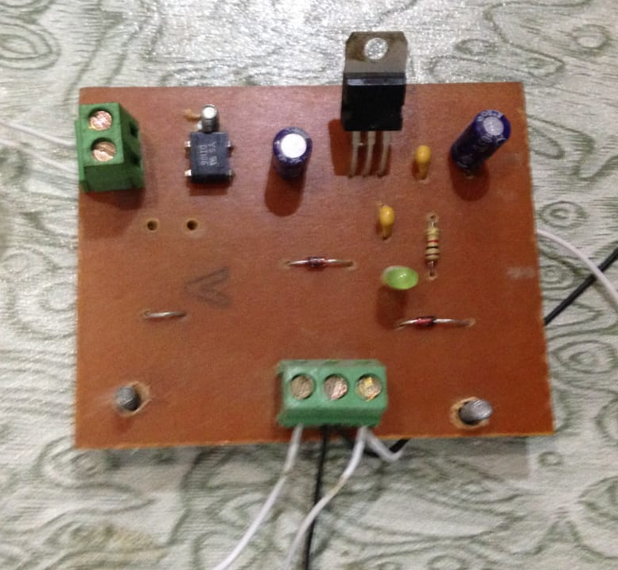
Figure 2.8. 5V DC Supply.
2.4.5 Step-up Transformer
The step-up transformer is used to step up the supply voltage of 12V AC from FET to Higher values, as the various loads used in this project require High voltages. The transformer consists of primary and secondary coils.
To increase or step up the voltage, the transformer is designed to contain greater number of turns in its primary core. The outputs from the secondary coil which is center tapped at the AC value of 220V AC as shown in Figure 2.9.

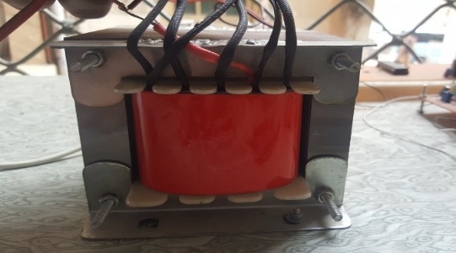

Figure 2.9. 12V AC to 220V AC Step-Up Transformer.

2.4.6 Battery
Dry cell battery of 9Ah rating is used in our project as shown in Figure 2.10. This battery will be charged from the generator and then provide supply of 12V DC to the inverter circuit indirectly from OSC.

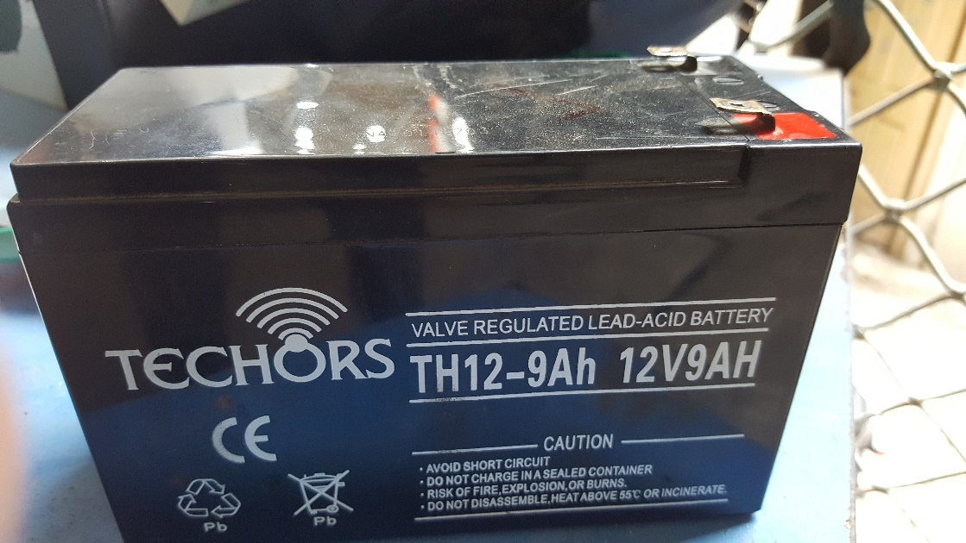
Figure 2.10. 12V DC Dry Cell Battery.

2.4.7 Inverter
Inverter consists of FET circuit and OSC circuit as shown in Figure 2.11(a) and 2.11(b) respectively. OSC circuit will get 12V DC from battery and convert it to 12V AC with 50 Hz frequency and FET circuit will boost its power to maximum 500W. They will supply this voltage and power to step-up transformer.
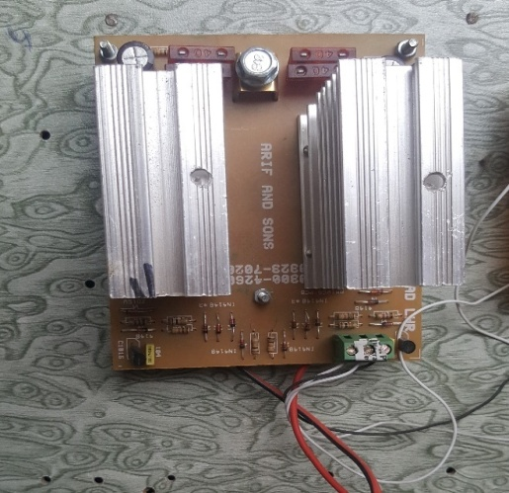
Figure 2.11(a). FET Module.

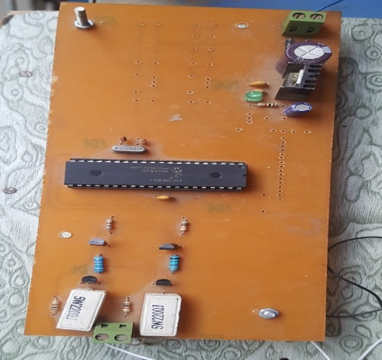
Figure 2.11(b). Oscillator Circuit.
2.4.8 CT/PT
For the measurement of current and voltages of our electrical system we took the help of measuring transformers like Current transformer and Potential transformer as shown in Figure 2.12(a) and 2.12(b) respectively. The two analogue pins A0 and A1 will get the analogue signals from CT and PT and display the readings measured by them on LCD used. The setting values of CT is 0.45 and PT 2.2.
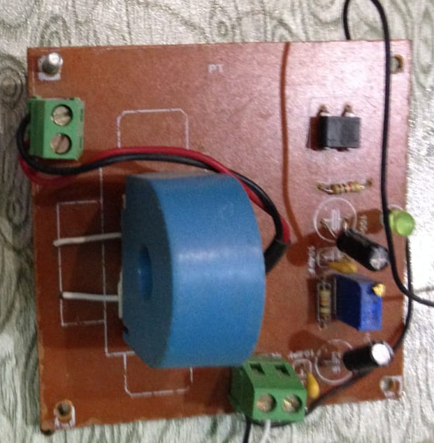
Figure 2.12(a). Current Transformer Circuit.
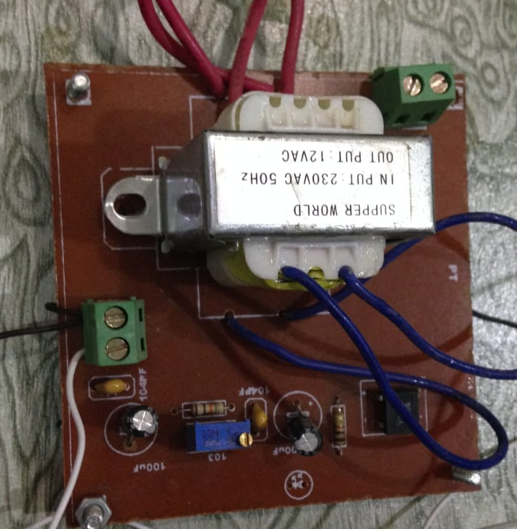
Figure 2.12(b). Potential Transformer Circuit.
2.4.9 Battery Module:
Battery module is used for the protection of the battery and is attached with the relay. The main purpose of this circuit is to protect the battery from over charging. If the battery is fully charged, this circuit will cut-off the charging in order to avoid the any effect on the life of the battery. The PCB design of charge controller is shown in Figure 2.13.
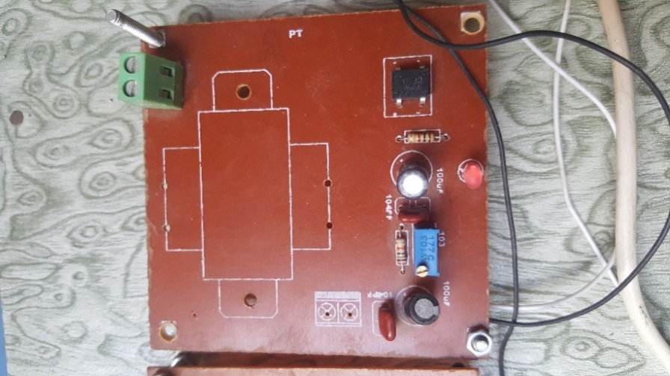
Figure 2.13. Charge Controller.
2.4.10 Arduino
Arduino is an open-source platform used for building electronics projects. Arduino consists of both a physical programmable circuit board (often referred to as a microcontroller) as shown in Figure 2.14(a) and a piece of software, or IDE (Integrated Development Environment) that runs on your computer, used to write and upload computer code to the physical board. The purpose of using Arduino in our project is to operate LCD and show the output results of CT, PT and desired Voltages and Currents. Its programming language is Assembly language and the code of our project is given in coming chapter.
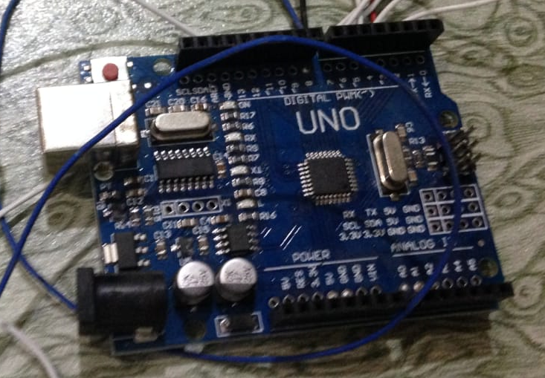
Figure 2.14(a). Arduino UNO.
2.4.10.1 Interfacing with LCD
LCD interfacing with the Arduino UNO is shown in Figure 2.14(b).

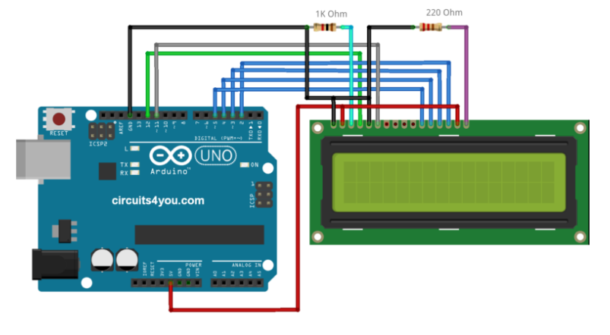
Figure 2.14(b). LCD Interfacing with Arduino.
2.4.11 Boost Convertor
We use Boost Convertor to increase the voltages of DC Generator. It is connected to DC Generator and works on the technique Switch mode power supply which consists of transistor for the very fast switching. In this circuit Capacitor of 1000uf 25V rating, is used as shown in Figure 2.15. The purpose of this capacitor is to store the charge and when the generator is turns off it will discharge first. In this way there will be no effect on battery and on life of battery. The capacitor will discharge slowly when the generator is sudden off.
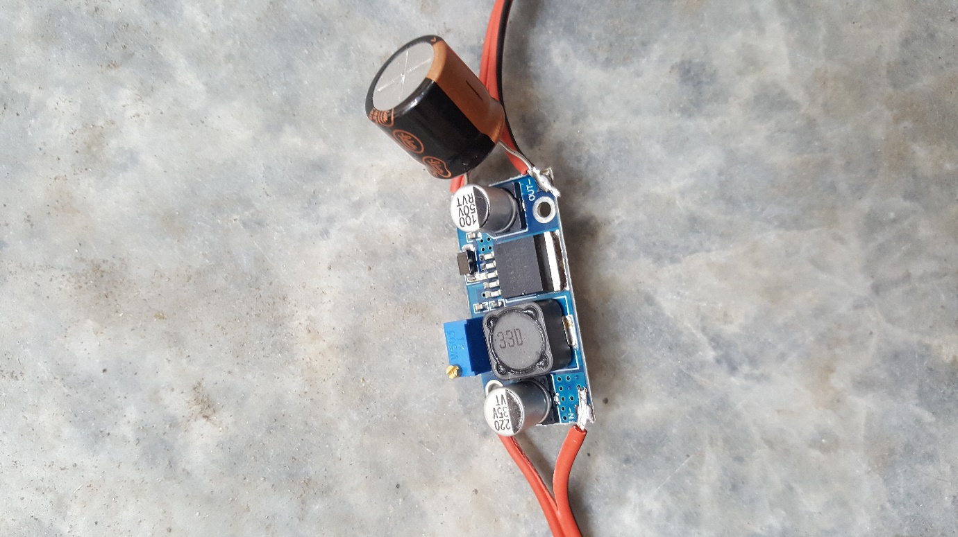
Figure 2.15. Boost Convertor.

Chapter 3
Design and Implementation
After making all the adjustments and the hardware of the project, the next main part was the design of the whole hardware. We started all from the cutting of steel sheets total of 6 as we made 6 blades turbine into the length of 30 inches and 6.9 inches in width then made a semi round shape by folded it by passing it through a bending machine. After that took two rims of a commonly used bicycle in Pakistan that is rotor and welded all of the blades 60 degree apart from each other with the rim using L-shaped clamp which was firstly screwed with blades. The designing of blades is shown in Figure 3.1.
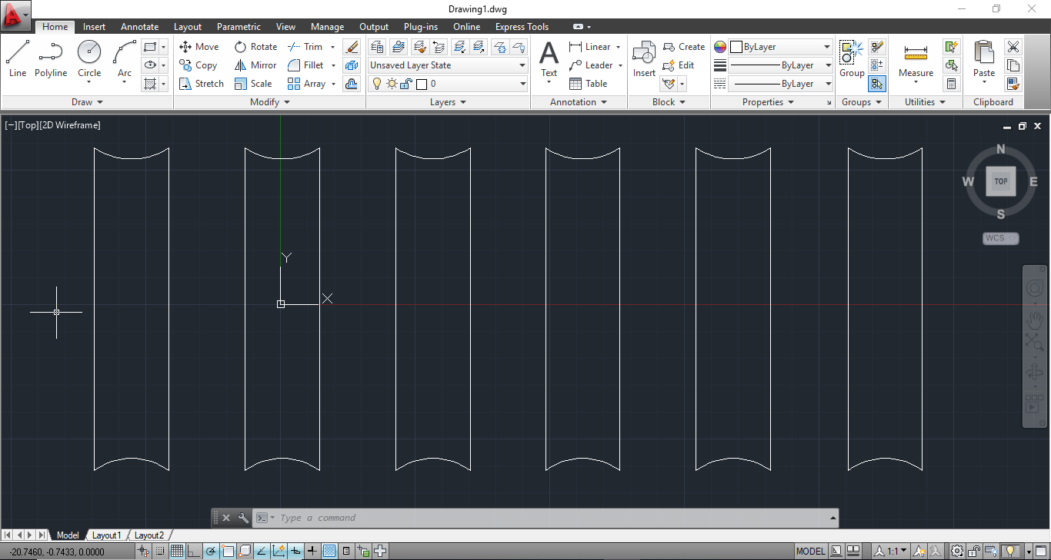
Figure 3.1 Designing of Blades of Vertical Axis Turbine.
Following figure shows when we implemented our design physically and after making the whole adjustments and spraying blue and black paint on the turbine blades and stand for decoration purpose, it started looking like as shown in Figure 3.2.
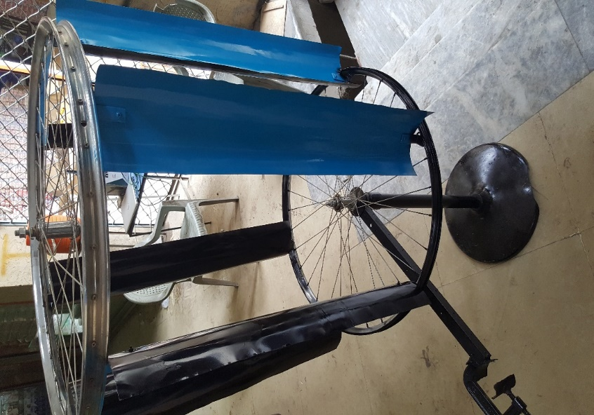
Figure 3.2 Vertical axis Wind Turbine.
The turbine is then mounted on the stand of pedestal fan and for the placement of generator we used the clamp on the rod connected with the common joints of turbine and its stand. In order to get the desired TSR (Tip-Speed Ratio) (X) we are going to take help from Table 3.1 and TSR should be in between 3-6. For the good efficiency it must be 5 [12].
Table 3.1. Calculated Values of Power Coefficients for VAWT.
TSR (X) | Power Coefficients
2 | 0.247
3 | 0.347
4 | 0.418
5 | 0.435
6 | 0.416
7 | 0.335
8 | 0.168

For the checking the TSR speed of our turbine we took help from the different books and calculated our TSR value by using the following formulas.
$P=0.5 ×p ×A ×Cp × V^{3} ×Ng ×Nb$ (3.1)
Above equation is used for wind power.
By (3.1) we can equate the following equations:
$p= \frac{P}{0.5×A×Cp× V^{3}×Ng×Nb }$ (3.2)
Above equation is used for Air Density
.$A= \frac{P}{0.5×p×Cp× V^{3}×Ng×Nb }$ (3.3)
Above equation will give us the area of rotor or blades.
$Cp= \frac{P}{0.5×A×p× V^{3}×Ng×Nb }$ (3.4)
Above equation is solved for the coefficient of performance.
$V^{3}= \frac{P}{0.5×A×p× Cp×Ng×Nb }$ (3.5)
Above equation is used to calculate the speed of the wind.
$Ng= \frac{P}{0.5×A×p× V^{3}×Cp×Nb }$ (3.6)
Equation (3.6) is used for generator efficiency.
$Nb= \frac{P}{0.5×A×p× V^{3}×Ng×Cp}$ (3.7)
Equation (3.7) is solved for bearing efficiency. All of the assumptions of the values and constant values used in mathematical calculations are listen in Table 3.2.
Table 3.2 Symbols description and assumptions values.
Symbol | Description | Typical Values
ρ | Air Density | 1.2 kg/m³
Cp | Performance Coefficient | 0.35 is typical
Cp | Performance Coefficient | 0.56 is theoretical
Ng | Generator Efficiency | 50 to 80 %
Nb | Gearbox | 95%

In order to find the TSR of our turbine we use the above assumptions and values. Following figure shows the TSR of our project by using a software:
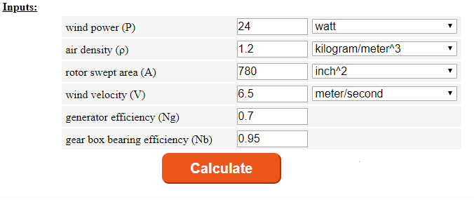
Figure 3.3. Input values of different variables and coefficients.
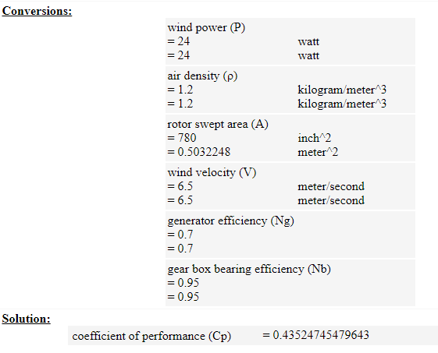
Figure 3.4. Conversions and results.
It is clearly shown in the above calculations of Figure 3.3 and 3.4 that the Power Coefficient is 0.4352 and from the Table 3.1, TSR is 5, which means that our system is accurate and efficient and gaining maximum power output. After this, we attach the lower rotor of turbine to the generator’s pulley with the help of belt. Two wires coming out of generator will then charge the Dry cell battery used of 12V,9Ah rating and that 12 volts will be supplied to the inverter circuit and indirectly to the oscillator circuit that will produce 50 Hz frequency by using the microcontroller used PIC and two 5W ceramic resistors are also used in OSC circuit to limit the back current, if there from the FET module. Then we got a convertor in shape of FET that will convert 12V DC to 12V AC and the power will be boosted to 500W and then a step-up transformer of 12-220V is used center tapped on HV side for the multiple voltages out.
For the measurements of current and voltage and battery reading we used CT, PT and charge controller interfaced with the Arduino through its analogue pins as the Arduino can sense the analogue signals and the results will be displayed on the LCD. For the protection of AC load we used two relays for overloading protection. All the three circuits including relay, Arduino and LCD will be power up by the DC supply of 5V from the power supply circuit. That 5 volts are the regulated 12 volts of battery.
Now the whole mechanism will be explained and easy to understand by the Block diagram made by using AutoCAD as shown in Figure 3.5.
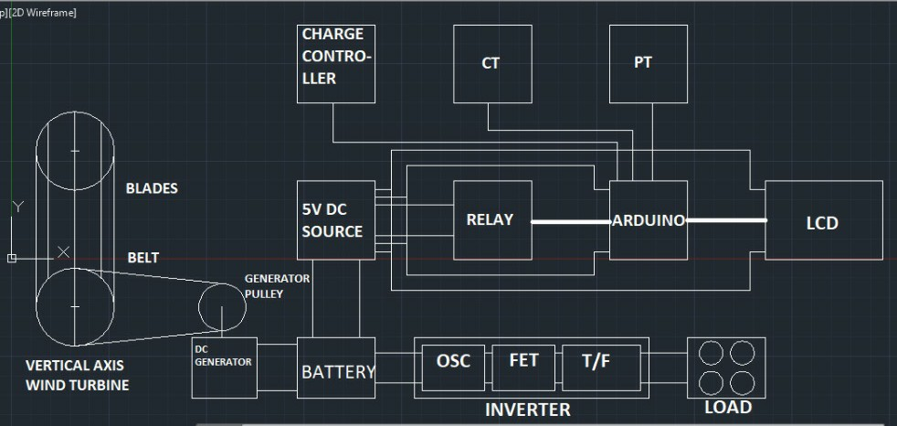
Figure 3.5. Block Diagram of our Project.

Chapter 4
Simulation
4.1 Relay Simulation
Circuit given below is the relay circuit in off condition as shown in Figure 4.1(a). It operates at 5V DC and it will operate when there is an overload condition and when the buttery is fully charged. It is connected to Arduino and when it generates an analog signal to Arduino, the Arduino will display Over Load or Battery Full on LCD. When the battery will be fully charged it will cut-off the Charge controller circuit.
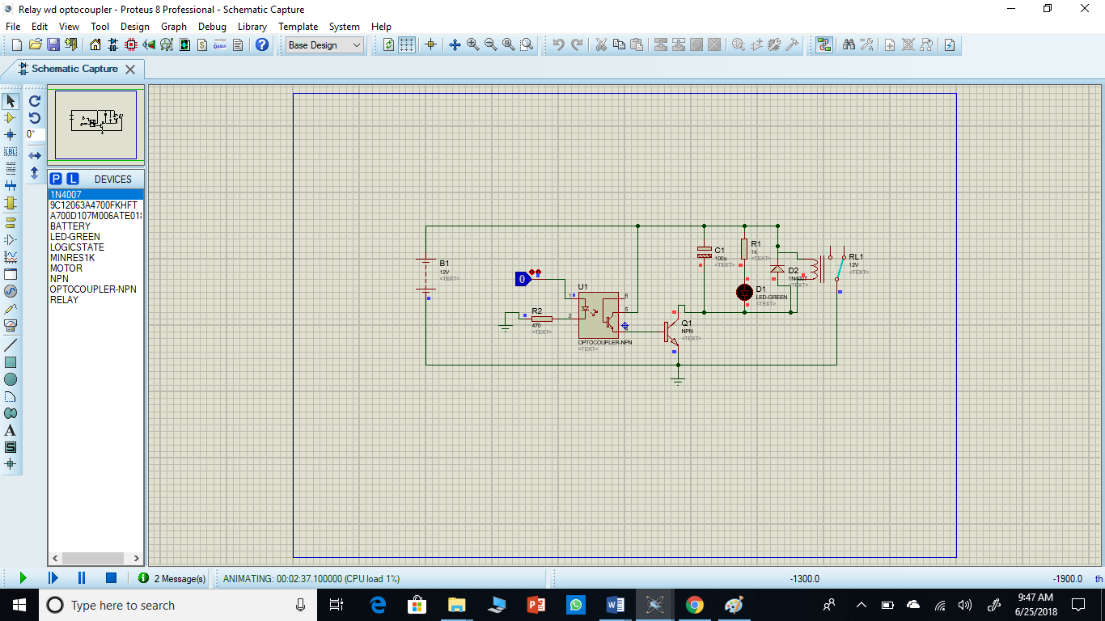
Figure 4.1(a). Relay under no load condition.
Following is the circuit when relay will operate under two given conditions.
- Battery is full
- Overload Condition.
As shown in the Figure 4.1(b).
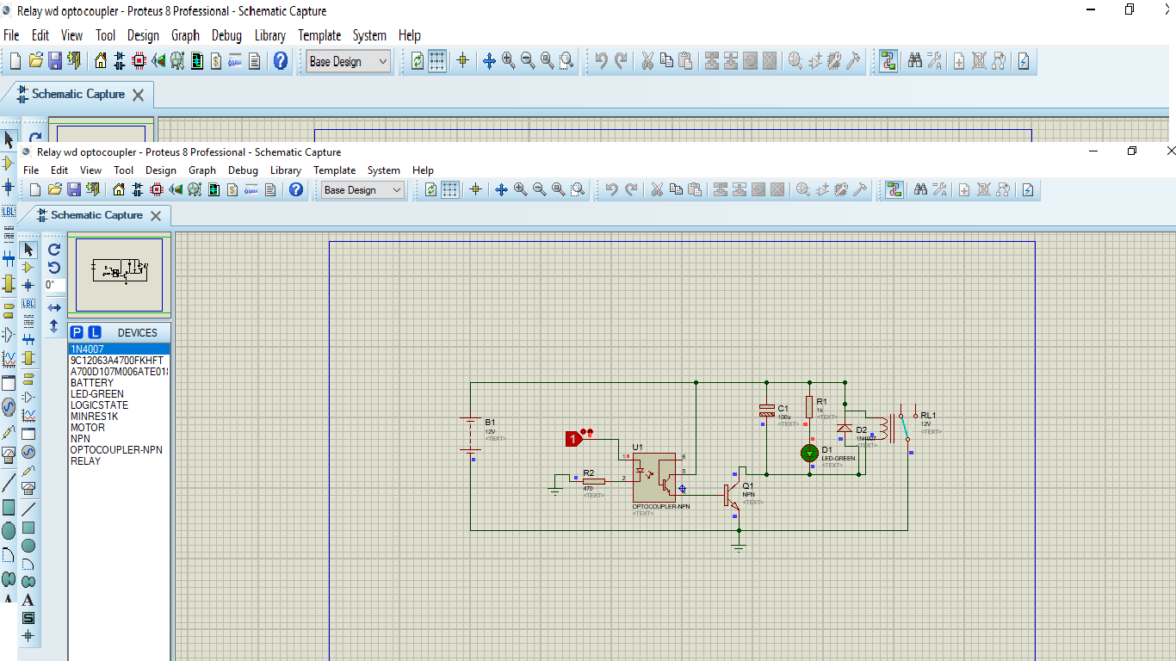
Figure 4.1(b). Relay under load condition.
4.2 CT/PT
CT/PT has the same circuit in this project as shown in Figure 4.2(a) and 4.2(b). The main function of these circuits are to calculate how much current and voltage are delivering at load end. It is also connected to Arduino so that Arduino display it’s results on LCD.
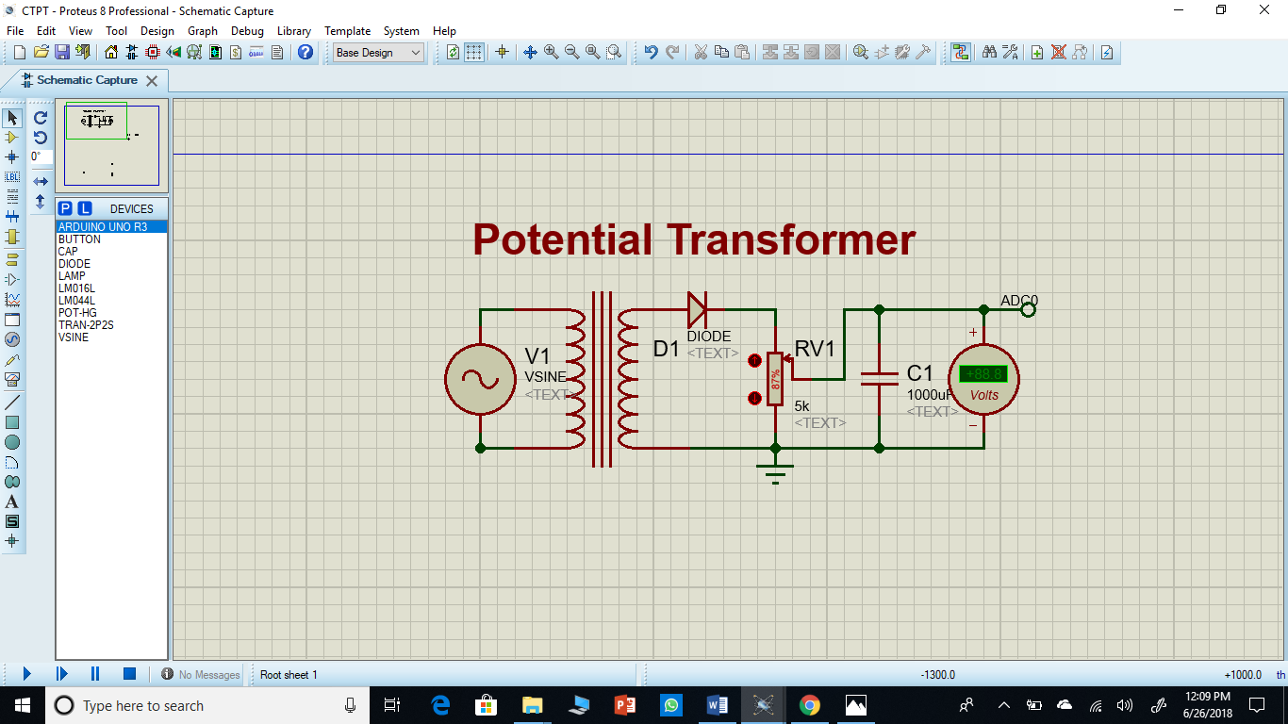
Figure 4.2(a). No load is passing through Current and Potential Transformer.
Following is the circuit when both circuits are at on condition when load is on and current is flowing.
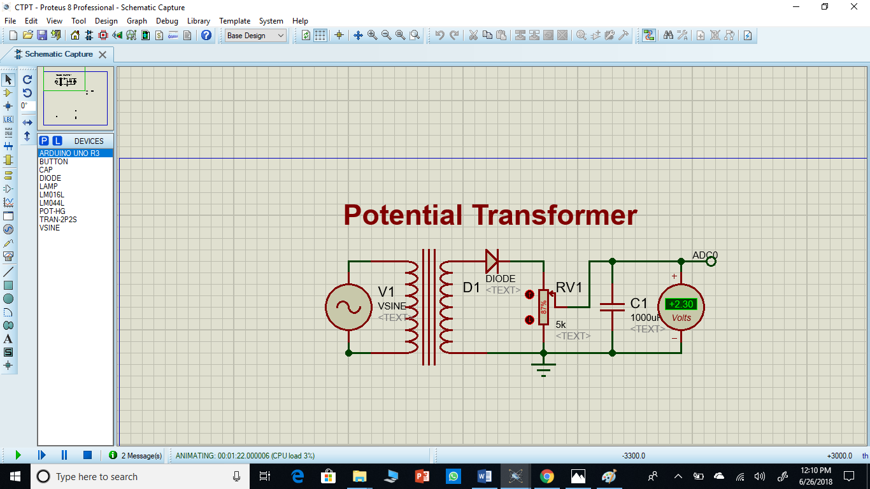
Figure 4.2(b). Load turned on and Current and Potential Transformer are working.
4.3 Power Supply
Following is the circuit of power supply as shown in Figure 4.3 which is connected to Arduino, LCD and relays. It will step down voltages from 12V DC to 5V DC with the help of Regulator IC-7805.
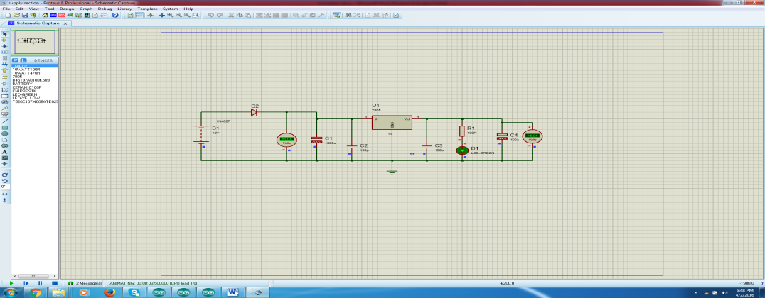
Figure 4.3. Power Supply from 12V DC to 5V DC.
4.4 Arduino Code
Figure 4.4 is showing that there is no error in the code when it is compiled in Arduino IDE software and the remaining code is written in Appendix.
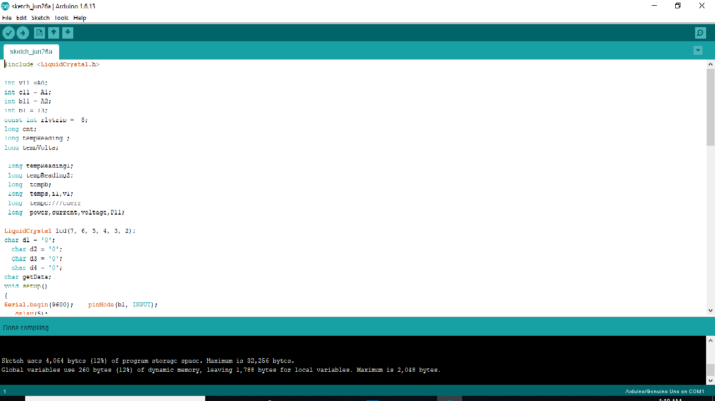Figure 4.4. Compiled Code.

Chapter 5
Results
Following two figures are of our results under no load condition and under load condition as shown in Figure 5.1 and 5.2 respectively. When under no load condition, current and voltages are zero and under load conditions the LCD will show the respective results that how much current is consumed by our load.
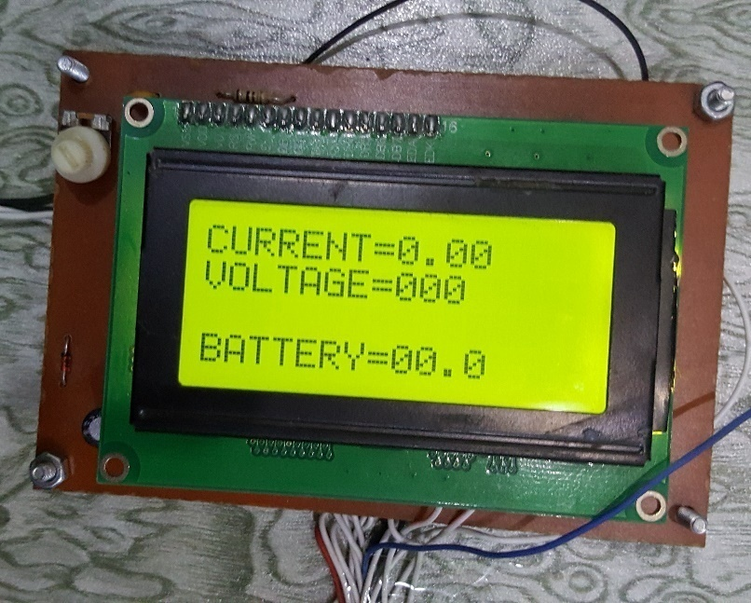
Figure 5.1. LCD Result at No Load.
The following diagram shows the system is under, load condition and when the battery voltage is 12.5 which is DC.
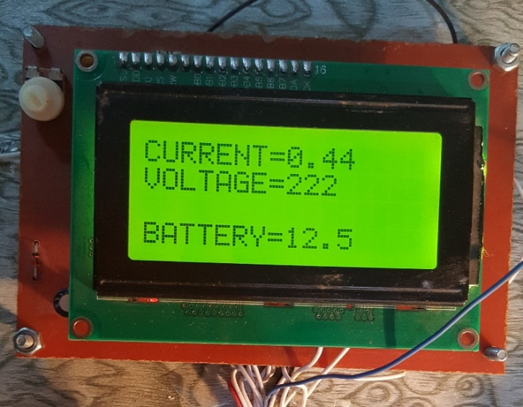
Figure 5.2. LCD Result at Load.

Table 5.1 Results under no load and under load conditions.
Under no Load Condition
Voltages | Current
0 | 0
Under Load Condition
Voltages | Current
222 | 0.44

Table 5.1 shows the result of our load when load is applied current is 0.44A and voltages are 222V. This LCD is connected with Arduino and this current reading displayed on LCD via Current transformer and Potential Transformer.

Chapter 6
Conclusion
Vertical Axis Wind Turbine is used in our project to produce the power and that is generated by using a DC generator along with the buck converter to increase the voltages coming from the generator end. We expected to make turbine to generate the power till 0.5KW and that’s what we get from our FET module of the inverter set. All of the remaining results were according to our desire as we designed the voltage regulator circuit of 12V to 5V and the exact voltage came and then supplied to the three components of our system including relays, LCD and Arduino. The basic application that urged us to make this project was at the highways because there the wind speed is comparatively high than rooftops because of the relative speed of the cars at highways. Also the rooftops of commercial and residential buildings can be installed with small wind turbines with multiple generators to charge the multiple batteries and to invert the voltage and stepping it up for the AC loads used.
We set our goal to achieve the watts as described above and that’s what we get by the hardware made by us. So results were according to our design and checked by DMM at various parts and measured and calculated values were compared which were almost the same with negligible effect. The scope of the project is now cleared as we planned everything after applying critical thinking on the problems we faced and after establishing the goals we achieved it. All of the tasks we performed were performed with excellence and skillfully in the given time schedule with almost the same cost we estimated i.e. 20,000

Appendix
Given below the Arduino code by which it will give feedback of respective component to the LCD. The code is working properly with no error and runs on Arduino software with no error.
#include <LiquidCrystal.h>
int v11 =A0;
int c11 = A1;
int b11 = A2;
int b1 = 13;
const int rlytrip = 8; // the number of the LED pin
long cnt;
long tempReading ;
long tempVolts;
long tempReading1;
long tempReading2;
long tempb;
long temps,i1,v1;
long tempc;///cuerr
long power,current,voltage,P11;
// BS E D4 D5 D6 D7
//LiquidCrystal lcd(7, 8, 9, 10, 11, 12);
LiquidCrystal lcd(7, 6, 5, 4, 3, 2);
//LiquidCrystal lcd(A0, 13, 12, 11, 10,9);
char d1 = '0';
char d2 = '0';
char d3 = '0';
char d4 = '0';
char getData;
void setup()
{
Serial.begin(9600); //initialize serial
pinMode(b1, INPUT);
// pinMode(sw4, INPUT);
delay(5);
lcd.begin(16, 4);
lcd.clear();
digitalWrite(rlytrip, LOW); //
tempReading1 = analogRead(c11);
delay(2500);
}
void loop()
{

getad();delay(500);
getad();delay(500);
getad();delay(500);
getad();delay(500);
}
void getad(){ /// measure current and display on lcd
///////////////////////////////////////
tempReading1 = analogRead(c11);
tempc = tempReading1 * 5000 / 1024;
i1=tempc;
lcd.setCursor(0, 0); lcd.print("CURRENT=");
d1=tempc/1000;
d2=(tempc/100)%10;
d3=(tempc/10)%10;
lcd.write(d1+48);
lcd.write('.');
lcd.write(d2+48);
lcd.write(d3+48);
d1=d1+48; d2=d2+48; d3=d3+48;
Serial.write(d1);Serial.write(d2);Serial.write(d3);
/////////////////////////////////////////////////
////////////////////////////////////////
tempReading1 = analogRead(v11);
tempc = tempReading1 * 5000 / 1024;
v1=tempc;
lcd.setCursor(0, 1); lcd.print("VOLTAGE=");
d1=tempc/1000;
d2=(tempc/100)%10;
d3=(tempc/10)%10;
lcd.write(d1+48);
lcd.write(d2+48);
lcd.write(d3+48);
d1=d1+48; d2=d2+48; d3=d3+48;
Serial.write(d1);Serial.write(d2);Serial.write(d3);
/////////////////////////////////////////////////
/////////////////////////////////////////////////
////////////////////////////////////////
tempReading1 = analogRead(b11);
tempc = tempReading1 * 5000 / 1024;
v1=tempc;
lcd.setCursor(0, 3); lcd.print("BATTERY=");
d1=tempc/1000;
d2=(tempc/100)%10;
d3=(tempc/10)%10;
lcd.write(d1+48);
lcd.write(d2+48);
lcd.write('.');
lcd.write(d3+48);
d1=d1+48; d2=d2+48; d3=d3+48;
Serial.write(d1);Serial.write(d2);Serial.write(d3);
/////////////////////////////////////////////////
/////////////////////////////////////////////////
//*/
/*
tempReading1 = analogRead(c33);
tempc = tempReading1 * 5000 / 1024;
t1=tempc;
lcd.setCursor(15, 2); lcd.print("T=");
d1=tempc/1000;
d2=(tempc/100)%10;
d3=(tempc/10)%10;
lcd.write(d1+48);
lcd.write(d2+48);
lcd.write(d3+48);
d1=d1+48; d2=d2+48; d3=d3+48;
Serial.write(d1);Serial.write(d2);Serial.write(d3);
digitalWrite(rly4, LOW);//
*/}
//}

