Final Year Project Report

A Resource Framework for Simulation, Visualization, and Analytics of Large Crowds



Project Advisor: Dr. Adnan Shahzada

Submitted By: Monis Hafiz Abdul Ghaffar | 13021020036
Hafiz Taha Jamil | 13021020014

Session 2013 - 2017

University of Management and Technology
C-II Johar Town Lahore Pakistan

Dedication

We would like to dedicate this effort to our parents, who have supported us throughout the course of our studies, and our teachers with direction of whom we have managed to come this far.
We would like to especially recognize the commendable mentoring of our project advisor Dr. Adnan Shahzada, who taught us to devise problem solving strategies in a critical manner and not to settle for less than the superlative.
We would also like to acknowledge Dr. Adnan Abid who came up with this idea and not only gave us the initial thrust in the realm of big data but also encouraged and steered us in hardest of times.

Acknowledgment

We would certainly like to acknowledge the effort of Department of Computer Science for setting up an incredible projects lab and apportioning us a place there during the period of our project. We would also like to appreciate the implausible staff of IPC who had provided us with whatever we had needed.
A special thanks to Mr. Maqsood Ahmad for helping us with computing infrastructural issues specifically Linux configuration, virtualization, and networking related problems.
Lastly, a special gratitude for stackoverflow.com and its community of developers.

Final Approval

Panel of Examiners

- Head of Department ______________________
Department of Computer Science
UMT Lahore

- Program Director (Final Year Projects) ______________________
Department of Computer Science
UMT Lahore

- Supervisor ______________________
Department of Computer Science
UMT Lahore

- Co-Supervisor ______________________
Department of Computer Science
UMT Lahore

Project Title: A Resource Framework for Simulation, Viusalization and Analytics of Large Crowds.
Objective: Provide crowd modeleres and authourities with a tool to effectively manage crowd in events of mass gathering.
Undertaken by : Monis Hafiz Abdul Ghaffar & Hafiz Taha Jamil
Supervised by: Dr. Adnan Shahzada & Dr. Adnan Abid
Starting Date: Mar 15, 2016
Completion Date: Apr 10, 2017
Tools Used: SIAFU (Context Simulator), MongoDB (NoSQL Storage), Spark(In-memory Cluster Computing Framework), Eclipse IDE
Operating System: Linux (Ubuntu), Windows 10
Documentation: Version 1.0

Plagairism Report

Abstract

Crowd management in large events with hundreds of thousands of individuals is a critical challenge. Use of computer vision techniques on visual feed has been the typical approach throughout the years to monitor mobility and behaviors of crowds. Despite the substantial advancement in this field, the massive deployment cost of a camera network and limitations of image processing restricts the productivity of this approach when applied at large scale. On the other hand, the evolving trend of smart or context aware environments has led to the proposition of geographically informative systems in which advance tracking technologies are used for collection of quantitative movement data. Individuals within a crowd are observed as profiled users, thus, making it an identifiable crowd. GPS localization [1] and proximity-based [2] tracking has been used to capture complex crowd dynamics during an event.
Following the above line of thought, our approach emphasizes on managing large scale events through multilevel contextual information and visualizations. Productive information on crowd condition is attained by performing real time analytics on positional data of individuals in a crowd. The nectar from raw data is extracted by harnessing the power of distributed processing platforms to process large amounts of data parallelly. The generated data is filtered and modeled to ensure the consistency of data coming at high volume and velocity.
The other aspect of the project is to simulate crowd dynamics beforehand to predict probable outcomes. For realistic simulation of such events, the approach of Multi-Agent System (MAS) is considered suitable as the agents are expected to move to their goals, interact with their environment, and respond to each other. MAS is also postulated as preferred approach for emergency evacuation simulations [3] because MAS model problem in terms of autonomous interacting component-agents, which is proving to be a more natural way of simulating the unpredictability factor of large crowds.
A generic simulator [4] is used for basic modeling of entities in a scenario. The simulator itself is broad in terms of information sources but limited in terms of even-driven activities and behaviors. We have extended and quantified the concept toward immensely crowded events and activities of individuals it comprehends. We advocate a seamless approach to model, simulate, analyze, and visualize crowd situations for actual venue settings. We equip crowd modelers and event organizers with a tool to effectively manage large events.

Revision Chart

Version | Primary Author(s) | Description of Version | Date Completed
Draft | Hafiz Taha Jamil | Initial draft created for distribution and review comments | 21-09-2016
Preliminary | Monis H. A. Ghaffar | Second draft incorporating initial review comments, distributed for final review | 15-12-2016
Final | Hafiz Taha Jamil | First complete draft, which is placed under change control | 26-04-2017

Contents
Contents 1
List of Figures 3
List of Tables 5
1. Introduction 6
1.1 Motivation 6
1.2 Project Overview 6
1.3 Problem Statement 7
1.4 Objectives 7
2. Domain Analysis 8
2.1 Customer 8
2.2 Stakeholders 8
2.3 Affected Groups with social or economic impact 8
2.4 Dependencies/ External Systems 8
2.5 Related Work 8
3. Requirements analysis 9
3.1 Requirements 9
3.2 List of Actors 10
3.3 List of use cases 10
3.4 System use case diagram 11
3.5 Extended use cases 12
3.6 User interfaces 24
4. System Design 28
4.1 System Architecture Diagram 28
4.2 Physical Layer 29
4.2.1 Location Aware Devices 29
4.2.2 Data Collection Nodes 29
4.2.3 Simulation Framework 29
4.3 Processing Layer 30
4.3.1 Data Collection Service 30
4.3.2 Data Filteration 31
4.3.3 Data Modeling 31
4.3.4 Big Data Environment 31
4.4 Application Layer 35
4.4.1 Pre-Analytics Visualizations 35
4.4.2 Post-Analytics Visualizations 36
4.5 Class Diagrams 37
4.6 Sequence Diagrams 40
5. Implementation details 44
5.1 Development Setup 44
5.1.1 Physical Layer 44
5.1.2 Processing Layer 44
5.1.3 Application Layer 46
5.2 Deployment setup 48
5.2.1 Simulator (SIAFU) 48
5.2.2 MongoDB 48
5.2.3 Spark 50
5.2.4 Crowd Analytics Application 50
5.2.5 Problems Faced 50
5.3 Algorithms 51
5.4 Constraints 54
5.4.1 Assumptions 54
5.4.2 System constraints 54
5.4.3 Restrictions 54
5.4.4 Limitations 54
6. Testing 55
6.1 Extended Test Cases 55
6.2 Traceability Matrix 61
6.2.1 Requirements vs Use Cases (RID vs UCID) 61
6.2.2 Prototypes (PID vs RID) 61
6.2.3 Test Cases (TID vs RID) 62
6.2.4 Coverage (UCID vs TID) 62
7. Results/Output/Statistics 63
7.1 % Completion 63
7.2 % Accuracy 63
7.3 % Correctness 63
7.4 Imapact of Indexes 63
8. Conclusion 70
9. Future work 71
10. Bibliography 72
11. Appendix 73

List of Figures

Figure 1: System Use Case Diagram 11
Figure 2: (P1) main screen 24
Figure 3: (P2) venue configurations screen 24
Figure 4: (P3) zone configurations screen 25
Figure 5: (P4) simulator configurations screen 25
Figure 6: (P5) Simulation Window Illustrating Participant’s Context 26
Figure 7: (P6) Crowd Trail Overlay 26
Figure 8: (P7) Crowd Analytics Screen 27
Figure 9: (P8) Crowd Density Heatmap 27
Figure 10: System Architecture 28
Figure 11: Location Aware Devices 29
Figure 12: Siafu’s Method of Operation 30
Figure 13: Participant’s Data Model 31
Figure 14: MapReduce Illustration 32
Figure 15: Component Interaction in a MongoDB Sharded Cluster 33
Figure 16: Spark Stack 34
Figure 17: Sample Zone Division of Arafat Plain (Mecca) 35
Figure 18: Real Crowd Movement 35
Figure 19: Simulated Crowd Movement 35
Figure 20: Class Diagram of Crowd Analytics Application 37
Figure 21: Class Diagram of Simulator (SIAFU) 38
Figure 22: Class Diagram of Simulation 39
Figure 23: SD – UC 1.1 (Create Venue Background) 40
Figure 24: SD – UC 1.2 (Create Pathways) 40
Figure 25: SD – UC 1.3 (Create Place) 41
Figure 26: SD – UC 1.4 (Create Zone) 41
Figure 27: SD – UC 3.1 (Visualize Participant’s Context) 42
Figure 28: SD – UC 3.2 (Analyze Crowd Condition) 42
Figure 29: SD – UC 3.4 (Analyze Heatmap) 43
Figure 30: Zone Population Graph 47
Figure 31: Color Scheme to Illustrate Crowd Density 47
Figure 32: Heatmap Depicting Crowd Density in Two Different Zones 48
Figure 24: Impact of Index on a Scenario I Query 65
Figure 25: Impact of Index on a Scenario II Query 67
Figure 26: Impact of Index on a Scenario III Query 69

List of Tables

Table 1: List of stakeholders 8
Table 2: Requirement Specifications 9
Table 3: List of Actors 10
Table 4: Evaluation of Scenario I Query …………………………………………………………64
Table 5: Evaluation of Scenario II Query ………………………………………………………... 66
Table 6: Evaluation of Scenario III Query ………………………………………………………. 68

Introduction

Motivation
Thousands have lost their invaluable lives due to human crush and stampedes in large events all around the world. These stampedes and crushes are primarily the resultant of crowd congestion and mass panic. Crowd management is emerging as a hot topic of research due to continuity of the problem. However, earlier work was focused on tackling the problem by means of computer vision techniques. But the deployment cost and overhead on image processing on one end with the evolving inclination towards context aware environments on the other has led to the proposition of advance tracking technologies. These are used for collection of positional data. GPS localization [1] and proximity-based [2] tracking has been used to capture complex crowd dynamics during an event. These large sets of collected data needs a distributed and parallel computing processing infrastructure to extract value out of that raw data in real time.

Project Overview
Crowd management in large events with hundreds of thousands of individuals is a critical challenge. We have emphasized on managing large scale events through multilevel contextual information on crowd conditions and portrayal of crowd situation through various visualizations. Productive information on crowd condition is attained by performing real time analytics on positional data. The massive locational data is gathered by means of tracking system. In which, individuals are equipped with location aware devices like smartphones or GPS wrist/ankle bands and data collection nodes are in place as well. Although implementation and evaluation of such systems yet adhere many challenges like gathering and processing of data from heterogeneous sources and expense of equipping individuals or places with sensors. Furthermore, large crowds and real settings cannot be reconstructed for testing purposes.
Simulation serves as a mean to design a problematic scenario as well as the mechanism to evaluate the behavior and operation of the opted solution or system. Crowd simulation attempts to give an appropriate abstraction of the domain. Therefore, the other aspect of our project is to simulate large events and crowd dynamics beforehand to predict probable outcomes.
We propose a resource framework for systematic monitoring of crowd in large events. Our software infrastructure provides means to analyze real event as well as in a simulated one. Crowd modeler and simulation designer can make use of the framework by configuring venue parameters, defining activities and interactions of individuals, contextualize the info of surroundings whereas crowd observers and monitoring authorities can perform analytics at both crowd and individual level and subsequently visualize the simulated or real event with appropriate dimension.

Problem Statement
Many have lost their lives due to stampedes and crushes. These stampedes are the resultant of crowd congestions at massively crowded events. The number of events arranged around the globe are increasing with each passing day along with the volume of the crowd they inhibit. The management of such events has challenges, both from the organizer’s perspective and the participants. The authorities want the safety and security of participants during the event. The participants require the guidance and awareness to the current situation. The use of location tracking technologies at massive scale results in generation of tons of positional data. These large sets of collected data needs a distributed and parallel computing infrastructure to be processed further for real-time analytics. We have, therefore, emphasized on developing a wide-ranging resource framework which includes a distributed processing infrastructure at its core and provides crowd monitoring platform for the authorities.

Objectives
- Provide crowd modeleres and authourities with a tool to effectively manage crowd in events of mass gathering.
- Provide simulation designer and developer a framework to create crowd simulations.
- Provide a decentralize crowd observation system.
- Facilitate crowd administration to have substantial degree of hold over crowd movement.
- Enhance mobility and safety of participants in a crowd.

Domain Analysis

Customer
Potential customers of our resource framework are large event organizers and crowd monitoring authorities.

Stakeholders

Stakeholder | Role in System
Crowd Managing Authority | Monitors crowd movement and analyzes crowd situation.
Simulation Developer | Defines crowd attributes and develops crowd simulation.
Crowd Modeler | Specifies event surroundings, models crowd activities and defines crowd attributes.
Crowd Observer | Observes crowd movement provided by the real-time system and can monitor crowd conditions in both pre-analytics and post-analytics visualization mode.
Table 1: List of stakeholders

Affected Groups with social or economic impact
- Crowd Management Authorities
They will have a systemic controlled view over crowd conditions. Real-time analytics on crowd congestion will enable them to act preemptively to avoid critical situations.
- Participants in Crowd
They can get location centric customized services through mobile app which will aware the individuals within crowd of their surroundings based on real time information.

Dependencies/ External Systems
- Physical Sensing Infrastructure
A distributed physical infrastructure consists of numerous crowd positioning and proximity sensors along with positional data collecting nodes.

Related Work
- Capturing crowd dynamics at large scale events using participatory GPS-localization. [5]
- A framework for real-time detection and visualization of collective behaviors in human crowds by tracking mobile devices. [6]
- Probing crowd density through smartphones in city-scale mass gatherings. [7]
- Crowd Management with RFID & Wireless Technologies [8]

Requirements analysis

Requirements
Following are the specified requirements for the development of our purposed resource framework. These requirements are created keeping in view the operational mechanism of our system as well as the roles of the involved entities.

RID | Description | Category
R1.1 | Setup of a distributed processing infrastructure | Functional
R2.1 | Retrieval of real map of the specified coordinates to be used as a background image in simulation | Functional
R2.2 | Generation of pathways for simulation | Functional
R.2.3 | Specification of point of interests for simulation | Functional
R2.4 | Division of venue in zones | Functional
R2.5 | Specification of crowd activities | Functional
R3.1 | Storage of participant’s positional data | Data
R3.2 | Storage for zone information | Data
R4.1 | Visualization of crowd movement | Functional
R4.2 | Visualization of participant’s context in a moving crowd | Functional
R5.1 | Computation of crowd population within a certain vicinity from available positional data in real time | Functional
R5.1.1 | Response time for R5.1 | Non-Functional
R5.2 | Analysis of historical crowd conditions with respect to the observed time. | Functional
R5.2.2 | Response time for R5.2 | Non-Functional
R5.3 | Illustration of crowd trail | Functional
R6.1 | Heatmaps rendering based on crowd population at real time | Functional
R6.1.1 | Response time | Non-Functional
R7.1 | Predictive analytics on crowd conditions | Functional
R8.1 | A communication gateway between the applications and the processing infrastructure | External Interface
Table 2: Requirement Specifications

List of Actors

Actor | Role
Crowd Modeler | Performs event and venue configurations.
Crowd Observer | Supervises crowd conditions.
Table 3: List of Actors

List of use cases

- Create Venue Background allow crowd modeler to specify venue location coordinates to set a real venue background.
- Create Pathways; allow crowd modeler to convert map image into a black and white image which acts as a wall for simulation.
- Create Place; allow crowd modeler to create a place by clicking at any point over map.
- Create Zone; allow crowd modeler to create a zone by dragging a rectangle over map at a specific region.
- Load Simulation; allow crowd modeler to update and load simulation to newly defined venue, places, and zones.
- Start Simulation; allow crowd modeler the preloaded simulation.
- Analyze Real - Time Crowd Condition; allow crowd observer to analyze current crowd conditions by crowd attributes i.e. density, flow, and speed.
- Analyze Historical Crowd Condition; allow crowd observer to analyze crowd conditions within a specified period.
- Analyze Crowd Trail Heat map; allow crowd observer to analyze crowd trail through a contextual overlay.
- Analyze Crowd Density Heat map; allow crowd observer to analyze crowd density through a contextual overlay.
- Analyze Predictive Heat map; allow crowd observer to analyze predictive heat map through a contextual overlay.

System use case diagram
The following diagram distinguishes the role of involved actors and the use cases they encompass.

Create Venue Background
Create Pathways
Create Place
Create Zone



Crowd
Modeler

Visualize Participant’s Movement
Visualize Participant’s Context

Visualize Contextual Layers

Analyze Real-time Conditions
Analyze Historical Conditions

Visualize Crowd Trail
Crowd Observer

Figure 1: System Use Case Diagram

Extended use cases
The extensions of the use cases showed in Figure 1 are described in detail here.

Use Case ID: | UC-1.1
Use Case Name: | Create Venue Background
Created By: | Hafiz Taha Jamil | Last Updated By: | Hafiz Taha Jamil
Date Created: | Jan 1, 2017 | Last Revision Date: | Feb 21, 2017
Actors: | Crowd Modeler
Description: | Get real map from Google Maps to be used as a background for simulation in order to give an essence of actual surroundings.
Trigger: | When crowd modeler proceeds to venue configurations screen.
Preconditions: | - Internet Connection  - Google Maps API Access
Post conditions: | - The map for the background is saved in simulation’s resources directory.
Normal Flow: | - Crowd modeler proceeds to venue configurations screen.  - Crowd modeler selects the simulator’s resources directory in order to save the background map.  - Crowd modeler specifies the centroid coordinates (longitude/latitude) of the venue.  - A 640x640 normal map of specified coordinates is attained through Google Maps Static API and is displayed at the left side of the screen.
Alternative Flows: | None
Exceptions: | Exceptions to the Create Venue Background Case  2a. In step 2 of the normal flow, if the modeler chose not to select a directory  - Message to modeler for the selection of directory  - Use Case resumes on Step 2  3a. In step 3 of the normal flow, if there is no response to the http request made by the software  - Message to modeler to check for internet connection or firewall settings.  - Use Case resumes on Step 3
Includes: | None
Frequency of Use: | Every time a simulation is created for new venue settings.
Special Requirements: | None
Assumptions: | Crowd modeler understands the geo coordinates system.
Notes and Issues: | Google Static Maps API restricts free users to the specified dimensions of 640x640

Use Case ID: | UC-1.2
Use Case Name: | Create Pathways
Created By: | Hafiz Taha Jamil | Last Updated By: | Hafiz Taha Jamil
Date Created: | Jan 1, 2017 | Last Revision Date: | Feb 10, 2017
Actors: | Crowd Modeler
Description: | Create black and white image from the map where white acts as a wall and black as a pathway.
Trigger: | When crowd modeler has loaded the background map
Preconditions: | - Background map is present in simulation’s resources directory.
Post conditions: | - The resultant black and white image of background is saved in the simulation’s resources directory.
Normal Flow: | - Crowd modeler proceeds with creating pathway by clicking at the provided button.  - Background map is converted into black and white and is displayed at the position of map.
Alternative Flows: | None
Exceptions: | Exceptions to the Create Pathways Case  2a. In step 2 of the normal flow, if the no map is found in the resources directory  - Message to modeler  - Use Case resumes on Step 2
Includes: | None
Frequency of Use: | Every time a simulation is created for new venue settings
Special Requirements: | None
Assumptions: | Background map of 640x640 is present
Notes and Issues: | None

Use Case ID: | UC-1.3
Use Case Name: | Create Place
Created By: | Hafiz Taha Jamil | Last Updated By: | Hafiz Taha Jamil
Date Created: | Jan 1, 2017 | Last Revision Date: | Mar 21, 2017
Actors: | Crowd Modeler
Description: | Create a place for simulation by clicking at a point over map which in turn creates a new image of the same dimension and place a black pixel at that point.
Trigger: | When crowd modeler has loaded the background map and pathways are also created.
Preconditions: | - Background map is present in simulation’s resources directory
Post conditions: | - A place is created against a click over a specific point over map
Normal Flow: | - Crowd modeler proceeds with creating a place by clicking at the provided button.  - Map is displayed in place of the pathways at the same location.  - Crowd modeler clicks at a point over map and a black pixel is places against it at a new white image of same dimension.
Alternative Flows: | None
Exceptions: | Exceptions to the Create Place Case  3a. In step 3 of the normal flow, if there is wall (white pixel at the same location in pathway image)  - Message to modeler ‘place cannot be created at a wall’  - Use Case resumes on Step 3
Includes: | None
Frequency of Use: | Every time a simulation is created for a new venue settings.
Special Requirements: | None
Assumptions: | Black and white image of pathways is already created and placed in the simulation’ resources directory.
Notes and Issues: | None

Use Case ID: | UC-1.4
Use Case Name: | Create Zone
Created By: | Hafiz Taha Jamil | Last Updated By: | Hafiz Taha Jamil
Date Created: | Jan 10, 2017 | Last Revision Date: | Mar 21, 2017
Actors: | Crowd Modeler
Description: | A venue is further divided into polygonal zones to be analyzed individually. A drag gable and resizable rectangle is placed over map to specify zone bounds.
Trigger: | When initial venue configurations are completed and crowd modeler proceeds to zone settings screen.
Preconditions: | - MongoDB Connection
Post conditions: | - Zone parameters including the converted coordinates from pixels to geo-coordinates are saved in zone collection of MongoDB.  - An image of zone bounds is cropped from the map image and saved in simulator’s resources directory.
Normal Flow: | - Crowd modeler proceeds to zone settings screen  - Crowd modeler enters zone ID.  - Crowd modeler drags/resizes the given rectangle and places it over a specific region over map.  - Zone parameters are computed and saved in MongoDB as polygon insertion.  - Zone parameters are displayed at bottom left side of the screen.
Alternative Flows: | None
Exceptions: | Exceptions to the Create Venue Background Case  3a. In step 3 of the normal flow, if the polygon is not totally over the map.  - Message to modeler to place it over the map.  - Use Case resumes on Step 3  3b. In step 3 of the normal flow, if there is no connection with MongoDB  - Message to modeler to build connection.  Use Case resumes on Step 3
Includes: | None
Frequency of Use: | Every time a new zone is created.
Special Requirements: | None
Assumptions: | The venue bounds (top right, top left, bottom right) as coordinates are already provided in the configuration
Notes and Issues: | None

Use Case ID: | UC-2.1
Use Case Name: | Load Simulation
Created By: | Hafiz Taha Jamil | Last Updated By: | Hafiz Taha Jamil
Date Created: | Jan 1, 2017 | Last Revision Date: | Feb 21, 2017
Actors: | Crowd Modeler
Description: | Updating and loading the simulation to lately defined venue parameters.
Trigger: | When crowd modeler proceeds to simulator and visualizer configurations screen.
Preconditions: | - Simulation resources directory contains required images.
Post conditions: | - Simulation is built or updated.
Normal Flow: | - Crowd modeler proceeds to simulator configurations screen.  - Crowd modeler selects the simulator’s main directory.  - Crowd modeler clicks the load simulation button.  - A batch script runs in the background to build simulation through maven.
Alternative Flows: | None
Exceptions: | Exceptions to the Load Simulation Case  4a. In step 4 of the normal flow, if maven is not found  - Message to modeler to install maven  - Use Case resumes on Step 3
Includes: | None
Frequency of Use: | Every time a simulation is updated.
Special Requirements: | Maven
Assumptions: | None
Notes and Issues: | Internet connectivity is required in case maven is updating for the first time.

Use Case ID: | UC-2.2
Use Case Name: | Start Simulation
Created By: | Hafiz Taha Jamil | Last Updated By: | Hafiz Taha Jamil
Date Created: | Jan 1, 2017 | Last Revision Date: | Mar 21, 2017
Actors: | Crowd Modeler
Description: | Starting the newly configured simulation
Trigger: | When crowd modeler loads the simulation.
Preconditions: | - Simulator’s main directory is selected.  - Simulation is loaded.  - MongoDB is running.
Post conditions: | - Simulation starts.
Normal Flow: | - Crowd modeler clicks the start simulation button.  - A batch scripts runs and starts the simulation
Alternative Flows: | None
Exceptions: | Exceptions to the Start Simulation Case  2a. In step 2 of the normal flow, if the modeler chose not to select a directory  - Message to modeler for the selection of directory  - Use Case resumes on Step 2  2b. In step 2 of the normal flow, if the connection with MongoDB is not established  - Message to start MongoDB and restart the simulation  - Use Case resumes on Step 2
Includes: | None
Frequency of Use: | Every time a simulation is started
Special Requirements: | None
Assumptions: | None
Notes and Issues: | The data generated through simulation goes to MongoDB for processing and analytics. Therefore, MongoDB should be configured prior to running the simulation.

Use Case ID: | UC-3.1
Use Case Name: | Visualize participant’s context
Created By: | Hafiz Taha Jamil | Last Updated By: | Hafiz Taha Jamil
Date Created: | Jan 1, 2017 | Last Revision Date: | Feb 17, 2017
Actors: | Crowd Observer
Description: | Visualize participant’s context in a running simulation
Trigger: | When crowd observer clicks on the participant
Preconditions: | - Running simulation
Post conditions: | - Participant’s context is displayed on right side of the screen
Normal Flow: | - Crowd observer opens the simulation window.  - Crowd observer clicks on a participant.  - Information related to that individual is displayed on right side of the screen.
Alternative Flows: | None
Exceptions: | Exceptions to the Visualize Participant’s Context Case  2a. In step 2 of the normal flow, if the modeler chose not to select a directory  - Message to modeler for the selection of directory  - Use Case resumes on Step 2  3a. In step 3 of the normal flow, if there is no response to the http request made by the system  - Message to modeler to check for internet connection or firewall settings.  - Use Case resumes on Step 3
Includes: | None
Frequency of Use: | Every time a participant in a simulation is clicked
Special Requirements: | None
Assumptions: | None
Notes and Issues:

Use Case ID: | UC-3.2
Use Case Name: | Analyze Real-Time Crowd Condition
Created By: | Hafiz Taha Jamil | Last Updated By: | Hafiz Taha Jamil
Date Created: | Feb 10, 2017 | Last Revision Date: | Mar 21, 2017
Actors: | Crowd Observer
Description: | Observe real time crowd conditions w.r.t population of zones through a line graph
Trigger: | When crowd modeler proceeds to analytics mode screen and selects the real-time analytics tab
Preconditions: | - Simulation is running  - MongoDB is connected
Post conditions: | - Real time population graph of the selected zone starts animating.
Normal Flow: | - Crowd observer selects analytics mode screen from main screen.  - Crowd observer selects the real-time analytics tab.  - Crowd observer selects the zone.  - Zone information is displayed on the screen.  - Live graph starts giving information of zone population with respect to ongoing time frames of the simulated event.
Alternative Flows: | None
Exceptions: | Exceptions to the Analyze Real-Time Crowd Condition Case  5a. In step 5 of the normal flow, if collection of results is empty or not found  - Message to observer for reconfigurations  - Use Case resumes on Step 3
Includes: | None
Frequency of Use: | Every time an observer needs to get hold of real-time crowd conditions
Special Requirements: | None
Assumptions: | None
Notes and Issues:

Use Case ID: | UC-3.3
Use Case Name: | Analyze Historical Crowd Condition
Created By: | Hafiz Taha Jamil | Last Updated By: | Hafiz Taha Jamil
Date Created: | Feb 10, 2017 | Last Revision Date: | Mar 21, 2017
Actors: | Crowd Observer
Description: | Observe crowd conditions w.r.t population of zones through a line graph
Trigger: | When crowd modeler proceeds to analytics mode screen and selects the historical analytics tab
Preconditions: | - Simulation is running  - MongoDB is connected
Post conditions: | - Historical population/time graph of the selected zone is displayed on the screen
Normal Flow: | - Crowd observer selects analytics mode screen from main screen.  - Crowd observer selects the real-time analytics tab.  - Crowd observer selects the zone.  - Zone information is displayed on the screen.  - Crowd observer enters the time-frame information.  - A graph of population recorded at series of intervals between the selected time-frame is displayed
Alternative Flows: | None
Exceptions: | Exceptions to the Analyze Real-Time Crowd Condition Case  5a. In step 5 of the normal flow, if collection of results is empty or not found  - Message to observer for reconfigurations  - Use Case resumes on Step 3
Includes: | None
Frequency of Use: | Every time an observer needs to get hold of historical crowd conditions.
Special Requirements: | None
Assumptions: | None
Notes and Issues:

Use Case ID: | UC-3.4
Use Case Name: | Analyze Crowd Trail Overlay
Created By: | Hafiz Taha Jamil | Last Updated By: | Hafiz Taha Jamil
Date Created: | Feb 1, 2017 | Last Revision Date: | Mar 1, 2017
Actors: | Crowd Observer
Description: | Crowd observer analyzes the frequent pathways used by crowd through an overlay.
Trigger: | When crowd modeler proceeds to overlays tab on simulator
Preconditions: | - Simulation is running
Post conditions: | - An image showing trail of participants, in a green, is overlaid on the background image
Normal Flow: | - Crowd observer proceeds to simulation running window.  - Crowd observer selects the overlay tab.  - Crowd observer selects the crowd trail from drop down list.  - A click ‘n hold button appears to show crowd trail.  - Crowd observer clicks and holds the button to see crowd trail.
Alternative Flows: | None
Exceptions: | Exceptions to the Analyze Crowd Trail Overlay Case  3a. In step 3 of the normal flow, if overlay is not available in the resources  - The observer cannot select the crowd trail overlay  - Use Case will restart upon the placement of image and reloading of simulation
Includes: | None
Frequency of Use: | Every time an observer needs to get hold of crowd trail
Special Requirements: | None
Assumptions: | An overlay image of crowd trail is available in the resources directory
Notes and Issues: | None

Use Case ID: | UC-3.5
Use Case Name: | Analyze Crowd Density Heatmap
Created By: | Hafiz Taha Jamil | Last Updated By: | Hafiz Taha Jamil
Date Created: | Feb 11, 2017 | Last Revision Date: | Mar 17, 2017
Actors: | Crowd Observer
Description: | Crowd observer analyzes the crowd density of different zones through a heatmap.
Trigger: | When crowd modeler proceeds to overlays tab on simulator
Preconditions: | - Simulation is running
Post conditions: | - An image showing trail of participants, in a green, is overlaid on the background image
Normal Flow: | - Crowd observer proceeds to simulation running window.  - Crowd observer selects the overlay tab.  - Crowd observer selects the crowd trail from drop down list.  - A click ‘n hold button appears to show crowd density.  - Crowd observer clicks and holds the button to see heatmap.
Alternative Flows: | None
Exceptions: | Exceptions to the Analyze Crowd Density Heatmap Case  3a. In step 3 of the normal flow, if overlay is not available in the resources  - The observer cannot select the crowd density overlay  - Use Case will restart upon the placement of image and reloading of simulation
Includes: | None
Frequency of Use: | Every time an observer needs to get hold of crowd density
Special Requirements: | None
Assumptions: | An overlay image of crowd density is available in the resources directory
Notes and Issues: | None

Use Case ID: | UC-3.6
Use Case Name: | Analyze Predictive Heatmap of Crowd Density
Created By: | Hafiz Taha Jamil | Last Updated By: | Hafiz Taha Jamil
Date Created: | Feb 10, 2017 | Last Revision Date: | Mar 15, 2017
Actors: | Crowd Observer
Description: | Crowd observer analyzes the forthcoming situations through heatmaps
Trigger: | When crowd modeler proceeds to overlays tab on simulator
Preconditions: | - Simulation is running  - A predictive data model is already created against the positional data managed by MongoDB.  - The results attained through Spark are saved in the predictive analytics collections.
Post conditions: | - A crowd density heatmap predicting forthcoming crowd situation is overlaid on the simulation
Normal Flow: | - Crowd observer proceeds to simulation running window.  - Crowd observer selects the overlay tab.  - Crowd observer selects the predictive heatmap from drop down list.  - A click ‘n hold button appears to show predictive heatmap.  - Crowd observer clicks and holds the button to see heatmap.
Alternative Flows: | None
Exceptions: | Exceptions to the Analyze Predictive Heatmap of Crowd Density Case  5a. In step 5 of the normal flow, if overlay image is not available  - The observer cannot select the crowd trail overlay  - Use Case will restart upon the placement of image and reloading of simulation  5b. In step 5 of the normal flow, if data needed for rendering of heatmap is not available  - The observer cannot see the heatmap
Includes: | None
Frequency of Use: | Every time an observer needs to get hold of predicted crowd situations.
Special Requirements: | None
Assumptions: | An overlay image of predictive heatmap is available in the resources directory
Notes and Issues: | Predictive analytics are formed using Spark and the resultant information is stored in MongoDB.

User interfaces
Following user interfaces are created keeping in view system use cases
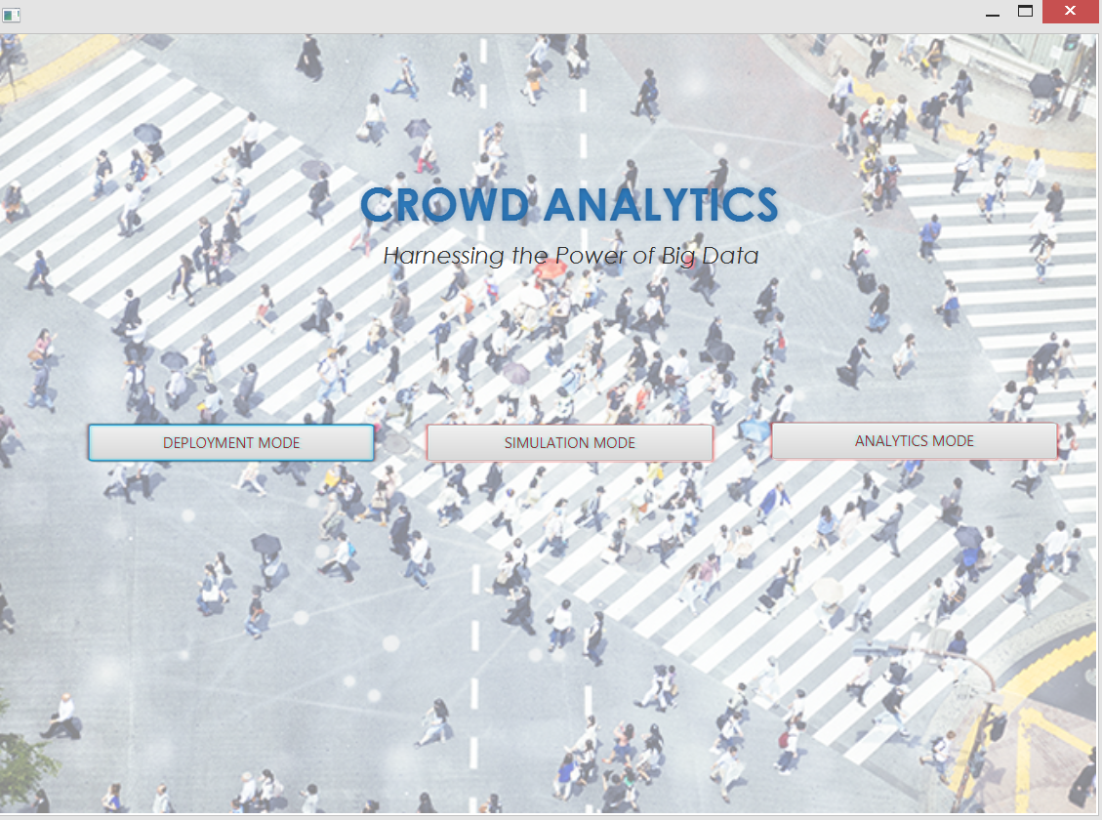
Figure 2: (P1) main screen
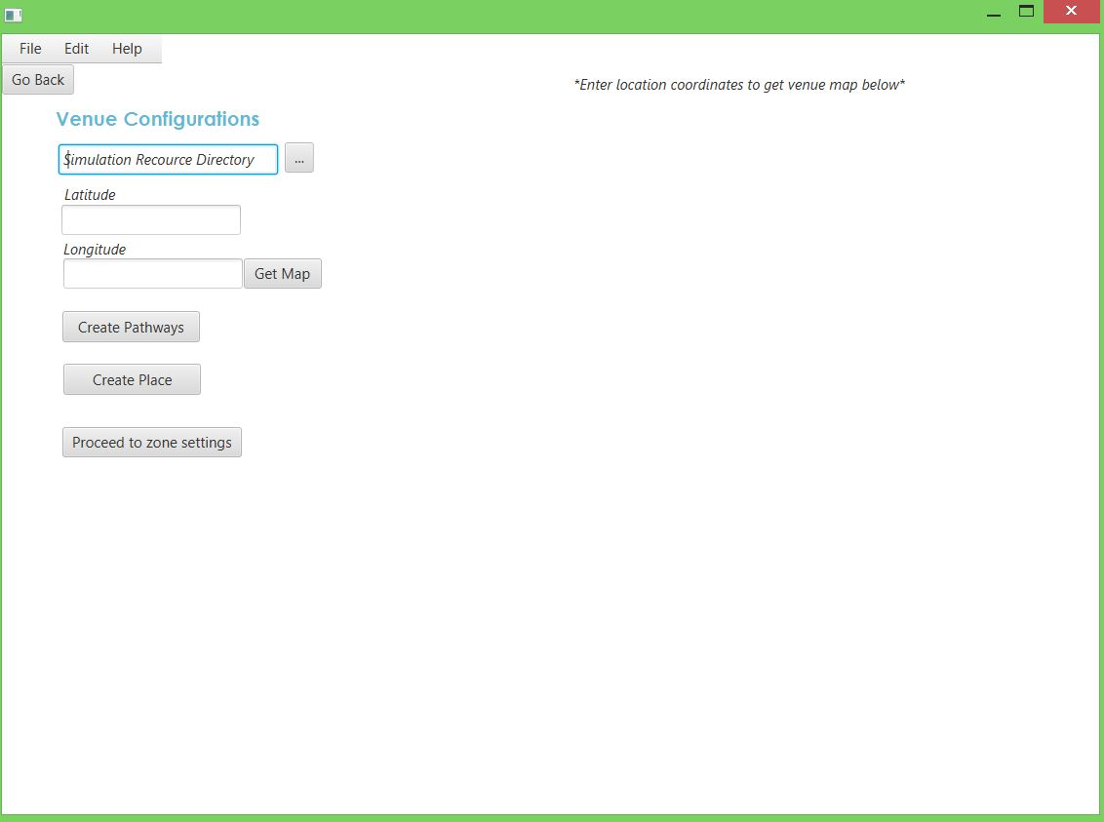
Figure 3: (P2) venue configurations screen
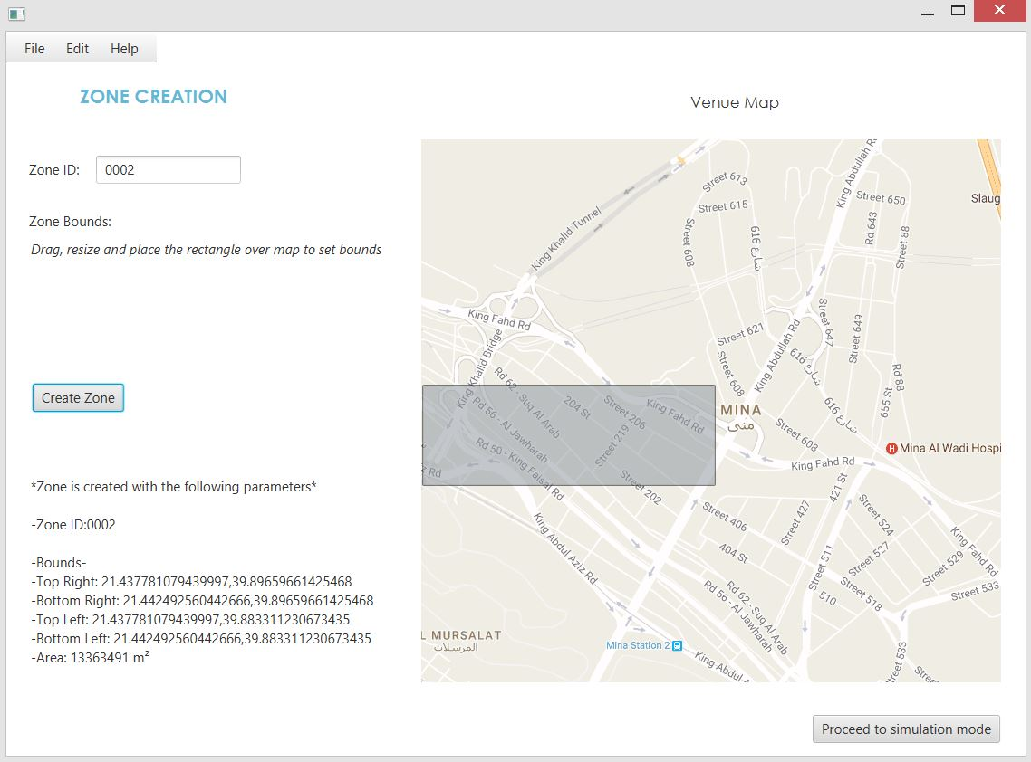
Figure 4: (P3) zone configurations screen

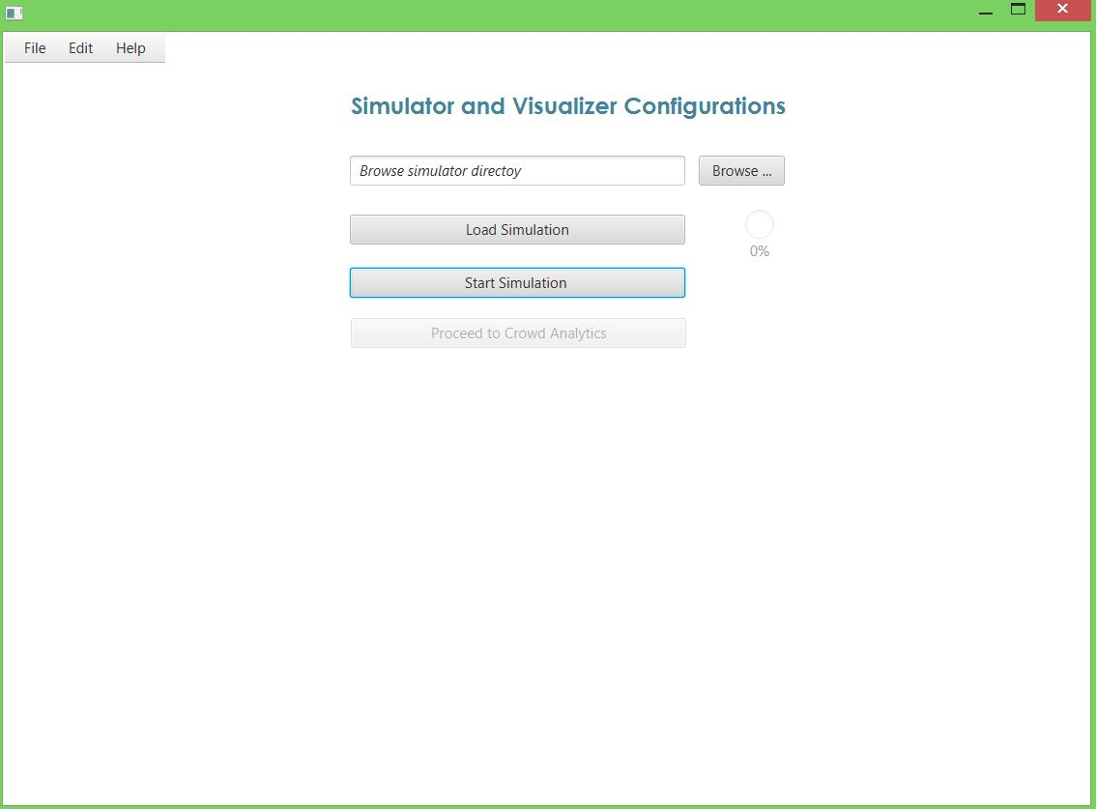
Figure 5: (P4) simulator configurations screen
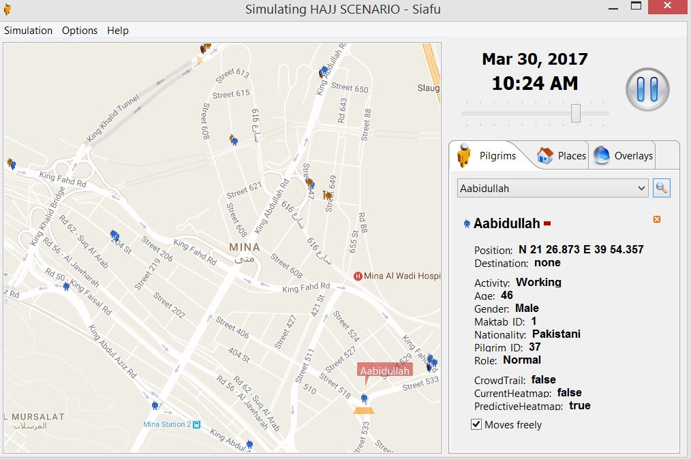
Figure 6: (P5) Simulation Window Illustrating Participant’s Context

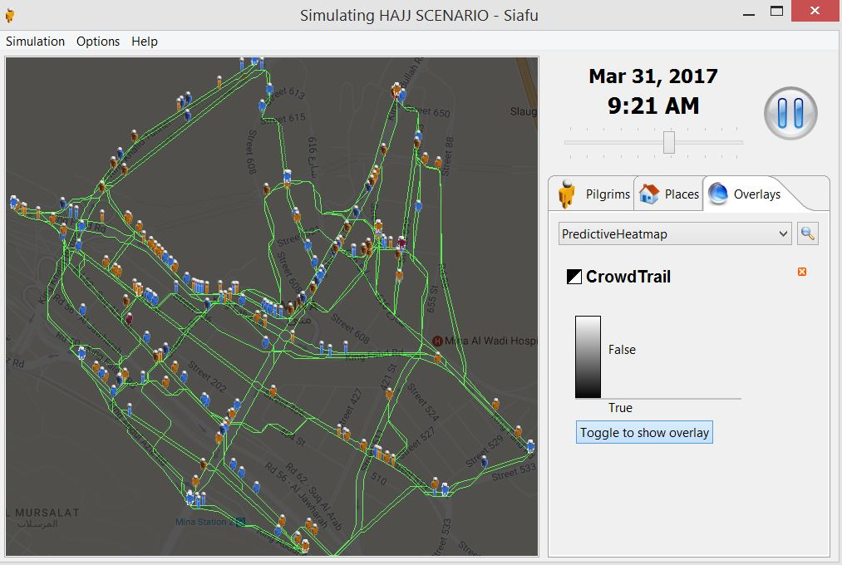
Figure 7: (P6) Crowd Trail Overlay
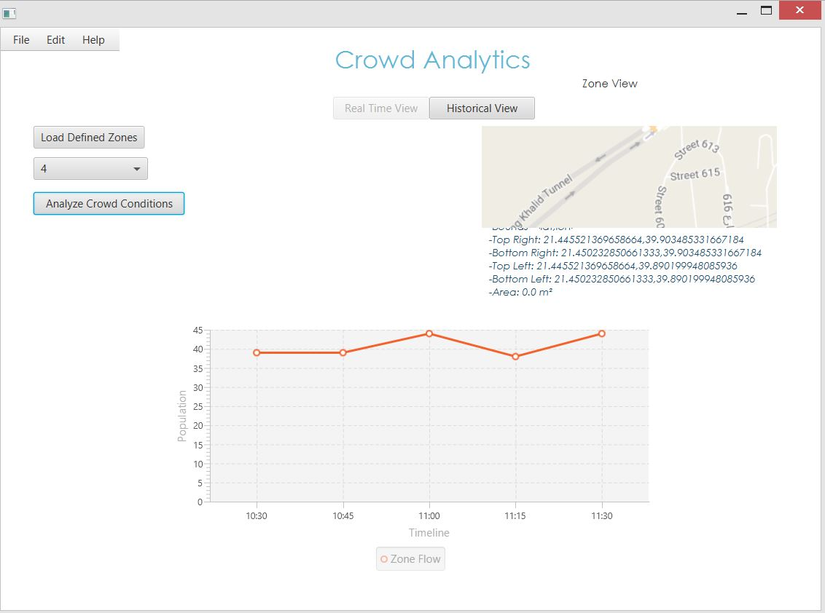
Figure 8: (P7) Crowd Analytics Screen

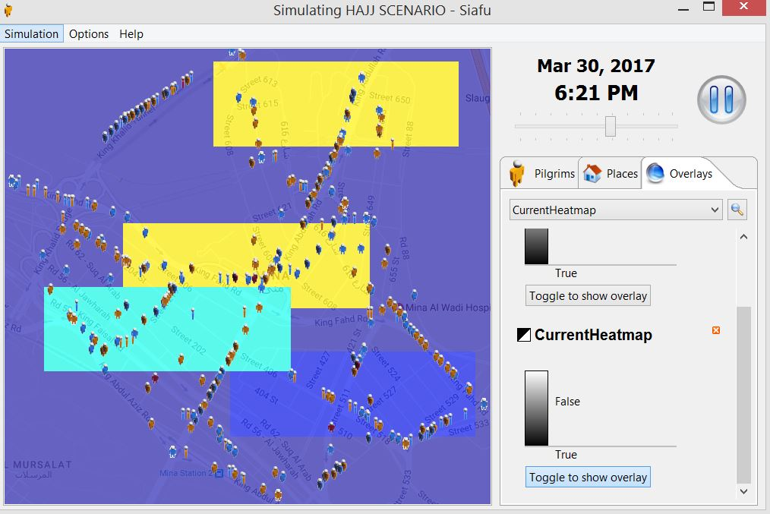
Figure 9: (P8) Crowd Density Heatmap

System Design

System Architecture Diagram
The architectural diagram illustrates the interaction of components at different layers and the flow of data between them. Each component and its role is explained in detail subsequently.
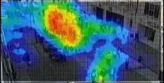
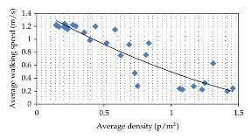
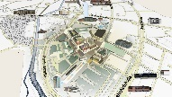
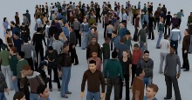

Visualizations

Crowd Movement

Crowd Dynamics

Pre – Analytics Context
Post - Analytics Context

APPLICATION LAYER

Contextual Rules

Communication Interface
(Web Service)


Machine Learning

Real-Time Analytics




MongoDB Spark Connector

Transformed Data
Filtered Data

Raw Data
Data
Model

Big Data Environment

Data Ingestion and Mapping
Data Collection Service
PROCESSING LAYER

Distributed Physical Infrastructure

Simulator

Data Collection Nodes

Movement Sensing Nodes


. . .
. . .

Location Aware Devices

PHYSICAL LAYER

Figure 10: System Architecture

Physical Layer
The layer consists of sensing infrastructure which contains devices capable of transmitting positional data and collection nodes for reception of that data. The sensing infrastructure operates in a distributed fashion as distribution of operations is the essence of our system design and hence maintained at every layer of the proposed architecture.

Location Aware Devices
There exist numerous devices capable of acting as location aware gadgets e.g. smartphones, smart devices such as GPS wrist/ankle bands, smart watches, proximity based sensing via Bluetooth/WLAN scanners and infrared based human presence sensors.
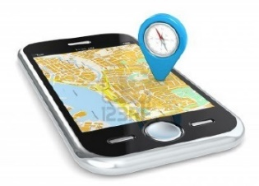
Figure 11: Location Aware Devices

Data Collection Nodes
A data collection node is used to capture positional update from those location aware devices. In our notion of large events, a data collection node not only serves the purpose of collecting data under a certain vicinity but also processes some local information about crowd condition. That information can further be sent to nearby participant if requested by its connecting device. These nodes are placed at different junctions and distributed across the venue to cover the whole event.

Simulation Framework
Simulation serves as a mean to design a problematic scenario as well as the mechanism to evaluate the behavior and operation of the opted solution or system. Crowd simulation attempts to give an appropriate abstraction of this domain.
Therefore, the other aspect of our project is to simulate large events along with the usual amount of crowd they comprehend. Firstly, large events cannot be recreated to deploy and test the actual viability of the proposed crowd monitoring system at such scale. Moreover, possible scenarios in a large event if simulated and analyzed beforehand can be useful in devising the appropriate strategies to efficiently manage large crowd on the day of the event.

SIAFU
We have used a context simulator i.e. Siafu Simulator, which is a comprehensive tool for the creation of a simulation of your choice. It works as a multi-agent system. The simulated world includes models for agents, world, and the context therein. Siafu can generate its own context and at the same time can augment real context coming from the sensors.

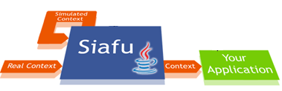
Figure 12: Siafu’s Method of Operation
The simulator is generic in terms of information sources but limited in terms of event-driven activities and behaviors. We propose to extend and enumerate the concept towards immensely crowed events and the activities of individuals it comprehends. The simulation model is categorized in three parts, namely, agent model, world model and context model.

Agent Model
The agent model is the decision logic of individuals. It is responsible for the actions and behavior of individuals (agents) in an environment. The change in states of an individual is also controlled by the respective agent model. Simulation designer must specify the model for each agent or group of agents.

World Model
The world model oversees the environment of a simulation which includes point of interests and pathways where agents can walk. The purpose for the formation of this model is to portray the sense of real world in a simulated one.

Context Model
The context model specifies context variables and the distribution of their values over the environment. The complete context of an individual is its own context (e.g. activity or behavior) and the environment context provided by this model.

Processing Layer
The processing layer is the core element of our system. The layer is composed of several interdependent components. At the bottom of this layer is the data ingestion and mapping component which spans from the collection of data to its filtration and modeling. The data source can be the actual physical layer or the simulator. The other important component in this layer is the big data environment specifically intended to incorporate the composition of several distributed processing frameworks.
The layer is designed in a way that the incorporation of heterogenous elements below and above this layer would not affect the seamlessness and transparency of its operations. Each component of the layer is described in detail below.

Data Collection Service
A data collecting service is induced at the bottom of the layer which is responsible for ingesting data from physical layer or simulator into the system. The service is generic to ensure that the system is not affected by the heterogeneity of devices in a physical sensing infrastructure or the operational difference of distributed processing frameworks.

Data Filteration
The collected data needs filtration on certain parameters to reduce the workload of both storage and processing. Therefore, the essential features, required to uniquely identify individuals and analyze crowd conditions, are kept and the rest is filtered accordingly.

Data Modeling
The data is modeled in a sense that it portrays the profile of a participant. Some unique attributes of individuals are for identification while others are event specific. For basic distinctiveness of participants in a crowd, the associated attributes are; a unique ID, name, age, gender, nationality (considering the aspect of global events), participant’s location and the observed timestamp.
The data modeling is subjective to the nature of large events as well. As in some religious events, individuals move in groups or assemblies to perform rituals. In that case, group related attributes have their significance as the movement of participant is tied to the movement of group. These attributes collectively form a profile which helps in identifying individuals in a large crowd.
Unique ID
Name
Age
Gender
Nationality
Group ID
Group Role
Location
(Latitude, Longitude)
Timestamp
Figure 13: Participant’s Data Model

Big Data Environment
The influx of data coming from the physical layer is expected to be huge in terms of volume and velocity. To process millions of records in real time, relational data stores and warehouses have limitations in terms of latency and scalability. Therefore, we propose to include big data processing frameworks in our system to be the driving force behind the extraction of value out of that humongous data.
The environment contains MongoDB, a robust and scalable NoSQL storage and Spark, an in-memory cluster computing framework for lighting fast analytics. They together give a vigorous combination for real time analytics. Although, MongoDB itself has wide array of query operations which are efficient to work on a huge volume of locational data. But the inclusion of Spark enhances the capabilities of the environment as different level of crowd information can be maintained by using Spark for rich analytics at both crowd and individual level.
These frameworks make use of multiple machines to manipulate data through distributed computing.

Distributed Computing
Putting big data in simple terms; data that cannot be processed using a single machine. Data of such magnitude is scattered over multiple systems and is wrought by means of distributed computing. These systems interact with each other to achieve a common goal.
In distributed computing, a problem is divided into sub parts and each of which is solved by one or more computers. In this sphere, however, the data is distributed and stored on a cluster of machines and extraction or transformation operations are performed accordingly. A noteworthy programming technique used to do distributed computing is Map Reduce.

MapReduce
Map Reduce is primarily a programming model used for distributed computing. An algorithm following Map Reduce paradigm has two phases. A ‘map’ phase which transforms the input data to key value pairs and a ‘reduce’ phase that takes output of the map phase as input and performs the transformation logic to combine those pairs. Map phase, in general, performs sorting or filtration whereas reduce phase does summarization.
Both of our used frameworks exploit the map-reduce model for parallel processing. Spark works on the principles of map-reduce whereas MongoDB provide map-reduce operations for aggregations.
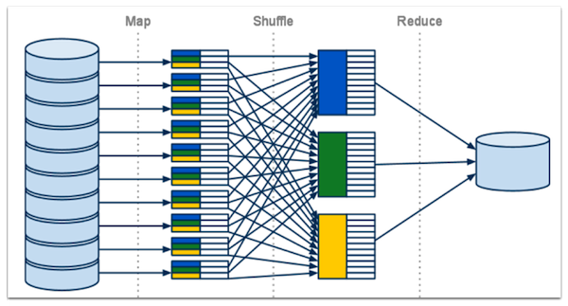
Figure 14: MapReduce Illustration

MongoDB
MongoDB is a NoSQL document oriented storage solution. MongoDB stores data in flexible, JSON-like documents. We have incorporated MongoDB in our system due to its wide range of query operations especially geo-spatial queries and indexes which highly complements in dealing with location data.
MongoDB is used here to store individual’s positional data after it is being filtered and modeled. Then it can be queried on certain parameters to formulate information on crowd condition and the resultant information can also be stored in some cases.

Sharded MongoDB
MongoDB operates in a distributed environment through a method known as ‘sharding’. In sharding, large database is partitioned in smaller, faster, easily managed parts. A MongoDB sharded cluster contain shards, mongos, and config servers. Each shard contains a subset of sharded data whereas mongos provide an interface between applications and the sharded cluster. A config server, however, stores configuration settings and metadata for the cluster.

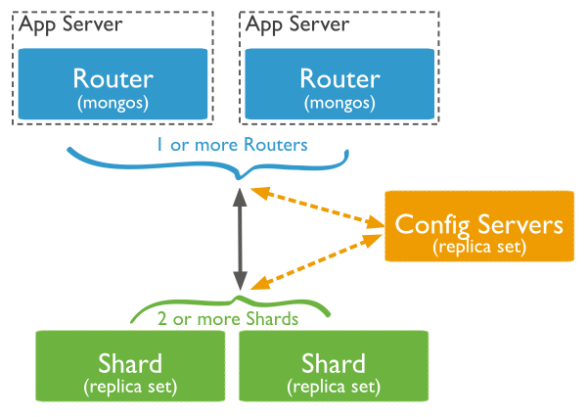
Figure 15: Component Interaction in a MongoDB Sharded Cluster

Geospatial Queries
MongoDB provides number of query mechanism to handle geospatial data. It offers two surface types. The first surface type is Spherical in which the location data is stored as GeoJSON objects with the coordinates order of longitude, latitude. The second one is Flat which is used to calculate distances on Euclidean plane.
MongoDB supports several GeoJSON objects out of which Point and Polygon suits our case. Point can be used to store the position of an individual in a moving crowd whereas polygon can be used to store the information of a certain vicinity which we intend to analyze. MongoDB can query for locations that are confined in a polygon or intersect with a defined region.
For instance, if we define location of individuals as points on a sphere and perform an inclusion query with respect of a certain vicinity, predefined as a polygon, we can get the amount of individual in that respective area.

Geospatial Indexes
MongoDB offers geospatial indexes for both spherical and flat surfaces to increase the performance of geospatial queries. 2d indexes works on flat geometry whereas 2dsphere indexes can be used on spherical GeoJSON objects

Aggregation Pipeline
The aggregation operations, in general, group values from multiple documents together and can perform various operations on that grouped data to return a single result. However, in MongoDB’s aggregation framework, documents enter a multi-stage pipeline which transmutes the documents into an aggregated result. It has an aggregated pipeline operator $geoNear which returns documents based on a geospatial point which comes handy when dealing with positional data.

Spark
Spark is a cluster computing in-memory framework. The data is stored as resilient distributed datasets (RDDs). A single data set can be spanned over multiple nodes. Spark is not only used here to extract real-time information on positional data but its machine learning capabilities are also exploited. Spark provides application programming interfaces for various languages on top of its different services.
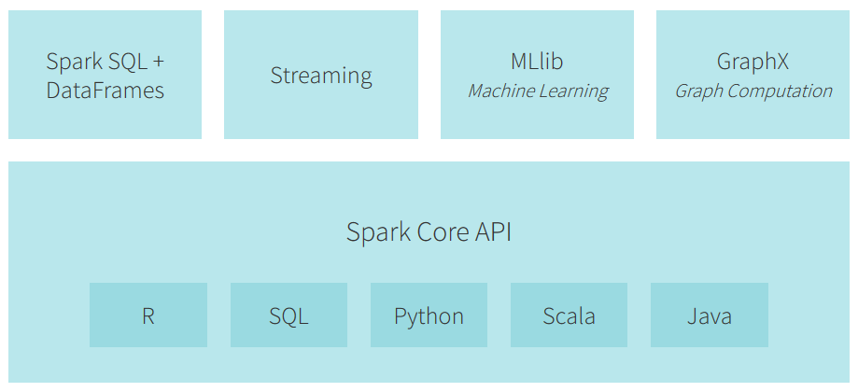
Figure 16: Spark Stack
Spark is used along with MongoDB as spark jobs can be executed against the operational data managed by MongoDB. The amalgamation of the leading analytics processing engine with the fastest growing database enables real-time analytics.

Analytics
There are several indicators which help determining the crowd condition under a specified area. The main indicator is crowd density, i.e. people / m². Relation of crowd density with respect to time is known as crowd flow, i.e. people / m² / sec. The criticality and assessment of these pointers are often referred as crowd dynamics.

Real-Time Analytics
The whole intention of our work is to enhance and ensure the safety of individuals involved in those immensely crowded event. Therefore, information of crowd situations at real-time is of utmost importance. The data coming into the system is analyzed and processed concurrently to deduce the required output and have an insight of the crowd situation.

Predictive Analytics
Stampedes and crushes can be avoided, if crowd managers and authorities are proactive in terms of devising strategies to deal with critical situations. The imminent knowledge on crowd condition attained through predictive analytics can help them to a significant deal.
These predictions are formulated by analyzing the previous data and making models out of that data. The crowd density, crowd flow along with its observed time work as feature set to be observed. Then the expected density and flow at a certain time can be predicted. We can make use of the machine learning capabilities of Spark for predictive analytics.

Zone Level Analytics
To methodically supervise large events, the venue can be further divided into smaller components called zones. Crowd situation with respect to those predefined zones can then be separately analyzed. The event modelers can categorize zones based on expected populous areas, critical junctions or elsewise.
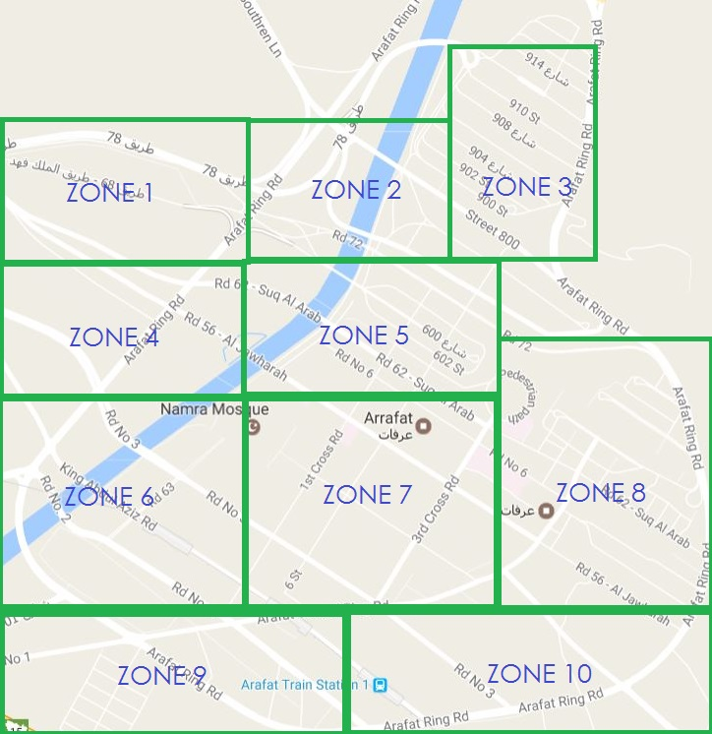

Figure 17: Sample Zone Division of Arafat Plain (Mecca)

Communication Interface (Web Service)
A generic communication interface is induced in our proposed big data environment to ensure the independency of data mapping and data modeling with processing or storage framework. It is an authenticated web service which has data retrieval and insertion methods specifically designed to facilitate the seamless flow of data in and out of the system.

Application Layer
The purpose of setting up the processing infrastructure is to build applications, which enable crowd modelers and crowd observers to effectively manage large events, on top of it. The authorities can visualize crowd movement and formulated analytics to have insight on rapidly changing conditions.

Pre-Analytics Visualizations
The portrayal of the on-ground crowd condition is important for the assessment of situation before analysis. Pre-analytics visualizations are, therefore, provided for the thorough monitoring of crowd movement at large.

Crowd movement
The movement of individuals in a real crowd can be observed as moving agents in a simulated environment.
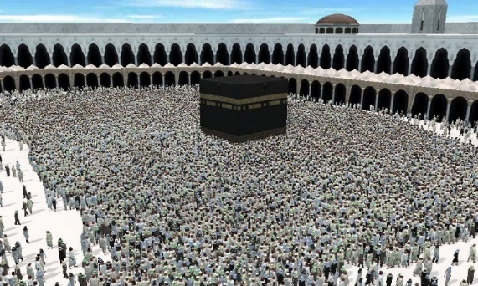
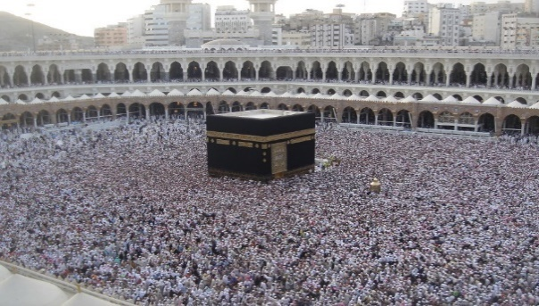

Figure 18: Real Crowd Movement
Figure 19: Simulated Crowd Movement

Participant’s Context
Individuals in a crowd stroll between different places in an event. The context of every individual is changed with respect its position, point of heading or on-going activity. Therefore, information of participant’s context is provided in way that monitoring authorities can specifically track a participant.

Post-Analytics Visualizations
The visualizations formulated after the transformation and processing of postional data of individuals are of extreme importance for the monitoring and organization of massively crowded events.

Crowd Parametric Information
These visualizations are formed by deducing information on different crowd parameters such as crowd density and crowd flow. The articulated graphics are relative to the population of participants under a certain vicinity over various timeframes.

Heatmaps
A heatmap is the illustration of data in which values are signified as colors. In case of crowd analytics, heatmaps generated on crowd density can give a bird’s eye view of the crowd situation and perhaps allow crowd monitoring authorities to easily determine the congested and free flowing areas in a large event.

Class Diagrams

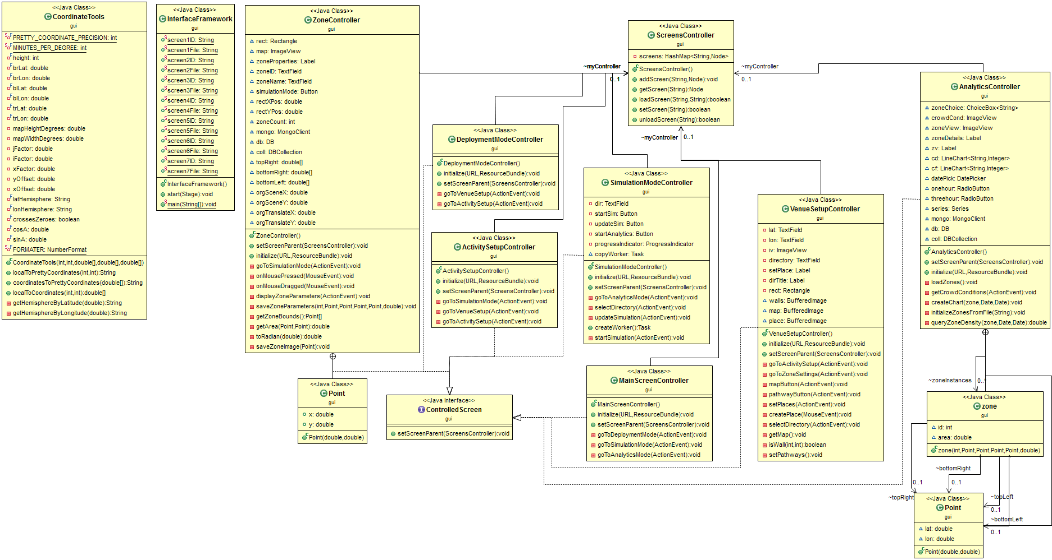

Figure 20: Class Diagram of Crowd Analytics Application

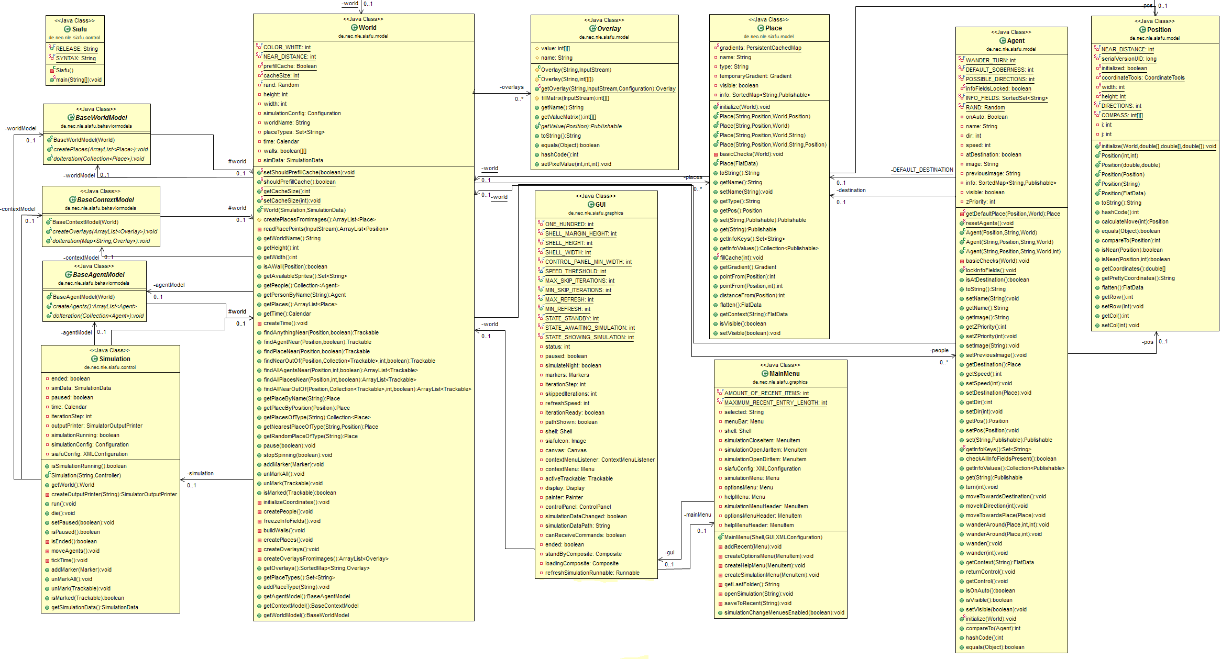

Figure 21: Class Diagram of Simulator (SIAFU)

: Class Diagram of the Simulation

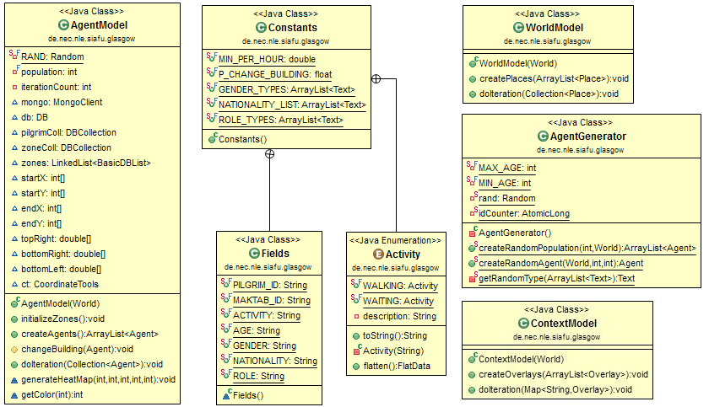

Figure 22: Class Diagram of Simulation

Sequence Diagrams
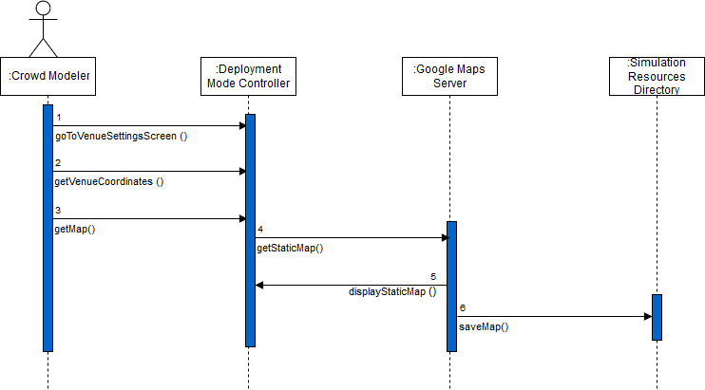

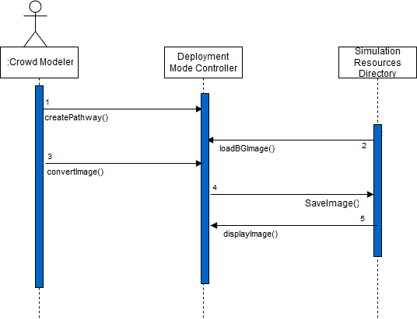
Figure 23: SD – UC 1.1 (Create Venue Background)

Figure 24: SD – UC 1.2 (Create Pathways)

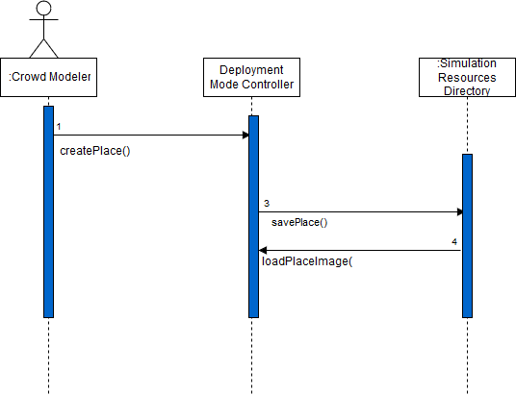
Figure 25: SD – UC 1.3 (Create Place)

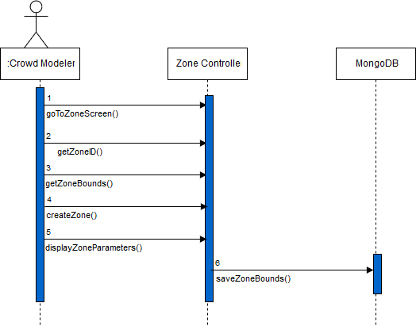

Figure 26: SD – UC 1.4 (Create Zone)
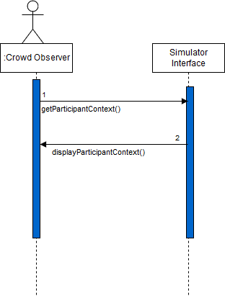
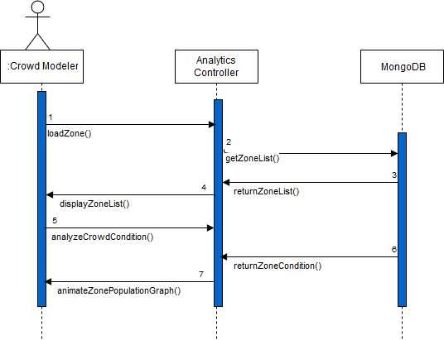
Figure 27: SD – UC 3.1 (Visualize Participant’s Context)

Figure 28: SD – UC 3.2 (Analyze Crowd Condition)

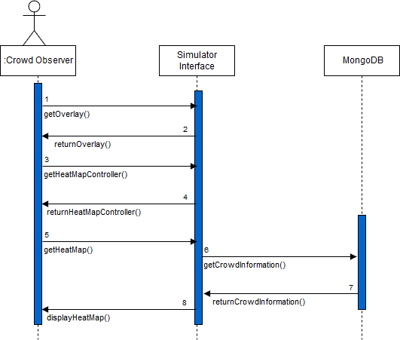

Figure 29: SD – UC 3.4 (Analyze Heatmap)

Implementation details

Development Setup
We have implemented a proof-of-concept cycle of our proposed framework. Our development work includes simulation of large events, real-time analytics on positional data of individuals in those events and multi-dimensional visualizations on crowd conditions.
Java is used a development language at every layer of the architecture as comprehensive APIs of the opted frameworks were available in Java.

Physical Layer
Our proposed architecture suggests the placement of distributed sensing infrastructure to gather positional data. Although, for valuation purposes, we have only used a simulator at the physical layer; a JAVA based context simulator SIAFU.

SIAFU
The core framework of SIAFU has been altered to suit crowd simulation. Moreover, a customized simulation to portray a large event was also modeled and developed to be run on top the framework. The participants were created with random attributes of both individual and group level. Arbitrariness was also instigated in the activities of participants. SIAFU requires background image of the venue and the real-world coordinates of its corners. Then SIAFU does the calibration between pixels and the coordinates. Therefore, the generated positional data of participants moving in a simulation is approximately the same as if they were moving in a real environment.

Processing Layer
The processing infrastructure, capable of demonstrating our approach, has been modeled and developed. Development of each component involved in the layer is described below.

Data Ingestion and Mapping
There needs a separate module designed and developed specifically to ingest data coming from the sensing infrastructure. But as of now the extensiveness of SIAFU allowed us to encapsulate the data ingestion and mapping component within its code. Therefore, the data generated by the simulator is also modeled and filtered there.

MongoDB
Many aspects are considered for the development work that is associated with MongoDB. The choice of application programming interface, quantity of collections, type of geospatial operations and the selection of apposite indexes

MongoDB Java Driver
MongoDB provides several application programming interfaces for developers for the interaction of MongoDB with the application. We chose MongoDB Java Driver as Java is our development language. It provides both synchronous and asynchronous interaction with the application.

Sharded Collections
We created four sharded collections in view of the required functionality our system.

Collection | Primary Function | Frequency of Use
Participant | To store participant’ data record. | The records are inserted continuously.
Zone | To store information on zones. | The records are inserted and retrieved for zone based crowd analysis.
Real-Time Analytics | To store crowd parametric information with respect to zone or elsewise | The results are stored and retrieved continuously.
Predictive Analytics | To store predictive information on crowd situation. | The results are updated after a certain time

GeoSpatial Queries
We used spherical GeoJSON objects to store locational data. Participant’s position is stored as a point while zone bounds are saved as a polygon. An inclusion geospatial query to find points confined in a polygon is executed which eventually returns the number of participants in that defined region.
GeoJSON (Point):
"geometry": {
"type": "Point",
"coordinates": [lat, lon]
}

GeoJSON (Polygon):
"geometry": {
type: "Polygon",
coordinates: [ [ [ lat , lon ] , [ lat , lon ] , [ lat , lon ] , [ lat , lon ] ] ]
}

MongoDB Geospatial (Inclusion) Query:
loc: {
$geoWithin: {
$geometry: {
type: "Polygon",
coordinates: [
[
[ lat, lon ]<1st Point>,[ lat , lon ] <2nd Point>, [ lat, lon ] <3rd Point>, [ lat, lon ]<4th Point>, [ lat, lon ] <1st Point>

Indexes
MongoDB provides different types of indexes to support specific type of data and queries. It offers single field, multi-field, multi-key, compound, and geospatial indexes. MongoDB creates a unique index on _id field by default upon the creation of a collection. We have created a geospatial index on the location field of a record and a single field index on timestamp. These indexes collectively increased the performance of queries.
We have also evaluated the impact of indexes on several complex queries against large operational data and the analysis is presented in section 7.

Spark
We used Spark’s Java API to write scripts for the analysis of operational data managed by MongoDB. MongoDB provides a special connector for Spark.

MongoDB Spark Connector
The MongoDB connector for Spark provides fusion of MongoDB with Spark. Spark libraries can be accessed through connector to be used with MongoDB datasets.

Application Layer
The application layer holds the importance in terms of modeling and monitoring of large events. Initially, we have developed a desktop application intended to capitalize on our processing infrastructure and to give crowd modelers and authorities a platform to model and monitor crowd movement at large.

Crowd Analytics Application
The application is developed using JavaFX to make the most of the extensive chart libraries. The application is categorized into three modes. Each mode is designed and developed to give a specified set of functionalities. The whole is built on a customized framework of screens so that modifications and adjustments are incorporated with ease.

Deployement Mode
The deployment mode is specifically designed for crowd modeler for configurations of venue environment. The application allows modeler to generate resources that are required in the simulation. The modeler can specify coordinates of the venue to get a real map to be used as a background in the simulation. Pathways and points of interests can be created with just a mere click. Moreover, the modeler can drag ‘n drop a polygon over the venue map to categorize venue into different zones. The polygonal bounds attained in pixels are first converted into locational coordinates, provided the bounds of venue in coordinates are provided, then saved accordingly.

Simulation Mode
The simulation mode is used to update the simulation by loading the newly created resources created in the deployment mode. The observer can start the simulation once it is laden. Few batch scripts were created to resolve the dependencies involve in the working of a simulation. These scripts are triggered and run in the background while making use of the functionalities given by simulation mode.

Analytics Mode
This mode is developed for the monitoring of crowds. Real-time information on several crowd parameters can be observed. Crowd observer can also get hold of the historical crowd conditions as well as zone level analysis can also be articulated.
It is easier to determine the criticality of a situation when information extracted from the data is displayed in the form of charts and maps. Therefore, charts are created on different crowd parameters.

Crowd Information Charts
The information attained through analytics on positional data is portrayed in the form charts. A dynamic line graph illustrating real-time crowd flow is generated. Moreover, a static line graph to show historical crowd flow with respect to recorded timestamps is also formulated.

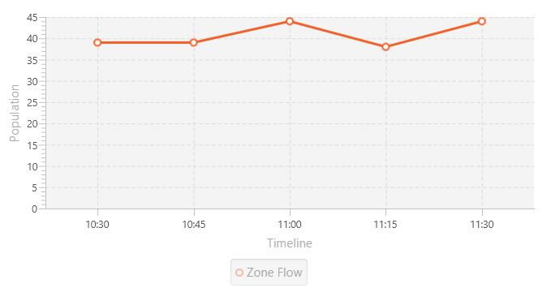
Figure 30: Zone Population Graph

Heatmaps
Heatmaps are based on crowd density of a specific zone. The values are associated with five colors i.e. blue, cyan, green, yellow, red with red being the immensely populated area. Heatmaps depicting real-time crowd information are rendered in every iteration of the simulation whereas predictive heatmap is rendered after one hour to forecast next hour’s conditions.
The results of predictive analytics attained through Spark are stored in a specified collection of MongoDB which is queried for the generation of a predictive heatmap.

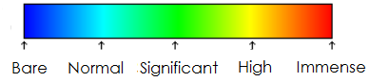
Figure 31: Color Scheme to Illustrate Crowd Density
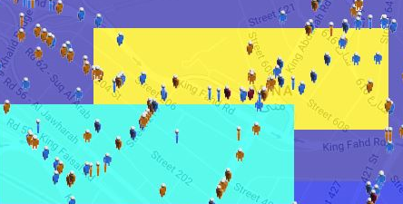
Figure 32: Heatmap Depicting Crowd Density in Two Different Zones

Deployment setup
Our developed infrastructure was deployed on different systems and machines as a whole due to the distributed nature of the architecture for the proposed system design. The deployment specifications of major components involved at different layers of the system are described below.

Simulator (SIAFU)
The context simulator SIAFU was deployed on a computing machine with the following specifications.
Processor | OS | RAM | Java Version
Core i7 (2.4 GHz) | Windows 8.1 | 8 GB | 8.101

SIAFU requires Maven, a project management tool, for compilation.

MongoDB
We deployed MongoDB (Version 3.2) in a sharded environment. We managed to setup MongoDB in a cluster of Linux machines through virtualization. VMWare is used as virtualization tool. Specifications of the environment and the steps involved in configuration are described in detail below.
Node Type | # of Nodes | OS | RAM | Disk Space
Master | 1 | Ubuntu (Desktop) | 2 GB | 40 GB
Shard | 2 | Ubuntu (Server) | 1 GB | 20 GB
Config Server | 3 | Ubuntu (Server) | 512 MB | 10 GB

Configuational Steps
The deployment of a production cluster involves the following steps provided that MongoDB is already installed in those:
- Start each mongod in the config server: The settings can be specified either through command line or a configuration file.

mongod --configsvr --replSet <setname> --dbpath <path>
OR
mongod --config <path-to-config-file>

- Connect to one of the config servers

mongo --host <hostname> --port <port>

- Start each mongod in the shard: The settings can be specified either through command line or a configuration file.

mongod –shardsvr --replSet <setname>
OR
mongod --config <path-to-config-file>

- Connect to a member of the shard

mongo --host <hostname> --port <port>

- Initiate the replica set: The rs.initiate() method initiates the replica set
- Start a mongos: The settings can be specified either through command line or a configuration file.

mongos --config <path-to-config>
OR
mongos –configdb <configReplSetName>/cfg1.example.net:27017,cfg2.example.net:27017,...

- Connect a mongo shell to a mongos

mongo --host <hostname> --port <port>

- Add shards to the cluster

sh.addShard( "s1-mongo1.example.net:27017")

- Enable sharding for the database

sh.enableSharding("<database>")

- Shard the collection

sh.shardCollection("<database>.<collection>", { <key> : <direction> } )

Spark
Spark v 2.10 was used which comes with the Hadoop binaries v 2.7 that are required to run Spark. A Linux machine was virtualized specifically for the execution of Spark Scripts.
Processor | OS | RAM | Java Version
Core i7 (2.4 GHz) | Ubuntu (Server) | 2 GB | 8.101

Crowd Analytics Application
The desktop application for crowd analytics was developed in Java and deployed on a system with following specifications.

Processor | OS | RAM | Java Version
Core i7 (2.4 GHz) | Windows 8.1 | 8 GB | 8.101

The application can be distributed in a JAR file along with its dependencies.

Problems Faced
Distributed processing frameworks, in general, are memory acquisitive. Therefore, we were presented with a challenge of utilizing our limited computing resources to their full extent. We had to increase the amount of RAM and make use of virtualization for the setup of our processing infrastructure.
The other problem was the network configurations for the environment. We did not have static IPs available for every node in the cluster and new IPs were assigned upon the rebooting of nodes. We overcame this problem by pausing the state of the machines included in the cluster. VMWare provides this functionality.

Algorithms

CREATE_RANDOM_PARTICIPANT(World w, C, G)
- let P be the object of participant’s class
- let R be the random number between 0 and 1
- let COLOR be the participant’s color
- let L be the group limit
- P.set(ID, uniqueID)
- P.set(GROUP_ID, G)
- P.set(AGE, Call Random(Age) )
- P.set(NATIONALITY, Call Random(NationalityList) )
- P.set(ACTIVITY, Call Random(Activity))
- IF R = 0 then
- COLOR := Blue
- P.set(GENDER, male)
- ELSE
- COLOR :=Brown
- P.set(GENDER, female)
- END IF
- IF C%L = 0 then
- COLOR := Magenta
- P.set(ROLE, leader)
- ELSE
- P.set(ROLE, normal)
- ENDIF

CREATE_RANDOM_POPULATION(World w)
- let C be the population count
- let P be the list of participants with size C
- let L be the group limit
- let G be the group check
- G := 1
- FOR i = 1 to C do
- IF i % L := 0 then
- INCREMENT G
- END IF
- P.add( CALL CREATE_RANDOM_AGENT(w ,i, G))
- END FOR
- RETURN P

Participant Information Insertion Query
- let P_ID be the MongoDB object with “p_id” as a key and participant’s unique ID as value
- let G_ID be the MongoDB object with “g_id” as a key and group ID of participant as value
- let ROLE be the MongoDB object with “role” a participant’s role in the group
- let POS be the list having latitude and longitude of participant’s position
- let COORDINATES be the MongoDB object with “coordinates” as a key and POS as value
- let TYPE be the MongoDB object with “type” as a key and “Point” as key
- let LOCATION be the MongoDB object with “loc” as a key and LOCATION as a value
- let TS be the timestamp
- COLL.insert(P_ID).append(G_ID).append(ROLE).append(ROLE)
.append(LOCATION.append(TYPE).append(COORDINATES)).append(TS)

Zone Information Insertion Query
- let COLL be the collection of MongoDB
- let ID be the zone ID
- let TR be the top right point of zone
- let BR be the bottom right point of zone
- let TL be the top left point of zone
- let BL be the bottom left point of zone
- let POLYGON be the linked list
- let ZONE be the MongoDB object with “zoneID” as a key and ID as value
- POLYGON.addLast(TR)
- POLYGON.addLast(BR)
- POLYGON.addLast(TL)
- POLYGON.addLast(BL)
- POLYGON.addLast(TR)
- let REGION be the MongoDB object with “coordinates” as a key and polygon as value
- let TYPE be the MongoDB object with “type” as a key and “Polygon” as a value
- let LOCATION be the MongoDB object with “loc” as a key and type as value
- COLL.insert(zoneID).append(location.append(region))

Zone Population Geospatial Query
- let COLL be the collection of MongoDB
- let ZONE be the list containing all polygonal points of that zone
- let POLYGON be the MongoDB object with $polygon as a key and ZONE as value
- let VICINITY be the MongoDB objfect with $geoWithin as a key and POLYGON as a value
- let QUERY be the MongoDB object with location field as a key and VICINITY as a value
- COLL.find(QUERY).count

HEAT_MAP_GENERATION (Overlay O)
- let TX be the top left horizontal point of zone on image
- let TY be the top left vertical point of zone on image
- let BX be the bottom right horizontal point of zone on image
- let BY be the bottom right vertical point of zone on image
- let C be the color value
- FOR i = TX to BX do
- FOR j = TY to BY do
- O.setPixelValue(i j, C);
- END FOR
- END FOR

Zone Area Calculation¹
- let TL be the top left point of zone
- let BR be the bottom right point of zone
- let R be the earth’s radius
- let Area be the zone area in square units
- let PI be the value of pi
- Area := (PI/180) * (R*R) * SIN (PI/180 * TL.latitude) – SIN (PI / 180 * BR.latitude) * (TL.longitude - BR.longitude)

- Formula taken from: http://mathforum.org/library/drmath/view/63767.html

Constraints

Assumptions
The processing infrastructure has been developed based on the assumption that a state of the art physical sensing infrastructure is in place. Although, for valuation and testing of our processing environment, we used a context simulator.

System constraints
The components in our system are dependent on each other. Therefore, they must be connected and configured to serve the purpose.

Restrictions
No Direct Restrictions implied by client.

Limitations
The scope of the developed application is thus far limited to crowd monitoring authorities only. Our system as of now does not provide any personalized services to participants in a crowd.

Testing

Extended Test Cases
Test Case ID: - TC_1.1 |  |  | Test Designed By: Monis Hafiz Abdul Ghaffar
Test Module Name: Controls on main screen |  |  | Test Design Date: 21/1/2017
Test Priority: High |  |  | Test Executed By: Hafiz Taha Jamil
Test Name: Deployment Mode Button |  |  | Test Executed Date:6/2/2017
Description: Test the deployment mode button on main screen
Pre-Condition: Main screen of the desktop application is loaded
Step | Test Step | Expected Result |  | Actual Result |  | Status
1 | Open the application | Display Main Screen |  | Main screen was displayed |  | Pass
2 | Click the deployment mode button | Move to new screen |  | Deployment mode screen was displayed |  | Pass
Post-Condition: Application moves to venue configurations screen
Test Case ID: - TC_1.2 |  |  | Test Design By: Monis Hafiz Abdul Ghaffar
Test Module Name: Controls on main screen |  |  | Test Design Date: 21/1/2017
Test Priority: High |  |  | Test Executed By: Hafiz Taha Jamil
Test Name: Simulation Mode Button |  |  | Test Executed Date:6/2/2017
Description: Test the simulation mode button on main screen
Pre-Condition: Main screen of the desktop application is loaded
Step | Test Step | Expected Result |  |  | Actual Result | Status
1 | Open the application | Display Main Screen |  |  | Main screen was displayed | Pass
2 | Click the simulation mode button | Display simulation mode screen |  |  | Simulation mode screen was displayed | Pass
Post-Condition: Application moves to simulation mode
Test Case ID: - TC_1.3 |  |  | Test Design By: Monis Hafiz Abdul Ghaffar
Test Module Name: Controls on main screen |  |  | Test Design Date: 21/1/2017
Test Priority: High |  |  | Test Executed By: Hafiz Taha Jamil
Test Name: Analytics Mode Button |  |  | Test Executed Date:6/2/2017
Description: Test the analytics mode button on main screen
Pre-Condition: Main screen of the desktop application is loaded
Step | Test Step | Expected Result |  |  | Actual Result | Status
1 | Open the application | Display Main Screen |  |  | Main screen was displayed | pass
2 | Click the analytics mode button | Display analytics mode screen |  |  | Analytics mode screen was displayed | pass
Post-Condition: Application moves to analytics mode

Test Case ID: - TC_2.1 |  |  |  | Test Design By: Monis Hafiz Abdul Ghaffar
Test Module Name: Deployment Mode |  |  |  | Test Design Date: 2/2/2017
Test Priority: High |  |  |  | Test Executed By: Hafiz Taha Jamil
Test Title/Name: Venue Settings |  |  |  | Test Executed Date:19/2/2017
Description: Assessment of functionalities provided by deployment mode
Pre-Condition: Venue configurations screen is loaded and the application is connected to the internet
Step | Test Step | Test Data | Expected Result |  | Actual Result | Status | Notes
1 | Click the button to open the select folder dialog | Input field will be filled by selecting the folder | Desired folder is selected |  | Desired folder was selected | Pass | Siafu resources file can be found in simulation/simulation-<name>/src/main
2 | Fill the latitude and longitude | Latitude (31.4509787)  Longitude (74.2908453) | Fields are filled |  | Fields were filled | Pass
3 | Click the get map button to get venue map | None | A map is displayed on the right side of screen |  | The map was displayed | Pass | The image is saved to resources directory
4 | Click on Create pathways | None | A map is converted into black and white |  | The map was converted | Pass | The image is saved to resources directory
5 | Click on create places to create a place | None | A message to user to click anywhere on the venue map |  | The message was displayed | Pass | Cursor is replaced with a location pin when placed over the map
6 | Creating a place by clicking over map | None | A place is created |  | The place was created | Pass | A black pixel against the clicked point is placed
6 | Click proceed to zone settings | None | Moved to new screen |  |  | Pass
Post-Condition: None

Test Case ID: - TC_2.2 |  |  |  | Test Design By: Monis Hafiz Abdul Ghaffar
Test Module Name: Deployment Mode |  |  |  | Test Design Date: 9/2/2017
Test Priority: High |  |  |  | Test Executed By: Hafiz Taha Jamil
Test Name: Zone Creation |  |  |  | Test Executed Date:28/2/2017
Description: Placing the resizable and draggable rectangle over venue map to create a zone
Pre-Condition: Zone creation screen is loaded and connection with MongoDB is established
Step | Test Step | Test Data | Expected Result |  | Actual Result | Status
1 | Fill the text field for zone ID | e.g. (1, 34B, 2, etc.) | The zone id is written |  | The zone id was written | Pass
2 | Drag and place the rectangle over map |  | Rectangle is dragged and moved |  | Rectangle was dragged and moved | pass
3 | Click create zone |  | Details of the created zone is displayed at bottom left of the screen and the information is stored in MongoDB |  | Successfully created the zone and the information was stored in MongoDB | pass
Post-Condition: Specified zone is created and the information is saved in MongoDB.

Test Case ID: - TC_3.1 |  |  | Test Design By: Monis Hafiz Abdul Ghaffar
Test Module Name: Simulation Mode |  |  | Test Design Date: 9/2/2017
Test Priority: High |  |  | Test Executed By: Hafiz Taha Jamil
Test Name: Running Simulation |  |  | Test Executed Date: 26/2/2017
Description: Giving the path of simulation to load and start it.
Pre-Condition: Simulation mode is loaded
Step | Test Step | Expected Result | Actual Result | Status | Notes
1 | Browse simulation directory by clicking the browse button | A dialog to select folder opens | The dialog opened and the path was accepted | Pass
2 | Click load simulation | Simulation is updated to the newly placed resources | Successfully updated | pass | A batch script will run to compile the simulation
3 | Click start simulation to start the simulation | Simulation will launch | Successfully launched | pass | Connection to MongoDB must be established before the start of simulation
Post-Condition: Running simulation

Test Case ID: - TC_4.1 |  |  | Test Design By: Monis Hafiz Abdul Ghaffar
Test Module Name: Simulation Mode |  |  | Test Design Date: 01/03/2017
Test Priority: High |  |  | Test Executed By: Hafiz Taha Jamil
Test Name: Crowd Context |  |  | Test Executed Date:5/03/2017
Description: Visualize participant’s context in a running simulation
Pre-Condition: Simulation is running
Step | Test Step | Expected Result |  | Actual Result | Status
1 | Click on a participant | Displays the current information (context) of the individual on the panel |  | Successfully received the complete information of the participant | pass
3 | Click on combo box | The list of participants’ name is displayed |  | This was displayed | pass
4 | Select any participant and click on search button | Shows the complete information of the context below the combo box |  | User successfully retrieved the complete information of participant | pass
Post-Condition: Participant’s context is displayed

Test Case ID:- TC_5.1 |  |  | Test Design By: Monis Hafiz Abdul Ghaffar
Test Module Name: Analytics Mode |  |  | Test Design Date: 02/3/2017
Test Priority: High |  |  | Test Executed By: Hafiz Taha Jamil
Test Name: Analyze Crowd Trail Overlay |  |  | Test Executed Date:10/3/2017
Description: Analyzes the frequent pathways used by crowd through an overlay
Pre-Condition: Simulation is running
Step | Test Step | Expected Result |  | Actual Result | Status
1 | Click on the overlay panel | Shows a combo box containing multiple overlays |  | Combo box was shown upon click | Pass
2 | Select the crowd trail overlay | The overlay is selected and a button to view the overlay is displayed |  | The overlay was selected and a button to view the overlay was displayed | Pass
3 | Hold the button to show overlay | Image showing trail of participants in a green, is overlaid on the background image |  | Crowd trail in green is overlaid on background image | Pass
Post-Condition: none

Test Case ID:- TC_5.2 |  |  | Test Design By: Monis Hafiz Abdul Ghaffar
Test Module Name: Analytics Mode |  |  | Test Design Date: 02/3/2017
Test Priority: High |  |  | Test Executed By: Hafiz Taha Jamil
Test Name: Analyze Current Crowd Density Heatmap |  |  | Test Executed Date:10/3/2017
Description: Analyze real-time crowd density of a zone through an overlay
Pre-Condition: Simulation is running
Step | Test Step | Expected Result |  | Actual Result | Status
1 | Click on the overlay panel | Shows a combo box containing multiple overlays |  | Combo box was shown upon click | Pass
2 | Select the current crowd density heatmap overlay | The overlay is selected and |  | The overlay was selected | Pass
3 | Hold the button to show overlay | Heatmap is overlaid on the background image |  | Heatmap was overlaid | Pass
Post-Condition: none

Test Case ID: - TC_5.3 |  |  | Test Design By: Monis Hafiz Abdul Ghaffar
Test Module Name: Analytics Mode |  |  | Test Design Date: 1/3/2017
Test Priority: High |  |  | Test Executed By: Hafiz Taha Jamil
Test Name: Analyze Predictive Crowd Density Heatmap |  |  | Test Executed Date:10/3/2017
Description: Analyze predictive crowd density of a zone through an overlay
Step | Test Step | Expected Result |  | Actual Result | Status
1 | Click on the overlay panel | Shows a combo box containing multiple overlays |  | Combo box was shown upon click | Pass
2 | Select the predictive crowd density heatmap overlay | The overlay is selected and a button to view the overlay is displayed |  | The overlay was selected and a button to view the overlay was displayed | Pass
3 | Hold the button to show overlay | Predictive heatmap showing forthcoming crowd density is overlaid on the background image |  | Heatmap was overlaid | Pass

Test Case ID: - TC_5.4 |  |  |  | Test Design By: Monis Hafiz Abdul Ghaffar
Test Module Name: Analytics Mode |  |  |  | Test Design Date: 1/3/2017
Test Priority: High |  |  |  | Test Executed By: Hafiz Taha Jamil
Test Title/Name: Analyze historical crowd conditions |  |  |  | Test Executed Date:10/3/2017
Description: Observe historical crowd condition w.r.t population of zones through a graph line
Pre-Condition: Analytics mode is loaded
Step | Test Step | Expected Result | Actual Result |  | Status | Notes
1 | Click the load defined zones button | Zone ids appear in drop down list | The ids were appeared |  | Pass | Retrieve zone list from mongo DB
2 | Select result from combo box | Analyze crowd condition button is enabled | The button was enabled |  | Pass
3 | Click analyze crowd condition button | Loads the zone view per selected one and zone population graph is displayed | Zone view was loaded and the graph was displayed |  | Pass | The graph is formulated from the results stored in MongoDB
Post-Condition: Real time population graph of the selected zone starts animating

Traceability Matrix

Requirements vs Use Cases (RID vs UCID)

UCID/RID | R 1.1 | R 2.1 | R 2.2 | R 2.3 | R 2.4 | R 2.5 | R 3.1 | R 3.2 | R 4.1 | R 4.2 | R 5.1 | R 5.1.1 | R 5.2 | R 5.2.1 | R 5.3 | R6.1 | R 6.1.1 | R 6.2 | R8.1
UC 1.1
UC 1.2
UC 1.3
UC 1.4
UC 2.1
UC 2.2
UC 3.1
UC 3.2
UC 3.3
UC 3.4
UC 3.5
UC 3.6

Prototypes (PID vs RID)

PID/  RID | R 1.1 | R 2.1 | R 2.2 | R 2.3 | R 2.4 | R 2.5 | R 3.1 | R 3.2 | R 4.1 | R 4.2 | R 5.1 | R 5.1.1 | R 5.2 | R 5.2.1 | R 5.3 | R6.1 | R 6.1.1 | R 6.2 | R8.1
P1
P2
P3
P4
P5
P6
P7
P8

Test Cases (TID vs RID)
TID/RID | R 1.1 | R 2.1 | R 2.3 | R 2.4 | R 2.5 | R 3.1 | R 3.2 | R 4.1 | R 4.2 | R 5.1 | R 5.1.1 | R 5.2 | R 5.2.2 | R 5.3 | R 6.1 | R 6.1.1 | R 7.1 | R 8.1
TC 1.1
TC 1.2
TC 1.3
TC 2.1
TC 2.2
TC 3.1
TC 4.1
TC 5.1
TC 5.2
TC 5.3
TC 5.4

Coverage (UCID vs TID)
UCID/TID | TC 1.1 | TC 1.2 | TC 1.3 | TC 2.1 | TC 2.2 | TC 3.1 | TC 4.1 | TC 5.1 | TC 5.2 | TC 5.3 | TC 5.4
UC 1.1
UC 1.2
UC 1.3
UC 1.4
UC 2.1
UC 2.2
UC 3.1
UC 3.2
UC 3.3
UC 3.4
UC 3.5
UC 3.6

Results/Output/Statistics

% Completion
The proportion of completion is calculated by comparing requirements with use cases i.e. (Requirements Covered / Total Requirements) * 100 = 89.47 %

% Accuracy
The proportion of accuracy is calculated by comparing requirements with test cases i.e. (Requirements Covered / Total Requirements) * 100 = 90.10 %

% Correctness
The proportion of correctness is calculated by comparing use cases with test cases i.e. (Use cases Covered / Total Use Cases) * 100 = 92.90 %

Imapact of Indexes
The performance of an index is evaluated on three different volumes of data. The quantum of positional data varies with respect to crowd population. Performance of a query with or without an index is measured with respect to its execution time.
- Operational Data

Operational Data - I
Crowd Population | 10,000
Crowd Observation Time | 180 Min
Data Collection Time Difference | 3 Min
No. of Records | 10000 x 180/3 = 600,000
Operational Data - II
Crowd Population | 50,000
Crowd Observation Time | 180 Min
Data Collection Time Difference | 3 Min
No. of Records | 50000 x 180/3 = 3,000,000
Operational Data - III
Crowd Population | 100,000
Crowd Observation Time | 180 Min
Data Collection Time Difference | 3 Min
No. of Records | 100,000 x 180/3 = 6,000,000

- Query: Scenario I

- No. of participants present in a specified region within a certain timeframe

Index Type | Field
2dsphere (Geospatial) | Location
Single field (ascending) | Timestamp

Performance Evaluation – Data I
Parameters | Without Indexing | With  Indexing
Execution Time (Milliseconds) | 550 | 53
Documents Returned | 35 | 35
Documents Examined | 600,000 | 10,000
Keys Examined | 0 | 10,000
Performance Evaluation – Data II
Parameters | Without Indexing | With  Indexing
Execution Time (Milliseconds) | 3093 | 788
Documents Returned | 188 | 188
Documents Examined | 3,000,000 | 50,000
Keys Examined | 0 | 50,000
Performance Evaluation – Data III
Parameters | Without Indexing | With  Indexing
Execution Time (Milliseconds) | 6484 | 1230
Documents Returned | 398 | 398
Documents Examined | 6,000,000 | 100,000
Keys Examined | 0 | 100,000

Table 4: Evaluation of Scenario I Query

- Summary
A compound query incorporating scenario I was executed against different sizes of positional data. The performance of a query was measured with respect to its time of execution and the evaluation results are presented in Table 4.
Data I include positional data of 10,000 participants observed with a time difference of 3 min resulting in 0.6 million records. An ‘and’ query in this case took 550 milliseconds without an index whereas 53 milliseconds with a compound index to execute. Data II include positional data of 50,000 participants observed with a time difference of 3 min resulting in 3 million records. The query took 3093 milliseconds without an index whereas 788 milliseconds with a compound index to execute. Data III include positional data of 100,000 participants observed with a time difference of 3 min resulting 6 million records. The query took 6484 milliseconds without and index whereas 1230 milliseconds with a compound index to execute.

Figure 24: Impact of Index on a Scenario I Query

The efficiency of a compound index is depicting in Figure 24 as the query takes almost linear time to execute if a compound index is maintained on a positional data in MongoDB.

- Query: Scenario II

- No. of participants present at a certain distance from a specified point

Index Type | Field
2dsphere (Geospatial) | Location

- Evaluation
Performance Evaluation – Data I
Parameters | Without Indexing | With  Indexing
Execution Time (Milliseconds) | 6123 | 2347
Documents Returned | 99,972 | 99,972
Documents Examined | 600,000 | 197,576
Keys Examined | 0 | 197,586
Performance Evaluation – Data II
Parameters | Without Indexing | With  Indexing
Execution Time (Milliseconds) | 23,587 | 7800
Documents Returned | 506,839 | 506,839
Documents Examined | 3,000,000 | 999,116
Keys Examined | 0 | 999,123
Performance Evaluation – Data III
Parameters | Without Indexing | With  Indexing
Execution Time (Milliseconds) | 52,138 | 18,022
Documents Returned | 1,045,933 | 1,045,933
Documents Examined | 6,000,000 | 2074134
Keys Examined | 0 | 2074141

Table 5: Evaluation of Scenario II Query

- Summary
A compound query incorporating scenario I was executed against different sizes of positional data. The performance of a query was measured with respect to its time of execution and the evaluation results are presented in Table 4.
Data I include positional data of 10,000 participants observed with a time difference of 3 min resulting in 0.6 million records. The query in this case took 6123 milliseconds without an index whereas 2347 milliseconds with a geospatial index to execute. Data II include positional data of 50,000 participants observed with a time difference of 3 min resulting in 3 million records. The query took 23,587 milliseconds without an index whereas 7800 milliseconds with a geospatial index. Data III include positional data of 100,000 participants observed with a time difference of 3 min resulting 6 million records. The query took 52,138 milliseconds without an index whereas 18,022 milliseconds with a geospatial index.

Figure 25: Impact of Index on a Scenario II Query

The efficiency of a geospatial index is clearly visible in Figure 25 as the query takes a lot less time to execute if a geospatial index is maintained on a positional data in MongoDB.

- Query: Scenario III

- Trail of a participant (getting all observed location points)

Index Type | Field
Single Field | Unique_ID

- Evaluation
Performance Evaluation – Data I
Parameters | Without Indexing | With  Indexing
Execution Time (Milliseconds) | 312 | 1
Documents Returned | 60 | 60
Documents Examined | 600,000 | 60
Keys Examined | 0 | 60
Performance Evaluation – Data II
Parameters | Without Indexing | With  Indexing
Execution Time (Milliseconds) | 1596 | 1
Documents Returned | 60 | 60
Documents Examined | 3,000,000 | 60
Keys Examined | 0 | 60
Performance Evaluation – Data III
Parameters | Without Indexing | With  Indexing
Execution Time (Milliseconds) | 3303 | 1
Documents Returned | 60 | 60
Documents Examined | 6,000,000 | 60
Keys Examined | 0 | 60

Table 6: Evaluation of Scenario III Query

- Summary
A compound query incorporating scenario I was executed against different sizes of positional data. The performance of a query was measured with respect to its time of execution and the evaluation results are presented in Table 4.
Data I include positional data of 10,000 participants observed with a time difference of 3 min resulting in 0.6 million records. The query in this case took 312 milliseconds without an index whereas 53 milliseconds with a single field index to execute. Data II include positional data of 50,000 participants observed with a time difference of 3 min resulting in 3 million records. The query took 1596 milliseconds without an index whereas 1 milliseconds with a single field index. Data III include positional data of 100,000 participants observed with a time difference of 3 min resulting 6 million records. The query took 1596 milliseconds without and index whereas 1 milliseconds with a single field index.

Figure 26: Impact of Index on a Scenario III Query

Figure 26 shows that a single field index in MongoDB is highly efficient as it takes almost constant time against different volumes of data.

Conclusion
In this project, we have presented a systematic design of a processing infrastructure for the real-time analysis on positional data of large crowds. We have also demonstrated a proof-of-concept implementation to model, simulate large events, analyze, and visualize crowd dynamics from different extents.
We have used a generic context simulator and extended its proficiencies to incorporate large events. We formed a processing infrastructure, an essential constituent of our work, consist of MongoDB; a distributed data store, Spark; a distributed processing framework for both real-time and predictive analytics, and a data ingestion component to facilitate pre-processing of data by means of filtration and modeling.
Firstly, positional data is generated through simulation then filtered, modeled, and stored in MongoDB geo-spatial queries are then used to analyze crowd conditions in terms of crowd density and crowd flow. The resultant information is in turn used by Spark to form predictive analytics. We have also assessed the impact of indexes on complex queries considering their frequent expected usage. The performance of complex queries with and without indexes are evaluated on related measurable parameters.
We created visualizations including heatmaps and graphs which depict real-time and historical crowd conditions.
A desktop based application is developed which allow crowd modelers to model large events, simulation designers to design event centric simulation and crowd monitoring authorities to analyze current and forthcoming crowd conditions.

Future work
In general, we would like to improve the functionalities of each layer of the proposed resource framework. At the application layer, we would develop a mobile application for participants. It will provide location specific services to individuals in a crowd. Participants will be able to get hold of the crowd conditions in their vicinity as well as information about other regions of the venue.
The focus of our work has been the monitoring and analysis of large events; therefore, our existing infrastructure needs to be scaled out at large. To categorically analyze crowd situation, we seek towards the inclusion of distributed visualizations.
We look forward to assessing the operations of our developed infrastructure on a real event in order to practically evaluate the efficacies and limitations of our system.

Bibliography
- Blanke, U., Tröster, G., Franke, T., & Lukowicz, P. (2014, April). Capturing crowd dynamics at large scale events using participatory gps-localization. In Intelligent Sensors, Sensor Networks and Information Processing (ISSNIP), 2014 IEEE Ninth International Conference on (pp. 1-7). IEEE.
- Versichele, M., Neutens, T., Delafontaine, M., & Van de Weghe, N. (2012). The use of Bluetooth for analysing spatiotemporal dynamics of human movement at mass events: A case study of the Ghent Festivities. Applied Geography, 32(2), 208-220.
- Almeida, J. E., Rosseti, R. J., & Coelho, A. L. (2013). Crowd simulation modeling applied to emergency and evacuation simulations using multi-agent systems. arXiv preprint arXiv:1303.4692.
- Martin, M., & Nurmi, P. (2006, July). A generic large scale simulator for ubiquitous computing. In 2006 Third Annual International Conference on Mobile and Ubiquitous Systems: Networking & Services (pp. 1-3). IEEE.
- Blanke, U., Troster, G., Franke, T., & Lukowicz, P. (2014, April). Capturing crowd dynamics at large scale events using participatory gps-localization. In Intelligent Sensors, Sensor Networks and Information Processing (ISSNIP), 2014 IEEE Ninth International Conference on (pp. 1-7). IEEE.
- Wirz, M., Franke, T., Mitleton-Kelly, E., Roggen, D., Lukowicz, P., & Tröster, G. (2013). Coenosense: A framework for real-time detection and visualization of collective behaviors in human crowds by tracking mobile devices. In Proceedings of the European Conference on Complex Systems 2012 (pp. 353-361). Springer, Cham.
- Wirz, M., Franke, T., Roggen, D., Mitleton-Kelly, E., Lukowicz, P., & Tröster, G. (2013). Probing crowd density through smartphones in city-scale mass gatherings. EPJ Data Science, 2(1), 5.
- Yamin, M., & Ades, Y. (2009, December). Crowd management with RFID and wireless technologies. In Networks and Communications, 2009. NETCOM'09. First International Conference on (pp. 439-442). IEEE.

Appendix
Analytics: The discovery of meaningful information in data
Application Layer: A layer in the system architecture which deals with applications
Big Data: Extremely large datasets
Crowd Density: Number of people per meter square
Crowd Flow: Crowd density per unit time
Crowd Simulation: The process of simulating crowd movement and dynamics
Distributed Computing: The use of multiple computers to run an application
GeoJSON: JSON object used for the encapsulation of geological data
Map Reduce: A programming model for distributed computing
MongoDB: A NoSQL database
Physical Layer: A layer in the system architecture which deals with physical devices
Processing Layer: A layer in the system architecture responsible for processing of data
SIAFU: A java based context simulator
Spark: An in-memory cluster computing framework
Visualization: A technique to create images or diagrams to communicate a message
Zone: A smaller section of a vast area

