Final Year Project Report
Patient Information Management System

Project Advisor:
Tayaba Anjum

Submitted By:
Usama Nasir 13022020-132
Ali Hassan 13022020-144
Rahma Ashfaq 13022020-110
Fahad Hassan 13022020-137

Session
2013 - 2017

University of Management and Technology
C-II Johar Town Lahore Pakistan

Dedication

We wish to dedicate this entire project report to our beloved mothers and fathers for their tireless support they accorded to us ever since we were children. We thank them for the spirit of hard work, courage and determination they had instilled in us throughout our school days till today. We also honor and owe our dear sisters and brothers for the happiness and appreciation for the guidance protection and financial support they offered us.
This project is especially dedicated to my Grandfather, who taught me that “Failure is only a temporary change in direction to set you straight for your next success.”

Final Approval

Panel of Examiners

- Head of Department ______________________
Department of Computer Science
UMT Lahore

- Program Director ( Final Year Projects) ______________________
Department of Computer Science
UMT Lahore

- Supervisor ______________________
Department of Computer Science
UMT Lahore

- Co-Supervisor ______________________

Acknowledgment

First and for most, we would like to express our sincere thanks to the Almighty ALLAH for the gift of life, wisdom and understanding he had given to us, a reason for our existence. And to our families for the love and support they had provided throughout our life. We also thank the staff of Tariq Hospital for having given their time at will during our System Study and Analysis stage they had been particularly helpful in providing the necessary data about the manual patient record management system. Special thanks goes to Ms.Tayaba Anjum for initiating the ideas for our project topic hence establishing a framework for the project proposal; she too has been good and understanding. Ms. Tayaba Anjum whom we regard as our mentor and supervisor, we thank her for the expertise and intelligence she has displayed while supervising this project. We believe this good work is a result of her good guidance and cooperation. We cannot forget our friends in the Faculty of Computing and Information Technology for the academic interactions and company they have accorded to us. Specially our teachers Dr. Adnan Shahzada, Abu baker Siddique shall always be remembered as good teachers in a life time. Lastly, we would like to convey our gratitude to the professors in our Faculty for the good job done during the 3 year period of our course. May the good lord bless them and keep them safe. We love you all.

Project Title PIMS (Patient Information Management System)
Objective Automate OPD system.

Undertaken by Usama Nasir 13022020-132
Ali Hassan 13022020-144
Rahma Ashfaq 13022020-110
Fahad Hassan 13022020-137

Supervised by Ms. Tayaba Anjum
Starting Date November, 2016

Completion Date June, 2017

Tools Used ASP.NET
MS Visual Studio Enterprise 2015
MySQL Server
SQL Management Studio
IIS Express

Operating System Windows
Documentation Completed

Abstract
Hospitals are the essential part of our lives, providing best medical facilities to people suffering from various ailments, which may be due to change in climatic conditions, increased work-load, emotional trauma stress etc. It is necessary for the hospitals to keep track of its day-to-day activities and records of its patients, doctors and other staff personals that keep the hospital running smoothly and successfully.
But keeping track of all the activities and their records on paper is very cumbersome and error prone. It also is very inefficient and a time-consuming process, Observing the continuous increase in population and number of people visiting the hospital. Recording and maintaining all these records is highly unreliable, inefficient and error-prone. It is also not economically and technically feasible to maintain these records on paper.
So keeping the working of the manual system as the basis of our project, we have developed an automated version of the manual system, named as “Patient Information Management System”.
The main aim of our project is to provide a paper-less OPD (Out Patient Data) up to 100%. It also aims at providing low-cost reliable automation of the existing systems. The system also provides excellent security of data at every level of user-system interaction and also provides robust and reliable storage and backup facilities. Basic functionalities of our project includes Consultant portal, Patient Portal, Admin portal, Book Appointments, Add prescription. Except these, previously stored data and prescriptions can also be viewed. Patients, Consultants and Clinics can register into our system. Guest users can search for doctors and their clinics.

Contents
Contents 1
Definitions and Acronyms 4
1. Introduction 7
1.1 Motivations 7
1.2 Project Overview 7
1.3 Problem Statement 7
1.4 Features 8
2. Domain Analysis 9
2.1 Customer 9
2.2 Stakeholders 9
2.3 Affected Groups with social or economic impact 9
2.4 Dependencies/ External Systems 10
2.5 Reference Documents 10
2.5.1 Related Projects 10
2.5.2 Feature Comparison 11
3. Requirements analysis 13
3.1 Requirements 13
3.2 List of Actors 15
3.3 List of use cases 15
3.4 System use case diagram 16
3.5 Extended use cases 17
3.6 User interfaces (mock screens) 18
4. Data flow diagram 23
4.1 Data Flow Diagram Level 0 23
4.2 Data Flow Diagram Level 1 23
4.3 Data Flow Diagram Level 2 24
5. System Design 25
5.1 System Architecture Diagram 25
5.2 Class Diagram 26
26
5.3 Sequence Diagrams 27
5.4 Collaboration Diagram 32
5.5 Other UMLs 33
5.6 ERD 33
5.7 Data Dictionary 33
6. Implimentation 34
6.1 Development Setup 34
6.2 Deployment Setup 35
6.3 Algorithms 36
6.4 Constraints 37
6.4.1 Assumption 37
6.4.2 System Constraints 37
6.4.3 Restriction 37
6.4.4 Limitation 37
7. Testing 38
7.1 Extended Test Cases 38
7.2 Decisions 45
7.2.1 Code snippet 45
7.2.2 Decision tree coverage 52
7.3 Traceability Matrix 52
7.3.1 RID VS UCID (REQUIREMENT VS USECASES) 52
7.3.2 Prototypes 53
7.3.3 Test cases 53
7.3.4 Coverage 54
8. Results /output / statistics 55
8.1 % COMPLETION 55
8.2 %ACCURACY 55
8.3 % CORRECTNESS 55
9. CONSLUSION 56
10. FUTURE WORK 57
11. BIOGRAPHY 58
11.1 BOOKS 58
11.1.0 Jesse Liberty, ‎Dan Hurwitz “Programming ASP.NET”, Third edition 58
11.1.1 Jess Chadwick, Todd Snyder, Hrusikesh Panda, “Programming ASP.NET MVC 4”,2012 58
11.2 JOURNALS 58
11.3 ARTICLES 58
11.3.0. (Online) Available https://www.asp.net/mvc/overview/getting-started RESECARCH PAPER 58
11.4 OTHERS REFERENCE 58
12. APPENDIX 59
12.1 GLOSSARY OF TERMS 59
12.2 PRE REQUISTIES 59

Definitions and Acronyms

Table 1: table of acronyms and definitions
Acronym | Definition
UMT | University of Management and Technology
POS | Point of Sale
OPD | Out Patient Data
PIMS | Patient Information Management System
ERM | Electronic Medical Records
RDLC | Report Definition Language Client

List of Tables

Table 1: table of acronyms and definitions 3
Table 2: list of stakeholders 8
Table 3: Feature Comparison 10
Table 4: Requirement table 13
Table 5: Extended Use Case 16
Table 6: Data Dictionary 32
Table 7: Decision tree coverage 51
This table shows how much conditions fulfilling the system rules. 51
Table 8: Requirement VS Use Cases Table 51
Table 9: Prototypes 52
Table 10: Test Cases 52
Table 11: Coverage 53

List of Figures
Figure 1: sample use case diagram with explanation 15
Figure 2: (P1) Register Patient Page 17
Figure 3: (P2) Display Patient Info 17
Figure 4: (P3) search patient 18
Figure 5: (P4) add Appointment 18
Figure 6: (P5) Patient Request for prescription 19
Figure 7: (P6) Prescription form 20
Figure 8: (P7) Patient Analysis 20
Figure 9: (P8) RDLC Report 21
Figure 10: DFD Level 0 22
Figure 11: DFD Level 1 22
Figure 12: DFD Level 2 23
Figure 13: System Architecture 24
Figure 14: Class Diagram 25
Figure 15: Sequence Diagram 1 (Register) 26
Figure 17: Sequence Diagram 3 (Login) 27
Figure 18: Sequence Diagram 4(Search) 28
Figure 21: Sequence Diagram 7 (Add Hospitals) 29
Figure 22: Sequence Diagram 7 (Add Hospitals) 30
Figure 23: Sequence Diagram 7 (Add Hospitals) 30
Figure 25: Sequence Diagram 11 (View Prescription) 31
Figure 26: Collaboration Diagram 31
Figure 27: ERD 32
Figure 28 34

Introduction
Patient Information Management System (PIMS) is designed for any hospital to replace their existing manual paper based system. The system is to control the information about the patient and nearby availability of the hospitals and their doctors. These services are to be provided in an efficient, cost effective manner, with the goal of reducing the time and resources currently required for such tasks.

Motivations
Pakistan is a huge country according to its growing population of 195.05 million. 66% of its population suffering from different diseases and visiting doctors. We cannot automate all the country but we can start from an area in our city with small hospitals and clinics which cannot afford web apps like these. So we want to automate these hospitals with (PIMS) which can cover the necessary modules to both hands (Patients and Hospitals). We are also facing these kinds of medical problems so this motivates us to change the system and serve our people. Our most of teachers said that this is not a good project. But we believe this project can change the life of agonized people.

Project Overview
Hospitals are the essential part of our lives, providing best medical facilities to people suffering from various ailments, which may be due to change in climatic conditions, increased work-load, emotional trauma, stress etc. it is necessary for the hospitals to keep track of its day to day activities and records of its patients and doctors.

An efficient and future proof Patients Information Management System is a key component of a viable health system as Healthcare business are evolving rapidly. Today, there is a need to control processes that govern this sector as costs rise and there is a requirement to manage the information that health professionals need.
Goals:
Our product will be providing facilities to private hospitals which are willing to register in a healthcare system. The registered hospitals can share the data of the patients as per need of the consultants. In a less cost our system will provide basic modules of OPD and EMR (Electronic Medical Records) in hospitals by which every patient can register online and book appointments anywhere in the given hospitals. Soon most of the patients records will be on our system and our product will be able to provide a paperless OPD system. The system becomes more efficient then existing system. Efficiency improves by reducing search cost and ability to produce more precise results.

Problem Statement
Healthcare is a very significant part of our society and it is imperative for healthcare providers to do their jobs in an efficient and effective manner. Each day hundreds of thousands of patients enter healthcare facilities challenging the administration to run the show smoothly. The patients have to manage and integrate clinical, financial and operational information that grows with the practice. Previously, this data was organized manually, which was time consuming and failed to deliver the desired level of efficiency. Most of the professionals run hospitals and clinics now rely on hospital information systems (HMS) that help them manage all their medical and administrative information. But there is no automation for the patients which isn’t fair. I use to handle all my grandfather’s prescriptions and medical records with care. Which was very difficult to manage and sometimes I lose some of the documents which was very important for him. This isn’t my problem only but everyone’s. So, to automate the patient information we are developing Patient Information Management System (PIMS) which can be able to store one to all the information about the patient and there will be no need to save the papers or documents anymore.

Features
These are mandatory objectives of our proposed system
- Patient can view prescriptions and medical records online.
- Patient can book appointment online from consultant.
- Consultant portal, in which patient are prescribed electronically.
- Consultant can register into different Clinics
- Patient portal
- Admin Portal.
- Admin can add hospital/clinics.
- RDLC reports of Patients
- Print Reports

Domain Analysis

Customer
Our project is not exactly contracted but during our capstone II we’ll visit those hospitals and clinics again which we have visited in our capstone I for requirements, so we can proceed with the contract, with that we add their info in our system so we can launch the system at the end of our capstone II.

Stakeholders
Table 2: list of stakeholders
Stakeholder | Role in System
Patient | The main point of this system is to automate the data of a patient. So, patient is the most important stakeholder because he’ll use the system for his ease and service.
Doctor | Doctor is also an important stakeholder because he is going to write prescriptions and medical statements. Also he can see the previous records of a patient.
Hospital Owner | The owner of the hospital can earn more if he/she provide this system for patients and doctors by setting registration fee for his system.
Receptionist | The receptionist of a hospital can maintain the data easily by getting help from the system. So he/she is also a stakeholder.
Admin | Admin of the system can manipulate with the data of patients and doctors with the help of this system so he/she is a stakeholder of this system as well.
Developer | We are spending our time to automate the medical system with the help of PIMS so we are also a stakeholders of this system.
Advisor | Our advisor is also a stakeholder of this system because he/she is helping us to develop this system.

Affected Groups with social or economic impact
- Doctors:
There will be reduced paper work for the doctors. Also they will be able to check previous records of patients easily on the system.
- Patients:
There will be no papers as prescriptions or medical records. Also they’ll acquire better service of appointment by online system and cost effective.
- Hospitals:
There will be reduced paper work for them. Also they will be able to provide better patient care as system will help them respond to queries quickly and efficiently.

Dependencies/ External Systems
This project depends upon this until its completion
- RDLC REPORTS
- Local Host

Reference Documents

Related Projects
List of all the documents/ projects that you have looked up as reference material for this project along with their links/references
In order to develop PIMS, we looked up several similar systems. Their details are given below
- Hospital Management System (HMS)
Developers Rishit Gajjar, Mehul Ranavasiya. The partial documentation was obtained by the Prof. Sapan Mankad development team and the documentation of this management software was observed [1].
- Kulsum International Hospital (KIH)
Developed by Softech Systems, the working of this management software was observed from [2] no relevant documentation was available.
- Max Hospital
Max Hospital is a multi-specialty hospital owned and managed by Max Healthcare Institute Limited (MHIL). The company provides patient services including nuclear medicine and cardiac imaging, labs and electrophysiology, neurosciences, orthopedics, general surgery, urology, nephrology, gastroenterology, mental health and behavioral sciences, rehabilitative services, and pulmonology.

Feature Comparison

Table 3: Feature Comparison
Sr. No. | Comparison Feature | HMS | KIH | MHC | PIMS | Remarks
1  2  3  4  5  6  7  8 | Consultant Portal  Admin portal  Book appointment  View appointment  Add Hospital  View prescription  Add prescription  View Medical Reports | HMS provide consultant portal but not for users.  Admin portal exist.  HMS doesn’t have such functionality.  HMS doesn’t provide this functionality.  HMS only for patients and Doctors.  HMS can view the prescription  HMS can add prescription.  HMS doesn’t have such functionality | KIH provide consultant portal but they don’t provide any kind of services.  Admin portal exist.  KIH doesn’t provide online service  KIH doesn’t provide this service.  KIH can only for patients and doctors.  KIH doesn’t provide this service.  KIH doesn’t provide this service.  KIH doesn’t provide this service. | MHC doesn’t provide such type of functionality  Admin portal exist.  MHC provide  Online book appointment to their patients.  MHC doesn’t provide this service online.  MHC doesn’t provide this service.  MHC doesn’t provide Online service.  MHC doesn’t provide Online service.  MHC doesn’t provide Online service. | Our System provide Online service for users  Our system has an admin portal.  Our system provides book appointment online.  PIMS allow the users to view their appointment if he/she have a account  PIMS provide this service to their users.  Our system allow the user to view the prescription  Our system can allow register doctor to add prescription.  In our system user view the medical reports and also download it. | PIMS much better then HMS and KIH.  No  PIMS and MHC are much better  PIMS solve user problem.  None  None  PIMS Solve both doctor and patient problem  PIMS solve patient problem and also provide solution for paper less system

Requirements analysis

Requirements
Software Requirement Specification
Software requirements specification (SRS), a requirements specification for a software system, is a complete description of the behavior of a system to be developed and may include a set of use cases that describe interactions the users will have with the software. In addition it also contains non-functional requirements. Non-functional requirements impose constraints on the design or implementation (such as performance engineering requirements, quality standards, or design constraints).
Introduction
The following subsections of Software Requirement Specifications Document should facilitate in providing the entire overview of the Information system “Patient Information Management System” under development. This document aims at defining the overall software requirements for admin. Efforts have been made to define the requirements of the Information system exhaustively and accurately.
Purpose
The main purpose of Software Requirement Specifications Document is to describe in a precise manner all the capabilities that will be provided by the Software Application “Patient Information Management System”. It also states the various constraints which the system will be abide to. This document further leads to clear vision of the software requirements, specifications and capabilities. These are to be exposed to the development, testing team and end users of the software.
Scope
The proposed software product is the Patient Information Management System (PIMS). The system will be used in any Hospital, Clinic, Dispensary or Pathology labs of any Hospital to get the information from the patients and then storing that data for future usage.
The current system in use is a paper-based system. It is too slow and cannot provide updated lists of patients within a reasonable timeframe. The intentions of the system are to reduce over-time pay and increase the number of patients that can be treated accurately. Requirements statements in this document are both functional and non-functional.

Functional Requirements | This system have following requirements
Non-Functional Requirements | This system will be time effective, cost effective, easy to use, interactive, reliable and maintainable.
Data Requirements | Data will be stored in secured SQL Database.
Constraints | None
External interface requirements | We are using visual studio enterprise so we’ll use RDLC reports by Microsoft for medical reports as external interface.

Table 4: Requirement table
RID | Description | Category | Attribute | Details and Boundary Constraints
R1.1 | Admin portal | Functional | System requirement | For patient, doctor and clinics registration.
R1.2 | Consultant portal | Functional | System requirement | For doctors
R1.3 | Patient portal | Functional | System requirement | For patients
R1.4 | Add appointment | Functional | System requirement | For patients, doctors  Display within 5sec
R1.5 | View appointment | Functional | System requirement | For patients and doctors
R1.6 | Billing Module | Functional | System requirement | For clinics
R1.7 | Add prescription | Functional | System requirement | For doctors
R1.8 | View prescription | Functional | System requirement | For register users
R1.9 | View Medical Reports | Functional | System requirement | For patients
R1.10 | Update Reports | Functional | System requirement | For doctors
R1.11 | Print Reports | Functional | System requirement | Patient and Doctors

List of Actors
Admin; this person supervises all the administrative activities.
Patient; this person performs all the patient module activities.
Doctor; this person supervises all the doctor module activities.
Clinic; this person assists doctor and performs all clinic module activities.

List of use cases
Register; register a new user.
Login; allow users to provide account information and access the restricted services.
Search; allow users to search desired information in the system.
Book Appointment; allow patients to book an appointment of doctor online.
View Appointment; allow patients to view his/her appointment
Add Prescription; allow doctors to add or update the appointed patient.
Medical Reports; allow users to see and add medical report referred by Doctor.
Print RDLC Reports; allows user to print medical reports.
Add Request for hospital; allow doctors to send request to desired hospital for job.
Add and Delete Patient or Doctor; allow admin of the respective hospital to add or delete the patient from the record.
Analysis Patients; allow to update records on the behalf of current doctor prescription along with identified patients symptoms.

System use case diagram
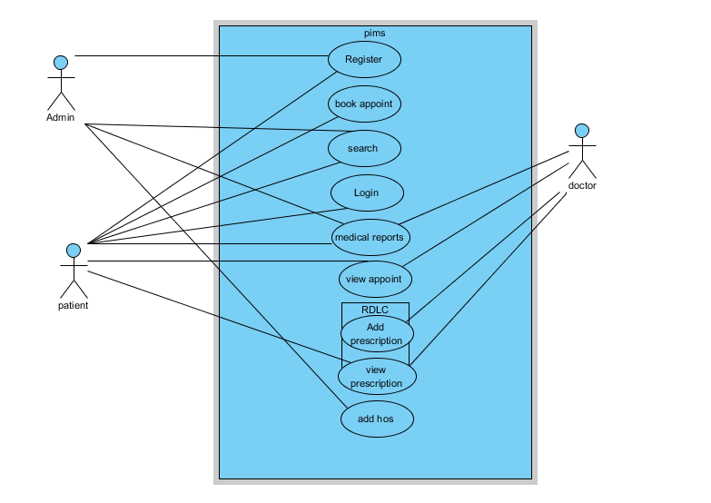
Figure 1: sample use case diagram with explanation

Extended use cases
Table 5: Extended Use Case
Use Case ID: | UC-1.5.1
Use Case Name: | Lab Reports
Created By: | Developers |  | Last Updated By:
Date Created: | 29/1/2017 |  | Last Revision Date:
Actors: |  | Primary: Patient
Description: |  | Lab module is not specified for every hospital if the visited hospital doesn’t have their lab and patient use another lab then this use case extended for adding lab reports by user or doctor.
Trigger: |  | This use case triggers when hospital don’t have its own lab system or patient don’t want to use their lab.
Preconditions: |  | - Doctor must refer for the labs for the patient  - Respective hospital don’t have lab.  - Patient don’t want to use the hospital’s lab
Post conditions: |  | - Patient adds his lab reports pic or file by himself.
Normal Flow: |  | When user take appointment for doctor and doctor write some labs on his prescription. If patient want to use the hospital’s lab. He’ll go to the lab. After that respected hospital add the lab result in the patient record. And both patient and doctor can see it.  - Patient book appointment  - Patient came to doctor as appointed time  - Doctor checks the previous record from the system and adds new prescription.  - Doctor refer patient for labs  - Patient got o the lab for sample  - Lab members add results in the patient’s record  - Patient and Doctor can check the result online
Alternative Flows: |  | When the flow reach the step five (Labs) and if the hospital don’t have labs facility or the patient don’t want to use their lab then this alternative flow will be used. In which patient has to add image or file of result of his lab report by himself to his record.  - System will prompt patient to add lab result  - Patient will add file in record  - Use Case resumes on step 6  - In step 5 of the normal flow, if the patient is not using the hospital’s lab  - Normal flow
Exceptions: |  | User must filled all the fields at the time of registration and add appointment.  User add patient date of birth in dd/mm/yy  User will not allow using comments or controls at login page. In steps 1.
Includes: |  | None
Frequency of Use: |  | 50 times a day
Special Requirements: |  | Patient must add results before next appointment
Assumptions: |  | The respective hospital don’t have the lab facility or patient don’t want to use their lab
Notes and Issues: |  | The alternative lab results which patient adds to his records cannot be authenticated.

User interfaces (mock screens)

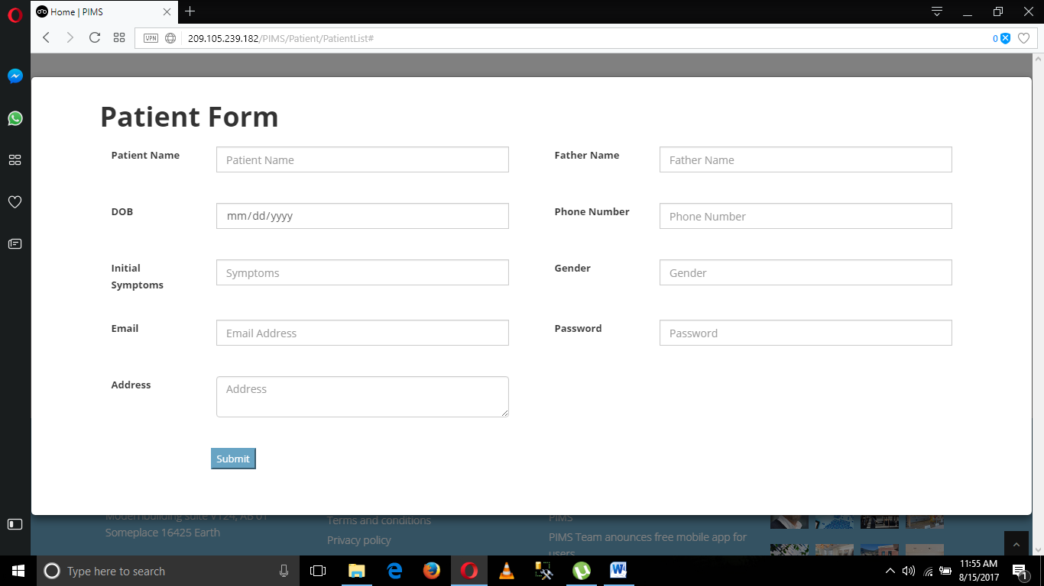
Figure 2: (P1) Register Patient Page

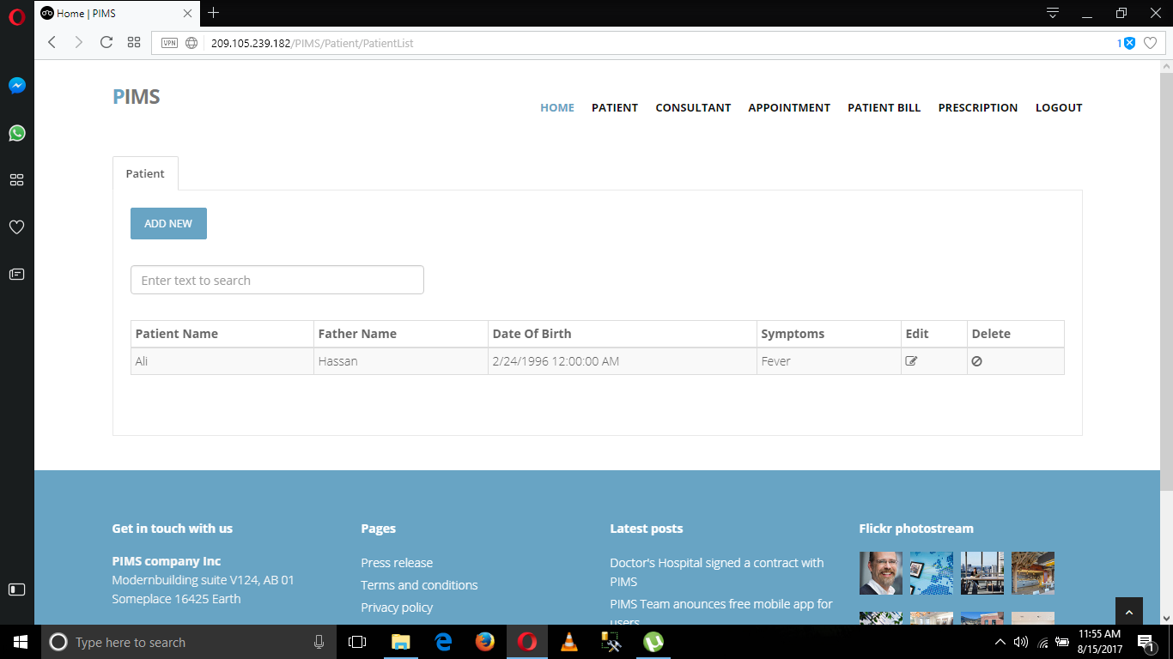
Figure 3: (P2) Display Patient Info

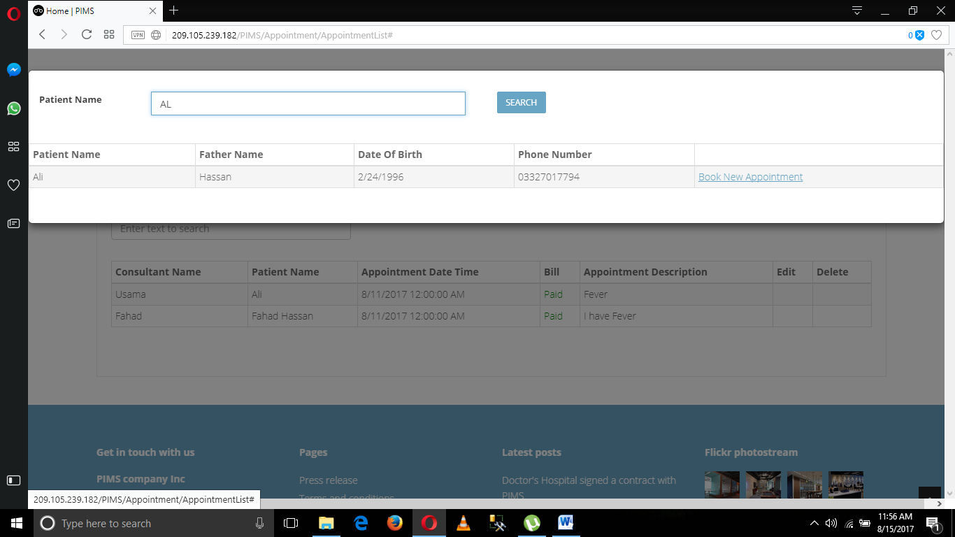
Figure 4: (P3) search patient

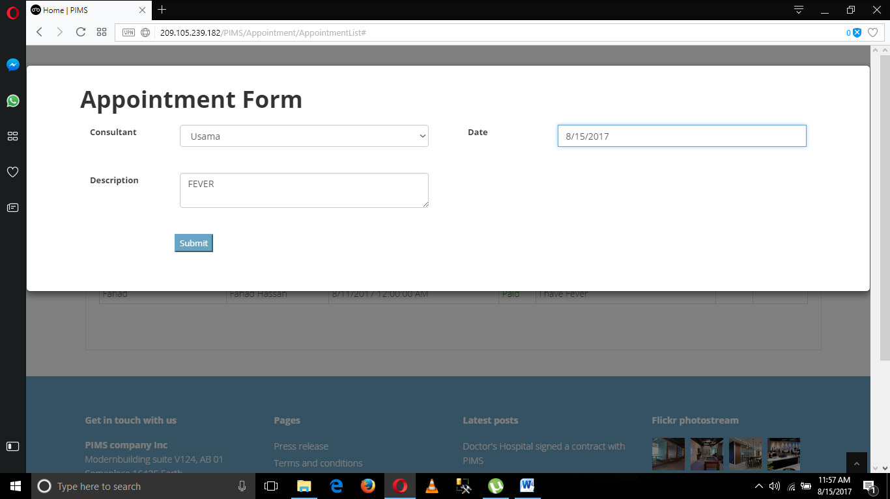
Figure 5: (P4) add Appointment

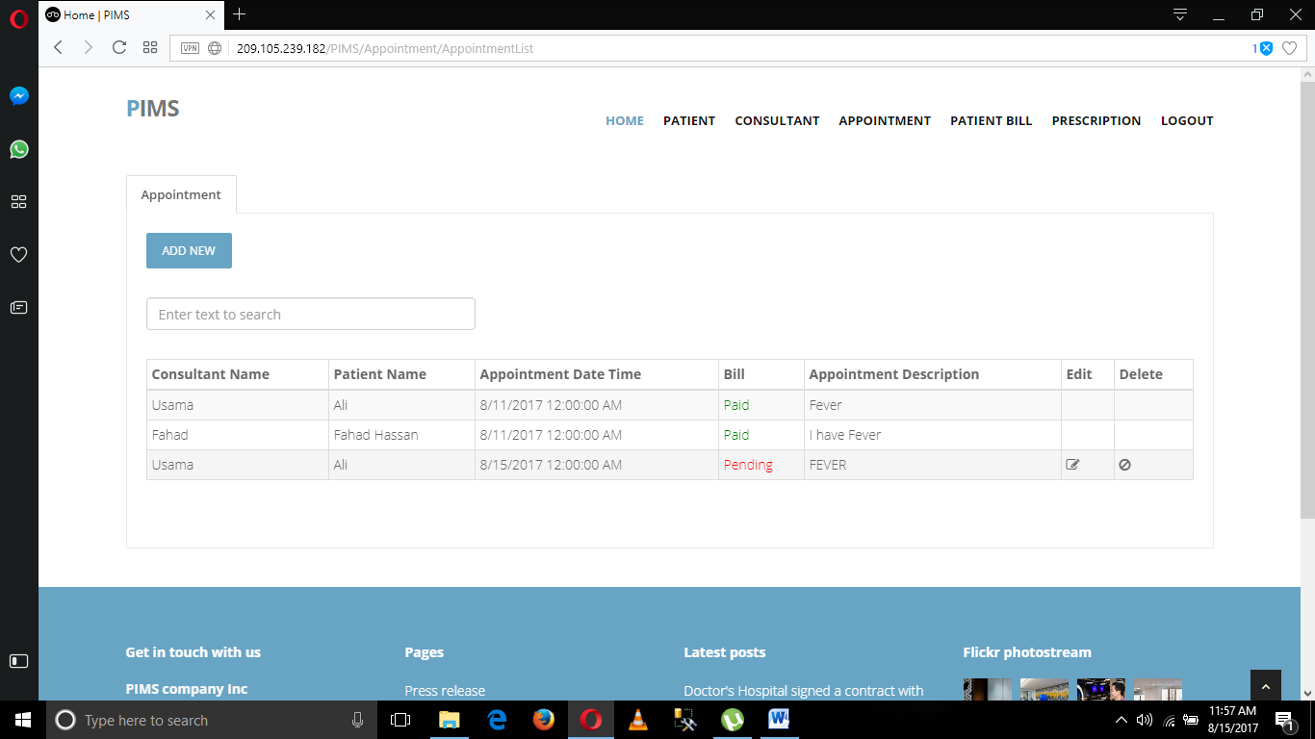
Figure 6: (P5) Patient Request for prescription

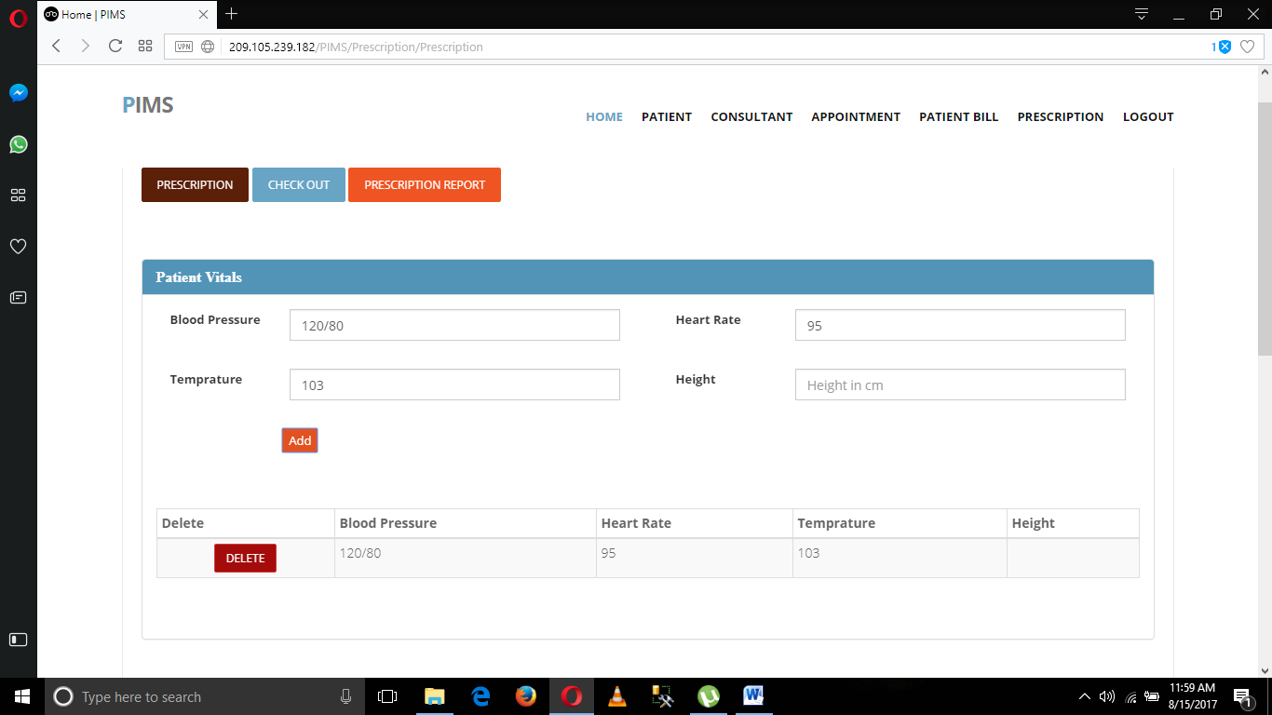
Figure 7: (P6) Prescription form

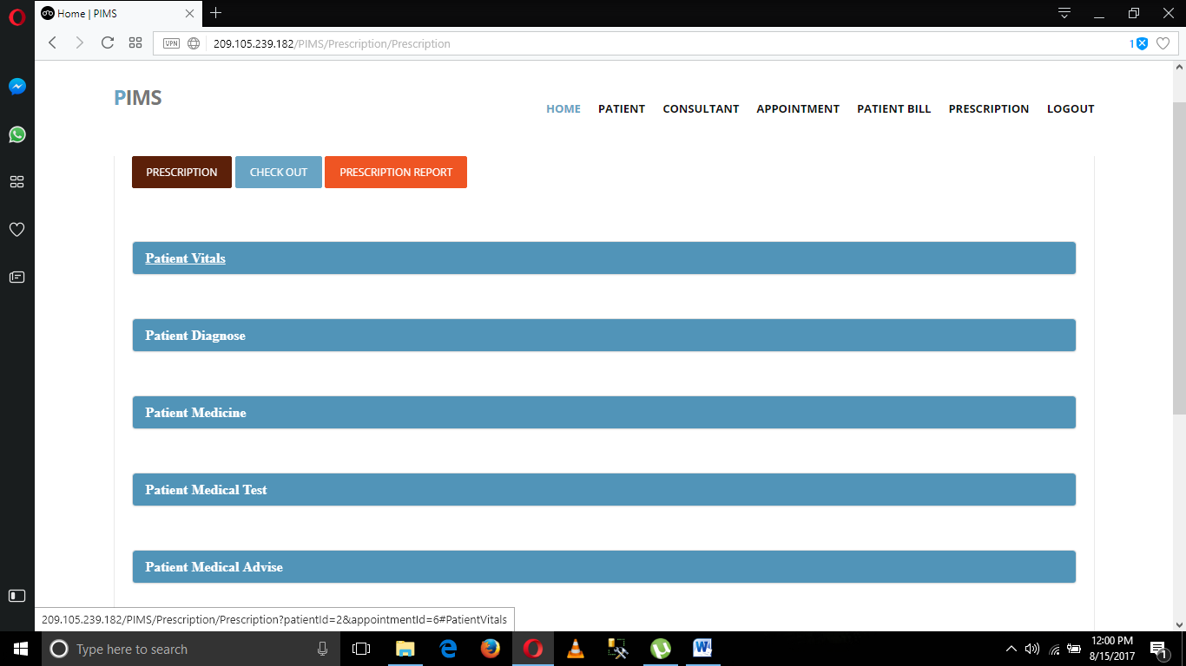
Figure 8: (P7) Patient Analysis

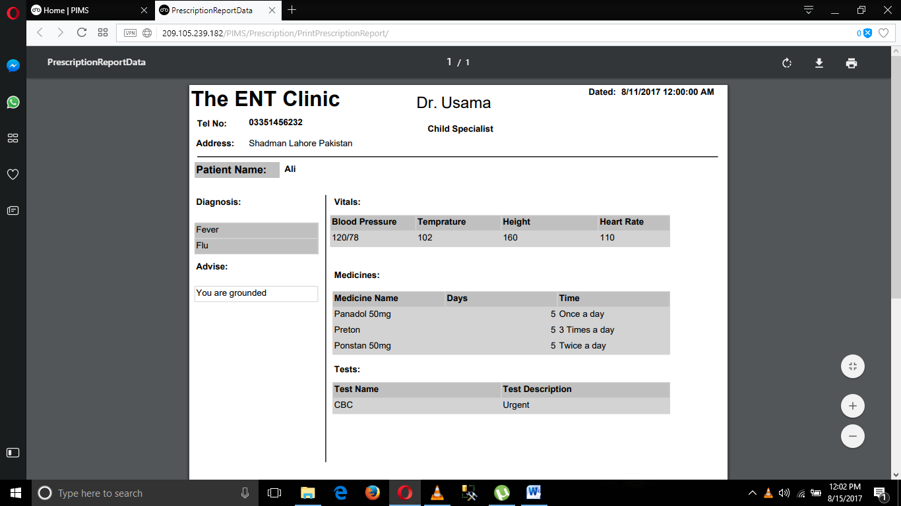
Figure 9: (P8) RDLC Report

Data flow diagram

Data Flow Diagram Level 0
DFD Level 0 shows the main flow of data in this system.

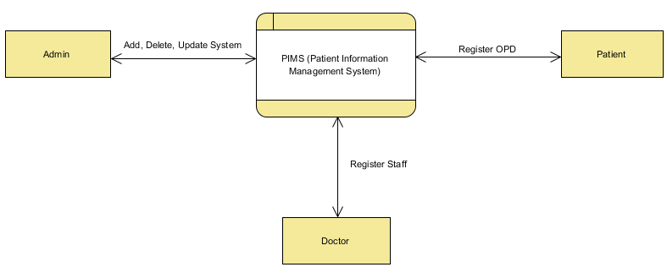
Figure 10: DFD Level 0

Data Flow Diagram Level 1
DFD Level 1 is more expanded than the previous level to show the inner data flow of the given modules in this system.
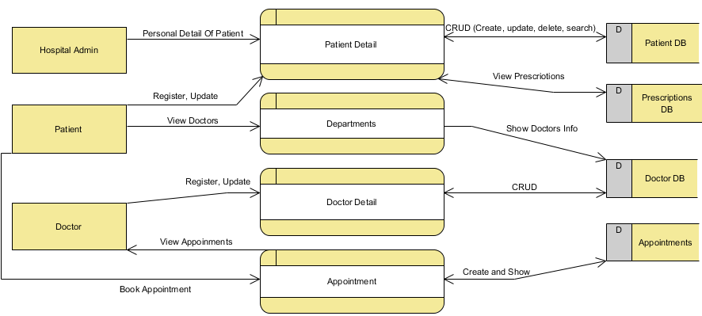
Figure 11: DFD Level 1

Data Flow Diagram Level 2
In DFD level 2 data flow of sub-modules have been shown. We cannot expand further to DFD level 3.

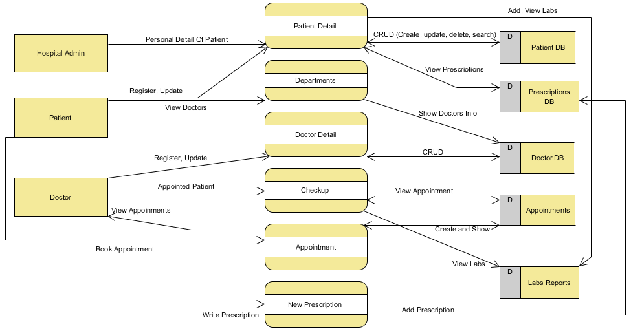
Figure 12: DFD Level 2

System Design

System Architecture Diagram
System architecture diagram shows the main architecture of our system that how the system working according to the MVC and interact with user and with the internet.
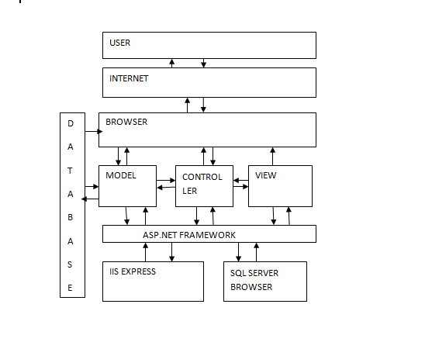
Figure 13: System Architecture

Class Diagram
Class diagram is showing that how different inherited classes are interacting with each other. The line also express the relation and its type with different classes.

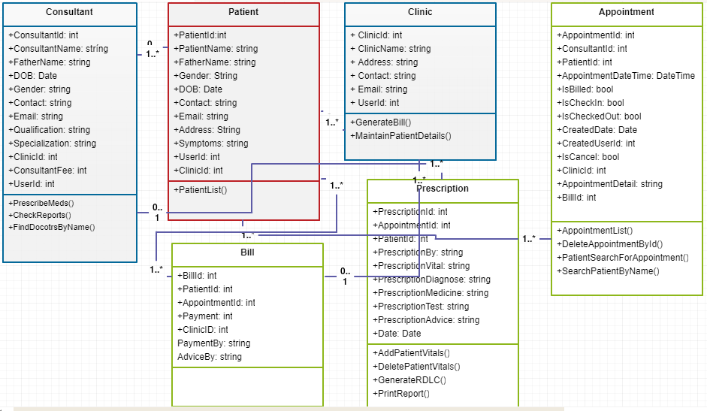
Figure 14: Class Diagram

Sequence Diagrams
These sequence diagrams shows the proper sequence of the system when a user want to use this system. For every event there is a separate sequence diagram to show the steps of completing that particular event.

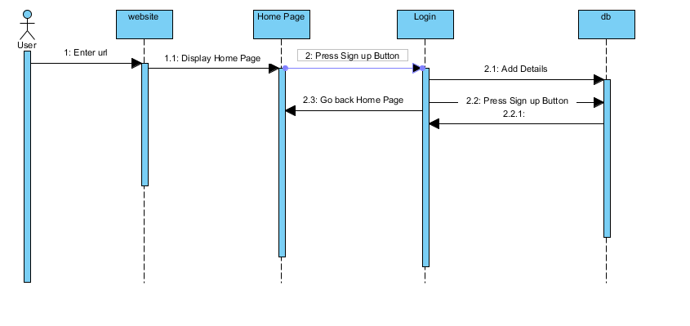
Figure 15: Sequence Diagram 1 (Register)

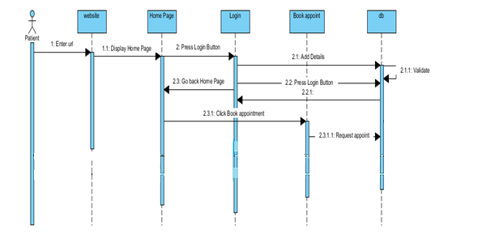
Figure 16: Sequence Diagram 2 (Book appointment)

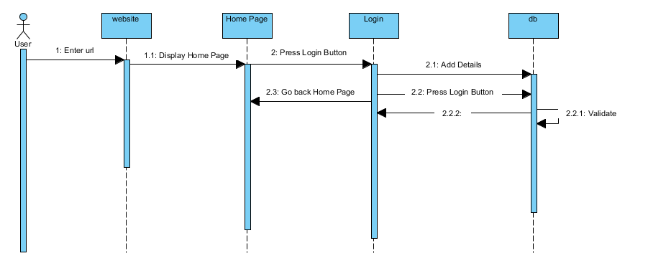
Figure 17: Sequence Diagram 3 (Login)

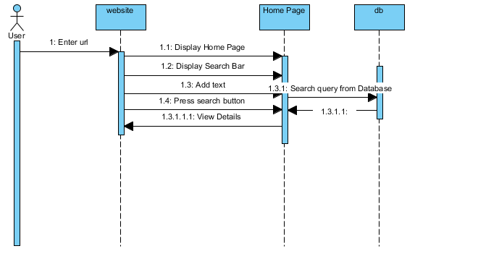
Figure 18: Sequence Diagram 4(Search)

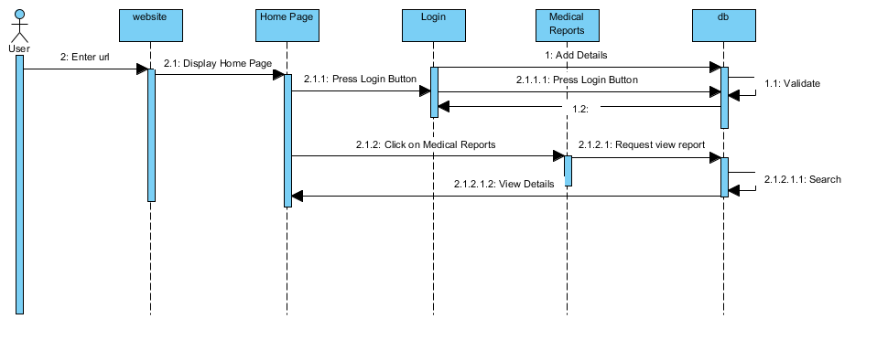
Figure 19: Sequence Diagram 5(Medical Reports)

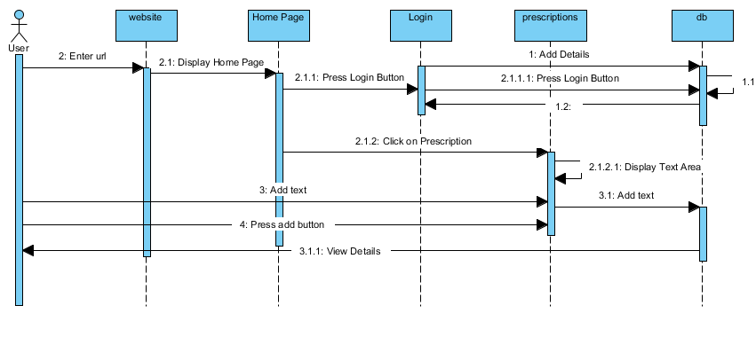
Figure 20: Sequence Diagram 6(Add Prescription)

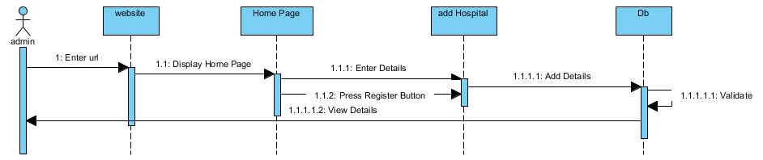
Figure 21: Sequence Diagram 7 (Add Hospitals)

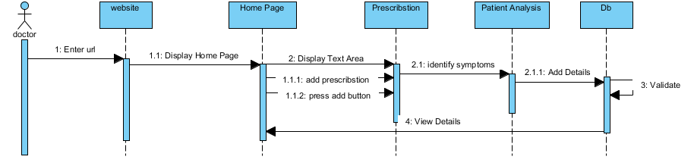
Figure 22: Sequence Diagram 7 (Add Hospitals)

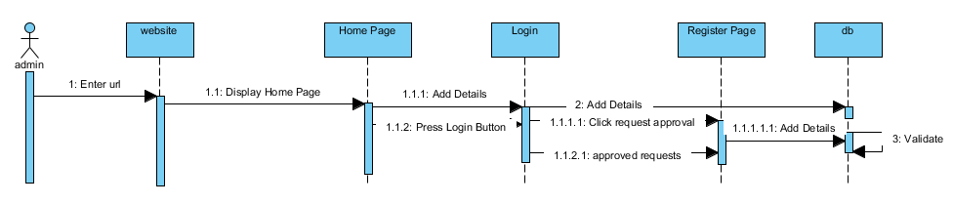
Figure 23: Sequence Diagram 7 (Add Hospitals)
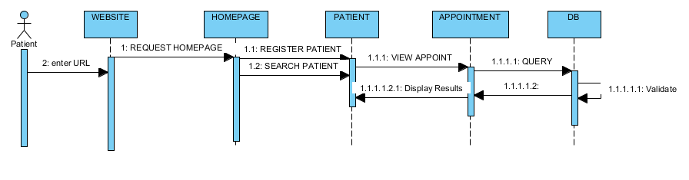
Figure 24: Sequence Diagram 10 (View Appointment)

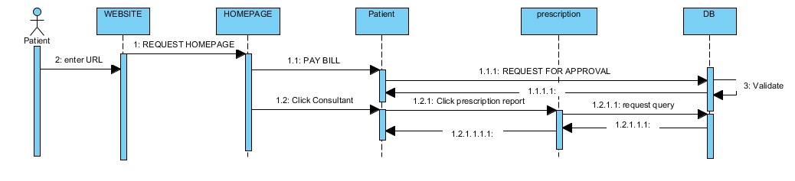
Figure 25: Sequence Diagram 11 (View Prescription)

Collaboration Diagram

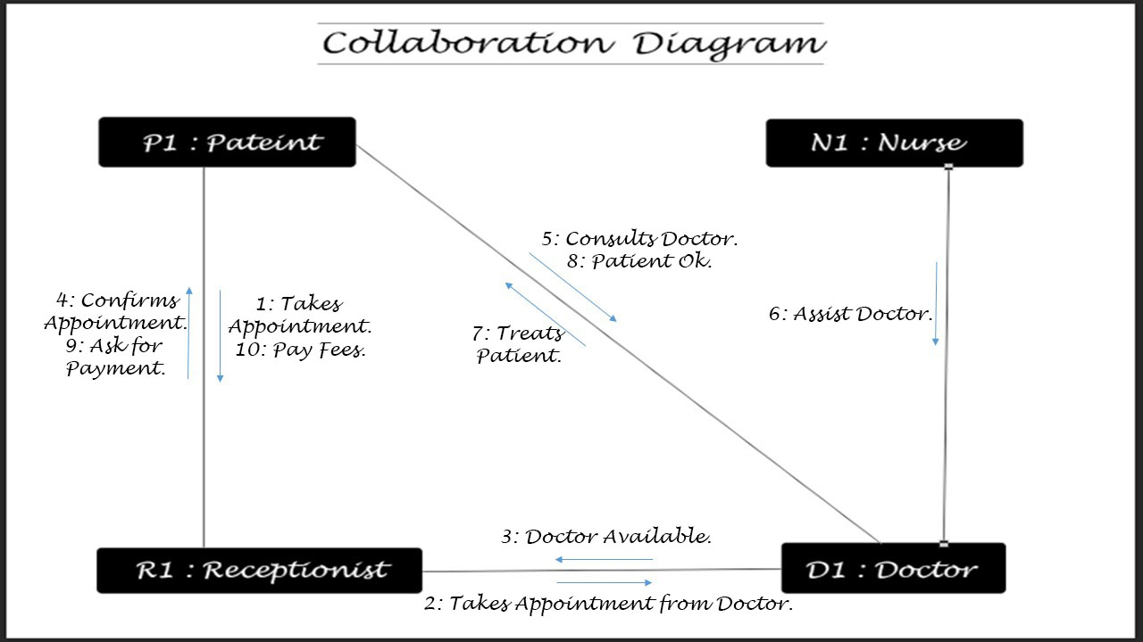
Figure 26: Collaboration Diagram

Other UMLs
None

ERD
Entity Relationship Diagram shows the relations of different entities in our database. Different tables are connected with each other with their foreign keys. The starting sign shows the primary key table and the sign of the key at the other end shows the foreign key containing table.

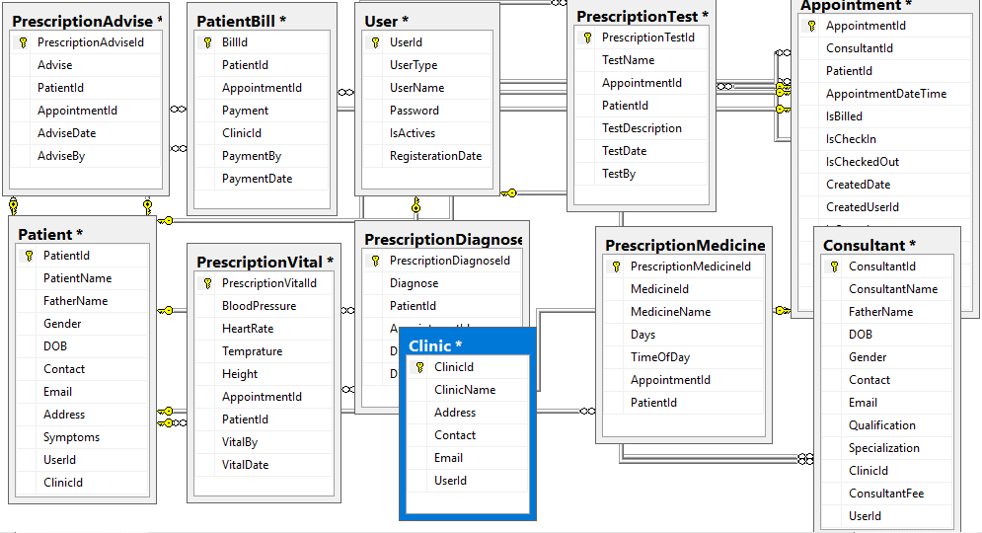
Figure 27: ERD

Data Dictionary

Table 6: Data Dictionary
Element Name | Type | Validation | Mandatory | Remarks
Patient vitals |  | Bill paid  Doctor Login | Bill paid and doctor login through their account | None
Prescription Report |  | Prescription Added | Bill paid and doctor login through their account | None

Implimentation

Development Setup
Tools require for developments:
    - Visual Studio (2012 or 2015)
    - Report Viewer
    - SQL SERVER (2012)
    - ASP.NET
Languages
- C# (.net)
- HTML
- CSS
- JAVASCRIPT
- BOOTSTRAP
Require Services
IIS EXPRESS
SQL BROWSER
Framework
Entity framework (5 or 6)
Procedure
First you need to install all these tools in your operating system. After installation, open new project and run it. If your project doesn’t run successfully then resolve all the issues first. Once your project execute properly, click on extension and updates from tools options. Install entity frame work and restart the project.
After restart, select server explorer and connect the database and test the connection. If you receive any exception then check incoming and outgoing connection and also make sure firewall allows to do so. After this, kindly check SQL services, start automatically from services. Otherwise set on automatic option.
Again open your project and check the connection again. Click on the project, a pop menu will appear. Click on add item. Again a pop menu will appear and click ado.net. After clicking ado.net window will appear having four options. Select second option, if you have a database. Otherwise select any option. If you don’t have a database then go to option 1. Don’t try option 3, if you are new in this technology.
Click on second option. A window will appear. In the above field of the window, name your data source. Then name of your server. Consult with the given image below in case of any issue.
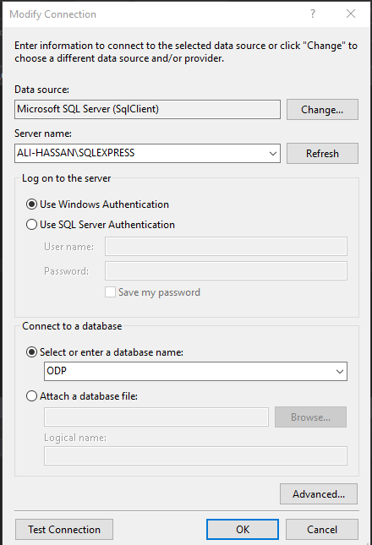
Figure 28

As you can see, in the above picture there are two modes of authentication. Select authentication mode (in case of sql server type username or password). After mode of authentication, name your database. Make sure that database exist.
Once you have done, this makes relations from Tool list, name your relations and map. After mapping, right click and generate code from model, or update your model. ( be careful if you have many to many relationship then each relation should map with other. Otherwise the program throws exceptions and your model couldn’t be updated. Add your business logic in controllers; add database queries in the model.

Deployment Setup
Tools require for developments:
- Visual Studio (2012 or 2015)
- Report Viewer
- SQL SERVER (2012)
- ASP.NET

Require Services
    - IIS EXPRESS
    - SQL BROWSER
Framework
Entity framework (5 or 6)

Procedure
First of all you need to install all the tools in your operating system. Open visual studio; import all the files in your project. Run your project. If your project run successfully then enjoys our services, otherwise check your connection. Make sure all the required services on automatic mode and no connection blocked by firewall.

Algorithms

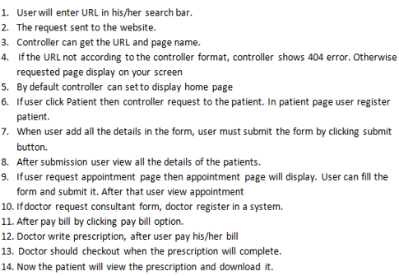

Constraints

Assumption
- All the connections are allowed.
- Database exists.
- Database connected to host.
- Sql server and iis express services are running properly.
- Server configured properly.
- Relation mapped properly.

System Constraints
    - Space on Hard disk > 1 GB
    - RAM > 2 (BETTER PERFORMANCE)
    - WINDOWS 7 (latest version)

Restriction
- Use either window authentication or SQL server authentication.
- Don’t try to mix code with data.
- Data should be valid.

Limitation
PIMS read and write data from local database.

Testing

Extended Test Cases

Test case ID: T-01 |  |  |  | Test Design by: Rahma Ashfaq
Test module name: register user |  |  |  | Test design Date: 31/7/2017
Test priority: high |  |  |  | Test executed by: Rahma Ashfaq
Test title/name: register functionality |  |  |  | Test Executed date: 08/082017
Description: to test patient register correctly
Pre Conditions:
- Already have an account
- Website should access
Description:
Step | Test step | Test data | Expected results |  | Actual results | Status  (pass/fail) | Notes
1 | Request page |  | Page should load with in sec |  | Page load with in sec | Pass
2 | Name field must not blank | Blank field, comments | Submission should not allowed |  | Page generate error field must be filled
3 | Email address | @missing | Display error |  | Display error
4 | password | Blank | Error must display |  | Display error
Post condition: none

Test case ID: T-02 |  |  |  | Test Design by: Ali Hassan
Test module name: book appointment |  |  |  | Test design Date: 31/7/2017
Test priority: high |  |  |  | Test executed by: Rahma Ashfaq
Test title/name: appoint functionality |  |  |  | Test Executed date: 08/082017
Description: to test appointment add successfully
Pre Conditions:
- Patient must be register in a system.
Description:
Step | Test step | Test data | Expected results |  | Actual results | Status  (pass/fail) | Notes
1 | Patient Name | Ali | Name must be display |  | Display Name | Pass
2 | Date | Correct format  Dd/mm/yy | Reject the data and display error |  | Error Display
3 | Description
Post condition: none

Test case ID: T-03 |  |  |  | Test Design by: Usama Nasir
Test module name: verify prescription |  |  |  | Test design Date: 31/7/2017
Test priority: high |  |  |  | Test executed by: Syed Fahad Hassan
Test title/name: prescription |  |  |  | Test Executed date: 08/082017
Description: to test prescription
Pre Conditions:
- User must login in a system.
Description:
Step | Test step | Test data | Expected results |  | Actual results | Status  (pass/fail) | Notes
1 | Patient Name | Ali | Name must be display |  | Display Name | Pass
2 | Hospital name | Ramzan Ali | Data must be in correct and readable |  | Data correct
3 | Format |  | Correct format will display |  | Display correct formatting
Post condition: for view reports user must have PDF

Test case ID: T-04 |  |  |  | Test Design by: Ali Hassan
Test module name: register hospital |  |  |  | Test design Date: 31/7/2017
Test priority: low |  |  |  | Test executed by: Rahma Ashfaq
Test title/name: register functionality |  |  |  | Test Executed date: 08/082017
Description: to test patient register correctly
Pre Conditions:
- Already have an account
- Website should access
Description:
Step | Test step | Test data | Expected results |  | Actual results | Status  (pass/fail) | Notes
1 | Page load |  |  |  |  | Pass
2 | Name field must not blank | Blank field, comments | Submission should not allowed |  | Page generate error field must be filled
3 | Email address | @missing | Display error |  | Display error
4 | Address | Blank | Error must display |  | Display error
Post condition: none

Test case ID: T-05 |  |  |  | Test Design by: Rahma Ashfaq
Test module name: login |  |  |  | Test design Date: 31/7/2017
Test priority: high |  |  |  | Test executed by: Rahma Ashfaq
Test title/name: login functionality |  |  |  | Test Executed date: 08/082017
Description: to test patient register correctly
Pre Conditions:
- Authorize user get access.
- Data must be correct
- Undefined behavior not allowed
Description:
Step | Test step | Test data | Expected results |  | Actual results | Status  (pass/fail) | Notes
1 | Email address | Comments, undefined behavior | User will not allow |  | Invalid email | Pass
2 | password | Blank | Submission should not allowed |  | Password field must not blank
Post condition: none

Test case ID: T-06 |  |  |  | Test Design by: Usama Nasir
Test module name: view appointment |  |  |  | Test design Date: 31/7/2017
Test priority: high |  |  |  | Test executed by: Usama Nasir
Test title/name: view appoint functionality |  |  |  | Test Executed date: 08/082017
Description: to test appointment
Pre Conditions:
- User must have account
Description:
Step | Test step | Test data | Expected results |  | Actual results | Status  (pass/fail) | Notes
1 | Name |  |  |  |  | Pass
2 | DOB |  | Correct format  Dd/mm/yy |  | Display error
3 | Description
Post condition: none

Test case ID: T-07 |  |  |  | Test Design by: Rahma Ashfaq
Test module name: add prescription |  |  |  | Test design Date: 31/7/2017
Test priority: high |  |  |  | Test executed by: Ali Hassan
Test title/name: add appoint functionality |  |  |  | Test Executed date: 08/082017
Description: to test add appointment
Pre Conditions:
- Doctor login
- Amount should be paid
Description:
Step | Test step | Test data | Expected results |  | Actual results | Status  (pass/fail) | Notes
1 | Doctor Login |  | Check authentication |  | Authorize user | Pass
2 | Bill paid approved |  | Bill should be paid by hand |  | Bill paid
Post condition: none

Decisions

Code snippet
Appointment Controller code
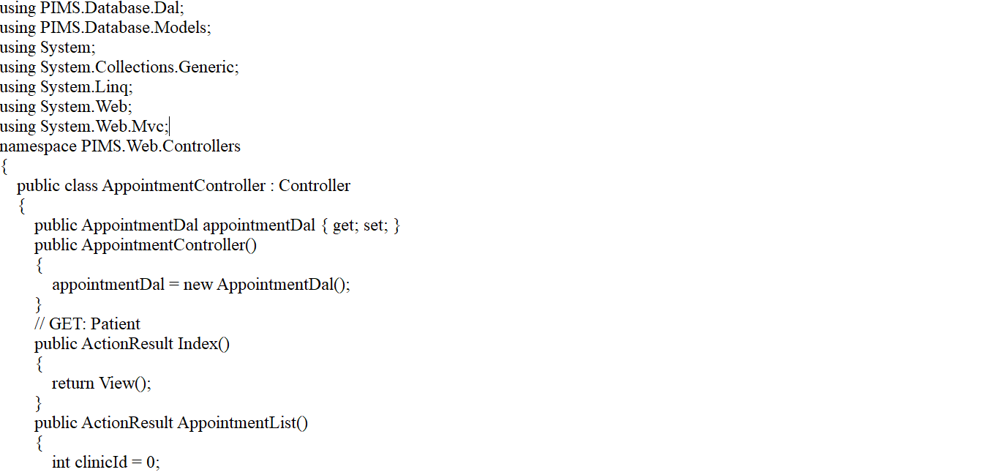
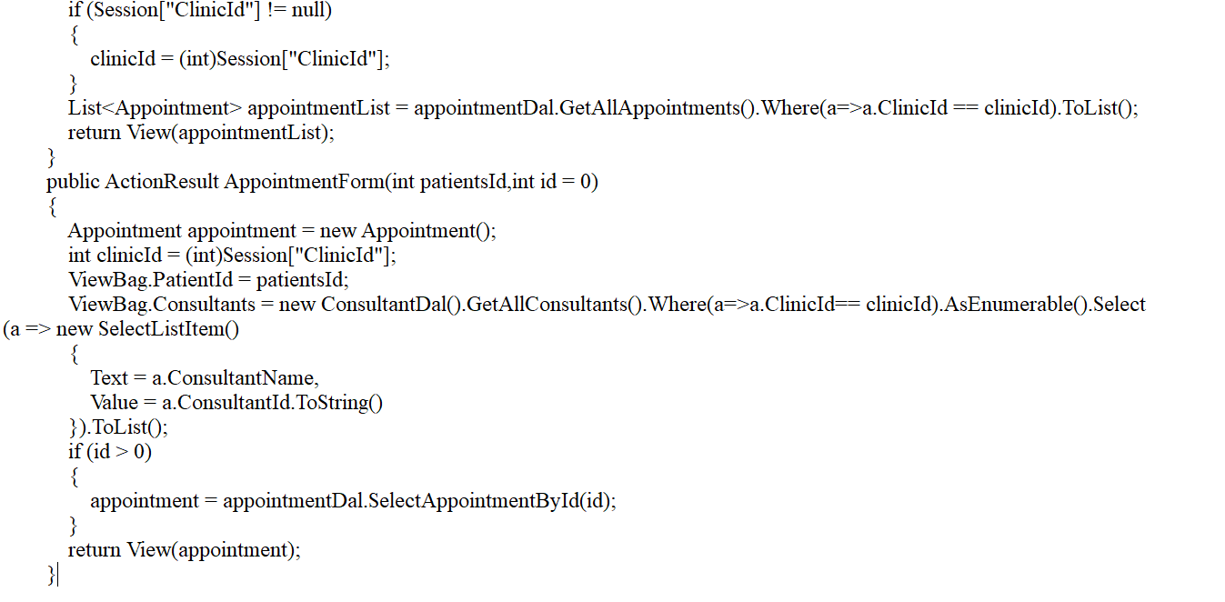

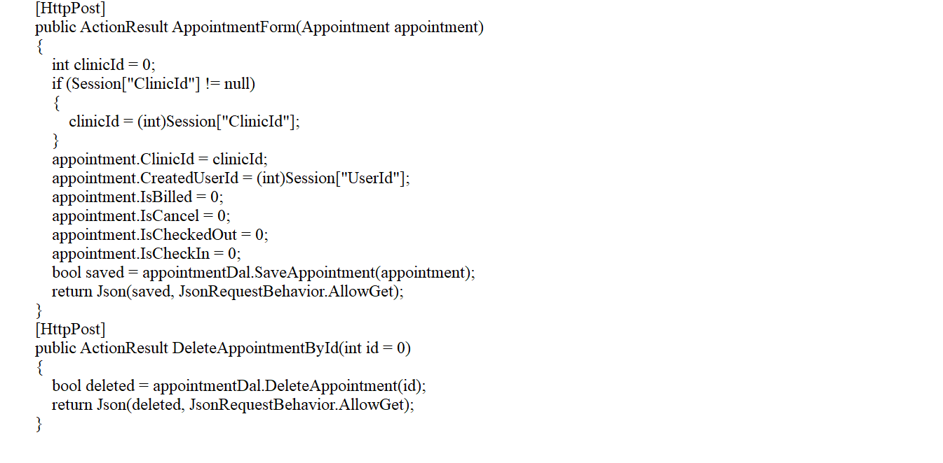
Patient Controller Code
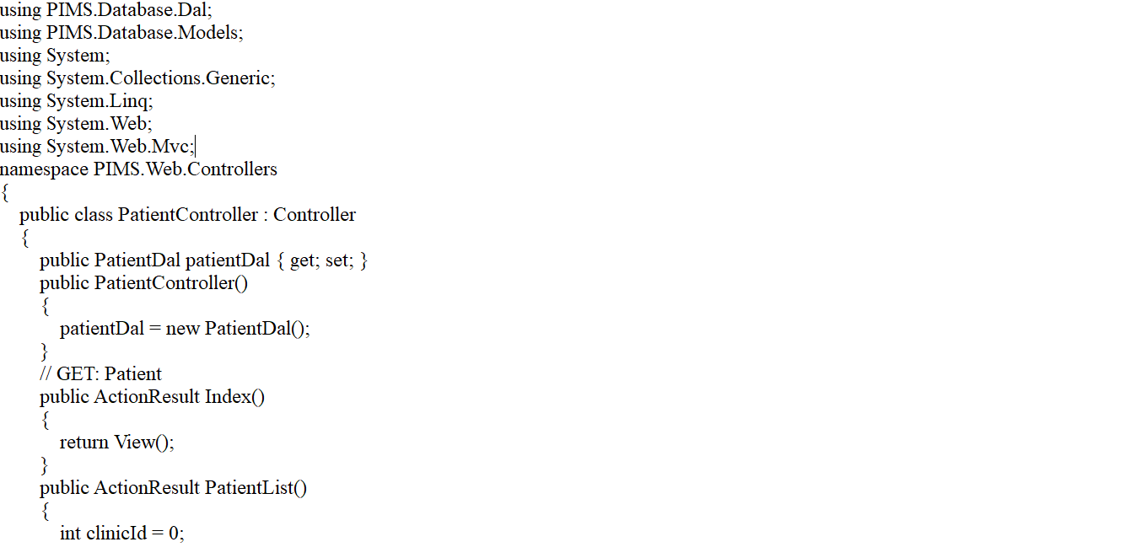
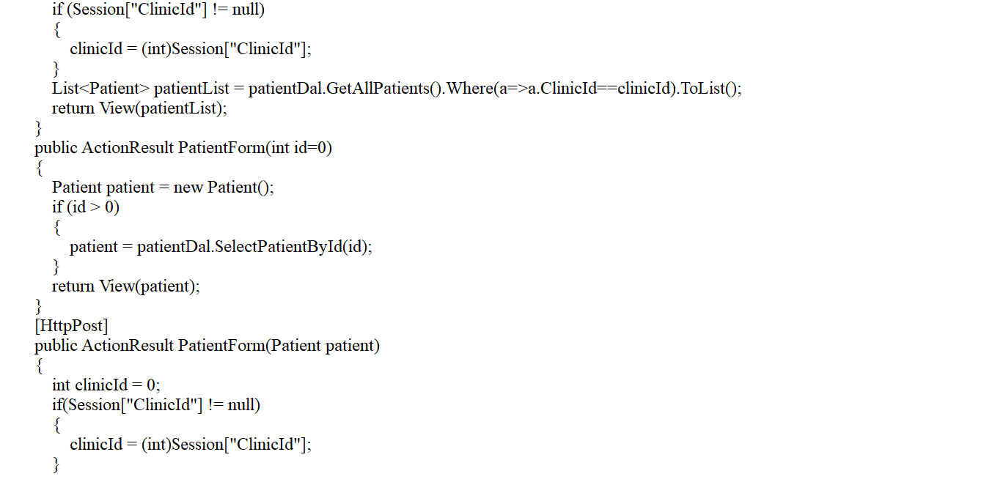
Prescription Controller Code
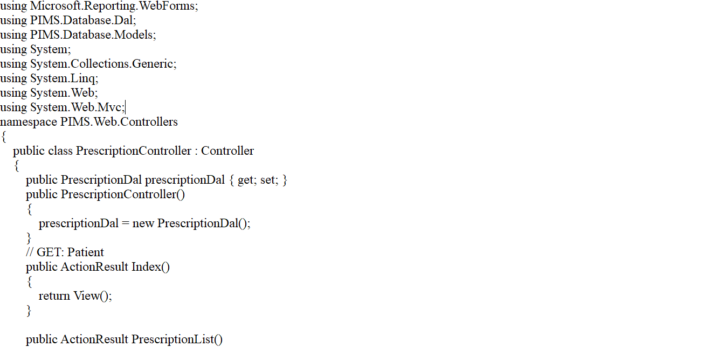
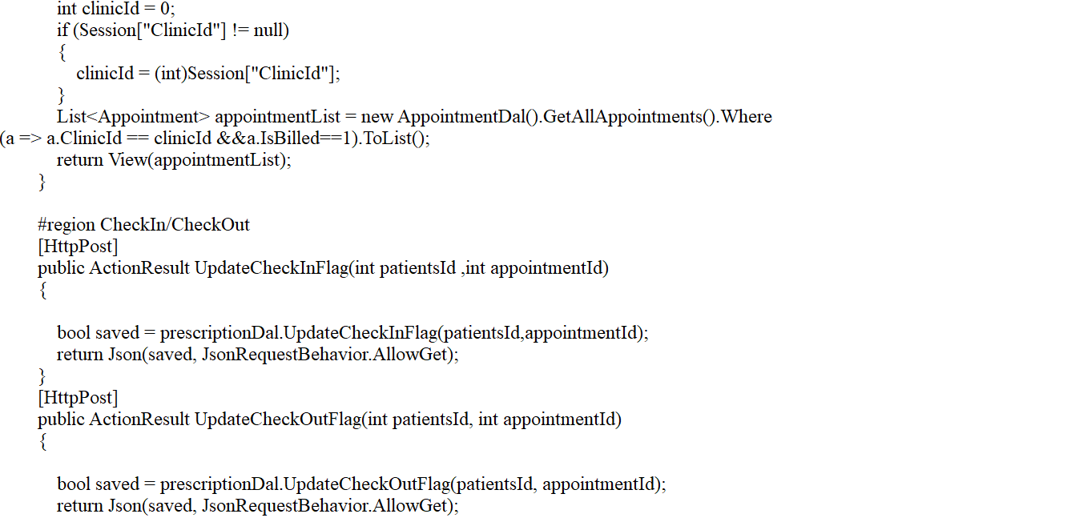
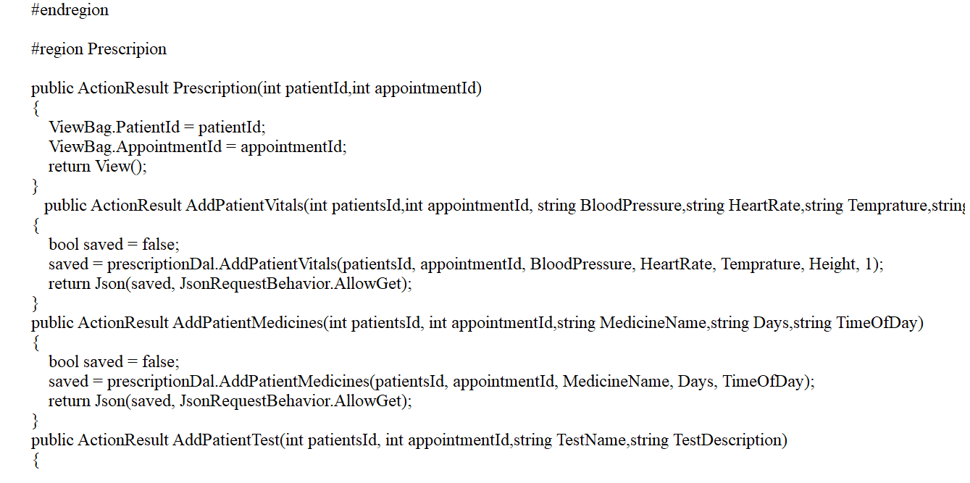
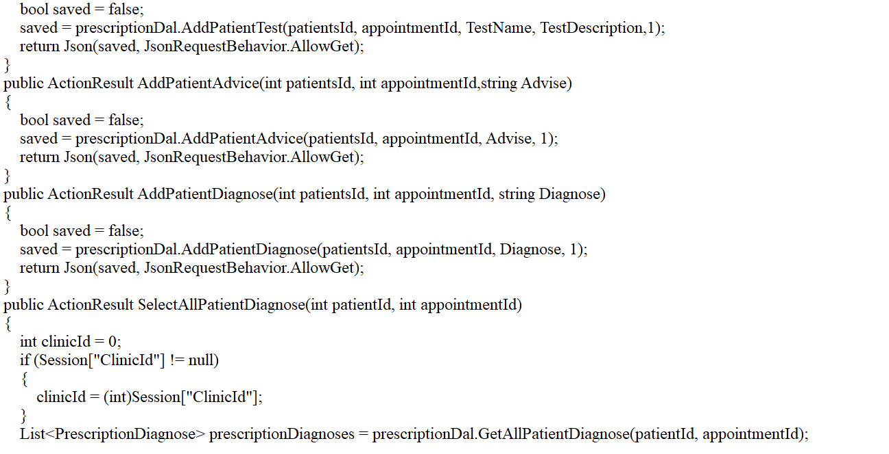
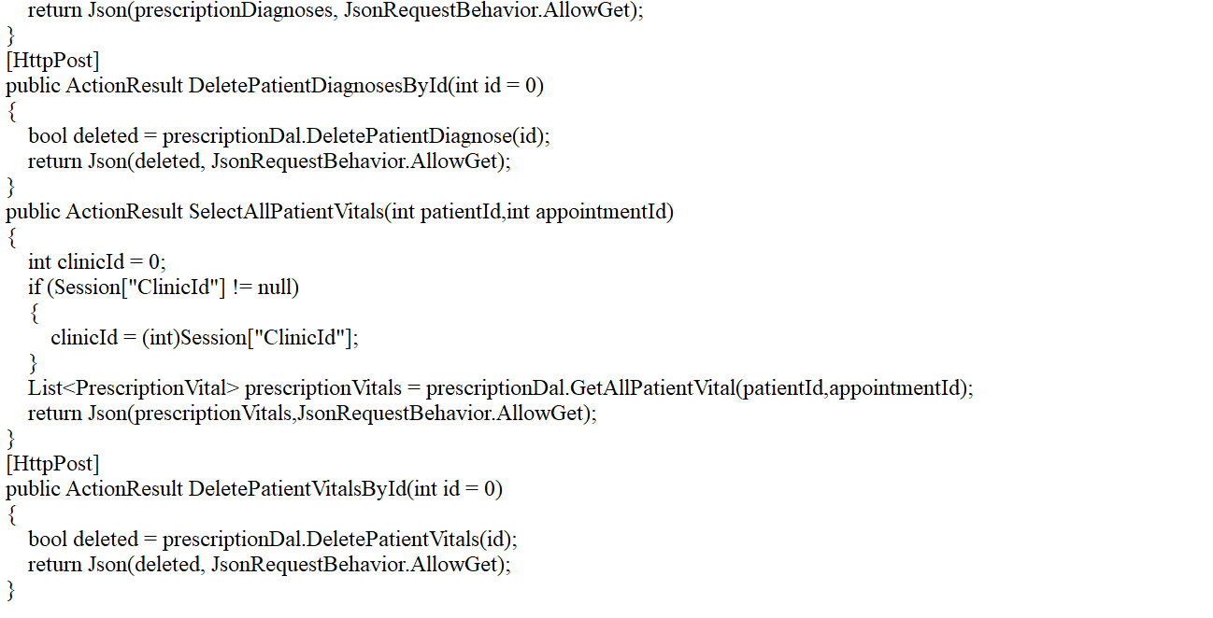
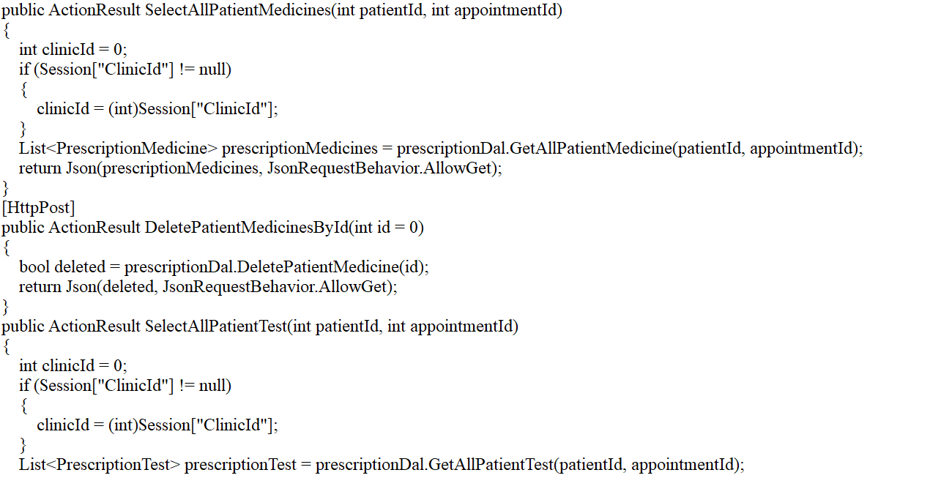

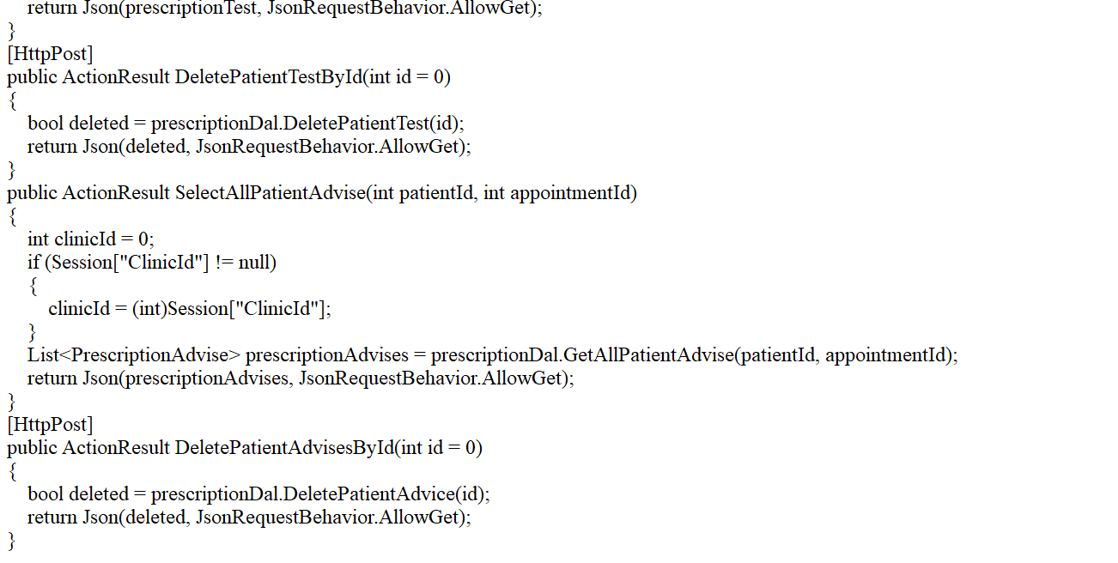

RDLC Report

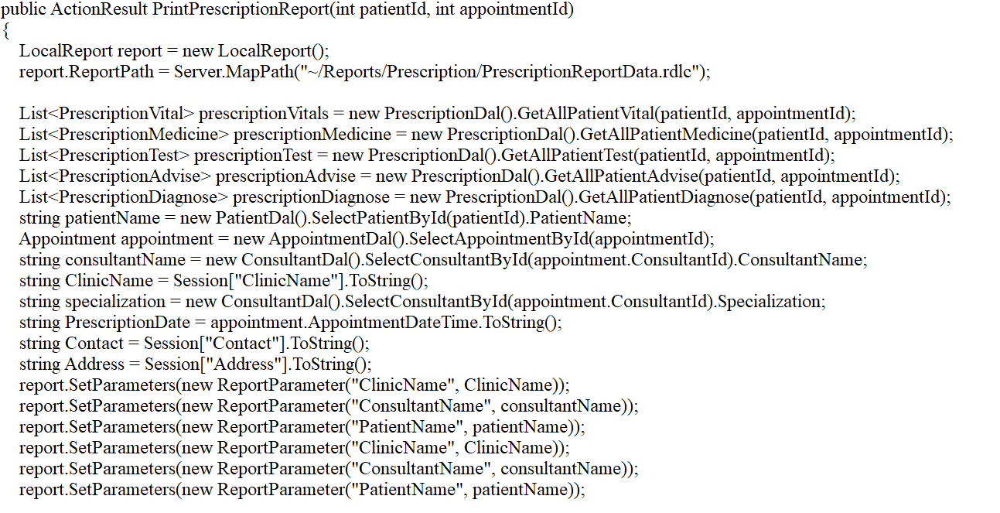
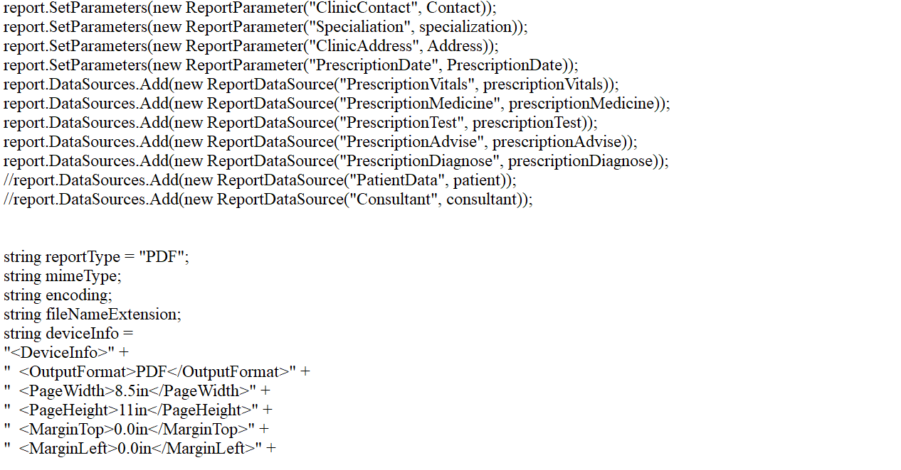

Decision tree coverage
Table 7: Decision tree coverage
This table shows how much conditions fulfilling the system rules.

Conditions | R1.1 | R1.2 | R1.3 | R1.4 | R1.5 | R1.6 | R1.7 | R1.8 | R1.9 | R1.10 | R1.11
Add Hospital | T | F | F | F | F | F | F | F | F | F | F
Medical Records | F | T | F | F | F | T | T | T | T | T | T
Add Patients , | T | F | F | F | F | F | F | F | F | F | F
Add Doctors | T | T | F | F | F | F | F | F | F | F | F
Actions
Book appointment | F | T | T | T | F | F | T | T | T | T | T

Traceability Matrix

RID VS UCID (REQUIREMENT VS USECASES)
Table 8: Requirement VS Use Cases Table
This table shows that how much requirements each use case is fulfilling.
 | R1.1 | R1.2 | R1.3 | R1.4 | R1.5 | R1.6 | R1.7 | R1.8 | R1.9 | R1.10 | R1.11
uc-1 | T | T
uc-2 |  | T |  | T
uc-3 | T |  |  |  |  | T
uc-4 | T |  |  |  |  |  |  |  |  | T | T
uc-5 |  |  |  |  | T |  | T | T | T | T | T
uc-6
uc-7 |  |  | T | T | T |  | T |  |  | T | T
uc-8 |  | T |  |  |  | T | T |  | T |  | T
uc-9 | T |  | T |  |  | T
uc-10
uc-11 |  |  |  | T |  | T |  |  |  |  | T

Prototypes
Table 9: Prototypes
This table shows which prototype is fulfilling which requirement.
 | R.1 | R.2 | R.3 | R.4 | R.5 | R.6 | R.7 | R.8 | R.9 | R.10 | R.11
P.1 | T |  |  |  | T
P.2 |  | T
P.3 |  | T | T
P.4 |  |  |  |  |  |  |  | T
P.5 |  | T |  |  |  |  | T
P.6 |  |  |  |  |  |  |  |  |  |  | T
P.7 |  |  | T
P.8 |  |  |  | T

Test cases
Table 10: Test Cases
In this table each test case is compared to each of our requirement.
 | R1.1 | R1.2 | R1.3 | R1.4 | R1.5 | R1.6 | R1.7 | R1.8 | R1.9 | R1.10 | R1.11
T-1 | T
T-2 |  |  | T
T-3 |  |  |  | T
T-4 | T |  |  |  |  |  | T
T-5 |  |  |  |  |  |  |  |  |  | T
T-6 |  |  | T | T |  |  |  | T
T-7 |  |  |  |  |  |  |  |  |  |  | T

Coverage
Table 11: Coverage
This table shows how much work we’ve done according to our test cases.
 | T1 | T2 | T3 | T4 | T5 | T6 | T7
UC-1 | T
UC-2 |  |  | T
UC-3 |  | T
UC-4 |  |  |  |  | T
UC-5 |  |  |  |  |  |  | T
UC-6
UC-7 |  | T
UC-8 |  |  |  |  |  |  | T
UC-9 |  |  | T
UC-10 |  |  |  |  |  | T
UC-11 |  |  |  | T

Results /output / statistics

% COMPLETION
Completion is calculated according to the use cases that they are fulfilling all the requirements. According to our table we are fulfilling all the requirement so our completion is 100%.

$Completion =\frac{Fullflled Requirements}{Total Requirements} ×$ 100
$Completion =\frac{11}{11} ×$ 100
$Completion =$ 100%

%ACCURACY
We have not compared all the prototypes with our test cases so according to our table and calculations we’ve calculated our accuracy is 63.63%.

$Accuracy =\frac{Total PID }{Tested PID} ×$ 100
$Accuracy =\frac{7}{11} ×$ 100
$Accuracy =$ 63.63%

% CORRECTNESS
Every use case in our project have been tested and given previously in this documentation so we are fulfilling all the tests in the given table so our correctness is 100%.

$Correctness =\frac{Tested Use Cases}{Total Use Cases} ×$ 100
$Correctness =\frac{11}{11} ×$ 100
$Correctness =$ 100%

CONSLUSION
The proposed software product is the Hospital Information Management System (HIMS). The system will be used in any hospital and clinic to get information from the patients and then storing the data for future usage. The current system is in use, is not fully automated. It is too slow and cannot provide updated lists of patients within a reasonable timeframe. The intentions of the system are too reduce over-time pay and increase the number of patients that can be treated accurately. Requirements statements in this product are both functional and non-functional.

FUTURE WORK

Our plan is quite simple regarding PIMS, that we enhance our project scope and add extra functionalities such as app for mobile users, replace local database with central repository and online functionality. We will work on optimize code; improve performance both in time and speed. We also use efficient algorithms that predict patient’s symptoms more precisely.

BIOGRAPHY

BOOKS

Jesse Liberty, ‎Dan Hurwitz “Programming ASP.NET”, Third edition

Jess Chadwick, Todd Snyder, Hrusikesh Panda, “Programming ASP.NET MVC 4”,2012

11.1.2 William Penberthy ,“Developing ASP.NET MVC 4 Web”,2013

JOURNALS

ARTICLES

11.3.0. (Online) Available https://www.asp.net/mvc/overview/getting-started RESECARCH PAPER
11.3.1. (Online) Available https://www.asp.net/mvc
11.3.2. (Online) Available https://www.youtube.com/watch?v=fJux0Ala1g0
11.3.3. (Online) Available https://www.learningtree.com/courses/.../developing-aspnet-mvc-4-web-applications/
11.3.4.(Online) https://www.youtube.com/watch?v=SE9_ZzjsLqs&list=PLyfqmAubyPBTSU7oZu8iLj0ZsLb36cDI3
11.3.5. Online Available https://docs.microsoft.com/en-us/aspnet/core/
11.3.6. Online Available https://msdn.microsoft.com/en-us/library/4w3ex9c2.aspx
11.3.7. Online Available https://www.nuget.org/profiles/aspnet
11.3.8. Online Available https://stackify.com/asp-net-razor-pages-vs-mvc/
11.3.9. Online Available https://www.tutorialspoint.com /Asp.net Mvc/ ASP.NET MVC - Getting Started

OTHERS REFERENCE
[1]. (Online) Available: http://slidesharer.com
[2]. (Online) Available: http://kih.com.pk
[3]. (Online) Available http://www.maxhealthcare.in/

APPENDIX

GLOSSARY OF TERMS
Collaboration : data flow for developers and programmer, in other words how the one class interacts with other class.
Decision tree coverage: a kind of matrix, which is used to analysis system requirements along with certain actions and condition.
Traceability matrix: a kind of matrix, which analysis system requirements, user cases and test cases.

PRE REQUISTIES
- Web knowledge
- Web technologies
- Web architecture, specially MVC
- C# Programming
- Object relational model
- OOP
- .net (c#)
- RDLC Reports

