Final Year Project Report
Project Name


Project Advisor:
- Professor Amjad Hussain Zahid

Submitted By:
- Syed Adeel Haider Kazmi
101620128

- Muhammad Rehan Afzal
13022020122

- Rana Gohar Ghaffar
13021020035
Session
2017

University of Management and Technology
C-II Johar Town Lahore Pakistan

Dedication
We would like to dedicate this project to our parents who have taught us in this great learning environment. Also we would like to dedicate to our teachers who helped us to complete this project. They always try to deliver the best. They advised us to make this project more helpful and more robust so that any organization can easily understand and can easily install into their organization.

Final Approval

Panel of Examiners

- Head of Department ______________________
Department of Computer Science
UMT Lahore

- Program Director ( Final Year Projects) ______________________
Department of Computer Science
UMT Lahore

- Supervisor ______________________
Department of Computer Science
UMT Lahore

- Co-Supervisor ______________________

Acknowledgment

Our deepest gratitude goes to ALLAH ALMIGHTY who has provided everything that was needed to complete this project. Throughout this entire time He (SWT) took care of everything and strengthens us even in my most difficult times. We appreciate the Rector of this great institution Dr. Muhammad Aslam of University of Management and Technology, A very kind and beautiful personality of the university and he is trying to raise this university. He is struggling and providing the best ways to gain the knowledge in this peaceful environment where I have been trained.
We also appreciate the Director Mr. Abid H K Shirwani. Who has shown exemplary leadership. We appreciate the Dean of SST (School of Systems and Technology) Dr. Shaukat Iqbal.
We also appreciate Dr. Yasir Daniyal Chairperson of Dept. of computer science. Also we appreciate Dr Adnan Shehzada ( Director of Final year projects). Also we appreciate Dr Muhammad Masroor Ahmed (Director of Final year projects).
We really appreciate our advisor Mr. Amjad Hussain Zahid who really spent his time and advised us to make this project. We learnt from him many things during developing this project. Our sincere appreciation also goes to our supervisor and Co-supervisor and other teachers. Thank you so much for your struggles and for your time.
Our utmost regard also goes to our parents, who carefully laid the foundation for our education giving it all it takes.

Project Title
Tourisma

Objective
The system is Android Mobile Application which helps tourist/visitor to explore famous and historical places and cities of pakistan and view latest travels and events.

Undertaken by
Professor Amjad Hussain Zahid
Supervised by
Professor Amjad Hussain Zahid

Starting Date
13-June-2017
Completion Date
10-Feb-2018

Tools Used
Android Studio, XML, Java, SDK, HTML, CSS, Php MySQL

Operating System

Android Operating System, Windows 7, 8, 10

Documentation

Microsoft Word, www.draw.io

Plagairism Report
Abstract

Tourist and Visitors are very important for the country they come to explore different beautiful hill stations and historical places of any country. As we know when tourists and visitors come to a new place they don’t know where to go and where are the places to explore. It is difficult to ask the people about the places because some of the people know about the place but some don’t know about them. Some tourist guiders takes money from the tourists and visitors in order to visit the places.
The purpose of this project is to develop an application for the tourist which reduce difficulties in exploring places. In this application we add an information of different tourist places like northern areas of Pakistan and different historical places of Pakistan. This application also includes the information of parks, restaurants, hotels and travel companies. A tourist can find it’s location through GPS and can find different nearby places like restaurants, parks, hotels and events. Tourist can also give feedback about the places he visited and travel company tour packages.

The main advantage of Tourisma system are:
- It is free.
- It can save time of users.
- It can save extra money of users.
- The tourist will able to know the exact place where he/she wants to go.

Major features of Tourisma:

- GPS system.
- View locations in Map.
- Zoom in and Zoom out the map.
- Check nearby events and places.
- Check hotels and hotels details and fare.
- Give Feedback about the places.
- Check travel packages of travel companies.
- Offline View.

Revision Chart

Version | Primary Author(s) | Description of Version | Date Completed
Draft | Adeel, Goher | Initial draft created for distribution and review comments | 10/10/17
Preliminary | Goher, Rehan | Second draft incorporating initial review comments, distributed for final review | 11/1/18
Final | Rehan, Adeel | First complete draft, which is placed under change control | 12/2/18

Contents
Contents 1
Definitions and Acronyms 3
List of Figures 4
List of Tables 5
1. Introduction 6
1.1 Motivations 6
1.2 Project Overview 6
1.3 Problem Statement 7
1.4 Objectives 7
2. Domain Analysis 9
2.1 Customer 9
2.2 Stakeholders 9
2.3 Affected Groups with social or economic impact 10
2.4 Dependencies/ External Systems 10
2.5 Reference Documents 10
2.5.1 Related Projects 10
2.5.2 Feature Comparison 10
3. Requirements analysis 12
3.1 Requirements 12
3.2 12
li 12
3.2 List of Actors 15
3.3 List of use cases 15
3.4 System use case diagram 22
3.5 Extended use cases 24
3.6 User interfaces (mock screens) 38
4. Data flow diagram (optional) 42
4.1 Data Flow Diagram Level 0 42
4.2 Data Flow Diagram Level 1 43
4.3 Data Flow Diagram Level 2 45
5. System Design 46
5.1 System Architecture Diagram 46
5.2 Class Diagram 48
5.3 Collaboration Diagrams 51
5.4 Other UMLs 52
5.5 ERD 52
5.6 Data Dictionary 52
6. Implementation details 55
6.1 Development Setup 55
6.2 Deployment setup 55
6.3 Algorithms 55
6.4 Constraints 55
6.4.1 Assumptions 55
6.4.2 System constraints 56
6.4.3 Restrictions 56
6.4.4 Limitations 56
7. Testing 57
7.1 Extended Test Cases 57
7.2 Decision Table 63
7.2.1 Code snippet 63
7.2.2 Decision coverage table 63
7.3 Traceability Matrix 64
7.3.1 RID vs UCID (requirements vs use cases) 64
7.3.2 Prototypes (RID vs PID) 65
7.3.3 Test Cases (RID vs TID) 65
7.3.4 Coverage (UCID vs TID) 65
8. Results/Output/Statistics 66
8.1 %completion 66
8.2 %accuracy 66
8.3 %correctness 66
9. Conclusion 67
10. Future work 68
11. Bibliography 69
11.1 Books 69
11.2 Journals 69
11.3 Articles 69
11.4 Research papers 69
11.5 Other References 69
12. Appendix 70
12.1 Glossary of terms 70
12.2 Pre-requisites 70

Definitions and Acronyms
Acronym | Definition
UMT | University of Management and Technology
POS | Point of Sale

List of Figures

Figure 1: Front End……………………………………………………………………..…12
Figure 2: GUI………….…………………………………………………………………..13
Figure 3: Admin Panel……...……………………………………………………………..14
Figure 4: Admin Use case...…………...…………………………………………………..22
Figure 5: User Use case……….…………………………………………………………..23
Figure 6: Travel Agent Use case…………………………………………………………..24
Figure 7: Login Area…………………………………………………………………...….26
Figure 8: Manage Users……………………………………………………………………27
Figure 9: Manage Places…………………………………………………………………...29
Figure 10: Manage Cities…………………………………………………………………..30
Figure 11: Manage Events…………………………………………………………………31
Figure 12: Manage Hotels………………………………………………………………….33
Figure 13: Manage Restaurants……………………………………………………………34
Figure 14: Manage Travel Company………………………………………………………35
Figure 15: Manage Travel Company Package………………………………….…………37
Figure 16: User Interface……………………………………………….………………….38
Figure 17: Login Page……………………………………………….………………….…38
Figure 18: Main Interface……………………………………………………………….…39
Figure 19: View Place………………………………………………………………..……39
Figure 20: View Places in Cities………………………………………………..…………40
Figure 21: DFD Level 0……………………………………………………………………42
Figure 22: Admin DFD Level 1……………………………………………………………43
Figure 23: User DFD Level 1………………………………………………………………44
Figure 24: DFD Level 2……………………………………………………………………45
Figure 25: System Architecture……………………………………………………………46
Figure 26: Class Diagram……………………………………………………………….…48
Figure 27: Admin Sequence Diagram…………………………………………………..…49
Figure 28: User Sequence Diagram……………………………..…………………………50
Figure 29: Admin Collaboration Diagram…………………………………………………51
Figure 30: User Collaboration Diagram……………………………………………………51
Figure 31: Admin ERD Diagram……………………......………………………………....52
Figure 32: User ERD Diagram………………………………………...………….………..53

List of Tables
Table 1: List of Stakeholders 9
Table 2: Feature Comparison 10
Table 3: Login …………………………………………………………………………………….25
Table 4: Manage User (Add, Update, Delete)…………………………………………………….26
Table 5: Manage Places (Add, Update, Delete)………………………………………………… 28
Table 6: Manage City (Add, Update, Delete)…………………………………………………….29
Table 7: Manage Events (Add, Update, Delete)………………………………………………….30
Table 8: Manage Hotels (Add, Update, Delete)………………………………………………….32
Table 9: Manage Restaurants (Add, Update, Delete)…………………………………………….33
Table 10: Manage Travel Company (Add, Update, Delete)……………………………………...34
Table 11: Manage Travel Company Packages (Add, Update, Delete)…………………………...36
Table 12: Test Case (Admin Login Button)………………………………………………………57
Table 13: Test Case (Add new City)……………………………………………………………..58
Table 14: Test Case (Add new Place)…………………………………………………………….59
Table 15: Test Case (Add new Place Type)……………………………………………………....60
Table 16: Test Case (User Login Button)…………………………………………………………61
Table 17: Test Case (Travel Company Login)…………………………………………………….62

Introduction
Tourisma is a Tourist guide Application. Tourisma provides guidance and help visitors and tourist to explore places like Historical places, Restaurants, Travel companies, Hotels, Travel Packages of different travel companies and Northern areas of Pakistan. As we know tourists and visitors don’t know about the places of the city to visit so this application will help them to know about the places. The GPS system will provide the information where he/she is now. It also tells the nearby places like Banks, ATMs, Parks, Hotels and other places. This application also tells about the Events which are organizing in different cities Events like Food Festival, Musical Events, and Mehfil-e-Ghazal etc. If someone is going to other part of the city like Township Lahore so the user will get the notification about the event which is occurring in the township. Admin can also add the event by getting the information through an event organizer company. User will get the notification when an event is taking place at certain place. There will be a separate login for tourist companies who will update their tourist packages on the application that will help the tourists for their trips. The package includes Description of the Tour, Available Seats, Hotel Name, Duration of the Tour, Package type (Family Package or Normal Package) and Fees of the Tour.

Tourisma also provides the information of the places like open and closing timing of Parks and Restaurants. User can also search the places and view galleries of the places. User can also get directions through map by entering the place name where he/she starts and also enters the destination place name the map will show the direction. Users can also give the feedback about the place which he visited.

Motivations

Internet and smart phones are in access of every person now a day’s majority of people in our country are familiar with use of internet and smart phones. Millions of mobile based and web based applications are providing services to people. Tourist guide applications are providing services in many countries but in Pakistan we have no such application which provide GPS location to users using mobile phone and internet. This thing motivates us for tourist guide application system.

Project Overview

Tourisma (Tourist guide Application System)

When there was no tourist guide application system people had to ask about their destination from other people and they had to face so many difficulties. When tourist had to visit tourist sites they had to face so many problems like finding a hotel, they were not aware of the hotel packages.
This tourist guide application is a totally mobile based internet application offering benefits to its users in finding their destinations, nearby events, restaurants etc. And for the sake of tourists a separate login for tourists companies is also added so they can update their packages for tourists. So the tourists can know about the fare of the package and their location. It also offers the power of decision making to customers to choose their suitable package. The basic components of tourist guide application are that it provides service to the tourist companies and customers consist of the following.
- Capture of customer information such as name, address, phone number and e-mail address.
- Location based service.
- Search.
- Packages of different hotels.
- Restaurants of their choice.
- Feedback session.

Problem Statement

When there was no tourist guide application system people had to ask about their destination from other people and they had to face so many difficulties. When tourist had to visit tourist sites they had to face so many problems like finding a hotel, they were not aware of the hotel packages. During holidays there is a large number of people who have to travel different tourist sites and many tourist are not able to find rooms in hotels. Through this application we will provide a separate login for the tourist companies who deal with different hotels and they will update their hotel packages and though this tourist will be able to find different hotels.

Objectives
This tourist guide application is a totally mobile based internet application offering benefits to its users

- In finding their destinations, nearby events, restaurants etc.

- And for the sake of tourists a separate login for tourists companies is also added so they can update their packages for tourists

- Tourists will able to know about the hotels and their rates

- It also offers the power of decision making to customers to choose their suitable package for travel.

- The basic components of tourist guide application are that it provides service to the tourist companies and customers consist of the following.

- Capturing customer information such as name, address, phone number and e-mail address.
- GPS system.
- Search.
- Packages of different hotels.
- Restaurants of their choice.
- Feedback of users about the place.

Domain Analysis

Customer
There are no customer of our system, because this system is not for sale.

Stakeholders
Below are the stakeholders of our system, who will use the system and who are actually involved in the whole system.
Table 1: List of Stake Holder
Stakeholder | Role in System
Travel Companies  Admin  Tourists and Visitors  Developers | The 3rd stake holder of the system is Travel Company. The travel companies will use this system to facilitate the tourist and visitors by updating the travel packages. They login into the system and give travel packages to the admin and admin approves the packages. The tourist or visitors view these travels and if they like travel plans they will contact or book to the travel company. These companies will able to generate the revenue through this system.  The 1st stakeholder of the system is Admin of the System. Admin will maintain the whole system. For example they have complete rights to operate the whole system. They will maintain and update the user records. For example they have rights to add or delete a user or registered travel company. They have rights to maintain and update the front end of the system. They are responsible to maintain the records; they are responsible if the admin make changes into the system for example if they update the sections, the same record shown to the user’s panel when they login into their system.  The 2nd stakeholder of the system are tourists and visitors. They login into the system where they see their current location through GPs, they also view different cities of Pakistan, and they can view different historical places, restaurants, events, hotels, places, travel companies and book travel package of their choice.  The 4th stakeholder of the system are developers which maintain the backend of the system in future. They also interact with the system after some time.

Affected Groups with social or economic impact

- Travel Companies: Travel companies which use this system in order to facilitate their customers (Tourist or Visitors). Participants will check the travel plan and fares through this system and if they like the tour they will contact to travel companies or book the Package.

- Tourist or Visitors: Tourist or Visitors use this system to view travels, places, search places, events and give feedback.

- Owners: Group of person work for this system in order to facilitate and provide better service for the user of this system will also effect with the up downs. Our main aim will be to attract more visitors or tourists toward the system and generate a better revenue.

Dependencies/ External Systems
- Database on Server.

Reference Documents
Provide references to all documents that have been consulted during the analysis phase.

Related Projects

- Pocket Guide App (pocketguideapp.com)
- Tourpal (tourpal.com)
- Tourbylocals.com (tourbylocals.com)
- World guide app.

Feature Comparison
This table shows us the comparison of the system with our system that we discussed earlier. We can see here the remarks also that shows the comparison.
Table 2: Feature Comparison
Serial No. | Comparison Feature | Pocket Guide app | Tour pal | World Guide App | remarks
1 | Tourisma | It provides location through GPS and shows nearby areas | Tour pal provides all the functionalities like tourist guide app and also provides international travel pkgs. | It provides international places like cities. | Our system is same like them they provide international packages and our system provides local areas with in the country.

Requirements analysis

Requirements
Remembering the true objective to better understand the method for our application and work we have sorted down the helpful and no valuable essentials of our project. As it is Final Year project its essential utilitarian requirements and nonfunctional requirements are particularly characterize.

Functional Requirements
Utilitarian necessities are regularly the components of the application which are typical by the users to be accessible to meet the specific and assigned functionalities. Our project has the following utilitarian prerequisites.
- Front End & Features
- GUI
- User

Front End Features
Since our project is web and android based. The content which is seen by user on the front is basically front end feature and it is developed in Android. The graphic user interface of the portal needs to work as the users expect. The portal highlights the best features and front end functionalities with an appropriate plan and design.
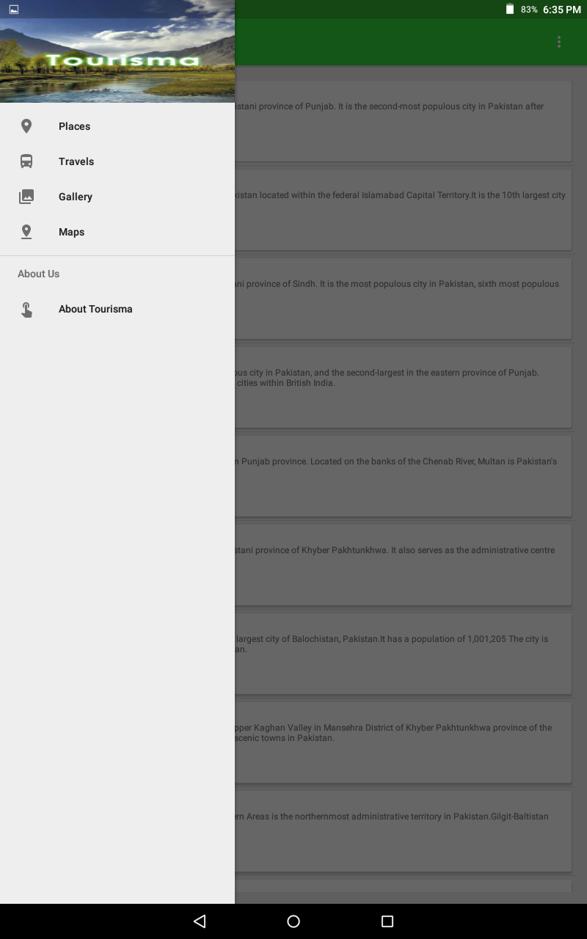
Figure 1: Front End
The above image is the main interface of the user’s end where user of the system can see all the main information. This main interface will be shown after when user login into the system. The sidebar of the interface shows the places like cities of the system, Travels in which approved travel packages will be shown to the user. Gallery in which user can see different images of the cities, historical places, hill stations, hotels, restaurants etc. Map will show the Current location of the user where user is standing.

GUI
All of the buttons and hyperlinks are accordingly set with the database of the application. Front end features comprise the whole header, footer side bars with all categories and options.
The front end functionalities allow the users to see the latest updates. He can touch places on the sidebar of the app, after touching the place he will able to see the list of different cities. After touching the particular city the user will enter into that city where he can see a brief description of that city. There is a button at the end of the description, user click on that button he will enter the city where he can see Hotels, Parks, Historical Places if any, Restaurants, Travel Companies and Events. The Frontend of the user is developed in Java and XML and some PNG images.
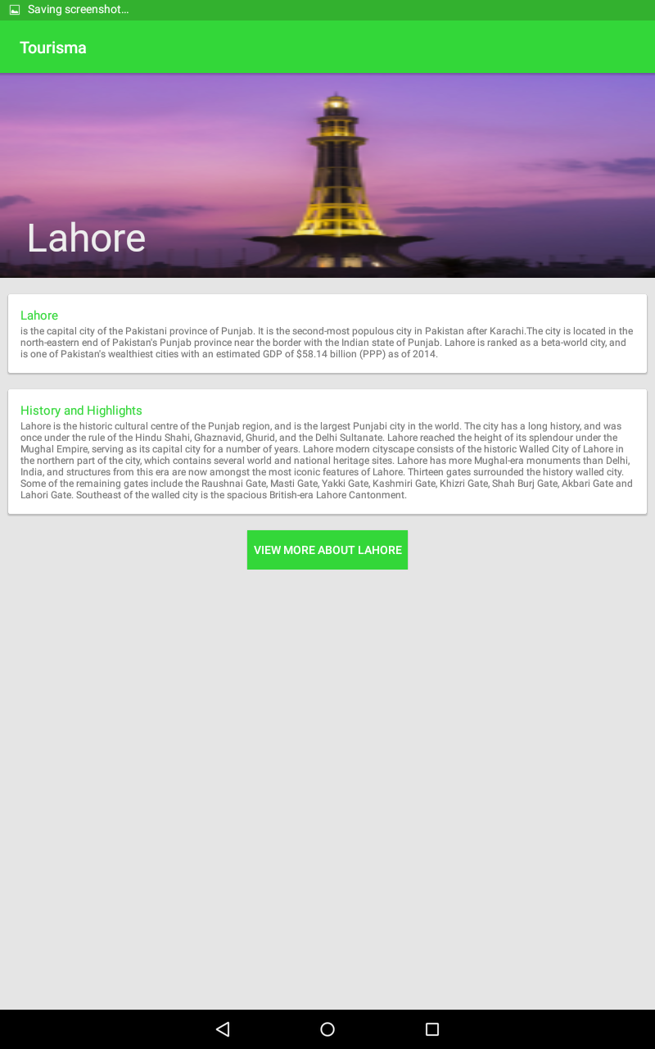
Figure 2: GUI
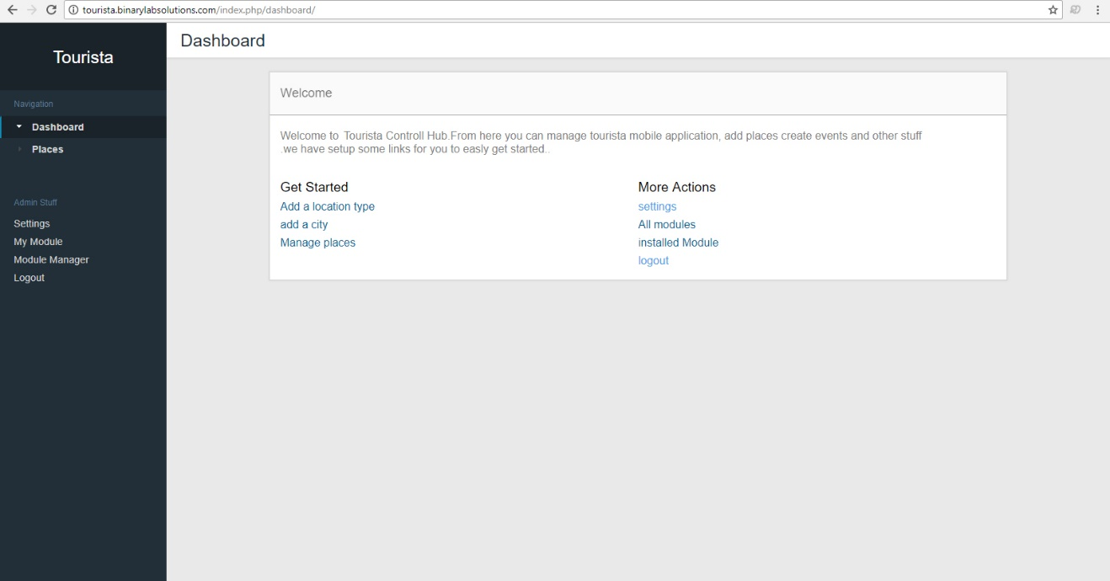
Figure 3: Admin Panel
The Admin will add, update, delete the users, manages places, manage events, manage parks, manage historical places, manage travel companies and travel packages. Manage records in database.

Users
The portal has the functionality to add, update and delete the users. Admin has rights to view the details of users, his feedback about the places and he can also update the user records. When admin adds a new user, user will have its own unique username and password. The same is like with the travel companies. Tourist will view all the given information about the places which he like and can also book a travel package of their choice.

Non Functional Requirements
Our System will be available 24hours. It will provide all the functionalities that we have implemented in our project. The admin or owner can easily access the system without any limitations. We have made this system more secured. If the admin add a new user so only the user knows his credential login and password. He can also change his login id and password via a secure link. So he can also access the system 24 hours.

Maintainability
The admin of the system will maintain and manage the application on time. When admin wants to add a new city he will add a new city and he will add all the city places like restaurants, hotels, travel companies, parks and events.

Error Handling
Routinely servers of destinations tend to trip due to basic exercises. This application has been made with basic square of JAVA codes and XML which we have written in essential and negligible way so the programs can read them without a lot of an extend and the reaction time of the site has a tendency to be useful for the users. All the data is coming from the database. The admin panel of the application is made in website using HTML, CSS and it is device friendly.

Accessibility
To access this system user must have an android operating system. If admin wants to access the system admin must have a PC or Smart phone. The most important thing to know is that both have internet access otherwise system will not perform well and user will not able to see updated information.

List of Actors

3.2.1 Travel Companies
Travel companies are the actors which logins into the system and provide the information of travels and different packages of travels.

3.2.2 Admin
Admin will login into the system through admin rights and admin can add, delete or updates the users, places, events, travels and feedbacks.

Tourists or Visitors
They are the users, they login into the system with username and password. They will able to see places, restaurants, parks, events and travels. They have right to give feedback about the places which they visited. They can also give their feedbacks about the travel company.

List of use cases

Use case name: User Registration

- Description: This use case describe the scenario where the user registers with the application by providing all necessary information or details, in order to view places, check information, check events, add events, view travels, search for places and give feedbacks.

- Actor: Tourists or the Visitors.

- Input: The tourist or visitor will have to provide all necessary information or details present in the user registration form of the application.

- Output: All the information or details entered in the user registration page will be verified, Accepted by the system into the database.

Use Case name: User Login

• Description: This use case describes the scenario where the user logs into the Application, with the username and password he has provided while registering with the system.
• Actor: Tourist or the Visitors.
• Input: The tourist or visitor creates a username and password at the time of registering with the system. He then uses them to login to the system and can view places, view travels, view travel companies, view galleries, search places, add an event, check events and give feedback.
• Output: The application then verifies the authenticity of the username and password that the customer has provided and allows the user to view the information available on the system, if the username and password are valid.

Use Case name: View Map

• Description: This use case shows the map of the city which user enters and check the areas, attractions and events in the city of user choice.
• Actor: Tourist or the Visitors.
• Input: The user will enter the city name of his/her choice and system will show the map on the interface, the map can be a satellite view or a street view.
• Output: The application then shows the map to the user if the user enters the valid city name. The system will check the information through the database and show the map.

Use case name: Check Location

• Description: This use case check and shows the location of the user through GPS system and inform the user that where he is locating on map.
• Actor: Tourist or the Visitors.
• Input: The user will turn on the GPS function of the application.
• Output: The application then shows the map to the user and location of the user, that where he/she is locating on the map in order to check the nearest attractions and events.

Use case name: View Places

• Description: This use case helps users to view places like Hotels, Restaurants, Parks, Travel Companies, Hospitals, Banks and any other place of the city.
• Actor: Tourist or the Visitors.
• Input: The user will enter the place name of his/her choice to view the place and its location.
• Output: The application then shows the map to the user if the user enters the valid place name. The system will check the information through the database and show the place on the map.

Use case name: Search Places

• Description: This use case search the place for the user which he enters in the system, the system will show these places and display them on the interface.
• Actor: Tourist or the Visitors.
• Input: The user will enter the place name of his/her choice and system will show the map on the interface, the map can be a satellite view or a street view.
• Output: The application then shows the map to the user if the user enters the valid place name. The system will check the information through the database and show the map.

Use case name: Get Information

• Description: This use case shows the information of the places like timings, fares of a restaurants, parks, hotels and events.
• Actor: Tourist or the Visitors.
• Input: The user will enter the place name of his/her choice and check the information of that particular place.
• Output: The application then shows the information to the user if the user enters the valid place name. The system will check the information through the database and show the information to the user.

Use case name: Give Feedback

• Description: This use case allow the users to give feedback about the places which they visited.

• Actor: Tourist or the Visitors.
• Input: The user will enter the feedback of the places.
• Output: The application then shows the feedback of that user to other users which are using this application and they will able to know about the place through feedbacks.

Use case name: View Travel Companies

• Description: This use case shows the travel companies like air companies, bus companies and train companies.
• Actor: Tourist or the Visitors.
• Input: The user will enter the travel company name of his/her choice and system will show that company on the map and as well as its website.
• Output: The application then shows travel companies on the map as well as the fare of these companies and updated routes.

Use case name: view Galleries

• Description: This use case shows the image galleries of the city, parks, restaurants, and hotels, attractive and historical places.
• Actor: Tourist or the Visitors.
• Input: The user will open the Gallery to view the images.
• Output: The application will display the image on the interface the images are stored in database of the system.

Use case name: view Events

• Description: This use case shows the Events Information which are happening in different cities.
• Actor: Tourist or the Visitors.
• Input: The user will get information of events like Food Festivals, Music Concerts etc.
• Output: The application will display the information on the interface that are stored in database of the system.

Use case name: Book Travel Companies Packages

• Description: This use case shows the travel companies Tour packages.
• Actor: Tourist or the Visitors.
• Input: The user will came to know the different packages of the different travel companies, user will direct connect with travel agent through email and number which travel agent has provided. User can also give its feedback about the travel package.
• Output: The application then shows travel companies packages description, fees of package, Hotel name, Available seats, Travel type (normal or family) and Duration of Tour.

Use case name: Login (Admin)

• Description: This use case is for admin, admin logins into the system with administration rights where admin update, delete or add user and user information as well as change the settings or add new features to the application.
• Actor: Administrator
• Input: The administrator of the applications logs onto the system with his/her username and password.
• Output: The application authenticates the administrator, and then displays the page where the administrator can add new users to the database, or delete existing users or modify details of users in the database.

Use case name: Accept/Reject Travel Company Package

• Description: This use case is for admin, admin logins into the system with administration rights where admin update, delete or add the travels. If Travel Company launch a new travel then admin will add travel, if company change travel the admin will update that travel and if travel is delete or cancel by the company the admin will delete that travel.
• Actor: Administrator
• Input: The administrator of the applications logs onto the system with his/her username and password.
• Output: The application authenticates the administrator, and then displays the updated travels list to the users. The updated travel will store on database of the system.

Use case name: Manage Places

• Description: This use case is for admin, admin logins into the system with administration rights where admin update, delete or add place or city and place or city information.
• Actor: Administrator
• Input: The administrator of the applications logs onto the system with his/her username and password.
• Output: The application authenticates the administrator, and then displays the place or city which is updated by the admin, these changes will store in the database and user will able to see the updated information of that place or city.

Use case name: Manage Travel Companies

• Description: This use case is for admin, admin logins into the system with administration rights where admin update, delete or add Travel Companies like Bus Stations, Air Companies and Railways in different cities of Pakistan.
• Actor: Administrator
• Input: The administrator of the applications logs onto the system with his/her username and password.
• Output: The application authenticates the administrator, and then displays the place or city which is updated by the admin, these changes will store in the database and user will able to see the updated information of that Travel Companies.

Use case name: Manage Events

• Description: This use case is for admin, admin logins into the system with administration rights where admin update, delete or add events and events information.
• Actor: Administrator
• Input: The administrator of the applications logs onto the system with his/her username and password.
• Output: The application authenticates the administrator, and then displays the updated events to users. The users will able to see the updated events in list. The information will store in database.

Use case name: Manage Feedbacks

• Description: This use case is for admin, admin logins into the system with administration rights where admin update, delete or add user’s feedback. Feedback will show to users after the approval of the admin.
• Actor: Administrator
• Input: The administrator of the applications logs onto the system with his/her username and password.
• Output: The application authenticates the administrator, if admin approve the feedback of the user then it will show in the list, if rejects then no feedback of that user will show on the list. The information will store in database of the system.

Use case name: Login (Travel Company)

• Description: This use case is for Travel Company, they logins into the system where they update, delete or add travel packages information. This information can be accept/reject by admin.
• Actor: Travel Company
• Input: The travel company of the applications logs onto the system with his/her username and password.
• Output: The application authenticates the Travel Company, and then displays the page where they can add different and updated travel packages.

Use case name: Manage Travels (Travel Company)

• Description: This use case is for Travel Company, where they can add new travels for tourist and visitors.
• Actor: Travel Company
• Input: The Travel Company of the applications logs onto the system with his/her username and password. They will add, update or delete the travel packages.
• Output: This travel packages will go for approval from the admin. If admin accepts the travel package then it will show to the users otherwise not.

System use case diagram

Use case Diagram of Admin

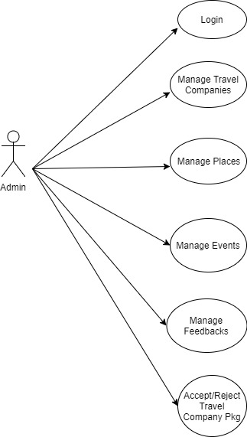
Figure 4: Admin Use Case

Use case Diagram of User
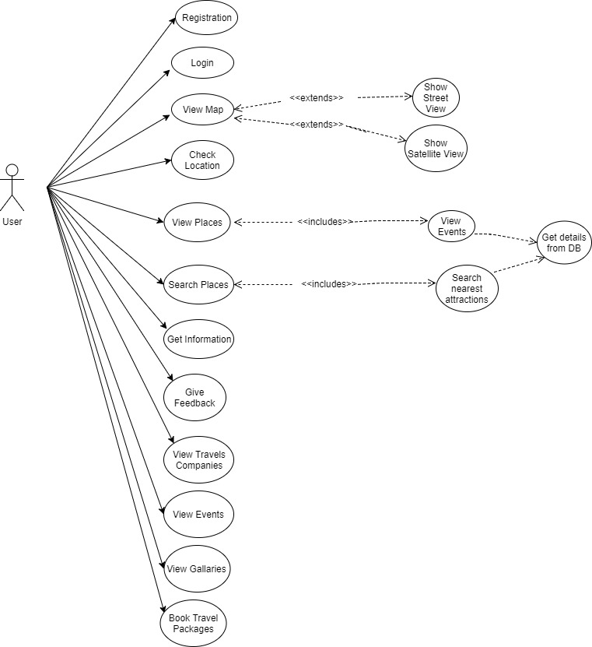
Figure 5: User Use Case

Use case Diagram of Travel Company
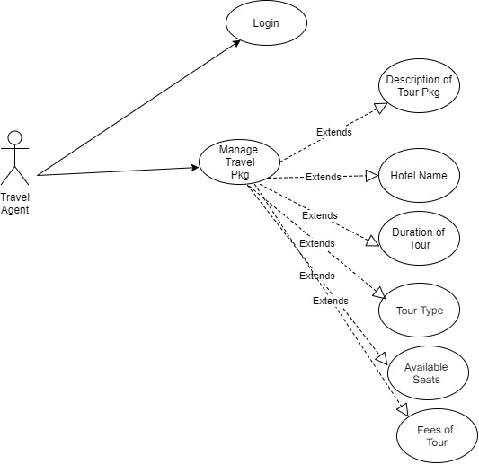

Figure 6: Travel Agent Use Case

Extended use cases
In extended use cases we make the design in which only registered users will access the system. The example is this that if admin and tourist or visitor wants to access the system they have to login first. After login in to the system they can perform functions like admin can update, delete, or add users as well their information’s. Below are the use cases of our system.

Admin and User Extended use case
Extended use case is meaningful on its own. The extended relationship is owned by the extending use case. The same extending use case extend more than one use case and extending use case may itself be extended.
Table 3: Login
Use Case ID: | UC 1
Use Case Name: | Login
Created By: | Adeel |  | Last Updated By: | Rehan
Date Created: | 1/11/2017 |  | Last Revision Date: | 12/1/2018
Actors: |  | Admin, Travel Company and Employee
Description: |  | Only registered user’s i.e. admin, travel company and tourist or visitor will login into the system. Admin, Travel Company and Employee They three will interact with the system until and unless they have their valid login credentials. Admin, Travel Company and Employee will first enter into the system. They will press the login button. Now they will see a login page appears. Now the system will ask to enter the user-name and password. If the login user-name and password are valid the user will simply enter into the system, otherwise system will generate an error.
Trigger: |  | First user will enter into the application; to login into the system user will press the login button.
Preconditions: |  | User has an activated login account.
Post conditions: |  | - Admin or Tourist or Travel Agent successfully login into the system.  - Retry to login into the system.
Normal Flow: |  | - Admin, Travel Company and Tourist login into the system.  - Admin, Travel Company and Tourist enters their login user-name and password.  - System validates if Admin, Travel Company and Tourist is a valid users or not.
Alternative Flows:  [Alternative Flow 1 – Not in Network] |  | - Forgot Password  - Forgot User Name
Exceptions: |  | a. Invalid user name  b. Invalid password  c. Invalid email address
Includes: |  | User information.
Frequency of Use: |  | On Demand User will login into the system.
Special Requirements: |  | User’s Email Address.
Assumptions: |  | None.
Notes and Issues: |  | In future we will add profile pictures.

Table 3 shows the extended login use case of the system. We can see the flow of our login system. Only registered user can access or enter into our system.
Below diagram shows only admin and the registered users will communicate with login area. If they want to update some stuff from the backend so they need to login to the system. After successfully login and enters the system then they are able to perform their tasks like user can view their profile, user will view map, its current location, view hotels, restaurants, historical places, events, parks and travel companies. Tourist can book travel package and Travel Company agent can add different travel packages.
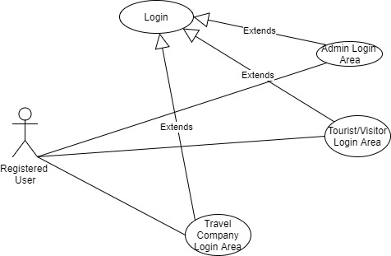
Figure 7: Login area

Figure 7 shows how the registered user communicates with the login area. Admin, Travel Company and Tourist will enter into the system. He will click the login button to access the Application. For example if the admin wants to add a new employee he will first login into the system.
Table 4: Add, Update and Delete Users
Use Case ID: | UC 2
Use Case Name: | Users(Tourist and Travel Company)
Created By: | Adeel | Last Updated By: | Goher
Date Created: | 1/11/2017 | Last Revision Date: | 12/1/2018
Actors: | Admin
Description: | Only Admin have rights to Add, update and delete the user. For example a new  Tourist or Travel agent registers itself only admin will add this user by clicking on the Add user button. When admin clicks on the button a form appears. Form displays the text fields, when we complete filling the form like name, email that specific user will enter password of its own. Likewise admin have rights to delete and update the user information. If admin wants to know about the user especially travel company agent admin first check it and then give the user username and password, if admin wants to view the travel package so definitely he can approve or reject travel package.
Trigger: | - Admin login into the system and clicks on tourist and Travel Company.
Preconditions: | Login to account.
Post conditions: | - Admin add a new users  - Admin update the information of an existing users.  - Admin delete the existing users.  - Admin view the travel packages and feedback of an existing users.  - Admin view the complete user details.
Normal Flow: | - Admin can add, update and delete the user.  - Admin can view the travel packages and feedback of the user.
Alternate flow: | No
Exceptions: | 1a. Error while adding a new user or Travel Company.  2b. Error while updating the information of the existing user or Travel Company.  3c. Error while deleting the user or Travel Company.  4d. Error while viewing the travel packages and feedback of the user.  5e. Error while viewing the details of the travel company or user.
Includes | UC 1.
Assumptions | 1a. System doesn’t process to add, update, and delete a new user.  2a. System doesn’t show the travel packages and feedbacks of the user.

Table 4 shows the extended use of add, update and delete users. We can see the flow of use case. Only admin of the system have rights to perform these operations.
Below diagram shows how the admin of the system adds, update, delete users. It also shows admin have a rights to view the Travel Company Packages and view tourist feedback and admin can view the complete information of the Users.

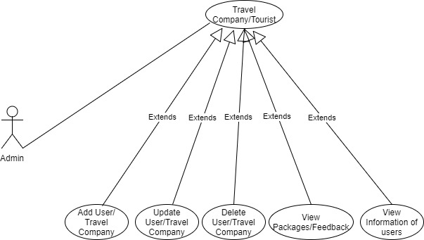

Figure 8: Manage Users
Figure 8 shows how admin will manage the users. For example if the admin wants update the user’s information he will definitely able to do by clicking on the user option. This option helps the admin if he wants to add a new user for example if admin wants to add a new travel company he will give user name and password to the travel agent and that travel agent registers his self in the system it is same for tourist. Admin can also update user’s information and can also delete user. Admin can view feedback of users about the places and also view the travel packages of the travel company.

Table 5: Add, Update and Delete Places
Use Case ID: | UC 3
Use Case Name: | Places
Created By: | Adeel | Last Updated By: | Goher
Date Created: | 1/11/2017 | Last Revision Date: | 12/1/2018
Actors: | Admin
Description: | Only Admin have rights to add and delete the places.
Trigger: | - Admin clicks on the places.
Preconditions: | - To add the places admin first login into the system.  - To delete the places admin first login into the system.  - To update places admin first login into the system.
Post conditions: | - Admin clicks on the places.  - To add the places admin clicks on add option.  - To delete the places admin clicks on delete option.  - To update the places admin clicks on update option.
Normal Flow: | - Admin of the system will view and update the places. He can add and delete the places.  - System will show him the complete information of all the users of this system. Like he can view user code, name, emails, and feedbacks.
Alternate flow: | No
Exceptions: | 1a. Error while viewing and updating the places.  2b. Error while deleting the places.
Includes | No.
Assumptions | 1a. System doesn’t process to add and updating the places.  2a. System doesn’t process to delete the places.

Table 5 shows the extended use case of add, update and delete places. We can see the flow of use case. Only admin have rights to perform these operations.
Below diagram shows how the admin of the system adds, update, delete places. It also shows admin has a right to add new places, update places information so the user of the system can view these places through maps or website. If admin deletes a particular place so no user will able to see those places.
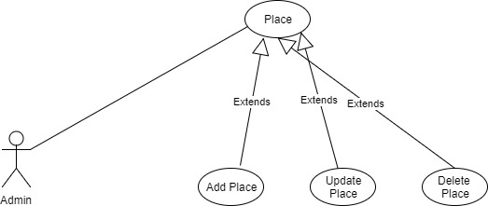

Figure 9: Manage Places
Figure 9 shows that how admin of the system can add, update and delete a place. If admin adds a new place and update its information so after that user of the system can view its information and view this place on map. If admin deletes the place so user of the system will not able to see the place on the system.

Table 6: Add, Update and Delete City
Use Case ID: | UC 4
Use Case Name: | Cities
Created By: | Rehan | Last Updated By: | Goher
Date Created: | 1/11/2017 | Last Revision Date: | 12/1/2018
Actors: | Admin
Description: | Only Admin has right to add and delete the cities.
Trigger: | Admin clicks on the cities.
Preconditions: | - To add the cities admin first login into the system.  - To delete the cities admin first login into the system.  - To update cities admin first login into the system.
Post conditions: | - Admin clicks on the city.  - To add a city admin clicks on add option.  - To delete a city admin clicks on delete option.  - To update a city admin clicks on update option.
Normal Flow: | - Admin of the system will view and update the city. He can add and delete the city.  - System will show him the complete information of all the users of this system. Like he can view user code, name, emails, and feedbacks.
Alternate flow: | No
Exceptions: | 1a. Error while adding and updating the city.  2b. Error while deleting the city.
Includes | No.
Assumptions | 1a. System doesn’t process to add and updating the city.  2a. System doesn’t process to delete the city.

Table 6 shows the extended use case of add, update and delete cities. We can see the flow of use case. Only admin have rights to perform these operations.
Below diagram shows how the admin of the system adds, update, delete cities. It also shows admin have a rights to add a new places, updates cities information and also add different places in cities so the user of the system can view these places in cities through maps or website. If admin delete a particular city so no user will able to see that city.
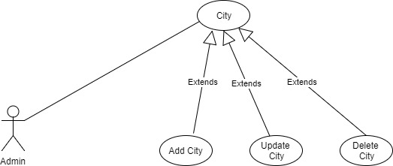

Figure 10: Manage Cities
Figure 10 shows that how admin of the system can add, update and delete a particular city. If admin add a new city and update its information so after that user of the system can view its information of different places of cities like Historical Places etc. View this city on map. If admin delete the city so user of the system will not able to see the city on the system.
Table 7: Add, Update and Delete Event
Use Case ID: | UC 5
Use Case Name: | Event
Created By: | Rehan | Last Updated By: | Goher
Date Created: | 1/11/2017 | Last Revision Date: | 12/1/2018
Actors: | Admin
Description: | Only Admin has right to add and delete the events.
Trigger: | Admin clicks on the Events.
Preconditions: | - To add the events admin first login into the system.  - To delete the events admin first login into the system.  - To update events admin first login into the system.
Post conditions: | - Admin clicks on the event.  - To add the events admin clicks on add option.  - To delete the events admin clicks on delete option.  - To update the events admin clicks on update option.
Normal Flow: | - Admin of the system will add and update the events. He can add and delete the events.  - System will show him the complete information of all the users of this system. Like he can view user code, name, emails, and feedbacks.
Alternate flow: | No
Exceptions: | 1a. Error while adding and updating the events.  2b. Error while deleting the events.
Includes | No.
Assumptions | 1a. System doesn’t process to add and updating the events.  2a. System doesn’t process to delete the events.

Table 7 shows the extended use case of add, update and delete events. We can see the flow of use case. Only admin have rights to perform these operations.
Below diagram shows how the admin of the system adds, update, delete events. It also shows admin have a rights to add a new events, updates events information and also add different events in cities so the user of the system can view these events in cities through map address and event information. If admin delete a particular events so no user will able to see that events.

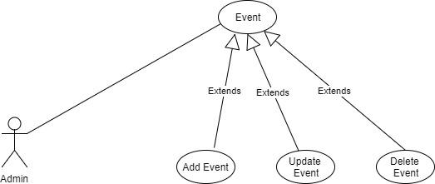

Figure 11 Manage Events
Figure 11 shows that how admin of the system can add, update and delete a particular event. If admin add a new event and update its information so after that user of the system can view the information of the event. Address of the event, where event is happing in the city. If the admin of the system delete a particular event so other user will able to see that event.
Table 8: Add, Update and Delete Hotel
Use Case ID: | UC 6
Use Case Name: | Hotel
Created By: | Rehan | Last Updated By: | Goher
Date Created: | 1/11/2017 | Last Revision Date: | 12/1/2018
Actors: | Admin
Description: | Only Admin have rights to add and delete the Hotel.
Trigger: | Admin clicks on the Hotel.
Preconditions: | - To add the Hotel admin first login into the system.  - To delete the Hotel admin first login into the system.  - To update Hotel admin first login into the system.
Post conditions: | - Admin clicks on the Hotel  - To add the hotels admin clicks on add option.  - To delete the hotels admin clicks on delete option.  - To update the hotels admin clicks on update option.
Normal Flow: | - Admin of the system will add and update the hotel. He can add and delete the hotel.  - System will show him the complete information of all the users of this system. Like he can view user code, name, emails, and feedbacks.
Alternate flow: | No
Exceptions: | 1a. Error while adding and updating the hotels.  2b. Error while deleting the hotel.
Includes | No.
Assumptions | 1a. System doesn’t process to add and updating the hotels.  2a. System doesn’t process to delete the hotels.

Table 8 shows the extended use case of add, update and delete hotels. We can see the flow of use case. Only admin have rights to perform these operations.
Below diagram shows how the admin of the system adds, update, delete hotels. It also shows admin have a rights to add a new hotel, updates hotel information and also add different hotels in cities so the user of the system can view these hotels in cities through map address and information of hotels like website of hotel and its fare. If admin delete a particular hotel so no user will able to see that hotel. User can also connect through hotel via booking through application and contact number. Admin can update information of hotels through admin panel or web crawlers. Application will fetch the data of hotels through a hotel website.

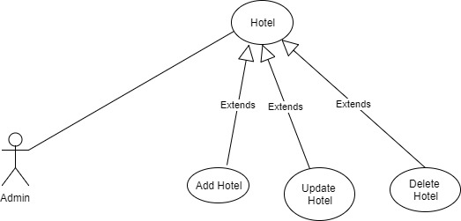

Figure 12: Manage Hotel
Figure 12 shows that how admin of the system can add, update and delete a particular hotel. If admin add a new hotel and update its information so after that user of the system can view the information of the hotel. Address of the hotel and its fare. If the admin of the system delete a particular hotel so other user will able to see that deleted hotel.

Table 9: Add, Update and Delete Restaurant
Use Case ID: | UC 7
Use Case Name: | Restaurant
Created By: | Adeel | Last Updated By: | Goher
Date Created: | 1/11/2017 | Last Revision Date: | 12/1/2018
Actors: | Admin
Description: | Only Admin have rights to add and delete the Restaurant.
Trigger: | Admin clicks on the Restaurant.
Preconditions: | - To add the Restaurant admin first login into the system.  - To delete the Restaurant admin first login into the system.  - To update Restaurant admin first login into the system.
Post conditions: | - Admin clicks on the Restaurant  - To add the Restaurant admin clicks on add option.  - To delete the Restaurant admin clicks on delete option.  - To update the Restaurant admin clicks on update option.
Normal Flow: | - Admin of the system will add and update the Restaurant. He can add and delete the Restaurant.  - System will show him the complete information of all the users of this system. Like he can view user code, name, emails, and feedbacks.
Alternate flow: | No
Exceptions: | 1a. Error while adding and updating the Restaurant.  2b. Error while deleting the Restaurant.
Includes | No.
Assumptions | 1a. System doesn’t process to add and updating the Restaurant.  2a. System doesn’t process to delete the Restaurant.

Table 9 shows the extended use case of add, update and delete Restaurant. We can see the flow of use case. Only admin have rights to perform these operations.
Below diagram shows how the admin of the system adds, update, delete Restaurant. It also shows admin have a rights to add a new restaurant, updates restaurant information and also add different restaurants in cities so the user of the system can view these restaurants in cities through map address and information of restaurants like website and its fare. If admin delete a particular restaurant so no user will able to see that restaurant.

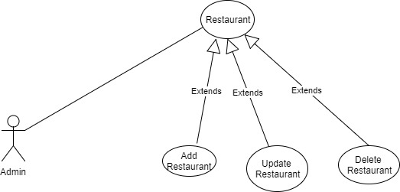

Figure 13: Manage Restaurant
Figure 13 shows that how admin of the system can add, update and delete a particular restaurant. If admin add a new restaurant and update its information so after that user of the system can view the information of the restaurant. Address of the restaurant and its fare. If the admin of the system delete a particular restaurant so other user will able to see that deleted restaurant.
Table 10: Add, Update and Delete Travel Company
Use Case ID: | UC 8
Use Case Name: | Travel Companies
Created By: | Adeel | Last Updated By: | Goher
Date Created: | 1/11/2017 | Last Revision Date: | 12/1/2018
Actors: | Admin
Description: | Only Admin have rights to add and delete the Travel Company.
Trigger: | Admin clicks on the Travel Company.
Preconditions: | - To add the Travel Company admin first login into the system.  - To delete the Travel Company admin first login into the system.  - To update Travel Company admin first login into the system.
Post conditions: | - Admin clicks on the Travel Company.  - To add the Travel Company admin clicks on add option.  - To delete the Travel Company admin clicks on delete option.  - To update the Travel Company admin clicks on update option.
Normal Flow: | - Admin of the system will add and update the Travel Company. He can add and delete the Travel Company.  - System will show him the complete information of all the users of this system. Like he can view user code, name, emails, and feedbacks.
Alternate flow: | No
Exceptions: | 1a. Error while adding and updating the Travel Company.  2b. Error while deleting the Travel Company.
Includes | No.
Assumptions | 1a. System doesn’t process to add and updating the Travel Company.  2a. System doesn’t process to delete the Travel Company.

Table 10 shows the extended use case of add, update and delete Travel Company. We can see the low of use case. Only admin have rights to perform these operations.
Below diagram shows how the admin of the system adds, update, delete Travel Company. It also shows admin have a rights to add a new Travel Company, updates Travel Company information and also add different Travel Companies in cities so the user of the system can view these Travel Companies in cities through map address and information of Travel Companies like website and its fare. If admin delete a particular travel company so no user will able to see that travel company.
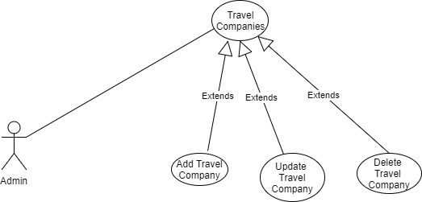

Figure 14: Manage Travel Company
Figure 14 shows that how admin of the system can add, update and delete a particular Travel Company. If admin add a new Travel Company and update its information so after that user of the system can view the information of the Travel Company. Address of the Travel Company and its fare. If the admin of the system delete a particular Travel Company so other user will able to see that deleted Travel Company.

Table 11: Add, Update and Delete Travel Company Package
Use Case ID: | UC 9
Use Case Name: | Travel Package
Created By: | Adeel, Rehan | Last Updated By: | Goher
Date Created: | 1/11/2017 | Last Revision Date: | 12/1/2018
Actors: | Admin
Description: | Only Admin have rights to add and delete the Registered Travel Company.
Trigger: | Admin clicks on the Travel Company.
Preconditions: | - To add the Travel Company admin first login into the system.  - To delete the Travel Company admin first login into the system.  - To update Travel Company admin first login into the system.
Post conditions: | - Admin clicks on the Travel Company Package.  - To add the Travel Company admin clicks on add option.  - To delete the Travel Company admin clicks on delete option.  - To update the Travel Company admin clicks on update option.
Normal Flow: | - Admin of the system will add and update the Travel Company. He can add and delete the Travel Company.  - Travel Company agent will login in the system and give a new travel package. After delivering a new travel package, admin will approve it, so the user can see travel package if they like it they will book that package, they can also give their feedback about the travel company if admin disapprove the travel package so no user will able to see and book that package.  - Admin can view the complete information of the user and its feedback about the travel package.
Alternate flow: | No
Exceptions: | 1a. Error while adding and updating the Travel Company Package.  2b. Error while deleting the Travel Company Package.
Includes | No.
Assumptions | - System doesn’t process to add and updating the Travel Company package.  - System doesn’t process to delete the Travel Company Package.

Table 11 shows the extended use case of add, update and delete package of Travel Company. We can see the flow of use case. Only admin have rights to perform these operations.
Below diagram shows how the admin of the system adds, update, delete Travel Company package. It also shows admin have a rights to add a new Travel Company that travel company will give its travel packages to the system the admin of the system will add or approve, updates Travel Company package information and also add different Travel Companies. If admin approve travel package so the user of the system will view its information like description of the travel company, fare to the package, number of members, name of hotel to stay, number of days of tour and user will also give its feedback to a particular travel package. If admin disapprove a particular travel company package so no user will able to see that travel company package.
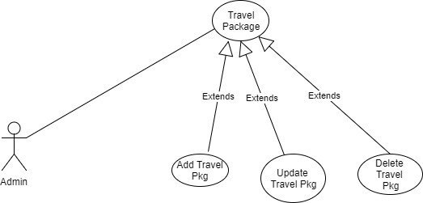

Figure 15: Manage Travel Company Package
Figure 15: shows that how admin of the system can add, update and delete a particular Travel Company. If admin add a new Travel Company and update its information so after that user of the system can view the information of the Travel Company. Address of the Travel Company and its fare. If the admin of the system delete a particular Travel Company so other user will able to see that deleted Travel Company.

User interfaces (mock screens)
User interfaces (mock screens) are the screenshots of the whole system in which we have shown our designs and backend images to our users to let them know how our system actually looks like. It shows the user how our system works

Prototype 0: (P0) Main Application User Interface
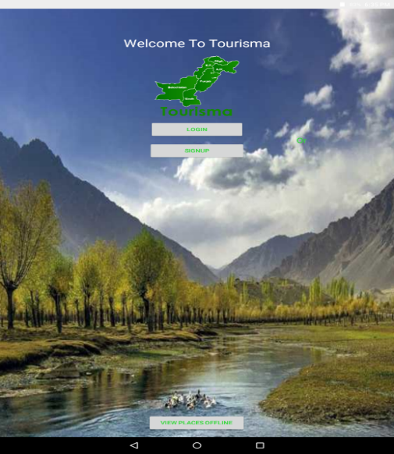
Figure 16: User Interface

Prototype 1: (P1) User Login Form
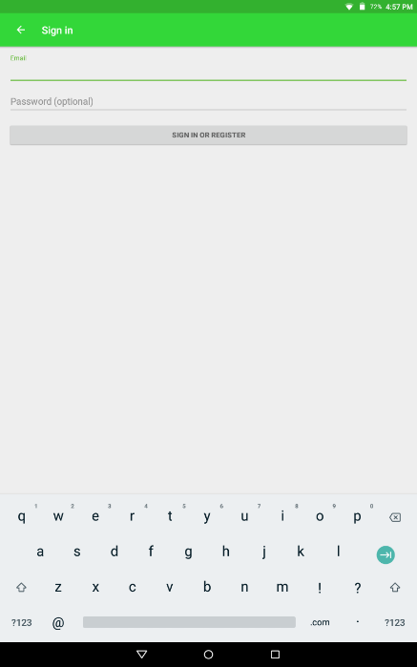
Figure 17: Login Page

Prototype 2: (P2) User Interface
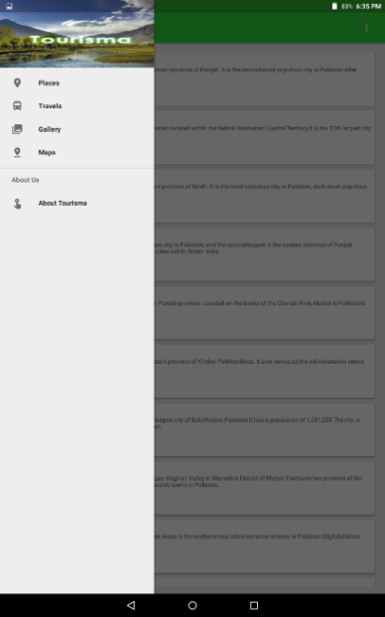
Figure 18: Main Interface

Prototype 3: (P3) View Places/Cities
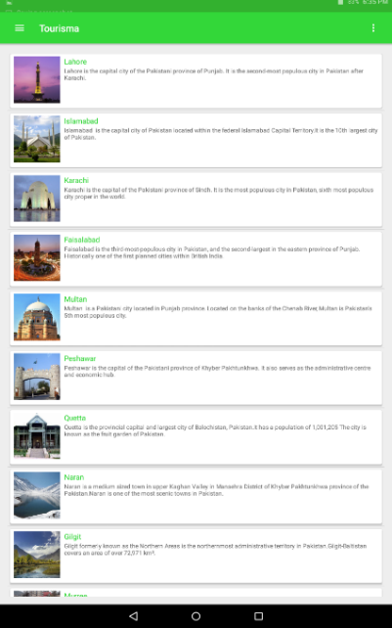
Figure 19: View Places

Prototype 4: (P4) View Places in Cities
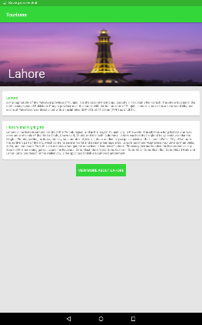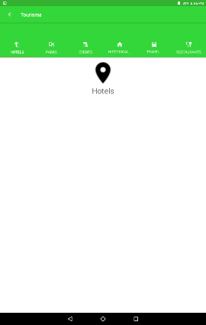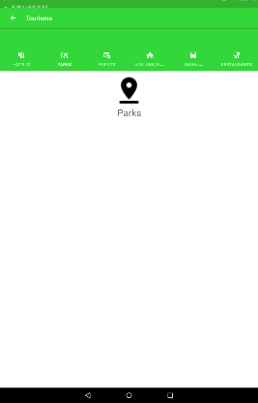
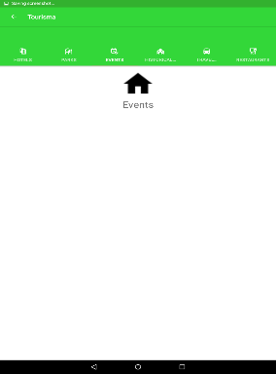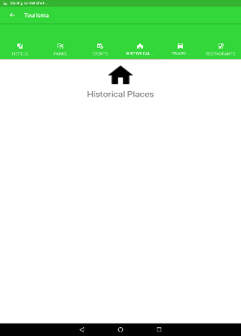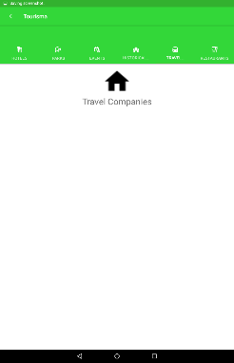

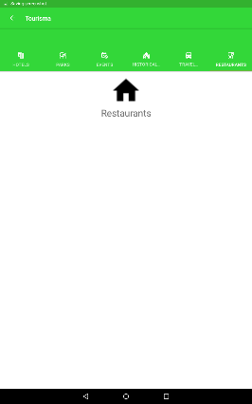

Figure 20: View Places in Cities

Data flow diagram (optional)
In order to better comprehend and understand the functionality of the whole system and the flow of data, we have formed data flow diagrams of 3 levels, starting from level 0 to level 2.

Data Flow Diagram Level 0

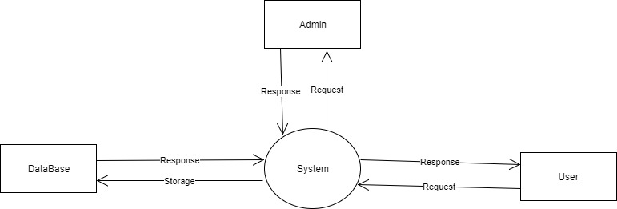
Figure 21: DFD Level 0

The figure 21 shows that the DFD level 0 in which we can see the flow of the system. The diagram shows the basic fuctionality of the system. We can see in our diagram that admin can add users, travel agents, cities, places, events and historical places. After adding a new user admin can send them login information so that the user can also use the system or access the system. Theu can view information and they can also book an travel company package.

Data Flow Diagram Level 1

Data Flow Diagram Level 1 of Admin
The below diagram shows that admin of the system gets login and he can perform different functions like admin can add, update, user or user’s information, admin can update, delete or add a city and city’s information. Admin can add, delete or update places and travel companies. Admin can approve or disapprove travel company agent travel packages if admin approves a package then a user will able to show particular package. Admin can also view the feedback of the users about the travel companies and places.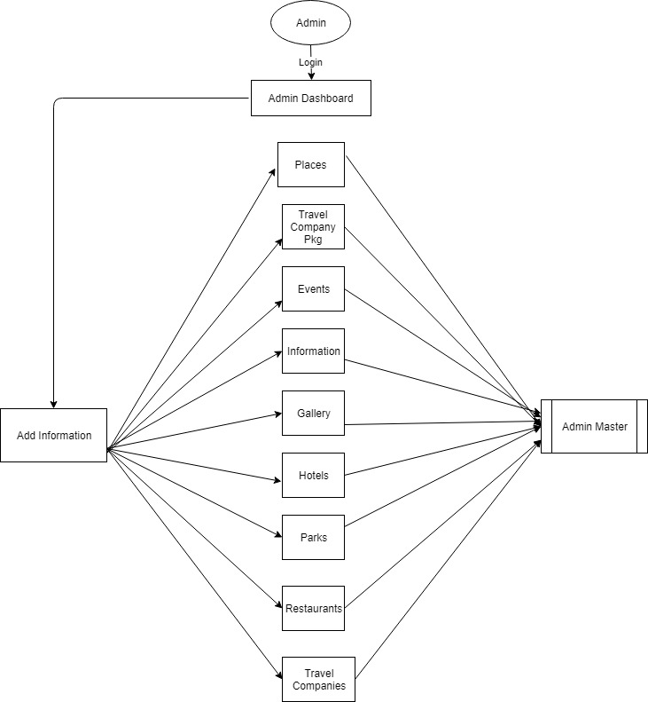
Figure 22: Admin DFD Level 1

Data Flow Diagram Level 1 of User
The below figure 23 shows that how registered user will access the system. User will enter his username and password and he will enter the system. After login into the system user can perform different functions like he can view places like cities, like parks, restaurants, historical places, Travel Company in city, hotels and events. He can also view map and his current location through GPS system. He will be able to book different travel packages of his choice and also he can view different pictures of famous places in Pakistan. He can also give feedback about the places.
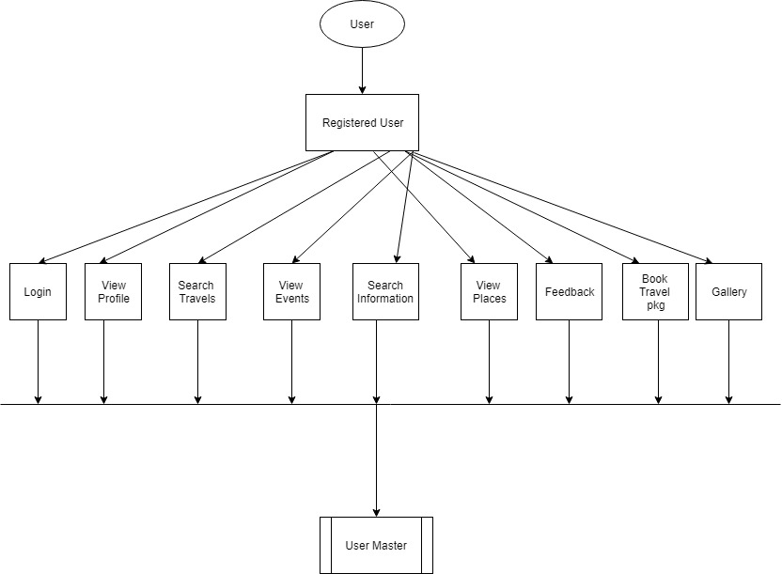
Figure 23: User DFD Level 1

Data Flow Diagram Level 2
In Data Flow Diagram level 2 we simply extend the diagram from level 1. Basically level 2 is the more advance version of level 1. So in level 2 we have simply shown the admin and user login process, if they are valid users so system verifies and allows them to access the system. If they are not valid users system simply denies them to access the system. If we talk about the admin so if he enters the correct email and password so they can enter the system and can perform his tasks, can view profile, can view, update and delete the user, places information. And if we talk about the users, after they successfully login to system, he can access his dashboard like he can view his profile update profile, he can book the travel package. User can give feedbacks and view different places like places and different places in the cities.

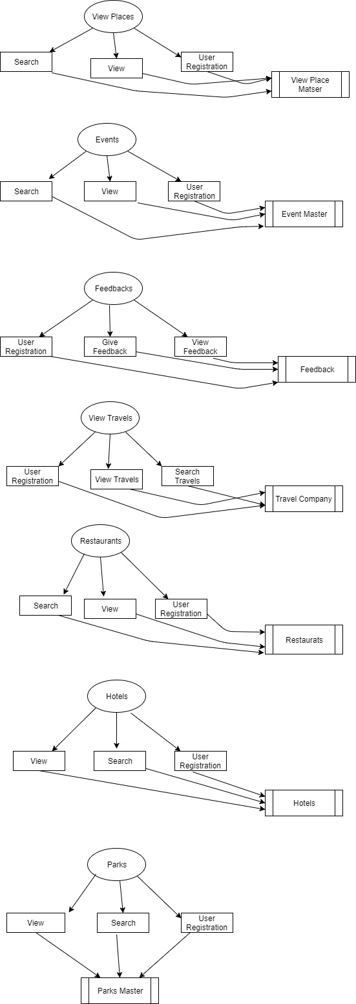

Figure 24: DFD Level 2

System Design

System Architecture Diagram
The system architecture diagrams shows that how system will work and what the functions of admin are and registered users. Admin can add, delete and update the users and places while the users can give the feedback and book the travel packages.

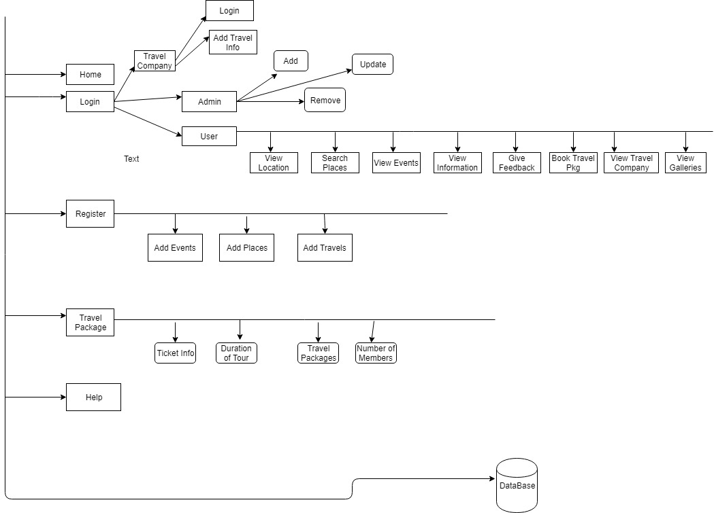

Figure 25: System Architecture

Class Diagram
In system design we usually make the diagrams in which we tell our users the complete work flow of our system. For example a class diagram in which we define the core functionalities of the system so that it will easy to understand the system.
A class diagram is an illustration of the relationships and source code dependencies among classes in the Unified Modeling Language (UML). In this context, a class defines the methods and variables in an object, which is a specific entity in a program or the unit of code representing that entity. Class diagrams are useful in all forms of object-oriented programming. The concept is several years old but has been refined as OOP modeling paradigms have evolved. In a class diagram, the classes are arranged in groups that share common characteristics. A class diagram resembles a flowchart in which classes are portrayed as boxes, each box having three rectangles inside. The top rectangle contains the name of the class; the middle rectangle contains the attributes of the class; the lower rectangle contains the methods, also called operations, of the class. Lines, which may have arrows at one or both ends, connect the boxes. These lines define the relationships, also called associations, between the classes.
In our case Admin can access everything in the system, admin can access everything of the users like he can view the user information, he can update the user information, he can delete the existing user, and if he wants to add a new user definitely he can add a new user. We also make the relations between the employee and admin. We also make the functions of users and as well as for admin, like login ( ), add user ( ), update ( ) and delete ( ), logout ( ) and so on. Admin can Accept or Reject the travel company packages with function Accept_travel_pkg ().
Admin can also add, delete and update the events like add_event (), delete_event () and update_event (). Admin can also update places like cities, historical places, events, travel companies, parks, hotels and restaurants. Admin can use functions like Add_cities (), Add_Places (), Add_Information () and Manage_Feedback ().
User of the system can view maps, view travel packages, view information, view places and view events. Like +select_places (), +view_city (), +select_events () and +view_maps ().

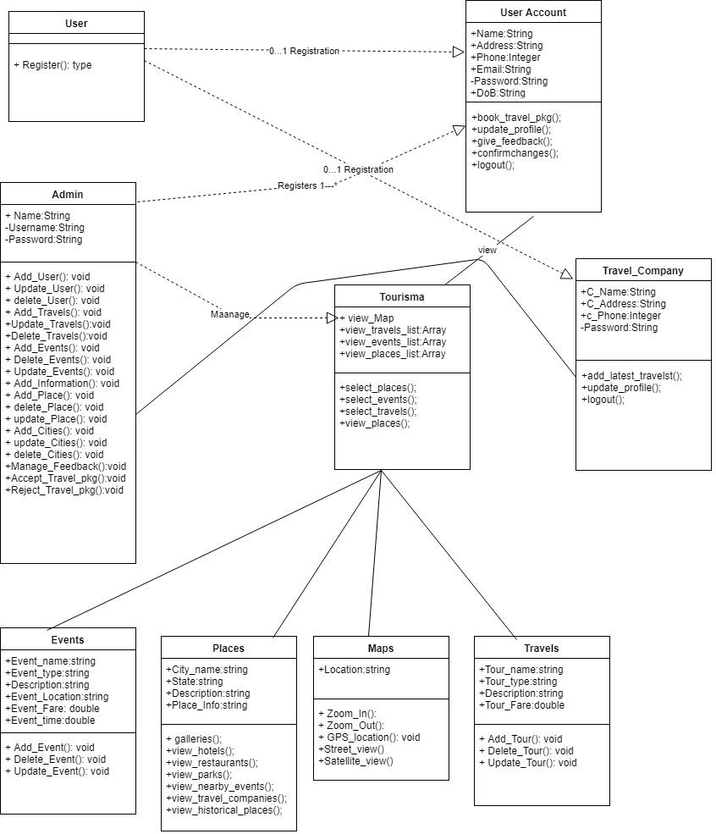

Figure 26: Class Diagram

Sequence Diagrams

Admin Sequence Diagram

The below admin sequence diagram is a demonstration that how admin controls the system. If admin logins into the system with username and password, the request is send to the database, if username and password is correct and matches with the correct username and password which is stored in database then the admin will enters in the system with administration rights. Once admin login into the system he can view anything. He can delete, update, and add new places, cities, information. He can accept or reject travel company packages. He can view user feedbacks also.

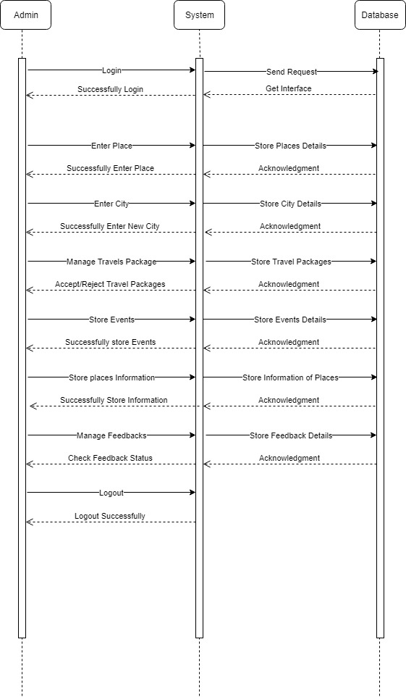
Figure 27: Admin Sequence Diagram

User Sequence Diagram
In this diagram user will registered himself and after registration he will get a login username and password. After login into the system he can view places, cities, events and book travel packages. He can also view maps and give feedbacks about the places.
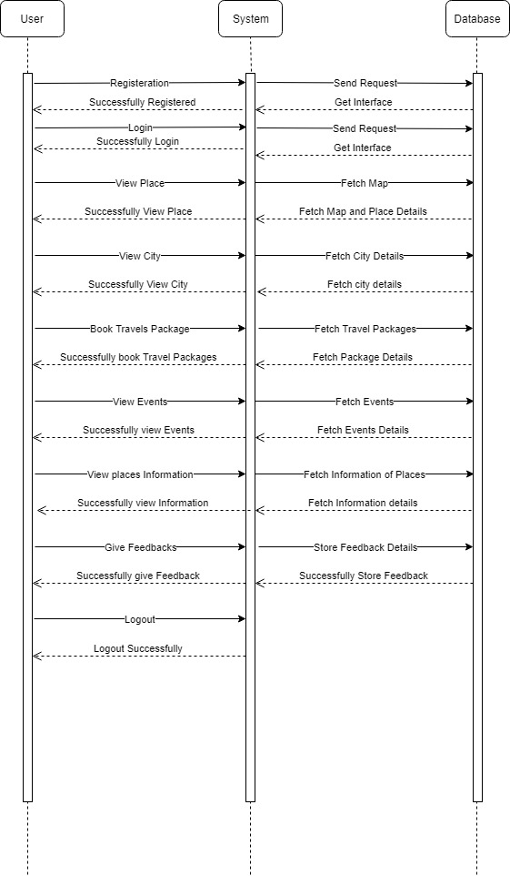
Figure 28: User Sequence Diagram

Collaboration Diagrams

Admin Collaboration Diagrams
The figure 29 shows how admin of the system will collaborate with the application or system.
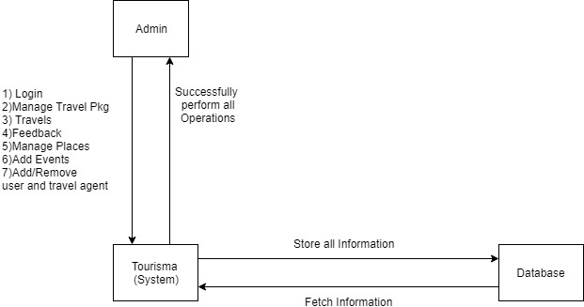
Figure 29: Admin Collaboration Diagram

User Collaboration Diagram
The figure 30 shows that how user will going to collaborate with the system.
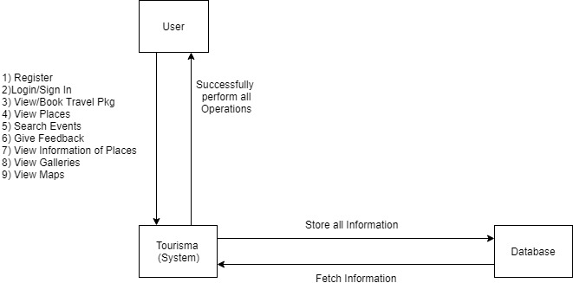
Figure 30: User Collaboration Diagram

Other UMLs
The other UML diagrams are as under

ERD
An Entity Relationship (ER) Diagram is a type of flowchart that illustrates how “entities” such as people, objects, or concepts relate to each other within a system. ER Diagrams are most often used to design or debug relational databases in the fields of software engineering, business information systems, education, and research.

Admin ERD Diagram
In this Figure 31 we simply plots our database tables which is attached at the backend of the system. We clearly see the relations with the different tables.

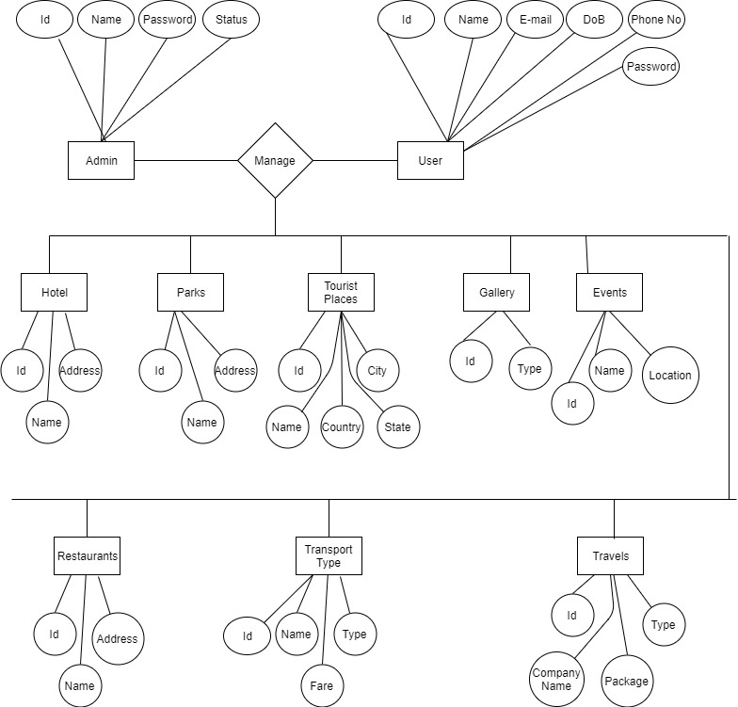
Figure 31: Admin ERD Diagram

User ERD Diagram
In this Figure 32 we simply plots our database tables which is attached at the backend of the system. We clearly see the relations with the different tables.

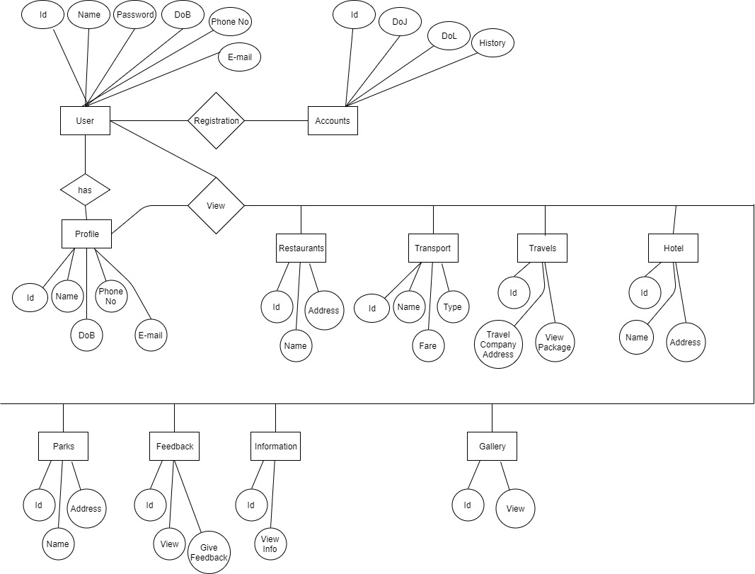
Figure 32: User ERD Diagram

Data Dictionary
This section may be used to provide the details of interface elements that are present on the screenshots.

Element Name | Type | Validation | Mandatory | Remarks
Sign Up | Varchar | 100 | Yes | User Registration
Log In | Varchar | 100 | Yes | User Login
Title | Varchar | 100 | Yes | Title of the System
Username | Varchar | 100 | Yes | Username of the User
Password | Varchar | 100 | Yes | Password of the User
Places | ArrayList | 30 | Yes | Places and Cities in the System
Events | ArrayList | 30 | Yes | Nearby Events
Travel Packages | ArrayList | 30 | Yes | Travel Packages that are given by Registered Travel Company.
Hotels | ArrayList | 30 | Yes | Update Hotel info, websites, contact, directions and fares.

Implementation details

Development Setup
The following Development tools of project are as under:-
Java and Xml is used for the frontend of the application. The compiler we used to develop frontend is Android studio. The interface of the Admin panel is developed from HTML and CSS. Admin panel of the system is device friendly it will open in Smart mobiles and PCs. The database for storing information of the admin and users is php MySQL.

Deployment setup
The most important interface of the application is developed in Android Studio using JAVA language and XML. The code is executed and related through the database with Apache Server which interfaces users with the database.
First we created user interface using android studio, in the first stage of development we have developed the user Login and Signup. Second we developed a main user interface where user can see places, Galleries, map and travel companies packages. Third we developed a list of cities and places, and add information like hotels, events, travel companies, restaurants, parks and historical places if any. Web crawlers through API and dynamically we can add hotels and their updated fares.
After developing the user interface we developed an admin panel in website through which admin can handle the whole system. Database is developed in the last and insert it into admin and user panels accordingly.

Algorithms
We use APIs and intents to call an activity in our application. The admin panel is developed in PHP MySQL using the code ignitor frame work and this code ignitor is live in Online Server.

Constraints
Constraints are conditions that we need to happen or would like to happen with a system. A limitation or restriction. Below are the constraints of the system.

Assumptions
Whenever we add a new user or travel company in the system we assume and we believe that user will login into the system by their respective username and password. We believe that when we delete or update anything including user information the system will delete or update those information’s. The thing is when we are going to insert correct input so far a particular input we want our desire output. So we follow the standards we implement the rules so that we can say our system will give us a unique output for against our input. So whenever a travel company gives their respective travel package we assume that after approving from the admin the travel package is viewable for all the tourists and visitors.

System constraints
System must operate by the Admin of the system. In which admin can easily add, update and delete the user record and as well as the travel company. Admin can easily review the feedback of the users about the different places. Admin can communicate through emails with the travel company who give their respective travel packages in sense of when approve or disapprove the travel package.
There are many constraints in the system one major constraint is user of the system book a travel package and he did not receive a notification or email. The other constraint is that user did not able to see an updated information about the places it may be a system fault and so system is not providing the user information to the admin of the system so if admin did not get the information so he is not able to process further.

Restrictions
When users have their invalid credentials so system will not let him access the system. So those are the constraints applied on the system by the users. System has some restricted areas in which users will not able to access such as he cannot change places, events, maps and travel packages. He can only view the information, access the address using maps, and check the places information through websites. He can only book the travel package if he interested to do it. He can also view its current location and view nearby areas.

Limitations
Our system will not provide to book the hotel we will implement these functionalities in future. Our system provides benefits to the travel companies which are updating their packages. In future we add a ride that will show tourists and visitor’s cities, different famous and historical places. In future we will add those cities who are rich from the natural beauty and yet not visited by the tourists and visitors.
By adding these functionalities we will able to generate more revenue and our system will give all the information to the users.

Testing

Extended Test Cases
In Extended Test cases we can easily navigate our system how it works and where defects is.
Does our system pass the cases or not? Below are the extended test cases.
Table 12: Test Login Button

Test case id:1 |  |  | Test Design By: Adeel
Login Button on a web admin panel |  |  | Test Design Date: 1/26/18
Test Priority: High |  |  | Test Executed By: Rehan
Test/Title Name: To test the login Button |  |  | Test Executed date: 10/2/18
Description: Test the login button of the admin panel developed in website
Pre-condition: The admin will open admin panel.
Dependencies
Step | Test Step | Test Data | Expected Result | Actual Result | Status(Pass/Fails) | Notes
1 | Navigate to login Page |  |  |  | Pass
2 | Click on the login button
3 | Fill the form according to the requirements | Email Id: root@tourisma.com  Password: Angel123
4 | Click on the login button. |  | The admin can add a new user, Update the user information, delete the users | The admin successfully add update and delete the users
Post Condition: The admin already logged into his account and update, add and delete the users.

Table 12 shows the test case of the admin login button. Admin gives his username and password and enters into the system where he can update, delete and add new users.

Table 13: Test Add new City
Test case id:2 |  |  | Test Design By: Adeel
Add new place like cities |  |  | Test Design Date: 1/26/18
Test Priority: High |  |  | Test Executed By: Rehan
Test/Title Name: To test the manage city |  |  | Test Executed date: 10/2/18
Description: Test the submit button in manage city of the admin panel developed in website
Pre-condition: The admin will open admin panel.
Dependencies
Step | Test Step | Test Data | Expected Result | Actual Result | Status(Pass/Fails) | Notes
1 | Navigate to login Page |  |  |  | Pass
2 | Click on the login button
3 | Fill the form according to the requirements | Clicking on manage city, add name, description and picture of the city.
4 | Click on the submit button. |  | The admin can add a new city, Update the city information, delete the city | The admin successfully add update and delete the city
Post Condition: The admin already logged into his account and update, add and delete the cities.

Table 13 shows the test case of the manage city submit button. Admin gives his username and password and enters the system where he can update, delete and add new and existing city.

Table 14: Test Add new Place
Test case id:3 |  |  | Test Design By: Adeel
Add new place type like parks and events |  |  | Test Design Date: 1/26/18
Test Priority: High |  |  | Test Executed By: Rehan
Test/Title Name: To test the manage types of places |  |  | Test Executed date: 10/2/18
Description: Test the submit button in manage places type of the admin panel developed in website
Pre-condition: The admin will open admin panel.
Dependencies
Step | Test Step | Test Data | Expected Result | Actual Result | Status(Pass/Fails) | Notes
1 | Navigate to login Page |  |  |  | Pass
2 | Click on the login button
3 | Fill the form according to the requirements | Clicking on manage place type
4 | Click on the submit button. |  | The admin can add a new place, Update the place information, and delete the place.  Place like hotel, event, parks, restaurants etc. | The admin successfully add update and delete the place
Post Condition: The admin already logged into his account and update, add and delete the places.

Table 14 shows the test case of the manage city submit button. Admin gives his username and password and enters into the system where he can update, delete and add new and existing places.

Table 15: Test Add new place type
Test case id:4 |  |  | Test Design By: Adeel
Add new place type like parks and events |  |  | Test Design Date: 1/26/18
Test Priority: High |  |  | Test Executed By: Rehan
Test/Title Name: To test the manage places |  |  | Test Executed date: 10/2/18
Description: Test the submit button in places type of the admin panel developed in website
Pre-condition: The admin will open admin panel.
Dependencies
Step | Test Step | Test Data | Expected Result | Actual Result | Status(Pass/Fails) | Notes
1 | Navigate to login Page |  |  |  | Pass
2 | Click on the login button
3 | Fill the form according to the requirements | Clicking on Places
4 | Click on the submit button. |  | The admin can add a new place, Update the place information, and delete the place.  Places like hotel, event, parks, restaurants etc. Place description, address, direction, contact, place type, website of place, and picture of place. Admin can add this place in every city of its choice. | The admin successfully add update and delete the place
Post Condition: The admin already logged into his account and update, add and delete the place.

Table 15 shows the test case of the manage city submit button. Admin gives his username and password and enters into the system where he can update, delete and add new and existing place.

Table 16: User Login Button
Test case id:5 |  |  | Test Design By: Adeel
User Login |  |  | Test Design Date: 1/26/18
Test Priority: High |  |  | Test Executed By: Rehan
Test/Title Name: User Login Button |  |  | Test Executed date: 10/2/18
Description: Test the user login button
Pre-condition: The user will open application.
Dependencies
Step | Test Step | Test Data | Expected Result | Actual Result | Status(Pass/Fails) | Notes
1 | Navigate to login Page |  |  |  | Pass
2 | Click on the login button
3 | Fill the form according to the requirements | Clicking on login button
4 | Click on the submit button. |  | User of the system enters his username and password and click the login button, if username and password is correct so he will login or enter the system. | The user Login Successfully.
Post Condition: The user already logged into his account and view places, maps and book a travel package.

Table 16 shows the test case login button of user where user press the button and logins into the system.
Table 17: Travel Company Login
Test case id:6 |  |  | Test Design By: Adeel
Travel Company Login |  |  | Test Design Date: 1/26/18
Test Priority: High |  |  | Test Executed By: Rehan
Test/Title Name: Travel company Login Button |  |  | Test Executed date: 10/2/18
Description: Test the travel company login button
Pre-condition: The travel agent will open application.
Dependencies
Step | Test Step | Test Data | Expected Result | Actual Result | Status(Pass/Fails) | Notes
1 | Navigate to login Page |  |  |  | Pass
2 | Click on the login button
3 | Fill the form according to the requirements | Clicking on login button
4 | Click on the submit button. |  | Travel agent of the system enters his username and password and click the login button, if username and password is correct so he will login or enter the system. | The user Login Successfully.
Post Condition: The user already logged into his account and add or update travel package.

Table 17 shows the test case login button of travel agent where agent press the button and logins into the system.

Decision Table

Code snippet

Decision coverage table
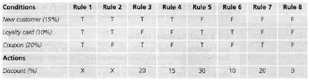

Traceability Matrix

RID vs UCID (requirements vs use cases)
UCID/RID | R  1 | R  2 | R  3 | R  4 | R  5 | R  6 | R  7 | R  8 | R  9 | R  10 | R  11 | R  12 | R  13 | R  14 | R  15 | R  16 | R  17 | R  18 | R  19 | R  20 | R  21
UC 1
UC 2
UC 3
UC 4
UC 5
UC 6
UC 7
UC 8
UC 9
UC 10
UC 11
UC 12
UC 19
UC 20
UC 21
UC 22
UC 23
UC 24
UC 25
UC 26
UC 27

Prototypes (RID vs PID)

Test Cases (RID vs TID)

Coverage (UCID vs TID)

Results/Output/Statistics

%completion
The whole necessities composed by our group have been worked out completely. The project is developed to meet all requirements that tourist needs.
Keeping in view all the essential prerequisites for a Tourisma are created, for example, adding a new user and sending them their login credentials. We tried the system altogether with all composed functionalities working adequately and decidedly. The security administration that we wished to include have additionally been included our project.
The interface of admin or employees and the UI is being completed decidedly as they were organized by us. The database is working thoroughly fine with all the fundamental requirements connected by us.
Among a few functionalities that we need to execute in our project for future work that will make our project more agent and give easy to use understanding to the users, the various errands have been pleasantly tried and are working legitimately.
The degree of accomplishment that we have decided is about liable to 90% in light of the fact that generally every one of the errands that we needed to gadget in our project have been included by our group.

%accuracy
Admin panel of the system is working properly. Admin can add, delete and update places like cites, manage places like events, historical places, parks and restaurants.
User panel is developed in android studio all the sidebars, touch panel is working correctly.

%correctness
Admin can login the system as well as the user and travel package agents.

Conclusion
By taking the opportunity to implement our idea of setting up Tourisma tourist guide application we believe that we were able to achieve many major milestones that were to develop the front end of the application in by applying Java and Xml etc. Afterwards we developed the back end through MySQL. The main milestone we had to achieve was connecting the users with the system and provide them limited access. But we are keen to make it more advanced by further adding additional features into it, still there are many features and functionalities which could be implemented but we were not able to push forward towards them due to time limitation. We can socialize our application by connecting through social sites like, Facebook and twitter.
We also learnt about how to manage the project and come up with deliverables on time. The experience of development and designing of project has been very fruitful for us as we came to understand different aspects of android application development.
The project was quite challenging for us as we decided to implement it from scratch using the java, xml, php. During the process we came across different hurdles but we were determined towards completing our project. To ensure our product meets the user requirements tried our level best to make the product dynamic with well-designed database architecture and to also ensure that our product meets the functional requirements for the Admin and for the users to view and maintain their profile, view information, view hotels and book packages.

Future work
As we know that tourist guide applications are very helpful to the tourists and visitors. We try to give our best to provide the accurate information about the places like cities and different places.
In future work we will try to extend this project and give login to different tourist companies that they will give their best packages. If user book travel package from our application he/she will get discount.
Other function we will implement is to give user can book their hotel through this application.

Bibliography

Books

Journals

Articles

Research papers

Other References

Appendix

Glossary of terms

Pre-requisites
Must use contents of development/ deployment setup & external system dependencies

