Final Year Project Report

You-Fit


Project Advisor: Bilal Hassan

Submitted By: Ismaeel Azeem
Ahmad Mehmood Haider
Hashir Kamal
Usama Sabir

Session
2013 - 2017

University of Management and Technology
C-II Johar Town Lahore Pakistan

Dedication
This thesis is dedicated to my father who taught me hard work is key to success no matter in which environment you are and also dedicated to my mother who helped me in achieve my goals. Also we would like to dedicate to our teachers who helped us to complete this project. They always try to deliver the best. They advised us to make this project more helpful and more robust so that any organization can easily understand and can easily install into their organization

Final Approval

Panel of Examiners

- Head of Department ______________________
Department of Computer Science
UMT Lahore

- Program Director ( Final Year Projects) ______________________
Department of Computer Science
UMT Lahore

- Supervisor ______________________
Department of Computer Science
UMT Lahore

- Co-Supervisor ______________________

Acknowledgment
Our deepest gratitude goes to ALLAH ALMIGHTY who has provided everything that was needed to complete this project. Throughout this entire time He (SWT) took care of everything and strengthens us even in my most difficult times. We appreciate the Rector of this great institution Dr. Muhammad Aslam of University of Management and Technology, A very kind and beautiful personality of the university and he is trying to raise this university. He is struggling and providing the best ways to gain the knowledge in this peaceful environment where I have been trained.
We also appreciate the Director Mr. Abid H K Shirwani. Who has shown exemplary leadership We appreciate the Dean of SST (School of Systems and Technology) Dr. Shaukat Iqbal.
We also appreciate Dr. Yasir Daniyal Chairperson of Dept. of computer science. Also we appreciate Dr Adnan Shehzada (Director of Final year projects). Also we appreciate Dr Muhammad Masroor Ahmed (Director of Final year projects).
We really appreciate our advisor Mr. Bilal Hassan who really spent his time and advised us to make this project. We learnt from him many things during developing this project. Our sincere appreciation also goes to our supervisor and Co-supervisor and other teachers. Thank you so much for your struggles and for your time.
Our utmost regard also goes to our parents, who carefully laid the foundation for our education giving it all it takes.

Project Title
You-Fit

Objective The system is Android Mobile Application which helps the busy schedule people to workout in their free time.
Undertaken by Ahmad Mehmood Haider, Ismaeel Azeem, Hashir Kamal, Usama Sabir
Supervised by Bilal Hassan
Starting Date November, 2016
Completion Date February, 2018
Tools Used Android Studio, Unity 3D, Microsoft Kinect, Open Kinect
Operating System Windows and Android
Documentation Microsoft Word

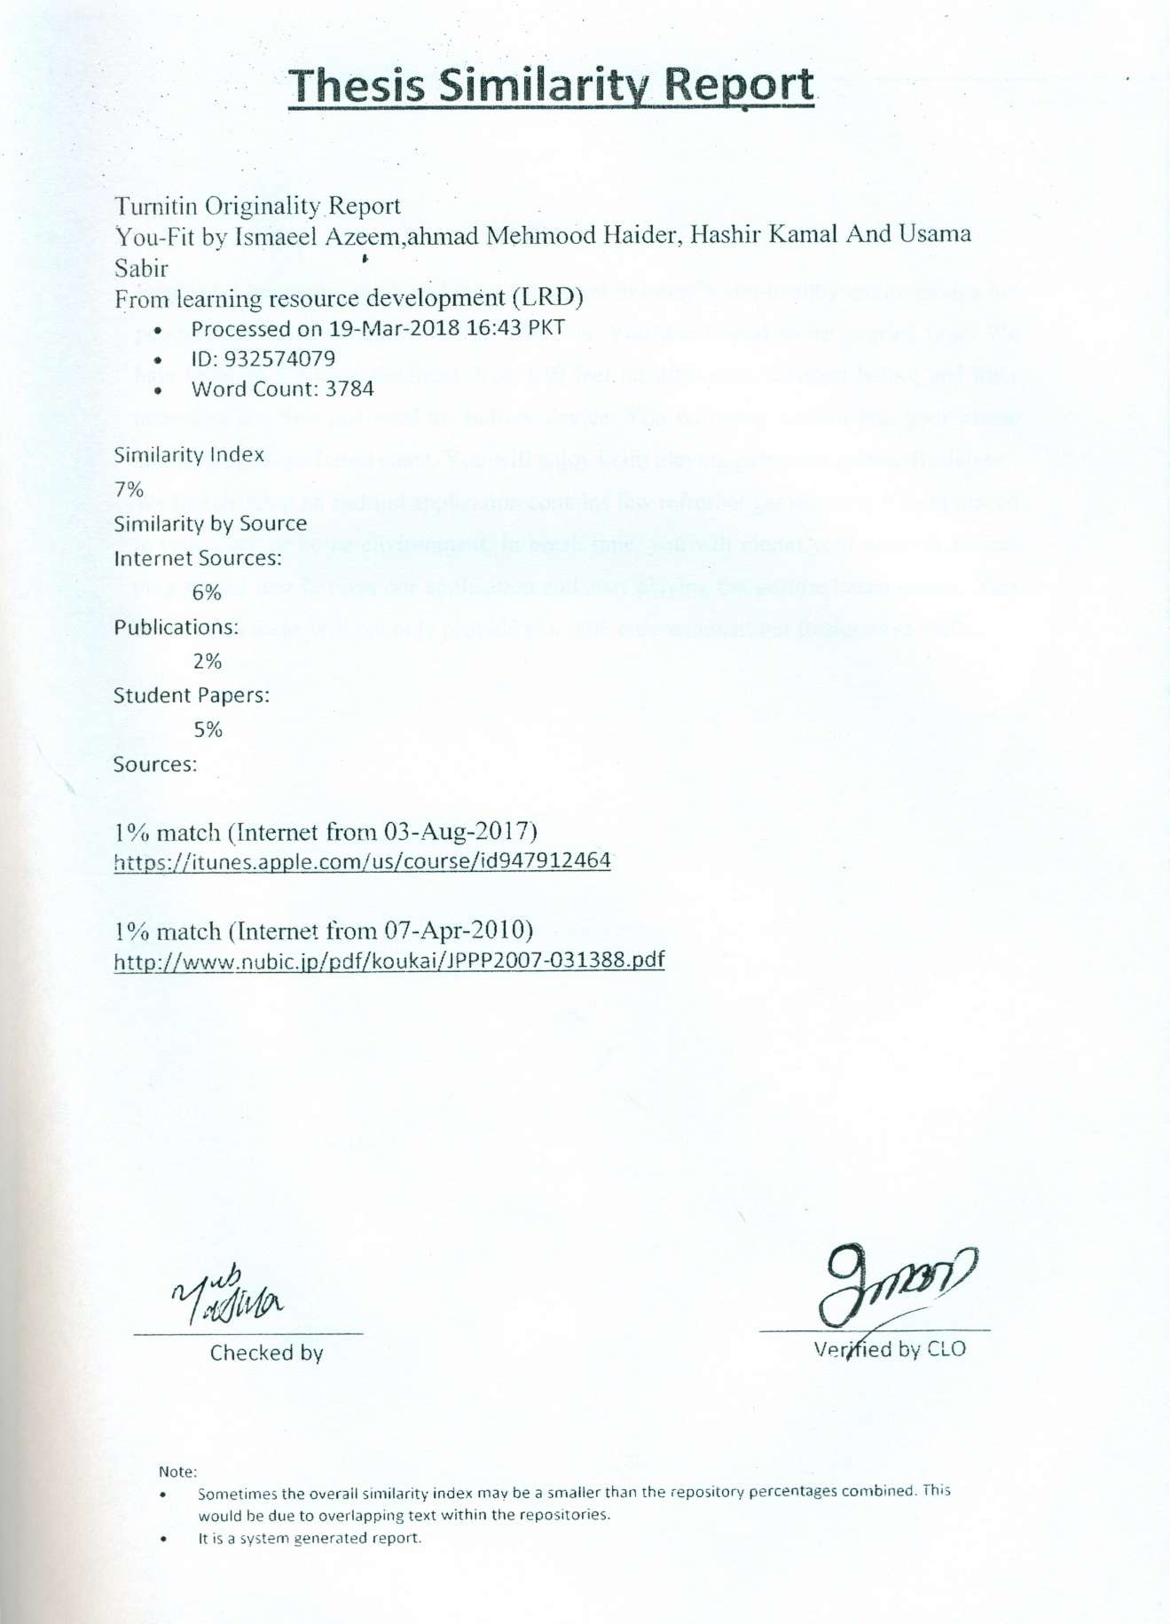

Abstract
Exercise is becoming more and more important in today’s non-healthy environments but people don’t have enough time for workouts. You don’t need to be worried now. We have solution for your tiredness. You will feel no difference between before and after noon session. You just need an android device. You will plug camera into your phone and play a gesture based game. You will enjoy both; playing game and getting freshness.
We will develop an android application contains few refresher games using Kinect placed in your work or home environment. In break time, you will mount your android device, plug Kinect into it, open our application and start playing the gesture based games. This ten minutes game will not only provide you with entertainment but freshness as well.

Revision Chart

Version | Primary Author(s) | Description of Version | Date Completed
Proposal | Ahmad Mehmood Haider  Usama Sabir  Ismaeel Azeem | Proposal was created to get approval from respected Advisor. | 1/10/16
Proposal Revision | Ismaeel Azeem  Usama Sabir | Changes were made as said by respected Advisor. | 7/10/2016
Documentation 1.0 | Ismaeel Azeem  Hashir Kamal | Work on introduction and scope of the project. | 1/5/17
Documentation 2.0 | Ahmad Mehmood  Ismaeel Azeem  Usama Sabir | Added features and Completed half of the documentation and revised the previous chapters. | 1/7/17
Final Documentation | By All Group Members | Completed the whole document and get it approved by our advisor. | 27/7/17

Contents
Contents 1
Definitions and Acronyms 3
List of Figures 4
List of Tables 5
1. Introduction 6
1.1 Motivations 6
1.2 Project Overview 6
1.3 Problem Statement 6
1.4 Objectives 6
2. Domain Analysis 8
2.1 Customer 8
2.2 Stakeholders 8
2.3 Affected Groups with social or economic impact 8
2.4 Dependencies/ External Systems 8
2.5 Reference Documents 8
2.5.1 Related Projects 9
2.5.2 Feature Comparison 9
3. Requirements analysis 10
3.1 Requirements 10
3.2 11
3.2 List of Actors 11
3.3 List of use cases 11
3.4 System use case diagram 11
3.5 Extended use cases 12
3.6 User interfaces (mock screens) 13
4. Data flow diagram (optional) 15
4.1 Data Flow Diagram Level 0 15
4.2 Data Flow Diagram Level 1 15
5. System Design 17
5.1 System Architecture Diagram 17
5.2 Class Diagram 18
5.3 Collaboration Diagrams 18
5.4 Other UMLs 19
5.6 Data Dictionary 20
Definitions and Acronyms

Acronym | Definition
UMT | University of Management and Technology
POS | Point of Sale
Table 1: table of acronyms and definitions

List of Figures
Table 1: table of acronyms and definitions 3
Table 2: list of stakeholders 8
Figure 1: sample use case diagram with explanation 11
prototype 1: (P1) register a new member 14
Figure 2: System Architecture 17

List of Tables
Table 1: table of acronyms and definitions 3
Table 2: list of stakeholders 8

Introduction
Exercise is becoming more and more important in today’s non-healthy environments but people don’t have enough time for workouts. You don’t need to be worried now. We have solution for your tiredness. You will feel no difference between before and after noon session. You just need an android device. You will plug camera into your phone and play a gesture based game. You will enjoy both; playing game and getting freshness.
We will develop an android application contains few refresher games using Kinect placed in your work or home environment. In break time, you will mount your android device, plug Kinect into it, open our application and start playing the gesture based games. This ten minutes game will not only provide you with entertainment but freshness as well.

The project is based on Exercise game named You-Fit. You will enjoy both; playing game and getting freshness. The application contains few refresher games using Kinect placed in your work or home environment. In free time, you will mount your android device, plug Kinect into it, open our application and start playing the gesture based games. This ten minutes game will not only provide you with entertainment but freshness as well. A digital dummy or avatar will be there in the application who teaches you how to perform body movements and give score on the perfect movement performed by the user. In the end, the score will be displayed to the user.

Motivations
There are many people who don’t have time for exercise even after the office or day long work at home. That’s why we develop this application which will eliminate element of tiredness of a person by playing a simple gesture based game and keep themselves fit and healthy.

Project Overview
Many people underestimate the importance of good health. The purpose of this project is to make people healthy and for staying healthy exercise is extremely important, this application teaches people how to exercise This project is based on Kinect, An avatar is in the application who perform body movements and user need to make same move in front of the Kinect. On performing same move the score will be given and at the end of the session it will be displayed to the user.
- Initial Statement:
We face many problems in the development of our application. Such as designing 3D models and their movements, Kinect connectivity with android phones and tabs.
- Customers:
The users of our application are offices employees, house wives at home, labors, children and anyone who wants to become fit and healthy.
- Goals:
We are looking for people who wants to get their dream body and changes in the attributes towards health and fitness.

- System functions:
Exercises for routine fitness, exercise for disease recovery, exercises bases upon BMI.
- System attributes:
Android supportive, Kinect connectivity.

Problem Statement
There are many exercises and health application. These application need user information about their body (weight, height, age etc.) and tells user in theoretical way what to do. It is obviously time consuming and irritating for the user to read the text file of different exercises. In our application we eliminate all these things, the user have just to make same movements in front of Kinect which is performed by the avatar in the application. We faced many difficulties in making 3D objects for our application. Other problems are basics like we face difficulty during connectivity sessions.

Objectives
The objective of exercise application are:
- Provide the facility of exercise for the benefits of its users.
- Provide the facilities of refreshment and entertainment.
- Increase the quality of life by providing a constructive alternative to anti-social behavior such as drugs & alcohol abuse, for the local youths.
- Promote fitness, discipline and self-confidence.
- Free from age group restriction.

Domain Analysis

Customer
We have friends and students of our university as clients. We show them demo of our application and get their response with the help of feedback.

Stakeholders
Stakeholder | Role in System
Marketer | If we sale our app in market in some price. Marketers have authority to sale that app to next person on their own price.
DVD shop keeper | They do same job as marketer did.
Table 2: list of stakeholders

Affected Groups with social or economic impact
- User
There will be less touchpads work for the user. Also they will be able to provide better customer care as system will help them respond to them quickly. User don’t need to plug controls with led or touch screen. They just move in front of Kinect and Kinect can take its values from human skeleton.

Dependencies/ External Systems
Kinect base android app

Reference Documents

Related Projects

Fitness coach

Fresh, fun workouts at your fingertips! Use Workout Trainer to get in *your best shape* with thousands of multimedia workouts and custom training programs. Our expert coaches will guide you through every exercise with timed, step-by-step audio, photo and video instruction - complete with the motivation you need to crush your fitness goals.
- 7 Minute Superhero Workout

Count every rep and every calorie of every exercise with 7 Minute Superhero Workout! Heroes aren’t born – they’re trained. You’re pilot of the prototype AEGIS One battle suit, tasked with defending Earth against alien invaders. Your punches become plasma blasts and your abdominal crunches power your suit’s reactor!

Feature Comparison
Sr No. | Comparison Feature | Fitness coach | 7 Minute Superhero Workout | You-Fit | Remarks
1 | Kinect and coaching features | Kinect is not supported but having training features | Kinect is supported but having no training features | Supported Kinect and training features | Using Kinect is very efficient for apps because you don’t need any touch pads or buttons.
2 | Calories or score base evaluation | It tells user how much calories he has burn. | It calculates the reps done by the user in-front of the device. | It gives score to the user on performing the perfect move. | Our game/application gives score. It is entertaining for the user to make high score and try to beat the older score.

Requirements analysis

Requirements
Remembering the true objective to better understand the method for our application and work we have sorted down the helpful and no valuable essentials of our project. As it is Final Year project its essential utilitarian requirements and nonfunctional requirements are particularly characterize

Functional Requirements
Utilitarian necessities are regularly the components of the application which are typical by the users to be accessible to meet the specific and assigned functionalities. Our project has the following utilitarian prerequisites.
- Front End & Features
- GUI
- User

Front End Features
Since our project is an android based. The content which is seen by user on the front is basically front end feature and it is developed in Android. The graphic user interface of the portal needs to work as the users expect. The portal highlights the best features and front end functionalities with an appropriate plan and design.

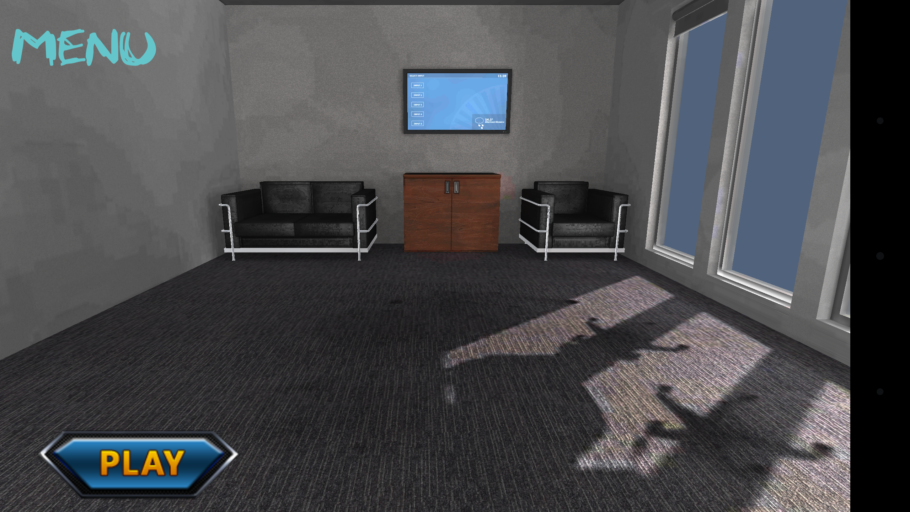

The above image is the main interface of the user’s end where user of the system can see all the main information. This main interface will be shown after when user login into the system. The sidebar of the interface shows the places like cities of the system, Travels in which approved travel packages will be shown to the user. Gallery in which user can see different images of the cities, historical places, hill stations, hotels, restaurants etc. Map will show the Current location of the user where user is standing.

GUI
The front end functionalities allow the users to select different characters. He can touch a select button and play, after touching the play button he will able to play the first exercise. After doing the first exercise there will be rest time of 30 seconds and then user can continue to next exercise. There will be total 10 exercises than the user can play.

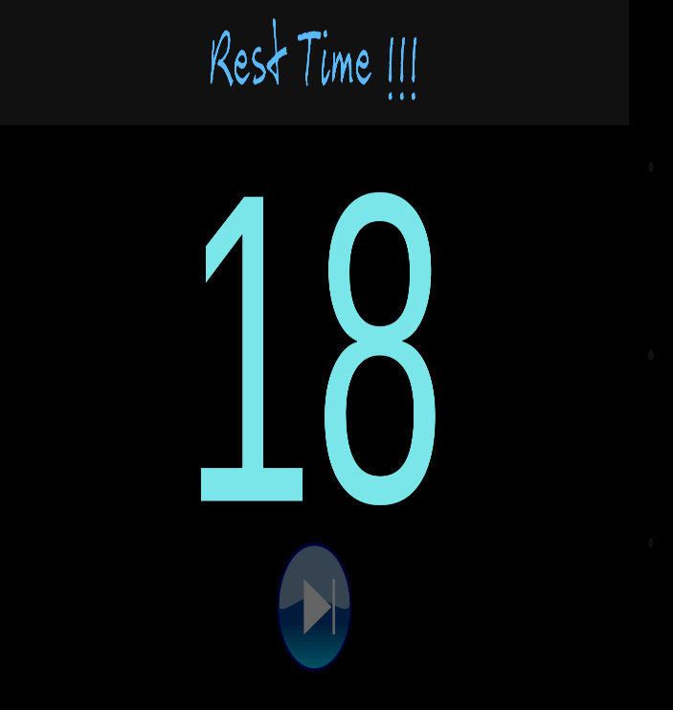
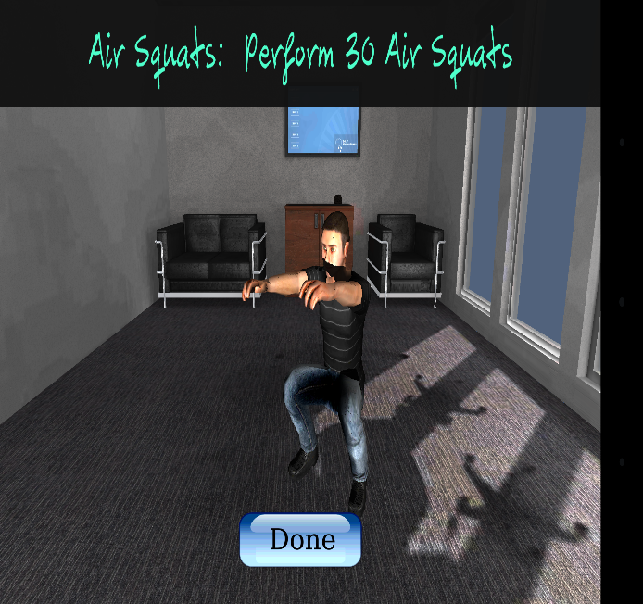

Users
Users will perform 10 daily different exercises and it will help his body to burn fat. User have to select a character and began with that specific character. It’s up to user how many exercises he want to perform.

Non Functional Requirements
Our System will be available 24hours. It will provide all the functionalities that we have implemented in our project. User can download this game from play store and it’s free. You just have to download it and then you can play without any cost.

Maintainability
So far there is nothing to maintain in our application. We will get help with our users it will help suggest users to give us feedback and then we can make changes to our application.

Error Handling
This application has been made with basic square of JAVA codes and C# which we have written in essential and negligible way so the programs can read them without a lot of an extend and the reaction time of the site has a tendency to be useful for the users. The frontend is design using unity 3D.

Accessibility
To access this system user must have an android operating system. User don’t need an active internet connection to play this game and you need to download it once.

List of Actors
User: This person performs all the activities.
System: The device which is use for running the game/application.

List of use cases
Character Selection: User have to choose a Character.
Play: It started the exercise.
Done: Yes or no
Next Button: For next exercise

System use case diagram
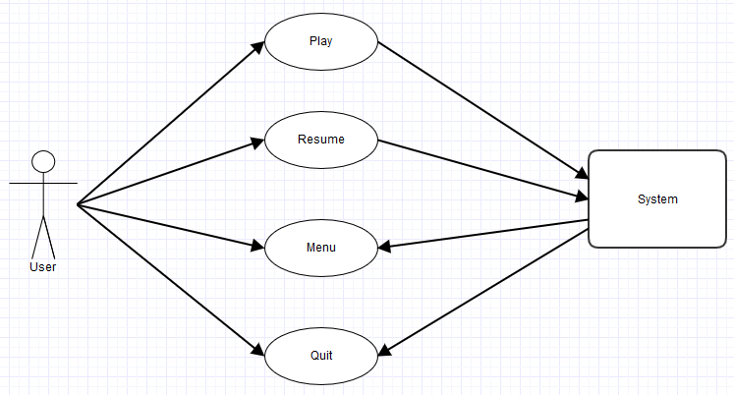
Figure 1: sample use case diagram with explanation

Extended use cases
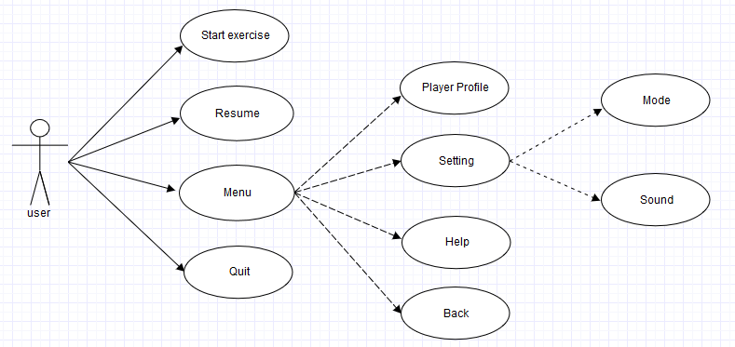

Use Case ID: | Extended Use case 1
Use Case Name: | Menu
Created By: | Our team |  | Last Updated By: | Ismaeel Azeem & Hashir Kamal
Date Created: | 23-1-2017 |  | Last Revision Date: | 27-1-2017
Actors: |  | User is our actor and secondary actor is our system.
Description: |  | We use the secondary actor because we played on it with the help of Kinect.
Trigger: |  | Kinect
Preconditions: |  | The user must choose the game mode that is easy or hard mode.
Post conditions: |  | User gets the total score which he/she earned or get how many calories it burned and user weaknesses in exercise.
Normal Flow: |  | - User select the game menu  - Then first it go to help option (It help user how to do exercise and use the system).  - Then user go to mode option (where he selects easy or hardest mode).  - Then user start exercise and whenever he/she closes his/her application and when user came back to exercise he click resume button to exercise where they left it.  - On exercise end system tells user his/her point.
Alternative Flows:  [Alternative Flow 1 – Not in Network] |  | - User select menu button.  - User select settings.  - System shows him option of mode for game and sound for game.  - User set mode and sound settings according to his choice.  At the end user exercise.
Exceptions: |  | If user don’t know how to exercise then he goes to help option to learn how to exercise.
Includes: |  | Menu includes four option.  - Player profile  - Settings  - Help  - Back
Frequency of Use: |  | Approx. in free time of user maximum two hours daily in different timing.
Special Requirements: |  | Kinect.
Assumptions: |  | User must know how to exercise, connection of Kinect and English language.
Notes and Issues: |  | No issue.

System use case diagram
Figure 1: sample use case diagram with explanation

Extended use cases

Use Case ID: | Extended Use case 1
Use Case Name: | Menu
Created By: | Our team |  | Last Updated By: | Ismaeel Azeem & Hashir Kamal
Date Created: | 23-1-2017 |  | Last Revision Date: | 27-1-2017
Actors: |  | User is our actor and secondary actor is our system.
Description: |  | We use the secondary actor because we played on it with the help of Kinect.
Trigger: |  | Kinect
Preconditions: |  | The user must choose the game mode that is easy or hard mode.
Post conditions: |  | User gets the total score which he/she earned or get how many calories it burned and user weaknesses in exercise.
Normal Flow: |  | - User select the game menu  - Then first it go to help option (It help user how to do exercise and use the system).  - Then user go to mode option (where he selects easy or hardest mode).  - Then user start exercise and whenever he/she closes his/her application and when user came back to exercise he click resume button to exercise where they left it.  - On exercise end system tells user his/her point.
Alternative Flows:  [Alternative Flow 1 – Not in Network] |  | - User select menu button.  - User select settings.  - System shows him option of mode for game and sound for game.  - User set mode and sound settings according to his choice.  At the end user exercise.
Exceptions: |  | If user don’t know how to exercise then he goes to help option to learn how to exercise.
Includes: |  | Menu includes four option.  - Player profile  - Settings  - Help  - Back
Frequency of Use: |  | Approx. in free time of user maximum two hours daily in different timing.
Special Requirements: |  | Kinect.
Assumptions: |  | User must know how to exercise, connection of Kinect and English language.
Notes and Issues: |  | No issue.

User interfaces

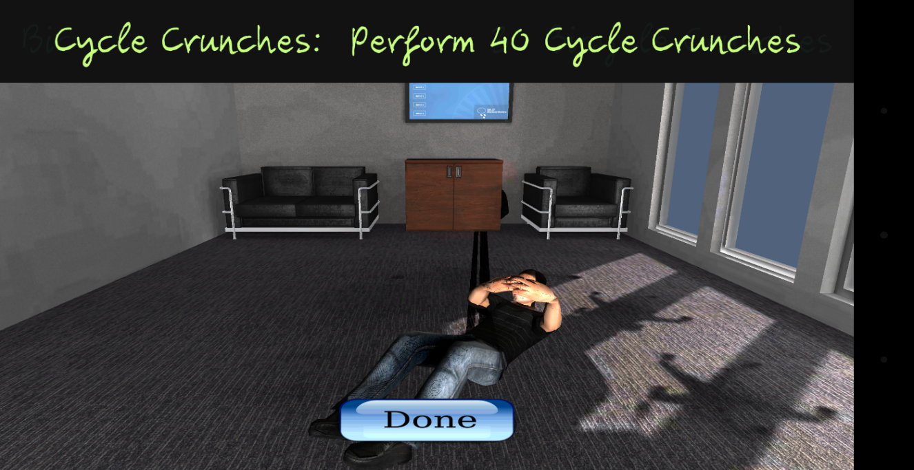

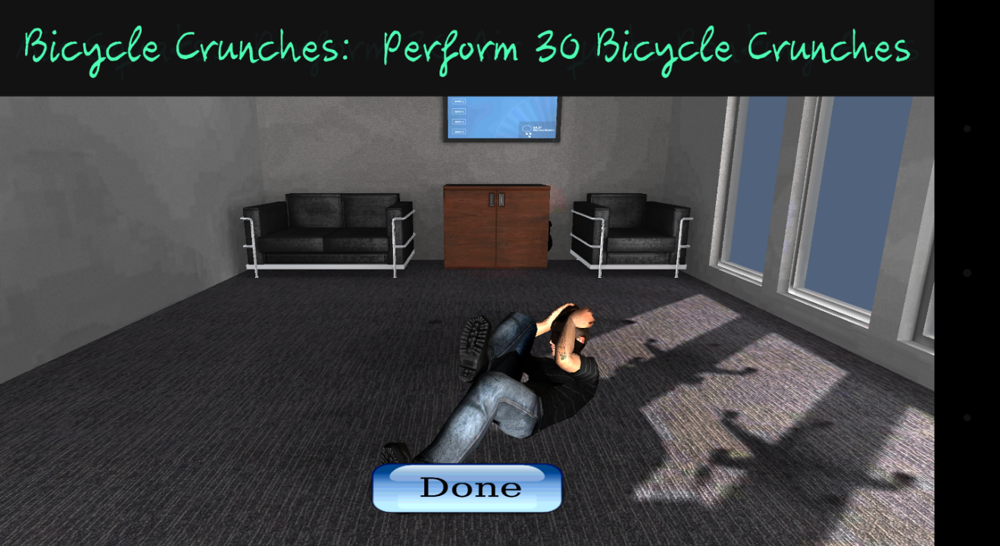
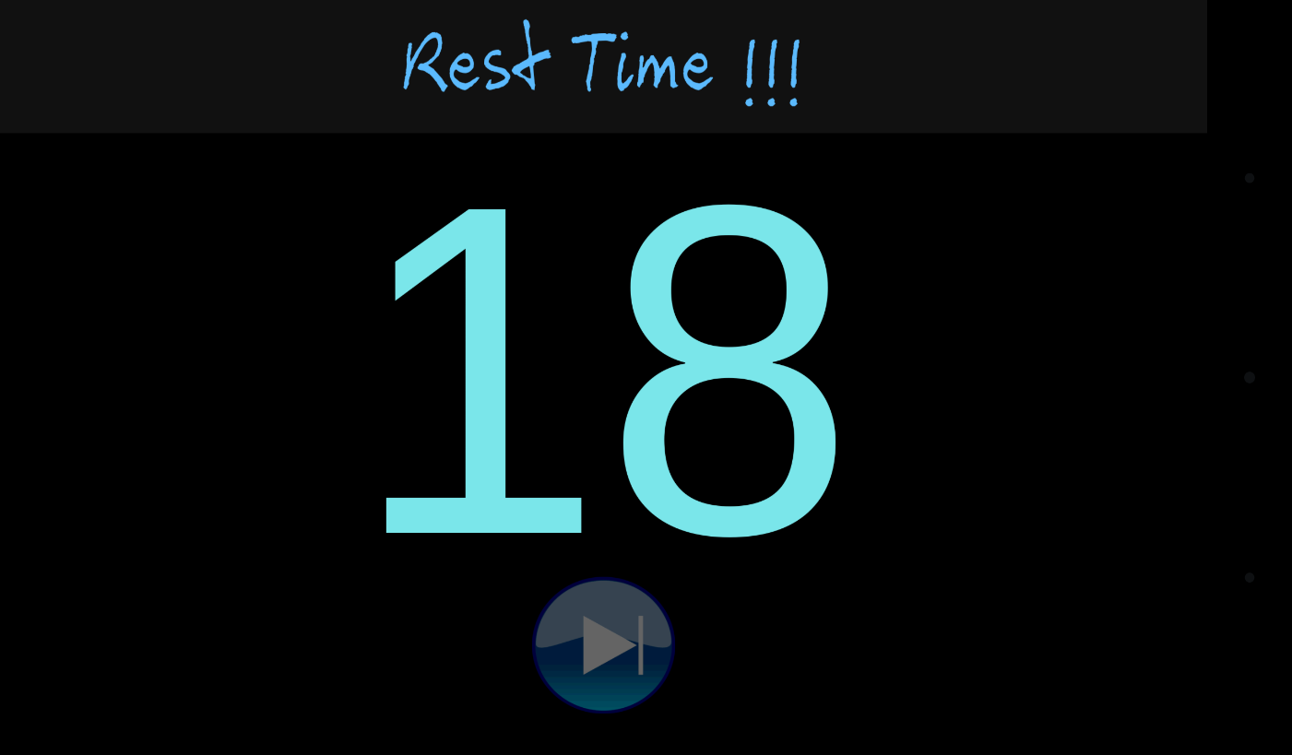
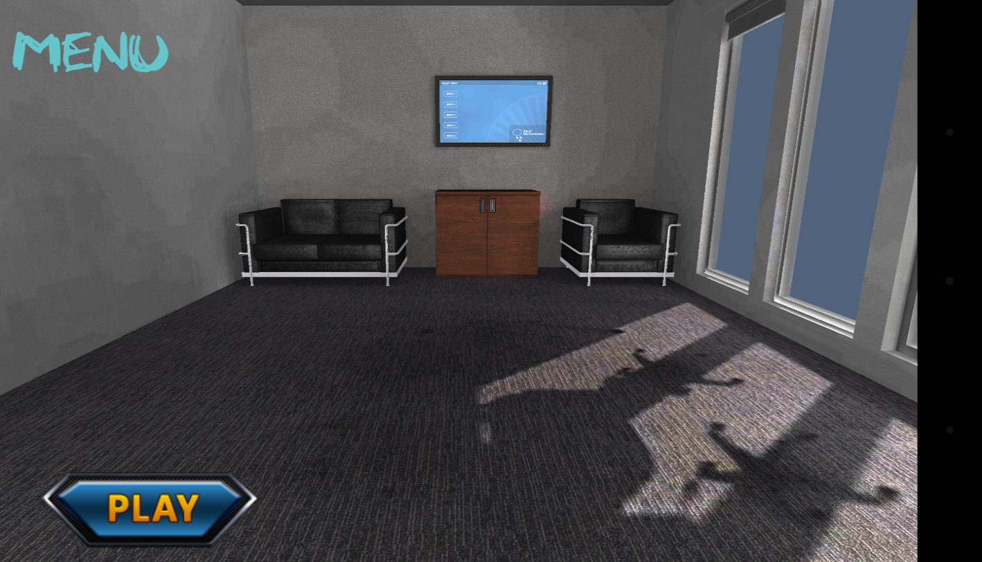
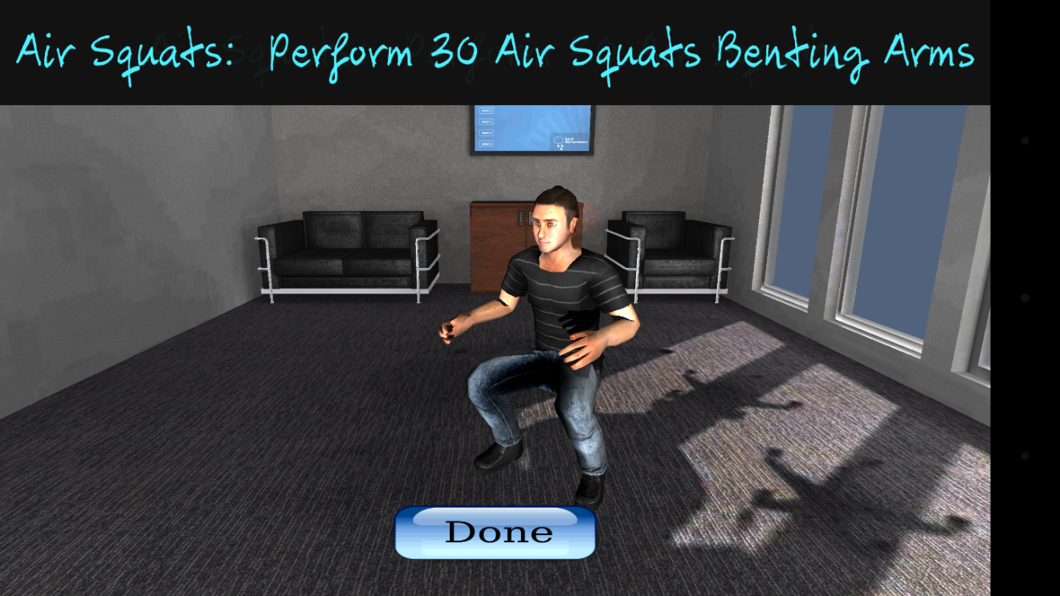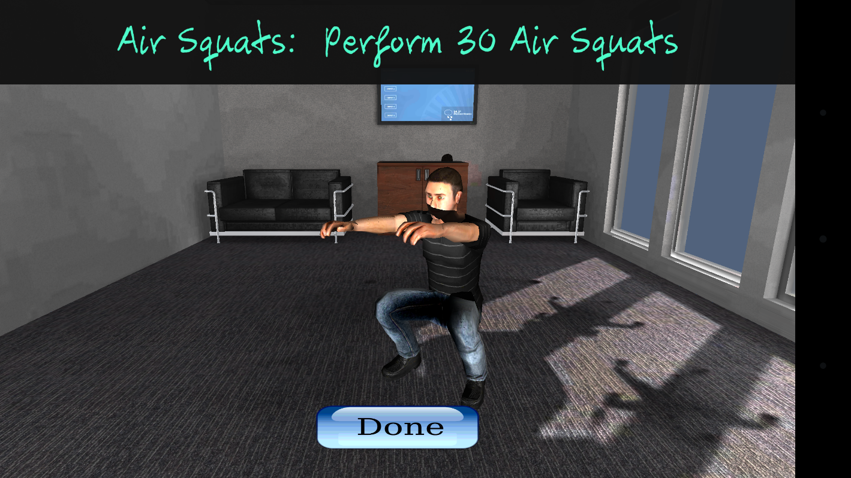

Data flow diagram (optional)

DFD Level 0
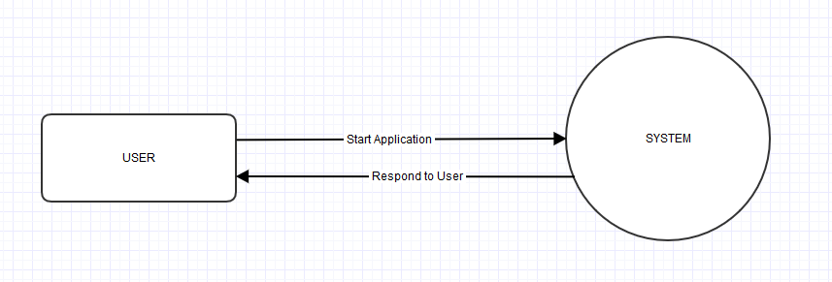

DFD Level 1

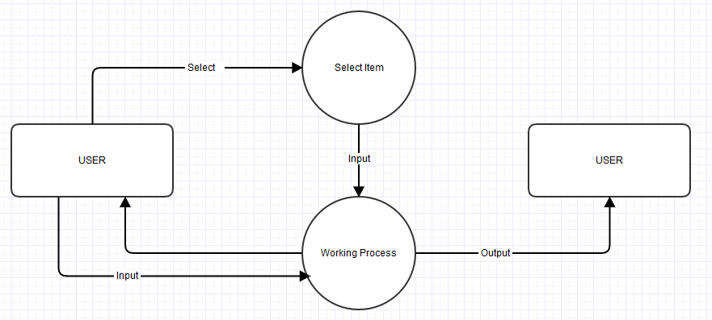

System Design

Application Architecture Diagram
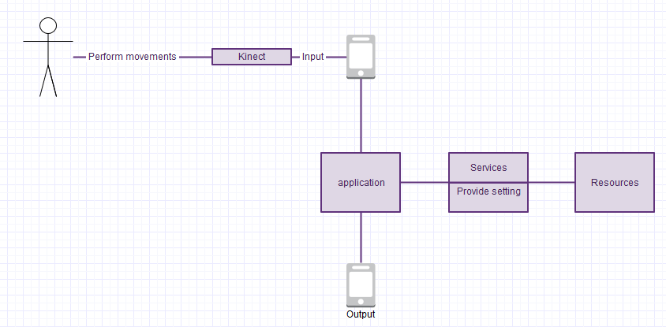
Figure 2: Architecture Diagram

Sequence Diagrams
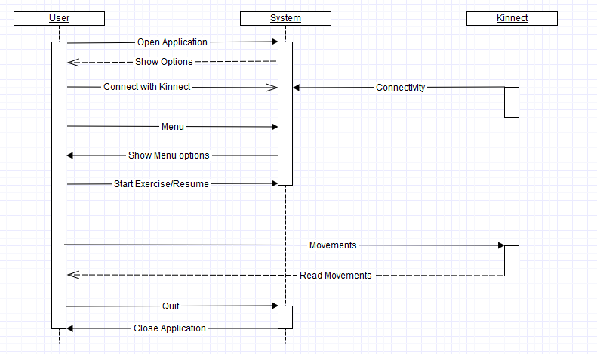

Collaboration Diagrams
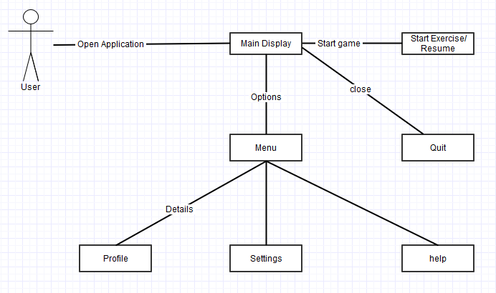

Data Dictionary
.

Element Name | Type | Validation | Mandatory | Remarks
Play | Varchar | 100 | Yes | Start game
Menu | Varchar | 100 | Yes | Different options
Timer | Varchar | 100 | Yes | Rest time
Next | Varchar | 100 | Yes | Next exercise

Implementation details

Development Setup
The following Development tools of project are as under:-
The tool we used to develop this game is Unity 3D. The main task is to connect Kinect with an android application. There was a Kinect and a PC involved in our development setup. We did not upload our game on google play yet.

Algorithms/Code

using UnityEngine;
using System.Collections;
using UnityEngine.UI;
public class gameManager : MonoBehaviour {
public string[] animName;

public int animIndex;
public int sec;

public float RestTime=30.0f;

public bool restOver;

public Animation playerAnimations;

public GameObject[] excercisePanels;
public GameObject[] Players;
public GameObject currentPlayer;
public GameObject startPanel;
public GameObject SkipPanel;

public Button btnSkip;

public Text timerText;
// Use this for initialization
void Start () {
animIndex = 0;
restOver = false;
currentPlayer=Players[PlayerPrefs.GetInt ("CurrentPlayer")];
currentPlayer.SetActive(true);
if (currentPlayer) {
playerAnimations=currentPlayer.GetComponent<Animation>();
}
startPanel.SetActive (true);
SkipPanel.SetActive (false);
for (int i = 0; i < excercisePanels.Length; i++) {
excercisePanels[i].SetActive(false);
}
}

void Update () {

if (RestTime > 1) {
restOver=false;
RestTime-=Time.deltaTime;
sec = Mathf.FloorToInt(RestTime % 60);
timerText.text=sec.ToString("00");

}
else if (RestTime<1&&restOver==false) {
restOver=true;
timerText.text="00".ToString();
btnSkip.interactable = true;

}
}

public void StartExcercise(){
startPanel.SetActive (false);
playerAnimations.Play(animName[animIndex]);
excercisePanels [animIndex].SetActive (true);
}

public void done(){
RestTime = 31.0f;
SkipPanel.SetActive (true);
btnSkip.interactable = false;
}

public void SkipRest(){
restOver=false;
SkipPanel.SetActive (false);
btnSkip.interactable = false;
if (animIndex < animName.Length-1) {
animIndex += 1;
StartExcercise();
}
}

}

Constraints
Constraints are conditions that we need to happen or would like to happen with a system. A limitation or restriction. Below are the constraints of the system.

Assumptions
User will download this app from play store. User must have a Kinect to play this app. When user will download this app he have to connect with this app and then he can play with the application. User can also give us feedback through app then we can make changes to our app for user requirements.

System constraints
There will be rest time of 30 seconds after performing each exercise, so the user can rest and then proceed to next exercise. Kinect is also can buggy sometimes. User must have knowledge to manage Kinect. User can give us feedback through play store reviews and comments.

Restrictions
There will be 10 exercises only that user can perform and after each time there would be rest time of 30 seconds. User must have to wait for 30 seconds which is rest time and then he can go to next exercise. There will be 4 different characters once user choose a specific character then he will play all exercises with that character only.

Limitations
This game is just limited to 10 exercises for now. Rest time is also limited for 30 seconds. We have also included 4 different characters that user can choose. After choosing that specific character user is just limited to play with that character only. When the game restarts then user can choose any character. This game is also limited with Kinect because sometime Kinect cannot read all the body movements and it’s also have a difficulty sending the movements to application.

Testing

Extended Test Cases
In Extended Test cases we can easily navigate our system how it works and where defects is.
Does our system pass the cases or not? Below are the extended test cases.
Table 1

Test case id:1 |  |  | Test Design By: Usama Sabir
Character Selecion |  |  | Test Design Date: 1/26/18
Test Priority: High |  |  | Test Executed By: Ahmad Mehmood Haider
Test/Title Name: To test the Character Selection |  |  | Test Executed date: 10/2/18
Description: Test the Character selection by the developer
Pre-condition: The User will open character menu
Dependencies
Step | Test Step | Test Data | Expected Result | Actual Result | Status(Pass/Fails) | Notes
1 | Character Menu |  | There will be 4 character | There was 4 character but they were blury | Pass

Table 2

Test case id:2 |  |  | Test Design By: Hashir Kamal
Play button |  |  | Test Design Date: 1/26/18
Test Priority: High |  |  | Test Executed By: Isameel Azeem
Test/Title Name: To test the Play button |  |  | Test Executed date: 10/2/18
Description: Test the Play button to start the exercise
Pre-condition: The user will peform exercise
Dependencies
Step | Test Step | Test Data | Expected Result | Actual Result | Status(Pass/Fails) | Notes
1 | Play button |  | There will be a exercise to perform |  | Pass
2 | Start the Exercise Yes or No
3 | 1st Exercise
4 | Rest time |  |  | There is a bug and stuck

Decision Table

Code snippet

Decision coverage table
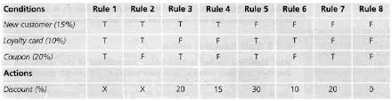

Traceability Matrix

RID vs UCID (requirements vs use cases)
UCID/RID | R  1 | R  2 | R  3 | R  4 | R  5 | R  6 | R  7 | R  8 | R  9 | R  10 | R  11 | R  12 | R  13 | R  14 | R  15 | R  16 | R  17 | R  18 | R  19 | R  21 | R  20
UC 1
UC 2
UC 3
UC 4
UC 5
UC 6
UC 7
UC 8
UC 9
UC 10
UC 11
UC 12
UC 19
UC 20
UC 21
UC 22
UC 23
UC 24
UC 25
UC 26
UC 27

Prototypes (RID vs PID)

Test Cases (RID vs TID)

Coverage (UCID vs TID)

Results/Output/Statistics

%Completion
The whole necessities composed by our group have been worked out completely. All the requirements that can be asked are completely fulfil included use cases, collaboration or any other diagram. It’s a 3d game that’s why it is difficult to manage or complete our project but we have almost complete our project with full hard work.

%Accuracy
Accuracy of our project is 90% because all the movements and designs creates successfully according to given conditions. Remaining 10% are the part of Kinect.

%Correctness
We are giving the training platform to the users to learn how to exercise in a correct way. We cannot guarantee the correctness of the data because our application is based on electronic devices.

Conclusion

By taking the opportunity to implement our idea of setting up “You fit” Kinect base android game. We believe that we were able to achieve many major milestones that were to develop the application in unity. The main milestone we had to achieve was connecting the Kinect with the system and people perform physical activities in front of Kinect. But we are keen to make it more advanced by further adding additional features into it, still there are many features and functionalities which could be implemented but we were not able to push forward towards them due to time limitation. We can socialize our application by connecting through social sites like, Facebook and twitter.
We also learnt about how to manage the project and come up with deliverables on time. The experience of development and designing of project has been very fruitful for us as we came to understand different aspects of android application development.
The project was quite challenging for us as we decided to implement it from scratch using the java and c sharp. During the process we came across different hurdles but we were determined towards completing our project. To ensure our product meets the user requirements tried our level best to make the product dynamic and to also ensure that our product meets the functional requirements.

Future work

Each new generation of game requires more processing power, rendering, faster movements and more memory than the generation before. We make no claim of almost 100 percent completion of this project because we need to improve and update this game with the time. We create better graphics for the game in future and include more characters and skills in this game. We have 10 physical exercises and in future we extended more exercises in our application. So this project need more improvements with the change of technology and devices. . Now a day there no such a device which connect Kinect device with mobile system. In future we also looking to upgrade this application by connected Kinect device with mobile system. Now a day there no such a device which connect Kinect device with mobile system.

Bibliography

Books

Journals

Articles

Research papers

Other References

Appendix

Glossary of terms

Pre-requisites

