Final Year Project Report
Python Coding Playground

Project Advisor:
Khawaja Ubaid Ur Rehman

Submitted By:
Abdul Basit – F2020266463
Ahmad Rumail – F2020266527
Fahad Hassan – F2020266453
Hassam Hameed – F2020266481
Waleed Butt – F2020266469

Session
2020-2024

University of Management and Technology
C-II Johar Town Lahore Pakistan

Contents
1. User manual 2
1.1 level 1 5
1.2 level 2 8
1.3 level 3 10
1.4 level 4 13
1.5 level 5 15

User Manual :
As the game opens the first screens that are displayed to the user are the storyline of the game. Below are the animations that will be displayed
- Animation 1
As the player clicks on the next button, screen 2 is displayed.
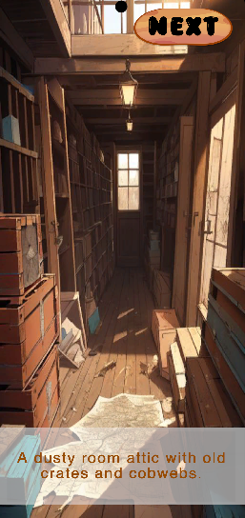
Screen 1: Animation 1

- Animation 2
As the player clicks on the next button, screen 3 is displayed.

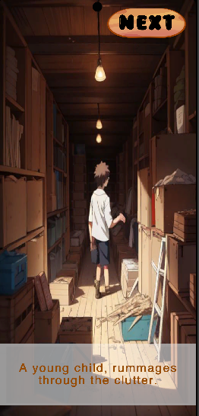
Screen 2: Animation 2

- Animation 3
As the player clicks on the next button, screen 4 is displayed.
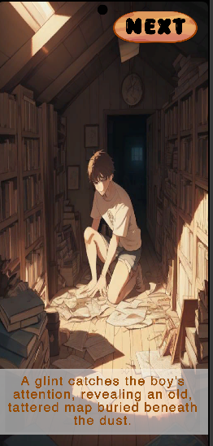
Screen 3: Animation 3

- Animation 4
As the player clicks on the next button, screen 5 is displayed.

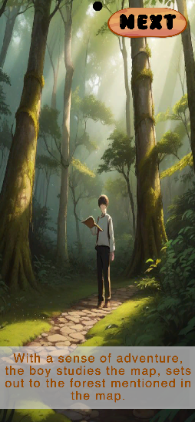
Screen 4: Animation 4

- Animation 5
As the player clicks on the next button, Main Menu Screen is displayed.

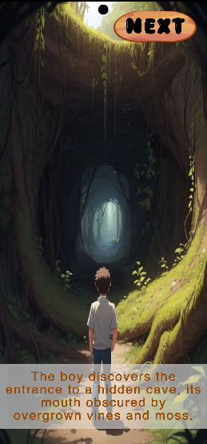
Screen 5: Animation 5
- Main Menu
Once the animations are played the user will be introduced by the game logo and a main menu screen.
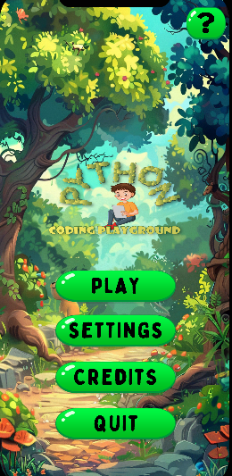
Screen 6: Main Menu

The user will click the “play” button to start the game and will be moved to level selection screen
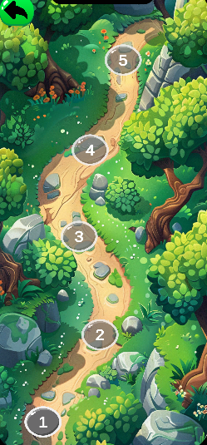
Screen 7: Level Selection Screen

After the screen is loaded, a level selection screen opens prompting it to select a level. Users will click on level 1 to start the game.

An animation will be played explaining the story then a tutorial will be displayed which will work as a guide through the level.
Level 1:
The first mini game focuses on the syntax understanding of Python. The user must drag and drop letters by picking them from the box below and placing them in the correct places.

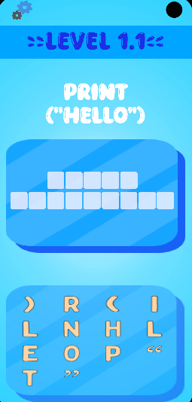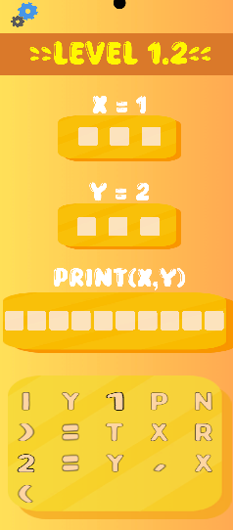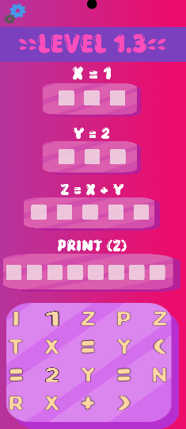
Screen 8: Level 1.1, 1.2, 1.3

When the level is in play a “pause” button will be there to pause game, from there user can resume the game, restart the game, go to main menu and mute and unmute the game music.

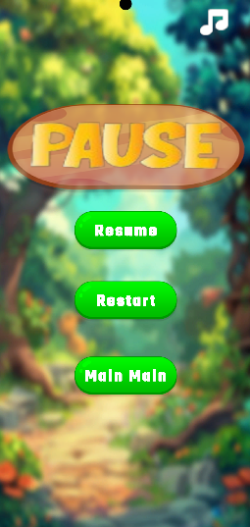
Screen 9: Pause Screen

When the user completes level 1.1 the next level will open, and user will move to that.

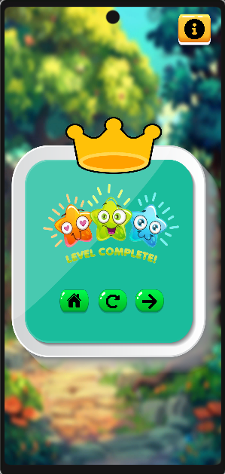
Screen 9: Level Completion Screen

In case, the user fails the level. It will be shown a level fail screen.

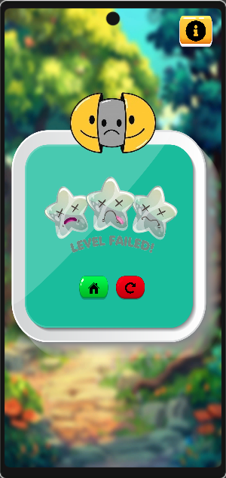
Screen 10: Level Failure Screen

After completing 3 levels (whole mini game) user will unlock the next mini game and move to level selection screen to select and play the next mini game.
The level selection screen will appear every time user opens the game to start over from where it left off or after completing each level.

Screen 7: Level Selection Screen

After Level 1 the user presses on the Level 2 button which takes them to level 2 gameplay screen. An animation will be played explaining the story then a tutorial will be displayed which will work as a guide through the level.

Level 2:
The second mini game is about program sequence and pattern learning. The user must move character from initial point to final point through implementing proper sequence.
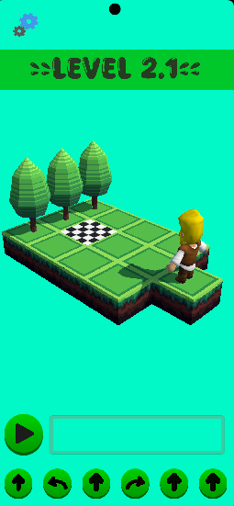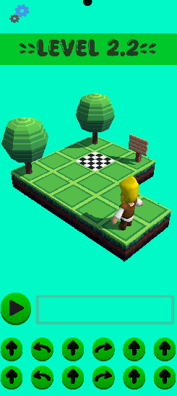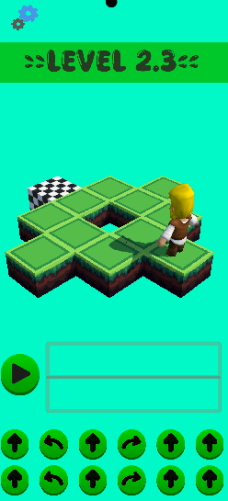
Screen 11: Level 2.1, 2.2, 2.3
When the level is in play a “pause” button will be there to pause game, from there user can resume the game, restart the game, go to main menu and mute and unmute the game music.

Screen 9: Pause Screen

When the user completes level 2.1 the next level will open, and user will move to that.

Screen 9: Level Completion Screen

In case, the user fails the level. It will be shown a level fail screen.

Screen 10: Level Failure Screen

After completing 3 levels (whole mini game) user will unlock the next mini game and move to level selection screen to select and play the next mini game.
The level selection screen will appear every time user opens the game to start over from where it left off or after completing each level.

Screen 7: Level Selection Screen

After Level 2 the user presses on the Level 3 button which takes them to level 3 gameplay screen. An animation will be played explaining the story then a tutorial will be displayed which will work as a guide through the level.

Level 3:
The third mini game is about introduction to data types, the user introduces data types like int, string and bool. This mini game is similar to level one like the drag and drop feature.
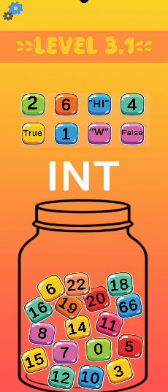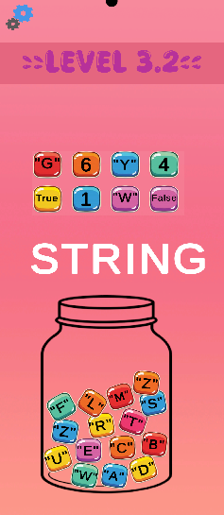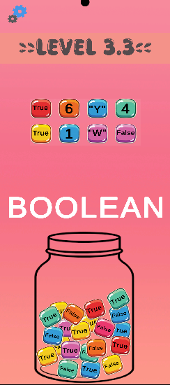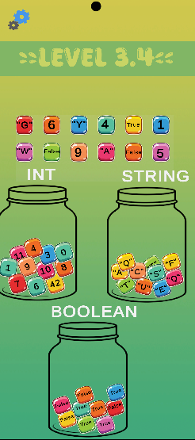
Screen 12: Level 3.1, 3.2, 3.3, 3.4

When the level is in play a “pause” button will be there to pause game, from there user can resume the game, restart the game, go to main menu and mute and unmute the game music.

Screen 9: Pause Screen

When the user completes level 3.1 the next level will open, and user will move to that.

Screen 9: Level Completion Screen

In case, the user fails the level. It will be shown a level fail screen.

Screen 10: Level Failure Screen

After completing 3 levels (whole mini game) user will unlock the next mini game and move to level selection screen to select and play the next mini game.
The level selection screen will appear every time user opens the game to start over from where it left off or after completing each level.

Screen 7: Level Selection Screen

After Level 3 the user presses on the Level 4 button which takes them to level 4 gameplay screen. An animation will be played explaining the story then a tutorial will be displayed which will work as a guide through the level.
Level 4:
The fourth mini game is about variable initialization. The user must connect the objects with the values they have been assigned to get the concept of variable assignment. This mini game consists of almost 3 levels.
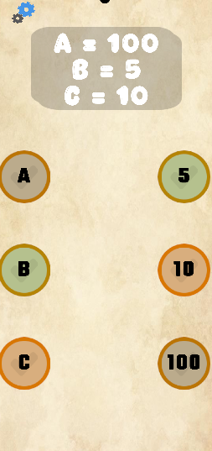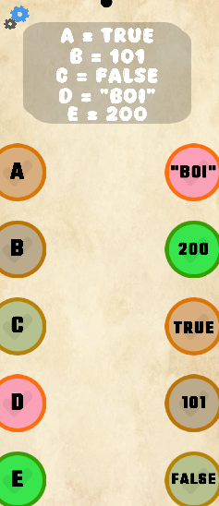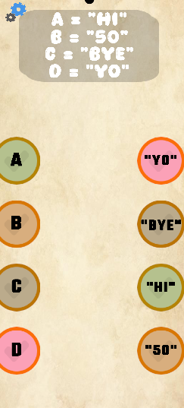
Screen 13: Level 4.1, 4.2, 4.3

When the level is in play a “pause” button will be there to pause game, from there user can resume the game, restart the game, go to main menu and mute and unmute the game music.

Screen 9: Pause Screen

When the user completes level 4.1 the next level will open, and user will move to that.

Screen 9: Level Completion Screen

In case, the user fails the level. It will be shown a level fail screen.

Screen 10: Level Failure Screen

After completing 3 levels (whole mini game) user will unlock the next mini game and move to level selection screen to select and play the next mini game.
The level selection screen will appear every time user opens the game to start over from where it left off or after completing each level.

Screen 7: Level Selection Screen

After Level 4 the user presses on the Level 5 button which takes them to level 5 gameplay screen. An animation will be played explaining the story then a tutorial will be displayed which will work as a guide through the level.

Level 5:
The fifth mini game is about learning the loop condition. The user has a character and can assign any movement for multiple options by dragging that movement in the loop and that movement will keep on happening until user ends the loop. It will consist of only one level but will have multiple movement/animation options for user to play with.
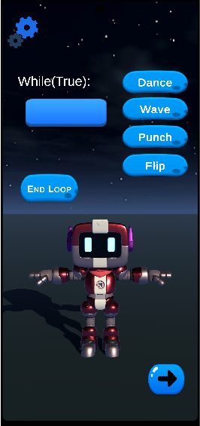
Screen 13: Level 5
When the level is in play a “pause” button will be there to pause game, from there user can resume the game, restart the game, go to main menu and mute and unmute the game music.

Screen 9: Pause Screen

When the user completes level 5 the storyline will open, and user will move to that. Screen 14 will be displayed.

Screen 9: Level Completion Screen

- Animation 6
As the player clicks on the next button, screen 15 is displayed.

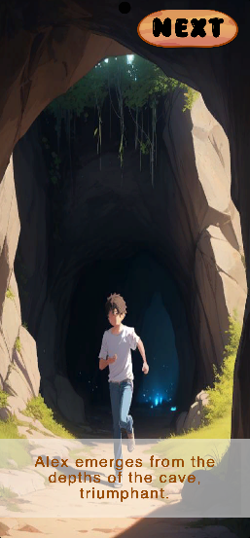
Screen 14: Animation 6

- Animation 7
As the player clicks on the next button, screen 16 is displayed.

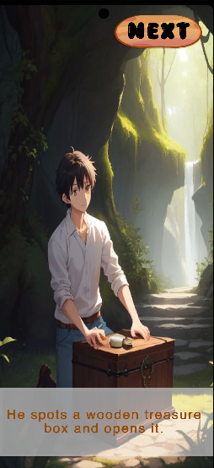
Screen 15: Animation 7

- Animation 8
As the player clicks on the next button, screen 17 is displayed.

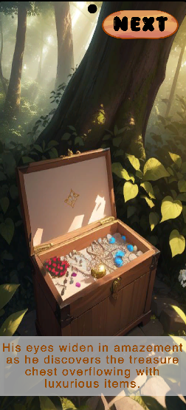
Screen 16: Animation 8

- Main Menu
The game can be played again
Screen 17: Main Menu

