Impact of CSR on financial performance: Fact or fiction? Evidence from Pakistani Banks
______________________________________________________
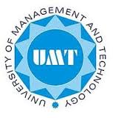
By
Haq Nawaz ID: 14007096004
MASTER OF SCIENCE

Department of Finance
School of Business and Economics
University of Management and Technology Lahore
2017
University Of Management and Technology
(UMT)

Impact of CSR on financial performance: Fact or fiction? Evidence from Pakistani Banks

Submitted to
School of Business and Economics
in Partial Fulfillment of the Requirements
for the Degree of

MASTER OF SCIENCE

By
Haq Nawaz ID: 14007096004
(MS Finance)
2017

