

Roles and Responsibilities of Flight Operations Officer
By
Ammar Akbar Butt
Submitted to: Imran Saeed (COD of Aviation Department)
This report is taking into account the Thesis of Ammar Akbar Butt submitted to Department of Aviation in satisfaction of necessities for the level of Bachelor of Aviation Management at University of Management and Technology.

Table Of Contents
Introduction: 7
Operational Control: 8
Licensing and Certification: 9
BASIC LICENSING PROCESS: 10
Legal Responsibilities: 11
Roles of Flight Operations Officer: 14
Load Planner: 14
Flight Follower: 14
Operations Coordinator: 14
Flight Planning: 16
Stages of Flight Planning: 16
Flight Information Gathering ( Pre Flight Planning ): 16
Flight Information Analyzing: 16
Flight Plan Calculation: 17
Conversions: 18
Fuel Requirement: 21
Aircraft Weights: 23
Aircraft Weight Limitations: 25
Mass and Balance: 26
Load Planning & Loading: 27
Center of Gravity (CG): 30
Semi-circular Cruising Levels: 31
CVSM (Conventional Vertical Separation Minimum): 31
Modified Cruising Level Table: 31
RVSM (Reduced Vertical Separation Minimum): 32
Altimetry: 32
Transition Altitude (QNH): 32
Transition Height (QFE): 32
Transition Level (QNE): 32
Transition Layer: 33
PNR (Point of No Return): 33
PNR3: 34
CP or ETP (Critical Point or Equi-Time Point): 34
CP3: 35
Documents to be Carried On Board: 35
Aircraft Related Documents : 35
Technical Library: 35
Flight Related Documents: 36
Flight Route Manual Library: 36
Criteria of Route selection: 37
Alternate Aerodrome: 38
Takeoff Alternate Aerodrome: 38
Enroute Emergency Aerodrome: 38
Destination Alternate Aerodrome: 38
Anti-Icing and De-Icing: 39
Fluids: 39
Type I 39
Type II 39
Type III 39
Type IV 39
Rubber Boots: 40
Heating Devices: 40
EXTENDED TWIN ENGINE OPERATIONS (ETOPS): 40
Introduction: 40
Purpose: 40
Type Design Eligibility: 40
Type Design Capability: 40
Type Design Operational Approval: 41
Adequate Airport: 41
Suitable Airport: 41
Take-off: 43
First Segment: 44
Second Segment: 44
Third Segment: 44
First Part: 44
Second Part: 44
Fourth Segment: 44
Take-off Speeds: 44
Factors Affecting Take-off and Landing: 45
Clear Way: 45
Stop Way: 45
Take-off Run Available (TORA): 45
Take-off Distance Available (TODA): 45
Accelerate Stop Distance Available (ASDA): 45
Landing Distance Available (LDA): 46
AVIATION TURBINE FUEL (JET FUEL): 46
CIVIL JET FUELS: 46
JET A-1 47
JET A 47
JET B 47
MILITARY: 47
JP-4 47
JP-5 47
JP-8 47
Required Aircraft General Knowledge to be an FOO 47
The Four Forces 49
Weight: 49
Lift: 49
Thrust: 49
Drag: 50
Principles of Flight 50
Axis of an Airplane 51
YAW: 51
ROLL: 52
PITCH: 52
Aircraft Components 52
Aircraft Systems 57
Hydraulic System: 57
Pneumatic System: 58
Airplane Oxygen and Pressurization system 59
Air conditioning system 59
Aircraft fuel system 60
Aircraft fire protection system 60
Engine (Power Plant) 61
Introduction: 61
Power: 63
Parts of Reciprocating Engine: 65
Turbo charging: 66
Supercharging: 66
The Fuel System: 67
The Carburetor: 68
Fuel Injection Systems: 69
Jet Propulsion: 71
The Ram Jet: 71
The Turbo Jet: 72
The Turbo Prop and Turbo Shafts: 72
The Turbo Fan: 73
Percent RPM: 73
Engine Pressure Ratio (EPR): 74
Minimum Equipment List (MEL) 74
INTERNATIONAL AERONAUTICAL TELECOMMUNICATION SERVICE 77
Time System: 77
Record of Communications: 77
Use of Abbreviations and Codes: 77
Cancellation of Messages: 78
Aeronautical Fixed Service (AFS): 78
Procedures for Communicating with Ground Stations: 79
Text Communication: 79
SITA (Société Interntionalé de Telecommunication Aeronautique): 79
AFTN (Aeronautical Fixed Telecommunication Network): 80
E-mail: 80
Procedures for Communicating with Aircraft: 80
Air-Ground Communications: 80
VHF Radio: 80
HF Radio: 80
SATCOM: 81
ACARS: 81
NOTAM: 81
SNOWTAM: 81

Introduction:
A Flight Operations Officer (otherwise called a aircraft dispatcher, carrier dispatcher, flight adherent or flight dispatcher) helps with arranging flight ways, considering wind bearing and velocity, climate, storms, aircraft execution and stacking, landing conditions at destination or adjust air terminals, and different conditions. Dispatchers give a flight taking after administration and prompt pilots if conditions or ways change. They ordinarily work in the operations or control focus of the aircraft. They are in charge of co-ordinating exercises to guarantee that aircraft leave for flights on time.
Flight operations officers liaise with a wide range of groups inside of an air terminal, including carriers, airplane terminal powers and other inner offices working in ground administrations. They need to verify that any work attempted to set up a flight is done to the right norms and inside of set time spans and have the last say regarding whether a aircraft can leave. They should likewise manage any sudden issues and verify that they are determined as fast and effectively as could reasonably be expected.
The occupation part can shift marginally between businesses; however flight operations officers are typically in charge of at any rate a percentage of the accompanying undertakings: utilizing carrier PC frameworks co-ordinating the turnaround of aircraft to guarantee on-time takeoff guaranteeing consistence with all significant security and wellbeing regulations arranging baggage situating, seating game plans and general burden dispersion and in addition fuel necessities, and checking them against regulations computing an aircraft's take-off and landing weights so as to get ready last weight and equalization documentation giving flight data to different offices/groups working at the air terminal guaranteeing that wellbeing and security norms are being met. The aircraft dispatcher will work with extraordinarily outlined programming that computes the payload (weight of load, gear, travelers and fuel) for the flight and prompts where it ought to be situated inside of the aircraft. They likewise compute the measure of fuel required for the flight. The aircraft dispatcher uses this data to create a heap sheet which is given to the pilot who enters this information into the flight deck PC before take-off. This is a vital assignment as this information guarantees that the airplane will fly securely all through its excursion.
The staff in an operations control focus work shifts, for the most part of around eight hours a day, five days a week, covering the greater part of the times that an air terminal is open. This can incorporate early mornings, nighttimes, weekends and bank occasions and potentially living up to expectations around evening time if the airplane terminal is open 24 hours a day. A significant part of the aircraft dispatcher's work happens at their work area in the operations office of the control focus. They invest a considerable measure of their energy chipping away at PCs. They likewise invest some of their energy airside (where the airplane are stopped up outside the terminal) and this can mean being outside in every climate condition. Flight operations officers may be given a uniform to wear, and must obviously demonstrate their character go at all times. When they are working airside they must wear a high-perceivability vest, ear safeguards and security shoes.
Operational Control:
Dispatchers for the most part share obligation regarding the activity of operational control, which gives them power to occupy, postpone or scratch off a flight.. After the arrival of a flight (in a joint obligation environment) the dispatcher uses advanced programming apparatuses to screen the flight's advancement and educates the flight team regarding any circumstances that may influence flight wellbeing. Shared obligation includes a layer of balanced governance to aircraft operation and significantly enhances security.
The International Civil Aviation Organization (ICAO), headquartered in Montreal, is the common flying branch of the UN (United Nations). ICAO states that the administrator (the carrier), is in charge of the operational control of its flights and just perceives dispatch frameworks utilizing flight dispatchers/flight operations officers as the intends to control and administer flights in Annex 6, Part 1, Chapter 3. Section 4 of Annex 6 portrays the obligations of flight dispatchers/flight operations officers while Chapter 10 of Annex 6 depicts the preparation and capability prerequisites for flight dispatchers/flight operations officers. Part 10 likewise perceives ICAO Document 7192 D3, The Flight Dispatcher/Flight Operations Officer Training Manual as the standard preparing asset for part States to add to their own particular flight dispatcher/flight operations officer preparing regulations.
The expressions "flight dispatcher", "aircraft dispatcher" and "flight operations officer" are to a great extent tradable relying upon the range of the world in which they are utilized. The expression "Aircraft dispatcher" is utilized the United States, while "flight operations officer" is more normal in Europe and Africa, and "flight dispatcher" is regularly utilized as a part of Asia and the Middle East.
At the point when working in an aircraft a flight operations officer needs to do a ton of work. He needs to correspond and coordinate with all other working branches of a carrier.

Licensing and Certification:
A License or a Certificate is the fundamental administrative device to guarantee that a man included with the operation of an aircraft has met the obliged information, preparing, knowledge and ability necessity for the doled out occupation. Chief General Civil Aviation Authority has assigned the Deputy Director General as the Licensing Authority.
Work force Licensing Office working under the Licensing Authority is approved to actualize the CAA Licensing Policy and release capacities identified with the staff permitting as per the CAA Regulations.
The Licensing Authority is in charge of all matters managing Personnel Licensing. In the implications of ICAO Annex 1, its capacities incorporate appraisal of a candidate's capability to hold a License/Certificate or a Rating, issue and supports of licenses, testaments & evaluations, assignments & approval of Approved persons, an Approval of Training Course, endorsement for the utilization of preparing gadgets and approval for their utilization in picking up experience and exhibition of expertise needed for the issue of a permit or a rating and acceptance of licenses issued by other contracting states.
In the event that you are 21 years old or above, with a Higher Secondary School Certificate, you are qualified to apply for the Flight Operations Officer License (FOOL). You should read the Licensing Regulations to recognize what exclusions are relevant to you on the premise of holding a flying permit or your flight related experience. Visit the Operation Room of an Airline or Handling Agency to get further direction.

BASIC LICENSING PROCESS:

• Applicant meets the Eligibility Criteria.

• Applicant has suitable Medical Class wellness.

• Appropriate ground Course/Training is finished.

• Flying Course/Training Program is finished.

• On Job Training is finished, if pertinent.

• Experience prerequisite is finished, if pertinent.

• Applicant has passed CAA Examinations, as pertinent.

• Applicant has finished CAA Skill Test/Check.

• CAA levy are paid & obliged records are submitted to Licensing Office.

Preceding the over, the Licensing Authority will guarantee that

• The Aviation Training Center meets the paradigm and is affirmed.

• The Instructors/Supervisors meet the endorsed capabilities and are affirmed.

• The preparing project is affirmed.

• Training Devices meet the endorsed criteria and are affirmed.

A dispatcher must be certificated by the aeronautics power of the nation in which they work or have a base of operations, for example, the CAA in Pakistan or FAA/DOT (Federal Aviation Administration/Department of Transportation) in the United States. Keeping in mind the end goal to get a declaration, a competitor must exhibit broad learning of meteorology and of flight when all is said in done, to a level equivalent to the holder of an Airline Transport Pilot (ATP) endorsement.

For carriers working under 14 CFR PART 135, dispatching obligations and obligations are really assigned to "flight devotees." The fundamental distinction between a flight dispatcher and a flight adherent is that recent does not share legitimate obligation regarding the operation of a flight. Moreover, a flight adherent is not needed to acquire a dispatcher's endorsement, despite the fact that he or she is generally urged to do as such by the aircraft for which they work and will likely not be utilized as a flight supporter in the event that they don't have the dispatcher declaration.

Numerous nations issue licenses or declarations which are taking into account ICAO Annex 1 and 6 and additionally ICAO DOC 7192 D3. Tragically not all nations have embraced a compulsory permit/accreditation and joint obligation/flight watch opera

Legal Responsibilities:
- Flight dispatchers are lawfully half in charge of the wellbeing of each flight they dispatch. The pilot in summon of the flight holds obligation regarding the other half. A flight dispatcher has the lawful power to decline to dispatch a flight if wellbeing is in any capacity being referred to, as does the pilot in order. This is known as 'Co-Authority Dispatch'. Since business choice making in a carrier can strife with the security of a flight, a flight dispatcher's obligations are kept separate from the business parts of an aircraft's operation, and as being what is indicated the calling is basically centered around the wellbeing of a flight; every single other dutie are optional.
- Flight dispatchers in a regular carrier are by and large in charge of directing anywhere in the range of 10 to 20 flights all the while, and are continually arranging new flights while checking current ones. Flight dispatchers are relied upon to have a major picture perspective of climate conditions, airplane status, fuel arranging, and other operational parts of keeping up smooth aircraft operations. On account of the always showing signs of change nature of carrier operations, flight dispatchers encounter an abnormal state of anxiety in the working environment, as they adjust operational limitations and weights with the overriding wellbeing order of the employment. As flight dispatchers are the 'concealed group part' in a carrier, pay is by and large much lower than that of pilots, in spite of being obliged to have the same learning of airplane frameworks, operations, climate and air law that a business pilot has. Combined with the high stretch of the employment, this outcomes in a high burnout rate among dispatchers and a comparable high turnover rate in most dispatch workplaces at the provincial carriers. Workload conditions at the significant aircraft level are enhanced drastically from the territorial level and turnover is thus lower.
- Dispatchers serve as a urgent part to the whole carrier operation. Flight operations officers are authorized pilots guaranteed by the Federal Aviation Administration. Dispatchers must experience broad testing and preparing to win this endorsement, and must pass both a broad oral examination and the complete composed Aircraft Dispatcher test. These tests are proportional to the Air Transport Pilot (ATP) composed and oral examinations that aircraft pilots should effectively finish.
- Crucial Duties and Responsibilities of a Flight Operations Officer:
- Responsible for financial matters, traveler administration and operational control of everyday flight operations.
- Prepare and sign the dispatch discharge to give lawful approval to a flight to withdraw as indicated by government and organization regulations to assist and guarantee security of flight.
- Analyze and assess meteorological conditions, aircraft position reports and aeronautical route diagrams to assess the advancement of flight, focus potential risks to security of flight, and select the most attractive and financial course of flight.
- Compute the measure of fuel needed for the protected finish of flight as indicated by kind of aircraft, separation of flight, upkeep confinements, climate conditions and least fuel prerequisites endorsed by government aeronautics regulations.
- Prepare flight arrangements containing data, for example, most extreme admissible departure and landing weights, climate reports, field conditions, NOTAMs, and numerous other instructive segments needed for the protected consummation of flight.
- Update the pilot in order of noteworthy changes to climate or flight plan, and suggest flight arrangement substitutes, for example, evolving course, height and, if needed, enroute arrivals in light of a legitimate concern for security and economy. This may incorporate deferring or crossing out flights if perilous conditions undermine the wellbeing of the dispatcher's airplane or travelers.
- Originate and scatter flight data to others in the organization including stations and reservations.
- Participate in yearly intermittent instructional classes covering aircraft frameworks, organization operations arrangement, meteorology and Federal Air Regulations as needed by the FAA. Likewise finish yearly operations acquaintance or "hop seating" for every aircraft the dispatcher is qualified in.
- Perform pre-flight checks and upkeep and get ready flight prepaCoordinate with pilot on allotted route with flight schedule, climate condition and geographical factors.
- Provide update on weather reports and inform pilots accordingly.
- Oversee aircraft safety and maintenance team to complete security and operational checks.
- Evaluate all fuel loads, cargo loads and aircraft weight.
- Maintain professional relations and inform airport staff and air traffic control regarding departure time to ensure aircraft’s timely departure.
- Provide a report on meteorology data with respect to icing, turbulence, rainstorms, haze and low roofs, winds on high, weight example flying and so on to educate pilots for smooth operation of flights amid such conditions.
- Coordinate with different offices, for example, aviation authority, air wellbeing office and other pertinent offices to encourage smooth operation of whole armada.
- Prepare and give residential and global climate preparation organizers, PC flight arrangements and locally available flight coordination arranges in meeting with sellers and government offices to guarantee productive operation.
- Provide flight dispatch and arranging administrations to organization administration in light of organization arrangements and strategies.
- Monitor locally available exercises amid flight operations and when grounded and guarantee agreeability to all strategies.
- Provide documentation backing to organization with respect to flight dispatch points of interest and brief lodge team on winning climate conditions.
- Maintain record sanctioning of aircraft and give backing to specially appointed arrangements, organization projects and crises.
- Provide complete record of flight operation that incorporates flight wellbeing and upkeep record, takeoff and entry data to organization and flight agencies.

Roles of Flight Operations Officer:

Load Planner:
Regularly (particularly in bigger aircrafts) a flight operations officer can be a heap organizer. Load organizers regularly have the same endorsement as a flight dispatcher. They should precisely arrange the stacking of the airplane and do the weight and equalization computations for the aircraft. In some payload aircraft, they need to outwardly review the stacking, verifying it has been done as per their guidelines. At the point when a heap organizer is ready the plane as an individual from the team, he or she will be accountable for arranging, stacking and offloading the freight for the length of time of the flight, and is known as loadmaster.

Flight Follower:
In a few nations, comparative obligations and obligations are assigned to flight devotees. The primary contrast between the aircraft dispatcher and the flight devotee is that the last does not share legitimate obligation regarding the operation of a flight. Amid the flight, the dispatcher is obliged to screen and educate the group regarding changes influencing wellbeing of flight. In flight taking after, extreme obligation and operational control of the flight rests with the Pilot in summon and Director of Operations (DO). Flight devotees work for the Director of Operations and are tasked with completing operational control capacities. Flight adherents are not needed to achieve a flight dispatcher's testament, despite the fact that they are normally urged to do as such.

Operations Coordinator:
In larger airlines flight operations officer also coordinate and communicate with other operational departments of airline. The typical operations of flight are catering, refueling, air conditioning, flight scheduling, crew scheduling and etc. So a flight operations officer communicates and coordinates with all these operations departments for safe and secure conduct of flight.

In Pakistan FOO courses are regulated by different airlines and handling agencies under the supervision of Pakistan Civil Aviation Authority. The course starts with 3 to 4 months ground training modules in which CAA approved and licensed teachers deliver the lectures in CAA approved facility. After that CAA conducts written exams to evaluate the candidate’s knowledge and skills. The exams are currently conducted in Islamabad and Karachi examination centers. After clearing the written exams, 3 months On Job Training has to be done at flight operations control centers at designated airports. After OJT a final viva is conducted by DG Operations to clear and approve the candidate for license of Flight Operations Officer.
The courses or modules offered during ground training are:
- Air Law
- ATC Procedures and Operational Procedures
- Aircraft Performance
- Human Performance
- Aircraft General Knowledge
- Principles of Flight
- Mass and Balance
- General Navigation
- Meteorology and Flight Planning
- VFR and IFR Communication
- Radio Navigation and Instrumentation
- Instrument Procedures

The main role and responsibility of Flight Operations Officer is Flight Planning, so let’s have deep look at what flight planning process involves and what information and calculations are required to complete this process.

Flight Planning:
Flight planning is a science and an art form that requires a high degree of technical knowledge and procedural discipline.

Stages of Flight Planning:
Operational Flight Plan is prepared in three major phases:
• Flight Information Gathering ( Pre Flight Planning );
• Flight Information Analyzing;
• Flight Plan Calculation.

Flight Information Gathering ( Pre Flight Planning ):
• Determine appropriate call-sign, aircraft type and registration, cockpit crew names.
• Gather MEL/CDL list, Payload, Dangerous Goods if any.
• Print weather (text & graphical) and NOTAM.
• Check ATC available departure slot, SID, route and any ATC delay.
• Check serviceability of aircraft.
• Gather information that pertains to a specific flight or station e.g. flight route clearance, curfew timings, airfield closure timings, noise restrictions etc.
• Prepare Informatory/Summary Flight Plan.

Flight Information Analyzing:
• Using weather, NOTAM information (including volcanic activity), cockpit crew and aircraft limitations, Jeppesen approach charts, special use airport consideration, determine takeoff and destination alternate(s), re-dispatch airports.
• Using weather, NOTAM and DDPG/MEL info, calculate MTOW and MLGW. Ensure all MEL/CDL performance penalties have been applied.
• Review routing, availability of over-flight and landing permissions. Check en-route weather conditions for hazardous weather phenomena.
• Review all station and FIR NOTAMs to determine their impact on the flight. Significant NOTAM should be briefed to the PIC or annotated on the flight plan for emphasis.
• Collecting and evaluating all data required to carry out flight planning i.e. weather forecast, METAR (if flight time is 2 hours or less), significant weather charts, upper wind charts, NOTAM.
• Review of Payload.

Flight Plan Calculation:
• Calculate Operational Flight Plan keeping in view meteorological conditions, en-route terrain clearance/limitations, oxygen requirement, ATC restrictions if any, constraint and any other conditions that may cause increase in fuel and/or oil consumption.
• Filing of ATC Flight Plan, as and where required.
• Preparing fuel advice form as per fuel policy. Sending fuel advice form to engineering informing the respective Trim Asst/Officer relevant fuel figures and take off performance, where applicable.
• Complete the remarks column of Flight Plan when applicable.
• The Operations Flight Plan is calculated on estimated payload or max payload if applicable and when final payload is received and difference is significant, the OFP shall be re-calculated.

Flight Planning:
Flight planning is a science and an art form that requires a high degree of technical knowledge and procedural discipline.

Conversions:
Distance:
1NM = 6080ft
1SM = 5280ft
1Km = 3280ft
Weight:
1Kg = 2.2046 Lbs
Volume:
1 IMPG = 4.5460 Liters
1 USG = 3.7853 Liters
Newton’s First law of Motion:
S = Vt
Where: S = Distance (Fuel Required / Used / Available)
V = Velocity (Fuel Flow)
t = Time
Track:
The path traveled by an aircraft along the ground to reach one point to another is called track. It is measured clockwise in terms of angle from the reference direction (usually North).

Heading:
The direction in which the nose of the aircraft is pointing is called heading. It is measured clockwise in terms of angle from the reference direction (usually North).
Course or Track Required:
It is the path on the earth’s surface that an aircraft is required to fly in going from one point to another. It is measured clockwise in terms of angle from the reference direction (usually North).
Track Made Good:
Actual path flown by an aircraft along the ground is called track made good. It is measured clockwise in terms of angle from the reference direction (usually North).
Track Error:
The angular difference between course and track made good measured right or left of the course is called track error.
Drift:
The deviation of aircraft from its course because of the movement of air mass in which the aircraft is flying is called drift.
Drift Angle:
The angular difference between heading and track made good measured right or left of the heading is called drift angle.
Drift Correction Angle:
It is the angular difference between course and heading measured right or left of the course. Drift Correction Angle is also called Wind Correction Angle or Crab Angle.
Air Speed:
Speed of an aircraft relative to the air mass in which it is flying is called air Speed.
Ground Speed:
Speed of an aircraft relative to the ground is called ground Speed.
Head Wind:
If an aircraft is flying in the opposite direction in which the wind is blowing then such a wind is named as head wind (when flying in head wind the ground speed is lesser than the air speed).
Tail Wind:
If an aircraft is flying in the same direction in which the wind is blowing then such a wind is named as tail wind (when flying in tail wind the ground speed is higher than the air speed).
Wind Component:
The resulting effect of blowing wind on a body is called wind component.
Speed of Sound:
The Speed at which sound travels through the air depends on its temperature.
Speed of Sound = 38.96 √ 273.15 + OAT
Mach Number:
It is the true air speed of an airplane specified as the ratio of the local speed of sound.
Mach Number = True Air Speed / Speed of Sound

Departure Base:
Departure base is the airport from where the flight is initiated.
Destination Base:
Destination base is the airport at which the flight will be terminating.
Alternate Base:
Alternate base is the airport to where the flight will proceed in case it becomes inadvisable to proceed to the destination.
Notes:
• Departure Base to Destination Base is called sector
• Rate of Climb (ROC) = Pressure Altitude / Climb Time
• Rate of Descent (ROD) = Pressure Altitude / Descent Time

Fuel Requirement:
• Taxi Fuel: A standard quantity of fuel to cater for ground maneuvers from engine start to brake release (including APU consumption).
• Trip Fuel: The fuel required from departure station to the planned destination, based on forecast meteorological conditions, is called Trip Fuel. This includes Take-off, Acceleration, SID, Climb, Cruise, Descent, STAR and Instrument Approach Procedure.
• Contingency Fuel: The fuel required to cover unforeseeable variations from the planned operation after engine start, i.e. changes in forecast wind/temperature, as well as ATC restrictions.
• Alternate Fuel: The fuel required to fly to an Alternate Airport, based on forecast meteorological conditions, which includes one Missed Approach at Destination, Climb, Cruise at LRC, Descent, STAR and Instrument Approach Procedure.
• Holding fuel: The fuel required for 30 minutes in clean Configuration at 1500 ft over the Alternate Airport in Standard Atmospheric Condition and will be calculated at estimated Landing Weight at the Alternate Airport.
• Stored Fuel: Any quantity of fuel carried for the purpose of ECONOMIC TANKERING.
• Discretion: Commander may ask for extra fuel uplift.
• Block Fuel: The block fuel is the sum of following:
- Taxi fuel
- Trip fuel
- Contingency fuel
- Alternate fuel
- Holding fuel
- Any stored fuel
- Discretionary Fuel, if any
- Extra fuel , if any
• Reserve Fuel: Reserve fuel depicted on the flight plan shall be the sum of alternate and holding fuel.

• Extra Fuel: Any additional fuel i.e. MEL required, Ballast, extra holding over destination due ATC or company requirements such extra holding fuel shall be calculated at the expected landing weight over destination at 1500’ AGL.

Aircraft Weights:

Basic Operating Weight (BOW):
Basic Operating Weight of the aircraft is the sum of aircraft empty weight, configuration weight, operating variables and additional weight.
Zero Fuel Weight (ZFW):
Zero Fuel Weight of the aircraft is the sum of Basic Operating Weight and Pay Load.
Pay Load (PL):
Load which generates revenue for the Operator is known as Pay Load, it includes Passengers and their baggage, Unaccompanied Baggage, Cargo and PO Mail.
Pay Load Available (PLA):
Maximum load that can be carried on a particular flight.
Pay Load Utilized (PLU):
Actual load that is being carried on a particular flight.
Ramp Weight:
Ramp Weight of the aircraft is the sum of ZFW and Block Fuel.
Take-off Gross Weight (TOGW):
Take-off Gross Weight of the aircraft is the sum of ZFW and Take-off Fuel.
Landing Gross Weight (LGW):
Landing Gross Weight of the aircraft is calculated by subtracting Burn-off Fuel/Trip Fuel from TOGW.

Notes:
Block Fuel = Taxi Fuel + Burn off Fuel + Reserve Fuel
Takeoff Fuel = Block Fuel – Taxi Fuel
TOGW = BOW + TOF + PL
BOW = Aircraft Weight + (Crew & their baggage)
TOW = BOW + TOF
ZFW = BOW + PL
TOGW = ZFW + TOF
Landing Weight = TOGW – BOF
Where:
TOGW = Takeoff Gross Weight
BOW = Basic Operating Weight
TOF = Takeoff Fuel
PL = Payload
ZFW = Zero Fuel Weight
TOW = Total Operating Weight
BOF = Burn off Fuel

Aircraft Weight Limitations:
Box A:
Box A is least of the following Take-off Gross Weights:
• Field Limit
• Climb Limit
• Obstacle Limit
• Brake Energy Limit
• Structure Limit
• Tire Speed Limit
Note: In case of Improved Climb Box A shall be Improved Climb Weight.
Box B:
Box B is the sum of Maximum Landing Gross Weight of the aircraft provided by manufacturer and Burn-off Fuel, when BOF is added in MLGW it becomes Maximum Landing Gross Weight limited TOGW.
Box C:
Box C is the sum of Maximum Zero Fuel Weight of the aircraft provided by manufacturer and Take-off Fuel, when Take-off Fuel is added in MZFW it becomes Maximum Zero Fuel Weight limited TOGW.
Box D:
Box D is the sum of Weight (limited at point X) and Burn-off Fuel from Departure to point X. Box D shall be calculated in case of any En-route aircraft performance weight limitation or approach climb weight limitations at any particular airfield. Box D is En-route Weight Limited or Approach Climb Weight Limited Maximum Take- off Gross Weight.
Note: Minimum of Box A, B, C and D shall be the maximum allowable Take-off Gross Weight of the particular flight.
The description of above mentioned BOXES may vary from company to company.

Mass and Balance:
At whatever point mass and equalization is talked about you will find that the terms mass and weight are viewed as tradable. This isn't in fact right in light of the fact that weight is a power and mass is a measure of the amount of matter. The unit utilized ought to clear up whether the amount is a mass or a weight be that as it may, once more, this regularly isn't the situation practically speaking. You will run over numerous shortened forms which can end either in mass or weight.
Aircraft Weights:
Basic Operating Weight (BOW):
Basic Operating Weight of the aircraft is the sum of aircraft empty weight, configuration weight, operating variables and additional weight.
Zero Fuel Weight (ZFW):
Zero Fuel Weight of the aircraft is the sum of Basic Operating Weight and Pay Load.
Pay Load (PL):
Load which generates revenue for the Operator is known as Pay Load, it includes Passengers and their baggage, Unaccompanied Baggage, Cargo and Mail.
Pay Load Available (PLA):
Maximum load that can be carried on a particular flight.
Pay Load Utilized (PLU):
Actual load that is being carried on a particular flight.
Ramp Weight:
Ramp Weight of the aircraft is the sum of ZFW and Block Fuel.
Take-off Gross Weight (TOGW):
Take-off Gross Weight of the aircraft is the sum of ZFW and Take-off Fuel.
Landing Gross Weight (LGW):
Landing Gross Weight of the aircraft is calculated by subtracting Burn-off Fuel/Trip Fuel from TOGW.

Load Planning & Loading
Loading an aircraft requires much more skills than loading of any other means of transportation. The total load and its distribution must be carefully planned and the plan must be rigidly adhered during loading.
The load must be distributed in such a way as to ensure that
• The aircraft is satisfactorily balanced after loading
• The load must be distributed in such a manner that neither the overall fuselage strength nor the local strength of the floor are exceeded
• The combine weight within a section of the fuselage (hold & the cabin compartment immediately above it) must not exceed the limits.
• Capacity governed by aircraft structure and version
• Capacity as determined by the anticipated flight, e.g. route and fuel.

Unit Load Device:
The very rapid development of aircraft type and the rapid expansion of the market during 1960s culminated in the wide body aircraft which are capable of carrying inter modal units. This rapid development led to a proliferation of unit type with an assortment of characteristics and dimensions.
Aircraft Pallet:
A thing of hardware comprising of a level stage with level under surface of standard measurements on which products are collected and secured before being stacked as unit on to the aircraft and which interfaces specifically with the aircraft load taking care of and restriction framework.
Aircraft Pallet Net:
A webbing or rope net for limiting burden onto a aircraft bed. It might likewise be utilized as a part of conjunction with an igloo. The net is a vital piece of the aircraft limitation framework. The bed and net are endorsed by the airworthiness power.
Aircraft Container:
A totally encased unit load gadget (made out of Base, Walls. Entryway and a Roof in partitioned amassed boards or as a solitary shell) which interface specifically with the aircraft load taking care of and restriction framework.
Lashing (Restraining the load):
• Ropes (Nylon or Sisal)
• Straps (Nylon)
• Nets (Nylon)
• Cables or coils (Metallic)
Purpose of ULD:
The motivation behind unit load gadget is to empower individual bits of payload to be gathered into standard estimated units to encourage fast stacking/emptying onto aircraft having perfect taking care of and limitation frameworks which interfaces specifically with the unit. Aircraft ULDs i.e. beds, Nets, Containers and Igloos are an essential piece of the aircraft and have been intended to existing models. Stacking/treatment of ULDs ought to be done with the most extreme consideration to guarantee in-flight security, unwavering quality and greatest gear life.
Advantages of ULDs:
• Time Saving
• Segregation
• Safety
• Protect (Goods) from adverse weather conditions
Effects of Improper Loading:
Safety is a first commandment and safe loading is a prime requirement. The aircraft is considered to be badly loaded if it is
• Nose Heavy
• Tail Heavy
• Over Loaded
In such cases conditions the expected effect would be as:
- Poor maneuver ability
- Longer take off run
- Lower rate of climb
- Increased fuel consumption
- Decreased endurance
- Reduction in safety factor – structure failure
- Tendency to dive
- Undue strain on nose wheel
- Tendency to stall
- Danger of tipping on ground

Improper loading / unloading can also cause damage to aircraft equipment, conveying system, cargo doors and damage to aircraft structure.

Center of Gravity (CG):
Introduction:
Center of Gravity is that point of body to which the total weight of body is considered to act.
Formula:
To calculate CG we require the information about Weight, the distance of that Weight from the Reference Point (Arm) and the Moments produced by that weight. The equation for Weight, Arm and Moments is as follows:
Moments = Weight x Arm

MAC (Mean Aerodynamic Chord):
MAC is the mean aerodynamic chord of the wing which is superimposed on the longitudinal axis of the aircraft.
LEMAC (Leading Edge of Mean Aerodynamic Chord)
TEMAC (Trailing Edge of Mean Aerodynamic Chord)
Formula:
CG aft of LEMAC = CG – LEMAC
CG (% of MAC) = (CG aft of LEMAC / MAC) x 100

Semi-circular Cruising Levels:
• The minimum vertical separation between two aircrafts shall not be less than 1000ft.
• An aircraft shall fly EVEN flight levels when flying towards west.
• An aircrafts shall fly ODD flight levels when flying towards east.

CVSM (Conventional Vertical Separation Minimum):
o The minimum vertical separation between the aircrafts flying in the opposite direction shall be 1000ft.
o The minimum vertical separation between the aircrafts flying in the same direction shall be 2000ft.
o This shall be applicable up to FL 290.

Modified Cruising Level Table:
o The minimum vertical separation between the aircrafts flying in the opposite direction shall be 2000ft.
o The minimum vertical separation between the aircrafts flying in the same direction shall be 4000ft.
o This shall be applicable between FL 290 and FL 410.

RVSM (Reduced Vertical Separation Minimum):
o The minimum vertical separation between the aircrafts flying in the opposite direction shall be 1000ft.
o The minimum vertical separation between the aircrafts flying in the same direction shall be 2000ft.
o This shall be applicable between FL 290 and FL 410.

Altimetry:
Subscale Setting Instrument Indication
On The Ground In The Air
QFE Zero Height above the aerodrome level
QNH Elevation of the aerodrome Height above mean sea level
QNE Pressure Altitude of the aerodrome Pressure Altitude of the aircraft

Transition Altitude (QNH):

The height in the region of an airplane terminal at or beneath which the vertical position of a aircraft is controlled by reference to elevations (MSL).

Transition Height (QFE):
The tallness in the region of an air terminal at or underneath which the vertical position of a aircraft is communicated in stature over the airplane terminal reference datum.

Transition Level (QNE):
The least Flight Level accessible for utilization over the move elevation.

Transition Layer:
The most minimal Flight Level accessible for utilization over the transition. The airspace between the move height and the move level. Aircraft plummeting through the move layer will utilize altimeters set to neighborhood station weight (QNH), while leaving aircraft moving through the layer will be utilizing standard altimeter setting (QNE) altitude.

PNR (Point of No Return):
The most remote point enroute from which an airplane can return back to flight station expending the accessible measure of fuel with extraordinary stores (PNR Reserves) in its fuel tanks.
Formula:
E = Fuel available for PNR / Fuel flow per hour
Time to PNR = (E x H) / (O + H)
Where:
E = Endurance
H = Ground speed home (GSH)
O = Ground speed out (GSO)
Note: WC = COS (WD - TT) x WS
XWC = SIN (WD - TT) x WS

PNR3:
PNR3 is described as the point of no return with, reduced speed or speed with one engine inoperative.
Formula:
Distance to PNR3 = Fuel available for PNR3 / (FRO + FRH)
Time to PNR3 = Distance to PNR3 / GSO (N)
FRO = FF (N) / GSO (N)
FRH = FF (R) / GSH (R)
Where:
FRO = Fuel Required for 1NM Out
FRH = Fuel Required for 1NM Home
FF (N) = Fuel Flow Normal
FF (R) = Fuel Flow Reduced
GSO (N) = Ground Speed Out Normal
GSH (R) = Ground Speed Home Reduced

CP or ETP (Critical Point or Equi-Time Point):
A point enroute from where it shall take equal time to proceed to destination base or to come back to departure base.
Formula:
Distance to CP = (Total Distance x H) / (O + H)

CP3:
CP3 is described as the critical point or equi-time point with, reduced speed or speed with one engine inoperative.
Formula:
Distance to CP3 = (Total Distance x GSH (R)) / (GSO (R) + GSH (R))
Time to CP3 = Distance to CP3 / GSO (N)

Documents to be Carried On Board:

Aircraft Related Documents :
• Air operator certificate (AOC)
• Certificate of Registration
• Certificate of Airworthiness
• Radio License
• Noise Certificate
• Insurance Certificate
• Operating Permits
• Weight Schedule

Technical Library:
• Operation Manual or Flight Crew Operating Manual (FCOM)
• MEL/DDPG
• Weight and Balance Manual
• Takeoff Gross Weight Book
• (OETB, OEIB, Routes and Navigation Bulletins, Standard Bulletins, Training Bulletins)
• Dangerous Goods Manual
• ETOPS Guide
• Flight Operations Manual

Flight Related Documents:
• Operational Flight Plan
• ATC Flight Plan
• Fuel Indent Advice
• Trim Sheet
• Aircraft Technical Log
• Passenger/Cargo Manifest
• General declaration. (For Intl. Flights)
• AIREP
• Bird Strike Form
• Air Miss Form
• Lightning Strike Reporting Form
• Birth onboard/Death onboard Form
• Post Flight Information Report
• Aircraft Occurrence Initial Report
• Disorderly Passenger Release Performa

Flight Route Manual Library:
Route Manuals in accordance with the route to be flown.

Criteria of Route selection:
The criteria for route selection shall be as follows:
a) The availability of en-route, terminal and alternate navaids;
b) Weather conditions and the availability of meteorological services;
c) Diplomatic clearance, over flight and traffic rights, politically sensitive area and special national requirements;
d) The availability of ground handling and servicing facilities;
e) Terrain to be over flown compared to aircraft performance limitations;
f) Oxygen requirements;
g) Fuel availability;
h) SAR facilities;
i) NOTAMs;
j) Within the constraints of route requirements, the flight routing selected shall be that which result in a minimum operational cost consistent with ATC restrictions, weather conditions and passenger convenience.

Alternate Aerodromes:

Takeoff Alternate Aerodrome:
A takeoff alternate aerodrome (at or above its own operating minima) should be chosen and indicated in the operational flight arrangement if the climate conditions at the aerodrome of takeoff are at or underneath the pertinent aerodrome working minima or it would not be conceivable to come back to the aerodrome of takeoff for some other reasons.
The departure interchange aerodrome might be situated inside of the accompanying separation from the aerodrome of takeoff.
a) Airplanes having two motors: not more than at a separation identical to a flight time of one hour at single-motor journey speed.
b) Airplanes having three or more motors: not more than at a separation comparable to a battle time of two hours at one-motor out of commission voyage speed.

Enroute Emergency Aerodrome:
ICAO Regulations dictate that an airport should be designated for flights over high terrain, where for performance or oxygen requirements, an enroute landing can be safely made. For planning purposes the Weather Minima of an Enroute Emergency Aerodrome shall be as per normal alternate planning minima. Such airports shall be selected and specified on the Operational as well as ATC Flight Plans.

Destination Alternate Aerodrome:
No less than one destination interchange aerodrome might be chosen and indicated in the Operational Flight Plan and ATS Flight Plan for a flight directed as per instrument flight rule (IFR).

Anti-Icing and De-Icing:
Numerous present day planes that are intended for individual and corporate utilization, and also bigger transport sort planes, are fitted with different frameworks intended to keep ice from shaping (hostile to icers) or to evacuate ice after it has shaped (de-icers).

Fluids:
There are liquids which are discharged through permeable driving edge individuals to stream over the cutting edges of the propellers and the surfaces of the wings. A liquid is an against icing gadget since it makes it troublesome for ice to frame. The gear most usually utilized on ground is the truck-mounted versatile hostile to icer/de-icer. For this situation liquids are utilized both as hostile to icers (when unheated) and de-icers (when warmed). The four essential sorts of liquids utilized are:

Type I (unthickened) liquids have at least 80% glycol content and are moderately low consistency, aside from at low temperatures. The consistency of sort I liquids depends just on temperature. The extra time is generally short for sort I liquids.
Type II (thickened) liquids have a fundamentally higher remainder time. Sort II liquids have a base glycol substance of half with 45% to half water in addition to thickeners and inhibit, Type II fluids should not be used on aircraft with a rotation speed of less than 100kts. Below this speed, some of the fluid may not completely flow away and may cause some degradation in performance.
Type III – Type III is a thickened fluid with properties between Types I and II. It has a longer holdover time than type I but less than Type II. It is suitable for use on aircraft with a shorter ground roll to rotation and a rotation speed of less than 100kts.
Type IV – Type IV fluids meet the same specifications as the Type II fluids while also having a significantly longer holdover time. They are dyed green so as not to be mistaken for ice.
Note: These fluids are also known as FDP (Freezing Point Depressant) fluids.
Rubber Boots:
Films of elastic are joined to the main edges. They can be made to throb in a manner that ice is split and severed after it has effectively framed. This is a de-icing gadget.
Heating Devices:
Warming defenseless ranges is a system for keeping the development of ice. Hot air from the motor or unique warmers is ducted to the main edges of wings, empennages, and so on.

EXTENDED TWIN ENGINE OPERATIONS (ETOPS)

Introduction:
ETOPS is the acronym made by ICAO to portray the operation of twin-engined airplane over a course that contains a point more distant than one hour's still air flying time, at the endorsed chose one motor out of commission voyage speed under ISA conditions, from a satisfactory air terminal. Time is the focal component in ETOPS, guidelines representing ETOPS are concerned with to what extent, and under what conditions a aircraft with two motors ought to be permitted to fly from a runway.

Purpose:
Motivation behind ETOPS is to give elevated amounts of wellbeing to encourage the utilization of twin planes on such courses which were confined to three and four motor aircraft.
Design Considerations:
ETOPS can be led by those planes which are either outlined or altered and affirmed to meet ETOPS accreditation necessities.

Type Design Eligibility:
Producer must show that airplane conforms to the obliged ETOPS plan criteria set by the administrative powers and is qualified to work ETOPS with indicated preoccupation time e.g. 120 minutes.

Type Design Capability:
ETOPS sort outline qualified aircraft must demonstrate that aircraft/motor mix is adequately solid on the in-administration experience.
(250,000 motor flying hours with 0.05% normal motor IFSD per 1000 hours)

Type Design Operational Approval:

75 minutes ETOPS endorsement (FAA regulation) or an hour and a half (ICAO regulation) can be gotten from nearby administrative organizations with insignificant or no administration encounter, one year in administration experience is needed for 120 minutes approbation.

(ETOPS regulations are material to courses over water and in addition land zones and beneath an hour limit ETOPS necessities don't have any significant bearing)

Adequate Airport:
An air terminal is viewed as "satisfactory" by administrator and concurred with the national power in view of the aircraft execution necessities relevant at the normal arrival weight.
Taking after thought ought to be met at the normal time of utilization:
• Availability of air terminal.
• Over flying and landing approvals.
• Capability of ground operational help. (ATC, MET, AIS workplaces, protect and firefighting classification)
• At minimum one let-down nav aid must be accessible for instrument approach. (ILS, VOR, NDB)

Suitable Airport:
Suitable is an affirmed satisfactory airplane terminal which fulfills ETOPS climate minima prerequisites regarding roof and perceivability with in a legitimacy period. This period starts one hour prior most punctual ETA and finishes one after most recent ETA, cross wind estimates and field conditions ought to additionally be considered in this legitimacy period.
Maximum Diversion Time (Rule Time):
It is the greatest time from any point on the course to a suitable airplane terminal determined by national power. It is just used to focus the region of operation, it is not an operational time impediment for directing a redirection, winning climate conditions and different elements may impact genuine preoccupation time.
Maximum Diversion Distance (Rule Distance):
It is the most extreme redirection separation secured in still air and ISA conditions inside of greatest preoccupation time at chose one motor out pace plan and at the related cruising height (counting float down stage). It is utilized as a part of dimensioning the zone of operation.
ETOPS Area of Operation:
It is the range in which it is approved to direct flight under ETOPS regulations characterized by most extreme preoccupation separation from a sufficient air terminal or set of air terminals; it is spoken to by circles fixated on the satisfactory airplane terminals.
ETOPS Entry Point (EEP):
It is the point situated on aircraft's outbound course at one hour flying time, at the chose one-motor out redirection rate plan (in still air and ISA conditions) from the last satisfactory airplane terminal preceding entering ETOPS fragment.
ETOPS Exit Point (EXP):
It is the point situated on aircraft's course at one hour flying time, at the chose one-motor out redirection pace plan (in still air and ISA conditions) from the first satisfactory air terminal before leaving ETOPS fragment.
Equi-Time Point (ETP):
It is a point on the aircraft course situated at same flying time from two suitable redirection air terminals.
Critical Point (CP):
It is a point on the airplane course which is discriminating as to ETOPS fuel prerequisites.
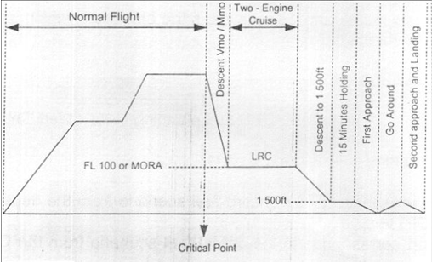
Aircraft Depressurization Flight Profile:

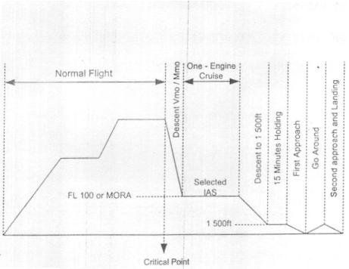
One Engine out Depressurization Flight Profile:

Take-off:
The act which take’s the aircraft in the air is called a take-off, it consists of four segments assuming critical engine inoperative.

First Segment:
The climb from the 35ft height point until the landing gear is fully retracted.

Second Segment:
The climb from gear retraction point until a height of 400ft is reached.

Third Segment:
This is the horizontal distance covered after the second segment until the flaps retraction speed is reached. This segment consists of two parts:

First Part:
The distance covered before flaps retraction accelerating to flaps retraction speed.

Second Part:
The distance covered after flaps retraction, accelerating to final take-off speed.

Fourth Segment:
The climb from 400ft height till 1500ft height is reached, after the end of the third segment, operating with Maximum Continuous Thrust/Power.

Take-off Speeds:
V1 (Take-off Decision Speed)
VR (Take-off Rotation Speed)
VLOF (Lift-off speed)
V2 (Take-off Safety Speed )
VMCG (Minimum control speed on the ground)
VMCA (Minimum control speed in the air in a take-off configuration)

Factors Affecting Take-off and Landing:

Clear Way:

A Clear Way is a region past runway, at least 500ft wide, halfway situated about the augmented centerline of the runway.

Stop Way:

A Stop Way is a region past runway, not less in width than the width of runway, midway situated about the expanded centerline of the runway, for decelerating the plane amid a denied take-off, stop way must be fit for supporting the plane without affecting the auxiliary harm.

Take-off Run Available (TORA):

The length of runway announced accessible and suitable for the ground keep running of a plane taking off.

Take-off Distance Available (TODA):
The length of the TORA in addition to the length of clear way, if gave.

Accelerate Stop Distance Available (ASDA):
The length of the TORA in addition to the length of stop way, if gave.

Landing Distance Available (LDA):
The length of runway pronounced accessible and suitable for the ground keep running of a plane arrival.
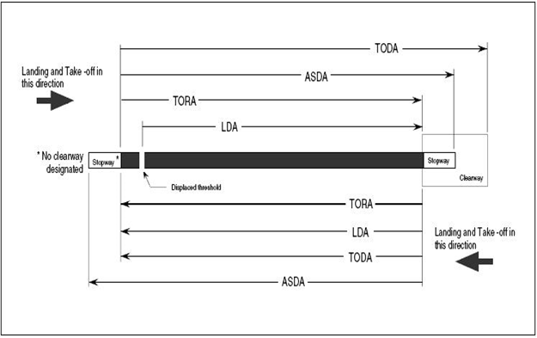

AVIATION TURBINE FUEL (JET FUEL):

CIVIL JET FUELS:
Fuel for cylinder motor controlled aircraft (normally a high-octane gas known as avgas) has a low blaze point to enhance its ignition attributes. Turbine motors can work with an extensive variety of powers, and plane aircraft motors regularly utilize powers with higher glimmer focuses, which are less combustible and along these lines more secure to transport and handle. The main plane energizes were in view of lamp oil or a gas lamp oil blend, and most fly powers are still lamp oil based.
JET A-1 is a lamp fuel evaluation of fuel suitable for most turbine motor aircraft. It is delivered to a stringent globally concurred standard, has a blaze point over 38°C (100°F) and a stop point most extreme of - 47°C. It is broadly accessible outside the U.S.A.
JET A will be a comparative lamp fuel sort of fuel, regularly just accessible in the U.S.A. It has the same glimmer point as Jet A-1 however a higher stop point most extreme (- 40°C).
JET B can be utilized as a distinct option for Jet A-1 but since it is more hard to handle (higher combustibility), there is just huge interest in exceptionally icy atmospheres where its better icy climate execution is essential.
MILITARY:
JP-4 is what might as well be called Jet B with the expansion of erosion inhibitor and hostile to icing added substances.
JP-5 is a high glimmer point lamp oil meeting the prerequisites of the U.S. Military Specification.
JP-8 is what might as well be called Jet A-1 with the expansion of consumption inhibitor and against icing added substance.

Required Aircraft General Knowledge to be an FOO
Airplane:
A plane is a vehicle heavier than air, fueled by a motor, which goes through the air by the response of air disregarding its wings.
Fuselage:
The fuselage is the focal body segment of a plane which suits the group and travelers as well as freight.
Wings:
Wings are the parts of plane which give lift and backing the whole weight of the plane and its substance while in flight
Folds:
Folds are the portable areas of a plane's wings nearest to the fuselage. They are moved in the same course (down) and empower the plane to fly all the more gradually.
Ailerons:
Ailerons are the outward portable areas of a plane's wings which move in inverse bearings (one up, one down). They are utilized as a part of making turns.
Rudder:
The rudder is the portable vertical area of the tail which controls parallel development.
Level Stabilizer:
The level stabilizer is the even surface of the toward the back piece of the fuselage used to adjust the plane.
Elevator:
The lift is the versatile level area of the tail which causes the plane to climb and down.
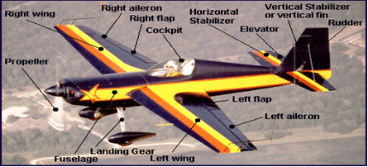

The Four Forces
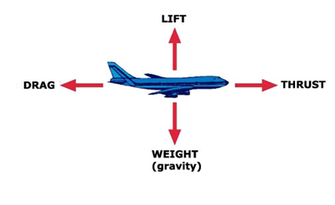
The four aerodynamic forces acting on an airplane during flight are Weight, Lift, Drag and Thrust.

Weight:
The mass of an item that equivalents the descending power of gravity pulling it to Earth. Gravity pulls the aircraft to Earth in a power equivalent to the heaviness of the aircraft.
Lift:
The upward drive that raises an airfoil when quick moving air ignores the highest point of the shape. Lift is the power that responds against the weight. It is made when air moves over the airfoil state of the wing, bringing about a decline in pneumatic stress on top of the wing and a response, or push upwards from the more prominent weight underneath the wing.

Thrust:
The forward compel that impels an article through the air. The forward power countering drag is pushed. Push may be given by a motor turning a propeller that pushes air in reverse as it twists or by a plane motor shooting hot gas in reverse. Both activities result in a forward development of the aircraft.
Drag:
The regressive power following up on an item traveling through air brought on via air resistance. As an aircraft travels through the air, the air resistance makes drag, easing the aircraft off. Drag pulls a aircraft in reverse.

Principles of Flight
Airfoils:
An airfoil, or airfoil area, may be characterized as any surface intended to get a response from the air through which it moves, that is, to acquire lift. It has been found that the most suitable shape for creating lift is a bended or cambered shape.
Camber:
The camber of an airfoil is the trademark bend of its upper or lower surface. The camber decides the airfoil's thickness. Yet, more vital, the camber decides the measure of lift that a wing produces as wind currents around it. A rapid, low-lift airfoil has practically nothing.
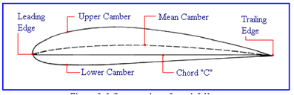

Bernoulli's Principle
Daniel Bernoulli, an eighteenth-century Swiss researcher, found that as the speed of a liquid expands, its weight diminishes.
Bernoulli's guideline can be seen most effortlessly through the utilization of a venturi tube. A venturi tube is essentially a tube, which is smaller in the center than it is at the finishes. At the point when the liquid going through the tube achieves the tight part, it accelerates. As per Bernoulli's rule, it then ought to apply less weight.
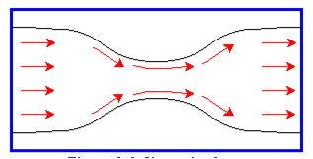

How Is Lift Created
Air streaming over the wing's upper surface quickens as it goes through the tightened region pretty much as it does in the venture tube. The outcome is a diminishing in weight on the upper surface of the wing that outcome in the marvel known as lift.
Control Surfaces
Planes have sections called ailerons embedded in the wings and portions called rudders and lifts embedded separately in the vertical balance and even stabilizer. The pilot controls their position from the plane cockpit. At the point when the pilot moves them into the airstreams, they cause the plane to respond to gaseous tension. The pilot utilizes them to go right or left furthermore here and there.

Axis of an Airplane
An airplane in flight changes direction by moving around one or more of its three axes of rotation: lateral axis, vertical axis, and longitudinal axis. These axes are imaginary lines that run perpendicularly to each other through the exact weight center of the airplane.

YAW:
Rudder rotates the airplane around vertical axis.

ROLL:
Ailerons rotate the airplane around longitudinal axis.

PITCH:
Elevators rotate airplane around lateral axis.
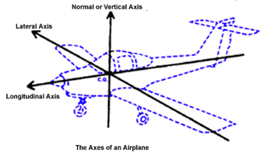

Aircraft Components
The Airplane:
The Federal Aviation Regulations characterize a plane as "a motor driven altered wing aircraft heavier than air, that is upheld in flight by the dynamic response of the air against its wings." There are various approaches to group a settled wing plane by:
The position of its wings in connection to the fuselage; The quantity of motors and by its arrival apparatus design
Planes may be of the high wing or low wing sort. A plane may be named single-motor if it has one motor or multi-motor in the event that it has two or more motors. A plane is likewise characterized by sort of landing rigging with which it is fitted for this decides the territory from which it can work: e.g. land, ocean, ski. Area planes can be further named having either traditional or retractable landing apparatus.
PARTS OF AN AIRPLANE
• Propeller
• Landing Gear
• Wing Strut
• Wings
• Ailerons
• Flaps
• Fuselage
• Horizontal Stabilizer
• Fin
• Rudder
• Elevator
• Door
• Seat
• Windshield
• Engine Cowl

The essential components of an airplane are:
• The Fuselage or body.
• The wings or lifting surfaces.
• The tail section (empennage) or canard.
• The Propulsion system, i.e. engine(s) with or without propeller(s).
• Undercarriage or landing gear.
The Fuselage:
The fuselage is the central body of the airplane, designed to accommodate the crew, passengers and cargo. It is the structural body to which the wings, tail assembly, landing gear and engine are attached.
The fuselage is usually classed according to its type of construction.
• Truss Type
• Monocoque
The Wing:
Most airplanes in use in general aviation today are monoplanes, that is, they have one pair of wings. Biplanes, those with two pairs of wings are also to be found although they are usually restored antiques, aerobatic planes or amateur built.
Five general systems of wing construction are now in use on modern airplanes. These are:
• Metal frame, metal covered skin (main strength in the covering, or skin i.e. stressed skin).
• Metal frame, metal covered (main strength in the frame).
• Metal frame, fabric covered.
• Composite.
• Wooden frame, fabric covered or plywood covered (found mostly in classic and antique airplanes).
The main members in a wing are:
• Spars
• Ribs
• Compression struts
• Drag and anti-drag wires
Some monoplanes with external bracing by wing bracing struts are known as non-cantilever wings, the others with no external bracing at all are known as cantilever wings.
WING TIP BOW:
This is generally a metal tube, curved to give the particular shape required.
WING ROOT:
The section of the wing nearest the fuselage. On the low wing airplanes, it is reinforced to permit the passengers and crew to walk on it.
WINGLETS:
A small nearly vertical wing like surface, usually of airfoil section, attached to the wing tip. The winglet is incorporated into the design of some modern airplanes. It is usually located rearward above the wing tip and is effective in reducing induced drag.

CHORD:
A fanciful straight line joining the main and trailing edge of the wing. The mean streamlined harmony (MAC) is the normal harmony of the wing.
SPAN:
The most extreme separation from wing tip to wing tip of an airfoil, wing or stabilizer.
The Tail section or Empennage:
The empennage is the tail segment of the plane and comprises of an altered vertical stabilizer or balance, the rudder, the stabilizer or tail plane, the lift and all trimming and control gadgets connected with them.
Rather than an altered stabilizer and portable lifts, a few planes have an one piece rotating, even stabilizer that is known as stabilator.
The Canard :
A couple of planes of cutting edge outline have supplanted the well known tail segment with a canard that fuses a level stabilizer gathering at the front of the plane.
Landing gear or Undercarriage:
The capacity of the arrival rigging is to take the stun the arrival furthermore to bolster the heaviness of the plane and empower it to move on the ground. The arrival apparatus on advanced plane is both of the altered rigging sort or retractable.
Stresses:
Stress is the force or combination of forces, exerting a strain. The pressure of your hand on a small empty box is an example of stress.
Strain is the distortion in the form or bulk of a body due to stress. If the small box is crushed, it is said to be strained.

There are five distinct type of stress:
• Compression or “crushing” as in the case of small box. Airplane wings are subjected to compression stresses.
• Tension or “stretching” as in the case of the wire. Bracing wires in airplanes are usually in tension.
• Torsion or “twisting” A screwdriver is subjected to severe torsional stress when forcing a screw into hardwood.
• Shearing or “cutting” The blades of scissor exert a shear stress on a piece of paper, which is sheared as a result.
• Bending as the name implies, means the bending of a long member due to load or weight being imposed on it.

Aircraft Systems

Hydraulic System:
The word hydraulics has been derived from the Greek word “HYDRO”, which meant the study of water at rest and in motion. Today it is been expanded to include the behavior of all liquids including hydraulic fluid. In brief “HYDRAULICS” is the science of liquids scientifically passed through pipelines, under pressure to get some useful work done.
Aircraft systems operated by hydraulic power are:
• Landing Gear
• Wheel Brakes
• Nose Wheel Steering
• Power Operated Flight Controls
• Wing Flaps System
Since water freezes and boils very quickly it was not suitable, and today in all aircrafts a suitable Hydraulic liquid is used. Some properties of hydraulic liquids are given below:
• Incompressible
• Viscosity un-affected (wide range of temperature)
• Oiliness for component lubrication e.g. Hydraulic pump
• Non-corrosive
• Economical and easily available
• Should not decompose or gum up.

Pneumatic System:
Air is freely available in the atmosphere. This fluid is in the shape of gas. The atmospheric air is a composition of 78% Nitrogen, 21% Oxygen and 1% other gases such as Hydrogen, Carbon dioxide, Argon etc. However to achieve it from atmosphere a compressor with some other components are required to be installed in the aero plane.
The principle operation of the Pneumatic System is basically the same as of a Hydraulic System.
Services that are operated, where Pneumatic System is installed are:
• Wheel Brakes
• Flaps
• Wind Screen Wipers
• Landing Gear

Following are some advantages and disadvantages of pneumatic system:
Advantages Disadvantages
i) Freely available and clean. i) Leak detection difficult.
ii) Light in weight. ii) Air pressure is dangerous.
iii) No return lines. iii) Moisture can not be eliminated.
iv) Small leaks allowed. iv) Dry operation causes more wear and tear.
v) No system bleeding required. v) Unsuitable for heavy duty.

Airplane Oxygen and Pressurization system
Anoxia and Hypoxia:
In high altitude flying the pilots reported lack of efficiency and fatigue. It was found that it was due to lack of oxygen at high altitudes, initially the pilots suffer from anoxia and the worse is hypoxia which results in sleepiness, headache, impaired vision, lack of judgment and finally unconsciousness.
Stages of Hypoxia:
• 10-14000 ft: with no oxygen supplement, vision and muscular co-ordination are impaired with slight dizziness.
• 15-18000 ft: mild drunkenness appears with a bluing of skin.
• 20-25000 ft: symptoms are the same as between 15-18000 ft but after 5mins unconsciousness usually follows.
• 35-40000 ft: unconsciousness occurs without warning in 15-45 sec. In the next 5sec, death may occur.
Due to high altitude flying, the aircrafts have been pressurized to cater for the lack of oxygen. Civil Air Regulations have been indoctrinated and they also ensure availability of oxygen for crew and passengers on commercial transports, in case of pressurization failure or a decompression.

Air conditioning system
The supply of air used for pressurization is cooled to an acceptable temperature for the passengers. It is the cooled air which may be conditionally adding some hot air, to maintain the selected temperature. The controls and indications are with the pilot. Two systems are used on airplanes.
i) Air-cycle system.
ii) Vapor-cycle system.

Aircraft fuel system
The purpose of the fuel system is to deliver all fuel on board to all engines and all fuel to the engine. Fuel supply should meet all engine demands at any altitude and attitude of the aircraft.
The main components of aircraft fuel system are:
• Tank.
• Boost pumps.
• Fuel filters.
• Fuel selector / shutoff valve.
• Fuel flow meters.

Aircraft fire protection system
Fire is one of the most dangerous threats to an aircraft. Fixed fire extinguishers are provided in the control cabin and passenger cabin.

Fire protection process can be divided in to three parts:
i) Fire detection.
ii) Fire warning and indication.
iii) Fire extinguishing.
a. Fixed fire extinguishing system:
The extinguishing agents used in this type of system are:
I. Carbon dioxide (older aircrafts).
II. Methyl bromide (F-27).
III. Freon (used in all modern aircrafts).
b. Portable fire extinguishers:
The extinguishing agents used in this type of system are:
I. Water glycol in passenger cabin.
II. Chemical type (soda bicarbonate) under nitrogen pressure in passenger cabin.
III. A carbon dioxide extinguisher in cockpit.
IV. A carbon tetrachloride extinguisher in cockpit.
The above extinguishers are checked for serviceability by the fire department, their presence by the engineering department and their inventory by the purser.

Engine (Power Plant)

Introduction:
Segment used to create energy to work airplane is known as motor or force plant. The more proper name for turbine sort motors utilized for aircrafts is gas turbine motor which is additionally importance full when contrasted with the name plane motor.
Turbine is any sort of turning gadget that uses the activity of liquid to deliver work. Run of the mill liquids utilized are air, wind, water steam and helium.
At the point when discussing gas turbine motors, the gas which works the turbine is that result of ignition, which happens when a suitable fuel is blended and copied with the air going through the motor.
At first planes were fueled by cylinder motors that turned a propeller yet now a days plane impetus is utilized usually, if there should arise an occurrence of plane drive the impelling power created is in the bearing inverse to the stream of a mass of gas or fluid under weight which is - getting away through a gap or opening called plane spout.
Normal thing between gas turbine and cylinder motor is that they both create power or push by blazing burnable blend of fuel and air, and believer vitality of the growing gasses in propulsive power, in cylinder motor this vitality is changed into mechanical vitality and used to turn a propeller which bestows moderately little increasing speed to a huge mass of air where as in plane motor fundamental turbo plane gives a generally huge quickening to a little mass of air and produces push drive specifically and this is the principle point which varies the two motors.
Turbo Jet Engine:
The straightforward gas turbine motor for aircraft is a turbo plane. It comprises of flat can like holder with both closures open it encases the interior parts and called as motor case.
Air enters from front burning so as to open, this air is warmed and quickened with fuel, remaining air and gasses created by this ignition are depleted intensive back opening.Inside the motor case a turning compressor is situated in forward segment took after by burning chamber (burner area or combustor) and afterward an arrangement of driving turbines which create energy to work compressor, and afterward comes the motor tail pipe or fumes conduit the back opening of channel or pipe called plane spout.

The compressor raises the weight of approaching air before passing it into the ignition chamber, fuel is showered through spouts before the chamber this fuel and air blend is blazed to deliver hot growing gasses which hurry into turbine segment bringing on the turbine rotors to rotate and from here these gasses are ousted outside through fumes conduit and plane spout. In single compressor turbo plane motor the turbine rotors and compressor are mounted on same shaft and the force of gasses which is utilized by turbine rotors to rotate is additionally used to drive compressor. Different variants or advancements of fundamental single compressor motor are double compressor (twin spool), turbo fans (fan planes), turbo props (prop planes) and turbo (shaft turbine) motors.

The sole motivation behind turbo plane motors is to create high speed gasses at plane spout; the motor is begun by turning compressor with starter and afterward lighting the blend of fuel and air in burning load by one or more igniters. Once the motor is begun in compressor picks up an adequate pivoting speed the starter and igniters are killed and motor begin running without their further help the length of fuel and air keep on enterring the ignition load in legitimate extents, and it is all because of compressor in light of the fact that as we realize that the gasses created by fuel and air blend smoldered under ordinary environmental weight don't grow much when contrasted with the air under weight and compressor, air must be blended with fuel before the gasses are delivered by burning which makes the motor to work, the more the air a motor can pack the more prominent is pushed created.

Power:
The result of cylinder driven motor is force. The standard unit for measuring the force delivered by a motor is strength. This speaks to the measure of work done when 33,000 lbs are brought 1ft up in 1 moment.

The aggregate sum of demonstrated torque a motor can deliver may be spoken to by the formula:
PLANK/33,000
Where,
P = The mean pressure in lbs per square inch
L = The length of stroke in feet
A = The area of piston in square inches
N = The number of impulse per min
K = The number of cylinders
Types of Combustion Engines
The three main type of combustion engine are:
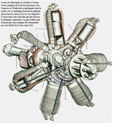
Radial Horizontally Opposed In Line
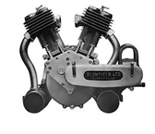
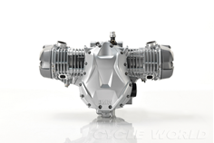

Parts of Reciprocating Engine:
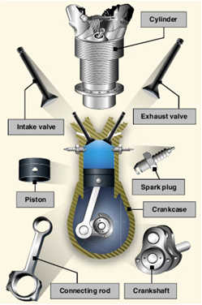

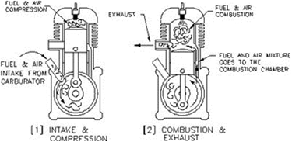
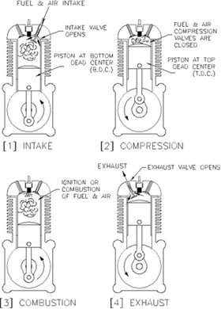
The Four Stroke Cycle The Two Stroke Cycle

Turbo charging:
A motor intended to work at typical ocean level environmental weight is called ordinarily suctioned motor. As we realize that as height expands, the air thickness diminishes which brings about less power creation demonstrated by diminishing rate of trip.
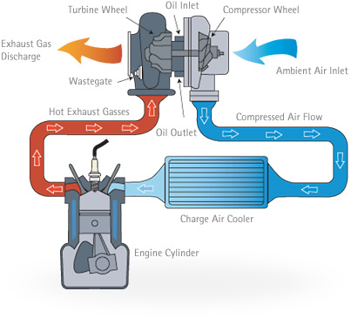
In present day planes, the occupation of supplying the motor with denser air when its working in slender air is finished by turbocharger. A turbocharger is controlled by the vitality of fumes gasses. It is introduced between the air admission and the carburetor so it packs the air before it blends the metered fuel in the carburetor.

Supercharging:
The supercharger is an inside driven compressor, controlled straightforwardly from the motor. It is introduced downstream from the carburetor and packs the air fuel blend after it leaves the carburetor. This is called constrained instigation. This may be utilized to build the force of the motor at low elevations, for this situation it is called help. When it's utilized at high heights to make the weight inadequacy because of lower air thickness, this is called supercharging.

Engine Cooling:
As we know that the source of all power is heat, the heat of combustion reaches as high as 2500 degree Celsius. The engine of some airplane use liquid coolant but most common is air cooling. Some parts of air cooling method are fins, shrouds, baffles. In high performance airplanes, cowl flaps are used to let the engine remain cool amid high power settings, for example, take off and climb.
Engine Oils and Lubrication:
Lubricating does four important functions:
1. Cooling
2. Sealing
3. Lubrication
4. Flushing
There are two methods of lubrication, Dry Sump lubrication and Wet Sump lubrication.

The Fuel System:
The aircraft fuel framework stores and conveys the correct measure of fuel at the right weight to meet the requests of motor all through all periods of flight. Types of fuel system include:
• Fuel pump fuel system
• Gravity feed fuel system

The Carburetor:
The burning procedure in the chamber depends on the best possible air fuel blend to accomplish ideal productivity. The capacity of the carburetor is to gauge the right amount of gas, vaporize this fuel, blend it with the air in the best possible partition and convey the blend to chamber.
The accompanying air fuel proportion (by weight) show the impact on an average motor.
Running mixture About 1 to 8
Best power mixture About 1 to 14
Chemically correct mixture About 1 to 15
Lowest fuel consumption mixture About 1 to 18
Leanest running mixture About 1 to 20
Excessively rich blend results in bringing down the ignition temperature and unburned waste fuel through the fumes framework.

Excessively incline blend may bring about harsh motor operation, removing, popping back or reverse discharges, explosion, overheating or obvious loss of force.
How Carburetor Works
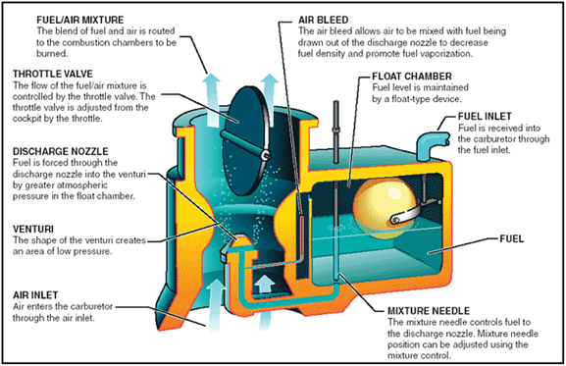

Carburetor Vs. Fuel Injection
The Carburetor:

The carburetor contains planes that will push the gas into the burning chambers. The measure of fuel that can course through these planes depends totally on the measure of air that can be maneuvered into the carburetor wander. The principle issue with acquiring the best execution utilizing a carburetor is that it can't screen the air to fuel proportion for every individual barrel. Carburetors are additionally much more straightforward to introduce than fuel infusion frameworks, in light of the fact that there are no electrical parts or return lines to the fuel tank. The carburetor is as of now substantially less lavish than the electronic fuel infusion frameworks.

Fuel Injection Systems:
There are two distinct renditions of fuel infusion - port fuel infusion and direct infusion. Port fuel infusion is the most ordinarily utilized and direct fuel infusion is the most recent created fuel infusion framework. This framework was composed particularly for four or two feed motors. The primary advantages to utilizing direct infusion is that the measure of fuel and air can be flawlessly discharged and afterward infused into the barrel as per the motor burden conditions. The gadgets utilized as a part of the framework will ascertain this data and continually alter. This sort of controlled fuel infusion results in a higher force yield, more noteworthy fuel proficiency and much lower outflows.
Carburetor Icing
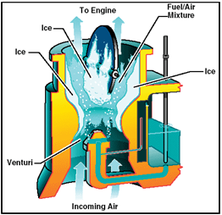
Carburetor, or carb icing, is an icing condition which can influence any carburetor under certain air conditions with temperatures running from - 5 to 30 degree Celsius. Carburetor icing happens when there is damp air, and the temperature drop in the venturi causes the water vapor to solidify. The ice will shape on the surfaces of the carburetor throat, further limiting it. This may expand the Venturi impact at first, however in the long run confines wind current, maybe notwithstanding bringing about a complete blockage of the carburetor. Icing may additionally bring about sticking of the mechanical parts of the carburetor, for example, the throttle, ordinarily a butterfly valve.
Aircraft controlled via carbureted motors are furnished with carburetor heat frameworks to conquer the icing issue.
The Propeller:
The capacity of the propeller is to change over the torque or turning snippet of the crankshaft in push or forward pace. To do this propeller is designed to the point that as it advances it pushes air in reverse with the object of bringing about a response, or push.
Propeller which are joined forward of the motor are called tractors, and those which are rearward of the motor are called pushers.
Pitch:
The separation in feet a propeller goes forward in one insurgency is called pitch.
The edge at which the propeller is set administers the pitch. Subsequently there is a coarse pitch, implying that the sharp edge is set at a bigger edge and fine pitch, implying that the cutting edge is set at a little point.
Coarse pitch is most appropriate for rapid journey and for high height flight. Fine pitch gives the best execution amid departure and ascension.
Types of Propellers:
• Fixed Pitch Propellers
• Variable Pitch Propellers
Featherings:
On some variable-pitch propellers, the sharp edges can be turned parallel to the wind stream to diminish drag if there should be an occurrence of a motor disappointment. This is called feathering. On single-motor airplane, whether a controlled lightweight flyer or turbine fueled aircraft, the impact is to build the skimming separation. On a multi-motor aircraft, feathering the propeller on a fizzled motor permits the aircraft to keep up elevation with the decreased force from the remaining motors.
Prop Reversing or Reverse Pitch:
In some aircraft, for example, the C-130 Hercules, the pilot can physically override the steady speed instrument to turn around the sharp edge pitch point, and hence the push of the motor (despite the fact that the revolution of the motor itself does not invert). This is utilized to help ease the plane off subsequent to arriving keeping in mind the end goal to spare wear on the brakes and tires, yet now and again likewise permits the aircraft to move down naturally.
Engine Instruments:
A portion of the standard motor instruments, which give the state of the motor, are:
• Oil Pressure Gage
• Oil Temperature Gage
• Cylinder Head Temperature Gage
• Carburetor Air Temperature Gage

• Outside Air Temperature Gage

Jet Propulsion:

It's not the impact of hot gasses out the fumes of a plane motor that gives the main impetus yet the response to the fumes plane. This expansive meaning of plane motors incorporates turbojets, turboprop, turbofans, ramjets. When all is said in done, most stream motors are inward ignition motors.

The Ram Jet:
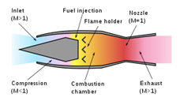
A ramjet, in some cases alluded to as a flying stovepipe, is a type of air breathing plane motor utilizing the motor's forward movement to pack approaching air, without a revolving compressor. Ramjets can't create push at zero velocity, subsequently they can't move an aircraft from a stop. Ramjets along these lines oblige helped take off like JATO (plane helped take off) to quicken it to a rate where it starts to deliver push. Ramjets work most effectively at supersonic rates around Mach 3. This sort of motor can work up to speeds of Mach 6.

The Turbo Jet:
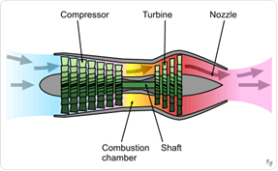
The turbojet is the most seasoned sort of universally useful air breathing plane motor. Turbojets comprise of an air channel, an air compressor, an ignition chamber, a turbine (that drives the air compressor) and a spout. The air is packed into the chamber, warmed and extended by the fuel burning and after that permitted to grow out through the turbine into the spout where it is quickened to fast to give drive.

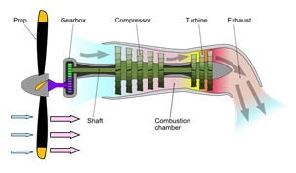
The Turbo Prop and Turbo Shafts:
A turboprop is a sort of turbine motor which drives an aircraft propeller utilizing a lessening rigging. The gas turbine is composed particularly for this application, with the majority of its yield being utilized to drive the propeller. The motor's fumes gasses contain little vitality contrasted with a plane motor and assume just a minor part in the impetus of the airplane. The propeller is coupled to the turbine through a lessening apparatus. The propeller itself is regularly a variable pitch sort like that utilized with bigger responding aircraft motors. In its least difficult structure a turboprop comprises of an admission, compressor, combustor, turbine, and an impelling spout. Propellers lose effectiveness as airplane rate expands, so turboprops are ordinarily not utilized on fast aircraft.
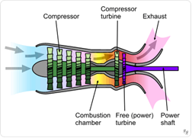
A turbo shaft motor is a type of gas turbine which is upgraded to deliver shaft power, as opposed to stream push. In idea, turbo shaft motors are fundamentally the same to turbojets, with extra turbine extension to concentrate heat vitality from the fumes and proselyte it into yield shaft power. They are significantly more like turboprops, with just minor contrasts and regularly a solitary motor is sold in both structures.

The Turbo Fan:
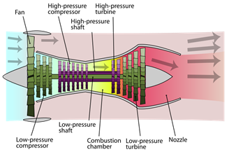
The turbofan or fanjet is a kind of air breathing plane motor that is broadly utilized for aircraft drive. "Turbofan" is a mix of "turbine" and "fan", the turbo part alludes to a gas turbine motor which takes mechanical vitality from ignition, and the fan, which utilizes the mechanical vitality from the gas turbine to quicken air rearwards. The motor produces push through a blend of these two parts cooperating, motors that utilization more fly push with respect to fan push are known as low sidestep turbofans, while those that have impressively more fan pushed than plane are known as high sidestep. Most business avionics plane motors being used today are of the high-sidestep sort, and most present day military contender motors are low-sidestep. The dominant part of turbofans take after the same essential outline, with an extensive fan at the front of the motor and a moderately little fly motor behind it. There have been various varieties on this configuration
Percent RPM:
In view of high rotational velocity of plane motor (around 6000 to 16000 rpm) plane motor tacho meters are graduated to peruse in percent RPM fairly then in RPM specifically. More or less full appraised push is made to fall close to 100% RPM.
Letters Used To Indicate Compressor Speed in RPM or Percent
N- - Compressor speed (rpm or percent) for a solitary compressor motor.
N1- - Speed (rpm or percent) of the low-weight compressor of a double compressor motor, or the compressor speed (rpm or percent) of a solitary compressor motor furnished with a free turbine.
N2- - Speed (rpm or percent) of the high weight compressor of a double compressor motor, or the free turbine speed (rpm or percent) of a solitary compressor motor furnished with a free turbine.

N3- - Free turbine speed (rpm or percent) of double compressor motor furnished with a free turbine.

Engine Pressure Ratio (EPR):
Proportion is one size isolated by other extent of the same kind. Any machine that takes a shot at a guideline of pressure and extension of gasses works over a scope of weight proportion. Incase of turbo plane it takes air in at the front, packs the air to given weight, copies fuel with the air, and after that allows the weight to drop back to environmental weight as the gasses are released at the plane spout, every time that the weight is raised or lower inside the plane motor, a weight proportion is included. Therefore, when talking about gas turbine motor or its compressor it means out let gas (or air) weight isolated by gulf gas (or air) weight.
On the other hand
EPR is turbine release aggregate weight partitioned by the aggregate weight at compressor gulf.
Exhaust Gas Temperature (EGT):
It is the temperature of gas at exhaust (jet nozzle) it should be maintained with in a safe margin, excess EGT can damage engine.
Thrust Reversers:
Thrust reversers are used to reverse thrust which is used along wheel brakes to slow the aircraft immediately after touch down.

Minimum Equipment List (MEL)
The Civil Aviation Rules oblige that all supplies introduced on an aircraft in consistence with the Airworthiness Standards and the Operating Rules must be agent. On the other hand, the Rules likewise allow the distribution of MEL where consistence with certain hardware prerequisites is a bit much in light of a legitimate concern for wellbeing under every single working condition.
Expert Minimum Equipment List (MMEL) is created by the FAA or the Regulatory Body of the nation of Origin of the subject aircraft; with investment by the flight business.
The MMEL is the premise of for the advancement of individual administrator MEL which takes into thought the administrator's specific aircraft gear design and operational conditions. An administrator's MEL may contrast in organization from the MMEL, however can't be less prohibitive than the MMEL. The MEL should not go astray from the Aircraft Flight Manual Limitations, Emergency Procedures or with Airworthiness Directives.
The MEL is planned to allow operation with out of commission things of gear for a span of time until repairs can be expert.
MEL has 4 sections:
i) "Item" (Column 1): Is the gear, framework, segment or capacities are recorded in this section.
ii) "Number Installed" (Column 2): Is the number (amount) of things introduced.
iii) "Number Required for Dispatch" (Column 3): Is the base number (amount) of things needed for operation gave the conditions determined in segment 4 are met.
iv) "Remarks or Exceptions" (Column 4): This section incorporates an announcement either precluding or allowing operation with a particular number of things out of commission, stipulations (conditions and confinements) for such operation, and fitting notes.
Note: "- " image in section 2 and/or segment 3 demonstrates a variable number (amount) of the thing introduced.

"(M)" image in segment 4 demonstrates a prerequisite for a particular upkeep technique which must be proficient before operation with the recorded thing broken.
"(O)"symbol in segment 4 demonstrates a prerequisite for a particular operations technique which must be refined in making arrangements for and/or working with recorded thing defective.
Time period restrictions given in MEL are as classifications A, B and C.
Category A:
Things in this classification should be repaired inside of the time interim indicated in the comments segment of the administrator's sanction MEL.
Category B:
Things in this class might be repaired inside of three back to back schedule days (72 hours), barring the day the glitch was recorded in the aircraft support record/logbook.
Category C:
Things in this class should be repaired inside of ten back to back schedule days (240 hours), barring the day the breakdown was recorded in the aircraft support record/logbook.
"Day of Discovery" is the schedule day a gear/instrument glitch was recorded in the aircraft upkeep log as well as record. This day is avoided from the schedule days or flight days indicated in the MMEL for the repair of out of commission gear. This procurement is material to all MMEL things, i.e. classifications A, B and C.

INTERNATIONAL AERONAUTICAL TELECOMMUNICATION SERVICE

Time System:

General Co-ordinated Time (UTC) should be utilized by all stations as a part of the aeronautical telecom administration. Midnight might be assigned as 2400 for the end of the day and 0000 for the start of the day.

A date-time bunch might comprise of six figures, the initial two figures speaking to the date of the month and the last four figures the hours and minutes in UTC.

Record of Communications:

A telecom log, composed or programmed, might be kept up in every station of the aeronautical telecom administration aside from that an aircraft station, when utilizing radiotelephony as a part of direct correspondence with an aeronautical station, require not keep up a telecom log.

Telecom logs, composed or programmed, might be held for a time of no less than thirty days. At the point when logs are related to request or examinations they might be held for more periods until it is apparent that they will be no more needed.

Use of Abbreviations and Codes:
Contractions and codes should be utilized as a part of the universal aeronautical telecom administration at whatever point they are fitting and their utilization will abbreviate or generally encourage correspondence.
Where shortenings and codes other than those sanction by ICAO are contained in the content of messages, the originator might, if so needed by the aeronautical telecom station tolerating the message for transmission, make accessible to that station a decipher for the contractions and codes utilized.

Cancellation of Messages:

Messages should be scratched off by a telecom station just when cancelation is approved by the message originator.

Aeronautical Fixed Service (AFS):
A telecom administration between determined settled focuses gave principally to the security of air route and for the general, proficient and prudent operation of the air administrations.
The aeronautical altered administration includes different kinds and frameworks of point-to-point interchanges in the universal aeronautical telecom administration.
The accompanying characters are permitted in messages:
Letters:
ABCDEFGHIJKLMNOPQRSTUVWXYZ
Figures:
1 2 3 4 5 6 7 8 9 0
Different signs:
- (hyphen)
? (question mark)
: (colon)
( (open section)
) (close section)
. (full stop, period, or decimal point)
, (comma)
" (punctuation)
= (twofold hyphen or equivalent sign)
/(angled)
+ (in addition to sign)
Characters other than those recorded above might not be utilized as a part of messages unless completely essential for comprehension of the content. At the point when utilized, they should be spelled out in full.
Location Indicator:
A four-letter code gathering detailed as per tenets recommended by ICAO and allocated to the area of an aeronautical settled station.
Note: The area pointer appointed to an aeronautical fix station should be of four letters designator by the ICAO. The principal letter shows the correspondence zone in which that station finds, the second letter ordinarily demonstrates the nation in which that station is found yet not generally, third and fourth letter might distinguish the name of the station (Town, City or Village) e.g. for Karachi OPKC O is correspondence zone, P is for Pakistan and KC is for Karachi.

Procedures for Communicating with Ground Stations:

Text Communication:
Text communication with ATC, ground stations and other support groups is facilitated through the use of SITA, AFTN and or E-mail. These communication methods are vital for maintaining Operational Control of the Flight Operations.

SITA (Société Interntionalé de Telecommunication Aeronautique):
SITA operates a worldwide teletype network and provides telecommunication capability to many overseas airline stations. The SITA messages can be transmitted from web by using SITA telex and from a SITATEX Terminal. The SITA messages can be received through e-mail or SITATEX printer.

AFTN (Aeronautical Fixed Telecommunication Network):
This is an ICAO worldwide teletype network which connects airlines with each other, governmental aeronautical services with each other and airlines with governmental agencies (ATS Flight Plan filing, NOTAM’s, Over-Flying Permissions).

E-mail:
The primary tool to be used to send and receive text messages is e-mail; it is fast, reliable and economical way of exchanging information.

Procedures for Communicating with Aircraft:

Air-Ground Communications:
A two route correspondence in the middle of aircraft and stations on the surface of the earth, this kind of correspondence with aircraft can be achieved by following means.
• VHF Radio
• HF Radio
• SELCAL
• SATCOM

VHF Radio:
A reliable two-way radio communications between the aircraft in flight and the appropriate Flight Dispatch Centre is required which can be achieved by VHF Radio.
HF Radio:
Overall telephone patches are intended to give direct voice correspondences between a Flight Crew and station on HF SSB frequencies. HF SSB correspondence unites the Air-Ground call through phone patch framework. Stations in Europe use STOCKHOLM radio and ARINC serve Europe, Middle East, Africa and Asia Pacific district. ARINC is the main administration supplier for HF information join.

SELCAL:

SELCAL is a specific calling radio framework that cautions a aircraft's group that a ground radio station wishes to correspond with the aircraft. SELCAL uses a ground-based encoder and radio transmitter to show a sound flag that is grabbed by a decoder and radio recipient on a aircraft. A SELCAL transmission comprises of a blend of four pre-chosen sound tones whose transmission requires roughly two seconds.

The utilization of SELCAL permits an aircraft team to be told of approaching correspondences notwithstanding when the aircraft's radio has been quieted. Along these lines, crewmembers need to dedicate their consideration regarding ceaseless radio tuning in.

SATCOM:

The Satellite Communication framework, known as SATCOM is present day Air-Ground correspondence mean and is just refined with the aircrafts outfitted with it.

It is quick and dependable yet extremely lavish mean of correspondence.

SATCOM gives overall scope, except for operation at the high scopes, (for example, required for flights over the posts).

ACARS:

Aircraft correspondence Addressing and Reporting System (ACARS) is a computerized datalink framework for transmission of short, moderately straightforward messages in the middle of aircraft and ground stations by means of radio or satellite.

NOTAM:

A notification disseminated by method for telecom containing data concerning the foundation, condition or change in any aeronautical office, administration, technique or danger, the opportune learning of which is crucial to work force concerned with flight operations.

SNOWTAM:
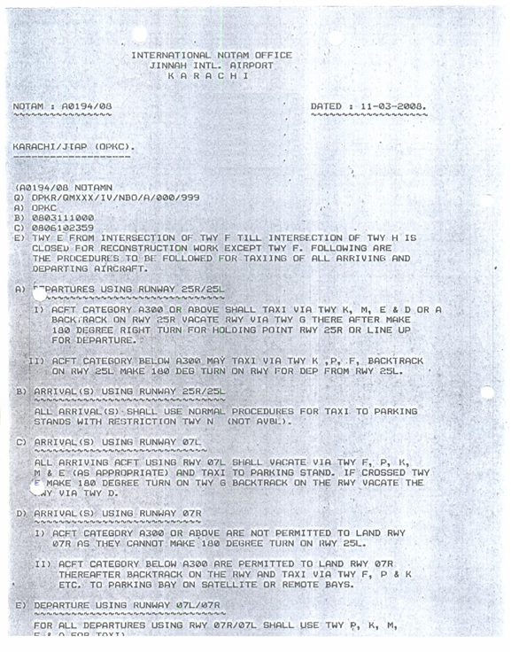
An exceptional arrangement NOTAM informing the vicinity or evacuation of dangerous conditions because of snow, ice, slush or standing water connected with snow, slush and ice on the development territory, by method for a particular configuration.

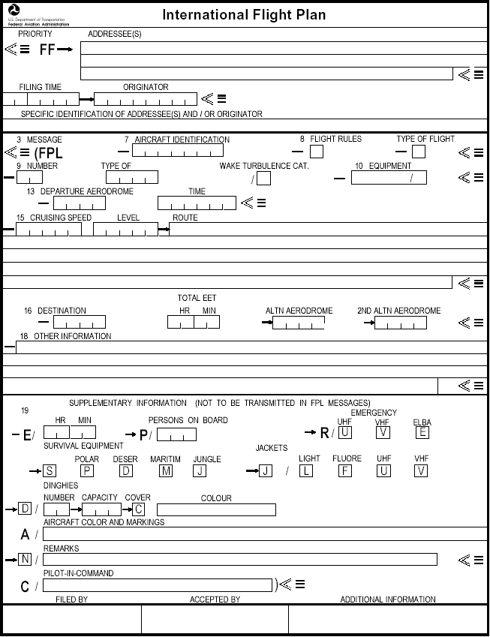
International Flight Plan:
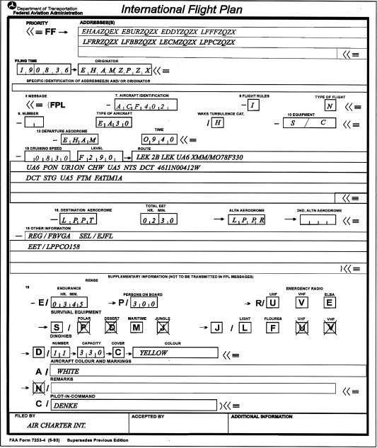

Recommendations:
- PCAA should change and improve the process of fee and documents submission. Proper infrastructure and bank facilitation at same location should be provided for candidates applying for FOO, CPL and other aviation related courses.
- PCAA should change policy of written examinations which currently complies with JAR or European standards because during ground training candidate learns about flight operations of airports in Pakistan.
- All international airports should have properly maintained and operating Flight Operations Centre for regularity and ease of operations.
- On Job Training facilities and services should be provided at all international airports for candidates.
- Proper ads for induction of new Flight Operations Officers should be given in newspapers or website and induction should be done on merit bases.

Abbreviations:

FOO Flight Operations Officer
PCAA Pakistan Civil Aviation Authority
FOOL Flight Operations Officer License
JAA Joint Aviation Authority
JAR Joint Aviation Regulations
EPR Engine Pressure Ratio
EGT Exhaust Gas Temperature
MEL Minimum Equipment List
MMEL Master Minimum Equipment List
ROC Rate of Climb
ROD Rate of Descend
BOW Basic Operating Weight
ZFW Zero Fuel Weight
PL Pay Load
TOGW Take Off Gross Weight
LGW Landing Gross Weight
PNR Point of No Return
CP Critical Point
ETOPS Extended Twin Engine Operations
TORA Take Off Run Available
TODA Take Off Distance Available
ASDA Accelerate Stop Distance Available
LDA Landing Distance Available

References:
- https://en.wikipedia.org/wiki/Flight_dispatcher
- http://caapakistan.com.pk/PL/PL-General.aspx
- http://www.airlinedispatcher.com/website/archive/faq.htm
- www.keilir.net/static/files/.../FOO%20COURSE%20-%20GENERAL.
- http://www.aviationjobsearch.com/job/flight-operations-officer-dispatcher-1/1505796

