Effect of Noil Extraction Percentage on Elastic and Mechanical Properties of 54/S Cotton Combed Yarn affect


A case study submitted by

Muhammad Saeed 12020011003
Mujahid Nazar 12020011013

In Partial Fulfillment of the Requirement for the Degree of
Bachelor of Science

School Of Textile And Design
UNIVERSITY OF MANAGEMENT AND TECHNOLOGY, LAHORE

Session 2012-2016
Effect of Noil Extraction Percentage on Elastic and Mechanical Properties of 54/S Cotton Combed Yarn

A Report Submitted to

School of Textile and Design

In partial fulfillment of the requirements for the
Degree

Bachelor of Science
In
Textile Sciences

By

Muhammad Saeed 12020011003
Mujahid Nazar 12020011013

University of Management and Technology
Session: 2012-16

Statement of Submission
Our research dissertation titled “Effect of Noil Extraction Percentage on Elastic and Mechanical Properties of 54/S Cotton Combed Yarn” is being submitted for completion of BS Textile degree from School of Textile and Design, University of Management and Technology, Lahore, Pakistan Dissertation

Muhammad Saeed 12020011003
Mujahid Nazar 12020011013

Supervised by: Mr. Ahmad Faraz
(Signed) ___________________ Date: __________________

Acknowledgment
First and Foremost we would like to thank Almighty Allah for giving us an opportunity, determination, and strength to do our research. His continuous grace and mercy was with us throughout our lives and even more during our research.
We officially place our sincere thank you to Dr. Mumtaz Hasan Malik Dean, Professor School of Textile and Design, University of management and technology, Lahore for the continuous encouragement.
We are also very grateful to Sir Naveed Akhtar, Sir Ahmad Faraz in the Department of STD. we are extremely thankful and indebted to Ma`am Qurbat Zahara for sharing expertise, and sincere and valuable guidance and encouragement to us.
We also like to take this opportunity to express gratitude to all of the Department faculty members of STD and our Batch mates for their help and support. We want to thank our parents for the unceasing encouragement, prayers, support, and attention.

(Signed)

____________________ (Muhammad Saeed Student ID: 12020011003)

____________________ (Mujahid Nazar Student ID: 12020011013)

Date: July 12, 2018

Declaration
We hereby declare that all the information in this thesis is the result of our concerted efforts and our original work. This research work, to the best of our knowledge and belief, reproduces no material previously published or written, or that has been accepted for the award of any other degree or diploma, except where due acknowledgment has been made in the text.

Student’s Signature: _______________________
Name of Student: _________________________
Student’s Signature: _______________________
Name of Student: _________________________

Date: July 12, 2018

Abstract
Quality of end product in spinning can improve significantly by combing and removing of short fibers. Combing process removes short staple fibers and eliminates the impurities which are present in carded sliver or in drawn sliver. In comber sliver, the fiber strands are straighter, parallel and align while the end yarn produced has smoothness, clear appearance, and more strength.
If we check all the processes in yarn manufacturing in spinning process, the combing processes is the one which has a significant effect on improving yarn quality. The short fibers removed in the combing process are called Noil. The noil extraction in the combing process has a direct effect on yarn quality but it has a limitation as well because increasing the noil extraction also increases the cost of yarn. Trails have been carried out on carded yarn, along with 12%, 16% and 20% Comber Noil on 54/s yarn respectively while keeping the other parameters constant from blow room to winding and conditioning in spinning yarn manufacturing. Then the results for mechanical properties of yarn were compared for these noil percentages. We find as expected that the increasing noil extraction improves yarn quality but these improvement in results are getting less distinguishable as we go up extracting more noil. In our results, we find, there is less difference in the properties of yarn having Noil extraction between 16% and 20% respectively.

KEYWORDS: Comber, Noil, Spinning Processes, Yarn Properties.

Table of Contents
ABSTRACT.................................................................................................................................... VI
TABLE OF CONTENTS.................................................................................................................... VII
LIST OF TABLES: ............................................................................................................................ IX
LIST OF FIGURES: ......................................................................................................................... X
CHAPTER 1 INTRODUCTION ......................................................................................................... 1
1.1.1 Textile includes………………………………………………………………………………………………………………………….1
1.1.2 In Textile industry……………………………………………………………………………………………………..………………1
1.1.3 Fiber Classifications………………………………………………………………………………………………………..…………2
1.1.4 Objectives of Research.…………………..…….…………………………………………………………………………..……..3
1.1.5 Selection Procedure of Raw Material………………………………………………….………………………………….…3
1.1.5.1 Grading Index…………………………………………………………………………………………………………………………3
Chapter 2 Literature review……………………………………………………………………………………………………………...9
2.1 Literature review………………………………………………………………………………………………………………………….9
2.2.1 Comber subcategories………………………………………………………………………………………………………………11
2.2.2 Comber operations…………………………………………………………………………………………………………….......11
Chapter 3 3.1 Material and methods………………………….…………………………………………………………………12
3.1.1 Plan of work………………………………………………………………………………………………………………..……………13
3.2.1. Blow room…………………………………………………………………………………………………………………..………….14
3.2.1.1 Objectives of Blow room……………………………………………………………………………………………………….14
3.2.1.2 Testing Data of Blow Room……………………….………………………………………………………………………….15
3.3.1 Carding…………………………………………………………………………………………………………………………………….15
3.3.2 Objectives of Card………………….………………………………………………………………………………………………..15
3.3.3 Card Sliver testing…………………………………………………………………………………………………………………….16
3.4.1 Draw frame………………………………………………………………………………………………………………………….…..17
3.4.2 Objectives of Draw Frame…………………………………………………………………………………………………………17
3.5.1 Breaker Draw Frame………………………………………………………………………………………………………………..17
3.5.2 Objectives of Breaker Draw Frame ……………..…………………………………………………………………………..17
3.6.1 Lap former………………………………………………………………………………………………………………………………..18
3.7.1 Comber…………………………………………………………………………………………………………………………………….19
3.7.2 Sequence of Operation in a comber………………………………………………………………………………………….19
3.7.3 Waste Percentage in Comber……………………………………………………………………………………………….….20
3.7.4 Comber Sliver Test……………..……………………………………………………………………………………………………20
3.8.1 Finisher Draw Frame………………………………………………………………………………………………………………..21
3.8.2 Objectives of Finisher Draw Frame………………………………………………………………………………………….21
3.9.1 Roving frame/ Speed frame / Simplex frame…………………………………………….……………………………..21
3.9.2 Objectives of the roving frame………………………………………………………………………………………………….21
3.9.3 Simplex frames Test Report……………………………………………………………………………………………………..22
3.10.1 Ring Fame…………………………………………………………………………………………………………………………..….23
3.10.2 Ring frame objectives…………………………………………………………………………………………..…………………23
3.11.1 Auto Cone……………………………………………………………………………………………………………….……………..24
3.11.2 Objective of Auto Cone..………………………………………………………………………………………….……………..24
3.11.3 Uster Quantum Setting…………………………………………………………………………………………….…………….25
3.12 Equipment and standards for yarn Testing…………………….……………….…………………………..…………….25
3.12.1 Tensile Strength…………………………………………………………………………………….……………………………….25
3.12.2. Tensile Strength of………………………………………….………………………………….…………………………………25
3.12.3 Tensile Strength Test of Fiber …………………………….…………………………….…………………………………..26
3.13.1 Latest Fiber Testing Instruments…………………………………………………………………………………………….26
3.13.2 High volume instrument……………………………………………………………..…….……………………………………26
3.13.3 Principles of fiber testing using HVI……………………………………………….….…………………………………...26
3.13.4 Measurement of different parameters using HVI…………………………..………………………………………27
3.14.1 Advanced Fiber Information System (AFIS)…………………………………….……….……………………………..27
3.14.2 AFIS -Working principle…………………………………………………………………………….…………………………...28
3.14.3 Fiber Contamination System……………………………………………………………………….………………………….28
3.14.5 Stelometer……………………………………………………………………………………………….…………………………….28
3.15.1 Pressley Fiber strength tester…………………………………………………………………………………….…………..29
3.16.1 Yarn strength test………………………………………………………….……………………………………………………….30
3.16.2 Uster Tester…………………………………….………………………………….………………………………………………….32
3.17 Results of Sample at Different Noil Extracted ………………………………………………………………………….33
3.18 Resulted Properties of samples ………………………………………………………………………………………………..36
CHAPTER 4 …………………………………………………………………………………………………………………………………..43
4.1 Discussion…………………………………………………………………………………………….……………………………………..43
4.2 CONCLUSIONS……………………………………………………………………………………………..………………………………44
REFERENCES ...........................................................................................................................................45

List of Tables:
Table.1 Staple Length Grading ........................................................................................3
Table .2 Uniformity Ratio Grading………………………………………………...........4
Table .3 Floating Fiber Index Grading…………………………………………………..4
Table.4 Pressley Strength Grading………………………………………………………4
Table.5 Micronaire Value Grading…………………..…………………………………6
Table.6 Trash Grading……………...………….……………………………….……….7
Table.7 Moisture Regain Grading………………………………………………….……7
Table.8 Grade Allocation……………………………………………………….…...….8
Table.9 Mixing Details…………………….………………….………………………..12
Table.10 Blow room Waste Produced………………………………………………….15
Table.11 Card Sliver Testing…….……………………………………………………...16
Table.12 Card Wrapping Report…………………………….……….………………….16
Table .13 Drawing Wrapping Test……………………………………………….….….17
Table.14 Comber Sliver testing…………………….……………….………………..…20
Table.15 Test Report simplex……………………………………………………….….22
Table.16 Wrapping Test of simplex.………………………..………..…………..….….23
Table.17 Uster Quantum Setting…………………………………………….……….…25
Table.3.17.1 Comber Sample Noil = 0% (carded)… …………………………….……..…..33
Table.3.17.1.1 Comber Sample Results of Noil =0% ………………..……………….….…33
Table.3.17.2 Comber Sample Noil=12%.............................................................................34
Table.3.17.2.1 Comber Sample Results of Noil=12%………………………….…………..34
Table.3.17.3 Comber Sample Noil=16%.............................................................................34
Table.3.17.3.1 Comber Sample Results of Noil=16%……….…………………….………..35
Table.3.17.4 Comber Sample Noil=20%............................................................................35
Table 3.17.4.1 Comber Sample Results of Noil 20%....……………..………….……..........35
List of Figures:
Fig.3.1 Card...…………………………………………….……………………..…….16
Fig.3.2 Breaker Draw Frame………………………………………………….....…...18
Fig.3.3 Lap Former…………………………………………………………..………..18
Fig.3.4 Comber……………………………………………………………...…………19
Fig.3.5 Finisher Draw Frame……………………………………………..…………..21
Fig.3.5 Simplex Frame…………………………………………………...……………22
Fig. 3.6 Ring Frame……………………………………………………...…………..…23
Fig.3.7 Auto-cone……………………………………………………………………...24
Fig. 3.8 AFIS…………………………………………………………………………...28
Fig.3.9 Stelometer……………………………………………………………………..29
Fig.3.10 Pressley Fiber strength tester…………………….……………………………30
Fig 3.11 Lea or skein wrapper………………………………..…………………………30
Figure: 3.12 Lea strength……………………………………………..……...……………..31
Figure: 3.13 Unevenness in Yarn Um%...................................................................................36
Figure: 3.14.1 Thick and Thin Places………………………………….………………………37
Figure: 3.14.2 Thin and Thick Places………………………………………...……………….37

Figure: 3.15.1 Neps ……………………………………………………….…………………38

Figure: 3.15.2 Neps ……………………………………………………….…………………38
Figure: 3.16.1 Hairiness……………………………….…………….……….…………………39
Figure: 3.16.2 Hairiness………………………….….……………………….…………………39
Figure: 3.17 Elongation…………………………………………………….………………...40
Figure: 3.18 RKM………………………………………………...………….……………….41
Figure: 3.19 B-force and B-work…………………………………………….……………….41
Figure: 3.20 IPI……………………………………………………………………….42

Chapter 1
  - INTRODUCTION:
The first section of this chapter gives a brief introduction to the textile industries and fiber types. The word ''textile'' was initially applied only to woven fabrics, but now generally used for fibers, yarns, fabrics and other fabric products. As the Textile Institute's Terms and Definitions explains, “any product which is manufacturing from yarn, filaments or fibers are characterized by its flexibility, fineness, a ratio of Length to diameter falls in the field of textile” [1]. In spinning, just like other industries quality of a product is the main goal as it defines the use of end products.
1.1.1 Textile includes:
- Verities of fibers (e.g. Cotton, Jute, Wool, Polyester, Viscose etc.)
- Various Process (e.g. Spinning, Weaving, Knitting, Dyeing, Printing, Finishing etc.)
- Numbers of machinery (e.g. Spinning machinery, weaving machinery, Knitting machinery, Dyeing machinery, Testing machinery etc.)
- Number of end products suitable for different purposes (e.g. Yarns, Garments, Technical textiles, Geo-textiles, Medical textiles, E-textiles etc.)
1.1.2 In Textile industry:
- Staple fibers and filaments: Fiber or filaments has diameter hundreds of times less than their length. This characteristic makes them suitable for converting into yarn and then for the preparation of woven, knit, or nonwoven fabrics.
- Yarns: Produced from Natural or manmade fibers
- Fabrics: Fabrics are other products made from yarns.
- Garments: Garment products are manufactured from fabrics while the products maintain the quality, elasticity, and drape of the original fabrics.

1.1.3 Fiber Classifications:
Fiber

Natural Fiber Man- Made Fiber

Cellulose Protein `Mineral In-organic Organic

Natural Polymer Synthetic Polymer
- Natural Fiber:
    - Cellulose: Cotton, Flax, Jute, Hemp, Ramie, Sisal, etc.
    - Protein: Silk (Filament Form), Wool, Camel, Cashmere, etc.
    - Mineral: Asbestos
- Man-Made Fiber:
    - In-organic: Glass, Metallic, etc.
    - Organic: Rayon Fiber, Acetate, Acrylic, Nylon, Polyester etc.

It is quite important that we briefly explain the importance of comber in spinning process of yarn manufacturing. Combing first defined by Gegauff refers to the relationship between the fiber length called "staple" length in particular to the staple diagram and percentage of waste, as well as the set distance of the detaching rollers and the amount of material fed [2].
No matter how much combing technology gets to advance the basic objective remains the same which is fractionation of fibers, removal of impurities and neps. As we know this, the Combing process is used to improve the raw material which directly influences the yarns evenness, smoothness, strength and visual appearance.
1.1.4 Objectives:
The objective of this research is to improve yarn quality by less waste extraction in the combing process, so we could optimize the raw material usage. So we will identify the Noil extraction and its impact on combed yarn.
- To improve yarn quality.
- Optimized the use of raw material.
- Less waste extraction.
- Identification of effect of noil extraction on properties of yarn in the spinning process of yarn manufacturing.
1.1.4 Selection Procedure of Raw Material:
Now a days with the usage of High Volume Instrument (HVI) the selection process of cotton bales has increased to a great extent. Most of the quality characteristic in cotton bales can be measured by using High Volume Instrument (HVI) which only takes less than a minute per sample during testing. The properties which are mainly checked by HVI are fiber length, trash and Moisture content in the material as well as maturity, strength, uniformity, Rd (brightness) and +b (yellowness).
1.1.4.1 Grading Index:
- Each point of parameter given blow is summed up to give a resultant value from which the grade of cotton is determined.
- The cotton grading index varies mills to mills depending on their preference towards the end products.

- Staple Length:
Table.1 Staple Length Grading:

Length | HVI |  | Points
28mm and above |  | HVI | 20
27.01mm to 27.99 |  | HVI | 18
26.51mm to 27.01 |  | HVI | 15
26.01mm to 26.50 |  | HVI | 10
25.51 mm to 26.00 |  | HVI | 5
25.50mm and below |  | HVI | 0

- Uniformity Ratio (U.R %):
U. R % =$\frac{ 50 \% Span Length }{2.5 \% Span Length}$ × 100

Eq.1, Ch.1
Table .2 Uniformity Ratio Grading:
Length | Categories |  | Points
50.00 and below |  | Category I |  | 20
48.01 to 49.99 |  | Category I |  | 15
48.01 to 48.00 |  | Category I |  | 10
45.01 to 46.00 |  | Category I |  | 5
45.00 and above |  | Category I |  | 0
48.01 to 49.99 |  | Category II |  | 10
46.01 to 48.00 |  | Category II |  | 8
45.01 to 46.00 |  | Category II |  | 3
45.00 and below |  | Category II |  | 0
- Floating Fiber Index (F.F.I):
Floating fiber index is very important as it indicates the fibers which are not clamped by either pair of rollers in the drafting zone. It is calculated from fiber length which is measured from FIBROGRAPH and is calculated as:
F. F. I = [ $\frac{2.5 \% Span Length }{2( 50\% Span length-0.075)}$ ] - 1 ×100
Eq.2, Ch.1
Table .3 Floating Fiber Index Grading:
Length | HVI & Fibro-graph | Points
15.00% and below | Both | 10
15.00 to 20.00 % | Both | 7
20.00 to 25.30 % | Both | 3
25.30 and above | Both | 0

- Pressley Strength:
Tenacity (gf / Tex) = $\frac{ Breaking Force \left(Kg.f \right) × 15 }{Sample Mass \left( mg \right)}$
Eq.3, Ch.1
Table.4 Pressley Strength Grading:
Length | Categories | Points
91.00 and above | Category I | 20
89.00 to 90.99 | Category I | 18
86.00 to 88.99 | Category I | 16
84.00 to 85.93 | Category I | 13
82.00 to 83.99 | Category I | 10
80.00 to 81.99 | Category I | 8
77.00 to 79.99 | Category I | 5
75.00 to 7699 | Category I | 6
Below 75.00 | Category I | -10
91.00 and above | Category II | 20
89.00 to 90.99 | Category II | 16
86.00 to 89.99 | Category II | 13
84.00 to 85.99 | Category II | 10
82.00 to 83.99 | Category II | 3
80.00 to 81.99 | Category II | 6
77.00 to 79.99 | Category II | 3
77.00 to 79.99 | Category II | 6
75.00 to 76.99 | Category II | 5
Below 75.00 | Category II | 10

- Micronaire Value (Mic):
dTex = MIC × 0.394
Eq.4, Ch.1
Table.5 Micronaire Value Grading:
Length | Categories | Points
Above 5.2 | Category I | 3
4.4 to 5.2 | Category I | 15
3.9 to 4.4 | Category I | 10
3.8 to 3.9 | Category I | 5
Below 3.8 | Category I | 0
Above 5.2 | Category II | 3
4.9 to 5.2 | Category II | 7
4.0 to 4.8 | Category II | 10
3.8 to 3.9 | Category II | 7
Below 3.8 | Category II | 0

- Trash %:
SHIRLEY ANALYZER is commonly used for trash percentage measurements apart that the HVI is the latest instrument for measuring trash in given sample.
Table.6 Trash Grading:
Length | Categories | Points
Below 6.00 % | Category I | 15
7.01 to 8.00 % | Category I | 10
8.01 to 9.00 % | Category I | 5
9.01 to 10.00 % | Category I | 0
Above 10 % | Category I | 4
Below 3.00 % | Category II | 7
3.00 to 3.50 % | Category II | 15
3.51 to 4.00 % | Category II | 12
4.01 to 4.50 % | Category II | 9
4.51 to 5.00 % | Category II | 6
Above 6.00 | Category II | 0

- Moisture Regain%:
Moisture Regain (M.R) is defined as the weight of Moisture in a material expressed as a %age of its oven-dry weight.
M.R % = $\frac{Moisture Weight }{Oven Dry Weight}$ × 100
Eq.5, Ch.1
Table.7 Moisture Regain Grading:
Below 9% | Category I | 0
9 % to 10 % | Category I | -5
Above 10 % | Category I | -7
Below 7 % | Category II | 0
7 % to 8 % | Category II | -5
8 % to 9 % | Category II | -7
- Grade Allocation:
After giving marks to the cotton as given above parameter wise then the grading tables comes next. It has certain numbers which allocate the final cotton grading.
Table.8 Grade Allocation:
Total points obtained by a type of cotton | Grade assigned
80 and above | A
70 to 79 | +B
60 to 69 | B
50 to 59 | -B
40 to 49 | C
Below 40 | R

Chapter 2

  - Literature review:
Over the years, many of researchers and manufacturers have considered presences of short fibers for resulting in variation of yarn properties and other spinning problems. The amount of short fibers present in the yarn significantly affects the properties such as tensile strength, uniformity, elongation, fineness, and imperfection of the yarn. The yarn is made of strands of fibers, cotton or different types, which are held together by inserting a twist. If these fiber strands are not having uniformity in length and cross-sectional area or they are irregularly and unevenly distributed throughout the cross-sectional structure of yarn then the resulting yarn has thick, thin, irregular structure, hairiness and contains soft and hard places, large and small cross-sectional segments, stronger and weaker places [3].
Cotton respond well to the combing for noil extraction up to 12%-16%, for every 1% increase in comber waste, yarn lea strength will increase by 1% and evenness is expected to improve by 0.15, while U% variation in noil % between combers must be maintained within ±0.5% [4].
Many pieces of research have been made by many researchers like Dr. Fehrer, W. klein, J. I. M. Wasiagi, L. C. Qian Wang, SANAD. P. F. C. O. T. Manufacturing, Itru Group Ltd, and Rieter manufacture to get better results from Noil extraction during the combing process [5]. All research work has been focusing to get enhanced quality and physical properties.
In combing process, the latest comber use lap coming from lap former for better quality these laps are prepared from doubling of sliver coming from the previous process, as some mills use doubling of laps instead of sliver doubling for homogeneous material obtaining. Lap doubling does not effect if there is more content of short fiber like the medium staple and for a medium count. But if there are long or extra long staples are present and we need fine count the doubling of sliver is essential instead of doubling of laps. As the sliver doubling gives more coherent and parallel fiber [6]. Carding produces more trailing hoocks but for better quality and results in combing, we need leading hoocks, for that an even number of drawing passages is required between comber and card. This effect was first observed by Morton and Nield in 1953. They introduced a third drawing passage and this resulted in 13.1% to 16.8% waste, as trailing hoocks were feed into comber then again by changing the direction of hoocks from trailing to leading the waste was reduced up to 11.3% [7].
Baviskar Dipali, P.M.Pachhade, S.P.Bandopadhyay, Ashok Akade, and P.P.Raichurkar also worked on comber noil percentage affecting the yarn quality. Their research method was based on cotton yarn of 35/s and 40/s count having noil percentage from 18%, 20%, and 22% respectively while keeping all the parameters constant from blow room, mixing to ring. They were focused on finding optimum comber noil percentage for both quality and economical point. Their result shows that the yarn produced from 22% comber noil extraction has low irregularities and a clear appearance also has stronger, smoother and more lustrous properties [8].
Another research done by E.C.Maduranga Ediriweera at Sri Lanka Institute of Textile and Apparel, they compare the yarn manufacturing processes of carded and combed yarn. They prepared yarn from both methods then the resulted yarn was compared the combed yarn has better quality then carded yarn. Apart from the comparing of carded and combed yarn manufacturing process, they conducted the impact of the removal of short fibers at combing to get better quality. A different number of the combed sample having various noil percentages were prepared and tested for elongation, neps, hairiness, imperfection and yarn strength. The finding of this research indicated that the more the comber noil extracted the better the end product gets. Much better U%, less IPI, more smother and good single yarn strength was obtained [9].
Some important work in the field of combed yarn production and its properties effecting by comber noil has done by Magdi El Messiry, Naglaa Hosny, and Gada Esmat from Alexandria University at Egypt. They performed the experiment on Giza-86 cotton for yarn having count 50/s, 60/s, 70/s, 90/s compact yarn respectively. The noil percentage of these sample was 13%, 14%, 15%, 16%, 18% and 20%. The properties which they study for different noil extraction were neps, short fiber content, long fiber content, hairiness, tenacity, and elongation. They obtained 5% optimum results of USTER for 50/s, 60/s, at 18% noil and for 70/s, 90/s yarn at 20% noil percentage. The particular finding of their research is that they find that hairiness of yarn has different behavior for noil percentage in combed yarn. It has shown in this research paper that the hairiness is independent of comber noil percentage in fine counts but the rest of the properties have a direct link with the noil percentage. They found 5% increase in yarn quality like fewer neps, IPI and more tensile strength [10]. In their research for Production of carded compact and combed yarn, and their comparison by M.A.M El-Sayed, Suzan H.Sanad, and H.E.M.Muahmoud at cotton research institute Agric Res.Center, Giza Egypt they find that combing processes alone nearly cost 9% of total production cost for 30/s combed yarn production. The prepared samples of 40/s, 30/s, and 20/s combed yarn having noil percentage of 18%. The properties which were under observation for these samples were Single yarn strength, mass irregularity, IPI. All these experiments were conducted on Giza cotton regardless of count all the properties were increased 5% of USTER level for comber yarn [11].
Our research focuses also on improving yarn quality parameters along with finding optimum Noil extraction percentage for minimum waste extraction and maximum usage of the raw material of yarn. The finding of our research shows how much noil extraction for carded, 12%, 16% and 20% effect on tensile strength, elongation, IPI, neps, hairiness, and evenness of 54/s cotton yarn.

2.2.1 Comber subcategories:

Combers can be divided into two categories in general:
- Back feed Combers: In this type, comber feed during the backward stroke, the material is fed at the same time as the nippers are rocking backward.
- Forward feed Combers: in this type of comber the material is fed during the forward stroke when the nipper is rocking forward, or during detaching.

2.2.2 Comber operations:
For better quality comber should perform following operations effectively.
- Predetermined short fibers.
- Removal of the reaming impurities from the card.
- Removing neps as much as
- The arrangement of fibers in align and straight manner to obtain sliver having maximum possible evenness

Chapter 3
3.1 Material and methods:
The raw material used was Shanker-6 Indian cotton for the count of 54/s in our research. There are four samples, one sample is of carded yarn 0% noil extraction and other three are of comber yarn having noil percentage extraction 12%, 16% and 20% respectively with mixing plan details given in Table.9
Table.9 Mixing Details:

Sr no | Fiber properties | Parameters
1 | Mixing | Shanker-6
2 | UHML | 29.2mm
3 | MIC | 3.85
4 | Maturity ratio | 0.87
5 | Uniformity ratio | 82.53
6 | Short fiber content | 6.98
7 | Gram pre tex | 29.26
8 | Elongation | 5.09
9 | Rd | 78.78
10 | +b | 8.76

The trials have carried out on COMBER E-7/6 by Reiter. The processing steps and machinery used are shown in the plan.

3.1.1 Plan of work:
Flow chart. 1

Blow Room

Mixing

Carding

Draw Frame Breaker

Uni-Lap

Comber

Noil‐12% |  | Noil‐16% |  | Noil‐20%

Draw Frame Finisher

Speed Frame

Ring Frame

Auto-Cone

Conditioning and Packing
54/s Carded yarn |  | 54/s Combed yarn

And a sample of carded yarn as will produced on same parameters [12].

3.2.1. Blow room:
In the process of yarn manufacturing, the first processing stage is Blow room. In Blow room, the cotton fibers are brought as a form of cotton bales. There are the numbers of machines in blow room which are used to convert these larger tufts size into smaller tuft size for ease in further processes in yarn manufacturing stages.
3.2.1.1 Objectives:
The main Operations and objectives of blow room are given below:
1) Opening
I. To reduce the tuft size gradually
II. Continuous extraction of trash particles
2) Cleaning
Cleaning of fiber is a delicate process as to clean the material effectively is quite important, it is necessary to remove at least as much fiber as waste as this influence the loss of good fibers, along with yield. Cotton contains up to 11% trash, but mostly this ratio lies in between 1%-7%.
3) Mixing and blending
It is important to obtain a homogeneous mixture from different lots and blend to gain uniformity in end products. The blow room is the first step for blending regularization and mixing of raw materials.
4) Material Transportation (Feed to card)
It provides the suitable form of material for the next stage of the spinning process which is called carding process.
Flow chart.2 Blow Room line.
Condenser
LVSA-375
Argus
AD-50
Pre-Cleaner
CL-P
VTW / VT2
Post-Cleaner or Cleanomat CL-C3
Multi-Mixer
MPM
Securomat SCFO
Card
Blendomat
BDT-019
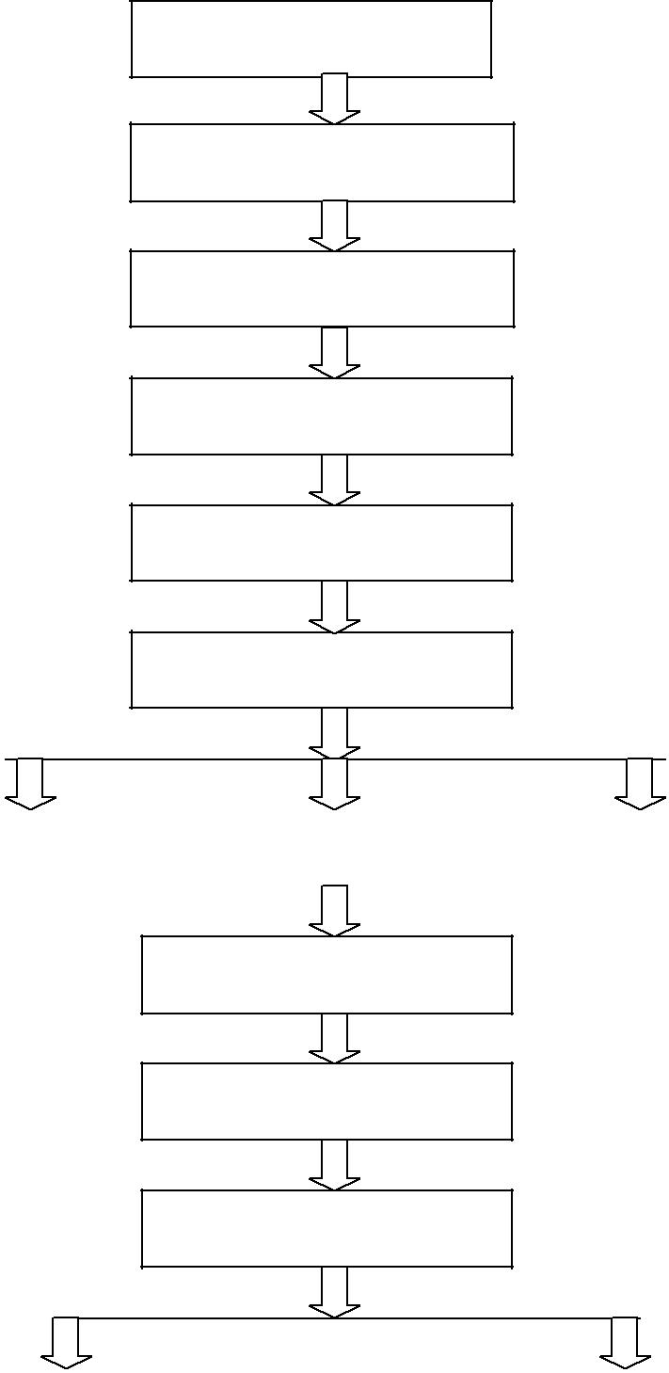
3.2.1.2Testing Data of Blow Room:
Total waste = 6.51%
Card Waste = 5.31%
Total weight feed for testing = 1508 kg
Production = 1410 kg
Table.10 In blow room waste produced:

m/c name | Waste (kg) | Waste (%)
Dropping | 15.80 | 1.05
Dust | 2.3 | 0.15
Pre-cleaner CLP | 0 | 0
Post-Cleaner CL-C1 | 0 | 0
Post-Cleaner CL-C2 | 0 | 0
Total | 18.1 | 1.20
3.3.1 Carding:
After the Blow Room, carding process is next processing stage in line for yarn production in a spinning mill. In spinning textile industry carding is known as the heart of the spinning process as the expert in spinning called "well-carded fibers are half spun" [13]. Carding is used to disentangle, separate and clean the fibers at an individual level by passing through wired surfaces which are called card clothing. These card clothing or surfaces are rotating at a different speed from each another. The level of opening of fibers depends on the differential speed between cards surfaces. The carding process produces the fibers in continuous sliver or web form which is suitable for the further operation in spinning unit apart from fibers opening at the individual level, the dust, dirt particles, along with neps are removed at the carding stage. Carding process is essential for both carded and combed yarn.
3.3.2 Objectives:
Objectives of carding are given below
1. Individualization of fiber strands
2. Blending or Homogeneousness
3. Orientation or alignment of fibers
4. Removal of short fibers
5. Removal of hooks
6. Removal of dust particles
7. Removal of neps and untangling of neps
8. Formation of sliver or web
Fig.3.1 Card:
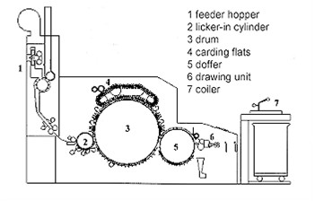
Carding Machine
3.3.3 Sliver testing:
Fiber Assembly: 60 gr/yd Fiber: 3.9 ug/I V: 25 m/min t: 1.0 min
Yarn Tension: 100% Imperfections: short
Table.11 card Sliver testing:
Test No. | Um (%) | CVm (%) | CVm(1m)% | Index(-) | Rel. Count (%)
1/1 | 2.97 | 3.76 | 1.13 | 6.26 | 100
1/2 | 2.97 | 3.80 | 1.72 | 6.32 | 98.8
1/3 | 2.85 | 3.73 | 1.47 | 6.21 | 100
Mean Value | 2.93 | 3.76 | 1.44 | 6.26 | 99.80
Table.12 Card Wrapping Report:
M/C No | 1 | 2 | 3 | 4 | 5 | 6
1 | 39.45 | 38.52 | 38.75 | 40.11 | 39.31 | 39.38
2 | 39.02 | 38.10 | 38.91 | 39.59 | 39.07 | 39.25
3 | 39.37 | 38.44 | 39.20 | 39.81 | 39.14 | 39.42
4 | 39.11 | 38.29 | 38.87 | 39.64 | 39.52 | 39.56
Gr/yd | 60.55 | 59.16 | 60.08 | 61.40 | 60.58 | 60.96
Cv% | 0.52 | 0.48 | 0.49 | 0.58 | 0.51 | 0.56

Summary
Raw Material: Indian cotton
AVG: 60.46 gr/yd
CV%: 1.13%

3.4.1 Draw frame:
Draw frame is a very critical machine in the spinning process. It is consist of breaker frame and finisher frames. Its influence on quality, especially on evenness is very important. If draw frame is not set properly, it will also result in drop in yarn strength and yarn elongation at break. The faults in the sliver that come out of draw frame cannot be corrected. It will pass into the yarn [14].
3.4.1Objectives of Draw Frame:
- Improving Fineness
- Parallelization
- Dust Removal
Table .13 Drawing Wrapping Test:
M/C No | 1 | 2 | 3 | 4
1 | 23.33 | 23.29 | 23.38 | 23.45
2 | 23.31 | 23.38 | 23.32 | 23.40
3 | 23.40 | 23.32 | 23.43 | 23.35
4 | 23.37 | 23.34 | 23.38 | 23.42
AVG | 60.06 | 60.01 | 60.12 | 60.19
CV% | 0.17 | 0.16 | 0.19 | 0.18
3.5.1 Breaker Draw Frame:
Breaker Draw Frame is also a very important machine in the spinning process. Fiber alignment in this step also increases fiber strength and elongation at break.
3.5.2 Objectives of Draw Frame:
- Improving Fineness
- Parallelization
- Dust Removal

Fig.3.2 Breaker Draw Frame
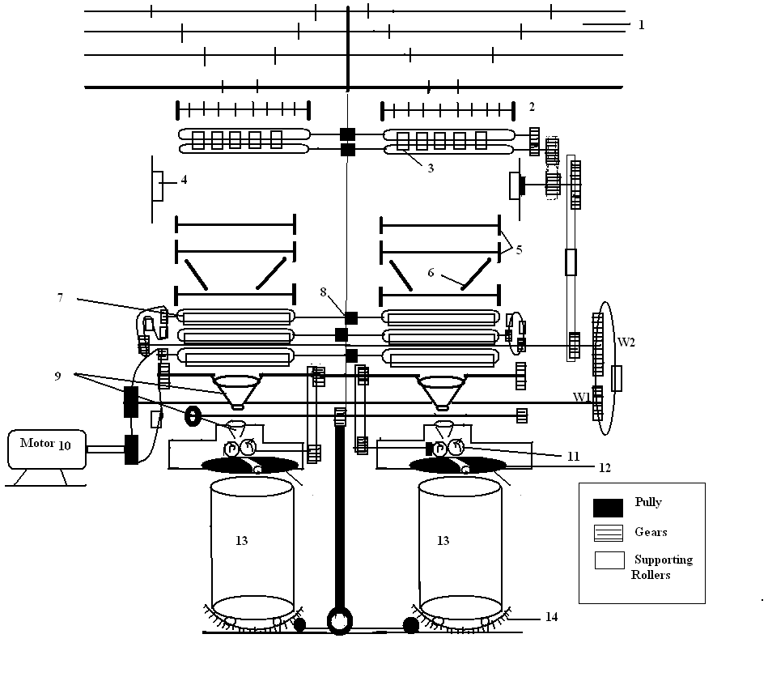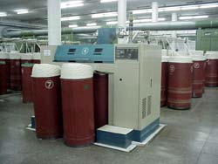
Reiter RSB-2
3.6.1 Lap former:
Lap former is used to prepare required lap which is essential in the combing process. It is a pre comber process. Lap preparation is necessary because it gives compact feeding to comber. More areas for combing action (then in case of sliver) in lap form.
- Easier machine operation.
- Preparation for best combing results.
- Flexibility (combed and carded cotton in the same line).
Fig.3.3 Lap Former:
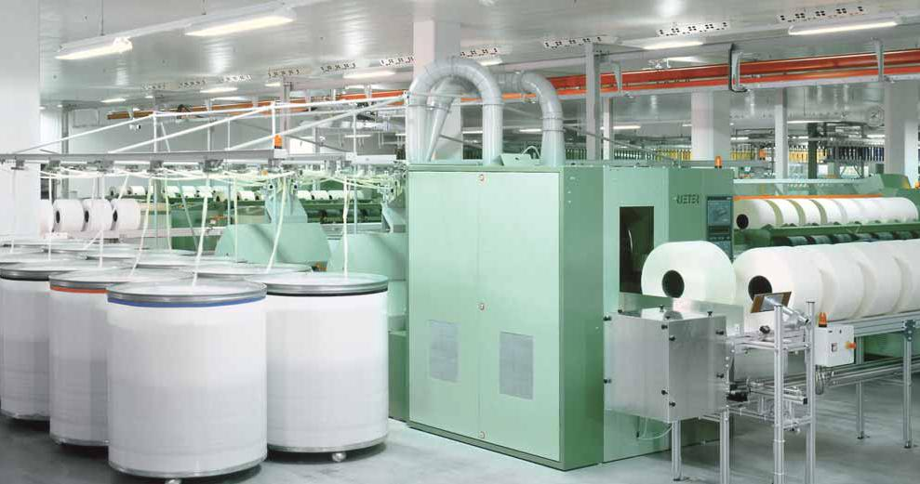
Reiter E-5/3

3.7.1 Comber:
Within the overall spinning process, the combing operation serves to improve the raw material. It is used in the production of medium fine and fine yarn which enables a positive influence to be exerted primarily on the following yarn characteristics [15].
- Yarn evenness
- Strength
- Cleanness
- Smoothness
- Visual appearance
In addition to this yarn made of combed cotton needs less twist than carded yarn.
3.7.2 Sequence of Operation in a comber:
- Feeding, the lap is fed by the feed roller
- fed lap gripped by the nipper
- gripped lap is combed by the circular comb
- detaching roller grips the combed lap and moves forward
- while the detaching roller delivers the material, top comb comes into action to further clean the lap
- While going back, nipper opens and receives a new bit of lap
Fig.3.4 Comber:
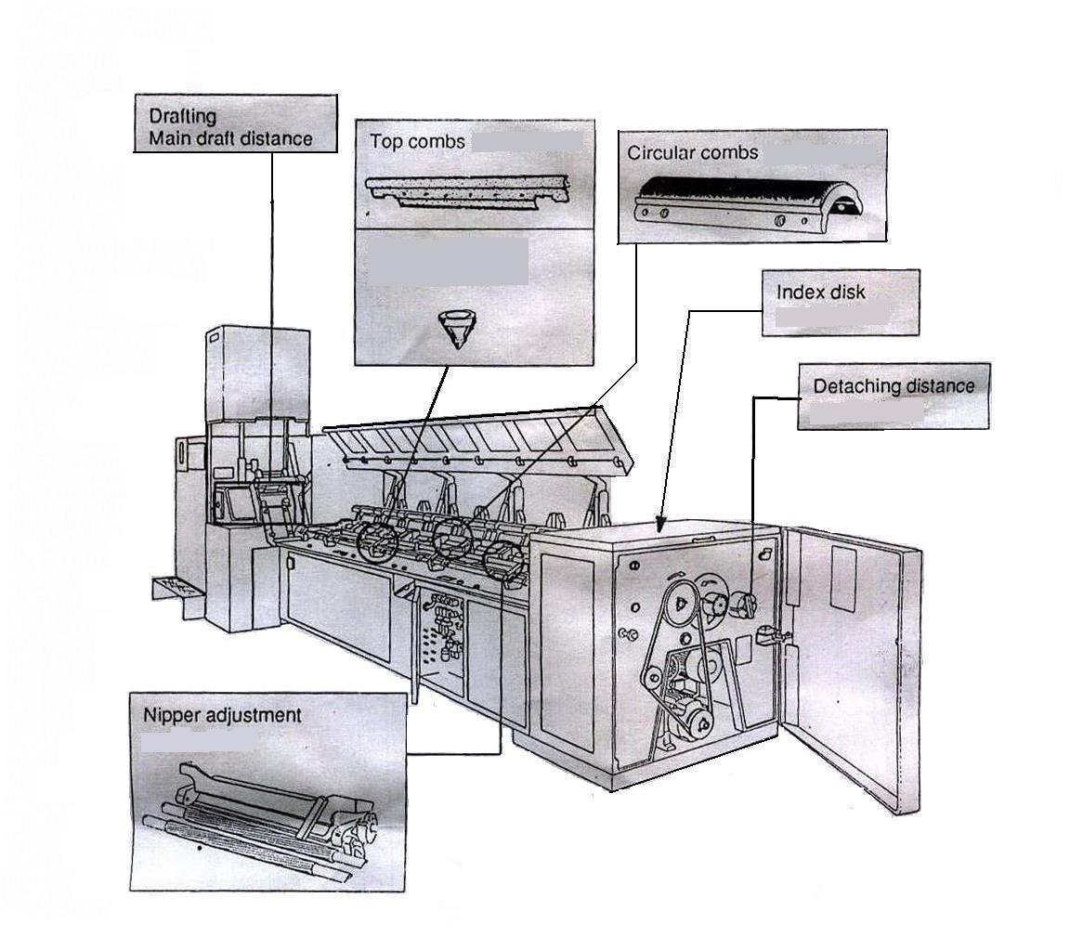
Reiter comber E-7/6

3.7.3 Waste Percentage:
The noil percentage from a comber depends upon the following
- short fiber content
- detaching distance
- feed length
- top comb penetration
- The basic idea of removing the waste is to remove the short fibers i.e. to improve 50% span length or mean length.
There are two important basic parameters to be considered in deciding the waste percentages are [9]:
- The fibers content in the raw material
- Yarn quality requirement

3.7.4 Sliver Test:
Fiber Assembly: 60 gr/yd
Fiber: 3.9 ug/i
V: 25 m/min t: 1.0 min Yarn Tension: 100% Imperfections: short staple
Table.14 comber sliver testing:
Quality parameters | 0% Noil | 12%-noil |  | 16%-noil | 20%-noil
U% | 5.79 | 4.43 |  | 4.14 | 4.01
Cvm 1mtr% | 2.31 | 1.46 |  | 1.16 | 1.11
Nep cnt/gm | 79 | 39 |  | 25 | 16
Short fiber content | 12.8 | 10.6 |  | 9.6 | 8.5

3.8.1 Finisher Draw Frame:
Finisher Draw Frame is an important machine in the spinning process as well. It is the final stage of drawing of Fiber aligns and makes them straighter in this step also increases fiber strength and elongation at break.
3.8.2 Objectives:
- Improving the Fineness of sliver
- Parallelization
- Dust Removal
- Homogeneous sliver
Fig.3.5 Finisher Draw Frame
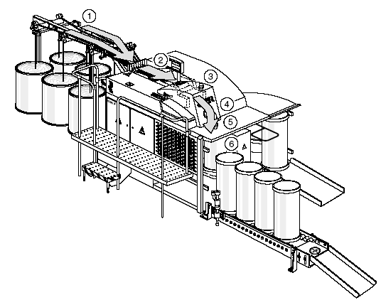
Reiter RSB – D30

    - Roving frame/ Speed frame / Simplex frame:

This frame is basically used to convert sliver into a suitable form which could be fed to ring achieving best quality results and efficiency. Slight twist insertion in this phase, also impart little strength to the feeding material but also avoids the need of high draft on the ring which enhances yarn quality to a great extent. The roving formed on the simplex is wound on roving bobbins and fed to ring. Roving count depends on the count of yarn to be made.
3.9.2 Objectives of the roving frame are as follows
- Drafting (to attenuate the feeding sliver )
- Twisting (Imparts supportive draft in the roving )
- Winding (winding to roving to suitable bobbin for easy efficient transportation)
Fig.3.5 Simplex Frame
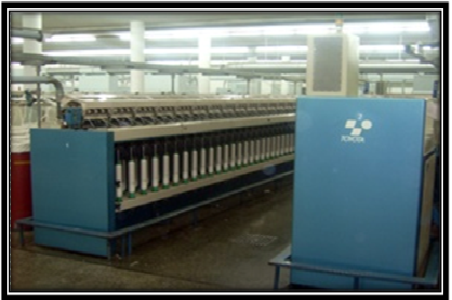
Toyota FL – 16

3.9.3 Simplex frames Test Report:
Fiber Assembly: 1.2 NEC Fiber: 3.9 ug/I
(IND Cotton)
V: 50 m/min t: 1 min Yarn Tension: 100% Imperfections: short staple
Table.15 Test Report simplex
Test No. | Um (%) | CVm (%) | CVm(1m)% | CVm(3m)% | Index (-) | Rel. Count
1/1 | 3.47 | 4.38 | 2.47 | 2.08 | 2.45 | 100.5
1/2 | 3.04 | 3.84 | 1.56 | 0.85 | 2.13 | 99.0
1/3 | 3.57 | 4.43 | 2.60 | 2.23 | 2.48 | 101.3
1/4 | 3.09 | 3.93 | 1.50 | 0.93 | 2.20 | 98.3
1/5 | 3.18 | 3.99 | 1.94 | 1.35 | 2.23 | 100.8
1/6 | 3.20 | 4.06 | 2.01 | 1.53 | 2.27 | 100.0
1/7 | 3.09 | 3.91 | 1.34 | 1.18 | 2.19 | 98.5
1/8 | 2.96 | 3.72 | 1.85 | 1.58 | 2.08 | 101.0
Mean Value | 3.20 | 4.03 | 1.93 | 1.47 | 2.26 | 100.0
CVm (%) | 6.66 | 6.23 | 21.65 | 33.74 | 6.23 | 1.21
Q95% +/- | 0.18 | 0.21 | 0.35 | 0.41 | 0.12 | 1.0

Table.16 Wrapping Test of simplex:
M/C No | 1 | 2 |  | 3 |  | 4
1 | 6.74 | 6.61 |  | 6.67 |  | 6.60
2 | 6.73 | 6.58 |  | 6.61 |  | 6.69
3 | 6.68 | 6.65 |  | 6.59 |  | 6.58
4 | 6.77 | 6.56 |  | 6.68 |  | 6.59
H.R | 1.203 |  | 1.227 |  | 1.220 |  | 1.224
C.V% | 0.55 |  | 0.59 |  | 0.66 |  | 0.76

Summary:
BLEND: Indian cotton
AVG: 1.218
CV%: 0.64%
3.10.1Ring Fame
Ring frame plays important role as it is the frame where yarn gets its final structural shape. Ring frame is used to convert roving from simplex into the yarn. Final attenuations to the yarn are given by drafting zone of ring. Then by ring cup and ring traveler twist of requirement is inserted into the yarn. After that the yarn formed is continuously wind on ring bobbins. These ring bobbins are called ring doff, which are then send t auto cone for further operation [16].
3.10.2 Ring frame has the following objectives:
- Drafting
- Twisting
- Winding
Fig. 3.6 Ring Frame
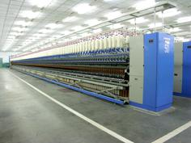
EJM-168 China (Suessen)

3.11.1 Auto Cone:
The yam from ring department comes in small packages called ring bobbin. This yarn is full of defects like thick and thin places. Also, these packages are the relatively shorter length to be used in the next processes like weaving, knitting etc. These defects are removed on winding machine.
3.11.2 Objective:
- Produce a bigger yarn package from short length ring bobbins.
- Remove faults from the yarn that may have created during the spinning process.
- Produce a package of maximum possible size so that the need to replace supply package at next stage of process is minimized.
- Produce a package of required density and shape for the next process.
- Produce a package containing a pre-determined length of yarn so that there is a minimum amount of yarn on the package.

Fig.3.7 Auto-cone:

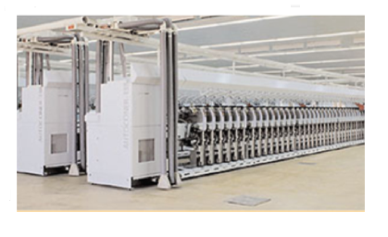
Muratec -21-C

3.11.3 Uster Quantum Setting:
Table.17 Uster Quantum Setting:
FAULT | DESCRIPTION | FAULT DIAMETER | FAULT LENGTH
N | Neps | 500% | 1 cm
S | Short Thick Places | 150% | 2.0 cm
L | Long Thick Places | 40% | 50 cm
T | Long Thin Places | --40% | 50cm
FD | Foreign Fiber Detector Dark | 20% | 0.6 cm
CP | Count Plus | +25% | 2.0 m
CM | Count Minus | -25 % | 2.0 m
CCP | Continuous Count Plus | +30 % | 0.8 m
CCM | Continuous Count Plus | -30% | 0.8 m
JP | Joining Plus | +140% | 4 cm
JM | Joining Minus | 0% | -
PC | Pearl Chain | 32 % | - cm

3.12 Equipment and standards for yarn Testing:
3.12.1 Tensile Strength
Tensile strength is the ability of a material to withstand a pulling (tensile) force. The tensile strength of a material is the maximum amount of tensile stress that it can take before failure, such as breaking or permanent deformation. Tensile strength specifies the point when a material goes from elastic to plastic deformation.
There are three types of tensile strength:
- Yield strength - The stress a material can withstand without permanent deformation
- Ultimate strength - The maximum stress a material can withstand
- Breaking strength - The stress coordinate on the stress-strain curve at the point of rupture.
3.12.2 Tensile Strength of:
- Fiber
  - Single fiber strength test
  - Bundle fiber strength test
- Yarn
  - Single yarn strength test
  - Lea yarn strength test
3.12.3. Tensile Strength Test of Fiber:
In textile field, the tensile strength is tested by HVI, AFIS & FCT. As the cotton bales and yarn are imported and exported throughout the globe it is quite important to maintain the quality parameters along with the rate of production. For this testing machine speeds and settings need to be matched to the properties of the fiber in process [17].
3.13.1 Latest Fiber Testing Instruments
- High volume instrument (HVI)
- Stelometer
- Advanced fiber information system (AFIS)
- Presley Fiber Strength Tester
- Fiber contamination tester (FCT)

3.13.2 High volume instrument:
For the strength of fiber Bundles testing HVI is used in which many fibers are checked at same times and their average values are determined. Apart HVI a number of equipment like Micronaire, Presley, Stelometer, and fibro graph are also in use for deterring the average value of larger number of fiber. HVI is automated bundle testing instrument a larger of number of sample can be tested in short time period with minimal operator negligence.
3.13.3 Principles of fiber testing using HVI:
The fiber strength testing in HVI is performed on a beard of fibers which are projecting to different clamping points While using the low volume instrument fibro-stelo is used for strength checking, a 10mm to 15mm long fiber strands is separated on a combing window For Micronaire a sample of cotton weighing approximately 10 grams is used then HVI measure airflow resistance by fibers surface than the surface which is in a tube-like shape in the HVI. On the other hand, the maturity ratio of fibers is calculated by using several testing samples results of HVI which are driven algorithmically. Uniformity index of fibers in HVI, which are automatically prepared by the help of brush and card-like devices, is measured by an optical sensor. Whiteness (Rd) and +b (yellowness) of material are also measured by optically filters and then converted to a customized color chart. A digital camera is used to determine the trash content by measuring the surface area covered by the trash then compare it to standards trash for the HVI.
3.13.4 Measurement of different parameters using HVI
- Length
In HVI optical sensors are used to measure the length of the fibers the optical sensor follows the rectangular beam of light which is allowed to fall on the beard of fiber bundles in a sample. The decreasing of Light while passing through the specimen at different areas of the beard is measured and then it is used to calculate different span length values. First, the tip of the beard is Scan then the rest of the sample gradually along, the span length values are obtained by actual measurement.
- Strength
n HVI Constant rate of elongation, the principle is used while testing the fiber sample. A sample after weighting is positioned to the jaws which break it by a constant amount along with a constant number of fibers is being broken between jaws.
Breaking tenacity in g/tax = (breaking load in kg/ sample weight in mg) x 15 mm [18].
3.14.1 Advanced Fiber Information System (AFIS):
In Advanced Fiber Information System fiber testing there are two modules, one for testing the size of neps and the number of neps. The second one for testing diameter and length. These modules can be applied together or individually depending on the need. AFIS is helpful to determined average properties of sample as well as variation of these properties from fiber to fiber. 3 minutes per sample is the testing time for default mode of AFIS-.N module.
Fig. 3.8 AFIS: 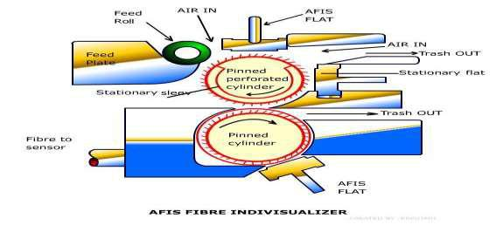
3.14.2 AFIS -Working principle
Advanced Fiber Information System (AFIS)
A sample of 500mg is placed between feed plate and feed roller of AFIS-N, where opening rollers are used to open the fiber assembles which separates the fibers, neps, trash and dust particles. Trash and other dust particles are removed by pneumatic system. This fiber assembles while passing through a channel called acceleration and transportation are checked by optical sensor. This optical sensor determines the size and number of neps. Optical sense collect data in electric signals detected are then processed for evaluation purposes then results are shown on screen and can printed out. A keyboard is used to control the whole measuring process.
3.14.3 Fiber Contamination System (FCT):
Cleaning, micro carding device integrated. This self-cleaning card produces a transparent web of 10m and separates impurities and all of contamination present in area of 1 sq. m per sample fed. The optical sensor of FCT analyzes the web for trash, neps and other seed particles. After that the web is passed through two stickiness crush rollers. A Vacuum deposits these cotton webs on stickiness rollers where a lazar is used to analyze the stickiness content .In FCT around 40 second take place for each sample.
3.14.4 Stelometer (CRL):
For measuring strength and elongation of fiber bundles Stelometer is used. It works on pendulum principle. Specimen loading is carried out by a pendulum system, which rotates about its C.G. in this system the inertia effect requirement like basic pendulums is removed. When the beam and pendulum start in a vertical position then the whole assembly rotates because of C.G. Dashpot is used to control and adjust the rotation speed.

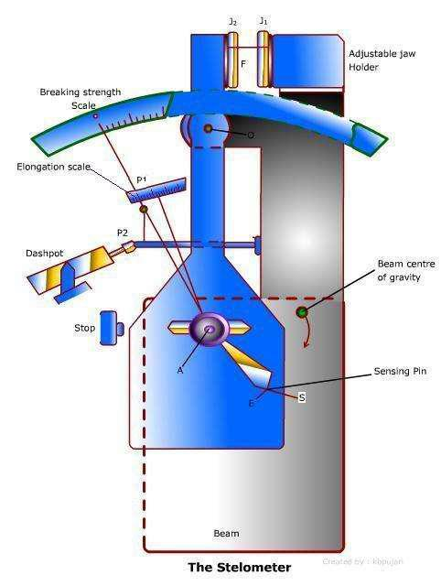
Figure.3.9 Stelometer:

3.15.1 Pressley Fiber strength tester:
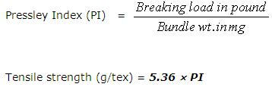
Another instrument which is used for measuring of fiber strength is Pressley which has a beam having pivoting point at O shown in diagram given below. The clamp c1 moves upward when point B of beam is raised. There is slight inclination of few degrees present is beam at horizontal position. When W the rolling weight is released from the catch then the beam moves down. The point O indicating the fiber break force increased at graduated beam until the fibers are breaks after the breaking of fibers the graduating beam drops and the breaking mechanism is stopped. There is a constant which is used to measure the tensile strength of fibers in Pressley Fiber Tester [19].

Ch.3.1

Fig.3.10 Pressley Fiber strength tester
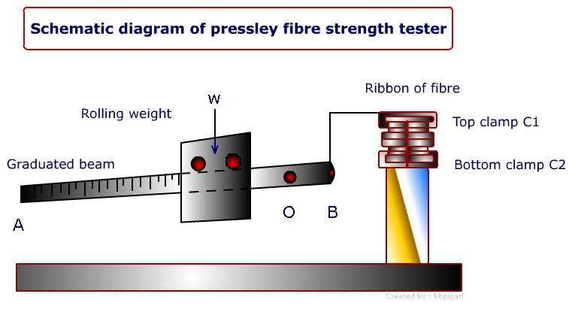

3.16.1 Yarn strength test:
There are two ways mostly in practice for measuring of yarn strength in most of mills.
(i) Single yarn strength: tenso-rapid by Uster is one of common instrument which is used to measure single yarn strength. It is automated and fast way to obtain actual values of yarn strength a number of yarns are set at the 500mm gauge length at tenso-rapid it has adjustable speed for testing. It only takes 20second to 25second to break testing sample and to measure its value of breaking force of yarn
(ii) Lea strength or skein method: leas are used for measuring of yarn tensile strength. A larger number of fibers lengths is tested in a skein method and realistic value is obtained as yarn is broken at its weak spots. Then theses hanks are useable for measuring of count. Some drawbacks are also mentionable here in using of skein method for yarn strength measurement such as the results are variable due to friction between fiber strands in yarn as well as number of hoocks in yarns.
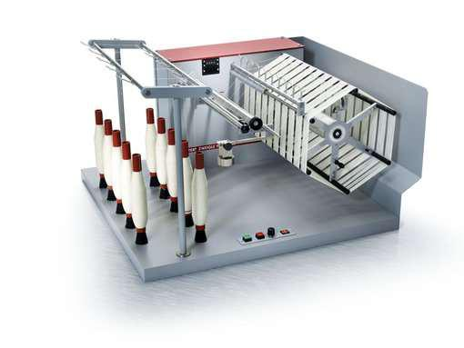
Figure: 3.11 Lea or skein wrappers

Skein wrapper

In spinning mills the strength of yarn is mostly associated to CLSP (count-lea-strength-product) which is the product of count (English count) and yarn strength in pounds. In English count number of hanks in one pound
Count = (L* w)/ (l*W). Here, L = length of the sample Eq.2. ch.3

l = unit length of the system
W = wt. Of the sample
w = unit wt. of the system.
Strength of one lea of yarn is measured in lea strength tester on which the lea is broken at a constant force in lbs.
M/c specification:
- Lea Strength Tester

- Good brand & Co. Ltd.
- Capacity: 100
Sample:

- Size - One lea cotton yarn (1 lea =120 yards).
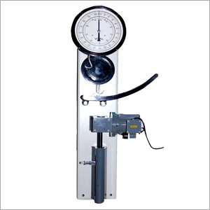
- No. of sample – 20
Figure: 3.12

Lea of yarn is prepared on wrapping reel having length of 120 yard which is used for testing. The lea is fixed with upper Jaw and lower of the machine. After that machine is started by a push button and dial is observed until the sample is torn up. At the moment of sample breakdowns the machine stops and dial goes back to its first position. This process is repeated on other leas of sample and readings are noted. After that all the samples are weighted and the count of these samples is calculated. Average count of sample and Average weight are multiplied to calculate CLSP.
3.16.2 Uster Tester:
The other Equipment use to check the quality of yarn is USTER Tester. It is also use to check the quality of different final product like yarns as well as intermediate products in processing line like sliver and roving. It specifies the quality parameters variation like Yarn Evenness, thick, thin places neps, diameter, dust, trash, fineness and hairiness in yarn and intermediate products. In auto- cone USTER Quantum / yarn Clearer is used to control the yarn quality.

3.17 Results of Samples at Different Noil Extraction:
Table 3.17.1 COMBER SAMPLE NOIL = 0% (carded)

INDIAN COTTON COMBER SAMPLE NOIL = 0% CD COUNT = 54/S
Test | Um% | CVm% |  | CVm(1m)% | CVm(3m)% | CVm(10m)% | Thin pl. (-50%) | Thick pl. (+50%) | Neps  (+200%) | Sh(-) | Hairiness(-)
Mean value | 13.9 | 16.8 | 7.22 |  | 5.55 | 4.7 | 129 | 247 | 539 | .76 | 4.59
CV% | 3.27 | 3.23 | 14.61 |  | 21.78 | 26.83 | 35.3 | 21.1 | 15.9 | 3.10 | 3.34
COUNT=54.35 |  |  | CV= 1.88% |  |  | STR=43.6 |  | CV= 5.09% |  | CLSP=2369

Table 3.17.1.1 COMBER SAMPLE NOIL = 0% (carded)

INDIAN COTTON COMBER SAMPLE NOIL = 0% CD COUNT = 54/S
Test | Time to Br(s) | B-Force(gf) |  | Elongation (%) | RKM(kgf*Nm) | B-Work(gf.cm)
Mean value | 0.2 |  | 165.1 | 3.12 | 15.13 | 138.6
CV% |  |  | 6.30 | 8.20 | 5.78 | 10.33
Min value |  |  | 138.8 | 2.98 | 12.51 | 104.67
Max value |  |  | 169.7 | 3.72 | 15.21 | 139.6

Total IPI of Sample 0% Noil (carded) = 915

Table 3.17.2 COMBER SAMPLE NOIL 12%:

INDIAN COTTON COMBER SAMPLE NOIL = 12% COUNT = 54/S
Test | Um% | CVm% |  | CVm(1m)% | CVm(3m)% | CVm(10m)% | Thin pl. (-50%) | Thick pl. (+50%) | Neps  (+200%) | Sh(-) | Hairiness(-)
Mean value | 13.1 | 16.6 | 6.27 |  | 5.13 | 4.4 | 96 | 198 | 432 | .74 | 3.23
CV% | 3.27 | 3.23 | 14.61 |  | 21.78 | 26.83 | 35.3 | 21.1 | 15.9 | 3.10 | 3.34
COUNT=54.35 |  |  | CV= 1.88% |  |  | STR=43.6 |  | CV= 5.09% |  | CLSP=2396

Table 3.17.2.1 COMBER SAMPLE NOIL 12%:

INDIAN COTTON COMBER SAMPLE NOIL = 12% COUNT = 54/S
Test | Time to Br(s) | B-Force(gf) |  | Elongation (%) | RKM(kgf*Nm) | B-Work(gf.cm)
Mean value | 0.2 |  | 166.64 | 3.19 | 15.30 | 146.5
CV% |  |  | 6.02 | 7.63 | 5.66 | 9.78
Min. value | ------- |  | 142.1 | 2.98 | 12.51 | 104.67
Max. value | ------- |  | 174.6 | 3.83 | 15.46 | 169.5

Total IPI of sample 12% Noil (carded) = 726

Table 3.17.3 COMBER SAMPLE NOIL 16%:

INDIAN COTTON COMBER SAMPLE NOIL = 16% COUNT = 54/S
Test | Um% | CVm% |  | CVm(1m)% | CVm(3m)% | CVm(10m)% | Thin pl. (-50%) | Thick pl. (+50%) | Neps  (+200%) | Sh(-) | Hairiness(-)
Mean value | 12.08 | 16.30 | 5.35 |  | 4.05 | 3.41 | 115 | 164 | 376 | .73 | 3.20
CV% | 4.22 | 4.22 | 9.29 |  | 14.40 | 18.78 | 53.5 | 29.3 | 16.8 | 3.95 | 4.90
COUNT=54.43 |  |  | CV= 1.71% |  |  | STR=45.7 |  | CV= 4.88% |  | CLSP=2487

Table 3.17.3.1 COMBER SAMPLE NOIL 16%:

INDIAN COTTON COMBER SAMPLE NOIL = 16% CD COUNT = 54/S
Test | Time to Br(s) | B-Force(gf) |  | Elongation (%) | RKM(kgf*Nm) | B-Work(gf.cm)
Mean value | 0.2 |  | 172.71 | 4.31 | 15.88 | 182.7
CV% |  |  | 4.77 | 6.96 | 4.91 | 6.57
Min value |  |  | 132.5 | 3.05 | 14.32 | 110.27
Max value |  |  | 179.9 | 4.82 | 16.12 | 189.8

Total IPI of sample 16% Noil = 605

Table 3.17.4 COMBER SAMPLE NOIL 20%:

INDIAN COTTON COMBER SAMPLE NOIL = 20% COUNT = 54/S
Test | Um% | CVm% |  | CVm(1m)% | CVm(3m)% | CVm(10m)% | Thin pl. (-50%) | Thick pl. (+50%) | Neps  (+200%) | Sh(-) | Hairiness(-)
Mean value | 12.97 | 16.45 | 5.91 |  | 4.72 | 4.07 | 101 | 187 | 326 | .75 | 3.27
CV% | 4.39 | 4.46 | 14.62 |  | 18.0 | 22.72 | 50.2 | 25.6 | 21.7 | 5.64 | 4.74
COUNT=54.47 |  |  | CV= 1.71% |  |  | STR=46.9 |  | CV= 4.74% |  | CLSP=2554

Table 3.17.4.1 COMBER SAMPLE NOIL 20%:

INDIAN COTTON COMBER SAMPLE NOIL = 20% CD COUNT = 54/S
Test | Time to Br(s) | B-Force(gf) |  | Elongation (%) | RKM(kgf*Nm) | B-Work(gf.cm)
Mean value | 0.2 |  | 177.23 | 4.65 | 16.31 | 199.5
CV% |  |  | 4.39 | 6.72 | 4.89 | 6.38
Min value |  |  | 142.5 | 3.18 | 14.84 | 114.37
Max value |  |  | 189.4 | 4.97 | 16.51 | 209.6

Total IPI of sample 20% Noil (carded) = 574

3.18 Resulted Properties of samples
i) Unevenness in Yarn Um%:
Simple definition for Um% or unevenness in yarn is change of mass per unit length. In sliver or in yarn this unevenness occurs due to the variation of fiber assembles in the structure. The more short fiber extracted in combing process makes these fiber assembles more regular throughout the structure of yarn, which gives less Unevenness in yarn. As we can see in figure 3.13 given blow results are getting much be if we compare carded and 12% combed yarn. Um% is also getting batter at 16% combed yarn but again slight increased happened at 20% combed yarn.
Figure: 3.13 Unevenness in Yarn Um%

ii) Thick and Thin Places
Short or long thick and thin places are one of major yarn faults. They happen due to high short fiber content in yarn structure. Short fiber gets different twist at same twist level during spinning processes. These faults are measurable by Uster Imperfection Indicator and can be observed on yarn appearance. Shown in figure 3.14.2 given below we can see that the number of thin places are less in 12% combed yarn then the other Noil percentages 0%, 16%, 20% respectively and for thick places the results are batter for 16% combed yarn then the rest of samples.

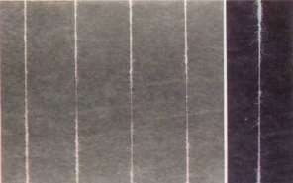Figure: 3.14.1 Thick and Thin Places

Thin and Thick Places
Figure: 3.14.2 Thick and Thin Places

iii) Neps
Yarn which contains rolled fiber mass know as neps these neps are generally balls or knots of entangled fibers. We can clearly see neps shown in picture on black board at close distance. In yarn these neps are measurable by Uster imperfection Indicator. Neps occur due to the presence of seed coat, leaf, seed, husk and dead or immature fiber in yarn or sliver. So combing processes eliminates these impurities and fibers more effectively which give more batter quality to yarn having less neps in its structure. Figure 3.15.2 shows the neps results are better for 20% combed yarn then the other samples.

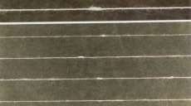Figure: 3.15.1 Neps

Neps
Figure: 3.15.2 Neps

iv) Hairiness:
Hairiness is “Protrusion of fiber ends from the main yarn structure”. If fiber assembles has not uniformity then the resulting yarn will have more hairiness. Like other properties hairiness can be improved by extracting short fibers in combing process. As we observed in our experiment show in figure 3.16.2 given below hairiness is better in 16% combed yarn. After 16% there is very less significant change has been observed

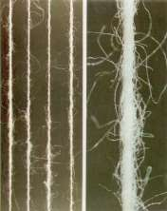Figure: 3.16.1
Hairiness
Figure: 3.16.2 Hairiness

v) Elongation %:
Elongation percentage is percentage of straight length of fiber or yarn. It is the length from which a fiber or yarn can get back to its normal shape or length after being under stress. Textile products made from less or having no elongation are hardly usable. For the usage of textile, product needs to be able of deformation and getting back to their original shape. Elongation percentage is much better for 20% combed yarn in our experiment as shown in figure 3.17 below.
Figure: 3.17 Elongations

vi) RKM (kgf.Nm):
RKM can be expressed by the “Length of yarn in km” at which yarn will break of under on its own weight if hang freely. Some times RKM is expressed as Breaking-kilometer or Resist-kilometer; these units simply explain if RKM of cotton fiber is 15 then it means if 15km yarn wound is hanged up, it would break off by its own weight. In our research sample having 20% comber noil has more RKM value as compare to the rest of samples shown in the figure 3.18 given below.
Figure: 3.18 RKM

vii) B-force (gf):
The amount of force which we need to break yarn is called B-force it is measured in gram force or centi-newton (CN). While gram force centimeter (gf-cm) is a measuring unit of torque. Figure 3.19 shows the results for B-force and B-Work are improving for 20% Noil samples as compare to the 0%, 12%, and 16% combed yarn, in our experiment

Figure: 3.19 B-force and B-work

viii) IPI:
Imperfections in yarn are called IPI they define the quality of yarn along the price of the yarn. Buyers check IPI and decides wither he should or should not buy the yarn as if these IPI falls in His expectable rage or not. IPI are consisting of thick and thin places, hairiness, Um%, Neps [20]. The less IPI were obtained in 20% combed yarn as compare to the rest of samples 0%, 12%, and 16% shown in figure 3.20 given below.

Figure: 3.20 IPI

CHAPTER 4
4.1 Discussion:
We can see results given in tables above that after extracting comber Noil the properties of yarn has dramatically change with quit difference as compare to carded yarn(from Noil 0% to 12%). After that there is miner change in quality and results from 12% to 16% noil extraction. As we find in our literature review the quality parameters are depending on the yarn manufacturing process like carded yarn or combed yarn. As some research explained in our literature review indicated yarn properties like tensile strength, elongation, hairiness, neps, can be significantly improve by extracting short fiber in combing process for yarn.
As we observed in our research, yarn properties for Noil extraction from 16-20% are slightly varying. As we increased the noil extraction percentage the number of neps, un-evenness, hairiness decreases and elongation, yarn strength increases. In comparison of our finding to those in literature review it is frequent observation indicating that all properties get batter for combed yarn as compared to the carded yarn.
We observed some property get improved for 12% combed yarn like thin places as compared to our sample of carded, 16% and 20% combed yarn. Unevenness was better for 16% combed yarn then the 12% and 20% combed yarn.
Hairiness also decreased for 16% combed yarn as compare to the other three samples. While the thick places were also better for 16% combed yarn then the 12% and 16% combed yarn. For 20% noil extracted combed yarn the properties which we observed enhanced were Elongation percentage apart that tensile strength, RKM, B-force, B-work were also improved. While thin places were improved as well for the 20% combed yarn then the rest of samples

4.2 Conclusions
As we explained how much all the properties of yarn were effecting by extracting noil percentage in combing process, but one thing established in our research which is that the properties mention above slightly vary after extraction of Comber Noil between 16% to 20%.Slightest difference of properties at high comber Noil shows that it is not wise to extract high noil as they affect minimum on properties as compare to the product cost and wastage of raw material.
In our finding in this research that if all of the quality related parameters are fixed then comber noil extraction has quite impact on yarn properties.
These properties are significantly better as compare to carded yarn. But the cost of combed yarn increases as the combed yarn needs more amount of raw material and more number of processes. To overcome this high costing problem we need to find optimum Noil extraction percentage. Already in this area work has been done but further a lot of work can be helpful for the improvement of yarn quality and maximum usage of raw material for economical point of view. Textile is still evolving even in this advance era of industries a lot of more work can be done, there is always room for betterment in every field so we are hoping with more research and study in combing process for yarn manufacturing optimum noil percentage can be obtained for better quality.

References

[1] | H. S. J. L. K. D. M. A. X. C. D. Thibodeaux, "The Impact of Short Fiber Content on the Quality of Cotton Ring Spun Yarn," The Journal of Cotton Science, vol. 12, no. 4, pp. 368-377, 2008.
[2] | A. M. A. GHOSH, "Process Control In Drawframe, Comber, And Speedframe," Delhi, India , Woodhead Publishing Limited, , 2012, pp. chapter 7, 158.
[3] | P. S. A. A. &. P. Baviskar Dipali, "To Study Effect Of Comber Noil Percentage On Yarn Quality".
[4] | S. LANKA, "COTTON YARN MANUFACTURING PROCESS," DIPLOMA IN TEXTILE & APPEREL TECHNOLOGY, SRI LANKA, 2015.
[5] | N. H. G. E. Magdi El Messiry, "Optimization Of The Combing Noil Percentage," single and ply compact spun yarn, no. 6 January 2013, pp. 308-311, 2 January 2012;.
[6] | F. C. O. T. Yarn Manufacturing Process, "http://textilelearner.blogspot.com/2012/02/textile-manufacturing-process-process.html".
[7] | T. O. S. S. Spinning, "The Technology of Short staple Spinning," vol. 3, no. part-I, 2006.
[8] | S. H. H. E. M. M. A. M. E.-S. SANAD, "Production of Carded Compact Cotton Yarn of Comparable Quality To The Combed Convention Ring YARN," pp. 203-209, 10-oct-2010.
[9] | W. Klein, "The Rieter Manual Of Spinning l," The Technology Of Short-Staple Spinning, Vols. V-1, p. 80, 2014.
[10] | D. N. H. a. E. G. E. Prof Dr. Magdy El Messiry, "A comparative study on Egyptian Carded, Combed compact and Combed Conventional Ring Yarn," pp. 1-13, ‎October-2016.
[11] | J. W. &. L. C. Qian Wang, "Analysis of Factors to Influence Yarn Dynamical Mechanical Property," Modern Applied Science, vol. 3, no. No.1, pp. 1-8, 2009.
[12] | T. T. A. DEFINITIONS, "http://dx.doi.org/10.1080/19447014408687719," Vol. 35, pp. P114-P117, 07 Jan 2009.
[13] | "Investigation on the Effect of Noil Extraction and Post Comber Drawing," pp. CHAPTER 7,163-192.
[14] | B.P._Saville, Physical_Testing_of_Textiles_(Woodh(BookZZ.org), Nort America: Woodhead publishing Limited, 2002.
[15] | J. I. Mwasiagi, "Use of SOM to Study Cotton Growing and Spinning for Bale Classification," Self Organizing Maps - Applications and Novel Algorithm Design, vol. I, pp. 578-599, January, 2011.
[16] | Itru Group Ltd, "Comber Data PC-Program Application," vol. 1, pp. 1-21, 2004.
[17] | "Textiles," IndustryMiningFuels, http://autocww.colorado.edu/~toldy2/E64ContentFiles/IndustryMiningFuels/Textiles.html.
[18] | S. M. N.-U.-S. M. Nafis Abir, "Effect of Changing Arm Pressure of Drafting Zone of a Roving Frme on yarn Quality," 03 October 2016.
[19] | "Textile term and defination," in https://www.tandfonline.com/doi/abs/10.1080/19447014708663093?journalCode=jtip20.
[20] | Rieter, "Spinning-preparation," 2006, pp. The-combing-section.

.

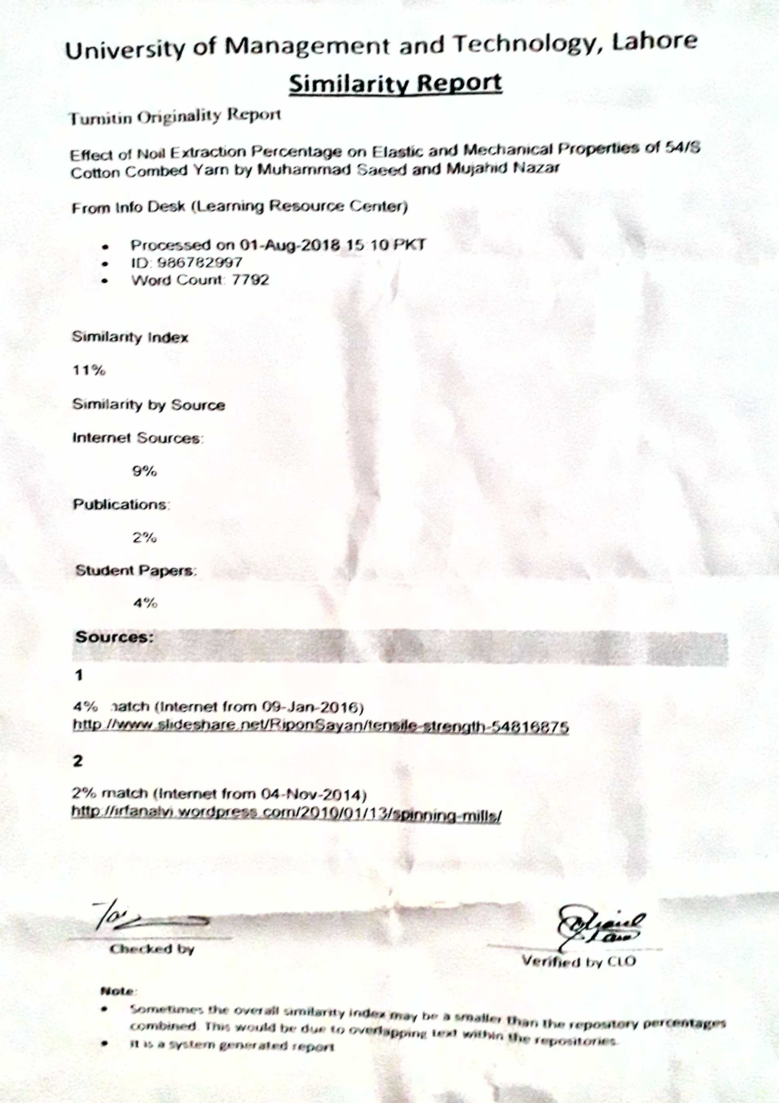
Plagiarism Report

