

Financial Stability of Islamic Banks:
An Empirical Study in SAARC and GCC Countries

Sidra Ayoub

A thesis submitted in partial fulfillment of the requirements for the
MS degree in Islamic Banking and Finance

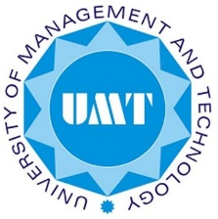
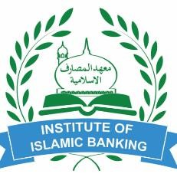

Institute of Islamic Banking university of Management And
Technology

Lahore, Pakistan.
1441 AH / 2019 CE

DECLARATION
I hereby declare that no portion of the work that appears in this study has been used in support of an application for another degree in qualification to this or any other university or institution of higher learning.

This thesis is a presentation of my original research work. Wherever contributions of others are involved, every effort has been made to indicate this clearly, with due reference to the literature and acknowledgement of collaborative research and discussions.

The work was done under the guidance of DR Mohammad Ayaz, Assistant Professor Institute of Islamic Banking (IIB), University of Management and Technology, Lahore, Pakistan.

_________________________
Sidra Ayoub

Date: ____________________

In my capacity as supervisor of the candidate’s thesis, I certify that the above statements are true to the best of my knowledge.

_____________________________
DR Mohammad Ayaz

Date: ________________________

DEDICATION
To the Holy Prophet of Allah (PBUH), who was sent to teach the Quran and the Wisdom and decontaminate our lives.

ACKNOWLEDGEMENT

First and foremost, I have to thank my Lord Almighty Allah SWT who alleviates my life by giving me contemporaries. I am grateful to my parents for their unconditional love and support; they has strengthened me to face the obstacle of the life and to realize the aspirations. My sincere thanks also go to my supervisor DR Muhammad Ayaz, for his insightful comments and encouragement, but also for the hard question which incented me to widen my research from various perspectives. He provided me an opportunity to join his team as Research Assistant, and he gave access to the resources and research facilities I could not have imagined having a better advisor and mentor for my MS IBF study.
I would like to express my sincere gratitude to my colleague Mr. Adeel Ilyass for the Continuous support of my MS IBF study and related research, who helped me a lot with his patience, motivation, and immense knowledge in finalizing this project within the limited timeframe. His guidance helped me in all the time of research and writing of this thesis. Without his precious support it would not be possible to conduct this Research. I thank my fellow and for all the fun we have had in the last two years. Also I thank my colleague’s in Institution of Islamic Banking (IIB) and University of Management Technology (UMT) for enlightening me the first glance of research.
Last but not the least; my brother Mr. Abdul Raheem, and my husband Mr. M Imran deserve my wholehearted thanks for their appreciation, support and trust on me. I would like to thank my in-laws, my Bhabhi Sofia Rehman for supporting me spiritually throughout my MS itinerary. And also thank to my sweet daughter Eshmal Eman who enlighten my life with spirt of love. May Allah bless her with all his blessings Ameen.

Sidra Ayoub
September, 2019

